Appendix A – DSERP Objectives

Objective |  | Performance Indicator
The primary objective (outcome) of the project is to ensure that settlement funds provided by the responsible party deliver the greatest long-term environmental benefits | The project will focus on maximising the chances for natural recovery and minimising the environmental and human risks of remediation activities | Post-remediation evaluation indicates that detailed remediation objectives have satisfied their evaluation criteria*
Remediation activities support natural recovery at Douglas Shoal
An effective Monitoring, Evaluation, Reporting and Improvement (MERI) framework delivers accountability and supports flexible, responsive decision-making | Indicators are selected to measure progress towards achieving detailed remediation objectives, monitoring results are analysed, and findings are reported and used to inform adaptive management decisions that continuously improve the project | Monitoring can reliably attribute changes at Douglas Shoal to remediation activities
 |  | Project Sponsor has adequate information to make decisions about adjusting the project plan
Knowledge gained is recorded and shared to inform other remediation efforts worldwide | As one of the most significant marine remediation projects in the world, the DSER project has the potential to add substantially to management knowledge worldwide. It is critical that the project successfully captures and shares lessons learned to inform other management actions | Number of people accessing reports/presentations about lessons learned
 | In addition, the project has the ability to attract related research that contributes significantly to GBRMPA’s ability to better manage the Reef, and also to scientific knowledge worldwide. It is appropriate for the project to intentionally communicate research priorities and potentially establish policies (related to permission decisions) that encourage such research | Number of papers published / amount of data provided to GBRMPA from aligned research
Traditional Owner values and opportunities are enhanced through the project | Douglas Shoal is within the Port Curtis Coral Coast TUMRA area, along with nearby islands which may serve as the base for fieldwork (such as North West Island and Heron Island). It is critical to understand the traditional values associated with these areas and to look for opportunities to not only protect, but also to enhance, Traditional Owner values. This may include opportunities for internship’s or employment through the project | TUMRA Steering Committee provides advice on the project’s Traditional Owner Participation Strategy (start of project)
 |  | – TUMRA Steering Committee provides advice on how well the project has delivered the strategy’s actions (end of project)
*Detailed remediation objectives (outcomes) and associated evaluation criteria will be developed as part of the project

Appendix B – GBRMPA Request for Quote

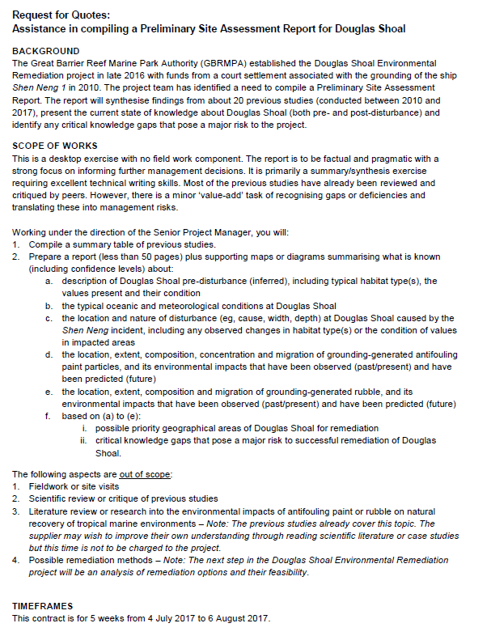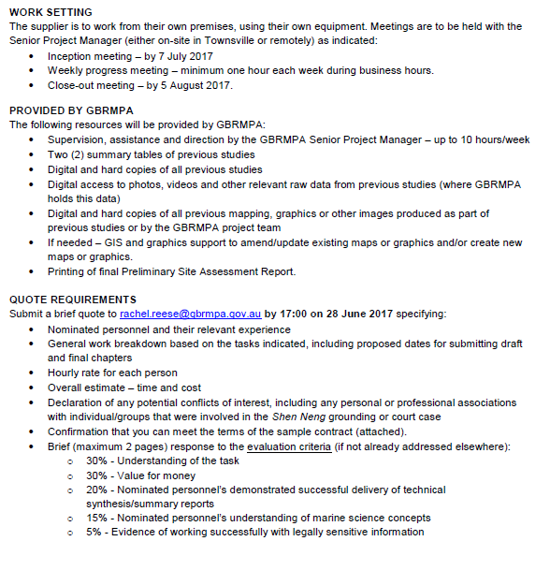

Appendix C - Cardno Team CVs

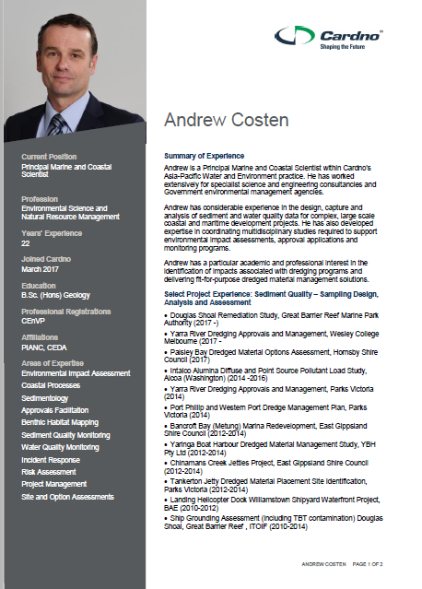
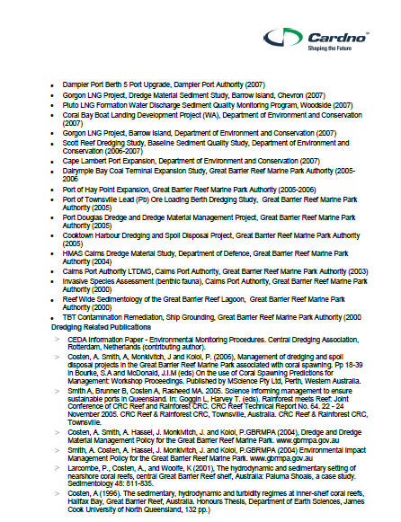
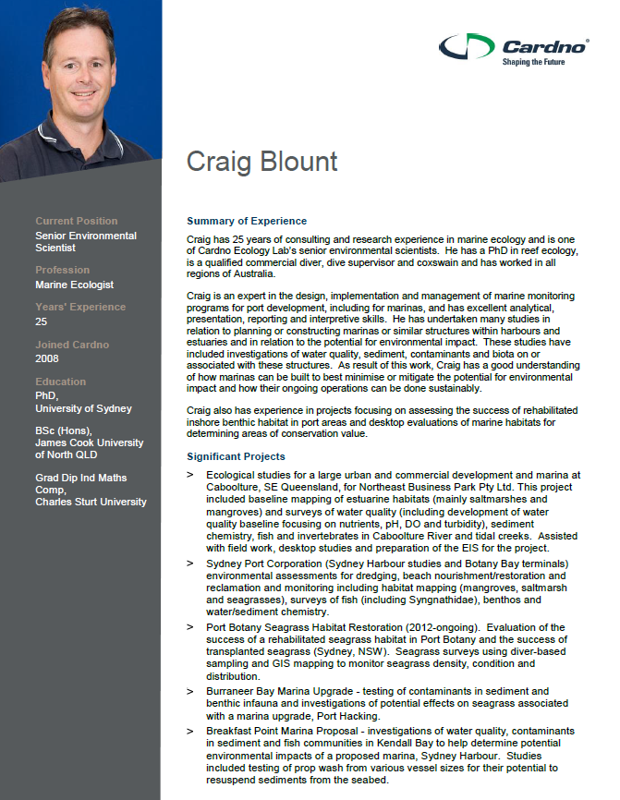

Appendix D – Method Statement - GIS Database

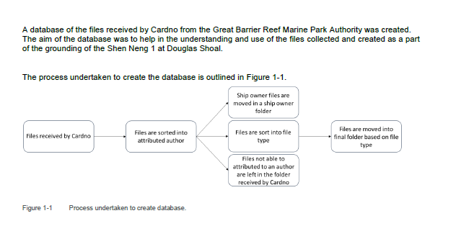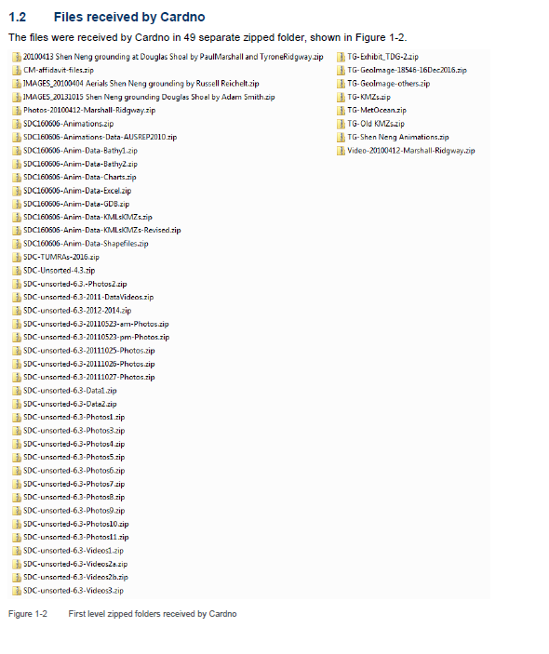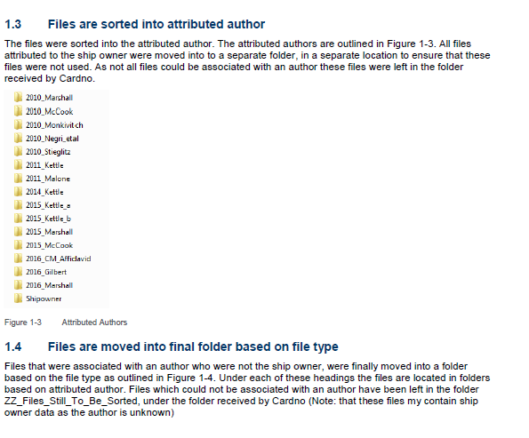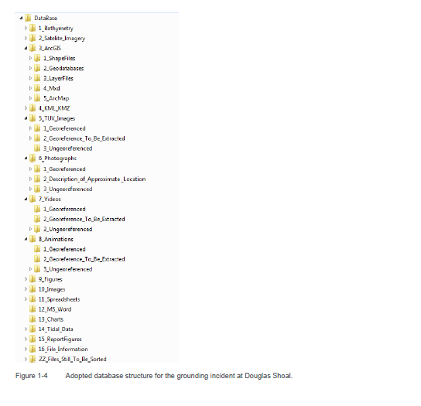

Appendix E – Build Reports for Maps and Figures

See PDF veriosn

