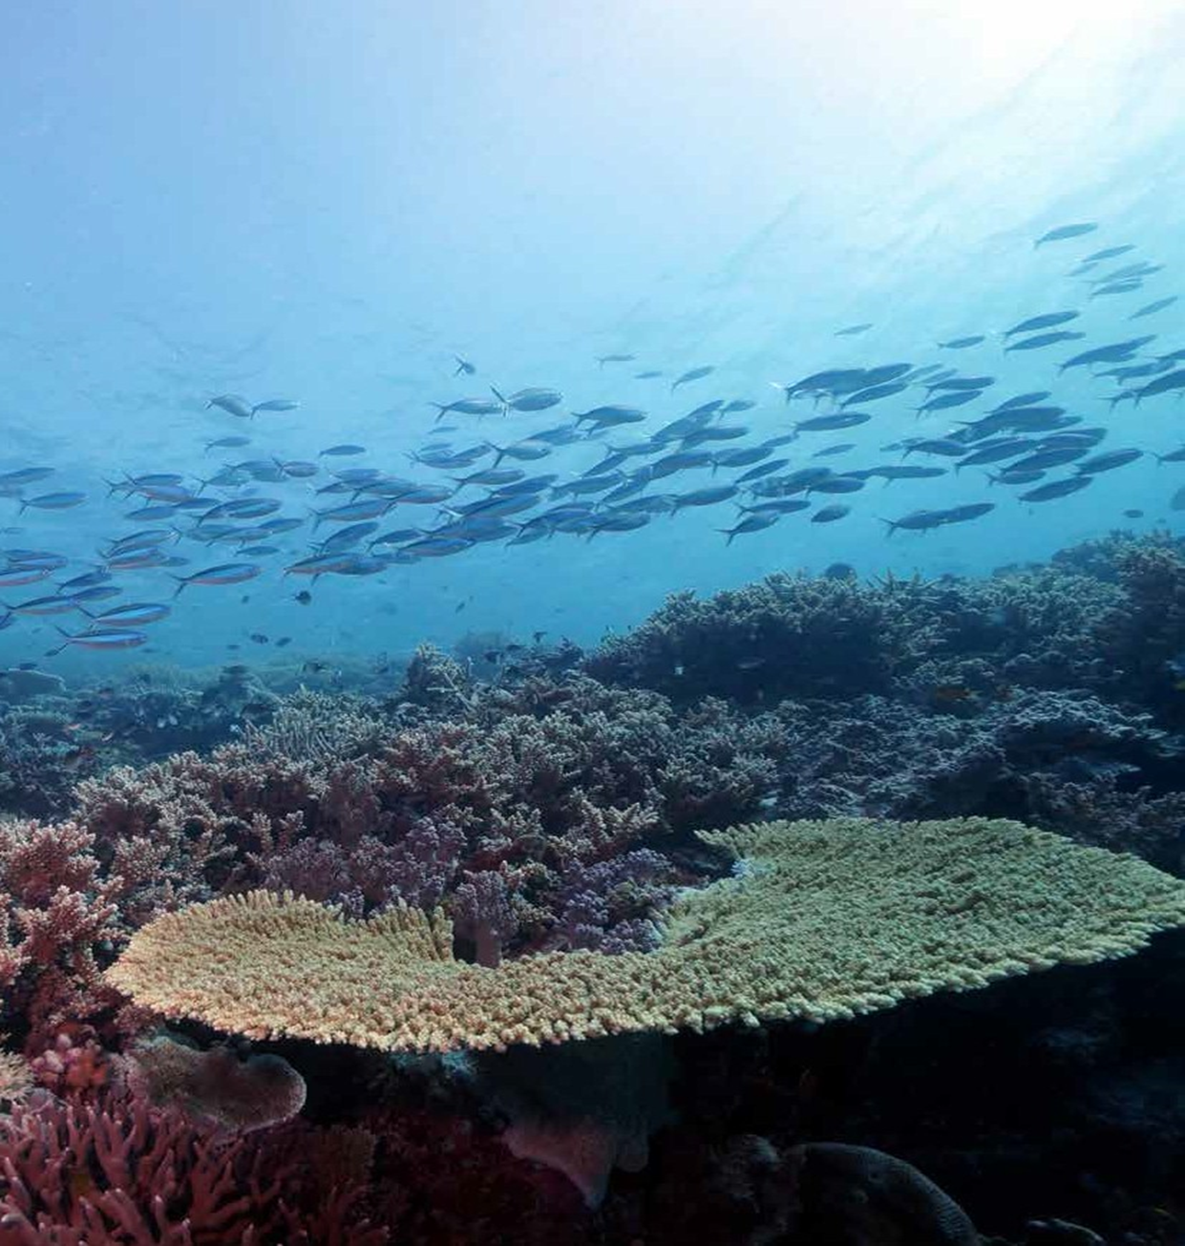

Russell-Mulgrave river mouth
(© Dieter Tracey, 2015)
Marine Monitoring Program
Summary Report — results for 2015-2016

Background

The Marine Monitoring Program¹ was established in 2005 to monitor the health of the inshore Great Barrier Reef (Reef), including water quality, seagrass and coral reef ecosystems. The program is one of 10 components of the Paddock to Reef Integrated Monitoring, Modelling and Reporting Program,² linking the health of the Reef with information on agricultural management practices, groundcover, catchment run-off and pollution loads. This monitoring directly supports the Reef Water Quality Protection Plan 2013 (Reef Plan), which aims to ensure that ‘by 2020 the quality of water entering the Reef from adjacent catchments has no detrimental impact on the health and resilience of the Great Barrier Reef.’

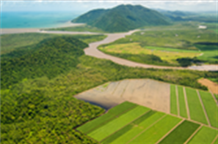

Snapshot of the Inshore Reef

Inshore coral reefs
Inshore coral reefs continued to improve in all regions in 2015-2016. All five indicators of coral health remained stable or improved slightly in all regions, and across the inshore Reef overall.³ This continued improvement follows successive years of below-median river discharge in combination with fewer disturbances such as cyclones. Record temperatures caused severe coral bleaching which affected the northern parts of the Reef in 2016; however, severe bleaching impacts were avoided in the inshore areas south of the Daintree.³ Outbreaks of crown-of-thorns starfish (COTS) continued to occur in the Wet Tropics and are being actively managed.

Inshore seagrass meadows
Seagrass cover continued to improve in Cape York, Wet Tropics, Mackay Whitsunday, Fitzroy and Burnett Mary regions and has declined slightly in the Burdekin region.⁴ There was a change in species composition to more stable and resilient meadows. However, declines in reproductive effort indicate meadows have low capacity to recover from large disturbances in the immediate future. Aerial surveys conducted in 2016 of dugongs and large juvenile and adult marine turtles showed significant increases in dugong and turtle populations in the south,⁵ coinciding with increases in seagrass cover.
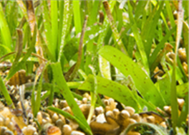

Subtidal seagrass meadows at Green Island
(© Dieter Tracey, 2013
2015-2016 Summary Report

Inshore water quality
A revised water quality metric was developed in 2015-2016 as an initial step towards integrating multiple streams of data to measure and report water quality scores.⁶ The new metric is underpinned by the eReefs biogeochemical model integrated with satellite data for improved accuracy. The modelled Reef-wide score for open coastal inshore waters was moderate overall, and the individual indicators chlorophyll-a and water clarity (Secchi depth) were rated as good and moderate respectively.⁶ Despite below-median annual river discharge in 2015-16,⁷ modelling showed key inshore ecosystems were potentially exposed to periods of poor water quality in the wet season.⁷ This was attributed to large amounts of sediment and nutrient already present in the lagoon, which continues to affect the condition of the water through resuspension from wind, currents and waves. The greatest effects attributed to human activities were seen in Wet Tropics and Burdekin, for dissolved inorganic nitrogen and total suspended solids respectively.⁷ Water samples were taken from specific long-term monitoring sites in focus areas within three regions⁷ and although this analysis is not yet integrated into the metric, if indicator guideline values were exceeded, these results are summarised in the table on the next page.

Pesticides
A wide range of pesticides – including insecticides and herbicides – were detected at 11 fixed long-term monitoring sites in 2015-2016.⁸ The most frequently detected pesticides in inshore waters (diuron, atrazine, hexazinone) are herbicides that inhibit photosynthesis (PSII herbicides). Pesticide concentrations were generally consistent with those detected in 2014-2015, in line with below-median river discharge and relatively low end of catchment pesticide loads. However, the highest concentrations of PSII herbicides detected in the marine environment since monitoring began were detected at Round Top Island in the Mackay Whitsunday region (category 2 - which has been shown to inhibit photosynthesis in some species of coral and seagrass).⁸ There were also minor exceedances of guideline values (current and proposed) at Round Top Island for three pesticides (diuron, imidacloprid and chlorpyrifos). Other emerging ‘alternative’ pesticides were also detected but at relatively low concentrations.⁸
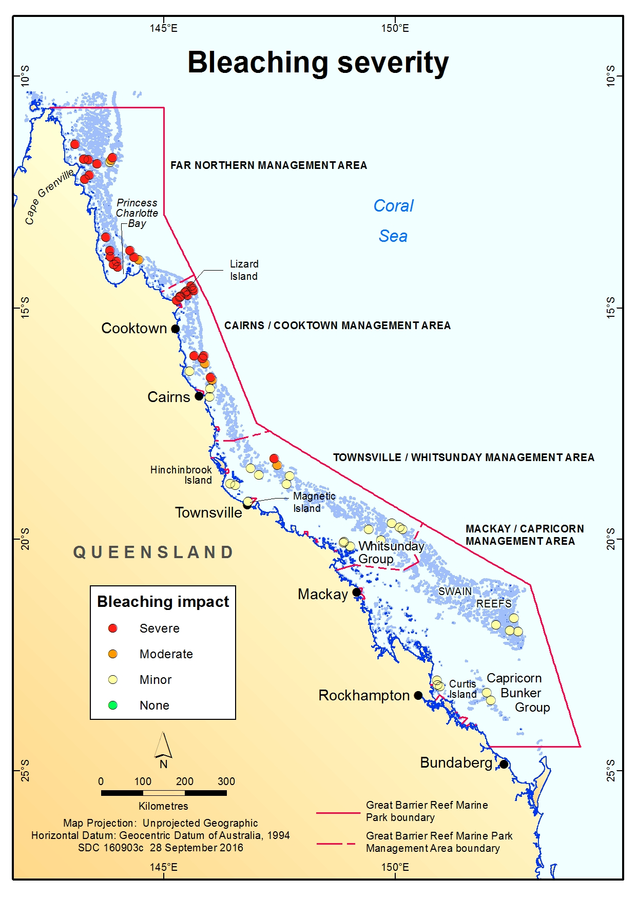
Disturbances
During 2015-2016, river discharge was below the long-term median for the Great Barrier Reef catchment⁷ and there were no cyclones or floods that affected the Great Barrier Reef.
Environmental conditions in the summer of 2015-2016 triggered the worst mass coral bleaching event to be recorded on the Reef up to then. Severe bleaching with subsequent coral mortality occurred at some inshore and mid-shelf reefs, with an estimated 29 percent of shallow-water coral lost across the Marine Park.⁹ The impact of bleaching decreased from north to south.
Of the 24 inshore reefs monitored through the MMP in mid-2016, 21 showed signs of bleaching between Cairns and Rockhampton.³ For the majority of reefs, coral bleaching was patchy within transects and restricted to a few individual colonies. Increases in coral cover at the majority of these sites demonstrate the very limited impact of the bleaching event at that time.
Areas where coral bleaching occurred in 2015-2016. The mortality level is indicated by the coloured circles.

Regional results

Cape York  — | Water quality | River discharge was below the long-term median.⁷ The modelled water quality score was very good in 2015-2016.⁶ Individual water quality indicators (chlorophyll-a and water clarity) were very good and moderate respectively.⁶ As in previous years, water quality sampling was not undertaken in the Cape York region in 2015-2016.
 | Seagrass | Seagrass cover continued to recover from the low point reached in 2011-2012. Abundance was moderate, leaf tissue nutrient content continued to increase while reproductive effort declined. Assessments now utilise information from more sites at coastal intertidal habitats (Shelbourne Bay and Bathurst Bay), reef intertidal habitats (Piper Reef and Stanley Is.) and coastal shallow subtidal habitats (Lloyd Bay).⁴
Wet Tropics  — | Water quality | Discharge from the Barron-Daintree, Russell-Mulgrave and Tully Rivers were below the long-term median.⁷ The modelled water quality score was good in 2015-2016 and the individual indicators chlorophyll-a and water clarity were very good and moderate respectively.⁶ Water quality sampled at long-term monitoring sites in the wet season exceeded guideline values for at least one indicator at 14 out of 17 sites.⁷ For example, mean or median concentrations of chlorophyll-a, nitrate/nitrite, particulate phosphorus and total suspended solids all exceeded guideline values at Fairlead Buoy.⁷
 | Pesticides | The PSII herbicides atrazine, diuron and hexazinone were frequently detected at the five long-term monitoring sites in the region. However, no concentrations of individual pesticides exceeded water quality guideline values. This was expected given below-median river discharge volumes this year. Low concentrations of ‘alternative’ pesticides such as 2,4-D, imidacloprid, MCPA and metolachlor were also detected. One-off samples ‘grabbed’ from flood waters from the Russell-Mulgrave and Tully Rivers had concentrations of PSII herbicides (Category 3 and 4) known to suppress photosynthesis in some diatom and seagrass species.⁸
 | Seagrass | Inshore seagrass in the Wet Tropics region remained poor in 2015-2016 and has generally been poor since 2005-2006,⁴ following the impact of two category 5 cyclones in the last decade. Seagrass condition varied across the region; however, abundance increased from very poor to poor overall, reproductive effort was very poor and leaf nutrient status remained poor.⁴ Together with other information about seagrass health, indications are that seagrass in the Wet Tropics remained vulnerable to future disturbances as past impacts have eroded their resilience and weakened their capacity to recover.⁴
 | Coral | The condition of inshore coral reefs continued to improve from the low point recorded in 2013 after a number of disturbances, but remained moderate.³ These improvements coincided with a period of reduced river discharge; however the legacy of past impacts including cyclone Ita and ongoing outbreaks of COTS continued to affect a number of reefs in the area.³ Four coral health indicators (coral cover, juvenile coral density, macroalgal cover and coral community composition) remained moderate, while coral change improved to good.³
Burdekin  — | Water quality | The modelled water quality score was good in 2015-2016 and the individual indicators chlorophyll-a and water clarity were very good and moderate respectively.⁶ Water quality sampled at long-term monitoring sites in the wet season exceeded the mean or median guideline values for at least one indicator at five out of six sites.⁷ For example, mean or median concentrations of chlorophyll-a, nitrate/nitrite and particulate phosphorus all exceeded guideline values at Palm Islands west.⁷
 | Pesticides | Pesticide monitoring only occurs at the mouth of the Barratta Creek. As in previous years, atrazine and atrazine breakdown products dominated the PSII herbicide profile at this site. The ‘alternative’ pesticides, MCPA and metolachlor, were also frequently detected. No concentrations of individual pesticides exceeded Water Quality Guidelines.⁸
 | Seagrass | Seagrass remained in moderate condition. Seagrass meadow abundance remained moderate across all habitat types, with the greatest improvements observed in coastal habitats. Reproductive effect increased to moderate whereas leaf nutrient content declined to moderate.⁴
 | Coral | Coral cover on inshore reefs continued to improve in 2015-2016 to levels comparable to those observed prior to losses associated with Cyclone Yasi. This coincides with low flow from adjacent catchments, improvements in the density of juvenile corals and the slow return of species sensitive to poor water quality. There were high levels of macroalgae on many reefs, which indicates that they were still affected by poor water quality.³
Mackay Whitsunday  — | Water quality | The modelled water quality score was moderate in 2015-2016 and the individual indicators chlorophyll-a and water clarity were both moderate.⁶ Water quality sampled at long-term monitoring sites in the wet season exceeded the mean or median guideline values for at least one indicator at four out of five sites.⁷ For example, mean or median concentrations of chlorophyll-a, nitrate/nitrite and particulate phosphorus and total suspended solids guideline values all exceeded guideline values at Double Cone Is., Pine Is., Seaforth Is. and Repulse Is.⁷
 | Pesticides | Concentrations of most of PSII herbicides including diuron, atrazine and hexazinone at Round Top Island were higher compared to any other inshore monitoring site on the Reef. This is the seventh consecutive year that the monitoring site with the highest PSII herbicide equivalent concentration was located in the Mackay Whitsunday region. In contrast to previous monitoring years, where diuron has been the dominant pesticide detected in the region, atrazine was detected at comparable concentrations in Repulse Bay in 2015-2016.⁸

Mackay Whitsunday continued | Seagrass | Seagrass condition improved, but remained poor overall. Seagrass abundance improved from poor to moderate. Reproductive effort continued to improve at coastal and estuarine habitats but remained poor overall due to the low reproductive effort at reef sites. Leaf tissue nutrient content was similar to the previous year and remained poor.⁴
 | Coral | The condition of inshore coral reefs in the region had improved to good for the first time since monitoring began, reflecting both the limited incidence of severe disturbances and the predominance of coral species tolerant of high turbidity, nutrients and sediment. Juvenile densities continued to increase, while the cover of macroalgae has remained stable and low.³
Fitzroy  — | Water quality | The modelled water quality score was moderate in 2015-2016 and individual indicators for chlorophyll-a and water clarity were poor and moderate, respectively.⁷ As in previous years, water quality sampling was not undertaken in the Fitzroy region in 2015-16.
 | Pesticides | The only pesticide monitoring site in the Fitzroy region is at North Keppel Island. Tebuthiuron was almost exclusively detected at this site, although atrazine and diuron were frequently detected at low concentrations.⁸
 | Seagrass | The condition of inshore seagrass increased from very poor to poor in 2015-2016. Abundance, reproductive effort and leaf tissue nutrient content all improved from 2014-2015. However, the Fitzroy seagrass meadows remained highly vulnerable to future disturbances as past impacts have eroded their resilience.⁴
 | Coral | Inshore coral reefs improved slightly in 2015-2016.³ Three indicators (coral cover, coral change and coral community composition) remained stable, but in poor condition. Juvenile densities showed slight improvement, while macroalgae showed no signs of declining.³ The influence of repeated and intense flooding, extreme temperatures and a series of severe storms since 2006 contributed to the overall decline in coral reef condition up to 2013-2014.³
Burnett Mary  — | Water quality | The modelled water quality score was good in 2015-2016 and individual indicators for chlorophyll-a and water clarity were good and moderate respectively.⁶ As in previous years, water quality sampling was not undertaken in the Burnett Mary Region in 2015-2016.
 | Seagrass | The condition of inshore seagrass improved to moderate from the previous year, the highest in a decade. Abundance (moderate), reproductive effect (poor) and leaf tissue nutrient content (moderate) all increased and the meadows are recovering.⁴
Scores: ■ = A, very good, ■ = B, good, ■ = C, moderate, ■ = D, poor, ■ = E, very poor. See www.reefplan.qld.gov.au/scoring for further details.

Regional results continued

Conclusion
References and further information
For more information please refer to our website, the Marine Monitoring Program publications and other websites:
- GBRMPA MMP website
- Paddock to Reef Program
- Inshore coral reef monitoring
- Inshore seagrass monitoring
- Final report: Dugongs and large turtle numbers
- NESP Project 3.2.5 Report
- Inshore water quality monitoring
- Inshore pesticides
- Final report: 2016 coral bleaching event on the Great Barrier Reef
- 2016 Marine Results
In 2015-16, the inshore marine environment score was moderate in all regions except the Fitzroy,¹⁰ following a second year of below-median river discharge. However an assessment of the long-term trend is not possible, as the revised water quality metric was only reported for the current year, and results are not comparable to previous report cards.

Trends in key habitats were positive. The modest increase in seagrass cover across the Reef indicates the system is still recovering from the legacy of multiple climate impacts.² Improvements in all indicators of coral health reflect the inherent resilience of inshore reefs.³ There was a corresponding increase in coral condition,³ despite the severe coral bleaching event in early 2016 that affected a large proportion of mid and outer shelf reefs.⁹

The scientific consensus is that the lag between management actions implemented now and realised improvements in marine water quality is such that sediments and nutrients will continue to affect the Reef for the next 25 years. Adaptive management to drive improved land management practices, guided by monitoring, evaluation and reporting programs which share information across partners^{1,2} will have a long-term positive outcome for the health and resilience of the Reef.

© Commonwealth of Australia 2017. Published by the Great Barrier Reef Marine Park Authority.
ISSN: 2208-4339

