MARINE MONITORING PROGRAM
Annual
Report
for
inshore
coral
reef
monitoring
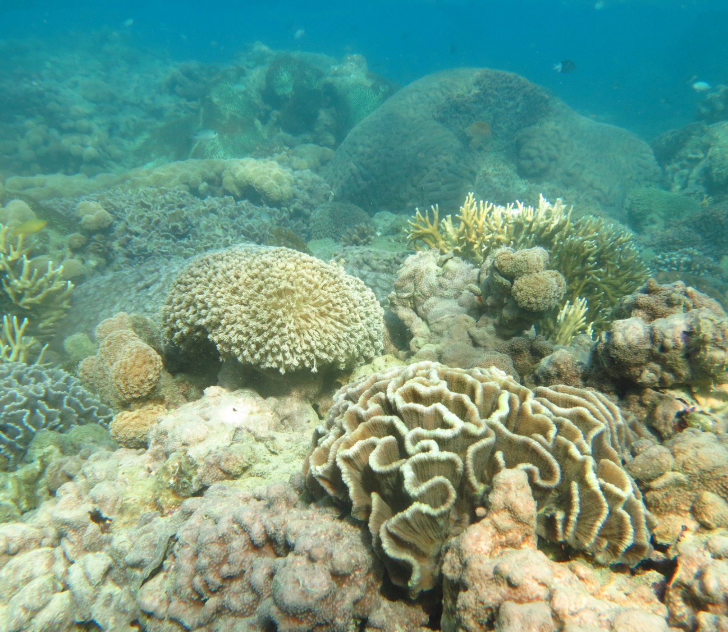
2 0 1 4 – 2 0 1 5
Angus Thompson, Paul Costello, Johnston Davidson, Murray Logan, Greg Coleman, Kevin Gunn, Britta Schaffelke

Australian Institute of Marine Science
PMB No 3
Townsville MC Qld 4810

© Copyright Australian Institute of Marine Science (AIMS) 2016
All rights are reserved and no part of this document may be reproduced, stored or copied in any form or by any means whatsoever except with the prior written permission of AIMS.

ISBN 9781922126924

This report should be cited as:
Thompson A, Costello P, Davidson J, Logan M, Coleman G, Gunn K, Schaffelke B (2016) Marine Monitoring Program. Annual Report for inshore coral reef monitoring: 2014 to 2015. Report for the Great Barrier Reef Marine Park Authority. Australian Institute of Marine Science, Townsville.133 pp.

Front cover image: The reef-flat coral community at Double Cone Island, Central Great Barrier Reef © AIMS 2014. Photographer: Johnston Davidson.

DISCLAIMER
While reasonable efforts have been made to ensure that the contents of this document are factually correct, AIMS does not make any representation or give any warranty regarding the accuracy, completeness, currency or suitability for any particular purpose of the information or statements contained in this document. To the extent permitted by law AIMS shall not be liable for any loss, damage, cost or expense that may be occasioned directly or indirectly through the use of or reliance on the contents of this document.

Direct Enquiries to –
Dr. Angus Thompson
Phone: +61 7 4753 4329
Fax: +61 7 4772 5852
Email: a.thompson@aims.gov.au
Web: http://www.aims.gov.au/

Contents
1. Executive Summary 1
2. Preface 6
3. Introduction 7
4. Methods 10
4.1 Sampling design 10
4.2 Coral community sampling 14
4.3 Environmental sampling 15
4.4 Coral reef data analysis and presentation 17
4.5 Pressure presentation 20
5. Results and discussion 22
5.1 Wet Tropics Region: Barron Daintree sub-region 23
5.2 Wet Tropics Region: Johnstone Russell-Mulgrave sub-region 26
5.3 Wet Tropics Region: Herbert Tully sub-region 30
5.4 Burdekin Region 33
5.5 Mackay Whitsunday Region 37
5.6 Fitzroy Region 41
6. Revision of report card indicator metrics 45
6.1 Report card concept 45
6.2 Metric 1: Proportional cover of macroalgae 50
6.3 Metric 2: Coral cover 54
6.4 Metric 3: Rate of change in hard coral cover 56
6.5 Metric 4: Juvenile hard coral density 59
6.6 Metric 5: Changes in community composition of hard corals 63
6.7 Aggregating indicator scores to regional-scale assessments 65
6.8 Comparison between revised and previously used coral index. 66
7. Conclusions 69
Pressures 69
Ecosystem State 71
Summary 73
Acknowledgments 75
8. References 76
Appendix 1: Additional Information 87
Appendix 2: QAQC Information 132
Appendix 3: Publications and presentations associated with the Program 2014-15 133

List of Figures and Tables
Figure 1: Coral Index and Water Quality Index. 2
Figure 2: The regional Coral Index with contributing indicator scores. 4
Figure 3: Sampling locations of the MMP coral and water quality monitoring. 11
Figure 4: Barron Daintree sub-region reef locations, environmental conditions and disturbances. 23
Figure 5: Coral reef community and water quality trends in the Barron Daintree sub-region. 25
Figure 6: Johnstone Russell-Mulgrave sub-region reef locations, environmental conditions and disturbances. 26
Figure 7: Coral reef community and water quality trends in the Johnstone Russell-Mulgrave sub-region. 28
Figure 8: Herbert Tully sub-region reef locations, environmental conditions and disturbances. 30
Figure 9: Coral reef community and water quality trends in the Herbert Tully sub-region. 32
Figure 10: Burdekin region reef locations, environmental conditions and disturbances 33
Figure 11: Coral reef community and water quality trends in the Burdekin region. 35
Figure 12: Whitsunday Mackay Region reef locations, environmental conditions and disturbances 37
Figure 13: Coral reef community and water quality trends in the Mackay Whitsunday region. 40
Figure 14: Fitzroy Association Region reef locations, environmental conditions and disturbances. 41
Figure 15: Coral reef community and water quality trends in the Fitzroy region. 44
Figure 16: Macroalgae proportion relationships to environmental conditions 52
Figure 17: Scoring diagram for the MAproportion indicator. 54
Figure 18: Scoring diagram for the coral cover indicator. 56
Figure 19: Scoring diagram for rate of change in hard coral cover metric 58
Figure 20: Relationship between juvenile density and probability of hard coral cover recovery. 61
Figure 21: Scoring diagram for Juvenile density metric. 62
Figure 22: Scoring diagram for community composition indicator metric. 65
Figure 23: Comparison between the revised and original coral index scoring systems. 68

Table 1: Sampling locations.. 13
Table 2: Summary of coral community sampling methods. 14
Table 3: Categorisation of disturbances 21
Table 4: Thresholds for proportion of macroalgae in the algae communities. 53
Table 5: Source of variables required for estimation of the rate of change indicator 59
Table 6: Genus group scores along constrained water quality axis at each depth 64
Table 7: Threshold values for the coral index metrics 67

List of Figures and Tables – Appendices
Figure A 1: Cover of major benthic groups and density of hard coral juveniles at reefs in the Daintree sub-region. 96
Figure A 2: Cover of major benthic groups and density of hard coral juveniles at reefs in the Johnstone sub-region.. 97
Figure A 3: Cover of major benthic groups and density of hard coral juveniles at reefs in the Tully sub- region. 100
Figure A 4: Cover of major benthic groups and density of hard coral juveniles at reefs in the Burdekin region. 102
Figure A 5: Cover of major benthic groups and density of hard coral juveniles at reefs in the Mackay Whitsunday region. 106
Figure A 6: Cover of major benthic groups and density of hard coral juveniles at reefs in the Fitzroy region. 110
Figure A 7: Coral disease by year in each region 112
Figure A 8: Cyclone exposure history 124
Figure A 9: Exposure to plume type waters 125
Figure A 10: Temporal trends in water quality: Baron Daintree sub-region 126
Figure A 11: Temporal trends in water quality: Johnstone Russell-Mulgrave sub-region 127
Figure A 12: Temporal trends in water quality: Herbert Tully sub-region. 128
Figure A 13: Temporal trends in water quality: Burdekin region. 129
Figure A 14: Temporal trends in water quality: Mackay Whitsundays region. 130
Figure A 15: Temporal trends in water quality: Fitzroy region. 131

Table A 1: Annual freshwater discharge for the major Reef Catchments 88
Table A 2: Disturbance histories for coral monitoring locations. 89
Table A 3: Report card index assessments. 92
Table A 4: Environmental covariates for coral locations 95
Table A 5: Composition of hard coral communities. 113
Table A 6: Composition of soft coral communities. 117
Table A 7: Composition of macroalgal communities. 120

Executive Summary
The management of water quality remains an essential requirement to ensure the long-term protection of the coastal and inshore ecosystems of the Great Barrier Reef (the Reef). The land management initiatives under the Australian and Queensland Government's Reef Water Quality Protection Plan (Reef Plan) are key tools to improve the water quality entering the GBR with the goal “To ensure that by 2020 the quality of water entering the reef from broadscale land use has no detrimental impact on the health and resilience of the Great Barrier Reef.” This report summarises the results of coral reef monitoring activities, carried out by the Australian Institute of Marine Science (AIMS) as part of the Reef 2050 Plan Marine Monitoring Program (MMP) from 2005 to 2015.

Methods
The objective of the MMP is to assess status and trends in ecosystem health and resilience indicators for the Great Barrier Reef in relation to water quality and its linkages to end-of-catchment loads. The sampling design for the coral reef monitoring component was selected for the detection of change in benthic communities on inshore reefs that could be related to observed changes in water quality. Within each of four Natural Resource Management (NRM) regions: Wet Tropics (comprising three sub-regions), Burdekin, Mackay Whitsunday and Fitzroy, sites were selected along a gradient of exposure to runoff to ensure coverage of communities occupying a range of environmental conditions. In 2015 the water quality component of the program was amended to provide added sampling intensity across gradients within Wet Tropics, Burdekin and Mackay Whitsunday regions. This change included the more direct alignment between the wet season flood monitoring and broad scale water quality programs (reported separately in Lønborg et al. 2015). This change to the water quality program will enhance the ability to detect change in the regional water quality, however, it comes at the cost of ceasing in-situ water quality sampling in the Fitzroy region.
Until 2014, coral reefs sites were designated as either ‘core’ or ‘cycle’ reefs. At the 14 core reefs, surveys of benthic communities were undertaken annually with instrumental and direct water sampling undertaken at co-located stations. The 18 cycle reefs were visited every other year for surveys of reef status only. Originally, cycle reefs were sampled each year (2005 and 2006), however, in 2007, as a result of funding reductions, the sampling frequency was reduced to every other year. In 2015, the sampling frequency of all reef sites was reduced to every other year as a cost-effective way to maintain spatial coverage and track long-term trends in community condition, and the sediment analyses were discontinued. The long-term coral reef monitoring program (LTMP) at AIMS has been monitoring three inshore reefs in each of the Wet Tropics, Burdekin and Mackay Whitsunday regions. The LTMP uses comparable methods to MMP and in this report these additional time-series of are included into the MMP reporting and report card scores.

Trends in key ecosystem health indicators
In this report we present temporal trends in coral reef condition indicators. Each of the five indicators; coral cover, hard coral community composition, macroalgae cover, juvenile coral density and the rate of coral cover increase are converted to metrics of a common scale to facilitate their combination into a coral index. For each NRM region the coral index provides a summary of the status and trend in coral community condition at inshore coral reefs (Figure 1). A suite of water quality indicators are similarly combined to summaries status and trend in marine water quality (Figure 1): Detailed water quality reporting is provided in a separate report (Lønborg et al. 2015),
The water quality index in the Wet Tropics Region has a ‘good’, though declining, score in recent years (Figure 1). It is pertinent to note at this point that the regional water quality index is currently based on a selected set of variables for which GBR water quality guidelines are available. The index as reported here represents the sampling design of the MMP up until 2014. While it does provide a valid estimation of water quality condition, it is important to emphasise that a more comprehensive sampling program was adopted in 2015 aimed at improving the monitoring and reporting of water quality trends.
The 2015 assessment of the coral index for the Wet Tropics is ‘moderate’ and represents an improvement from a low point recorded in 2013 (Figure 1).
In both the Barron-Daintree and Johnstone Russell-Mulgrave sub-regions high levels of coral disease were observed in 2010 and 2011, followed by outbreaks of crown-of-thorns seastars (COTS), both are stressors with potential links to elevated nutrient and or turbidity associated with runoff. Physical damage occurred during the passage of tropical cyclones at most reefs with the cyclones Larry (2006), Tasha (2010), Yasi (2011) and Ita (2014) variously reducing coral cover at reefs across the region. In tandem with the loss of coral cover was an increase in the cover of macroalgae at several reefs. The proliferation of macroalgae indicated that, despite the water quality being scored as “good”, water quality at these reefs was sufficiently poor to promote macroalgal growth.

In both the Johnstone Russell-Mulgrave and Tully Herbert sub-regions, in the absence of any acute disturbance events, scores for the majority of indicator metrics have improved over the last two years (Figure 2). Improvement across a range of indicators provides a positive indication of community resilience. Coral communities in the Barron-Daintree sub-region were affected by Cyclone Ita in 2014 and are yet to show clear recovery. In the past, these reefs demonstrated the ability to recover from acute disturbances with index scores increasing to ‘good’ in 2008 (Figure 2).

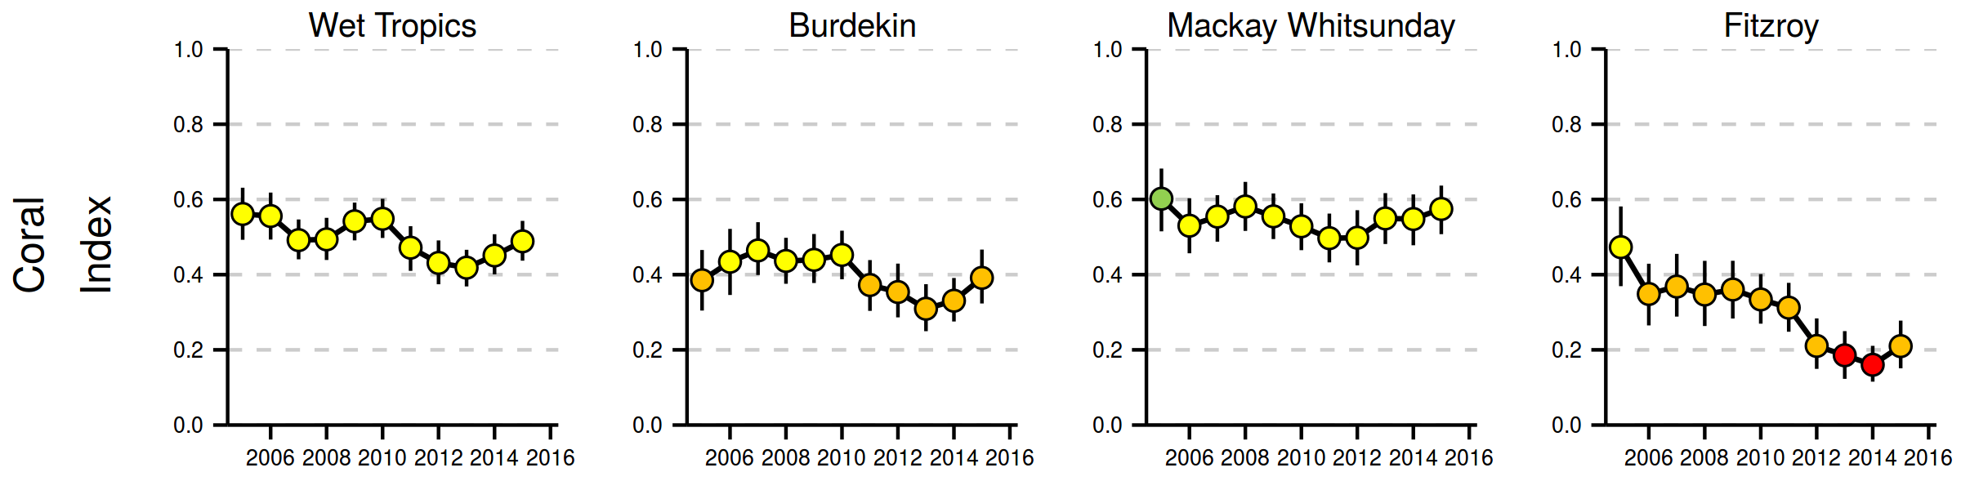
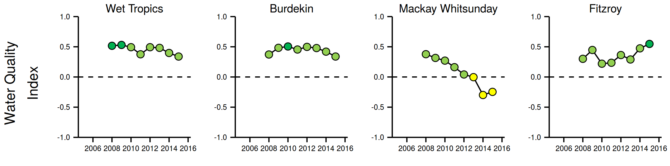
Figure 1: Coral Index and Water Quality Index.
The regional coral index aggregates scores for coral cover, proportional cover of macroalgae, density of juvenile corals, the rate of coral cover increase and change in coral community composition. Colours for the coral index classify condition as: red= very poor, orange= poor, yellow= moderate, light green= good, dark green= very good. The water quality index aggregates scores for five indicators: concentrations of particulate nitrogen, particulate phosphorus, nitrate and nitrite, chlorophyll, and a combined water clarity indicator (suspended solids, turbidity, and Secchi depth), calculated as the mean of the proportional deviations of each indicator from Guideline values, with the boundary between a good and a moderate score being the respective guideline value (see Lønborg et al. (2015) for a detailed description of the derivation of water quality scores).

The overall condition of the water quality in the Burdekin Region showed initial improvements at the start of the monitoring program and has declined slightly over the last several years though retains an overall index score of ‘good’ in 2015 (Figure 1). There has, however, been a noticeable increase in both NO_{X} and turbidity levels though these are offset by improvements in other indicators. Despite the ‘good’ water quality index scores, regionally low coral cover as a result of wide-spread disturbances, in particular cyclone Yasi in 2011, coupled with slow rates of coral recovery and low densities of juvenile corals resulted in a decline in the coral index to a low point in 2012 (Figure 2). The recent upward trend in the coral index does, however, indicate some improvement in the condition of coral communities with condition poised on the boundary between ‘poor’ and ‘moderate’ classifications in 2015 (Figure 1).
Historically, inshore reefs in the Burdekin Region have demonstrated low recovery potential following widespread loss of corals. This low recovery potential appears linked to a combination of water quality-related pressures and limited connectivity between these reefs and coral communities further offshore that limits the supply of coral larvae. Suppression of coral communities as a result of poor water quality is indicated by observations of high levels of coral disease that coincided with the change from a period of low flow from adjacent catchments to consecutive years of flooding. The ongoing availability of elevated nutrients is indicated by persistently high cover of macroalgae on many of the reefs in this region. Improvements in reef condition through to 2015 are due to slight improvement in the density of juvenile corals and the rate of coral cover increase along with a gradual return of species sensitive to poor water quality. These combined observations suggest a reduction in the chronic pressures associated with water quality in recent years during which inflows from the catchment have been low. .
The coral index in the Mackay Whitsunday Region maintained a ‘moderate’ score though it has continued to improve from a low point reached in 2012 (Figure 1). The positive attributes of moderate to high coral cover coupled with regionally low cover of macroalgae and increasing densities of juvenile corals balanced the low rate of coral cover increases (Figure 2). The influence of prevailing environmental conditions such as high turbidity, nutrient availability and sedimentation have clearly selected for coral species tolerant of those conditions and this, in combination with a lack of recent severe disturbance events, explains the relatively high and stable coral cover in this region despite observed declines in water quality. The ongoing selection against corals sensitive to poor water quality is indicated by increased levels of coral disease and declines in the density of juvenile corals that coincided with elevated discharge from both local rivers and the large rivers in neighbouring regions. Recent increases in both coral cover and juvenile density observed since 2012 further indicate the tolerance of the coral communities to the region’s water quality. What remains largely untested is how resilient these communities will be if exposed to a severe disturbance event. The slow rate of coral cover increase in this region suggests recovery from any such disturbance may be slow.
Coral communities in the Fitzroy Region have been severely impacted by a series of disturbances from thermal bleaching in 2006, through multiple storm events and repeated major flooding of the Fitzroy River. The influence of flooding on the water quality within the region largely explains the variability in the water quality index (Figure 1) and contributed to the decline in the coral index through to 2014. The 2011 flood had a severe impact on reefs inshore of Great Keppel Island by killing the majority of corals to depths of at least 2m below low tide, with negligible recovery from this event to date. Elsewhere, the resilience of coral communities was compromised by a persistent bloom of macroalgae and occasional high levels of disease since high water temperatures in 2006 bleached and killed corals across the region. In addition, the density of juvenile corals has been consistently low across the entire region – an observation likely linked to the high cover of macroalgae. Both the prevalence of disease and persistence of high macroalgae cover (Figure 2) provide a clear indication that nutrient levels have played a role in inhibiting the coral community’s resilience to recent disturbances. The improvement of the coral index to ‘poor’ in 2015 represents the first signs of recovery of the coral communities with the return to lower loads of sediments and nutrients entering the Reef from the Fitzroy River.

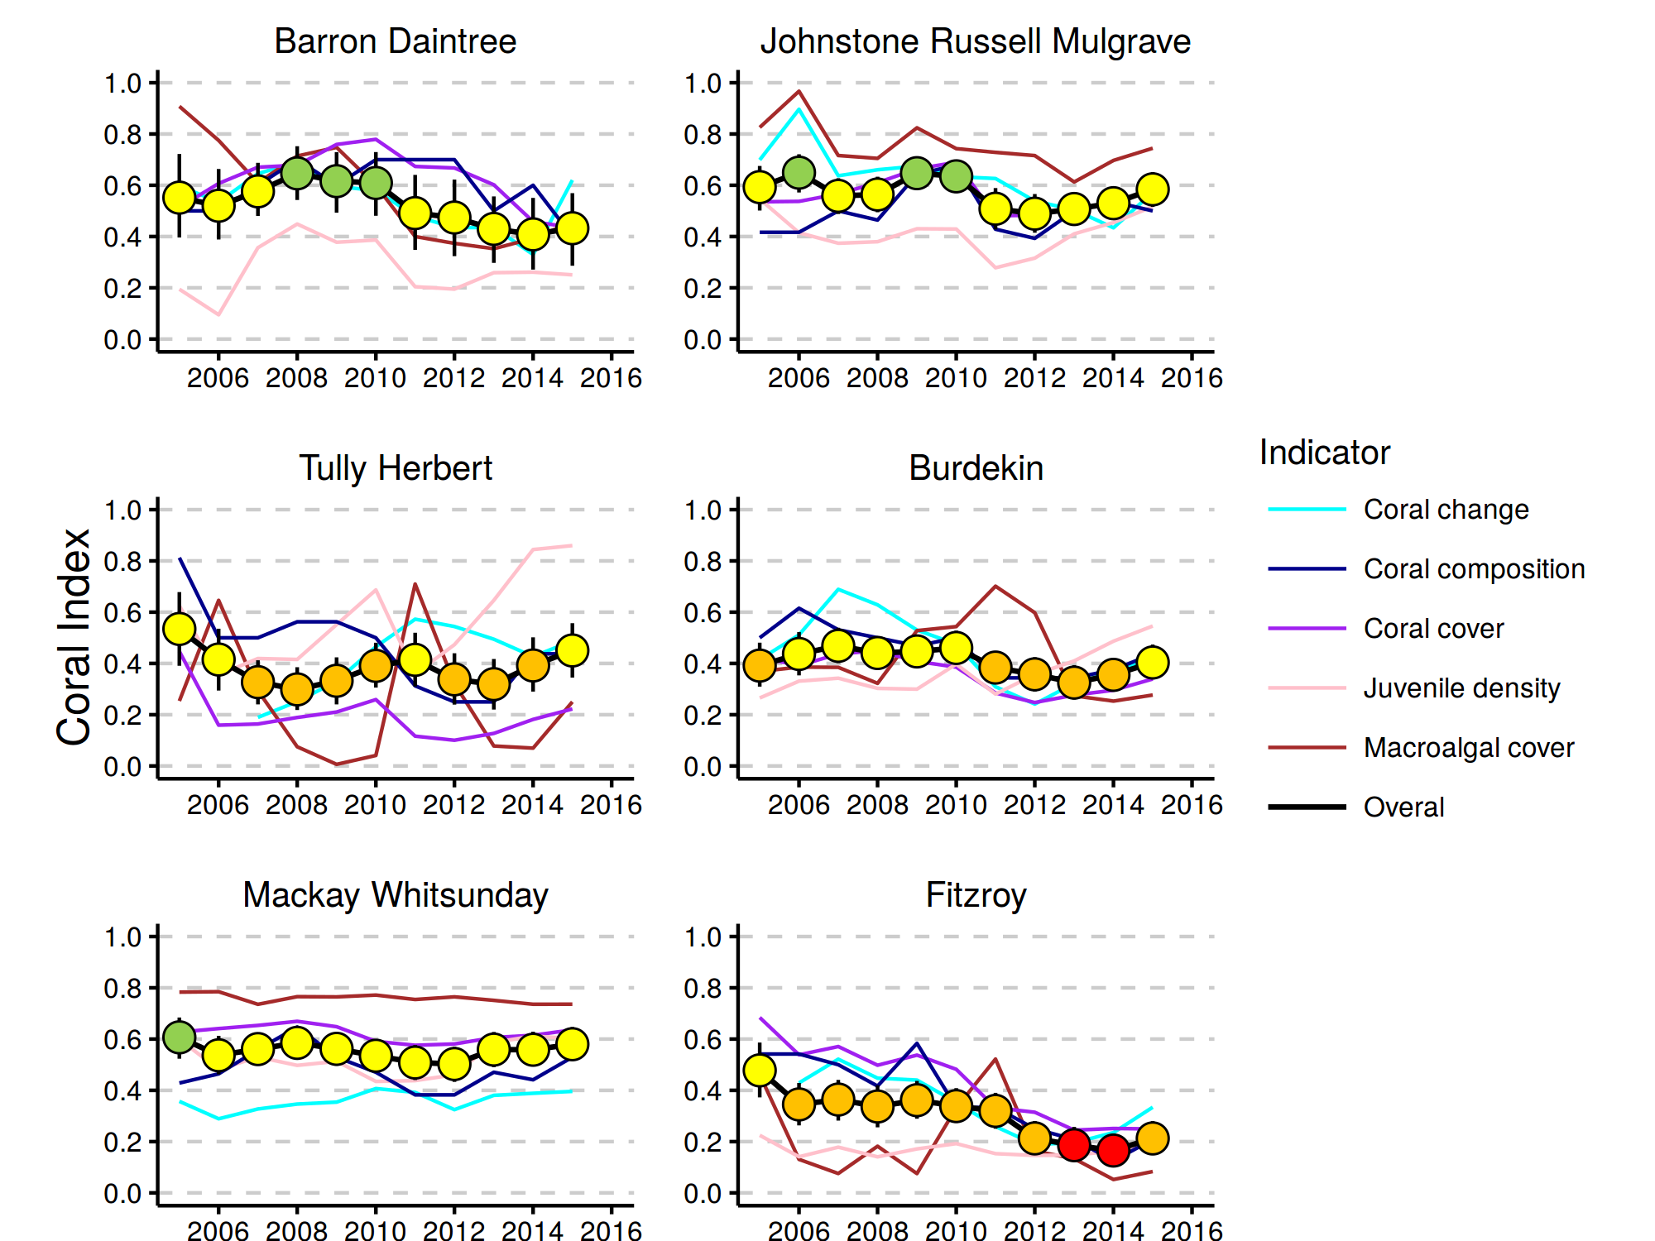
Figure 2: The regional Coral Index with contributing indicator scores.
The regional Coral Index is derived from the aggregate of metric scores for indicators of coral community health through time within each (sub) region. The contributing indicators are described in Methods Summary; their metric score calculations are detailed in section 6

Conclusions
In this report the metrics contributing to the coral index have been revised to more specifically represent aspects of coral community resilience. These revisions are subtle and do not greatly alter the scoring compared to the previous metrics used to calculate report card scores. What is clearly apparent is that the cumulative impact of multiple disturbance events, including tropical cyclones, outbreaks of crown-of-thorns seastars, coral bleaching and a period of high discharge and associated nutrient and sediment loads, have combined to cause declines in coral community condition through to 2012-2014, depending on the region. Collectively, changes in the revised resilience indicators (proportion of macroalgae in benthic algal communities, density of juvenile corals, change in coral cover), were broadly similar among regions and across environmental gradients and declined to low levels following a prolonged period with high volumes of runoff to the Reef lagoon. This consistent response affecting a diversity of indicators demonstrates the importance and the broad ‘footprint’ of runoff within the inshore Reef lagoon. Improvements in the coral index in all regions in 2015 coincided with low levels of runoff entering the Reef and built on improvements recorded in 2014.
The reversal in the declining trend in the coral index provides some guidance for the distinction between catchment loads that caused community decline compared to the more recent period of reduced loads due to reduced rainfall and runoff, which have fostered improved community resilience. It is increasingly apparent that, within a location, stress to coral communities is most obvious during extremes in environmental conditions that expose corals to conditions beyond those to which they are either adapted or acclimated. Links between coral disease, poor rates of increase in coral cover and declines in the community composition metric all point to water quality pressures experienced either during, or in the period of months following major floods as being sufficiently removed from ambient conditions to select against sensitive species on a site-by-site basis. The challenge will be how to reduce runoff loads during inevitable future flood events to limit the impact to coral communities.
In addition to the direct effects of changed water quality observed on inshore reefs reported here are larger-scale or indirect potential impacts of water quality on the Reef. Recent research into the interactions between water quality and climate change suggests that corals tolerance to heat stress and ocean acidification is reduced by exposure to contaminants including nutrients, herbicides and suspended particulate matter. The initiation of COTS outbreaks have also been linked to increased nutrient loads delivered to the Reef lagoon during major flood events. Observations from the MMP water quality monitoring program demonstrate large-scale and persistent changes in the water quality following the high loads nutrients that entered the reef over the period 2008-2013. In particular, concentrations of dissolved organic carbon, dissolved nitrogen and turbidity levels have increased in all regions. These findings show that the mechanisms controlling the carbon and nutrient cycles in the Reef lagoon have undergone changes and in combination extend the influence of runoff to large tracts of the Reef beyond the inshore zone reported here.
With the prediction that the severity of disturbance events is projected to increase as a result of climate change, it is essential to mitigate local stressors that increase corals susceptibility to these disturbances. The evidence summarised in the 2013 Reef Plan Scientific Consensus Statement “indicates that a reduction in catchment pollutant loads is essential to halt and reverse further decline in the Reef ecosystem condition at a time of rapidly warming climate and ocean acidification”. The 2015 GBRMPA Strategic Assessment and 2014 Outlook reports identify the understanding of cumulative impacts as a key knowledge gap and their management a key strategic challenge. Continued and improved monitoring of the coastal and inshore Reef lagoon is fundamental to track long-term trends in the condition of marine water quality and ecosystem health in the face of cumulative impacts and to identify the ecosystem responses to management actions and interventions, for example those under Reef Plan.

Preface
Management of human pressures, such as enhanced nutrient runoff and overfishing, is vital to provide corals and reef organisms with the optimum conditions to cope with global stressors, such as climate change and ocean acidification (Bellwood et al. 2004, Marshall & Johnson 2007, Carpenter et al. 2008, Mora 2008, Hughes et al. 2010). The management of water quality remains a strategic priority for the Great Barrier Reef Marine Park Authority (GBRMPA) to ensure the long-term protection of the coastal and inshore ecosystems of the Reef (GBRMPA 2014 a, b). A key management tool is the Reef Water Quality Protection Plan (Reef Plan; Anon. 2013), with the actions being delivered through the Reef 2050 Plan. The Reef 2050 Plan includes the Reef Trust, to which the Australian Government has committed continued funding to protect the Reef through improvements to the quality of water flowing into the Reef lagoon, and the Reef 2050 Long Term Sustainability Plan, which provides a framework for the integrated management of the GBRWHA.
The Marine Monitoring Program (MMP), formerly known as the Reef Plan MMP, was designed and developed by the GBRMPA in collaboration with science agencies and is currently funded by the Australian Government Reef Programme. A summary of the MMP’s overall goals and objectives and a description of the sub-programs are available at the GBRMPA 2050 marine monitoring program website and the e-atlas website. The MMP forms an integral part of the Paddock to Reef Integrated Monitoring, Modelling and Reporting Program, which is a key action of Reef Plan and is designed to evaluate the efficiency and effectiveness of implementation and report on progress towards the Reef 2050 Plan goals and targets. A key output of the Paddock to Reef Program is an annual report card, including an assessment of Reef water quality and ecosystem condition to which the MMP contributes assessments and information. The first Annual Reef Plan Report Card for 2009 (Anon. 2011), serves as a baseline for future assessments, and report cards for 2010, 2011, 2012/13 and 2014 have since been released (available at www.reefplan.qld.gov.au).
The Australian Institute of Marine Science (AIMS) and the GBRMPA entered into a co-investment agreement in June 2015 to provide monitoring activities under the MMP in 2015. The AIMS monitoring activities in the current contract period of the MMP are largely an extension of activities established under a previous arrangements from 2005 to 2014 and are grouped into two components:
- Inshore Marine Water Quality Monitoring
- Inshore Coral Reef Monitoring
In previous years, AIMS has combined the results of the AIMS Water Quality and Coral Reef Monitoring into an integrated report. However, with the revision of the water quality monitoring component in 2015 it was decided that the in situ water quality monitoring undertaken by AIMS and the flood plume monitoring by James Cook University will be merged and provide a combined marine water quality report (see Lønborg et al. 2015). Hence, this present report is now focused at only the coral monitoring component. In keeping with the overarching objective of the MMP to:
“Assess trends in ecosystem health and resilience indicators for the Great Barrier Reef in relation to water quality and its linkages to end-of-catchment loads”,
Key water quality results are replicated here as required for the analysis and interpretation of coral results. The report covers coral reef monitoring conducted between May 2015 and August 2015 with inclusion of data from previous MMP and LTMP monitoring.

Introduction
Coastal environments are under increasing pressure from human population growth, intensifying land use and urban and industrial development (Halpern et al. 2015). Increased loads of suspended sediment, nutrients and pollutants, such as pesticides and other chemicals, invariably enter coastal waters and lead to a decline in estuarine and coastal marine water quality and the ecosystems therein.
It is well documented that sediment and nutrient loads carried by land runoff into the coastal and inshore zones of the Great Barrier Reef (Reef) have increased since European settlement (e.g., Kroon et al. 2012, Waters et al. 2014). Concern about the negative effects that these increases were having on the Great Barrier Reef ecosystem triggered the formulation of the Reef Water Quality Protection Plan (Reef Plan) for catchments adjacent to the GBR World Heritage Area by the Australian and Queensland governments (Anon. 2003, 2009). Reef Plan was revised and recently updated (Anon. 2013). The current Reef 2050 Plan actions and initiatives aim to improve land management practices to achieve improvement in the downstream water quality of creeks and rivers. These actions and initiatives should, with time, also lead to improved water quality in the coastal and inshore Reef that in turn support the ongoing health and resilience of Great Barrier Reef (see Brodie et al. 2012a for a discussion of expected time lags in the ecosystem response).
Reef Plan can be considered in a Drivers-Pressures-States-Impacts-Responses (DPSIR) framework (Maxim et al. 2009, Rehr et al. 2012). Socio-economic factors are the drivers of human activities from local, within catchment, scale through to the global scale. Human activities result in both locally derived pressures on downstream ecosystems such as increased exposure to sediments, nutrients and toxicants that interact with global pressures such as climate change. These pressures change the state of the Great Barrier Reef ecosystems. This state can then be interpreted in terms of impact on desirable ecosystem functioning or services that in turn can be used to inform decisions as to the need for response such as policy or regulatory actions to alleviate that impact.
To allow the full application of a DPSIR framework requires the monitoring of both pressures and states that should be reported where possible in terms of impacts so that appropriate management responses can be devised, or conversely, the outcomes of existing management strategies assessed. Reef Plan actions included the establishment of monitoring programs extending from the paddock to the Reef (Anon. 2010), to assess the effectiveness of Reef Plan's implementation. The MMP is an integral part of this monitoring providing physicochemical and biological data to document the state of water quality, concentrations of pesticides, coral reefs and seagrass beds in inshore areas of the Reef. The MMP additionally collates observations of extrinsic pressures such as sea temperature variability, occurrence of tropical cyclones, river discharge volumes and predator populations that must be variously considered in any assessment of water quality or ecosystem state. Ultimately the state of marine waters and the ecosystems of the Reef will provide both a basis for assessing the success of Reef Plan and the necessity for future management strategies.
The coral reef component of the MMP is based on the general understanding that healthy and resilient coral communities exist in a dynamic equilibrium with communities in a cycle of recovery punctuated by acute disturbance events. Common disturbances to inshore reefs include cyclones (often associated with flooding), thermal bleaching, and outbreaks of crown-of-thorns seastars (COTS), all of which can result in widespread mortality of corals (e.g. Sweatman et al. 2007, Osborne et al. 2011) on the Reef. The potential impact of pollutants carried into the system as runoff is both an increase in the susceptibility of corals to these disturbances; nutrient availability may promote outbreaks of COTS (Wooldridge & Brodie 2015) and increase susceptibility to thermal stress (Wooldridge & Done 2004, Wiedenmann et al. 2013), and/or the suppression of the recovery process (Schaffelke et al. 2013). The replacement of corals lost to disturbance is reliant on both the recruitment of new colonies and regeneration of existing colonies from remaining tissue fragments (Smith 2008, Diaz-Pulido et al. 2009). Elevated concentrations of nutrients, agrochemicals, and turbidity can negatively affect reproduction in corals (reviewed by Fabricius 2005, van Dam et al. 2011 Erftemeijer et al. 2012). High rates of sediment deposition and accumulation on surfaces can affect larval settlement (Babcock & Smith 2002, Baird et al. 2003, Fabricius et al. 2003) and smother juvenile corals (Harrison & Wallace 1990, Rogers 1990, Fabricius & Wolanski 2000). In addition, macroalgae have higher abundance in areas with high water column chlorophyll concentrations, indicating higher nutrient availability (De’ath & Fabricius 2010). High macroalgal abundance may suppress reef resilience (e.g. Hughes et al. 2007, Cheal et al. 2010, Foster et al. 2008, but see Bruno et al. 2009) by increased competition for space or changing the microenvironment into which corals settle and grow (e.g. McCook et al. 2001, Hauri et al. 2010). Macroalgae have been documented to suppress fecundity (Foster et al. 2008), reduce recruitment of hard corals (Birrell et al. 2008b, Diaz-Pulido et al. 2010), diminish the capacity of growth among local coral communities (Fabricius 2005),and suppress coral recovery by altering microbial communities associated with corals (Morrow et al. 2012, Vega Thurber et al. 2012).
In addition to influences on the early life stages of corals, changes in water quality have been shown to increase incidence of coral disease: for example increased organic carbon concentrations promote coral diseases and mortality (Kline et al. 2006, Kuntz et al. 2005). The selective pressure of water quality on coral communities is clearly evident in changes in community composition along environmental gradients (De’ath & Fabricius 2010, Thompson et al. 2010a, Uthicke et al. 2010, Fabricius et al. 2012). Corals derive energy in two ways, by feeding on ingested particles and plankton organisms and from the photosynthesis of their symbiotic algae (zooxanthellae). The ability to compensate by feeding where there is a reduction in energy derived from photosynthesis, e.g. as a result of light attenuation in turbid waters, varies between species (Anthony 1999, Anthony & Fabricius 2000). Similarly, the energy required to shed sediments varies between species due to differences in the efficiencies of passive (largely depending on growth form) or active (such as mucus production) strategies for sediment removal (Rogers 1990, Stafford-Smith & Ormond 1992). At the same time, high nutrient levels may favour particle feeders such as sponges and heterotrophic soft corals which are potential space competitors of hard corals. The result is that the combination of environmental parameters at a given location will disproportionately favour some species and thus influence the community composition of coral reef benthos. However, coral communities occur in a wide range of environmental settings because different coral species have different tolerances to environmental pressures (e.g. Done 1982, Fabricius & De’ath 2001, DeVantier et al. 2006, De’ath & Fabricius 2010).
Coral reefs in the coastal and inshore zones of the Reef, which are often fringing reefs around continental islands, are subject to high turbidity due to frequent exposure to re-suspended sediment and episodic flood events. It is difficult to quantify the changes to coral reef communities caused by runoff of excess nutrients and sediments because of the lack of historical biological and environmental data that predate significant land use changes on the catchment. However, recent research has strengthened the evidence for causal relationships between water quality changes and the decline of some coral reefs and seagrass meadows in these zones (reviewed in Brodie et al. 2012b and Schaffelke et al. 2013).
Given that the benthic communities on inshore reefs of the Reef show clear responses to gradients in turbidity, sedimentation rate and nutrient availability (van Woesik et al. 1999, Fabricius & De’ath 2001, Fabricius et al. 2005, Wismer et al. 2009, Uthicke et al. 2010, Fabricius et al. 2012), improved land management practices have the potential to reduce levels of chronic environmental stresses that impact on coral reef communities. However, recent assessments raise the question whether these actions will be sufficient to ensure the resilience of the Reef ecosystems into the future (Bartley 2014a, b, Kroon et al. 2014). Nutrients to sustain the biological productivity of the Reef are supplied by a number of processes and sources such as upwelling of nutrient-enriched deep water from the Coral Sea and nitrogen fixation by (cyano-) bacteria (Furnas et al. 2011). However, land runoff is the largest source of new nutrients to the inshore Reef (ibid.), especially during monsoonal flood events. These nutrients augment the regional stocks of nutrients already stored in biomass or detritus (Furnas et al. 2011) which are continuously recycled to supply nutrients for marine plants and bacteria (Furnas et al. 2005, Furnas et al. 2011).
The complexity of interactions between benthic communities and environmental pressures makes it important to synthesize coral community condition for reporting purposes. In this report we present a revised scoring system based on five independent indicators of reef ecosystem state that forms the basis of the coral component of the Reef report card. This scoring system makes subtle adjustments to previously reported indicators of coral cover, macroalgae cover, density of juvenile corals and the rate at which coral cover increases and includes an additional indicator of coral community composition. In combination these indicators each represent different aspects of coral community resilience.
In order to relate inshore coral reef community health to variations in local reef water quality, this component of the MMP has the following objectives:
- To assess the condition of inshore coral reef communities;
- To assess variation in this condition in relation to exposure to both: acute pressures associated with disturbance events and chronic pressures related to marine water quality;
- Provide an integrated assessment of inshore coral community condition as the basis for the coral community component of the Report card.

Methods

4.1 Sampling design
Monitoring of inshore coral reef communities is limited to reefs adjacent to four of the six natural resource management (NRM) regions with catchments draining into the Reef: Wet Tropics, Burdekin, Mackay Whitsunday and Fitzroy. No reefs are included adjacent to Cape York due to logistic and occupational health and safety issues relating to diving in coastal waters in this region. Limited development of coral reefs in nearshore waters adjacent to the Burnett Mary NRM region precluded sampling there. Sub-regions were included in the Wet Tropics NRM to more closely align reefs with the combined catchments of; the Barron and Daintree rivers, the Johnstone and Russell-Mulgrave Rivers, and the Herbert and Tully rivers

4.1.1 Site Selection
On advice from an expert panel the GBRMPA selected the reefs monitoring by the MMP. The selection was based upon two primary considerations:

- Within the Reef strong gradients in water quality exist with distance from the coast and increasing distance from rivers in a northerly direction (Larcombe et al. 1995, Brinkman et al. 2011). The selection of reefs for inclusion in the sampling design was informed by the desire to include reefs spanning these gradients so as to facilitate the teasing out of water quality associated impacts;
- Sampling locations were selected where there was either an existing coral reef community or evidence (in the form of carbonate-based substratum) of past coral reef development. Exact locations were selected without prior investigation, once a section of reef had been identified that was of sufficient size to accommodate our sampling design a marker was deployed from the surface and transects established from this point.

In the Wet Tropics region, where few reefs exist in the inshore zone and well-developed reefs existed on more than one aspect of an island, separate reefs on windward and leeward aspects were included in the design. Coral reef communities can be quite different on windward compared to leeward reefs even though the surrounding water quality is relatively similar. Differences in wave and current regimes determine whether materials, e.g. sediments, fresh water, nutrients or toxins imported by flood events, accumulate or disperse and hence determine the exposure of benthic communities to environmental stresses. A list of the selected reefs is presented in Table 1 and the geographic locations are shown in Figure 3 and also indicated on maps within each (sub-) regional section.
There have been two changes to the selection of reefs sampled. In 2005 and 2006 three mainland fringing reef locations were sampled along the Daintree coast. Concerns over increasing crocodile populations in this area led to the cessation of sampling at these locations. In 2015 a revision of the marine water quality monitoring component of the MMP resulted in a concentration of sampling effort along a gradient away from the Tully River mouth. To better match the water quality sampling to the coral reef sampling in the Tully-Herbert sub-region a new reef site was initiated at Bedarra and sampling at King Reef discontinued.
In addition to reefs monitored by the MMP data from inshore reefs monitored by the AIMS long-term monitoring program have been included in this report (Table 1, Figure 3). The addition of these reefs serves to extend the basis for assessments of coral community condition. Finally, as the MMP sites at Middle reef in the Burdekin region were co-located with LTMP sites this reef was also removed from the MMP sampling schedule in 2015.

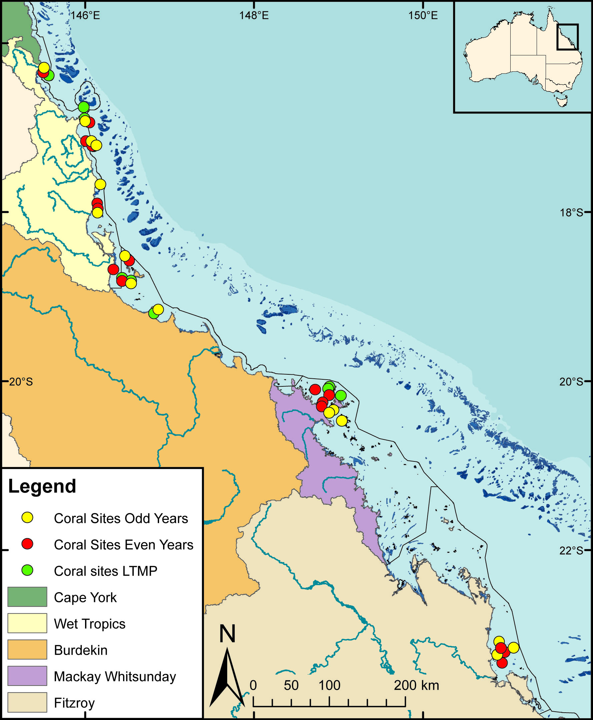
Figure 3: Sampling locations of the MMP coral and water quality monitoring.
Table 1 (below) describes monitoring activities undertaken at each location. NRM Region boundaries are represented by coloured catchment areas.

4.1.2 Depth Selection
From observations of a number of inshore reefs undertaken by AIMS in 2004 (Sweatman et al. 2007), marked differences in community structure and exposure to perturbations with depth were noted. The lower limit for the inshore coral surveys was selected at 5m below datum, because coral communities rapidly diminish below this depth at many reefs, 2m below datum was selected as the ‘shallow’ depth as this allowed surveys of the reef crest. Shallower depths were considered but discounted for logistical reasons, including the inability to use the photo technique in very shallow water, site markers creating a danger to navigation and difficulty in locating a depth contour on very shallow sloping substrata typical of reef flats. The AIMS LTMP sites are not as consistently depth defined as those of the MMP with most sites set in the range of 5-7m below LAT. Middle Reef is the exception with sites there at approximately 3m below LAT.

4.1.3 Site marking
At each reef (Table 1) two sites separated by at least 250 m were selected along a similar aspect. These sites are permanently marked with steel fence posts at the beginning of each of five 20m transects and smaller (10mm diameter) steel rods at the 10m mark and the end of each transect. Compass bearings and measured distances record the transect path between these permanent markers. Transects were set initially by running two 60m fibreglass tape measures out along the desired 5m or 2m depth contour. Digital depth gauges were used along with tide heights from the closest location included in ‘Seafarer Tides’ electronic tide charts produced by the Australian Hydrographic Service to set transects as close as possible to the desired depths of 5m and 2m below lowest astronomical tide (LAT). Consecutive 20m transects were separated by 5m. The position of the first picket of each site was recorded by GPS. Site directions and waypoints are stored electronically in AIMS databases.

4.1.4 Sampling timing and frequency
Coral reef surveys were undertaken predominantly over the months May-July as this allows the full influences of summer disturbances such as cyclones and bleaching events to be realised. Although the acute events occur over summer the stress incurred can cause ongoing mortality for several months. The winter sampling also protects observers from potential risk from marine stingers over the summer months. The exception was Snapper Island where sampling occurred typically in the months August –October.
The frequency of survey has changed incrementally due to budgetary constraints. In 2005 and 2006 all MMP reefs were surveyed. From 2007 through to 2014 a subset of reefs at which there were co-located water sampling sites (Table 1, section 4.2.1) were classified as “core” reefs and sampled annually. The remaining reefs were classified as “cycle” and sampled only in alternate years with half sampled in odd numbered years (i.e. 2009, 2011 & 2013) and the remainder in even numbered years. When an acute disturbance was suspected to have impacted cycle reefs during the preceding summer they were resurveyed irrespective of their odd or even year classification so as to gain the best estimate of the impact of the acute event and bookend the start of the recovery period. From 2015 further funding reductions necessitated a move to sampling all reefs on a biennial cycle though a contingency for the out-of-phase resampling of reefs impacted by acute disturbance was maintained.

Table 1: Sampling locations. Black symbols mark reefs surveyed as per sampling design, Grey symbols mark reefs out of schedule to assess disturbance. At each reef surveys of juvenile coral densities, benthic cover estimates derived from photo point intercept transects and scuba searches for incidence of coral mortality are undertaken. WQ, indicates reefs at which water quality monitoring is undertaken, * indicates WQ was ceased in 2014, and ** indicates WQ was begun in 2015.
Region | Sub Region | Reef | Program | 2005 | 2006 | 2007 | 2008 | 2009 | 2010 | 2011 | 2012 | 2013 | 2014 | 2015
Wet Tropics | Barron Daintree | Cape Tribulation North | MMP | ● | ●
 |  | Cape Tribulation Mid | MMP | ● | ●
 |  | Cape Tribulation South | MMP | ● | ●
 |  | Snapper North (WQ) | MMP | ● | ● | ● | ● | ● | ● | ● | ● | ● | ● | ●
 |  | Snapper South | MMP | ● | ● | ● | ● | ● | ● | ● | ● | ● | ● | ●
 |  | Low Isles | LTMP | ● |  | ● |  | ● |  | ● |  | ● |  | ●
 | Johnstone Russell-Mulgrave | Green | LTMP | ● |  | ● |  | ● |  | ● |  | ● |  | ●
 |  | Fitzroy West | LTMP | ● |  | ● |  | ● |  | ● |  | ● |  | ●
 |  | Fitzroy West (WQ) | MMP | ● | ● | ● | ● | ● | ● | ● | ● | ● | ● | ●
 |  | Fitzroy East | MMP | ● | ● | ● | ● |  | ● | ● | ● |  | ●
 |  | High East | MMP | ● | ● | ● |  | ● |  | ● |  | ● |  | ●
 |  | High West (WQ) | MMP | ● | ● | ● | ● | ● | ● | ● | ● | ● | ●
 |  | Frankland East | MMP | ● | ● | ● |  | ● |  | ● |  | ● |  | ●
 |  | Frankland West (WQ) | MMP | ● | ● | ● | ● | ● | ● | ● | ● | ● | ●
 | Tully | Barnards | MMP | ● | ● | ● |  | ● |  | ● |  | ● |  | ●
 |  | King | MMP | ● | ● |  | ● |  | ● |  | ● |  | ●
 |  | Dunk North (WQ) | MMP | ● | ● | ● | ● | ● | ● | ● | ● | ● | ●
 |  | Dunk South | MMP | ● | ● |  | ● |  | ● | ● | ● |  | ●
 |  | Bedarra | MMP |  |  |  |  |  |  |  |  |  |  | ●
Burdekin |  | Palms West (WQ) | MMP | ● | ● | ● | ● | ● | ● | ● | ● | ● | ● | ●
 |  | Palms East | MMP | ● | ● |  | ● |  | ● | ● | ● |  | ●
 |  | Lady Elliot | MMP | ● | ● |  | ● |  | ● |  | ● |  | ●
 |  | Pandora North | LTMP | ● |  | ● |  | ● |  | ● |  | ● |  | ●
 |  | Pandora (WQ) | MMP | ● | ● | ● | ● | ● | ● | ● | ● | ● | ●
 |  | Havannah North | LTMP | ● |  | ● |  | ● |  | ● |  | ● |  | ●
 |  | Havannah | MMP | ● | ● | ● |  | ● |  | ● |  | ● |  | ●
 |  | Middle Reef | LTMP | ● |  | ● |  | ● |  | ● |  | ●
 |  | Middle Reef | MMP | ● | ● | ● |  | ● |  | ● |  | ●
 |  | Magnetic (WQ) | MMP | ● | ● | ● | ● | ● | ● | ● | ● | ● | ● | ●
Mackay Whitsunday |  | Langford | LTMP | ● |  | ● |  | ● |  | ● |  | ● |  | ●
 |  | Hayman | LTMP | ● |  | ● |  | ● |  | ● |  | ● |  | ●
 |  | Border | LTMP | ● |  | ● |  | ● |  | ● |  | ● |  | ●
 |  | Double Cone (WQ) | MMP | ● | ● | ● | ● | ● | ● | ● | ● | ● | ●
 |  | Hook | MMP | ● | ● |  | ● |  | ● |  | ● |  | ●
 |  | Daydream (WQ*) | MMP | ● | ● | ● | ● | ● | ● | ● | ● | ● | ●
 |  | Shute Harbour | MMP | ● | ● |  | ● |  | ● |  | ● |  | ●
 |  | Dent | MMP | ● | ● | ● |  | ● |  | ● |  | ● |  | ●
 |  | Pine (WQ) | MMP | ● | ● | ● | ● | ● | ● | ● | ● | ● | ● | ●
 |  | Seaforth (WQ**) | MMP | ● | ● | ● |  | ● |  | ● |  | ● |  | ●
Fitzroy |  | North Keppel | MMP | ● | ● | ● |  | ● |  | ● |  | ● | ● | ●
 |  | Middle | MMP | ● | ● |  | ● |  | ● |  | ● |  | ● | ●
 |  | Barren (WQ) | MMP | ● | ● | ● | ● | ● | ● | ● | ● | ● | ● | ●
 |  | Keppels South (WQ) | MMP | ● | ● | ● | ● | ● | ● | ● | ● | ● | ● | ●
 |  | Pelican (WQ) | MMP | ● | ● | ● | ● | ● | ● | ● | ● | ● | ● | ●
 |  | Peak | MMP | ● | ● |  | ● |  | ● |  | ● |  | ● | ●

4.2 Coral community sampling
Three separate sampling methodologies were used to describe the benthic communities of inshore coral reefs (Table 2).

Table 2: Summary of coral community sampling methods.
Survey Method | Information provided | Transect dimension
 |  | MMP (20m long transects) | LTMP (50m long transects)
Photo point Intercept | Percentage covers of the substratum of major benthic habitat components. | Approximately 34cm belt along upslope side of transect sampled at 50 cm intervals from which 32 frames are sampled. | Approximately 34cm belt along upslope side of transect sampled at 1m intervals from which 40 frames are sampled.
Demography | Size structure and density of juvenile coral communities. | 34cm belt along the upslope side of transect. Size classes: 0-2cm, 2-5cm, 5-10cm. | 34cm belt along the upslope side of the first 5m of transect. Size class: 0-5cm.
Scuba search | Incidence of factors causing coral mortality | 2m belt centred on transect | 2m belt centred on transect

4.2.1 Photo point intercept transects
Estimates of the composition of the benthic communities were derived from the identification of organisms on digital photographs taken along the permanently marked transects. The method followed closely the Standard Operation Procedure Number 10 of the AIMS Long-Term Monitoring Program (Jonker et al. 2008). In short, digital photographs were taken at 50cm intervals along each 20m transect. Estimations of cover of benthic community components are derived from the identification of the benthos lying beneath five fixed points digitally overlaid onto these images. A total of 32 images are randomly selected and analysed from each transect. Out of focus images are excluded and replaced by an image from those not originally randomly selected. The AIMS LTMP utilise longer 50m transects sampled at 1m intervals from which 40 images are selected.
For the majority of hard and soft corals, identification to at least genus level is achieved. Identifications for each point are entered directly into a data entry front end to an Oracle-database, developed by AIMS. This system allows the recall of images and checking of any identified points.

4.2.2 Juvenile coral surveys
These surveys aimed to provide an estimate of the number of both hard and soft coral colonies that were successfully recruiting and surviving early post-settlement pressures. The number of juvenile coral colonies were counted along the permanently marked transects. In 2005 and 2006 these juvenile coral colonies were counted as part of a demographic survey that counted the number of all individuals falling into a broad range of size classes that intersected a 34cm wide belt along the first 10m of each 20m transect. As the focus narrowed to just juvenile colonies, the number of size classes was reduced allowing an increase in the spatial coverage of sampling. From 2007 coral colonies less than 10cm in diameter were counted along the full length of each 20m transect within a belt 34cm wide (data slate length) positioned on the upslope side of the marked transect line. Each colony was identified to genus and assigned to a size class of either, 0-2cm, >2-5cm, or >5-10cm. Importantly, this method aims to record only those small colonies assessed as juveniles, i.e. which result from the settlement and subsequent survival and growth of coral larvae, and so does not include small coral colonies considered as resulting from fragmentation or partial mortality of larger colonies. In 2006 the LTMP also introduced juvenile surveys though only within the first 5m of each transect and focused on the single size-class of 0-5cm

4.2.3 SCUBA search transects
SCUBA search transects document the incidence of disease and other agents of coral mortality and damage. Tracking of these agents of mortality is important, because declines in coral condition due to these agents are potentially associated with increased exposure to nutrients or turbidity (Morrow et al. 2012, Vega Thurber et al. 2012).. The resulting data are used primarily for interpretive purposes and help to identify both acute events such as a high proportion of damaged corals following storms or high densities of coral predators, or periods of chronic stress as inferred from high levels of coral disease. This method follows closely the Standard Operation Procedure Number 9 of the AIMS Long-Term Monitoring Program (Miller et al. 2009). For each 20m transect a search was conducted within a 2m wide belt centred on the marked transect line for any recent scars, bleaching, disease or damage to coral colonies. An additional category not included in the standard procedure was physical damage. This was recorded on the same 5 point scale as coral bleaching and describes the proportion of the coral community that has been physically damaged, as indicated by toppled or broken colonies. This category may include anchor as well as storm damage. The LTMP include this survey over the full 50m length of transects used in that program.

4.2.4 Coral Settlement
Until 2013 the settlement of corals to terracotta tiles was included at the then core reefs and a summary of that component of the program can be found in Thompson et al. 2013.

Environmental sampling

4.3.1 Water quality sampling
Within each NRM region MMP water quality monitoring sites were co-located with a subset of coral monitoring reefs (). The reefs chosen spanned the gradient expected gradient of exposure to runoff within each region. At each reef two water quality sampling methods were used. Firstly, WET Labs ECO FLNTUSB Combination Fluorometer and Turbidity Sensors were deployed at 5m at the start of coral survey transects to provide a continuous record (10 minute interval) of chlorophyll concentration and Turbidity. Secondly, detailed water sampling was undertaken three times a year until 2014 then more frequently in 2015, sampling included: vertical profiles of water temperature, salinity, chlorophyll, and turbidity measured with a Conductivity Temperature Depth profiler (CTD) and discrete water samples collected with Niskin bottles at bottom (1m from seabed) and surface. Niskin samples were also taken alongside the autonomous water quality instruments located at the reef sites. Sub-samples taken from the Niskin bottles were analysed for a suite of dissolved and particulate nutrient and carbon species. From 2015 water quality sampling was discontinued in the Fitzroy region and at Snapper North in the Wet Tropics region, in the Mackay Whitsunday region the water quality station was moved from Daydream to Seaforth, additional in situ instrument and Niskin sampling sites were located in off reef areas.
Flood plume monitoring combined with satellite data allow flood plume exposure, chlorophyll a and total suspended sediment concentrations to be estimated for all reef sites (Table A 4). Detailed descriptions of water quality monitoring methods can be found in the companion 2015 annual MMP Water Quality Monitoring report (Lønborg et al. 2015).

4.3.2 Sea temperature sampling
Temperature loggers were deployed at each coral monitoring reef at both 2m and 5m depths and routinely exchanged at the time of the coral surveys (i.e. every 12 or 24 months). Exceptions were Snapper South, Fitzroy East, High East, Franklands East, Dunk South, and Palms East where loggers were not deployed due to the proximity of those deployed on the western or northern aspects of these same islands. Initially Odyssey temperature loggers (http://www.odysseydatarecording.com/) were used prior to gradual change over to Sensus Ultra temperature loggers (http://reefnet.ca/products/sensus/). The Odyssey loggers were set to take readings every 30 minutes. The Sensus loggers were set to take readings every 10 minutes. Loggers were calibrated against a certified reference thermometer after each deployment and were generally accurate to ± 0.2°C.

4.3.3 Sediment sampling
Until 2014 sediment samples were collected from all reefs at the time of coral surveys for analysis of grain size and proportion content of inorganic carbon, organic carbon and nitrogen. At each 5m deep site five 60ml syringe tubes were used to collect cores of surface sediment from available deposits along the 120m length of the site. The end of the syringe tube was cut away to produce a uniform cylinder. Sediment was collected by pushing the tube into the sediment being careful not to suck sediment and pore-water into the tube with the plunger. A rubber stopper was then inserted to trap the sediment plug. On the boat, the excess sediment was removed to leave 10mm in each syringe, which represented the top centimetre of surface sediment. This sediment from each of the five tubes was combined in a single sample jar. The sample jars were stored in an ice box with ice packs to minimise bacterial decomposition and volatilisation of the organic compounds until transferred to a freezer on the night of collection and kept frozen until analysis.
For the purpose of this report only the grainsize of sediments are of consequence as these form a proxy for the hydrodynamic setting of the coral sites (Table A 4). A full description of nutrient analysis and tends in sediment compositions can be found in Thompson et al. 2014b.
Grain size fractions were estimated by sieving two size fractions (1.0 -1.4mm, >2.0mm) from each sample followed by MALVERN laser analysis of smaller fractions (<1.0mm). Sieving and laser analysis was carried out by the School of Earth Sciences, James Cook University for samples collected in 2005-2009 and subsequently by Geoscience Australia. The mean proportion of sediments constituting grain-sizes of less than 63µm (clay and silt) from all samples collected between 2006 and 2014 for the “clay and silt” covariate used in coral community analysis. For LTMP sites the clay and silt content of sediments was estimated by interpolating between MMP reefs with similar exposure to the SE as the predominant direction of wave energy in the GBR. Estimated sediment composition was verified by visually checking images including sediment from photo transects against images from MMP reefs with similar exposure.

4.4 Coral reef data analysis and presentation
Previous MMP reports presented comprehensive statistical analyses of spatial patterns in the inshore coral reef data and identified both regional differences in community attributes as well as the relationships between both univariate and multivariate community attributes and key environmental parameters such as water column particulates and sediment quality (Schaffelke et al. 2008, Thompson et al. 2010a). Statistical analysis of spatial relationships between coral communities and their environmental setting are not repeated here.
In this report results are presented to reveal temporal changes in coral community indicators, metrics and the coral index, as well as trends in key water quality parameters of chlorophyll; as a general proxy for nutrient availability, and turbidity. These two water quality parameters were chosen as they are data rich as a result of being monitored by in-situ data loggers compared to the parameters measured by Niskin bottle sampling. We do however include a range of additional water quality parameters in the Appendix and point the reader to Lønborg et al. (2015) for detailed reporting of these data. Generalized additive mixed models (GAMMs, Wood 2006) were fitted to community attributes and environmental variables separately for each NRM region. The analyses were carried out using the R statistical package (R_Development_Core_Team 2011). In these analyses we were interested in identifying the presence and consistency of trends. To this end, observations for each variable were averaged to the reef level for each year and individual reefs treated as random factors. To allow flexibility in their form, trends are modelled as natural cubic splines. A log link function was used as we were explicitly interested in identifying the consistency of proportional changes in a given variable among reefs, acknowledging that the absolute levels of that variable may differ between reefs.
The results of these analyses are graphically presented in a consistent format for both, environmental variables and biological variables: Predicted trends were plotted as bold blue lines, the confidence intervals of these trends delimited by blue shading; the observed trends at each survey reef were plotted in the background as thin grey lines. A point to note is that in some instances it appears that the predicted trends are slightly offset to the observed changes, which is due to the inclusion in the analysis of reefs sampled at both annual and biennial frequencies Changes occurring on a reef sampled biennially will be perceived as having occurred in the survey year when they may have occurred in the previous (un-sampled) year. Results presented for chlorophyll a use data derived from both FLNTU loggers and niskin grab samples. NTU is derived solely from logger data. The data are analysed to generate trend predictions from thin-plate splines fitted via Generalised Additive Mixed Models (GAMM's). These models also incorporated seasonal cyclical cubic splines with sample location set as the random effect.
Multimetric indices are used to summarise both the water quality and coral community data. The water quality index is based on comparisons with existing water quality guidelines (DERM 2009, GBRMPA 2010), to generate an overall assessment of water quality for each of the 6 (sub)-regions. The Water Quality Index is derived from the aggregated metric scores of a suite of indicators:
  - Suspended solids concentration (TSS) in water samples, Secchi depth, and turbidity measurements (NTU) by FLNTUSB instruments, where available. These are three indicators are often collectively referred to as turbidity;
  - Chlorophyll a (Chl a) concentration in water samples;
  - Oxidised nitrogen (nitrate, nitrite) referred to here as NOx;
  - Particulate nitrogen (PN) concentrations in water samples;
  - Particulate phosphorus (PP) concentrations in water samples.
Detailed description of the methods used to calculate the water quality index along with interpretation of the trends can be found in the companion report Lønborg et al. (2015). An important point to note is that within each region the mean Water Quality Index score will reflect the location of sampling sites relative to the strong gradient of improving water quality with distance from the coast. As such, it is the trend in this index, or any of the constituent parameters that is most relevant to coral communities as this will reflect increased or decreased exposure through time.
The coral index is formulated around the concept of community resilience. The underlying assumption is that a ‘resilient’ community should show clear signs of recovery after inevitable acute disturbances, such as cyclones and coral bleaching events, or, in the absence of disturbance, maintain a high cover of corals and successful recruitment processes. Below is a brief outline of methods used to calculate metric scores for the five indicators used to determine the coral index. Data for each indicator are derived from LTMP and MMP point intercept transects and juvenile coral belt transects. The coral index was revised for this report and a detailed description including the reasoning behind threshold selection and methods used for the calculation of the coral index is presented as section 6.3 of this report.

4.4.1 Coral cover metric
High coral cover is a highly desirable state for coral reefs both in providing essential ecological goods and services related to habitat complexity by also from a purely aesthetic perspective with clear socio economic advantages. In terms of reef resilience although low cover may be expected following severe disturbance events, high cover implies a degree of resilience to any chronic pressures influencing the reef. This metric simply scores reefs based on the level of coral cover. For each reef the proportional cover of all genera of hard (order Scleractinia) and soft (subclass Octocorallia) corals are combined into two groups, “HC” and “SC” respectively. The coral cover indicator is then calculated as;
${Coral cover}_{ij}$ = ${HC}_{ij}$ + ${SC}_{ij}$
Where $i$ = reef and $j$ = time.
The resulting value for coral cover is then scaled linearly from zero (when cover is 0%) through to 1 (when cover is at or above the threshold of 75%).

4.4.2 Macroalgae cover metric
In contrast to coral cover high macroalgal cover on coral reefs is widely accepted as representing a degraded state. As opportunistic colonisers, macroalgae generally out-compete corals, recovering more quickly following physical disturbances. In order to consolidate their presence within the reef habitat, macroalgae have been documented to suppress coral fecundity (Foster et al. 2008), reduce recruitment of hard corals (Birrell et al. 2008b, Diaz-Pulido et al. 2010) and diminish the capacity of growth among local coral communities (Fabricius 2005). Until and including 2014 the response variable for this indicator was simply the percent cover of macroalgae as recorded from point intercept transects. This was revised in 2015 to be the percent cover of macroalgae as a proportion of the total cover of all algal forms, and is calculated as;
${MAproportion}_{ij}$ = ${MA}_{ij}$ / $A_{ij}$
Where $A$= percent cover of all algae, $i$ = reef, $j$ = time and $MA$ = percent cover of macroalgae.
The change to consider the proportional representation of macroalgae serves to decouple the coral cover and macroalgae cover metrics. In addition separate upper and lower thresholds were estimated for each reef and depth, based on the long-term mean chlorophyll concentrations at each reef (see section 6 for detail). Scores for this indicator were scaled linearly from 0 when MAproportion is at or above the upper threshold through to 1 when MAproportion is at or below the lower threshold.

4.4.3 Density of juvenile hard corals metric
For coral communities to recover rapidly from disturbance events requires adequate recruitment of new corals into the population. This metric scores the important recruitment process by targeting corals that have survived the early life stages. With the inclusion of LTMP data into the coral index juvenile count data were subset to only include colonies up to 5cm in diameter as this size class was common to both MMP and LTMP sampling. Counts of juvenile hard corals were converted to density per m² of space available to settlement as;
${Juvenile density}_{ij}$ = $J_{ij}$ / ${AS}_{ij}$
Where, $J$= count of juvenile colonies < 5cm in diameter, $i$ = reef, $j$ = time and $AS$ = area of transect occupied by algae.
The resulting density was scaled linearly from 0 at a density of 1 or less through to 0.4 at a density of 4.6 colonies m⁻² then linearly again (though with a reduced slope) though to a score of 1 when the density was 13 colonies per m⁻² or above.

4.4.4 Change in coral cover metric
A second avenue for recovery of coral communities is the growth of corals during periods free from acute disturbance. Chronic pressures associated with water quality may suppress the rate that coral cover increases and indicate a lack of resilience. The change in coral cover indicator score is derived from the comparison of the observed change in coral cover between two visits and predicted change in cover derived from multi-species forms of the Gompertz growth equation (Dennis & Taper 1994, Ives et al. 2003). Due to differences in growth rates models were run separately for the fast growing corals of the family Acroporidae and the slower growing combined grouping of all other hard corals. A continuous scoring system was then applied by scoring observed changes in coral cover against the upper and lower 95% confidence intervals predicted by the models (for details of model including equations, and the classifications used in the scoring system see (Section 6)

4.4.5 Community composition metric
This metric compares the composition of hard coral communities to a baseline composition and interprets any observed change as being representative of communities expected under improved or worsened water quality. The basis of the metric is the scaling of cover for constituent genera (subset to life forms for the abundant genera Acropora and Porites) by genus weightings that correspond to the distribution of each genus along a gradient of turbidity and chlorophyll concentration (Thompson et al. 2014b, Table 6) as:
$$C_{t}= \sum_{i=1}^{n}{H_{it}*G_{i}}$$
Where $C_{t}$ = the community composition location on along the water quality gradient at time $t$,
$H_{it}$ = the Hellinger transformed cover of genus $i$ at time $t$, and
$G_{i}$ = the score for genus $i$ taken from Table 6.
Indicator metric scores are assigned based on the location of $C_{t}$ for the year of interest relative to a community specific baseline. The baseline for each community is simply the 95% confidence intervals about the mean $C_{t}$ from the first five years of observations of the community at each reef and depth. The scoring of the metric is categorical being 0.5 when $C_{t}$ falls within the 95% confidence intervals for the location, 1 if beyond the confidence interval in a direction toward communities representative of and 0 if beyond the confidence interval in the direction of communities representative of higher turbidity and chlorophyll concentrations.

4.5 Pressure presentation
In addition to the cumulative impacts of water quality coral communities are impacted by a range of other environmental pressures that will influence their condition. As an aid for the interpretation of tends in coral indicators and the coral index a panel of four figures is included for each reporting (sub) region that summarise the environmental pressures and disturbances that have influenced coral communities.
For each reporting (sub) region there are the following figures:
- A map of coral monitoring locations. This map includes a representation of the gradient in water quality expressed as the exposure to secondary plume-type waters. These estimates are supplied by the Centre for Tropical Water and Aquatic Ecosystem Research, Catchment to Reef Research Group, James Cook University and reported in full the companion MMP water quality report (Lønborg et al. 2015). These exposure maps represent the proportion of time within the wet season (December to April, over the years 2003 to 2015 inclusive) during which the optical properties of the water were consistent with those classified as “secondary” water masses in GBR flood plumes as described by Devlin et al. (2012). Coastal waters are grouped into plume-types based on three water-quality characteristics; total suspended solids (TSS), coloured dissolved organic matter (CDOM), and chlorophyll a (chl a). The secondary flood plume is characterised by lower levels of TSS and CDOM than occur in primary plumes (mean TSS of approximately 14 mg l⁻¹ compared to 23 mg l⁻¹, mean CDOM 0.26 m⁻¹ compared to 0.36 m⁻¹. In contrast chlorophyll a concentrations are higher in secondary plumes (1.4 vs. 1.1 µg l⁻¹) (Devlin et al. 2012). The plume types therefore represent different degrees of exposure to stressors on coral such as decreased light availability and nutrient levels. In brief, the estimates of exposure were derived following the methodology of Alvarez Romero et al. (2013) wherein water type was classified on the basis of two ocean-colour products (nLw667 and adg443, see Alvarez Romero et al. 2013 for further detail) applied to data derived from the satellite-mounted Moderate Resolution Imaging spectroradiometer (MODIS) Aqua sensor. The secondary plume-type was chosen over primary plume-type waters this gradient provides greater distinction across the reefs sampled – Primary plume exposure tends to be limited to areas closer inshore than the reefs sampled (Figure A 9). It is important to note that the classifications for plume types are mutually exclusive and as such there appears to be a decline in exposure to secondary plume type waters toward the coast; this is an artefact of those waters being classified as primary plume type waters for much of the wet season.
- A breakdown of disturbance history. Loss of coral cover can result from a range of disturbances or pressures making the disturbance history of a location important background for interpreting observed coral index scores. Disturbance histories are presented as pie charts that aggregate disturbances observed at 2m and 5m depths separately. For each observation of hard coral cover at a reef and depth the observation was categorised by any disturbance that had impacted the reef since the previous observation and the proportion of cover lost calculated as:
$$Loss= \frac{observed-predicted}{predicted} \\ w$$here, observed was the hard coral cover observed, and predicted was the coral cover predicted from the application of the coral growth model described in detail in Section 6. The mean cover lost per year per reef was calculated from the aggregation of Loss for each disturbance type. Within the time-series for coral cover on inshore reefs six disturbance categories were applied (Table 3). It is important to note that for each loss attributed to a specific disturbance any cumulative impact of water quality is implicitly included. For reference among regions the size of the pies were scaled to the maximum rate of hard coral cover loss observed across regions of 16% per reef per year at 2m depth in the Herbert – Tully sub-region.
Table 3: Categorisation of disturbances
Bleaching | Greater than 60 degree heating days (see temperature figure description below) in the region during the preceding summer with observations of coral bleaching also considered.
COTS | SCUBA search revealing > 40 ha⁻¹ density of crown-of-thorns during present or previous survey of the reef
Disease | SCUBA search revealing above median incidence of coral disease during present or previous survey of the reef coinciding with decline in coral cover
Flood | Loss of cover coinciding with flooding in the preceding summer. Reserved for instances where exposure to low salinity can reasonably be inferred. An exception was classification of a flood effect in the Whitsundays region based on high levels of sediment deposition to corals. This classification has been retained for historical reasons and would not be classified as a flood effect under the current criteria
Storm | Observations of physical damage to corals during survey that can reasonably be attributable to a storm or cyclone event based nature of damage and the proximity of the reef to storm or cyclone paths.
Multiple | When a combination of the above occur
None | In years that no acute disturbance was recorded a Loss was recorded when observed hard coral cover fell below the predicted cover and these losses classified as disturbance type ‘None’. This categorisation will include the cumulative impacts of minor exposure to any of the above disturbances along with chronic environmental conditions. Importantly as estimates for each disturbance are a mean and the disturbance categorisation none includes all non-disturbance observations any proportion of loss attributed to this category represents a mean under performance in rate of cover increase overall yeas for which reefs were not subject to an acute disturbance.
“Water Quality” | The impact of water quality cannot be directly measured, however, as a generalisation the combined loss of cover attributed to “None” and “Disease” can be assumed to represent reduced rates of coral cover increase as a result of chronic environmental pressures including poor water quality.

- Temperature records. Data from temperature loggers deployed at the monitoring locations within the (sub) region were averaged to derive a mean daily temperature estimates. Time series analyses were applied to these estimates over the period 2005-2015 to describe a season temperature profile. Data are presented as deviations of mean regional daily temperature from the seasonal baseline. This presentation of the data allows the easy visualisation of a-seasonally high or low temperatures and so the identification of periods likely to have resulted in thermal stress to coral communities. Additionally, Degree Heating Days (DHD) for each summer were calculated as the sum of daily positive deviations of (sub) regional mean temperature from the long-term seasonal average – a one degree exceedance for one day equates to one degree heating day. DHD values for each location and summer season (December 1st to March 31st) were derived from the Bureau of Meteorology satellite-based interactive website ReefTemp Next Generation and based on 14 day IMOS climatology. ReefTemp Next Generation was developed through the Centre for Australian Weather and Climate Research (CAWCR) – a partnership between CSIRO and the Bureau of Meteorology (Garde et al. 2014). For DHD calculations in this report, the average DHD among nine 1km square pixels adjacent to each reef location within a (sub) region was used.

- River discharge. Daily and annual records of river discharge were obtained from Queensland Government Department of Natural Resources and Mines river gauge stations for the major rivers draining to the Reef. A time series of these records are displayed with reference to the long-term median discharge for a particular river calculated over the 1970 to 2000 period. Total annual discharge for each water year, 1st October to 30th September, are also included.

Results and discussion
This section provides detailed trend analysis of coral community condition indicators along with key water quality constituents and other environmental drivers of coral condition within each region. For the Wet Tropics Region, data are presented for sub-regions corresponding to major catchments.
Specifically, the information provided here is focused on identification and interpretation of temporal trends observed in the coral community attributes monitored. For each region two panels of figures are presented. The first summarises the environmental conditions and disturbance events experienced at the coral monitoring locations. Collectively these environmental data summarise the key pressures that have influenced coral communities in the region and must be considered in the interpretation of trends in the coral index, the index’s constituent indicators and observed trends in turbidity and chlorophyll concentrations that are presented as a second panel.
Site-specific data and additional information tables are presented in Appendix 1 (referred to by Figure and Table numbers prefixed “A”) and may be referred to where specific detail is required. These more detailed data summaries include:
- Table A 1: Annual freshwater discharge for the major Reef Catchments relative to long term medians
- Table A 2: Chronology of disturbance to coral communities at each monitoring location.
- Table A 3: Report card metric scores for coral communities at each monitoring location.
- Table A 4: Mean environmental conditions experienced at reef locations
- Table A 5: Taxonomic composition of hard coral communities
- Table A 6: Taxonomic composition of soft coral communities
- Table A 7: Taxonomic composition of algal communities
- Figure A 1 to Figure A 6: Time series of coral community composition for both cover and juvenile observations for each reporting region.
- Figure A 7: Times series of disease in each reporting region
- Figure A 10 to Figure A 15: Time series of water quality parameters in each reporting region.

5.1 Wet Tropics Region: Barron Daintree sub-region
Catchments in the Barron Daintree sub-region are characterised by a high proportion of tropical forest and National Park reserves. Outside of these areas, the primary agricultural land use is grazing (Brodie et al. 2003, GBRMPA 2012). Coral monitoring sites in this sub-region are exposed to discharge from several rivers, predominately the Daintree and Barron rivers.
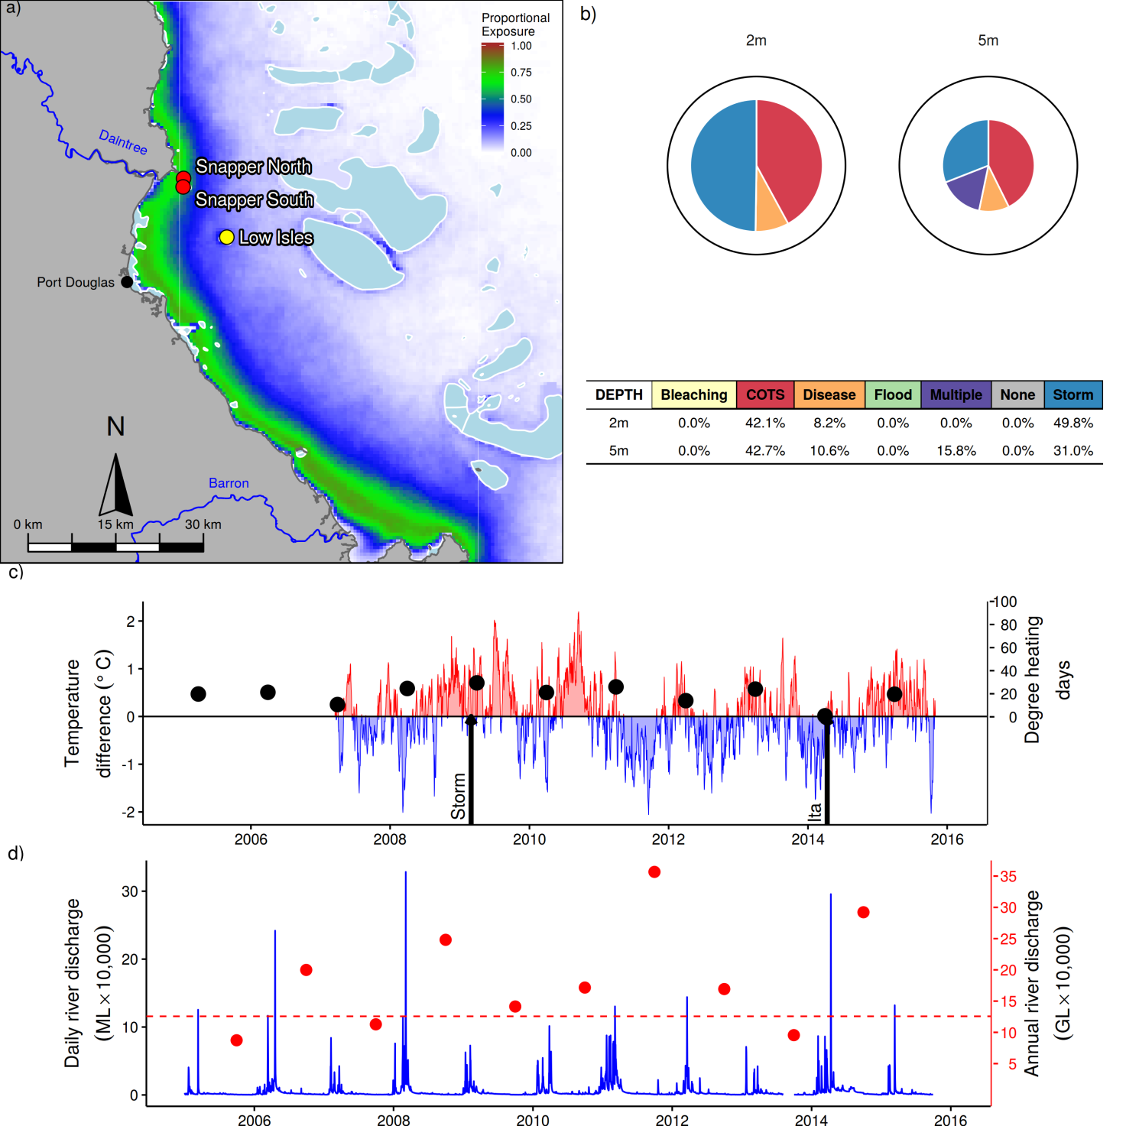
Figure 4: Barron Daintree sub-region reef locations, environmental conditions and disturbances.
a) Location of monitoring sites red symbols MMP, black symbols LTMP, mean exposure to secondary plume type waters (Álvarez-Romero et al. 2013) during the wet season: December to March, over the period 2003-2015 indicated by colour. b) break-down and level of disturbances causing loss of hard coral cover over the period 2005-2015, level of disturbance is scaled to the maximum disturbance rate of 16% reduction in hard coral per year that occurred in the Tully Herbert sub-region (outer black ring), loss due to disturbance type ‘none’ reflects a shortfall in rate of cover increase during years free from acute disturbances. c) Seasonally adjusted temperature deviation, timing of cyclones and storms indicated by black arrows, accumulated degree heating days over the summer period (1st of December - 31st March) indicated by black symbols d) Combined daily (blue) and annual (red) discharge for the Barron and Daintree rivers, red dashed line represents long-term median discharge (1970-2000).

Within this sub-region coral surveys have been conducted under the MMP since 2005 at Snapper North and Snapper South. Snapper Island is located 4km from the mouth of the Daintree River, and is regularly exposed to secondary plume-type waters (Figure 4a). Low Isles is located further offshore and rarely exposed to secondary plume-type waters (Figure 4a).
Monitoring by Sea Research prior to 2005 identified flooding of the Daintree River in 1996 and again in 2004 along with Cyclone Rona in 1999 as having substantial impacts on the coral communities at Snapper Island (Table A 2). Importantly, subsequent observations identified recovery of the coral communities following each event suggesting that these reefs were resilient to the disturbance regime during that period (Ayling & Ayling 2005, Sweatman et al. 2007) This resilience remained apparent following the commencement of monitoring under the MMP, with the general trend in the coral index improving to be categorised as “good” by 2008 (Figure 4a). Supported by continued high coral cover, rates of increase in cover meeting or exceeding model predictions and low macroalgae cover (Figure 5b,c,d).
Since 2010 the coral index score steadily declined to reach a low point in 2014 with a slight indication of improvement in 2015 (Figure 5a). Three key pressures stand out as forcing the decline in coral community condition; crown-of-thorns seastars (COTS), storms, and disease (Figure 4b). COTS have been responsible for the greatest proportion of coral cover loss over the course of the MMP and LTMP at both 2m and 5m depths. In the late 1990’s COTS caused a 52% reduction in coral cover at Low Isles (Table A 2), At Snapper Island low densities of COTS were observed during surveys in 2012. The following year an outbreak was evident with high densities of adults (288 per hectare at Snapper North, 613 per hectare at Snapper South) causing combined loss of coral cover ranging from 66% at Snapper North(5m depth) to 17% at snapper south (5m depth ); the family Acroporidae was most severely impacted (Table A 2, Figure A 1). By 2014 COTS numbers had substantially declined with no individuals recorded at Snapper North in 2014 and densities of 63 per hectare at Snapper South. In 2015 no COTS were observed.
Physical impacts to these reefs were recorded following a severe storm in 2009 and most significantly Cyclone Ita in 2014 that removed 90% and 49% of the hard coral cover from Snapper North 2m and 5m depths respectively (Figure 5, Table A 2).
Increased incidence of disease was observed in 2006 (though this resulted in little if any reduction in coral cover suggesting losses where compensated for by growth of corals) and over the 2010 to 2011 period when coral cover was reduced by between 20% and 36% at Snapper North 2m and 5m sites respectively (Figure 5, Table A 2).Combined discharge from the Barron and Daintree rivers (Figure 4d) was well above median flows in 2011, supporting the documented link between increased runoff and disease prevalence (Bruno et al. 2003, Kline et al. 2006, Kuntz et al. 2005, Voss & Richardson 2006,Kaczmarsky & Richardson 2010, Haapkylä et al. 2011, 2013, Vega Thurber et al. 2013). This was not the case in 2010 when discharge was typical for the sub-region, however since 2008 the water quality index has steadily declined (Figure A 10) and turbidity remained consistently high (Figure 5h), in addition there was a particularly warm winter in 2010 (Figure 4c) that may also have contributed to the disease levels observed in that year.
In summary the coral communities in the Barron-Daintree sub-region have shown a history of strong resilience under previous disturbance regimes. The combined effects of Cyclone Ita, and the recent COTS outbreak have clearly influenced these communities and resulted in declines in all 5 of the coral index metrics, most significantly coral cover, coral composition and the proportion of macroalgae in the algal community (Figure 5b,c,f). That occurrence of disease and increased representation of macroalgae coincide with a period of declining water quality implicate local water quality as playing a role in observed declines. At a larger scale, COTS outbreaks have been prevalent on midshelf reefs for several years the timing of this current outbreak reinforces prior observations of outbreaks following major flooding of rivers to the south and in particular the Burdekin River that had major floods in 2008 and 2009 (Table A 1, Brodie et al. 2008, Fabricius et al. 2010, Furnas et al. 2013) further linking water quality to the recent decline in this sub-region. With a return to drier conditions and correspondingly lower loads of sediments and nutrients delivered to the ocean in 2015 it is encouraging to see the slight improvement in coral community condition observed in 2015.

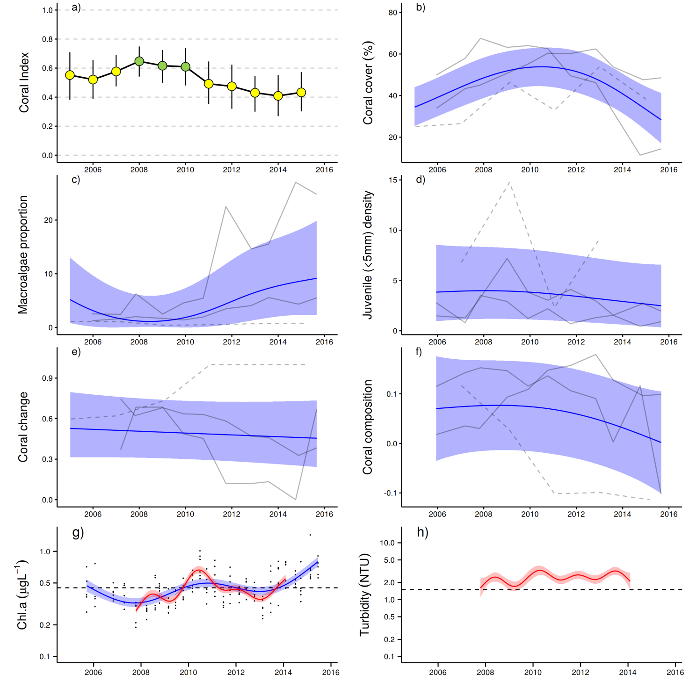
Figure 5: Coral reef community and water quality trends in the Barron Daintree sub-region.
Coral index colour coding: dark green- ‘very good’; light green-‘good’; yellow – ‘moderate; orange – ‘poor’; red – ‘very poor’. Coral index is calculated from benthic community variables plotted in b-f. Trends in benthic community variables are represented by blue lines with blue shaded areas defining 95% confidence intervals of those trends, grey lines represent observed profiles averaged over depths at individual reefs. Trends in manually sampled chlorophyll a (g) are represented by blue lines with blue shaded areas defining 95% confidence intervals of those trends, black dots represent observed data. Trends in records of chlorophyll a and turbidity (g, h) from ECO FLNTUSB instruments are represented in red, individual records are not displayed. Dashed reference lines indicate GBRMPA (2010) guideline values.

5.2 Wet Tropics Region: Johnstone Russell-Mulgrave sub-region
The catchments within this sub-region have a high proportion of upland National Park and forest. Land use in this sub-region is primarily for sugar production on the coastal plain and a significant area of the Johnstone catchment is utilised as grazing land (Brodie et al. 2003). The inshore reefs adjacent to these catchments are most directly influenced by the discharge from the Russell-Mulgrave and Johnstone rivers.
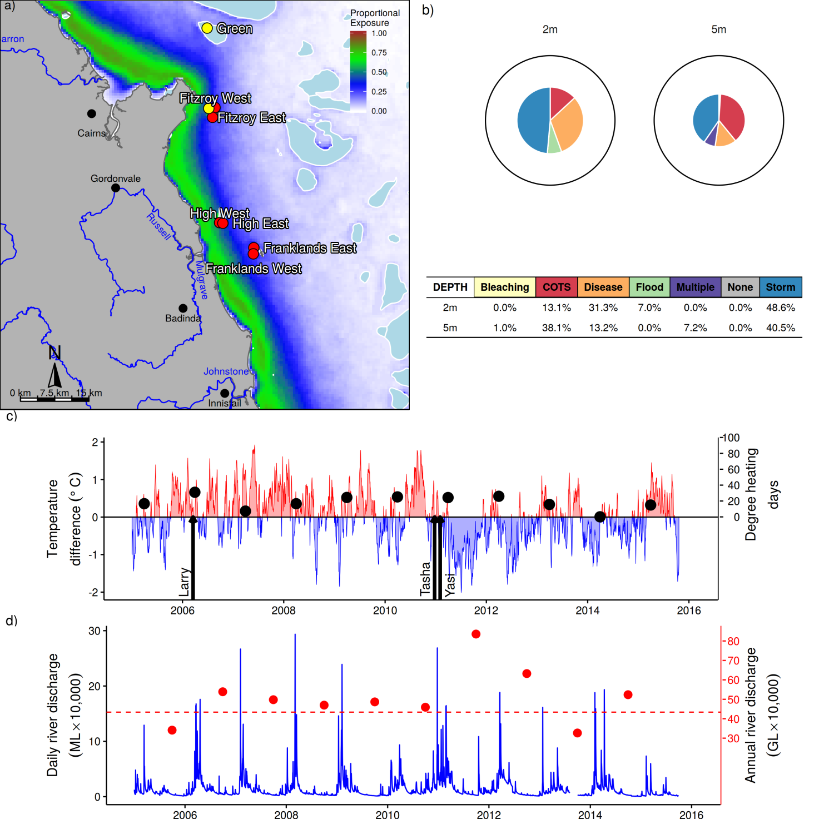
Figure 6: Johnstone Russell-Mulgrave sub-region reef locations, environmental conditions and disturbances.
a) Location of monitoring sites red symbols MMP, black symbols LTMP, mean exposure to secondary plume type waters (Álvarez-Romero et al. 2013) during the wet season: December to March, over the period 2003-2015 indicated by colour. b) break-down and level of disturbances causing loss of hard coral cover over the period 2005-2015, level of disturbance is scaled to the maximum disturbance rate of 16% reduction in hard coral per year that occurred in the Tully Herbert sub-region (outer black ring), loss due to disturbance type ‘none’ reflects a shortfall in rate of cover increase during years free from acute disturbances. c) Seasonally adjusted temperature deviation, timing of cyclones and storms indicated by black arrows, accumulated degree heating days over the summer period (1st December to 31 March) each year indicated by black symbols d) Combined daily (blue) and annual (red) discharge for the combined Johnstone, Russell, and Mulgrave rivers, red dashed line represents long-term median discharge (1970-2000).

Information from six reefs sampled under the MMP along with Fitzroy and Green, monitored under the LTMP contribute to coral index (Figure 6a). Compared to reefs in other regions these reefs experience less exposure to plume type waters – only High West is exposed to secondary plume-type waters for more than 40% of the wet season (Figure 6a, Table A 4). This lower exposure to flood plumes is reflected in the regional chlorophyll and turbidity levels that are typically below guideline values (Figure 7g,h) and the water quality index that has remained “good” to “very good” (Figure A 11).
In 2015 the coral index for this sub-region was ‘moderate’ with the trend in the index over time showing fluctuations between this current score and ‘good’ (Figure 7a). Initial improvements in the index form 2005 to 2006 reflect the recovery of reefs form previous impacts attributed to crown-of-thorns seastars and coral bleaching (Sweatman et al. 2007, Ayling & Ayling 2005).
Over the course of the MMP the impacts of cyclones have had the most significant direct effect on the state of coral communities in this sub-region (Figure 6b). In 2006 Cyclone Larry caused a 63% (2m depth) and 50% (5m depth) loss of coral cover at Franklands East (Table A 2, Figure A 2). In the years following, strong positive trends in coral cover, the increase in representation of sensitive species in the coral community and moderate rates of coral cover increase saw the coral index rapidly return to ‘good’ in 2009 and 2010 (Figure 7a,b,d,e). In 2011 two consecutive cyclones, Tasha and Yasi caused significant widespread physical damage to reefs in the southern part of the sub-region as well as freshwater bleaching at High West associated with flooding of the local rivers (Figure 6d, Figure A 2, Table A 2) the overall result being a sharp decline in the coral index (Figure 7a).
The effects of cyclones were further compounded by the increased prevalence of disease in 2011. The most affected reefs where at Fitzroy Island where mortality, predominantly of Acropora colonies, resulted in a loss of 60% (2m) and 42% (5m) of the coral cover at Fitzroy East (Figure A 2, Table A 2). The drivers of the marked increase in disease observed at the Fitzroy Island sites are not immediately obvious. Although increased incidence of disease did coincide with the record annual discharge of 2011, the previous year saw similar levels of disease, albeit far less mortality, despite discharge being near median level (Figure 6d). The onset of disease in this region did correspond to slight increases in both turbidity and chlorophyll concentrations (Figure 7g, h).
Two cycles of crown-of-thorns seastar (COTS) outbreaks have influenced coral communities in this region since monitoring began in 1992, the first in 1996-2000 caused substantial loss of cover at Green (where 55% of coral was lost in the year January 1996 to January 1997), Fitzroy Island and The Frankland Group (Table A 2). In 2012 and 2013 elevated numbers of COTS were again observed in at Fitzroy and targeted for removal by Australian Government funded crown-of-thorns seastar management program. In 2013 COTS had caused a 44% of the hard coral cover compared to that observed in 2011 (Table A 2). At both Fitzroy and Green reductions in hard coral cover and in particular the family Acroporidae (Figure A 2) through to 2015 are primarily the result of COTS feeding. In contrast although low numbers of COTS were observed at the Frankland Group and High between 2012 and 2015 there was little evidence for an impact to coral cover at these reefs.
The water quality index for the sub-region, though showing slight declines has remained ‘good’ over the course of the MMP (Figure A 11). However, there has been a consistent increase in the detected levels of NO_{x} to near GBRMPA guideline levels in recent years, a pattern also seen to the north in the Barron-Daintree sub-region (Figure A 11). Nitrate (the dominant component of NO_{x}) is soluble and bonds to soil particles, as such it accumulates in groundwater supplies until soil saturation is reached at which point it is remobilised and transported via runoff (Rasiah & Armour 2001). This accumulation and eventual transport of nitrate may explain the observed increases in NO_{x}. It is possible the peak in disease was related to the changing nitrogen conditions, a link previously demonstrated (Kuta & Richardson 2002, Bruno et al. 2003, Vega Thurber et al. 2013).

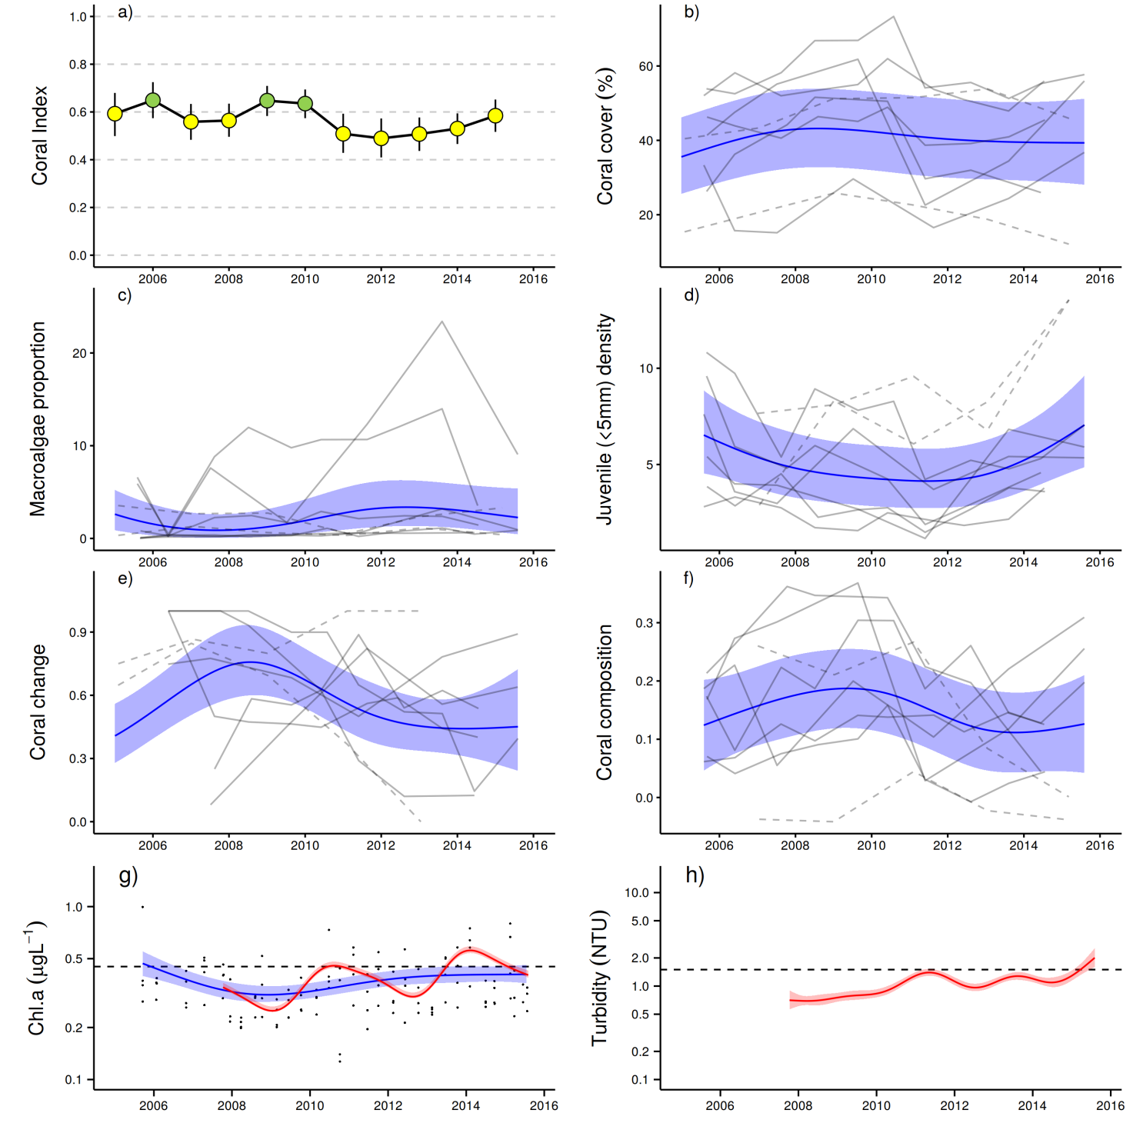
Figure 7: Coral reef community and water quality trends in the Johnstone Russell-Mulgrave sub-region.
Coral index colour coding: dark green- ‘very good’; light green-‘good’; yellow – ‘moderate; orange – ‘poor’; red – ‘very poor’. Coral index is calculated from benthic community variables plotted in b-f. Trends in benthic community variables are represented by blue lines with blue shaded areas defining 95% confidence intervals of those trends, grey lines represent observed profiles averaged over depths at individual reefs. Trends in manually sampled chlorophyll a (g) are represented by blue lines with blue shaded areas defining 95% confidence intervals of those trends, black dots represent observed data. Trends in records of chlorophyll a and turbidity (g, h) from ECO FLNTUSB instruments are represented in red, individual records are not displayed. Dashed reference lines indicate GBRMPA (2010) guideline values.

Given the repeated disturbances and suppression of recovery evidenced by losses attributed to disease, the trajectory of the coral index in the years since 2011 has not shown the same rapid improvement observed following previous disturbances (Figure 7a). This slowed recovery is evident in the negative trends observed for coral composition and most significantly change in coral cover (Figure 7e,f). Despite this, the coral index has steadily improved in the last few years as a result of increasing densities of juvenile corals (Figure 7d), recent declines in the representation of macroalgae in the algal community (Figure 7c) and increased representation of sensitive coral species especially at High East and the Frankland East (Figure 7f, Figure A 2).
That the reefs in poorest condition in this sub region are those in the best water quality (Table A 4) is initially counterintuitive, this result does not, however, preclude the role of nutrient loading as a contributing factor. The reefs at Green Island, Fitzroy Island and the Frankland Group all have a history of COTS outbreaks as do the more offshore reefs throughout this region (De’ ath et al. 2011, Sweatman et al. 2007). Links between water quality and the outbreaks of COTS suggest the broader impact of nutrient loading to coral reefs in this region (Brodie et al. 2008, Fabricius et al. 2010, Furnas et al. 2013). In addition the coral communities at these reefs are dominated by Acropora spp. a group most impacted by disease. The loss of these corals to disease results in declines in both the cover change and community composition indicators.

5.3 Wet Tropics Region: Herbert Tully sub-region
The Tully catchment has a high proportion of forest and National Park areas while the predominant land use in the Herbert catchment is grazing. Around 10% of the sub-regional area is used for sugarcane cropping along the coastal flood plain (Brodie et al. 2003, GBRMPA 2012). Combined, these two catchments form the largest drainage area of the three sub-regions in the Wet Tropics.

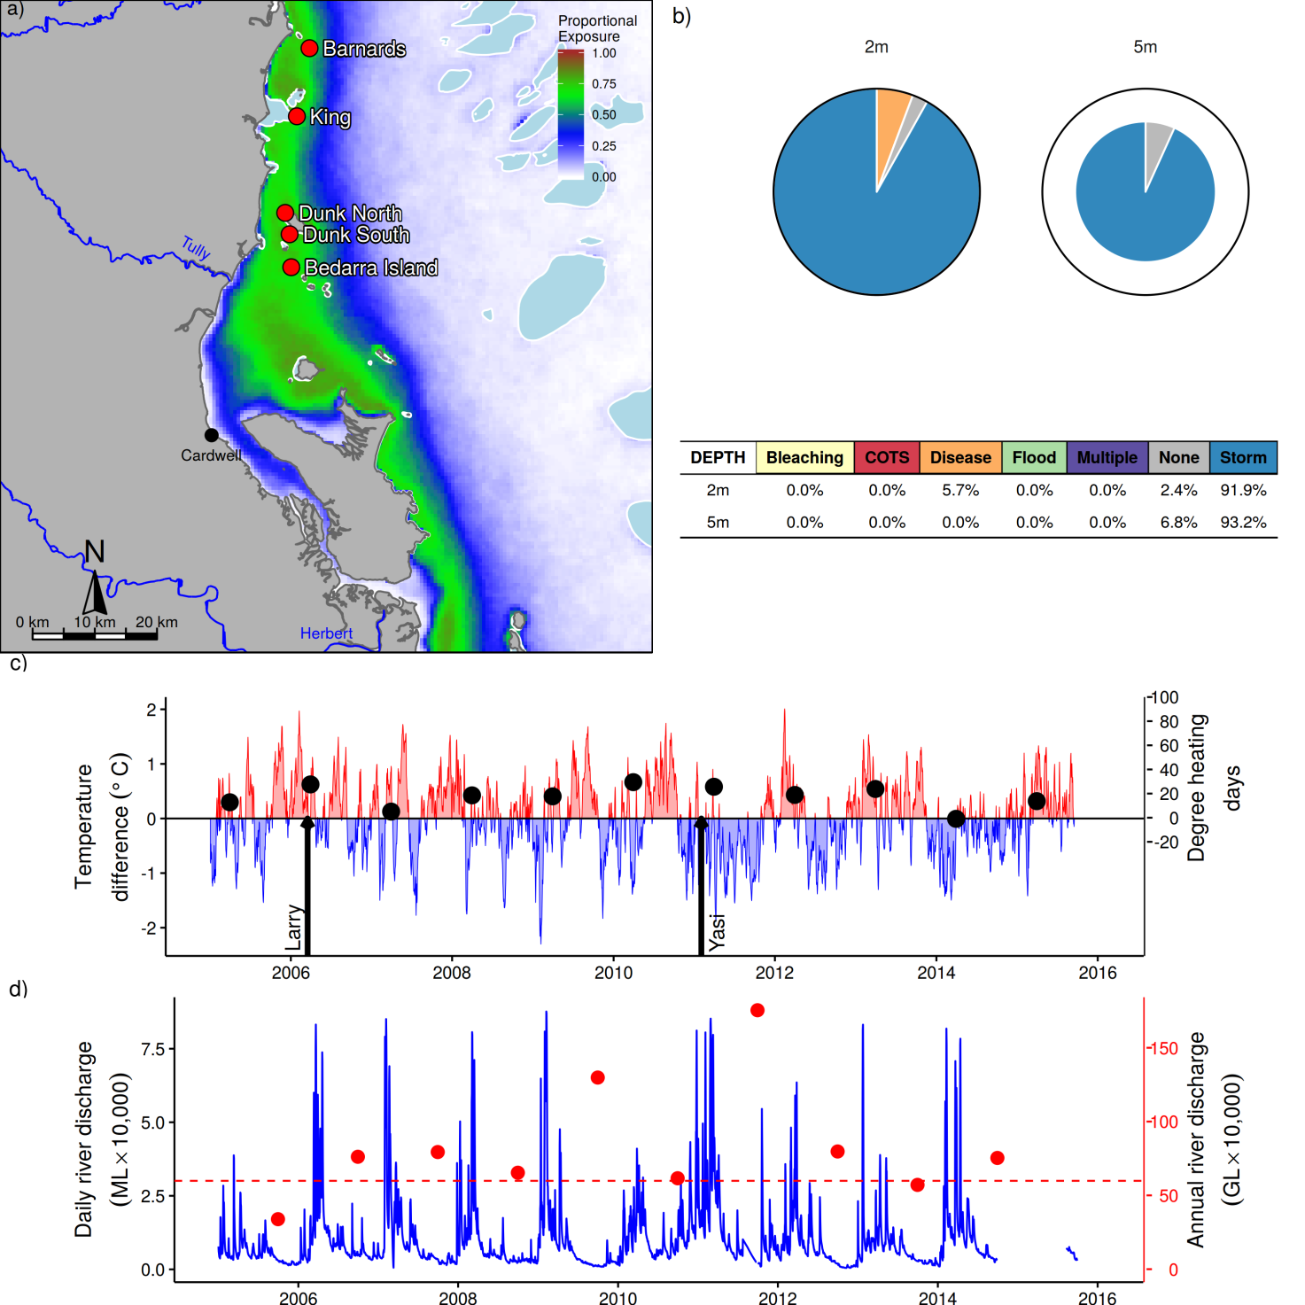
Figure 8: Herbert Tully sub-region reef locations, environmental conditions and disturbances.
a) Location of monitoring sites red symbols MMP, black symbols LTMP, mean exposure to secondary plume type waters (Álvarez-Romero et al. 2013) during the wet season: December to March, over the period 2003-2015 indicated by colour. b) break-down and level of disturbances causing loss of hard coral cover over the period 2005-2015, level of disturbance is scaled to the maximum disturbance rate of 16% reduction in hard coral per year that occurred in the Tully Herbert sub-region (outer black ring), loss due to disturbance type ‘none’ reflects a shortfall in rate of cover increase during years free from acute disturbances. c) Seasonally adjusted temperature deviation, timing of cyclones and storms indicated by black arrows, accumulated degree heating days over the summer period (1st December to 31 March) each year indicated by black symbols d) Combined daily (blue) and annual (red) discharge for the Herbert and Tully rivers, red dashed line represents long-term median discharge (1970-2000).

The sampling sites in this sub-region are primarily influenced by discharge from the Tully and Herbert rivers. As of 2015, monitoring of King was ceased in favour of a new location at Bedarra selected to coincide more closely with a revised sampling design for water quality monitoring in the sub-region. All of these sites experience substantial exposure to secondary plume-type waters during the wet season (Figure 8a) though a gradient of exposure from south to north is apparent in magnitude of this exposure to plume type waters and more specifically chlorophyll a and turbidity levels (Table A 4).
The coral index has improved from ‘poor’ to ‘moderate’ in 2015. Overall the trend in the health index identifies two distinct declines in the condition of the coral communities in the sub-region followed by a gradual improvement in subsequent years (Figure 9a). The declines seen in the health index have, on both occasions, been the result of impacts on the coral communities resulting from cyclones: Cyclone Larry in 2006 and Cyclone Yasi in 2011 (Figure 8c), which combined, account for 89.7% and 98.6% of the hard coral cover lost since 2005 at 2m and 5m depths respectively (Figure 8b) and incur the highest level of disturbance to coral communities of any regions monitored by the MMP.
The slow rate of recovery following disturbances (Figure 9e) and the loss of hard coral cover due to disease, indicates a strong likelihood that the high turbidity and chlorophyll concentrations (Figure 9g,h) have suppressed the resilience of coral communities in this sub-region. The trend in instrument measured turbidity (NTU) consistently exceeds guideline thresholds, and whilst concentrations have fluctuated, with peaks well above guideline levels, there is an indication of an increase in the background levels of chlorophyll a (Figure 9g, h). As seen in the other two sub-regions of the Wet Tropics there has also been a consistent increase in the concentration of NO_{x} and dissolved organic carbon (DOC) in the Herbert Tully sub-region (Figure A 12d,j & Lønborg et al. 2015). Further evidence of the effects of nutrients as a pressure for coral communities in this sub-region is the persistently high representation of macroalgae on most reefs, and in particular at the 2m depths (Figure 9c, Figure A 3).
Marked increases in the density of juvenile hard corals have played a role in the improvements of the coral index following cyclones in the sub-region (Figure 9d). In many cases this is due to large numbers of Turbinaria spp. (family Dendrophylliidae, Figure A 3). This genus is known for being tolerant of poor water quality (Sofonia & Anthony 2008) and as such this marked increase in juveniles of this genus does not necessarily imply a response to improved environmental conditions. In contrast, increases in both the density of juveniles and the cover of adult corals of the family Acroporidae (Figure A 3), a group sensitive to poor water quality, contribute to the improvement of the community composition indicator (Figure 9f) as well as the increase in coral cover (Figure 9b).
On balance, given the severe impacts resulting from tropical cyclones, it is difficult to assess the chronic pressures potentially associated with poor water quality. That said, the persistence of high proportions of macroalgae on all reefs, with the exception of Barnards where chlorophyll and turbidity levels are lowest (Figure A 3, Table A 4), does imply a nutrient related limitation to the resilience of these reefs. The proportion of macroalgae on reefs within the nearshore GBR shows a clear relationship with chlorophyll levels (see section 6.2.2) a proxy for nutrient availability.

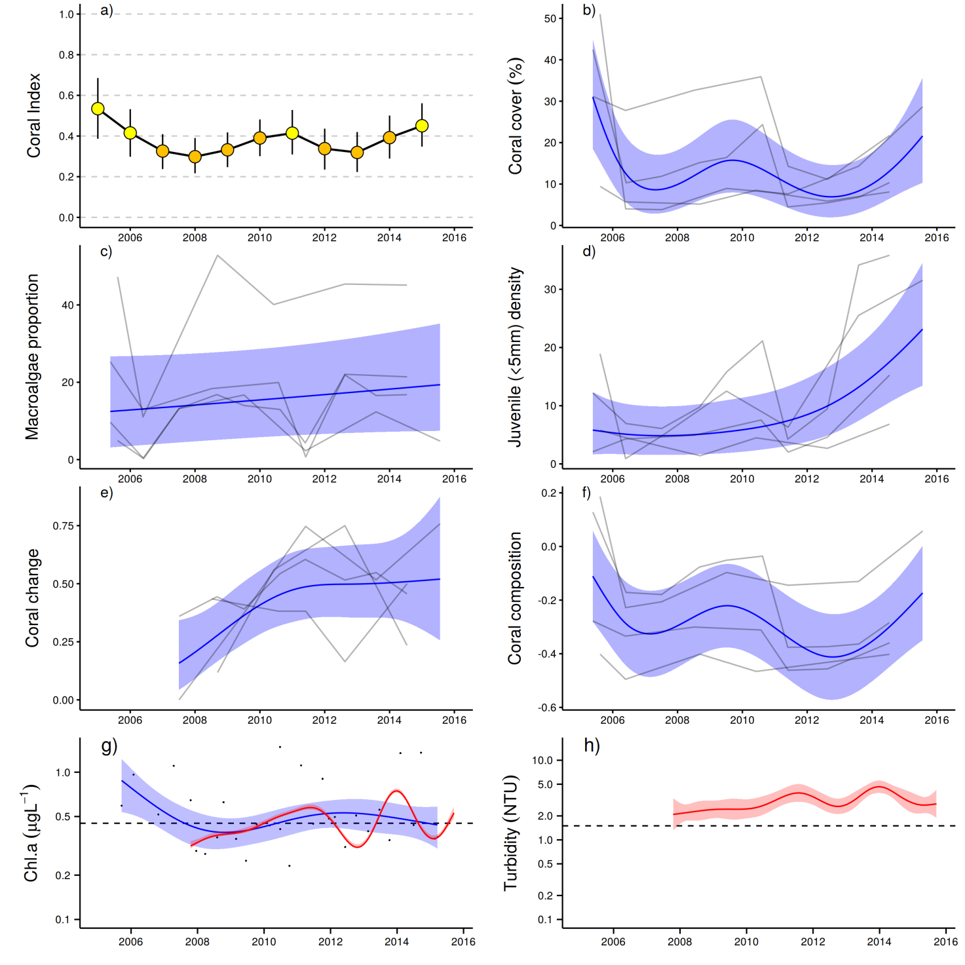
Figure 9: Coral reef community and water quality trends in the Herbert Tully sub-region.
Coral index colour coding: dark green- ‘very good’; light green-‘good’; yellow – ‘moderate; orange – ‘poor’; red – ‘very poor’. Coral index is calculated from benthic community variables plotted in b-f. Trends in benthic community variables are represented by blue lines with blue shaded areas defining 95% confidence intervals of those trends, grey lines represent observed profiles averaged over depths at individual reefs. Trends in manually sampled chlorophyll a (g) are represented by blue lines with blue shaded areas defining 95% confidence intervals of those trends, black dots represent observed data. Trends in records of chlorophyll a and turbidity (g, h) from ECO FLNTUSB instruments are represented in red, individual records are not displayed. Dashed reference lines indicate GBRMPA (2010) guideline values.

5.4 Burdekin Region
The Burdekin Region is one of the two large dry tropical catchment regions adjacent to the Reef, with cattle grazing as the primary land use on over 95% of the catchment area (Brodie et al. 2003, GBRMPA 2012). There is also extensive irrigated planting of sugarcane on the floodplains of the Burdekin and Haughton rivers. Fluctuations in climate and cattle numbers greatly affect the state and nature of vegetation cover, and, therefore, the susceptibility of soils to erosion and off-site transport of suspended sediments and associated nutrients.
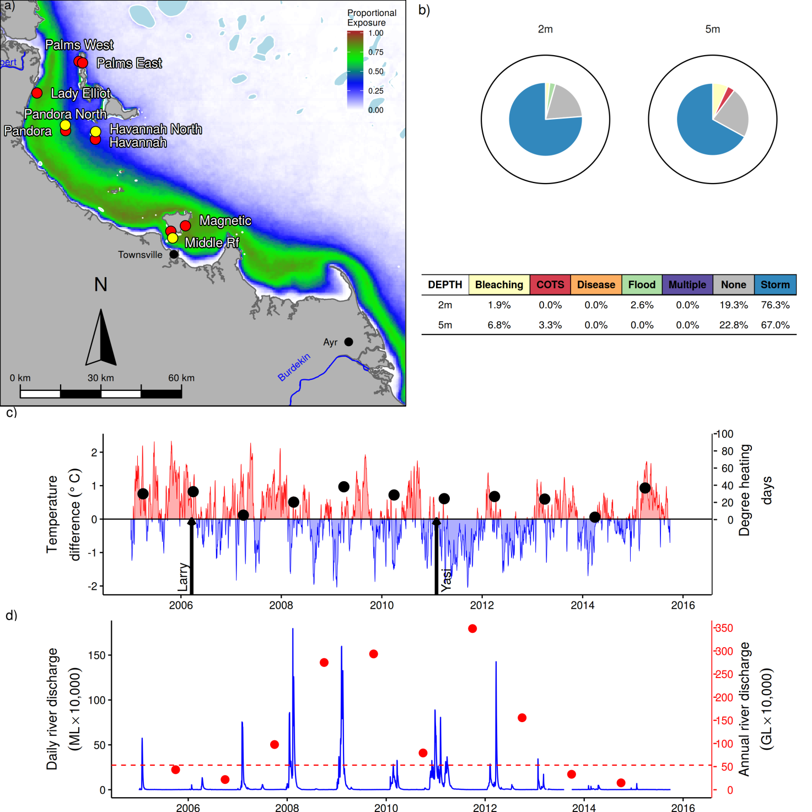
Figure 10: Burdekin region reef locations, environmental conditions and disturbances
. a) Location of monitoring sites red symbols MMP, black symbols LTMP, mean exposure to secondary plume type waters (Álvarez-Romero et al. 2013) during the wet season: December to March, over the period 2003-2015 indicated by colour. b) break-down and level of disturbances causing loss of hard coral cover over the period 2005-2015, level of disturbance is scaled to the maximum disturbance rate of 16% reduction in hard coral per year that occurred in the Tully Herbert sub-region (outer black ring), loss due to disturbance type ‘none’ reflects a shortfall in rate of cover increase during years free from acute disturbances. c) Seasonally adjusted temperature deviation, timing of cyclones and storms indicated by black arrows, accumulated degree heating days over the summer period (1st December to 31 March) each year indicated by black symbols d) Combined daily (blue) and annual (red) discharge for the Burdekin River, red dashed line represents long-term median discharge (1970-2000)

Ten reefs are sampled for estimation of the coral index in this region, with three water quality sampling locations co-located at Magnetic, Pandora Reef, and Palms West (Figure 10a). The inner reefs of Middle, Magnetic, and Lady Elliot are, on average, exposed to secondary plume-type waters for more than 75% of the wet season (Figure 10a). Exposure to secondary plume-type waters then declines through Pandora, Havannah and Palms West to Palms East that is exposed for an average of 13% of the wet season (Figure 10a, Table A 4). At over 100km from the mouth of the Burdekin River reefs at Magnetic Island are the closest well developed coral communities in the inshore area to this major river.
The composition of coral communities vary in response to environmental gradients. Within the Burdekin region there is a shift from communities dominated by the families Acroporidae, Pocilloporidae and Poritidae (genus Porites) in clearer waters through to communities dominated by families such as Agariciidae, Oculinidae, Pectiniidae and Poritidae (Genus Goniopora) in more turbid and sheltered settings (Figure A 4). In addition to selecting for different community types, the environmental setting of these reefs has also resulted in differential exposure to disturbances. The orientation of the reef differentially exposes corals to physical damage by cyclone-driven waves (e.g. Palms East vs Palms West), and those locations in the north of the region have experienced more cyclonic events than those in the south (Table A 2). Differences in community composition also result in differential impact of bleaching events as susceptibility to thermal stress varies among species (Marshall & Baird 2000). The coral communities in clear waters or shallow depths in more turbid waters tend to be dominated by Acroporidae and have been most damaged by cyclones and bleaching events, and continue to share very low coral cover (Figure A 4). The exception is Havannah where the Acroporidae at 2m was sheltered from Cyclone Yasi and cover has shown a marked increase. Conversely, the relatively sheltered communities at Middle Reef, Lady Elliot Reef (5m), and Pandora North, maintain a moderate coral cover as they have been less exposed to recent cyclones and have a high representation of slow growing species relatively resistant to thermal stress, and high turbidity.
Since monitoring began cyclones account for >50% of declines in coral cover observed within the region (Figure 10b). East-facing locations, such as Palms East and Lady Elliot, are particularly exposed to storm driven seas, and show the impacts of Cyclone Larry (2006) and Cyclone Yasi (2011) (Figure A 4, Table A 2). A period of excessive monsoonal floodwaters (2007 – 2012) has been the only other identifiable pressure over the last ten years. This period saw Burdekin River discharge at well above median flows following a period of several years of drought (Figure 10d, Table A 1). Although not categorised as a disease outbreak for the purpose of disturbance estimation (Figure 10b), elevated levels of disease where observed from 2007 to 2009 (Figure A 7) consistent with the selection against sensitive species as a result of increased loads of sediment and nutrients being delivered from the catchment (Joo et al. 2012, Turner et al. 2012, 2013). This loss of Acropora spp. cover, in particular, contributed to the slight decline in the composition indicator (Figure 11f), the coral change indicator and also the coral cover indicator over the period of high river discharge (Figure 11b,e,f)..
There has been no outbreak of COTS at these locations since the MMP began in 2005. Temperature records since 2005 reveal no extreme temperature events that would be expected to cause extensive coral bleaching (Figure 10c). Prior to the temperature records provided here, thermal bleaching in 1998 was responsible for losses of 49% and 11% of the hard coral cover at Havannah North and Pandora North respectively (Table A 2) with impacts wide spread across the reefs in this region (Berkelmans et al. 2004) and recovery slow (Done et al. 2007, Sweatman et al. 2007, Cheal et al. 2013)
The coral index declined from a moderate condition in 2010 to poor as result of the impact of Cyclone Yasi and associated extreme flooding (Figure 10c,d) then continued to decline through to 2013 (Figure 11a). Both the high representation of macroalgae and continually low densities of juvenile corals (Figure 11,c,d) along with the loss of species sensitive to water quality at some reefs (Figure 11f, below 0.5) suggest general suppression of coral community resilience through to 2013. After the impact of Cyclone Yasi the coral index could have dropped lower but was offset by the physical removal of macroalgae. Macroalgae was, however, quick to re-establish on the newly available space. Coinciding with lower river flows in 2014 and 2015 (Figure 10d) was an increase in coral cover, coral growth, densities of juvenile corals along with an increase in the proportion of water quality sensitive species in the coral communities and corresponding reduction in the cover of macroalgae (Figure 11b,c,d,e,f). The rise in juvenile density was driven predominantly by high numbers of Turbinaria spp. at Lady Elliot (Figure A 4), a genus that favours turbid high nutrient environments. There were also increases in the density of Acroporidae juveniles most reefs in Halifax bay compared to that observed prior to 2011 (Figure A 4) signalling an important return of this sensitive species to the communities.

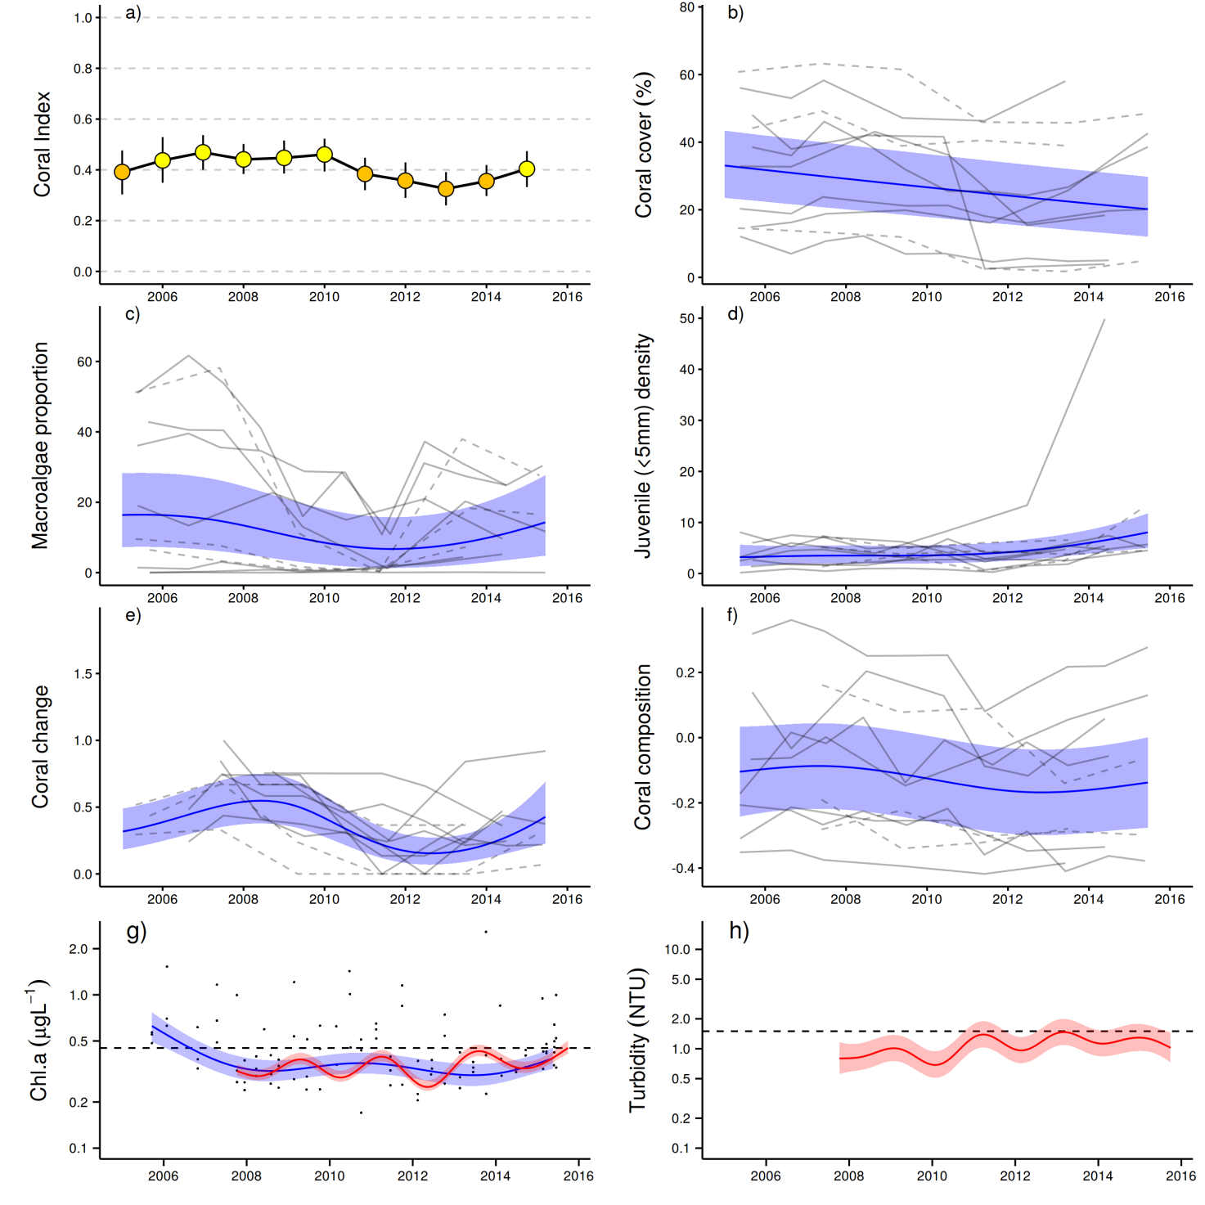
Figure 11: Coral reef community and water quality trends in the Burdekin region.
Coral index colour coding: dark green- ‘very good’; light green-‘good’; yellow – ‘moderate; orange – ‘poor’; red – ‘very poor’. Coral index is calculated from benthic community variables plotted in b-f. Trends in benthic community variables are represented by blue lines with blue shaded areas defining 95% confidence intervals of those trends, grey lines represent observed profiles averaged over depths at individual reefs. Trends in manually sampled chlorophyll a (g) are represented by blue lines with blue shaded areas defining 95% confidence intervals of those trends, black dots represent observed data. Trends in records of chlorophyll a and turbidity (g, h) from ECO FLNTUSB instruments are represented in red, individual records are not displayed. Dashed reference lines indicate GBRMPA (2010) guideline values.

Macroalgae has maintained a dominant presence at most of the monitored locations (Figure 11c, Figure A 4), indicating the availability of nutrients, space, and appropriate light levels. Exceptions are Palms East and West where nutrient levels are lowest and Middle Reef where there is limited space suitable for macroalgal colonisation due to high levels of silt deposited to the substrate, but also high turbidity limiting the light available to the algae (Table A 4). Macroalgae cover was regionally high following the first flood of the Burdekin River in 2007, and has generally declined since (Figure 10c). Low cover of macroalgae in 2011 coincided with Cyclone Yasi and was likely the result of physical removal. Recent regional declines in the cover of macroalgae following the decrease in Burdekin River flow will partially release their downward pressure on coral settlement and survival (Birrell et al. 2008 a, b).
In contrast to the coral index the water quality index for the Burdekin Region has declined slightly from 2013 to 2015 though remains categorised as ‘good’ (Figure A 13). Variables that did rise or were high over the 2011-2013 period that coincided with a period of low rates of cover increase on most reefs (Figure 11e), were dissolved organic carbon (DOC) and oxides of nitrogen (NOx) (Figure A 13j,d) and turbidity (NTU) measured by continuous data loggers (Figure 11h). The prolonged increase in these variables suggests that there is a long residence time producing a distinctive lag in the decline of these metrics (Brodie et al. 2012a).
In summary, recent gains in the coral index indicate that recovery is underway, and, if the change in weather patterns delivers another ‘drier’ wet season, improvement in water quality and ongoing recovery should be expected. A caution, however, is that palaeo-ecological evidence suggests that present-day coral assemblages on reefs in Halifax Bay are the result of a shifted baseline from dominant arborescent Acropora communities to a remnant community of sparse Acropora and/or dominant non-Acropora species (Roff et al. 2013). An implied cause of this change was the sustained decline in water quality resulting from the expansion of agriculture in the catchment. Exposed to increased chronic stress the once ubiquitous suite of arborescent Acropora species were no longer able to recover from recurring impacts of cyclones and floodwaters, suffering a systematic collapse between 1920 and 1955. The dynamics of the communities observed in this study broadly corroborate the interpretations of Roff et al. (2013). That our observation of increased level of disease in 2007-2009 (Figure A 7), decline in the rate of coral cover increase, and a slight shifts in coral community composition toward those more typical of turbid and nutrient rich habitats, all coincided with a period of high discharge of the Burdekin River (Figure 10d, Table A 1) suggest the ongoing selection against species insensitive to the elevated levels of pollutants delivered in flood plumes. Compounding the periodic impacts of poor water quality is that densities of juvenile corals are regionally low (Figure 11d). Hydrodynamic modelling (Luick et al. 2007, Connie 2.0) and differences in population genetics of corals (Mackenzie et al. 2004) indicates limited connectivity between Halifax Bay and reefs further offshore. This isolation, coupled with the widespread loss of cover in 1998 and 2002 as a result of thermal bleaching (Berkelmans et al. 2004, Sweatman et al. 2007, Table A 2) may explain the low densities of juvenile colonies observed (Done et al. 2007, Sweatman et al. 2007). In late 2010, we recorded a strong settlement pulse of Acropora to settlement tiles, potentially indicating that atypical currents provided greater connectivity to more distant brood-stock in that year (see case study in Thompson et al. 2013). However, their survival and progression into juvenile size classes was not strongly apparent (Figure 11). Recently slight increases in the density of Acroporidae juveniles at Palms East, Lady Elliot (2m), Pandora (5m), and Havannah North (Figure A 4) are an encouraging sign that community recovery is underway.

5.5 Mackay Whitsunday Region
The Proserpine, O’Connell, Pioneer and Plane catchments that enter the sea to the south are the most direct sources of runoff. The region is also potentially influenced by runoff from the Burdekin and Fitzroy rivers during extreme events or through longer-term transport and mixing. Land in this region is dominated by agriculture broadly divided into grazing in the upper catchments and sugarcane cultivation on the coastal plains (Brodie et al. 2003, GBRMPA 2012). In addition, there are expanding urban areas along the coast.
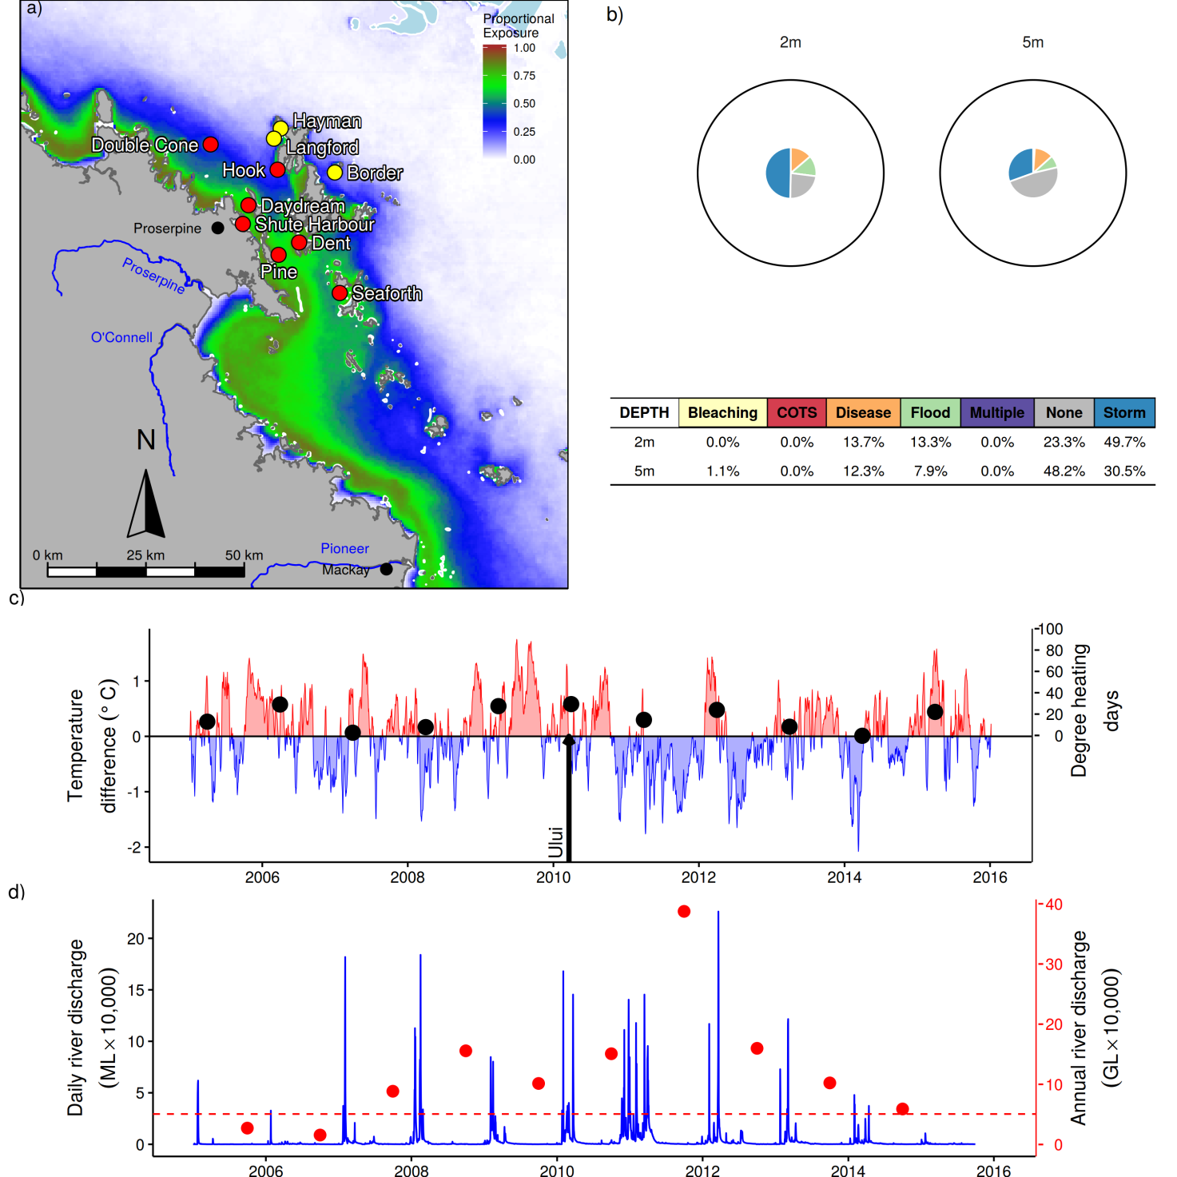
Figure 12: Whitsunday Mackay Region reef locations, environmental conditions and disturbances
. a) Location of monitoring sites red symbols MMP, black symbols LTMP, mean exposure to secondary plume type waters (Álvarez-Romero et al. 2013) during the wet season: December to March, over the period 2003-2015 indicated by colour. b) break-down and level of disturbances causing loss of hard coral cover over the period 2005-2015, level of disturbance is scaled to the maximum disturbance rate of 16% reduction in hard coral per year that occurred in the Tully Herbert sub-region (outer black ring), loss due to disturbance type ‘none’ reflects a shortfall in rate of cover increase during years free from acute disturbances. c) Seasonally adjusted temperature deviation, timing of cyclones and storms indicated by black arrows, accumulated degree heating days over the summer (1st December to 31 March) each year indicated by black symbols, d) Combined daily (blue) and annual (red) discharge for the O’Connell and Pioneer rivers, red dashed line represents long-term median discharge (1970-2000).

The coral communities in this region (Figure 12a) have had the lowest exposure to disturbances of any of the regions reported (Figure 12b). Temperature records since 2005 show no extreme temperature events that would have led to coral bleaching (Figure 12c) though aerial surveys indicated extensive bleaching in the Whitsunday Islands in both 1998 and 2002 (Berkelmans et al. 2004, Table A 2). Observations from Dent and Daydream suggest an approximate 40% reduction in coral cover in shallow waters during 1998, while observations from AIMS LTMP monitoring sites further off shore and at depths of 6-8m record only marginal reductions (Sweatman et al. 2007).
COTS outbreaks have not severely influenced any of the monitoring sites, though COTS have been observed in low numbers around Langford and Bird and also Hayman (pers. obs.) in the mid 1990’s with feeding scars also observed at LTMP sites in 2015.
The most severe acute disturbance to coral communities since monitoring began in 1992 was caused by Cyclones Ului in 2010. Loss of cover during the cyclone was highly variable ranging 53 % of coral cover lost at Daydream (5m), where stands of the fragile branching Acropora where patchily damaged though to no or negligible impacts at reefs sheltered from the storm (Figure 12b, Figure A 5).
Over the period 2007 to 2013, annual discharge from the O’Connell and Pioneer rivers was above median levels (Figure 12d, Table A 1). The 2011 flood was the third largest on record for the O’Connell River. The onset of this period of high discharge carrying elevated loads of nutrients and sediments (Turner et al. 2012, 2013, Wallace et al. 2014, 2015) was accompanied by elevated incidence of coral disease (Figure A 7). The loss of coral attributed to floods (Figure 12b) was categorised due to observed high loads of sediments on corals during surveys in 2009. The source of these sediments is not clear as the local rivers did not experience extreme flooding over the preceding summer (Figure 12d). Very high loads of sediments were introduced to the north by the Burdekin River in 2008 and 2009 and to the south by the Fitzroy River in 2008 (Joo et al. 2012) potentially offering an explanation for the origin of these sediments. The coral index for the Mackay Whitsunday region maintains a relatively stable profile, with a general assessment of ‘moderate’ (Figure 13a). The generally high cover of corals and correspondingly low representation of macroalgae in the algal communities across the region serve as a base for the continued ‘moderate’ classification (Figure 13b,c). The index did, however, decline to a low point in 2012 and has since recovered to 2008 levels in 2015. Declines in the index were influenced by; Cyclone Ului in 2010 that caused a substantial loss of coral cover at Daydream in particular (Figure A 5), declines in the density of juvenile corals (Figure 13d) and a loss of sensitive coral species (Acroporidae) (Figure A 5) both of which occurred during the period of high discharge from local rivers (Table A 1. The upturn to 2015 largely reflects the return of these indicators to levels observed at the beginning of the program.
Despite being situated in an area frequently exposed to tropical cyclones (Figure A 8) physical damage from storms is limited (Figure 12b) as the fringing reefs are reasonably sheltered by the surrounding continental islands and mainland hills. High coral cover on these reefs appears to be the result of both the low incidence of recent disturbance events (Figure 12b) and the predominance of species that tolerate the high turbidity and nutrient levels in this region (Figure A 5, Figure 13g,h). In the sheltered locations of most of the coral sites high turbidity, represents both rapid light attrition and high rates of sedimentation resulting in selective pressures that have clearly influenced the composition of both adult and juvenile coral communities (Thompson et al. 2012). Marked differences in composition of coral communities between 2m and 5m indicates a steep gradient in environmental conditions; there is a clear predominance of corals tolerant to low light and high rates of sedimentation at 5m (e.g. families Oculinidae, Pectinidae, Agariciidae, genus Goniopora) compared to the 2 m depth where Acroporidae and Porites are most represented (Figure A 5).
The cover of macroalgae has remained stable and low throughout the region. Only Pine and Seaforth maintain significant macroalgal cover (Figure A 5). Of all the reefs monitored Pine has the highest exposure to secondary plume type waters, chlorophyll a concentration and turbidity (Figure 12a, Table A 4, Figure 13g,h). Seaforth also has high concentrations of chlorophyll a though conditions are not worse than experienced at Shute harbour, Dent or Daydream (Table A 4) and so it is not certain what has inhibited macroalgal cover at these reefs. One possible explanation is a difference in grazing pressure. Herbivory has been demonstrated as critically important for the maintenance of reefs in a coral-dominated state (Hughes et al. 2007), and postulated to offer resilience to conditions that may otherwise support a shift to algal dominance (Cheal et al. 2013). For example, at Daydream Is, we consistently see higher numbers of the grazing urchin Diadema sp. than at Pine Is.
Overall, the influence of prevailing environmental conditions such as high turbidity, nutrient availability and sedimentation have clearly selected for coral species tolerant of those conditions. Although recovery from the relatively minor disturbance attributed to Cyclone Ului is occurring, the generally slow rate of coral cover increase (coral change indicator consistently below 0.5, Figure 13e) questions the resilience these communities would show to a more severe and widespread disturbance if water quality remains at recently observed levels.

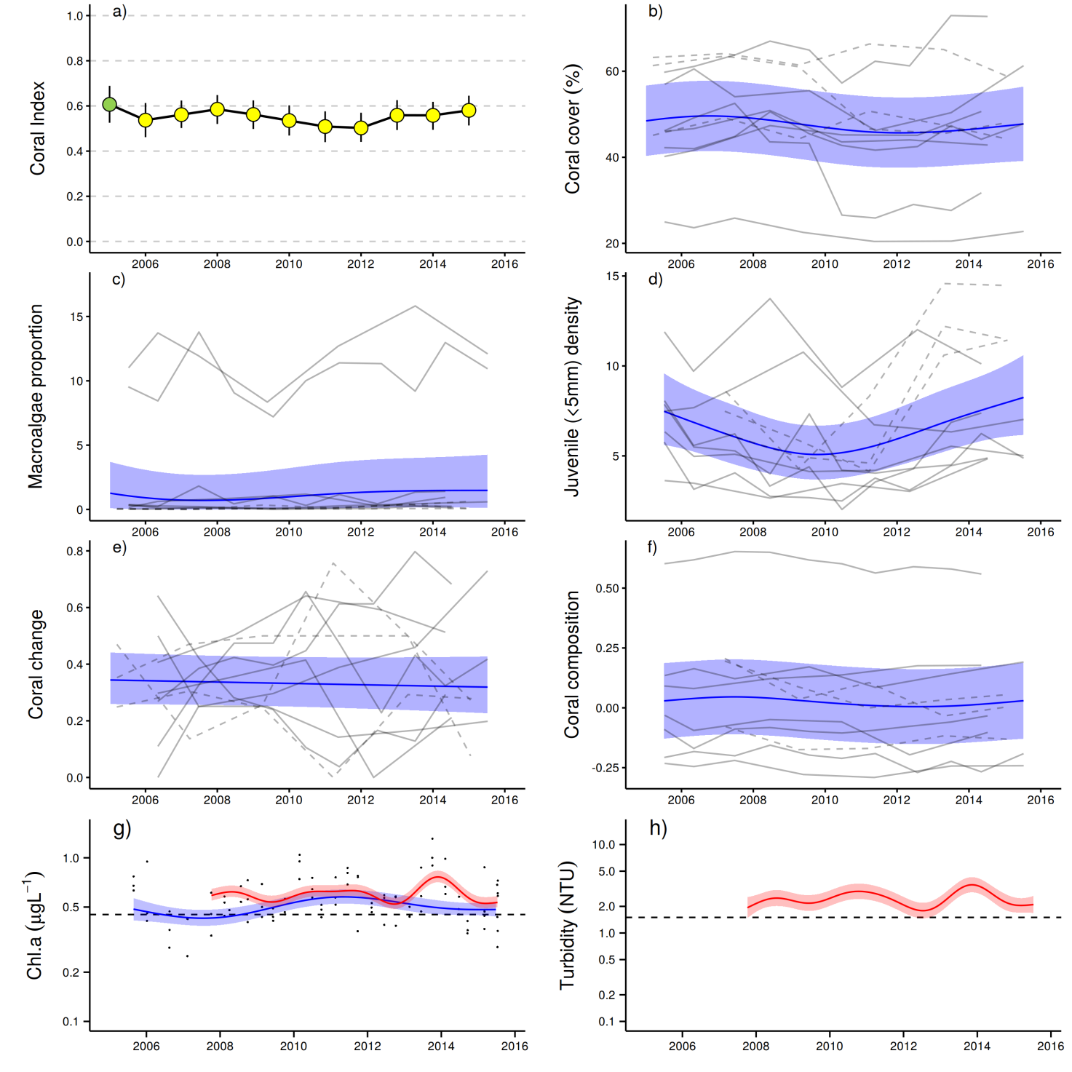

Figure 13: Coral reef community and water quality trends in the Mackay Whitsunday region.
Coral index colour coding: dark green- ‘very good’; light green-‘good’; yellow – ‘moderate; orange – ‘poor’; red – ‘very poor’. Coral index is calculated from benthic community variables plotted in b-f. Trends in benthic community variables are represented by blue lines with blue shaded areas defining 95% confidence intervals of those trends, grey lines represent observed profiles averaged over depths at individual reefs. Trends in manually sampled chlorophyll a (g) are represented by blue lines with blue shaded areas defining 95% confidence intervals of those trends, black dots represent observed data. Trends in records of chlorophyll a and turbidity (g, h) from ECO FLNTUSB instruments are represented in red, individual records are not displayed. Dashed reference lines indicate GBRMPA (2010) guideline values.

5.6 Fitzroy Region
The Fitzroy NRM Region has the largest catchment area draining into the Reef. By area, cattle grazing is the primary land use in the catchment (Brodie et al. 2003, GBRMPA 2012) and the initial clearing of vegetation for this purpose marked a significant change in the sources and increase in the quantity of sediment exported by the Fitzroy River (Hughes et al. 2009). Fluctuations in; climate, cattle numbers and farming greatly affect the state and nature of vegetation cover, and therefore, the susceptibility of soils to erosion and subsequent runoff.
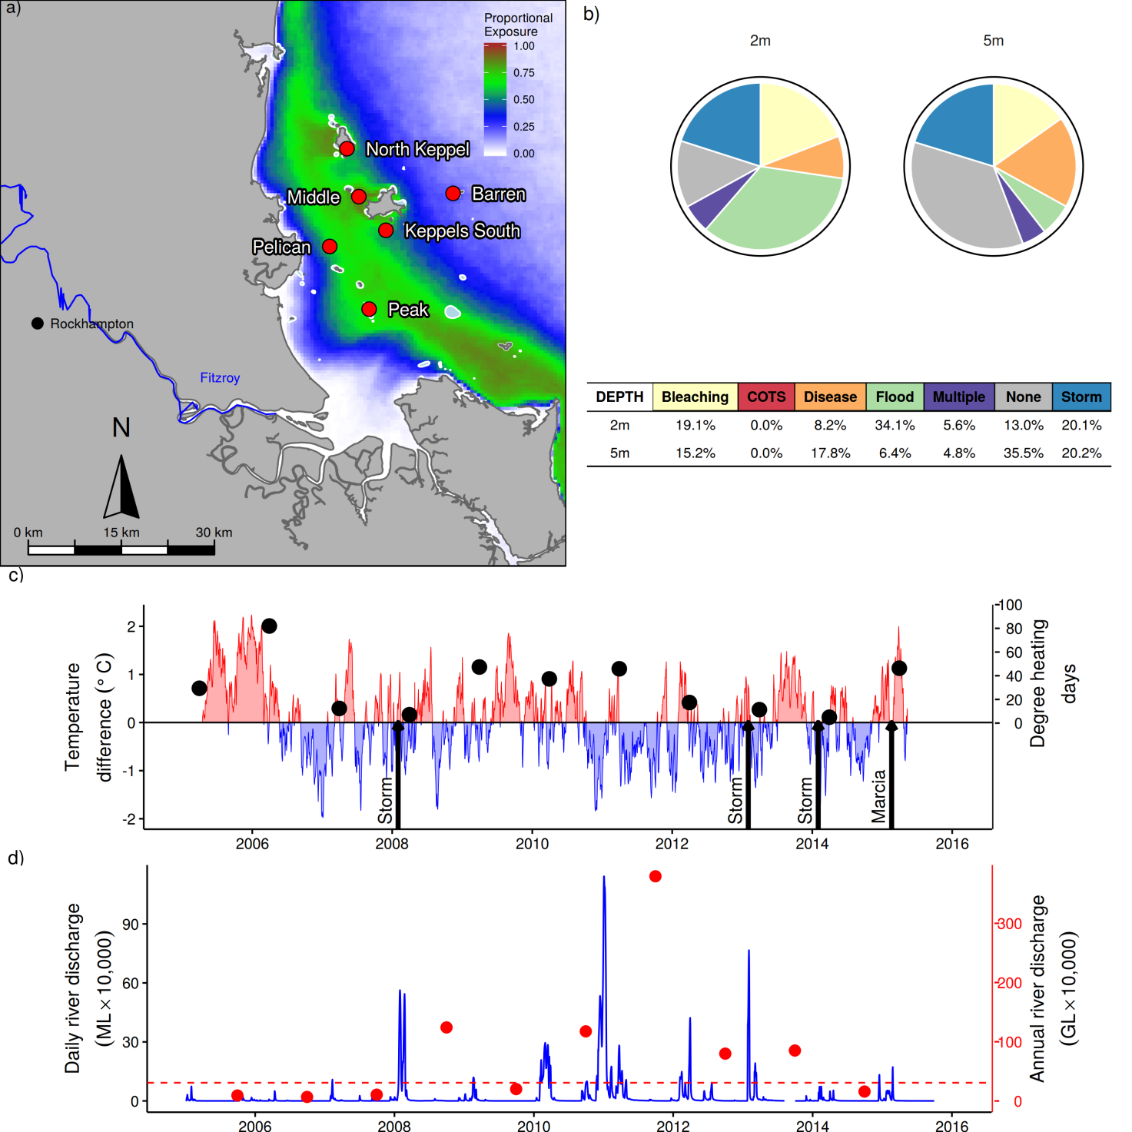
Figure 14: Fitzroy Association Region reef locations, environmental conditions and disturbances.
a) Location of monitoring sites red symbols MMP, black symbols LTMP, mean exposure to secondary plume type waters (Álvarez-Romero et al. 2013) during the wet season: December to March, over the period 2003-2015 indicated by colour. b) break-down and level of disturbances causing loss of hard coral cover over the period 2005-2015, level of disturbance is scaled to the maximum disturbance rate of 16% reduction in hard coral per year that occurred in the Tully Herbert sub-region (outer black ring), loss due to disturbance type ‘none’ reflects a shortfall in rate of cover increase during years free from acute disturbances. c) Seasonally adjusted temperature deviation, timing of cyclones and storms indicated by black arrows, accumulated degree heating days over the summer period (1st December to 31 March) each year indicated by black symbols d) Combined daily (blue) and annual (red) discharge for the Fitzroy River, red dashed line represents long-term median discharge (1970-2000).

Coral communities are monitored at six fringing reefs within Keppel Bay. Differences in turbidity and nutrient concentration at these reefs (Figure 14a, Table A 4)) influence both the composition and dynamics of benthic communities. Peak and Pelican are situated in relatively turbid and nutrient rich waters compared to reefs further offshore (Table A 4), Keppels South, Middle and North Keppel also share frequent exposure to secondary plume-type waters and higher nutrient and turbidity levels than Barren (Figure 14a, Table A 4). These differences in water quality are clearly evident in the benthic communities. At Peak and Pelican benthic communities differ markedly between the 2m and 5m depths (Figure A 6), illustrating the substantial attenuation of light as a result of high turbidity. Pelican has a highly stratified environment, supporting slow growing, low-light tolerant corals at depth, and fast-growing, light-loving Acroporidae in the shallows; the Acroporidae at 2m were completely killed by exposure to freshwater during the 2011 floods and replaced by macroalgae (Figure A 6). Recent surveys have noted the re-appearance of juvenile Acroporidae (Figure A 6). Even closer to the Fitzroy River, Peak is defined by a low cover of corals, low density of juvenile corals, high cover of macroalgae, and a lack of substantial reef development, suggesting that the environmental conditions at this location are marginal for most corals (Figure A 6). Further from the Fitzroy River, the coral communities at Keppels South, Middle Is, North Keppel, and Barren have dominant Acroporidae cover, principally, but not restricted to, the branching Acropora sp., Acropora intermedia and A. muricata at both 2m and 5m (Figure A 6).
Prior to the commencement of the MMP in 2005, Queensland Parks and Wildlife Service monitoring of reefs in Keppel Bay from 1993-2003 recorded substantial loss of coral cover as a result of thermal bleaching events in 1998 and 2002 (Table A 2). Importantly, these surveys also demonstrated the resilience of the corals to these events with coral cover rapidly increasing in subsequent years (Sweatman et al. 2007). Initial MMP surveys in 2005 documented moderate to high hard coral cover on all the Acropora-dominated reefs confirming this recovery (Figure A 6). In 2005-06, increased sea surface temperatures (Figure 14c) again led to a severe bleaching event resulting in marked reductions in coral cover, in particular Acroporidae, and a resultant bloom of the brown macroalgae Lobophora variegata (Figure A 6, Diaz-Pulido et al. 2009). This event was responsible for approximately 15% of the coral cover lost in the region since 2005 (Figure 14b) and a reduction in the coral index from ‘moderate’ to ‘poor’ (Figure 15a).
Following on from 2006 has been a period of frequent disturbances from both storms and flooding of the Fitzroy River (Figure 14c,d, Table A 1,Table A 2). While the region receives few cyclones compared to other regions (Figure A 8), the northward-facing reefs of Barren and Middle have been particularly vulnerable to storm damage. Storm driven waves in 2008, 2010, ex-TC Oswald 2013, ex-TC Dylan 2014 and Cyclone Marcia 2015 have been the main cause of coral cover declines at these reefs since the 2006 bleaching event (Table A 2). Compounding the impact of these storm events has been a period of intense flooding with annual discharge from the Fitzroy River exceeding the long-term median in 2008, and 2010-2013 (Figure 14d, Table A 1). The 2011 flood event was the largest on record and exposed shallow coral communities to low salinity waters that caused widespread mortality of corals at the 2m depths of Peak, Pelican and Keppels South (Table A 2, Figure A 6). Flooding also coincided with elevated levels of coral disease in 2008, 2010 and 2011 (Figure A 7). The consistent pattern of high incidence of disease amongst coral communities following each of the recent floods supports the hypotheses that increased organic matter availability, reduced salinity (Haapkylä et al. 2011), and increased nutrient enrichment (Vega Thurber et al. 2013) play a role in facilitating coral disease. Reduction in light levels over extended periods of time as a result of higher turbidity from increased concentrations of suspended sediments as well as dense plankton blooms following floods is another plausible explanation for reduced fitness of corals (Cooper et al. 2007) that may lead to disease.
As a result of repeated disturbance the coral index remained in the ‘poor’ category for several years, balanced only by short-term depletion of macroalgae caused by hyposaline water and storms. With the seasonal floods diminishing in 2012-2013 (Figure 14d), macroalgae was released to grow (Figure 15c), dropping the index to ‘very poor’ (Figure 15a). Despite the recent impact on coral cover by Cyclone Marcia (2015) the coral index has risen to ‘poor’, buoyed by an increase in juvenile density, a decline in macroalgae and an improvement in the rate coral cover has increased during periods free from disturbance (Figure 15d,c,e).
The improvement in the coral change metric is encouraging given the underperformance of this indicator, especially at 5m depths in recent years (Figure 15e). Lower than expected rates of recovery of coral cover during years free from disturbance are categorised as disturbance type ‘None’ (Figure 14b). Low rates of cover increase were likely due to a combination of localised factors, such as low levels of juvenile recruitment at Pelican 2m depth where the entire coral community was killed by floodwaters (Figure A 6), competitive interactions between corals and the high cover of macroalgae present at the majority of sites, along with general water quality related stress of low light and ongoing low levels of disease. Specific limitation to cover increase also included a persistent population of the coral eating snail Drupella sp. at North Keppel and loss of coral cover to over-growth by the bio-eroding sponge Cliona orientalis at Pelican and Peak in particular (SCUBA search data).
The regional water quality index has maintained an assessment of ‘good’ since 2008, increasing to ‘very good’ based on the limited data collected in 2015 prior to ending of the water quality time series (Figure A 15). Regional water quality indicators had remained at or bordering defined thresholds, with reasonably flat trends in particulate phosphorous, dissolved oxidised nitrogen, and dissolved organic carbon (Figure A 15). There was a slight downturn for 2014-2015 in measures of chlorophyll a particulate nitrogen and particulate organic carbon that contribute to the improvement in the index (Figure A 15).
Variation in the resilience of communities to the 2006 bleaching event provides insight into the role of water quality in suppressing resilience in this region. The level of recovery following the 2006 bleaching event is inversely related to the persistence of macroalgal communities. At the three Acropora sp. dominated communities most often exposed to secondary plume-type waters (Keppels South, Middle and North Keppel, Figure 14a, Table A 4) macroalgal cover (predominantly Lobophora variegata) remained high and rates of change in coral cover remained low or cover has continued to decline (Figure A 6). In contrast, Barren, where exposure to flood plumes is rare, had lower levels of all water quality variables (Table A 4) and the bloom of L. variegata was less pronounced and recovery of the coral community clearly progressed in 2007 (Figure A 6).
In summary, the improvement of the coral index to ‘poor’ represents the first sign that coral communities are beginning to recover from a period of frequent disturbance and regain the resilience demonstrated following previous bleaching events (Sweatman et al. 2007). Light reduction as a result of turbidity, increased nutrient supply, along with lower salinity, are all mechanisms that reduce coral fitness or contribute to higher rates of disease in corals (e.g. Fabricius 2005, Voss & Richardson 2006, Haapkylä et al. 2011, Vega Thurber et al. 2013). With the recent return to lower flows and correspondingly lower loads of sediments and nutrients delivered by the Fitzroy River (Garzon-Garcia et al. 2015), the rate at which coral condition improves will help to assess the longer term impacts of runoff on the ecology of the reefs in this region.
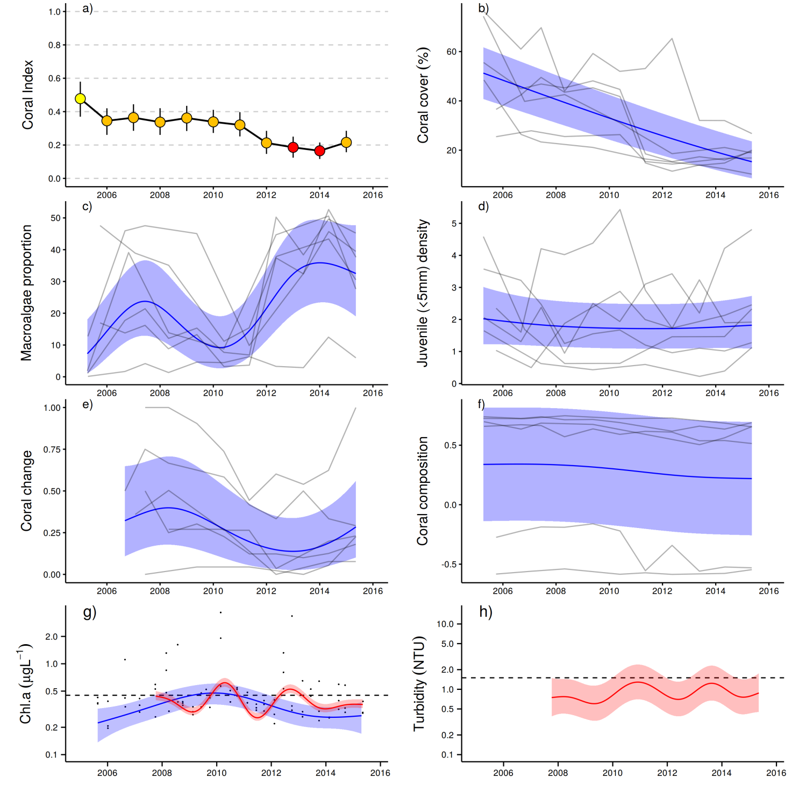
Figure 15: Coral reef community and water quality trends in the Fitzroy region.
Coral index colour coding: dark green- ‘very good’; light green-‘good’; yellow – ‘moderate; orange – ‘poor’; red – ‘very poor’. Coral index is calculated from benthic community variables plotted in b-f. Trends in benthic community variables are represented by blue lines with blue shaded areas defining 95% confidence intervals of those trends, grey lines represent observed profiles averaged over depths at individual reefs. Trends in manually sampled chlorophyll a (g) are represented by blue lines with blue shaded areas defining 95% confidence intervals of those trends, black dots represent observed data. Trends in records of chlorophyll a and turbidity (g, h) from ECO FLNTUSB instruments are represented in red, individual records are not displayed. Dashed reference lines indicate GBRMPA (2010) guideline values.

Revision of report card indicator metrics

6.1 Report card concept
The coral reef component of the marine monitoring program (MMP) has the primary aim of monitoring the condition of reefs in the inshore waters of the GBR. These reefs are directly influenced by sediments, nutrients and toxicants resulting from activities occurring in the catchments and abutting coastal zones. As expected, coral communities show clear relationships to local environmental conditions, however, these relationships do not easily translate into an assessment of the condition of these communities in response to degraded water quality, as gradients in both environmental condition and community composition may naturally occur.
Reef Plan in general can be considered in a Drivers-Pressures-States-Impacts-Responses (DPSIR) framework (Maxim et al. 2009, Rehr et al. 2012). Socio-economic factors are the drivers of human activates from local, within catchment, scale through to the global scale. Human activities result in both locally derived pressures on downstream ecosystems such as increased exposure to sediments, nutrients and toxicants that interact with global pressures such as climate change. These pressures change the state of the waters surrounding coral reefs and in turn influence the state of coral communities. The purpose of the coral component of the Reef Report Card is to synthesise the state of coral communities based on a range of indicators of coral community condition. This state can then be interpreted in terms of impact on desirable ecosystem functioning or services that in turn can be used to inform decisions as to the need for response such as policy or regulatory actions to alleviate that impact.
Following the DPSIR framework it is obvious that the choice of indicators used to assess ecosystem state should have the properties of being responsive to pressures of interest but also relevant in terms of the desirable state of the ecosystem. The underlying premise of Reef Plan is that land use practices adjacent to the GBR have resulted in increased loads of contaminants in the form of sediments, nutrients and pesticides into the waters of the GBR (Waters et al. 2014) and this has resulted in a concomitant reduction in water quality that has impacted GBR ecosystems. This concept is captured by the stated goal of Reef Plan 2013 that is “To ensure that by 2020 the quality of water entering the reef from broadscale land use has no detrimental impact on the health and resilience of the Great Barrier Reef” (Anon. 2013). This goal sets the purpose of the Reef Plan multimetric index for coral communities as one of assessing communities for improvements consistent with expectations under reduced water quality pressure. At a higher level it is the Vision of Reef 2050 Long-Term Sustainability Plan that “In 2050 the Great Barrier Reef continues to demonstrate the Outstanding Universal Value for which it was listed as a World Heritage Area and supports a wide range of sustainable economic, social, cultural and traditional activities”, a vision that brings a socioeconomic perspective to the desirable state of GBR ecosystems.
The coral community component of the Reef Report card is a biological assessment that is used to evaluate the state of coral communities as a means of inferring cumulative effects of a range of environmental conditions and pressures (Karr & Chu, 1999). As a tool of both ecologists and managers, biological assessments are particularly useful as the biological responses measured can indicate the cumulative response to multiple pressures over a range of spatial or temporal scales where those pressures, or their interactions, are difficult to fully identify or parameterise (Karr 2006). As discussed by Bradley et al. (2010), biological assessments should be based on a range of indicators that each focus on separate scales of influence or modes of response. The aggregation of multiple indicators into a “multimetric index” provides a broad basis for the assessment of biological integrity while also producing a single “score” for reporting purposes.

6.1.1 Rationale for indicator selection
Due to the inference ascribed to biological assessments it is important that each indicator included in a multimetric index be carefully selected and tested to ensure it is both relevant to the purpose of the index and can be feasibly implemented in a manner able to detect differences in the response (Jameson et al. 2001). The conceptual model underpinning the selection of coral community indicators for Reef Plan is that coral communities are naturally dynamic; existing in a cycle of disturbance and recovery. For coral communities to persist requires the long-term balance between the frequency and severity of disturbances and the rate at which communities recover. Poor water quality is assumed to disrupt this balance by either increasing the susceptibility of coral communities to disturbance or supressing the rate at which communities recover, that is, poor water quality reduces the resilience of coral communities. This conceptual model identifies community resilience as the overarching response for the coral index and steers the selection of indicators toward those representing critical demographic: recruitment, growth, mortality, or ecological: competition, processes that underpin coral community resilience. A further important consideration is the large spatial (ideally the length of the GBR) and temporal (responses to improved land use practices are likely to decadal) scale of interest as this imposes limitations to sampling methods employed along with the spatial and temporal replication of that sampling. In the case of the MMP the sampling strategy adopted from the onset constrained the choice of indicators to those that are: represented across the range of coral reefs within the inshore GBR, have an expected response time in the order of months to years; as determined by the annual or biennial sampling design, and be reliably estimated from the sampling methods employed.
Several studies have assessed potential indicators to be used in a multimetric index as a way of evaluating the integrity of communities influenced by local pressures such as increases in nutrients and sediments (e.g. Fisher et al. 2008, Cooper et al. 2009, Fabricius et al. 2012) or by global pressures such as climate change (McClanahan et al. 2012). A number of biological indicators introduced by Fabricius et al. (2012) and McClanahan et al. (2012) were not incorporated in the MMP for the following reasons.
- Firstly, there are a range of indicators that focus on short-term stress responses of organisms (Cooper et al. 2009). We will not expand on these here, save to say, that such indicators are more suited to impact assessment work related to specific activities, such as dredging operations. Here, the motivation would be to identify sub-lethal levels of stress that could be mitigated through management of the activity prior to mortality occurring. For a monitoring program such as the MMP where the focus and sampling design is aligned with monitoring the long-term dynamics of communities over large spatial scales and in response to cumulative environmental stressors, it is unclear how the identification of sub-lethal stress could lead to any management action that could immediately alleviate that stress. Rather, it is the culmination of such stressors that will result in differences in key demographic indicators such as growth rate of corals, recruitment success and also selection against sensitive species, and this type of information is available from the MMP sampling design.
- A second group of indicators are those that target changes within a single species in response to environmental conditions (e.g. the density of bio-eroding organisms in, or the rugosity of, massive Porites colonies as described by Cooper et al. (2009). The focus on single species or groups of species has two primary drawbacks for long term programs: either, the species may be rare or absent from some locations and so time consuming or impossible to sample, or, the species may become locally extinct as a response to a disturbance event. In both cases the missing scores for the indicator has the potential to bias indicators across reefs or through time.
- Finally, there are abiotic indicators that describe the environmental conditions of a location. For the monitoring of coral communities environmental conditions should be viewed as pressures rather than indicators. McClanahan et al. 2012 included the environmental variables; temperature variability, sedimentation, pollution along with direct human impacts of fishing pressure and physical damage as indicators of resilience to thermal bleaching. Such location-specific physical properties are relevant for matters such as decisions on the location of protected areas (Maynard et al. 2015). For the monitoring of coral community resilience however, such abiotic variables are more appropriately viewed as pressures. When such pressures do not vary through time, rather describe the environmental setting of a location, such as depth of water, aspect in relation to prevailing winds and waves or location along naturally occurring gradients of turbidity it is important to consider these variables in determining appropriate thresholds for biological indicators that may vary in response to these underlying conditions. When pressures are temporally variable monitoring exposure can facilitate the interpretation of likely causes for observed change in biological indicators – this includes both pressures associated with human activities, such as nutrient and turbidity levels as well as natural pressures such as exposure to cyclones.

6.1.2 Reason for revision of report card metrics
The initial selection of indicators to report coral community condition on reefs monitored under the MMP were formulated during a workshop in 2007 run by the GBRMPA and subsequent post workshop deliberations between workshop participants and GBRMPA staff. Each of the indicators could be considered in terms of current state, or potential for recovery, of a coral dominated community. Indicators were further developed and linked to key water quality parameters during a series of workshops in which expert opinion was used to develop the conceptual model for corals presented in Kuhnert et al. (2014) that largely reiterates that of Fabricius (2011). In combination, these more formal expressions of the conceptual model for coral community dynamics under the influence of water quality pressures served to reinforce the appropriateness of the selected indicators.
The indicators selected were: the combined cover of hard and soft corals, the cover of macroalgae, the density of juvenile hard corals, the rate of change of coral cover and the settlement of hard corals to terracotta tiles. Thompson et al. (2010b) presented a baseline assessment of coral community condition based on data collected between 2005 and 2009, which was included in the First Report Card of the Paddock to Reef Integrated Monitoring, Modelling and Reporting Program (Anon. 2011). Thompson et al. 2010b
Subsequent to Thompson et al. 2010b, the estimation of coral community condition was revised with the view to enhancing the sensitivity of the assessment to change. In short, the period over which the metric based on rates of increase in cover of hard corals was restricted to three years, and coral settlement was removed as a metric due to high inter-annual variability without clearly attributable causes. The 2010-2014 coral scores for the reef report card used this revised assessment protocol (most recently Thompson et al. 2014b).
To date, the thresholds applied to each indicator metric have been consistent among reefs, though did vary between 2m and 5m depths for some indicators, and were based on the distribution of values observed in 2005 as a baseline condition (Table 7). The assessments of condition applying these thresholds were deliberately coarse and were categorised on a three point scale:
- Positive (numerical score of 1), when the value of the indicator was above the threshold;
- Neutral (score of 0.5), when the value of the indicator fell within the range of the threshold, or
- Negative (score of 0), when the value of the indicator was below the threshold.
The aggregation of these individual scores at the level of reef and depth was simply a matter of averaging the scores to the spatial level of interest. Lastly, these average scores were converted to qualitative assessments by converting to a five point rating and colour scheme whereby scores of:
- 0 to 0.2 were rated as ‘very poor’ and coloured red
- >0.2 to 0.4 were rated as ‘poor’ and coloured orange
- >0.4 to 0.6 were rated as ‘moderate’ and coloured yellow
- >0.6 to 0.8 were rated as ‘good’, and coloured light green
- >0.8 were rated as ‘very good’, and coloured dark green.
This scoring procedure provided a consistent framework within which to compare the condition of communities between locations and through time. It was, however, insensitive to the natural variation in indicators that may occur due to underlying differences in the environmental conditions influencing a particular location, but also the magnitude of deviation from the threshold condition.
Armed with: the accumulated time-series of observations collected by the MMP since 2005, and an independent review of the program that identified short comings in the initial approach (Kuhnert et al. 2014), along with the intention to include additional time-series of coral communities monitored by the AIMS long-term-monitoring program (LTMP) to improve the precision of estimates of coral community condition (Walshe et al. 2014), it is timely that the calculation of the coral index component of the Report Card be revised.
The purpose of this revision is to ensure that the methods used to calculate Report card scores are transparently documented but also that the scores are based on the most relevant indicators and thresholds for the assessment of coral community condition. This revision specifically:
- Considers additional indicators that could enhance the assessment of coral community condition and describes a new indicator based on change in coral community composition;
- Sets thresholds that take into account variability in communities along environmental gradients;
- Incorporates a scoring system that scales scores relative to the magnitude of deviations away from thresholds;
- Incorporates a measure of uncertainty in resulting report card scores aggregated to regional and GBR-wide scales;
- Provides clear description of the methodology used to estimate scores for each indicator, and aggregate scores into the coral index at increasing spatial scales.
The intent is that this report chapter will be transferred to the MMP QA/QC document in 2016 and serves as the rationale and methodological reference for the coral community component of the Report Card. Each of the four previously utilised indicators are retained in a revised form and are complemented by the introduction of a fifth indicator that assesses long-term change in community composition. For each indicator the rationale for their inclusion and detailed descriptions of the derivation of index scores are presented separately. Secondly, the methods used to aggregate these scores into the coral index that forms the basis of the Report Card score at the scale of NRM regions and the GBR are presented. Finally, as a point of reference, a comparison between report card scores estimated from the revised and previously used methods is included.

6.1.3 Metric thresholds and scoring
Critical to the application of biological indicators as a means of inferring ecosystem condition or state is the setting of reasonable thresholds against which observed condition can be assessed. To be useful in inferring condition, thresholds must be within the range of plausible outcomes for the indicator to which they pertain and set so that deviations can sensibly be interpreted in terms of ecosystem condition (Bradley et al. 2010). When considering the scoring of indicators for coral reef community state in the inshore GBR it is important to consider the natural state that would be expected or desired in any particular location. Importantly, the fact that coral reef communities vary naturally along environmental gradients should be explicitly considered and scoring of state adjusted based on ecological understanding of such gradients where appropriate. Equally important, is how the deviations from any thresholds are scored so that information from separate indicators, or locations, can be combined into a multimetric index over a range of spatial scales of interest.
To date the thresholds used in the coral Report Card were commonly applied across all reefs and largely selected to broadly cover the range of values observed in baseline surveys of the communities. While this approach ensured that the threshold values were plausible in terms of representing achievable conditions across the reefs, in general it did not consider the appropriateness of these thresholds in either ecological terms or the validity of using the same threshold values for reefs spanning a range of environmental conditions. For each indicator the following questions were asked as a way of guiding the final selection of indicator thresholds:
- Is there an expectation that condition of the indicator should naturally vary along the steep gradient in water quality spanning monitoring locations? If so, this would suggest the development and use of location-specific thresholds.
- Is there a desirable state in terms of ecosystem function or value that can guide the setting of a threshold?
A second, related issue is how to score deviations from threshold values. To date, the scoring for indicators within the coral Report Card has been based on a categorical scale with thresholds set as a range of conditions within which the indicator scored a neutral score of 0.5 and then either a positive score of 1 or negative score of 0 when observed condition deviated either above or below these threshold ranges (Table 7). The consequence of this scoring system was the quite dramatic shift in scores when community condition changed marginally about the threshold’s upper or lower limits. An advantage of this scoring system is that all scores were scaled between 0 and 1, allowing for simple aggregation across indicators and sites. For the revised scoring system we have applied a continuous scoring where appropriate, but maintained the scaling of these scores to lie within the range of 0 to 1 to facilitate aggregation of across metrics and spatial scales.

6.1.4 Scope of Data
In determining the sources of data that could be incorporated into the coral index we were guided by the desire that report card scores should be spatially and temporally comparable and data quality assured. These considerations effectively constrain retrospective inclusion of data to the time series of coral community observations collected by the AIMS long-term monitoring program (LTMP) and the MMP. Should recent monitoring initiated by the Gladstone Healthy Harbour Project receive a commitment to continue as a long-term data series then this and any similar locally focused projects could be incorporated in future report cards. Programs such as the reef health and impact survey (RHiS) undertaken as part of the Eye on the Reef program managed by the GBRMPA also provide estimates of the indicators of coral and macroalgae cover. This technique appears well suited to its intended use as a rapid assessment tool. However, it is not currently considered suitable for inclusion as a source of data for the report card due to the lack of a past or future sampling design and that the biases between this technique and those used by the long-term data sets have not been determined. Another program that has the potential to add information to the coral index is Reef Check. This program has established monitoring sites at inshore locations in the Wet Tropics (Low Isles), Burdekin (Palm Group and Magnetic Island) and Mackay – Whitsunday (Hayman Island) regions and appears to provide sound estimates of coral cover that could add to coral index (Loder et al. 2015). As for RHiS consideration of Reef Check data would be based on the ongoing commitment to a suitable sampling design along with willingness by Reef Check to make their data available

Sampling design of MMP and LTMP
Both the MMP and LTMP utilise two sampling methods to describe coral communities along permanently marked transect. Photo point-intercept transects are used to quantify the proportional cover of various benthic organisms (Jonker et al. 2008), and co-located belt transects are used in which the number of juvenile corals are quantified. For both techniques the identification of corals is generally to the level of genus (image quality may limit the taxonomic resolution). For the purpose of the report card indicators, genus-level identification is required for the coral community composition indicator while the distinction between Acroporidae corals and all other families of hard coral is required for the coral change indicator. As benthic communities in the inshore GBR vary strongly with depth (Sweatman et al. 2007), the MMP includes transects at both 2 and 5 m below lowest astronomic tide at each reef, while the LTMP has transects at ~6m below LAT only. Deeper transects were not included as at many reefs coral communities either peter out or the reef slope merges with surrounding unconsolidated substrates beyond 5-6m depth. To account for spatial heterogeneity of benthic communities within reefs the MMP includes five 20m long transects, at each of two sites at each depth from which the reef mean cover of the benthos and juvenile densities are estimated. The LTMP design includes three sites, each with five 50 m long transects for photo point intercept: juvenile densities are estimated from the first 5 m of each of these transects. The nominal temporal replication for the MMP was for all reefs to be surveyed in both 2005 and 2006. From 2007 to 2014 surveys were continued annually at 15 “core” reefs and reduced to once every two years for the remaining 17 “cycle” reefs. Some cycle reefs were resampled in unscheduled years to quantify the effects of acute disturbance events on those communities. From 2015, all reefs are scheduled for sampling on a two year cycle, however with the provision for additional surveys following acute disturbances. The LTMP reefs were nominally sampled annually from 1992 through to 2005 after which sampling frequency was reduced to once every two years. Some scheduled samples of LTMP reefs were not achieved as a result of poor weather.

Environmental covariates
To determine the relationship between indicators and environmental gradients, that would suggest the need for location specific thresholds, required environmental covariates that were consistently estimated over the spatial scale of coral monitoring programs. For the inshore reefs monitored by the MMP and LTMP this limits the available WQ variables to those estimated from satellite imagery. For the analyses presented in this report estimates of the concentration of chlorophyll a (Chl a) as a proxy for nutrient availability and non-algal particulates (NAP) as an estimate of total suspended solids were sourced from the Bureau of Meteorology (2015) which are derived from methods described by Brando et al. (2012).
For each coral reef monitoring location a square of nine 1 km pixels was identified in adjacent open water and all available estimates of Chl a and nap for the period July 2002 until the end of 2014 obtained. For each day, available data with a quality level of 4 were averaged for each location. From these daily averages the median levels for each variable were extracted as the long-term condition estimated for each reef (Table A 4). The relative hydrodynamic forcing of each site was estimated as the proportion of clay and silt sized particles in sediments collected from 5 m depth at MMP sites (Table A 4) averaged over samples collected during annual or biennial sampling of the coral communities between 2007 and 2014. Reefs with a high proportion of fine grained particles are assumed to represent locations at which turbulence is low and so the accumulation of fine sediments promoted. In contrast, a low proportion of fine grained particles are assumed to reflect higher levels of turbulence that precludes the accumulation of fine-grained sediments. For LTMP reefs no sediment data exist and estimates of the proportion of clay and silt in the sediments was interpolated by placing the LTMP sites within the gradient of MMP sites by considering their comparable exposure to waves from the SE as the predominant direction of waves in the inner GBR. Images from LTMP photo-transects that included sand or silt observations were visually compared to images from MMP reefs with similar exposure to visually verify the validity of interpolated estimates.

6.2 Metric 1: Proportional cover of macroalgae
Macroalgal recruitment, growth and biomass are controlled by a number of environmental factors such as the availability of suitable substratum, sufficient nutrients and light, and rates of herbivory (Schaffelke et al. 2005). Abundant fleshy macroalgae on coral reefs are considered to be a consequence and, mostly, not a cause of coral mortality (McCook et al. 2001, Szmant 2002). However, high macroalgal abundance may suppress reef resilience (e.g., Hughes et al. 2007, Foster et al. 2008, Cheal et al. 2010; but see Bruno et al. 2009) by increased competition for space or changing the microenvironment for corals to settle and grow in (e.g. McCook et al. 2001, Hauri et al. 2010). On the Reef, high macroalgal cover correlates with high concentrations of chlorophyll, a proxy for nutrient availability (De’ath & Fabricius 2010). Once established, macroalgae pre-empt or compete with corals for space that might otherwise be available for coral growth or recruitment (e.g. Box & Mumby 2007, Hughes et al. 2007). However, as the interactions between corals and algae are complex, likely species-specific and, mostly, un-quantified (McCook et al. 2001), it is difficult to determine realistic thresholds of macroalgal cover from which to infer impacts to the resilience of coral communities.
Until and including 2014, the scoring of the macroalgae indicator for the Great Barrier Reef Report Card was based on baseline data from the MMP. This approach imposed common thresholds for macroalgae cover across all inshore reefs that were based on the distribution of macroalgae cover observed in 2005 (Table 7). From a practical perspective these thresholds clearly identified, and positively scored reefs at which cover of large fleshy algae was low and unlikely to be influencing coral resilience. Moreover, the distinction between moderate and high levels of macroalgal cover appropriately scored reefs at which the cover of macroalgae was high and indicated a high likelihood of increased coral-algal competition. A significant disadvantage was that this uniform categorical scoring system when applied across natural gradients in conditions that govern macroalgae abundance limited the sensitivity of scoring. At one extreme, reefs at which water quality is optimal for macroalgae are likely to constantly support levels of macroalgae above the threshold, in contrast at reefs toward the cleaner end of the water quality gradient are unlikely to ever support macroalgae cover above the threshold. In addition, there was no consideration of ecological thresholds about which the cover of macroalgae had detrimental impacts on coral communities other than those implicitly implied from the categorisation.

6.2.1 The response variable
The response variable for the macroalgae indicator up to and including 2014 was the mean proportion of the reef benthos occupied by macroalgae, as estimated from photo point intercept transects at a given reef and depth, expressed as percent cover of macroalgae. The collective term; “macroalgae” here represents a broad functional grouping that combines species clearly visible to the naked eye, but excluding crustose coralline and fine filamentous or “turf” forms. This percent cover estimate did not account for the area of substrate occupied by soft sediments that are largely unavailable to algal colonisation, and so values between reefs were potentially biased. Similarly, the area of substrate occupied by other benthos such as corals that could preclude macroalgae colonising the area was not considered, again providing for bias between reefs but also leading to potential co-variation between the indicators for coral cover and macroalgae. The revised response variable is the relative proportion of macroalgae within the algal community, expressed as the percent cover of large structurally complex macroalgae (as opposed to fine filamentous turf or crustose coralline forms) as a proportion of the total cover of all algae. Explicitly if we allow $A_{ij}$ to represent the percent cover of all algae ($A$) at a reef ($i$) at time ($j$) and ${MA}_{ij}$ to be the percent cover of macroalgae $MA$ at a reef ($i$) at time ($j$) then macroalgae indicator response variable $MAproportion$ is:
${MAproportion}_{ij}$ = ${MA}_{ij}$ / $A_{ij}$
Within the LTMP and MMP database percent cover of each benthic category is estimated based on the proportional representation of that benthic category within all points identified along point intercept transects. The identification of points follows a hierarchical system allowing aggregation of data into increasingly broad classifications. The hierarchy follows the levels: species, genus, family, benthos, and group. Each point overlaid on photos taken along the photo point intercept transects is assigned a point_code that describes the benthos to the highest taxonomic resolution afforded by image quality and observer skill. This point_code may sit anywhere in the hierarchy listed above and maps automatically with the appropriate higher level taxonomy or propagates that identified level into lower levels. For example an alga identified as the genus Sargassum will back-fill the species-level classification codes with Sargassum sp. and assign the family to the poly-familial group “Brown macroalgae”, the benthos as macroalgae (benthos_code, MA) and the group as algae (group_code, A). Although genus and family-level differentiation is often achieved for macroalgae, the level of benthos_code is consistently achieved, and as such, the percent cover of both macroalgae and total algae are retrievable from the AIMS oracle database tables REEFMON_BENTHOS_SUMMARY_ZEROS and REEFMON_GROUP_SUMMARY_ZEROS respectively.

6.2.2 Selection of threshold values and scoring
As natural variation in macroalgae communities occurs along gradients in water quality (De’ ath and Fabricius 2008) reef-specific thresholds based on ambient environmental conditions are appropriate. For this purpose Generalised Boosted Models (GBM’s, Ridgeway 2007) were applied separately to the average and minimum MAproportion observed at all MMP and inshore LTMP reefs and depths over the period 2005-2014.
At 2m depth the concentration of chlorophyll was the most important of the environmental variables assessed to predict MAproportion, with MAproportion increasing sharply at reefs experiencing mean chlorophyll concentrations in excess of 0.4µgL⁻¹ (Figure 16a). MAproportion was also higher at more exposed sites, i.e. sites where the proportion of clay and silt sized particles in sediments was low, and in less turbid water (Figure 16b,c). At 5m depths, MAproportion was also higher where chlorophyll concentrations were above 0.4 ugL⁻¹ and was lower in sheltered habitats (Figure 16d,e). The influence of turbidity was more pronounced at 5m than at 2m, demonstrating the limiting influence of low light on Map (Figure 16f).

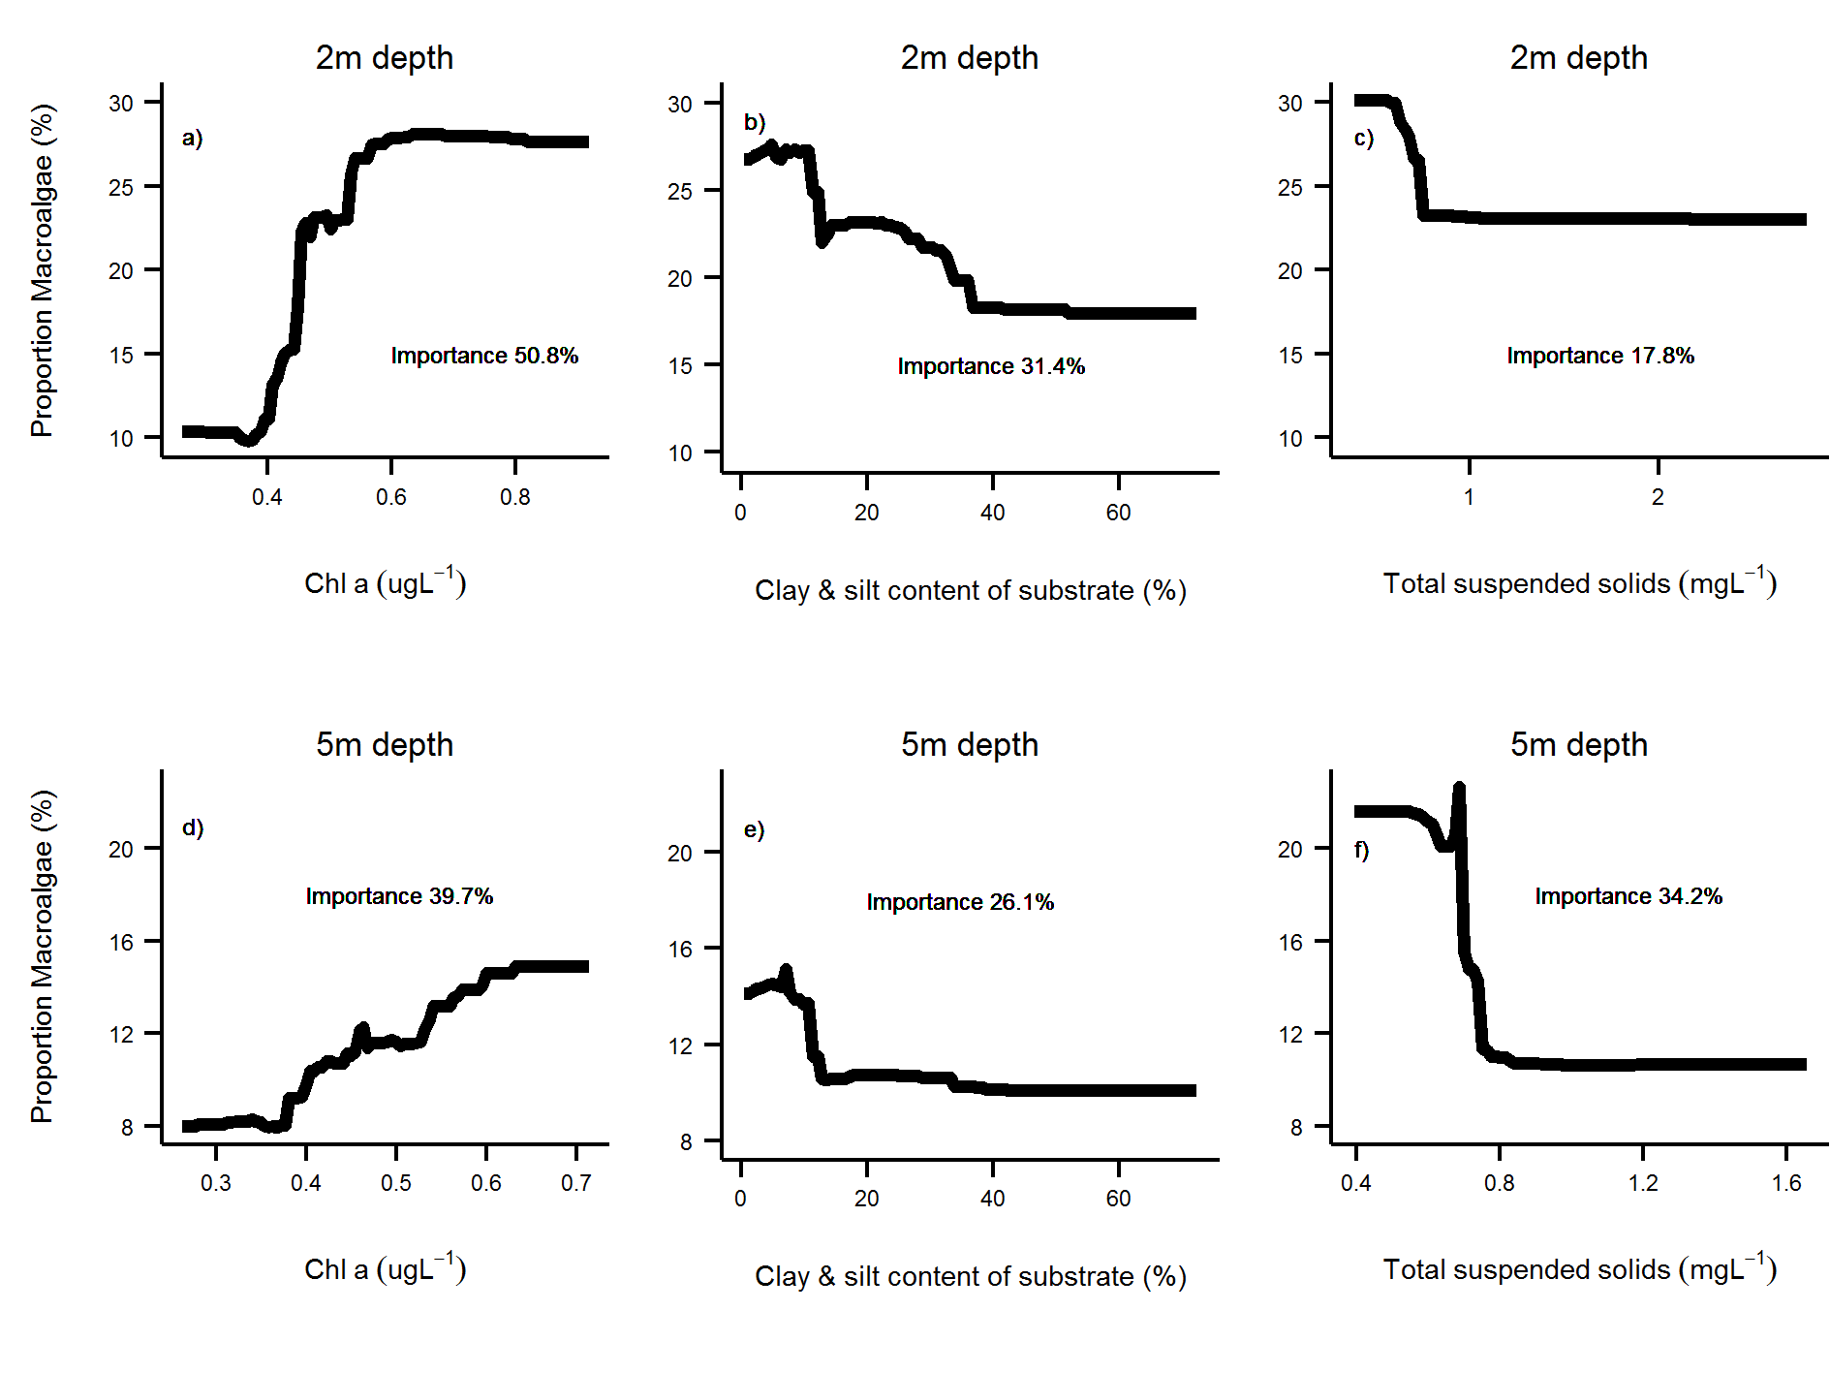
Figure 16: Macroalgae proportion relationships to environmental conditions
. Generalised boosted model partial plots demonstrating the relationship between MAproportion and environmental conditions. Pseudo R2 for the full models were 0.15 at 2m and 0.17 at 5m.

Based on the GBM results, it is clear that the combination of water quality and hydrodynamic setting influenced the relative abundance of macroalgae within algal communities. As such it is not appropriate to have consistent expectations of MAproportion across all sites. For each reef and depth, the predicted MAproportion from the GBM’s was extracted as the upper threshold for MAproportion (Table 4). The reason for considering the predicted level as the upper bound for MAproportion is that the response of macroalgal communities to Chl a as a proxy for nutrient availability must be considered as being a worst case scenario in terms of the relationship between water quality and this indicator. On the one hand the period (2005-2014) of observations leading to these predictions began at the beginning of Reef Plan when it could be assumed that loads of nutrients were at a maximum. Although Reef Plan actions throughout the period have resulted in improvements in management practice (Anon. 2015), the period 2007-2013 was particularly wet resulting in high flows with high loads of nutrients and sediments entering the reef (Turner et al. 2012, 2013; Wallace et al. 2014, 2015). In combination, it should be considered that any increase in MAproportion above these levels would be counter to the underlying goals of Reef Plan.
An additional consideration in setting the upper threshold for MAproportion is the ecological influence of macroalgae on other indicators of coral community condition. Regression tree analyses that included MAproportion as the predictor variable indicated reduced levels of the other three indicator metrics juvenile density, coral cover and the rate of change in coral cover at higher levels of MAproportion. These thresholds for an ecological impact serve as potential caps for MAproportion at any given reef. The thresholds for an influence of MAproportion are, however, variable both between indicators and depths. To set caps to the upper bound of MAproportion across all reefs at either 2 m or 5 m depths the mean of the thresholds evident for the three indicators was taken resulting in an upper bound cap of 23% at 2 m and a 25% at 5 m. The upper bounds for any reefs with predicted MAproportion higher than these caps were reduced to the cap level (Table 4).
The setting of lower bounds was based primarily on the consideration of what was an achievable lower MAproportion based on the ambient environmental setting of a given reef. A second set of GBM’s was applied to the minimum MAproportion observed at each reef over the period 2005-2014. The predictions from these models were taken as the lower bound for MAproportion as representing the lower levels of MAproportion that could reasonably be expected at the different locations along the environmental gradients (Table 4). Scoring the MAproportion indicator at each reef linearly scales from 0 when MAproportion is at or above the upper threshold through to 1 when MAproportion is at or below the lower threshold (Figure 17).

Table 4: Thresholds for proportion of macroalgae in the algae communities.
Reef | 2m Depth |  | 5m Depth |  |  | Reef | 2m Depth |  | 5m Depth
 | Upper | Lower | Upper | Lower |  |  | Upper | Lower | Upper | Lower
Barnards | 23 | 4.8 | 20.8 | 1.7 |  | Keppels South | 23 | 3.9 | 24 | 1.7
Barren | 13 | 3.7 | 12.6 | 1.6 |  | King | 23 | 6.2 | 24.8 | 1.8
Border |  |  | 8.2 | 1.4 |  | Lady Elliot | 23 | 6.1 | 15.3 | 1.9
Daydream | 13.5 | 3.5 | 10.4 | 1.5 |  | Langford |  |  | 7.9 | 1.4
Dent | 11.6 | 3.5 | 10.2 | 1.5 |  | Low Isles |  |  | 8.9 | 1.4
Double Cone | 8.9 | 3.4 | 7.6 | 1.4 |  | Magnetic | 23 | 6.4 | 19 | 2
Dunk North | 23 | 4.6 | 13.5 | 1.7 |  | Middle Rf | 21.9 | 5.5
Dunk South | 23 | 5.3 | 15.6 | 1.9 |  | Middle | 23 | 5.2 | 23 | 1.8
Fitzroy East | 11.7 | 3.5 | 10 | 1.5 |  | North Keppel | 23 | 5.1 | 22.6 | 1.8
Fitzroy West | 12.5 | 3.3 | 13.3 | 1.5 |  | Palms East | 12.2 | 3.6 | 10.5 | 1.5
Franklands East | 12.2 | 3.4 | 10.5 | 1.5 |  | Palms West | 12.8 | 3.4 | 17.5 | 1.5
Franklands West | 11.4 | 3.4 | 15.8 | 1.5 |  | Pandora North |  |  | 13.1 | 1.6
Green |  |  | 11.9 | 1.6 |  | Pandora | 23 | 4.7 | 16.2 | 1.6
Havannah North |  |  | 21.7 | 1.5 |  | Peak | 23 | 6.3 | 19.1 | 2
Havannah | 18.2 | 3.4 | 25 | 1.6 |  | Pelican | 23 | 6.4 | 18.8 | 2
Hayman |  |  | 9.4 | 1.4 |  | Pine | 18.3 | 4.4 | 11.2 | 1.6
High East | 11.2 | 3.4 | 13 | 1.4 |  | Seaforth | 11.8 | 3.4 | 10.2 | 1.4
High West | 22.4 | 4.4 | 12.1 | 1.6 |  | Shute Harbour | 17.6 | 4.2 | 11.7 | 1.6
Hook | 9.3 | 3.4 | 8.1 | 1.4 |  | Snapper North | 18.7 | 4.4 | 11.3 | 1.6
Keppels South | 23 | 3.9 | 24 | 1.7 |  | Snapper South | 23 | 4.4 | 13.1 | 1.6

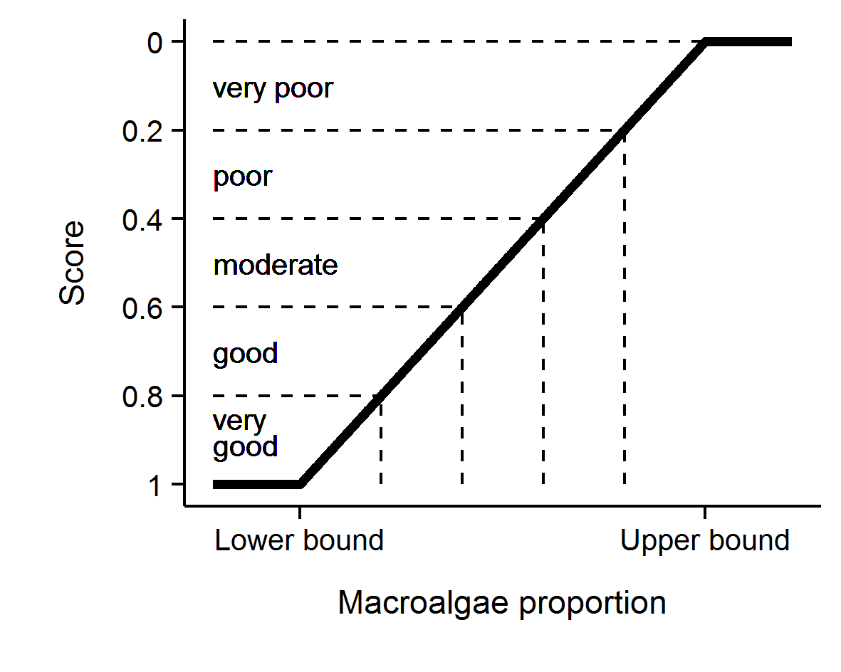
Figure 17: Scoring diagram for the MAproportion indicator.
Upper and lower threshold values are reef and depth specific. Numeric scores and associated condition classifications are presented. Values on the x axis are reef specific and interpolate between lower and upper bounds.

6.3 Metric 2: Coral cover
For coral communities, the underlying assumption for long-term resilience is that recruitment and subsequent growth of colonies is sufficient to compensate for losses resulting from the combination of acute disturbances and chronic environmental limitations. High coral abundance, expressed as proportional cover of the substratum, can be interpreted as an indication of resilience as the corals are clearly adapted to the ambient environmental conditions. Also, high cover equates to a large broodstock, a necessary link to recruitment and an indication of the potential for recovery of communities. Of all indicators, coral cover is the most tangible in terms of people’s perception of the environment and is central to the aesthetic value of a coral reef and as such is an important indicator for the outstanding universal values of the GBR World Heritage Area. This metric is however predominantly an indicator of current state. Low values of the metric cannot necessarily be interpreted as an indication of low resilience as resilient communities may incur substantial reductions in coral cover when exposed to acute disturbances such as tropical cyclones.

6.3.2 The response variable
For the coral cover indicator the data are derived from the LTMP and MMP point intercept transects. As described above, each benthic category is estimated based on the proportional representation of that benthic category within all points identified along point intercept transects. Although corals are generally reliably identified to the taxonomic resolution of genus, for the coral cover indicator estimates of cover for each reef are the combined cover of all hard (order Scleractinia) and soft (subclass Octocorallia) corals. This data is extracted from the AIMS Oracle database table REEFMON_GROUP_SUMMARY_ZEROS where GROUP_CODE is either “HC” or “SC” for hard and soft coral, respectively. Explicitly, where ${HC}_{ij}$ is the cover of all hard corals at a reef ($i$) at time ($j$) and ${SC}_{ij}$ is the cover of all soft corals at a reef ($i$) at time ($j$) then coral cover indicator response variable Coral cover is:
${Coral cover}_{ij}$ = ${HC}_{ij}$ + ${SC}_{ij}$

Soft corals are included in this indicator as they represent a substantial component of coral reef biodiversity and there is no reason to expect they are not a natural component of coral communities on nearshore reefs of the GBR. As direct competitors for space with hard corals their exclusion would potentially bias the metric for coral cover based on hard corals alone.

6.3.2 Selection of threshold values and scoring
Until and including 2014 the coral cover indicator included a threshold range of 25-50% with coral cover below this range scoring 0, covers within the range scoring 0.5 and cover exceeding the range scoring 1. The basis of these categories was that they approximated the distribution of coral cover observed historically on inshore reefs at AIMS LTMP and MMP sites, with each category representing approximately a third of the overall distribution of observed cover values prior to 2006. Consistent categorisations were applied to all reefs, as high coral cover is a desirable condition for all coral reefs and prior observations indicate the capacity for inshore reefs of the GBR to support high cover of corals in a wide range of environmental conditions (e.g. Sweatman et al. 2007, Browne et al. 2012, Thompson et al. 2014a). A drawback of the categorical classification was the abrupt transition between scores about categorical boundaries and the insensitivity of the scoring system to the magnitude of deviation from the thresholds.
The primary decision to be made for this indicator was the setting of the upper threshold for the scoring index to reflect a condition that is both unambiguously ‘very good’ but also attainable for the coral communities on inshore reefs of the GBR. Secondarily was how to scale this indicator across its range to achieve a sensible match between indicator scores and the categorical condition estimates used by the report card. As of 2015, the median coral cover observed on inshore reefs by the LTMP since 1992 and the MMP since 2005 was 38.6%, a figure influenced by the impacts of severe bleaching events in 1998 and 2002 (Berkelmans et al. 2004) and a more localised event in the Keppel Islands in 2006 (Section 3.6) along with frequent exposure to cyclones as well as localised exposure to low salinity flood waters (Section 3, Berkelmans et al. 2012), and crown- of- thorns seastar outbreaks (Section 3, Sweatman et al. 2007).
Of the 40 reefs monitored over half recorded a maximum combined hard and soft coral cover of > 50%. From separate surveys of reefs between Cape Flattery to the Keppel Islands undertaken prior to the 1998 bleaching event, Ayling (1997) reported a mean cover of hard corals alone of 62% from regions other than Broad Sound where cover was lower (mean of 25%). The data reported by Ayling (1997) was based predominantly on line intercept transects (LIT). Comparative data collected using LIT and the MMP photo point intercept transects (PIT) available from Snapper Island and Cape Tribulation reefs reveal a bias between techniques with consistently higher cover estimated from LIT than PIT (PIT=0.85 LIT, r² =0.97). Converting the pre-bleaching mean cover of 62% to comparable PIT estimate returns a mean in the order of >50% hard coral cover. From these past observations it is clear that many inshore reefs have previously supported combined coral cover in excess of 50% and that this level of cover reefs should be considered to be representing at least good condition. It is unlikely that coral will ever completely occupy the full area of substrate on any given reef due on going demographic processes and the presence of patches of unstable substrates such as sand or silt suggesting the maximum threshold should be set lower than 100%. For the coral report card we have elected the upper threshold for coral cover (where the score is at a maximum of 1) at 75% for the following reasons:
- This captures the plausible level of coral cover achievable by reefs within the inshore GBR,
- While higher covers have been observed, any community supporting 75% cover will be clearly in very good condition,
- The use of 75% allows categorisation of coral cover estimates into 5 reporting bands for the coral report card, each with a range of 15% (Figure 18), which are, at the same time convenient and broadly representative of the aesthetic values that could be assigned to these levels of cover.
The scoring of the coral cover indicator is scaled linearly from zero when cover is 0% through to 1 when cover is at or above the threshold level of 75% (Figure 18). There is some evidence that the relationship between coral cover and other indicators of ecological condition, such as diversity of reef fish is non-linear with a rapid loss of diversity at very low coral cover (<10%, Holbrook et al. 2009,Halford et al. 2004). This relationship may support the use of a lower threshold for coral cover in the vicinity of 5-10% we don’t however consider we have sufficient data to identify such a threshold and consider that any such threshold would likely lie within our 0-15% range of coral cover that is categorised as “very poor” (Figure 18). 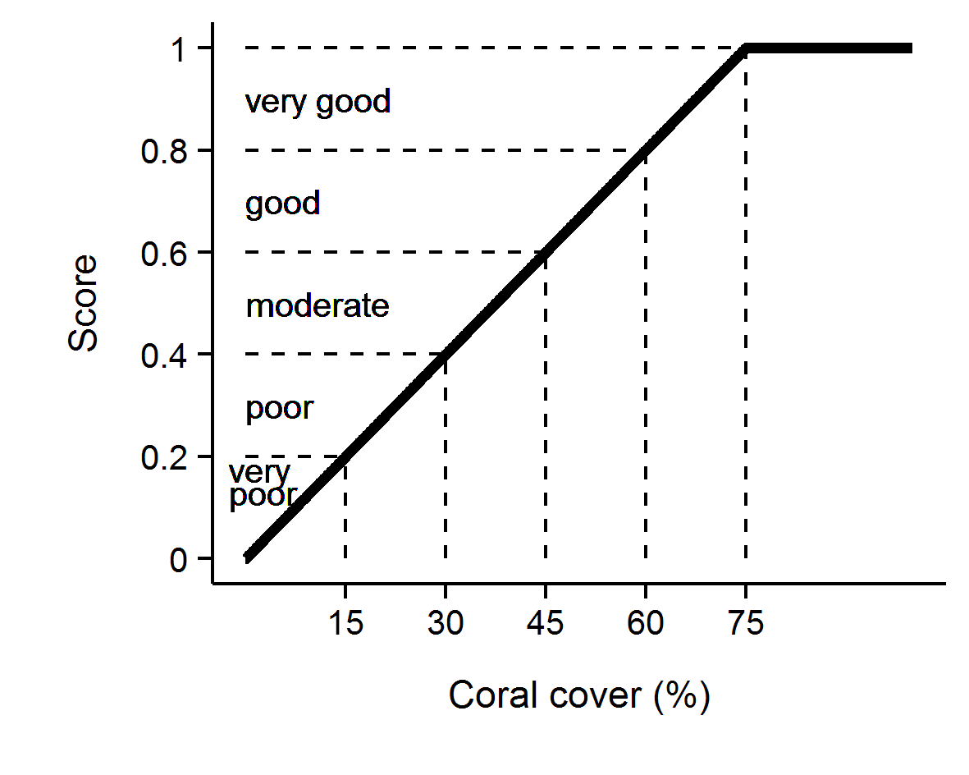
Figure 18: Scoring diagram for the coral cover indicator.
Numeric scores and associated condition classifications based on observed coral cover are presented.

6.4 Metric 3: Rate of change in hard coral cover
This indicator metric is based on the rate at which coral cover increases. While observations of high coral cover can justifiably be considered a positive indicator of community condition, the reverse is not necessarily true for observations of low cover. Low cover may occur following acute disturbance and, hence, may not be a direct reflection of the community’s resilience to underlying environmental conditions. For this reason, in addition to considering the actual level of coral cover (as per above) we also assess the rate at which hard coral cover increases as a direct measure of recovery potential. This indicator reflects the coral growth performance for individual reefs by comparing observed rate of change in hard coral cover at a given reef (in the absence of acute disturbance) to expected coral growth predicted by a multi-species form of the Gompertz growth equation (Dennis & Taper 1994, Ives et al. 2003). The equations used were parameterised from the time-series of coral cover from reefs monitored by the LTMP and the MMP over the period 1987-2007 (Thompson and Dolman 2010).

6.4.1 Selection of threshold values and scoring
Until and including 2014, scores for this indicator were based on comparing the observed change in coral cover between samples to the predicted cover based on Gompertz growth equations developed by Thompson and Dolman (2010). In brief, observations of annual change in benthic cover derived from 47 inshore reefs sampled over the period 1987-2007 were used to parameterise two multi-species Gompertz growth equations. Importantly only changes occurring over periods during which no acute disturbances occurred were used to ensure the response was not confounded by disturbance events. These models returned estimates of growth rates for corals of the family Acroporidae and the combined grouping of all other hard corals. These two groups were modelled separately as the growth rate of Acroporidae is substantially higher than most other corals. Within these models growth rate estimates are dependent on the cover of each of these hard coral groups along with the cover of soft coral, which in combination represent space competitors and so limit the area available for coral cover increase.
Model projections of future coral cover on GBR inshore reefs based on the growth rates estimated by these models coupled with the observed disturbance history for inshore reefs of the GBR over the period 1987-2002 indicated a long-term decline in coral cover (Thompson & Dolman 2010). For this reason the positive score of 1 was reserved for only those reefs at which the observed rate of change in cover exceeded the upper 95% confidence interval of the change predicted (Table 7). Observations falling within the upper and lower confidence intervals of the change in predicted cover were scored as neutral (indicator score 0.5) and those not meeting the lower confidence interval of the predicted change received an indicator score of 0. Initially the rate of change was averaged over the years 2005-2009 as a baseline estimate for this metric (Thompson et al. 2010b, Anon. 2011). Subsequently, the period over which the rate of change was averaged was reduced to three years of observations including the most recent. Years in which disturbance events occurred at particular reefs were not included as there is no logical expectation for an increase in cover in such situations.
Two short-comings of the method as described above were noted by Kuhnert et al. (2014), both concerning the estimate of confidence intervals. The first concern was that bias was being introduced during the back-transformation from the log scale used to model the data to the observational scale. The second concern related to the aggregation of errors from the two separate models. The necessity to aggregate confidence errors was a result of the categorical scoring method being used that was focused on deviations in rate of increase beyond those within the error in the models. Unfortunately there was no strictly legitimate method for combining these errors and so a conservative approach that summed both the upper or lower CI from the two models was used. In light of these issues the original growth models were re-parameterised in a Bayesian framework to permit propagation of uncertainty from the two models onto the overall expected growth. In addition, the model was parameterised separately for communities at 2m and 5m (or greater) depths.
In the revised models expected coral cover increase was estimated by prediction against a multi-species form of the Gompertz growth equation (Dennis & Taper 1994, Ives et al. 2003) in which the maximum total percent cover possible (100% - proportion of area occupied by soft substrate) was considered the equilibrium size. The model, as detailed below, fits the natural logarithm of Acroporidae cover at time (t) - which is first standardised for a 12 month period between samples, against the rate of Acroporidae growth given the cover of Acroporidae, other hard and soft corals and soft coral and available substrate at time (t - 1). A Bayesian framework was used to permit propagation of uncertainty through the predictions of expected coral cover increase from the two separately predicted coral types. Noting, that the example presented below for Acroporidae (Acr) has the same form as that applied for other hard corals (OthC) if these terms are exchanged where they appear in the equations.

$\ln\left({Acr}_{it}\right) \sim N(μ_{it},σ^{2})$
$μ_{it}=v{Acr}_{i}+\ln\left({Acr}_{it-1}\right)+\left(-\frac{v{Acr}_{i}}{\ln\left(estK_{i}\right)}\right)*ln⁡({Acr}_{it-1}+ {OthC}_{it-1}+ {Sc}_{it-1})$
$v{Acr}_{i}= α+ \sum_{j=0}^{J}{β_{j}{Region}_{i}}\sum_{k=0}^{K}{γ_{k}{Reef}_{i}}$
$α \sim N(0,{10}^{6})$
$β_{j} \sim N(0, σ_{Region}^{2})$
$γ_{k} \sim N(0, σ_{Reef}^{2})$
$$σ^{2},σ_{Region}^{2},σ_{Reef}^{2}= U(0,100)$$
$rAcr=v{\overline{A}cr}_{i}$
Where ${Acr}_{it},{OthC}_{it}$ and ${Sc}_{it}$ are the cover of Acroporidae coral, other hard coral and soft coral respectively at a given reef at time $t$. $eskK$is the community size at equilibrium (100 minus the area of un-colonisable soft substrate) and $rAcr$ is the rate of increase (growth rate) in percent cover of Acroporidae coral. Varying effects of Region and Reef ($β_{j}$ and $Υ_{k}$ respectively) were also incorporated to account for spatial autocorrelation. Model coefficients associated with the intercept, Region and Reef ($α_{i},$ $β_{j}$ and $Υ_{k}$) all had weekly informative Gaussian priors, the latter two with model standard deviation). The overall rate of coral growth parameters ($rAcr$ or alternatively$, rOthC$) constituted the mean of the individual posterior rates of increase (${vAcr}_{i}$ or alternatively, ${vOthC}_{i}$ ).
The model included 100,000 iterations across three chains and a burn-in of 50,000 per chain and a thinning rate of 10. Chain mixing and convergence were assessed via trace-plots, autocorrelation and Gelman-Rubin diagnostics (all scale reduction factors less than 1.05).
Credibility intervals of predictions were used to define upper and lower bounds of expected coral growth.
The Bayesian growth model was fit using JAGS (Plummer 2003) via the R2jags (Su and Masano Yajima 2014) and coda (Plummer et al. 2006) packages for R.
A further refinement from the original categorical scoring (Table 7) was the introduction of a continuous scoring with distance away from the predicted change in cover. The new scoring system (Figure 4) is as follows:
- If coral cover declines, a score of 0 is applied.
- If cover change is between 0 and double the lower confidence interval, scores are scaled to between 0.1 when no change was observed through to 0.4 when change was equal to the lower 95% confidence interval of the predicted change.
- If cover change was within the 95% confidence intervals the score was scaled from 0.4 at the lower confidence interval through to 0.6 at the upper confidence interval.
- If cover change was greater than the upper 95% confidence interval though less than double the upper 95% confidence intervals, scores where scaled from 0.6 at the upper confidence interval to 0.9 at double the upper confidence interval.
- If change was greater than double the upper 95% confidence interval, a score of 1 was applied.

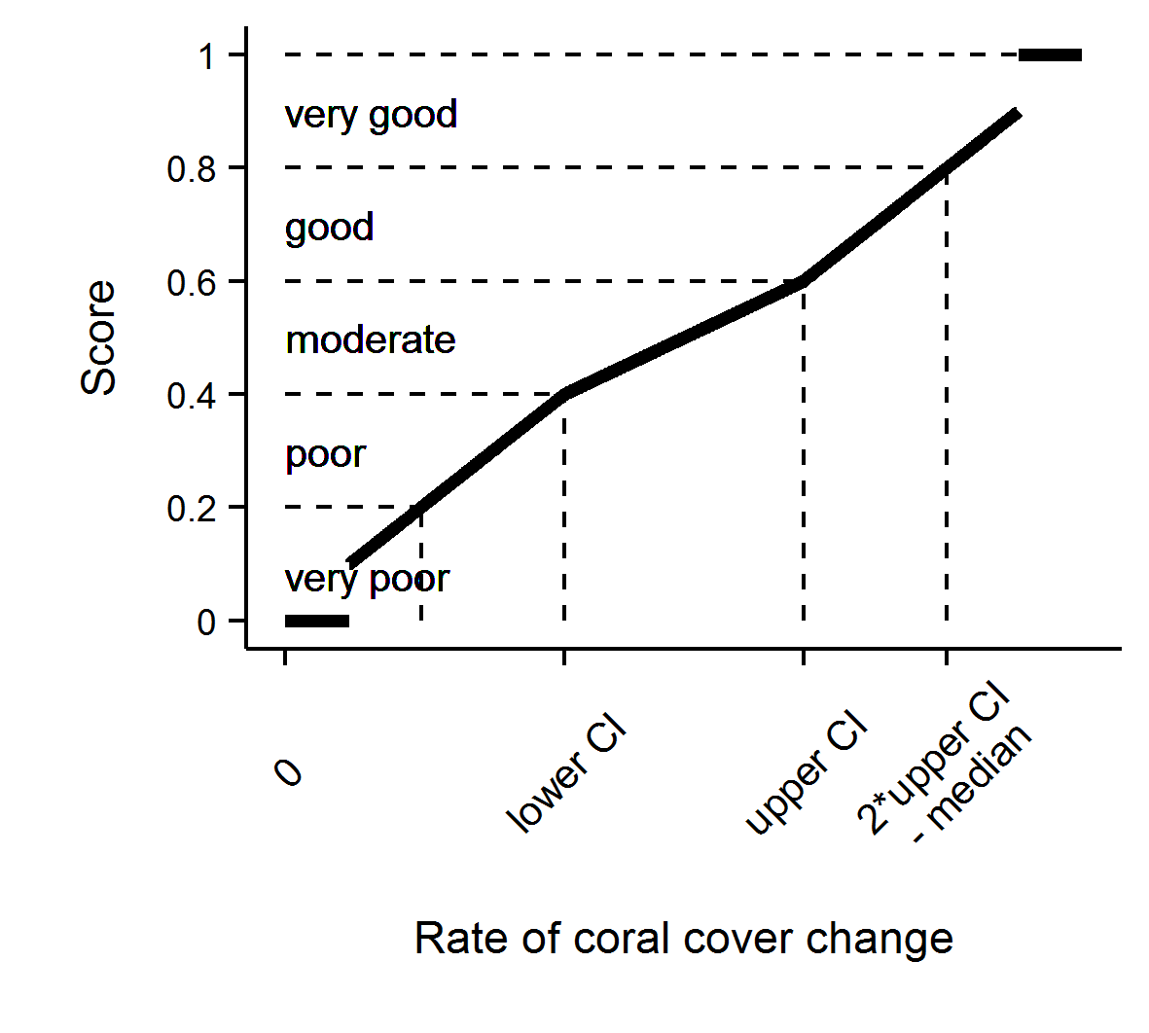
Figure 19: Scoring diagram for rate of change in hard coral cover metric

6.4.2 The response variables
Parameters input into the model from which the estimated rate of change is determined are the mean values for each reef and depth and year derived from the photo point intercept transects (Table 5).
Table 5: Source of variables required for estimation of the rate of change indicator
Variable | AIMS Oracle database table source
Acr : Cover of the Family Acroporidae | REEFMON_OT_FAMILY_SUMMARY_ZEROS where FAMILY_DESC is “ACROPORIDAE”
OthC: Cover of all other hard corals | REEFMON_OT_GROUP_SUMMARY_ZEROS  where GROUP_CODE is “HC” minus the cover of Acroporidae
SC: Cover of soft corals | REEFMON_OT_GROUP_SUMMARY_ZEROS where GROUP_CODE is “SC”
EstK: which is the proportion of the transect not occupied by deposits of sand or silt (AB) | REEFMON_OT_GROUP_SUMMARY_ZEROS where GROUP_CODE is “AB” and
Sample information including date, reef and depth | REEFMON_V_IN_SAMPLE and REEFMON_V_RM_SAMPLE
Disturbance categorization used to exclude observations when disturbances had occurred | REEFMON_IN_DISTURBANCE and REEFMON_DISTURBANCE.DISTURBANCES

6.5 Metric 4: Juvenile hard coral density
Common disturbances to inshore reefs include cyclones (often associated with flooding), thermal bleaching, and outbreaks of crown-of-thorns seastar, all of which can result in widespread mortality of corals (e.g. Sweatman et al. 2007, Osborne et al. 2011). Recovery from such events is reliant on both the recruitment of new colonies and regeneration of existing colonies from remaining tissue fragments (Smith 2008, Diaz-Pulido et al. 2009). Previous studies have shown that elevated concentrations of nutrients, agrochemicals, and high turbidity can negatively affect reproduction in corals (reviewed by Fabricius 2005, van Dam et al. 2011 Erftemeijer et al. 2012). Furthermore, high rates of sediment deposition and accumulation on reef surfaces can affect larval settlement (Babcock & Smith 2002, Baird et al. 2003, Fabricius et al. 2003) and smother juvenile corals (Harrison & Wallace 1990, Rogers 1990, Fabricius & Wolanski 2000). Any of these water quality-related pressures on the early life stages of corals have the potential to suppress the resilience of communities reliant on recruitment for recovery. For these reasons the density of juvenile corals is an important indicator of coral community resilience, especially in periods following severe disturbance events. The density of juvenile corals represents the culmination of importance demographic processes from fecundity through fertilisation, planula survival, settlement and early post settlement survival.
The setting of a threshold against which to assess observed densities of juvenile corals is problematic as detailed demographic studies that allow the estimation of adequate levels of recruitment to ensure coral community resilience have not been undertaken for the range of communities present in the turbid inshore waters of the GBR. For the MMP, the thresholds used until 2014 were based on the distribution of densities observed at the beginning of the program in 2005 as a baseline condition (Table 7).

6.5.1 The response variable
Prior to analysis of the MMP and LTMP data aimed at further refining juvenile density scoring thresholds a decision needed to be made on the appropriate response variable to use. The MMP counts juvenile corals in three size classes: 0 to <2cm, 2cm to < 5cm and 5cm to 10cm and has previously reported juvenile density as derived from the combined number of colonies in all these size classes. In contrast, the LTMP includes a single size class of 0 to 5 cm diameter. Experience gained over the MMP has shown that as colony size increases it becomes more difficult to confidently categorise a colony as a juvenile (i.e. the result of settlement and growth of a coral larvae) as opposed to the product of colony fragmentation or partial mortality. It is also apparent that as colony size increases the age of the colony becomes less defined and it is very likely that corals in the 5-10cm size class represent increasing proportions of mature colonies of species with typically small colony size of indeterminate age as opposed to juveniles of <3 years of age, which was the original intention of the size classes selected. In the interests of: keeping this indicator consistent across the MMP and LTMP data sets, reducing ambiguity in terms of colony status as a juvenile, and narrowing the likely age range of colonies classified as juveniles, only colonies up to 5cm in diameter are considered as the response variable for juvenile densities for the revised juvenile density indicator. In addition, at a subset of reefs there are high numbers of juvenile corals of the genus Fungia. Fungia are small, free-living corals that reproduce by repeatedly budding off individuals from an attached polyp: this genus is excluded from estimates of hard coral juvenile density.
The number of juvenile colonies observed along fixed-area transects may be biased due to the different proportions of substratum available for coral recruitment. For example, live coral cover effectively reduces the space available for settlement, as do sandy or silty substrata onto which corals cannot settle. To create a comparative estimate of the density of juvenile colonies between reefs and through time, the numbers of juveniles observed along fixed transects are converted to densities per area of transect that is ‘available’ to settlement, as:
$${Juv}_{den}=\frac{{Juv}_{abun}}{(Transect area*Proportion Available)}$$
Where;
${Juv}_{abun}$ is the observed abundance of juvenile hard coral colonies < 5cm in diameter (database table REEFMON_V_DEMOG_ZEROS, field ABUNDANCE, where field SIZE_CLASS= ('000-002' or '002-005' (MMP), or ‘RM_JUV’ (LTMP). Genus Fungia is excluded.
$Transcect area$ is the area of the belt transect, 34 m² for MMP and 8.5m² for LTMP
$Proportion Available$ is the proportion of transect occupied by algae (database table REEFMON_GROUP_SUMMARY_ZEROS, field COVER, where GROUP_CODE=’A’).

An issue that emerged following a period of flooding was that there was a continuum from algae (which are collectively considered as occupying space available to coral settlement) through to silt (which is not considered suitable settlement substrate). In sheltered sites it is the accumulation of silt on otherwise suitable substrate that is a plausible consequence of increased supply of fine sediments on coral community recovery. To resolve the issue that fluctuations in siltation vary the estimate of available substrate, a new code was implemented into the photo transect data in 2015 that differentiates between silt deposits that are effectively a soft bottom substrate (POINT_CODE =132) and silt that is potentially transient on what would otherwise be a potential coral settlement substrate (POINT_CODE=698). In practice points are classified as transient silt where the structure of the underlying hard substrate is discernible. A very general approximation of deposits less than 5mm depth could be assumed. Importantly the at the GROUP_CODE level POINT_CODE 698 maps to “A” and so is classified as available substrate. There is some residual ambiguity in the categorisation along a continuum although this is an improvement on the previous situation that included only the code 132. All MMP points classified as 132 from 2006 through to 2014 have been reassessed and changed to transient silt where appropriate.

6.4.2 Selection of threshold values and scoring
The now 11-year time series of the MMP along with juvenile density data from the LTMP since 2006, provide guidance for the setting of ecologically relevant thresholds. Graham et al. (2015) provide a binomial model to estimate the threshold between a high likelihood for coral communities after a severe bleaching event to recover toward coral dominance or to remain in a macroalgal-dominated state. Within the LTMP and MMP time series there are 72 observations where coral cover was low (<10%) and subsequent recovery rate could be estimated. These observations allowed a similar analysis as that used by Graham et al. 2015 to identify the threshold of juvenile density at which recovery (in coral cover) was more likely than not, to achieve modelled expectations. This analysis involved the application of a binomial model to juvenile densities categorised on the basis of the observed change as either falling below or above the predicted lower estimate of hard coral cover increase, as estimated by the coral change indicator described above. We acknowledge that this analysis is potentially confounded by increase in cover due to growth of non-juvenile corals though argue that this confounding is limited by the consideration of recovery rates at low coral cover based on the expectation that as cover decreases the relative influence of survival and growth of juvenile colonies on recovery will increase compared to that resulting from the growth of larger colonies. This analysis identified a threshold of 4.6 juveniles per m⁻² beyond which the probability that coral cover would subsequently increase at predicted rates outweighed the probability of lower than predicted rates of recovery (Figure 20). Adding some weight to the selection of these thresholds is that density of 4.6 juveniles per m⁻² at which the probability of recovery became greater than 50% was broadly consistent with that reported by Graham et al. 2015 from the Seychelles. Graham et al. (2015) reported a density of 6.3 juveniles, <10 cm in size, per m⁻² – a figure that adjusted back to <5cm size class based on the proportions of <5cm to <10cm size classes on MMP reefs (56%) equates to 3.5 colonies m⁻². As the upper density of juvenile colonies is effectively unbounded, it is desirable to set an upper threshold for scoring purposes. The density at which the probability was > 80% for coral cover to recover at predicted rates was 13 juveniles per m⁻² and this density was chosen as the upper threshold. Based on the above analysis thresholds for the density of juvenile corals were set at 4.6 colonies m⁻² as the boundary between categorising this indicator as poor and moderate (score 0.4) and an upper bound set at 13 colonies per m⁻² (Figure 21). Densities below 4.6 colonies m⁻² down to 0 colonies m⁻² were scaled linearly from 0.4 to 0, while those between the thresholds of 4.6 and 13 colonies m⁻² were scaled linearly from 0.4 to 1, any densities higher 13 colonies m⁻² were scored as 1 (Figure 21).
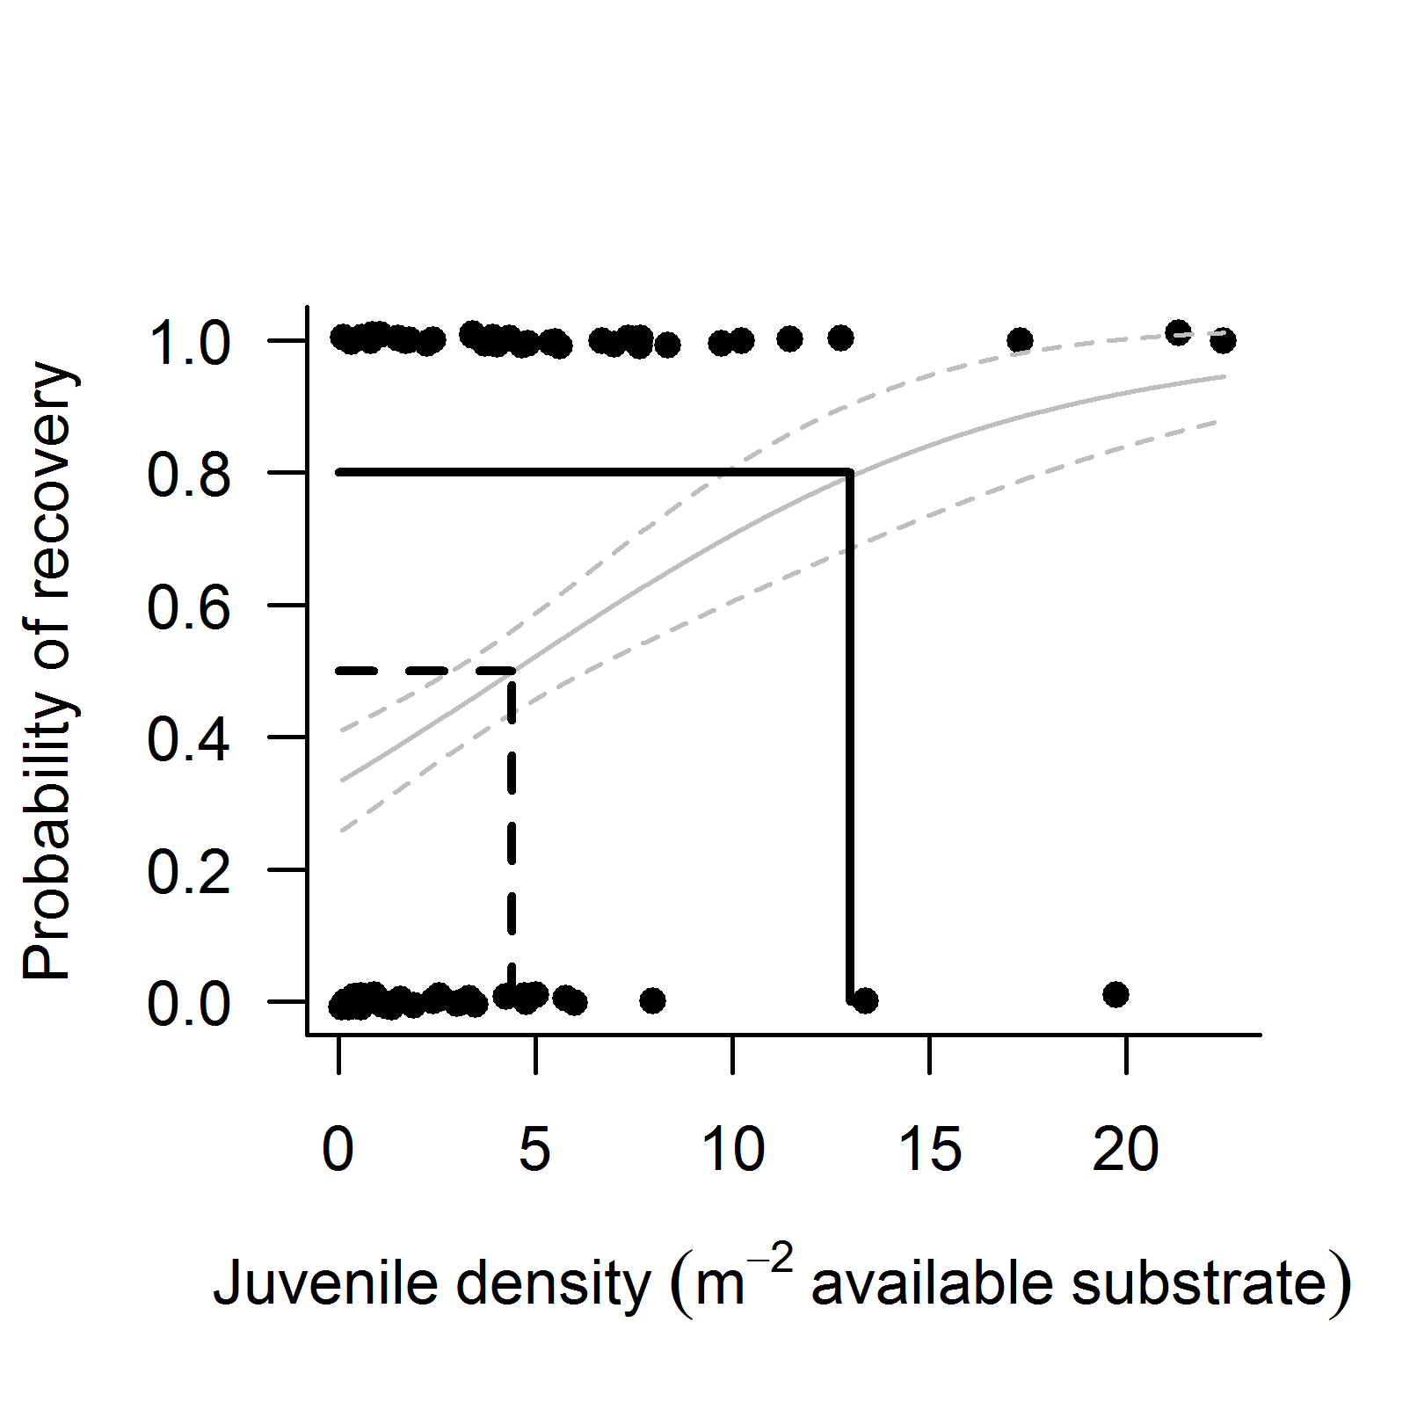
Figure 20: Relationship between juvenile density and probability of hard coral cover recovery.
Prediction from a binomial model relating probability that a coral cover will increase at model-predicted rates (see section 4.3), given observed density of juvenile hard corals. Imposed lines identify juvenile densities at which the probability of attaining predicted rates of recovery of coral cover are 50% (dashed line) or 80% (solid line).

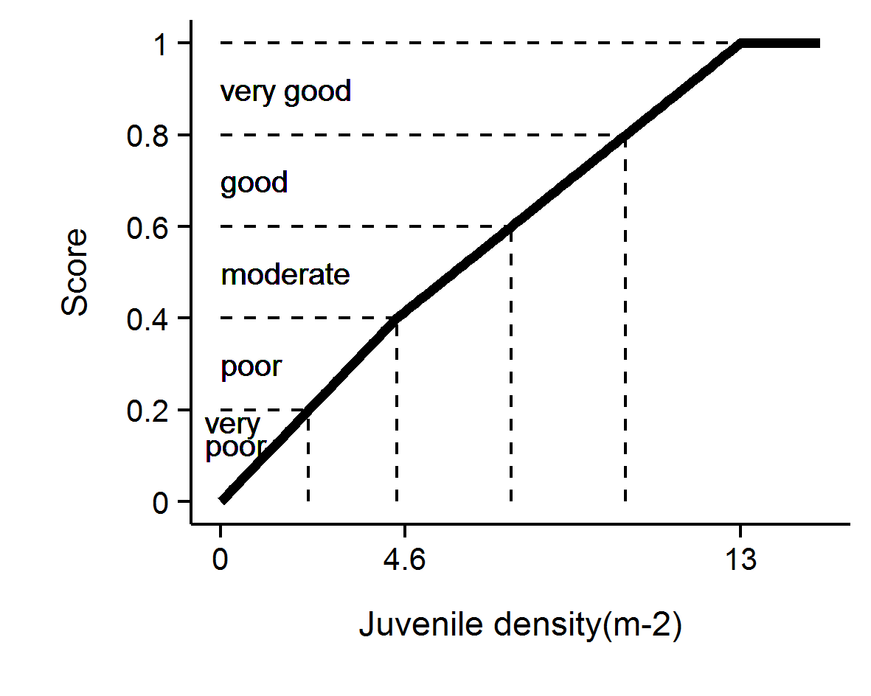
Figure 21: Scoring diagram for Juvenile density metric.

6.6 Metric 5: Changes in community composition of hard corals
The coral communities monitored by the Marine Monitoring Program (MMP) vary considerably in the relative composition of coral species (Uthicke et al. 2010, Thompson et al. 2014a, Section A 1 of this report). As demonstrated by Uthicke et al. (2010) and Fabricius et al. (2012), some of this variability can be attributed to differences in environmental conditions between locations, which implies selection for certain species based on the environmental conditions experienced. Coral communities respond to environmental conditions in a variety of ways. Most noticeably they respond to acute shifts in conditions such as exposure to substantially reduced salinity (van Woesik 1991, Berkelmans et al. 2012), deviations from normal temperature (Hoegh-Guldberg 1999) or hydrodynamic conditions (cyclones); all of which result in reductions in coral cover as susceptible species are killed. In contrast, the increased loads of sediments and nutrients entering the Reef as a result of land use practices in the adjacent catchments (Waters et al. 2014) may include a combination of acute conditions associated with flood events and then chronic change in conditions as pollutants are cycled through the system. Chronic change in conditions could provide a longer period of selective pressures as environmental conditions disproportionately favour recruitment and survival of species tolerant to those conditions.
A new indicator added to the MMP in 2015 assesses change in the composition of coral communities in terms of the changing balance between genera with varying susceptibilities to poor water quality. The underling concept for this indicator is that the environmental conditions of a location impose selective pressure on the communities and changes in community composition through time can be assessed as reflecting a shift toward communities that are typical of either better or worse water quality than those originally observed.

6.6.1 The response variable
The metric for assessing change in coral community composition is enabled by estimating the differential representation of genera along a water quality gradient (Table 6). The scores presented in Table 6 were derived by Thompson et al. 2014b, following the procedure outlined below:
- For each MMP reef and depth the mean cover of coral genera (split additionally into lifeforms for the genus Acropora and Porites) over the period 2005 to 2014 was calculated.
- A regionally-adapted, physics-based ocean colour algorithm (Brando et al. 2012, Schroeder et al. 2007, 2012) was used to derive daily means of chlorophyll and total suspended solids concentration for a grid of nine, 1 km² pixels adjacent to each coral monitoring site over the period 2002-2012. For each reef the median and 90th percentiles of all observations of chlorophyll and total suspended solids from each reef were calculated and a principle components analysis used estimate a single water quality score (the scores along the first principle component) for each reef.
- The sediment composition at each reef was similarly reduced to a single score by extracting the site scores along the first principle component run on sediment variables: organic carbon and nitrogen content along with the proportion of grain-size less than 63 µm (clays and silts) averaged over samples collected between 2007 and 2013.
- Prior to analysis, the coral community data was Hellinger-standardised. This standardisation divides the square root of the cover for each genus by the sum of square root covers for all genera at that reef (Legendre & Gallagher 2001). Hellinger-standardisation has the dual effect of down-weighting the influence of abundant species and focusing the analysis on relative cover (composition) rather than cover. The focus on compositional cover has a particular advantage for analyses of time-series of community composition as fluctuations in cover due to disturbance events bear less weight than shifts in comparative abundance among the groups present.
- The water quality gradient described by the scores along the first principal component of the water quality variables (from 2.) was used as the explanatory variable in a partial Canonical Analysis of Principal Coordinates (partial CAP; Anderson & Willis 2003). From this partial CAP analysis, the magnitude and direction of response for each genus group to the water quality gradient was extracted as the genus group scores along the constrained axis (Table 6, Oksanen et al. 2013). For the 2 m depth, the constrained axis of the partial CAP explained 13.3% of the variation in community compositions once the effects of Region and sediment composition had been accounted for, compared to the 19% explained at 5 m depth where only regional effects were first removed.

Table 6: Genus group scores along constrained water quality axis at each depth
* indicates genus group with both low cover (maximum < 0.5% on any reef) and limited distribution (present on < 25% of reefs).
Genus | 2 m | 5 m | Genus | 2 m | 5 m
Psammocora | -0.194 | -0.366 | Submassive Porites | -0.047 | -0.005
Turbinaria | -0.279 | -0.307 | Submassive Acropora | 0.043 | -0.004
Goniopora | -0.320 | -0.304 | Halomitra * |  | -0.002
Goniastrea | -0.115 | -0.278 | Plerogyra | 0.002 | -0.001
Pachyseris | -0.077 | -0.235 | Lithophyllon* |  | -0.001
Favites | -0.096 | -0.230 | Tubastrea* | 0.005 | -0.000
Alveopora | -0.076 | -0.221 | Scolymia * | 0.001 | 0.000
Hydnophora | -0.047 | -0.213 | Ctenactis * | 0.016 | 0.001
Cyphastrea | -0.386 | -0.193 | Anacropora * |  | 0.001
Galaxea | -0.081 | -0.159 | Physogyra | 0 | 0.001
Mycedium | -0.017 | -0.151 | Cynarina * | -0.000 | 0.004
Favia | -0.134 | -0.136 | Sandalolitha* | 0.003 | 0.005
Pectinia | -0.030 | -0.126 | Montastrea | 0.019 | 0.005
Podobacia | -0.025 | -0.122 | Fungia | 0.013 | 0.015
Plesiastrea | -0.125 | -0.114 | Encrusting Acropora | 0.048 | 0.015
Echinophyllia | -0.002 | -0.11 | Acanthastrea * | -0.014 | 0.017
Moseleya * | -0.058 | -0.091 | Symphyllia | 0.034 | 0.018
Oxypora | -0.008 | -0.076 | Seriatopora | 0.05 | 0.027
Merulina | -0.01 | -0.073 | Stylophora | 0.035 | 0.033
Coscinaraea | -0.011 | -0.062 | Oulophyllia | 0.02 | 0.037
Duncanopsammia * |  | -0.042 | Digitate Acropora | 0.034 | 0.039
Caulastrea | 0.007 | -0.041 | Montipora | -0.131 | 0.045
Platygyra | 0.048 | -0.040 | Leptastrea * | 0.022 | 0.048
Herpolitha | -0.013 | -0.034 | Coeloseris | 0.052
Lobophyllia | 0.018 | -0.034 | Bottlebrush Acropora | 0.153 | 0.070
Pavona | -0.152 | -0.024 | Pocillopora | 0.058 | 0.074
Astreopora | 0.031 | -0.023 | Branching Porites | 0.059 | 0.075
Euphyllia | -0.012 | -0.023 | Leptoria | 0.054 | 0.077
Leptoseris | -0.011 | -0.021 | Porites rus | 0.122 | 0.087
Palauastrea * | 0.002 | -0.021 | Echinopora | 0.076 | 0.096
Polyphyllia * | 0 | -0.020 | Massive Porites | -0.054 | 0.122
Heliofungia | 0.015 | -0.007 | Diploastrea | 0.003 | 0.173
Catalaphyllia * | -0.002 | -0.006 | Tabulate Acropora | 0.052 | 0.224
Stylocoeniella * | 0.004 | -0.006 | Corymbose Acropora | 0.060 | 0.240
Pseudosiderastrea * | -0.001 | -0.006 | Branching Acropora | 0.657 | 0.810
Gardineroseris * | -0.004

The genus scores along the single derived water quality variable (Table 6) can be used to scale the cover estimates from any reef or year to predict the location of the community along the water quality gradient, based on the relative cover of genus groups. It is this scaling of observed compositional data relative to the combined water quality variable that is at the core of this indicator.
For each observation of community composition, the location of that community along the water quality gradient is calculated as the sum of the Hellinger-transformed cover estimates for each genus multiplied by the genus score along the water quality gradient.
$$C_{t}= \sum_{i=1}^{n}{H_{it}*G_{i}}$$
Where $C_{t}$ = the community composition location along the WQ gradient at time $t$,
$H_{it}$ = the Hellinger transformed cover of genus $i$ at time $t$, and
$G_{i}$ = the score for genus $i$ taken from Table 6.

6.6.2 Coral composition indicator metric scoring
Indicator scores are assigned based on the location of $C_{t}$ for the year of interest relative to a community specific baseline. For each community monitored (unique reef and depth combination) the baseline composition lies within the 95% confidence intervals about the mean $C_{t}$ from the first five years of observations. The scoring of the indicator is categorical, being 0.5 when $C_{t}$ falls within the 95% confidence intervals for the location, 1 if beyond the confidence interval in a direction toward communities in better water quality, and 0 if beyond the confidence interval in the direction of communities in poorer water quality (Figure 22).

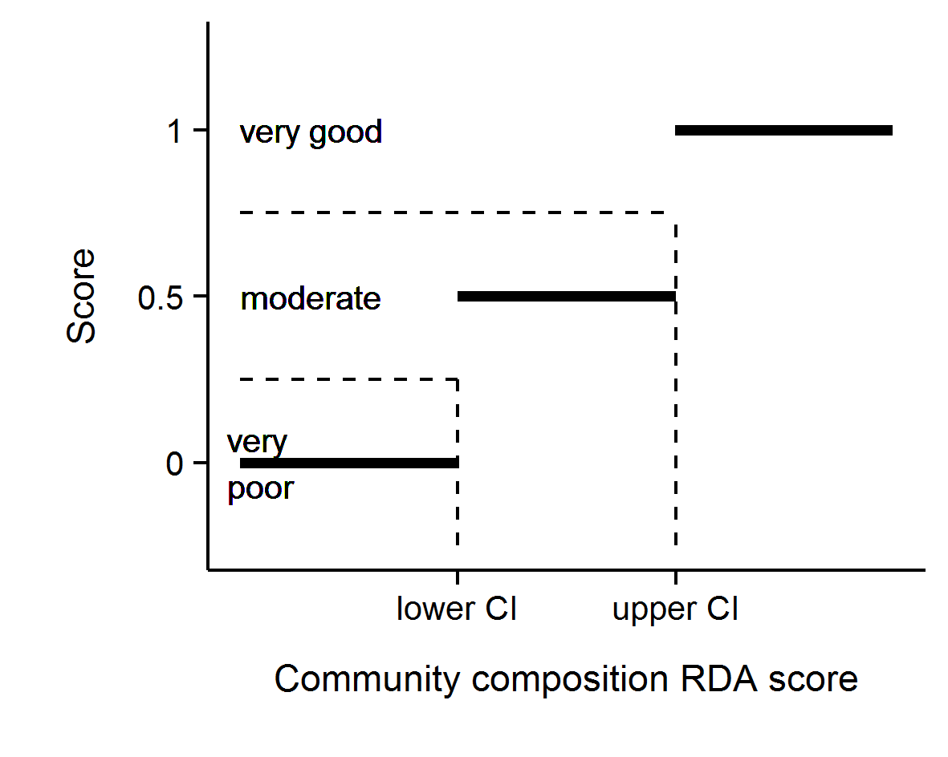
Figure 22: Scoring diagram for community composition indicator metric.

6.7 Aggregating indicator scores to regional-scale assessments
In aggregating scores for various indicators into a single index uncertainty should be considered. The degree of uncertainty in an index score derived for any spatial scale of interest will include uncertainty across multiple levels: from basic observational error, the relevance of thresholds and then variation in scores for different indicators or communities being assessed.
In order to derive report card scores for Regions a bootstrapping method was adopted, which propagated uncertainty through the double hierarchical aggregation of indicators and then reefs. Firstly, for each indicator a distribution of 10,000 observations was created by resampling (with replacement) from the observed scores for all reef and depth combinations within the Region. For the three sub-regions of the Wet Tropics an additional step involved the adding together of the three 10,000-strong distributions for each indicator from each sub-region, and resampling the resulting distributions (with replacement) 10,000 times to derive a single 10,000-strong distribution for each indicator at the regional scale. Secondly these five resulting (one for each indicator) distributions were added together and collectively resampled 10,000 times (with replacement) to derive a single distribution comprising 10,000 scores. Importantly, the large number of resamples ensures that the distributions accurately reflect the underlying data distributions and yet comprise a known number of items independent of the original input sizes. This ensures that all inputs have equal weights and aggregations are not biased towards inputs with more data (for example, all reefs and sub-regions contribute equally to region level aggregations despite there being more reefs in some sub-regions than others.
The mean of the resulting distribution for the sub/Region was taken as the coral index score. Confidence intervals are typically based on estimates of precision (such as standard error) rather than variance. Precision is itself an estimate of repeatability, in the case of precision of a mean it is an estimate of the variance of repeated means. Hence, we can estimate precision by repeatedly resampling from the distribution and each time calculating a mean. However, the more times the distribution is resampled, the more means are generated and thus the lower the variance of means.
To generate estimates of precision (and thus confidence intervals) appropriate for the scale of the sampling design, it is necessary to resample the distribution once for every original input (e.g. resample in proportion to the original sample size). This sample size is calculated by tabulating the number of unique items in the distribution (t) and then summing the division of the tabulated values by their minimum.

$$n= \sum{\frac{t}{min⁡(t)}}$$
Confidence intervals were then calculated as the 95% quantiles of repeated means.
Lastly index scores were converted to qualitative assessments by converting to a five point rating and colour scheme for scores rounded to 2 decimal places of:
- 0 to 0.20 were rated as ‘very poor’ and coloured red
- 0.21 to 0.40 were rated as ‘poor’ and coloured orange
- 0.41 to 0.60 were rated as ‘moderate’ and coloured yellow
- 0.61 to 0.80 were rated as ‘good’, and coloured light green
- 0.81 were rated as ‘very good’ and coloured dark green.

6.8 Comparison between revised and previously used coral index.
The indicators and the associated thresholds and scoring system utilised up until 2014 are summarised in Table 7. A comparison between coral index scores utilising the previous and revised methods demonstrates the consistency in the results obtained by the two methods (Figure 23). It is evident that the revised results are slightly less variable than those derived from the previous methods. This is to be expected given the inclusion of an additional three LTMP reefs in each of the Wet Tropics, Burdekin and Mackay Whitsunday Regions along with the additional indicator for community composition result in the index becoming less sensitive to change in individual indicators or at individual sites.

Table 7: Threshold values for the coral index metrics
Pre 2015 Report card index |  |  | New Report card index
Community attribute | Score | Thresholds | Community attribute | Score | Thresholds
Combined hard and soft coral cover | 1 | > 50% | Combined hard and soft coral cover | Continuous between 0-1 | 1 at 75% cover or greater
 | 0.5 | between 25% and 50% |  |  | 0 at zero cover
 | 0 | < 25%
Rate of increase in hard coral cover (preceding 3 years) | 1 | above upper confidence interval of model-predicted change | Rate of increase in hard coral cover (preceding 4 years) | 1 | Change > 2x upper 95% CI of predicted change
 |  |  |  | Continuous between 0.6 and 0.9 | Change between upper 95% CI and 2x upper 95% CI
 | 0.5 | within confidence intervals of model-predicted change |  | Continuous between 0.4 and 0.6 | Change within 95% CI of the predicted change
 |  |  |  | Continuous between 0.1 and 0.4 | Change between lower 95% CI and 2x lower 95% CI
 | 0 | below lower confidence interval of model-predicted change |  | 0 | change < 2x lower 95% CI of predicted change
Macroalgae cover | 1 | < 5% | Proportion of algae cover classified as Macroalgae | Continuous between 0-1 | ≤ reef specific lower bound and ≥ reef specific upper bound (Table 4)
 | 0.5 | stable between 5-15%
 | 0 | > 15%
Density of hard coral juveniles (<10cm diameter) | 1 | > 10.5 juvenile colonies per m² of available substratum (2m depth), or  > 13 juvenile colonies per m² of available substratum (5m depth) | Density of hard coral juveniles (<5cm diameter) | 1 | > 13 juveniles per m2 of available substrate
 | 0.5 | - between 7 and 10.5 juvenile colonies per m² of available substratum (2m depth), or  - between 7 and 13 juvenile colonies per m² of available substratum (5m depth) |  | Continuous between 0.4 and 1 | 4.6 to 13 juveniles per m2 of available substrate
 | 0 | < 7 juvenile colonies per m² of available substratum |  | Continuous between 0 and 0.4 | 0 to 4.6 juveniles per m2 of available substrate
 |  |  | Composition of hard coral community | 1 | Beyond 95% CI of baseline condition in the direction of improved water quality
 |  |  |  | 0.5 | Within 95% Confidence intervals of baseline composition
 |  |  |  | 0 | Beyond 95% CI of baseline condition in the direction of declined water quality
. *Settlement of coral spat is not considered in regional assessments.
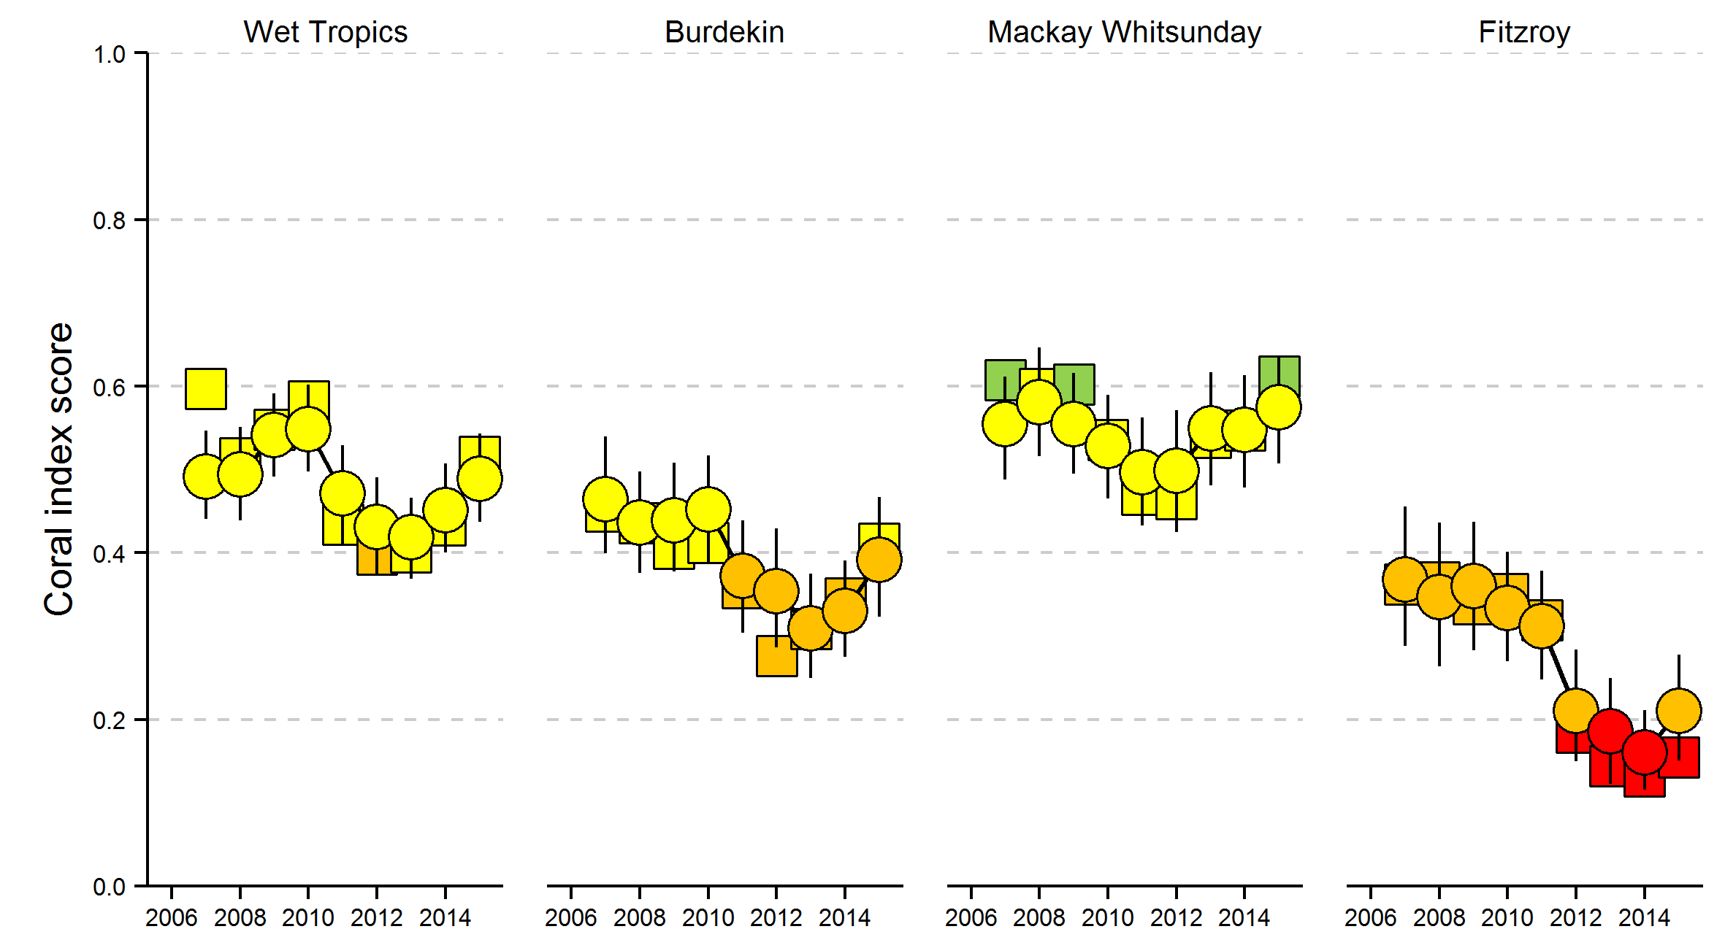
Figure 23: Comparison between the revised and original coral index scoring systems.
Revised scoring represented by round symbols and included error, original scoring system represented by square symbols. Colour coding reflects condition classification as per section 6.7

Conclusions
Observations presented in this report demonstrate recent improvements in the coral index in all regions. This improvement is consistent across most community resilience indicators and coincides with reduced loads of nutrients and sediments entering the Great Barrier Reef (the Reef) as runoff, as well as a recent reprieve from a period of frequent and intense acute disturbances over the last decade. The strong impact of acute disturbances such as: cyclones, bleaching, and outbreaks of crown-of-thorns seastars on coral communities impose an unavoidable confounding influence on assessments of ecosystem state. What has become increasingly apparent over the duration of the MMP is that it is the ability of coral communities to resist or recover from acute events that will allow their ongoing persistence. The role of water quality in altering the balance between rate and intensity of impacts associated with acute events and community’s subsequent recovery is the primary focus of the MMP with metrics contributing to the coral index having been formulated so as to focus on recovery potential of coral communities. The emerging pattern is that environmental conditions experienced during years of high inflow from the catchments are sufficient to suppress the recovery potential of coral communities. More positively the recent improvements in coral community condition imply the maintenance of recovery potential under conditions lower catchment input.
Results are discussed in terms of the Pressure, State and Impact components of a broader Driver-Pressure-State-Impact-Response (DPSIR) framework. This allows identification of some of the key pressures influencing coral community condition. In this context, there is a natural distinction between pressures that are beyond the realm of management under Reef Plan, such as acute disturbances associated with severe storms or cyclones, and those related more tangibly to water quality.
It is the recognition of the need to separate responses of coral communities to pressures associated with acute disturbances from those relating to the more chronic pressures associated with environmental conditions, and specifically water quality, that prompted the revision and improvement of the indicator metrics used to summarise coral community condition. Collectively the revised metrics:
- incorporate a continuous scoring system to more naturally scale deviations from metric thresholds,
- include additional time-series for inshore coral communities monitoring by the AIMS long-term-monitoring program to enhance the information base on which condition assessments are based, and
- reduce the inter-dependence of the indicator metrics and include community composition as an additional indicator that broadens the ecological basis of assessments.

These changes, while subtle, in combination allow a more intuitive interpretation of condition changes. However, we emphasise that region-level condition assessments do not vary substantially from those previously reported.

Pressures

Acute disturbances
Since MMP surveys began in 2005, substantial loss of coral cover occurred as a result of: thermal bleaching (Fitzroy Region 2006), Cyclone Larry (Wet Tropics and Burdekin regions 2006), Cyclone Ului (Whitsunday Region 2010), Cyclone Tasha (Wet Tropics 2011), Cyclone Yasi (Wet Tropics and Burdekin regions 2011), Cyclone Ita (Wet Tropics 2014), Cyclone Marsha (Fitzroy Region 2015), sub-cyclonic storms (Barron Daintree sub-region 2009, Burdekin 2009, Fitzroy 2008, 2010, 2013), predation by COTS (Wet Tropics 2012-2014) and exposure to low salinity flood waters (2m depths, Fitzroy Region in 2011). These disturbance events contribute strongly to the declines in coral community condition observed in all regions. Acute pressures most directly influence coral cover and contribute to between 43% of the coral cover lost at 5m depth in the Fitzroy region to greater than 90% in the Tully and Baron-Daintree sub-regions. These losses unavoidably translated into reductions in the scores for the coral cover indicator metric and contribute to declines in overall reef condition assessments following severe disturbance events. Each of the remaining four indictor metrics has been formulated to limit responsiveness to acute pressures so as to focus as directly as possible on changes in condition that can be interpreted as resulting from changes in water quality.

Chronic conditions - water quality
As the environment in which corals occur, water quality exerts a fundamental influence on the processes governing coral community composition and condition. Water quality in the inshore Reef shows a strong gradient, improving with distance from the coast and major rivers. Variation in benthic communities on coral reefs along this water quality gradient is evidence for the selective pressures imposed by water quality on coral reef communities (van Woesik & Done 1997, van Woesik et al. 1999, Fabricius et al. 2005, De’ath & Fabricius 2008, Uthicke et al. 2010, Fabricius et al. 2012), but also within individual reefs in response to localised hydrodynamic conditions (Uthicke et al. 2010, Thompson et al. 2010a, Browne et al. 2010). Such gradients and processes are a natural part of the Reef ecosystem, albeit under far lower levels of input of runoff-derived pollutants than presently occurs (Belperio & Searle 1988, Waters et al. 2014). The premise underpinning Reef 2050 Plan is that anthropogenic contaminant loads delivered by rivers sufficiently alter the environmental conditions in inshore Reef lagoon to suppress ecological resilience. It is the quantification of the compounding conditions along naturally occurring gradients as a result of runoff and any subsequent improvement under the Reef 2050 Plan that is the core focus of the water quality monitoring component of the MMP (see separate report by Lønborg et al., 2015).
For corals, the pressure relating to land management practices is the ‘state’ of marine water quality, which in turn is influenced by the pressure of contaminant loads entering marine waters as runoff. The loads of sediments, nutrients and pesticides exported by rivers into the Reef are strongly related to discharge volume. A crude comparison between the seven end-of-catchment load-monitoring sites in the Wet Tropics, Burdekin, Mackay Whitsunday and Fitzroy NRM regions, for which loads were estimated in both 2011 and 2015, show loads of total suspended solids, total nitrogen and total phosphorous that were delivered into the marine system to be in the order of 22, 9 and 13 times higher respectively in 2011 compared to 2015 when the combined discharge was 1/8th that of 2011 (data extracted from Turner et al. 2012, Garzon-Garcia et al. 2015).
The MMP river plume monitoring (see Lønborg et al., 2015, and key maps reproduced in this report) clearly shows that inshore Reefs monitored by MMP and the LTMP are directly exposed to elevated loads of sediments and nutrients carried by flood plumes. Variability in flood-delivered loads (Joo et al. 2012, Turner et al. 2011, 2012, Wallace et al. 2014, 2015, Garzon-Garcia et al. 2015) has however not been closely linked to variability in marine water quality conditions as measured by the MMP in-situ monitoring program. This is not unexpected given the complexity of nutrient cycling that occurs in marine waters, dilution of plumes, and the necessarily sparse in situ sampling regime of the long-term water quality monitoring program. It is evident from marine water quality time-series that the period of high discharge into the Reef (2008-2013) has resulted in a general increase in turbidity, oxidised forms of dissolved nitrogen (NOx) and dissolved organic carbon (DOC) that have persisted through to 2015. These observations suggest that the carbon and nutrient cycling processes in the Reef lagoon have undergone dramatic changes (Lønborg et al. 2015). Turbidity in the Reef lagoon is strongly influenced by variations in the inflow of particles from the catchment and resuspension by wind, currents and tides. The trends emerging from the MMP support other studies showing that the additional flux of fine sediment imported by rivers remains in the coastal zone for periods of months to years leading to chronically elevated turbidity and rates of sedimentation (Wolanski et al. 2008, Lambrechts et al. 2010, Brodie et al. 2012a, Thompson et al. 2012, Fabricius et al. 2013a, Fabricius et al. 2014, Fabricius et al. 2016). Any increase in turbidity associated with runoff will reduce the level of photosynthetically reactive radiation reaching the benthos - a key factor limiting coral distribution (Cooper et al. 2007, Muir et al. 2015).

Ecosystem State

Coral cover
For corals to persist in a location requires that they are able to survive extremes in environmental conditions but also maintain a competitive ability under ambient conditions. Although the coral cover metric is strongly influenced by disturbance events, low cover as a response to water quality pressures can also be inferred. COTS outbreaks at several inshore reefs in the Wet Tropics Region have resulted in a loss of coral cover with COTS being recognised as a major contributor to loss of coral cover in midshelf areas of the Reef also (Osborne et al. 2011, De’ath et al. 2012). The transport of coastal nutrients to the midshelf Reef has been associated with the initiation of COTS outbreaks (Brodie et al. 2005, Fabricius et al. 2010, Furnas et al. 2013, Wooldridge & Brodie 2015). Additionally, there are number of reefs monitored at which coral cover has remained low and not increased during periods free from acute disturbance events. The majority of these reefs have had a persistent cover of macroalgae strongly implying an environmental suppression of coral cover to recovery. High turbidity and / or nutrient levels do not however preclude high cover of corals on inshore reefs. In the Mackay Whitsunday Region, for example, turbidity is regionally high and coral cover has been consistently high. This observation demonstrates the importance of disturbance history but also community composition when considering coral cover as the high cover maintained in the Mackay Whitsunday region is influenced both by a lack of acute disturbances in recent decades as well as the selection for species tolerant of high turbidity.

Rate of change in coral cover
The rate of change indicator estimates the rate of change in coral cover (growth) during years free from acute disturbances. An adequate rate of coral cover increase is essential to ensure the long term balance between cover lost to disturbances and that regained during periods of ambient conditions. The indicator for rate of cover change has shown general declines in most regions through to 2014. These declines in rate of cover increase coincided broadly with the period of high loads of sediments and nutrients entering the reefs and, in turn, the increases in NO_{x}, turbidity and DOC (Joo et al. 2012, Turner et al. 2012, 2013, Wallace et al. 2014, 2015 Lonborg et al. 2015). DOC constitutes the major carbon source for heterotrophic microbial growth in marine pelagic systems (e.g. Lønborg et al. 2011) and increases in DOC have been shown to promote microbial activity and coral diseases (Kline et al. 2006, Kuntz et al. 2005). In each region we noted peaks in coral disease that corresponded to either the onset of flooding, or, in the case of the Johnstone Russell-Mulgrave region, changed water quality that preceded flooding in that catchment but corresponded with flooding in catchments to the south. The conclusion that environmental conditions associated with increased loads of sediments and nutrients have been sufficiently stressful to corals to reduce growth rates and/or induce disease in susceptible species is well supported by previous observations linking nutrients and organic matter availability to higher incidence and severity of coral disease (Bruno et al. 2003, Haapkylä et al. 2011, Vega Thurber et al. 2013).
In the pie diagrams that are used in this report to illustrate causes of coral loss within the regions the shortfall in observed increase in cover compared to that predicted based on the coral growth model are categorised into a variety of acute disturbances, “disease” and “none”. In practice, disease is only noted as a disturbance when highly prevalent as a way in capturing obvious outbreaks explicitly in the data. In reality disease prevalence occurs along a continuum from very low levels on individual colonies to major outbreaks infecting a high proportion of susceptible species. The mortality of sensitive species as a result of disease indicates a selection pressure for species not tolerant or adapted to the environmental conditions realised at the site. It is reasonable to interpret the combined loss of coral to “disease” and “none as representing the relative influence of chronic environmental pressures on the rate that coral communities can recover. In addition to influencing the coral change metric through disease, regression tree analyses indicated that macro-algal abundance was linked to nutrient availability and in turn limited coral change. These are just two examples of the way in which environmental conditions can influence recover rates of coral cover and demonstrate that differing mechanisms of influence may be expected dependant on community type and position along a water quality gradient.

Composition
It is well documented that compositional differences in coral communities occur along environmental gradients (Done 1982, van Woesik & Done 1997, van Woesik et al. 1999, Fabricius et al. 2005, De’ath & Fabricius 2008, Browne et al. 2010, De’ath & Fabricius 2010, Thompson et al. 2010a, Uthicke et al. 2010, Browne et al. 2012, Fabricius et al. 2012). The relationships between disease and altered environmental conditions presented above demonstrates the dynamic nature of coral community selection occurring on inshore reefs, with sensitive species gaining a foot-hold during relatively benign conditions, only to be removed during periods of environmental conditions beyond their tolerance. The newly included coral community composition indicator tended to decline along with coral cover indicating the disproportionate loss of species sensitive to water quality. The genus most susceptible to poor water quality is Acropora. This genus is also fragile and very susceptible to loss of cover during cyclones, as well as being a preferred prey group for COTS (Pratchett 2007). This means that these declines, and the subsequent recovery, cannot unambiguously be interpreted as representing a response to and subsequent release from water quality pressures alone. Over the longer term, however, there is evidence that the representation of Acropora on reefs in the Burdekin region has declined since the mid-20th century, possible as a result of increased runoff from the adjacent catchments (Roff et al. 2013). As a rapidly growing and diverse group the reduced representation of Acropora will have a logical impact on both the rate of recovery of coral cover and diversity on inshore reefs.

Macroalgae
Macroalgae generally benefit from increased nutrient availability due to runoff (e.g., Schaffelke et al. 2005) and, as coral competitors, supress both coral growth and juvenile settlement or survival (e.g., Tanner 1995, McCook et al. 2001, Birrell et al. 2005, 2008). There was a clear relationship between chlorophyll a concentration – a proxy for nutrient availability and the proportion of macroalgae, demonstrated in our analyses aimed at determining reef-specific macroalgae indicator metric thresholds. The occurrence of macroalgae was much higher on reefs with chlorophyll a concentrations > 0.4 µgL⁻¹, which is in close agreement to the analysis of De’ath & Fabricius (2008) and the resulting guideline of 0.45 µgL⁻¹ (GBRMPA 2010). Unlike the coral indicators that are plausibly responsive to environmental extremes, macroalgae must persist throughout a substantial period of the year suggesting that ambient water quality levels may be more important than extremes. Despite our development of reef specific thresholds for macroalgae in 2015 this indicator is strongly biased toward low scores at the reefs with poorer water quality. This arose due the proportion of macroalgae on reefs with high long-term median chlorophyll a being consistently at levels likely to have detrimental influences on coral recruitment and growth.
It is important to note that the relationship between high chlorophyll concentration and macroalgae cover is correlative only and does not indicate a proven cause-effect relationship. Chlorophyll may be a proxy for other environmental variables or ecological processes that influence macroalgae on inshore reefs. Wismer et al. (2009) and Cheal et al. (2013), for example, demonstrate a decline in herbivorous fish populations with increasing turbidity. Grazing is a key process for the control of macroalgal blooms and there is a wealth of research demonstrating the importance of the maintenance of herbivore populations to avoid a phase shift to macroalgae (e.g. Hughes et al. 2007). Within the Burdekin region Hughes et al. 2007 demonstrated that dense macroalgal communities could be supported in the absence of grazing on a reef with generally low cover of fleshy macroalgae, partly divorcing macroalgae biomass from direct relationship to nutrient levels alone. The relative influences of herbivory and nutrients on coral reef macroalgae is undoubtedly complex and likely to “depend on the species, circumstances and life-history processes under consideration” (Diaz-Pulido & McCook 2003). Irrespective of the underlying mechanism limiting macroalgae on reefs with lower chlorophyll a concentrations our results do demonstrate that the nutrient availability where chlorophyll a concentrations are above guideline values are sufficient to support macroalgal biomass at levels detrimental to coral community resilience.

Juvenile density
The density of juvenile corals has remained stable or improved in all regions since 2013. This reverses the declining trends that coincided with the period of high nutrient, sediment and pesticide loads entering the Reef from 2008-2012. The early life history stages of corals are sensitive to a range of water quality parameters that vary in response to runoff (see Fabricius 2011 for a synthesis). The observed declines in the number of juvenile corals occurred at reefs across the range of exposures to poor water quality, which indicates that the causes of these declines are not clearly linked to a single environmental threshold. Rather, the stressors influencing larval settlement and/or subsequent survival are likely to vary across environmental gradients. Confounding direct links between water quality and coral recruitment will be secondary influences of water quality, such as the presence/absence of persistent macroalgal communities, as well as factors like reduced brood-stock due to disturbance events that are not linked directly to water quality. As this indicator aggregates over at least 2 cohorts of juvenile corals, the influence of acute disturbances that remove juvenile corals will lead to a reduction in juvenile densities for at least 2 years. The density of juvenile corals remains low in both the Barron Daintree sub-region, where Cyclone Ita substantially impacted communities in 2014, and the Fitzroy Region where a high cover of macroalgae has persisted at most reefs and flooding in 2011 has resulted in a marked reduction of local broodstock by removing a high proportion of reef flat and shallow reef crest corals (Berkelmans et al. 2012, data herein).
In the Herbert Tully sub-region, the increase in juvenile density was predominantly due to very high numbers of the coral genus Turbinaria. As this genus was not well represented in the adult community prior to the successive cyclonic disturbances in 2006 and 2011, it is unclear whether this recruitment pattern is simply due to natural variability or indicates the selection for species more suited to the recent environmental conditions than those previously present. Although less extreme, the genus Turbinaria has also recruited in higher proportions to several of the more turbid water reefs in the adjacent Burdekin Region. In contrast, at a number of reefs at which water quality is better, increased number of juveniles of the genus Acropora indicates the recovery of this disturbance-sensitive group of coral.

Summary
The cumulative impacts of physical disturbance associated with tropical cyclones and storms along with elevated loads of contaminants introduced to the Reef over the last decade has resulted in clear declines in the condition of coral communities. Encouragingly, the release from these pressures in most regions over the last few years has resulted in observable recovery of communities, indicating a degree of resilience under location-specific ambient water quality conditions.
The emerging picture is that for coral communities the pressures associated with runoff are twofold. The location of sampling sites along underlying environmental gradients and adjacent to different catchments influences the exposure to the various components of runoff either as peak loads associated with flood plumes, or as more chronic conditions. It is increasingly apparent that, within a location, stress to coral communities is most obvious during extremes in environmental conditions that expose corals to conditions beyond those to which they are either adapted or acclimated. Links between coral disease, poor rates of increase in coral cover and declines in the community composition metric all point to water quality pressures experienced either during, or in the period of months following major floods as being sufficiently removed from ambient conditions so as to select against sensitive species on a site-by-site basis. Beyond the direct influence of water quality pressures the initiation of outbreaks of COTS have also been linked to increased nutrient loads delivered to the Reef lagoon during flood events, extending the influence of pulses of high nutrient loads to large tracts of the Reef (Fabricius et al. 2010, Caballes & Pratchett 2014, Wooldridge & Brodie 2015).
The ambient conditions of a site can influence the resilience of reef communities, for example by supporting a sustained high cover of macroalgae. In addition, degraded water quality may increase the susceptibility of corals to disturbance. Evidence from recent research into the interactions between water quality and climate change suggests that the tolerance to heat stress of corals is reduced by exposure to contaminants including nutrients, herbicides and suspended particulate matter (Wooldridge & Done 2004, Negri et al. 2011, Wiedenmann et al. 2013, Fabricius et al. 2013b). With the exception of the Fitzroy Region in 2006, the water temperatures have not shown substantial deviations from summer climatology over the first 10 years of the MMP. This does not however diminish the concern for inshore reefs given that persistence of altered water quality conditions and ongoing threat of summer temperature anomalies in a changing climate.
The amount and variability of rainfall has significantly increased in northern Australia over the past 100 years (Lough 2011) and the severity of disturbance events is projected to increase as a result of climate change (Steffen et al. 2013). Any increase in susceptibility to these disturbances as a result of local stressors will compound the pressures imposed on sensitive species and potentially lead to profound changes in coral communities for Reef inshore communities. At present, there is a limited understanding of the cumulative impacts of these multiple pressures. The GBRMPA Strategic Assessment identified this as a key knowledge gap and the management of these impacts as a major strategic challenge (GBRMPA 2014a). What can be concluded from the observed responses of coral communities on inshore reefs, and COTS population outbreaks, is the clear need to reduce the anthropogenic loads entering the Reef. In particular the loads carried during the larger flood events appear to have the most direct effect on coral community condition, and also incur a persistent change in ambient conditions.

Acknowledgments
We thank Aaron Anderson, Joe Gioffre, Charlotte Johansson, Kate Osborne, Shawn Smith, Marcus Stowar and Irena Zagorskis for valuable field assistance over the years. We also thank Ed Butler, Terry Done, Johanna Johnson, Katherine Martin and a number of anonymous reviewers for their detailed reviews that improved the previous reports on which this current instalment builds. Finally we acknowledge the valuable contributions to data collection, sampling integrity and reporting of John Carlton, Stephen Neale and Damian Thomson over the first few years of the monitoring program.

References
Álvarez-Romero JG, Devlin MJ, Teixeira da Silva E, Petus C, Ban N, Pressey RJ, Kool J, Roberts S, Cerdeira WA, Brodie J (2013) A novel approach to model exposure of coastal-marine ecosystems to riverine flood plumes based on remote sensing techniques. Journal of Environmental Management 119:194–207
Anderson MJ, Willis TJ (2003) Canonical analysis of principal coordinates: a useful method of constrained ordination for ecology. Ecology 84:511–525
Anon (2003) Reef Water Quality Protection Plan for catchments adjacent to the Great Barrier Reef World Heritage Area. The State of Queensland and Commonwealth of Australia. Queensland Department of Premier and Cabinet, Brisbane. 43p
Anon. (2009) Reef Water Quality Protection Plan 2009. For the Great Barrier Reef World Heritage Area and adjacent catchments. The State of Queensland and Commonwealth of Australia. Queensland Department of the Premier and Cabinet, Brisbane. 30 pp.
Anon. (2010) Paddock to Reef Integrated Monitoring, Modelling and Reporting Program Design (DRAFT) Version 12 February 2010. The State of Queensland, Queensland Department of the Premier and Cabinet, Brisbane. 93p
Anon. (2011) Reef Water Quality Protection Plan. First Report 2009 Baseline. The State of Queensland and Commonwealth of Australia. Queensland Department of Premier and Cabinet, Brisbane. 140 pp. Available at www.reefplan.qld.gov.au
Anon. (2013) Reef Water Quality Protection Plan 2013.Securing the health and resilience of the Great Barrier Reef World Heritage Area and adjacent catchments. The State of Queensland. Reef Water Quality Protection Plan Secretariat, Brisbane. 34 p. Available at www.reefplan.qld.gov.au
Anon. (2015) Great Barrier Reef report card 2014. Queensland Government,
http://www.reefplan.qld.gov.au/measuring-success/report-cards/2014/assets/gbr-2014report-card.pdf
Anthony KRN (1999) Coral suspension feeding on fine particulate matter. Journal of Experimental Marine Biology and Ecology 232:85-106
Anthony KRN, Fabricius KE (2000) Shifting roles of heterotrophy and autotrophy in coral energetics under varying turbidity. Journal of Experimental Marine Biology and Ecology 252:221-253
Ayling AM, Ayling AL (2005) The dynamics of Cairns and Central section fringing reefs: 2005 Unpublished report submitted to the Great Barrier Reef Marine Park Authority, Townsville.
Ayling A (1997) The biological status of fringing reefs in the Great Barrier Reef world heritage area. Proceedings of the State of the Great Barrier Reef World Heritage Area Workshop pp. 109-113
Babcock RC, Smith L (2002) Effects of sedimentation on coral settlement and survivorship. In: Proceedings of the 9th International Coral Reef Symposium, Bali, Indonesia, 245–248
Baird AH, Babcock RC, Mundy CP (2003) Habitat selection by larvae influences the depth distribution of six common coral species. Marine Ecology Progress Series 252:289-293
Bartley R, Corfield JP, Hawdon AA, Kinsey-Henderson AE, Abbott BN, Wilkinson SN, Keen RJ (2014) Can changes to pasture management reduce runoff and sediment loss to the Great Barrier Reef? The results of a 10-year study in the Burdekin catchment, Australia. The Rangeland Journal 36:67-84
Bartley R, Bainbridge ZT, Lewis SE, Kroon FJ, Wilkinson SN, Brodie JE, Silburn DM (2014) Relating sediment impacts on coral reefs to watershed sources, processes and management: A review. Science of the Total Environment 468–469:1138-1153
Belperio AP, Searle DE (1988) Terrigenous and carbonate sedimentation in the Great Barrier Reef province. In: J, D.L., H, R.H. (Eds.), Carbonate to Clastic Facies Changes. Developments in Sedimentology. Elsevier Science Publishers, Amsterdam, pp. 143–174
Bellwood DR, Hughes TP, Folke C, Nyström M (2004) Confronting the coral reef crisis. Nature 429:827-833
Berkelmans R, De’ath G, Kininmonth S, Skirving WJ (2004) A comparison of the 1998 and 2002 coral bleaching events on the Great Barrier Reef: spatial correlation, patterns, and predictions. Coral reefs, 23(1):74-83
Berkelmans R, Jones A, Schaffelke B (2012) Salinity thresholds of Acropora spp. On the Great Barrier Reef. Coral Reefs 31:1103-1110
Birrell CL, McCook LJ, Willis BL (2005) Effects of algal turfs and sediment on coral settlement. Marine Pollution Bulletin 51:408-414
Birrell CL, McCook LJ, Willis BL, Diaz-Pulido GA (2008a) Effects of benthic algae on the replenishments of corals and the implications for the resilience of coral reefs. Oceanography and Marine Biology: An Annual Review 46:25-64
Birrell CL, McCook LJ, Willis BL, Harrington L (2008b) Chemical effects of macroalgae on larval settlement of the broadcast spawning coral Acropora millepora. Marine Ecology Progress Series 362:129-137
Box SJ, Mumby PJ (2007) Effect of macroalgal competition on growth and survival of juvenile Caribbean corals. Marine Ecology Progress Series 342:139-149
Bradley P, Fore LS, Fisher W, Davis W (2010) Coral reef biological criteria: using the Clean Water Act to protect a national treasure. US Environmental Protection Agency
Brando VE, Dekker AG, Park YJ, Schroeder T (2012) Adaptive semi-analytical inversion of ocean color radiometry in optically complex waters. Applied Optics 51:2808-2833
Brinkman R, Herzfeld M, Andrewartha J, Rizwi F, Steinberg C, Spagnol S (2011) Hydrodynamics at the whole of GBR scale. AIMS Final Project Report MTSRF Project 2.5i.1, June 2011. Report to Reef and Rainforest Research Centre. Australian Institute of Marine Science, Townsville. 42pp
Brodie J, Binney J, Fabricius K, Gordon I, Hoegh-Guldberg O, Hunter H, O’Reagain P, Pearson R, Quirk M, Thorburn P, Waterhouse J, Webster I, Wilkinson S (2008) Synthesis of evidence to support the Scientific Consensus Statement on Water Quality in the Great Barrier Reef. The State of Queensland (Department of the Premier and Cabinet). Published by the Reef Water Quality Protection Plan Secretariat, Brisbane. 59pp
Brodie J, Fabricius K, De’ath G, Okaji K (2005) Are increased nutrient inputs responsible for more outbreaks of crown-of-thorns starfish? An appraisal of the evidence. Marine Pollution Bulletin, 51(1):266-278
Brodie JE, Kroon FJ, Schaffelke B, Wolanski EC, Lewis SE, Devlin MJ, Bohnet IC, Bainbridge ZT, Waterhouse J, Davis AM (2012b) Terrestrial pollutant runoff to the Great Barrier Reef: An update of issues, priorities and management responses. Marine Pollution Bulletin 65:81-100
Brodie J, Wolanski E, Lewis S, Bainbridge Z (2012a) An assessment of residence times of land-sourced contaminants in the Great Barrier Reef lagoon and the implications for management and reef recovery. Marine Pollution Bulletin 65:267-279
Brodie JE, McKergow LA, Prosser IP, Furnas MJ, Hughes AO, Hunter H (2003) Sources of sediment and nutrient exports to the Great Barrier Reef World Heritage Area. Australian Centre for Marine and Tropical Freshwater Research Report No. 03/11. James Cook University, Townsville
Browne NK, Smithers SG, Perry CT (2010) Geomorphology and community structure of Middle Reef, central Great Barrier Reef, Australia: an inner-shelf turbid zone reef subject to episodic mortality events. Coral Reefs 29: 683-689
Browne NK, Smithers SG, Perry CT (2012) Coral reefs of the turbid inner-shelf of the Great Barrier Reef, Australia: An environmental and geomorphic perspective on the occurrence, composition and growth. Earth-Science Reviews 115:1-20
Bruno JF, Petes LE, Harvell CD, Hettinger A (2003) Nutrient enrichment can increase the severity of coral diseases. Ecology Letters 6:1056-1061
Bruno JF, Sweatman H, Precht WF, Selig ER, Schutte VGW (2009) Assessing evidence of phase shifts from coral to macroalgal dominance on coral reefs. Ecology 90:1478-1484
Caballes CF, Pratchett MS (2014) Reproductive biology and early life history of the crown-of-thorns starfish. In: Whitmore E (Ed) Echinoderms: ecology, habitats and reproductive biology. Nova Science Publishers, New York, NY, USA
Carpenter KE, Abrar M, Aeby G, Aronson RB, Banks S, Bruckner A, Chiriboga A, Cortes J, Delbeek JC, DeVantier L, Edgar GJ, Edwards AJ, Fenner D, Guzman HM, Hoeksema BW, Hodgson G, Johan O, Licuanan WY, Livingstone SR, Lovell ER, Moore JA, Obura DO, Ochavillo D, Polidoro BA, Precht WF, Quibilan MC, Reboton C, Richards ZT, Rogers AD, Sanciangco J, Sheppard A, Sheppard C, Smith J, Stuart S, Turak E, Veron JEN, Wallace C, Weil E, Wood E (2008) One-Third of Reef-Building Corals Face Elevated Extinction Risk from Climate Change and Local Impacts. Science 321:560-563
Cheal AJ, , Emslie M, MacNeil MA, Miller I, Sweatman H (2013) Spatial variation in the functional characteristics of herbivorous fish communities and the resilience of coral reefs Ecological Applications, 23:174–188
Cheal AJ, MacNeil MA, Cripps E, Emslie M, Jonker M, Schaffelke B, Sweatman H (2010) Coral-macroalgal phase shifts or reef resilience: links with diversity and functional roles of herbivorous fishes on the Great Barrier Reef. Coral Reefs 29:1005-1015
Cooper TF, Gilmour JP, Fabricius KE (2009) Bioindicators of changes in water quality on coral reefs: review and recommendations for monitoring programmes. Coral Reefs 28:589-606
Cooper TF, Uthicke S, Humphrey C, Fabricius KE (2007) Gradients in water column nutrients, sediment parameters, irradiance and coral reef development in the Whitsunday Region, central Great Barrier Reef. Estuarine, Coastal and Shelf Science 74:458-470Darnell R, Henderson B, Kroon FJ, Kuhnert P (2012) Statistical power of detecting trends in total suspended sediment loads to the Great Barrier Reef. Marine Pollution Bulletin 65:203-209
De'ath G, Fabricius KE (2008) Water Quality of the Great Barrier Reef: Distributions, Effects on Reef Biota and Trigger Values for the Protection of Ecosystem Health. Research Publication No. 89. Great Barrier Marine Park Authority, Townsville, p. 104p
De'ath G, Fabricius KE (2010) Water quality as a regional driver of coral biodiversity and macroalgae on the Great Barrier Reef. Ecological Applications 20:840–850
De’ath G, Fabricius KE, Sweatman H, Puotinen M (2012) The 27-year decline of coral cover on the Great Barrier Reef and its causes. Proceedings of the National Academy of Sciences 190(44):17995-17999
Dennis B, Taper ML (1994) Density dependence in time series observations of natural populations: estimation and testing. Ecological Monographs 64:205-224
Department of Environment and Resource Management (2009) Queensland Water Quality Guidelines, Version 3. 167 p. Available at www.derm.qld.gov.au. ISBN 978-0-9806986-0-2
DeVantier L, De’ath G, Turak E, Done TJ, Fabricius KE (2006) Species richness and community structure of reef-building corals on the nearshore Great Barrier Reef. Coral Reef 25:329-340
Devlin M, McKinna LW, Álvarez-Romero J, Petus C, Abott B, Harkness P, Brodie J (2012) Mapping the pollutants in surface plume waters in the Great Barrier Reef, Australia. Marine Pollution Bulletin 65:224:235
Diaz-Pulido G, Harii S, McCook LJ, Hoegh-Guldberg O (2010) The impact of benthic algae on the settlement of a reef-building coral. Coral Reefs 29:203-208
Diaz-Pulido G, McCook LJ (2003) Relative roles of herbivory and nutrients in the recruitment of coral-reef seaweeds. Ecology 84:2026-2033
Diaz-Pulido G, McCook LJ, Dove S, Berkelmans R, Roff G, Kline DI, Weeks S, Evans RD, Williamson DH, Hoegh-Guldberg O (2009) Doom and Boom on a Resilient Reef: Climate Change, Algal Overgrowth and Coral Recovery. PLoS ONE 4(4): e5239
Done T, Turak E, Wakeford M, DeVantier L, McDonald A and Fisk D (2007) Decadal changes in turbid-water coral communities at Pandora Reef: loss of resilience or too soon to tell? Coral reefs 26:789–805
Done TJ (1982) Patterns in the distribution of coral communities across the central Great Barrier Reef. Coral Reefs 1:95-107
Erftemeijer PLA, Reigl B, Hoeksema BW, Todd PA (2012) Environmental impacts of dredging and other sediment disturbances on corals: A review. Marine Pollution Bulletin 64:1737-1765
Fabricius KE (2005) Effects of terrestrial runoff on the ecology of corals and coral reefs: Review and synthesis. Marine Pollution Bulletin 50:125-146
Fabricius KE (2011) Factors determining the resilience of coral reefs to eutrophication: a review and conceptual model. In: Dubinsky Z, Stambler N (Eds) Coral Reefs: An Ecosystem in Transition, Springer Press, pp.493-506
Fabricius KE, Cooper TF, Humphrey C, Uthicke S, De’ath G, Davidson J, LeGrand H, Thompson A, Schaffelke B (2012) A bioindicator system for water quality on inshore coral reefs of the Great Barrier Reef. Marine Pollution Bulletin 65:320-332
Fabricius KE, Cseke S, Humphrey CA, De’ath G (2013b) Does trophic status enhance or reduce the thermal tolerance of scleractinian corals? A review, experiment and conceptual framework. PLoS ONE 8 e54399
Fabricius KE, De’ath G (2001) Biodiversity on the Great Barrier Reef: Large-scale patterns and turbidity-related local loss of soft coral taxa. In Wolanski E (Ed) Biological-Physical Links: Oceanographic processes on the Great Barrier Reef. CRC Press, Boca Raton
Fabricius KE, De’ath G, Humphrey C, Zagorskis I, Schaffelke B (2013a) Intra-annual variation in turbidity in response to terrestrial runoff on near-shore coral reefs of the Great Barrier Reef, Estuarine Coastal and Shelf Science 116:57-65
Fabricius KE, De’ath G, McCook L, Turak E, Williams DMcB (2005) Changes in algal, coral and fish assemblages along water quality gradients on the inshore Great Barrier Reef. Marine Pollution Bulletin 51:384-396
Fabricius KE, Logan M, Weeks S, Brodie J (2014) Assessing inter- and intra-annual changes in water clarity in response to river run-off on the central Great Barrier Reef from 10 years of MODIS-Aqua data. Marine Pollution Bulletin 84:191-200
Fabricius KE, Logan M, Weeks SJ, Lewis SE, Brodie J (2016) Changes in water clarity in response to river discharges on the Great Barrier Reef continental shelf: 2002-2013. Estuarine Coastal and Shelf Science 173:A1-A15
Fabricius KE, Okaji K, De’ath G (2010) Three lines of evidence to link outbreaks of the crown-of-thorns seastar Acanthaster planci to the release of larval food limitation. Coral Reefs 29:593-605
Fabricius KE, Wild C, Wolanski E, Abele D (2003) Effects of transparent exopolymer particles and muddy terrigenous sediments on survival of hard coral recruits. Estuarine, Costal and Shelf Science 57:613-621
Fabricius KE, Wolanski E (2000) Rapid smothering of coral reef organisms by muddy marine snow. Estuarine, Costal and Shelf Science 50:115-120
Faithful J, Finlayson W (2005) Water quality assessment for sustainable agriculture in the Wet Tropics, a community assisted approach, Marine Pollution Bulletin 51:99-112
Fisher WS, Fore LS, Hutchins A, Quarles RL, Campbell JG, LoBue C, Davies WS (2008) Evaluation of stony coral indicators for coral reef management. Marine Pollution Bulletin 65:320-332
Foster NL, Box SJ, Mumby PJ (2008) Competitive effects of macroalgae on the fecundity of the reef-building coral Montastrea annularis. Marine Ecology Progress Series 367:143-152
Furnas M, Alongi D, McKinnon AD, Trott L, Skuza M (2011) Regional-scale nitrogen and phosphorus budgets for the northern (14°S) and central (17°S) Great Barrier Reef shelf ecosystem. Continental Shelf Research 31:1967-1990
Furnas M, Brinkman R, Fabricius K, Tonin H, Schaffelke B (2013) Linkages between river runoff, phytoplankton blooms and primary outbreaks of crown-of-thorns seastars in the Northern GBR. Chapter 3 in Waterhouse et al. Assessment of the relative risk of water quality to ecosystems of the Great Barrier Reef. Department of the Environment and Heritage Protection, Queensland Government, Brisbane
Furnas MJ, Mitchell AW, Skuza M, Brodie J (2005) In the other 90%: Phytoplankton responses to enhanced nutrient availability in the Great Barrier Reef lagoon. Marine Pollution Bulletin 51: 253-256
Garde LA, Spillman CM, Heron S, Beeden R (2014) ReefTemp Next Generation: A New Operational System for Monitoring Reef Thermal Stress, Journal of Operational Oceanography, 7:21-33
Garzon-Garcia A, Wallace R, Huggins R, Turner RDR, Smith RA, Orr D, Ferguson B, Gardiner R, Thomson B, Warne MStJ (2015) Total suspended solids, nutrient and pesticide loads (2013–2014) for rivers that discharge to the Great Barrier Reef – Great Barrier Reef Catchment Loads Monitoring Program. Department of Science, Information Technology and Innovation. Brisbane
Graham NAJ, Jennings S, MacNeil MA, Mouillot D, Wilson SK (2015) Predicting climate-driven regime shifts versus rebound potential in coral reefs. Nature 518(7537):94-97
Great Barrier Reef Marine Park Authority (2010) Water Quality Guidelines for the Great Barrier Reef Marine Park. Revised Edition 2010. Great Barrier Reef Marine Park Authority, Townsville. 100p
Great Barrier Reef Marine Park Authority (2012) Informing the outlook for Great Barrier Reef coastal ecosystems. Great Barrier Reef Marine Park Authority, Townsville
Great Barrier Reef Marine Park Authority (2014a) Great Barrier Reef Region Strategic Assessment. Great Barrier Reef Marine Park Authority, Townsville
Great Barrier Reef Marine Park Authority (2014b) Great Barrier Reef Outlook Report 2014, Great Barrier Reef Marine Park Authority, Townsville.
Great Barrier Reef Marine Park Authority (2016) Reef Rescue Marine Monitoring Program quality assurance and quality control manual. Great Barrier Reef Marine Park Authority, Townsville.
Haapkyla J, Melbourne-Thomas J, Flavell M, Willis B (2013) Disease outbreaks, bleaching and a cyclone drive changes in coral assemblages on an inshore reef of the Great Barrier Reef. Coral Reefs 32:815-824
Haapkylä J, Unsworth R, Flavell M, Bourne D, Schaffelke B, Willis BL (2011) Seasonal rainfall and runoff promote coral disease on an inshore reef of the Great Barrier Reef, Australia. PLoS One. 6(2): e16893
Halford A, Cheal AJ, Ryan D, Williams DMcB (2004) Resilience to large-scale disturbance in coral and fish assemblages on the Great Barrier Reef. Ecology 83: 1891-1095
Halpern BS, Frazier M, Potapenko J, Casey KS, Koenig K, Longo C, Stewart Lowndes J, Rockwood C, Selig ER, Selkoe KA, Walbridge S (2015) Spatial and temporal changes in cumulative human impacts on the world’s oceans. Nature Communications 6:7615 DOI:10.1038/ncomms8615
Harrison PL, Wallace CC (1990) Reproduction, dispersal and recruitment of Scleractinian corals. In Dubinsky Z (Ed) Ecosystems of the world 25: Coral Reefs. Elsevier, New York, pp 133-202
Hauri C, Fabricius K, Schaffelke B, Humphrey C (2010) Chemical and physical environmental conditions underneath mat- and canopy-forming macroalgae, and the effects on understory corals. PLoS ONE 5(9): e12685
Hoegh-Guldberg O (1999) Climate change, coral bleaching and the future of the world’s coral reefs. Marine and Freshwater Research 50:839-866
Holbrook SJ, Schmitt RJ, Brooks AJ (2009) Resistance and resilience of a coral reef fish community to changes in coral cover. Marine Ecology Progress Series 371:263-271
Hughes AO , Olley JM , Croke JC , McKergow LA (2009) Sediment source changes over the last 250 years in a dry-tropical catchment, central Queensland, Australia. Geomorphology 104:262–265
Hughes TP, Graham NAJ, Jackson JBC, Mumby PJ, Steneck RS (2010) Rising to the challenge of sustaining coral reef resilience. Trends in Ecology and Evolution 25(11):633-642
Hughes TP, Rodrigues MJ, Bellwood DR, Ceccarelli D, Hoegh-Guldberg O, McCook L, Moltschaniwskyj N, Pratchett MS, Steneck RS, Willis B (2007) Phase Shifts, Herbivory, and the Resilience of Coral Reefs to Climate Change. Current Biology 17:360-365
Ives AR, Dennis B, Cottingham KL, Carpenter SR (2003) Estimating community stability and ecological interactions from time series data. Ecological Monographs 73:301-330
Jameson SC, Erdmann MV, Karr JR, Potts WK (2001) Charting a course toward diagnostic monitoring: A continuing review of coral reef attributes and research strategy for creating coral reef indexes of biotic integrity. Bulletin of Marine Science, 69:701-744
Jonker M, Johns K, Osborne K (2008) Surveys of benthic reef communities using underwater digital photography and counts of juvenile corals. Long-term Monitoring of the Great Barrier Reef, Standard Operational Procedure Number 10, Australian Institute of Marine Science, Townsville
Joo M, Raymond MA, McNeil VH, Huggins R, Turner RD, Choy S (2012) Estimates of sediment and nutrient loads in 10 major catchments draining to the Great Barrier Reef during 2006–2009. Marine pollution bulletin, 65(4):150-166
Kaczmarsky L, Richardson LL (2010) Do elevated nutrients and organic carbon on Philippine reefs increase the prevalence of coral disease? Coral Reefs 30:253-257
Karr JR, Chu EW (1999) Restoring life in running waters: Better biological monitoring. Island Press Washington DC, 206p
Karr JR (2006) Seven foundations of biological monitoring and assessment. Biologia Ambientale 20(2):7-18
Kline DL, Kuntz NM, Breitbart M, Knowlton N, Rohwer F (2006) Role of elevated organic carbon levels and microbial activity in coral mortality. Marine Ecology Progress Series 314:119–125
Kroon FJ, Kuhnert PM, Henderson BL, Wilkinson SN, Kinsey-Henderson A, Abbott B, Brodie JE, Turner RDR (2012) River loads of suspended solids, nitrogen, phosphorus and herbicides delivered to the Great Barrier Reef lagoon. Marine Pollution Bulletin 65:167–181
Kroon FJ, Schaffelke B, Bartley R (2014) Informing policy to protect coastal coral reefs: Insight from a global review of reducing agricultural pollution to coastal ecosystems. Marine Pollution Bulletin 85:33-41
Kuhnert PM, Liu Y, Henderson B, Dambacher J, Lawrence E, Kroon F (2014) Review of the Marine Monitoring Program (MMP), Final Report for the Great Barrier Reef Marine Park Authority (GBRMPA), CSIRO, Australia
Kuntz N, Kline D, Sandin S, Rohwer F (2005) Pathologies and mortality rates caused by organic carbon and nutrient stressors in three Caribbean coral species. Marine Ecology Progress Series 294:173–180
Kuta KG, Richardson LL (2002) Ecological aspects of black band disease of corals: relationships between disease incidence and environmental factors. Coral Reefs 21: 393–398
Lambrechts J, Humphrey C, McKinna L, Gourge O, Fabricius KE, Mehta AJ, Lewis S, Wolanski E (2010) Importance of wave-induced bed liquefaction in the fine sediment budget of Cleveland Bay, Great Barrier Reef. Estuarine, Coastal and Shelf Science 89:154-162
Larcombe P, Ridd PV, Prytz A, Wilson B (1995) Factors controlling suspended sediment on inner-shelf coral reefs. Townsville, Australia. Coral Reefs 14:163-171
Legendre P, Gallagher ED (2001) Ecologically meaningful transformations for ordination of species data, Oecologia 129:271-280
Fabricius KE, Logan M, Weeks SJ, Lewis SE, Brodie J (2016) Changes in water clarity in response to river discharges on the Great Barrier Reef continental shelf: 2002-2013. Estuarine Coastal and Shelf Science
Loder J, Done T, Lea A, Bauer A, Salmond J, Hill J, Galway E, Kovacs E, Roberts J, Walker N, Mooney S, Pribyl A, Schlappy ML 2015 Citizens & reef science: a celebration of Reef Check Australia’s volunteer reef monitoring, education and conservation programs 2001-2014. Reef Check Foundation Ltd.
Lønborg C, Álvarez-Salgado XA, Martínez-Garcia S, Teira E (2011) Carbon cycling and bacterial growth efficiency in a coastal upwelling system (NW Iberian Peninsula). Aquatic Microbial Ecology 63:183-191
Lønborg C, Devlin M, Brinkman R, Costello P, da Silva E, Davidson J, Gunn K, Logan M, Petus C, Schaffelke B, Skuza M, Tonin H, Tracey D, Wright M and Zagorskis I (2015) Reef Rescue Marine Monitoring Program. Annual Report of AIMS and JCU Activities 2014 to 2015– Inshore water quality monitoring. Report for the Great Barrier Reef Marine Park Authority. Australian Institute of Marine Science and JCU TropWATER, Townsville.168p
Lough JM (2011) Great Barrier Reef coral luminescence reveals rainfall variability over north-eastern Australia since the 17th century. Paleoceanography 26 doi:10.1029/2010PA002050
Luick JL, Mason L, Hardy T, Furnas MJ (2007) Circulation in the Great Barrier Reef Lagoon using numerical tracers and in situ data. Continental Shelf Research 27:757-778
McClanahan TR, Donner SD, Maynard JA, MacNeil MA, Graham NA, Maina J, Baker AC, Alemu JB, Beger M, Campbell SJ, Darling ES, Eakin CM, Heron SF, Jupiter SD, Lundquist CJ, McLeod E, Mumby PJ, Paddack MJ, Selig ER, van Woesik, R (2012) Prioritizing key resilience indicators to support coral reef management in a changing climate. PLoS ONE 7(8): e42884.
McCook LJ, Jompa J, Diaz-Pulido G (2001) Competition between corals and algae on coral reefs: a review of evidence and mechanisms. Coral Reefs 19:400-417
Mackenzie JB, Munday PL, Willis BL, Miller DJ, Van Oppen MJH (2004) Unexpected patterns of genetic structuring among locations but not colour morphs in Acropora nasuta (Cnidaria; Scleractinia). Molecular Ecology 13(1):9-20
Marshall PA, Baird AH (2000) Bleaching of corals on the Great Barrier Reef: differential susceptibilities among taxa. Coral Reefs 19:155-163
Marshall PA, Johnson JE (2007) The Great Barrier Reef and climate change: vulnerability and management implications. In: Johnson JE, Marshall PA (Eds) Climate change and the Great Barrier Reef. Great Barrier Reef Marine Park Authority and the Australian Greenhouse Office, Australia, pp 774-801
Maxim L, Spangenberg JH, O’Conner M (2009) An analysis of risks for biodiversity under the DPSIR framework. Ecological Economics 69:12-23
Maynard JA, McKagan S, Raymundo L, Johnson S, Ahmadia GA, Johnston L, Houk P, Williams GJ, Kendall M, Heron SF, van Hooidonk R, Mcleod E, Tracey D, Planes S (2015) Assessing relative resilience potential of coral reefs to inform management. Biological Conservation 192:109-119
Miller IR, Jonker M, Coleman G (2009) Crown-of-thorns seastars and coral surveys using the manta tow and SCUBA Search techniques. Long-term Monitoring of the Great Barrier Reef Standard Operational Procedure Number 9, Edition 3. Australian Institute of Marine Science, Townsville
Mora C (2008) A clear human footprint in the coral reefs of the Caribbean. Proceedings of the Royal Society B 275:767-773
Morrow KM, Ritson-Williams R, Ross C, Liles MR, Paul VJ (2012) Macroalgal extracts induce bacterial assemblage shifts and sub lethal tissue stress in Caribbean corals. PLoS ONE 7(9):e44859
Muir PR, Wallace CC, Done T, Aguirre DJ (2015) Limited scope for latitudinal extension of reef corals. Science 348:1135-1138
Negri AP, Flores F, Röthig T, Uthicke S (2011) Herbicides increase the vulnerability of corals to rising sea surface temperature. Limnology and Oceanography 56:471-485
Oksanen J, Guillaume Blanchet F, Kindt R, Legendre P, Minchin PR, O’Hara RB, Simpson GL, Solymos P, Stevens MHH, Wagner H (2013) vegan: community ecology package. R package version 2.0-8. http://CRAN.R-project.org/package=vegan
Osborne K, Dolman AM, Burgess SC, Johns KA (2011) Disturbance and the Dynamics of Coral Cover on the Great Barrier Reef (1995–2009). PLoS ONE 6:e17516
Plummer M (2003) JAGS: A Program for Analysis of Bayesian Graphical Models Using Gibbs Sampling. In Proceedings of the 3rd International Workshop on Distributed Statistical Computing. Vienna, Austria.
Plummer M, Best N, Cowles K, Vines K (2006) CODA: Convergence Diagnosis and Output Analysis for MCMC. R News 6 (1): 7–11. http://CRAN.R-project.org/doc/Rnews/.
Pratchett MS (2007) Feeding preferences of Acanthastrea planci (Echinodermata: Asteroidea) under controlled conditions of food availability 1. Pacific Science 61(1): 113-120
Puotinen M, Maynard JA, Beeden R, Radford B, Williams GJ (2016) A robust operational model for predicting where tropical cyclone waves damage coral reefs. Sci. Rep. 6, 26009; doi: 10.1038/srep26009
Rasiah V, Armour JD (2001) Nitrate accumulation under cropping in the ferrosols of Far North Queensland Wet Tropics. Australian Journal of soil research 39:329-341
Rehr AP, Small MJ, Bradley P, Fisher WS, Vega A, Black K, Stockton T (2012) A decision support framework for science-based multi-stakeholder deliberation: A coral reef example. Environmental Assessment 50:1204-1218
Ridgeway G (2007) Generalized boosted models: a guide to the gbm package, http://www.saedsayad.com/docs/gbm2.pdf
Roff G, Clark TR, Reymond CE, Zhao J-x, Feng Y, McCook LJ, Done TJ, Pandolfi JM (2013) Palaeoecological evidence of a historical collapse of corals at Pelorus Island, inshore Great Barrier Reef, following European settlement. Proceedings of the Royal Society B 280 1750 20122100; doi:10.1098/rspb.2012.2100
Rogers CS (1990) Responses of coral reefs and reef organisms to sedimentation. Marine Ecology progress Series 62:185-202
Schaffelke B, Anthony K, Blake J, Brodie J, Collier C, Devlin M, Fabricius K, Martin K, McKenzie L, Negri A, Ronan M, Thompson A, Warne M (2013) Supporting evidence to Scientific consensus statement: Land use impacts on Great Barrier Reef water quality and ecosystem condition. Chapter 1, Marine and Coastal ecosystem impacts, Reef Water Quality Protection Plan Secretariat, Brisbane. Available at: www.reefplan.qld.gov.au
Schaffelke B, Mellors J, Duke NC (2005) Water quality in the Great Barrier Reef region: responses of mangrove, seagrass and macroalgal communities. Marine Pollution Bulletin 51:279-296
Schaffelke B, Thompson A, Carleton J, Cripps E, Davidson J, Doyle J, Furnas M, Gunn K, Neale S, Skuza M, Uthicke S, Wright M, Zagorskis I (2008) Water Quality and Ecosystem Monitoring Programme – Reef Water Quality Protection Plan. Final Report August 2008. Report to the Great Barrier Reef Marine Park Authority. Australian Institute of Marine Science, Townsville. 153p
Schroeder T, Behnert I, Schaale M, Fischer J, Doerffer R (2007) Atmospheric correction algorithm for MERIS above case-2 waters. International Journal of Remote Sensing, 28:1469-1486
Schroeder T, Devlin M, Brando V, Dekker AG, Brodie JE, Clementson LA, McKinna L (2012) Inter-annual variability of wet season freshwater extent into the Great Barrier Reef lagoon based on satellite coastal ocean colour observations. Marine Pollution Bulletin 65: 210-223
Smith LD (2008) Resilience of coral communities on an isolated system of reefs following catastrophic mass-bleaching. Coral Reefs 27:197-205
Sofonia JJ, Anthony KRN (2008) High-sediment tolerance in the reef coral Turbinaria mesenterina from the inner Great Barrier Reef lagoon (Australia). Estuarine & Coastal Shelf Science 78: 748–752
Stafford-Smith MG, Ormond RFG (1992) Sediment-rejection Mechanisms of 42 Species of Australian Scleractinian Corals. Australian Journal of Marine and Freshwater Research 43:683-705
Steffen W, Hughes L, Karoly, D (2013) The Critical Decade: Extreme Weather. Climate Commission Secretariat, Department of Industry, Innovation, Climate Change, Science, Research and Tertiary Education, Commonwealth of Australia, 63p
Su Y-S, Yajima M (2014) R2jags: A Package for Running Jags from R. http://CRAN.R-project.org/package=R2jags.
Sweatman H, Thompson A, Delean S, Davidson J, Neale S (2007) Status of inshore reefs of the Great Barrier Reef 2004. Australian Institute of Marine Science, Townsville
Szmant AM (2002) Nutrient enrichment on coral reefs: Is it a major cause of coral reef decline? Estuaries 25: 743-766
Tanner, J. E. (1995) Competition between scleractinian corals and macroalgae: an experimental investigation of coral growth, survival and reproduction. Journal of Experimental Marine Biology and Ecology 190(2): 151-168
Thompson A, Brando VE, Schaffelke B, Schroeder T (2014a) Coral community responses to declining water quality: Whitsunday Islands, Great Barrier Reef, Australia. Coral Reefs 33:923-938
Thompson A, Costello P, Davidson J, Logan M, Schaffelke B, Takahashi M, Uthicke S (2012) Reef Rescue Marine Monitoring Program. Final Report of AIMS Activities 2011 Inshore coral reef monitoring. Report for Great Barrier Reef Marine Park Authority. Australian Institute of Marine Science, Townsville
Thompson A, Dolman A (2010) Coral bleaching: one disturbance too many for inshore reefs of the Great Barrier Reef. Coral Reefs 29:637-648
Thompson A, Schaffelke B, De’ath G, Cripps E, Sweatman H (2010a) Water Quality and Ecosystem Monitoring Programme-Reef Water Quality Protection Plan. Synthesis and spatial analysis of inshore monitoring data 2005-08. Report to the Great Barrier Reef Marine Park Authority. Australian Institute of Marine Science, Townsville. 81p
Thompson A, Davidson J, Schaffelke B, Sweatman H (2010b) Reef Rescue Marine Monitoring Program. Final Report of AIMS Activities – Inshore coral reef monitoring 2009/10. Report for Reef and Rainforest Research Centre. Australian Institute of Marine Science, Townsville
Thompson A, Schaffelke B, Logan M, Costello P, Davidson J, Doyle J, Furnas M, Gunn K, Liddy M, Skuza M, Uthicke S, Wright M and Zagorskis I (2013) Reef Rescue Marine Monitoring Program. Annual Report of AIMS Activities 2012 to 2013– Inshore water quality and coral reef monitoring. Report for the Great Barrier Reef Marine Park Authority. Australian Institute of Marine Science, Townsville. 182p
Thompson A, Lønborg C, Costello P, Davidson J, Logan M, Furnas M, Gunn K, Liddy M, Skuza M, Uthicke S, Wright M and Zagorskis I, Schaffelke B (2014b) Marine Monitoring Program. Annual Report of AIMS Activities 2013 to 2014– Inshore water quality and coral reef monitoring. Report for the Great Barrier Reef Marine Park Authority. Australian Institute of Marine Science 146p
Turner RDR, Huggins R, Wallace R, Smith RA, Vardy S, Warne MStJ (2012) Sediment, nutrient, and pesticide loads: Great Barrier Reef Catchment Loads Monitoring Program 2009–2010. Department of Science, Information Technology, Innovation and the Arts, Brisbane
Turner RDR, Huggins R, Wallace R, Smith RA, Vardy S, Warne MStJ (2013) Total suspended solids, nutrient and pesticide loads (2010–2011) for rivers that discharge to the Great Barrier Reef: Great Barrier Reef Catchment Loads Monitoring Program 2010–2011. Department of Science, Information Technology, Innovation and the Arts, Brisbane.
Uthicke S, Thompson A, Schaffelke B (2010) Effectiveness of benthic foraminiferal and coral assemblages as water quality indicators on inshore reefs of the Great Barrier Reef, Australia. Coral Reefs 29:209-225
van Dam JW, Negri AP, Uthicke S, Muller JF (2011) Chemical pollution on coral reefs: exposure and ecological effects. In: Sanchez-Bayo F, van den Brink PJ, Mann RM (Eds.), Ecological Impact of Toxic Chemicals. Bentham Science Publishers Ltd.
Van Woesik R (1991) Immediate impact of the January 1991 floods on the coral assemblages of the Keppel Islands. Research Publication No. 23, GBRMPA
van Woesik R, Done TJ (1997) Coral communities and reef growth in the southern Great Barrier Reef. Coral Reefs 16:103-115
van Woesik R, Tomascik T, Blake S (1999) Coral assemblages and physico-chemical characteristics of the Whitsunday Islands: evidence of recent community changes. Marine and Freshwater Research 50:427-440
Vega Thurber RL, Burkepile DE, Fuchs C, Shantz AA, McMinds R, Zaneveld JR (2013) Chronic nutrient enrichment increases prevalence and severity of coral disease and bleaching. Global Change Biology 2014 Feb; 20(2):544-54
Vega Thurber R, Burkepile DE, Correa AMS, Thurber AR, Shantz AA (2012) Macroalgae decrease growth and alter microbial community structure of the reef-building coral, Porites astreoides. PLoS ONE 7(9): e44246
Voss JD, Richardson LL (2006) Nutrient enrichment enhances black band disease progression in corals. Coral Reefs 25:569-576
Wallace R, Huggins R, Smith R, Turner R, Vardy S and Warne MStJ (2014) Total suspended solids, nutrient and pesticide loads (2011–2012) for rivers that discharge to the Great Barrier Reef – Great Barrier Reef Catchment Loads Monitoring Program 2011–2012. Department of Science, Information Technology, Innovation and the Arts. Brisbane
Wallace R, Huggins R, Smith RA, Turner RDR, Garzon-Garcia A and Warne MS J (2015) Total suspended solids, nutrient and pesticide loads (2012–2013) for rivers that discharge to the Great Barrier Reef – Great Barrier Reef Catchment Loads Monitoring Program 2012–2013. Department of Science, Information Technology and Innovation. Brisbane
Walshe T, MacNeil A, Archer A, Sweatman H, Lawrey E, Bay L, Addison P, Anthony K (2014) Integrated monitoring, modelling and management of the Great Barrier Reef World Heritage Area – Demonstration case for the Mackay Region. Report to the Department of the Environment 81pp
Waters DK, Carroll C, Ellis R, Hateley L, McCloskey GL, Packett R, Dougall C, Fentie B (2014) Modelling reductions of pollutant loads due to improved management practices in the Great Barrier Reef catchments – Whole of GBR, Technical Report, Volume 1, Queensland Department of Natural Resources and Mines, Toowoomba, Queensland (ISBN: 978-1-7423-0999)
Wiedenmann J, D'Angelo C, Smith EG, Hunt AN, Legiret FE, Postle AD, Achterberg EP (2013) Nutrient enrichment can increase the susceptibility of reef corals to bleaching. Nature Climate. Change 3:160-164
Wismer S, Hoey AS, Bellwood DR (2009) Cross-shelf benthic community structure on the Great Barrier Reef: relationships between macroalgal cover and herbivore biomass. Marine Ecology Progress Series 376:45-54
Wolanski E, Fabricius KE, Cooper TF, Humphrey C (2008) Wet season fine sediment dynamics on the inner shelf of the Great Barrier Reef. Estuarine, Coastal and Shelf Science 77:755-762
Wood SN (2006) Generalized Additive Models: An Introduction with R. Chapman & Hall/CRC
Wooldridge S, Done T (2004) Learning to predict large-scale coral bleaching from past events: A Bayesian approach using remotely sensed data, in-situ data, and environmental proxies. Coral Reefs 23:96–108
Wooldridge S, Brodie JE (2015) Environmental triggers for primary outbreaks of crown-of-thorns starfish on the Great Barrier Reef, Australia. Marine Pollution Bulletin. http://dx.doi.org/10.1016/j.marpollbul.2015.08.049

Appendix 1: Additional Information

Table A 1: Annual freshwater discharge for the major Reef Catchments
Region | River | Median | 2001 | 2002 | 2003 | 2004 | 2005 | 2006 | 2007 | 2008 | 2009 | 2010 | 2011 | 2012 | 2013 | 2014 | 2015
Wet Tropics | Daintree River (108002A) | 727872 | 1.4 | 0.1 | 0.2 | 2.0 | 0.7 | 1.7 | 1.0 | 1.2 | 0.9 | 1.7 | 2.3 | 1.3 | 0.9 | 3.2 | 1.1
 | Barron River (110001D) | 529091 | 1.6 | 0.3 | 0.2 | 1.8 | 0.7 | 1.4 | 0.8 | 3.0 | 1.5 | 0.9 | 3.6 | 1.5 | 0.5 | 1.1 | 0.7
 | Mulgrave River (111007A) | 728917 | 1.1 | 0.3 | 0.5 | 1.6 | 0.6 | 1.3 | 1.0 | 1.3 | 1.0 | 1.0 | 2.1 | 1.5 | 0.7 | 1.3 | 0.8
 | Russell River (111101D) | 995142 | 1.2 | 0.4 | 0.6 | 1.4 | 1.0 | 1.3 | 1.3 | 1.1 | 1.2 | 1.3 | 1.7 | 1.3 | 0.8 | 1.3 | 0.7
 | North Johnstone River (112004A) | 1764742 | 1.2 | 0.4 | 0.5 | 1.3 | 0.8 | 1.2 | 1.2 | 1.1 | 1.1 | 1.0 | 2.0 | 1.7 | 0.8 | 1.2 | 0.0
 | South Johnstone River (112101B) | 850463 | 0.9 | 0.4 | 0.4 | 0.5 | 0.6 | 1.2 | 1.0 | 0.9 | 1.2 | 0.8 | 1.8 | 1.1 | 0.6 | 0.9 | 0.5
 | Tully River (113006A) | 2944018 | 1.2 | 0.4 | 0.5 | 1.1 | 0.7 | 1.2 | 1.3 | 1.1 | 1.2 | 1.0 | 2.1 | 1.2 | 1.0 | 1.2 | 0.1
 | Herbert River (116001E/F) | 3041440 | 1.5 | 0.3 | 0.2 | 1.1 | 0.4 | 1.3 | 1.3 | 1.1 | 3.1 | 1.0 | 3.8 | 1.4 | 1.0 | 1.3 | 0.3
Burdekin | Burdekin River (120006B) | 5312986 | 1.6 | 0.8 | 0.4 | 0.3 | 0.8 | 0.4 | 1.8 | 5.2 | 5.5 | 1.5 | 6.6 | 2.9 | 0.6 | 0.3 | 0.2
Mackay Whitsunday | O’Connell River (124001B) | 150788 | 1.0 | 0.6 | 0.2 | 0.2 | 0.5 | 0.6 | 1.1 | 1.7 | 1.3 | 2.2 | 3.9 | 1.9 | 0.7 | 0.6 | 0.1
 | Pioneer River (125007A) | 355584 | 2.1 | 0.6 | 0.3 | 0.1 | 0.6 | 0.2 | 2.0 | 3.7 | 2.3 | 3.3 | 9.2 | 3.7 | 2.6 | 1.4 | 0.3
Fitzroy | Fitzroy River (130005A) | 3071435 | 1.0 | 0.2 | 0.8 | 0.4 | 0.3 | 0.2 | 0.3 | 4.0 | 0.7 | 3.8 | 12.4 | 2.6 | 2.8 | 0.5 | 0.9

Values for each water year (October to September) represent the proportional discharge relative to long-term medians for each river (in ML). Median discharges were estimated from available long-term time series and included data between 1970 until 2000. Colours highlight years for which flow was 1.5 to 2 times the median (yellow), 2 to 3 times the median (orange), or more than three times the median (red). *** Indicates years for which >15% of daily flow estimates were not available, ** similarly indicate years for which >15% of daily flow was not available but these missing records are likely have been zero flow and so annual flow estimates are valid, whereas an * indicates that between 5% and 15% of daily observations were missing. Discharge data were supplied by the Queensland Department of Natural Resources and Mines (gauging station codes given after river names).

Table A 2: Disturbance histories for coral monitoring locations.
For coral bleaching, decimal fractions indicate the probability of occurrence at this site (see table footnote). Percentages in brackets are the observed proportional loss of hard coral cover for a given disturbance at that reef. Proportional coral lost is the difference between model predicted coral cover and observed cover divided by model predicted cover, following an identified disturbance (where predicted cover is based on pre-disturbance cover and allowing for growth as per the coral change indicator).
Region | Catchment | Reef | Bleaching |  |  | Other recorded disturbances
 |  |  | 1998 | 2002 | 2006
Wet Tropics | Barron  Daintree | Snapper North | 0.92 (19%) | 0.95 (Nil) |  | Flood 1996 (20%), Cyclone Rona 1999 (74%), Storm 2009 (13% at 2m 8% at 5m),Disease 2011 (20% at 2m, 27% at 5m), crown-of-thorns 2012-2013 (38% at 2m, 66% at 5m), Cyclone Ita 12th April 2014 (90% at 2m, 49% at 5m) – possible flood associated and crown-of-thorns 2014
 |  | Snapper South | 0.92 (Nil) | 0.95 (Nil) |  | Flood 1996 (87%), Flood 2004 (32%), crown-of-thorns 2013 (25% at 2m, 17% at 5m), Cyclone Ita April 12th 2014, (17% at 2m, 21% at 5m)
 |  | Low Islet |  |  |  | Crown-of-thorns 1997-1999 (52%), Multiple disturbances (Cyclone Rona, crown-of-thorns) 1999-2000 (61%), Multiple disturbances (Cyclone Yasi, bleaching and disease) 2009-2011 (23%), Crown-of-thorns 2013-2015(38%)
 | Johnstone  Russell-Mulgrave | Fitzroy East | 0.92 | 0.95 |  | Cyclone Felicity 1989 (75% manta tow data), Disease 2010 (14% at 2m, 6% at 5m), Disease 2011 (60% at 2m, 42% at 5m), crown-of-thorns 2012 (12%), ), crown-of-thorns 2014(26% at 2m, 48% at 5m)
 |  | Fitzroy West | 0.92 (13%) | 0.95(15%) |  | Crown-of-thorns 1999-2000 (78%), Cyclone Hamish 2009 (stalled recovery trajectory),  Disease 2011 (41% at 2m, 17% at 5m), crown-of-thorns 2012 (12% at 5m), crown-of-thorns 2013 (32% at 2m,36% at 5m),  crown-of-thorns 2014(5% at 2m)
 |  | Fitzroy West LTMP | 81% |  |  | Crown-of-thorns and continued bleaching 1999-2000 (81%), crown-of-thorns 2013 (5%) and 2014-15(46%)
 |  | Franklands East | 0.92 (43%) | 0.80 (Nil) |  | Unknown though likely crown-of-thorns 2000 (68%) Cyclone Larry 2006 (63% at 2m , 50% at 5m), Disease 2007-2008 (34% at 2m), Cyclone Tasha/Yasi 2011 (60% at 2 m, 41% at 5m)
 |  | Franklands West | 0.93 (44%) | 0.80 (Nil) |  | Unknown though likely crown-of-thorns 2000 (35%) Cyclone Tasha/Yasi 2011 (35% at 2m)
 |  | High East | 0.93 | 0.80 |  | Cyclone Tasha/Yasi 2011 (80% at 2m, 58% at 5m)
 |  | High West | 0.93 | 0.80 |  | Cyclone Larry 2006 (24% at 5m), Flood/Bleaching 2009(10% at 2m), Storm 2011 (21% at 2m, 33% at 5m)
 |  | Green |  |  |  | Crown-of-thorns 1997 (55%), crown-of-thorns 2011-2013 (44%), 2014-2015 (46%)
 | Herbert  Tully | Barnards | 0.93 | 0.80 |  | Cyclone Larry 2006 (95% at 2m 87% at 5m), Cyclone Yasi 2011 (53% at 2m, 24% at 5m)
 |  | King Reef | 0.93 | 0.85 |  | Cyclone Larry 2006 (56% at 2m,50% at 5m), Cyclone Yasi2010-2012 Cyclone(70% at 2m, 36% at 5m)
 |  | Dunk North | 0.93 | 0.80 |  | Cyclone Larry 2006 (81% at 2m , 72% at 5m), Disease 2007 (33% at 2m), Cyclone Yasi 2011 (93% at 2m, 75% at 5m)
 |  | Dunk South | 0.93 | 0.85 |  | Cyclone Larry 2006 (22% at 2m , 18% at 5m), Cyclone Yasi 2011 (79% at 2m, 55% at 5m)

Table A 2 continued
Region | Catchment | Reef | Bleaching |  |  | Other recorded disturbances
 |  |  | 1998 | 2002 | 2006
Burdekin | Burdekin | Palms East | 0.93 | 0.80 |  | Cyclone Larry 2006 (22% at 2m, 39% at 5m), Cyclone Yasi 2011 (83% at 2m, 83% at 5m)
 |  | Palms West | 0.92 (83%) | 0.80 |  | Unknown 1995-1997 though possibly Cyclone Justin (32%) , Cyclone Larry 2006 (15% at 2m),  Storm 2010 (68% at 2m)
 |  | Lady Elliott Reef | 0.93 | 0.85 |  | Cyclone Yasi 2011 most likely although reef not surveyed that year (863% at 2m, 45% at 5m)
 |  | Pandora Reef | 0.93 (21%) | 0.85 (2%) |  | Cyclone Tessie 2000 (9%), Cyclone Larry 2006 (27% at 2m, 7% at 5m), Storm 2009 (40% at 2m, 53% at 5m), Cyclone Yasi 2011 (11% at 2m, 46% at 5m)
 |  | Pandora North | 11% |  |  | Cyclone Yasi 2011 (24%)
 |  | Havannah | 0.93 | 0.95 |  | Combination of Cyclone Tessie and Crown-of-thorns 1999-2001 (66%) Cyclone Yasi 2011 (3% at 2m, 19% at 5m)
 |  | Havannah North | 49% | 21% |  | Cyclone Tessie 2000 (54%), 2001 Crown-of-thorns (44%) Cyclone Yasi 2011 (68%)
 |  | Middle Reef LTMP | (7%) | (12%) |  | Flood/freshwater bleaching 2009 (20%)
 |  | Magnetic | 0.93 (24%) | 0.95 (37%) |  | Cyclone Joy 1990 (13%), Bleaching 1993 (10%), Cyclone Tessie 2000 (18%), Cyclone Larry 2006 (39% at 2m, 6% at 5m), Cyclone Yasi and Flood/Bleaching 2011 (38% at 2m, 19% at 5m)
Mackay Whitsunday | Proserpine | Hook | 0.57 | 1 |  | Coral Bleaching Jan 2006, probable though not observed as we did not visit region at time of event. Same for other reefs in region, Cyclone Ului 2010 (31% at 2m,16% at 5m)
 |  | Dent | 0.57 (32%) | 0.95 |  | Disease 2007(16% at 2m and 17% 5m), Cyclone Ului 2010 most likely although reef not surveyed in that year (20% at 2m,26% at 5m)
 |  | Seaforth | 0.57 | 0.95 |  | Flood 2009 (15% at 2m,, 21% at 5m)
 |  | Double Cone | 0.57 | 1 |  | Flood 2009( 12% at 2m), Cyclone Ului 2010 (26% at 2m, 11% at 5m)
 |  | Daydream | 0.31 (44%) | 1 |  | Disease 2008 (25% at 2m, 20% at 5m), Cyclone Ului 2010 (46% at 2m, 46% at 5m)
 |  | Shute Harbour | 0.57 | 1 |  | Cyclone Ului 2010 (7% at 2m)
 |  | Pine | 0.31 | 1 |  | Flood 2009(13% at 2 and 5m), Cyclone Ului 2010 (12% at 2m, 9% at 5m), Disease 2011(14% at 5m)
 |  | Hayman |  |  |  | Cyclone Ului 2010 (36%)
 |  | Langford
 |  | Border |  | (10%)

Table A 2 continued
Region | Catchment | Reef | Bleaching |  |  | Other recorded disturbances
 |  |  | 1998 | 2002 | 2006
Fitzroy | Fitzroy | Barren | 1 | 1 | (25%, 2m ) (30%, 5m) | Storm Feb 2008 (42% at 2m, 25% at 5m), Storm Feb 2010 plus disease (23% at 2m,9% at 5m),  Storm Feb 2013 (50% at 2m, 49% at 5m) ), Storm Feb 2014 (17% at 2m, 19% at 5m), Cyclone Marcia 2015 (62% at 2m, 23% at 5m)
 |  | North Keppel | 1 (15%) | 0.89 (36%) | (61%, 2m) (41% , 5m) | Storm Feb 2010 possible though not observed as site not surveyed that year. 2011 ongoing disease (26% at 2m and 55% at 5m) possibly associated with flood.
 |  | Middle Is | 1 (56%) | 1 (Nil) | (61%, 2m) (38%, 5m) | Storm Feb 2010 plus disease (28% at 2m, 43% at 5m) Cyclone Marcia 2015 (29% at 2m, 33% at 5m)
 |  | Keppels South | 1 (6%) | 1 (26%) | (27%, 2m) (28%, 5m) | Flood 2008 (6% at 2m), Disease 2010 (10% at 2m 23% at 5m), Flood 2011 (84% at 2m)
 |  | Pelican | 1 | 1 | 17%, 5m | Flood /Storm 2008 (28% at 2m, 6% at 5m), Disease 2009 (12% at 5m), Disease 2010 (26% at 2m),  Flood 2011 (99%at 2m, 32% at 5m), Cyclone Marcia 2015 (34% at 5m)
 |  | Peak | 1 | 1 |  | Flood 2008 (28% at 2m), Flood 2011 (70% at 2m, 26% at 5m)

Note: As direct observations of impact were limited during the wide spread bleaching events of 1998 and 2002 tabulated values for these years are the estimated probability that each reef would have experienced a coral bleaching event as calculated using a Bayesian Network model (Wooldridge & Done 2004). The network model allows information about site-specific physical variables (e.g. water quality, mixing strength, thermal history, wave regime) to be combined with satellite-derived estimates of sea surface temperature (SST) in order to provide a probability (= strength of belief) that a given coral community in a given patch of ocean would have experienced a coral bleaching event. Higher probabilities indicate a greater strength of belief in both the likelihood of a bleaching event and the severity of that event. Where impact was observed the proportional reduction in coral cover is included. For all other disturbances listed the proportional reductions in cover are based on direct observation.

Table A 3: Report card index assessments.
Benthic community condition fort each reef and depth based on 2015 metric scores. Coral index scores are colour coded by condition categories: red = very poor, orange = poor, yellow = moderate, light green = good and dark green = very good. Reefs within (sub) regions are ordered by increasing chlorophyll a concentration in the water (Table 1 4).
Region | Reef | depth |  | Coral cover | Juvenile corals | Macro- algae | Cover change | Coral  composition | Coral index
Daintree | Low Islet | 5 |  | 0.49 | 0.73 | 1.00 | 1.00 | 0.50 | 0.74
 | Snapper North | 2 |  | 0.09 | 0.06 | 0 | 0.34 | 0.00 | 0.10
 |  | 5 |  | 0.29 | 0.11 | 0.28 | 1.00 | 0.00 | 0.34
 | Snapper South | 2 |  | 0.57 | 0.28 | 1 | 0.35 | 1.00 | 0.64
 |  | 5 |  | 0.73 | 0.07 | 0 | 0.41 | 0.50 | 0.34
Report Card Score - Moderate |  |  |  | 0.43 | 0.25 | 0.46 | 0.62 | 0.40 | 0.43
Johnstone Russell-Mulgrave | Fitzroy East |  | 2 | 0.32 | 0.42 | 1.00 | 0.50 | 0.50 | 0.55
 |  |  | 5 | 0.38 | 0.40 | 1.00 |  | 0.00 | 0.45
 | Franklands East |  | 2 | 0.36 | 0.30 | 0.00 | 0.38 | 0.50 | 0.31
 |  |  | 5 | 0.62 | 0.61 | 0.00 | 0.90 | 1.00 | 0.63
 | Green |  | 5 | 0.16 | 1.00 | 0.68 |  | 0.00 | 0.47
 | Franklands West |  | 2 | 0.81 | 0.43 | 0.37 | 0.55 | 0.50 | 0.53
 |  |  | 5 | 0.69 | 0.25 | 0.56 | 0.33 | 1.00 | 0.57
 | Fitzroy West |  | 2 | 0.86 | 0.50 | 1.00 | 0.79 | 0.50 | 0.73
 |  |  | 5 | 0.68 | 0.67 | 1.00 | 0.00 | 0.50 | 0.57
 | Fitzroy West LTMP |  | 5 | 0.61 | 1.00 | 1.00 |  | 0.50 | 078
 | High East |  | 2 | 0.75 | 0.37 | 1.00 | 1.00 | 0.50 | 0.72
 |  |  | 5 | 0.74 | 0.64 | 0.95 | 0.78 | 0.50 | 0.72
 | High West |  | 2 | 0.82 | 0.35 | 0.90 | 0.48 | 0.50 | 0.61
 |  |  | 5 | 0.39 | 0.30 | 0.97 | 0.59 | 0.50 | 0.55
Report Card Score - Moderate |  |  |  | 0.58 | 0.52 | 0.74 | 0.57 | 0.50 | 0.58
Herbert Tully | Barnards |  | 2 | 0.36 | 0.97 | 0.37 | 0.72 | 0.50 | 0.58
 |  |  | 5 | 0.40 | 1.00 | 0.79 | 0.79 | 0.50 | 0.70
 | Dunk North |  | 2 | 0.12 | 1.00 | 0.00 | 0.58 | 0.00 | 0.34
 |  |  | 5 | 0.15 | 1.00 | 0.00 | 0.33 | 0.50 | 0.40
 | Dunk South |  | 2 | 0.15 | 0.81 | 0.00 | 0.50 | 0.50 | 0.39
 |  |  | 5 | 0.43 | 1.00 | 0.56 | 0.50 | 0.00 | 0.50
 | Bedarra |  | 2 | 0.17 | 0.77 | 0.00 |  |  | 0.31
 |  |  | 5 | 0.22 | 1.00 | 0.79 |  |  | 0.66
Report Card Score - Moderate |  |  |  | 0.25 | 0.94 | 0.31 | 0.57 | 0.33 | 0.48

Table A 3 continued
Region | Reef | depth | Coral cover | Juvenile corals | Macro- algae | Cover change | Coral  composition | Coral index
Burdekin | Palms East | 2 | 0.06 | 0.43 | 1.00 | 0.40 | 0.00 | 0.38
 |  | 5 | 0.05 | 0.51 | 0.05 | 0.33 | 0.50 | 0.29
 | Havannah North | 5 | 0.06 | 0.98 | 0.00 | 0.31 | 0.50 | 0.37
 | Palms West | 2 | 0.47 | 0.49 | 1.00 | 0.50 | 0.50 | 0.59
 |  | 5 | 0.56 | 0.50 | 1.00 | 0.25 | 0.00 | 0.46
 | Havannah | 2 | 0.76 | 0.28 | 1.00 | 1.00 | 1.00 | 0.81
 |  | 5 | 0.38 | 0.51 | 0.00 | 0.84 | 1.00 | 0.55
 | Pandora North | 5 | 0.64 | 0.41 | 0.00 | 0.07 | 0.50 | 0.32
 | Pandora | 2 | 0.05 | 0.23 | 0.00 | 0.14 | 0.50 | 0.18
 |  | 5 | 0.09 | 0.58 | 0.00 | 0.35 | 0.50 | 0.30
 | Lady Elliot | 2 | 0.12 | 1.00 | 0.21 | 0.57 | 0.50 | 0.48
 |  | 5 | 0.37 | 1.00 | 0.00 | 0.38 | 0.50 | 0.45
 | Magnetic | 2 | 0.19 | 0.20 | 0.00 | 0.21 | 0.00 | 0.12
 |  | 5 | 0.35 | 0.64 | 0.00 | 0.23 | 0.00 | 0.25
 | Middle LTMP | 2 | 0.52 | 0.55 | 0.00 |  | 0.50 | 0.52
Report Card Score - Moderate |  |  | 0.30 | 0.58 | 0.32 | 0.40 | 0.43 | 0.41

Table A 3 continued
Region | Reef |  | depth | Coral cover | Juvenile corals | Macro- algae | Cover change | Coral composition | Coral index
 | Hayman |  | 5 | 0.64 | 0.89 | 1.00 | 0.28 | 0.50 | 0.66
Mackay Whitsunday | Langford |  | 5 | 0.59 | 0.89 | 1.00 | 0.08 | 0.50 | 0.61
 | Hook |  | 2 | 0.58 | 0.47 | 1.00 | 0.20 | 0.50 | 0.55
 |  |  | 5 | 0.56 | 0.39 | 1.00 | 0.22 | 0.50 | 0.53
 | Border |  | 5 | 0.78 | 1.00 | 1.00 | 0.27 | 0.50 | 0.71
 | Double Cone |  | 2 | 0.97 | 0.39 | 1.00 | 0.89 | 1.00 | 0.85
 |  |  | 5 | 0.97 | 0.48 | 1.00 | 0.33 | 0.50 | 0.66
 | Seaforth |  | 2 | 0.38 | 0.47 | 0.00 | 0.40 | 0.50 | 0.35
 |  |  | 5 | 0.23 | 0.70 | 0.00 | 0.00 | 1.00 | 0.39
 | Dent |  | 2 | 0.90 | 0.38 | 1.00 | 0.80 | 1.00 | 0.82
 |  |  | 5 | 0.74 | 0.50 | 0.95 | 0.66 | 0.50 | 0.67
 | Daydream |  | 2 | 0.42 | 0.45 | 1.00 | 0.40 | 0.00 | 0.45
 |  |  | 5 | 0.42 | 0.76 | 0.87 | 0.38 | 0.00 | 0.49
 | Shute harbour |  | 2 | 0.86 | 0.83 | 1.00 | 0.75 | 1.00 | 0.89
 |  |  | 5 | 0.49 | 0.76 | 0.69 | 0.28 | 0.00 | 0.45
 | Pine |  | 2 | 0.68 | 0.45 | 0.00 | 0.42 | 0.50 | 0.41
 |  |  | 5 | 0.59 | 0.41 | 0.00 | 0.42 | 0.50 | 0.39
Report Card Score - Moderate |  |  |  | 0.64 | 0.60 | 0.74 | 0.40 | 0.53 | 0.58
Fitzroy | Barren | 2 |  | 0.24 | 0.70 | 1.00 | 1.00 | 0.00 | 0.59
 |  | 5 |  | 0.47 | 0.08 | 0.00 | 1.00 | 0.00 | 0.31
 | Keppels South | 2 |  | 0.12 | 0.11 | 0.00 | 0.19 | 0.00 | 0.09
 |  | 5 |  | 0.40 | 0.12 | 0.00 | 0.17 | 0.50 | 0.24
 | North Keppel | 2 |  | 0.39 | 0.11 | 0.00 | 0.26 | 0.50 | 0.25
 |  | 5 |  | 0.14 | 0.09 | 0.00 | 0.19 | 0.50 | 0.19
 | Middle | 2 |  | 0.33 | 0.14 | 0.00 | 0.15 | 0.00 | 0.12
 |  | 5 |  | 0.17 | 0.28 | 0.00 | 0.00 | 0.00 | 0.09
 | Pelican | 2 |  | 0.01 | 0.05 | 0.00 | 0.25 | 0.00 | 0.06
 |  | 5 |  | 0.27 | 0.30 | 0.00 | 0.33 | 0.00 | 0.18
 | Peak | 2 |  | 0.12 | 0.08 | 0.00 | 0.32 | 0.50 | 0.20
 |  | 5 |  | 0.33 | 0.37 | 0.00 | 0.15 | 0.50 | 0.27
Report Card Score - Poor |  |  |  | 0.25 | 0.20 | 0.08 | 0.33 | 0.21 | 0.22

Table A 4: Environmental covariates for coral locations
For plume-type water exposure estimate, Chlorophyll a (chl) and Non algal particulates (nap) a square of nine 1km square pixels was selected adjacent to each reef location. From these pixels the mean exposure to plume type waters over the period 2003-2015 (Figure A2-9) and mean concentrations of chl and nap over the period 2005-2015 downloaded from the Bureau of Meteorology, Marine Water Quality Dashboard are reported. Clay and silt is the mean proportion of sediments from reef sites with grainsize < 63um. Reefs are ordered by chlorophyll a concentration
(sub) Region | Reef | Plume-type water exposure |  |  | Chl a  (µgL⁻¹) | Nap  (mgL⁻¹) | clay and silt (%)
 |  | primary | secondary | tertiary
Barron Daintree | Low Isles | 0.024 | 0.186 | 0.579 | 0.342 | 0.898 | 7.500
 | Snapper North | 0.049 | 0.503 | 0.329 | 0.482 | 0.923 | 40.462
 | Snapper South | 0.058 | 0.510 | 0.345 | 0.492 | 0.924 | 11.154
Johnstone Russell-Mulgrave | Fitzroy East | 0.016 | 0.178 | 0.415 | 0.262 | 0.618 | 1.653
 | Franklands East | 0.033 | 0.164 | 0.425 | 0.278 | 0.658 | 3.236
 | Green | 0.020 | 0.212 | 0.304 | 0.297 | 0.509 | 6.500
 | Franklands West | 0.036 | 0.267 | 0.480 | 0.339 | 0.680 | 31.268
 | Fitzroy West | 0.015 | 0.293 | 0.494 | 0.375 | 0.678 | 9.302
 | High East | 0.036 | 0.229 | 0.543 | 0.391 | 0.703 | 1.349
 | High West | 0.061 | 0.493 | 0.366 | 0.525 | 0.787 | 12.758
Herbert Tully | Barnards | 0.035 | 0.525 | 0.327 | 0.471 | 0.653 | 6.101
 | Dunk North | 0.053 | 0.739 | 0.110 | 0.537 | 0.807 | 12.321
 | King | 0.061 | 0.632 | 0.212 | 0.543 | 0.692 | 2.200
 | Dunk South | 0.107 | 0.706 | 0.112 | 0.601 | 0.853 | 12.146
Burdekin | Palms East | 0.014 | 0.134 | 0.581 | 0.264 | 0.606 | 0.480
 | Havannah North | 0.040 | 0.241 | 0.608 | 0.380 | 0.685 | 7.100
 | Palms West | 0.043 | 0.278 | 0.575 | 0.381 | 0.672 | 5.590
 | Havannah | 0.030 | 0.367 | 0.509 | 0.414 | 0.688 | 7.049
 | Pandora North | 0.038 | 0.564 | 0.338 | 0.473 | 0.741 | 46.000
 | Pandora | 0.034 | 0.546 | 0.353 | 0.486 | 0.760 | 4.141
 | Lady Elliot | 0.134 | 0.790 | 0.028 | 0.658 | 0.961 | 14.474
 | Magnetic | 0.114 | 0.812 | 0.043 | 0.714 | 1.572 | 9.963
 | Middle Rf | 0.188 | 0.767 | 0.007 | 0.920 | 2.781 | 51.539
Mackay Whitsunday | Hayman | 0.010 | 0.083 | 0.642 | 0.275 | 0.709 | 8.000
 | Langford | 0.010 | 0.120 | 0.690 | 0.301 | 0.831 | 46.000
 | Hook | 0.014 | 0.300 | 0.599 | 0.336 | 0.987 | 35.636
 | Border | 0.003 | 0.244 | 0.639 | 0.342 | 0.968 | 12.500
 | Double Cone | 0.009 | 0.387 | 0.527 | 0.358 | 1.146 | 36.103
 | Seaforth | 0.006 | 0.536 | 0.417 | 0.420 | 1.112 | 37.121
 | Dent | 0.007 | 0.651 | 0.290 | 0.440 | 1.204 | 53.768
 | Daydream | 0.016 | 0.650 | 0.270 | 0.447 | 1.150 | 72.426
 | Shute Harbour | 0.014 | 0.692 | 0.226 | 0.458 | 1.207 | 53.872
 | Pine | 0.003 | 0.727 | 0.198 | 0.476 | 1.421 | 60.969
Fitzroy | Barren | 0.060 | 0.222 | 0.507 | 0.324 | 0.393 | 4.236
 | Keppels South | 0.130 | 0.546 | 0.289 | 0.446 | 0.553 | 9.785
 | North Keppel | 0.088 | 0.579 | 0.299 | 0.463 | 0.612 | 21.317
 | Middle | 0.056 | 0.632 | 0.280 | 0.471 | 0.671 | 4.766
 | Pelican | 0.282 | 0.647 | 0.040 | 0.631 | 1.036 | 2.125
 | Peak | 0.223 | 0.724 | 0.033 | 0.651 | 1.656 | 9.532

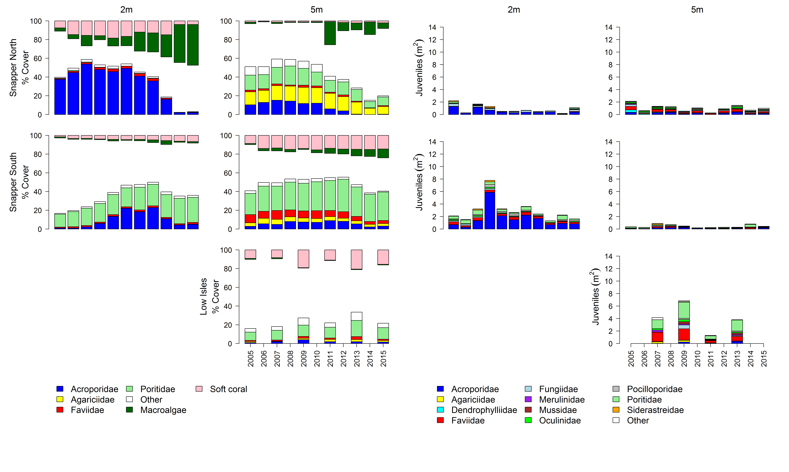
Figure A 1: Cover of major benthic groups and density of hard coral juveniles at reefs in the Daintree sub-region.
Cover estimates are separated into regionally abundant hard coral families and the total cover for soft corals and macroalgae (hanging). Juvenile density estimates are for regionally abundant hard coral families. Separate legends relevant groupings for cover and juvenile density estimates are located beneath the relevant plots.

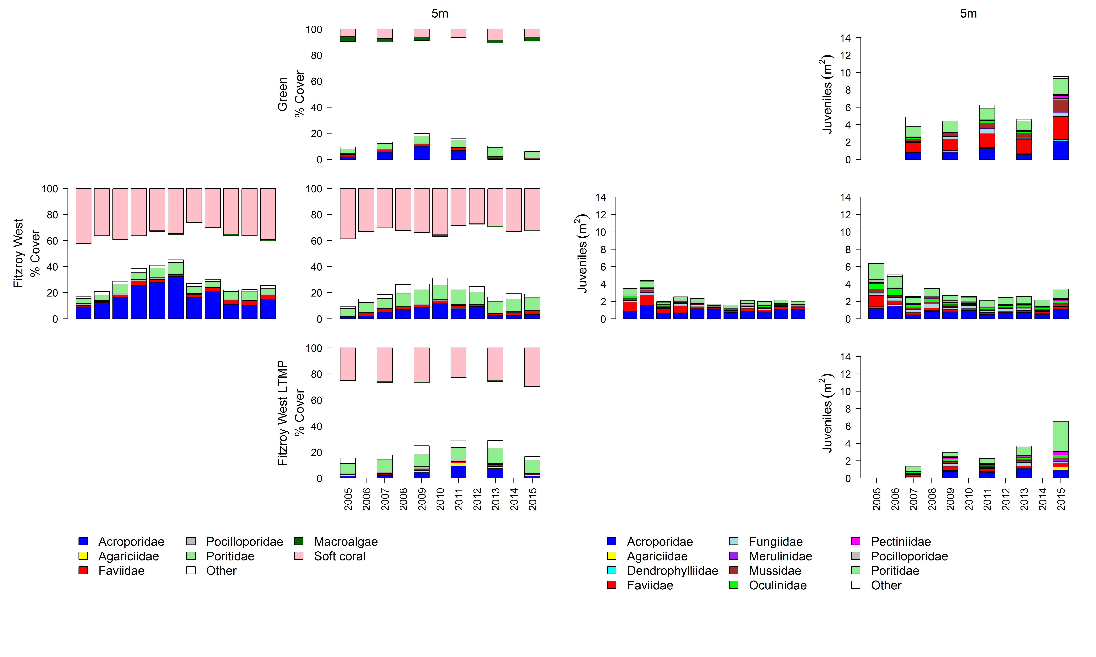

Figure A 2: Cover of major benthic groups and density of hard coral juveniles at reefs in the Johnstone sub-region. Cover estimates are separated into regionally abundant hard coral families and the total cover for soft corals and macroalgae (hanging). Juvenile density estimates are for regionally abundant hard coral families. Separate legends relevant groupings for cover and juvenile density estimates are located beneath the relevant plots.

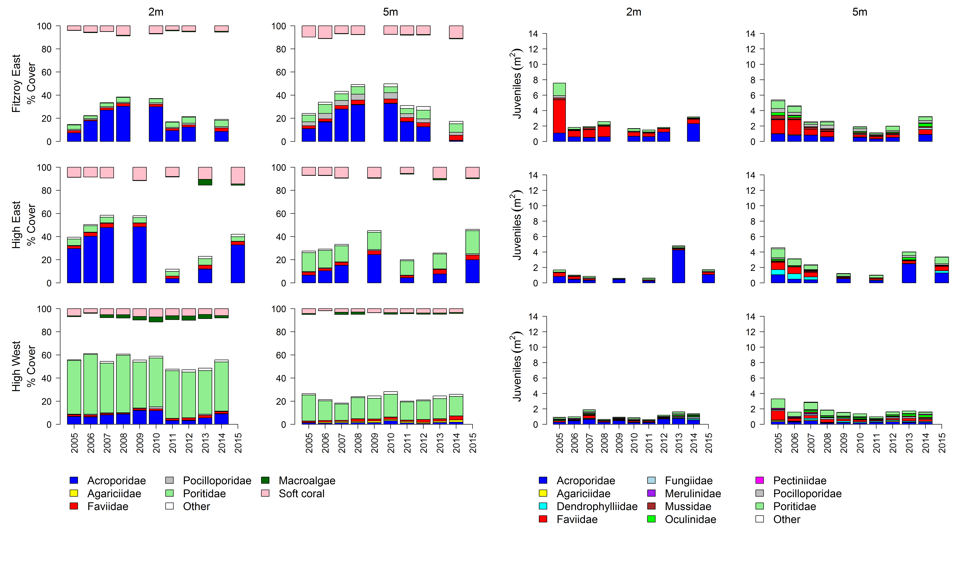Figure A 2 continued
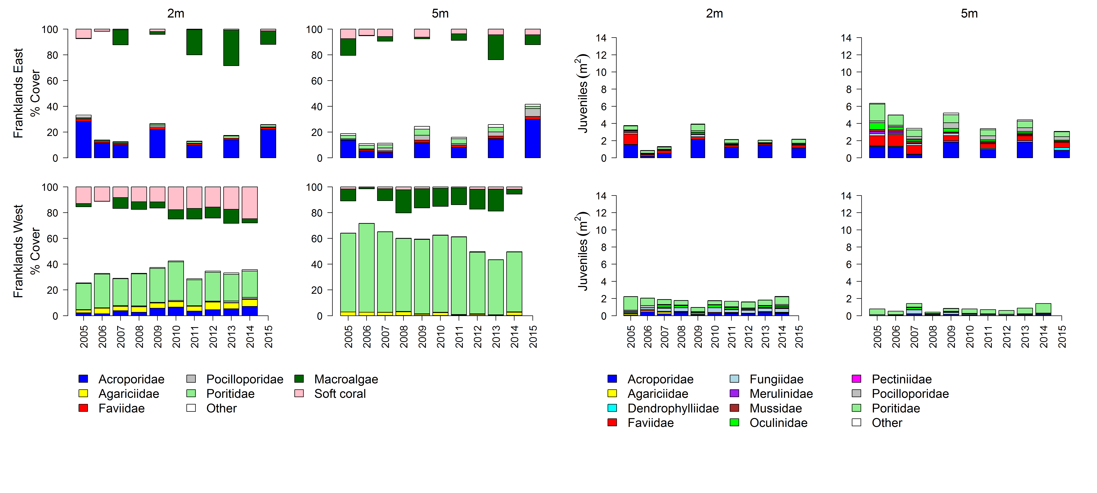
Figure A 2 continued

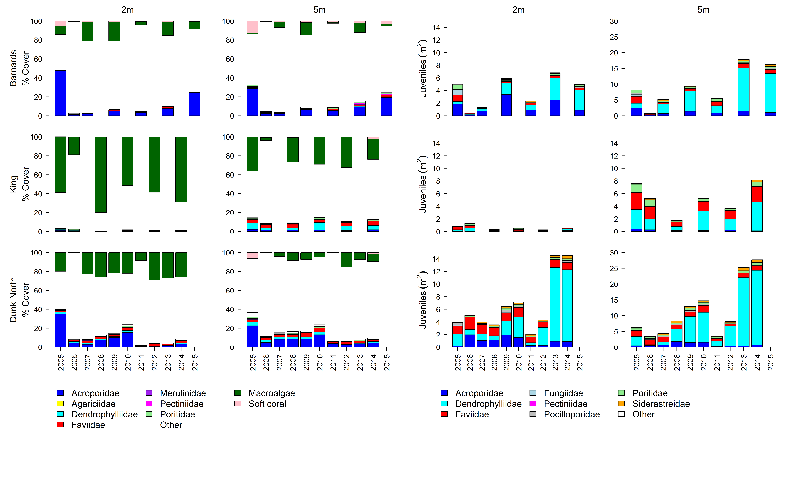
Figure A 3: Cover of major benthic groups and density of hard coral juveniles at reefs in the Tully sub- region.
Cover estimates are separated into regionally abundant hard coral families and the total cover for soft corals and macroalgae (hanging). Juvenile density estimates are for regionally abundant hard coral families. Separate legends with relevant groupings for cover and juvenile density estimates are located beneath the respective plots.
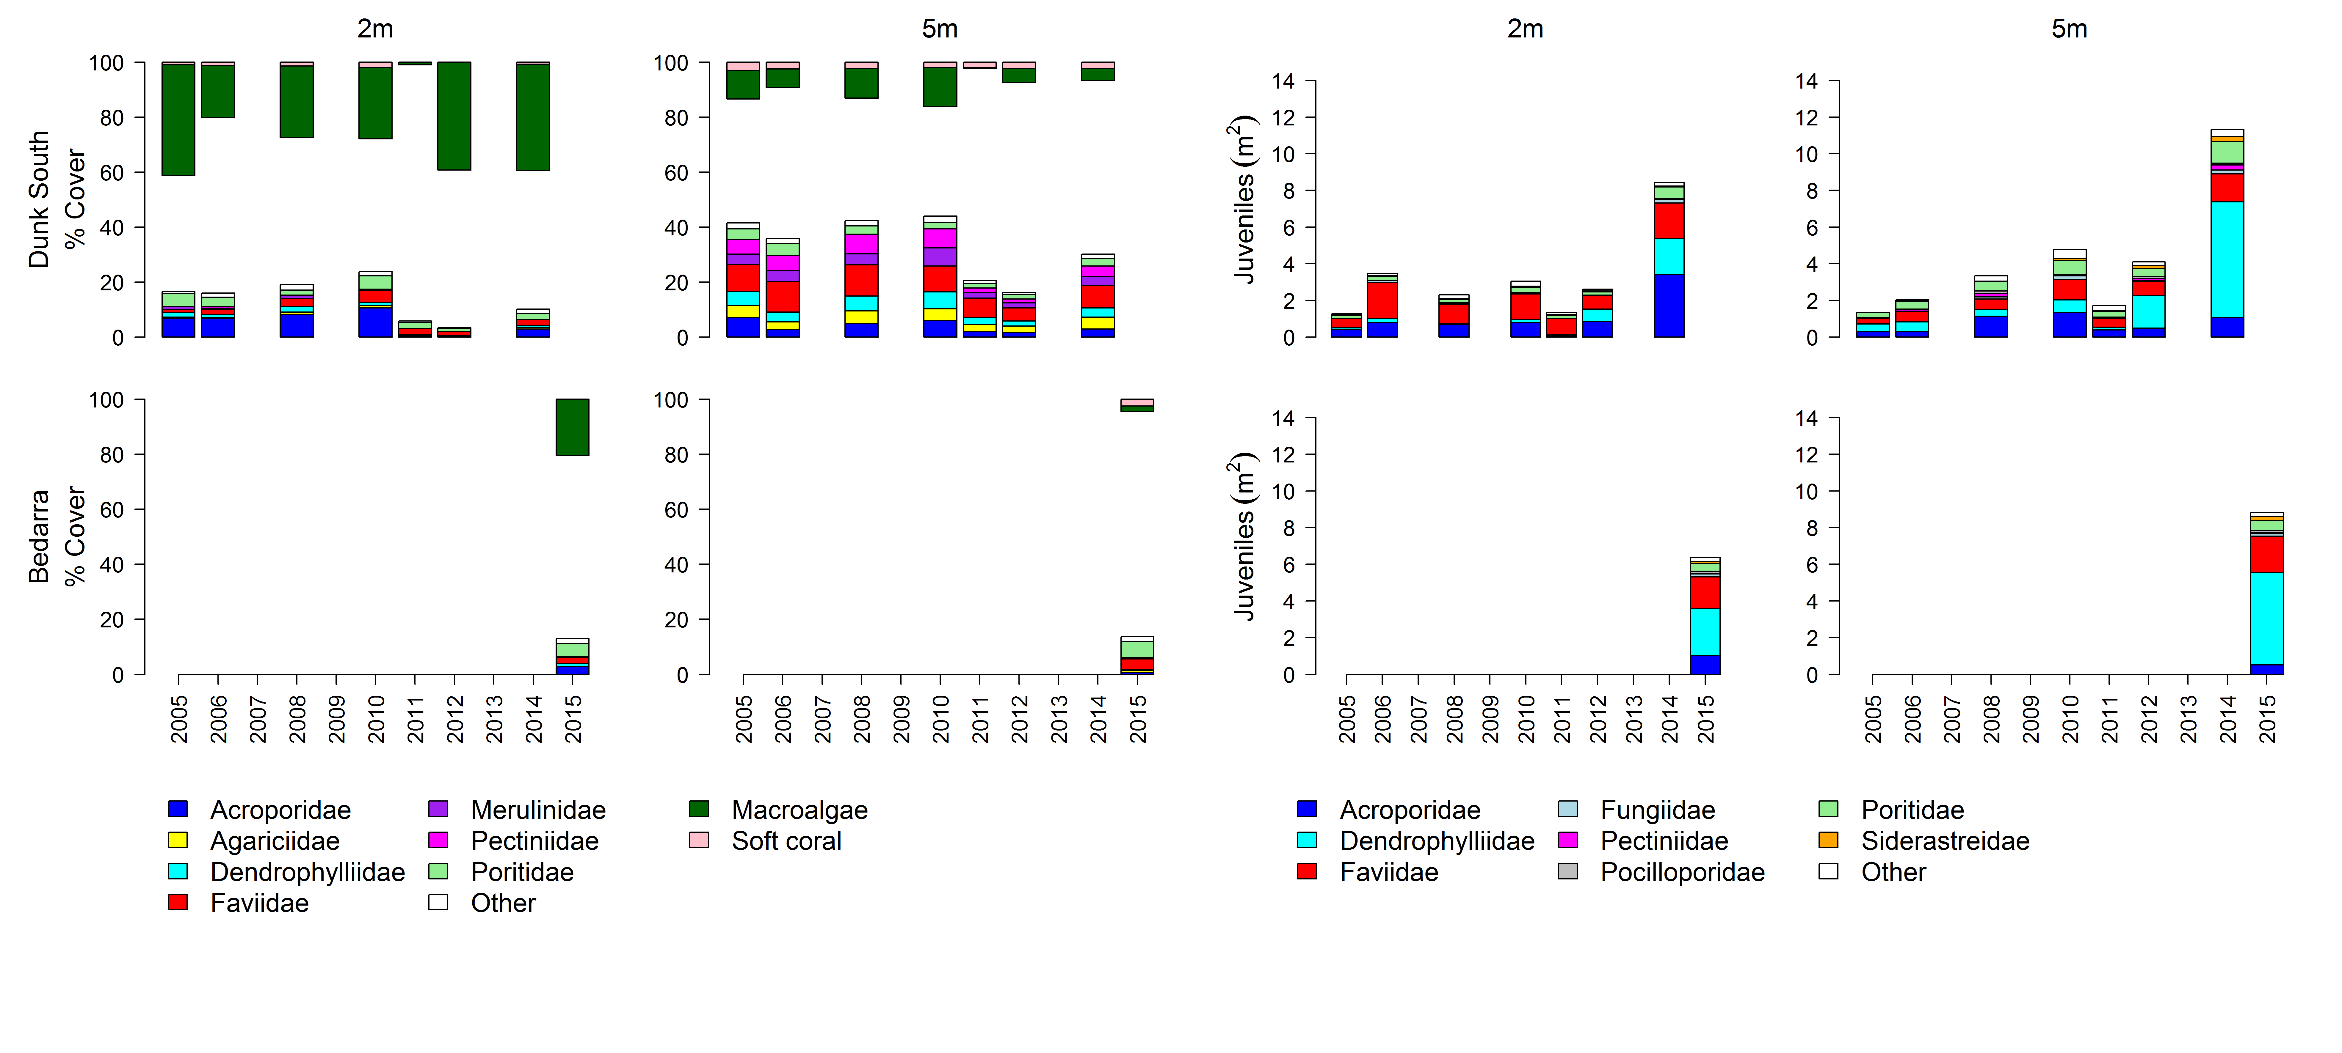
Figure A 3 continued

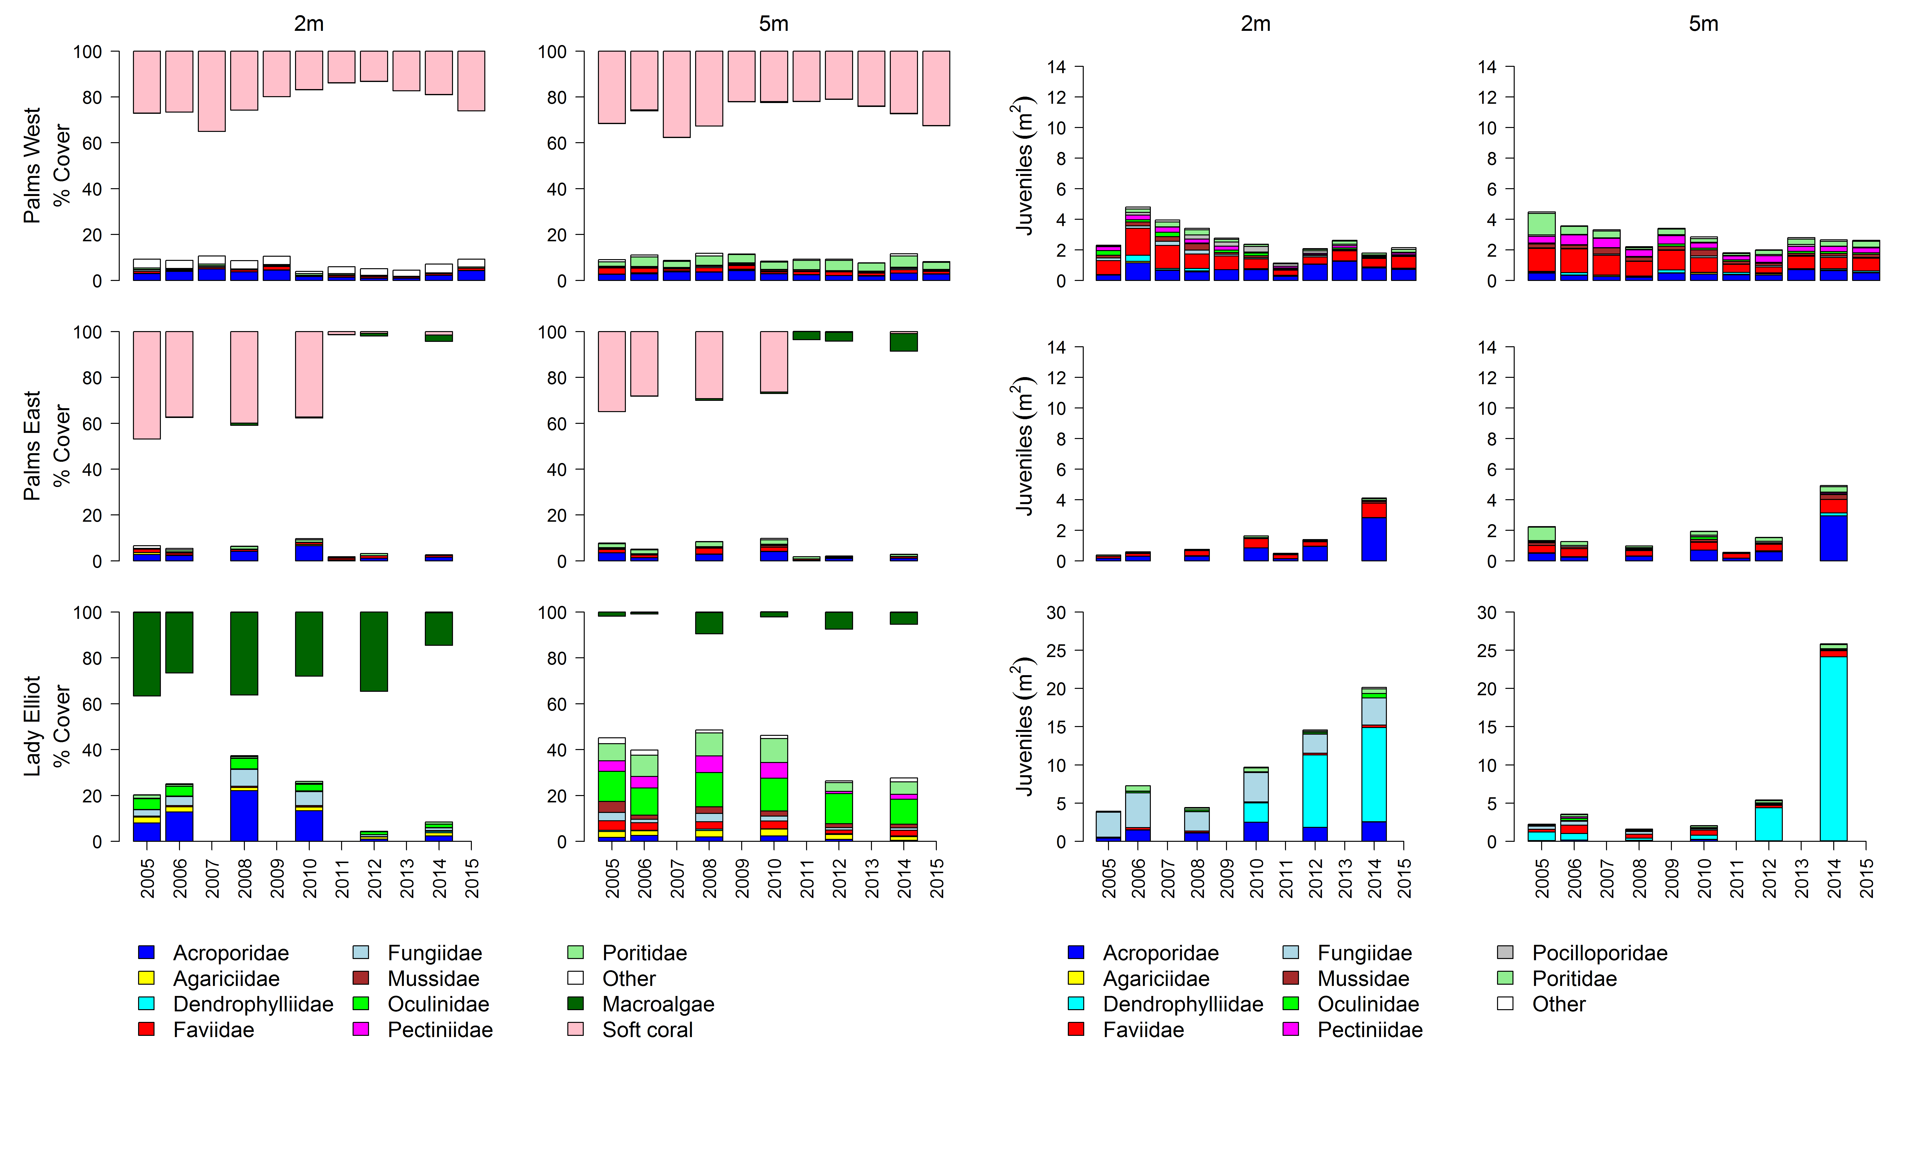
Figure A 4: Cover of major benthic groups and density of hard coral juveniles at reefs in the Burdekin region.
Cover estimates are separated into regionally abundant hard coral families and the total cover for soft corals and macroalgae (hanging). Juvenile density estimates are for regionally abundant hard coral families. Separate legends with relevant groupings for cover and juvenile density estimates are located beneath the respective plots.
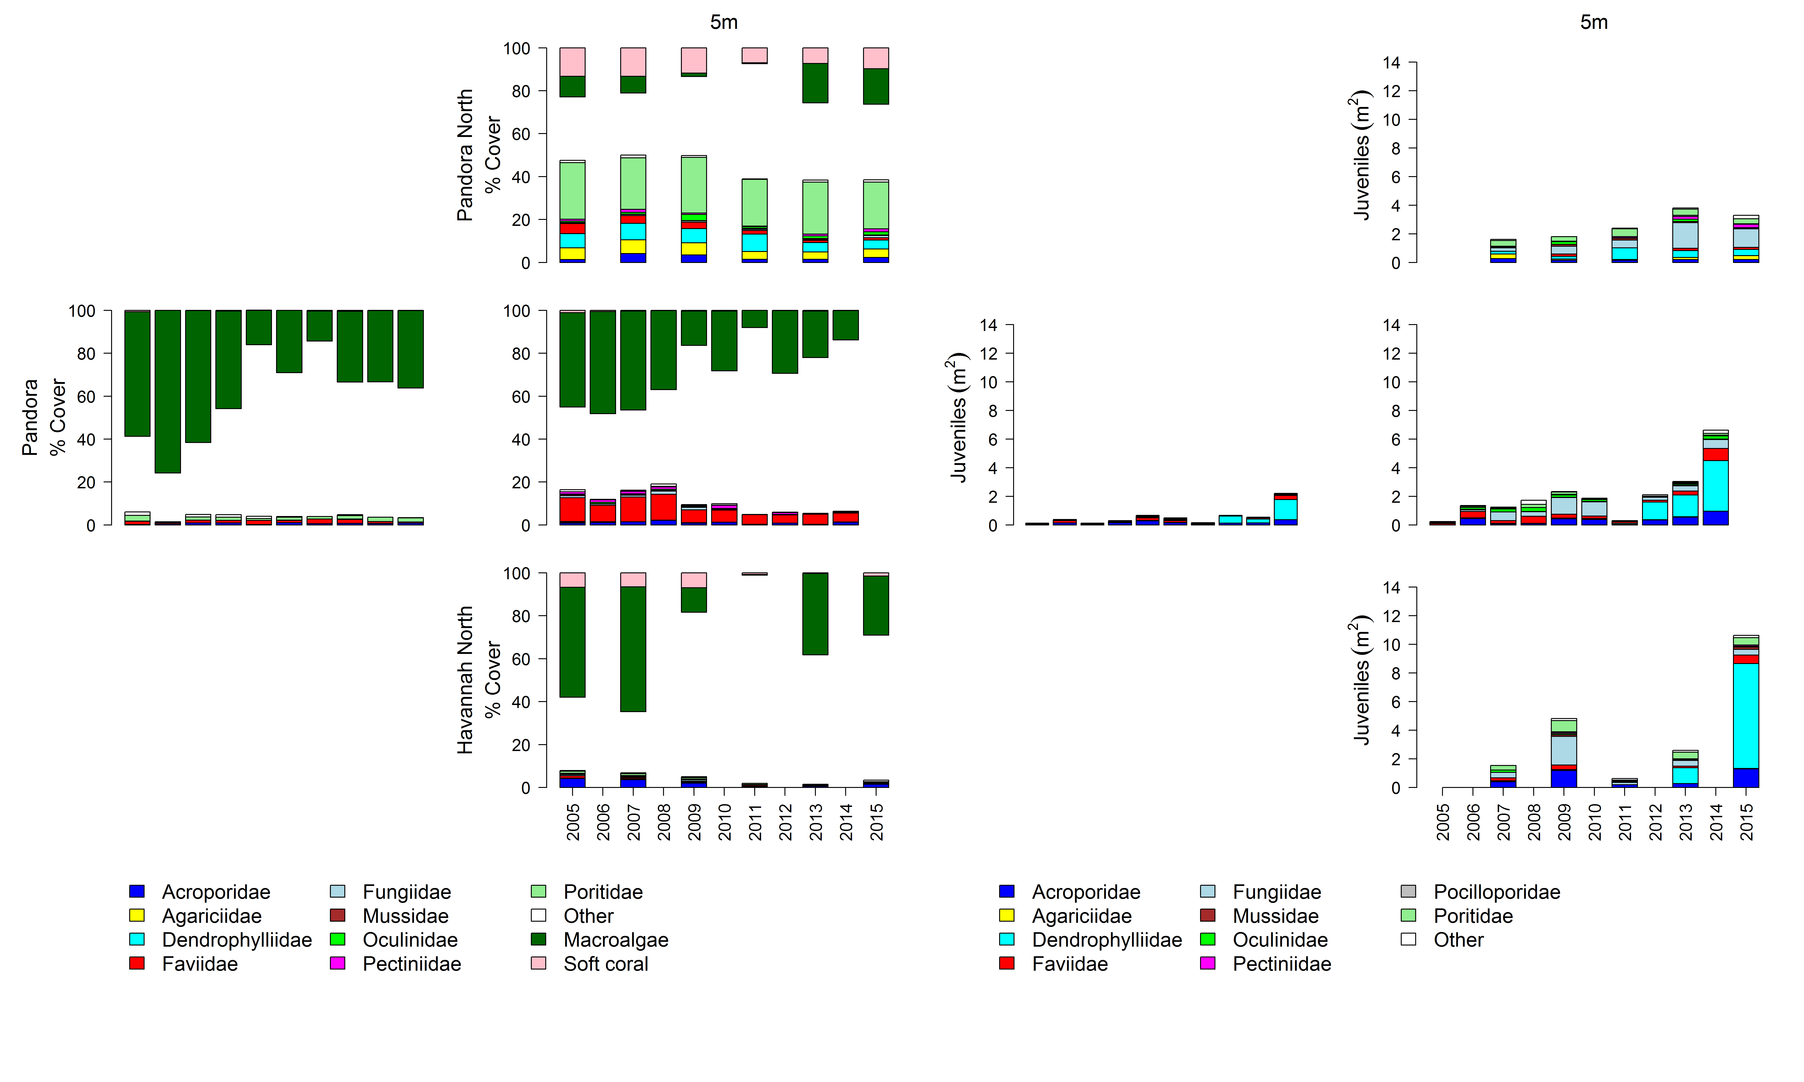
Figure A 4 continued

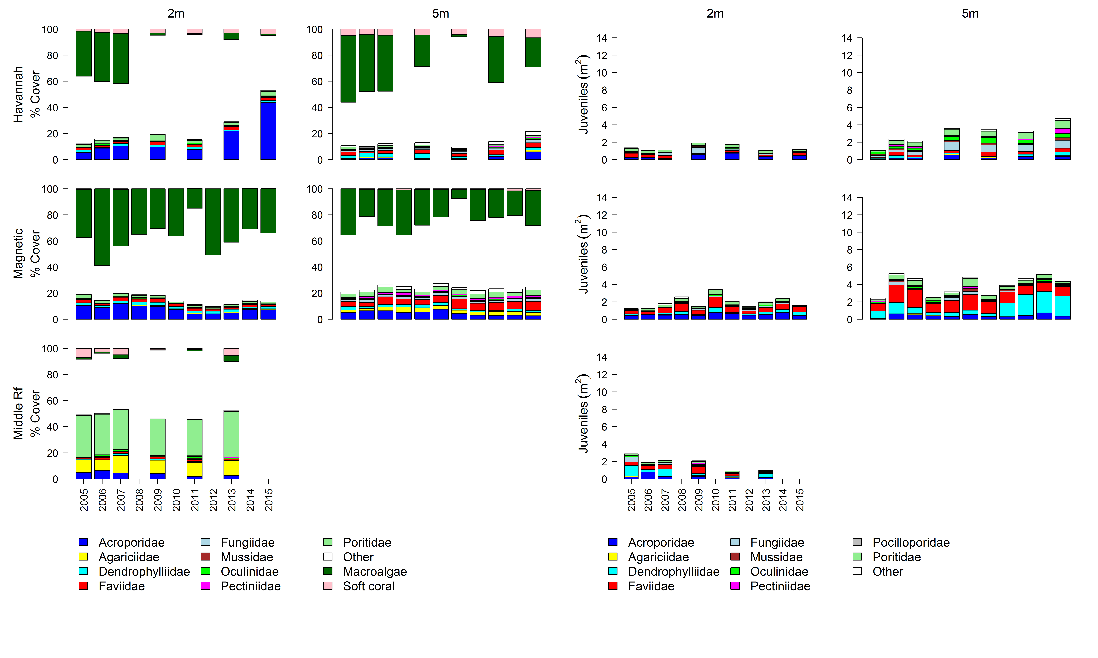
Figure A 4 continued

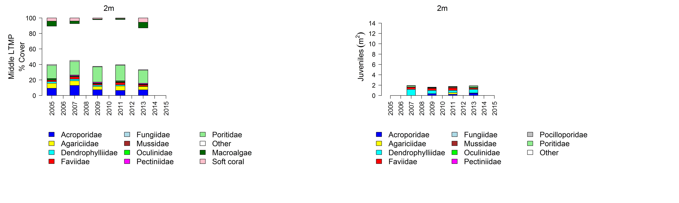
Figure A 4 continued

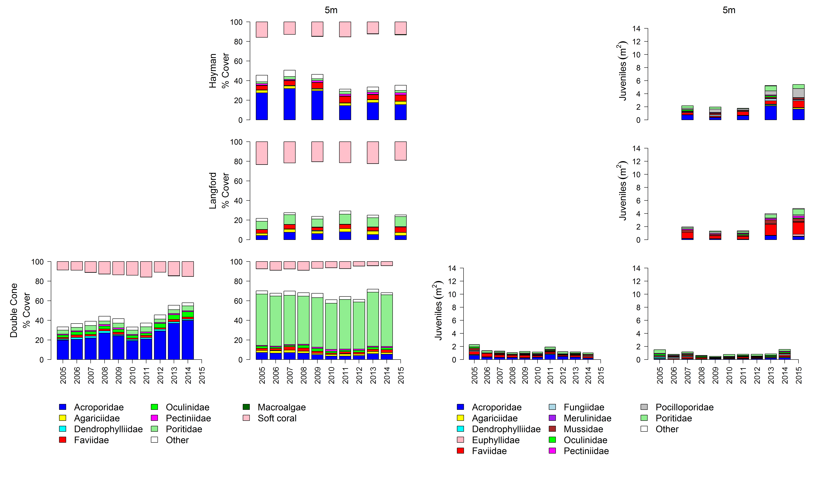
Figure A 5: Cover of major benthic groups and density of hard coral juveniles at reefs in the Mackay Whitsunday region.
Cover estimates are separated into regionally abundant hard coral families and the total cover for soft corals and macroalgae (hanging). Juvenile density estimates are for regionally abundant hard coral families. Separate legends with relevant groupings for cover and juvenile density estimates are located beneath the respective plots.

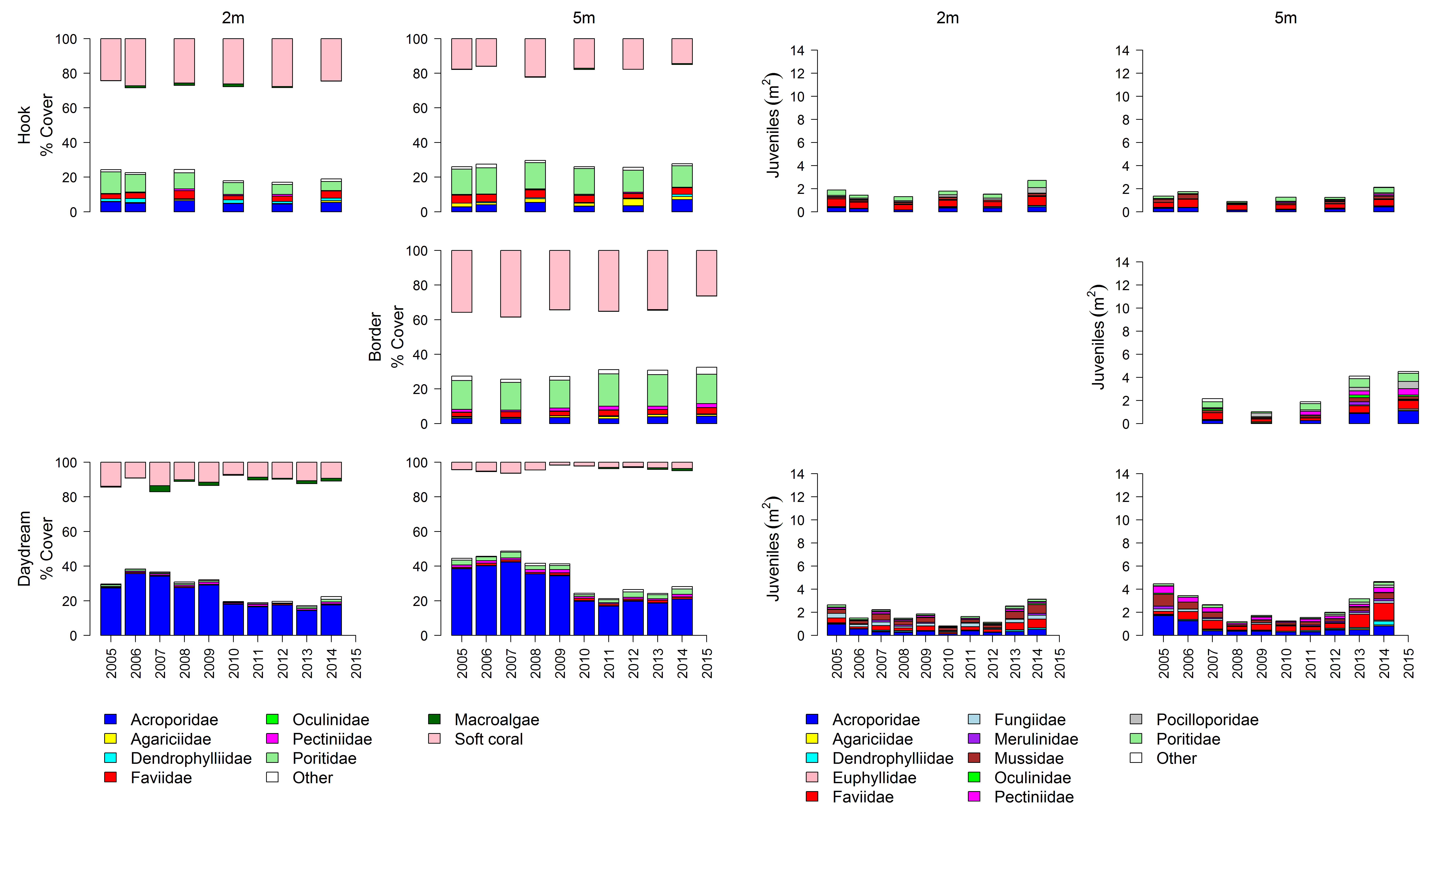
Figure A 5 continued

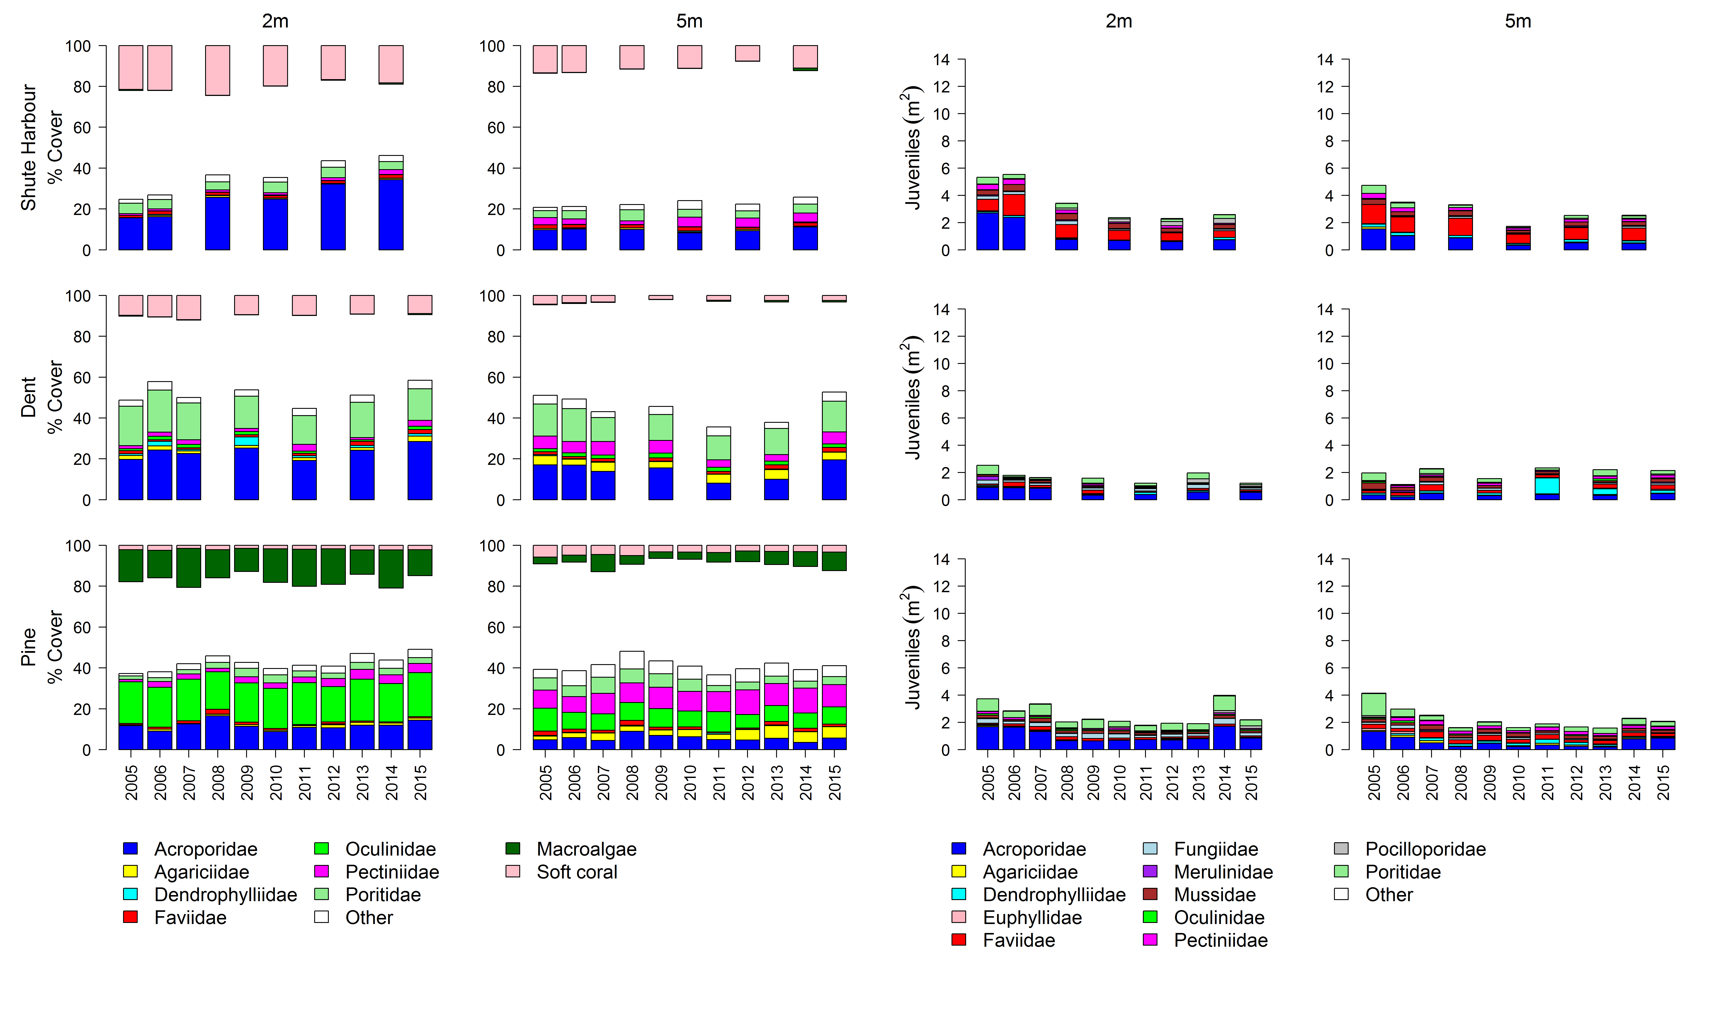
Figure A 5 continued
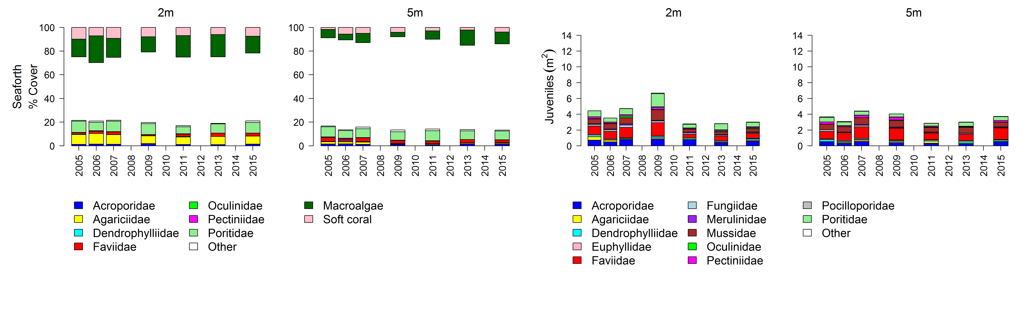
Figure 5 continued

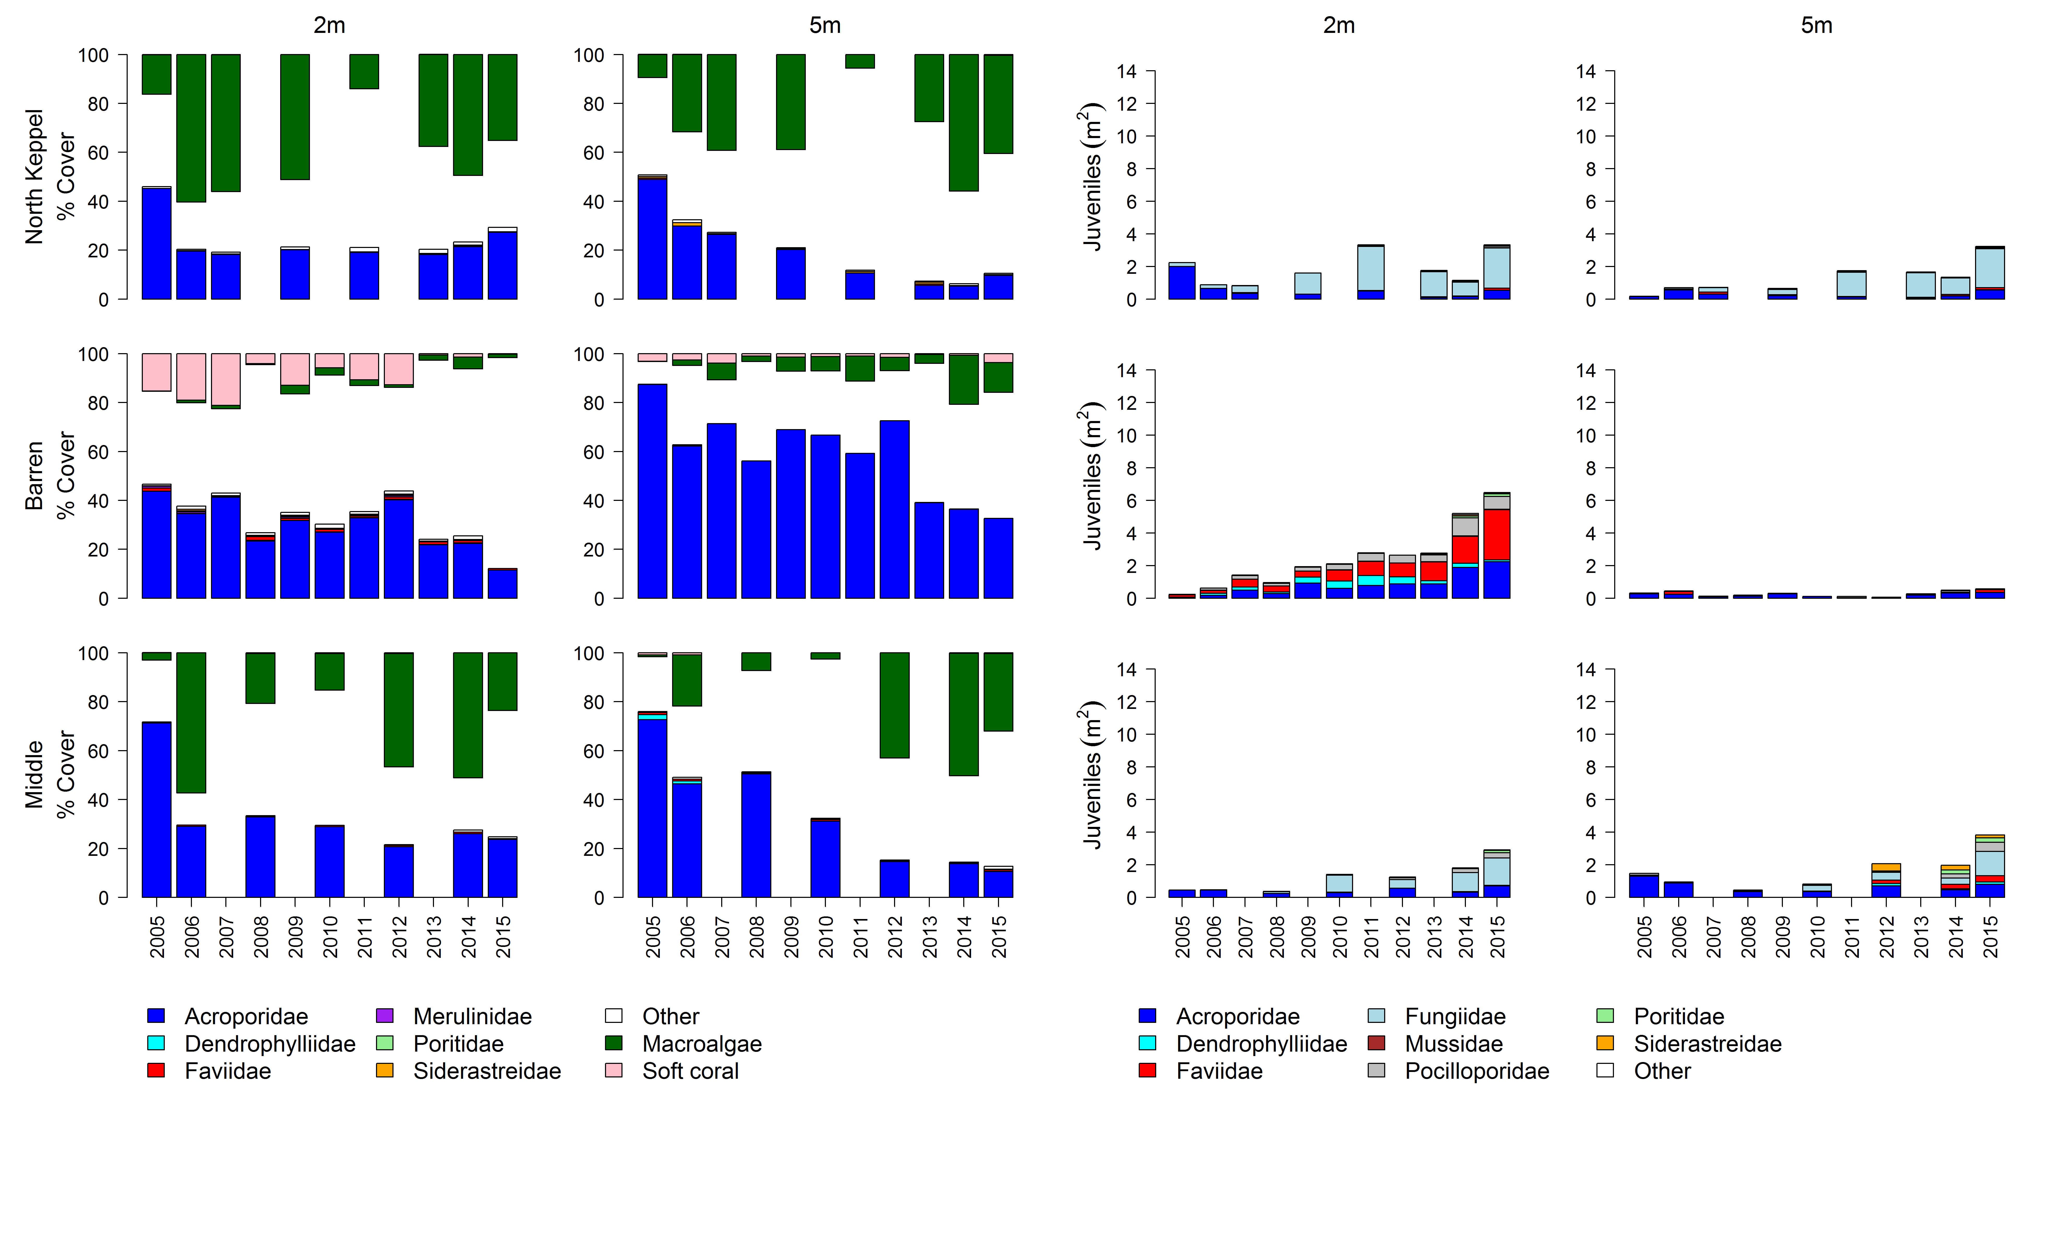
Figure A 6: Cover of major benthic groups and density of hard coral juveniles at reefs in the Fitzroy region.
Cover estimates are separated into regionally abundant hard coral families and the total cover for soft corals and macroalgae (hanging). Juvenile density estimates are for regionally abundant hard coral families. Separate legends with relevant groupings for cover and juvenile density estimates are located beneath the respective plots.
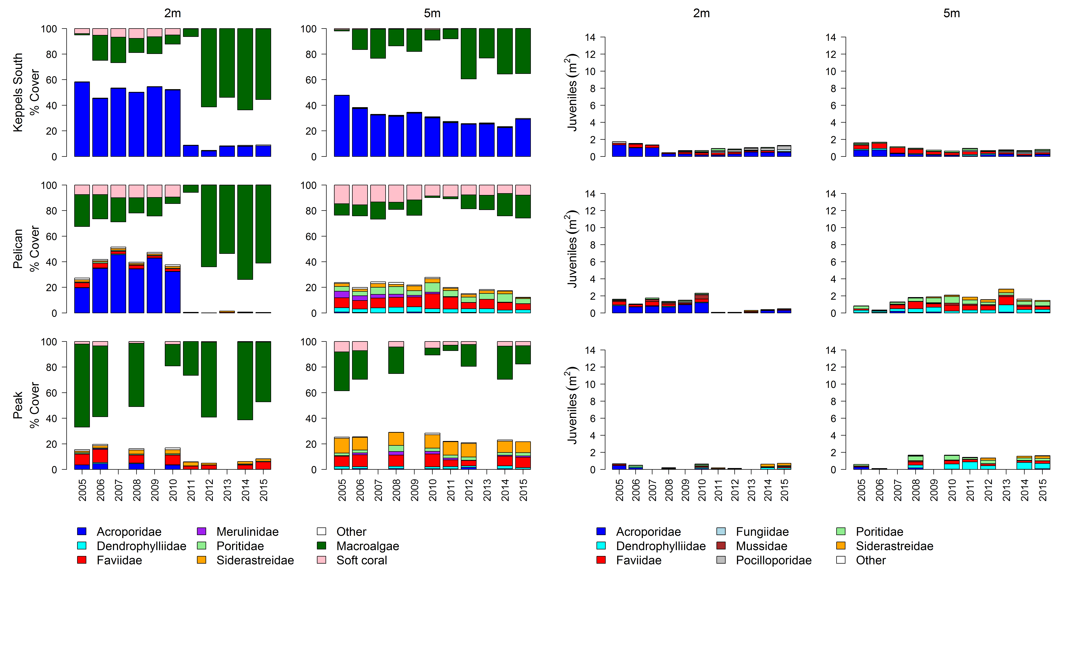Figure A 6 continued

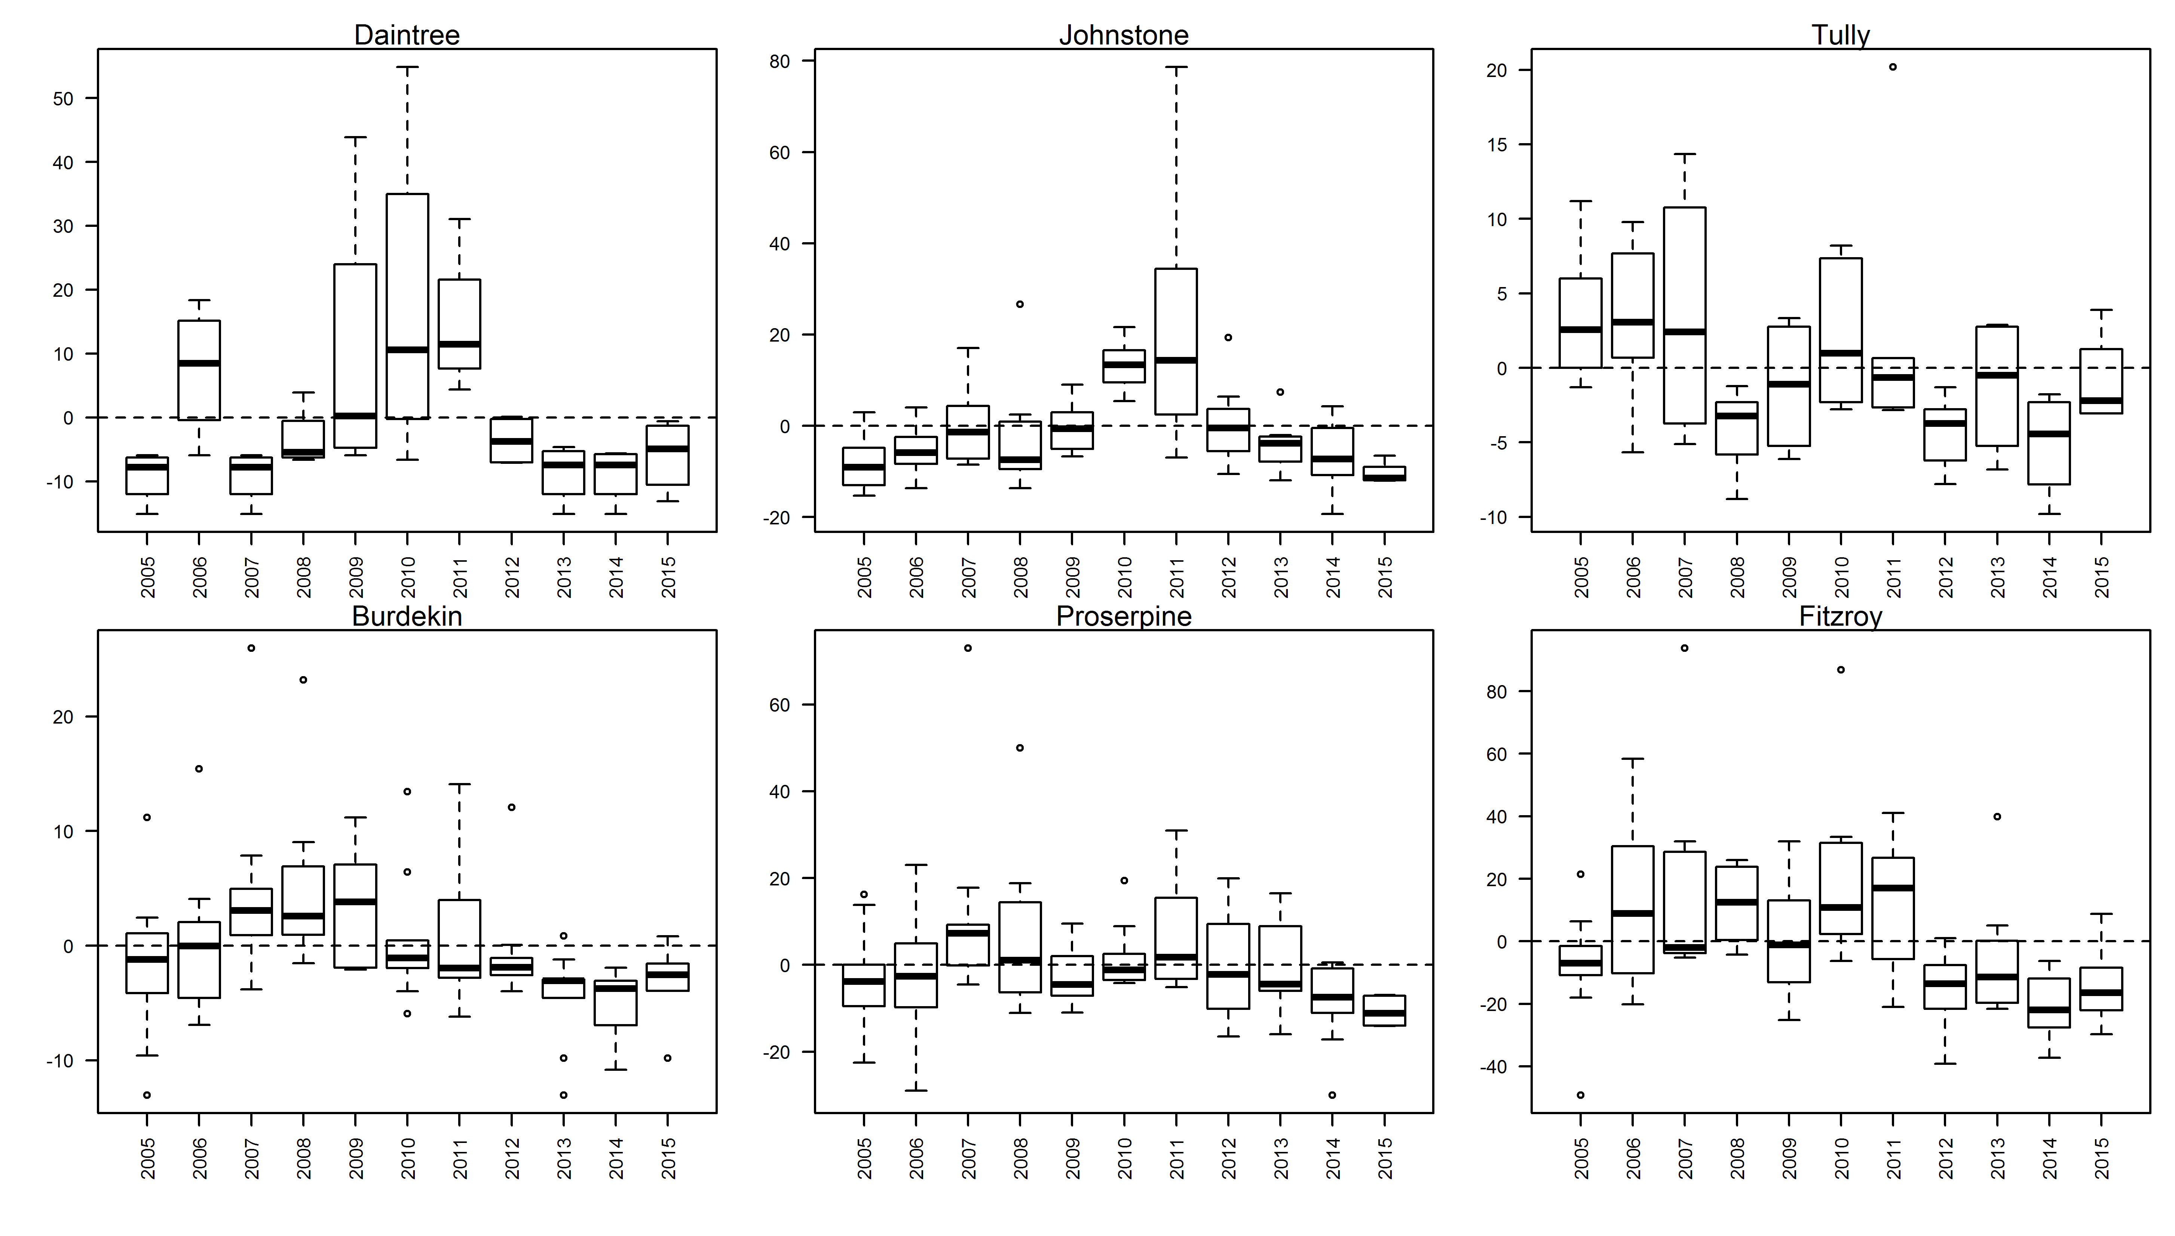
Figure A 7: Coral disease by year in each region
. Boxplots include the number of coral colonies suffering ongoing mortality attributed to either disease, sedimentation or ‘unknown causes’ for each reef, depth and year standardised to the reef and depth mean across years.

Table A 5: Composition of hard coral communities.
Common genera of Hard corals (% cover) 2015, presented are genera for which cover exceeded 0.5% on at least one reef, rare or unidentified genera are grouped as “other”.
sub/Region | Reef | DEPTH | Acropora | Alveopora | Caulastrea | Cyphastrea | Diploastrea | Echinophyllia | Echinopora | Favia | Favites | Fungia | Galaxea | Goniastrea | Goniopora | Hydnophora | Leptoseris | Lobophyllia | Merulina | Montipora | Mycedium | Oxypora | Pachyseris | Pavona | Pectinia | Platygyra | Pleisiastrea | Pocillopora | Podobacia | Porites | Psammocora | Seriatopora | Stylophora | Symphyllia | Turbinaria | Other
Barron Daintree | Snapper North | 2 | 1.92 |  |  |  |  |  | 0.25 |  |  | 0.08 |  |  | 0.04 |  |  |  |  | 0.17 |  |  |  |  |  |  |  | 0.04 |  |  |  | 0.04
 |  | 5 | 0.06 |  | 0.25 | 0.06 |  |  |  |  |  | 0.06 | 0.38 | 0.06 | 4.75 |  | 0.69 | 0.06 |  | 0.25 | 0.06 |  | 6.25 | 1.25 |  | 0.25 |  |  | 0.06 | 4.38 |  | 0.06 |  |  |  | 0.94
 | Snapper South | 2 | 4.34 |  |  | 0.13 |  |  |  | 0.13 | 0.13 |  | 1.29 | 1.00 |  |  |  | 0.04 |  | 0.67 |  |  |  | 0.29 |  | 0.13 |  | 0.58 |  | 25.3 | 0.17 |  |  |  | 0.17 | 0.25
 |  | 5 | 2.75 |  | 2.96 |  |  |  | 0.19 |  | 0.06 |  | 0.06 |  | 1.55 |  |  |  |  | 0.30 |  |  | 2.64 | 0.13 |  |  |  | 0.13 |  | 28.9 | 0.44 |  |  |  | 0.13 | 0.25
 | Low Isles | 5 |  |  | 0.07 |  | 0.30 |  | 0.63 | 0.13 | 0.03 | 0.23 | 2.03 | 0.07 | 0.23 | 0.07 |  | 0.87 | 0.07 | 1.57 |  |  | 1.60 | 0.03 | 0.13 | 0.13 |  | 0.10 |  | 12.2 | 0.13 | 0.17 | 0.03 |  | 0.23 | 0.50
Johnstone Russel-lMulgrave | Green | 5 | 0.10 |  |  | 0.07 | 0.10 |  | 0.07 | 0.03 |  |  | 0.10 | 0.03 | 0.13 |  |  | 0.17 |  | 0.17 |  |  | 0.07 |  |  | 0.20 |  |  |  | 4.43 |  | 0.03 |  | 0.03 | 0.07 | 0.20
 | Fitzroy West LTMP | 5 | 0.03 |  | 0.03 | 0.03 |  |  | 0.10 | 0.10 |  | 0.30 | 0.60 | 0.13 | 0.20 |  |  | 0.94 | 0.27 | 1.54 | 0.03 | 0.03 | 0.60 | 0.03 | 0.07 | 0.23 |  | 0.20 | 0.10 | 10.3 |  | 0.03 | 0.27 |  | 0.03 | 0.27
 | Fitzroy East | 2 | 3.13 |  |  |  |  |  | 0.25 | 0.38 | 0.69 |  |  | 1.19 |  | 0.06 |  | 0.06 |  | 5.44 |  |  |  | 0.06 |  | 0.19 |  | 1.06 |  | 5.50 |  |  | 0.06 | 0.56 |  | 0.38
 |  | 5 | 0.38 |  |  | 0.06 | 0.88 |  | 1.06 | 0.56 | 0.06 |  | 1.31 | 0.25 |  |  | 0.06 | 0.19 |  | 0.31 |  | 0.13 | 0.06 |  |  | 0.69 |  | 2.63 |  | 7.31 | 0.31 |  |  |  |  | 1.00
 | Fitzroy West | 2 | 10.1 |  |  |  | 1.00 |  | 0.95 | 0.19 | 0.06 | 0.06 | 0.69 | 0.19 | 0.31 | 0.06 |  | 0.75 |  | 5.08 |  |  |  | 0.06 |  | 0.19 |  | 0.56 |  | 3.77 | 0.13 |  | 0.31 | 0.31 | 0.38 | 0.25
 |  | 5 | 2.06 |  | 0.06 |  | 1.25 |  | 0.75 | 0.19 |  | 0.31 | 0.88 | 0.06 | 0.13 | 0.13 | 0.06 | 0.63 | 0.13 | 0.94 | 0.19 | 0.06 | 0.25 |  |  | 0.13 |  | 0.38 |  | 9.88 | 0.06 | 0.06 | 0.13 | 0.06 |  | 0.19
 | Franklands East | 2 | 9.63 |  |  | 0.19 |  |  | 0.19 | 0.56 | 0.13 |  |  | 0.06 | 0.19 |  |  | 0.13 |  | 12.3 |  |  | 0.06 | 0.06 |  | 0.31 |  | 0.31 |  | 1.44 |  |  | 0.13 | 0.13 |  | 0.13
 |  | 5 | 23.7 |  |  |  |  |  | 0.81 | 0.50 | 0.31 | 0.19 | 0.19 | 0.31 | 0.06 | 0.13 |  | 0.13 | 0.44 | 5.94 |  | 0.19 |  |  |  | 0.19 |  | 0.81 |  | 1.63 | 0.06 | 4.63 | 0.75 | 0.06 | 0.25 | 0.31
 | Franklands West | 2 | 7.00 |  |  |  |  |  | 0.31 |  |  | 0.06 | 0.63 | 0.06 | 1.13 |  |  | 0.19 |  | 0.19 | 0.06 |  | 5.44 |  |  | 0.06 |  | 0.31 |  | 19.4 | 0.06 | 0.81 |  |  |  | 0.06
 |  | 5 | 0.19 |  |  |  |  |  | 0.25 |  |  | 0.13 |  |  |  |  |  | 0.06 |  | 0.06 |  |  | 2.44 |  |  |  |  |  |  | 46.5
 | High East | 2 | 24.3 |  |  | 0.06 |  |  | 0.81 | 0.13 | 0.94 |  | 0.38 | 0.19 | 0.25 | 0.19 |  | 0.06 |  | 8.56 |  |  |  | 0.06 |  | 0.38 |  | 0.25 |  | 3.69 |  |  |  | 1.06 | 0.38 | 0.38
 |  | 5 | 11.19 |  |  | 0.13 |  |  | 1.31 | 0.19 | 0.56 |  | 0.31 | 0.19 | 0.56 | 0.13 |  | 0.31 |  | 8.69 |  |  |  |  |  | 0.81 |  | 0.69 | 0.06 | 19.4 | 0.19 |  | 0.50 |  | 0.13 | 0.88
 | High West | 2 | 7.06 |  | 0.06 | 0.06 |  |  | 0.19 | 0.38 |  | 0.25 | 0.13 | 0.38 | 3.56 | 0.25 |  | 0.19 | 0.19 | 1.94 | 0.13 |  | 0.06 | 0.25 |  | 0.06 |  | 0.44 | 0.31 | 38.9 | 0.38 |  |  |  |  | 0.63
 |  | 5 | 1.50 |  |  | 0.38 |  |  | 0.19 | 0.69 | 0.56 | 0.13 | 0.25 | 0.25 | 2.64 |  | 0.06 | 0.06 | 0.38 | 0.13 |  | 0.19 | 0.44 | 1.32 |  | 0.56 |  | 0.13 |  | 14.2 |  |  |  |  |  | 1.88

Table A 5 continued
sub/Region | Reef | DEPTH | Acropora | Alveopora | Caulastrea | Cyphastrea | Diploastrea | Echinophyllia | Echinopora | Favia | Favites | Fungia | Galaxea | Goniastrea | Goniopora | Hydnophora | Leptoseris | Lobophyllia | Merulina | Montipora | Mycedium | Oxypora | Pachyseris | Pavona | Pectinia | Platygyra | Pleisiastrea | Pocillopora | Podobacia | Porites | Psammocora | Seriatopora | Stylophora | Symphyllia | Turbinaria | Other
Herbert Tully | Barnards | 2 | 16.0 |  |  | 0.13 |  |  |  |  | 0.06 |  | 0.13 |  |  |  |  |  |  | 8.26 |  |  | 0.06 |  |  | 0.31 |  | 0.69 |  | 0.13 |  |  |  |  | 0.38
 |  | 5 | 8.31 |  |  | 0.75 |  | 0.50 | 0.13 | 0.50 | 0.13 |  | 0.13 |  | 0.38 | 0.25 |  | 0.19 | 0.06 | 10.8 | 0.06 | 0.25 |  |  |  |  |  | 1.50 | 0.06 | 1.13 | 0.13 | 0.31 | 0.44 |  | 1.00 | 0.13
 | Dunk North | 2 | 1.13 |  |  | 0.88 |  |  | 0.13 | 0.25 | 0.13 |  | 0.31 | 0.19 |  | 0.19 |  |  | 0.06 | 2.38 |  |  |  |  |  | 0.25 | 0.13 | 0.63 |  | 0.44 | 0.13 |  |  |  | 1.00 | 0.44
 |  | 5 | 0.75 | 0.13 |  | 0.44 |  | 0.25 |  | 0.50 | 0.69 |  | 0.06 | 0.19 | 0.13 |  |  | 0.25 |  | 3.88 |  | 0.06 |  |  |  | 0.19 | 0.06 | 0.63 |  | 0.25 | 0.06 |  | 0.06 |  | 1.19 | 0.19
 | Dunk South | 2 | 2.06 |  |  | 1.00 |  |  |  | 0.63 | 0.19 | 0.06 | 0.69 | 0.19 | 0.06 |  |  | 0.44 |  | 0.88 |  |  |  | 0.63 |  |  |  |  |  | 2.13 | 0.44 |  |  |  | 0.50 | 0.31
 |  | 5 | 0.50 |  |  | 1.06 |  | 0.25 | 0.63 | 3.25 | 1.38 | 0.06 | 0.25 | 0.94 | 0.56 | 0.13 | 0.06 | 0.63 | 3.19 | 2.19 | 2.25 | 0.63 | 4.01 | 0.25 | 0.63 | 0.88 |  | 0.19 | 0.31 | 2.19 |  |  | 0.06 |  | 3.32 | 0.31
 | Bedarra | 2 | 2.06 |  |  | 0.44 |  |  |  | 0.81 | 0.56 |  | 0.25 | 0.06 | 0.25 | 0.25 |  | 0.75 |  | 0.63 |  | 0.06 |  | 0.06 |  | 0.25 | 0.13 |  | 0.19 | 4.38 |  |  |  | 0.19 | 1.00 | 0.56
 |  | 5 | 0.38 |  |  | 0.06 |  |  |  | 2.88 | 0.44 |  |  | 0.06 | 2.44 |  |  | 1.31 | 0.25 | 0.38 | 0.13 | 0.19 | 0.38 | 0.25 |  | 0.13 | 0.06 |  | 0.13 | 3.38 |  |  | 0.06 | 0.13 | 0.44 | 0.25
Burdekin | Palms East | 2 | 0.94 |  |  |  |  |  |  | 0.13 | 0.25 |  |  | 0.06 |  |  |  |  |  | 0.69 |  |  |  |  |  |  |  |  |  | 0.25 | 0.06 |  |  |  |  | 0.25
 |  | 5 | 0.38 |  |  | 0.06 |  |  |  |  | 0.13 |  | 0.06 |  |  |  |  |  |  | 0.75 |  |  |  |  |  | 0.06 |  | 0.06 |  | 0.88 |  |  |  |  |  | 0.44
 | Palms West | 2 | 3.75 |  |  |  |  |  | 0.19 |  | 0.44 |  |  | 0.06 | 0.06 |  |  | 0.06 |  | 0.38 |  |  | 0.06 | 0.06 |  |  |  | 3.44 |  | 0.44 |  |  |  |  |  | 0.31
 |  | 5 | 1.50 |  |  |  |  | 0.06 | 0.06 | 0.06 | 0.25 | 0.25 |  | 0.06 | 0.75 |  |  | 0.25 |  | 1.06 |  |  |  | 0.13 | 0.06 | 0.25 |  | 0.31 |  | 2.31 | 0.06 |  |  |  |  | 0.75
 | Havannah North | 5 | 0.90 |  |  | 0.03 |  | 0.17 |  |  |  | 0.07 | 0.17 | 0.13 | 0.07 | 0.13 |  |  |  | 0.57 | 0.17 | 0.07 |  | 0.03 |  |  |  |  |  | 0.20 | 0.17 | 0.20 | 0.13 |  | 0.10 | 0.03
 | Havannah | 2 | 38.9 |  |  | 0.13 |  |  | 0.88 | 0.38 | 0.06 |  | 0.50 | 0.31 | 0.19 | 0.06 |  | 0.19 | 0.19 | 4.88 |  |  |  | 0.06 |  | 0.69 |  | 0.25 | 0.19 | 3.13 |  |  | 0.44 | 0.25 | 1.38
 |  | 5 | 3.26 |  | 0.25 | 0.13 | 0.88 |  | 1.07 | 0.31 | 0.31 | 1.38 | 0.88 | 0.44 | 0.25 |  |  | 0.56 | 1.94 | 1.85 | 0.06 | 0.69 | 1.00 | 0.31 | 0.25 | 0.31 |  | 0.25 | 0.13 | 0.94 | 0.13 |  | 0.76 | 0.06 | 1.88 | 1.38
 | Pandora North | 5 | 1.23 |  | 0.07 | 0.10 |  | 0.03 | 0.53 | 0.13 | 0.07 | 0.73 | 1.50 |  | 14.7 | 0.07 | 0.87 | 0.17 | 0.50 | 1.07 | 0.60 | 0.37 | 2.43 | 0.63 | 0.37 | 0.13 |  | 0.20 | 0.10 | 7.07 | 0.23 | 0.03 |  | 0.03 | 4.23 | 0.20
 | Pandora | 2 | 0.75 |  |  |  |  |  |  |  | 0.19 |  |  |  |  |  |  |  |  | 0.06 |  |  |  |  |  |  | 0.31 |  |  | 1.94 |  |  |  |  | 0.06
 |  | 5 | 1.00 |  |  | 0.06 | 2.00 |  |  | 0.63 | 0.13 | 0.06 | 0.19 |  | 0.06 | 0.19 |  |  | 0.19 | 0.31 |  |  |  |  |  | 0.94 |  |  |  |  |  |  |  |  | 0.06 | 0.56
 | Lady Elliot | 2 | 1.25 |  |  | 0.06 |  |  |  |  | 0.06 | 1.19 | 1.44 |  | 0.06 |  |  | 0.13 |  | 1.13 |  | 0.06 |  | 1.31 |  |  | 0.13 |  |  | 0.88 |  |  |  |  | 0.69 | 0.06
 |  | 5 | 0.44 | 0.25 |  | 0.06 |  |  |  | 1.00 | 1.13 |  | 10.8 |  | 1.38 | 0.81 |  | 1.69 | 0.44 |  | 1.75 | 0.06 | 1.56 |  | 0.38 | 0.25 |  |  | 0.94 | 3.81 | 0.44 |  |  |  | 0.31 | 0.13
 | Magnetic | 2 | 1.00 |  |  | 0.50 |  |  | 0.13 | 0.19 | 0.56 | 0.06 | 0.19 |  | 0.19 |  |  |  | 0.25 | 6.25 |  |  | 0.31 | 0.38 |  |  | 0.19 |  |  | 1.25 | 0.25 |  |  |  | 1.94 | 0.25
 |  | 5 | 1.25 |  |  | 0.50 |  |  | 0.06 | 3.31 | 0.75 | 0.06 | 0.38 | 0.13 | 2.53 | 0.75 |  | 0.19 | 1.50 | 1.25 | 0.75 | 0.69 | 2.13 | 0.19 | 0.25 | 1.31 | 0.25 | 0.06 | 2.00 | 1.50 |  |  | 0.06 |  | 1.75 | 1.13

Table A 5 continued
sub/Region | Reef | DEPTH | Acropora | Alveopora | Caulastrea | Cyphastrea | Diploastrea | Echinophyllia | Echinopora | Favia | Favites | Fungia | Galaxea | Goniastrea | Goniopora | Hydnophora | Leptoseris | Lobophyllia | Merulina | Montipora | Mycedium | Oxypora | Pachyseris | Pavona | Pectinia | Platygyra | Pleisiastrea | Pocillopora | Podobacia | Porites | Psammocora | Seriatopora | Stylophora | Symphyllia | Turbinaria | Other
Mackay Whitsunday | Hayman | 5 | 3.83 |  | 0.03 |  | 1.90 | 0.17 | 1.33 | 0.90 | 0.50 | 0.07 | 0.10 | 0.63 | 0.23 |  |  | 0.57 | 2.30 | 11.6 | 0.53 | 0.83 | 3.13 | 0.17 | 0.73 | 0.50 |  | 0.20 |  | 2.13 |  | 1.80 | 0.03 | 0.20 | 0.23 | 0.50
 | Langford | 5 | 2.67 |  |  | 0.07 | 0.80 |  | 1.50 | 1.30 | 0.43 |  |  | 0.50 | 6.10 | 0.23 |  | 0.70 | 0.17 | 1.13 | 0.07 | 0.03 | 0.10 | 3.00 | 0.43 | 0.10 |  | 0.13 | 0.03 | 4.13 |  | 0.20 | 0.03 |  | 0.13 | 1.20
 | Border | 5 | 2.97 |  |  | 0.17 | 0.43 | 0.20 | 0.33 | 1.20 | 0.37 | 0.10 | 0.10 | 0.40 | 11.5 | 0.60 |  | 1.23 | 0.30 | 1.17 | 0.33 | 0.67 | 0.50 | 0.47 | 1.07 | 0.57 |  | 0.23 |  | 5.43 |  | 0.97 | 0.33 | 0.03 | 0.27 | 0.63
 | Hook | 2 | 2.69 |  |  |  | 1.13 |  | 0.19 | 0.44 | 1.63 | 0.06 | 0.06 | 0.31 | 0.13 |  | 0.38 |  | 0.25 | 2.32 |  | 0.25 | 0.57 |  |  | 0.25 |  | 0.06 |  | 5.08 |  |  | 1.06 |  | 1.56 | 0.50
 |  | 5 | 2.56 |  |  | 0.19 | 0.19 |  | 0.25 | 1.31 | 0.19 |  | 0.19 | 0.50 | 3.56 | 0.06 |  | 0.50 |  | 3.69 |  | 0.06 | 1.00 | 0.81 | 0.06 | 0.50 |  | 0.06 |  | 8.81 |  |  | 0.13 |  | 1.31 | 1.81
 | Double Cone | 2 | 34.3 | 0.38 |  | 0.06 |  | 0.13 | 1.31 | 0.06 |  | 0.06 | 5.44 | 0.31 | 3.94 | 0.25 |  | 0.88 | 1.75 | 5.56 |  | 0.13 | 0.25 |  | 0.75 | 0.31 |  | 0.31 |  | 0.63 |  |  |  |  | 1.19
 |  | 5 | 5.38 | 0.13 |  | 0.19 | 0.94 |  | 0.69 | 0.19 | 0.50 | 0.13 | 2.06 |  | 48.4 |  |  | 1.69 | 0.25 | 0.06 |  | 0.25 | 0.63 | 1.13 | 1.06 |  | 0.19 | 0.06 | 0.06 | 4.06 |  |  |  |  |  | 0.13
 | Daydream | 2 | 16.6 |  |  |  |  |  | 0.25 |  |  | 0.06 |  | 0.06 | 0.13 |  |  | 0.69 | 0.06 | 0.94 | 0.25 | 0.56 | 0.25 |  | 0.38 |  |  | 0.38 | 0.13 | 1.38 |  |  |  |  |  | 0.25
 |  | 5 | 16.6 |  |  |  |  |  | 0.31 | 0.38 |  | 0.06 | 0.06 | 0.19 |  |  |  | 0.25 |  | 4.25 | 0.75 | 0.25 |  |  | 0.50 | 0.19 |  |  | 0.06 | 3.13 |  | 0.75 | 0.19 |  |  | 0.31
 | Dent | 2 | 27.9 |  |  | 0.31 |  |  | 0.88 | 0.06 |  |  | 1.63 | 0.19 | 4.33 |  | 0.19 | 1.88 | 1.75 | 0.56 |  |  | 0.25 | 2.31 | 2.88 | 0.06 |  |  |  | 11.1 | 0.19 |  | 0.31 |  | 1.13 | 0.56
 |  | 5 | 18.7 | 0.19 |  |  |  | 0.13 | 0.81 | 0.38 | 0.25 | 0.06 | 1.69 | 0.19 | 12.6 | 0.19 | 1.19 | 1.50 | 1.44 | 0.81 | 0.31 | 2.94 | 2.06 | 0.38 | 2.51 | 0.31 |  | 0.06 | 0.31 | 2.25 |  |  | 0.44 |  | 0.06 | 1.06
 | Shute Harbour | 2 | 31.1 |  | 0.38 | 0.06 |  |  |  | 0.31 | 0.25 |  | 0.13 |  | 3.63 | 0.38 |  | 0.63 | 0.31 | 3.19 | 0.75 | 0.56 | 0.06 | 0.63 | 1.00 | 0.25 |  | 0.81 |  | 0.31 | 0.06 | 0.06 | 0.31 |  | 0.06 | 0.88
 |  | 5 | 8.00 |  |  | 0.13 | 0.31 | 0.06 |  | 0.06 | 0.19 |  | 0.38 | 0.31 | 3.19 |  |  | 1.38 | 0.56 | 3.13 | 0.69 | 1.63 | 0.25 | 0.06 | 2.06 |  |  |  | 0.32 | 1.19 |  |  | 0.38 |  | 0.13 | 1.38
 | Pine | 2 | 6.81 |  |  | 0.06 |  |  | 0.06 | 0.19 | 0.19 | 0.13 | 21.6 | 0.06 | 0.25 | 0.50 | 0.06 | 1.38 | 0.69 | 7.63 | 0.13 | 1.25 | 0.94 |  | 3.06 |  |  | 0.81 | 0.31 | 2.63 |  |  |  |  | 0.06 | 0.38
 |  | 5 | 1.75 |  |  |  |  | 1.25 | 0.31 | 0.38 | 0.13 | 0.13 | 8.34 | 0.13 | 2.88 | 0.19 | 0.31 | 2.32 | 0.13 | 3.94 | 1.75 | 2.00 | 5.14 |  | 5.95 |  |  |  | 1.19 | 1.00 |  |  |  |  | 0.13 | 1.69
 | Seaforth | 2 | 0.81 | 0.31 |  |  |  |  | 0.31 | 0.50 | 1.00 | 0.13 | 0.06 | 0.19 | 1.94 | 0.06 |  | 0.56 | 0.06 | 0.13 |  |  | 0.25 | 6.50 |  | 0.06 |  | 0.31 | 0.19 | 6.69 |  |  |  |  | 0.06 | 0.88
 |  | 5 | 0.25 |  | 0.31 |  | 0.50 |  | 0.06 | 0.32 | 0.13 | 0.06 | 0.06 | 0.56 | 5.69 | 0.06 |  | 0.19 |  | 0.70 |  | 0.13 | 0.13 | 0.69 |  | 0.32 |  |  | 0.13 | 1.78 |  |  |  |  | 0.38 | 0.81

Table A 5 continued
Sub/Region | Reef | Depth | Acropora | Alveopora | Caulastrea | Cyphastrea | Diploastrea | Echinophyllia | Echinopora | Favia | Favites | Fungia | Galaxea | Goniastrea | Goniopora | Hydnophora | Leptoseris | Lobophyllia | Merulina | Montipora | Mycedium | Oxypora | Pachyseris | Pavona | Pectinia | Platygyra | Pleisiastrea | Pocillopora | Podobacia | Porites | Psammocora | Seriatopora | Stylophora | Symphyllia | Turbinaria | Other
Fitzroy | Barren | 2 | 5.88 |  |  |  |  |  |  |  |  |  |  | 0.38 |  |  |  |  |  | 5.63 |  |  |  |  |  |  |  |  |  |  |  |  |  |  |  | 0.25
 |  | 5 | 31.9 |  |  |  |  |  |  |  |  |  |  |  |  |  |  |  |  | 0.75
 | North Keppel | 2 | 26.2 |  |  |  |  |  |  |  |  | 1.69 |  | 0.06 |  |  |  |  |  | 1.13 |  |  |  |  |  |  |  |  |  |  | 0.13
 |  | 5 | 9.00 |  |  |  |  |  |  |  |  | 0.50 |  |  |  |  |  |  |  | 0.69 |  |  |  |  |  |  |  |  |  |  | 0.31
 | Middle | 2 | 21.8 |  |  |  |  |  |  |  |  | 0.56 |  |  |  |  |  |  |  | 1.94 |  |  |  |  |  | 0.25 |  | 0.25
 |  | 5 | 9.94 |  |  |  |  |  |  |  |  | 0.75 |  |  |  |  |  |  |  | 0.63 |  |  |  |  |  | 0.63 |  | 0.38 |  | 0.13 |  |  |  |  | 0.13
 | Keppels South | 2 | 7.25 |  |  |  |  |  |  |  |  | 0.06 |  |  |  |  |  |  |  | 1.07 |  |  |  |  |  |  |  | 0.63
 |  | 5 | 28.4 |  |  | 0.13 |  |  |  |  |  |  |  |  |  |  |  | 0.06 |  | 0.75 |  |  |  |  |  |  |  | 0.38
 | Pelican | 2 | 0.06 |  |  | 0.06 |  |  |  |  |  |  |  |  | 0.06 |  |  |  |  |  |  |  |  |  |  |  |  |  |  |  | 0.13 |  |  |  |  | 0.06
 |  | 5 |  | 2.69 |  | 0.13 |  |  |  | 0.13 | 2.88 |  |  | 0.94 | 1.13 | 0.13 |  | 0.06 |  |  |  |  |  |  |  | 0.13 | 0.19 |  |  | 0.19 | 0.56 |  |  |  | 2.47 | 0.63
 | Peak | 2 |  |  |  | 0.56 |  |  |  | 0.06 | 0.81 |  |  |  | 0.19 |  |  |  |  | 0.06 |  |  |  |  |  |  | 4.32 |  |  | 0.31 | 1.88 |  |  |  | 0.06 | 0.06
 |  | 5 |  | 1.00 |  | 1.88 |  |  |  | 0.25 | 3.88 |  |  | 0.25 | 0.81 | 1.00 |  |  |  | 0.25 |  |  |  |  |  | 0.06 | 1.81 |  |  | 0.75 | 8.38 |  |  |  | 1.13 | 0.19

Table A 6: Composition of soft coral communities.
Percentage cover of common soft corals families 2015 , presented are genera for which cover exceeded 0.25% on at least one reef, rare or unidentified genera are grouped to ‘Other’.
Sub/Region | Reef | Depth | Alcyoniidae | Anthothelidae | Briareidae | Clavulariinae | Helioporidae | Isidae | Nephtheidae | Xeniidae | Gorgoniidae like | Other
Barron  Daintree | Snapper North | 2 | 0.02 |  | 1.63 | 1.04
 |  | 5 | 0.01 |  | 0.19 | 0.03 |  |  |  | 0.22
 | Snapper South | 2 | 0.37 |  | 0.79 | 0.02 | 2.42 |  |  |  |  | 0.06
 |  | 5 | 0.01 |  | 8.13 |  | 6.13 |  |  |  | 0.09
 | Low Isles | 5 | 0.65 |  | 9.30 |  | 0.13 |  | 0.00 | 0.00 | 0.03
Johnstone- Russel-Mulgrave | Green | 5 | 0.59 |  | 0.23 |  |  | 0.23 | 0.00 | 0.02 | 0.03 | 0.03
 | Fitzroy West LTMP | 5 | 3.20 |  | 0.47 |  |  |  |  | 0.01 | 0.03 | 0.03
 | Fitzroy West | 2 | 4.32 |  | 0.25
 |  | 5 | 3.55
 | Fitzroy East | 2 | 0.24 |  | 0.56 | 0.72 |  |  | 0.05
 |  | 5 | 0.53 |  | 4.38 | 0.78 |  |  | 0.01
 | High East | 2 | 0.76 |  | 7.19 | 0.16 |  |  | 0.01 |  |  | 0.03
 |  | 5 | 0.03 |  | 8.94 |  |  |  |  | 0.01
 | High West | 2 | 0.33 |  |  |  | 3.00
 |  | 5 | 0.22 |  | 0.75 |  | 0.63
 | Franklands East | 2 | 0.12 |  | 0.19 |  | 0.06 |  |  | 0.02
 |  | 5 | 0.45 |  | 0.44
 | Franklands West | 2 | 1.33 |  |  | 6.31 | 0.06
 |  | 5 | 0.19 |  |  | 0.06
Herbert-Tully | Barnards | 2 | 0.03 |  | 0.25
 |  | 5 | 0.08 |  | 1.63 |  |  |  |  | 0.08 |  | 0.25
 | King | 2
 |  | 5 | 0.22 | 0.03 | 0.06 |  |  |  | 0.01 | 0.02 |  | 0.13
 | Dunk North | 2 | 0.03 |  |  | 0.09 |  |  | 0.01 | 0.01 |  | 0.03
 |  | 5 | 0.01 |  | 0.06 |  |  |  | 0.05 | 0.04 | 0.06
 | Dunk South | 2 | 0.02 |  | 0.44 | 0.09
 |  | 5 | 0.01 |  | 2.19 |  | 0.06
 | Bedarra | 2
 |  | 5 | 0.08 | 0.06 | 1.50 |  |  |  |  |  | 0.13

Table A 6 continued
Sub/Region | Reef | Depth | Alcyoniidae | Anthothelidae | Briareidae | Clavulariinae | Helioporidae | Isidae | Nephtheidae | Xeniidae | Gorgoniidae like | Other
Burdekin | Palms West | 2 | 2.23 |  | 0.25 | 0.34 |  |  | 0.40 | 0.03 | 0.44
 |  | 5 | 2.70 |  | 4.88 | 0.31 |  |  | 0.21 |  | 0.03
 | Palms East | 2 | 0.17
 |  | 5 | 0.10
 | Lady Elliot | 2 | 0.03 |  |  |  |  |  |  |  |  | 0.13
 |  | 5 | 0.01 |  |  |  |  |  |  |  |  | 0.06
 | Pandora | 2 | 0.01
 |  | 5 |  |  |  | 0.06 |  |  |  |  | 0.06
 | Pandora North | 5 | 0.12 |  | 5.00 | 1.67 |  |  | 0.02 |  | 0.13 | 0.03
 | Havannah | 2 | 0.15 |  | 2.44
 |  | 5 | 0.08 |  | 5.88 |  |  |  |  |  |  | 0.06
 | Havannah North | 5 | 0.04 |  | 1.03 | 0.03 |  |  |  |  |  | 0.03
 | Magnetic | 2 |  |  | 0.06
 |  | 5 | 0.10 | 0.06 | 0.31 |  |  |  |  | 0.01 | 0.06
 | Middle Rf | 2 | 0.43 |  |  |  |  |  | 0.01 |  | 1.23 | 0.37
Mackay Whitsunday | Hayman | 5 | 1.16 |  | 1.63 |  |  |  | 0.06 |  |  | 0.07
 | Langford | 5 | 2.00 |  | 0.43 |  |  |  | 0.04 | 0.00 |  | 0.13
 | Double Cone | 2 | 1.16 |  | 4.63 |  |  |  |  |  |  | 0.03
 |  | 5 | 0.21 | 0.03 | 2.06 |  |  |  | 0.02
 | Hook | 2 | 2.51 |  | 1.82 |  |  |  |  |  |  | 0.06
 |  | 5 | 1.44 | 0.03 | 1.25 |  |  |  | 0.02
 | Border | 5 | 2.86 |  | 0.30 |  |  |  | 0.02 | 0.01
 | Daydream | 2 | 1.03 |  | 0.06
 |  | 5 | 0.40
 | Shute Harbour | 2 | 1.93 | 0.03 | 0.13 |  |  |  | 0.02 | 0.05
 |  | 5 | 1.18 | 0.03 |  |  |  |  | 0.03 | 0.01
 | Dent | 2 | 0.67 |  | 2.82
 |  | 5 | 0.24 |  | 0.25 |  |  |  | 0.01
 | Pine | 2 | 0.13 |  | 0.94
 |  | 5 | 0.31 |  | 0.50 |  |  |  |  |  | 0.06
 | Seaforth | 2 | 0.68 | 0.06 | 1.25
 |  | 5 | 0.09 | 1.34 | 0.19 |  |  |  | 0.02
Table A 6 continued
Sub/Region | Reef | Depth | Alcyoniidae | Anthothelidae | Briareidae | Clavulariinae | Helioporidae | Isidae | Nephtheidae | Xeniidae | Gorgoniidae like | Other
Fitzroy | North Keppel | 2
 |  | 5 | 0.03
 | Barren | 2 | 0.03
 |  | 5 |  |  |  |  |  |  |  | 0.45
 | Middle | 2
 |  | 5 | 0.04
 | Keppels South | 2 | 0.03
 |  | 5 |  |  |  |  |  |  |  | 0.01
 | Pelican | 2 |  | 0.03
 |  | 5 | 0.62 | 0.50 |  | 0.06 |  | 0.81 |  | 0.02 | 0.25
 | Peak | 2 | 0.01 | 0.09 |  |  |  |  | 0.01
 |  | 5 | 0.15 | 0.06 |  | 0.09 |  | 0.13 | 0.05 | 0.02

Table A 7: Composition of macroalgal communities.
Common genera and families (% cover) 2015, presented are genera for which cover exceeded 0.5% on at least one reef, rare or unidentified genera are grouped to ‘Other’.
Sub/region | Reef | Depth | Rhodophyta (red algae) |  |  |  |  | Chlorophyta (green algae) |  |  |  | Phaeophyta (brown algae)
 |  |  | Hypnea | Peyssonnelia | Calcareous | Asparagopsis | Other | Neomeris | Caulerpa | Halimeda | Other | Stypopodium | Spatoglossum | Padina | Dictyota | Lobophora | Sargassum | Other
Baron Daintree | Snapper North | 2 | 0.42 | 1 | 8.71 | 10.2 | 3.83 | 0 | 0.71 | 2.54 | 0.08 | 0 | 0 | 1.04 | 14.7 | 0 | 0 | 0.29
 |  | 5 | 0 | 0.06 | 0.06 | 0.13 | 0.25 | 0 | 0 | 0.19 | 0 | 0 | 0 | 0.19 | 5 | 0 | 0 | 0.19
 | Snapper South | 2 | 0.33 | 0 | 0.29 | 0 | 0.75 | 0 | 0 | 0 | 0.13 | 0 | 0 | 0 | 0.04 | 0 | 0 | 0
 |  | 5 | 3.38 | 0.38 | 0.81 | 0 | 3.69 | 0 | 0 | 0 | 0.13 | 0 | 0 | 0 | 1.13 | 0 | 0 | 0
 | Low Isles | 5 | 0.07 | 0 | 0 | 0 | 0.43 | 0 | 0 | 0 | 0.07 | 0 | 0 | 0 | 0 | 0 | 0 | 0.13
Johnstone Russel-Mulgrave | Fitzroy East | 2 | 0 | 0 | 0 | 0 | 0.38 | 0 | 0.25 | 0 | 0.06 | 0 | 0 | 0 | 0 | 0 | 0 | 0
 |  | 5 | 0 | 0.19 | 0 | 0 | 0.38 | 0 | 0 | 0 | 0 | 0 | 0 | 0 | 0 | 0 | 0 | 0
 | Fitzroy West | 2 | 0.06 | 0.06 | 0 | 0 | 0.25 | 0 | 0.06 | 0.31 | 0.38 | 0 | 0 | 0 | 0 | 0 | 0 | 0
 |  | 5 | 0.13 | 0 | 0 | 0 | 0.13 | 0 | 0 | 0.19 | 0.13 | 0 | 0 | 0 | 0 | 0.06 | 0 | 0
 | Fitzroy West LTMP | 5 | 0 | 0.03 | 0 | 0 | 0.17 | 0 | 0 | 0 | 0.03 | 0 | 0 | 0 | 0 | 0 | 0 | 0.17
 | Franklands East | 2 | 3.5 | 0.13 | 1.44 | 0.56 | 1.44 | 0 | 1.31 | 0.13 | 0.44 | 0 | 0 | 0.44 | 0.13 | 0 | 0 | 1
 |  | 5 | 0.81 | 0 | 1.81 | 1.81 | 1.63 | 0 | 0.5 | 0 | 0.25 | 0 | 0 | 0.5 | 0 | 0 | 0 | 0.31
 | Franklands West | 2 | 0.69 | 0.06 | 0.69 | 0 | 1.75 | 0 | 0 | 0.06 | 0 | 0 | 0 | 0 | 0 | 0.06 | 0 | 0
 |  | 5 | 0.13 | 0.19 | 0.25 | 0 | 3.01 | 0 | 0 | 0.19 | 0 | 0 | 0 | 0 | 0 | 0 | 0 | 0
 | High East | 2 | 0.31 | 0.25 | 0 | 0 | 0.44 | 0 | 0 | 0 | 0.06 | 0 | 0 | 0 | 0 | 0 | 0 | 0.06
 |  | 5 | 0.5 | 0 | 0 | 0 | 0.13 | 0 | 0 | 0 | 0.06 | 0 | 0 | 0 | 0.06 | 0 | 0 | 0
 | High West | 2 | 0.81 | 0 | 0.06 | 0 | 1.13 | 0 | 0 | 0 | 0 | 0 | 0 | 0 | 0 | 0 | 0 | 0
 |  | 5 | 0 | 0 | 0 | 0 | 0.88 | 0 | 0 | 0 | 0 | 0 | 0 | 0 | 0 | 0 | 0 | 0
 | Green | 5 | 0 | 0 | 0.03 | 0 | 2.27 | 0 | 0 | 0.37 | 0.07 | 0 | 0 | 0 | 0 | 0 | 0 | 0.4

Table A 7 continued
Sub/region | Reef | Depth | Rhodophyta (red algae) |  |  |  |  | Chlorophyta (green algae) |  |  |  | Phaeophyta (brown algae)
 |  |  | Hypnea | Peyssonnelia | Calcareous | Asparagopsis | Other | Neomeris | Caulerpa | Halimeda | Other | Stypopodium | Spatoglossum | Padina | Dictyota | Lobophora | Sargassum | Other
Herbert Tully | Barnards | 2 | 0.19 | 0.13 | 0.25 | 0.13 | 0.75 | 0 | 1.31 | 0 | 0.75 | 0 | 0 | 0.13 | 2.19 | 0.69 | 0.56 | 0.69
 |  | 5 | 0 | 0.31 | 0.19 | 0.06 | 0.44 | 0 | 0 | 0.06 | 0 | 0 | 0 | 0 | 0.5 | 0 | 0 | 0.25
 | Bedarra | 2 | 1.25 | 0.19 | 1.25 | 0 | 1.56 | 0 | 0.06 | 0 | 0.31 | 0 | 0 | 0.19 | 1.56 | 2.75 | 8.88 | 2.38
 |  | 5 | 0 | 0.31 | 0 | 0 | 0.13 | 0 | 0 | 0 | 0 | 0 | 0 | 0 | 1 | 0.19 | 0.06 | 0.25
 | Dunk North | 2 | 0.06 | 0.13 | 0.25 | 0 | 3.88 | 0.94 | 0 | 0 | 0.56 | 0 | 0 | 0.13 | 0.75 | 3.31 | 15.13 | 0.25
 |  | 5 | 0 | 0.38 | 0.5 | 0 | 3.19 | 0 | 0.06 | 0 | 0.25 | 0 | 0 | 0 | 1.06 | 1.25 | 1.38 | 0.13
 | Dunk South | 2 | 0 | 0.06 | 1.44 | 0 | 3.63 | 0 | 0 | 0 | 0.38 | 0.69 | 0.13 | 0.25 | 1.38 | 8.25 | 21.44 | 0.94
 |  | 5 | 0 | 0.13 | 0.06 | 0 | 1 | 0 | 0 | 0 | 0.06 | 0 | 0 | 0.13 | 0.5 | 2.25 | 0.13 | 0
Burdekin | Palms East | 2 | 0 | 0 | 0 | 0 | 0 | 0 | 0 | 0 | 2.5 | 0 | 0 | 0 | 0.13 | 0 | 0 | 0.13
 |  | 5 | 0 | 0 | 0.63 | 0 | 0.25 | 0 | 0 | 0 | 6.81 | 0 | 0 | 0 | 0 | 0 | 0 | 0
 | Palms West | 2 | 0 | 0 | 0 | 0 | 0 | 0 | 0 | 0 | 0 | 0 | 0 | 0 | 0 | 0 | 0 | 0
 |  | 5 | 0 | 0 | 0 | 0 | 0.06 | 0 | 0 | 0 | 0 | 0 | 0 | 0 | 0 | 0 | 0 | 0
 | Lady Elliot | 2 | 4.94 | 4.69 | 0.25 | 0 | 3.31 | 0 | 0 | 0 | 0 | 0 | 0 | 0.06 | 0.44 | 0.13 | 0.06 | 0.31
 |  | 5 | 0 | 1.5 | 0 | 0 | 2.88 | 0 | 0 | 0 | 0 | 0 | 0 | 0 | 0.44 | 0 | 0 | 0.31
 | Pandora | 2 | 0 | 0 | 0 | 1.31 | 0.13 | 0 | 0 | 0 | 0.38 | 0 | 0 | 0.38 | 0.81 | 3.44 | 26.89 | 2.75
 |  | 5 | 0 | 0 | 0 | 3.56 | 0.56 | 0 | 0 | 0 | 0.13 | 0 | 0 | 0.31 | 1.81 | 4.69 | 2.31 | 0.25
 | Pandora North | 5 | 0 | 0.07 | 0.03 | 1.23 | 1.13 | 0 | 0 | 0 | 0.17 | 0 | 0 | 0.17 | 1.67 | 5.2 | 3.67 | 0.7
 | Havannah  North | 5 | 0 | 0.06 | 0 | 0 | 0 | 0 | 0 | 0 | 0.56 | 0.13 | 0 | 0 | 0 | 0.19 | 0.06 | 0.06
 | Magnetic | 2 | 0 | 0.25 | 0 | 0 | 0.38 | 0 | 0 | 0 | 4.38 | 0.06 | 0.19 | 0.13 | 3.25 | 8 | 4.69 | 1
 |  | 5 | 0 | 0 | 0.07 | 4.2 | 0.93 | 0.03 | 0.33 | 0.3 | 0.4 | 0 | 0 | 3.2 | 1.07 | 7.27 | 4.57 | 1
 |  | 5 | 0 | 0.5 | 1 | 0 | 4.56 | 0 | 0 | 0.06 | 0.19 | 0.13 | 0 | 0 | 1.88 | 8.06 | 0.75 | 0.81

Table A 7 continued
Sub/region | Reef | Depth | Rhodophyta (red algae) |  |  |  |  | Chlorophyta (green algae) |  |  |  | Phaeophyta (brown algae)
 |  |  | Hypnea | Peyssonnelia | Calcareous | Asparagopsis | Other | Neomeris | Caulerpa | Halimeda | Other | Stypopodium | Spatoglossum | Padina | Dictyota | Lobophora | Sargassum | Other
Mackay Whitsunday | Double Cone | 2 | 0.5 | 0.5 | 0.06 | 0 | 1.81 | 0 | 0 | 0 | 0 | 0 | 0 | 0 | 0.63 | 13.06 | 16.31 | 1.06
 |  | 5 | 0.06 | 0.75 | 0.63 | 0 | 2.88 | 0 | 0.06 | 0 | 0.13 | 0 | 0.06 | 0 | 6.63 | 2.63 | 9.06 | 3.94
 | Hook | 2 | 0 | 0 | 0 | 0 | 0.06 | 0 | 0 | 0 | 0 | 0 | 0 | 0 | 0 | 0.06 | 0 | 0
 |  | 5 | 0 | 0 | 0 | 0 | 0.13 | 0 | 0 | 0 | 0 | 0 | 0 | 0 | 0 | 0 | 0 | 0
 | Daydream | 2 | 0 | 0 | 0 | 0 | 0.06 | 0 | 0 | 0 | 0 | 0 | 0 | 0 | 0 | 0 | 0 | 0
 |  | 5 | 0 | 0 | 0 | 0 | 0.38 | 0 | 0 | 0 | 0 | 0 | 0 | 0 | 0 | 0.06 | 0 | 0
 | Shute Harbour | 2 | 0 | 0.06 | 0 | 0 | 0 | 0 | 0 | 0 | 0 | 0 | 0 | 0.06 | 0 | 1.44 | 0 | 0
 |  | 5 | 0 | 0.06 | 0 | 0 | 0.31 | 0 | 0 | 0 | 0 | 0 | 0 | 0 | 0 | 0.75 | 0 | 0.13
 | Pine | 2 | 0 | 0 | 0.06 | 0 | 0.19 | 0 | 0 | 0 | 0 | 0 | 0 | 0 | 0 | 0.44 | 0 | 0
 |  | 5 | 0 | 0 | 0 | 0 | 0.63 | 0 | 0 | 0 | 0 | 0 | 0 | 0 | 0 | 0.57 | 0 | 0
 | Dent | 2 | 0.44 | 0.19 | 0.19 | 0 | 2.38 | 0 | 0 | 0 | 0 | 0 | 0 | 0.06 | 0 | 6.5 | 3 | 0
 |  | 5 | 0 | 0.44 | 0 | 0 | 0.63 | 0 | 0 | 0.06 | 0 | 0 | 0 | 0 | 0.19 | 7.5 | 0.13 | 0.13
 | Seaforth | 2 | 0 | 0.31 | 0.06 | 0 | 0 | 0 | 0 | 0.06 | 0.06 | 0 | 0 | 0 | 0 | 0 | 0 | 0
 |  | 5 | 0 | 0.44 | 0 | 0 | 0 | 0 | 0 | 0 | 0 | 0 | 0 | 0 | 0 | 0.25 | 0 | 0
 | Border | 5 | 3.88 | 0.06 | 1.25 | 0 | 2 | 0 | 0 | 0 | 0.31 | 0 | 0 | 1.31 | 0.13 | 2.31 | 2.13 | 0.75
 | Hayman | 5 | 0 | 0 | 4.13 | 0 | 0.5 | 0 | 0.06 | 0.06 | 0 | 0 | 0 | 0.44 | 0.06 | 4.19 | 0.56 | 0.06
 | Langford | 5 | 0 | 0 | 0 | 0 | 0.03 | 0 | 0 | 0 | 0 | 0 | 0 | 0 | 0 | 0 | 0 | 0

Table A 7 continued
Sub/region | Reef | Depth | Rhodophyta (red algae) |  |  |  |  | Chlorophyta (green algae) |  |  |  | Phaeophyta (brown algae)
 |  |  | Hypnea | Peyssonnelia | Calcareous | Asparagopsis | Other | Neomeris | Caulerpa | Halimeda | Other | Stypopodium | Spatoglossum | Padina | Dictyota | Lobophora | Sargassum | Other
Fitzroy | North Keppel | 2 | 0 | 0 | 0 | 0 | 0.17 | 0 | 0 | 0 | 0.23 | 0 | 0 | 0 | 0 | 0 | 0 | 0.17
 |  | 5 | 0 | 0 | 0 | 0 | 0.07 | 0 | 0 | 0 | 0 | 0 | 0 | 0 | 0 | 0 | 0 | 0
 | Middle | 2 | 0 | 3.2 | 0.06 | 0 | 0.69 | 0 | 0 | 0 | 0 | 0 | 0 | 0 | 0 | 29.59 | 0.06 | 1.51
 |  | 5 | 0 | 3 | 0.25 | 0 | 0.5 | 0 | 0 | 0 | 0 | 0 | 0 | 0 | 0.06 | 33.96 | 0 | 2.38
 | Barren | 2 | 0 | 5.75 | 0 | 0 | 0.5 | 0 | 0 | 0 | 0 | 0 | 0 | 0 | 0 | 17.19 | 0.06 | 0.13
 |  | 5 | 0 | 5.88 | 0 | 0 | 2.63 | 0 | 0 | 0 | 0.13 | 0 | 0 | 0 | 0.13 | 22.25 | 0.25 | 0.38
 | Keppels South | 2 | 0 | 0 | 0 | 0 | 1.13 | 0 | 0 | 0 | 0 | 0 | 0 | 0 | 0 | 0.25 | 0 | 0
 |  | 5 | 0 | 1.13 | 0 | 0 | 1 | 0 | 0 | 0 | 0 | 0 | 0 | 0 | 0 | 10.02 | 0 | 0
 | Pelican | 2 | 0 | 8.07 | 0.06 | 1.06 | 3.88 | 0 | 0 | 0 | 0 | 0 | 0 | 0 | 0.19 | 19.82 | 20.31 | 1.88
 |  | 5 | 0 | 4.5 | 0.06 | 2.69 | 4.94 | 0 | 0 | 0 | 0.13 | 0 | 0 | 0 | 0.69 | 21.13 | 0.19 | 0.88
 | Peak | 2 | 0 | 1.06 | 3.81 | 0 | 3.69 | 0 | 0 | 0 | 0 | 0.13 | 1.75 | 0.75 | 7.19 | 7.13 | 32.5 | 3
 |  | 5 | 0 | 0.5 | 1 | 0 | 4.56 | 0 | 0 | 0.06 | 0.19 | 0.13 | 0 | 0 | 1.88 | 8.06 | 0.75 | 0.81

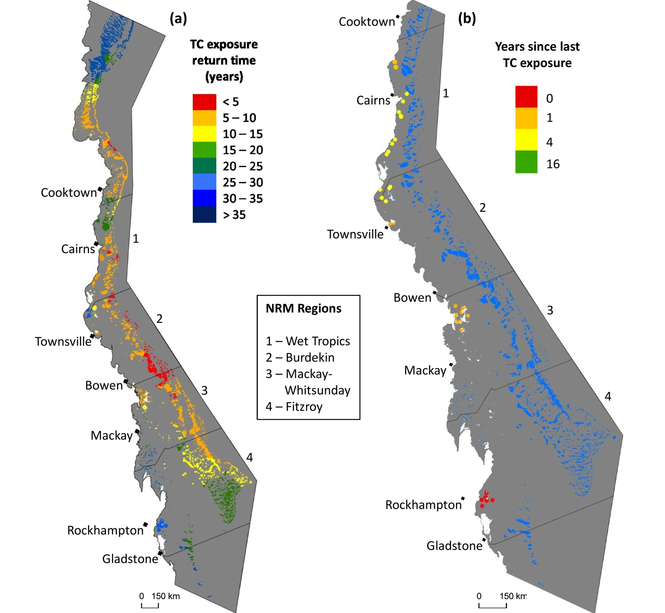

Figure A 8: Cyclone exposure history
. a) Return times (years) of exposure to cyclone-generated seas sufficient to damage most coral colonies (wave height = 4metres) on the Great Barrier Reef, based on 1985-2015 cyclone data. b) For MMP reef locations, the number of years from 2015 since last exposure to cyclone-generated damaging seas, based on 1985-2015 cyclone data. Courtesy M. Puotinen. Methods described in Puotinen et al. (2016).

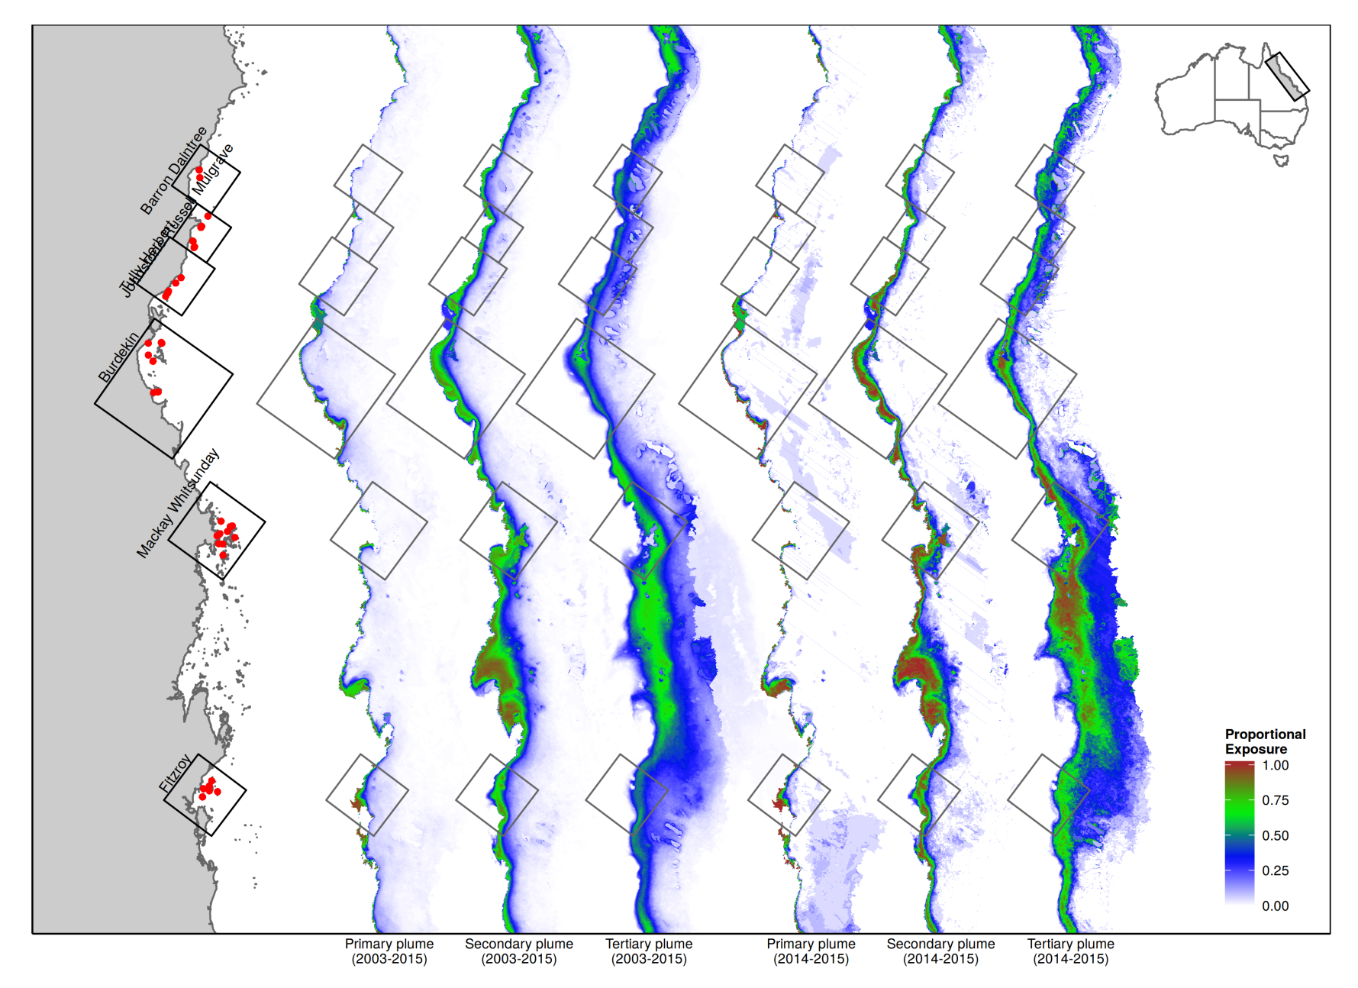
Figure A 9: Exposure to plume type waters
. Panels represent the proportion of the wet season (December-March) that waters were classified as Primary secondary or tertiary plume types following Álvarez-Romero et al. (2013). From left to right the first three exposures represent long term wet season mean exposure 2003-2015, the second group of three represents exposures estimated for the 2014-2015 wet season only.

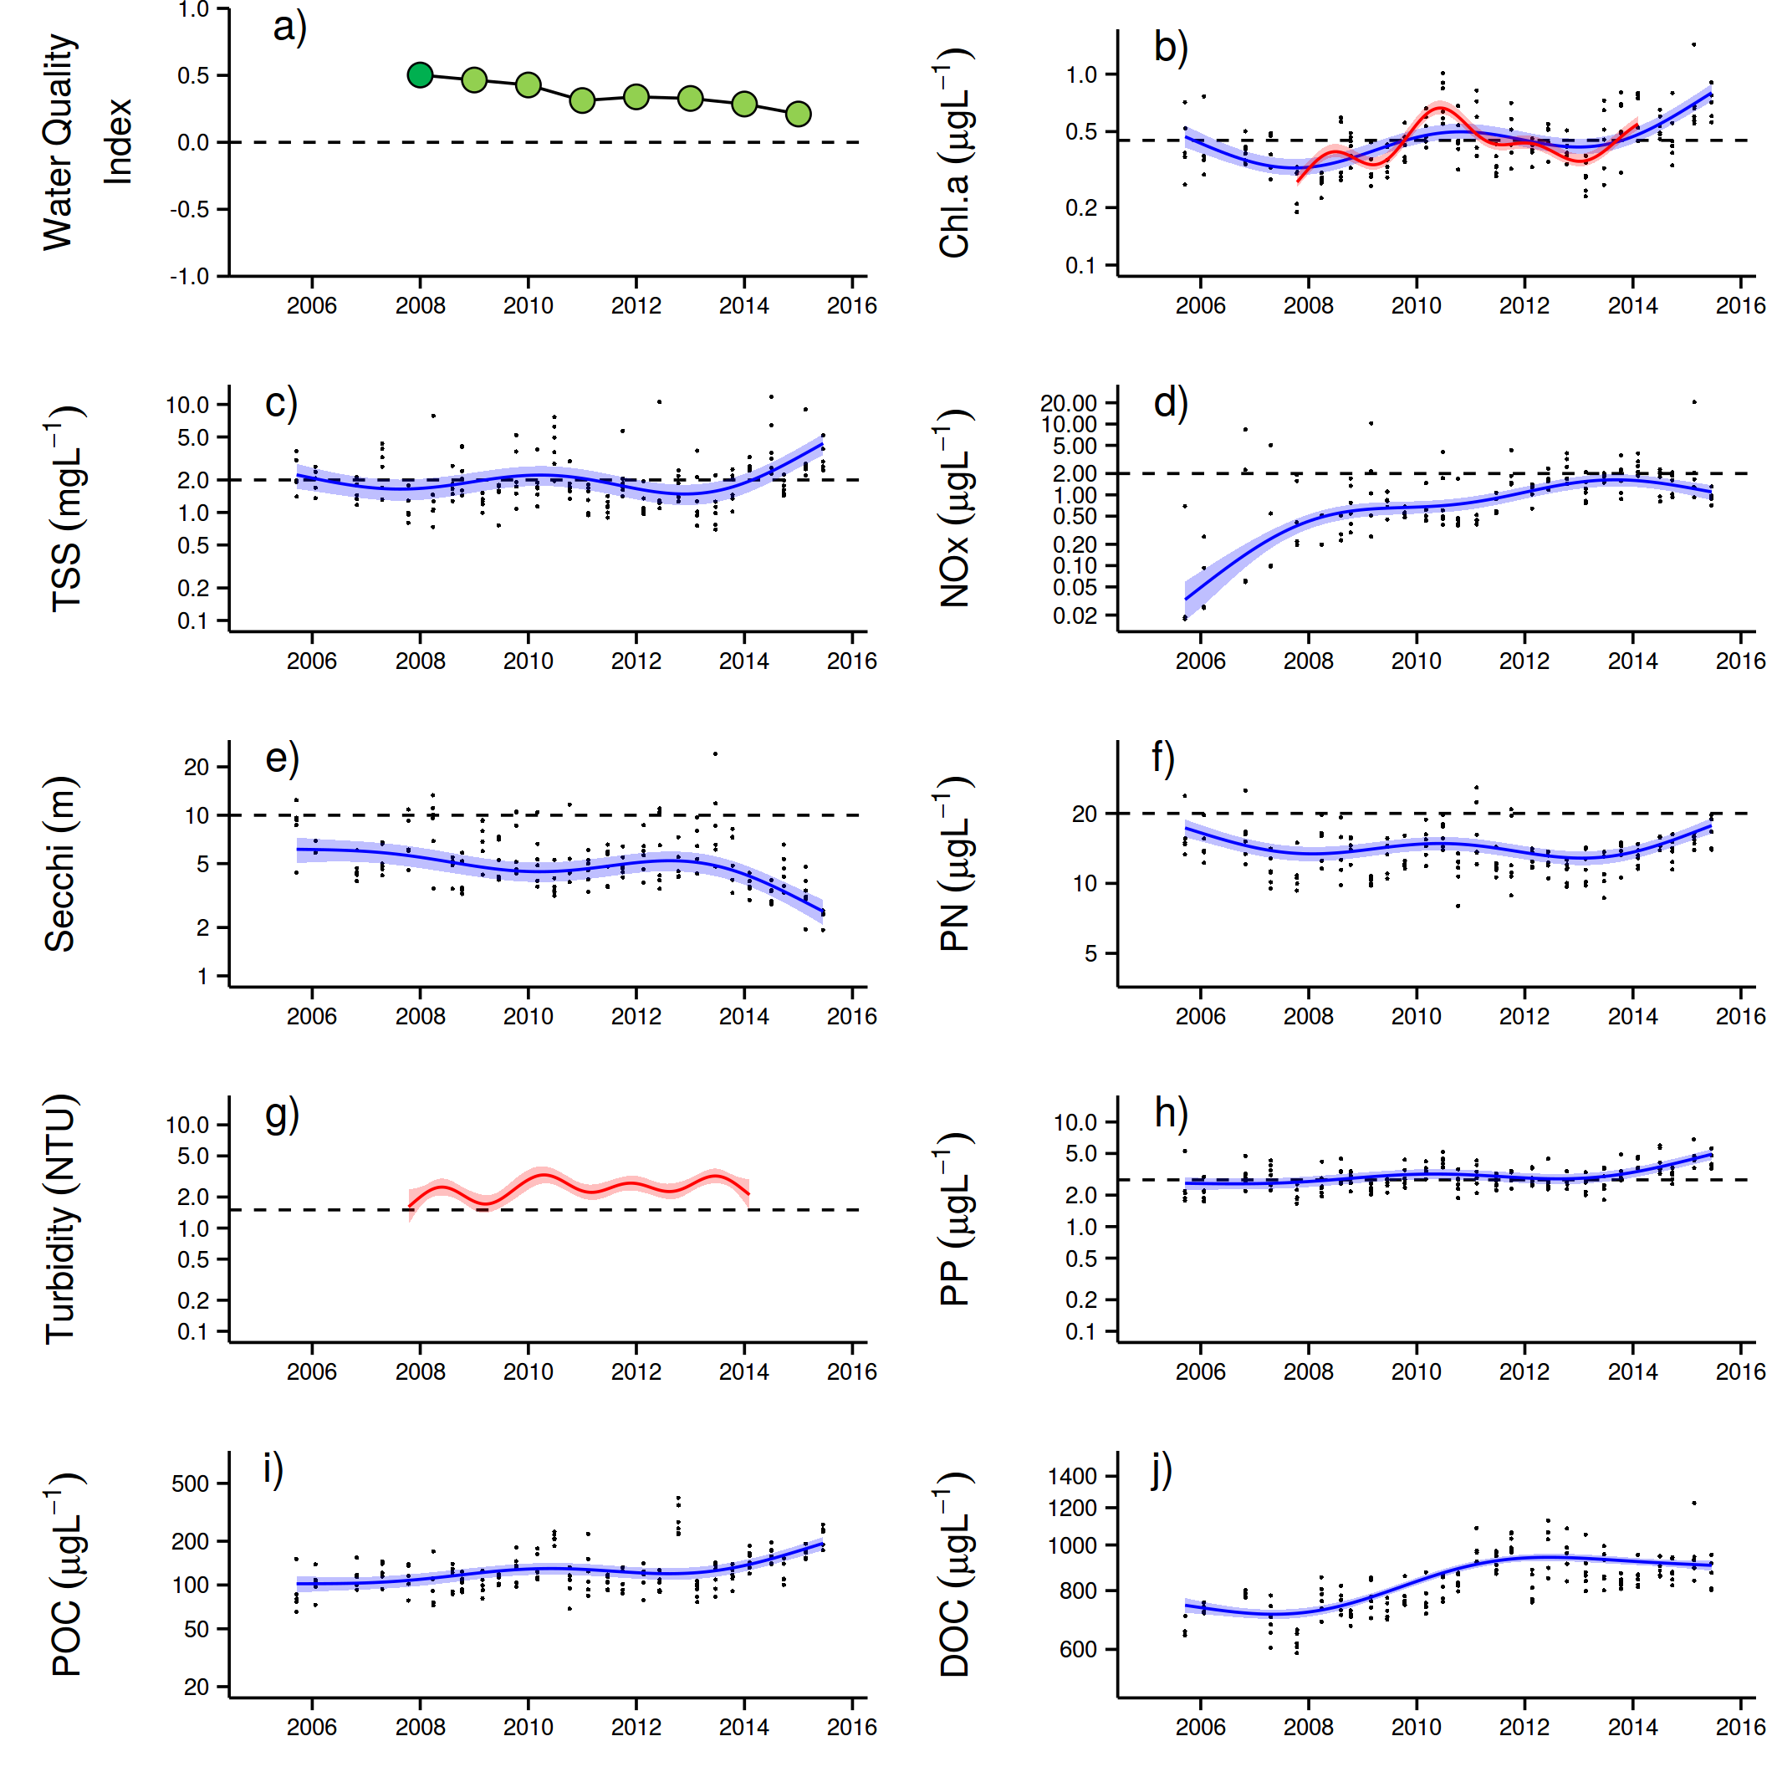
Figure A 10: Temporal trends in water quality: Baron Daintree sub-region
- water quality index, b) chlorophyll a, c) total suspended solids, d) nitrate/nitrite, e) secchi depth, f) particulate nitrogen, g) turbidity, h) particulate phosphorus, i) particulate organic carbon and j) dissolved organic carbon. Water quality index colour coding: dark green- ‘very good’; light green-‘good’; yellow – ‘moderate; orange – ‘poor’; red – ‘very poor’. The water quality index is the aggregate of variables plotted in b - h and calculated as described in Lønborg et al. (2015). Trends in POC and DOC values are plotted here (I, j); threshold levels have yet to be established. Trends in manually sampled water quality variables are represented by blue lines with blue shaded areas defining 95% confidence intervals of those trends, black dots represent observed data. Trends of records from ECO FLNTUSB instruments (b, g) are represented in red, individual records are not displayed. Dashed reference lines indicate guideline values (GBRMPA 2010). Extract from Lønborg et al. (2015).

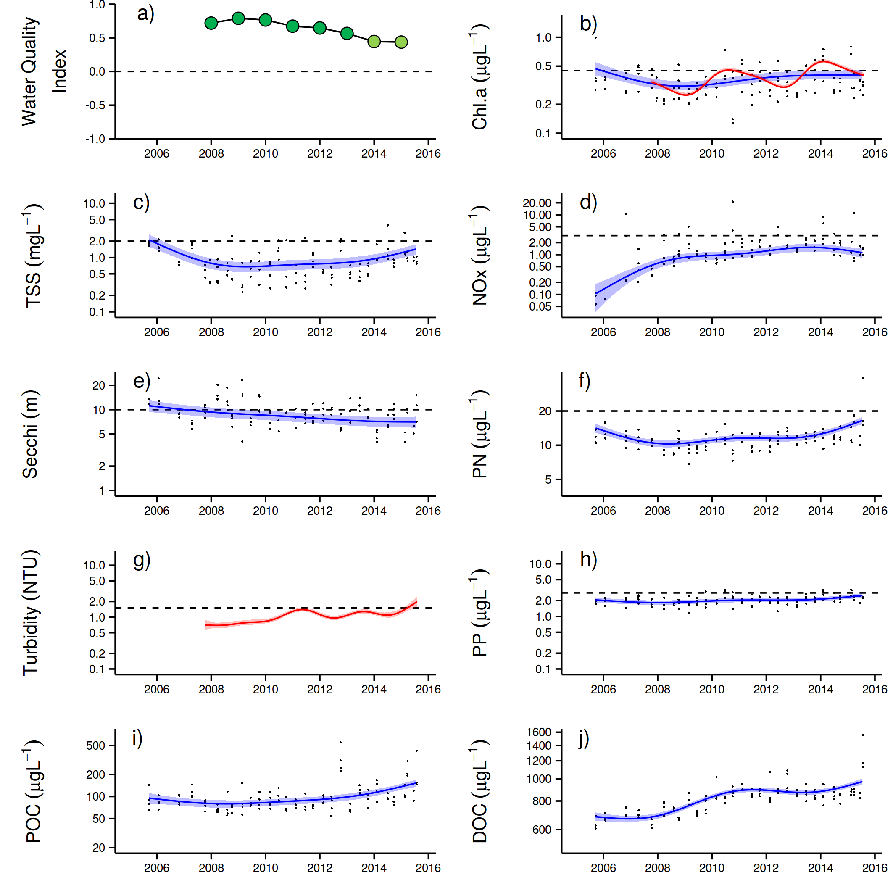
Figure A 11: Temporal trends in water quality: Johnstone Russell-Mulgrave sub-region
. a) water quality index, b) chlorophyll a, c) total suspended solids, d) nitrate/nitrite, e) secchi depth, f) particulate nitrogen, g) turbidity, h) particulate phosphorus, i) particulate organic carbon and j) dissolved organic carbon. Water quality index colour coding: dark green- ‘very good’; light green-‘good’; yellow – ‘moderate; orange – ‘poor’; red – ‘very poor’. The water quality index is the aggregate of variables plotted in b - h and calculated as described in Lønborg et al. (2015).Trends in POC and DOC values are plotted here (I, j); threshold levels have yet to be established. Trends in manually sampled water quality variables are represented by blue lines with blue shaded areas defining 95% confidence intervals of those trends, black dots represent observed data. Trends of records from ECO FLNTUSB instruments (b, g) are represented in red, individual records are not displayed. Dashed reference lines indicate guideline values (GBRMPA 2010). Extract from Lønborg et al. (2015).

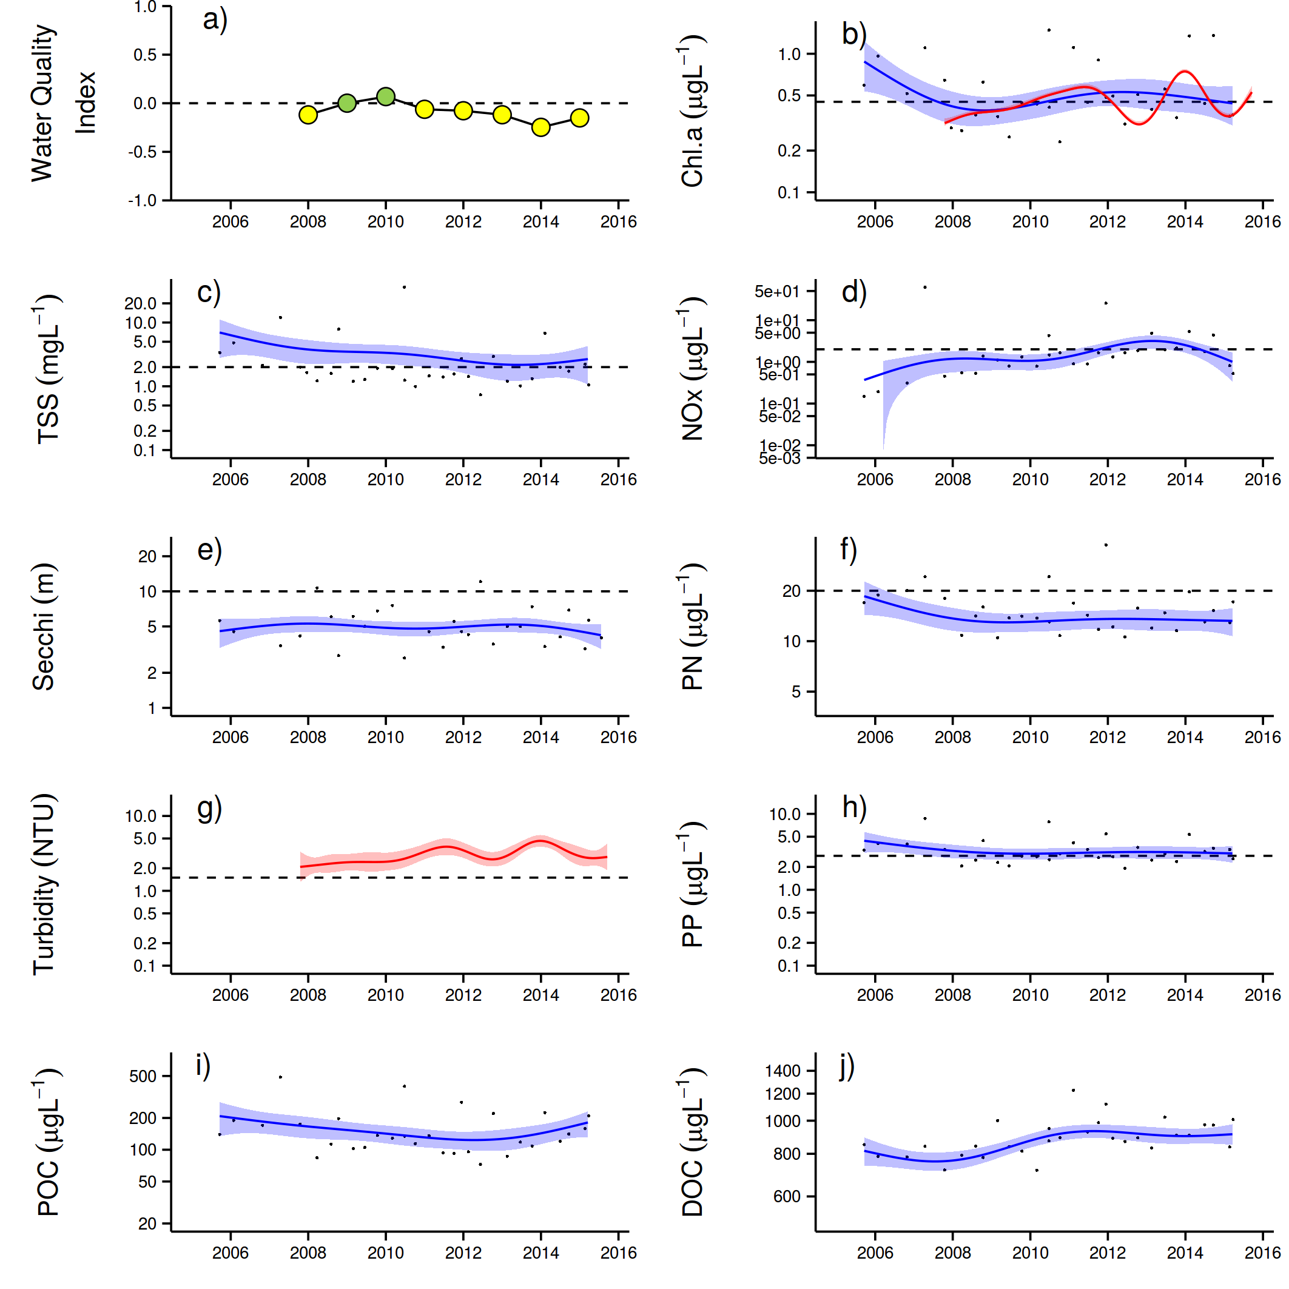
Figure A 12: Temporal trends in water quality: Herbert Tully sub-region.
a) water quality index, b) chlorophyll a, c) total suspended solids, d) nitrate/nitrite, e) secchi depth, f) particulate nitrogen, g) turbidity, h) particulate phosphorus, i) particulate organic carbon and j) dissolved organic carbon. Water quality index colour coding: dark green- ‘very good’; light green-‘good’; yellow – ‘moderate; orange – ‘poor’; red – ‘very poor’. The water quality index is the aggregate of variables plotted in b - h and calculated as described in Lønborg et al. (2015).Trends in POC and DOC values are plotted here (I, j); threshold levels have yet to be established. Trends in manually sampled water quality variables are represented by blue lines with blue shaded areas defining 95% confidence intervals of those trends, black dots represent observed data. Trends of records from ECO FLNTUSB instruments (b, g) are represented in red, individual records are not displayed. Dashed reference lines indicate guideline values (GBRMPA 2010). Extract from Lønborg et al. (2015).

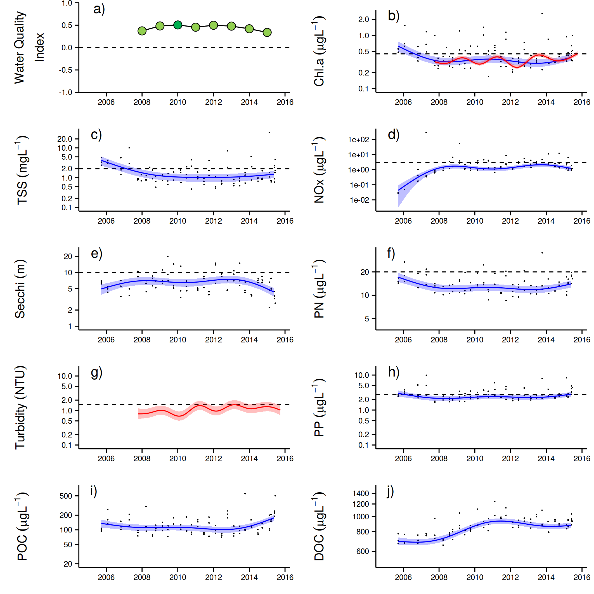

Figure A 13: Temporal trends in water quality: Burdekin region.
a) water quality index, b) chlorophyll a, c) total suspended solids, d) nitrate/nitrite, e) secchi depth, f) particulate nitrogen, g) turbidity, h) particulate phosphorus, i) particulate organic carbon and j) dissolved organic carbon. Water quality index colour coding: dark green- ‘very good’; light green-‘good’; yellow – ‘moderate; orange – ‘poor’; red – ‘very poor’. The water quality index is the aggregate of variables plotted in b - h and calculated as described in Lønborg et al. (2015). Trends in POC and DOC values are plotted here (I, j); threshold levels have yet to be established. Trends in manually sampled water quality variables are represented by blue lines with blue shaded areas defining 95% confidence intervals of those trends, black dots represent observed data. Trends of records from ECO FLNTUSB instruments (b, g) are represented in red, individual records are not displayed. Dashed reference lines indicate guideline values (GBRMPA 2010). Extract from Lønborg et al. (2015).

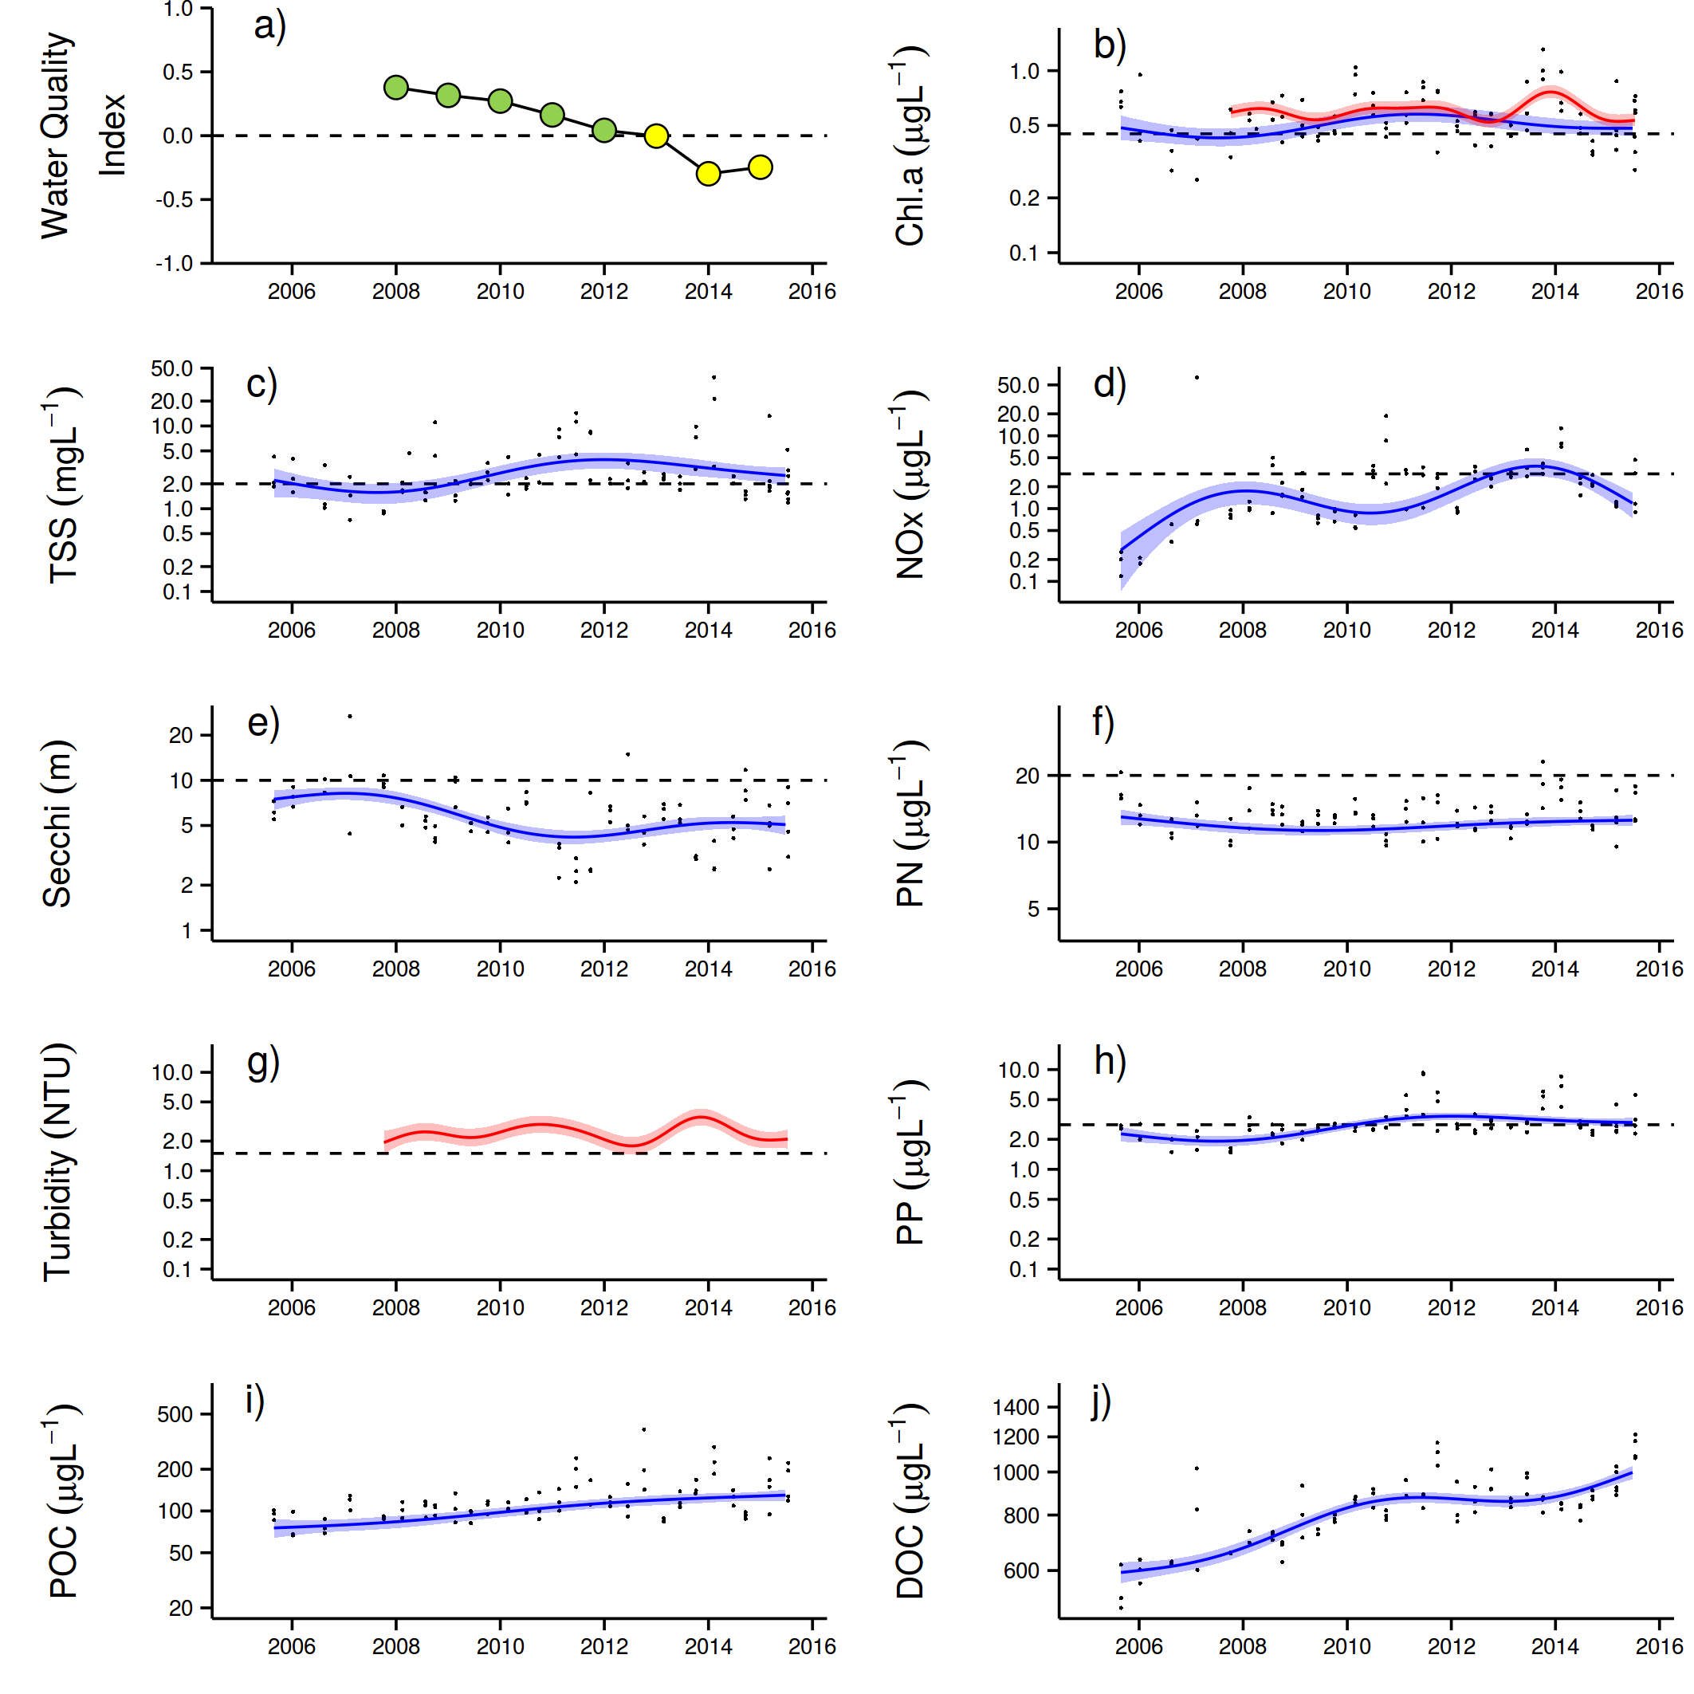
Figure A 14: Temporal trends in water quality: Mackay Whitsundays region.
a) water quality index, b) chlorophyll a, c) total suspended solids, d) nitrate/nitrite, e) secchi depth, f) particulate nitrogen, g) turbidity, h) particulate phosphorus, i) particulate organic carbon and j) dissolved organic carbon. Water quality index colour coding: dark green- ‘very good’; light green-‘good’; yellow – ‘moderate; orange – ‘poor’; red – ‘very poor’. The water quality index is the aggregate of variables plotted in b - h and calculated as described in Lønborg et al. (2015). Trends in POC and DOC values are plotted here (I, j); threshold levels have yet to be established. Trends in manually sampled water quality variables are represented by blue lines with blue shaded areas defining 95% confidence intervals of those trends, black dots represent observed data. Trends of records from ECO FLNTUSB instruments (b, g) are represented in red, individual records are not displayed. Dashed reference lines indicate guideline values (GBRMPA 2010). Extract from Lønborg et al. (2015).

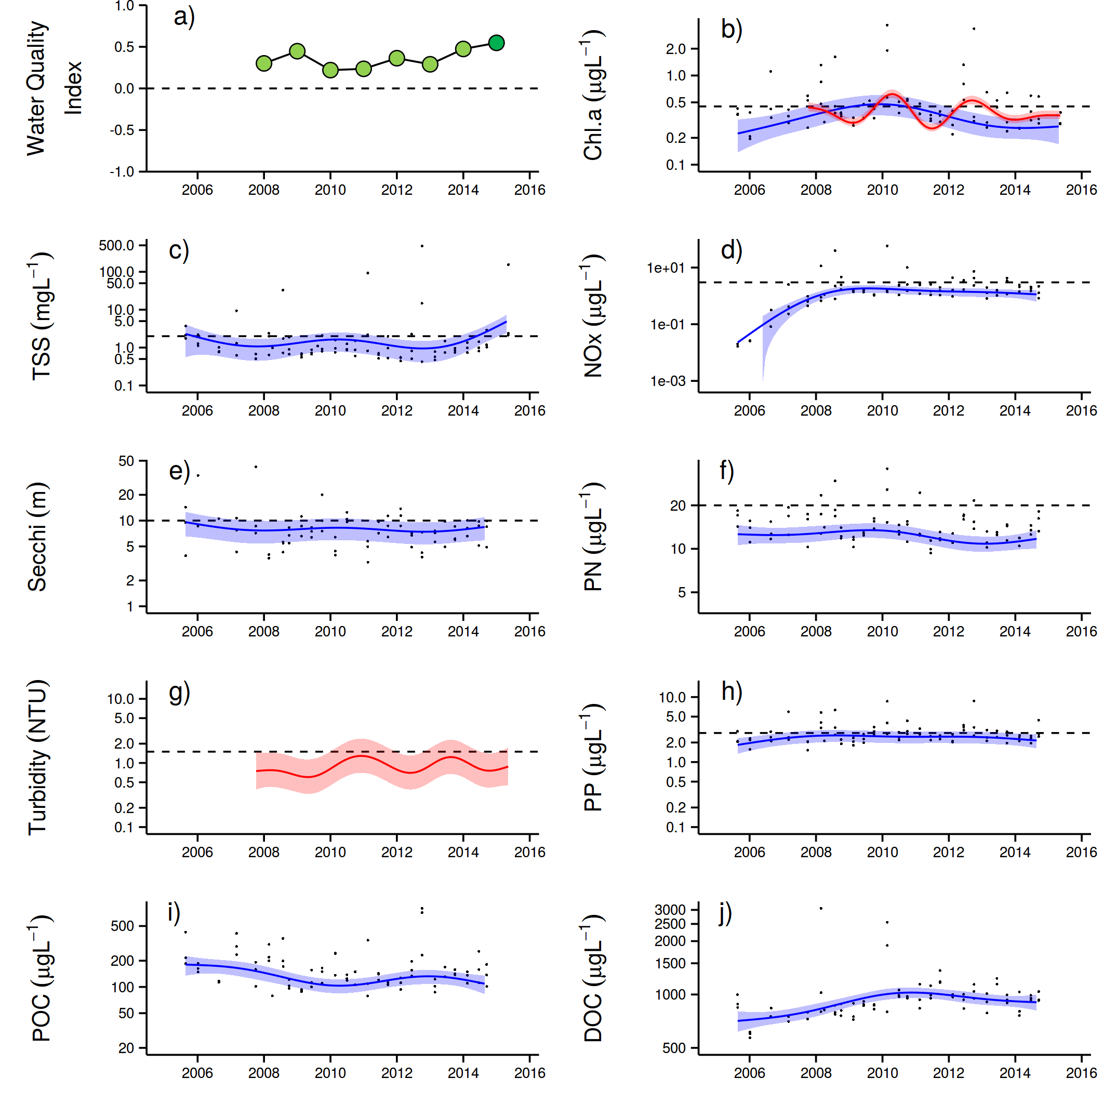
Figure A 15: Temporal trends in water quality: Fitzroy region.
a) water quality index, b) chlorophyll a, c) total suspended solids, d) nitrate/nitrite, e) secchi depth, f) particulate nitrogen, g) turbidity, h) particulate phosphorus, i) particulate organic carbon and j) dissolved organic carbon. Water quality index colour coding: dark green- ‘very good’; light green-‘good’; yellow – ‘moderate; orange – ‘poor’; red – ‘very poor’. The water quality index is the aggregate of variables plotted in b - h and calculated as described in Lønborg et al. (2015). Trends in POC and DOC values are plotted here (I, j); threshold levels have yet to be established. Trends in manually sampled water quality variables are represented by blue lines with blue shaded areas defining 95% confidence intervals of those trends, black dots represent observed data. Trends of records from ECO FLNTUSB instruments (b, g) are represented in red, individual records are not displayed. Dashed reference lines indicate guideline values (GBRMPA 2010). Extract from Lønborg et al. (2015).

Appendix 2: QAQC Information
Method performance and QAQC information for coral monitoring activities
Photo point intercept transects.
The QA/QC for the estimation of cover of benthic communities has two components. The sampling strategy which uses permanently marked transects ensures estimates are derived from the same area of substratum each year to minimise possible sampling error. The second component is to ensure the consistency of identification of community components from digital photo images. All points are double-checked by a single observer on completion of analysis each year. This double-checking has now been done for all digital still photograph images in the database. All hard corals, soft corals and macroalgae were identified to at least genus level where image quality allowed. Other benthic groups were also checked and consistency in differentiation achieved.
Juvenile coral belt transects.
Two observers collected juvenile coral count data in 2014. Data from Snapper Is was supplied by Sea Research. The Sea Research observer, Tony Ayling, is the most experienced individual in Australia in surveying the benthic communities of inshore coral reefs. Like the AIMS observers, his taxonomic skills are complete at genus level and he used the same field protocols, pre-printed datasheets and data entry programs as AIMS observers. Prior to commencement of surveys observer standardisation for Tony Ayling included detailed discussion and demonstration of methodologies with the AIMS team. While we are confident that limited bias was introduced as a result of his participation, as the focus of the program is for temporal comparisons any bias between Tony Ayling and AIMS observers will not manifest in temporal comparisons at Snapper Is. All other reefs were surveyed by an experienced AIMS staff member. It must be acknowledged however that for some of the smallest size class <2cm identification to genus is impossible in the field, though for the most part this is the case for relatively rare taxa for which reference to nearby larger individuals cannot be made. All data are entered into the database and rechecked against field data sheets.

Appendix 3: Publications and
presentations associated with the Program 2014-15
Publications
Addison P, Walshe T, Sweatman H, Jonker M, MacNeil A, Thompson A, Logan M (2015) Towards an integrated monitoring program: Identifying indicators and existing monitoring programs to effectively evaluate the Long Term Sustainability Plan. Report to the National Environmental Science Programme. Reef and Rainforest Research Centre Limited, Cairns.
Presentations
Thompson A, Logan M (2015) Revising coral community condition indicators for the inshore Great Barrier Reef. Australian Coral Reef Society, July 2015.

Connie 2.0, CSIRO Connectivity Interface, CSIRO connie2
Marine water quality indices produced by the Australian Bureau of Meteorology as a contribution to eReefs - a collaboration between the Great Barrier Reef Foundation, Australian Government, Bureau of Meteorology, Commonwealth Scientific and Industrial Research Organisation, Australian Institute of Marine Science and the Queensland Government. Data are acquired from NASA spacecraft by the Bureau, Australian Institute of Marine Science, and the Commonwealth Scientific and Industrial Research Organization.

