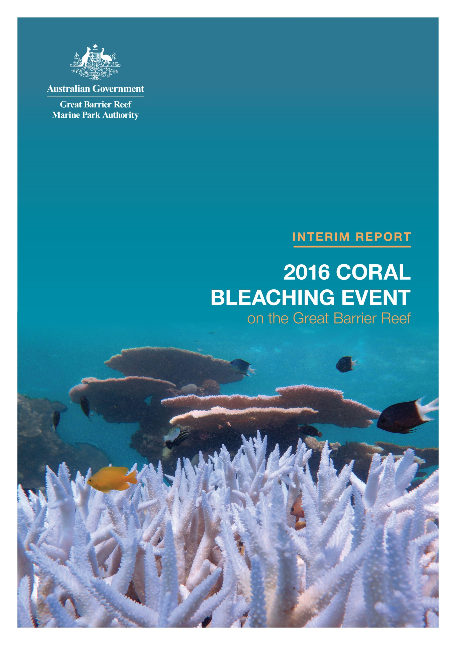

Interim report: 2016 coral bleaching event on the Great Barrier Reef
Preliminary findings of a rapid ecological impact assessment and summary of environmental monitoring and incident response
September 2016

© Commonwealth of Australia 2016
Published by the Great Barrier Reef Marine Park Authority
ISBN 9781922126955
The Interim report: 2016 coral bleaching event on the Great Barrier Reef is licensed by the Commonwealth of Australia for use under a Creative Commons By Attribution 4.0 International licence with the exception of the Coat of Arms of the Commonwealth of Australia, the logo of the Great Barrier Reef Marine Park Authority, any other material protected by a trademark, content supplied by third parties and any photographs. For licence conditions see: http://creativecommons.org/licences/by/4.0

A catalogue record is available for this publication from the National Library of Australia
Acknowledgements:
This report was compiled and edited by Dr Jessica Stella, Dr Rachel Pears and Dr David Wachenfeld of the Great Barrier Reef Marine Park Authority.
This publication should be cited as:
Great Barrier Reef Marine Park Authority 2016, Interim report: 2016 coral bleaching event on the Great Barrier Reef, GBRMPA, Townsville.

Further information is available from:
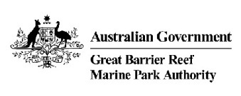
Great Barrier Reef Marine Park Authority
2–68 Flinders Street
(PO Box 1379)
Townsville QLD 4810, Australia

Phone: (07) 4750 0700
Fax: (07) 4772 6093
Email: info@gbrmpa.gov.au
www.gbrmpa.gov.au

Acknowledgements

The Great Barrier Reef Marine Park Authority’s (GBRMPA) field assessments under its incident response to the 2016 coral bleaching event were mainly resourced through the Field Management Program, which is jointly funded by the Australian and Queensland governments. Staff from the program, the incident management team, and the agency’s spatial data centre contributed to this work, along with many other agency teams. The agency’s Reef Recovery section led the forward-planning and environmental assessment. Thank you to the many staff who participated in the incident response from March to June 2016.
The agency’s Eye on the Reef program provided the monitoring network and reporting system that underpinned this assessment. We thank everyone who contributes to this important monitoring effort. Further details on the program are available on our website.
The Reef health early warning system uses tools and services provided by the Bureau of Meteorology, the United States National Oceanic and Atmospheric Administration and several other organisations. For details, see GBRMPA's Coral Bleaching Risk and Impact Assessment Plan.
We thank staff from the agency and Queensland Parks and Wildlife Service who conducted in-water surveys and helped collect and process the data. We also extend our thanks to Scott Firth from the Association of Marine Park Tourism Operators, Lyle Vail from Lizard Island Research Station, and Paul Marshall and Adam Smith from Reef Ecologic for assisting with some of the surveys in the Cairns–Port Douglas, Lizard Island and Townsville transects respectively.
In-kind fieldwork support was provided by the Australian Institute of Marine Science and the Australian Research Council Centre of Excellence for Coral Reef Studies. We thank the crews of the joint Field Management Program vessels, and Australian Institute of Marine Science’s Cape Ferguson, as well as Adrenalin Dive. Thanks also to the many staff who provided operational, communications and administrative support.
The bleaching impact assessment has been conducted in collaboration with the Queensland Parks and Wildlife Service, and many other partners including the Bureau of Meteorology, National Oceanic and Atmospheric Administration, Australian Institute of Marine Science, Australian Research Council Centre of Excellence for Coral Reef Studies, and the National Coral Bleaching Taskforce.
The information in this report is focused on the Great Barrier Reef. We recognise the current global coral bleaching event is affecting other parts of Australia and the world.

Executive Summary

Coral bleaching, due to ocean warming associated with climate change, is one of the most pressing threats to coral reefs worldwide. Mass bleaching events occur during extended periods of elevated sea surface temperatures and have the potential to be widespread, resulting in significant loss of coral.
Since 2014, severe mass coral bleaching has been occurring in most tropical regions across the world in the longest mass bleaching event ever recorded. This global event was triggered by record-breaking sea surface temperatures caused by climate change and amplified by a strong El Niño. For the Great Barrier Reef, this resulted in the worst ever coral bleaching in 2016.
The Great Barrier Reef Marine Park Authority (GBRMPA or ‘the agency’) used its Reef Health Incident Response System to predict, forward-plan and respond to the coral bleaching event. The agency and key partners recognised and stated that there would be a high risk of bleaching in 2016, and monitored early warning tools. As the mass bleaching unfolded, the agency triggered its Coral Bleaching Risk and Impact Assessment Plan and, consequently, its largest-ever in-water monitoring effort. GBRMPA formed an incident management team to coordinate and undertake the surveys, as well as logistics, mapping, data analysis, and stakeholder and broader communications. The incident response was supported by many collaborations and partnerships, and the agency was also a member of Australia's National Coral Bleaching Taskforce.
This report includes the preliminary results of in-water reef health and impact surveys conducted by GBRMPA and the Queensland Parks and Wildlife Service. The surveys provided a rapid assessment of the spatial extent and severity of the 2016 mass coral bleaching event in the Great Barrier Reef Marine Park. Similar information was provided to the public through regular updates on GBRMPA’s website and associated communication tools. The agency and the Queensland Parks and Wildlife Service are also preparing to undertake further Reef-wide surveys in October and November 2016 to assess recovery rates and survivorship.
In-water survey data has documented widespread but patchy bleaching of varying levels of severity throughout the Marine Park as a result of prolonged heat stress. The most severe bleaching occurred between the tip of Cape York and just north of Port Douglas (that is, in the remote northern third of the Marine Park). This area experienced the greatest heat stress, with abnormally high sea surface temperatures persisting for a long period of time and as a result, a substantial amount of severely bleached coral died. The Torres Strait also had severe bleaching, but is not covered in this report.
Die-off of corals (coral mortality) south of Port Douglas was highly variable by location, and many reefs escaped with little or no mortality. Bleaching-related mortality of corals was highest on inshore and mid-shelf reefs in the far north around Cape Grenville and Princess Charlotte Bay. Severe bleaching also occurred at all shelf locations in the Lizard Island region, with substantial coral die-off now reported. Variability in bleaching severity was highest among reefs in the Cairns–Port Douglas and Townsville areas. Most reefs south of Cairns escaped major impacts. The strong latitudinal gradient and high variability of bleaching severity among reefs has left many reefs relatively unaffected and still in relatively good condition. Despite the bleaching event, the Great Barrier Reef remains in a much better state than many other coral reef ecosystems around the world.
Surveys detailed in this report were supplemented by additional surveys by science partners, and information from a network of tourism industry operators and the public. In particular, the Australian Institute of Marine Science conducted in-water surveys and the ARC Centre of Excellence for Coral Reef Studies conducted aerial and in-water surveys. Science partners are also conducting further assessments throughout 2016. All information on the event is being used to build a comprehensive picture of reef health and condition, and the impacts of bleaching. Full analyses are ongoing and will be reported on in future joint publications.
Analyses show the Great Barrier Reef has typically been robust in response to disturbances and is likely to fare better than most reef regions around the world. However this severe bleaching will have lasting impacts on the health and resilience of affected reefs, primarily via reductions in the amount of coral, shifts in coral community structure, and flow-on effects for reef fish and invertebrate communities. Such impacts then have the potential to affect the social and/or economic value of reef sites important to Reef-based industries.
The severity of this bleaching event reinforces the need for a concerted international effort to rapidly mitigate global climate change, as well as national and local actions to build the Reef’s resilience by reducing direct and indirect impacts. These efforts are our best insurance for protecting this precious natural icon.

Table of Contents

Acknowledgements iii
Executive summary iv
Introduction 1
Environmental monitoring and incident response 3
Early warning system to detect heat stress 3
Pre-summer risk assessment and national taskforce 3
Global pattern of heat stress 4
Pattern of heat stress for the Great Barrier Reef waters 4
Incident response as the coral bleaching event unfolded 5
Environmental impact assessments 6
Survey plan and methodology 6
Detailed observations and results 9
Scale and spatial patterns of coral bleaching 9
Scale and spatial patterns of coral mortality (as at 13 June 2016) 15
Other impacts of record-breaking heat stress 15
Conclusions and outlook for recovery 17
References 19
APPENDIX A: List of reefs surveyed in each cross-shelf transect 23
APPENDIX B: example illustrations and descriptions 24
APPENDIX C: Time-series images 26

Introduction

Climate change, and its associated impacts, poses the greatest threat to the long-term sustainability of coral reefs worldwide, primarily via mass coral bleaching events.^{1,2} Rapid increases in atmospheric carbon dioxide are consequently warming ocean temperatures beyond thresholds in which corals can thrive. Severe bleaching can cause substantial loss of coral.^{3,4,5} As corals form the foundation of the reef, and provide essential habitat to reef fish and invertebrates^{6,7}, the loss of coral can cause reductions in the populations of other reef inhabitants⁸.
A global mass-bleaching event began in the north Pacific in mid-2014. From 2014 to 2016, record-breaking sea temperatures were observed over several months at various locations. These higher than average temperatures were caused by climate change and boosted by a strong El Niño^{9,10,11}, triggering mass coral bleaching in the Caribbean, Indian and Pacific oceans and the Great Barrier Reef. Many different stressors can cause coral bleaching, including freshwater inundation and poor water quality from run-off, however heat stress from above-average temperatures is the only known cause of mass coral bleaching.^{1,12,13,14} Prior to the 2016 summer, the worst global mass bleaching event occurred in 1998, and is estimated to have seriously degraded up to 16 per cent of the world’s coral reefs.¹⁵ The current coral bleaching event is only the third on record and has been the longest lasting and most widespread.
Corals reefs are particularly vulnerable to ocean warming because corals can tolerate only a narrow range of temperatures and when exceeded (even by one degree Celsius above the normal summer maximum), corals experience heat stress.^{1,16,17} Most corals have microscopic marine algae (called zooxanthellae) living inside their tissue which not only colour the coral tissue but also provide up to 90 per cent of their food. When corals are under stress, this symbiotic relationship breaks down, and corals expel the zooxanthellae. As the natural pigments in corals’ tissue are often fluorescent, the corals may then display a striking fluorescent hue in pink, yellow, purple or blue.^{18,19} If they lack fluorescent pigments or their fluorescence is not visible to the human eye, they will instead appear bright white due to their underlying skeleton. Although these corals may appear astonishingly vivid, the corals are severely stressed and at risk of dying.
The level of exposure to heat stress largely determines the fate of the coral and overall impacts to the ecosystem.¹⁷ If heat stress is only short term, corals can recover as indicated by the return of zooxanthellae and hence, a darker colour.²⁰ However, residual effects of bleaching may negatively impact coral reproduction for one or two years^{5,21,22} , slow coral growth and calcification rates^{23,24}, and increase their susceptibility to disease^{25,26}.
If heat stress is prolonged, bleached corals will starve and eventually die. Remaining coral skeletons are then colonised by algae, restricting the ability of coral larvae to establish themselves on these sites. If coral recovery is hindered this way, the ecosystem can potentially shift from being coral-dominated to algal-dominated.^{27,28,29} Coral reefs that have high rates of coral death from bleaching can take many years or decades to recover.^{30,31} The ecological implications of severe bleaching include a reduction in the abundance of coral, shifts in coral community structure, altered habitat composition, and many other ecosystem flow-on effects.^{3,8,13,30,31,32} Some of these impacts may not become apparent until many years after the event⁸, and during that time other disturbances can take place.
On the Great Barrier Reef, a changing climate is expected to increase the frequency and severity of coral bleaching events.^{17,33,34} Prior to 2016, there were two widespread mass bleaching events on the Reef — these occurred in 1998 and 2002.^{35,36} In both events it was estimated nearly half of the 3000 reefs in the Marine Park experienced some bleaching, with about 18 per cent experiencing severe bleaching.³⁶ However, most corals survived, and in each event an estimated five per cent or less of reefs in the Marine Park experienced high coral mortality. While this indicates the Reef has been resilient to mass bleaching events in the past, the capacity of the ecosystem to recover is likely to diminish as the frequency and intensity of disturbances increases.^{37,38} Severe bleaching also has various implications for communities and industries that depend on the Great Barrier Reef.^{39,40,41}
Bleaching is not the only threat to coral reef habitats and its impacts cannot be viewed in isolation from the legacy impacts of past practices and current pressures. Other threats include severe tropical cyclones, coral predation by the crown-of-thorns starfish and poor water quality. Research by the Australian Institute of Marine Science shows average coral cover on the Reef fell by approximately 40 per cent between 1985 and 2012, due to several cyclones, outbreaks of crown-of-thorns starfish and mass bleaching. However, between 2012 and 2015, there was an overall 19 per cent increase in coral cover (to almost 20 per cent from a low point of about 17 per cent).
The biggest increase was in the southern Great Barrier Reef (Australian Institute of Marine Science, 2016). As exposure to major disturbances in the southern Reef was minimal in these three years (surveys occurred prior to Cyclone Marcia), these results exemplify the capability of the Reef to recover from past disturbances in the absence of new ones. Reducing other pressures on the Reef where possible, such as controlling outbreaks of crown-of-thorns starfish, is crucial to improve the ecosystem’s resilience in the face of multiple pressures.
Given the implications of severe bleaching, the Great Barrier Reef Marine Park Authority (GBRMPA) has a responsibility to monitor risks, better understand coral bleaching impacts, and keep the public informed. This report presents the preliminary results of in-water surveys conducted by GBRMPA and the Queensland Parks and Wildlife Service to assess the spatial extent and severity of the 2016 mass coral bleaching event in the Great Barrier Reef Marine Park.
These surveys were conducted with the support of the Australian Institute of Marine Science and the Australian Research Centre of Excellence for Coral Reef Studies. GBRMPA uses its Reef Health Incident Response System⁴² and associated plans, specifically the Coral Bleaching Risk and Impact Assessment Plan⁴³, for this purpose. Greater comprehension of the impacts and implications of these events is essential to refining and further developing management strategies and policies that support the resilience of the Reef ecosystem and Reef-based industries in the face of climate change.

Environmental monitoring and incident response

Early warning system to detect heat stress
The agency has an early warning system to predict Reef health risks, including bleaching. Mass coral bleaching is preceded by a series of environmental conditions that can be used to assess the probability of such an event occurring. A number of agencies and research institutions have developed tools, in close collaboration with GBRMPA, to monitor these conditions. These tools predict future conditions and enable near real-time monitoring of conditions that are conducive to bleaching (for example, sea surface temperature anomalies).
The agency’s Eye on the Reef program also routinely collects information submitted by Reef users and is monitored regularly for any reports of reef health impacts. Key partners in this monitoring network include the marine tourism industry. The program is critical to receiving real-time information on any signs of coral bleaching within the Marine Park.
Collectively, these tools provide the early warning system for coral bleaching and include:
- climate forecasts in the months preceding the summer to ascertain the likelihood of bleaching
- near real-time monitoring of temperature stress during the summer to target monitoring efforts
- a monitoring network to detect early signs of bleaching
- site inspections to ground-truth predictions or reports of bleaching and to determine if specific thresholds requiring incident response have been exceeded¹.

Pre-summer risk assessment and national taskforce
Before each summer, the agency convenes a workshop to seek expert advice on the probable risks to reef health for the coming summer. Attendees include Marine Park managers, climate and weather scientists, coral reef ecologists and water quality specialists from organisations such as the Australian Institute of Marine Science, the National Oceanic and Atmospheric Administration, the Australian Research Centre of Excellence for Coral Reef Studies, the University of Queensland, and the Queensland Parks and Wildlife Service.
After reviewing climate forecasts, the workshop attendees conduct a collective risk assessment. The risk assessment for the 2015–16 summer concluded there were high environmental risks from possible mass coral bleaching and chronic effects of coral disease, and a very high risk from ongoing crown-of-thorns starfish outbreaks. The highest risk period for mass bleaching was identified as early February to March — a period when the probability for accumulated heat stress to exceed bleaching thresholds is at its greatest. Subsequently, the agency monitored predictive tools weekly and reported results to senior decision-makers and stakeholders on the likelihood of summer bleaching.
The agency also joined and contributed to the National Coral Bleaching Taskforce which was established to coordinate the research efforts by marine scientists in the event of mass bleaching in Australia.

Global pattern of heat stress
Each of the first six months of 2016 set a record as the warmest respective month globally in the modern temperature record, which dates back to 1880. When combined, this six-month period was also the planet's warmest half-year on record, with an average air temperature of 1.3 degrees Celsius higher than the late 19th century.
June 2016 marked the 14th consecutive month that the monthly global temperature record was broken, the longest such streak in the 137-year temperature record. In addition to the global warming trend, the El Niño in the tropical Pacific has boosted global sea surface temperatures since October 2015.

Pattern of heat stress for the Great Barrier Reef waters
This year’s mass coral bleaching on the Great Barrier Reef was triggered by record-breaking sea surface temperatures (Figure 1). The rising temperatures reflect the underlying trend of global ocean warming caused by climate change. Great Barrier Reef waters have warmed by approximately 0.67 degree Celsius since 1871, with most of the warmest years occurring in the past two decades. A strong El Niño also resulted in little monsoon activity and, as a consequence, long periods without cloud cover which would typically have offered corals some respite from heat stress.
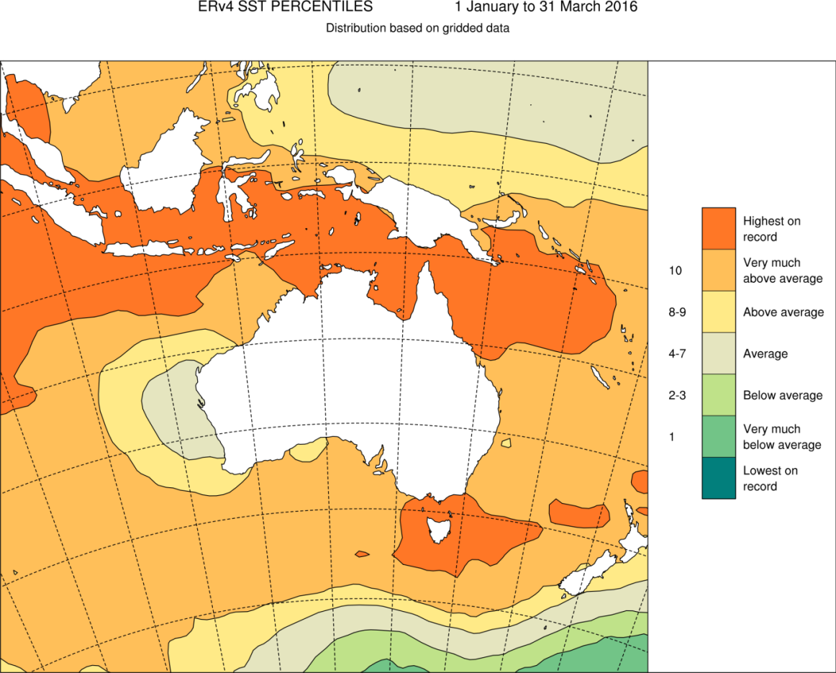
Figure 1 Distribution of record-breaking sea surface temperatures around Australia from 1 January to 31 March, 2016.
Highest on record refers to highest sea surface temperature value since 1900. Decile 10 is the highest 10 percent of records — this category is 'very much above average'. Analysis supplied by the Bureau of Meteorology. Based on the ERSST v4 dataset produced by the National Oceanic and Atmospheric Administration. © Australian Bureau of Meteorology
According to the Bureau of Meteorology, in 2016 the Great Barrier Reef recorded its hottest-ever average sea surface temperatures for February, March, April, May and June since records began in 1900. Each month was one to 1.3 degrees Celsius higher than the 1961–1990 average. Importantly, heat stress was not uniform across the Reef over these months. Local weather patterns, including rain and heavy cloud cover, also influenced sea temperatures — the southern half of the Reef experienced late summer cooling due to high cloud cover from ex-cyclones Winston and Tatiana. It was largely due to the influence of local weather patterns that the intensity of coral bleaching in each region varied and why some regions narrowly avoided more heat stress and hence severe coral bleaching.

Incident response as the coral bleaching event unfolded
GBRMPA uses the Australasian Inter-service Incident Management System framework to coordinate the governance, planning, operations, logistics, financial and inter-agency liaison arrangements required to adequately respond to a reef health incident.
Information gathered from the early warning system and site inspections helps the agency to understand the severity and spatial extent of impacts. The extent and severity is classified based on the standardised criteria for each incident, and a matrix is used to ‘score’ the event and inform a detailed situation analysis (Figure 2).
The agency’s incident management team assesses the situation analysis to decide on the required level of response. There are three potential response levels — 1, 2 and 3. Each increment corresponds to an increase in the severity and spatial extent of the impacts, and the management resources required to effectively respond.
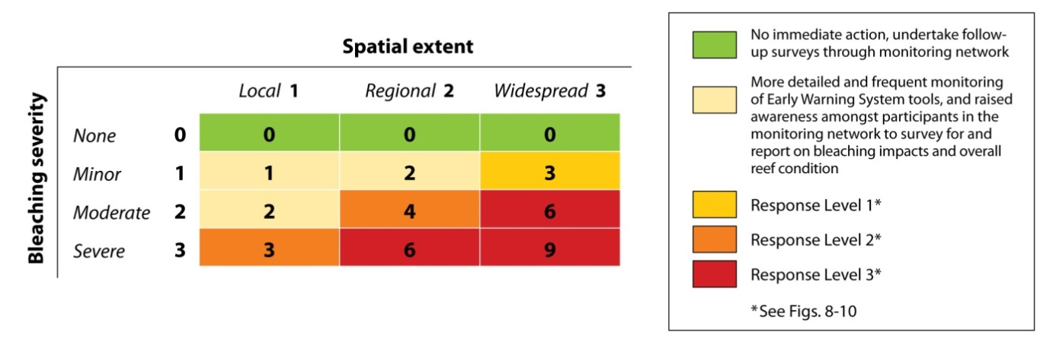

Figure 2 Matrix combining impact severity and spatial extent used to inform a situation analysis

By early March 2016, the Eye on the Reef program received reports of minor to moderate coral bleaching in 40 per cent of recent surveys in three management areas. As a result, GBRMPA declared a coral bleaching response level one under the Coral Bleaching Risk and Impact Assessment Plan.
After in-water site inspections by Reef managers and rangers in the far north revealed severe bleaching and high mortality on inshore and mid-shelf reefs, the agency declared a coral bleaching response level two. Once further site inspections documented moderate to severe bleaching offshore of Townsville, a level three response was declared due to severe regional bleaching and moderate bleaching over multiple management areas.
Aerial surveys by the Australian Research Centre of Excellence for Coral Reef Studies (with in-kind support from GBRMPA) were undertaken in March. The aerial surveys provided a rapid Reef-wide assessment of the spatial extent of bleaching and proportion of coral cover bleached on 876 reefs, helping to direct where in-water survey efforts should be targeted.
This interim report summarises the findings of the agency’s in-water reef health and impact surveys and how they were conducted. These surveys enabled a rapid environmental assessment, and were complemented by numerous additional surveys by science partners, and supplementary information from tourism industry operators, Indigenous rangers and community members.
All the information gathered is being used to build a comprehensive picture of reef health and condition, and bleaching impacts. Full analyses are ongoing and will be reported in future collaborative publications.

Environmental Impact assessments

Survey plan and methodology
The Coral Bleaching Risk and Impact Assessment Plan contains an approach to rapidly assess the severity and extent of coral bleaching on 45 reefs from the Lizard Island area (in the far north) south to the Swains (off Rockhampton), using reef health and impact surveys. The plan also recommends additional reefs be included if needed to fully cover an event.
The plan was modified through the addition of 18 reefs in two northern transects, meaning the final survey plan that was implemented covered a total of 63 reefs across seven transects (Figure 3).This ensured inclusion of areas that experienced the most significant heat stress (represented as degree heating days (DHDs), Figure 3) and better representation of Reef-wide patterns. This design allows the capture of any cross-shelf and/or latitudinal gradients along the Reef.
The transects (reef groupings) are located at latitudes centred on Cape Grenville, Princess Charlotte Bay, Lizard Island, Cairns–Port Douglas, Townsville, Whitsunday Islands and Rockhampton. Each transect consisted of nine reefs, however in the Whitsundays only eight reefs were surveyed as poor weather conditions prevented access to the ninth reef. A total of 62 reefs were surveyed under the structured assessment reported here. Numerous supplementary reef health and impacts surveys were also conducted at additional reefs to provide greater spatial coverage, particularly in the Port Douglas to Townsville area. These data will be summarised in the final reporting.
Reef health and impact surveys record benthic information (estimates of percentage cover of sea floor categorised as live coral, algae, dead coral, sand etc.) and coral impacts over a series of five-metre radius point surveys (circular plots of 78.5 square metres). These are 50 metres apart at each location. Where feasible, the surveys targeted reefs for which there was existing data through ongoing monitoring programs. This maximised their value to longer-term studies of reef health and resilience in the face of climate-related disturbances and other impacts such as crown-of-thorns starfish predation.
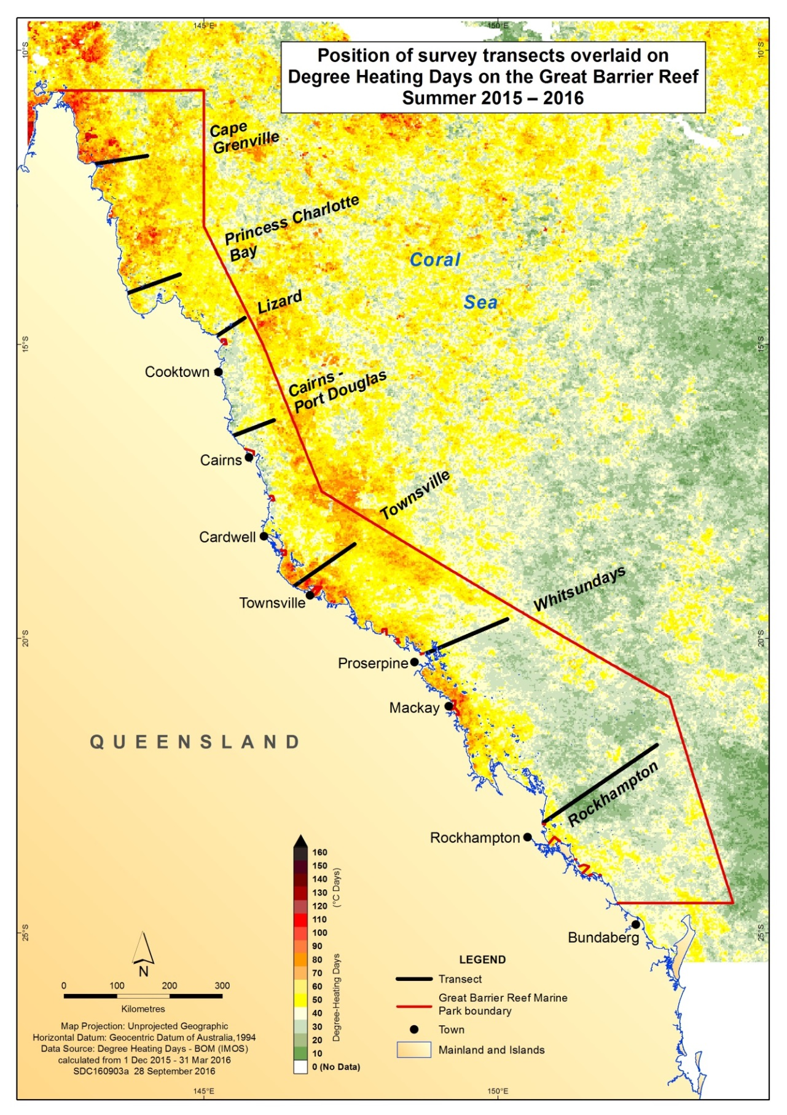
Figure 3 Location of each survey transect along the length of the Great Barrier Reef overlaid on the pattern of accumulated heat stress. (Degree Heating Day data sourced from ReefTemp Next Generation)
Heat stress is measured as Degree Heating Day (DHD) of Great Barrier Reef surface waters. One DHD is calculated as one degree Celsius above the local long-term average temperature for one day. If sea surface temperatures exceed the average by two degrees Celsius on a single day, it is counted as two DHDs. Higher degree heating day counts relate to an increased risk of bleaching.
Three inshore, three mid-shelf and three outer shelf reefs were surveyed in each transect (listed in Appendix A). To increase data accuracy and reliability, and to capture variability in bleaching patterns within a reef (based on exposure and depth), the survey plan aimed to conduct 15 or more surveys (that is, replicate samples) on three different locations on each reef, corresponding to three different aspects (north-east, north-west and south-west).
At each of the western locations, three surveys were conducted at the same depth. At the eastern location, three surveys were conducted at three different depths (approximately one to three metres, six metres and nine metres). Survey data was uploaded to the Eye on the Reef system, and analysed daily to ‘score’ bleaching impact severity at the survey and reef level (Appendix B). The results showed the extent and severity of bleaching in near real-time, which was communicated to senior management, government officials, partner organisations, stakeholders and the public.
The percentage of coral cover (if any) that had recently died from each impact-type (that is, bleaching, disease, predation, damage) was estimated for each reef health and impact survey by examining all coral colonies within the point surveys for any impacts. This data was used to categorise the average percentage of coral bleaching mortality for each reef as follows:
- none (0 per cent)
- low (greater than 0 per cent and less than 10 per cent)
- medium (10 per cent or more and less than 30 per cent)
- high (30 per cent or more and less than 50 per cent)
- very high (50 per cent or more).
Surveys that did not record any coral cover (for example reefs with high damage from previous cyclones) were excluded from the analysis of bleaching impacts. Between March and early June, each reef was surveyed either once or twice. Re-surveying the same reefs provides information on both bleaching and bleaching-related mortality at different points in time. Time-series bleaching records can illustrate either coral recovery or death (Appendix C). Given observations of bleaching and coral mortality continued in the 2016 winter, and some locations were surveyed before the peak of bleaching and initial mortality, estimates of coral die-off may increase. Final mortality estimates will be assessed in follow-up surveys in late 2016.

Detailed observations and results

Scale and spatial patterns of coral bleaching
Across the Reef, all surveyed reefs exhibited bleaching to some degree, however there was high variation in bleaching severity (Figure 4). The severity generally varied in relation to the amount of accumulated heat stress over the summer (Figure 3).
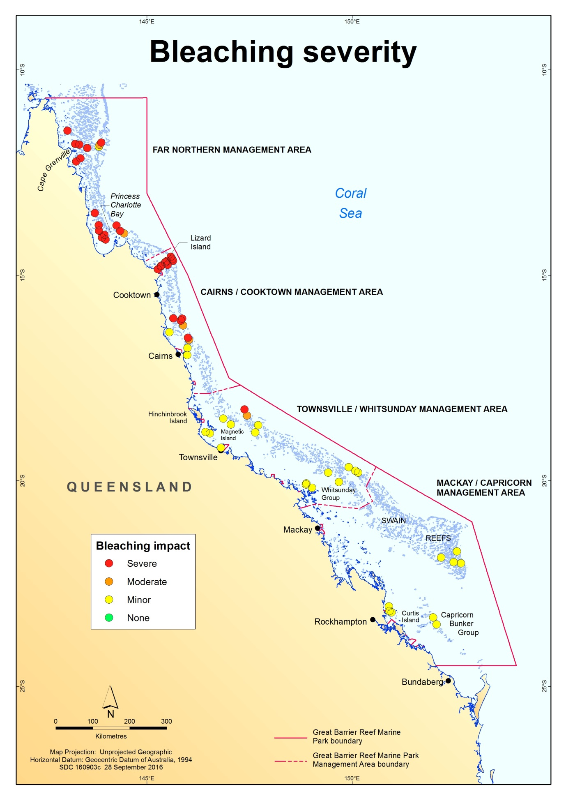Figure 4 Reef-wide pattern of bleaching severity impacts on the Great Barrier Reef in 2016.
Each circle represents a survey reef and colours indicate severity category, with red indicating the most severely impacted reefs. See Appendix B for descriptions.
A latitudinal gradient of severity was observed — the most severe bleaching impacts were on reefs within the three northern-most transects, with impacts generally decreasing southward (Figure 5). The Cairns–Port Douglas area exhibited the highest variability in bleaching patterns across reefs, with a mix of minor, moderate and severely bleached reefs. Supplementary reef health and impact surveys confirmed this pattern. Only one surveyed reef was categorised as severely bleached on the Townsville transect. No moderate or severe bleaching was observed in the Whitsunday transect. Although some severe bleaching was observed at sites within reefs in the Rockhampton transect, the overall impact of bleaching was minor on all reefs.

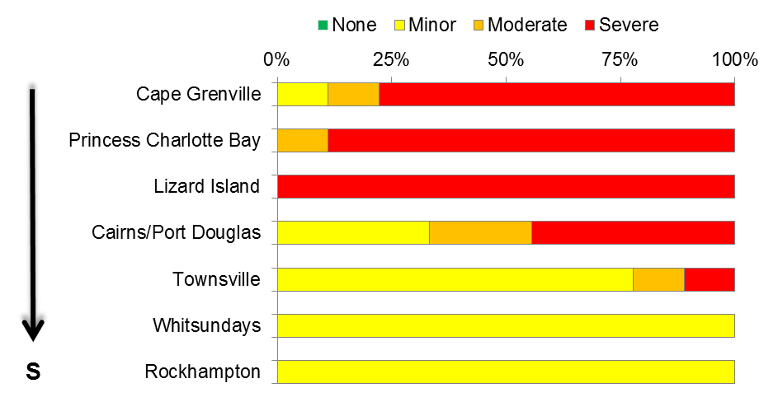
N
Figure 5 Illustration of the proportion of reefs within each transect that exhibited either no, minor, moderate or severe bleaching.

The high variability in bleaching severity is best illustrated at the survey level. Of all the reef health and impact surveys, bleaching was observed in 92.1 per cent (Figure 6). Most of the 873 surveys analysed in this report recorded either a bleaching impact of minor (48.6 per cent) or severe (33.2 per cent). Only 7.9 per cent of all surveys showed no bleaching and 10.3 per cent scored a moderate impact. Surveys that recorded bleaching also revealed a high variability in the proportion of coral bleached, ranging from 0.2 per cent of coral cover to 100 per cent.
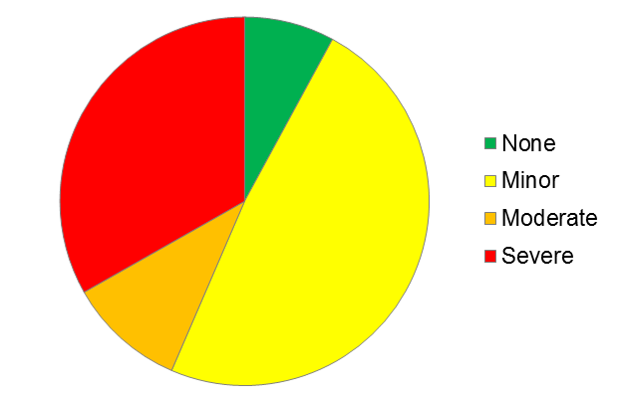

Figure 6 Bleaching severity impacts as a proportion of all reef health and impact surveys conducted along the Great Barrier Reef during this assessment.

Overall, across the entire Reef, severe bleaching did not follow a strong pattern with regards to shelf position. Of the 290 surveys that recorded severe bleaching impacts, 35.5 per cent were located on inshore reefs, 39 per cent on mid-shelf reefs and 25.5 per cent on outer shelf reefs. However, latitudinally (by transect), severe bleaching was highly variable amongst shelf positions (Figure 7a, b, c). Although the two northern-most transects had severe bleaching in all shelf positions, most of the severe bleaching occurred on the inshore and mid-shelf reefs.
Less severe bleaching was observed on outer shelf reefs of Cape Grenville, and to a lesser extent, of Princess Charlotte Bay. In the Lizard Island and Cairns–Port Douglas transects, the most severe bleaching occurred on the mid and outer shelf reefs, whereas the Townsville transect had the most severe bleaching on outer shelf reefs. In the two southern-most transects, the Whitsundays reefs only exhibited minor bleaching, while the Rockhampton one only exhibited severe bleaching on a single inshore reef.
Even on individual reefs, large variations in bleaching severity were observed (Figure 8a, b, c). This is illustrated by plotting bleaching severity impacts from individual surveys on a reef outline. In this example, based on actual survey data, bleaching severity within a reef varied from minor to severe. As replicate surveys within a particular aspect of the reef (for example, north-east) were only 50 metres apart, the severity of bleaching within a small area differed greatly (Figure 8a, b, c). Even on severely impacted reefs, patches of unbleached coral cover were often found adjacent to completely bleached corals. Bleaching was observed at all surveyed depths in this example (as was generally the case), and depth did not appear to be a factor in bleaching severity. Direct observations of bleaching down to 25 metres were noted on several reefs.
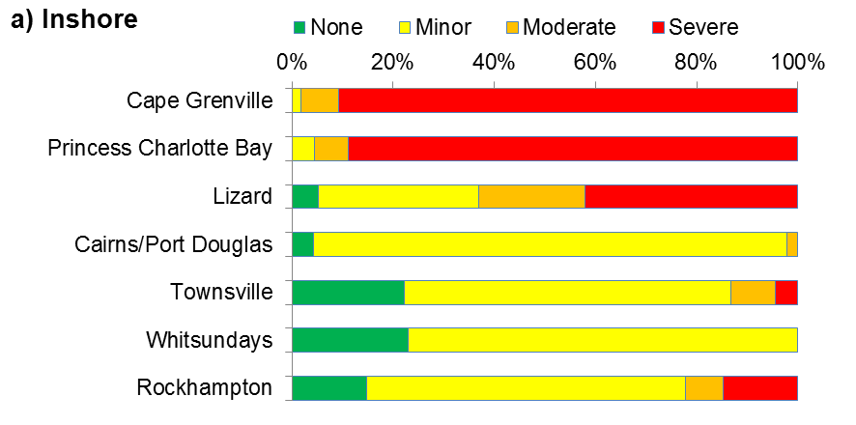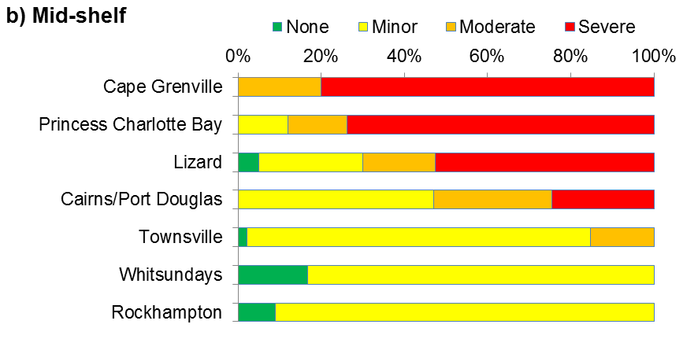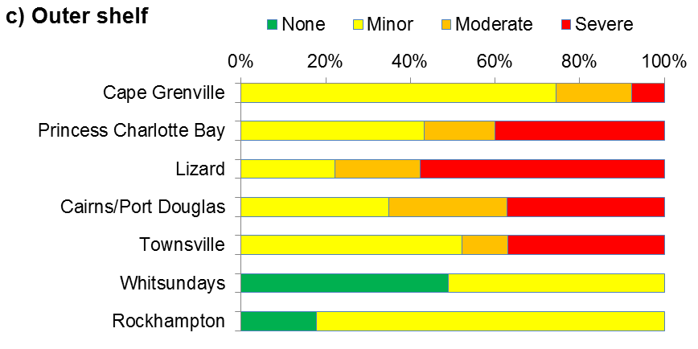
Figure 7a,b,c Illustration of bleaching severity impacts as a proportion of the total surveys conducted on a) inner shelf reefs, b) mid-shelf reefs and c) outer shelf reefs of each transect along the Great Barrier Reef.
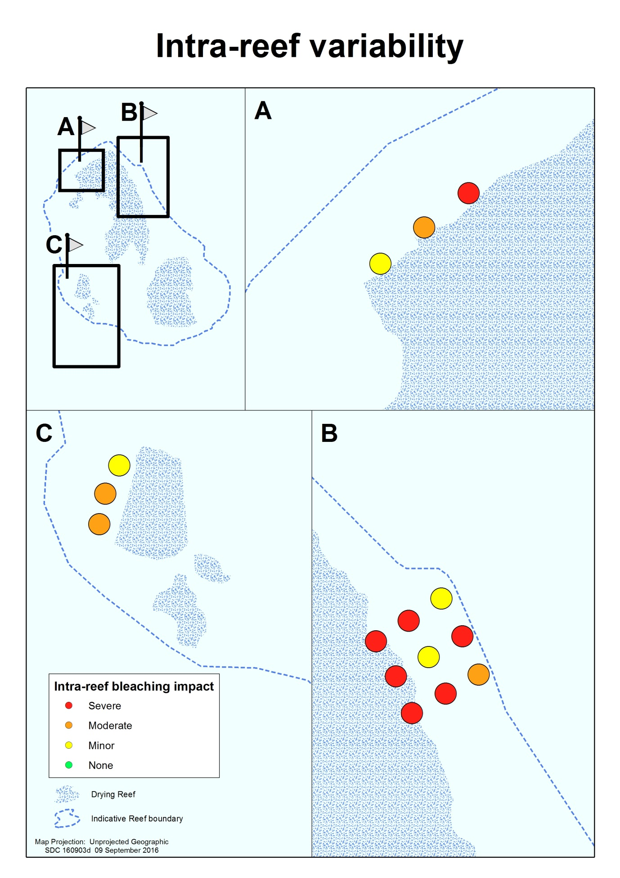Figure 8a,b,c Illustration of bleaching variability within a reef.
Bleaching severity impacts recorded on individual surveys 50 metres apart on three different reef aspects and depths: a) one depth on the north-west aspect, b) three depths on the north-east aspect and c) one depth on the south-west aspect.

Scale and spatial patterns of coral mortality (as at 13 June 2016)
Reef-wide bleaching caused substantial die-off of corals during the event and patterns of mortality also exhibited a north-south gradient, with high variability across locations
(Figure 9). The proportion of coral that had recently died due to severe bleaching ranged from zero to 100 per cent of total coral cover in individual surveys, and many areas escaped with little or no bleaching mortality. Some reefs off the Cape Grenville and Princess Charlotte Bay transects had very high bleaching mortality, losing over 50 per cent of their coral cover, whereas reefs in the south had little to no coral mortality from bleaching. The proportion of coral that died on each reef was associated with bleaching severity — the highest levels of mortality were observed in areas with the most accumulated heat stress (Figure 3).
The agency’s preliminary findings indicated 22 per cent of coral on the Reef died due to severe bleaching. Eighty-five per cent of this mortality occurred in the 600 kilometre stretch between the tip of Cape York and just north of Lizard Island. Since surveys were last conducted on reefs around Lizard Island, further mortality was reported.
The level of bleaching-related mortality differed depending on shelf-position. Of all surveys that recorded coral mortality, the greatest proportion of die-off was on mid-shelf reefs (47 per cent of all surveys), then inshore reefs (32 per cent of surveys), with the least on outer shelf reefs (21 per cent).
Follow-up surveys in late 2016 will enable the agency to assess the full extent of bleaching-related mortality, therefore these estimates are considered to be preliminary and will be updated as new data is available.

Other impacts of record-breaking heat stress
Although this report focuses on coral bleaching as an adverse effect of warming sea surface temperatures on the Great Barrier Reef, other impacts within the ecosystem were also reported over summer. For example, bleaching is not a unique response among corals — other animals also rely on zooxanthellae for nutrition, such as anemones and giant clams, making them susceptible to impacts from heat stress. GBRMPA received several anecdotal reports and directly observed bleaching and mortality in anemones and giant clams within the northern half of the Marine Park.
Reports of impacts on other reef organisms were also received, mainly from the northern part of the Reef, and include: mortality of crayfish, crabs, shrimp, stingrays, eels and fish in shallow water lagoons and the absence of coral-associated fish from reefs with high coral mortality. High densities of Diadema sea urchins were found on reefs overgrown with algae due to high coral mortality. Other impacts may become apparent over time.

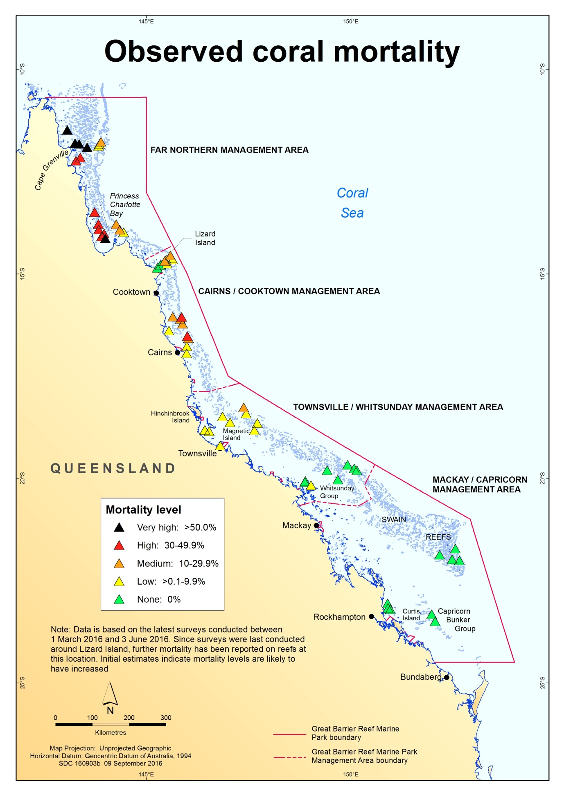Figure 9 Reef-wide pattern of coral mortality on the Great Barrier Reef in 2016.
Each triangle represents a reef, and colours indicate the percentage of coral cover that died (mortality level). Black triangles indicate reefs with greater than 50 per cent coral loss due to severe bleaching.

Conclusions and outlook for recovery

The global bleaching event, which began in 2014, was triggered by record-breaking temperatures and in 2016 resulted in the worst-ever coral bleaching on the Great Barrier Reef. Underwater surveys documented widespread but patchy bleaching of varying levels of severity throughout the Reef, with the most severe bleaching occurring north of Port Douglas.
As at June 2016, preliminary estimates indicated prolonged heat stress had resulted in the death of 22 per cent of coral on the 3000 reefs of the Great Barrier Reef, with the highest coral mortality on inshore and mid-shelf reefs around Cape Grenville and Princess Charlotte Bay, in the far north. Variability in bleaching severity and coral mortality was greatest among reefs in the Cairns–Port Douglas areas. Most reefs in the lower half of the Marine Park escaped major impacts. The strong latitudinal gradient and high variability of bleaching severity among and within reefs suggests it is highly likely many reefs were relatively unaffected and still in good or pre-bleaching condition.
Early signs of coral recovery have been observed on parts of the Reef. A reef can recover in two ways: its surviving corals recover from bleaching over time, and/or successful coral recruitment replenishes the reef with baby corals which, if no further stress is experienced, will grow to eventually take the place of corals that died in this event.^{5,13} On the most resilient reefs and in ideal circumstances, bleached corals can regain their colour within a period of weeks to months once water temperatures return to normal.⁴⁴ However, if corals experience prolonged heat stress, they will be less likely to recover and mortality may be very high.¹⁴
Even if a coral regains its colour, this does not necessarily mean it is in good health. Research shows bleaching can deplete the corals' energy resource to the extent that corals do not reproduce for one or two years.^{5,21,22} They can also experience slower growth and lower calcification rates for up to eight years^{23,24}, and are more vulnerable to subsequent diseases^{25,26}. Additionally, many coral reef fishes and invertebrates rely on live, healthy coral for their survival, and so may have been impacted by this event.^{6,7,45} Given the unprecedented scale and nature of the bleaching event, reef resilience may have been reduced, and it is too early to estimate how long it will take for coral reefs to recover from this period of extreme heat stress.
The severity of this bleaching event reinforces the urgent need for strong global action on climate change, as agreed at the United Nations Framework Convention on Climate Change Conference of the Parties (COP21), and strong local action to improve the resilience of the Reef ecosystem.
The Great Barrier Reef has demonstrated the ability to recover from past disturbances, including mass bleaching events.^{46,47,48} However, bleaching events are expected to increase in frequency and severity as a result of climate change, making recovery processes increasingly important for reefs to persist as coral-dominated systems.^{27,49} Significantly, many human activities have impacts on the Reef — these compound the risks imposed by coral bleaching and can work to lengthen recovery timeframes.⁵⁰ For example, chronic stress due to poor water quality can affect the recovery potential of reef communities because reproduction and larval recruitment in corals are particularly sensitive to environmental conditions.^{51,52,53} Reducing compounding stressors will help reefs cope with or recover from coral bleaching events, which will in turn build the resilience of reefs to future climate-related disturbances.
Assessing reef condition and impacts ensures GBRMPA has an up-to-date understanding of Reef health. It enables the agency to distinguish between the effects of acute and chronic stressors (for example, bleaching events and water quality, respectively). It also assists in targeting resilience-building management strategies and awareness raising (for example, communicating the importance of protecting herbivorous reef fishes to support recovery processes on coral reefs). This is underpinned by an integrated monitoring and reporting program.
The agency is also working with researchers to rapidly advance its understanding of factors which increase the resilience of reefs, as measured by the capacity to resist, tolerate and cope with, and recover from disturbances. It is also increasing its understanding of spatial variability in the likelihood that a site will be impacted by climate change-related disturbances such as bleaching, disease outbreaks, floods and cyclones based on location, community composition and thermal history. Greater knowledge of the spatial variability in factors that confer resilience to reefs will inform resilience-based management. Furthermore, knowledge of spatial variability in resilience factors enables assessments of the effectiveness of strategies implemented to support resilience.
The agency also has strong measures in place to protect biodiversity, including no-take green zones which make up 33 per cent of the Marine Park. Practical conservation actions for species and habitats are also undertaken to support ecosystem resilience.
Through the Australian and Queensland governments’ Reef 2050 Long-Term Sustainability Plan, significant investment is being made to improve water quality, in addition to work that has been taking place since 2003 to reduce nutrients, pesticides and sediments in farm run-off. Actions contained in the plan are also designed to improve the overall health of the Reef, such as strategic control of crown-of-thorns starfish, which will help build the ecosystem’s resilience to impacts such as climate change.
In addition to measures aimed at building ecosystem resilience, partnerships with a broad range of stakeholders can help build social and economic resilience to coral bleaching events. GBRMPA partners with Reef users to ensure they are well-informed of risks and are included in management and contingency planning to help them cope and adapt to reef health incidents. Similarly, stewardship activities such as the Reef Guardian program are encouraging responsible reef practices, such as not anchoring on corals or disposing of fishing tackle on the Reef. Overall, the Reef remains in better condition than many other reef systems around the world.

References
1. Hughes, T.P., Baird, A.H., Bellwood, D.R., Card, M., Connolly, S.R., Folke, C., Gosberg, R., Hoegh-Guldberg, O., Jackson, J.B.C., Kleypas, J.A., Lough, J.M., Marshall, P.A., Nyström, M., Palumbi, S.R., Pandolfi, J.M., Rosen, B. and Roughgarden, J. 2003, Climate change, human impacts, and the resilience of coral reefs, Science 301: 929-933.
2. Hoegh-Guldberg, O., Hughes, T., Anthony, K., Caldeira, K., Hatziolos, M. and Kleypas, J. 2009, Coral reefs and rapid climate change: impacts, risks and implications for tropical societies, in Climate change: global risks, challenges and decisions. IOP conference series: earth and environmental science, eds. Anonymous, IOP Publishing, pp. 1-2.
3. Loya, Y., Sakai, K., Yamazato, K., Nakano, Y., Sambali, H. and van Woesik, R. 2001, Coral bleaching: the winners and the losers, Ecology Letters 4(2): 122-131.
4. Marshall, P.A. and Baird, A.H. 2000, Bleaching of corals on the Great Barrier Reef: differential susceptibilities among taxa, Coral Reefs 19(2): 155-163.
5. Baird, A.H. and Marshall, P.A. 2002, Mortality, growth and reproduction in scleractinian corals following bleaching on the Great Barrier Reef, Marine Ecology Progress Series 237: 133-141.
6. Pratchett, M.S., Munday, P.L., Wilson, S.K., Graham, N.A.J., Cinner, J.E., Bellwood, D.R., Jones, G.P., Polunin, N.V.C. and McClanahan, T.R. 2008, Effects of climate-induced coral bleaching on coral-reef fishes: ecological and economic consequences, Oceanography and Marine Biology: An Annual Review 46: 251-296.
7. Stella, J.S., Pratchett, M.S., Hutchings, P.A. and Jones, G.P. 2011, Coral-associated invertebrates: diversity, ecological important and vulnerability to disturbance, Oceaongraphy and Marine Biology: An Annual Review 49: 43-104.
8. Graham, N.A.J., Wilson, S.K., Jennings, S., Polunin, N.V.C., Robinson, J.A.N., Bijoux, J.P. and Daw, T.M. 2007, Lag effects in the impacts of mass coral bleaching on coral reef fish, fisheries, and ecosystems, Conservation Biology 21(5): 1291-1300.
9. Cai, W., Santoso, A., Wang, G., Yeh, S.W., An, S.I., Cobb, K.M., Collins, M., Guilyardi, E., Jin, F., Kug, J.S., Lengaigne, M., McPhaden, M.J., Takahashi, K., Timmermann, A., Vecchi, G., Watanabe, M. and Wu, L. 2015, ENSO and greenhouse warming, Nature Climate Change 5: 849-859.
10. Cai, W., Borlace, S., Lengaigne, M., van Rensch, P., Collins, M., Vecchi, G., Timmermann, A., Santoso, A., McPhaden, M.J., Wu, L., England, M.H., Wang, G., Guilyardi, E. and Jin, F. 2014, Increasing frequency of extreme El Niño events due to greenhouse warming, Nature Climate Change 4: 111-116.
11. Mann, M.E., Ramstorf, S., Steinman, B.A., Tingley, M. and Miller, S.K. 2016, The likelihood of recent record warmth, Scientific Reports 6: 19831.
12. Brown, B.E., LeTissier, M.D.A. and Bythell, J. 1995, Mechanisms of bleaching deduced from histological studies of reef corals sampled during a natural bleaching event, Marine Biology 12224800: 655-663.
13. Goreau, T.J. 1992, Bleaching and reef community change in Jamaica: 1951-1991, American Zoologist 32: 683-695.
14. Glynn, P.W. and D'Croz, L. 1990, Experimental evidence for high temperature stress as the cause of El Niño-coincident coral mortality, Coral Reefs 8: 181-191.
15. Wilkinson, C. (ed) 2004, Status of Coral Reefs of the World: 2004, Volume 2 edn, Australian Institue of Marine Science, Townsville.
16. Hoegh-Guldberg, O., Mumby, P.J., Hooten, A.J., Steneck, R.S., Greenfield, P., Gomez, E., Harvell, C.D., Sale, P.F., Edwards, A.J., Caldeira, K., Knowlton, N., Eakin, C.M., Iglesias-Prieto, R., Muthiga, N., Bradbury, R.H., Dubi, A. and Hatziolos, M.E. 2007, Coral reefs under rapid climate change and ocean acidification, Science 318: 1737-1742.
17. Hoegh-Guldberg, O. 1999, Climate change, coral bleaching and the future of the world's coral reefs, Marine and Freshwater Research 50(8): 839-866.
18. Salih, A., Larkum, A., Cox, G., Kuhl, M. and Hoegh-Guldberg, O. 2000, Fluorescent pigments in corals are photoprotective, Nature 408(6814): 850-853.
19. Salih, A., Cox, G., Szymczak, R., Coles, S.L., Baird, A.H., Dunstan, A., Cocco, G., Mills, J. and Larkum, A. 2006, The role of host-based colour and fluorescent pigments in photoprotection and in reducing bleaching stress in corals, in Proc. 10th Int. Coral Reef Symp. eds. Anonymous, pp. 746-756.
20. Jokiel, P.L. and Coles, S.L. 1990, Response of Hawaiian and other Indo-Pacific reef corals to elevated temperature, Coral Reefs 824520: 155-162.
21. Hoeke, R.K., Jokiel, P.L., Buddemeier, R.W. and Brainard, R.E. 2011, Projected changes to growth and mortality of Hawaiian corals over the next 100 years, PloS one 6(3): e18038.
22. Ward, S., Harrison, P. and Hoegh-Guldberg, O. 2000, Coral bleaching reduces reproduction of scleractinian corals and increases susceptibility to future stress, in Proceedings of the 9th International Coral Reef Symposium, eds. M. K. Moosa and et al, Ministry of Environment, Indonesia Institute of Sciences, Bali, Indonesia, pp. 1123-1128.
23. Cantin, N.E. and Lough, J.M. 2014, Surviving coral bleaching events: Porites growth anomalies on the Great Barrier Reef, PLoS One. 9(2): e8872.
24. Cantin, N.E., Cohen, A.L., Karnauskas, K.B., Tarrant, A.M. and McCorkle, D.C. 2010, Ocean warming slows coral growth in the Central Red Sea, Science 329(5989): 322-325.
25. Bruno, J.F., Selig, E.R., Casey, K.S., Page, C.A., Willis, B., Harvell, C.D., Sweatman, H. and Melendy, A.M. 2007, Thermal stress and coral cover as drivers of coral disease outbreaks, PLoS Biology 5(6): e124.
26. Jones, R.J., Bowyer, J., Hoegh-Guldberg, O. and Blackall, L. 2004, Dynamics of a temperature-related coral disease outbreak, Marine Ecology Progress Series 281: 63-77.
27. Hughes, T.P. 1994, Catastrophes, phase shifts, and large-scale degradation of a Caribbean coral reef, Science 265(5178): 1547-1551.
28. Hughes, T.P., Rodrigues, M.J., Bellwood, D.R., Ceccarelli, D., Hoegh-Guldberg, O., McCook, L.J., Moltschaniwskyj, N.A., Pratchett, M.S., Steneck, R.S. and Willis, B. 2007, Phase shifts, herbivory, and the resilience of coral reefs to climate change, Current Biology 17(4): 360-365.
29. Bellwood, D.R., Hoey, A.S., Ackerman, J.L. and Depczynski, M. 2006, Coral bleaching, reef fish community phase shifts and the resilience of coral reefs, Global Change Biology 12(9): 1587-1594.
30. Baker, A.C., Glynn, P.W. and Riegl, B. 2008, Climate change and coral reef bleaching: an ecological assessment of long-term impacts, recovery trends and future outlook, Estuarine, Coastal and Shelf Science 80(4): 435-471.
31. Glynn, P.W. 1993, Coral reef bleaching: ecological perspectives, Coral Reefs 12(1): 1-17.
32. Przeslawski, R., Ahyong, S., Byrne, M., Worheide, G. and Hutchings, P. 2008, Beyond corals and fish: the effects of climate change on noncoral benthic invertebrates of tropical reefs, Global Change Biology 14(12): 2773-2795.
33. Done, T., Whetton, P., Jones, R.J., Berkelmans, R., Lough, J.M., Skirving, W. and Wooldridge, S. 2003, Global climate change and coral bleaching on the Great Barrier Reef, Department of Natural Resources and Mines, Brisbane.
34. Donner, S.D., Skirving, W.J., Little, C.M., Oppenheimer, M. and Hoegh-Guldberg, O. 2005, Global assessment of coral bleaching and required rates of adaptation under climate change, Global Change Biology 11(12): 2251-2265.
35. Berkelmans, R. and Oliver, J.K. 1999, Large-scale bleaching of corals on the Great Barrier Reef, Coral Reefs 18: 55-60.
36. Berkelmans, R., De'ath, G., Kininmonth, S. and Skirving, W.J. 2004, A comparison of the 1998 and 2002 coral bleaching events on the Great Barrier Reef: Spatial correlation, patterns and predictions, Coral Reefs 23(1): 74-83.
37. Anthony, K.R.N., Maynard, J.A., Diaz-Pulido, G., Mumby, P.J., Marshall, P.A., Cao, L. and Hoegh-Guldberg, O. 2011, Ocean acidification and warming will lower coral reef resilience, Global Change Biology 17: 1798-1808.
38. Bellwood, D.R., Hughes, T.P., Folke, C. and Nyström, M. 2004, Confronting the coral reef crisis, Nature 429: 827-833.
39. Westmacott, S., Cesar, H., Pet-Soede, L. and Lindén, O. 2000, Coral Bleaching in the Indian Ocean: Socio-Economic Assessment of Effects, in Collected Essays on the Economics of Coral Reefs, ed. H. Cesar, CORDIO, Kalmar University, Sweden, pp. 94-106.
40. Cesar, H., Pet-Soede, L., Westmacott, S., Mangi, S. and Aish, A. 2002, Economic Analysis of Coral Bleaching in the Indian Ocean – Phase II, in Coral degradation in the Indian Ocean: Status Report 2002., ed. D. Obura, CORDIO, Department of Biology and Environmental Science, University of Kalmar, Kalmar, Sweden, pp. 251-262.
41. Westmacott, S., Teleki, K., Wells, S. and West, J. 2000, Management of bleached and severely damaged coral reefs, Washington, DC.
42. Great Barrier Reef Marine Park Authority 2013, Reef health Incident response system, GBRMPA, Townsville.
43. Great Barrier Reef Marine Park Authority 2013, Coral bleaching risk and impact assessment plan, GBRMPA, Townsville.
44. Douglas, A.E. 2003, Coral bleaching-how and why? Marine Pollution Bulletin 46: 385-392.
45. Jones, G.P., McCormick, M.I., Srinivasan, M. and Eagle, J.V. 2004, Coral decline threatens fish biodiversity in marine reserves, Proceedings of the National Acadamy of Sciences of the United States of America 101(21): 8251-8253.
46. Halford, A., Cheal, A.J., Ryan, D. and Williams, D.M. 2004, Resilience to large-scale disturbance in coral and fish assemblages on the Great Barrier Reef, Australia, Ecology 85: 1892-1905.
47. Beeden, R.J., Maynard, J., Puotinen, M.L., Marshall, P., Dryden, J., Goldberg, J. and Williams, G. 2015, Impacts and recovery from severe tropical Cyclone Yasi on the Great Barrier Reef, PLoS ONE 10(4): e0121272.
48. Emslie, M.J., Cheal, A.J., Sweatman, H. and Delean, S. 2008, Recovery from disturbance of coral and reef fish communities on the Great Barrier Reef, Australia, Marine Ecology Progress Series 371: 177-190.
49. Bruno, J.F., Sweatman, H., Precht, W.F., Selig, E.R. and Schutte, V.G.W. 2009, Assessing evidence of phase shifts from coral to macroalgal dominance on coral reefs, Ecology 90(6): 1478-1484.
50. Hughes, T.P. and Connell, J.H. 1999, Multiple stressors on coral reefs: a long-term perspective, Limnology and Oceanography 44(3): 932-940.
51. Wooldridge, S.A. and Done, T.J. 2009, Improved water quality can ameliorate effects of climate change on corals, Ecological Applications 19: 1492-1499.
52. Wooldridge, S.A. 2009, Water quality and coral bleaching thresholds: formalising the linkage for the inshore reefs of the Great Barrier Reef, Australia, Marine Pollution Bulletin 58(5): 745-751.
53. De'ath, G. and Fabricius, K.E. 2008, Water quality of the Great Barrier Reef: Distributions, effects on reef biota and trigger values for the protection of ecosystem health, Great Barrier Reef Marine Park Authority, Townsville.

APPENDIX A: List of reefs surveyed in each cross-shelf transect
Transect | Inner | Mid | Outer
Cape Grenville | U/N Reef (11–060)  Nomad Reef (12–007)  Kay Reef (12–010) | Guthray Reef (11–171)  Cockburn Reef (11–173)  Sir Charles Hardy Islands Reef (11–184c) | Three Reefs (11–223)  Devlin Reef (11–229a)  Five Reefs (11–232)
Princess Charlotte Bay | Pelican Island Reef  (13–107)  Eden Reef (14–008)  Wharton Reef (14–022) | Morris Island Reef  (13–072)  Magpie Reef (13–087)  Grub Reef (14–003) | U/N Reef (13–121)  Rodda Reef (13–127)  Davie Reef (13–130)
Lizard Island | Martin Reef (14–123)  Linnet Reef (14–126)  Decapolis Reef (14–131) | MacGillivray Reef  (14–114)  Lizard Island Reef (Lagoon) (14–116d)  North Direction Reef (14–143) | Carter Reef (14–137)  Yonge Reef (14–138)  No Name Reef (14–139)
Cairns–Port Douglas | Low Islands Reef  (16–028)  Green Island Reef  (16–049)  Fitzroy Island Reef  (16–054a&f) | Mackay Reef (16–015)  Hastings Reef (16–057)  Michaelmas Reef  (16–060) | Agincourt Reefs (No. 1) (15-099c)  St Crispin Reef (16–019)  Opal Reef (16–025)
Townsville | Pandora Reef (18-051)  Havannah Reef (18-065)  Middle Reef (19-011) | Rib Reef (18–032)  John Brewer Reef  (18–075)  Davies Reef (18-096) | Myrmidon Reef (18–034)  Dip Reef (18–039)  Chicken Reef (18–086)
Whitsundays | Hayman Island Reef (20–014)  Langford-Bird Reef  (20–019)  Border Island Reef (No.1) (20–067a) | U/N Reef (19–138)  U/N Reef (20–104) | Slate Reef (19–159)  Hyde Reef (19–207)  Rebe Reef (19–209)
Rockhampton | North Keppel (Ko-no-mie) Island Reef (No. 1) (23–004a)  Middle (Ba-la-ba) Island Reef (23–010)  Halfway Island Reef  (23–014) | U/N Reef (21–529)  Wreck Island Reef  (23–051)  One Tree Island Reef (23–055a) | Gannett Cay Reef  (21–556)  Turner Reef (21–562)  Chinaman Reef  (22–102)

APPENDIX B: example illustrations and descriptions
Below are example illustrations and descriptions of coral bleaching impact severity levels used to assess reef health. Factors that differ among severity levels are: types of coral affected, how severely corals are bleached, depth distribution of impacts, and the amount of coral affected (Coral Bleaching Risk and Impact Assessment Plan 2013).
Severity | Description
- Minor impacts  (photos taken at 2–3 metres)  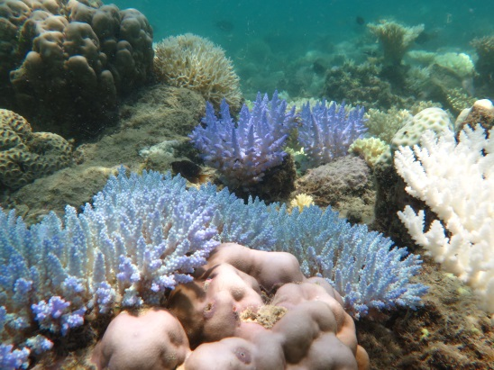  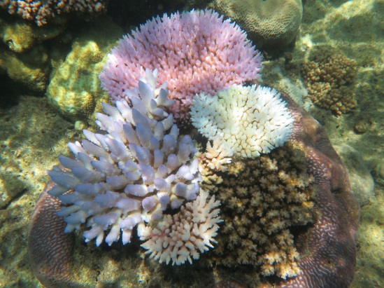 | - Bleaching mainly confined to reef flat  - Severe bleaching of many (10–50 per cent) colonies of taxa (Acropora and Pocillopora), or morphologies (branching, bushy, tabular/plate) usually highly sensitive to bleaching)  - Severe bleaching of some (<10 per cent) colonies of taxa (Montipora and Faviids) or morphologies with low sensitivity to bleaching (encrusting and mushroom)  - Paling of colonies of taxa (Porites) or morphologies (massives) with very low sensitivity to bleaching  - Severe bleaching of colonies of taxa or morphologies with low or very low sensitivity to bleaching but confined to reef flat.
- Moderate impacts  (photos taken at 3–6 metres)  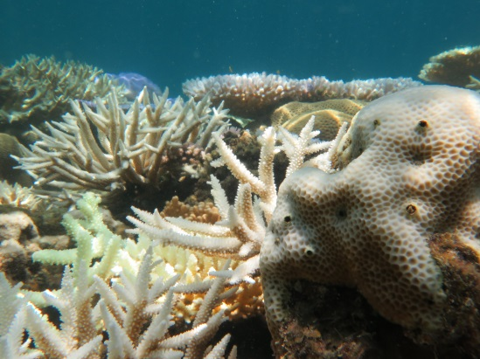  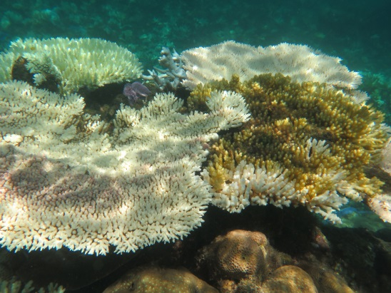 | - Mortality confined to reef flat; bleaching extends deeper than reef flat  - Severe bleaching of most (>50 per cent) colonies of taxa or morphologies usually highly sensitive to bleaching  - Severe bleaching of many (10–50 per cent) colonies of taxa or morphologies with low sensitivity to bleaching below reef crest  - Severe bleaching of some (<10 per cent) colonies of taxa or morphologies with very low sensitivity to bleaching  - Some mortality of colonies of taxa or morphologies usually highly sensitive to bleaching but confined to reef flat.  (Continued over page)
- Severe impacts  (photos taken >9 metres)  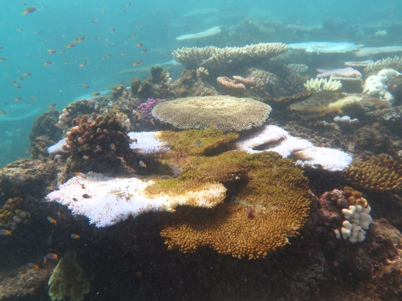  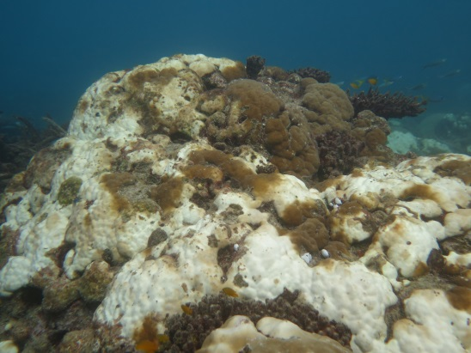 | - Bleaching extends deeper than upper reef slope  - Mortality of many (>50 per cent) colonies of taxa or morphologies usually highly sensitive to bleaching  - Severe bleaching of most (>50 per cent) colonies of taxa or morphologies with low sensitivity to bleaching  - Severe bleaching of many (10–50 per cent) colonies of taxa or morphologies with very low sensitivity to bleaching.

APPENDIX C: Time-series images

Below are time-series images taken at a patch of coral reef over 10 months, with red stars indicating areas of coral that died due to severe bleaching and the two yellow stars on the third photograph indicate crown-of-thorns starfish feeding scars:
a) healthy coral on a reef flat in October 2015
b) half of the coral had died from bleaching with the other half still bleached by April 2016
c) surviving coral recovering after the peak of the bleaching event amid very high mortality (>50 per cent) in September 2016.
The bleaching susceptibility of any area of reef will be influenced by the community composition, among other factors.
(Photos: ©Taylor Simpkins 2016)
a) 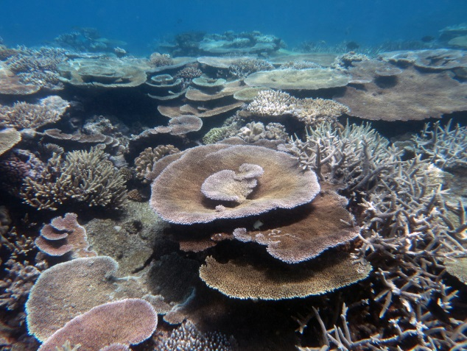 b) 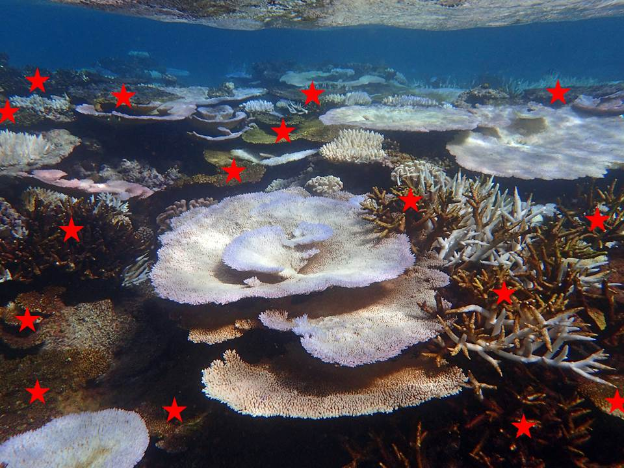 c) 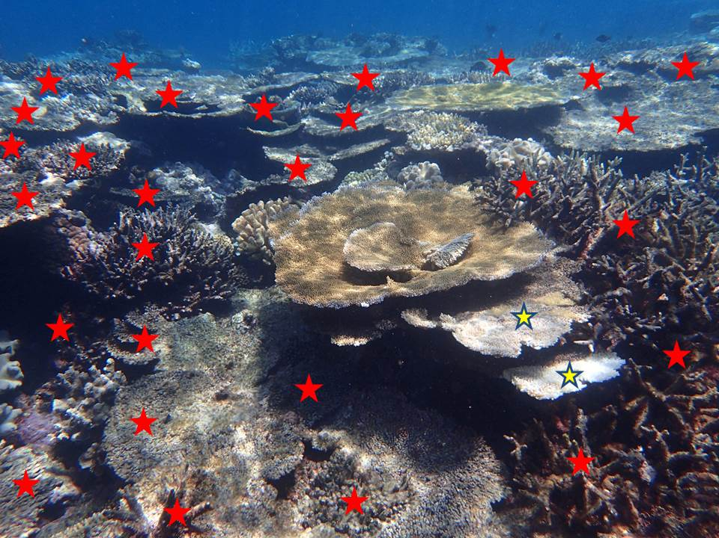

Source: Goddard Institute for Space Studies
Australasian Fire Authority Council website, 2004, www.afac.com.au
The survey was carefully designed so that bleaching patterns could be assessed at a range of scales.
The score given for the severity of the bleaching impact is a composite measure of the impact the stress has had on corals. The four levels of impact (no bleaching, minor impacts, moderate impacts, and severe impacts) are assigned based on a range of factors as set out in Appendix B.
It should be noted that GBRMPA and the Queensland Parks and Wildlife Service will re-survey the transect reefs in October and November 2016 to update estimates of bleaching-related mortality and assess the early stages of coral recovery.

