Australian Government, Great Barrier Reef Marine Park Authority logo

Coastal Ecosystem Management - Lower Burdekin Floodplain

Review of coastal ecosystem management to improve the health and resilience of the Great Barrier Reef World Heritage Area

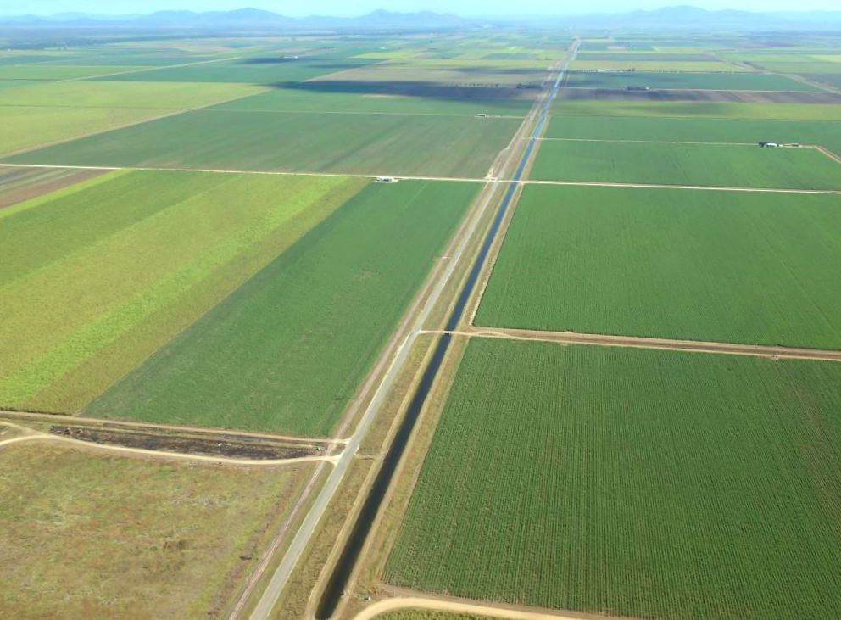

Page intentionally left blank for printing double-sided.

The logo shows the Australian Coat of Arms and reads:  Australian Government - Great Barrier Reef Marine Park Authority.  Underneath the logo is the title of the document:  Water management to support coastal ecosystems - Lower Burdekin Floodplain - Review of coastal ecosystem management to improve the health and resilience of the Great Barrier Reef World Heritage Area.


**Coastal ecosystems management –** Lower Burdekin Floodplain

Review of coastal ecosystem management to improve the health and resilience of the Great Barrier Reef World Heritage Area

© Commonwealth of Australia 2013

Published by the Great Barrier Reef Marine Park Authority 2013

This work is copyright. You may download, display, print and reproduce this material in unaltered form only (appropriately acknowledging this source) for your personal, non-commercial use or use within your organisation. Apart from any use as permitted under the *Copyright Act 1968*, all other rights are reserved.

**Disclaimer**

The views and opinions expressed in this publication are those of the authors and do not necessarily reflect those of the Australian Government or the Minister for Sustainability, Environment, Water, Population and Communities.

While reasonable efforts have been made to ensure that the contents of this publication are factually correct, the Australian Government does not accept responsibility for the accuracy or completeness of the contents, and shall not be liable for any loss or damage that may be occasioned directly or indirectly through the use of, or reliance on, the contents of this publication.

**National Library of Australia Cataloguing-in-Publication entry**

*Coastal ecosystems management – case study: water management*/Great Barrier Reef Marine Park Authority.

ISBN  978 1 922126 17 7 (ebook)

Coastal zone management--Queensland----Burdekin River Valley.  
Coastal zone management--Queensland--Great Barrier Reef.  
Floodplains--Queensland--Burdekin River Valley.  
Natural resources management areas--Queensland--Great Barrier Reef.  
Burdekin River Valley (Qld.)--Management.  
Burdekin River Valley (Qld.)--Environmental conditions.  
Great Barrier Reef (Qld.)--Management.  
Great Barrier Reef (Qld.)--Environmental conditions.

Great Barrier Reef Marine Park Authority.

577.099436

**This publication should be cited as:**

Great Barrier Reef Marine Park Authority 2013 *Coastal ecosystems management – case study: water management,* GBRMPA, Townsville.

**Acknowledgements**

This report was supported through funding from the Australian Government Department of Sustainability, Environment, Water, Population and Communities.

This report is based on a report commissioned by the Great Barrier Reef Marine Park Authority, prepared on 13 June 2013 by Jim Tait, Econcern. The Great Barrier Reef Marine Park Authority also acknowledges the contributions of Hugh Yorkston, Donna-marie Audas, Jason Vains, Paul Groves, Carol Marshall, Melissa Evans, Ben Palmer, Rose Dunstan and Sara Dunstan.

**Coverphoto: Lower Burdekin floodplain by Jim Tait (2013).**

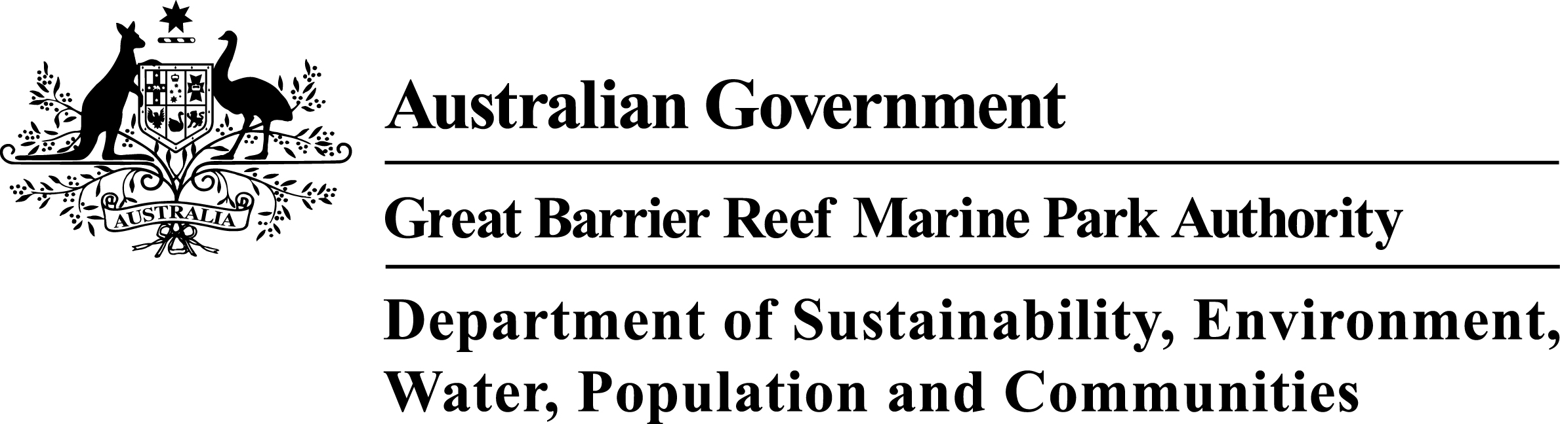

**Requests and enquiries concerning reproduction and rights should be addressed to:**

Great Barrier Reef Marine Park Authority

2-68 Flinders Street (PO Box 1379)

Townsville QLD 4810, Australia

Phone: (07) 4750 0700

Fax: (07) 4772 6093

Email: [info@gbrmpa.gov.au](mailto:info@gbrmpa.gov.au)

www.gbrmpa.gov.au

**Table of contents**

EXECUTIVE SUMMARY 1

Context summary 1

Key issues 1

Current management 2

Potential management actions 2

INTRODUCTION 4

Background 4

Objectives and purpose of case study 4

METHODOLOGY 4

COASTAL ECOSYSTEMS OF THE REGION 5

Background 5

Overview of the basin within the study area 7

History of land use and development 17

Impact on coastal ecosystems 20

Impacts to ecosystem functions 31

Current condition and trend 37

Forecast of likely future activities and impacts on coastal ecosystems 43

LAND-USE MANAGEMENT AND COASTAL ECOSYSTEMS 45

Overlapping roles of government 45

Protecting existing undisturbed coastal ecosystems 47

Reconnection and rehabilitation of disturbed coastal ecosystems 51

Return of coastal ecosystem function to modified landscapes 56

Pumped Flood Flow 60

Hydrological Isolation 61

Uncertainty in assessment and managing risk 62

Adaptive management 62

DISCUSSION 63

An important landscape 63

Information Driven Management Mechanisms 64

Improving farm practices 64

Natural resource management 65

Protection of assets 67

Management of threats 67

Restoration of ecosystems and ecosystem function 68

REFERENCES 72

APPENDIX A: Ecological processes of natural coastal ecosystems linked to the health and resilience of the World Heritage Area 76

APPENDIX B: Ecological processes of modified systems linked to the health and resilience of the World Heritage Area. 78

# EXECUTIVE SUMMARY

## Context summary

The lower Burdekin is the largest floodplain system on the Australian east coast. It has a diverse assemblage of coastal ecosystems, including one of the greatest concentrations of wetlands situated in the Great Barrier Reef catchment. Given the magnitude of its physical, biogeochemical and biological process functions, it is an important functional component of the overall catchment of the Great Barrier Reef, and provides a host of ecological functions and processes for the Great Barrier Reef World Heritage Area (World Heritage Area).

The lower Burdekin floodplain has been extensively developed to intensive irrigated agriculture. Sugarcane production systems dominate the floodplain ecosystem in terms of area and biophysical processes. The remaining remnant coastal ecosystems occur predominantly in areas not suitable for agricultural development, such as low lying and tidally influenced coastal margins. Remnant areas outside of the coastal margin include river and stream riparian corridors, intentionally retained vegetated corridors within the Burdekin Haughton Water Supply Scheme (BHWSS) area, inland floodplain areas outside the footprint of existing irrigation infrastructure, and small isolated and degraded remnants within the agricultural landscape.

These remnant coastal ecosystems retain important physical, biogeochemical and biological processes but are under pressure due to the influence of the irrigated agriculture system, system-wide alteration of floodplain hydrology and pervasive threats posed by weeds and hot fire regimes. Alteration of floodplain hydrology is driven by large volume aseasonal flows of irrigation scheme tailwater, aquifer recharge operations and rising groundwater levels. Increased levels of nutrients, pesticides and sediment occur in run-off moving from production areas to receiving coastal ecosystems, including the waters of the Bowling Green Bay Ramsar site.

## Key issues

It is predicted interception of groundwater with ground surface, associated loss of the non-saturated zone, water logging and potential salinisation will occur in significant areas of the lower Burdekin floodplain within the next decade.1 It would seem that, given the magnitude of this water management issue, is beyond the capacity of just local stakeholders to address through improvements in water use efficiency or other on-farm practices.

This report examines the lower Burdekin floodplain as a case study of the coastal ecosystem management challenges presented on a floodplain dominated by irrigated agriculture. The study reviews land use activities and practices and identifies associated arrangements that have an influence on the management of land use practices and activities, and the maintenance of the coastal ecosystems and coastal ecosystem functions linked to the ecological health and resilience of the World Heritage Area.

## Current management

In the last few decades significant advancements have been made in natural resource management on the lower Burdekin floodplain toward improving the extent and condition of coastal ecosystems and reducing the impacts of agriculture on coastal ecosystems. However, significant management challenges remain and a major land degradation risk is emerging. The rise of groundwater associated with irrigation has continued in the BHWSS since the scheme commenced more than 20 years ago.

The condition, extent and function of coastal ecosystems and agricultural production systems on the lower Burdekin floodplain have strong linkages to the management of land and water resources. Factors governing land and water resource outcomes represent direct and indirect mechanisms for altering the extent, condition and function of coastal ecosystems. There is a hierarchy of such factors that can be identified including societal and individual values, economic considerations, information and data gaps, available resources, organisational vehicles, stakeholder capacity and legislative and planning frameworks.

While all these factors make some contribution as ‘management mechanisms’ for coastal ecosystems, this report focuses on statutory tools, planning frameworks and programs and voluntary initiatives by industry and community based natural resource management organisations associated with the management of coastal ecosystems and water resources.

## Potential management actions

The following are potential actions for improved management and protection of coastal ecosystem and functions in the lower Burdekin floodplain:

1. Priority areas for coastal ecosystem protection in the lower Burdekin floodplain include significant areas of remnant floodplain coastal ecosystems set aside during the development of the BHWSS. Other key remnant coastal ecosystem assets include intact riparian systems, remnant delta habitats on the coastal fringe, coastal wetland buffers, remnant coastal ecosystem landscape corridor linkages and nodes, wetlands that have retained predevelopment ecological character and remnant floodplain habitats representative of areas developed to agriculture and potentially suitable for future development.
2. Areas for improved management of threats to coastal ecosystems and the inshore World Heritage Area in the lower Burdekin floodplain include water use, exotic grass weeds and an associated hot fire regime; and increased innovation and adoption of best management practices on farms.
3. Coastal ecosystem restoration priorities in the lower Burdekin floodplain include revegetation of functional landscape elements, restoration of bunded coastal wetlands and addressing major fish passage barriers.
4. Modification of some coastal ecosystems on the lower Burdekin floodplain are irreversible or will be slow to respond to management interventions. In this case, the priority should be on reinstating ecosystem functions and values that are important to the health of the World Heritage Area within the modified landscape. Opportunities for improving ecosystem functions include:
   1. Reconfiguring the layout of agricultural production systems to emulate coastal ecosystem function outcomes (particularly interception and detention of run-off, and nutrient uptake)
   2. Sustaining and expanding control programs for aquatic weed infestations in hydrologically modified stream systems
   3. Adopting ecosystem restoration targets that suit modified floodplain conditions (i.e. the establishment of riparian rainforests on hydrologically modified drainage reaches)
   4. Using seasonal distributary channels to bypass wet season flows around anoxic (low dissolved oxygen) stream reaches to facilitate fish movement and recruitment
   5. Restoring seasonal hydrological regimes in impacted high value wetland systems using hydrological isolation of selected wetlands or sub catchments from irrigation tailwater base flows to reinstate hydrological seasonality at micro- or meso-scales
   6. Using pumped ‘environmental flows’ to replicate wet season river overbank flows down distributary creek systems to avoid critical wet season water quality “crashes” and enhance fish passage opportunities in floodplain distributary stream systems which have been hydrologically modified by river levees and non-seasonal flows.
5. Development of a floodplain management plan that integrates water use and ecosystem function measures noted above to guide management effort, set priorities, identify dependent and rate determinant steps, recognising required trade-offs, and engagement of stakeholder.

# INTRODUCTION

## Background

The focus for this case study has been developed in association with the Great Barrier Reef *Coastal Ecosystem Assessment Framework* (CEAF) basin assessments.2 The CEAF delivers an assessment of the cumulative impacts of development in highly developed and less developed areas of the Great Barrier Reef coastal zone to inform assessment of both present and future development pressures and potential net conservation gain opportunities for the World Heritage Area.

## Objectives and purpose of case study

This report is one of a series of spatially nested case studies to examine how present coastal land-use activities and practices affect the protection of the Great Barrier Reef coastal ecosystems.

The objective of this report is to provide a case study that reviews opportunities to achieve improvement in condition, extent and function of coastal ecosystems important to the health of the World Heritage Area, while maintaining the capacity of the landscape to provide for sustainable irrigated agriculture.

The case study supports the CEAF basin assessments which are intended to inform the strategic assessment of the World Heritage Area and adjacent coastal zone by exploring the current extent and connections of coastal ecosystems, land use in the basins and identify loss of ecosystem function in the environment that has the potential to affect the ecological processes important to the Great Barrier Reef. This case study has reviewed the current state of knowledge regarding the coastal ecosystem management challenges presented on a floodplain dominated by irrigated agriculture. Through input from local stakeholders as well as reviewing available literature, this case study has identified the various management mechanisms that influence irrigated agriculture’s impact on coastal ecosystems and the ecosystem functions that are or could potentially be provided to the World Heritage Area.

# METHODOLOGY

This study was conducted during the first half of 2013. The study reviewed extensive literature sources concerning natural resource and coastal ecosystem management in the lower Burdekin floodplain study area and biophysical linkages between coastal ecosystems and the ecological health and resilience of the World Heritage Area. Mapped and remote sensed information including satellite imagery and data sets available in Geographic Information System (GIS) formats were also consulted. Targeted stakeholder consultation was conducted either in person or via phone to ascertain lower Burdekin stakeholder views on land-use activities and protection of coastal ecosystems for the health of the World Heritage Area.

# COASTAL ECOSYSTEMS OF THE REGION

## Background

Great Barrier Reef coastal ecosystems (coastal ecosystems) in and adjacent to the Great Barrier Reef are the critical habitats that connect the land and sea. Coastal ecosystems provide the interconnections that support the physical, biological and biogeochemical process that underpin the ecosystem health of the World Heritage Area. Healthy coastal ecosystems are critical for the long term health of the reef. Ecosystem services are often considered within the context of the provision of services to human society. The Millennium Ecosystem Assessment grouped these services into four categories:3

* Provisioning services such as food, water, timber, and fibre.
* Regulating services such as the regulation of climate, floods, disease, wastes, and water quality.
* Cultural services such as recreational, aesthetic, and spiritual benefits.
* Supporting services such as soil formation, photosynthesis, and nutrient cycling.

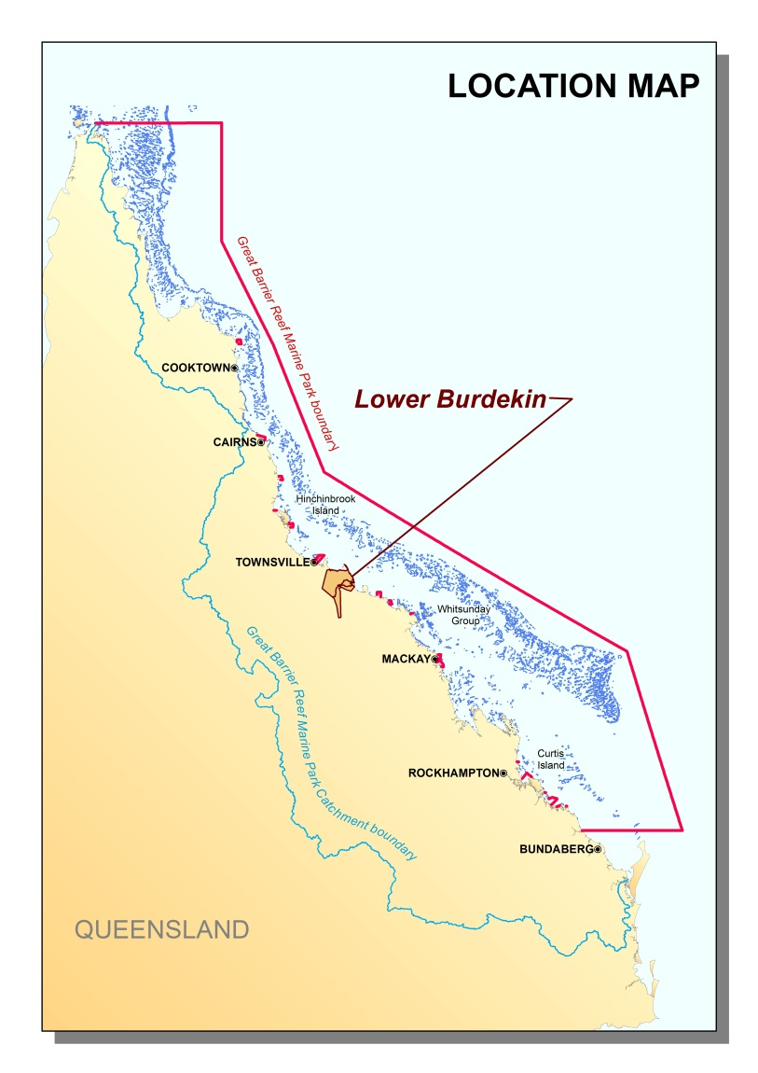

Figure : Lower Burdekin floodplain study area

Supporting services are those that maintain other ecosystem functions such as the provision of habitat to support commercial fisheries. Regulating services not only provide services to human wellbeing but also to other ecosystems. Coastal and marine ecosystems are closely interlinked and rely on each other for the provision of many ecosystem functions and processes to maintain ecosystem health.

The CEAF identifies 14 natural ecosystems within the coastal zone of the Great Barrier Reef and a range of physical, biogeochemical and biological processes that are provided to the Great Barrier Reef (Appendix A). Since European settlement, coastal regions have undergone significant modification and the naturally occurring ecosystems are no longer the only ones to influence the number and extent of ecosystem functions provided. To account for these, the CEAF also identifies a further eight "modified" ecosystems (Appendix B).

This case study focuses on the lower Burdekin floodplain, comprised of four basins (refer to Figure 1). The Queensland Government regional ecosystem mapping identifies that each of these basins has representations of eight coastal ecosystems identified in the CEAF (Table 1).

Table : Areas of concern – percentage of remaining coastal ecosystems within the study area. Red cells indicate areas with less than 10 per cent remaining; orange 10–30 per cent, yellow 31–50 per cent and green greater than 50 per cent. Note these figures provide no information about ecosystem condition or functionality. White cells denote an absence of this coastal ecosystem from the basin and pink cells denote an increase in area.

|  |  |  |  |  |  |  |  |  |
| --- | --- | --- | --- | --- | --- | --- | --- | --- |
|  | **Rainforests (%)** | **Forests (%)** | **Woodlands (%)** | **Forested floodplain (%)** | **Grass and sedgelands (%)** | **Heath and shrublands (%)** | **Freshwater wetlands (%)** | **Estuaries (%)** |
|  |  |  |  |  |  |  |  |  |
| Ross |  | **100** |  |  |  | **80** | **100** | **100** |
| Haughton | **75** | **33** | **87** | **23** | **56** | **95** | **67** | **100** |
| Burdekin | **82** | **52** | **56** | **48** | **31** | **78** | **23** | **102** |
| Don | **100** | **39** | **18** | **9** | **16** | **57** | **25** | **91** |

Modifying coastal ecosystems through development for agriculture, urbanisation or industry, can alter or even remove the ecosystem functions provided by the original ecosystem, which can be detrimental to adjacent ecosystems such as the Great Barrier Reef. One of the dominant issues associated with the development of land is the modification of waterways, from draining wetlands to provide land for agriculture, or building roads to allow access to new areas. These modifications often result in changes to the way water behaves within a catchment, causing it to run-off the land faster without being intercepted, slowed and filtered by natural vegetation. Infrastructure such as roads and dams create barriers in natural watercourses that can impede fish migration. These changes in ecosystem extent and function reduce the capacity for providing ecological processes such as flow detention, sediment trapping, nutrient regulation and habitat provision (Appendix A and B).

## Overview of the basin within the study area

The lower Burdekin floodplain case study area lies within the North Queensland Dry Tropics natural resource management region and the Northern Brigalow Belt Bioregion approximately 65 km to the south east of Townsville.

The Burdekin River is considered one of Australia’s largest in terms of peak discharge, and its floodplain represents the broadest expression of the quaternary coastal plain on the east coast of Australia.4 The study area is dominated by alluvial land forms including active deltas and river levees and older floodplain units5, and has one of the greatest concentrations of floodplain wetlands in eastern Australia6.

Mean annual rainfall varies between 750 mm and 1300 mm and is highly seasonal with the majority falling in the summer months, usually in association with monsoonal systems, and occasionally with tropical cyclones.

While the Burdekin River is the dominant drainage system and driver of landform geomorphology, most of the floodplain to the west and north of the Burdekin River falls within the defined Haughton River basin and the southern margin of the Burdekin Delta extends into the defined Don River basin.7

The Haughton River drains to the north western portion of the floodplain and enters the sea via an estuary that represents a former mouth of the Burdekin River.8 Between the mouth of the Haughton and Burdekin there are numerous floodplain distributary streams which receive overbank flows from the larger river systems during large flood events, and drain to independent estuaries.7

The largest of these, Barratta Creek, also has its own substantive catchment originating in the Leichardt Range to the south. Several anabranches also distribute to the north and south off the Burdekin main channel at its delta, and additional overbank distributary streams (Iyah Creek and Saltwater Creek) drain the southern floodplain to independent estuaries south of the Burdekin River mouth. During large flood events the majority of the study area can be inundated and form one contiguous floodplain wetland system.

The pre-European settlement landscape of the lower Burdekin floodplain (Figure 2) comprised a tropical savanna mosaic of forest, woodland, grassland and wetland determined by soil type, drainage, fire regime, proximity to the coast and tidal influence. While the climate is seasonally dry, the lower Burdekin floodplain is well watered, with many areas of shallow sandy groundwater aquifers which supplement wetlands formed by overbank flows and historical meanderings of the Burdekin River.9 The result is numerous seasonal swamps and shallow lakes, deep perennial lagoons, and extensive coastal sedgelands. The flat low lying coastal margin of the floodplain is influenced by freshwater discharge and sediment deposition, tide, wind and wave action. This has created bands of mangrove forests dissected by tidal channels, fronted by mud flats or beaches and dune ridges and backed by saltpans and marsh, brackish seasonal lakes and sedgelands.

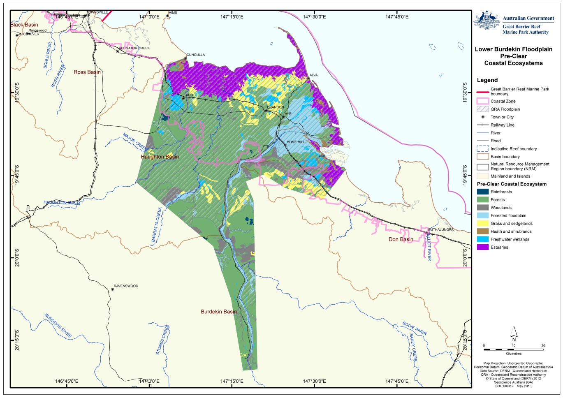

Figure Lower Burdekin floodplain pre-clear coastal ecosystems

The extent of remaining coastal ecosystems in the contemporary lower Burdekin floodplain (Figure 3) reflects the suitability and/or capability of the landscape to be developed for irrigated agriculture. Floodplain forest and forest coastal ecosystems in particular have been extensively cleared and developed for agriculture.

Remnant coastal ecosystems remain in areas where the ability to develop is constrained by environmental and logistical factors. These areas include saline estuarine areas, wetlands and seasonally inundated grasslands and sedgelands. Remnant forest coastal ecosystems also remain in areas that are not suitable for irrigated agriculture, and are outside the current reach of existing irrigation infrastructure, or as smaller remnants reflecting soil limitations or historic tenure artefacts (for example, Crown camping and watering reserves).

Given that extensive areas of floodplain have been intensively developed for irrigated agriculture, and that coastal ecosystems only remain in dedicated corridors and isolated remnants and residual downstream areas, it is expected that the larger area of irrigated agriculture will continue to have a dominating and potentially detrimental influence on the condition of the sub-dominant area of remnant coastal ecosystems. Further description of the remnant coastal ecosystems of the lower Burdekin floodplain, including their extent, values, functions, condition risks and drivers is summarised below.

More detailed information on each of the basins within the study area can be found in the respective CEAF Basin Assessment Reports for the Haugton, Don and the Ross basins.

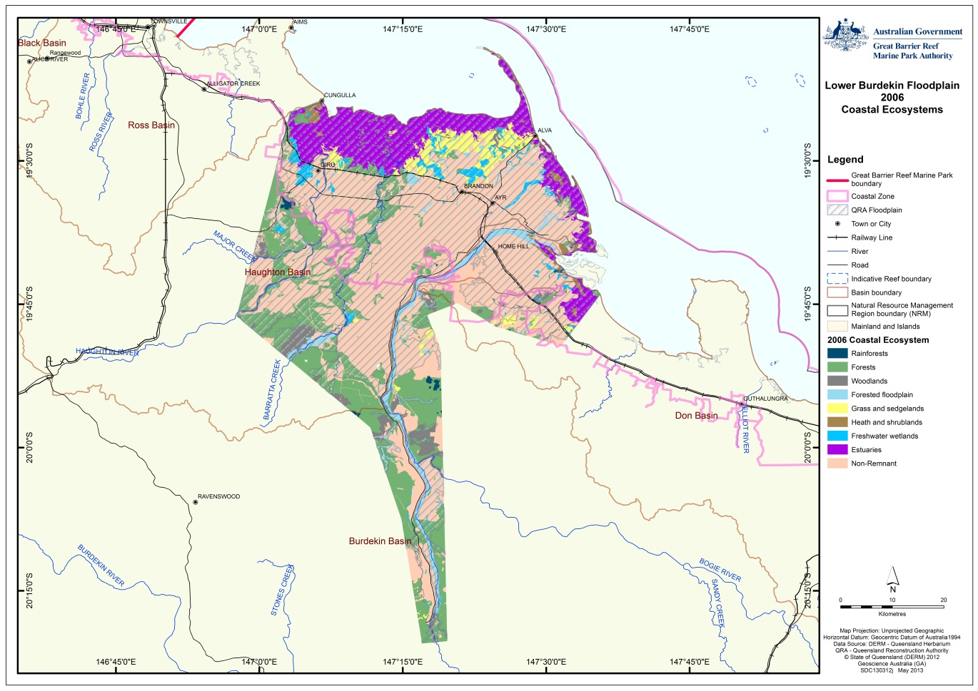

Figure Lower Burdekin Floodplain Post-Clear Coastal Ecosystems

## History of land use and development

Agricultural development of the lower Burdekin floodplain began in the mid-1870s with legislation passed in 1868 enabling individual land holders to resume land from pastoral runs. In 1875 the first small paddock of sugarcane in the district was grown on the floodplain between Plantation Creek and the Burdekin River.10

When rainfall was found to be inadequate in some years for good crop growth, crops were supplemented with irrigated water from the abundant surface water supplies associated with the numerous floodplain lagoons in the district. Irrigation first commenced in 1885 when surface water from lagoons on the Pioneer Estate was used to irrigate cane.11

When surface water supplies became limited, groundwater extraction for irrigation was introduced to the lower Burdekin floodplain by John Drysdale in 1887. This facilitated further cane land development to areas underlain by shallow sand aquifers.10 By the mid-1890s, over 2000 hectares of the lower Burdekin floodplain was being irrigated using both surface and groundwater sources.11

By the mid-20th century, reduced replenishment of groundwater by annual flood events highlighted the limitations in shallow aquifer water supplies for facilitating extensive irrigated agriculture. Declines in irrigation water quality became apparent, with saltwater intrusion occurring where aquifer levels were drawn down below sea level.10

Engineering response from the 1930s through to the 1960s included construction of saltwater intrusion dams at the bottom of Plantation Creek and in the lower Burdekin anabranch channels and construction of a tunnel through the Burdekin River bank into the top of the Plantation Creek, a floodplain distributary system to facilitate more frequent aquifer recharge flows during Burdekin River high flow events.

During 1965-66 both the North and South Burdekin Water Boards were formed in response to the identified need to artificially replenish aquifers via pumping from the Burdekin River.

Pumping to Sheep Station and Plantation Creeks on the northern Burdekin floodplain commenced in 1965-66 and to the Warren Gully absorption channel and Iyah Creek distributary on the southern floodplain in 1967.10 Groundwater levels and water quality improved with artificial replenishment, but prior to the construction of the Burdekin Falls Dam in 1987, pumping from the Burdekin River could only operate while there was sufficient river flow.

Following construction of the Burdekin Falls Dam in 1987, irrigation development extended beyond the historic limitations of irrigation supplies linked to shallow groundwater aquifers, to the older floodplain soils between the Burdekin and Haughton Rivers drained by Barratta Creek.

Under the BHWSS, water released from the Burdekin Fall Dams and pumped from the Clare Weir (constructed in 1978), now supplies the Haughton and Barratta constructed irrigation channels to the Burdekin River Irrigation Area (BRIA).

The Burdekin Water Board management of the aquifers facilitated the expansion of the amount of land under irrigation in the Burdekin Delta to over 35,000 hectares.11 The development of the BRIA has facilitated a further 40,000 hectares of additional irrigation development within the lower Burdekin floodplain.

Today, irrigated agriculture dominates land use on the Burdekin floodplain (Figure 4) and totals some 80,000 hectares, representing northern eastern Australia’s largest irrigation area. Agricultural production is almost exclusively sugarcane with approximately one quarter of Australia’s sugar crop grown in the study area. Smaller areas are committed to horticulture including vegetables and tree crops such as mangos, and more recently sandalwood. In total the Burdekin Floodplain generates more than $450 million in gross value of production from irrigated sugar and horticulture.12

Grazing is also a significant land use and occurs on native vegetation (with some pasture improvement and tree clearing) and on extensive areas of ponded pastures developed on bunded tidal flats and drainages of the near coastal zone (Figure 4).

As a land use, “Conservation, natural environments (inc. wetlands)” (Figure 4) is equally dominant but is primarily restricted to the near coastal zone and is comprised of coastline, mangrove estuarine, saltmarsh, grassland and freshwater wetland coastal ecosystems.

Protected and managed habitat areas include National Parks, Conservation Parks, Nature Refuges and Fish Habitat Areas. Other land uses in the study area include small areas of dryland agricultural production, intensive animal production including cattle feed lots, prawn aquaculture, water storage and transport and intensive urban residential including the main town settlements of Ayr, Home Hill, Giru and Clare.

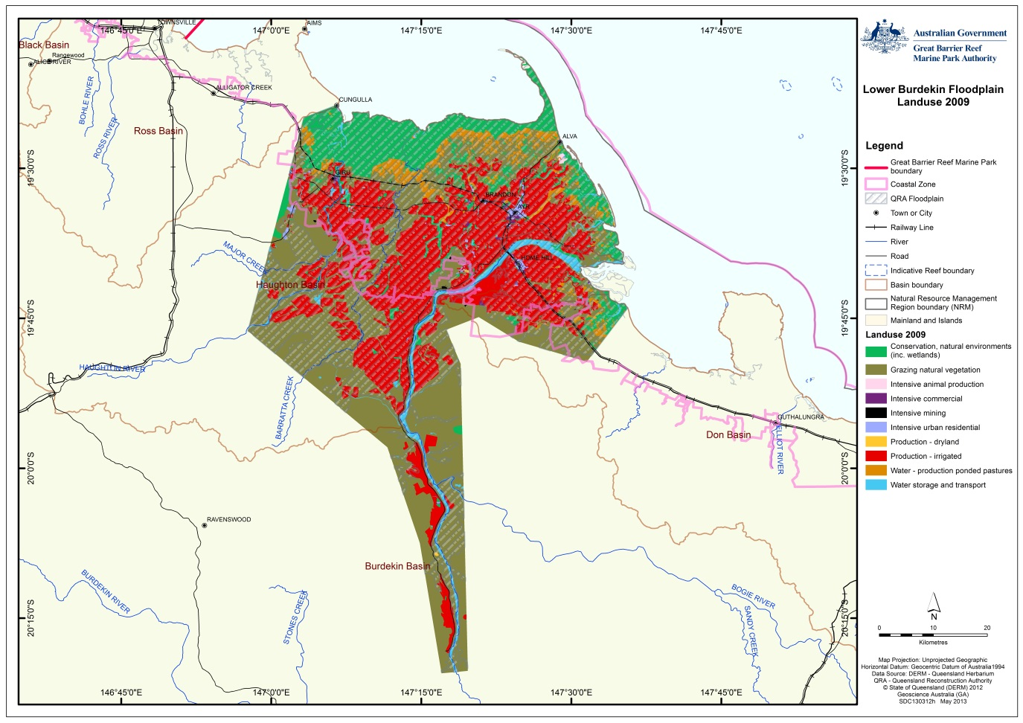

**Figure 4 Broad land use categories in the lower Burdekin Floodplain.**

Pre-European settlement, the study area was dominated by forests and forested floodplain coastal ecosystems (Table 2) and fringing freshwater and estuarine systems. This landscape has been extensively modified (Figures 3 and 4, and Table 2) with much of the forested floodplain cleared for irrigated agriculture. As illustrated in Table 2, some of the original coastal ecosystems have been significantly reduced.

Table : Area (ha) of pre-clear and 2009 coastal ecosystems within the study area based upon Queensland Government Regional Ecosystem mapping.

|  |  |  |  |
| --- | --- | --- | --- |
| **Coastal Ecosystem** | **Pre clear extent (ha)** | **2009 extent (ha)** | **% remaining** |
| Rainforests | 1405 | 1117 | 80 |
| Forests | 177786 | 68665 | 39 |
| Woodlands | 23180 | 13747 | 59 |
| Forested floodplain | 31851 | 11371 | 36 |
| Grass and sedgelands | 25458 | 11580 | 45 |
| Heath and shrublands | 4070 | 3431 | 84 |
| Freshwater wetlands | 11978 | 6765 | 56 |
| Estuaries | 36699 | 36314 | 99 |
| Non Remnant | 0 | 159316 |  |

## Impact on coastal ecosystems

The ability to identify the risks, steps and opportunities to achieve more sustainable agricultural production, and improvements in understanding ecosystem functions in the lower Burdekin floodplain, will determine the study area’s capacity to both support further economic development and contribute to the health and resilience of the World Heritage Area. This complex issue underpins the impetus for compiling strategic Regional Sustainability Plans to which this study contributes.

The extensive pattern of intensive agricultural land use on the lower Burdekin floodplain presents the primary risk to the condition of the smaller extent of remnant coastal ecosystems. Land development patterns, water resource use practices and associated pervasive changes to floodplain hydrology are the largest drivers of impacts on coastal ecosystems. Aquatic and terrestrial weed invasion, associated water quality decline, fire regimes, instream structures and fish passage barriers also generate major impacts on the condition of coastal ecosystems and their capacity to provide ecological functions for the World Heritage Area.

Modified floodplain hydrology includes elevated and aseasonal inputs of water to coastal ecosystems originating from irrigation scheme, farm losses and elevated and rising groundwater levels. Historically, river overbank flow breakout points formed the ‘streamhead’ for floodplain distributary creek systems draining away from major river channels. Overbank flows conveyed down these distributary creek systems provide a host of important ecological and hydrological functions which help maintain the condition of associated wetlands including channel scouring, organic load flushing, in stream habitat resetting, water quality improvement and groundwater recharge.13 In past decades River Improvement Trusts have sought to protect downstream farmland from these flood flows by constructing rock armoured levees at breakout points. These elevated levees in conjunction with basin scale hydrological changes generated by the Burdekin Falls Dam have reduced the frequency of breakout flows to the extent that they now only occur during extreme flood events. The loss of river breakout flow events in conjunction with the loss of flow seasonality due to sustained use of these creek systems as water distribution infrastructure has collectively contributed to the major condition impacts now observed in lower Burdekin floodplain distributary channel wetland systems.

Freshwater wetlands have become water logged, lost their historical seasonality and are subsequently subject to ecosystem changing weed infestations, contaminant loading, and poor river reach condition associated water quality decline, resulting in lost biological and biogeochemical process functions. In contrast to most other sugar producing regions where wet season events are the usual mode of off farm pollutant movement, irrigation tailwater flows in the dry season are the primary driver of nutrient and pesticide losses to downstream receiving environments from the lower Burdekin.14 Estuarine wetlands downstream of irrigation areas are also being subjected to elevated and perennial versus historically seasonal freshwater inflows9,15 with accompanying weed infestation and water quality decline occurring in upper estuarine reaches, nutrient and agric-chemical contaminant loading and an associated loss of biological and biogeochemical process functions.

Coastal bunds and saltwater intrusion dams, which are often the same type of structure with different intended functions, also impact connectivity and hydrology of both palustrine and riverine wetlands in near tidal coastal areas of the lower Burdekin floodplain.7,13,16 Coastal bunds have been established by graziers to reclaim saline coastal flats for ponded pasture development and to provide stock watering sources. Saltwater intrusion dams established by Burdekin Water Boards seek to exclude tidal ingress and maintain freshwater head pressure to help prevent saltwater wedge incursion into shallow groundwater aquifers. Flow regulating in-stream infrastructure, including weirs on major rivers, and flow gates, drop boards and tidal exclusion dams on regulated distributary streams and bunds on coastal inter-tidal areas also represent another major source of water resource management impact on coastal ecosystems in addition to volumetric management considerations.

In the last decade and a half predicted risks associated with irrigation area development have begun to be realised as groundwater levels have risen steadily within the BHWSS (Figure 5). This has begun to affect crop productivity and the hydrology, habitat quality and ecosystem functioning of downstream systems, and could potentially cause widespread salinisation and ecosystem degradation.11,12,17 Changing groundwater levels, salinity and downstream environmental impacts associated with irrigation area management have not only been restricted to the BHWSS/BRIA but have also emerged in the Water Board Managed Areas of the Burdekin Delta.13,18

Sustained groundwater rise through significant areas of the BHWSS19 and some delta irrigation areas threaten to extinguish the non-saturated soil zone and subject thousands of hectares of floodplain within the BHWSS to waterlogging and/or salinity degradation. Potentially affected areas include significant areas of remnant woodland and wetland habitat and millions of dollars of irrigated agricultural production.

Figure 5 is a graph showing the rainfall, groundwater level and salinity of groundwater statistics taken over a period of 34 years.

Figure Rainfall, groundwater level and salinity of groundwater over 34 years for a bore in the BHWSS (Source: Dr Keith Bristow, CSIRO)

#### Forest and woodlands

The extent of forest and woodland on the lower Burdekin floodplain has been extensively reduced by agricultural development, and remnant areas are affected by various condition drivers.

Forest coastal ecosystems on the lower Burdekin floodplain have experienced greater losses to development relative to other coastal ecosystem types due to their presence in a landscape suitable for agricultural development. Retained forest ecosystems have a representational bias toward types or sites with lower development suitability. Forests typical of the well-drained younger alluvial soils of the river deltas and levees have been most developed and only small isolated remnants of these types remain within the study area, with the largest occurrences on narrow levees of the Burdekin and Haughton River.

Altered groundwater levels and sea level rise are another source of hydrological impact to forested and woodland ecosystems. Forest stand die-offs due to groundwater saltwater wedge intrusion are observed at some sites on the coastal margin of the floodplain. Loss of vigour and die off due to water logging is also being observed on parts of the floodplain affected by elevated and rising water tables.

The lower Burdekin floodplain vegetation assemblages have always been a fire mediated mosaic and this fact remains current for the contemporary landscape. Changes in fire frequency and intensity towards either end of the hotter / cooler and frequent / less frequent spectrums are observed to drive changes in remnant woodland and forest condition on the lower Burdekin floodplain. In agricultural dominated areas of the lower Burdekin there is a propensity toward frequent fire in remnant vegetation areas associated with annual cane burning and management practices concerning perceived fire risks to cane crops from unburnt remnant vegetation. Intentionally lit late dry season fires have been implicated in the degradation of forest condition and wildlife populations in habitat areas set aside within the BRIA / BHWSS.17

High grass fuel loads predominate in ungrazed irrigated agricultural areas of the seasonally dry lower Burdekin. Tall and dense invasive exotic pasture species can cause catastrophically intense fires in remnant vegetation stands resulting in death of mature stands and individuals and significant simplification of structure and composition.20

While some exotic pasture species utilised as ‘ponded’ pastures are sensitive to fire others associated with more well drained soils (for example Guinea Grass *Megathyrsus maximus)* are pyrophytic and benefit from intense fire regimes, often reducing and replacing woody overstorey through successive hot fires.20 Areas of floodplain forest or woodland with a simplified structure dominated by exotic grasslands and isolated trees have an altered and reduced capacity for delivering ecosystem functions including flow baffling and soil stabilisation.

#### Wetlands

Many of the sources of impact on the condition and the ability of freshwater wetland coastal ecosystems to deliver ecological functions to the World Heritage Area are common to those identified for floodplain forests and woodlands.

Palustrine wetland systems are generally shallow, seasonal and dominated by emergent vegetation. Vegetation dominated palustrine wetlands are the classic sediment trapping wetland. In the lower Burdekin they occur in amongst floodplain forest and woodland coastal ecosystems adjacent riverine wetland systems and in association with floodplain drainage depressions or in grassland coastal ecosystems on the coastal plain adjoining areas of tidal influence. Land filling and levelling has facilitated agricultural development on this wetland system type (Figure 6 and Figure 7).

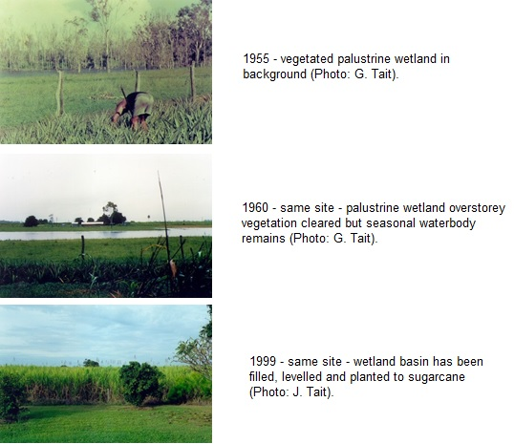

Figure 6 Example of palustrine wetland loss to agricultural development in Lower Burdekin Floodplain

Assessments of pre-development topographic maps suggest up to 50 per cent of larger seasonal palustrine wetlands have been lost to agricultural development on the lower Burdekin floodplain.6 The most significant extents of remaining palustrine wetland occur in areas unsuited to agricultural development (i.e. more incised distributary drainage channels and large coastal plain depressions in old marine sediments and / or subject to tidal influence). Large areas defined by Queensland wetland mapping as contemporary palustrine wetland systems adjoining estuarine areas are actually exotic ponded pastures developed behind coastal bund walls.

Riverine wetland systems occur in association with the major river and stream systems including:

* The Burdekin and Haughton Rivers, Barratta Creek, and tributary streams such as Majors, and St Margaret’s.
* Floodplain distributary streams of the main Haughton (Ironbark Creek) and Burdekin River channels. Burdekin distributries include:
  + Northern distributaries Sheep Station, Kalamia, and Plantation Creeks.
  + Southern distributaries Iyah and Saltwater Creeks.

Floodplain distributary streams generally have less defined stream channels and prior to contemporary hydrological modification only flowed seasonally, occurring as a chain of isolated waterholes and lagoons outside of the wet season (Figure 7).

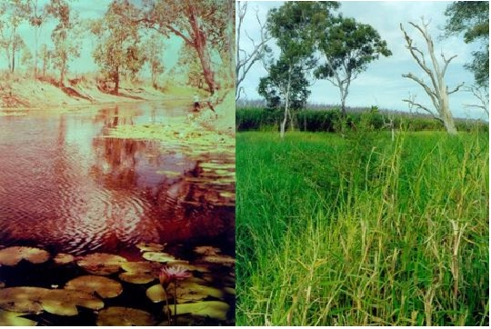

Figure 7: Northern floodplain distributary Sheep Station Creek ‘Round Waterhole’ 1970 (left) and 1999 (right). Observed changes include: Loss of open water; waterlogging death of riparian trees; removal of grazing; loss of recreational fishing value; replacement of native submerged, floating and emergent macrophytes with surface smothering exotic aquatic pasture grasses; encroachment of agriculture; reduced recruitment of riparian tree saplings. Photos by G. Tait and J. Tait.

Due to a lack of suitability for agricultural development, the areal extent of riverine wetlands within the lower Burdekin floodplain has not been as significantly affected by development as palustrine systems (above), though associated riparian vegetation regional ecosystems have been extensively cleared and within channel habitat condition often degraded. Significant areas of riverine wetland system within distributary streams are now classed and mapped as palustrine due to a modified dominance by emergent (usually exotic) vegetation. Some riverine systems are also classed and mapped as lakes (lacustrine) due to constructed barriers to flow or the lack of a defined stream channel within floodplain distributary systems.

The lower Burdekin has a highly seasonal climate and historically the supply of water to wetlands was governed by seasonal rainfall, flooding and aquifer levels and discharge. This seasonality underpinned a high level of variability observed for wetland habitat characteristics and many important ecosystem process functions (Figure 8).

With the contemporary dominance of irrigated agriculture on the lower Burdekin floodplain, water supply to receiving wetlands has become near perennial. This has been driven by a combination of factors including:

* The use of distributary stream networks as conduits for river water pumped for groundwater recharge and irrigation supplies
* Irrigation losses via supply channel leakage or overflows
* Farm losses via deep drainage to aquifers or surface run-off as tailwater, and via surface drainage network interception with recharged or rising groundwater levels.

In addition to altered water inflows, reduced wetland seasonality and enhanced perenniality has been affected by drainage channel blockages associated with bunds, levees, weirs and other in-stream structures and weed infestations. Reduced seasonality in water flow and levels linked to irrigation scheme driven hydrological modification of the floodplain is the primary mediator of freshwater wetland condition impacts caused by nearly all other drivers.9,13,16 While most riparian vegetation communities can tolerate some period of inundation, sustained bank full water levels through the lower Burdekin floodplain distributary stream network have resulted in waterlogging deaths of many mature riparian tree stands, including melaleuca swamp forest in the Plantation Creek system.

Lower Burdekin floodplain wetlands are also impacted by the quality of inflows from a variety of sources including the Burdekin River (via irrigation and groundwater recharge distribution networks), farm irrigation losses through deep drainage to groundwater, tailwater run-off, catchment surface run-off and shallow aquifer discharges. Water quality issues affecting lower Burdekin floodplain freshwater wetlands include low dissolved oxygen, turbidity, elevated nutrient levels, pesticides and salinity.14,21,22,23,24

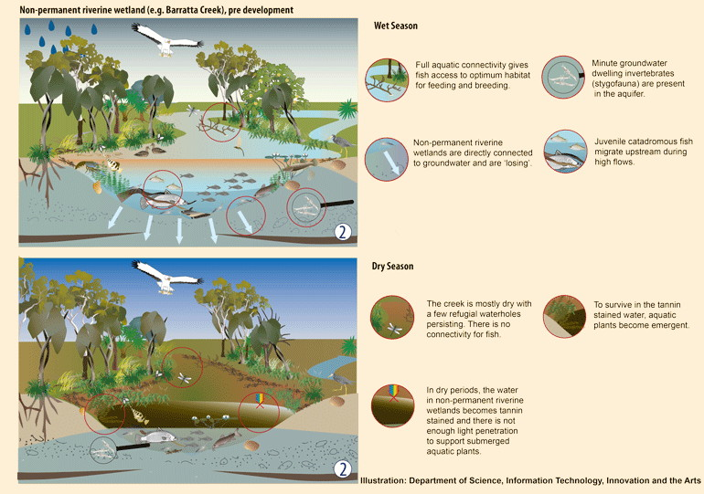

Figure 8 Conceptual model of seasonal variability within Lower Burdekin riverine wetland9

#### Grasses and sedgelands

Historically the most extensive sedgelands on the lower Burdekin floodplain occurred in drainage depressions and basins within coastal grassland ecosystems within areas influenced by spring tide. The most extensive sedgelands were formed of almost monotypic stands of *Eleocharis dulcis* also known as *‘*Bulkuru’.25 These unique communities are the primary focus of discussion in this section.

Due to generally lower development suitability, natural grasslands have not been significantly developed for irrigated agriculture although drainage and land levelling has facilitated the development of some areas of this ecosystem type. However hydrological impacts associated with irrigation scheme tailwater inflows has resulted in areas being largely replaced by invasive exotic grass species.

Bund wall reclamation of supra-tidal coastal drainage depressions on the lower Burdekin floodplain has had a major impact on the extent of Bulkuru sedgelands. The extensively bunded wetland and ponded pastures systems of the lower Burdekin floodplain are mutually exclusive with the historical distribution of this sedgeland community type. The only significant stands now occur in the Cromarty – Wongaloo Swamp area. Other than the Cromarty Swamps, Bulkuru sedgelands now only occur as isolated stands in unbunded wetlands of the coastal plain or in bunded wetlands that retain some level of tidal inflow and an associated seasonally brackish water quality regime.

Bunding and nutrient rich tailwater inflows pose the greatest condition impacts to these seasonal communities. Under sustained freshwater conditions Bulkuru sedgelands are outcompeted by other aquatic macrophytes (predominantly exotic ponded pasture species). Water quality conditions in these bunded wetland communities are often high in Biological Oxygen Demand (BOD), tending to become anoxic. Such conditions impact the capacity for biological process functions, including the provision of fishery nursery habitats associated with Bulkuru sedgelands. Tailwater supplemented full to semi-full bunded wetlands do not provide the same run-off capture role historically provided by these communities in the supra-tidal zone. Due to their aseasonal retention of anoxic water, they will also generate a pulse of high BOD blackwater into upper estuarine reaches at the onset of wet season run-off generated flows, at a time of fish reproduction and recruitment of vulnerable larval stages.

#### Estuaries

Estuarine coastal ecosystem mapping for the Haughton basin estimates 99 per cent of pre-development area of estuarine ecosystems remains in that component of the lower Burdekin floodplain.7 The large proportional area of estuarine coastal ecosystems remaining on the lower Burdekin floodplain is related to their limited suitability for development and the inclusion of significant areas in protected areas.

As identified for freshwater wetland systems the greatest driver of condition impacts on the lower Burdekin floodplain estuarine ecosystems is altered hydrology. This includes aseasonal flows emanating from irrigation system tailwater and elevated groundwater discharges and also physical structures such as earth bunds and sand dams placed in tidal channels and drainage depressions to retain freshwater and exclude tidal flows (Figure 9).

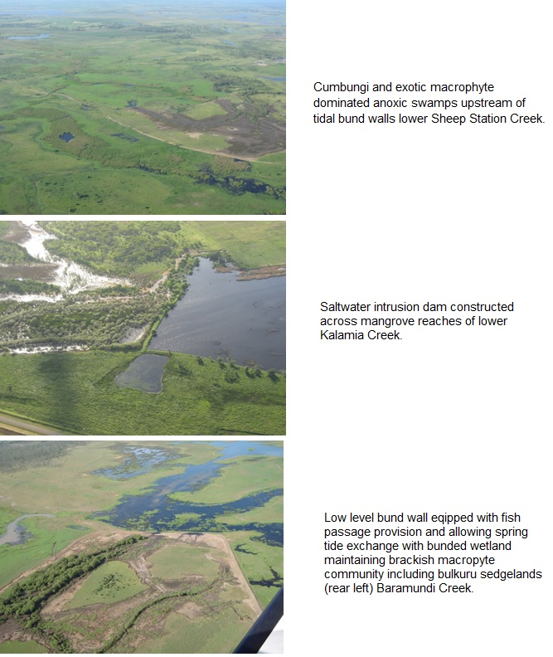

Figure 9 Saltwater Intrusion Dams and Bunds on lower Burdekin floodplain Estuaries

The increased volume of freshwater entering the Barratta Creek estuary downstream of the BHWSS during the dry season is now altering it to the extent that upper estuarine areas are essentially fresh during the dry season, when historically this was a period of higher salinity.26 Observed impacts associated with this change include the establishment of freshwater aquatic weeds such as *Hymenachne* sp. in the understorey of mangroves with accompanying impacts to dissolved oxygen levels.17 Riparian vegetation is also observed to be responding to these salinity changes with recruitment of *Melaleuca sp.* occurring in previously tidal salt couch flats in the lower West Barratta Creek system.

Elevated freshwater inflows (with or without low dissolved oxygen) threaten estuarine fish and invertebrate communities e.g. sesarmid crabs, which are a cornerstone species for driving ecological process functions in estuaries, are sensitive to freshwater inputs into estuarine systems.

Saltwater intrusion dams and bunds are the other primary source of hydrological and water quality impacts to estuarine ecosystems. The impacts of these structures on freshwater ecosystems and fish passage have been previously discussed for riverine wetland systems. For the downstream estuarine system the impacts are related to fish passage barriers, alienation of supra-tidal habitat (including important post-wet season fishery nursery habitat), alteration of salinity regimes (including toward fresh or hypersaline), reduced tidal flushing and associated water quality decline, and inflows of anoxic ‘blackwater’ during peak or sustained baseflow events. While low dissolved oxygen levels have been recorded for baseflows through bunded anoxic wetlands in the dry season, the impact to receiving estuaries have yet to be monitored during a peak wet season flow event. The volume of anoxic water available within some of these reaches would suggest that such impacts may be substantial.13 Impacts could be exacerbated by the generally poor flushing characteristics of upper estuary reaches and coincident timing within the wet season which is a period when larval fish occupy and shelter in upper estuarine reaches.27

Dry season tailwater flow concentrations of nutrients and pesticides also pose serious risks to estuarine ecosystems with monitored levels in adjoining freshwater exceeding Australian and New Zealand Environment Conservation Council guidelines on some occasions and posing considerable ecological risks to aquatic ecosystems.14

Other issues affecting estuarine ecosystem condition in the lower Burdekin floodplain include high levels of recreational fishing and associated beach hut settlements, boat traffic, vehicular access to intertidal habitats and aquaculture development (Figure 10). The Water Board also construct temporary sand dams (on the Burdekin river estuary) to exclude tide and saltwater wedge ingress. In recent years the Burdekin Water Boards have become increasingly responsive to the needs for fish passage past sand dams, and at least one permanent fish passage structure has been constructed to facilitate passage past an annually re-established sand dam.

#### Coastlines

The extent of coastline ecosystems fringing the lower Burdekin floodplain has not altered substantially since pre-European settlement. The coastal ecosystems along the coastal margin of the lower Burdekin floodplain include a beach strand dominated shoreline running from the Burdekin River mouth west to Cape Bowling Green Bay, and then a sheltered mangrove and intertidal flat dominated shoreline from Cape Bowling Green Bay running along the inside of Bowling Green Bay to the Haughton River mouth, with short sections of beach associated with some estuary mouths. Coastline vegetation communities associated with beach ridges (i.e. beach ridge vine thickets and woodlands) have been cleared in some areas of the Burdekin Delta coastal fringe. The settlement of Alva Beach occupies a small area of beach ridge vegetation communities.

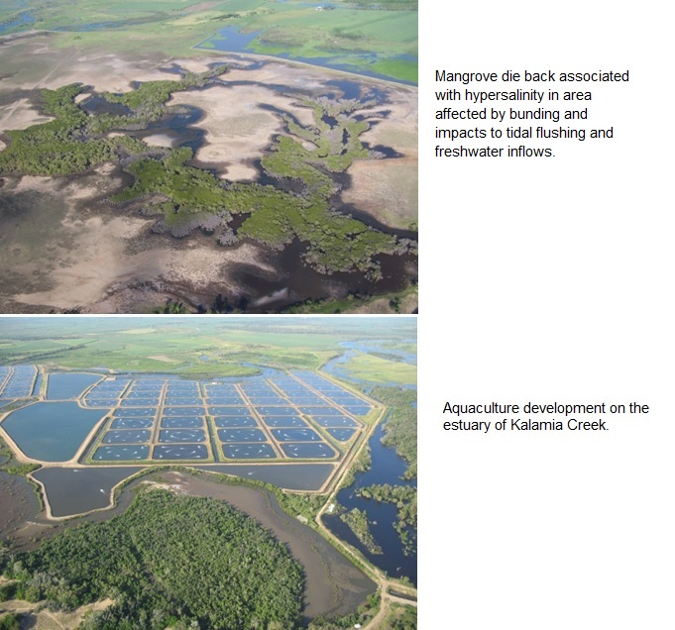

Figure 10 Examples of development and practices that affect estuary condition in the lower Burdekin floodplain

## Impacts to ecosystem functions

#### Forest and woodlands

Forests and woodlands on floodplains become periodically inundated during periods of high rainfall and breakout flows from adjoining stream and river channels. Forests and woodlands help to slow water velocity, capture sediment and recycle nutrients while protecting the soil from erosive forces of rainfall and flow.28 Vegetated floodplains are also important areas for regulating groundwater recharge and discharge contributing to the water balance in the landscape. Consequently forested floodplain coastal ecosystems are identified as having a high to medium capacity for a wide range of physical, biogeochemical and biological processes that can deliver ecological functions for the World Heritage Area (Appendix A).

The contemporary lower Burdekin floodplain has undergone extensive surface and groundwater hydrological modification. Surface hydrology has been modified by vegetation clearing and land levelling for farm development, the construction of tailwater drains (primarily in the BHWSS), changes to riparian vegetation condition within distributary stream channels, built (road, rail) infrastructure on the floodplain, and by elevated groundwater tables in some areas decreasing the non-saturated zone and reducing infiltration capacity.

Cumulative hydrological impacts on the larger floodplain system (including lack of consideration for pre-existing natural drainage depressions networks or preferential flow paths during past land levelling and development of drainage infrastructure), has resulted in reduced interaction of floodplain water run-off and flow with forests or woodlands in a manner that supports the full capacity for vegetated ecosystem functional processes. Flood water flowing from the top of the floodplain to the bottom is described by local stakeholders to now ‘take hours instead of days’.

Flows are concentrated by infrastructure or drains, often bypassing and short circuiting remaining drainage depressions, where flows historically slowed and spread across the landscape. Instead of entering distributary streams via broad natural drainage depressions with distributed flow paths, constructed drains deliver concentrated flows often resulting in greater erosion potential. Higher flow velocities and reduced residence time for flood water on forested floodplains limits the capacity for many of the physical and biochemical processes to occur (for example, those associated with flow detention, sediment trapping, and nutrient uptake).

Farm development has extended into shallow drainage depressions that previously acted as preferential flow paths during periods of floodplain inundation and has contributed to unco-ordinated drainage patterns, including flood preferential flow paths through developed areas.12 Un-coordinated drainage also affects remnant floodplain forests and woodlands by creating areas artificially watered by irrigation and tailwater. The resulting higher soil moisture and nutrient status can enhance understorey growth including invasive and pyrophytic pasture grasses.20

One other key factor affecting the capacity of remnant forests and woodlands to deliver ecosystem functions and processes (Appendix A) is the shape, location and extent of coastal ecosystem remnants. Narrow linear corridors and small areas have a large external boundary to core area ratio and are more vulnerable to edge effects, including weed invasion and hydrological change associated with neighbouring land uses. Small isolated stands alienated from floodplain overland flow and/or drainage paths have little capacity to deliver flow detention, silt trapping and landscape water balance functions. When you have a situation where the extent of the catchment is extensively cleared and developed dwarfs receiving remnant areas, the capacity of the smaller remnant area to physically or ecologically process received run-off or flows can be overwhelmed (Appendix B).

#### Wetlands

Freshwater wetlands are usually associated with areas subject to periodic flooding where standing freshwater persists for at least part of the year, in most years. These areas slow the overland flow of water and cycle nutrients and trap sediment. Freshwater wetlands are also important dry season refugia for a host of aquatic and semi-aquatic species and are used by some marine species with links to the World Heritage Area for parts of their life history.28 Freshwater wetland coastal ecosystems are identified to have one of the highest capacities of any coastal ecosystem types for a wide range of physical, biogeochemical and biological processes that can deliver ecological functions for the World Heritage Area (Appendix A).

Palustrine wetlands have experienced the greatest losses to agricultural development (

Figure 6). Historically, this type of wetland system was abundantly distributed along drainage depressions across the lower Burdekin floodplain. With loss of palustrine wetlands, the ability to continue to deliver ecological functions for downstream receiving estuarine and marine systems via processes such as flow detention and sediment retention needs to be considered in terms of the cumulative functional contributions of the chain of palustrine wetlands that used to intercept floodplain run-off.

Under perennial and near stable wetland water level conditions created by the hydrological modification of the floodplain, a suite of aquatic weeds create wetland choking weed mats that in the absence of active management can cover the entire water surface of even deep riverine wetlands.29 Formed weed mats shade out and exclude native submerged and bankside emergent macrophytes which have important habitat values. Anoxic water conditions created by the water surface smothering of such weed infestations and the associated organic loading of the water column generate fish kills and create permanent fish passage barriers in floodplain distributary streams.

Secondary water quality impacts include the enhanced liberation of phosphorus from bottom sediments under the created anoxic conditions.13 While aquatic weed choked wetlands may have a potentially enhanced capacity for some wetland ecosystem functions (e.g. flow detention, sediment trapping and nutrient uptake) this needs to be weighed against ecological impacts. These include degraded water quality, alienation of upstream fish habitats and impacts associated with the export of anoxic blackwater and delivery of large accumulated organic loads to downstream estuarine and marine systems during peak flows associated with flood events.

Bunded coastal wetlands are a particular class of artificial wetland often created in areas that were previously seasonally brackish. Prior to the establishment of perennial irrigation supplies with the Burdekin Falls Dam, most bunded coastal areas still drew down or dried up in the dry season promoting seasonal native macrophyte communities. Seasonal drying facilitating cattle access to weed species, the desiccation and incorporation of organic loads in bed sediments and the creation of open distributary channels prior to wet season flow events.

Due to the impacts noted above, effective recruitment of catadromous fish species up distributary streams of the lower Burdekin floodplain has not been demonstrated since the early 1990s30 and recent records for migratory species such a barramundi are attributed to stocking efforts13. The lack of effective fish passage on the lower reaches of the main distributary streams of the lower Burdekin floodplain represent a major condition impact on the migratory fish populations of the areas riverine wetland systems.

#### Grasses and sedgelands

Coastal sedgelands and to lesser degree seasonally inundated grasslands are the classic ‘filtering wetland’. Under natural conditions, at the initiation of the wet season, these seasonal swamps are dry and senescent growth is desiccated and often forms an organic mulch layer on the surface of the dry basin (some of which has decomposed and has been captured as stored soil carbon). The first run-off events from contributing distributary drainages are ‘captured’ and detained in these basins reducing the potential of high BOD discharges being directly received in upper estuarine reaches. With the infill of low lying areas, *Eleocharis* sp*.* sedgelands grow into tall stands. Subsequent run-off events into these basins are baffled and detained by the mass of standing sedges, facilitating the trapping of sediment and uptake and cycling of nutrients.

Because sedges are aquatic plants they do not decompose and produce high BOD when inundated (in contrast to ponded pasture grasses), and have characteristically high dissolved oxygen concentrations in contained water bodies, also promoted by algal growth on sedge stems. The high productivity and good water quality of inundated sedgelands make them high value nursery habitats for fish including juvenile barramundi which recruit into these areas from adjoining estuarine systems during the wet season and can be found in high abundances in these habitat types.

#### Estuaries

Estuaries mix and accumulate organic and mineral nutrients from the land and sea and are consequently highly productive environments and important for recycling nutrients. The fertile and protected environment provided by estuaries provides nurseries for fish and crustacean species that are directly linked to commercial and recreational fisheries is in the Burdekin coastal region.26,31 Many estuarine fish species also have life cycle linkages with Great Barrier Reef habitats.

The capacity of estuarine ecosystems to assimilate sediment provides an important water quality role on the margin of the World Heritage Area, as does their ability to biogeochemically modify chemicals and heavy metals. They are also one of the most effective natural carbon sinks.28 Mangrove forests and other estuarine vegetation communities also provide physical protection of the coastline providing security for landward coastal ecosystem and production systems.

Besides functional values, estuarine ecosystems of the lower Burdekin floodplain also have high biodiversity and nature conservation values. Burdekin coastal estuaries are recognised for their high mangrove species diversity.26 Conservation values are recognised by inclusion of a significant proportion of lower Burdekin floodplain estuarine coastal ecosystems in protected areas or recognised as areas of specific value:

* Cape Bowling Green Bay National Park (also a listed Ramsar Internationally important wetland)
* Two declared fish habitat areas (Figure 11)
* Four Nationally important (DIWA) wetlands: Burdekin - Townsville Coastal Aggregation; Burdekin Delta; Wongaloo Fans Aggregation; and Wongaloo Swamps Aggregation are also comprised wholly or significantly of estuarine wetlands of the lower Burdekin floodplain.

The lower Burdekin floodplain estuarine wetlands support a number of *Environment Protection and Biodiversity Conservation Act 1999* (EPBC Act) listed species including inshore dolphins, saw sharks, saltwater crocodiles and migratory water birds.

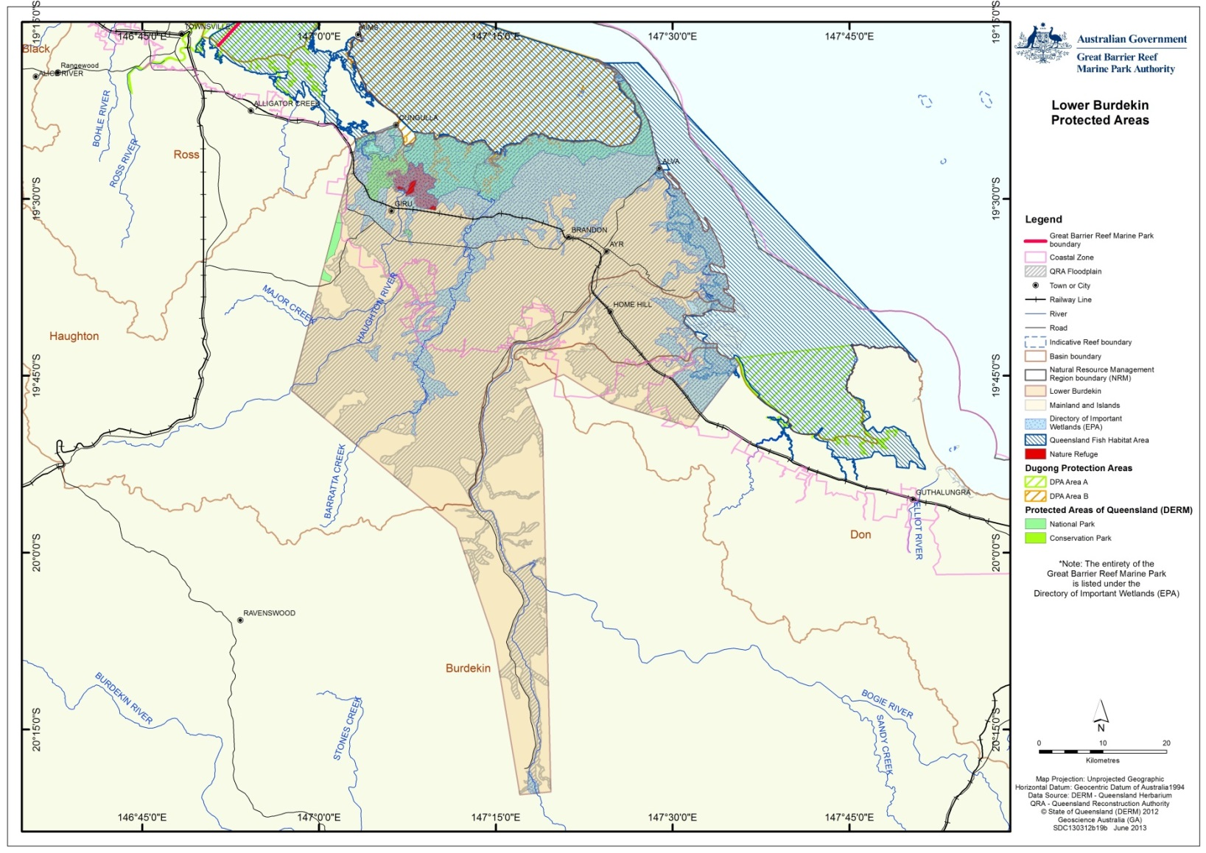

Figure 11 Spatial extent of some Matters of National Environmental Significance including World Heritage Properties, National Heritage Properties, Ramsar wetlands, Nationally Important wetlands, National Parks, Conservation Parks, forest reserves, Fish Habitat Areas

#### Coastlines

Sandy beach shorelines of the lower Burdekin floodplain coastline serve a function as filters processing ground water and beached organic matter. Muddy shorelines act as depositional areas for sediments and nutrients discharged from the catchment or transported along the coast. These are then consolidated into food chains and natural recycling processes by the biological activity of worms and other species common in these environments.28 Invertebrates consuming small fish prey make shorelines a productive area for a host of recreational and commercial finfish and crustacean species.

Shorelines of the lower Burdekin floodplain provide nesting grounds for EPBC Act listed seabirds and marine turtles.32 Shallow aquifers in some beach ridges (i.e. delta coastal margins) also support beach ridge vegetation communities which are EPBC Act listed endangered ecological communities.

The high functional, productive and biodiversity values of the lower Burdekin floodplain coastline is reflected in substantial areas of it being protected within National Park, Declared Fish Habitat Areas and Ramsar listing for Internationally Important wetlands (Figure 11).

While much of the lower Burdekin floodplain coastline is relatively isolated from areas of human settlement it is still vulnerable to a number of local, regional and more global drivers of condition impact. Even remote coastline ecosystems of the lower Burdekin floodplain are subject to impact risks to biota posed by marine debris. High levels of recreational boat and vehicle ownership also mean that local residents and visitors to the region alike have relatively unregulated access to much of the beach coastline posing risks to matters of national environmental significance. Damage to dune vegetation by quad bikes and associated erosion risks and disturbances to nesting birds and turtles has been noted at Alva Beach.26

Impacts to coastal processes including the supply of beach forming sand attributed to coastal development and dam infrastructure in the Burdekin basin have been cited in relation to changes in coastal landforms adjoining the Kalamia Creek mouth.26

Like many coastal ecosystems downstream of intensive agriculture in the lower Burdekin floodplain, shoreline sediment samples recorded at the mouth of the Burdekin River have also contained agri-chemical residues associated with dichloro-diphenyl-trichloroethane (DDT).33

Some of the most significant changes to the lower Burdekin floodplain coastline are associated with cyclones and storm surge events. Both southern Bowling Green Bay and Cape Bowling Green Bay have been identified as being particularly vulnerable to erosion. The latter is known to host large populations of EPBC listed migratory wader birds.32 Predicted increases in the severity of cyclonic events in tropical north Queensland associated with the impacts of global warming highlights the importance of ensuring all available management avenues are pursued to increase the resilience of these coastline ecosystems.

## Current condition and trend

The lower Burdekin floodplain has a very intensive pattern of agricultural land use   
(Figure 12). All soils with some suitability for agriculture within the economic reach of irrigation infrastructure have largely been developed to irrigated sugarcane cultivation and lesser areas to horticulture. Developed areas include coastal margins of the Burdekin Delta and floodplain abutting areas of low fertility beach ridge sands and coastal plains comprised of marine sediments adjacent to areas subject to tidal influence.

With the exception of intentionally retained habitat corridors within the BHWSS and contiguous Pastoral Leasehold properties adjoining Barratta Creek, all other larger areas of remnant coastal ecosystem on the lower Burdekin floodplain define areas beyond the reach of current irrigation supplies (on the upper catchment margin of the floodplain) or with limitations to agricultural land use.

The latter include stream drainage lines and associated wetlands, saline coastal plains, beach ridges and extensive estuarine mangrove and channel complexes.

While more extensive areas of coastal ecosystem types with agricultural limitations occur on the coastal margins of the study area, drainage lines and riverine wetland coastal ecosystems are also present in the main agricultural areas. These have usually been subject to historical vegetation clearing and patterns of development that extended to the margin of stream channels or beyond. Remnant riparian vegetation corridors are consequently narrow, discontinuous, and have a low resilience to threats presented by invasive weeds and hot fire regimes.

In simplistic terms the lower Burdekin floodplain landscape can be conceptualised as one large levelled sugarcane field fringed on its coastal margin by a relatively narrow band of coastal estuarine ecosystems. This cane field is perennially watered, and periodically inundated and is drained by a combination of high capacity constructed earthen drains   
Figure 13), grassy distributary stream channels which retain isolated small stands of riparian vegetation and the higher integrity Barratta Creek channel which retains broader bands of riparian and transition into forest assemblages. Significant volumes of water also leave the landscape to shallow groundwater aquifers, and consequent discharges through surface flows to streams and river channels or submarine discharges to near shores area through old alluvial fan conduits.

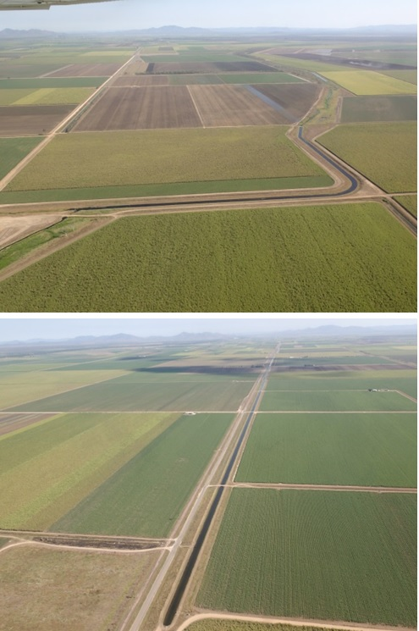

Figure12 Example of extensive patterns of intensive agricultural development including irrigation supply channel (top) and drain (bottom) on the Lower Burdekin Floodplain (BHWSS).

The current condition of riparian vegetation in much of the lower Burdekin floodplain is extremely poor, particularly, but not exclusively, along floodplain distributary streams in the Burdekin Delta. These areas are characterised by exotic grass dominated channel margins and banks with isolated trees, with some reaches retaining no over-storey vegetation. Streams that retain higher integrity riparian vegetation corridors have been identified as assets requiring protective management. Main river channels in the lower Burdekin floodplain (i.e. the Haughton and Burdekin) also have some reaches lacking riparian over-storey vegetation, but most reaches retain at least degraded vegetated corridors.

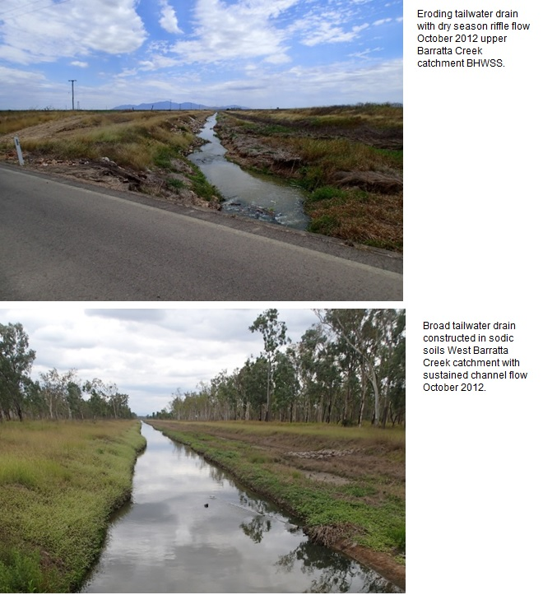

Figure13. Examples of large BHWSS tailwater drains with sustained dry season flows

#### Forests and woodlands

At least five primary sources of impact on the condition and the ability of floodplain forests and woodlands to deliver ecological function for the World Heritage Area can be identified including:

* + Hydrological change
  + Fire regime
  + Weeds
  + Grazing regime
  + Retention extent and pattern

Global warming and associated climate change and sea level rise also present significant emerging risks that will drive the condition of floodplain forest and woodlands. These risks will be primarily realised via the other identified condition drivers and are discussed in conjunction with them.

#### Wetlands

The resilience and condition of lower Burdekin wetlands (primarily determined in terms of floristic integrity) has been shown to be related to their land zone type.16 Conceptual models of the current condition and management issues of lower Burdekin floodplain wetland’s (Figure 14) have been compiled under the Queensland Wetlands Program.9 Most recently as part of the Haughton basin assessment, the drivers of freshwater wetland condition have been summarised and presented with additional conceptual models of management issues.7 They include:

* Hydrological change
* Weeds
* Water quality
* In-stream barriers, connectivity
* Grazing regime
* Fire regime
* Retention extent and pattern of coastal ecosystems

Global warming and associated climate change and sea level rise also present significant emerging risks that will drive the condition of freshwater wetlands. These risks will be primarily realised via the other identified condition drivers and are discussed in conjunction with them.

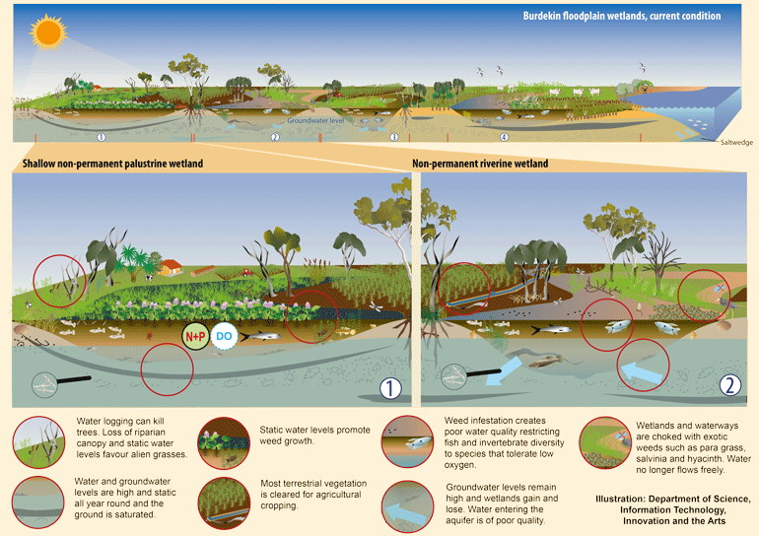

Figure 14 Conceptual models of lower Burdekin floodplain wetland’s current condition and management issues.9

In terms of freshwater ecosystem functional process impacts, increased and sustained turbidity in the Burdekin River downstream of the Burdekin Falls Dam following its construction is highly significant for riverine wetland systems, which historically had clear water conditions outside of the wet season period.9,29 This turbidity reflects the high colloid content of wet season flood flows captured by the dam which remain suspended, impacting light penetration, submerged macrophyte growth, in stream photosynthesis, primary production pathways and groundwater recharge (siltation). Although levels of nutrient attached to colloids are low, water pumped into floodplain riverine wetland’s used as distributary systems for irrigation and groundwater recharge supplies result in nutrient loads in orders of magnitude greater than pre-development catchment loadings.34

Application of fertilisers at rates in excess of crop requirements and associated off farm losses via rainfall run-off, irrigation deep drainage and/or tailwater run-off has long been identified as a source of elevated nutrients recorded in receiving wetland systems (including areal drainage networks, floodplain creek systems and shallow aquifers).35 Elevated nutrients cause eutrophic conditions promoting excessive algae and macrophyte growth and hypoxia, impacting aquatic and marine habitat values. Such nutrient loading can also overwhelm the assimilation capacity of remnant wetlands resulting in loads to receiving downstream estuarine and marine systems including within the World Heritage Area.

Pesticides are widely used in lower Burdekin farming systems and off farm losses conveyed by the same pathways described for irrigation water result in detectable levels and some exceedences of ecosystems guidelines being recorded in receiving surface water bodies and shallow aquifers.14 Pesticides have the capacity to cause direct or sub lethal impacts on biota in freshwater wetland ecosystems or if transported downstream, in receiving estuarine and marine systems including within the World Heritage Area.

Even where wetlands remain within floodplain drainage lines or flow paths the relatively small extent of remnant wetland to the developed contributing catchment increases the likelihood of individual wetlands being overwhelmed in terms of their capacity to detain sufficient volumes of run-off for sufficient periods of time to effectively perform biophysical and geochemical process functions. In the more recently developed BRIA/BHWSS irrigation scheme areas, constructed areal drainage networks were often designed to avoid remnant palustrine wetlands to meet required drainage performance specifications, or to avoid tailwater inputs to seasonal wetlands nominated to have environmental values30 (Figure 15). The condition, impacts and loss of function associated with decoupling floodplain drainage networks from retained palustrine wetlands and the reduction in the areal extent of wetland basins relative to contributing catchment are hard to quantify but are likely to be significant at a whole of floodplain scale.

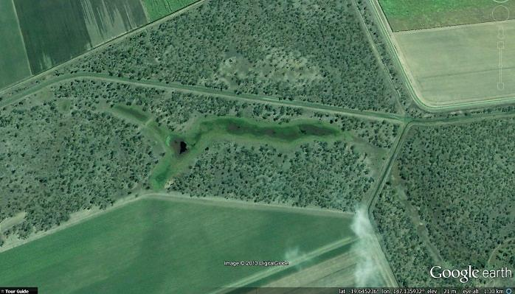Figure 15. Circumventing of floodplain palustrine wetlands by constructed drainage networks. Palustrine wetlands on the Barratta Creek floodplain circumvented by areal drainage networks at Green Swamp1 West Barratta Ck catchment.

#### Grasses and sedgelands

As identified in the discussion on the extent of these community types, the greatest risk to their occurrence is hydrological modification that reduces their required seasonal hydrological regime. In the case of Bulkuru, there is also a requirement for seasonally brackish water conditions to which they are adapted and which enables them to out-compete other emergent macrophytes (including exotic aquatic grasses).

Sea level rise associated with global warming will pose threats but also possibly opportunities for these ecotonal sedge communities. If bund wall structures are maintained or established to prevent tidal incursion extending further inland, the landward migration of Bulkuru sedgelands will be compressed and halted by such structures. If bundwalls are increasingly breached by sea level rise, established salinity conditions on the landward sides may support succession of degraded bunded wetland communities toward Bulkuru sedgelands. This will also depend on the retention of seasonal hydrology and dry season draw down. Planned removal of bund structures from the near coastal zone and cessation of aseasonal tailwater inputs would provide the best conditions for landward migration of these valuable functional communities.

## Forecast of likely future activities and impacts on coastal ecosystems

The highest priority for improved protective measures is the remnant floodplain coastal ecosystems set aside during the development of the BHWSS. Relatively large areas of forest and woodland also remain on the periphery of the floodplain including coastal remnants, inland upper catchment margins of the floodplain and the southern margin of the delta where marginal soil conditions, salinity constraints and access to irrigation infrastructure currently limit development suitability. Inland and southern margin areas are potentially suitable for further agricultural development, however due to their location have been beyond the economic reach of irrigation supply infrastructure and current constraints on broadscale tree clearing.36

While elevated salinity is yet to emerge as a significant driver of freshwater wetland condition in the lower Burdekin floodplain, rising groundwater high in salinity in the BRIA/BHWSS, and the identified critical need to develop groundwater dewatering and drainage strategies19, would suggest that there is a high potential for impact on wetland conditions. Perennial base flows in the historically seasonal Barratta Creek are already being partially driven by elevated groundwater discharge in conjunction with surface tailwater discharges9,15. If saline groundwater discharges were to become dominant in the future, this could substantially impact the areas productivity, water quality and future viability of coastal ecosystems.

# LAND-USE MANAGEMENT AND COASTAL ECOSYSTEMS

## Overlapping roles of government

The complex jurisdictional environment and the arrangements applying to the coastal zone around Australia are well recognised.28 There are four tiers of governance with overlapping roles in the planning and management frameworks that regulate activities impacting on the lower Burdekin floodplain.

The World Heritage Committee plays an international oversight and assistance role under the *World Heritage Convention*. While the Committee cannot make decisions implementable under Australian law, its decisions affect the governance of the World Heritage Area. While it has an important international role, the World Heritage Committee is not directly involved in the day-to-day planning and management of activities within or affecting the World Heritage Area.

The Commonwealth or Australian Government is ultimately responsible for fulfilling Australia’s obligations under the *World Heritage Convention* to protect, conserve, and restore the World Heritage Area. The Australian Government Department of Environment administers the EPBC Act, which regulates new development, both within and outside the World Heritage Area, likely to significantly impact on the World Heritage Area but which has little control over the legacy effect of development prior to its commencement in 2000.

The Queensland Government has primary responsibility for the planning and management of activities in the State of Queensland. It has many departments with roles in coastal planning, fisheries management, ports, agriculture and mining. Land-use and development (other than mining and petroleum extraction) are primarily regulated under the *Sustainable Planning Act 2009* (Qld) (SPA). Many other pieces of legislation are integrated under SPA, including the *Water Act 2000* (Qld) and associated water resource plans and operating plans. Local governments are statutory authorities created by the Queensland Government to govern within the local government areas. Local governments play a central role in most land-use planning in the Great Barrier Reef catchment through the creation of planning schemes to guide new development.

#### General laws, policies and programs relevant to this case study

A general point to be aware of is that the various Commonwealth and Queensland planning and management frameworks principally regulate new activities and development. The legacy of past development tends to become a fixed part of the “status quo” forming a background of impacts or condition of the environment. In the lower Burdekin floodplain, most suitable sites for water infrastructure and most land suitable for irrigated agriculture have already been developed or are protected for other purposes. The main pieces of legislation regulating water infrastructure are the:

* *Water Act 2000* (Qld)
* *Sustainable Planning Act 2009* (Qld)
* *Environment Protection and Biodiversity Conservation Act* *1999* (C'wth)

The SPA creates a development assessment system linked to the *Water Act*, *Fisheries Act* and other Acts for, amongst other things, operational works:

* Interfering with a watercourse, lake or spring or overland flow
* Damaging, removing or destroying marine plants (i.e. plants normally subject to tidal inundation including mangroves and marine couch) and declared fish habitat areas

#### Water Resource Management Regulatory Framework

The *Water Act 2000* is the head of power in Queensland for the management of water, including the establishment of authorities and development of plans for the management of water resources. A number of tools are available under the *Water Act 2000* for the sustainable management of water resources; some of the main tools include the development of Water Resource Plans, resource operation plans, water use plans, land and water management plans, licencing and water allocation.

The relationship between the Water Resource Plans (WRP) and the Resource Operating Plans (ROP) is set out in the *Water Act 2000*, which specifies that the ROP must ensure that strategies established in the WRP for advancing sustainable water allocation and management are met. To this end, monitoring arrangements will be implemented and refined under the ROP.37

Despite the detailed list of relevant ecological matters nominated for consideration in the Burdekin WRP the current ROP has only six environmental management rules that relate to the operation of the BHWSS and water allocation within the lower Burdekin floodplain study area:

* Water courses authorised to be used for water distribution
* Minimum operating levels of storages
* Changes in rates of release to avoid adverse environmental impacts
* Operation of Clare Weir flap gates
* Releases of water at Clare weir in relation to fishway operation
* Minimum stream flow requirements at defined drainage network nodes.

The ROP is intended to provide for the sustainable management of water by a range of mechanisms including detailing water and natural ecosystem monitoring responsibilities for the holders of both the resource operations and distribution operations licences for the BHWSS. With regards to natural ecosystem monitoring the ROP stipulates that37:

The chief executive must collect and keep publicly available information, including information on:

1. ecological assets that are linked to the ecological outcomes of the *Water Resource (Burdekin Basin) Plan 2007*; and
2. the critical water requirements of ecological assets, including the provision of these requirements under the *Water Resource (Burdekin Basin) Plan 2007*.

While specific indicators are nominated for monitoring by scheme licence holders in relation to defined environmental management rules, monitoring proposed to assess general ecological outcomes makes reference only to ‘*chief executive data collection and assessment, use of performance indicators for monitoring by chief executive’* and to ‘*links to monitoring and assessment programs undertaken by other stakeholders and agencies’*. No specific ecological assets or performance indicators are identified.

The Burdekin Basin WRP and associated ROP only deal with surface water resources and exclude groundwater management considerations other than outcomes specified in relation to managing access to water to support the ongoing management of the lower Burdekin delta groundwater system*.* The State Government has been working toward compiling the knowledge base to inform the inclusion of groundwater and groundwater dependent ecosystems in future iterations of the ROP.9

The ROP provides the opportunity to establish clearer management and monitoring linkages to coastal ecosystem condition to improve coastal ecosystem functions for the World Heritage Area. These include:

* Measurable performance indicators of lower Burdekin floodplain freshwater and estuarine wetland health and biological function potentially including dissolved oxygen status, aquatic weed infestation levels, trends in riparian vegetation extent, maintenance of catadromous fish recruitment, estuarine salinity regimes, effective connectivity of wet season flood flows could all be considered as a basis for ROP environmental management rules in the lower Burdekin floodplain.
* Groundwater level and behaviour (i.e. rates of rise) and quality (salinity, nutrients, agri-chem residues) triggers linked to Water Use Efficiency and conjunctive use and intervention strategies i.e. dewatering / drainage.
* Mean water use efficiency compliance targets established for individual irrigators within farming districts and/or subcatchments defined on the basis of farm systems and soil types.

Monitoring and management requirements included in a ROP would provide the basis for improved systems understanding and stimulate local stakeholder innovation in finding effective acceptable solutions to identified water resource management issues.

## Protecting existing undisturbed coastal ecosystems

In terms of cost effectiveness, protection of assets is usually an order of magnitude more effective than restoration strategies.38 In the case of the lower Burdekin floodplain this concept would need to be qualified by recognition that some of the ecosystem restoration needed (i.e. hydrological modification associated with water resource use patterns), is a macro scale systemic driver of coastal ecosystem modification affecting even assets within protected areas and therefore needs to be addressed as a priority.

The lower Burdekin floodplain is an intensively developed landscape. Existing protected areas are heavily biased toward marine and tidal wetland areas not representative of coastal ecosystem on the developed floodplain. Most areas of suitable soils on the lower Burdekin floodplain have been developed to irrigated agriculture with poor retention of functional landscape components such as riparian corridors and wetlands. Those areas that have not been developed in this manner are rare and have high values for the remnant biodiversity they contain and the ecosystem functional processes they retain. These are the types of coastal ecosystem assets identified here.

#### Woodhouse - BRIA/BHWSS - Jerona - Barratta Creek Habitat corridors

These areas are collectively the highest value remnant coastal ecosystem asset on the lower Burdekin floodplain and the highest priority for protective management. This remnant of contiguous coastal ecosystems is comprised of a complex of woodland and wetlands. It extends from Gladys Lagoon, and adjoining properties downstream through retained habitat corridors adjoin the Barratta Creek system via the Digeridoo Lagoon systems to Jerona Station which abuts the intertidal ecosystems of Cape Bowling Green Bay National Park.

The value of this overall system is underpinned by its longitudinal connectivity from inland rangelands to coast, lateral connectivity via retained floodplain habitat corridors to adjoining Haughton and Burdekin River riparian corridors (the latter now tenuous) and representation of riparian, wetland (including deep-water lagoons), woodland and associated ecotonal communities that have been extensively impacted by or developed to agriculture elsewhere on the lower Burdekin floodplain. The area includes three nationally important (DIWA) wetlands, is the catchment for an internationally important (Ramsar) wetland and includes a number of species listed under Queensland’s *Nature Conservation Act 1992* (NCA) and Commonwealth EPBC Act legislation. The site also has fishery and recreational values.17

Other than the leasehold properties on the coastal and inland sections of the described site and freehold properties adjoining the Bruce Highway and Didgeridoo Lagoon systems, the remainder is owned by the State of Queensland, managed by Sunwater. Community calls to have formal conservation tenure management arrangements established for this remnant coastal ecosystem complex have been made for over two decades.17,35,39

#### Majors – Double Creek riparian corridor to Mt Elliot National Park

This area was identified as part of the AquaBAMM assessment of riverine and non-riverine wetlands in the Great Barrier Reef catchment.40 Both these streams originate in Bowling Green Bay National Park and have high integrity bedrock hosted perennial upper catchment reaches providing good water quality and natural hydrology. Where these streams flow into the lower Burdekin floodplain lowlands they still retain relatively intact riparian and ecotonal woodland vegetation. In recent years agricultural development and clearing has encroached on all sides of these riparian corridors and further encroachment and intensification of surrounding uses will begin to impact in stream values and functions. Ideally a broad agriculture setback corridor needs to be retained along these streams so that grazing can be retained and issues associated with pasture grass weed infestation and hot fire regimes can be avoided. Protective management of tributary stream riparian corridors and intervening floodplain woodlands would also consolidate the habitat and functional values of this coastal ecosystem complex.

#### St Margaret’s to Palm Creek Riparian corridors and alluvial remnants.

The values of St Margaret’s Creek were identified as part of the AquaBAMM assessment of riverine and non-riverine wetlands in the Great Barrier Reef catchment.40 Both it and adjoining Palm Creek’s upper catchments reside within national park, contributing good water quality and natural hydrology to receiving lowlands which include the high value Cromarty wetlands in the Cape Bowling Green Bay Ramsar wetland site. Their riparian vegetation corridors are intact and include lowland alluvial landform hosted reaches which are typically disturbed elsewhere by agricultural encroachment in the lower Burdekin floodplain. Ecotonal woodland adjoins the riparian corridor in some reaches. Intervening alluvial plains retain lowland coastal woodland assemblages though half of it has been cleared. Saint Margaret Creek has a unique rainforest community on the distil flood delta. There are no fish passage barriers on these streams and creeks support a diverse fish community. This area represents one of the last relatively undeveloped alluvial plain linkages between Mt Elliot foot-slopes (within the Bowling Green Bay National Park) and lowland coastal wetlands. The high agricultural suitability of this area presents a high probability that the area could be sought to accommodate further agricultural expansion on the lower Burdekin floodplain.

#### Burdekin Delta Coastal Margins

Much of this area was previously included on the register of the National Estate (site ID 15070). Many of the habitat and geomorphic values for which it was originally listed on the National Estate register remain. Clearing and development has extended beyond what would be objectively described as soil type and land form. However a discontinuous band of remnant coastal ecosystems comprised of beach ridge vine thickets, coastal woodlands, riverine and palustrine wetlands remain along the landward side of shoreline beaches and mangroves from south of the Burdekin River mouth running from Wunjunga to Groper Creek north to Rita Island and along the coast to as far as Alva Beach. These remnant coastal ecosystems represent the last terrestrial buffer between the developed lower Burdekin floodplain and marine protected areas. They include threatened ecological communities and species and provide habitat for EPBC Act listed migratory species. This whole complex of remnant coastal ecosystems warrants protective management.

#### Cassidy Creek and Stokes Creek corridors between Stokes Range and Burdekin River

The values of Cassidy Creek were identified as part of the AquaBAMM assessment of riverine and non-riverine wetlands in the Great Barrier Reef catchment.40 While Cassidy Creek is hydrologically modified by sustained discharges from the Burdekin – Haughton Water supply scheme in its upper reaches, these artificial flows contribute to the maintenance of a well structure riparian forest community and high value in stream habitats, including channel hosted lagoons which support significant fish and bird populations. The value of this tributary system to catadromous fish such as barramundi within the Burdekin basin is accentuated because it joins the river system below Clare Weir, which is currently a major fish passage barrier. Stokes Creek has an identical remnant context as Cassidy Creek but has become more disturbed through weed infestation and unmanaged fire. Remnant Burdekin River levee forest and floodplain woodland adjoin the confluence of both creeks with the Burdekin River main channel. There is also a contiguous corridor of remnant woodland habitat linking both creek systems back to the Stokes Ranges which skirts the southern boundary of the southern Burdekin floodplain providing terrestrial biodiversity corridor values. This latter value is also accentuated by the relative proximity of the Kelly’s Mountain complex on the opposite bank of the Burdekin River which represents the terminus of habitat corridor linkages across the lower Burdekin floodplain to the Haughton River and Bowling Green Bay National Park.

#### Floodplain Distributary Stream Remnant Habitats

The distributary stream networks of the lower Burdekin floodplain are key functional elements of the landscape but are generally highly degraded and a priority focus for restoration activities. They do however contain isolated areas of remnant and regrowth native vegetation some of which are not captured by state regional ecosystem mapping or current vegetation clearing protection provisions (i.e. they lie further than 50 metres from a defined watercourse or are regrowth). These remnants still contribute ecosystem functional values to the distributary stream catchments and serve the conservation of catchment biodiversity and provide important nuclei for future restoration aspirations. Remnant habitat complexes of one distributary stream network (Sheep Station creek) were catalogued by Tait41. Identification and protective management for all remnant habitat areas associated with the lower Burdekin floodplain is important for securing the long term rehabilitation prospects of the distributary stream systems within the intensively developed Burdekin delta areas.

#### Floodplain Lagoons Inkerman Station, 8-Mile Creek Dalbeg, Swans Lagoon Millaroo

The values of these lagoons were identified as part of the AquaBAMM assessment of riverine and non-riverine wetlands in the Great Barrier Reef catchment.40 Deepwater lagoons formed on prior river channels and distributary streams are a characteristic component of the riverine wetlands of the lower Burdekin floodplain. Most occur on stream systems used for irrigation purposes or receiving large tailwater volumes and have been extensively modified and degraded by altered hydrology and inputs of elevated nutrient and sediment.

Remnant examples that lie on the margin and/or upstream of irrigation development are not as impacted by altered hydrology and retain background water quality, seasonal habitat characteristics and native macrophyte communities. These sites are a high priority for protection from agricultural encroachment.

#### Floodplain levee forests, woodlands and drainage lines

Undeveloped coastal ecosystems occurring on soil and landform types representative of areas suitable for agricultural development now only remain on the inland, southern and western margins of the lower Burdekin floodplain, the upper Barratta, Haughton and Majors Creek catchments and south of Inkerman on the southern floodplain. These areas until now have been beyond the economic reach of existing irrigation infrastructure and/or have not been developed due to other constraints such as less suitable soil types and legislative restrictions on vegetation clearing. Protective management provisions required for these areas include planning measures that ensure retained areas preserve the ecosystem functional values of the floodplain landscapes.

Ecosystem retention goals should consider integration of broad retained woody vegetation corridors and palustrine drainage lines amongst agricultural development areas for landscape water balance, overland flow baffling, run-off detention, wildlife corridors and biodiversity conservation values.

#### Mt Kelly node

Mt Kelly is an important remnant habitat complex which lies at the top of the Sheep Station Creek and Collinsons Lagoon – East Barratta Creek catchments.41 It is comprised of a range of coastal ecosystem types including woodlands on slopes and adjoining alluvial plains and wetlands on its northern foots slopes. In the 1970s the site was known to host more than six species of macropods and enigmatic fauna such as the northern spotted quoll (pers. obs.). It is also one of the last sites within the Burdekin delta that the spectacled hare wallaby *Lagorchestes conspicillatus* has been recorded.41 The site has now been extensively disturbed by clearing on colluvial foot slopes, extractive industry, erosion, rural residential development, weeds and unmanaged hot fire regimes, however it still retains valuable examples of most habitat types. Further clearing of vegetation on the lower slopes of Mt Kelly could mobilise erodible soils and present landscape water balance issues for foot slope areas. From a habitat connectivity perspective the main value of Mt Kelly is that it represents a corridor node. It is the terminus for habitat corridors extending from the Haughton River across the Barratta Creek floodplain and sits adjacent the Sheep Station Creek and Burdekin River riparian corridors and opposite corridor linkages from the Stokes Range to the south to the Burdekin River riparian corridor. Protective management for the Mt Kelly remnant habitat complex is warranted to retain corridor connectivity and ensure the retention of woodlands representative of delta alluvial soils.

#### Mt Inkerman-Mt Alma to Grouper Creek Remnant Corridors

This complex of remnant woodland, grassland and wetland provide floodplain habitat linkages from Saltwater Creek east of the Bruce Highway, north via Mt Inkerman to the settlement of Grouper Creek, east from Mt Inkerman via Mt Alma to Wallace’s Landing. Much of the site has been heavily disturbed by weeds and past land use practices including clearing, grazing, burning and irrigation tailwater discharges. However the site still includes valuable examples of wetland and woodland habitats and provides important functional roles processing irrigation tailwater discharges from the upper floodplain catchments, and acts as a detention area for larger rainfall events. Coastal wetlands within the complex are also likely to have locally important fishery habitat. While there is significant opportunity for habitat restoration works in this site the primary protective management measures required are planning provisions that recognise the functional values of the area and prevent development incursion that could result in the loss of vegetated buffers (and habitats) or decrease its hydrological functions.

#### Alva Beach to Lochinvar Coastal Swamps

This continuous complex wetland aggregation32 occurs between the coastal margin of agricultural development and the Bowling Green Bay National Park. Most of the site falls within a nationally important (DIWA listed) wetland site (Burdekin-Townsville Coastal Aggregation),but is predominantly freehold land and not formerly protected in terms of nature conservation tenure designation. Many of the natural palustrine wetlands within the area are protected as Great Barrier Reef wetlands under *State Planning Policy 4/11: Protecting Wetlands of High Ecological Significance in Great Barrier Reef Catchments.* However, more extensive areas of artificially bunded wetlands are not. This area has highly significant functional values, being the terminus for much of the irrigation system tailwater that emanates from the Sheep Station Creek and Collinsons lagoon catchments. In the dry season, tailwater is retained within these extensive swamp complexes providing opportunities for assimilation of nutrients and agri-chemical residues, rather than allowing direct discharge to receiving marine environments. In the wet season these coastal wetlands provide detention areas for large flow events. Impairment of some biological functions (such as fish passage and fish nursery provision) and water quality risks (such as low dissolved oxygen and blackwater flow events) are associated with their modified hydrology. Restoration of seasonal hydrology, with / without tidal incursion reinstatement, would significantly improve their functional value. Independent of restoration needs, protective management provisions are required to ensure inappropriate land uses do not further undermine the functional values of this area. These coastal wetlands will also be the front line of coastal habitat changes associated with global warming driven sea level rise and management planning should seek to accommodate the landward migration of supra-tidal wetland communities.

## Reconnection and rehabilitation of disturbed coastal ecosystems

Key considerations in moving toward improved ecological sustainability of the lower Burdekin floodplain sugar production system include reducing the level of energy and material inputs, decreasing its ‘leakiness’ (particularly with regard to water and nutrients), improving soil structure, organic content and biodiversity and altering the nature and rate of its material exports to that which can be more sustainably received and processed by downstream ecosystems.

Another opportunity lies in the geography of the production landscape. Currently most farms on the lower Burdekin floodplain are characterised as a mono-cultural landscape. For many farms the only vegetation on-farm other than sugarcane itself is exotic grasses lining tailwater drains and growing on headlands. These farms have very limited capacity for on-farm ecological processes other than what occurs via the growth of the crop and within the soil profile and shallow aquifers. Contaminant and nutrient loads leaving the farm via irrigation tailwater or rainfall run-off are not intercepted and processed until they are off farm.

In the longer term addressing the systemic water management drivers of aquatic weed infestation will help alleviate some weed infestation issues in tailwater receiving wetland systems. However where distributary stream systems continue to be utilised as conduits for aquifer replenishment pumping, nutrient loading (including that associated with suspended solids in sourced river water) and altered hydrology will remain fixed aspects of the modified floodplain distributary streams.

Under this scenario, it is expected that infestation of aquatic weeds will remain in the system, and continue to proliferate if unmanaged.

In the last decade lower Burdekin floodplain stakeholders with Government funding support have recovered some floodplain distributary streams from ecological collapse associated with aquatic weed infestation.29 This has involved innovative use of weed harvesters and Burdekin Water Board operated weed rakes to remove chronic weed mat infestations and pioneering establishment of cost shared Riparian Management Agreements that have managed weed infestation by scheduling chemical spraying interventions.

Under the Queensland *Land Protection Act 2002,* Class 2 pests require coordinated management between State and local government and landholders. Landowners must also take reasonable steps to keep land free of Class 2 pests and it is a serious offence to introduce, keep or supply these plants without a permit.

#### Irrigated agriculture the dominant ‘coastal ecosystem’

There is significant scope for establishing vegetation with ecosystem functional values such as that provided by riparian and palustrine wetlands on-farm. To be most effective, such vegetation should be established in relation to the drainage lines and topography of individual farms. The conceptual model would be for revegetation of drainage lines, configured to collect farm run-off from individual farm paddocks for conveyance to on-farm collector detention basins (delta areas) or recycle pits (for heavy soils / BHWSS areas). Improved ecosystem function can then be achieved by creating wetland forest and/or emergent palustrine vegetation margins in this receiving basins.

Ideally a pattern of connected detention / drainage / vegetation interception-detention could be established on the lower Burdekin floodplain at primary to tertiary scales:

* On-farm drainage and detention/recycle basin systems would represent the primary scale run-off from individual farms
* Run-off conveyed by areal multi-farm vegetated drainage networks (or low order drainage lines) to larger detention areas (possibly natural wetland basins) would represent a secondary scale
* Outflow from these basins via distributary stream networks to receiving estuarine and/or coastal swamps would represent at the tertiary scale drainage network.

This would provide an integrated and ecologically functional network that promotes nutrient uptake and sediment retention in the ecosystem and reduced production system leakiness. At a floodplain macro scale, run-off hydrology would also be returned to a flow modulus (run-off rate / area) that approximate natural floodplain behaviour, particularly if flow detention areas were integrated at all scales. Additional on-farm revegetation efforts could also seek to establish transverse bands of vegetation where opportunities are provided along boundaries, service and wildlife corridors which sought to contribute functional benefits for landscape water balance (groundwater level management) and overland flow baffling during flood events.

#### Weeds - terrestrial

The use of floodplain distributary stream systems for distribution of aquifer recharge and irrigation water has changed them from seasonal systems to perennial systems. Through-put of Burdekin River water, irrigation tailwater inputs and groundwater discharges to these creek systems have collectively generated nutrient loadings an order of magnitude greater than natural for receiving water bodies and lagoons.

Exotic pasture grasses now represent the ‘climax’ community for woodland, riparian and wetland habitat remnants within the agriculture dominated areas of the lower Burdekin floodplain. While addressing systemic water management issues will assist in reduction of unwanted pasture grasses in wetter areas, most are widely naturalised and will outcompete native understorey species in the absence of grazing. As identified for aquatic weeds even with improved tailwater management, extensive areas of stream reach will remain hydrologically modified in the service of aquifer replenishment scheme operations.

To reduce the dominance of pasture grasses in habitat remnants the current disturbance regime needs to be changed. Total fire exclusion is required to facilitate overstorey recruitment toward riparian forest re-establishment. Intensive revegetation can also achieve this outcome, though given the fire burning practices observed in the lower Burdekin floodplain fire exclusion is difficult to maintain and one uncontrolled late dry season burn in an un-grazed pasture grass understorey can potentially undo a decade of ecosystem regeneration.

Simplistically the most obvious solution for pasture grass weed infestations is controlled re-introduction of managed grazing. Other management methods, such as mechanical and chemical control, have limited reasonable application at a broad acre floodplain scale though they can be appropriate for small intensively managed areas. Dense canopy forming revegetation may also have a role in pasture grass weed control (and for the re-instatement of other wetland biogeochemical process functions) but only in sites where fire risks can be adequately managed during the establishment period.

Currently most individual remnants are too small to support economically viable grazing operations or the costs of fencing infrastructure. Sugarcane farming landholders have limited capacity to take on the additional management and time costs associated with maintaining livestock and fencing infrastructure. Ways to overcome these constraints need to be found if the full potential of controlled grazing is to be realised as a coastal ecosystem rehabilitation and maintenance management tool in the lower Burdekin floodplain.

Not all environmental weeds are declared and landholder capacity to abide by even regulatory enforced control measures is often constrained. While most environmental weeds undermine the biodiversity and functional values of remnant coastal ecosystems it is often primarily public benefit that is associated with their control. These factors highlight the need to increase the capacity and uptake for environmental weed management in the lower Burdekin floodplain.

#### Weeds - aquatic

The loss of seasonal hydrology and nutrient loading have created conditions promoting the infestation of a host of aquatic weed species described in the review of wetland coastal ecosystems. Improved water use efficiency by individual irrigators and bulk water distributors and further adoption of best management practices on-farm could result in reduced nutrient loads put through water and lower contaminant loads entering these streams. Moreover, they could possibly result in re-instatement of greater seasonality in terminal bunded coastal swamps. However, for most of these stream systems the threat of aquatic weed infestation will remain a permanent feature.

During the wet season, flow events through weed infested reaches push deoxygenated ‘blackwater’ flows downstream to receiving environments, increasing the cumulative impact to the biological process functions of these stream systems.

Because of their mobile nature, floating weed infestations can move from one riparian landholder’s property boundary to the next within days and individuals who actively manage aquatic weeds can have their property subject to reinfestation from unmanaged upstream sources. Opportunities to increase the cost efficiency of aquatic weed management operations therefore include:

* capitalising on wet season flushing flows;
* greater attention to residual weed re-infestation sources;
* greater use of surveillance trigger based management responses; and
* commitment to scheduled management interventions.

If unmanaged, weed infestations form impenetrable surface mats, creating anoxic water columns resulting in poor reach conditions, creating fish passage barriers and potentially causing fish kills.

To maintain the biological function of hydrologically modified lower Burdekin floodplain wetlands better, more cost efficient management strategies for controlling aquatic weeds are required.

#### Fire regimes

Fire is an integral component of seasonal dry tropics coastal floodplain ecosystems. However, in concert with invasive grass weed species that have altered fuel load dynamics, fire has become one of the major drivers of impact on the structure and composition of remnant vegetation assemblages. The highly simplified wetland riparian and floodplain woodland assemblages that results from the unmanaged, predominantly hot and often frequent fires that occur within the agriculture dominated areas of the lower Burdekin floodplain have a much lower capacity for delivering physical and biogeochemical process functions (Appendix A and B). Improvement in fire regime management on the lower Burdekin floodplain has the capacity to deliver broad acre recovery of coastal ecosystems condition and functional capacity.

Unlike most other sugarcane growing regions in north Queensland, due to a suite of local agronomic factors including generally taller heavier crops, cooler winter climate (believed to effect ratoon crop emergence through a trash blanket), and dependence on furrow irrigation, the lower Burdekin floodplain sugar industry still employs pre-harvest burning to remove cane trash.

The operational environment for fire regime management in the lower Burdekin floodplain includes large areas of remnant habitat with a predominance of native pastures and grazed areas and a single ‘land owner’ within the BHWSS; and small areas of remnant habitat, predominantly with ungrazed exotic pastures and multiple land owners and adjoining properties outside the BHWSS. Opportunities for delivering non-destructive ‘controlled burns’ in the latter are limited to narrow set of seasonal conditions and/or to sites where grazing has provided mitigation of high fuel load hot fire risks.

In the contemporary lower Burdekin floodplain agricultural landscape un-grazed habitat remnants become dominated by an understorey of invasive African grasses (predominantly guinea grass and para-grass). Without management intervention of these grasses, hot fires from large fuel loads, seasonally dry climate and local burning practices is leading to the landscape scale simplification and degradation of native woodland, riparian and wetland overstorey (and emergent marginal) vegetation and an associated loss of coastal ecosystem functional values. Management responses to this threat include:

* Mechanical and chemical control (only viable for small areas)
* Re-vegetation of a shade producing overstorey canopy (still threatened by hot fires and only viable in certain riparian reach contexts and discussed in next section)
* Fire exclusion allowing eventual recovery of overstorey vegetation (hard to achieve in seasonally dry and frequently burnt landscape and slow recovery gains remain exposed to perennial hot fire risks)
* Use of controlled grazing to manage exotic grass dominance and fuel load generation and to create enhanced recruitment opportunities for native overstorey vegetation (only viable broad acre method, though subject to site, cost and cultural constraints).

Controlled grazing has been trialled and found to be a successful method for maintaining and improving the condition of coastal ecosystem remnants within agricultural landscapes of the lower Burdekin floodplain.20 Widespread adoption of controlled grazing in suitable areas of remnant woodland and riparian habitat in agricultural areas of the lower Burdekin floodplain in conjunction with improved fire management could facilitate rehabilitation of the overstorey vegetation component and associated functions of coastal ecosystems at a landscape scale.

Improved fire management could be achieved by on-farm engagement, better ecological guidelines on fire permit conditions and greater surveillance. A fire management plan for the BHWSS remnant habitat areas has now been developed by Reef Catchments - Natural Resource Management (NRM) body in conjunction with Wetlandcare Australia and Sunwater and is to be implemented in conjunction with Traditional Owner Gugjuda Reference Group NRM teams. Currently there isn’t a fire management plan for other remnant habitat areas of the lower Burdekin floodplain.

#### Fish passage barriers

In stream structures presenting barriers to water flow and fish movement are prevalent throughout the lower Burdekin floodplain. The majority of structures are infrastructure associated with the development of water resources for irrigation (weirs, flow control structures, saltwater intrusion dams), while others (such as coastal bunds) have been developed to provide additional freshwater and pasture resources for coastal grazing enterprises. Levee banks are another set of flow controlling structures albeit only during flood events, that have been established to protect farmland from river overbank flows. A fourth set of more innocuous structures are the numerous road and rail crossings of floodplain waterways and drainage lines many of which utilise pipes or culverts that impact the free passage of aquatic biota and/or surface flow hydrology.42

There are four generalised classes of fish passage barrier that can be identified on the lower Burdekin floodplain. These include:

* Weed infested / low dissolved oxygen, poor reach conditions
* Road and rail bridge infrastructure
* Small scale water infrastructure i.e. Burdekin Water Board – flow gates, drop boards, sand dams
* Large water infrastructure i.e. Sunwater – weirs and dams.

There are three weirs on the two major river systems of the lower Burdekin floodplain, two on the Haughton River (Giru and Val Bird Weirs) and one on the Burdekin River (Clare Weir). The Giru Weir is located on the tidal interface of the Haughton River while the Val Bird weir is located a further seven kilometres upstream. Both lack fish passage, and are major barriers for migratory fish species, though the Giru weir does connect the landscape across the floodplain during larger flood events.42 These weirs also impact upon downstream sediment supply dynamics and groundwater levels in adjoining areas of the lower Burdekin floodplain. The Clare Weir is located on the Burdekin River approximately 57 km from its mouth and has been fitted with a fishway comprised of double hydraulically operated fish lock – lifts. While this fishway has the capacity to move tens of thousands of fish each day, these are primarily large numbers of small bodied species and small individuals of larger species, its capacity to move large individuals including species with linkages to the World Heritage Area and/ or representing matters of national environmental significance is limited. The mechanical operation of this fishway is also impacted by high flows (wet season) that result in it being unserviceable for significant periods that coincide with seasonally high levels of fish movement. The lack of effective fish passage on the lower reaches of the major rivers of the lower Burdekin floodplain represent a major condition impact on the migratory fish populations of the areas riverine wetland systems.

Burdekin Water Board infrastructure including drop board and gate water control structures and river sand dams are another source of fish passage barrier in distributary and ana-branch river channels of the lower Burdekin floodplain. Poorly designed road crossing culverts are also a source of fish passage barrier, though most of these are bypassed during large flood events.42 While fish passage barriers associated with in stream infrastructure in lower Burdekin floodplain distributary streams are being slowly addressed, fish barriers persist where weed infestation and associated anoxic reach conditions in bunded lower catchment near tidal areas still remain.13

In 2007 NQ Dry Tropics NRM invested in a regional study identifying and prioritising fish passage barriers for rectification.42 Subsequent to that study, NQ Dry Tropics NRM partnered with local stakeholders across the region to deliver a program of fish barrier rectification works.43 The North Burdekin Water Board has been a major partner in these works and has also made substantial individual investment in fish passage works to facilitate fish passage past a saltwater barrage in the lower Kalamia Creek catchment. Consequently road, rail and small infrastructure fish passage barriers have been considerably rectified in the last decade. Further support for this program will continue to provide coastal ecosystem dividends in the region.

In areas with poor stream reach condition, fish passage barriers remain a significant issue. Progress in addressing the management needs of bunded coastal wetlands and the maintenance of aquatic weed control programs are key to addressing these fish passage barriers.

The main outstanding fish passage barrier issues in the lower Burdekin floodplain concern the major river systems and large water infrastructure. Two weirs on the Haughton River (Giru and Val Bird) and one on the Burdekin River system (Clare Weir) remain poorly serviced in terms of provision of fish passage. The Haughton River weirs currently have no fish passage provision while the Clare Weir has had substantial investment in a poorly performing double fish lock fishway.

The greatest opportunity for facilitating effective fish passage past the major Clare Weir barrier on the Burdekin River may be in the use of fishway designs utilising a low gradient river bypass channels that replicates natural channel hydrological conditions.44,45 Engineered and mechanical fishway design solutions are often found to have temporal or fish community constraints in terms of passage opportunities.

## Return of coastal ecosystem function to modified landscapes

Management considerations that emerge with recognition of the relative dominance of production systems over coastal ecosystems in regard to the restoration of ecosystem function and values for the benefit of downstream receiving systems such as the World Heritage Area can be categorised as:

1. In the face of the larger contributing catchment area of agricultural production system the capacity of the relatively smaller retained extent of coastal ecosystems to perform ecological functions required to maintain downstream healthy receiving environments is likely to be regularly if not consistently overwhelmed. Therefore agricultural production systems could take up an increased share of the ecosystem functional processing required to maintain the health of downstream receiving environments;
2. Moves toward best management practices adoption and management actions to address systemic issues affecting the leakiness of the dominant production system takes time and some characteristics of the downstream receiving environment will remain permanently modified. Therefore ways of maintaining ecosystem function and values in modified coastal ecosystems also need to be identified.

To restore the ecosystem health of the lower Burdekin floodplain system as a whole and its functional capacity for delivering ecological processes for the World Heritage Area, the extent of coastal ecosystem in the lower Burdekin floodplain needs to be increased including via functionally integrated nodes and networks through the mono-cultural agricultural landscape. Landscape components with a high functional capacity for ecosystem services, such as riparian vegetation corridors, palustrine wetland basins and bunded supra-tidal wetlands are the obvious focus for major rehabilitation efforts. However, the ecological processing capacity and resilience of even this rehabilitated coastal ecosystem network would be placed under stress unless the larger contributing catchment areas of agricultural production system can also be managed and reconfigured to share the ecosystem functional processing required to maintain the health of downstream receiving environments.

It is unrealistic to expect that irrigated agricultural production systems can be totally ‘contained’ in terms of generating no off farm losses of water, nutrient or pesticides. One of the valuable roles identified for ‘frontline’ downstream coastal ecosystems is the interception and processing of such losses to mitigate their potential for impact further along the interlinked coastal ecosystem chain in the ultimate receiving environment. However, the contemporary pattern of land use on the lower Burdekin floodplain comprises a subdominant extent of remnant coastal ecosystems and their capacity to physically and bio-geochemically process nutrient and other contaminant loads from the larger area of agricultural productions systems is likely to be continually overwhelmed unless these losses are minimised to the greatest extent possible.

Restoration of coastal ecosystems can be progressed by extensive threat management approaches including grazing based management of weed and hot fire risks or via intensive methods such as targeted revegetation. Intensive restoration methods are expensive and therefore need to be strategically targeted at key functional components of the landscape to be cost-effective.

The current modified status of some coastal ecosystems reflects management decisions made to increase the pastoral or agricultural productive potential of the lower Burdekin floodplain. In some cases with unintended costs to ecosystem physical, biogeochemical or biological process values and even production values in the longer term. Restoration of ecosystems to a pre-development condition can be at odds with desired productive uses of local stakeholders. In these instances restoration targets need to consider options that restore key ecosystems functions while retaining production system benefits.

#### Revegetation of functional landscape elements

The ecosystem functional benefits of riparian vegetation in agricultural landscapes are well established. They include maintenance of stream bank stability, absorption of channel and overbank flow water energy in flood, providing interception of sediment, nutrients and other contaminants draining to waterways, nutrient uptake, carbon sequestration, maintenance of biological process integrity via shading weeds, maintaining lower water temperature and higher dissolved oxygen levels, inputting energy, leaf litter and snags, stabilising channels and creating scour to maintain deep water habitat, providing undercut bank habitats, and providing corridors for movement of aquatic and terrestrial fauna.46

Where no remnant riparian vegetation remains, intensive revegetation methods involving the planting of tube stock are required to initiate regeneration. The establishment of suitable pioneer species that attract frugivorus birds and bats can promote natural recruitment processes. An effective revegetation strategy for any distributary system should ideally include a mix of extensive and intensive methods. Such a strategy has been proposed for the Sheep Station Creek system.47

The capacity for large scale distributary stream system revegetation has been previously demonstrated in the lower Burdekin floodplain with the State Government *Burdekin Riparian Rehabilitation* project conducted on Sheep Station Creek. At a cost of around $500,000 this project ran for two years (2001 – 2002) and included employment, job skills training and accreditation objectives as well as environmental outcomes, and resulted in successful revegetation along significant sections of approximately half ~15 km of Sheep Station Creek’s freshwater reaches.

The Burdekin Riparian Rehabilitation project provided a number of lessons with regard to species selection, planting timing, establishment and maintenance needs that could be applied in future programs.47,48 The program did not examine revegetation approaches suitable for Burdekin Water Board distribution channels or specifically seek to establish closed canopy rainforest to exclude the growth of weed species.

Beyond stream bank habitat plantings, there are a range of other revegetation opportunities in the lower Burdekin floodplain that could deliver substantial ecosystem health and functional benefits. These include:

* The targeting of tailwater drain and drainage line plantings potentially including commercially viable timber species for nutrient interception
* Dense swamp forest plantings in drainage depressions to re-instate flow detention functions
* Transverse corridor plantings on extensively cleared floodplain areas to provide landscape water balance and overland flow baffling functions
* Targeted reinstatement of terrestrial habitat and wildlife corridor plantings.

The ultimate landscape pattern objective would be to have riparian and woody overstorey vegetation integrated with the production system landscape via natural and constructed drainage lines. The potential for this outcome can be ascertained by examining the current lower Burdekin floodplain landscape and considering that most of the drainage lines that are currently dominated by exotic grasses in the contemporary landscape could potentially be supporting riparian overstorey communities with enhanced ecosystem function benefits in terms of nutrient uptake, in stream water quality, low flow channel capacity maintenance and high flow retardation, landscape water balance and carbon sequestration.

#### Bunded coastal wetlands

Improved management of the bunded coastal wetlands on the lower Burdekin floodplain is a high priority and would deliver significant coastal ecosystem benefits.

Constructed earth bunds on supra-tidal drainage depressions and channels occur across the coastal margin of the lower Burdekin floodplain. These have been established for pastoral production (watering points and provision of ponded pastures) and for water management (tidal exclusion and maintenance of freshwater head pressure to buffer sea water wedge). While reclamation of saline coastal flats for productive purposes is generally perceived to be positive by local lower Burdekin floodplain stakeholders, in recent decades there has been greater realisation of the habitat and fisheries production potential of these areas and of the potential merits of bund removal.16,28,49

Prior to the establishment of perennial irrigation supplies and associated tailwater flows in the late 1980s these bunded coastal wetlands retained seasonal hydrology with many drying in the late dry season. This seasonality helped to maintain many important ecosystem and production functional values including detention of run-off, fish passage and nursery habitat, productive pastures and biogeochemical cycling.

With the advent of sustained tailwater inputs to these bunded coastal wetlands many of these functional values have been lost. Sustained water levels have seen ponded pastures with dense cumbungi bull rush stands and surface smothering floating exotic macrophytes replace native and ponded pasture species.

Contained water in bunds can and does become anoxic with high biological oxygen demand organic matter. These anoxic wetlands now act as fish passage barriers for upstream recruiting catadromous species during many wet season flow events and do not provide suitable post wet season fishery nursery habitats. Bunded wetlands that are not dry at the onset of the wet season also have less volume capacity to retain catchment run-off and to function as detention areas. Bunded wetlands export blackwater flow pulses to receiving estuarine wetlands with likely ecological impacts.13

Recent ecological investigations have utilised a land system framework to identify which individual wetlands are more likely to respond positively in terms of habitat values and ecosystem function to reinstatement of more natural hydrological conditions including removal of bunds and cessation of tailwater inputs.16

Any reinstatement or modification of bunds will need to be supported by hydrological studies that examine risks associated with saltwater intrusion and potential impacts to aquifers. It is suggested that such management initiatives should proceed on a site by site basis rather than be a floodplain wide prescription. These areas are also the most likely coastal ecosystems to be impacted by changes in coastal ecological community composition due to sea level rise. These communities will need to migrate landward in the longer term. Retention of bunds in these systems will impair this movement and lead to compression of the areal extent of communities such as samphire flats. Removal of bunds where possible and acceptable will facilitate natural landward migration of these coastal habitat types.

Opportunities to improve management of the bunded coastal wetlands of the lower Burdekin floodplain need to be progressed step wise and systematically. Examination of hydrological risks is a pre-requisite to gaining local stakeholder support for any re-instatement of tidal incursion of bunded areas and is the first priority for further investment. The land systems framework of Connolly *et al.*16 also needs to be utilised in conjunction with understanding of the tailwater distribution / supplementation network to identify prioritised targets for hydrological re-instatement. Trials should also be established to examine the benefits of tide gated outlets and/or inflow cessation as an alternative to complete bund removal. Re-instatement of dry seasonal hydrology that promoted the re-establishment of productive pastures and reduction in anoxic water masses would likely be sufficient to facilitate wet season fish passage and would represent a win-win management outcome.

Full bund removal and tidal re-instatement should be trialled at identified suitable sites. Monitoring habitat and fishery/ hydrology outcomes associated with this re-instatement will be important at these sites to communicate benefits and impacts to local stakeholders.

#### Ecosystem function restoration

One of the challenges encountered implementing revegetation based restoration of riparian ecosystems on the lower Burdekin floodplain is the near permanent risk of a hot fire regime associated with dense exotic grass understoreys. Means of managing these fire risks have been identified in strategic revegetation strategies proposed for delta distributary streams.47 One option proposed for suitable reaches is the establishment of closed canopy vegetation communities including gallery rainforest which will exclude grass understoreys.

Historically, closed forest communities did not typically occur within distributary stream systems although many of the tree species that comprise closed forest elsewhere in the lower Burdekin floodplain occur as components of their riparian communities. Seasonal rainfall and associated stream flow and moisture regimes, prevalent dry season fires and a lack of natural fire refuges were the historical constraints to closed forest development. Riparian communities of distributary stream were typically eucalypt and melaleuca dominated woodlands.

While gallery rainforest may not represent the historically dominant vegetation community of delta distributary streams there are many ecosystem functional benefits associated with these communities including exclusion of exotic grass understoreys and associated fire risks, lower water temperatures supporting increased dissolved oxygen levels, increased nutrient interception and uptake, greater density of bank binding root masses, denser stands providing greater channel high flow and break out flow baffling and high biodiversity and habitat values. In the lower Burdekin floodplain rainforest habitats also support several sensitive fauna species including owls which are predators of farm pests.

While rainforest revegetation is not suitable for all distributary stream reaches it does illustrate an example of where restoration targets need to consider the altered hydrological regime of the modified landscape and see it as an opportunity rather than a constraint.

Another ‘functional’ consideration in the establishment of riparian vegetation communities along distributary stream systems is the requirement for access for Burdekin Water Board channel maintenance operations. Typically these operations involve the use of tracked back hoes equipped with weed rakes. These machines move along one side of water distribution channels removing aquatic weed growth and blockages that are usually comprised of a combination of exotic ponded pasture grasses, floating water hyacinth and native bull rushes.

Water Board operational managers consulted during the compilation of this report indicated that channel maintenance operations represented the largest component (~75 per cent) of their operations in terms of costs and resources. While much of the Water Board distribution channel network is constructed it also includes natural distributary stream channels and drainage depressions. Access requirements for Water Board maintenance operations severely restrict the prospects for riparian vegetation establishment along distributary stream networks. During the implementation of the Burdekin Riparian Rehabilitation project in 2001-02, revegetation targeted broad deep-water lagoons and only one side of intervening channels often at some distance from the active distribution channel to avoid conflict with Water Board management needs.

Establishing closed canopy weed excluding riparian vegetation offers management opportunities that have synergies with Water Board operations.

In its simplest form a management trial should examine closed canopy vegetation establishment in consideration of incident sun aspect to shade and prevent the establishment of understorey grass and emergent macrophyte weeds on one side of active distribution channels. This condition would maintain some water flow capacity and reduce weed maintenance needs while maintaining machinery access.

A more innovative trial requiring substantially more funding to lease or purchase dedicated machinery would be to establish closed canopy vegetation along both sides of distribution channels to the extent that the mid channel is fully shaded to prevent the growth of understorey grass weeds. Potential floating weed mats and other channel blockages would still require maintenance machinery to access the channel but this operation could be facilitated by amphibious machinery capable of working from within the channel.

Water Board operational managers have indicated that the potential of such machinery has been favourably considered by the Boards in the past but despite potential benefits mobilisation costs have been prohibitive.

#### Restoring hydrological function and variability

Opportunities to reinstate hydrological function and variability within the modified system need to be identified. Two opportunities for re-instating hydrological function variability are presented here for further consideration.

### Pumped Flood Flow

In the pre-development floodplain system distributary streams were near dry by the end of the dry season and contained limited loads of organic matter that could create biological oxygen demand (BOD) when inundated. Rainfall and aquifers did not contain significant inorganic nutrients, and large rainfall and associated river flow events resulted in refreshing river outbreak flows that reset the distributary stream habitats and provided connectivity for fish movement between lagoons and estuaries.

In the contemporary landscape during the wet season there is limited irrigation demand and rainfall provides natural recharge opportunities for shallow Burdekin aquifers and hence Burdekin Water Board pumping operations cease. Observed wet season impacts of cane dominated catchment run-off in conjunction with pumped flow cessation on distributary stream systems include severe drops in water quality and dissolved oxygen levels.13 These conditions result in fish kills and do not facilitate effective connectivity for fish recruitment from estuarine reaches. Exceptions to these wet season conditions occurs during peak flood events associated with cyclonic rain depressions; however these events are too infrequent to maintain effective fish recruitment to distributary streams.

A proposed management response is to use Water Board river pumps to deliver a ‘refreshing’ flow event down distributary stream systems during wet seasons of normal or small magnitude. Conducting such a trial along with monitoring undertake a cost benefits analysis could support further opportunities for restoring biological functions to the developed floodplain.

### Hydrological Isolation

Another opportunity for addressing the poor coastal ecosystem health symptoms associated with the loss of hydrological seasonality is the possibility of isolating individual wetlands or sub catchments from irrigation system tailwater inflows. This approach was raised in an assessment of catchment based management solutions for the high value wetland systems of the Barratta Creek catchment.17 In that report, it was proposed that using an engineered structure at a channel bifurcation to alternate flows down the separate East and West Barratta Creek branches for yearlong or more extended periods could provide a means to reinstate meso scale hydrological seasonality. Other opportunities could also occur at the micro scale via channels or earthworks that isolate individual wetlands from constructed or active drainage channels. This approach is part of the solution proposed for anoxic bunded coastal wetlands and has previously been applied by both Burdekin Water Boards and Sunwater in the lower Burdekin floodplain.

Burdekin Water boards regularly avoid natural wetlands with their channel infrastructure, primarily as a means of avoiding excessive channel water losses but have also employed levee structures to maintain the isolation of channels and seasonal wetlands. During the development of the BHWSS some seasonal wetlands that were identified to have higher conservation values were avoided by constructed tailwater drainage systems as a means of maintaining their seasonal hydrology.

As identified in the Protecting Assets section of this report, there are also several high value examples of remnant deep water lagoons on the lower Burdekin floodplain that have retained their ecological character and biodiversity value due to their maintained isolation from the irrigation supply or tailwater drainage network. Engineering such isolation where possible should have the capacity to restore ecological character and biodiversity values.

Isolation of all floodplain wetlands from the irrigation supply or tailwater drainage network would be contrary to ecosystem function restoration concepts which seek to incorporate wetland functional benefits into the irrigation drainage network. As described for the restoration of ecological function in agricultural ecosystems, constructed revegetated detention basins (or potentially degraded natural wetland basins) are capable of providing such functional benefits and can be designed to the developed catchment hydrological regime.

In contrast the management case being made here is for the targeted re-instatement of seasonal hydrology to a subset of natural wetland basins for biological function and biodiversity outcomes. Unless drainage patterns are highly modified, such wetlands will still contribute functional benefits to the overall floodplain and downstream coastal ecosystems during major rainfall run-off or flooding events. Several examples of ‘excessive isolation’ of floodplain wetlands exist on the lower Burdekin floodplain. These include the palustrine swamps isolated by areal drains in the BHWSS (Figure 15) and a floodplain lagoon on Iyah Creek adjacent the Bruce highway isolated from adjoining Water Board channels by an excessively high levee structure.

The ideal engineering design concept is to have drainage line off take connectors to wetlands set at the upper margins of drainage channels that isolate dry season tailwater ‘baseflows’ while connecting and operating during large rainfall event associated higher flows and flood flows. Besides the specific sites identified in this discussion, reference to the land system framework of Connolly *et al.* (2012) could help identify numerous other hydrologically degraded wetlands in the lower Burdekin floodplain where this engineered hydrological isolation approach could be used to re-instate seasonal ecological character and biodiversity values in lower Burdekin floodplain wetlands.

## Uncertainty in assessment and managing risk

There remain many uncertainties in any assessment on the importance of ecosystem services, particularly where it may be required to compare the importance of one service to another when considering whether or not to undertake a management intervention. Ecosystem services and the role that they play is a very complex issue. While it is well accepted that services ecosystems provide are vitally important to the heath of ecosystems, and subsequently to human society, the importance of one service over another is less understood. There also remain many unknowns with respect to the functions that one ecosystem provides for others as highlighted by both the blank cells within Appendix A and B and those labelled with a tick where the function is known but the capacity is unknown.

## Adaptive management

Although there remains many knowledge gaps regarding the provision of ecosystem functions, there is sufficient understanding of the importance of ecosystem function provision to undertake management action. This action should however be designed with the principals of adaptive management incorporated. This is particularly important due to the number of unknowns associated with the various ecosystems and the functions that they may potentially provide. As a greater understanding of this area is developed the management actions should be reviewed and revised accordingly. Similarly, any management strategy aimed at a regional scale must be able to adjust to local/fine scale conditions. The adaptive management process (plan, implement, monitor, review, adapt, etc) is fundamental to most effective environmental management.

Management vision cannot be static but needs to consider land use and environmental changes over decadal time scales and incorporate potential changes in land use pattern that may be required to respond to sustainability, production goals and coastal ecosystem responses to emerging threats posed by climate change and sea level rise.

# DISCUSSION

Capacity for improved coastal ecosystem management is underpinned by access to appropriate information. This includes information related directly to coastal ecosystem management (the location and values of remnant coastal ecosystems, or appropriate remnant vegetation fire management) or related indirectly via other natural resource management activities (i.e. on-farm practices) that ultimately act as drivers of coastal ecosystem condition.

In compiling this report reference could be made to a plethora of NRM studies and strategies that have been produced for, or are relevant to the lower Burdekin floodplain study area over at least the last two to three decades. Information contained in these earlier studies and the NRM issues they describe are often still relevant to management challenges confronting the lower Burdekin floodplain today. However, locating much of this information including ‘grey literature’ sources and/or GIS data sets held by different governments, industry and community organisations can prove challenging for individuals or organisations involved with NRM on the lower Burdekin floodplain. An excellent model for a ‘walk in’ resource information centre located in another North Queensland sugar producing district is the award winning Herbert Resource Information Centre (HRIC) based in Ingham.50

The HRIC is a non-profit catchment-based GIS facility that supports decision-makers in the Herbert River Catchment. Work undertaken by the HRIC is designed to improve land and water management in the district by providing and allowing access to geographic information, GIS tools, and expertise in an environment that improves communication and collaboration. The HRIC also plays a vital role in facilitating communications and rapport between diverse interest groups and is recognised as playing an important part in community development. The HRIC was an unincorporated joint venture partnership between Hinchinbrook Shire Council, CSR Ltd, Herbert Cane Productivity Services Ltd, CANEGROWERS, the Queensland Department of Natural Resources and Mines and CSIRO – Sustainable Ecosystems.

## An important landscape

The lower Burdekin floodplain is the largest on the Australian east coast and has been formed by geomorphic processes of one of Australia’s largest Rivers, the Burdekin. This floodplain has a diverse assemblage of coastal ecosystems including one of the greatest concentrations of coastal wetlands located in the Great Barrier Reef. Given its size and the associated magnitude of its physical, biogeochemical and biological process functions, it is an important functional component of the overall catchment of the Great Barrier Reef and provides a host of ecological functions for the World Heritage Area. It also hosts and adjoins a number of matters of national environmental significance including EPBC Act listed species, ecological communities and protected areas.

The lower Burdekin floodplain has been extensively developed to intensive irrigated agriculture. Cane production systems are the dominant system in the lower Burdekin floodplain in terms of area and biophysical processes. Remnant coastal ecosystems are predominantly those not suited to agricultural development and concentrated around the saline and tidally influenced coastal margin of the lower Burdekin floodplain. A relatively smaller area of remnant coastal ecosystems suitable for development remains around the inland margins of the lower Burdekin floodplain in areas not available to irrigation infrastructure or in intentionally retained corridors within the BHWSS and as riparian corridors and small isolated and degraded remnants.

These remnant coastal ecosystems retain important physical, biogeochemical and biological processes but are under a high level of stress due to the larger extent of irrigated agriculture and the associated systemic alteration of floodplain hydrology and pervasive threats posed by weeds and a hot fire regime. Alteration of floodplain hydrology is driven by large aseasonal irrigation scheme tailwater flows, aquifer recharge operations and rising groundwater levels. High export of nutrients, pesticides and sediment occur in run-off from the agricultural areas to receiving coastal ecosystems.

## Information Driven Management Mechanisms

A range of potential legislative management mechanisms for coastal ecosystems examined in preceding sections are dependent upon supporting documented information. One example is threatened species and ecological communities. While both Commonwealth EPBC Act legislation and the Queensland’s NCA include provisions for the protection of threatened species and ecological communities, such legislation is not triggered unless site scale data is available to decision makers.

While there are known to be a range of threatened species and ecological community values associated with remnant coastal ecosystems in the lower Burdekin floodplain, this information is not always readily available to local stakeholders and what information is available is also often poorly resolved and / or inaccurate at the local scale. Dedicated compilation of such information by community NRM organisations and/or relevant government agencies and provision to decision making stakeholders via some information brokering facility as described above would empower additional management mechanisms for coastal ecosystems in the lower Burdekin floodplain.

The coastal ecosystems data management example cited above is only one example of where more resolved coastal ecosystem / natural resource data could better empower legislative or other forms of management decision making. Other examples could include weed data and water quality and flow data.

Local government planning schemes developed under the SPA represent the coal face for the management of the development assessment process. Improvement in the resolution of data provided by State and Commonwealth referral agencies in regards to State interests in NCA listed species or ecological communities, Great Barrier Reef wetlands and threatened regional ecosystems and Commonwealth interests in relation to matters of national environmental significance could improve the protective provisions for remnant coastal ecosystems on the lower Burdekin floodplain.

The linkage between information being made available to inform improved NRM including on-farm practices and the adoption of improved practices is provided by extension services. While officers of community NRM bodies such as NQ Dry Tropics now provide some extension functions via programs associated with Water Quality Improvement Plans and other NRM initiatives (i.e. wetland management projects), there is still an identified need for greater levels of extension activity to support improved on-farm practices for both production and non-production areas of farms.

## Improving farm practices

Off farm exports of water, nutrient, pesticides and soil contribute to impacts in receiving ecosystems extending from freshwater wetlands of the lower Burdekin floodplain to inshore areas of the Great Barrier Reef and beyond. Given the limited extent and capacity of receiving coastal ecosystems to mitigate the potential impacts of off farm exports from the lower Burdekin floodplain every effort must be made to reduce these exports at the point of generation (i.e. through improved on-farm practices).

Reviews of potential improved practices that could be adopted for specific areas of the lower Burdekin floodplain sugar industry have identified significant scope for reducing off farm impacts to coastal ecosystems.

In developing and implementing best management practices system it is important that industry and government draw upon the valuable insights provided by successes associated with the Reef Water Quality Protection Plan (Reef Plan) regulatory framework. While producers expressed opposition to the incursion of additional regulation into their industry and the burden of additional record keeping, the intent of the regulation was generally supported.

Better farm information and monitoring data is identified as a key opportunity for driving increased best management practices adoption. The question then becomes “what information and monitoring data could be captured and provided to producers to improve best management practices adoption?” Improved water use efficiency is obviously a primary target for best management practices improvement given that the generation of large tailwater volumes and deep drainage losses is the primary means for off farm export of nutrients and pesticides on the lower Burdekin floodplain.14

As identified in the discussion of improved water management above, there is also an opportunity to promote individual area water use efficiency targets under the regulatory framework provided by the Burdekin ROP developed under the *Water Act 2000*. Similarly to the current Reef Plan regulatory framework such a move could provide an impetus for improved practice adoption, though the main tool could be data collected by producers monitoring their own practices.

## Natural resource management

In the last few decades there has been significant advancements made in NRM on the lower Burdekin floodplain toward improving the extent and condition of coastal ecosystems and reducing the impacts of production systems on coastal ecosystems. Examples include: the retention of significant areas of floodplain habitat during the development of the BHWSS; the increased adoption of best management practices on farms including tailwater recycling pits now found on ~50 per cent of BHWSS farms; system scale riparian revegetation on a Burdekin delta distributary stream; implementation of cost-shared system scale aquatic weed management programs on a number of distributary stream networks; rectification of fish passage barriers at multiple sites including Burdekin River anabranches and delta distributary streams; reductions in fertiliser application rates and improved pesticide practices following Reef Plan regulatory initiatives; trialling and implementation of grazing based weed management in riparian and wetland areas; and the recent implementation of a fire regime management plan for the remnant habitat corridors of the BHWSS.

#### Water resource management

However, significant management challenges remain and a major land degradation risk is emerging. Irrigation associated rise in groundwater has continued in the BHWSS since the scheme commencement more than 20 years ago. Groundwater levels have risen an average 0.5 m a year from a typical 12 to 14 m depth historically to within a few metres of the surface through significant areas of the contemporary BHWSS. If not reversed, interception of groundwater with ground surface, associated loss of the non-saturated zone, water logging and potential salinisation may occur in significant areas of the BHWSS within the next decade. Such an outcome will create major impacts to production areas and remnant coastal ecosystems such as forests, both on site and off site. For example, loss of forests potentially leads to greater loss of recharge and discharge functions in the landscape, and change hydrological regimes for the World Heritage Area. The loss of these functions could result in increased volume of run-off entering the Great Barrier Reef transporting large nutrient and sediment loads. Ongoing research has established that coral reefs are adversely affected by eutrophication and increased sedimentation. Other functions and values are listed in Appendix A.

The magnitude of this water management issue is deemed to be beyond the capacity of local stakeholders to address through improvements in water use efficiency or other practices alone. The issue is a legacy of past irrigation scheme development and operation. The Queensland Government’s proposed future transitioning of management of the BHWSS from Sunwater to local management may provide the capacity, impetus and opportunity to address this issue within a more locally embedded and responsive management framework.

There are a suite of other water management issues that also need to be addressed to remove systemic drivers of impacts on coastal ecosystems associated with current water management arrangements. These include:

* + Institutional issues associated with current water pricing arrangements that act as perverse incentives against water use efficiency
  + On-farm practice issues to deliver improved water use efficiency
  + Establishment of an appropriate organisational vehicle with clear lead responsibility for delivering integrated water management across the surface and groundwater system of the lower Burdekin floodplain.

#### Better Information to support improved management

Improved information is identified as a key opportunity for improving not only water resource management but coastal ecosystem management outcomes generally. Opportunities to improve information to support management include:

* + Provision of improved information to landholders concerning protected threatened species present in their local area
  + Providing producers with good and near ‘real time’ monitoring data of farm water use or exported contaminant loads or other management practice indicators i.e. groundwater levels
  + Providing local industry stakeholders (landholders) access to tools to undertake monitoring of groundwater to make informed management decisions
  + Greater provision of extension services to encourage best management practices adoption
  + Greater provision of higher resolution data (such as mapped layers of coastal ecosystem attributes and functions) to local governments to support environmental outcomes planning schemes and development codes.

The Reef Plan regulatory requirement for soil testing prior to fertiliser applications is a recent example of resource condition information underpinning better practice. Burdekin floodplain experience suggests that such data independent of punitive enforcement has driven changes in practices that are also motivated by economic considerations as well as off farm impact potential. It is recognised that there are other opportunities to use an approach of information driven change for encouraging adoption of other on-farm Better Management Practices.

Establishing a collaborative ‘Burdekin Resource Information Centre’ equivalent to the HRIC facility established in the Herbert River basin is one possible proven model for an information brokering facility that could support improved production system and coastal ecosystem management outcomes on the lower Burdekin floodplain.

#### Protection, Management and Restoration of Coastal Ecosystems

Strategies for improving the extent, condition and function of lower Burdekin floodplain coastal ecosystems fall into three non-exclusive classes including:

* + Protection of assets
  + Management of threats
  + Restoration of ecosystems and ecosystem function.

### Protection of assets

Coastal ecosystems outside of the existing protected area estate require protection due to the prospect of further agricultural development and /or other management changes that could negatively affect ecosystem function and processes. The highest priorities for protection are the significant areas of remnant floodplain coastal ecosystems that were set aside during the development of the BHWSS but have not yet been formally included under a nature conservation tenure. As it was mentioned earlier in this report, coastal ecosystems such as freshwater wetlands play a significant role in trapping pollutants, producing fish and providing specialised biodiversity habitats for animals and plants. By providing these functions, they mitigate negative impacts on the Great Barrier Reef and maintain healthy conditions within the catchment. For additional ecosystem functions refer to Appendix A.

Other key remnant coastal ecosystem assets on the lower Burdekin floodplain identified for improved protection include intact riparian-ecotonal systems, remnant delta habitats on the coastal fringe, coastal wetland buffers, remnant coastal ecosystem landscape corridor linkages and nodes, wetlands that retain predevelopment ecological character and seasonality due to some degree of isolation from irrigation scheme areas and remnant floodplain habitats representative of areas developed to agriculture and potentially suitable for future development.

Protection of these assets could be achieved via formal conservation tenures such as Conservation Park or Declared Fish Habitat Areas or establishment of formal conservation agreements for nature refuges or coordinated conservation areas. Other options identified include the use of the local government Planning Schemes and provisions of the SPA.

### Management of threats

Four key areas for improved management of threats to lower Burdekin floodplain coastal ecosystems were identified. These included:

* Improved water resource management
* Broadacre management of the pervasive threats posed by exotic grass weeds and associated hot fire risks via improved fire management
* The use of controlled grazing and incentives for the establishment of fencing infrastructure
* Increased adoption of best management practices on farms

The management of water quality, exotic weeds and grazing is crucial to maintaining the integrity of the Great Barrier Reef ecosystems. Adopting best management practices for both farmers and graziers could aid in reducing the impact of nutrients and sediments from farming practices on the health and resilience of Great Barrier Reef habitats such as inshore coral reefs and seagrasses. Adequate management by controlled grazing for example of exotic weeds would control them spreading into pristine areas where they could reduce biodiversity at a site, disrupting coastal ecosystem processes.

The opportunity for the increased adoption of best management practices on farms is timely given that the sugar industry is currently engaged in industry wide review, benchmarking and implementing best management practices systems. Identified opportunities for supporting increased adoption of best management practices are seen to lie with supporting a significant increase in extension services available to the industry; establishing an increased capacity for industry self- monitoring reporting and information sharing including for water use and contaminant loads in tailwater flows; and the potential for water use efficiency benchmark references for the region.

### Restoration of ecosystems and ecosystem function

While ecosystem restoration is a more costly strategy for managing coastal ecosystems than protection or management, it may in some instances be the only viable option due to the poor condition status of much of the lower Burdekin floodplain remnant coastal ecosystems. Restoration priorities could include:

1. Revegetation of functional landscape elements: Strategic use of a variety of revegetation methods to re-establish vegetation for ecosystem functional benefits on the lower Burdekin floodplain. Functional landscape element revegetation targets include riparian buffers on natural and constructed drainage lines, run-off detention basins, and overland flow baffling and landscape water balance (groundwater management) corridors. Opportunities to integrate revegetation within the agricultural landscape are also seen to provide increased functional benefits for management of downstream coastal ecosystem condition. Catchments channel sediment, nutrients like nitrogen and phosphorus, and large volumes of freshwater to the Great Barrier Reef. By establishing riparian vegetation, ecosystem functions such as nutrient uptake, bank stabilization and passages for movement of aquatic and terrestrial animals could be achieved. They would ensure that less sediment and nutrient reach the Catchment thereby improving the quality of water reaching coastal waters.
2. Restoration of bunded coastal wetlands: Restoring the functional and production benefits of extensive areas of bunded coastal wetlands by re-instating their hydrological seasonality and tidal incursion where feasible, provides opportunities for reaping significant dividends in improved physical, biogeochemical and biological processes. Recent research has established the merits of using a land system framework or prioritising feasible restoration sites but additional hydrological investigations are required to address likely stakeholder concerns regarding potential salinity impacts on delta aquifers. A land system framework is usually developed to describe the impacts of ecosystem dynamics such as changes in land surface albedo on ecosystem processes like carbon sequestration.51 Moreover, adopting a strategic approach where reinstatement of dry seasonal groundwater drawn down is recognised as a valuable solution and provision of funding incentives for potentially forgone pasture production, are seen as opportunities for increasing landholder project uptake. Reinstating natural seasonal hydrology would help to reestablish lost biogeochemical processes that are associated with land-water interfaces. Functions such as sedimentation, production, nutrient cycling, survival and reproduction will help to control run-off, and improve coastal biodiversity and productivity.
3. Addressing outstanding and major fish passage barriers: Outstanding fish passage barrier issues in the lower Burdekin floodplain include poor reach condition (anoxic water) barriers and large water infrastructure barriers. The latter include bunded coastal wetlands (addressed above and further below). Large water infrastructure barriers are the most significant in the lower Burdekin floodplain study area and include two weirs on the Haughton River that lack any fish passage provision and the Clare Weir on the Burdekin River which has an ineffective fishway. The latter is the most significant considering some 200 km of riverine habitat previously hosting catadromous species is largely alienated above it. In most objective assessments the size and significance of the Burdekin River System and the extent of alienated upstream habitat justify major investment in facilitating full fish passage at the Clare weir. A river channel bypass fishway is identified as the best opportunity for providing this capacity.

It has been identified that some modified aspects of the lower Burdekin floodplain are irreversible or will be slow to respond to management interventions, in particular the dominance of the landscape by agriculture and altered hydrology of distributary stream systems. Therefore, opportunities and strategies to reinstate ecosystem values and /or function in these modified components of the lower Burdekin floodplain need to be identified. The following are examples for working within the modified Burdekin systems to deliver improved ecosystem functions for the Great Barrier Reef:

1. **Agricultural ecosystem function**. Given the dominance of agricultural land-use over natural coastal ecosystems on the lower Burdekin floodplain, improved management of agriculture presents a significant opportunity to generate improved ecosystems functions for the Great Barrier Reef. Improved water management and adoption of best management practices that reduce the leakiness of the agricultural ecosystem is half of the solution. Leakiness refers to the ability of a landscape to retain or regulate water and soil nutrients which are vital for plant growth hence agricultural production. Healthy, functional ecosystems are able to retain and manage water, whereas leaky landscapes leak water and nutrients to the nearby waterbodies. The development of sugarcane industry has produced a number of local farming systems that are different in scale, soil properties and on-farm agricultural practices. Identifying the impact of movement and volume of water through both individual farms and the landscape could help to determine methods of controlling loss of sediment and nutrients. To return ecosystem function to the landscape, methods may include structural systems such as dams, functional drainage systems or reinstatement of coastal ecosystems. Returning ecosystem function to the landscape may also require changes to the geography of the farming landscape from a mono-cultural system to one that incorporates areas of vegetation integrated with functional drainage systems at both local and basin scales (such as recycling basins / run-off retention areas and flow detention areas). Pilot ‘model’ integrated farm layouts could be established via incentives for retrofitting existing farms or with statutory water management plans required for new development in irrigation scheme areas.
2. **Aquatic weed management**. Aquatic weed infestations are symptomatic of the hydrological modification of lower Burdekin floodplain stream and wetland systems. Unmanaged, they cause the ecological collapse of riverine wetland systems and loss of associated biological and biogeochemical functions. Where systems can be isolated from tailwater or seasonal hydrology can be re-instated there is an opportunity to reduce weed infestation potential. Removal bunds, or modification of bunds to allow some tidal influence, can also assist by promoting the reinstatement of natural or brackish systems less favorable to weeds species. Weed infestation potential will remain high in systems where hydrological modification persists, such as in distributary stream systems used for aquifer recharge operations and wetlands receiving irrigation system tailwater inputs. Sustained aquatic weed management represents an ongoing management issue to ensure regular, scheduled weed control to minimise costs rise and ecosystem health declines.
3. **Riparian rainforest revegetation**. Riparian woodland revegetation on the lower Burdekin floodplain is plagued by grass understoreys and fire risks due to the seasonal dry climate and regularly burnt landscape. Establishing closed canopy riparian rainforests on suitable distributary stream reaches provides a means of shading out grass weeds and reducing fire risks. Although rainforest communities were not common on seasonally dry floodplain distributary streams historically, the modified hydrological conditions including near perennial flows in the modified landscape now support rainforest establishment. Rainforest riparian communities are identified to have a higher capacity for some ecosystem functions including: weed and water column shading, nutrient interception and uptake, full channel and outbreak flow velocity baffling, bank stability and biodiversity and habitat values. Closed canopy revegetation could potentially help reduce Burdekin Water Board channel maintenance needs via shading and reducing weed growth on channel edges. As this is an untried method, one side of the channel could potentially be trialed to develop machinery to facilitate maintenance. Opportunities for ecosystem function and management benefits associated with establishing closed canopy riparian communities on the lower Burdekin floodplain could be explored via management trials. Government support for Burdekin Water Board trials of alternative machinery platforms for stream channel maintenance including amphibious in-channel base operations could lead to significantly improved opportunities for riparian revegetation on the lower Burdekin floodplain.
4. **Fish Passage Bypass**. Another opportunity to work within the modified floodplain creek systems to improve ecosystem values and functions is the concept of bypassing terminal anoxic reach barriers to facilitate fish passage. The building of dams and wetlands alter the velocity, discharge regime and water quality having major impact on fish populations. As discussed above in regard to bunded coastal wetland restoration, these terminal wetlands create poor reach conditions such as anoxic waters for longitudinal fish migration and rectification options for many may be slow or unachievable on account of management response times or lack of landholder support. In the radiating distributary channel networks of the Burdekin floodplain, there are usually some channel systems that only operate on higher flows. These have not been impacted by receiving tailwater discharges and retain a weed free status. An engineered structure that could provide flow shunting from the active distributary network to a ‘clean’ bypassing system for the wet and post-wet season period may provide an upstream recruitment pathway for catadromous fish to bypass anoxic terminal swamps and access the significant habitat resources of delta distributary stream channels and lagoons. A potentially suitable site for the trialing of this concept has been identified.13 Further support for this approach may deliver improved biological function outcomes in such affected streams of the lower Burdekin floodplain. The viability of this approach may also be enhanced by a ‘pumped wet season flow’.
5. **Restoration of Hydrological Function and Variability**. The lower Burdekin floodplain has had significant alterations to its hydrology including permanent and slow alterations. Management interventions that can restore hydrological variability to individual sites or systems provide opportunities to restore ecosystem values and functions. Two examples of coastal ecosystem management opportunities provided by this approach have been identified.
   1. Environmental Flow. This option involves utilising Burdekin Water Board pumping infrastructure to replicate a river overbank flow down distributary creek systems. The frequency of natural outbreak flows has been decreased by the impact of the Burdekin Falls Dam on large flow events and constructed levees at previous break out points. Hydrologically modified distributary streams currently suffer extreme water quality stress during the wet season when Water Board pumping operations cease. A dedicated pumped flood flow down distributary streams during the wet season would ‘refresh’ water quality and enhance fish passage opportunities including by appropriate water quality stimuli.
   2. Hydrological Isolation. Remnant wetland systems on the periphery of the lower Burdekin floodplain that have no or low levels of connectivity to irrigation scheme flows are observed to retain some level of seasonality and habitat characteristics indicative of good ecological condition. This concept could be applied as a management tool in the modified floodplain by using engineered structures and/or earthworks channel forming to isolate individual wetlands or sub catchments from irrigation tailwater flows. This would provide opportunities to reinstate hydrological seasonality at micro or meso scales in lieu of management solutions at the macro scale. This would only be a suitable option for a subset of higher value wetlands and not a general prescription for all wetlands as valuable containment load interception functions would be lost if tailwater flows bypassed all wetlands. A design consideration for isolating targeted wetlands from active channels would be to retain tie channel linkages that become active during higher channel and flood flow events but remain inactive during tailwater base flows. This would enable isolated wetlands to retain hydrological connectivity and to perform ecosystem process functions during higher rainfall or flood events.

The overall effects of the aforementioned strategies are expected to have positive impact on ecosystem processes. Revegetation, restoration of hydrological function and the adoption of best management practices contribute to the reduction of soil erosion, excess sediment loads and pollutants which in turn manifest in improved water quality of discharged water and improved ecosystem function. For example, riparian vegetation traps sediment and nutrients as well as protects river banks hence providing buffer and nutrient cycling. Significant number of fish species move between fresh and saltwater to complete their life cycle. Therefore, providing full fish passages would restore connectivity and aid in the restoration of fish populations, which in turn will increase biodiversity by enhancing dispersal and migration to reefs and waterways.

# REFERENCES

1. Lenahen, M.J. and Bristow, K.L. 2010, Understanding sub-surface solute distributions and salinization mechanisms in a tropical coastal floodplain groundwater system. *Journal of Hydrology* 390(3-4): 131-142.

2. Great Barrier Reef Marine Park Authority 2012a, *Great Barrier Reef Coastal Ecosystems Assessment Framework,* Great Barrier Reef Marine Park Authority, Townsville.

3. United Nations Environment Programme (UNEP) 2006, *Marine and coastal ecosystems and human well-being: A synthesis report based on the findings of the Millennium Ecosystem Assessment.* United Nations Environment Programme, Nairobi, Kenya.

4. Fleming, P.M. and Scientific, C. 1981, *Burdekin Project Ecological Study, Canberra, August 1980,* Australian Government Publishing Service.

5. Christian, C.S. and Scientific, C. 1953, *Survey of the Townsville-Bowen region, north Queensland, 1950,* CSIRO.

6. Lukacs, G. 1995, Wetlands of the lower Burdekin region, north Queensland, *Wetland research in the Wet-Dry tropics of Australia* : 86-94.

7. Great Barrier Reef Marine Park Authority 2013, *Haughton Basin Assessment - Burdekin Dry Tropics Natural Resource Management Region,* Great Barrier Reef Marine Park Authority, Townsville.

8. Hopley, D. 1970, *The geomorphology of the Burdekin Delta, North Queensland,* James Cook University of North Queensland, Department of Georgraphy Monograph No:1, Townsville.

9. Perna, C., O'Connor, R., Cook, B., Queensland. Dept. of Environment, Resource Management and FRC Environment 2012, *Hydroecology of the lower Burdekin River alluvial aquifer and associated groundwater dependent ecosystems / Colton Perna, Ruth O'Connor and Benjamin Cook,* Brisbane, Qld. : Dept. of Environment and Resource Management.

10. Kerr, J. 1994, *Black Snow and Liquid Gold: A History of the Burdekin Shire from First Contact of Europeans with the Aborigines, Analysing the Development of the Past,* Council of the Shire of Burdekin.

11. Williams, J. 2007, *Document of Discovery: to inform the management of groundwater in the Burdekin River Irrigation Area,* John Williams Scientific Services Pty Ltd, Queensland.

12. Evans, R., Holland, G., Schofield, N., Bristow, K. and Crawford, S. 2009, *A science plan for the sustainable management of the lower Burdekin groundwateer system: groundwater science plan,* SKM, Burdekin Water Futures and NQ Dry Tropics, Queensland.

13. Veitch, V., Tait, J. and Burrows, D. 2008, *Fish passage connectivity issues Lower Sheep Station Creek: dry and wet season investigation of water quality and fish assemblages,* Australian Centre for Tropical and Freshwater Research, Townsville, Qld.

14. Davis, A.M., Thorburn, P.J., Lewis, S.E., Bainbridge, Z.T., Attard, S.J., Milla, R. and Brodie, J.E. In press, Environmental impacts of irrigated sugarcane production: Herbicide run-off dynamics from farms and associated drainage systems, *Agriculture, Ecosystems and Environment*.

15. Cook, P.G., Lamontagne, S., Stieglitz, T., Cranswick, R. and Hancock, G. 2011, *A re-evaluation of groundwater discharge from the Burdekin floodplain aquifer using geochemical tracers,* The National Centre for Groundwater Research and Training, Australia.

16. Connolly, N., Kahler, C., Mackay, S., Fry, S. and Cameron, R. 2012, *Variations in wetland condition across Land Zones in the lower Burdekin. Aquatic weed distributions determined by underlying differences in water and salinity regines.* Queensland Department of Environment and Heritage Protection, Brisbane, Queensland.

17. Tait, J. and Veitch, V. 2007, *Freshwater Wetlands of the Barratta Creek Catchment, Management Investment Strategy 2007.* Econcern & Australian Centre for Tropical Freshwater Research, Australia.

18. Charlesworth, P.B. and Bristow, K. 2004, Sustainable Management of the Burdekin Delta Groundwater Systems.

19. Williams, J., Stubbs, T. and Bristow, K.L. 2009, The water and salt balances of the Burdekin River Irrigation Area. : 1 - 37.

20. Tait, J. 2011, *Guidelines for the use of grazing in the management of exotic pasture weeds in wetland and riparian habitats,* WetlandCare Australia, Ballina, NSW.

21. Hunter, H.M., Hargreaves, P.A. and Rayment, G.E. 1999, Pesticide residues in surface waters of two northern Queensland catchments, in *Sources, fates and consequences of pollutants in the Great Barrier Reef and Torres Strait: conference abstracts,* eds. D. Kellaway, Great Barrier Reef Marine Park Authority, Townsville.

22. Keating, B.A., Bauld, J., Hillier, J., Ellis, R., Weier, L.L., Sunners, F. and Connell, D. 1996, *Leaching of nutrients and pesticides to Queensland groundwaters.  In:  Hunter, H.M., Eyles, A.G., Rayment, G.E. (eds), Downstream Effects of Land Use.* Department of Natural Resources, Brisbane.

23. Congdon, R.A. and Lukacs, G. 1996, Water quality aspects of irrigation runoff from the Burdekin rover irrigation area, *Downstream effects of land use* : 73-76.

24. Mitchell, A., Lewis, S., Brodie, J., Bainbridge, Z. and Maughan, M. 2007, Water quality issues in the Burdekin Region, *Report to the BDT NRM Coastal Catchments Initiative.Australian Centre for Tropical Freshwater Research, Townsville* .

25. Blackman, J.G. 1978, The Swamps - A habitat in motion, in *Exploration North: Australia's wildlife from desert to reef*, ed. H.J. Lavery, Richmond Hill Press.

26. Heydon, L., Scheltinga, D., Narayan, K., Tilden, J., Vandergragt, M., Bristow, K. and Board, B.D.T. 2005, Report on the Condition of Estuarine, Coastal and Marine Resources of the Burdekin Dry Tropics Region.

27. Robertson, A.I. and Duke, N.C. 1990, Recruitment, growth and residence time of fishes in a tropical Australian mangrove system, *Estuarine, Coastal and Shelf Science* 31(5): 723-743.

28. Great Barrier Reef Marine Park Authority 2012b, *Informing the outlook for Great Barrier Reef coastal ecosystems,* Great Barrier Reef Marine Park Authority, Townsville.

29. Tait, J. and Perna, C.N. 2001, Fish Habitat Management Challenges on an Intensively Developed Tropical Floodplain, *Marine Pollution Bulletin* (19): 14-21.

30. Research,Australian Centre for Tropical Freshwater 1994, *Burdekin River Irrigation Area Flora and Fauna Survey,* Australian Centre for Tropical Freshwater Research, James Cook University of North Queensland.

31. Robertson, A. and Duke, N. 1987, Mangroves as nursery sites: comparisons of the abundance and species composition of fish and crustaceans in mangroves and other nearshore habitats in tropical Australia, *Marine Biology* 96(2): 193-205.

32. Blackman, J. 1999, *Characteristics of important wetlands in Queensland,* Queensland Government, Environmental Protection Agency.

33. Haynes, D., Mueller, J. and Carter, S. 2000, Pesticide and herbicide residues in sediments and seagrasses from the Great Barrier Reef World Heritage Area and Queensland coast, *Marine Pollution Bulletin* 41(7-12): 279-287.

34. Perna, C. 2004, *Impacts of agriculture and restoration of the habitat values, water quality and fish assemblages of a tropical floodplain,* James Cook University, Townsville, Qld.

35. Tait, J., Burdekin-Bowen Integrated Floodplain Management Advisory Committee and Natural Heritage Trust 2000, *A community based natural resource management strategy for the Burdekin-Bowen floodplain sub-region of the Burdekin dry tropics,* The Committee.

36. Queensland Government 2013, *Vegetation Management Framework Ammendment Bill 2013,* Queensland Government, Brisbane.

37. Department of Environment and Resource Management 2010, *Burdekin basin resource operations plan*, State of Queensland, Brisbane.

38. Morton, S., Bourne, G., Cristofani, P., Possingham, H. and Young, M. 2002, *Sustaining Our Natural Systems and Biodiversity: A Report to the Prime Minister's Science, Engineering and Innovation Council,* CSIRO Sustainable Ecosystems.

39. Tait, J. 1990, *Planning principles for nature conservation in the Burdekin River Irrigation Area,* Department of Environment and Heritage and Queensland Water Resources Commission, Brisbane.

40. Inglis, S.N. and Howell, S. 2009, *Aquatic Conservation Assessments (ACA), using AquaBAMM, for the riverine wetlands of the Great Barrier Reef catchment,* Department of Environment and Resource Management, Brisbane.

41. Tait, J. 2005a, Appendix 7 - habitat complexes, in *Sheep Station Creek Draft Catchment Management Plan* Lower Burdekin Landcare Association.

42. Carter, J., Tait, J., Kapitzke, R. and Corfield, J. 2007, *Final report: Burdekin Dry Tropics NRM Region fish passage study,* Prepared by Alluvium Consulting for Burdekin dry tropics NRM, Queensland.

43. Moore, M., Marsden, T. and Jennings, D. 2011, *Restoring native fish passage - remediation work to 5 sites in the lower Burdekin and Townsville areas,* Department of Agriculture, Fisheries and Forestry, Canberra.

44. Wildman, L., Parasiewicz, P., Kaptodis, C. and Dumont, U. 2008, *An illustrative handbook on nature-like fishways - summarized version,* American Rivers, Glkastonbury, CA.

45. Schweiger, P.G., Aadland, L., Roarabaugh, D., Neast, E. and Hoover, C. 2011, Improving fish passage and public safety at low head dams, in *21st Century Dam Design - Advances and Adaptations, 31st Annual USSD Conference,* eds. Anonymous , US Society on Dams, USA.

46. Queensland. 1998, *Land use practices for wet tropical floodplains,* Dept. of Natural Resources, Brisbane.

47. Tait, J.T.P. 2005b, Appendix 9: Sheep Station Creek revegetation master plan - a proposal, in *Sheep Station Creek Draft Catchment Management Plan* Lower Burdekin Landcare Association, Queensland.

48. Tait, J.T.P. 2005c, Chapter 5 - Riparian and remnant vegetation, in *Sheep Station Creek Draft Catchment Management Plan* Lower Burdekin Landcare Association, Queensland.

49. Brizga, S.O., Kapitzke, R., Butler, B., Cappo, M., Connolly, N., Lait, R., Pearson, R.J., Pusey, B., Smithers, S. and Werren, G.L. 2006, *Burdekin Basin Draft WRP. Environmental Assessment Report. Phase 1 - Current Environmental Condition.* Department of Natural Resources and Mines, Queensland.

50. Department of Regional Australia, Local Government, Arts and Sport *The Herbert Resource Information centre: A community GIS partnership,* Australian Government, viewed 30/06/2013, <<http://www.regional.gov.au/local/awards/leading/entrydetails.aspx?entry=RC005&entryYear=2010>>.

51. Schlosser, C.A., Kicklighter, D. and Sokolov, A. 2007, *A global land system framework for integrated climate-change assessments,* MIT Joint Program on the Science and Policy of Global Change.

52. Great Barrier Reef Marine Park Authority 2011, *Catchment to Reef Ecological Expert Advisory Workshop,* Great Barrier Reef Marine Park Authority, Townsville.

# APPENDIX A: Ecological processes of natural coastal ecosystems linked to the health and resilience of the World Heritage Area

Note: Islands have been excluded as they vary considerably between island types.

| Process | Ecological Service | Coral Reefs | Lagoon floor | Open water | Seagrass | Coastline | Estuaries | Freshwater wetlands | Forest floodplain | Heath and shrublands | Grass and sedgelands | Woodlands | Forests | Rainforests |
| --- | --- | --- | --- | --- | --- | --- | --- | --- | --- | --- | --- | --- | --- | --- |
|  | ***Physical processes- transport and mobilisation*** | | | | | | | | | | | | | |
| Recharge/discharge | Detains water |  |  |  |  |  | MH | H | ✓ |  |  |  |  |  |
| Flood mitigation |  |  |  |  |  | M | ✓ | H |  | L |  |  |  |
| Connects ecosystems |  |  |  |  |  | ✓ | H | H |  |  |  |  |  |
| Regulates water flow (groundwater, overland flows) | H | L |  | ✓ | ✓ | MH | H | ✓ |  | L | MH | MH | H |
| Sedimentation/ erosion | Traps sediment | M | MH | ML | M |  | H | H |  |  | L | MH | MH | MH |
| Stabilises sediment from erosion |  | ✓ |  | M | H | ✓ | ✓ | ✓ | ✓ | L | MH | MH | M |
| Assimilates sediment |  |  |  |  | ✓ | ✓ | H |  |  |  | MH | MH | H |
| Is a source of sediment |  |  |  |  |  |  | M |  |  |  | MH | MH |  |
| Deposition and mobilisation processes | Particulate deposition & transport (sed/nutr/chem. etc) |  |  |  |  |  |  | H |  |  |  |  |  |  |
| Material deposition & transport (debris, DOM, rock etc) |  |  |  |  |  |  | H |  |  |  |  |  |  |
| Transports material for coastal processes |  |  |  |  |  |  | H |  |  |  |  |  |  |
|  | ***Biogeochemical Processes – energy and nutrient dynamics*** | | | | | | | | | | | | |  |
| Production | Primary production | ✓ | ✓ | H | H | ✓ | H | H |  |  |  | M | M | H |
| Secondary production |  |  |  | H | ✓ | H | ✓ |  |  |  |  |  |  |
| Nutrient cycling (N, P) | Detains water, regulates flow of nutrients |  |  |  |  |  |  | H |  |  |  |  |  |  |
| Source of (N,P) |  |  |  | M | L | H |  |  |  |  | M | M | H |
| Cycles and uptakes nutrients | L | H | H | M | L | H | MH |  | ✓ | ✓ |  |  |  |
| Regulates nutrient supply to the reef |  |  |  | M | L | H | M | H |  |  | M | M | H |
| Carbon cycling | Carbon source |  |  |  | M | L | H | H |  |  |  |  |  | H |
| Sequesters carbon | ✓ | H | L | M | L | H | H | ✓ |  |  |  |  |  |
| Cycles carbon | L | H | H | M | L | H |  |  |  |  | H | H | H |
| Decomposition | Source of Dissolved Organic Matter |  |  |  |  |  | H | H |  |  |  |  |  | H |
| Oxidation-reduction | Biochar source |  |  |  |  |  |  |  |  |  |  | H | H |  |
| Oxygenates water |  | H | H |  | L | ✓ |  |  |  |  |  |  |  |
| Oxygenates sediments |  | ✓ |  | M | L | ✓ |  |  |  |  |  |  |  |
| Regulation processes | pH regulation |  |  |  | M |  |  | H |  |  |  |  |  |  |
| PASS management |  |  |  |  |  | H | H |  |  |  |  |  |  |
| Salinity regulation |  |  |  |  |  |  |  |  |  |  |  |  |  |
| Hardness regulation |  |  |  |  |  |  | H |  |  |  |  |  |  |
| Regulates temperature |  |  |  |  | ✓ | ✓ | ✓ | ✓ |  |  |  |  | ML |
| Chemicals/heavy metal modification | Biogeochemically modifies chemicals/heavy metals | L |  |  | M |  | ✓ | H |  |  |  |  |  |  |
| Flocculates heavy metals |  |  |  |  |  | ✓ | H |  |  |  |  |  |  |
|  | ***Biological processes (processes that maintain animal/plant populations)*** | | | | | | | | | | | | |  |
| Survival/reproduction | Habitat/refugia for aquatic species with reef connections | H | M | L | ✓ | H | H | H |  | ✓ |  |  |  |  |
| Habitat for terrestrial spp with connections to the reef | H |  |  |  |  |  | H |  |  |  |  |  |  |
| Food source |  | ✓ |  | H | ✓ | ✓ | ✓ |  | H |  |  |  |  |
| Habitat for ecologically important animals | H | ✓ |  | H | L | H |  |  | ✓ | ✓ |  |  |  |
| Dispersal/ migration/ regeneration | Replenishment of ecosystems – colonisation (source/sink) | H |  |  | H | M | H | H |  |  |  |  |  |  |
| Pathway for migratory fish |  |  |  |  |  |  | H |  |  |  |  |  |  |
| Pollination |  |  |  |  |  |  |  |  |  |  |  |  |  |  |
| Recruitment | Habitat contributes significantly to recruitment | H |  |  | H | H | H | H |  | H |  |  |  |  |

**Capacity of natural coastal ecosystems to provide ecological functions for the Great Barrier Reef**52

H – High capacity for this system to provide this function, M – medium capacity for this system to provide this function, L- low capacity for this system to provide this function, N – No capacity for this system to provide this function, X- Not applicable, ✓– function is provided but capacity unknown. Boxes with no data indicate a lack of information available.

# APPENDIX B: Ecological processes of modified systems linked to the health and resilience of the World Heritage Area.

Note: Islands have been excluded as they vary considerably between island types.

| Process | Ecological Service | Groundwater Ecosystems | Irrigated agriculture | Non-irrigated agriculture | Dams & Weirs | Urban | Mining – operational o/cut | Forestry Plantation | Extensive agriculture | Ponded pastures |
| --- | --- | --- | --- | --- | --- | --- | --- | --- | --- | --- |
| *Physical processes- transport & mobilisation* | | | | | | | | | | |
| Recharge/Discharge | Detains water | ✓1 | M |  |  | L | M |  | H |  |
| Flood mitigation | ✓ | N |  |  | L | X |  | X |  |
| Connects ecosystems | H | L |  |  | L | N |  | L |  |
| Regulates water flow (groundwater, overland flows) | H | M |  |  | L | L |  | M |  |
| Sedimentation/ erosion | Traps sediment | N | M4 |  |  | L | M |  | H |  |
| Stabilises sediment from erosion | ✓ | M4 |  |  | H | N |  | H |  |
| Assimilates sediment |  | M |  |  | L | N |  | H |  |
| Is a source of sediment |  | L |  |  | L11 | M |  | L |  |
| Deposition & mobilisation processes | Particulate deposition & transport (sed/nutr/chem. etc) | ✓2 | L |  |  | L | L |  | H |  |
| Material deposition & transport (debris, DOM, rock etc) |  | L |  |  | L | L |  | L |  |
| Transports material for coastal processes |  | N |  |  | M | L |  |  |  |
| *Biogeochemical Processes – energy & nutrient dynamics* | | | | | | | | | | |
| Production | Primary production | N |  |  |  |  |  |  | M |  |
| Secondary production | ✓3 |  |  |  |  |  |  | H |  |
| Nutrient cycling (N, P) | Detains water, regulates flow of nutrients | ✓ |  |  |  |  |  |  | M13 |  |
| Source of (N,P) | ✓ |  |  |  |  |  |  | M |  |
| Cycles and uptakes nutrients | ✓ |  |  |  |  |  |  | H |  |
| Regulates nutrient supply to the reef | ✓ |  |  |  |  |  |  | H |  |
| Carbon cycling | Carbon source | ✓ |  |  |  |  |  |  | M |  |
| Sequesters carbon | ✓ |  |  |  |  |  |  | MH |  |
| Cycles carbon | ✓ |  |  |  |  |  |  | H |  |
| Decomposition | Source of Dissolved Organic Matter | ✓ |  |  |  |  |  |  | L14 |  |
| Oxidation-reduction | Biochar source |  |  |  |  |  |  |  | X |  |
| Oxygenates water | N |  |  |  |  |  |  | L |  |
| Oxygenates sediments | N |  |  |  |  |  |  | ✓15 |  |
| Regulation processes | pH regulation | ✓ |  |  |  |  |  |  | ✓15 |  |
| PASS management |  |  |  |  |  |  |  | L |  |
| Salinity regulation |  |  |  |  |  |  |  | ✓15 |  |
| Hardness regulation |  |  |  |  |  |  |  | ✓15 |  |
| Regulates temperature |  |  |  |  |  |  |  | L16 |  |
| Chemicals/heavy metal modification | Biogeochemically modifies chemicals/heavy metals | ✓ |  |  |  |  |  |  | X17 |  |
| Flocculates heavy metals | ✓ |  |  |  |  |  |  | L |  |
| *Biological processes (processes that maintain animal/plant populations)* | | | | | | | | | | |
| Survival/reproduction | Habitat/refugia for aquatic species with reef connections | N | L5 | L5 | L8 | L12 | N | N | L | M18 |
| Habitat for terrestrial spp with connections to the reef | N | L | L | H9 | L | N | N | L | L19 |
| Food source | N | N | N | M | L | N | L | M | L |
| Habitat for ecologically important animals |  | N | N | L10 | N | N | N | M | L19 |
| Dispersal/ migration/ regeneration | Replenishment of ecosystems – colonisation (source/sink) | N | N | N | L | N | N | N | M | L20 |
| Pathway for migratory fish | - | N6 | N6 | L8 | N | N | N | ✓15 | L21 |
| Pollination |  | - | L7 | L7 | N |  | N |  |  |  |
| Recruitment | Habitat contributes significantly to recruitment |  | N | N | L | N | N | N | M | N |

Capacity of natural and modified coastal ecosystems to provide ecological functions for the Great Barrier Reef. H – High capacity for this system to provide this function, M – medium capacity for this system to provide this function, L- low capacity for this system to provide this function, N – No capacity for this system to provide this function, X- Not applicable, ✓– function is provided but capacity unknown. Boxes with no data indicate a lack of information available. Note that the capacity shown for modified systems assumes periods of low hydrological flow. End-notes 1 – Capacity depends on hydraulic characteristics of the aquifer (porosity, permeability, storativity); 2- particulate transport occurs sometimes in subterranean systems; 3- secondary production is variable; 4- dependent upon crop cycle; 5- Habitat for crocodiles and turtles; 6- especially in channels, but is dependent on water quality; 7- depends upon crop; 8- only where fish passage mechanisms exist; 9- especially water & shorebirds; 10- particularly aquatic species (though may lack connectivity); 11- refers to new developments; 12- impoundments, ornamental lakes and stormwater channels; 13- hoof compaction of soil increases runoff; 14- particulate Organic Carbon is high, Dissolved is Low; 15- unchanged from natural ecosystem capacity; 16- relates more to extent of vegetation clearance of riparian zone; 17- contaminant; 18 – in the dry season amongst Hymenachne; 19- particularly for birds; 20- sink biologically as species move into areas but reduced water quality can affect badly; 21- subject to water quality and grazing regime.