Great Barrier Reef Marine Park Authority

Annual Report

2013-14

Plain text version
© Commonwealth of Australia (Great Barrier Reef Marine Park Authority) 2014

This work is copyright. Apart from any use as permitted under the Copyright Act 1968, no part may be reproduced by any process without prior written permission from the Great Barrier Reef Marine Park Authority. Requests and enquiries concerning reproduction and rights should be addressed to Communications, Great Barrier Reef Marine Park Authority, PO Box 1379, Townsville, Queensland 4810.

ISSN: 0155-8072

Web address of this report: http://www.gbrmpa.gov.au/about-us/corporate-information/annual- report

Prepared by: Great Barrier Reef Marine Park Authority Designed by: Vetta Productions Pty Ltd
Front cover image: A paddleboarder navigates through shallow reefs in the Cairns region. Photograph © Matt Curnock 2013

Printing standards

Printed on Impress Satin archival-quality paper, which meets the printing standards for documents presented to the Australian Parliament. This report has been printed using environmentally responsible print techniques and carbon neutral paper stock.

Contact officer

Director
Communications and Parliamentary Section
Great Barrier Reef Marine Park Authority
PO Box 1379
TOWNSVILLE QLD 4810

Telephone: (07) 4750 0700
Fax: (07) 4772 6093
Email: info@gbrmpa.gov.au Web: http://www.gbrmpa.gov.au./
LETTER OF TRANSMITTAL
Great Barrier Reef Marine Park Authority PO Box 1379
TOWNSVILLE QLD 4810
16 October 2014
The Hon Greg Hunt MP Minister for the Environment PO Box 6022
House of Representatives Parliament House CANBERRA ACT 2600
Dear Minister

In accordance with subsection 53(1) of the Great Barrier Reef Marine Park Act 1975, I submit the annual report of the Great Barrier Reef Marine Park Authority for the year ended 30 June 2014.
The report has been prepared in accordance with the Requirements for annual reports for departments, executive agencies and FMA Act bodies, as approved by the Joint Committee of Public Accounts and Audit under subsections 63(2) and 70(2) of the Public Service Act 1999.

In accordance with the Commonwealth Fraud Control Guidelines 2011, the agency has prepared fraud risk assessments and has in place appropriate fraud prevention, detection, investigation, reporting and data collection procedures and processes. We have also taken all reasonable measures to minimise the incidence of fraud and to investigate and recover the proceeds of fraud against the agency.

Yours sincerely
Russell Reichelt Chairman

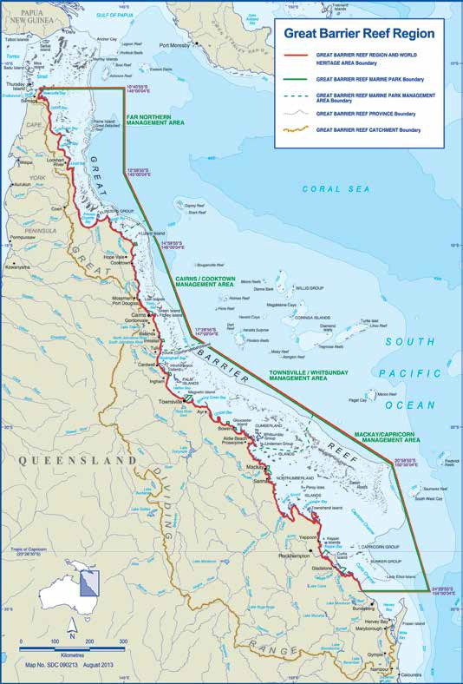
Figure 1: Map of the Great Barrier Reef Region

TABLE OF CONTENTS
INTRODUCTION 1
In this annual report 2
Chairman's review 3
OVERVIEW 9
About the Great Barrier Reef Marine Park Authority 10
Organisational structure 12
Responsible Minister 13
Legislative framework 13
Finances overview 14
Staff overview 15
PERFORMANCE 17
Introduction 18
Objective 1: Protect and restore the Reef’s biodiversity 24
Biodiversity Conservation Strategy
Field management — conservation and compliance 37
Crown-of-thorns starfish management 52
Outlook Report 2014 52
Objective 2: Safeguard the Reef’s heritage values 55
Fulfil heritage obligations 56
Field management — cultural heritage protection 62
Strategic assessment 63
Objective 3: Ensure use of the Region is ecologically sustainable and the socio-economic benefits derived from the Reef are maintained 72
New and existing framework 73
Field management — incident response, facilities, Indigenous engagement 82
Stewardship and partnership programs 85
Education and engagement 104
International Coral Reef Initiative 115
Enabling services 116
MANAGEMENT AND ACCOUNTABILITY 123
Corporate governance 124
Audit committee 128
External scrutiny 134
Management of human resources 135
Assets management 138
Purchasing 139
Grant programs 140
FINANCES 141
Independent auditor’s report 143
Financial statements 146
APPENDICES
Appendix A: Agency resource statement and resources for outcomes 208
Appendix B: Staffing overview 211
Appendix C: Advertising and marketing 212
Appendix D: Freedom of information 213
Appendix E: Ecologically sustainable development and environmental performance 215
Appendix F: Papers and presentations by agency staff 219
Appendix G: Queensland Government financials 222
ACRONYMS AND INDEX 233
Acronyms 234
Glossary 235
Compliance index 236
Alphabetical index 240

LIST OF FIGURES
Figures Page
Figure 1 Map of the Great Barrier Reef Region IV
Figure 2 Great Barrier Reef Marine Park Authority organisational structure (as at 30 June 2014) 12
Figure 3 Income by source 2013-14 14
Figure 4 Expenses by category 2013–14 14
Figure 5 Paths and destructive wind zones of seven severe cyclones that have crossed the 30
Great Barrier Reef in the past decade
Figure 6 Location of sites at which reef health and impact surveys were conducted by field 38
management staff during 2013–14
Figure 7 Marine animal stranding responses in 2013–14 41
Figure 8 Number of possible offences reported to the Field Management Program since the 44
rezoning of the Great Barrier Reef Marine Park in July 2004
Figure 9 Annual number of information reports recorded by the Field Management Program 47
since 2004–05
Figure 10 Type and number of permissions granted during 2013–14 as a proportion of the total
number of permissions managed by the agency 75
Figure 11 Tourist visits to the Great Barrier Reef Marine Park since 2007–08 92
Figure 12 Spatial coverage of all Eye on the Reef surveys during 2013–14 94
Figure 13 Traditional Use of Marine Resources Agreements and Indigenous Land Use 99
Agreements within the Great Barrier Reef Marine Park
Figure 14 The turtle as an example of the hero experience spectrum 107
Figure 15 The agency’s website and social media statistics for 2013–14 110
Figure 16 Great Barrier Reef Marine Park Authority’s strategic planning process 132
Figure 17 Trend in new and ongoing consultancy services since 2010–11 139

LIST OF TABLES
Table 1 Deliverables, key performance indicators and achievement highlights 2013–14 18
Table 2 Reef health and impact surveys undertaken in the Great Barrier Reef World Heritage 37
Area in 2013–14
Table 3 Number of possible Commonwealth offences, by user group and type, reported to the 44
Field Management Program during 2013–14
Table 4 Outcomes of assessments and compliance actions taken in relation to reported 48
offences during 2013–14
Table 5 Fines resulting from court prosecutions for different types of offences during 2013–14 49
Table 6 Number of environmental management charge administrative compliance actions undertaken from July 2013 to June 2014 80
Table 7 Late payment penalty applied to environmental management charge payments due for the July 2013 to March 2014 period 80
Table 8 Distribution of public moorings and reef protection markers 84
Table 9 Number of surveys received through Eye on the Reef program 94
Table 10 Quantitative deliverables — targets and achievements since 2011–12 121
Table 11 Quantitative key performance indicators since 2011–12 122
Table 12 Meetings of the Great Barrier Reef Marine Park Authority 2013–14 127
Table 13 Meetings of the Great Barrier Reef Marine Park Authority Audit Committee 2013–14 128
Table 14a Great Barrier Reef Marine Park Authority resource statement 2013–14 208
Table 14b Expenses and resources for outcome 1 210
Table 15 Employee overview as at 30 June 2014 211
Table 16 Workplace diversity figures as at 30 June 2014 211
Table 17 Media advertising organisations used in 2013–14 212

CHAPTER PHOTOGRAPHS
Introduction Aerial photograph of the Great Barrier Reef in the Whitsundays region 1

Overview A visitor at Taylor Reef sand cay, east of Mission Beach. Photograph © Matt Curnock 2012 9

Performance Great Barrier Reef Marine Park Authority officer Jen Dryden (left) and Marine Park ranger Gemma Haley conduct reef health and impact surveys at Sandbank Number 8 Reef as part of the tropical cyclone Ita impact assessment surveys 17

Management and accountability Queensland Parks and Wildlife Service officer Andrew McDougall monitors seabirds at Unnamed Reef 12-127, out from Lockhart River in the far northern Great Barrier Reef 123

Finances Reef Guardian farmer Paul Gregory on his cane farm at Gordonvale, south of Cairns 141

Appendices Elder Russell Butler holds a spear on Marrajumban (Goold Island), north-east of Cardwell, part of the sea county belonging to his people, the Bandjin Traditional Owners 207

Acronyms and index A school of big eye snapper at Steve’s Bommie near the Ribbon Reefs, south of Lizard Island 233

ANNUAL REPORT

Introduction

2013-14

Introduction

In this annual report
The Great Barrier Reef Marine Park Authority’s Annual Report 2013–14 complies with requirements for annual reports outlined by the Australian Government Department of Prime Minister and Cabinet. It is also consistent with the structure of the Portfolio Budget Statement for the agency

Following the Introduction and Chairman’s review, the annual report comprises six chapters:

- Overview
- Performance
- Management and accountability
- Finances
- Appendices
- Acronyms and index.

The Overview provides a corporate background to the agency including its role and functions. It also provides a summary of financial performance and a staff overview.

The Performance chapter details the actions taken by the agency in 2013–14 to meet its stated outcome of the long-term protection, ecologically sustainable use, understanding and enjoyment of the Great Barrier Reef for all Australians and the international community, through the care and development of the Marine Park.

This chapter is presented in three parts under the agency’s three objectives. It details how the agency has met the deliverables and key performance indicators that relate to the objectives, as outlined in the agency’s Portfolio Budget Statement.

The first part addresses Objective 1: Protect and restore the Reef’s biodiversity.

The second part addresses Objective 2:Safeguard the Reef’s heritage values.

The third part addresses Objective 3: Ensure use of the Region is ecologically sustainable and the socio-economic benefits derived from the Reef are maintained.

The Management and accountability chapter covers the delivery of the management framework that supports effective functioning of the agency. This includes corporate governance, statutory and advisory committees, management and training, work health and safety, asset management, corporate services and management of consultants.

The Finances chapter delivers an analysis of financial performance and a detailed financial statement.

The Appendices chapter comprises the agency resource statement, staffing overview, advertising and marketing, freedom of information, ecologically sustainable development and environmental performance, staff papers and presentations, and Queensland Government financials.

The Acronyms and index comprises a list of acronyms, glossary, compliance index and alphabetical index.

CHAIRMAN’S REVIEW
The Great Barrier Reef has outstanding universal value — its natural beauty, heritage, social and economic values are immense. That’s why Australians and the international community care deeply about the Reef and want to ensure it is protected for future generations.

The Great Barrier Reef Marine Park Authority has been at the forefront of managing this great natural wonder for 40 years and we take our role in protecting the Reef seriously. Our work is recognised as world leading — moving from the early days of mapping the myriad of reefs and shoals to identifying and addressing critical threats to the Reef’s long- term future.

A partnership approach
It is important for current policy makers to understand the history of management of the Reef — which includes a pattern of identifying risks and solutions, then forming the working partnerships to reduce those risks.

Foreseeing a risk that the Reef could be ‘loved to death’ through overuse, the agency established a zoning plan system in the 1970s — similar to town planning but over a Region the size of Victoria and Tasmania combined — in order to protect biodiversity and manage sustainable use. This year marks the tenth anniversary of the current zoning plan that increased areas of high protection from five to 33 per cent of the Marine Park. It remains an international benchmark for marine conservation and protected area management.

In the 1980s there were concerns that the rising number of tourists visiting the Reef might have an adverse influence on its health. We addressed this through permits and site plans, as well as a partnership approach with the tourism industry leading to the high standard eco-certified tourism we have today.

In the 1990s the agency identified sediment and nutrient-laden catchment run-off as a critical issue for Reef water quality. This resulted in collaboration between the agency, the World Wide Fund for Nature and the Australian and Queensland governments in 2003 which created an agreement that led to what is now called the Reef Water Quality Protection Plan, or Reef Plan. In the past year, we continued our strong support of Reef Plan.

Thousands of farmers are now improving their land use practices and in 2011, for the first time, demonstrated that improvements in farm management and repairs to damaged floodplains could reduce pollutant loads in catchment run-off. It’s a sign that what seemed an insurmountable problem can be solved.

Partnerships with Reef industries and communities are vital for the Reef’s future, and key to the agency’s ongoing work.

Future management
Over the past year, our primary focus has been to set a new course for the future management of the Great Barrier Reef. We completed the draft strategic assessment of the Great Barrier Reef Region which, when combined with the Queensland Government’s draft strategic assessment of the adjoining coastal zone, forms the largest and most comprehensive strategic assessment conducted in Australia.

This work addresses concerns raised by the World Heritage Committee about the extent of development along the Queensland coastline.

The draft Great Barrier Reef Region Strategic Assessment Report found the northern third of the region has good water quality and its ecosystems are in good condition. However, areas in the central and southern inshore areas have continued to deteriorate from the cumulative effects of impacts such as climate change, catchment run-off, coastal development and fishing. Our draft program report — which outlines our 25-year management plan for the Reef — proposes actions to strengthen existing management and introduces a raft of new initiatives, such as cumulative impact guidelines and regional standards for ecosystem health.

In November 2013, we released the draft strategic assessment report and program report, for three months of community consultation. This included targeted stakeholder meetings, community forums and an online survey whereby anyone with an interest in the Reef and its future could have a say on what was being proposed. We received more than 6600 submissions, highlighting the considerable interest in Reef protection. This feedback was considered in finalising the reports, which were due to be provided to the Environment Minister in the latter half of 2014. Once endorsed by the Minister, these reports will be publicly released and guide our management for the next 25 years.

Outlook Report
This year we prepared the second Great Barrier Reef Outlook Report. Published every five years, it provides a summary of the Reef’s health, management and likely future. This report will compare and contrast progress since the first Outlook Report, which was released in 2009.

For the first time, the Outlook Report considers heritage values in detail. This is in response to amended Great Barrier Reef Marine Park Regulations which, at the request of the World Heritage Committee, now include heritage values as a matter that needs to be assessed by the Outlook Report.

As part of this process, a scientific consensus workshop was convened to secure independent expert advice about the condition, trends and risks to the Reef’s health. There was also an independent review of management effectiveness. Both were used to inform preparation of the Outlook Report which was presented to the Minister on 30 June 2014.

Field work
Out on the water, the agency has a key role in incident response, maintaining recreation and tourism facilities, and Indigenous engagement. The Field Management Program, established in 1979, is run jointly by the agency and the Queensland Government. This year there were 1289 dedicated compliance vessel patrol days and 34 land-based patrol days. During the reporting period, there were 1057 possible offences from 614 incident reports across the Commonwealth and Queensland jurisdictions of the World Heritage Area. This represents the highest annual number of offences reported since 2004, and is testament to a higher number of patrols targeting fishing in high-risk areas.

We undertook vessel and land-based patrols with Traditional Owners for 143 person days, helping deliver field activities such as the Raine Island recovery project which involves on-ground works such as fencing cliff edges to help protect the world’s largest green turtle nesting rookery. Fifty-eight Indigenous community rangers and 57 Indigenous community members were supported in compliance training, helping expand the network of people looking out for the Reef.

To assist with field management and expand our capabilities, the Field Management Program commissioned the new patrol boat Reef Ranger. This $5 million, 24-metre aluminium catamaran will improve our ability to protect the Reef and its biodiversity. It has a range of up to 2000 nautical miles, a speed of up to 25 knots and can carry 28 people, enabling it to reach remote areas of the Marine Park.

In-water surveys and monitoring are an important aspect of keeping abreast of changes in the marine environment. In 2013– 14, we recorded 4337 reef health and impact surveys in the Eye on the Reef database, including 2259 surveys by field management officers. Many of these surveys were part of our summer response program and post- cyclone impact checks.

Crown-of-thorns starfish
During the past year, there has been a continued focus on an outbreak of coral- eating crown-of-thorns starfish in the northern section of the Marine Park. Native to the Reef, this starfish can boom and bust like plague locusts on land and consume vast areas of living coral. Outbreaks recurring every 15 or so years appear to start north of Cairns. Scientific understanding of the outbreaks is still developing. In the meantime, improving water quality, protecting predators and tactically culling the starfish remain ‘no regrets’ actions to reduce the impact of these outbreaks and protect coral cover.

The agency managed a dedicated control program targeting protection efforts to key tourism sites. The tactical control efforts were delivered by teams of trained divers managed by the Association of Marine Park Tourism Operators, with funding from the Australian and Queensland governments. The program successfully protected coral cover on more than 59 reefs by culling almost 183,000 crown-of-thorns starfish. A new single-shot injection method was fully implemented, replacing the need to inject each starfish multiple times and resulting in an average two-and-a-half fold efficiency gain.

Protecting world heritage values
The Great Barrier Reef Marine Park Authority is responsible for safeguarding the heritage values for which the Reef was placed on the
World Heritage List more than 30 years ago. This inscription recognises the Reef’s great diversity of species and habitats, as well as its rich and diverse cultural heritage.

We have important heritage obligations under the World Heritage Convention and Environment Protection and Biodiversity Conservation Act 1999. This year we established best practice standards for collecting, managing and sharing Indigenous cultural knowledge acquired through the agency’s work. An integral part of this was customising an information sharing and protection toolkit that staff can use to guide their decisions when collecting, acknowledging and using cultural information.

We also began the process of increasing protection of two World War Two Catalina aircraft wrecks and documented six shipwrecks in the northern part of the park. Heritage conservation works were carried out at the Lady Elliot Island Lightstation, and we registered the Dent Island Lightstation Heritage Management Plan as a legislative instrument — the first plan to be jointly produced by the agency and the Australian Maritime Safety Authority

There continues to be a strong focus on protecting biodiversity and implementing the Great Barrier Reef Biodiversity Conservation Strategy 2013, which provides a framework to protect at-risk plants, animals and habitats. This year we completed vulnerability assessments for dugongs, marine turtles, snapper and whales. These assessments are key to understanding the status and pressures on these species and are used to inform management decisions.

Recognising the impact of land practices on water quality, we implemented systems to better integrate the Paddock to Reef program’s catchment and marine monitoring components. We also began developing maps to identify priority catchment areas for maintenance, restoration or enhancement.

Permits and ports
This year we managed a total of 1373 permits for a range of uses in the Marine Park, from lower-risk commercial tourism operations to complex activities such as the construction and operation of marine facilities. There is a rigorous process in place when considering applications and this involves looking at potential impacts on the Reef’s environmental, social, cultural and heritage values. When permits for complex or large- scale projects are approved, they are subject to strict conditions and approved only if they can be shown to avoid long-term harm to the Reef.

In January 2014 we gave conditional approval to North Queensland Bulk Ports to dispose of dredge material, associated with the Abbot Point coal terminal expansion, within the Marine Park. The permits were subject to 47 strict conditions, including our approval of a dredge and spoil disposal management plan, which was to comprise a tourism, fishing and social impact program. The Authority had not received this plan from the proponent as at 30 June 2014.

The basis for our decision was outlined in a statement of reasons published on our website. The decision is in line with our long- held strategic view that port development along the Great Barrier Reef coastline should be limited to existing major ports, and that ports should achieve high environmental standards.

While we have always advocated strongly for land-based disposal of dredge material where it can be done safely, the permit application from North Queensland Bulk Ports was for ocean disposal — and we were legally required to assess the permit before us.

I recognise our decision generated considerable community debate; however, I firmly believe the application of strict conditions will allow the Abbot Point project to be managed in a way that protects the Great Barrier Reef.

Port operations have been part of the Great Barrier Reef for more than 100 years and will be ongoing. I expect that, in the near future, new technologies for land-based options will lead to reductions in the disposal of dredge material at sea. The design and adoption of shallower draught vessels will further reduce the need for dredging deeper channels.

To put the issue of port operations into perspective, the 2013 Scientific Consensus Statement showed broadscale agricultural run-off — including sediments, nutrients and pesticides — is the major cause of poor water quality in the marine environment. While the effects of port activities are significant, they are relatively more localised than the broadscale impacts from land-based run-off. The expansion of towns along the coast is another source of disturbance. Nevertheless, disturbances of water quality from all risks should be managed downwards and ports will be no exception.

Scientific knowledge of the Reef is continually improving and work commenced this year to help inform future port development permit decisions — an issue of high public concern. We issued new standards for oceanographic modelling of the distribution of sediments in port operations and finalised the improved dredge material management project and ship anchorage management project, all of which contributed to the strategic assessment of the Great Barrier Reef Region and our 25-year management plan.

We also began work with the Australian Institute of Marine Science and an expert panel to compile existing scientific knowledge of how dredging activities affect the Great Barrier Reef ecosystem and to identify what further research is needed to assess those impacts. This dredge synthesis statement will be finalised later this year.

Stewardship
Our highly successful Reef Guardians program, which sees a range of sectors involved in local environmental activities to protect the Reef, expanded to now include 308 schools, 15 councils, 25 farmers and graziers, and 12 fishers across a range of fisheries. Through Reef Guardian Schools alone, we engage with more than 126,000 students across the Great Barrier Reef catchment — making it a powerful tool for encouraging young people to adopt positive practices that benefit the Reef.

This year we boosted membership of our High Standard Tourism program from 59 to 62 operators — with 64 per cent of visitors to the Reef now travelling with these eco- certified operators.

We also strengthened participation in our Eye on the Reef program, with about 135 tourism staff monitoring reef sites and submitting sightings of marine species.

Positive work continued with Great Barrier Reef Traditional Owners, with the accreditation of the Yirrganydji Traditional Use of Marine Resources Agreement — the first agreement for sea country management in the Cairns to Port Douglas area .
Another milestone in sea country management was the accreditation of the Woppaburra people’s third Traditional Use of Marine Resources Agreement — it will run for 10 years, making it the longest such agreement to be accredited by the Australian and Queensland governments. Although recognised in last year’s report, the Yuku-Baja-Muliku and Lama Lama agreements formally came into effect during the reporting period.

There are now seven Traditional Use of Marine Resources Agreements and one Indigenous Land Use Agreement in operation along the Great Barrier Reef coast, covering a total of 45,207 square kilometres of sea country and involving 16 Traditional Owner groups. This positive outcome is testament to the valuable work of our Indigenous Partnerships group and the ongoing commitment of Great Barrier Reef Traditional Owners to the management of their sea country. I value the work of our partners and am delighted to see these successful working relationships manifest into effective management of the Great Barrier Reef Marine Park.

Education and engagement
Reef HQ Aquarium — our national education centre for the Great Barrier Reef — is the cornerstone of our broad public education programs. Reef HQ attracted more than 137,000 visitors during the reporting year. Of those, more than 70 per cent were involved in educational talks and tours. More than 27,000 people toured our turtle hospital, helping improve understanding of the issues surrounding threatened turtle species. Cutting-edge videoconferencing technology helped us reach more than 4500 people around the world, raising awareness about the Reef and our work.

Technology was also central to our communications effort this year. Our website received almost 500,000 visits over the past 12 months, almost double the previous year. Our Facebook page, which was created in 2011 to reach an online community of people who care about the Reef, reached a milestone of 20,000 followers.

We are internationally recognised for our work and are committed to mentoring the next generation of Reef custodians. We provided financial support to 19 postgraduate students through the 2014 Science for Management Awards and implemented a program of small grants to community groups engaged in coral reef and related ecosystem conservation and management.

This year we continued to collaborate with Reef-based scientists, particularly those funded through the National Environmental Research Program. We wrapped up our role in co-hosting the International Coral Reef Initiative for 2012–14, in partnership with the government of Belize, however our staff continue to be sought after internationally as a source of information on reef management.

Our organization
This year saw some significant changes within the agency’s staffing and structure. We implemented the Australian Government’s interim public service recruitment arrangements. We also commenced a voluntary redundancy program which was taken up by 17 staff members. I acknowledge the valuable contributions of these employees, some of whom have spent decades working towards the long-term protection of the Great Barrier Reef.

We also implemented an agency restructure, to better align our people resources with our work program for the years ahead. At the end of the financial year, we had 214 employees, which is a slight decrease from 222 employees the previous year.

The agency’s 2013–14 financial report shows that, at 30 June 2014, the agency had a small operating deficit after depreciation.

Looking ahead
This report provides a timely opportunity to take stock of the past year, the key projects, achievements and challenges. In doing so, I recognise and thank everyone who has contributed to Reef management — the Authority’s board members, the agency’s professional and dedicated staff, and all of the partners, stakeholders and government colleagues who care about the Great Barrier Reef and its future.

The coming year represents an exciting time for this agency as we begin implementing our 25-year plan for managing the Great Barrier Reef. Our program report — which is aligned to the most comprehensive strategic assessment ever undertaken of the Great Barrier Reef World Heritage Area — clearly outlines how the Reef will be managed for the years ahead.

We will be focused on clear outcomes and driven by specific measurable targets, cumulative impact guidelines, a Reef recovery program to restore areas of high environmental value, and a Reef-wide integrated monitoring and reporting program. We’ll also adopt a net benefit policy to guide decision-making on the actions required to deliver an overall improvement to ecosystem health and the condition of the Reef’s values.

Importantly, this work will feed into the Australian Government’s Reef 2050 Long- term Sustainability Plan — an overarching framework for Reef management to improve the Reef’s resilience.

For the past 40 years, our agency has been steadfast in its commitment to the long-term protection of the Great Barrier Reef. We will continue to do everything within our power to improve the health of this precious place for current and future generations.
Dr Russell Reichelt
Chairman

ANNUAL REPORT

Overview

2013-14

Overview

The Great Barrier Reef Marine Park Authority

The Great Barrier Reef Marine Park Authority is an Australian Government statutory authority within the Environment portfolio

The Great Barrier Reef Marine Park Authority is responsible for managing one of the world’s premier natural resources, the Great Barrier Reef Marine Park. The agency implements a range of policies and programs, management strategies and legislative measures to work towards the following outcome:

The long-term protection, ecologically sustainable use, understanding and enjoyment of the Great Barrier Reef for all Australians and the international community, through the care and development of the Marine Park.

Delivery of this outcome is through three objectives set out in the agency’s strategic and corporate plans:

- Protect and restore the Reef’s biodiversity

- Safeguard the Reef’s heritage values

- Ensure use of the Region is ecologically sustainable and the socio-economic benefits derived from the Reef are maintained.

The Great Barrier Reef Outlook Report 2014 provides a comprehensive assessment of what is known about the Great Barrier Reef ecosystem, its use, its management and the pressures it is facing, and will help underpin future management decisions. It has been informed by the strategic assessment which found that, while the outstanding universal- value of the Great Barrier Reef World Heritage Area remains largely intact, additional management intervention is needed to halt further declines in the health of the ecosystem.

The agency is focused on improving the resilience of the Great Barrier Reef by addressing declining water quality from catchment run-off, the degradation of coastal habitats, and the remaining impacts from fishing, illegal fishing and poaching. The agency also works to minimise the impacts of shipping and coastal developments. This work will enable the Reef to better withstand the impacts of major threats, particularly climate change and extreme weather events.
The agency engages with communities and industries to raise awareness of climate change risks, vulnerability and resilience, and encourage local stewardship actions that can help the Great Barrier Reef ecosystem cope with climate change. The agency also employs a range of programs and partnerships aimed at protecting species and habitats from unsustainable uses and land- based sources of pollution.

The agency actively promotes the sustainable use of the Marine Park, including the use of the adjacent coast and catchments which affect it. Many commercial and non- commercial uses of the Great Barrier Reef Region depend on the biodiversity and health of this ecosystem. The agency aims to ensure these activities occurring within the Marine Park continue to operate on an ecologically sustainable basis.

To effectively manage the Great Barrier Reef, the agency works with a wide range of government agencies, Reef users, industries, Traditional Owners and other community representatives with an interest in the Reef and its outlook. These working partnerships are vital given the challenges facing the Reef.

The relationship between the agency, the Queensland Government and a range of other government agencies is critical for effective management of the Great Barrier Reef. In particular, the Field Management Program, a jointly funded cooperative partnership between the Australian and Queensland governments, coordinates the day-to-day activities and field operations required to manage the Great Barrier Reef Marine Park, the associated Queensland Great Barrier Reef Coast Marine Park and the World Heritage Area.

The agency acknowledges and respects the native title rights and cultural responsibilities of the Traditional Owners of the Great Barrier Reef Region. Traditional Owners have a long association with the region. There are more than 70 Traditional Owner groups whose sea country lies within the Great Barrier Reef Region. The agency partners with these groups to help maintain their cultural rights and interests and, through collaboration, to achieve the most effective management of the Marine Park.

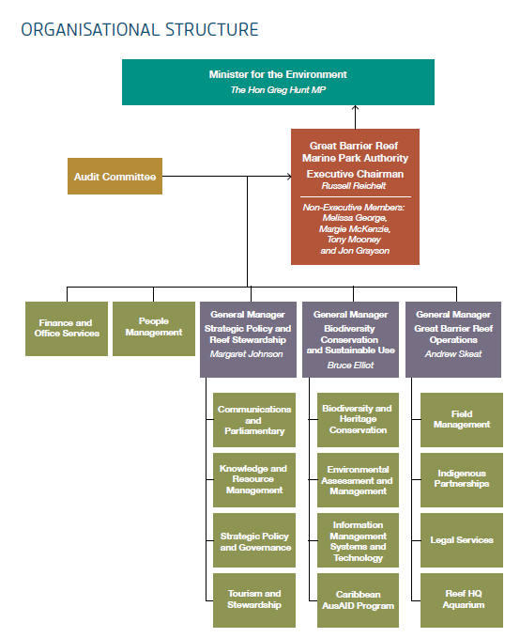

Figure 2: Great Barrier Reef Marine Park Authority organisational structure as at 30 June 2014
The Great Barrier Reef Marine Park Authority manages the Great Barrier Reef Marine Park in accordance with the Great Barrier Reef Marine Park Act (1975).
As the agency head, the Executive Chairman also has responsibilities under the Financial Management and Accountability Act 1997 and the Public Service Act 1999. The audit committee reports directly to the Executive Chairman.

Responsible Minister
As Minister for the Environment, the Hon Greg Hunt MP, was responsible for the Great Barrier Reef Marine Park Authority as at 30 June 2014.

No Ministerial directions were issued to the agency in 2013–14.

Legislative framework
The agency is established by the Great Barrier Reef Marine Park Act 1975 (the Act) as an Australian Government statutory authority. The objects of the Act are set out in section 2A, and the specific functions of the Great Barrier Reef Marine Park Authority are defined in sections 7 and 7A.

The Great Barrier Reef Marine Park consists of areas declared by the Great Barrier Reef (Declaration of Amalgamated Marine Park Area) Proclamation 2004 made under the Great Barrier Reef Marine Park Act.

Other Acts administered by the agency are:
- Great Barrier Reef Marine Park (Environmental Management Charge- Excise) Act 1993
- Great Barrier Reef Marine Park (Environmental Management Charge- General) Act 1993.

Regulations in force under the Act are:
- Great Barrier Reef Marine Park Regulations 1983
- Great Barrier Reef Marine Park (Aquaculture) Regulations 2000.

The agency also administers the Great Barrier Reef Marine Park Zoning Plan 2003 and the following plans of management:
- Cairns Area Plan of Management 1998
- Hinchinbrook Plan of Management 2004
- Shoalwater Bay (Dugong) Plan of Management 1997
- Whitsundays Plan of Management 1998.

The Authority’s statutory board has four part-time members and a full-time chair who is also the agency head for the purposes of the Public Service Act 2009 and the Chief Executive for the purposes of the Financial Management and Accountability Act 1997.

Amendments to legislation during 2013–14
On 26 November 2013 the Great Barrier Reef Marine Park Regulations 1983 were amended to clarify and expand upon the prohibition on misuse of public moorings under regulation 102. The amendments:
- clarify the types of moorings that regulation 102 applies to (public moorings rather than Authority moorings)
- clarify the types of acts and omissions that constitute misuse
- expand the application of the regulation to other types of public infrastructure
- reduce the infringement notice penalty applicable under regulation 102 from five penalty units to three penalty units to bring the offence in line with other similar types of offences.

On 18 December 2013 the Great Barrier Reef Marine Park Regulations 1983 were amended to prescribe that an assessment of heritage values must be contained in the Great Barrier Reef Marine Park Outlook Report. In the same amendment package, the agency took the opportunity to rectify typographical errors and other minor issues in the Great Barrier Reef Marine Park Regulations 1983.

Amendments were introduced into parliament in November 2013 to sections 38BA, 38BB, 38GA and 38GB of the Great Barrier Reef Marine Park Act 1975 to triple penalties for the taking of, or injury to, dugongs or turtles. These amendments have not yet passed the Senate.

New legislative instruments during 2013–14
On 29 January 2014, the Dent Island Lightstation Heritage Management Plan took effect. The Plan was made jointly by the Great Barrier Reef Marine Park Authority and the Australian Maritime Safety Authority to satisfy statutory obligations which both agencies have under the Environment Protection and Biodiversity Conservation Act 1999.

It provides for the future management of the Dent Island Lightstation, with the objective of identifying, protecting, conserving, presenting and transmitting the Commonwealth heritage values of the area

Finances overview
Details of the Great Barrier Reef Marine Park Authority’s financial operations are provided in the Finances chapter. An overview of the agency’s financial operations follows and a summary of financial and staffing resources is in Figure 3, Figure 4 and Appendix A.

Total operating revenue for 2013-14 was $52 467 million. Apportion for 2013-14 of $28 412 million was $0.473 million more than the 2012–13 appropriation, with supplementary funding being received for voluntary redundancies.

Own source income includes support for the continuation of the agency’s work and measures to improve the outlook for the Great Barrier Reef being funded from the National Landcare Programme. This is included in funding from related entities. Related entities are bodies which either form part of the Australian Government or are controlled by the Australian Government. In Figure 3, related entity refers primarily to funds received from the Department of Environment.

Own source income for 2013–14 was $24.055 million, $2.124 million less than in 2012–13. Significant funding was received for ‘Ensuring the resilience of the Reef’, for a targeted crown-of-thorns starfish control program, for the marine monitoring program and Indigenous Sea Country Partnerships as part of the Australian Government’s National Landcare Programme.

The Australian and Queensland governments provided matching funding for field management of the Marine Park, which was implemented in partnership with the Queensland Department of National Parks, Recreation, Sport and Racing and other agencies.

The operating expense of managing the Marine Park in 2013–14 was $54.517 million.

Employee expenses were higher than in 2012–13 with additional costs incurred to implement a number of voluntary redundancies late in the financial year. This measure is designed to reduce the agency’s employee expenses and ensure financial sustainability. Expenses for suppliers were $0.868 million less than 2012–13 with a reduction in travel and charter costs.

Expenses by category is outlined in Figure 4, page 14.

The agency had an operating deficit of $1.996 million in 2013–14 including the unfunded depreciation expense
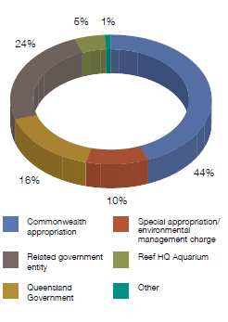
Figure 3: Income by source 2013–14
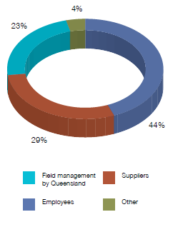

Figure 4: Expenses by category 2013–14

Staff overview
The Executive Management Group consists of the Chairman and three Senior Executive Service (SES) Band 1 General Managers:

- Strategic Policy and Reef Stewardship
- Biodiversity Conservation and Sustainable Use
- Great Barrier Reef Operations.

The number of employees in the agency was 214 for 2013–14, which is a decrease from 222 in 2012–13. The total number of employees in 2011–12 was 211. (See Appendix B for an overview of staffing, employee numbers, composition and location at 30 June 2014).

The staff figure for 2013–14 includes fixed-term, non-ongoing positions.

The agency also employs casual staff to work in the Reef HQ Aquarium which operates seven days a week. In addition, about 155 volunteers assist in the day-to-day operation of the aquarium.

ANNUAL REPORT

Performance

2013–14

Agency performance
In 2013–14 the agency delivered a range of programs and initiatives to manage the Great Barrier Reef and protect it from potential threats. Its three main objectives were to:

- protect and restore the Reef’s biodiversity

- safeguard the Reef’s heritage values

- ensure use of the Region is ecologically sustainable and the socio-economic benefits derived from the Reef are maintained.

The agency’s performance report is based on the agency’s Portfolio Budget Statement 2013–14, which details the deliverables and key performance indicators for the year.

These provide a framework for the agency to measure progress in meeting its three objectives.

Table 1: Deliverables, key performance indicators and achievement highlights 2013–14

OBJECTIVE 1: Protect and restore the Reef’s biodiversity
BIODIVERSITY CONSERVATION STRATEGY

Deliverable Implement the Great Barrier Reef Biodiversity Conservation Strategy 2013
Key Performance Indicators:
- Improved protection for Great Barrier Reef habitats and species
- Standards set in the Reef Water Quality Guidelines are met
- Restored health of coastal ecosystems

Achievement highlights
- Conducted 1954 reef health and impact surveys across 140 reefs as part of the summer response program, which are stored in the agency’s Eye on the Reef data management and reporting system
- Implemented recommendations from a review of Reef Plan and the Paddock to Reef program such as creating and linking marine monitoring sites to investigate pollutant transport of individual river reaches
- Commenced development of ‘blue maps’ to identify catchment areas that are most connected to Reef ecosystems by fresh and marine water — they indicate priority areas for maintenance, restoration or enhancement
- Began developing an ‘ecological calculator’ in partnership with natural resource management bodies and the Queensland Wetlands Program to calculate the benefits better land management practices can have on ecological functions provided by coastal ecosystems

OBJECTIVE 1: Protect and restore the Reef’s biodiversity
FIELD MANAGEMENT — CONSERVATION AND COMPLIANCE

Deliverable Implement the marine and island conservation and the compliance program components of the 2013-14 annual business plan for filed management
Achievement highlights
- Commissioned the new patrol boat, Reef Ranger, which will improve the Field Management Program’s ability to protect the Reef and its biodiversity
- Continued working with Queensland Government on adaptation work at Raine Island, including specific on-ground actions to modify and enhance turtle nesting habitat
- Recorded 4337 reef health and impact surveys in the Eye on the Reef database, including 2259 surveys by field management officers
- Implemented priority pest management projects on island protected areas, resulting in a 60 per cent reduction in the predation of flatback turtle eggs at the Curtis Island environmental management precinct
- Monitored seabird rookeries at 38 key sites, including the trial of remote monitoring cameras and acoustic recorders for improved population assessments

CROWN-OF-THORNS STARFISH OUTBREAK

Deliverable Respond to the emerging crown-of-thorns starfish outbreak

Achievement highlights

- Managed successful control program by the Association of Marine Park Tourism Operators which protected coral cover on more than 59 reefs by culling 182,800 crown-of-thorns starfish
- Fully implemented new single-shot injection method, resulting in an average two-and-a-half fold efficiency gain

OUTLOOK REPORT

Deliverable Finalise the Great Barrier Reef Outlook Report 2014

Achievement highlights

- Presented second five-yearly Outlook Report for the Great Barrier Reef Region to the Environment Minister
- Convened scientific consensus workshop to secure an independent set of expert judgements about condition, trends and risks in the Great Barrier Reef Region. This was used to inform preparation of the Outlook Report
- Conducted independent review of management effectiveness for the Great Barrier Reef Region, which was used to inform preparation of the Outlook Report

OBJECTIVE 2: Safeguard the Reef’s heritage values
FULFIL HERITAGE OBLIGATIONS

Deliverable Fulfil heritage obligations under the World Heritage Conservation and Environmental Protection and Biodiversity Conservation Act 1999

Key performance indicator Enhanced identification, understanding, recognition, protection and conservation of the Great Barrier Reef’s outstanding universal value, and of Aboriginal and Torres Strait Islander’s and historic heritage
Achievement highlights

- Established a best practice standard of collecting, managing and sharing Indigenous cultural knowledge that is acquired through agency’s work
- Amended the Great Barrier Reef Marine Park Regulations to include heritage values as part of the considerations required by the Outlook Report
- Participated in a maritime heritage expedition to the far northern Great Barrier Reef which surveyed and documented six wreck sites on Great Detached Reef

FIELD MANAGEMENT — CULTURAL HERITAGE PROTECTION

Deliverable Implement the cultural heritage protection components of the 2013-14 annual business plan for field management

Achievement highlights

- Completed upgrade to the culturally significant Magnetic Island forts precinct
- Carried out heritage conservation works to the Lady Elliot Island Lightstation, including full restoration of the lantern room to weatherproof the lighthouse
- Registered the Dent Island Lightstation Heritage Management Plan as a legislative instrument — the first plan to be made jointly by the agency and the Australian Maritime Safety Authority

STRATEGIC ASSESSMENT

Deliverable Finalise the Great Barrier Reef Region strategic assessment

Achievement highlights
- Completed a draft strategic assessment of the Great Barrier Reef Region
- Coordinated the launch of the draft comprehensive strategic assessment of the Great Barrier Reef World Heritage Area for public consultation
- Worked with the Queensland Government on an extensive community consultation program for the draft strategic assessment
- Received and analysed more than 6600 submissions on the comprehensive strategic assessment, which were considered in finalising the reports

OBJECTIVE 3: Ensure use of the Region is ecologically sustainable and the socio- economic benefits derived from the Reef are maintained

NEW AND EXISTING FRAMEWORK

Deliverable Develop new and implement the existing policy, planning and regulatory framework

Key performance indicator Use of the Great Barrier Reef is ecologically sustainable

Achievement highlights
- Managed a total of 1347 permits covering a range of uses, from commercial tourism operations that provide scuba diving to complex projects such as dredge disposal
- Finalised improved dredge material management project and ship anchorage management project
- Provided advice on 28 major development projects in or adjacent to the Great Barrier Reef World Heritage Area
- Worked with Australian Institute of Marine Science and expert panellists on development of a dredge synthesis statement
- Reviewed the marine tourism contingency plan

FIELD MANAGEMENT — INCIDENT RESPONSE, FACILITIES, INDIGENOUS ENGAGEMENT

Deliverable Implement the incident response management, recreation and tourism facilities and Indigenous engagement components of the 2013–14 annual business plan for field management

Achievement highlights
- Participated in multi-agency incident response to the detection of the pest species, Asian green mussel, at Mackay shipyards
- Completed restoration works to campgrounds and walking tracks on Lizard Island following cyclone Ita
- Maintained and operated 124 public moorings and 137 reef protection markers across the Marine Park
- Partnered with Traditional Owners in field management vessel patrols for 143 person days, helping deliver field activities such as the Raine Island recovery project
- Supported compliance training for Traditional Owners and Indigenous communities

OBJECTIVE 3: Ensure use of the Region is ecologically sustainable and the socio- economic benefits derived from the Reef are maintained

STEWARDSHIP AND PARTNERSHIP

Deliverable Expand stewardship and partnership programs

Key performance indicator Increased support for, and the uptake of, best practices approach

Achievement highlights

- Expanded Reef Guardian program to include 308 schools, 15 councils, 25 farmers and graziers, and 12 fishers across a range of fisheries
- Boosted membership of High Standard Tourism program from 59 operators to 62, meaning 64 per cent of visitors to the Reef now travel with these eco-certified operators
- Strengthened participation in Eye on the Reef program, with about 135 tourism staff monitoring reef sites and submitting sightings
- Accredited the Yirrganydji Traditional Use of Marine Resources
- Agreement — the first for the Cairns to Port Douglas area
- Delivered compliance training to 58 Indigenous community rangers and 57 Indigenous community members
- Administered an Australian Awards Fellowship program on reef stewardship, in partnership with the government of Mexico

EDUCATION AND ENGAGEMENT

Deliverable Implement education and engagement programs

Key performance indicator Improved community understanding and consideration of the benefits the Great Barrier Reef provides

Achievement highlights

- Delivered educational talks and tours to almost 98,000 Reef HQ Aquarium visitors
- Provided Reef HQ Aquarium turtle hospital tours to more than 27,000 people, helping to raise their awareness of the issues surrounding threatened turtle species
- Delivered Reef education to more than 4500 people around the world through cutting-edge videoconferencing technology
- Achieved the milestone of more than 20,000 followers on agency’s Facebook page
- Collaborated with Reef-based scientists, particularly those funded through the National Environmental Research Program
- Provided financial support to 19 postgraduate students through the 2014 Science for Management Awards

OBJECTIVE 3: Ensure use of the Region is ecologically sustainable and the socio- economic benefits derived from the Reef are maintained

INTERNATIONAL CORAL REEF INITIATIVE

Deliverable Co-host the International Coral Reef Initiative in 2012 and 2013

Achievement highlights

- Completed co-hosting the International Coral Reef Initiative for 2012–14, in partnership with the Government of Belize
- Jointly coordinated the second meeting of International Coral Reef Initiative members, held in Belize City in October 2013
- Held events at major international summits
- Implemented a program of small grants to community groups engaged in coral reef and related ecosystem conservation and management

ENABLING SERVICES

Deliverable Deliver enabling services to support high performance and productivity across the agency

Key performance indicator Integrated, efficient and effective business systems and management processes

Achievement highlights

- Prepared Accountable Authority Instructions for the implementation of the Public Governance, Performance and Accountability Act 2013
- Implemented the 2014 agency restructure and Australian Public Service-wide interim recruitment arrangements
- Reviewed generations and use of scientific information for management of the Marine Park, which informed development of the Science Strategy and Information Needs 2014-2019
- Processed 14 requests for information under the Freedom of Information Act
- Reduced calls for information technology helpdesk assistance by 48 per cent through the implementation of a new standard operating system and a desktop hardware refresh

Objective 1

Protect and restore the Reef’s biodiversity
The World Heritage status of the Great Barrier Reef recognises its great diversity of species and habitats. This outstanding biodiversity and the interconnectedness of species and habitats make the Reef and surrounding areas one of the most complex natural systems on Earth.

In recognition of the importance of maintaining a healthy and diverse Reef ecosystem, the agency has this year changed its first objective to ‘protect and restore the Reef’s biodiversity’.

In 2013–14, the agency dedicated substantial effort and resources towards this goal. Key work in this area included implementing the Great Barrier Reef Biodiversity Conservation Strategy 2013, which provides a framework for biodiversity protection, conservation and management within the Reef.

Another key focus was responding to the outbreak of the crown-of-thorns starfish — one of the most significant contributors to the long-term decline in average hard coral cover over areas of the Reef.

The agency also worked towards the protection of biodiversity through implementing the marine and island conservation components of the joint Field Management Program, and through its wide-ranging compliance activities.

Deliverables

Biodiversity Conservation Strategy p. 25

Field management — conservation and compliance p. 37

Crown-of-thorns starfish management p. 52

Outlook Report 2014 p. 52

Case studies

Cyclone Ita p. 30

Repairing coastal ecosystems p. 36

Smart seabird monitoring p. 40

Reef Ranger p. 42

Crown-of-thorns starfish p. 50

BIODIVERSITY CONSERVATION STRATEGY
The Great Barrier Reef is internationally recognised for its outstanding biodiversity, a key aspect of its World Heritage status.

The Great Barrier Reef Marine Park Authority published the Great Barrier Reef Biodiversity Conservation Strategy 2013 to provide a framework to protect at-risk plants, animals and habitats of the Great Barrier Reef. A strong focus of the strategy was to improve inshore biodiversity where species and habitats are under the greatest pressure from a range of threats, including coastal developments.

Vulnerability assessments
The Great Barrier Reef Biodiversity Conservation Strategy 2013 is supported by vulnerability assessments that give an overview of the habitats and species at risk, their health and status. It also identifies the key pressures that are acting on these elements of biodiversity so that resources can be directed to mitigating the impacts of those pressures.

Twenty-one at-risk habitats, species and groups of species were identified as requiring vulnerability assessments. Twelve of these vulnerability assessments were published in early 2013 and a further four were completed in early 2014 and are due to be published on the agency’s website later this year. These latest vulnerability assessments are for dugongs, marine turtles, snapper and humpback whales.

The Biodiversity Conservation Strategy and much of the information contained in the vulnerability assessments informed the drafting of the Great Barrier Reef Region strategic assessment and associated case studies, and the draft program report.

Key performance indicator
Improved protection for Great Barrier Reef habitats and species.

The Great Barrier Reef Biodiversity Conservation Strategy 2013 provides a framework for the improved protection of Great Barrier Reef habitats and species.

During the reporting period, the strategy and the associated vulnerability assessments were regularly used by agency staff to focus attention on high- priority habitats and species, and to target those habitats and species for the allocation of resources.

The Biodiversity Conservation Strategy was also used to increase science focus, and to engage with Traditional Owners, Reef-based industries, researchers and the community.

A range of stakeholders such as scientists have also used the documents as key information sources leading to targeted research on the high-priority habitats and species identified.

The strategy and assessments were used as key source documents to inform the development of the agency’s strategic assessment of the Great Barrier Reef Region, and the recommendations in the associated program report regarding improved protection for high-priority habitats and species.

The key documents were also used to identify priority habitats and species on which to focus attention and resources in the Australian Government’s Great Barrier Reef Long-term Sustainability Plan.

Species monitoring by Traditional Owners
In developing the vulnerability assessments, the agency worked with Traditional Owners to incorporate traditional knowledge into the understanding of species. Those groups who identified inshore biodiversity monitoring as a priority within their Traditional Use of Marine Resources Agreement implementation plans have been supported to develop networks throughout the scientific community.

The agency has supported Traditional Owners to conduct monitoring activities, meet with research teams in various locations along the coast and develop research partnerships based on species of interest.

Climate change action plan
Climate change and ocean acidification are recognised as two of the greatest threats to the long-term health of the Great Barrier Reef, with predicted effects including severe weather events, rising sea temperature, rising sea levels, and changes in biological processes. The agency is now implementing its second climate change action plan, the Great Barrier Reef Climate Change Adaptation Strategy and Action Plan 2012–2017, which outlines how it will work to improve the resilience of the Reef so it is better able to cope with stress and reduce the impacts of climate change.

Research program
Significant progress was made under the joint agency and CSIRO Great Barrier Reef Climate Adaptation Research program during the 2013–14 financial year. The intention of the collaboration is to combine the two organisations’ expertise to address critical knowledge gaps in how Reef users and ecosystems within the Great Barrier Reef can best adapt to climate change. The collaboration has developed draft climate adaptation pathway case studies, new tools that assess connectivity processes underlying crown-of-thorns starfish outbreaks and coral recruitment, and fisheries adaptation initiatives. The main adaptation pathway case study is focused upon ensuring the long-term sustainability of Raine Island, the world’s largest green turtle nesting rookery. Reef connectivity maps developed under the program are currently being used to better direct crown-of-thorns starfish management efforts, and a situation analysis of fisheries in Queensland to support their long-term future under a changing climate is underway.

Partnerships with industries
During the reporting period, the agency maintained its partnership approach to the climate change challenge through work with Reef industries such as commercial fishing and tourism. This included:

- continuing the agency’s partnership with the Queensland Seafood Industry Association to progress work around Reef resilience, stewardship and climate change issues, including support for industry liaison to disseminate key climate change messages

- providing training in the Eye on the Reef — Tourism Weekly Monitoring and Reef Health and Impact Survey programs to marine tourism crew and Queensland Parks and Wildlife Service staff throughout the Marine Park

- working with CSIRO and other partners on climate change adaptation research partnerships.

Summer response program
Summer can be a period of increased risk to the Reef from temperature-related coral bleaching and extreme weather events such as cyclones and flooding. Stressful conditions can lead to coral disease outbreaks, while nutrient-rich floodwaters can lead to an increase in coral-eating crown-of-thorns starfish.

The agency prepared for these risks by holding a pre-summer workshop with relevant experts, Marine Park rangers, Great Barrier Reef Marine Park Authority staff and a selection of tourism operators. The November 2013 workshop focused on reef health and impact survey techniques and reporting, helping the agency to monitor the health of the Reef over summer. The workshop evaluated the risk of impacts occurring in the coming summer in light of their potential to compound the effects of the ongoing crown- of-thorns starfish outbreak.

The review of the survey data from the previous year clearly showed the extent and severity of the impact of the crown-of-thorns starfish outbreak.

Regular updates on current conditions were provided on the agency’s website throughout the reporting period.

The summer summary was also published on the agency’s website. According to the Bureau of Meteorology, the Great Barrier Reef Region experienced neutral El Niño-Southern Oscillation conditions over summer 2013–14. On the scale of the whole Great Barrier Reef, these neutral conditions meant that there was an average number of cyclones, but relatively fewer impacts from coral bleaching and flood plumes than in recent years.

Reef health and impact surveys
The agency, Queensland Parks and Wildlife Service, and Eye on the Reef monitoring network partners conduct reef health and impact surveys throughout the year to gain a better understanding of what’s happening in the Marine Park. The surveys conducted during the hotter months are particularly important because most impacts occur during summer, and this data can alert the agency to specific impacts that require a management response.

As part of the summer response program, the partner organisations conducted 1954 reef health and impact surveys across 140 reefs on the Great Barrier Reef between 1 December 2013 and 30 April 2014. The results of these surveys are stored in the agency’s Eye on the Reef data management and reporting system, providing program managers with up-to-date information on reef health status and trends.

Most of the surveys (87.5 per cent) conducted during this five-month window were in the Cairns–Cooktown sector of the Marine Park due to the focus on field response efforts following tropical cyclone Ita and the ongoing crown-of-thorns starfish outbreaks. Of all the surveys throughout the Marine Park, 27 per cent recorded healthy coral reefs with no impacts, 33 per cent recorded the presence of one type of impact per survey and another 40 per cent recorded a combination of impact types.

The impacts surveyed included predation (993 surveys), coral bleaching (356), coral damage (1025) and coral disease (200). The survey results provided a valuable assessment of the extent and severity of crown-of-thorns starfish outbreaks and cyclone damage in the Cairns–Cooktown region, helping to guide and measure the effectiveness of the crown-of-thorns starfish control program. (Reef health and impact surveys are also reported on pages 37 and 94.)

Cyclone recovery checks

Cyclone Yasi
In August 2013, the agency collaborated with the Queensland Parks and Wildlife Service to survey reefs in the Townsville to Cairns areas to assess the level of recovery following cyclone Yasi. The surveys revealed that damage from cyclone Yasi — which crossed the North Queensland coast on 3 February 2011 — was still very evident and low-level coral bleaching and disease was observed.

However, corals were beginning to recover, with juvenile corals and regrowth of surviving coral colonies observed on many reefs. Crown-of-thorns starfish were observed affecting one recovering reef offshore from Lucinda, near Ingham. The crown-of-thorns starfish control program visited the area in early 2014 in an effort to support reef recovery.

Cyclones Dylan and Edna
Tropical cyclone Dylan formed as a low- pressure system in the Coral Sea on 24 January 2014 and moved into the Great Barrier Reef Marine Park where it intensified into a Category 2 cyclone on 30 January. It made landfall between Proserpine and Bowen early on 31 January. Shortly after Dylan crossed the Queensland coastline, a second low-pressure system approximately 400 kilometres north-east of Mackay intensified into tropical cyclone Edna (Category 1) on 1 February 2014. The system was then downgraded to a low-pressure system which continued in a north-easterly direction out of the Marine Park without making landfall. The Tropical Cyclone Risk and Impact Assessment Plan was not triggered by these low-level cyclones.

Cyclone Ita
Category 5 severe tropical cyclone Ita crossed the Reef in the Lizard Island region, north of Cairns, on 11 April 2014 and later made landfall at Cape Flattery as a Category 4 cyclone. The cyclone impacted an area of the Great Barrier Reef Marine Park with a relatively high level of coral cover. The Field Management Program conducted a dedicated field trip in April 2014 to assess the impact of the cyclone on reefs. Queensland Parks and Wildlife Service rangers conducted 153 reef health and impact surveys, while a further 81 surveys were conducted by agency staff. In addition to this, tourism operators independently carried out 31 post-Ita reef health and impact surveys and 18 rapid monitoring surveys at their tourism sites. (See case study, page 30, and Table 2, page 37.)

Reef Futures Genomics
In 2013–14, the agency continued its support of the Reef Futures Genomics (ReFuGe 2020) consortium. This project was formed by the Great Barrier Reef Foundation to bring scientists and managers together to focus on the use of genetics-based approaches for understanding and enhancing the adaptability of coral reef ecosystems in the face of climate change. The agency is the consortium’s key management partner.

Remaining impacts from fishing
Sustainable fishing is an important use of the Great Barrier Reef Marine Park and World Heritage Area. The agency addresses the impacts of fishing using an ecosystem- based management approach and works cooperatively with managers from the Queensland and Australian governments and a range of fisheries stakeholders to deliver ecologically sustainable fishing. A number of key initiatives were implemented during 2013–14.

Fishing industry partnership
The agency’s continuing partnership with the Queensland Seafood Industry Association has facilitated work around Reef resilience, stewardship and climateadaptation, including working with industry to deliver key messages on biodiversity protection and the status of the Great Barrier Reef. In April 2014, a workshop was held in Townsville between the Queensland Seafood Industry Association board and executive, and staff of the Great Barrier Reef Marine Park Authority to further strengthen the partnership. It provided a valuable opportunity for agency staff to explain their responsibilities for managing the Reef and for industry participants to update agency staff on challenges faced by the fishing industry. Detailed regional information provided by fishing industry board members was well received by agency staff. Port development, dredging and zoning plan compliance were among the issues discussed at the workshop.

Netting buyback scheme
The agency has been a member of the Netting Buyback Working Group that provides advice to the Queensland Minister for Agriculture, Fisheries and Forestry on the Queensland Government’s $9 million East Coast inshore net buyback scheme. This voluntary scheme targets large mesh nets and gill nets, with the aim of helping to restore the health and wellbeing of the East Coast Inshore Fin Fish Fishery, and the sustainability of the commercial fishing industry. Such outcomes would be beneficial to the longer term conservation of the Great Barrier Reef. The agency continued to be involved in the Netting Buyback Working Group during the second stage of the buyback scheme, which began in October 2013. At the end of the reporting period the scheme had resulted in a buyback of 69 commercial large mesh net symbols for a total cost of $3.81 million.

Coral Reef Fin Fish Fishery
As a member of the Fisheries Queensland-led line review working group, the agency has been heavily involved in discussions about future management of the Coral Reef Fin Fish Fishery. Over the past year, the working group developed decision rules for setting the annual commercial coral trout quota — the major target species group in the commercial fishery.

Fisheries Queensland provided the draft rules to the fishing industry for comment, and has since adopted them as part of a dynamic approach to quota setting in this fishery — based on fishery performance, best available science and pre-determined goals.

As a result, the 2014–15 total allowable catch of coral trout has been reduced by 200 tonnes from the previous year, the first time there has been an individual quota unit reduction since quotas were introduced in this fishery a decade ago.
Reef Guardian Fishers program
The Reef Guardian Fishers program recognises the environmental initiatives and active stewardship of fishers. The program achieved targeted growth during 2013–14 through the positive relationships developed with fishers and Fisheries Queensland.

There are eight participating Coral Reef Fin Fish Fishery operations in the program, encompassing up to 59 vessels including primary vessels and dories from ports including Gladstone, Bowen, Innisfail and Cooktown. There are also two smaller diversified fishing operations from Innisfail and Mission Beach.

Evaluation of three predominantly large mesh net commercial fishers in the diverse multi- species East Coast Inshore Fin Fish Fishery has commenced as part of a pilot program in this fishery. The development of operational standards to address ecological risk in this fishery is picking up on work initiated by a former multi-agency protected species working group that was disbanded following structural changes to Fisheries Queensland.

The Marine Aquarium Fish and Coral Collection pilot program has been strengthened through the revision of the Pro-vision Reef stewardship action plan in late 2013. This work will enable the fishery to better meet the Convention on the International Trade of Endangered Species’ requirements as well as to incorporate learnings from the application of the stewardship action plan.

The agency also initiated discussions with other collectors at several ports along the Great Barrier Reef Marine Park coast and they subsequently participated in a steering committee meeting in February 2014. Evaluation of two of these prospective program participants is being finalised. (The Reef Guardian program is reported in more detail under Objective 3, page 85.)

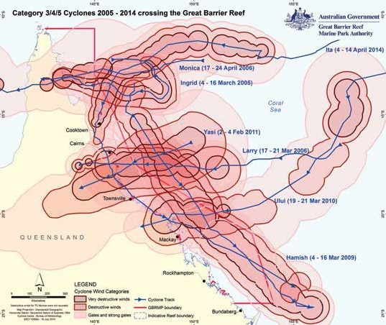

Figure 5: Seven severe cyclones have crossed the Great Barrier Reef in the past decade. This map shows the paths and destructive wind zones of these cyclones, and illustrates the cumulative impact of these storms. It must be noted that parts of the Reef are showing signs of recovery

CYCLONE ITA CAUSES SEVERE IMPACT

Severe tropical cyclone Ita was the latest in a series of severe tropical cyclones to have affected the Great Barrier Reef over the past 10 years, and the strongest since cyclone Yasi.

The Category 5 system crossed the Reef in the Lizard Island region, north of Cairns, on Friday 11 April 2014, generating damaging waves. It later made landfall at Cape Flattery as a Category 4 cyclone, impacting an area of the Great Barrier Reef Marine Park which was considered to have, on average, a high level of coral cover.

The severe cyclone triggered a level two response under the agency’s Tropical Cyclone Risk and Impact Assessment Plan, and officers worked with the tourism industry, Queensland Parks and Wildlife Service and James Cook University to assess the extent and the severity of the damage to islands, coral reefs, seagrass meadows and other habitats.

Of the reefs and islands affected by the destructive waves caused by the cyclone, several are important sites for the Great Barrier Reef tourism industry, and nine are among the 47 permanent sites of the Australian Institute of Marine Science Long- term Monitoring Program. The Starcke River region is also of critical importance for dugongs and turtles, because some of the most extensive coastal seagrass meadows in the Great Barrier Reef occur here.

Even though the damage footprint of cyclone Ita was considerably smaller than that of cyclone Yasi, it is likely to register in the Long-term Monitoring Program trend data for coral cover in the Marine Park due to impacts on the program’s permanent monitoring sites.

Initial surveys of a subset of impacted reefs in the region indicate the impact was severe in areas affected by destructive and very destructive winds as a result of the damaging waves. Between the destructive and gale force wind boundaries, the degree of coral damage was more variable between reefs.

Many of the reefs damaged by the cyclone have also previously been affected by the ongoing crown-of-thorns starfish outbreak. In many of the high-impact areas, crown- of-thorns starfish numbers were noticeably lower. However, where there were no obvious signs of damage, crown-of-thorns starfish were still evident in outbreak numbers resulting in significant coral mortality and loss of coral cover.

The recovery potential of reefs in this region will be influenced by the ongoing crown-of- thorns starfish outbreak, as well as further pressure from any subsequent destructive storm events, coral bleaching events or coral disease outbreaks.

There was no substantial impact to coastal seagrass meadows in the path of cyclone Ita and several dugong feeding trails were observed in surveys conducted through the marine monitoring program.
The fact that coastal ecosystems in the Cape Flattery area are intact helped minimise the impacts of cyclonic winds on adjacent seagrass meadows.

More information on direct and indirect impacts is still being gathered. Specific information on the impacts of the cyclone on islands, beaches, water quality, dugongs, turtles and fish was still pending as at 30 June 2014.

Initial reports from the tourism, commercial fishing and shipping industries indicate there were some disruptions to individual operators, but in general no immediate major impact on businesses in the Great Barrier Reef Region.

Address remaining impacts
Over the last two decades, considerable progress has been made towards sustainable fisheries in the Great Barrier Reef; however, the Great Barrier Reef Outlook Report 2009 recognised that more could be done to address remaining impacts from fishing.

The agency has continued to review the remaining impacts from fishing, and incorporated this work into relevant assessments in the Great Barrier Reef Region Strategic Assessment Report and the next Great Barrier Reef Outlook Report — both due to be released later in 2014. Assessment of changes in the sustainability of fishing activities since Outlook Report 2009, including the findings of the Ecological risk assessment of the East Coast Otter Trawl Fishery in the Great Barrier Reef Marine Park, have identified the remaining ecological risks that the agency needs to address with its partners.

The agency has also continued to advise the Queensland and Australian governments on strategies to address the remaining impacts from fishing and continues to work with partners, including the fishing industry, to mitigate those impacts. The agency routinely engages with Fisheries Queensland to advance sustainable fishing issues and compliance matters.

The agency also supported the Australian Department of the Environment in developing conditions and recommendations related to the Declaration of an Approved Wildlife Trade Operation for fisheries operating in the Great Barrier Reef Marine Park, including for the East Coast Otter Trawl Fishery.

A number of projects relevant to sustainable fisheries have been supported including:

- a joint fisheries adaptation project with CSIRO, the Queensland Department of Agriculture, Fisheries and Forestry, the Queensland Seafood Industry Association and other partners

- underwater surveys of reef fish fauna (including coral trout species) to assess current status and long-term trends, including flow-on effects of cyclone damage to reef habitats

- a project using fisher interviews and historical data to generate novel insights for contemporary.

Addressing declining water quality
The Reef Water Quality Protection Plan (Reef Plan), released in 2003, is a whole-of- government program addressing the critical issue of declining water quality in the Great Barrier Reef. Between 2008 and 2013, the Australian and Queensland governments invested $375 million to reduce pollutant loads entering the Reef lagoon. In June 2014 the governments committed a further $375 million to implement Reef Plan through to 2018.

As part of its $200 million commitment to Reef
Plan, the Australian Government allocated an additional $12 million over five years (2013–2018) to the Great Barrier Reef Marine Park Authority to continue its marine monitoring program — a core part of Reef Plan’s Paddock to Reef Monitoring, Modelling and Reporting program (Paddock to Reef program). The objective of the Paddock to Reef program is to measure and report on progress towards Reef Plan and Reef Programme goals and target.

Key performance indicator
The standard set in the Reef Water Quality Guidelines are met

The results from the marine monitoring program informed the 2013 Reef Plan risk assessment and helped identify priority locations for future investments in on-ground actions to improve water quality.

The program found the annual trigger levels for chlorophyll a and sediments in the agency’s water quality guidelines are regularly exceeded in the Reef’s inshore waters, around eight per cent of its area.

While some exceedance of chlorophyll a is expected during the wet season, these high concentrations are indicative of high nutrient loading from the catchments. The level of sediments also reflects the continued flooding in recent years and resuspension of finer sediment particles by wind and wave action.

Future marine monitoring program reports will determine if these actions are improving the quality of water entering the Great Barrier Reef and if the agency’s water quality guidelines are being met.

Marine monitoring program
The agency’s main role under Reef Plan is to deliver the marine monitoring program. Information from the marine monitoring program is used to assess the condition and trend of inshore water quality, seagrass and coral health, which is documented in the annual Reef Plan Report Card.

In securing funding through to 2018, the agency treated the first year as transitional and secured contracts with its main partners the Australian Institute of Marine Science, James Cook University and the University of Queensland — for 2013–14. This enabled the agency to implement recommendations from a July 2013 review of Reef Plan and its Paddock to Reef program, aimed at better integrating the program’s catchment and marine monitoring components. This included creating and linking marine monitoring sites to investigate pollutant transport of individual river reaches, and integrating data about other pressures on the Reef outside of water quality.

The agency also developed a comprehensive monitoring, evaluation, reporting and improvement strategy for the marine monitoring program to support its delivery and continuous improvement.

During this transitional year the agency also reviewed the marine monitoring program’s operation. This included commissioning CSIRO to undertake a detailed statistical analysis of the data collected through the program over the past nine years to evaluate its effectiveness in tracking progress towards the Reef Plan goal. The review of the marine monitoring program is expected to be completed in September 2014.

Integrate monitoring efforts
The 2013 review of the Paddock to Reef program, which monitors a range of attributes at a different scales, identified a need to better integrate monitoring efforts at a catchment level with monitoring conducted in adjacent marine areas. This will help enhance assessments of how much progress is being made in reducing pollutant loads from catchments.

The agency led a process of identifying actions to achieve this goal, including developing sites to link monitoring actions across the catchment to the Reef. Specific locations have been identified, and this new action will be considered in the marine monitoring program review options to be put to an independent science panel for assessment.

The agency also supports the implementation of integrated monitoring through development of regional report cards. These report cards provide a snapshot of progress against Reef Plan targets and are in place Reef-wide under Reef Plan’s Paddock to Reef program, and regionally in the Fitzroy region. They are also under development in the Mackay– Whitsunday–Isaac region and Port Curtis– Gladstone area.

Calculate cumulative impacts
The agency has been working with the Queensland Department of Science, Information Technology, Innovation and the Arts in reviewing how it should calculate cumulative impacts of multiple pesticides on plants and animals in catchment and marine waters. This work will provide improved understanding of the load and impact of pesticides, and will inform the current review of the marine monitoring program and the Great Barrier Reef Water Quality Guidelines planned for 2014–15. A key outcome was the development of a unified strategy for the monitoring and reporting of pesticides from the paddock to the Reef.

Lead agency role
The Great Barrier Reef Marine Park Authority continued its lead agency role in reporting on water quality and ecosystem health under the Reef Plan Report Card and integrating information from other monitoring programs. This includes bringing together relevant information from the Australian Institute of Marine Science’s Long-term Monitoring Program and working with the Australian Institute of Marine Science to develop the Reef 2050 Integrated Monitoring Program.

Coastal ecosystem work
The agency has been building on its work in detailing the impact of coastal land use changes on water quality, habitats and inshore biodiversity in the Marine Park, and developing tools to identify which areas in the catchment are the most critical to the Reef’s long-term health. This work has been incorporated into the revised Reef Plan, and has informed the development of a $50 million investment by the Australian Government over five years in repairing or restoring coastal ecosystem functions. The agency is responsible for identifying priority areas for this work.

Through its stewardship program Reef Guardians, the agency will also work with industry to incorporate elements of this initiative into industry best management practice programs. This work is supported financially by the Australian Government’s Reef Programme through the agency’s Reef Guardian and Indigenous Partnership programs, as well as the crown-of-thorns starfish control program.

Key performance indicator
Restored health of coastal ecosystems

During the reporting period, the agency developed a suite of tools to map and identify areas for protecting, restoring or maintaining coastal ecosystem functions that support the health of the Great Barrier Reef.

The Fisheries Research and Development Corporation compiled its report Revitalising Australia’s Estuaries in 2013 with funding from the Australian Government’s Biodiversity Fund and support from the Great Barrier Reef Marine Park Authority.

This report included a five-year business plan focused on restoring the health of Australia’s coastal ecosystems. The loss or modification of the Great Barrier Reef coastal ecosystem was one of the major case studies used in this report.

This work highlighted the need for actions in restoring the health of coastal ecosystems and was supported by the Australian Government’s announcement of new investment in coastal and wetland ecosystem repair in the Reef’s catchment under Reef Rescue ($50 million over five years) and the Biodiversity Fund (about $17.5 million over six years).

Coastal repair
The agency’s work on coastal ecosystems over the past three years has been instrumental in identifying priority areas for coastal repair. In 2012–13, the Australian Government’s Regional Sustainability Plan provided funding to further develop mapping products for this work. This resulted in the agency developing or commissioning 13 reports covering seven basin assessments of coastal ecosystem health, four coastal resource management case studies and two technical synthesis works on hydrology in the Great Barrier Reef catchment and non-Reef Plan pollutant risks.

These reports, and a revised coastal ecosystems framework, provided the foundation for mapping the values of the Great Barrier Reef’s functional coastal ecosystems and identifying how these ecosystems are hydrologically connected to the Great Barrier Reef.

In working with the Queensland agencies, regional natural resource management bodies, local government, industry and other stakeholders, the agency has mapped areas hydrologically connected to the Reef and also developed an ecological calculator. Together, these tools assist managers to identify the different functional values of coastal ecosystems and plan for protection, restoration and management.

During the reporting period, the agency also began drafting a position statement on the priorities for restoring lost connectivity and functioning of coastal ecosystems. When it is finalised later this year, this statement will be used to consult with stakeholders on the importance of coastal ecosystem functions for maintaining a healthy Great Barrier Reef.

Water quality improvement plan
During the reporting period, the agency worked closely with the Mackay–Whitsunday and Wet Tropics regions’ natural resource management bodies to review their water quality improvement plans. These plans set targets for improving the water quality and ecological health of waterways that flow into the Great Barrier Reef lagoon, and establish practical implementation strategies. The review was consistent with Reef Plan requirements using funds from the Australian Government’s Reef Programme. In revising water quality improvement plans, the agency is incorporating its work on restoring coastal ecosystem functions and focusing on priority areas for management and on-ground actions.

e-Reefs project
During the reporting period, the agency worked closely with the Great Barrier Reef Foundation and the Bureau of Meteorology to transition the remote sensing element of its marine monitoring program into the e-Reefs water quality dashboard. The Bureau’s water quality dashboard uses remote sensing technology to look at the status of water quality anywhere in the Great Barrier Reef in near-real time. This information is accessible through the Bureau of Meteorology’s website.

GROUNDWORK LAID FOR REPAIRING COASTAL ECOSYSTEMS

A five-year project by the Great Barrier Reef Marine Park Authority has laid the groundwork for restoring and reconnecting coastal ecosystems that are vital to the health of the Reef.

Healthy coastal ecosystems — including those on the coast and in marine waters — provide important functions for the Reef such as habitat for aquatic and marine life. They also trap, transform and recycle sediments and nutrients suspended in surface run-off.

Research by the agency shows coastal ecosystems south of Cooktown, including their functions and processes, have been heavily modified or lost through coastal development.

After mapping the value of coastal ecosystems in partnership with the Queensland Wetlands Program, the Great Barrier Reef Marine Park Authority worked with stakeholders to ensure regional planning incorporates steps to reconnect and restore these critical areas.

In 2013–14, the agency’s coastal ecosystems group commenced developing ‘blue maps’ which identify catchment areas that are most connected to Great Barrier Reef ecosystemsby fresh and marine water. Taking steps to maintain, restore and enhance functions in these areas is likely to benefit the Reef.
The agency then worked with natural resource management bodies Reef Catchments and Terrain to ensure steps are taken to apply the information on the ground.

Development of an ‘ecological calculator’ also began this year in partnership with natural resource management bodies and the Queensland Wetlands Program.

This tool calculates the benefits that better land management practices can have on ecological services provided by coastal ecosystems. This information can then be incorporated into regional planning and water quality improvement plans.

Together, the blue maps and the calculator help identify priority areas for coastal repair, and represent a big step forward in taking a whole-of-landscape approach to managing the Reef.

Importantly, the work allows on-ground actions to be targeted where they will provide the greatest benefit to the Reef’s inshore areas.

FIELD MANAGEMENT

— CONSERVATION AND COMPLIANCE
The Field Management Program delivered a range of activities to help maintain or improve the condition of the Reef, including at specific sites where direct threats are a high risk and where management actions and interventions will have a positive and ongoing benefit.

The agency manages compliance across the World Heritage Area for both the Australian and Queensland governments.

Raine Island adaptation work
The agency has continued working closely with the Queensland departments of National Parks, Recreation, Sports and Racing, and Environment and Heritage Protection, on adaptation work at Raine Island — the world’s largest green turtle rookery and the most significant seabird island on the Great Barrier Reef.

Long-term monitoring programs have identified declining trends in seabird populations and concerns for the green turtle population that nests there. Managers have been trialling adaptive management actions to strengthen the resilience of the marine and island ecosystem. These include specific on- ground actions to modify and enhance turtle nesting habitat, such as installing fencing on cliff edges, filling holes in beachrock that trap turtles and installing electronic equipment such as a weather station, remote cameras and tide gauges which can relay information back to Brisbane via satellite.

In 2013-14, officers worked with Traditional Owener groups who express certain native title rights and interests over the area to erect an additional 150 metres of pool fencing along cliff edges. This brings to 400 metres the total amount of fencing installed since the program began in 2011–12.

These on-ground actions will help reduce mortality of adult female turtles that nest on the island and better inform future adaptive management, thereby enhancing the population’s resilience to other impacts.

The influence of tidal inundation on hatching success and whether re-profiling the beach will improve nesting and hatching success, are currently being investigated.
Reef health and impact surveys
Reef health and impact surveys conducted by Field Management Program staff in 2013– 14 contributed to the broad assessment of coral reef health. When combined with regular localised tourism operator surveys and reactive agency surveys, these field management surveys produce a Reef-wide picture of the condition of the Great Barrier Reef. A total of 4337 reef health and impact surveys were undertaken in 2013–14, of which Queensland Parks and Wildlife Service field management staff conducted 2259 surveys across 210 reefs (see Table 2 below and Figure 6 page 38)

Table 2: Reef health and impact surveys undertaken in the Great Barrier Reef World Heritage Area in 2013
Organisation Surveys Undertaken 2013-14

Queensland Parks
and Wildlife Service 2259

Great Barrier Reef
Marine Park Authority 277

Tourism 131

Other (including Australian
Institute of Marine Science and
Association of Marine Park
Tourism Operators) 1670

Total 4337

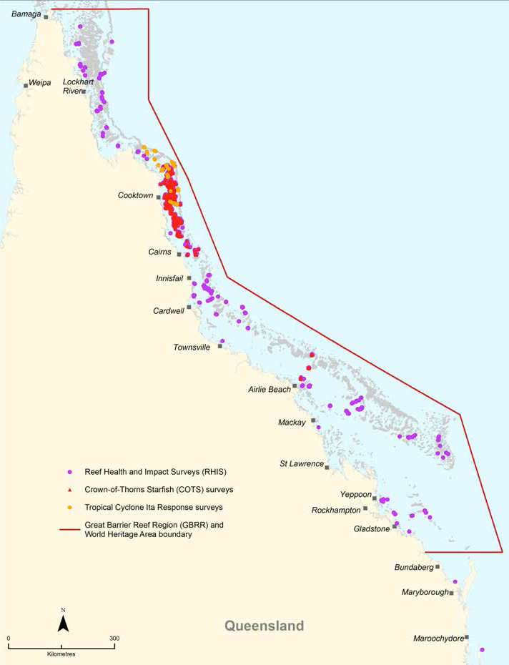

Figure 6: Location of sites at which reef health and impact surveys were conducted by field management staff during 2013–14. The red triangles are associated with surveys undertaken specifically to locate outbreaks of crown-of-thorns starfish, enabling control teams to better target their efforts to cull these marine pests. The orange circles show sites where impacts from tropical cyclone Ita were assessed.

Lady Elliot Island adaptive management
Lady Elliot Island, located in the southern Great Barrier Reef, 80 kilometres north-east of Bundaberg, is a Commonwealth-owned island leased to Lady Elliot Island Eco Resort. It is one of the most significant seabird breeding sites in the Great Barrier Reef World Heritage Area and the southernmost extent of many species’ breeding distribution.

Weed and pest issues, largely a legacy from past guano mining and lighthouse occupation, have impacted the island’s ecological values and resilience. A draft ecosystem resilience management plan was completed in 2013–14, with implementation commencing in June 2014.

Under the plan, a vegetation management trial was conducted including finding the most effective lantana removal techniques. A combination of using machinery, hand tools and manual removal was found to be the most effective method. Approximately one hectare of lantana was completely reduced to mulch in three days using this combination method.

Island pest and weed management
Protecting the natural integrity of priority island locations through targeted conservation management actions continued during 2013–14. Field management staff implemented targeted as well as routine island conservation activities.
Priority pest and weed management projects were chosen based on the conservation threats to island values, the likelihood
of success and their enduring benefits. Significant gains were made during the reporting period, particularly with regard to pest eradication from islands.

Curtis Island
The flatback turtle is listed as a vulnerable species under the Environment Protection and Biodiversity Conservation Act 1999 and Curtis Island, offshore Gladstone, has one of the main flatback turtle nesting sites on Queensland’s east coast. Fox and wild dog control within the Curtis Island environmental management precinct during 2013–14 reduced predation of flatback turtle eggs by 60 per cent, compared to the 2012–13 laying season.

A muster removed 45 head of feral cattle from the Curtis Island environmental management precinct in April 2014. Another muster is planned for early in the 2014–15 reporting period. If it yields similarly good results, the island’s feral cattle population will be reduced by a total of 90 per cent.

Field management officers also undertook prickly pear controls in the Curtis Island environmental management precinct during the reporting period, resulting in an estimated 95 per cent reduction in prickly pear mass. Prickly pear is a class two weed and a food source for feral pigs which are present on the island.

Some of the Curtis Island control work was funded through liquefied natural gas offsets, negotiated as part of Queensland Government approvals.

SMART SEABIRD MONITORING TRIALS

More than 22 species of seabirds breed in large colonies among the 1050 islands that dot the Great Barrier Reef, and field management officers monitored 38 key breeding sites in 2013–14.

Obtaining regular and reliable bird counts which are representative of all the nesting and breeding sites on the Reef is logistically and financially challenging, so the Field Management Program is trialling cutting-edge new technologies to undertake bird surveys on Capricornia and Michaelmas cays.

During the reporting period, the program conducted an acoustic monitoring trial of two significant bird species — black noddies and wedge-tailed shearwaters — at Capricornia Cays National Park.

The monitoring devices, with pairs of weatherproof microphones, recorded bird calls at 10-minute intervals.

The trial was successful in estimating the density of wedge-tailed shearwater burrows and has been expanded to test whether other species can also be ‘counted’ using this technique.

In July 2013 a trial video camera for monitoring seabird numbers was installed on Michaelmas Cay.
The pole-mounted surveillance camera with pan, tilt and 20-times optical zoom capacity takes high-definition footage, enabling Queensland Parks and Wildlife staff to view the island on a daily basis, within a 360 degree arc of the camera’s line of sight.

On-site ground-truthing counts will be compared with counts of the camera footage to assess whether autonomous camera systems can provide reliable data on seabird numbers year round.

Because these devices can gather information throughout the year, in contrast to Queensland Parks and Wildlife Service’s ability to visit a remote site once or twice a year, they may allow staff to monitor logistically challenging bird breeding sites with less effort and potentially more reliability.

These techniques could enable field management staff to learn more about the timing, duration and success of seabird breeding at key sites.

Understanding Reef-wide bird trends will help guide future management decisions and actions at key nesting islands and foraging grounds.

Wild Duck and High Peak islands
Feral animal control activities removed 69 goats from High Peak Island and 21 deer from Wild Duck Island in 2013–14. This has significantly reduced the number of these feral species with less than 100 goats remaining on High Peak Island and less than 50 deer on Wild Duck Island. Trials, including the use of GPS trackers on male goats on St Bees Island, have proven successful and may be implemented on Wild Duck and High Peak islands in 2014–15.

Wuthura Island National Park
A project to eradicate lantana thickets on Wuthura Island continued in 2013–14. Field trips in July, August and November 2013 included surveys of more remote areas of the island and noted an absence of lantana with the exception of some scattered individual plants. The project is making considerable headway towards the long-term goal of eradication by 2018.

Volunteers assisting with stranded marine animals
Marine animal stranding training has now been delivered to a total of 329 volunteers at 15 locations between Gladstone and Mossman, including 136 people in 2013–As a result, there were 171 volunteer responses to strandings in 2013–14. This comprised 46 per cent of all reported strandings, up from 18 per cent in 2012–13 (see Figure 7).

This community-based approach will boost the amount of data collected about stranding events, increase local stewardship, and elevate community awareness about the risks to marine fauna.

The marine animal stranding training program was established in 2012–13 in response to a growing community desire to actively help in protecting marine turtles in the Great Barrier Reef.
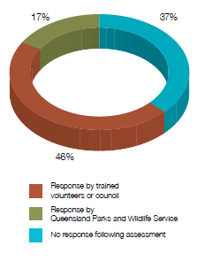
Figure 7: Marine animal stranding responses in 2013–14. The majority of responses were from trained volunteers

Quick guide for marine animal stranding response
The World Wide Fund for Nature, through a Queensland Parks and Wildlife Service Friends of Parks grant, has been working with the Field Management Program to develop a quick guide to help volunteers respond to marine animal strandings, focusing on marine turtles. The quick guide will assist volunteers in primary responses to routine stranding.

The guide and associated training is due to be completed in November 2014.

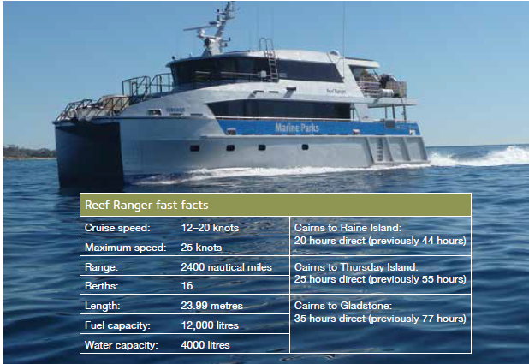
The Reef Ranger and its key statistics. Photograph courtesy of Queensland Parks and Wildlife Service

REEF RANGER ON THE WATER

The $5 million patrol boat Reef Ranger is the newest addition to the Field Management Program’s toolkit for protecting the Reef and its amazing biodiversity.

The 24-metre catamaran was jointly funded by the Australian and Queensland governments, and built by Gold Coast firm Marine Engineering Consultants. It was completed in the last week of June 2014.

Described as a floating ranger base, the aluminium catamaran has the capacity to reach all corners of the 348,000 square kilometre Great Barrier Reef World Heritage Area — improving the ability to respond to incidents quickly.

It replaces the 24-year-old Kerra Lyn which has been an integral part of field work and enforcement activities for the past two decades.
The Reef Ranger is twice as fast as the Kerra Lyn, as well as more environmentally friendly, and more cost-effective.

In reducing travel time, the new vessel allows field management staff to spend more time at remote locations such as Raine Island — an important turtle nesting site in the far northern part of the Reef.

The Kerra Lyn took two days to get to Raine Island, whereas the Reef Ranger will take just one.

The boat will be based in Cairns but spend up to 290 days of the year at sea.

It will be used for a wide range of activities, including compliance, maintaining visitor sites, fire and weed control on islands, surveying crown-of-thorns starfish, monitoring the health of the Reef, and responding to boating or shipping incidents.

Compliance
Compliance is managed across the Great Barrier Reef World Heritage Area for both the Australian and Queensland governments.

Surveillance
The field management compliance unit coordinates vessel, aerial and land-based surveillance activities across the World Heritage Area. A cooperative multi-agency approach to patrolling is used to enable the application of a broad range of legislation and compliance management tools in an efficient whole-of-government manner.

Across the participating agencies, there were 1289 dedicated compliance vessel patrol days undertaken in 2013–14. Thirty-four land-based patrol days focused on high-risk areas including Cape Bowling Green, Starcke River coastline and Princess Charlotte Bay.Eighty targeted aerial surveillance days using chartered helicopters complemented the Border Protection Command aircraft surveillance program and focused on coastal and inshore areas.

Inshore helicopter surveillance provided a highly visible compliance presence in remote areas of World Heritage Area and resulted in the detection of a large number of possible illegal incidents, including commercial netting and crabbing, unlawful hunting and recreational fishing. The inshore helicopter surveillance program is a very effective and successful patrolling method for both detection of and deterrence against these illegal activities. It has resulted in the detection of recreational and commercial offenders that intentionally fish in Marine National Park zones (green zones) where vessel and land-based surveillance is difficult or ineffective.
To further assist and expand compliance capabilities, technology trials of suitable vessel monitoring technology advanced during 2013–14. Sixteen units were installed on field management vessels to enhance the monitoring and measurement of fleet activity and to assess the suitability of these units for broader use.

Incidents and offences
Figure 8, page 44, shows the number of possible offences reported to the Field Management Program each year since the rezoning of the Great Barrier Reef Marine Park came into effect in July 2004. During the reporting period, 1057 possible offences from 614 incident reports were reported from across the Commonwealth and Queensland jurisdictions of the World Heritage Area. This represents the highest annual number of offences reported since 2004 and maintains the marked increase seen in 2012–13 — which has resulted from a targeted focus on recreational fishing compliance.

Although a wide variety of offences were reported during 2013–14, recreational offences, particularly recreational fishing offences, were the most common offences reported (Table 3, page 44.)

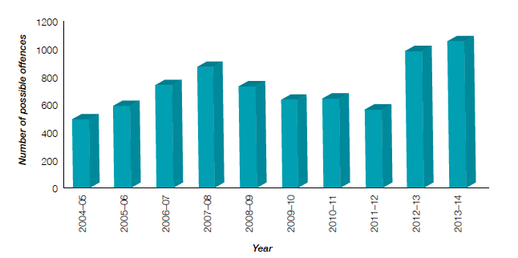

Figure 8: The number of possible offences reported to the Field Management Program since the rezoning of the Great Barrier Reef Marine Park in July 2004
Table 3: Number of possible Commonwealth offences, by user group and type, reported to the Field Management Program during 2013–14
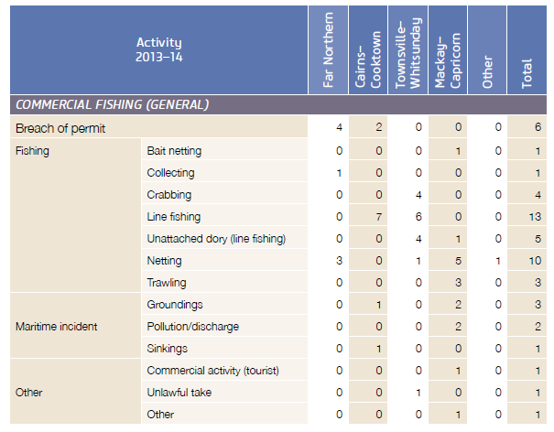
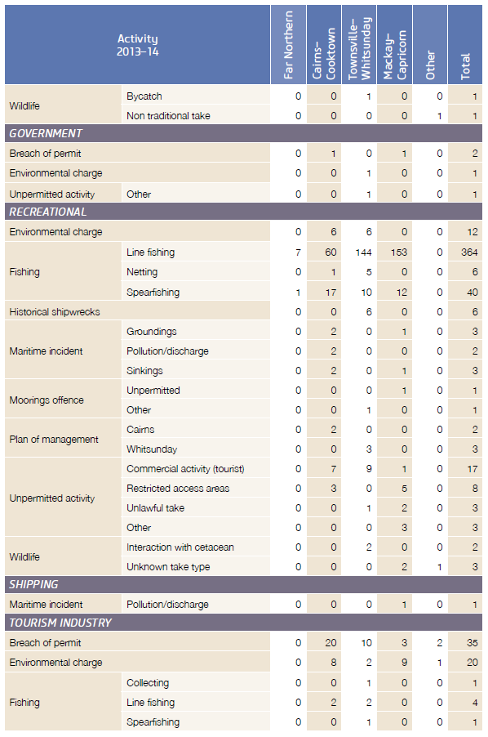

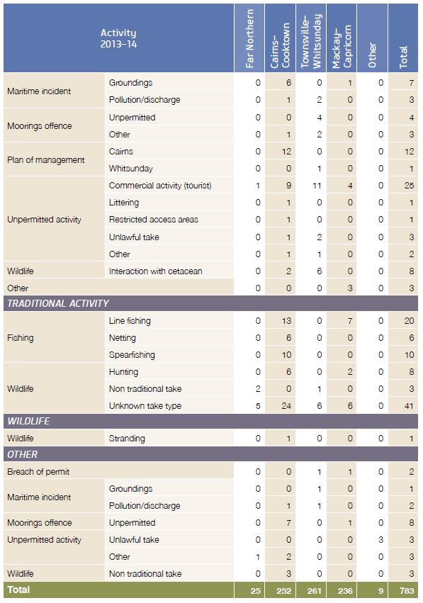

Information reports
The field management compliance unit receives information relating to issues of compliance on a regular basis. These reports can provide general information on an activity or specific detail regarding the conduct of alleged offences.

During the reporting period, 437 information reports relating to a wide variety of issues and activities were recorded and analysed. Most of these reports contained information related to the commercial fishing industry and non-compliant recreational fishing.

The gathering of this information enables a greater understanding of these issues and emerging compliance problems in the World Heritage Area. It also assists in the allocation of Field Management Program resources to address these issues. Figure 9 below shows the number of information reports received each year since 2004–05.

Compliance actions
Table 4, page 48, provides details of the assessments and compliance actions other than prosecution that were taken in relation to reported offences during 2013–14. The individual circumstances of each matter are assessed and considered before a decision on appropriate action is made.
As in previous years, a significant number of offences were addressed with an advisory letter. The low incidence of reoffending after receipt of an advisory letter demonstrates their effectiveness as a compliance action. More serious matters were dealt with through an infringement notice or court prosecution. The 23 court prosecutions finalised during 2013–14 resulted in fines totalling $105,000 (Table 5, page 49).
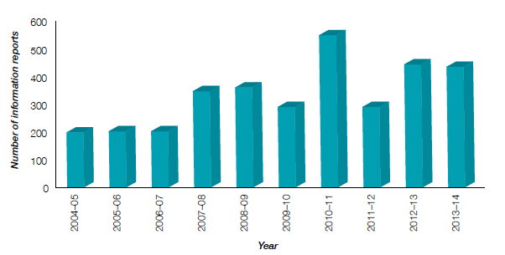

Figure 9: The annual number of information reports recorded by the Field Management Program since 2004–05

Table 4: Outcomes of assessments and compliance actions taken in relation to reported offences during 2013–14.
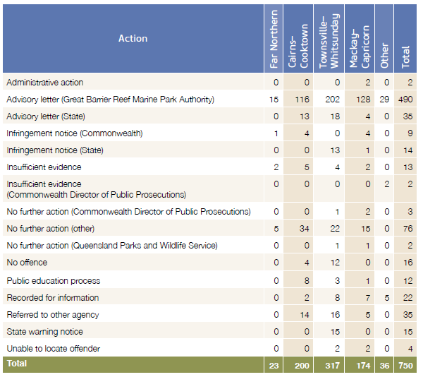

Other compliance initiatives
During 2013–14, the program enhanced its compliance management capability by implementing and progressing a range of initiatives.

The program enhanced the application of legislative powers and offence provisions through:

- creating the capacity to apply ‘three strikes and you’re out’ legislative provisions

- developing a field caution notice system

- advancing the capacity to collect court-imposed fines.

The use of technology was expanded by:

- piloting trials to collect position reports from the Field Management Program vessels

- installing video technology enabling live visual relays from the field to the field management compliance unit operations centre

- developing a reporting application that enables patrol reports and other information to be submitted electronically from the field, thereby increasing intelligence capacity.

The multi-agency approach to field operations was consolidated and supported through:

Table 5: Fines resulting from court prosecutions for different types of offences during 2013–14
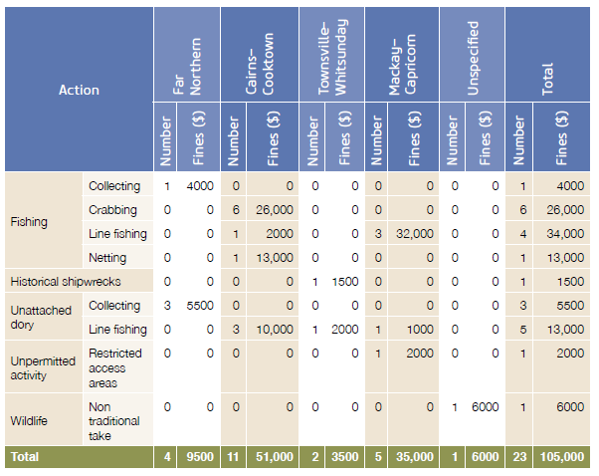

- extending the participation of multi-agency staff in compliance management planning

- implementing four sector compliance groups to guide the targeting of highest risk and recidivous offenders

- appointing additional multi-agency staff as Marine Park inspectors, bringing the current total to 137 officers.

International engagement
A number of international visitors spent time with compliance staff in 2013–14, obtaining advice on implementing compliance management in marine protected areas within their own countries.

An Ecuadorian delegation spent three days at the agency in July 2013, seeking guidance on implementing their nation-wide coastal surveillance system.
Field management compliance unit staff explained compliance strategies for the World Heritage Area, how vessel tracking systems work and how they can be used. The delegates also met with the Australian Maritime Safety Authority and visited the REEFVTS operations centre.

Delegates from Grenada were given an overview of the compliance systems and operations centre during July 2013. They were hosted by the Australian–Caribbean collaboration on climate change and coral reefs.

A delegation of officials from the Indonesian
Ministry of Marine Affairs and Fisheries was hosted by the agency and Border Protection Command visited during May 2014, representing the second such visit from Indonesian officials.

The visit included a presentation in the compliance operations centre and a trip to Magnetic Island to learn about island management from Queensland Parks and Wildlife Service rangers.

ONE HIT WONDER BOOSTS FIGHT AGAINST

CROWN-OF-THORNS STARFISH

A new and efficient measure for managing crown-of-thorns starfish numbers has resulted in better protection of coral on the Great Barrier Reef.

In 2013, the Australian Government’s crown- of-thorns starfish control program adopted the use of a single injection method to cull the coral predator.

The breakthrough meant the number of starfish culled by trained diving teams increased significantly, reaching 182,848 by June 2014.

The technique developed by James Cook University uses an injection of bile salts, and is a more efficient method of managing large aggregations of starfish than the previous multi-injection method using the pool chemical sodium bisulphate.

The bile salts solution — which produces an allergic reaction in the starfish, causing it to break apart and die within 24 hours —resulted in a two-and-a-half fold increase in the number of starfish culled by diving teams.

The teams are at the frontline of the tactical management program being delivered by the Great Barrier Reef Marine Park Authority, in partnership with the Association of Marine Park Tourism Operators and the Queensland Parks and Wildlife Service.

Together, the three organisations deliver three critical aspects of the program: extensive surveillance of reefs through manta tows and reef health and impact surveys, injections of the starfish, and a comprehensive reef health database to monitor the effectiveness of cull efforts in protecting coral cover.

Permanent monitoring sites were also established in 2013–14 to record the change in coral cover over time at selected high- priority tourism locations.

The coordinated efforts and the development of the single injection method allowed large numbers of the crown-of-thorns starfish to be wiped out in 2013–14 on reefs near Cairns, including 27,000 in just eight days at Arlington Reef and 9000 at Batt Reef, as well as 14,000 at Spitfire Reef near Cooktown.

The control program targets popular tourist sites and conducts population controls in other areas.

The Association of Marine Park Tourism Operators also began delivering capacity- building training within the tourism industry this year to enable operators to ‘self-control’ their sites.

Research by the Australian Institute of Marine Science suggests the Great Barrier Reef has lost half of its coral cover since long-term monitoring began in 1985 and 42 per cent of this loss was due to crown-of-thorns starfish.

CROWN-OF-THORNS STARFISH MANAGEMENT
The crown-of-thorns starfish continues to be one of the most significant threats to the health of coral cover on the Reef, particularly in the northern region between Lizard Island and Cairns. In 2013–14, the agency managed a successful control program in partnership with the Association of Marine Park Tourism Operators and the Queensland Parks and Wildlife Service, which culled 182,800 crown-of-thorns starfish, contributing to the protection of coral cover at more than 59 reefs. The new single-shot injection was fully implemented through the control program, resulting in an average two-and-a-half fold efficiency gain (see case study, page 50).

During the year the agency’s joint Field Management Program conducted 6338 manta tow surveys covering 1140 kilometres cumulative distance, and 1916 reef health and impact surveys across 88 reefs to identify locations of crown-of-thorns starfish. The surveillance efforts informed the cull program and greatly increased its efficiency and effectiveness.

Further to this, the program is trialling a new adaptive connectivity-based management approach developed by the University of Queensland and Australian Institute of Marine Science. This approach uses predictive modelling to identify the likely transport of crown-of-thorns starfish larvae between reefs, and identifies which reefs are important ‘feeder’ reefs that could supply larvae to other reefs. Preliminary results have enabled the agency to focus some of its management efforts on sites where crown-of-thorns starfish congregations were likely to cause the most damage to high priority tourism reefs. This type of predictive modelling is also used to predict the spread of contagious diseases and dissemination of information in criminal networks.

During the year, the Association of Marine Park Tourism Operators provided crown- of-thorns starfish management training to 17 tourism industry members and two community groups — boosting the capacity of regular Reef users to conduct their own programs. The agency also facilitated three crown-of-thorns starfish workshops and four data sharing agreements, resulting in new national and international research collaborations to address important information gaps and develop a longer-term, more integrated approach to management of the starfish.

OUTLOOK REPORT 2014
The second five-yearly Outlook Report for the Great Barrier Reef Region was presented to the Minister for the Environment by 30 June 2014. The aim of the Outlook Report is to provide a reliable means of assessing and reporting on the Region and the management of it, in an accountable and transparent manner, to inform policy and decision- making.
The report assesses the current state of the Region’s environmental, social and economic values. It also examines pressures and current management responses, as well as the resilience of the Region’s values and the remaining risks to those values. Most importantly, the report considers the overall likely outlook for the Great Barrier Reef Region.

The 2014 Outlook Report has a much expanded consideration of the Region’s heritage values. This reflects new regulatory requirements and responds to the request by the World Heritage Committee to include an explicit assessment of the Great Barrier Reef World Heritage Area’s outstanding universal value in subsequent outlook reports.

An independent assessment of the effectiveness of existing measures to protect and manage the Region was undertaken by four experts. Their report is the basis for the Outlook Report chapter on this topic.

The Outlook Report underwent an expert peer review process before being provided to the Minister.

Scientific consensus workshop
To inform the Outlook Report, the agency convened a scientific consensus workshop on 14–16 October 2013. The objective was to secure an independent set of expert judgements about condition, trends and risks in the Great Barrier Reef Region that could be used to inform the preparation of the Great Barrier Reef Outlook Report 2014.

The workshop involved 31 external experts, selected for their knowledge across a range of issues and their long-standing field experience in the Region.

Twenty-eight experts attended the workshop and the other three submitted their advice as a set of score sheets ahead of the event.

The workshop was conducted and moderated by an independent external expert with extensive experience in the conduct of marine performance assessment processes.

The report on the workshop will be made available when the Outlook Report is tabled in Australian Parliament in the latter half of this year.

SUMMARY OF ACHIEVEMENTS FOR OBJECTIVE 1
- Presented second five-yearly Outlook Report for the Great Barrier Reef Region to
the Environment Minister

- Managed successful control program which protected coral cover on more than 59 reefs by culling 182,800 crown-of-thorns starfish

- Fully implemented new single-shot injection method throughout the crown-of- thorns starfish management program, resulting in an average two-and-a-half fold efficiency gain

- Commissioned the new patrol boat Reef Ranger, which will improve the Field Management Program’s ability to protect the Reef and its biodiversity

- Recorded 4337 reef health and impact surveys in the Eye on the Reef database, including 2259 surveys by field management officers

- Conducted dedicated field trips to do initial surveys of reefs following severe tropical cyclone Ita, which made landfall at Cape Flattery on 22 April 2014. Surveys indicated the impact was severe in areas affected by destructive and very destructive winds

- Implemented recommendations from a July 2013 review of Reef Plan and its Paddock to Reef program, aimed at better integrating the program’s catchment and marine monitoring components

- Commenced development of a suite of tools, including hydrological connection maps and an ecological calculator. These tools help identify ecological functions provided by coastal ecosystems to the Great Barrier Reef, which will map the priority areas for maintenance, restoration or enhancement

- Completed vulnerability assessments for dugongs, marine turtles, snapper and humpback whales, which provide an overview of the species’ health and status, which are due to be published in late 2014

- Worked with CSIRO on a climate change adaptation pathway case study focused on ensuring the long-term sustainability of Raine Island

- Helped develop decision rules for setting the annual commercial coral trout quota through membership of the Fisheries Queensland-led line review working group. The total allowable catch of coral trout for 2014–15 has subsequently been reduced by 200 tonnes from the previous year

- Provided advice on the Queensland Government’s East Coast inshore net buyback scheme through membership of the Netting Buyback Working Group. The scheme has resulted in a buyback of 69 commercial large mesh net symbols for a total cost of $3.81 million

- Achieved targeted growth in Reef Guardian Fishers pilot program, with eight participating Coral Reef Fin Fish Fishery operations encompassing up to 59 vessels

- Implemented priority pest management projects on island protected areas, resulting in a 60 per cent reduction in the predation of flatback turtle eggs at the Curtis Island environmental management precinct

- Delivered marine animal stranding training to 136 volunteers between Gladstone and Mossman, enabling volunteers to respond to almost half of all reported strandings.

Objective 2

Safeguard the Reef’s heritage values

The Great Barrier Reef was declared a World Heritage Area in 1981 because of its outstanding universal value. This recognised the Reef as being one of the most remarkable places on Earth, as well as acknowledging its global importance and its natural worth.

As the agency charged with protecting the Reef for future generations, the Great Barrier Reef Marine Park Authority is responsible for safeguarding the very heritage values for which the Reef was World Heritage-listed more than three decades ago.

The priority given to this duty is reflected in the agency’s decision to change its second objective this year to ‘safeguarding the Reef’s heritage values’. It is also an acknowledgement of concerns raised by the World Heritage Committee about the extent of development along the Great Barrier Reef coast and the impact this may have on the Reef’s World Heritage status.

In 2013–14, the agency worked towards this new objective by fulfilling its heritage obligations under the World Heritage Convention and Environment Protection and Biodiversity Conservation Act 1999.

Through the joint Field Management Program, the agency implemented cultural heritage protection, such as the protection of lightstations.

The agency also made substantial progress towards finalising the Great Barrier Reef Region strategic assessment and program report, which will provide a roadmap for managing the Marine Park over the next 25 years.

Deliverables
Fulfil heritage obligations p. 56

Field management — cultural heritage protection p. 62

Strategic assessment p. 63

Case studies
Maritime heritage survey p. 60

Strategic assessment consultation p. 68

FULFIL HERITAGE OBLIGATIONS

The Great Barrier Reef has long been recognised both nationally and internationally for its significant biodiversity and heritage values. This recognition has been expressed in a variety of ways including:

- World Heritage listing since 1981
- National Heritage listing since 2007
- various Commonwealth heritage specific listings (such as various historic lightstations).

This wide-ranging significance was further
recognised in 2008 when the main object
of the Great Barrier Reef Marine Park Act (s. 2A) was amended “…to provide for the long term protection and conservation of the environment, biodiversity and heritage values of the Great Barrier Reef Region”.

In addition to the extraordinary natural values for which the area was listed as World Heritage, the Great Barrier Reef includes an enormous range of other heritage values. These include Indigenous heritage values such as places and traditions, key historic sites such as shipwrecks, plane wrecks, lightstations, research stations and places such as Endeavour Reef where Captain Cook ran aground on 11 June 1770.

Key performance indicator
Enhanced identification, understanding, recognition, protection and conservation of the Great Barrier Reef’s outstanding universal value, and of Aboriginal and Torres Strait Islander’s and historic heritage

An important component of the draft Great Barrier Reef Region strategic assessment was an assessment of the current condition and trend of the outstanding universal value of the Great Barrier Reef World Heritage Area. This was benchmarked against the retrospective Statement of Outstanding Universal Value as a way of assessing changes in the property’s condition since its inscription in 1981.

An overall trend in condition was provided, comparing the current condition with the likely condition at the time of inscription.

The overall assessment shows the outstanding universal value of the World Heritage Area remains largely intact, with many elements remaining in good condition. However, the trend for about two-thirds of the elements assessed are considered to be deteriorating compared to their condition in 1981.

The Great Barrier Reef Marine Park also encompasses a diverse and historically significant maritime cultural heritage that includes both tangible and intangible components. Tangible heritage includes sites such as stone fish traps, ship and plane wrecks, lightstations and the remains of pearling stations, while intangible heritage includes Indigenous stories, song, dance and cultural practices.

The Great Barrier Reef Marine Park Regulations were amended in 2013–14 to include heritage values as part of the considerations required by the agency’s Outlook Report, which is published every five years. These new regulatory requirements ensure that heritage values are well considered in the agency’s five- yearly Outlook Reports, beginning with the 2014 report which was provided to the Environment Minister at the end of the reporting period.

The agency is working to enhance its Indigenous cultural capability by establishing a best practice standard of collecting, managing and sharing any Indigenous cultural knowledge that is acquired through its work.

An integral part of this was customising an information sharing and protection toolkit that staff can use to guide their decisions when collecting, acknowledging and using cultural information. A key aspect of this toolkit is recognition of intellectual property rights, and cultural protocols that are associated with the use of cultural information.

Currently in draft form, the cultural information sharing and protection toolkit will be further developed with Traditional Owners of the Great Barrier Reef catchment area to ensure a robust and usable information management protocol is in place for the whole agency.

A beta version of a cultural knowledge management database has also been developed. This addresses the long-standing need for an information system which supports the best practice and effective management of the Great Barrier Reef World Heritage Area by storing and categorising information that the agency has on the work it undertakes with Traditional Owners of the Great Barrier Reef.

Together, the toolkit and database complement each other and present a holistic, culturally appropriate management system that has been designed for internal use.

The agency has made significant inroads to improve the identification and protection of historic heritage in the Marine Park. During 2013–14, the agency conducted targeted patrols to protect significant plane and ship wrecks, continued developing a comprehensive database on heritage sites, developed extra protection for World War II plane wrecks which contain human remains, and developed management plans for lightstations at Dent Island and Lady Elliot Island. The agency is currently reviewing its heritage strategy to reflect changes to legislation.

World heritage
During the reporting period, agency officers provided comprehensive input to the Department of the Environment for a guidance document being compiled to help proponents understand how to assess outstanding universal value.

The agency also provided input into Australia’s State Party Report which was submitted to the UNESCO World Heritage Centre in early 2014. The State Party Report outlines the actions Australia is taking to preserve and protect the Great Barrier Reef, in response to World Heritage Committee concerns about the potential effects of coastal development on the Reef’s world heritage values.

The approach developed by the agency for assessing components of the outstanding universal value in the Great Barrier Reef as part of the Great Barrier Reef Region strategic assessment has now been presented to various other world heritage managers, both within Australia and internationally, and received widespread interest.

National heritage
In May 2014, the agency was invited to brief the Australian Heritage Council’s meeting as follow-up to the council’s submission on the Great Barrier Reef Region Strategic Assessment Report. One of the items discussed was getting the Reef’s historic and Indigenous heritage values included as part of its national heritage listing.

A preliminary assessment of Reef values was subsequently prepared against the relevant national heritage criteria and presented to the council.

Indigenous heritage
The recording and storing of cultural information regarding marine resource use is carefully managed by Traditional Owners who are part of the Traditional Use of Marine Resources Agreement program.

A number of groups have developed their own management regimes based on a deep understanding of their sea country. Much of this knowledge is passed down through on- country activities where Traditional Owners implement their Traditional Use of Marine Resources Agreement program.

Groups hold extended on-country programs during school holiday periods, ensuring that as many participants as possible are included.

Junior ranger programs provide a supported platform to express culture, learn about heritage, and learn about land and sea management practices. These activities also form an educational program for children of all ages. (Traditional Use of Marine Resources Agreements are reported in more detail under Objective 3, page 97.)

Historic heritage
The appointment of a new project manager with expertise in maritime cultural heritage represents a new focus on verifying and recording information about the Region’s historic heritage. This information will be invaluable, not just for a broader understanding to meet the agency’s statutory obligations, but also for use in environmental and permit assessments.

During the reporting period, considerable effort went into developing a preliminary heritage register covering historic shipwrecks, aircraft wrecks and island heritage. This is now available internally to agency staff on the intranet.

The agency’s spatial data centre is working to ensure key heritage sites, such as historic shipwrecks are included in the agency’s Reef Explorer — an online mapping service provided to internal staff — to enable them to seek quick answers to location-based questions.

Staff members are also adding new information about North Queensland wrecks to the Australian National Shipwrecks Database.

A program has commenced to develop photographic mosaics of key heritage sites, such as the SS Yongala wreck off Cape Bowling Green. These will be used for monitoring change in condition and assisting in court cases for such things as the disturbance of wrecks. Investigations are also occurring as to the effectiveness of a 3D underwater scanner for baseline site surveys. This may have good applications for reef monitoring as well as for heritage sites.

Catalina aircraft wrecks
A formal proposal for increasing the protection for two World War Two Catalina aircraft wrecks was endorsed by the Great Barrier Reef Marine Park Authority board in March 2014.

The wrecks — off Bowen and near the Frankland Islands south of Cairns — are also the final resting place of 25 World War II service personnel and the agency has proposed declaring two Special Management Areas around the sites. At the end of the reporting period, instructions were being drafted to be presented to the Office of Parliamentary Counsel for amending of the regulations.

In August 2013, the Australian Hydrographic Service issued a notice to mariners about the Catalina A24-24 wreck off Bowen, advising that they should avoid anchoring in the area.

In addition, the agency’s Field Management Program has been conducting targeted patrols to deter illegal fishers from the site of Catalina A24-25 near the Frankland Islands, which is also a Marine National Park Zone (green zone).

Review of heritage strategy
The agency commenced a review of the 2005 Great Barrier Reef Heritage Strategy during the reporting period.

During 2013–14, work on the 2014 Great Barrier Reef Outlook Report provided agency officers with an opportunity to reassess and elaborate on many of the heritage values in the Great Barrier Reef. In preparing the heritage chapter for the report, officers were required to compile heritage information in a logical and structured way — a process which will be helpful in the review of the heritage strategy.

Other agency initiatives that will contribute to this review include the GIS mapping of key heritage values and updated databases of historic heritage.

MARITIME HERITAGE SURVEY FINDS NEW WRECKS

A maritime heritage expedition to the far northern Great Barrier Reef resulted in the survey and documentation of six wreck sites located on Great Detached Reef, about 80 kilometres east of Cape Grenville on Cape York Peninsula.

Agency officer and experienced maritime archaeologist Pete Illidge joined colleagues from the Australian National Maritime Museum in November 2013 for the two-week project. It was organised and funded by the Silentworld Foundation.

The expedition equipment included the
metre vessel MY Silentworld II and three diving support vessels, metal detectors, a remotely operated vehicle or ROV, and a helicopter for aerial rapid wreck surveys.

One of the survey’s eight objectives was to survey Great Detached Reef for potential wrecks at the entrance to Blackwood Channel, which was used as a major entry point to the inner shipping route during the 1800s.

The shape of the reef is a deeply indented ‘V’ which, to sailing ships at sea without the benefit of modern charts, would have deceptively looked like a safe passage through the outer reef. By the time unsuspecting mariners had sailed into
the deep bay of the reef and realised it was a dead end, it was too late to turn away. Consequently, this reef has become something of a wreck trap, concentrating shipwrecks in a relatively small area.

According to the Australian National Shipwreck Database, this wreck trap claimed at least six historic ships and not all have been positively identified from their remains.
Those believed to be wrecked there are: the Charles Eaton, Francis Walker, Sultana, Sata and at least two unidentified wrecks.

The survey team used magnetometers, aerial surveys and snorkel surveys to search the extensive reef system. They located six certain shipwrecks and a possible seventh, all of which are believed to be from the period between 1818 and 1854.

Despite anecdotal reports of their existence, this expedition represents the first formal documentation of these wrecks. They have now been added to the Australian National Shipwreck Database, and constitute significant new maritime heritage knowledge in the Great Barrier Reef Marine Park.

There are estimated to be at least 800 ships and over 100 plane wrecks within the World Heritage Area, of which only a small percentage have been located and positively identified.

Silentworld Foundation is a philanthropic foundation with the purpose of supporting maritime archaeology in Australia, especially related to early colonial history

Mr Illidge has taken part in seven Silentworld Foundation expeditions including the inaugural Mermaid Expedition where Phillip Parker King’s vessel of exploration, the Mermaid, was discovered.

FIELD MANAGEMENT — CULTURAL HERITAGE PROTECTION
The Field Management Program is responsible for managing cultural heritage on island national parks and Commonwealth islands, with a small number of sites where active maintenance and restoration works are performed. Some of these are outlined below.

Magnetic Island WWII forts complex
Field management rangers completed an upgrade to the culturally significant Magnetic Island forts precinct in 2013–14, at a cost of $400,000 over three years. It was funded from Queensland Parks and Wildlife Service capital works, additional to joint Field Management Program funding.

The project included substantial walking track upgrades, preparation of a conservation management plan for the site’s five concrete buildings, concrete repairs to the main buildings, painting of the main buildings, and the installation of an extensive network of high-quality interpretive signs.

The site receives up to 50,000 visitors each year and the newly installed signage shares the precinct’s history with those visitors. Island residents and tour operators have given very positive feedback about the upgrade.

Lady Elliot Island lightstation
The Lady Elliot Island Lightstation Heritage Management Plan was registered as a legislative instrument on 2 April 2012, and outlined the work required to ensure the lightstation’s heritage values are managed and protected into the future.

Under the plan, the Field Management Program engaged contractors to carry out heritage conservation works on the lightstation in partnership with the Lady Elliot Island resort leaseholder at a cost of $20,000 in 2013–14. This included full restoration of the lantern room to weatherproof the lighthouse.

The Field Management Program spent $40,000 on the lighthouse in May 2014, removing rust, painting the exterior, and refurbishing the interior.

Work is continuing to ensure the lightstation is maintained to the high standard expected of heritage-listed structures.

Dent Island lightstation
The Dent Island Lightstation Heritage Management Plan was registered as a legislative instrument on 28 January 2014. The plan was the first to be made jointly by the agency and the Australian Maritime Safety Authority to satisfy statutory obligations which both agencies have under the Environment Protection and Biodiversity Conservation Act 1999. It provides for the future management of the Dent Island lightstation, with the objective of identifying, protecting, conserving, presenting and transmitting the Commonwealth Heritage values of the area.

Through leasing arrangements, about $327,000 was spent on Dent Island heritage conservation works in 2013–14, including restoration of the heritage-listed winch house and derrick crane, the generator shed, water tank, workshop shed and some upgrades to paths to address safety issues.

Low Isles heritage management plan
To ensure Low Isles’ heritage values are maintained and to satisfy statutory obligations under the Environment Protection and Biodiversity Conservation Act 1999, the agency and Australian Maritime Safety Authority have commenced development of the Low Isles Heritage Management Plan. This first stage addresses the European cultural heritage values of the site with the second stage to address the Indigenous cultural values at this site. Once the draft is finalised, it will be released for public consultation. The Field Management Program funds a caretaker at Low Isles to ensure the heritage-listed infrastructure is maintained to a high standard.

STRATEGIC ASSESSMENT
The comprehensive strategic assessment of the Great Barrier Reef World Heritage Area remained a key focus for the agency this year. The assessment examined impacts on relevant matters of national environmental significance as defined in the Environment Protection and Biodiversity Conservation Act 1999, including the outstanding universal value of the Great Barrier Reef World Heritage Area and the agency’s management arrangements to deal with such impacts.

As part of the comprehensive assessment, the agency prepared a strategic assessment of the Great Barrier Reef Region, as set out in an agreement with the then Minister for Sustainability, Environment, Water, Population and Communities. This was complemented by a strategic assessment of the Great Barrier Reef Coastal Zone undertaken by the Queensland Government.

The Great Barrier Reef Region strategic assessment utilised a range of best practice approaches and tools to:

- analyse the Region’s values and identify a suite of key attributes and environmental processes

- analyse drivers, activities and impacts acting on key attributes and environmental processes and assess the effect of impacts on them

- examine the cumulative effects of some of the key impacts on water quality, coral reefs and seagrass meadows

- assess the condition and trend of key attributes and environmental processes using best available information, including scientific data, expert opinion and Traditional Owner and stakeholder knowledge

- assess the effectiveness of current management arrangements to manage the impacts of activities on values, identify problematic issues and identify areas for improvement

- identify key knowledge gaps and priorities for research, modelling and monitoring to address information needs critical to management

- assess future risks to the Great Barrier Reef ecosystem posed by identified impacts, based on the assessment of the current condition of key attributes and environmental processes, effectiveness of management and ecosystem resilience

- project the future condition of the Great Barrier Reef, including matters of national environmental significance.

The agency and the Queensland Government worked closely on many aspects of the strategic assessment, including the development of a joint technical framework, and on issues where there were joint management responsibilities.

Independent review of management effectiveness
An independent assessment of management effectiveness commissioned as part of the strategic assessment built upon the review of management effectiveness undertaken as part of the Great Barrier Reef Outlook Report 2009. The assessors completed the review in early 2013 and it forms a chapter of the draft strategic assessment report.

The review found that, while the agency’s management of activities within the Region is generally effective, more is required to halt and reverse declines in Reef health, especially in addressing impacts arising outside the Region.

Addressing cumulative impacts across jurisdictions, the application of socio- economic and Indigenous knowledge, and setting targets to benchmark performance were found to be problematic for most management areas examined.

Gathering the views of Traditional Owners and stakeholders, including members of the agency’s advisory committees, was an important part of the independent review of management effectiveness. This recognised their valuable knowledge and practical experience of management issues, as well as the tools used by the agency.

Demonstration cases
A series of demonstration case studies highlighted that Reef-wide approaches to management need to be complemented by regional cooperative management approaches to account for spatial variation. They also highlighted:

- the advantages of being proactive in tackling issues facing the Reef

- the importance of partnerships including across all levels of government, and with Traditional Owners, industry and the broader community — to strengthen efforts to improve water quality, address impacts at a local scale and implement regionally or sector-specific best practice management solutions

- the value of foundational activities to underpin management, such as long-term integrated monitoring and improved understanding of heritage values and community benefits derived from the Region

Regional sustainability projects
Eight Sustainable Regional Development program projects were undertaken to address a number of important knowledge gaps for matters relevant to the strategic assessment. Where available, relevant outcomes of these projects were incorporated into the strategic assessment report. The projects are:

- Improved dredge material management for the Great Barrier Reef Region: To provide improved information on which to base dredge spoil management decisions for the five major ports in the Great Barrier Reef World Heritage Area.

- Ship anchorage management in the Great Barrier Reef World Heritage Area: To identify environmental impacts of existing offshore anchoring for the five major Great Barrier Reef ports and the likely future impacts of increased shipping.

- Great Barrier Reef coastal ecosystems assessment framework: To examine development impacts in selected basins within the Great Barrier Reef coastal zone to assess present and future development pressures and potential offset opportunities.

- Great Barrier Reef resilience decision framework: To develop a resilience framework to inform decision-making in the Great Barrier Reef coastal zone.

- Economic contribution of the Great Barrier Reef: To update understanding of the Great Barrier Reef’s economic contribution, including analysis of commercial and non-commercial uses and detailed regional-scale analysis.

- Geological and geomorphological features of outstanding universal value in the Great Barrier Reef World Heritage Area: To identify geological and geomorphological features of outstanding universal value that may not have been previously identified and provide an overview of the pressures affecting values.

- Defining the aesthetic values of the Great Barrier Reef World Heritage Area: To identify and map aesthetic values and analyse the sensitivity of those values to impacts.

- Integrated monitoring framework for the Great Barrier Reef World Heritage Area: To establish a framework for a standardised and integrated ecological, social and economic monitoring program to address critical information needs, align existing monitoring assessing the condition of values and effects of pressures, as well as the impact on those values. This project was also funded through the National Environmental Research Program — Marine Biodiversity Hub.

The project reports are available on the Department of the Environment’s website, www.environment.gov.au.

Advisory committee input
Throughout the assessment process, the agency consulted with its established expert and community advisory groups. The four expertise-based Reef Advisory Committees provided advice on catchment and coastal, ecosystem, Indigenous, and tourism and recreation issues. The 12 community-based Local Marine Advisory Committees provided advice on management issues across the Region.

Traditional Owner and stakeholder input
Opportunities for broader Traditional Owner and stakeholder input were provided through series of purpose-designed workshops and follow-up surveys. This targeted consultation achieved representation from a diverse range of interests including: Traditional Owners; local government; ports, shipping and related development sectors; mining and resource sectors; research organisations; tourism operators; commercial fishers; recreational users including fishers; natural resource managers; farmers; conservation groups and the broader community.

Independent peer review
In accordance with the terms of reference, the draft strategic assessment report was peer reviewed. Consultant Sinclair Knight Merz was commissioned to evaluate the draft Great Barrier Reef Region Strategic Assessment Report and draft program report against the following criteria:

- consistency with its terms of reference

- structure and cohesiveness of presentation

- breadth and depth of matters covered

- technical accuracy

- validity of conclusions drawn.

The team of independent specialists which carried out the review included: Dr Michael Huber, Senior Executive Marine Scientist at Sinclair Knight Merz; John Gunn, Chief Executive Officer at the Australian Institute of Marine Science; and Associate Professor Peter Valentine from James Cook University. Its key findings are being considered in finalising the strategic assessment reports.

A comparative assessment of the agency’s strategic assessment of the marine region and the Queensland strategic assessment of the coastal zone was also made to identify any gaps or duplication in the management and protection of matters of national environmental significance.

The full report, titled the Great Barrier Reef Strategic Assessment, Independent Review Report (dated 3 February 2014), and the agency’s response (the supplementary report) are available on the agency’s website at www.gbrmpa.gov.au.

Draft findings
The draft strategic assessment of the Great Barrier Reef Region found the Great Barrier Reef World Heritage Area’s outstanding universal value remains largely intact and the Reef is one of the world’s most resilient tropical marine ecosystems. However,impacts are accumulating over time and over an ever-increasing area, which is diminishing the Reef’s resilience.

The northern third of the Great Barrier Reef Region was found to be in in good condition, but inshore areas south of Cooktown were in decline. The strategic assessment concluded that managing the multiple impacts affecting the Reef requires a multi-pronged approach.

Draft 25-year plan
The draft program report — the agency’s 25-year plan for reef management — outlined how the Reef would be managed for the years ahead. It builds on the strong foundational management arrangements already in place to protect biodiversity and heritage values, and provide for ecologically sustainable use. The strategic assessment demonstrated the need to strengthen the agency’s management in a number of key areas and the agency has committed to adopting a suite of new initiatives, including:

- a management framework focused on clear outcomes and driven by specific measurable targets

- cumulative impact guidelines and regional standards

- a net benefit policy to guide decision- making and actions required to deliver an overall or ‘net’ improvement to ecosystem health and the condition of the Region’s values

- a program of regionally based Reef recovery actions to support restoration

- a Reef-wide integrated monitoring and reporting program.

This draft plan represents a major change in how the agency is managing the Reef. It considers the whole-of-Reef, with a focus on regional and local solutions. There are also measurable targets to ensure the clear goals for Reef resilience are monitored

WIDESPREAD CONSULTATION ON STRATEGIC ASSESSMENT
Three months of community consultation on the draft comprehensive strategic assessment of the Great Barrier Reef World Heritage Area resulted in more than 6600 public submissions being received.

The consultation period opened on 1 November 2013, with submissions closing on 31 January 2014.

The comprehensive strategic assessment, undertaken by the Australian and Queensland governments, looked at the Reef’s values, threats to those values and what’s needed to protect it.

It formed part of Australia’s response to the World Heritage Committee’s concerns about the impact of coastal development on the Reef.

Given the heightened interest in Reef health and management, the agency developed a joint consultation plan with the Queensland Government to ensure the draft materials were widely available. Central to that plan was a joint website www.reefhaveyoursay. com.au.

The website included copies of the reports, supporting materials and information sheets, and an online feedback form. Submissions could also be made via post or email.

Hard copies of the reports were displayed in 31 libraries (30 in Queensland and one in Canberra), six Queensland Government offices and five Great Barrier Reef Marine Park Authority offices. The reports were also available on CDs.

The agency coordinated open information sessions in six locations along the Queensland coast — Airlie Beach, Townsville, Cairns, Mackay, Rockhampton and Gladstone — for community members interested in providing feedback.

Regional briefings to targeted stakeholders were held before the public information sessions at Townsville, Cairns and Rockhampton as follow-ups to previous meetings in 2012.

An Indigenous stakeholder workshop took place in Cairns in November 2013, bringing together 40 Traditional Owners to discuss the draft reports and promote the opportunity for consultation.

The agency also ran a full-day workshop with members of our regionally based Local Marine Advisory Committees and four Reef Advisory Committees, competency- based committees with a cross-section of stakeholder interests.

Further promotion included news releases and interviews, public notices placed in a range of metropolitan and regional newspapers, an electronic advertisement, social media posts, a video, flyers and posters.

Agency staff delivered a range of presentations and attended events to promote the consultation period.

A total of 6616 submissions were received. Of these, 6008 were petition-style campaign submissions, 376 were survey submissions and 232 submissions were received by email or post.

The submissions were considered in finalizing the reports, which will be released in 2014–15.

Public comment
The agency and the Queensland Government implemented a joint process for public consultation on the strategic assessment reports and program reports for the Great Barrier Reef Region and Great Barrier Reef Coastal Zone.

Websites, mail-outs, print and electronic advertising were among the key publicity tools for the joint process. The agency also used its Reef in Brief e-newsletter, website, Local Marine Advisory Committee and stakeholder meetings, information sessions, social media (Facebook and Twitter), and
a Reef HQ Aquarium display to promote awareness of the public comment period. The consultation and submissions process is outlined in a case study, page 68.

Finalising reports for submission to the Environment Minister
The agency is currently finalising a supplementary report outlining how public responses and peer review comments have been taken into account in the strategic assessment and revised program report.

The outcomes of the independent assessment of management effectiveness, the independent peer review, and the public consultation, together with the agency’s response (the supplementary report) and the final program report will be provided to the Environment Minister for endorsement consideration in the latter half of 2014.

SUMMARY OF ACHIEVEMENTS FOR OBJECTIVE 2
- Completed a draft strategic assessment of the Great Barrier Reef Region which was complemented by a strategic assessment of the Great Barrier Reef Coastal Zone undertaken by the Queensland Government. Together, the reports made up the comprehensive strategic assessment of the Great Barrier Reef World Heritage Area

- Coordinated the launch of the draft comprehensive strategic assessment of the Great Barrier Reef World Heritage Area for public consultation

- Worked with the Queensland Government on an extensive community consultation program for the draft strategic assessment

- Received and analysed more than 6600 submissions on the comprehensive strategic assessment, which were considered in finalising the reports

- Established a best practice standard of collecting, managing and sharing Indigenous cultural knowledge that is acquired through the agency’s work

- Conducted targeted patrols to protect significant plane and ship wrecks, and continued developing a comprehensive database on heritage sites

- Participated in a Silentworld Foundation maritime heritage expedition to the far northern Great Barrier Reef which surveyed and documented six wreck sites on Great Detached Reef

- Carried out heritage conservation works to the Lady Elliot Island Lightstation, including full restoration of the lantern room to weatherproof the lighthouse

- Registered the Dent Island Lightstation Heritage Management Plan as a legislative instrument — the first plan to be made jointly by the agency and the Australian Maritime Safety Authority.

Objective 3
Ensure use of the Region is ecologically sustainable and the socio-economic benefits derived from the Reef are maintained

As the body responsible for managing a multiple-use Marine Park, one of the agency’s roles is to ensure use of the Region is ecologically sustainable. This role has elevated in importance as the Reef faces increasing pressures from continued growth and development — both within and outside the Marine Park.

The agency is also focused on ensuring the socio-economic benefits derived from the Reef are maintained. This involves recognising the needs and uses of a myriad of Reef users, including tourism operators, coastal residents, commercial fishers, Traditional Owners, scientists and shipping companies.

This third objective — ensure use of the Region is ecologically sustainable and the socio-economic benefits derived from the Reef are maintained — is also new for the agency’s annual reporting. This recognises that sustainable use remains a core objective, but that socio-economic benefits must also be maintained.

The agency has worked towards meeting its third objective through a wide range of deliverables — from ensuring its policy, planning and regulatory framework supports this goal to expanding its stewardship and partnership programs.

Deliverables
New and existing framework p. 73

Field management — incident response, facilities, Indigenous engagement 82

Stewardship and partnership p. 85

Education and engagement p. 104

International Coral Reef Initiative p. 115

Enabling services p. 116

Case studies
Mission Beach wetlands p. 90

Eye on the Reef p. 96

Yirrganydji Traditional Use of Marine Resources Agreement p. 101

Reef videoconferencing program p. 106

NEW AND EXISTING FRAMEWORK
As the primary environmental regulator, the agency is responsible for ensuring use of the Great Barrier Reef Region is ecologically sustainable through management tools such as regulations, the zoning plan, plans of management, permits and compliance.

There are about 1200 permit holders that are jointly managed by the agency with the Queensland Government, and about 50 permit holders that are jointly managed by the agency with the Department of the Environment under the Environment Protection and Biodiversity Conservation Act 1999. These permits cover a range of uses, from lower risk commercial tourism operations to complex activities such as construction and operation of marine facilities.

The agency continued to deliver environmental assessment and management services, advice on Environment Protection and Biodiversity Conservation Act 1999 proposals, management of Environment Protection and Biodiversity Conservation Act offsets and administration of the environmental management charge.

In addition to this, the agency advanced a review of its environmental impact management policy and completed a review of its 2005 moorings policy.

Environmental assessments and management
The agency regulates use of the Marine Park through a range of mechanisms, including policy, permits, plans, environmental impact assessments and partnerships. The agency adopts a risk-based and sector approach to manage major projects, ports and shipping, defence and routine permits.

Under the Great Barrier Reef Marine Park Zoning Plan 2003, some uses of the Marine Park require permission from the agency. This might take the form of a permit or an accreditation. In some cases, the agency directs that notification of an intended activity such as maintenance of beacons and lighthouses is required, often called Part 5 Directions.

Key performance indicator
Use of the Great Barrier Reef Region is ecologically sustainable

As a multiple-use area, the Great Barrier Reef Marine Park supports a range of communities and industries including tourism, fishing, boating and shipping. One of the agency’s key objectives is to ensure that these multiple uses are carried out in an ecologically sustainable way.

The agency does this through administration of its zoning plan, special management areas, plans of management, compliance program, permits, environmental management charge and the provision of environmental advice relating to proposals referred under the Environment Protection and Biodiversity Conservation Act 1999 in the Region, among other things.

During the reporting period, the agency furthered measures to ensure ecologically sustainable use by preparing a formal response to the draft Queensland Ports Strategy and participating in the development of the draft North-east Shipping Management Plan.

There has been good progress in reducing pollutant loads in catchment run-off in recent years, as well as actions to benchmark the present status of coastal ecosystems which support the health of the Reef. However, water quality and ecosystem functions both remain in poor condition and it may be decades before improvements are seen. The development of a Reef 2050 Long- term Sustainability Plan, announced by the Australian and Queensland governments in December 2013, will develop actions focused on addressing these issues.

Permits managed
At 30 June 2014, the agency was managing 1347 permits. Of these, 1208 permits are lower risk level one permits, such as those for commercial tourism operations that provide scuba diving and non-motorised water sports activities. The remaining 139 permits, which represent about 10 per cent of current permits, are categorised as level two (such as heli-pontoons), level three (such as sewage and aquaculture discharge) or level four assessments for complex or large- scale projects that may have a significant impact on the Marine Park. All permits and applications under assessment are published on the agency’s website, www.gbrmpa.gov.au.

New applications
During 2013–14, the agency received 482 applications for new permits and issued 449 permits. More than 90 per cent of those issued were level one permits. The remaining applications received were either refused, withdrawn, lapsed or are still under assessment.

Multiple permissions
Each permit typically includes multiple permissions and each permission has multiple conditions. At the end of the reporting period, the agency was managing a total of 2436 permissions.

Of the 449 permits granted during the reporting period, 764 permissions were issued. Figure 10, page 75, represents the total number of current permissions in the Marine Park, with those granted within 2013–14 highlighted. Most of the permissions granted were for tourist programs, charter vessel/aircraft, research, moorings and other facilities. Facilities include moorings and structures such as barge ramps, boat ramps, jetties, marinas, pipelines, pontoons and snorkel trails. There are currently 307 permitted facilities in the Marine Park.

The category called ‘other activities’ includes:

- commercial collecting of coral and
- aquarium fish
- carrying out dredging works
- carrying out disposal of dredge spoil
- navigating a ship
- implementing Traditional Use of Marine Resources Agreements.

Deliverable 2011-12 Target 2012-13 Target 2013-14 Target
(Achievement) (Achievement) (Achievement)
Permits issued
per annum 650 (625) 650 (552) 650 (449)
(number)

The agency manages permissions for a range of uses, including navigating ships at sea.
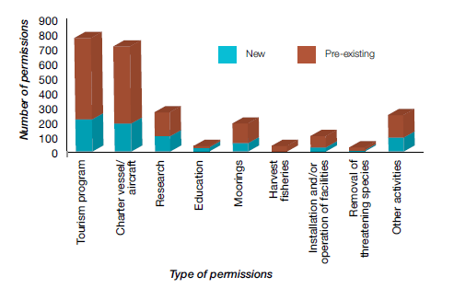
Figure 10: Type and number of permissions granted during 2013–14 as a proportion of the total number of permissions managed by the agency

Dredging and disposal
Carrying out dredging and disposal of dredge spoil requires a permit from the agency, and is included under ‘other activities’ in Figure 10, above.

During the reporting period, the agency was required to assess and make a decision on a development proposal under the Great Barrier Reef Marine Park Act 1975 and Environment Protection (Sea Dumping) Act 1981, which had been approved under the Environment Protection and Biodiversity Conservation Act 1999. The permit application related to the expansion of the Abbot Point coal terminal, near Bowen, and was subsequently granted with strict conditions (see page 77 for more detail).

The agency also made assessments and decisions on three maintenance dredging and disposal applications, and one permit variation, under the Great Barrier Reef Marine Park Act 1975 and the Environment Protection (Sea Dumping) Act 1981. These applications — for existing port, marina and boat ramp facilities — were granted.

During the reporting period, the agency conducted four field inspections, including environmental site supervision. In consultation with the Australian Maritime Safety Authority, the agency also issued exemptions to compulsory pilotage regulations for three vessels travelling through the inner route of the Marine Park.

Further, the agency provided advice and input into three port development and expansion applications under the Environment Protection and Biodiversity Conservation Act 1999 that were deemed to also be applications under the Marine Park Act, as elements of the applications might occur in the Marine Park. In addition, the agency continues to provide advice to the Australian Department of the Environment for port- related projects that are located in the Great Barrier Reef World Heritage Area and outside the Marine Park in port exclusion areas.

Legislation governing decisions
While the agency has the authority to assess and make decisions about permit applications under the Environment Protection (Sea Dumping) Act 1981 and the Sea Installations Act 1987, most decisions
are made under the Great Barrier Reef Marine Park Act 1975. Of the permits issued under the Great Barrier Reef Marine Park Act, more than 97 per cent — or 438 permits were jointly issued with the Queensland Department of National Parks, Recreation, Sport and Racing which administers the Queensland Marine Parks Act 2004.

Review of policies
The agency’s review of the environmental impact management policy and the risk management framework and structures policy is well advanced. Proposed revisions are scheduled for internal consultation in the latter half of 2014.

Traditional use agreements
The agency assessed four applications for Traditional Use of Marine Resources Agreements against Regulation 89 of the Great Barrier Reef Marine Park Regulations 1983. This resulted in the Yirrganydji, Lama Lama Region, Woppaburra and Yuku-Baja- Muliku agreements being accredited during 2013–14. Accredited agreements now cover a total of 45,200 square kilometres of sea country and involve 16 Traditional Owner Groups. (Traditional Use of Marine Resources Agreements are reported in more detail, page 97.)

Applications refused, reconsidered and appealed
In 2013–14, three applications for a permit or permission were refused by the delegate: one related to a research application; one related to a tourism application; and the other related to a facility. The agency received four requests for a reconsideration of a decision: two requests related to access to the Cairns Planning Area; another related to a bond amount for a facility; and the fourth related to maintenance dredging.

Three requests for reconsideration were affirmed by the relevant delegate during the reporting period. Subsequent to the reconsideration process, two applications — both relating to access to the Cairns Planning Area — were taken to the Administrative Appeals Tribunal.

There were also two legal challenges in which the agency was directly involved during the reporting period, both of which related to the Abbot Point project permit decisions.

Post-decision monitoring and compliance
A suite of monitoring and administrative compliance activities was carried out in 2013–14 including targeted field inspections, monitoring of permitted use, ensuring permitted facilities are well maintained, and education designed to promote self- regulation. Environmental site supervision was also conducted at priority sites, typically linked to an approved schedule of works or environmental management plan. Staff also participated in two far northern patrols with the Queensland Parks and Wildlife Service. Conditions associated with three permits were varied as a result of administrative compliance actions.

During 2013–14 several staff participated in training related to environmental impact assessment and environmental auditing and compliance.

Part 5 Directions
During the reporting period, the agency gave two Part 5 Directions under the Great Barrier Reef Marine Park Zoning Plan 2003 relating to the operation and maintenance of essential navigation aids in the Marine Park. One direction was for external painting and maintenance of the Dent Island lighthouse in the Whitsundays. The other was for the decommissioning, relocation and construction of the Bailey Islet helipad and the replacement of the Bailey Islet aid to navigation, offshore Mackay.

Defence
The agency also participated in planning and monitoring of major defence activities. This included Talisman Saber 2013 — a joint exercise between Australia and the United States — and Wallaby 2013 — a joint exercise between Australia and Singapore. For both exercises, the agency reviewed the proposed activities and worked with Defence to improve environmental management and reporting.

After Talisman Saber, the agency completed a risk assessment of a salvage plan developed by the Australian Department of Defence and the United States Navy to recover and dispose of jettisoned ordnance. An agency representative also embarked on the USS Germantown to observe and assist in the operation to recover the ordnance from the seafloor. This included developing environmental management strategies for inclusion in the retrieval and disposal plan.

Abbot Point permit approval
On 10 December 2013 Federal Environment Minister Greg Hunt approved an application by North Queensland Bulk Ports under the Environment Protection and Biodiversity Conservation Act 1999 to expand its coal terminal at Abbot Point, near Bowen. As part of the development of Terminal 0, Terminal 2 and Terminal 3, North Queensland Bulk Ports will dredge approximately three million cubic metres from the seabed to deepen an area around six new ship berths.

The Great Barrier Reef Marine Park Authority subsequently considered permit applications from North Queensland Bulk Ports to dispose of dredge material associated with this development to a location within the Great Barrier Reef Marine Park. These applications were considered under the Great Barrier Reef Marine Park Act 1975 and the Environment Protection (Sea Dumping) Act 1981. On 31 January 2014, the agency approved the permit applications under these acts subject to strict conditions.

The basis for decision was outlined in a statement of reasons, published on the agency’s website, www.gbrmpa.gov.au.

The decision made by the Minister under the Environment Protection and Biodiversity Conservation Act 1999 is the subject of legal challenge in the Federal Court and the decision made by the agency as the Minister’s delegate under the Environment Protection (Sea Dumping) Act 1981 is the subject of legal challenge in the Administrative Appeals Tribunal.

Improved dredge management
The improved dredge material management for the Great Barrier Reef Region project was finalised in July 2013 and the final reports were published on the Australian Department of Sustainability, Environment, Water, Population and Communities’ (now Department of the Environment) website. The agency finalised an interpretive statement regarding the dredge report and published it on the agency’s website in October 2013.

The improved dredge material management project was one of five projects funded through the Australian Government’s Sustainable Regional Development program in 2012–13 to inform the strategic assessment of the Great Barrier Reef Region.

Its purpose was to review options for the beneficial reuse and land disposal of dredge material, develop a framework for water quality monitoring and management programs during dredging and disposal, and assess potential alternative dredge material placement sites in six study areas along the Great Barrier Reef coast. It was not intended to inform project assessments.

The research, which was carried out by Sinclair Knight Merz and Asia-Pacific Applied Science Associates, was the first to incorporate the combined influence of waves, tides, local winds and large-scale currents when modelling the movement of dredge material over 12 months at multiple locations.

The improved dredge material management project identified a number of knowledge gaps and subsequently the joint agency– Australian Institute of Marine Science dredge synthesis project commenced in October 2013 to further understand the physical, chemical and ecological aspects of dredging and dredge material disposal management. This is reported in more detail on page 79.

Ship anchorage management
The ship anchorage management in the Great Barrier Reef World Heritage Area project was finalised in July 2013 and the final reports were published on the Australian Department of Sustainability, Environment, Water, Population and Communities’ (now Department of the Environment) website.

This project was also funded through the Australian Government’s Regional Sustainability Planning program to inform the strategic assessment of the Great Barrier Reef Region.

The project was carried out by Gutteridge Haskins & Davey and encompassed an environmental impact assessment of ship anchorages, a cost-benefit analysis of potential ship anchorage management arrangements and identified viable environmental management strategies of ship anchorages in the World Heritage Area.

The project findings have been incorporated into the North-east Shipping Management Plan, led by the Australian Maritime Safety Authority and developed in close consultation with a range of government agencies, including the Great Barrier Reef Marine Park Authority, and key stakeholders.

Coastal ecosystems and water quality
During the reporting period, the agency undertook a number of actions aimed at improving the outcomes for the Great Barrier Reef’s water quality and coastal ecosystems that are subject to changing levels of human uses, especially associated with major projects. This included undertaking assessments, and providing advice to the Australian Government, on 28 major development proposals in or adjacent to the Great Barrier Reef World Heritage Area.

The agency provided further advice on major issues and reviews such as the Independent Review of Gladstone Harbour, an ongoing review by the Queensland Competition Authority of legislation especially around aquaculture management in Queensland and the discharge of water from flooded mines in the Fitzroy catchment.

The agency also provided advice to the Queensland Government on the amendment of several pieces of its legislative and planning instruments including its new one- stop State Planning Policy, the Vegetation Management Framework Amendment Bill 2013, and the Cape York Regional Plan. (The agency’s work on the area of coastal ecosystems and water quality is also reported in Objective 1, pages 32–36.)

Dredge synthesis project
The agency has been working with the Australian Institute of Marine Science to compile existing scientific knowledge of how dredging and disposal impacts on habitats of the Great Barrier Reef and identify what further research is needed.

This work is being done through a panel of 19 technical and scientific experts, who were selected based on their expertise in areas relevant to the scope of the dredge synthesis project. They have a broad range of skills, experience and perspectives — from oceanographic modelling to coral ecology.

The expert panel met for a three-day workshop in May 2014 to review existing information on the physical and biological effects of dredging and disposal.

Senior scientists from the agency and Australian Institute of Marine Science are now working with panellists to develop a synthesis statement summarising what is known about the biophysical effects of dredging, what are the areas of uncertainty or debate, and what are the key knowledge gaps. The synthesis statement is expected to be published in the latter half of 2014.
The project will improve the agency’s understanding of the effects of dredging in the Great Barrier Reef Region, and help it develop policy and best practice guidelines which will inform the assessment of proposed developments that involve dredging.

The gaps in knowledge identified through the project are likely to guide further research into the effects of dredging and disposal.

Offsets management
The agency is continuing to work with the Department of the Environment to utilise the new Reef Trust as a mechanism through which the agency will receive conditioned financial offset funding associated with five developments approved under the Environment Protection and Biodiversity Conservation Act 1999.

Project proponents are required to provide direct and indirect offset funding as part of conditions associated with three liquefied natural gas developments on Curtis Island, a coal terminal at the Port of Abbot Point and a marina development on Great Keppel Island.

These funds will be used to assist with the management of the Great Barrier Reef World Heritage Area, and include the direct provision of offset revenue to the Great Barrier Reef Marine Park Authority.

The agency has consulted with the three proponents associated with the Curtis Island liquefied natural gas developments. Offset funding from these developments will be pooled to enable the agency to deliver actions that will provide greater environmental benefits to the Mackay– Capricorn section of the Great Barrier Reef in line with the conditions of their respective Environment Protection and Biodiversity Conservation Act approvals.

Environmental management charge
The management and administration of the environmental management charge — placed on most commercial activities, including tourism operations, in the Marine Park — continues to be an agency priority. A formal set of environmental management charge guidelines for permittees has been reviewed by the agency’s legal team to ensure best practice and transparent management of the revenue.

In 2012 the Australian Government announced a temporary reduction in the standard tourist program charge (a category of the environmental management charge) until 31 March 2015. This brought the charge for full-day passengers down from $6 to $3.50.
During the reporting period, all tourism operators were advised that the temporary reduction was coming to an end. This means, from 1 April 2015, the standard tourism program charge will return to $6 per visitor for a full-day visit and $3 per visitor for trips less than three hours, or for trips where visitors enter the Marine Park after 5 pm and depart prior to 6 am.

During 2013–14 the agency undertook a number of environmental management charge administrative compliance actions as noted in Table 6 below.

Table 6: The number of environmental management charge administrative compliance actions undertaken from July 2013 to June 2014
July-September 2013
Action
I intention to suspend 95
Suspended permissions 2
Revoked permissions 2
Reinstated 3

October-December 2013
Action
I intention to suspend 111
Suspended permissions 1
Revoked permissions 1
Reinstated 0

January-March 2014
Action
I intention to suspend 108
Suspended permissions 1
Revoked permissions 0
Reinstated 1

April-June 2014
Action
I intention to suspend 170
Suspended permissions 2
Revoked permissions 1
Reinstated 0

Year to date
Action
I intention to suspend 484
Suspended permissions 6
Revoked permissions 4
Reinstated 4

Table 7: Late payment penalty applied to environmental management charge payments due for the July 2013 to March 2014 period. Information on the April to June quarter was not available at 30 June 2014

Action July-September 2013 October-December 2013 January-March 2014

Late payment $3250 $4250 $3250
penalty applied

Tourism plans and policies

Marine tourism contingency plan
The Marine Park Authority board approved a review of the 2004 marine tourism contingency plan in March 2014. The plan — which focuses on assisting tourism operators following a severe environmental incident — clarifies the definition of severe environmental incident and the eligibility requirements for operators. Depending on the nature and scale of the severe environmental incident, there are three levels of response that may be implemented:

- Immediate responses — actions which may be taken immediately under the existing Marine Parks permit or management arrangements.

- Recovery responses — short- to medium-term actions, such as temporary relocation, that may require additional Marine Parks permits.

- Adaptation responses — long-term actions which may require changes to the operation and are required due to the nature and scale of the incident or where the number of operators impacted does not allow a case-by-case assessment of applications.

Moorings policy
The agency conducted a review of its 2005 moorings policy during 2013–14. The public consultation period for comments on the new draft policy closed on 30 June 2014, and the agency received 10 submissions.

The draft policy provides a framework for the management and use of moorings in the Marine Park that protects the environment and promotes ecologically sustainable access. It seeks to promote best practice design and management for moorings with a greater focus on achieving compliance with the agency’s requirements. Once public comments have been considered, the draft policy will be forwarded to the Marine Park Authority Board for approval.

Cruise shipping policy
A review of the agency’s 1999 cruise shipping policy commenced in June 2013 to ensure cruise shipping in the Marine Park continues to be ecologically sustainable and that the industry supports the protection of the Marine Park and the presentation of its World Heritage values. To inform the review, the agency held a cruise shipping workshop in Brisbane on 12 June 2014. Key stakeholders attended, including representatives of
the cruise industry, Australian Reef Pilots, Australian Maritime Safety Authority, Maritime Safety Queensland, Tourism and Events Queensland, and the Queensland Department of National Parks, Recreation, Sports and Racing.

Tourism permissions
As part of implementing its policy on managing tourism permissions, the agency conducted an expression of interest process in 2013–14 to allocate three special tourism permissions. These are permissions to conduct a tourism program, or to conduct an activity under a tourist program, where the regulations or a plan of management has imposed a limit on the number of such permissions that may be granted.

The special tourism permissions provided for two tourism operations to access the Hinchinbrook Planning Area on a daily basis, and for a tourism operator to conduct swims with dwarf minke whales in the Cairns Planning Area.

Applicants who expressed interest in the permissions were assessed against their responses to selection criteria relating to their competency to conduct the tourism operation and activity, the extent to which they would foster protection and presentation of the Marine Park, and the value of their contribution to Marine Park management.

All three special tourism permissions were allocated.

FIELD MANAGEMENT — INCIDENT RESPONSE, FACILITIES, INDIGENOUS ENGAGEMENT

During the reporting period, the Field Management Program managed, or assisted with, a range of incident responses in the World Heritage Area for both the Queensland and Australian governments.
Field management staff also worked on the provision and maintenance of visitor facilities on Great Barrier Reef islands, and supported Traditional Owners in implementing their sea country management initiatives.

Asian green mussels
On 5 September 2013, Asian green mussels an invasive marine pest which is declared under the Fisheries Act 1994 — were detected and removed from a 26-metre work boat at the Mackay shipyards, after the vessel went in for anti-fouling treatment.

A multi-agency incident response led by the Queensland Department of Agriculture, Fisheries and Forestry was initiated. The Field Management Program conducted the underwater surveys of the Mackay Marina’s tug berth and coal loader construction site, where no further mussels were detected.

Follow-up surveillance and water sample collection to check for mussel planktonic larvae found no indication of mussel spawning. The Queensland Department of Agriculture, Fisheries and Forestry also undertook education and awareness activities to alert Mackay Marina users to be vigilant about the marine pest.

Vessel and pollution incidents
The Field Management Program works in collaboration with partners such as Maritime Safety Queensland to deliver effective responses to incidents such as vessel groundings and pollution incidents. During the reporting period, the agency was involved in the following notable incidents:

Seafaris sinking
The luxury yacht Seafaris burnt and sank five
nautical miles south of Cape Tribulation on 3 October 2013. Shoreline inspections did not identify any impacts from diesel. Burnt, floating debris was removed soon after the incident; however, salvage attempts were hampered by adverse weather conditions.

Peg 1 grounding
The trawler Peg 1, with 5000 litres of diesel and four tonnes of prawns and bugs on board, grounded on Trokolby Reef, offshore from Mackay, on 14 April 2014.The grounding was linked to rough weather associated with severe tropical cyclone Ita. The crew were evacuated by rescue helicopter and no pollution was reported. A removal order was issued and the vessel salvaged. Inspections of the vessel on return to port indicated damage to the reef was likely to be minimal.

Vessel collision
On 29 April 2014, the northbound Golden Tiffany, a 149-metre oil/chemical tanker, collided with the southbound 19-metre cray boat Bandill K near Cape Direction in Cape York Peninsula. The Golden Tiffany was not carrying any oil or chemicals at the time. No injuries or pollution were reported.

Cyclone clean-ups

Cyclone Dylan
Tropical cyclone Dylan moved into the Marine Park on 30 January 2014 and crossed the coast as a Category 2 cyclone between Proserpine and Bowen early on 31 January. Thirty-nine visitor sites, 18 walking tracks, 85 public moorings and 44 reef protection markers in the Whitsundays were checked immediately after the cyclone. Thirty-four of the 39 visitor sites required maintenance and all walking tracks needed repairs. One public mooring and two reef protection markers also needed repairs. Reef health and impact surveys were also conducted to determine the extent of damage to the island’s fringing reefs.

Clean-up activities were completed quickly with only two sites — Black Island day use area and Peter Bay camp site — still closed in February 2014 due to large amounts of sand loss. The Black Island day use area was reopened on 4 February. However, due to a large amount of sand loss affecting the viable camping area, the Peter Bay camp site has been permanently closed with a new camp site opened at the nearby Cairn Beach.

Cyclone Ita
Tropical cyclone Ita was a powerful Category 5 system in the Coral Sea before crossing the Queensland coast as a Category 4 near Cape Flattery on 11 April 2014. It then made its way south along the Queensland coast

Under an incident response plan, Queensland Parks and Wildlife Service rangers arrived at Lizard Island on 17 April 2014 where two crews completed restoration works to park campgrounds and walking tracks and conducted 177 reef health and impact surveys covering 19 reefs.

All key visitor and management tracks and roads were cleared of fallen trees and the new Watson’s Bay boardwalk was cleared. The national park was quickly reopened to visitors.

The storm caused 15 reef protection markers to break away from their moorings. Four intact reef protection markers were collected and reinstalled, three were recovered for retackling and eight were missing.

At the same time other Queensland Parks and Wildlife Service rangers worked to reopen island campgrounds along the affected Queensland coast in time for Easter.

Visitor facilities
Ensuring visitor facilities are regularly inspected and appropriately maintained is a priority activity for the Field Management Program. Across the World Heritage Area 100 per cent of required inspections occurred on elevated platforms and moorings by the end of the maintenance cycle.

Fitzroy Island lookout
Construction of a new lookout platform on Fitzroy Island, off Cairns, was completed by field management rangers as part of the 2013–14 Queensland Parks and Wildlife Service capital works program. The project included track work to reinstate drainage, complete rock steps, repair eroded sections of track, install stone pitched steps and install retaining walls. All materials, tools and equipment were slung onto the construction sites by helicopter.

Public moorings and reef protection markers
A total of 124 public moorings and 137 reef protection markers are maintained and operated across the Great Barrier Reef Marine Park (see Table 8, below). These moorings and markers ensure protection of key locations and high use areas. Most public moorings and reef protection markers were operational at 30 June 2014, with
one mooring in the Whitsundays and two in the Cairns area unserviceable. Five reef
protection markers were missing in the Cairns area and will be reinstated along with two moorings early in 2014–15.

Table 8: Distribution of public moorings and reef protection markers
Management Moorings Reef protection
Unit markers
Far North 30 24
North Tropical 8 28
Coast
Whitsundays 86 49
Capricorn Coast 36

Indigenous engagement
The Field Management Program supports the land and sea country management initiatives of Traditional Owners, Indigenous communities, and the Australian and Queensland governments. This includes support for compliance training through the agency’s Indigenous Partnerships program, outlined on page 100. In addition, the program continued to employ officers that identify as Aboriginal or Torres Strait Islander people, and employed temporary Indigenous rangers from Raine Island Traditional Owner groups to assist with monitoring and on- ground work as part of the Raine Island recovery project. (The Raine Island recovery project is reported in more detail on page 37.)

Traditional Owners participated in field management vessel trips and land-based patrols for 143 person days, helping deliver field activities ranging from cultural site assessment and pest management through to wildlife surveys, compliance patrols and visitor management. Specific examples of the work carried out include:

- Traditional Owners supervising removal of a disused lighthouse on King Island within the Flinders Island Group
- undertaking site clean-up and lantana removal on Kuuku Ya’u-owned islands
- developing the Mazie Bay interpretive signage on North Keppel Island
- participating in the Raine Island recovery project

STEWARDSHIP AND PARTNERSHIP PROGRAMS
The Reef Guardian program and community stewardship projects create awareness and understanding of Reef issues, encourage local leadership on environmental projects and recognise people’s efforts to improve the health of the Reef catchment.

Key performance indicator
Increased support for, and the uptake of, best practice approaches

The growth in the High Standard Tourism and Reef Guardian programs indicates the agency has been successful in increasing support for, and the uptake of, best practice approaches. About 64 per cent of visitors to the Reef now travel with high standard tourism operators and the Reef Guardian program continues to grow. The program now has 308 schools, up from 293 at the end of the 2012–13 reporting period; 15 councils, up from 13; and 25 farmers and graziers, up from 19.

The Reef Guardian Fishers program is still in a pilot phase. At the end of the reporting period it included eight line fishing operations encompassing up to 59 vessels, two mixed diversified fishing operations, two marine aquarium fish and coral collecting operations with a further two evaluations pending. There were also three (predominantly) net fishing operations pending evaluation.

Reef Guardian program
The Reef Guardian program is the agency’s biggest and widest-reaching stewardship program. It creates awareness and understanding of Reef issues, fosters stewardship and recognises people’s efforts to improve the health of the Reef.

The program began with schools in 2003 and has grown over the years to include councils, fishers, farmers and graziers. In 2013–14, the program expanded the overall number of Reef Guardian participants, with increases in the number of schools, councils, fishers, farmers and graziers involved.

Reef Guardian Schools
The Reef Guardian Schools program engages with more than 126,000 students in 308 schools across Queensland — a significant growth on the 2012–13 financial year when the program reached 115,000 students at 293 schools.

In 2013–14, students undertook more than 1600 projects in their schools and local communities in the areas of water management, waste management, biodiversity, land management and climate change. Students are engaged in the program from early learning through to year 12.

The annual Future Leader Eco-challenges attracted 1030 students and 180 teachers from 122 schools, as well as 78 partner organisations.

The eco-challenges and the 2013 Reef Beat education series, ‘The amazing Great Barrier Reef, Let’s keep it great’, encouraged students to explore the Reef’s environmental, social and economic values, Traditional Owner connections to sea country and how the Great Barrier Reef is managed. It also highlighted the importance of healthy catchments and coastal ecosystems to the health of the Great Barrier Reef.

During the reporting period, the agency presented 10 Reef Guardian schools with $1000 annual awards in recognition of outstanding environmental projects. An additional 20 schools received $500 Ripples of Change funds to implement environmental initiatives in their school community that contribute to improving the health and resilience of the Great Barrier Reef.

Nearly 200 teachers from more than 120 schools participated in 15 Reef Guardian networking meetings in diverse locations across Queensland. These meetings were enhanced by the active participation of almost 160 representatives from 118 partner organisations.

Reef Guardian Councils
There are 15 councils along the Great Barrier Reef coastline participating in the Reef Guardian Councils program which covers all coastal councils from Bundaberg to Cooktown and equates to 317,271 square kilometres and a combined population of more than 890,000.

These councils are involved in more than 900 projects in the areas of land management, water management, waste management, climate change, and community education and capacity building.

Through the de-amalgamation of Queensland councils, there are three council regions that have been divided. Two of these councils
Livingstone and Mareeba — have joined the Reef Guardian program. At the end of the reporting period Douglas Shire Council had expressed interest and was working on developing an action plan.

Two steering committee meetings were held this financial year — one in October 2013 and the other in May 2014. The meetings present an opportunity for chief executive officers and mayors from Reef Guardian councils in the Great Barrier Reef catchment to come together with agency staff and other organisations to exchange experiences, identify opportunities to pool resources and swap ideas on improving sustainable practices.

Reef Guardian Farmers and Graziers
Over the last two years, 25 farmers spanning sugar, banana, horticulture and beef industries across the Great Barrier Reef catchment have participated in the development and piloting of the Reef Guardian Farmers and Graziers program. Forty-two other industry stakeholders and extension specialists have also been involved in developing the program.

During the reporting period, there has been a focus on resolving issues identified during the pilot phase of the Reef Guardian Farmers and Graziers program and aligning the program with the best management practice programs for the sugar, beef and banana industries. This will improve efficiency and consistency with other programs supporting practice change to benefit the health of the Great Barrier Reef. It will also strengthen the agency’s influence on drivers and activities affecting the Region’s values.

The assessment tools and processes are
finalised and a strategy for expansion is
in place, subject to resource prioritisation. Stakeholder and participant engagement in the program ‘post-pilot’ is likely to take more of a regional focus in contrast to the industry focus during its development. This should enable participants to get greater value from networking and stewardship actions with Reef Guardian farmers from other sectors, as well as councils and schools.

Reef Guardian Fishers
There are eight participating reef line fishing operations in the program encompassing up to 59 vessels including primary vessels and dories from ports including Gladstone, Bowen, Innisfail and Cooktown. There are also two smaller diversified fishing operations from Innisfail and Mission Beach.

The Marine Aquarium Fish and Coral Collection pilot program was initially based around the involvement of two operators in the Cairns area. Discussions with other collectors were initiated at several ports along the Great Barrier Reef Marine Park coast and they subsequently participated in a steering committee meeting in February 2014. Evaluation of two of these collectors is being finalised.

An ecological risk assessment of the Marine Aquarium Fish and Coral Collection Fishery was completed in May 2013. As a result, the Pro-vision Reef stewardship action plan, which is relevant to this fishery, was revised collaboratively by industry, management and science in late 2013. This was to enable the fishery and its members to better meet the Convention on the International Trade of Endangered Species requirements as well as to incorporate learnings from the application of the stewardship action plan.

Evaluation of three predominantly large mesh net fishers in the diverse multi- species inshore net fishery has commenced as part of a pilot program in this fishery. The development of relevant operational standards to address ecological risk in this fishery is picking up on work that was initiated by a former multi-agency protected species working group that was disbanded following structural changes to Fisheries Queensland.

Given the complexities of the various fisheries and the pending review of fisheries management by the Queensland Government, the Reef Guardian Fishers program is still in a pilot phase.

Development and direction
Reef Plan, a joint commitment between the Australian and Queensland governments to improve water quality in the Great Barrier Reef, has an objective to foster and recognise stewardship activities within farming, grazing, councils and schools across the Great Barrier Reef catchment that help achieve Reef Plan outcomes. In line with this objective, the Reef Guardian farmers and graziers and fishers pilot programs have sought to engage a greater regional spread of participants to help facilitate Reef Guardian program participation. Engagement has been focused on priority areas identified by Reef Plan for rehabilitation and restoration to support the health and resilience of the Great Barrier Reef.

Community partnership projects
In the past year, regional staff working in Cairns, Mackay and Rockhampton increased their focus on bringing together industry, government and community stakeholders for on-ground projects aimed at improving Reef health. Using funds provided through the Climate Change Action Plan 2012–2017, five small community stewardship activities were initiated. These community partnership projects brought together participants from all Reef Guardian programs, as well as from industry, government and the wider community to work on local projects that improve the health and resilience of the Reef and the connected ecosystems.

The aim of these community partnership projects is to foster a sense of community stewardship, and to build the knowledge and capacity needed for community members to work together on regional projects that can have a positive impact on Reef health and recovery. This model of regional stewardship action will be the vehicle for integrating Reef Guardian programs with each other, and strengthening partnerships between these programs, regional organisations, industry groups and communities. (See also case study, page 90.)

Innisfail farm tour
Collaboration between Reef Guardian farmers, government agencies and the Johnstone River Catchment Management Association led to a tour of four Innisfail district farms in May 2014. Farmers, catchment volunteers, extension officers and researchers shared their experiences and looked at systems to protect farm soil. The event showcased innovative soil sediment controls and how partners can work together effectively on common issues.

Mission Beach wetland project
During the reporting period, the Mission Beach State School and other community partners led a campaign to restore a wetland adjoining the school which was damaged by cyclones Larry and Yasi (see case study, page 90).

The success of Mission Beach State School’s wetland project has led to an expansion of the rehabilitation program to a neighbouring site managed by the Djiru Traditional Owners. With the help of community volunteers, council staff and researchers, Mission Beach State School is teaching students to monitor the improvements at the wetland, and plan to showcase their work to other Cassowary Coast schools in September 2014.

Kinka Wetlands community event
About 90 people celebrated wetlands biodiversity in May 2014 at the Kinka Wetlands Reserve near Yeppoon. The community education event was organised by the Reef Guardian program’s Livingstone Shire Council in partnership with the agency, catchment groups and wildlife organisations. The event led to the local community becoming more supportive of the council’s proposed management strategy for the wetlands, suggesting stewardship is more likely to occur when education has been focused on a particular area and its importance has been showcased to the local community. The event also facilitated the formation of a Friends of Kinka Wetlands group, which will be consulted about council plans for the area and be involved in further on-ground maintenance and planting.

Mackay Wetlands Walkabout
The agency worked with Reef Guardian schools, the Mackay Regional Council and Conservation Volunteers Australia to develop activity books and improve interpretive trails to encourage school excursions to the Wetlands Walkabout on Keeley’s Road, Mackay. The project has led to these partners strengthening their relationship. They hope that, by supporting schools to visit the wetland, they will inspire students to do their bit to maintain healthy wetlands.

Demonstration wetland at Lower Burdekin
NQ Dry Tropics, Burdekin Bowen Integrated Floodplain Management Advisory Committee, Lower Burdekin Landcare, Wetlands Australia and the Burdekin Shire Council have been the key players behind the construction ofan artificial wetland at the Lower Burdekin Landcare nursery to manage irrigation water draining from the site. This water filtering system, comprising a series of planted ponds, will make the nursery a good excursion destination for local schools as well as an environmental education opportunity for community visitors. The nursery is a key resource for local agencies and farmers, providing plants for wetland rehabilitation and other local projects that improve ecosystem health.

Marine debris clean-up
More than 100 Gunggandji Traditional Owners and Yarrabah State School students joined forces with Cairns residents to clean up a remote beach near the Cairns district Aboriginal community in September 2013. The event was initiated by the Cairns Local Marine Advisory Committee to raise awareness of marine debris washing up on far northern beaches. It brought together a range of partners including the Cairns naval base and the Yarrabah Shire Council to tackle a common problem.

Tree planting project
More than 60 students from Mossman State School participated in tree planting and water quality studies at Cassowary Creek in April 2014. The project was a partnership between the Douglas Shire Council, Terrain Natural Resource Management, farmers and the Douglas Local Marine Advisory Committee.

Unfortunately, cyclone Ita crossed the far north Queensland coast a few weeks later, washing away about 50 of the 250 trees planted. The young trees have since been replaced by council officers, who continue to monitor and maintain the site.

COMMUNITY MISSION BEACH WETLANDS PROJECT
In 2013–14, the agency used funding through the Climate Change Action Plan 2012–2017 to increase its focus on improving Reef health at a local level by bringing together industry, government and community stakeholders to participate in regionally based stewardship projects.

The Mission Beach wetlands restoration project in far north Queensland was one such project. The wetlands between Mission Beach State School and Dunk Island View Caravan Park suffered significant environmental damage from cyclone Larry in 2006 and cyclone Yasi in 2011.

The cyclone knocked out much of the higher vegetation, resulting in the once healthy wetland becoming infested with weeds and losing biodiversity. The weeds blocked the creek flow causing localised flooding during rain periods and the wetland was no longer effectively filtering water flowing into the Great Barrier Reef Marine Park.

Led by the Reef Guardian program’s Mission Beach State School, community members, the River Improvement Trust, Dunk Island View Caravan Park, Cassowary Coast Regional Council and Djiru Traditional Owners, the project saw 20 truckloads of weeds removed and more than 500 native trees planted in November 2013.
A second tree planting involving community members, school students, Cassowary Coast Regional Council and Djiru Traditional Owners took place in March 2014 and saw another 400 trees planted.

The school and neighbouring caravan park, along with the Cassowary Coast Regional Council, are involved in ongoing monitoring and maintenance of the restoration works. The project has also expanded to include an education component between community partners and school students.

More than 60 students took part in wetlands education days on site in June 2014, learning about water quality monitoring, biodiversity and cultural values of the Traditional Owners.

Further information seminars involving local experts and community members are planned to coincide with working bees later in 2014 to assist with weed management.

Community education
Community events such as outdoor expos and festivals provided an opportunity for agency staff to engage face-to-face with stakeholders. Staff participated in events specifically aimed at educating communities on issues such as improving urban water quality, improving green zone compliance and promoting Reef Guardian stewardship behaviours.

Reports of increased recreational fishing in green zones led the agency to step up its focus on compliance education. Zoning maps were provided to more than 290 visitor centres, tackle shops and other community information access points. Staff attended fishing competitions and children’s fishing days to promote the benefits of no-take zones. Senior compliance officers presented at Local Marine Advisory Committee meetings in regions where a high number of incidents have been reported. Stakeholders report that the increased awareness has led to greater community support for protecting green zones.
High Standard Tourism program
The High Standard Tourism program continues to promote tourism operators who voluntarily operate to a higher standard than required by legislation as part of their commitment to ecologically sustainable use. These operators are independently certified with the ECO certification program, managed by Ecotourism Australia, as meeting best practice standards for the key areas of protection, presentation and partnership.

The number of high standard tourism operators increased from 59 operators in 2012–13 to 62 operators in 2013–14. About 64 per cent of visitors to the Reef now travel with high standard tourism operators.

In May 2014, the agency showcased its High Standard Tourism program at the Australian Tourism Exchange in Cairns. The event is the largest trade show of its kind, attracting almost 2000 delegates from 36 countries.

The agency and Ecotourism Australia jointly funded a booth to promote high standard tourism operators operating in the Marine Park. Agency officers participated in over 70 appointments to promote high standard operators to buyers, international education providers and tourism associates.

Tourism visitation
The Great Barrier Reef remains an iconic destination for both international and domestic visitors. Visitation in 2013–14 grew in comparison to 2012–13 and there is a continuing trend of a slow but steady recovery. Figure 11 below is based on information provided by tourism operators in their environmental management charge returns.

During the reporting period, the agency continued to work on analysing tourism visitation. Visitation fluctuates depending on tourism trends, weather and even global factors.Through this project, the agency has identified the need to refine permit and environmental management charge data to ensure that finer scale data is available on tourism visitation patterns to the Marine Park, is timely and of the highest quality. Quarterly tourism visitation figures continue to be available through the agency’s website.

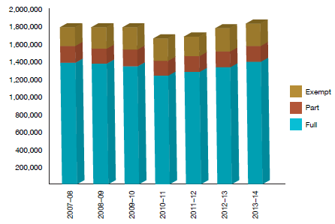

Figure 11: Tourist visits* to the Great Barrier Reef Marine Park since 2007–08
Source: Great Barrier Reef Marine Park Authority environmental management charge records
* These figures do not include stand-alone coral-viewing activities and scenic flights

Local Marine Advisory Committees
During the year, the agency’s 12 Local Marine Advisory Committees continued to play an influential role, providing advice on a range of policy and management issues. Committee members come from a wide range of backgrounds and include Traditional Owners, commercial fishers, farmers, local councillors, conservationists, tourism operators, recreational reef users, shipping representatives and port operators. They provide a diverse range of views on policy proposals, and also communicate matters of local concern to the agency.

The committees supported a wide range of projects in their communities, including education and awareness raising activities about wetlands, marine debris, turtle strandings and sustainable fishing practices.
Reef Advisory Committees
Up to December 2013, the agency had four issue-related Reef Advisory Committees comprising a cross-section of stakeholder interests with experience and expertise in relevant areas. They were:

- Catchment and Coastal Reef Advisory
- Committee
- Ecosystem Reef Advisory Committee
- Indigenous Reef Advisory Committee
- Tourism and Recreation Reef Advisory Committee.
During 2013–14, the committees provided advice and guidance on a range of issues including the strategic assessment of the Great Barrier Reef Region.

The Reef Advisory Committee terms ended 30 December 2013. In April 2014, the Marine Park Authority Board approved the establishment of a Tourism Reef Advisory Committee to replace the Tourism and Recreation Reef Advisory Committee

Contribution to the strategic assessment
The agency’s Local Marine Advisory Committees and Reef Advisory Committees played an important role in the development of the draft Great Barrier Reef Region Strategic Assessment Report. During the consultation phase of the assessment, stakeholders who had previously contributed to its development were invited to attend presentations about the draft reports. Presentations were held in Cairns, Townsville, Airlie Beach, Mackay, Rockhampton and Gladstone and were followed by public information sessions. Other consultation included:

- an additional workshop at Cairns specifically for Traditional Owners

- a briefing about the draft strategic assessment reports at the November 2013 round of Local Marine Advisory Committee meetings

- a workshop in December 2013 where the draft reports were discussed by members of each of the Reef Advisory Committees and the Chair or representative from each of the Local Marine Advisory Committees.

Eye on the Reef program
Eye on the Reef is an environmental monitoring, education and stewardship program run by the agency in partnership with scientists, the tourism industry, Marine Park rangers and other Reef users.

The program began in 1997 as a set of observations collected by tourism operators. It has since been expanded to include a

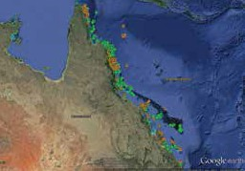

Figure 12: Spatial coverage of all Eye on the Reef surveys during 2013–14
number of monitoring tools that collect different types of information on reef health, species and incidents. All of the information is combined in an integrated data management system to provide an up-to-date picture of reef-wide health and the distribution of marine species.

The different monitoring tools are designed to suit people from all walks of life, with various levels of reef monitoring experience. They include Tourism Weekly Monitoring, Reef Health and Impact Surveys, Rapid Monitoring and Sightings network.

During the reporting period, the agency received more than 5600 surveys from almost 270 reefs in the Great Barrier Reef Marine Park (see Table 9, below). The spatial coverage of these surveys is depicted in Figure 12, above. Along with reef health surveys the agency received 1100 sightings through the smartphone app and sightings forms.

Table 9: Number of surveys received through the Eye on the Reef program

The Eye on the Reef program is now recognised on a national and international scale and, as such, many countries have started replicating the program and modifying it to suit their local reef area. An example of this is on Reunion Island (French territory) and, more recently, islands of the Caribbean.

In-water training days
During the reporting period, the agency conducted annual in-water training days for tourism operators and the joint Field Management Program, with 80 Marine Park rangers and tourism crew trained in reef health monitoring. The program was further expanded in the southern Great Barrier Reef to broaden the reach and gather health information on previously unknown Reef locations (see case study, page 96).

Tourism Weekly Monitoring
Participation in the Tourism Weekly Monitoring program strengthened during 2013–14 due to a renewed focus on engagement with tourism operators in the Whitsunday, Cairns and Far North regions. The agency also introduced the program to operators and researchers in the southern Great Barrier Reef region

About 135 tourism crew are currently involved in the program, monitoring sites on up to 25 reefs on a regular basis and submitting sightings of protected and iconic species through the Sightings and Rapid Monitoring programs from more than 160 reefs.

Data uses
The agency has long used the data collected through Eye on the Reef to inform Reef Health Incident Response, resilience mapping and water quality. This data is now being used by researchers from the Australian Institute of Marine Science, James Cook University, University of Queensland and the Reef and Rainforest Research Centre to inform protected species abundance and distribution, crown-of-thorns starfish impact and density analysis, and current Reef health.
Smartphone app
The Eye on the Reef smartphone app, launched in June 2013, provided a new way for Reef visitors and users to send in real- time sightings of marine animals while still out on the water. The app enables anyone with a smartphone to send photos, video recordings and observations of marine animals to the agency, while also sharing these sightings with Facebook friends.

The free app has been downloaded more than 700 times since its release, with new participants signing up daily to submit their sightings.

While most sightings reports continue to be submitted through the old paper forms, a growing number of regular reef users are submitting observations through the smartphone. During the reporting period, the agency received more than 500 observations through the app — a figure which is expected to grow as the agency continues to promote the app.

Online training
The agency completed its Eye on the Reef online training package in May 2014, enabling interested people to do a course on reef health assessment from anywhere in Australia or the world. Developed by experts in the field of reef health assessment, the package contains four interactive modules covering Great Barrier Reef biology and ecology, coral impacts, best environmental practice on coral reefs and how to provide valuable monitoring data to the Great Barrier Reef Marine Park Authority.

Each module can be viewed independently or completed as a course in rapid coral reef assessments.

More than 400 people have already completed the online training courses and now actively contribute by providing survey data to the agency. Feedback has consistently been positive.

EYE ON THE REEF EXPANDS SOUTH

The Eye on the Reef — Tourism Weekly program has swelled its ranks, thanks to a concerted effort to expand the program in the southern Great Barrier Reef Region.

Tourism Weekly originated in the Port Douglas area in the late 1990s and has been well supported by tourism operators in the Port Douglas and Cairns areas since that time. The program was expanded to the Whitsundays in 2007 and is now one of the world’s largest tourism-based coral reef monitoring collaborations.

During 2013–14, the agency further expanded Eye on the Reef into the southern Great Barrier Reef.

Participants from the resorts and research stations on Lady Musgrave, Heron and Lady Elliot islands completed in-water training sessions at these islands in May 2014. For most of the tourism staff, this was their first exposure to the program.
Key outcomes of the training sessions were:

- the agency now receives regular reef health surveys from the southern region
- tourism and research staff in the southern Great Barrier Reef have a greater
- understanding of Reef health impacts, and the presence or absence of protected and iconic species
- increased staff interest in getting visiting school groups to do rapid monitoring surveys as part of their marine science studies
- staff are trialling the rapid monitoring surveys as a stepping stone to other tools in the program.

Citizen science networks
The international community has recently established national networks or associations to coordinate the development of citizen science amongst researchers, managers and the public. Australia is now planning to establish a similar governing framework with access to the latest resources, methods and international networks. As such, the Eye on the Reef program is now part of a broader collective of Great Barrier Reef citizen science groups. The collective aims to enhance the visibility of participation in citizen science on the Great Barrier Reef. The collective has developed a Great Barrier Reef hub which brings all the Great Barrier Reef Citizen Science groups under one umbrella on the web. This will broaden the reach of citizen science groups and enhance education, community engagement and collaboration.

Australian Awards Fellowship
During the reporting period, the agency successfully administered an Australian Awards Fellowship through the Department of Foreign Affairs and Trade. The fellowship enabled capacity building of six individuals responsible for managing the healthiest reef system in the Mexican Caribbean — the Mesoamerican Barrier Reef — through interaction with key staff and stakeholders involved in the agency’s stewardship and partnership programs.

The visit provided Fellows with the technical leadership skills required to implement similar programs on the island of Cozumel, Mexico, and an insight into governance arrangements. It also gave Fellows the opportunity to hear firsthand from industry stakeholders and other partners as to why they are involved in programs such as Reef Guardians, Eye-on the Reef, and High Standard Tourism, and how this involvement positively affects their business. Two workshops were held to explore options for implementing this new knowledge on their return to Mexico.

Indigenous Partnerships program
More than 70 Aboriginal and Torres Strait Islander Traditional Owner clan groups have continuing relationships with the Great Barrier Reef Region and its natural resources, dating back more than 60,000 years. The agency works in partnership with Traditional Owner groups to manage sea country, primarily through the Land and Sea Country Indigenous Partnerships program.

Funding for second phase
The agency’s Indigenous Partnerships group began implementing phase two of the Land and Sea Country Indigenous Partnerships program in July 2013, after securing $10 million over five years from the Australian Government. This funding will enable the agency’s Indigenous Partnerships group to:

- expand the Traditional Use of Marine Resources Agreement program across the Great Barrier Reef catchment
- implement marine resources agreements and their associated management plans; and enhance compliance to address illegal activities that threaten cultural and natural heritage values

- strengthen communication and engagement across the Great Barrier Reef catchments and other sectors to build a better understanding of management issues for Traditional Owners.

Traditional Use of Marine Resources Agreements
The agency continues to provide high level support to Traditional Owners to implement their accredited Traditional Use of Marine Resources Agreements — each of which has an implementation plan that describes priority work around the identification, protection and conservation of natural and cultural heritage values, and compliance management

The agency also provides intensive on- ground support through dedicated project managers assigned to each agreement group and, through this effort, facilitates joint management activities, such as ranger patrols and other field management activities, including comprehensive compliance management. These project managers also facilitate other active partnerships to implement the marine resources agreement, such as with the Australian Maritime Safety Authority and research partners.

At the end of the reporting period, there were seven Traditional Use of Marine Resources Agreements and one Indigenous Land Use Agreement in operation along the Great Barrier Reef coast. The agreements cover a total of 45,207 square kilometres of sea country and involve 16 Traditional Owner groups (see Figure 13, page 99). They are:

  - Wuthathi agreement
  - Lama Lama agreement
  - Yirrganydji agreement
  - Yuku-Baja-Muliku agreement
  - Girringun regional agreement
  - Woppaburra agreement
  - Port Curtis Coral Coast regional agreement
Kuuku Ya’u (Indigenous Land Use Agreement.

New Traditional Use of Marine Resources Agreements
During the reporting period, four new agreements were either accredited by the agency or came into effect.
- The Yirrganydji Traditional Use of Marine Resources Agreement, which covers an offshore area of 2066 square kilometres between Cairns and Port Douglas, came into effect on 29 April 2014. It is the first such agreement for the Yirrganydji Traditional Owners. (See case study, page 101.

- The Woppaburra people’s third Traditional Use of Marine Resources Agreement came into effect on 30 June 2014. It covers 561 square kilometres of the Marine Park, including the Keppel Islands and surrounding sea country. The agreement will run for 10 years, making it the longest such agreement to be accredited by the Australian and Queensland governments.
- The Yuku-Baja-Muliku Traditional Use of Marine Resources Agreement was accredited by the agency in June 2013, and came into effect on 16 August 2013 when it was accredited by the Queensland Government. It covers 1088 square kilometres in the Archer Point area, south of Cooktown in Cape York Peninsula. The traditional sea country estate of Yuku-Baja-Muliku stretches from Monkhouse Point south to Forsberg Point and extending east to just past the Ribbon Reefs.

- The Lama Lama Traditional Use of Marine Resources Agreement came into effect on 1 August 2013. It extends over the western half of Princess Charlotte Bay in Cape York Peninsula and covers 2323 square kilometres, stretching south from Massy Creek to the entrance of the Normanby River and extending east to Hedge Reef.

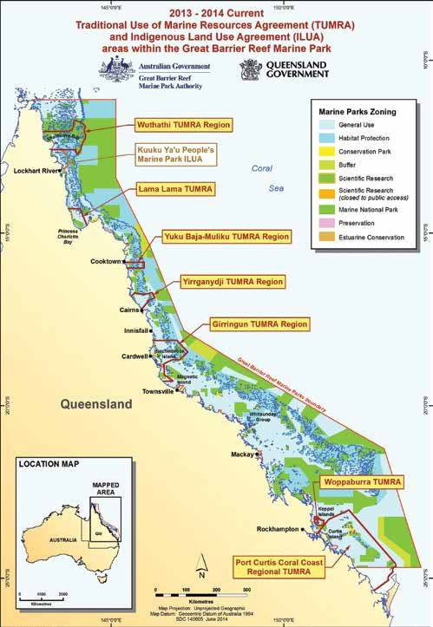

Figure 13: Traditional Use of Marine Resources Agreements and Indigenous Land Use Agreements within the Great Barrier Reef Marine Park

Cultural authority
A key outcome of the implementation of the Traditional Use of Marine Resources Agreements is the empowerment of Traditional Owners to assert their cultural authority over hunting and collecting activities across their sea country, identified as one of the essential elements in addressing management issues surrounding sustainable take and poaching.

Implement compliance program
The demand by Traditional Owners for compliance assistance remained high during the reporting period and the agency continued to provide specialised support in this area to Traditional Owner groups along the Great Barrier Reef coast. The agency continues to deliver targeted compliance training to Indigenous rangers. It also facilitates joint patrols, undertakes compliance planning and risk assessments with Traditional Use of Marine Resources Agreement groups and responds to areas at high risk of non-compliance. These are some of the ways in which the Australian Government is supporting cultural authority on the ground.

In addition, the expertise and experience of the Indigenous compliance team is routinely called upon across the agency to provide investigation advice and support to the broader field management compliance program.

The agency’s Indigenous compliance team continues to work with community ranger groups on potential incidents in the Marine Park and the key achievements for 2013–14 include:

- continued development of compliance management plans and risk assessments for each individual Traditional Use of Marine Resources Agreement and Indigenous Land Use Agreement, which are updated annually

- drafting of regional compliance management plans for specific areas where compliance matters are of high concern
- providing high-level advice and support to the field management compliance unit on information relating to investigations, trends, intelligence and concerns.

Deliver compliance training
During the reporting period, the agency delivered compliance training to 58 Indigenous community rangers from six ranger groups and 57 Indigenous community members from seven Traditional Owner groups. Participants included Indigenous rangers, Indigenous and non-Indigenous community members and Traditional Owners from within and outside the Great Barrier Reef Region. Other Indigenous community members have expressed strong interest in attending training programs to be delivered by the agency in 2014–15.

Compliance partnerships
In February 2014, the agency formalised a partnership with the Torres Strait Regional Authority which saw the rollout of the agency’s Eyes and Ears compliance training program to rangers in the Torres Strait. This training will provide rangers with greater skills to manage compliance in the far northern section of the Great Barrier Reef.

NEW TRADITIONAL USE OF MARINE RESOURCES

AGREEMENT FOR CAIRNS AREA

The first Traditional Use of Marine Resources Agreement for the Cairns to Port Douglas region was officially launched in June 2014.

The voluntary agreement between the Yirrganydji people, the Great Barrier Reef Marine Park Authority and the Queensland Government, outlines how the Traditional Owners will manage their sea country and its resources over the next five years.

The agreement covers an offshore area of 2066 square kilometres between Cairns and Port Douglas, including important tourism sites and several Marine Park, National Park and Conservation Park zones.

It ensures the traditional use of marine resources such as turtles and dugongs is sustainable, and that valuable cultural practices continue to coexist with the conservation and management of the Great Barrier Reef.
Importantly, it recognises the Yirrganydji people’s cultural authority to stop illegal. activities that are occurring in their sea country through a compliance management plan.

Yirrganydji Traditional Owners are now working in partnership with the agency to stamp out illegal activities in the agreement area, particularly the illegal hunting of dugongs and turtles.

The Yirrganydji agreement took two years to develop and was accredited by the agency and the Queensland Government in April 2014. About 150 Yirrganydji Traditional Owners celebrated the launch of the agreement and their sea country management plan at the Holloways Beach
Environmental Education Centre on 27 June 2014.

The launch was also attended by representatives of the agency and the Queensland Department of National Parks, Recreation, Sport and Racing.

Compliance patrols
Indigenous community rangers participated in six multi-agency compliance patrols, logging seven patrol days under the agency’s Indigenous Partnerships compliance training program. These included:

- a land-based compliance patrol conducted with Wakooka and Kalpowar rangers at Bathurst Head, Boat Bay and Bathurst Bay to address compliance concerns in the ecologically sensitive Princess Charlotte Bay area

- aerial compliance helicopter patrols conducted with Apudthama, Lama Lama, Yuku Baja Muliku and Hopevale Congress rangers in the Cape York area. The patrols were conductedto support rangers and conduct surveillance over areas identified as high compliance risk by the field management compliance unit.

The consolidation of compliance training, together with direct support from the agency in cooperative compliance activities, resulted in rangers providing high-standard surveillance and evidence collection on several investigations. Key achievements in this area were:

- Apudthama rangers provided expert advice and evidence to determine the legitimacy of two people located hunting turtles in contravention of the rights and interest conferred under the Native Title Act to the Traditional Owners of the Boydong Island area. This information, coupled with the support of the Gudang Traditional Owners, led to sufficient evidence being gathered to instigate compliance actions against the two alleged offenders.

- Lama Lama rangers identified and collected detailed evidence that led to compliance actions being instigated against three people in contravention of the Lama Lama Traditional Use of Marine Resources Agreement.

- Apudthama rangers collated detailed information that led to a multi-agency compliance response targeting a high- risk recidivist commercial operator in the Northern Peninsula. Apudthama rangers participated in patrols that led to the identification of alleged offenders and subsequent compliance actions.

Indigenous engagement
The Sea Country Partnerships sponsorship program continues to provide Great Barrier Reef Traditional Owners sponsorship opportunities of up to $5000 per person to cover the costs of participating in training, events and exchanges. Since the implementation of phase two of the Reef Rescue program, a further 11 Traditional Owners have been provided a range of sponsorship opportunities.

These include Mandubarra Traditional Owners participating in a sea turtle health and rehabilitation workshop to assist in the establishment of their own turtle rehabilitation centre, a Traditional Use of Marine Resources Agreement and knowledge exchange workshop between the Koinjmal and Girringun Traditional Owners, and the Yuku-Baja-Muliku Junior Rangers participating in turtle conservation activities at the Mon Repos turtle rookery.

While the sponsorship program continues to be delivered in its current form, a full review is being undertaken to ensure all opportunities for Great Barrier Reef Traditional Owners to enhance their capacity to conserve and protect their natural resources are maximised to their full potential.

Sense Activity program
The Sense Activity program provides a framework for Traditional Owner groups to deliver an Indigenous-focused outdoor education and awareness activity using sensory and holistic learning.

The key focus of the program is to enhance Indigenous leadership in the realm of sea country management. This is achieved by providing opportunities for the exchange of traditional ecological knowledge through such things as bushwalking, on- water activities, beach clean-ups, plant identification or language activities and by providing a strong mentoring environment for youth or community. Participants learn from cultural mentors, agency staff, Queensland Parks and Wildlife Service staff and marine scientists about connection with land and sea country and how to protect and conserve that country.

The program was developed in 2011 and initially targeted Indigenous male high school students. It has now expanded cross- culturally to both male and female high school students, mentors, community leaders and broader community members.

During the reporting period, the program was delivered with a targeted approach to Traditional Owner groups with existing Traditional Use of Marine Resources Agreements.

The program places an emphasis on demonstrating and maintaining leadership through cultural respect in addition to providing participants an avenue to progress towards the development and implementation of a Sense Activity program within their own sea country areas.

Cape York engagement
The Cape York Local Marine Advisory Committee met five times during 2013–14 and saw an increase in Traditional Owner representation and attendance. The group now includes representation from Yuku-Baja- Muliku, Hopevale Congress, Lama Lama and Wuthathi.

Indigenous Partnerships staff maintained and serviced Cape York community access points throughout the year, with at least two face-to- face visits and phone contact.

The agency conducted Reef Guardian School activities across Cape York schools including:

- collaborative Traditional Owner beach clean-up events at Chilli Beach and Archer Point

- junior ranger program activities with Pul Pul, Lama Lama , and Yuku-Baja-Muliku Traditional Owner groups

- two Reef Guardian School teacher networking meetings

- Ripples of Change awards to Darnley Island (Tagai College) and Cooktown State School

- an action and adventure award to Badu Island School (Tagai College).

Indigenous Reef Advisory Committee
Members of the Indigenous Reef Advisory Committee attended a special meeting of all Reef Advisory Committee members on 12 and 13 December 2013 in Townsville to be briefed on the comprehensive strategic assessment of the Great Barrier Reef (see also page 130).

EDUCATION AND ENGAGEMENT

Reef HQ Aquarium
Through the provision of education and information services relating to the Marine Park, Reef HQ Aquarium ensures the community and stakeholders have a clear understanding of the value of the Great Barrier Reef, the threats to its sustainable future and their role in protecting it. Reef HQ Aquarium achieves this by providing world-class living exhibits complemented by thematic and interactive educational experiences, which raise awareness of the threats to the Reef and encourage behavioural change that will help protect the Great Barrier Reef.

Visitor numbers
Reef HQ Aquarium consistently meets visitor expectations and continues to attract visitors from throughout Australia and the world. The aquarium received 137,375 visitors during 2013–14. More than 97,900 people participated in Reef HQ Aquarium’s program of talks and tours during the reporting period. Therefore more than 71 per cent of people who visited the aquarium participated in a formal talk and/or tour, which raise awareness of threats to the Reef and encourage behavioural change.

Key performance indicator
Improved community understanding and consideration of the benefits the Great Barrier Reef provides

As the Australian Government’s national education centre for the Great Barrier Reef Marine Park, Reef HQ Aquarium plays a key role in teaching people about the value of the Reef and the benefits it provides to the community. Along with maintaining world-class living exhibits and interactive educational experiences, the aquarium connects with thousands of people across Australia and the world through its award-winning Reef videoconferencing program.

The agency also improves community understanding of the benefits of the Reef through its Reef Guardian program, which engages with students, councils, farmers, graziers and fishers across the Great Barrier Reef catchment. This expanding program creates awareness and understanding of Reef issues, fosters stewardship and recognises people’s efforts to improve the health of the Reef.

The agency’s communications section also plays a lead role in improving community understanding and consideration of the benefits the Reef provides. The agency uses a number of communication channels to reach a variety of audiences, both domestically and internationally. In recent years, it has also expanded its use of new media channels and has achieved significant growth in its Facebook following.

Visitor satisfaction
Reef HQ Aquarium implemented an electronic visitor survey in 2013–14 to enhance its commitment to continual improvement. The survey was commissioned on 1 November 2013 and was completed by 1516 visitors by 30 June 2014.

Survey results revealed 74 per cent of respondents agreed or strongly agreed that they had an improved understanding of Reef issues because of their visit to Reef HQ Aquarium. About 73 per cent of respondents agreed or strongly agreed that they had a better understanding of how they could help protect the Great Barrier Reef because of their visit to Reef HQ Aquarium.

Education programs
The Reef HQ Aquarium education team continues to deliver world-class reef education programs to students at all stages of learning, from early childhood through to tertiary level. Professional development programs are also provided to primary and secondary school teachers. During the reporting period, the team delivered formal reef education programs to 9055 students and teachers.

They included reef day programs, reef sleepovers, early years education Reef Kids, outreach education via videoconferencing, international student study abroad programs and teacher professional development.

Ecotourism certification
Reef HQ Aquarium has achieved and maintained triple-tier ecotourism certification. The Ecotourism Certification Program is Ecotourism Australia’s flagship product. It provides industry, protected area managers, local communities and travellers with an assurance that certified experiences are committed to best practice ecological sustainability, natural area management and the provision of quality ecotourism experiences.
Reef HQ Aquarium has achieved and maintained Advanced Ecotourism, Climate Action Business and Respecting Our Culture (ROC) certification since 2011.

Ecotourism awards
Reef HQ Aquarium was recognised for its commitment to ecotourism at the 2013 North Queensland Tourism Awards, winning the ecotourism award category. This award recognises ecologically sustainable tourism with a primary focus on experiencing natural areas that foster environmental and cultural understanding, appreciation and conservation. Reef HQ Aquarium went on to win the Silver Award in the Qantas Award for Excellence in Sustainable Tourism at the 2013 Queensland Tourism Awards.

Reduced energy use
In 2006, Reef HQ Aquarium set itself an ambitious energy use reduction target of 50 per cent. The facility achieved this in 2013– 14, recording an average total energy use of 52 per cent less than the 2006 baseline. This amounted to a 1163 tonne reduction in carbon dioxide emissions over the reporting period.

A significant contribution to the overall energy reduction outcome was made by Reef HQ Aquarium’s 161 kilowatt roof-mounted solar power array. This generated 260,337 kilowatt hours of electrical energy during 2013–14, saving 236 tonnes of carbon dioxide emissions.

Turtle hospital
The Reef HQ Aquarium turtle hospital has been a success story in terms of encouraging positive environmental behaviour change in the community. (Continued on page 107.)

TAKING THE REEF TO THE WORLD’S CLASSROOMS

Reef HQ Aquarium’s virtual outreach has taken the Reef to nearly every corner of the globe, delivering education without borders and knowledge without limits.

During 2013–14, the aquarium delivered 107 reef videoconferences to locations around Australia and the world, interacting with 4545 people.

The award-winning videoconferencing program has grown from strength to strength, extending the reach of the aquarium’s reef education efforts.

Cutting-edge technology enables high- definition sound and vision of a living reef to be taken virtually into classrooms all over the world, with sessions delivered by an experienced marine biologist from the Reef HQ Aquarium tank.

The diver teaches students about the Great Barrier Reef’s delicate marine ecosystem, taking them on exciting underwater journeys to see a living coral reef ecosystem and the creatures who call it home.

The interactive program also enables students to learn firsthand about the issues affecting the Reef — something they would not normally be able to experience.
The reef videoconferencing program effectively doubles the number of students aquarium staff can reach and teach. Around the world, Malaysian, American, Canadian, Korean and United Kingdom students have joined Australian classrooms immersed in a live reef education experience.

In 2013–14, the program won two awards, as voted by teachers in the United States. For the sixth consecutive year it was awarded the Berrien Regional Education Service Agency Teachers’ Favorite Award and, for the fourth consecutive year, it received a Center for Interactive Learning and Collaboration Pinnacle Award for outstanding education content delivered via videoconferencing technology.

Roy Campbell, the director of exhibits and digital media at the North Carolina Museum of Natural Sciences, gave this feedback after a videoconferencing session: “Fellas, this is fantastic! You didn’t tell us we’d be staring into a shark’s mouth! Everyone here is completely wowed!”

Supported by its technology partner, Polycom, the videoconferencing program helps Reef HQ Aquarium to remain at the forefront of contemporary education initiatives.

The turtle hospital operates under, and promotes, the C.A.R.E (Conserve. Act. Rehabilitate. Educate) philosophy. As well as rehabilitating sick and injured turtles, the hospital offers visitors a unique and powerful educational experience. It raises community awareness of issues surrounding threatened turtle species and encourages behavioural change that will benefit these species.

Staff and volunteers have cared for 168 marine turtles at the hospital since its opening in August 2009. Seventeen turtles were cared for during 2013–14, seven of which were released back into the Great Barrier Reef Marine Park.

More than 27,000 people participated in the turtle hospital tour during the reporting period, bringing the total number of tour participants since the facility’s August 2009 opening to more than 120,000. This educational experience leaves visitors with a fuller appreciation for how they can help provide a sustainable future for marine turtles.

There is strong community ownership for the turtle hospital, to the extent that it is now commonly referred to as Townsville’s Turtle Hospital.

Hero experiences
Reef HQ Aquarium has strived to develop true ‘hero experiences’ for visitors to participate in. The hero experience spectrum in Figure 14 demonstrates how moving from offering individual commodities, products and services to delivering compelling and engaging experiences serves to increase the value proposition to the visitor and, most importantly, increase the potential for positive environmental behavioural change.

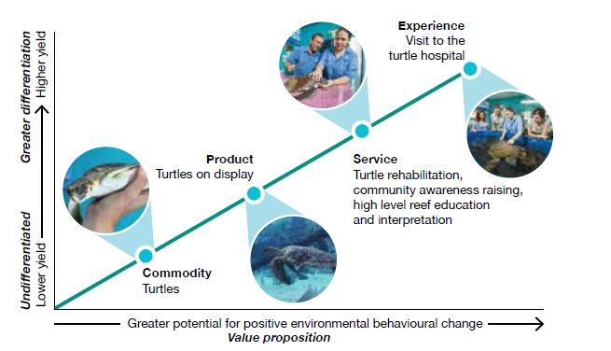

Figure 14: The turtle as an example of the hero experience spectrum

Communications plan
The agency undertakes a coordinated, strategic communication program to support and promote its work managing the Marine Park. Communications plans — outlining key messages, audiences and channels are developed for all major activities and programs. Core activities include communications management and planning, the external website, social media, media and issues management, newsletters and publications, and internal communications.

Strategic assessment
The agency worked cooperatively with the Queensland Government to undertake a joint community consultation on the Great Barrier Reef strategic assessment which looked at the Reef’s values, threats to those values and what’s needed to protect them. The three-month consultation, from 1 November 2013 to 31 January 2014, was guided by a joint communications plan which identified tools and channels for promoting the consultation process, including a joint website, stakeholder communication, display outlets, advertising and media. (The strategic assessment consultation is outlined in a case study, page 68.)

Outlook Report
A communications plan was developed for the release of the second five-yearly Outlook Report; the final report was submitted to the Environment Minister on 30 June 2014. The report, which covers the Reef’s health, management and likely future, is
a key information tool produced by the agency and will underpin key messages and communication for the next five years. (The Outlook Report is also reported on page 52.)

Reef in Brief newsletter
The agency’s primary stakeholder e-newsletter Reef in Brief is distributed to more than 1000 subscribers. It summarises hot topics, key work, programs and achievements. The electronic format enables information to be provided in a timely, cost- effective and environmentally friendly way. Twelve editions were distributed in 2013–14.

A new look and platform is being developed for implementation in 2014–15, along with a strategy to boost subscription rates.

Social media
The agency runs three social media platforms: Facebook, Twitter and YouTube. These contemporary online communication tools are key channels for the agency to promote its work and raise awareness about the Reef to a wide audience in Australia and around the world.

The agency’s Facebook page began in 2011 to create an online community of people who care about the Reef. Several posts are made each week drawing from news releases, corporate content, interesting facts, images and video.

In 2013–14, engagement on the page increased and reached a milestone of 20,000 followers. Interaction is highest for content that is visual and informative, for example a short video of lemon sharks at Heron Island attracted the highest reach on the agency’s Facebook page — nearly 113,000, with more than 550 shares.

The agency’s YouTube channel includes 11 playlists and 128 videos about Reef management, plants, animals and habitats. In 2013–14 there were 11,614 views and 70 subscribers, double the previous year. The most widely accessed video was Fighting the crown-of-thorns foe, about work combating the crown-of-thorns starfish outbreak, with 924 views. It’s part of the most popular playlist— the Reef Tube video series. During the year a new graphic was designed for the agency’s first series of corporate videos, produced under the Reef Tube title. Videos in this series highlight work the agency is doing to protect the Reef.

Twitter was added to the social media suite in 2012–13 and has increased steadily to more than 900 followers this year. The platform is used to promote news from the agency. Other information, photos and stories about the Marine Park are also tweeted. In 2013–14, a scrolling feed of tweets was added to the external website home page to raise the profile of the platform and the content that is shared. (See Figure 15, page 110.)

Website
A year-by-year project plan outlines how the agency’s external website will be maintained, developed and enhanced. Key aspects of the strategy included:

- modifying the home page to include improved navigation and features (such as a Twitter feed and supporting programs’ logos and links)

- the use of online flip books for major reports

- developing new banners to promote key content

- site-wide updated colour scheme for menu items and new reef imagery

- amending the site’s information architecture on the menu items.

The website continues to receive a high amount of traffic — just under 500,000 visits over the last 12 months, almost double the previous year. Users spend an average of three minutes on the site. The most popular content is pages on Reef facts, zoning maps, animals, management and climate change.

There was a 200 per cent spike in traffic from tablet devices and a 154 per cent increase in mobile traffic compared to the previous 12 months. (See Figure 15, page 110.)

Accessibility continues to be a key focus, ahead of whole-of-government requirements to meet Level AA standards by 31 December 2014. These requirements seek to ensure everyone, regardless of location or ability, can access government materials online.

Media
The agency deals with a range of media organisations, from small regional newspapers to international film crews, interested in the Reef.

Over 2013–14, the agency distributed 67 news releases to local, state and national media. About 84 per cent of these resulted in at least one news story. Popular topics included post-cyclone recovery work, Reef Guardian schools projects and the release of rehabilitated turtles from Reef HQ’s turtle hospital.

There was also a considerable increase in media enquiries, particularly from national and international media, on topical issues such as the Abbot Point permit decision.

A monthly interview segment with ABC radio Townsville was also established, enabling agency scientists and experts to discuss reef issues at length. Topics over the last 12 months included the benefits of zoning, whale migration, port and coastal development, and the Eye on the Reef program.

The agency also liaised with a range of documentary producers, including extensive work with Northern Pictures, a company producing a three-part series for ABC television.
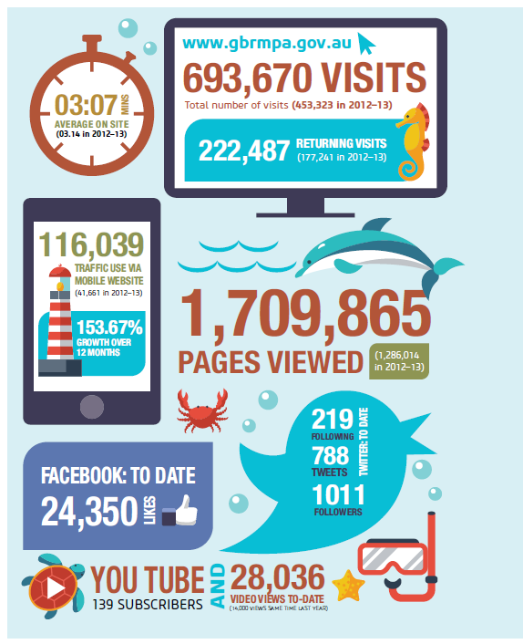

Figure 15: The agency’s website and social media statistics for 2013–14

Public information unit
The agency’s public information unit provides information to stakeholders and community members on the work being undertaken to manage the Reef. The public information unit is often the first point of contact stakeholders have with the organisation.

Over 2013–14, the public information unit answered 17,907 phone calls on a range of topics, including the Abbot Point permit decision. More than 49,000 emails were received, including orders for zoning maps and information requests from students. More than 3500 customers presented to the front office counter at the Townsville headquarters. The agency distributed 132,120 zoning maps, which show where activities can take place in the Marine Park. These were supplied to community access points —a network of bait and tackle shops and other locations along the coast that distribute material —and to recreational users who requested maps.

Community events
The agency took part in some key community events throughout the year, providing a good platform for staff to speak with local residents about zoning, fishing regulations and a range of other Marine Park issues. The face-to- face interactions with community members were also a good opportunity to spread key messages about Marine Park management, provide educational activities for children and hear residents’ views on Reef issues. Staff also handed out hundreds of free zoning maps, brochures and posters.

Events at which the agency had a booth or presence included:

- Townsville Fishing and Outdoor Expo

- Townsville Defence Expo

- Townsville Seafood Festival

- James Cook University sustainability expo

- Boyne Tannum HookUp

- Gladstone Ecofest

- Bundaberg Lighthouse Festival

- Burnett Heads Voluntary Marine Rescue Safety Day

- Yeppoon Tightlines Fishing Classic

- Sarina Landcare Community Day

- AgForce Expo, Mackay

- Take a Kid Fishing Day, Mackay

- Mackay Eco Expo

- Whitsunday Reef Festival

- St Lawrence Wetlands Weekend

- Moranbah Rotary Home and Leisure Show

- Sarina Beach Clean-up Day

- Cairns City Council Sustainable Living Expo.

Science engagement work
The agency engages with a large number of scientists, science organisations and research programs to ensure management of the Great Barrier Reef Marine Park is underpinned by the best available science. Throughout the past 12 months, close collaboration has been maintained between agency staff and Reef-based scientists, especially those funded through the National Environmental Research Program. This program is in its final year and research projects are generating a wealth of new and exciting information for Reef managers. Agency officers are formally members of more than 40 scientific program or project committees, working groups or teams.

The agency’s science information needs are addressed by a number of research and monitoring programs, including the National Environmental Research Program.

Science information needs for managing the Great Barrier Reef World Heritage Area are currently being updated and will be published alongside the agency’s 2014 Outlook Report in the latter half of 2014.

National Environmental Research Program
The National Environmental Research Program, funded by the Australian Government, is a key program delivering science to inform management of the Great Barrier Reef. The Great Barrier Reef Marine Park Authority is engaged with the program’s Tropical Ecosystems Hub through representation on the steering committee, chairing the Biodiversity Implementation Group, and membership on the Water Quality Implementation Group. With advice from the implementation groups, the steering committee directs the Tropical Ecosystems Hub research program.

At the project level, nominated staff members are part of project teams and/or stakeholder teams, including chair of the Social and Economic Long-term Monitoring Program Steering Committee.

The agency’s role in this national program not only provides it with front seat access to the latest science about the Reef, it also enables the agency to have input to the research questions asked to ensure they are relevant to its management needs.

The National Environmental Research Program is performing well and delivering important science for management. Some of the highlights from the Tropical Ecosystems Hub in 2013–14 are detailed below.

Long-term Monitoring Program
The National Environmental Research Program part funds important monitoring in the Great Barrier Reef through the Australian Institute of Marine Science Long-term Monitoring Program. This program is the primary source of information on the health of mid-shelf and offshore coral reefs, including status of crown-of-thorns starfish outbreaks. The program also focuses on work that synthesises and value-adds to existing data.

In 2013–14 this program contributed long- term condition and trend information for the 2014 Outlook Report and the Great Barrier Reef Region strategic assessment. The program informed preliminary draft targets for the 2050 Long-term Sustainability Plan, and informs management advice, policy and actions regarding crown-of-thorns starfish.

Protection of marine predator species
Research to understand the residency and movements of large predators is being undertaken to ensure the long-term sustainability of this functional group. This project defines the extent of mobile predator species movements in coastal and reef ecosystems to inform spatial management of the Marine Park and fishery management.

Fourteen species of marine predator have been monitored at reefs offshore from Townsville to determine their presence and movement patterns in relation to marine park zoning. As expected, movement patterns differ between species indicating variable benefits from marine park protection.

The research results suggest that marine protected areas alone will not provide a solution for management due to the high degree of variability in how these species use reef ecosystems. Complementary non-spatial management measures are also needed to ensure the long-term protection of these species within the Great Barrier Reef.

Social and economic long-term monitoring program
A project to develop a robust method for a social and economic long-term monitoring program for the Great Barrier Reef is being implemented through National Environmental Research Program funding. The project team has mapped, measured and monitored the activities and dependencies of people on the Great Barrier Reef, human wellbeing and important drivers for the region such as perceptions, values, behaviours, markets, media, demography and technology. During July to December 2013, the team surveyed more than 8000 people.

The program aligns with the agency’s integrated monitoring framework, and will eventually form part of the integrated monitoring program. In 2013–14 the social and economic long-term monitoring program contributed to the 2014 Outlook Report,
the Great Barrier Reef Region strategic assessment, preliminary draft targets for the Reef 2050 Long-term Sustainability Plan, and development of Great Barrier Reef Marine Park Authority social impact assessment guidelines and aesthetics.

Staff from across the agency participate through membership on the social and economic long-term monitoring program steering committee, the stakeholder and scientific advisory panel and several working groups focused on drivers of change, Traditional Owners, coastal communities, catchment industries, tourism, recreation, and commercial fishing and aquaculture.

Effectiveness of no-take zones
National Environmental Research Program Tropical Ecosystems Hub research is informing the effectiveness of Great Barrier Reef management initiatives such as the zoning plan, using novel techniques to test its performance. Conclusive evidence has been gathered that marine reserves can act as an interconnected network with no-take areas supplying larvae to each other and to areas open to fishing. This was a key assumption underlying the agency’s 2003 Zoning Plan. Genetic databases have been compiled for 4334 individual coral trout from two species (common coral trout and bar- cheeked coral trout) from three regions — the Keppel Islands, Capricorn Bunkers and Percy islands. Preliminary population-level analyses show strong genetic differences between the three regions for common coral trout, but not for bar-cheeked coral trout, suggesting different patterns of connectivity between species. It suggests that common coral trout from the three regions are discrete genetic stocks.

The project team is developing a spatially explicit metapopulation model to examine effects of marine reserves, fishing pressure and habitat damage on coral trout dynamics. The results of this project are expected in late 2014.

Water quality
The National Environmental Research Program’s water quality research complements the agency’s Reef Rescue marine monitoring program by providing a better understanding of coastal turbidity and the chronic effects of pesticides as well as cumulative impacts of declining water quality and climate change–derived pressures on seagrass and coral habitats.
As part of the development of the Reef Water Quality Protection Plan 2013, a multidisciplinary group of scientists reviewed and synthesised advances in scientific knowledge of Great Barrier Reef water quality issues. The scientific consensus
statement, published in July 2013, concluded that key Great Barrier Reef ecosystems are showing declining trends in condition due to continuing poor water quality, cumulative impacts of climate change and increasing intensity of extreme events.

Integrated monitoring and reporting program
The agency will establish an integrated Region-wide monitoring and reporting program to support implementation of the Reef 2050 Long-term Sustainability Plan. In 2013–14 the agency completed a project plan for the program and contributed to the draft Reef 2050 Long-term Sustainability Plan, including the integrated monitoring and reporting component.

The integrated monitoring and reporting program will build upon existing monitoring programs of the agency and its partners, including:

- the condition and trend of the Region’s key values and processes related to matters of national environmental significance

- individual (direct, indirect and consequential) and cumulative impacts acting on the values

- ecosystem thresholds, environmental standards and trigger levels for the protection of values.

It will also contribute to assessing the effectiveness of policies, plans and programs implemented to protect matters of national environmental significance and ensure ecologically sustainable use.

The program will improve the integration and coordination of existing monitoring programs through the development and implementation of standardised protocols for information collection, collation analysis, reporting and data availability. It will improve the scalability of data (from point source or local, to regional and Reef-wide scales) and synthesis of information from different sources. Thiswill provide a more comprehensive and systematic understanding of the condition of values and scale of impacts.

eReefs marine water quality dashboard
The agency continues to actively engage with the eReefs project — a collaboration between the Great Barrier Reef Foundation, Bureau of Meteorology, CSIRO, Australian Institute of Marine Science and the Queensland Government, supported by funding from the Australian Government’s Caring for our Country grants, the Queensland Government, the BHP Billiton Mitsubishi Alliance, and the Science Industry Endowment Fund.

The first available eReefs product was released in early 2014. The marine water quality dashboard is an interactive tool for near real-time mapping and visualisation of water quality information derived from satellite remote sensing. This is a powerful tool that will allow management to react to water quality issues more rapidly.

Other science partnerships
The agency partners and engages with a wide range of other research agencies and initiatives, and this work continues to inform our policy development across the spectrum of our management. Prominent partners include the Australian Research Council Centre of Excellence for Coral Reef Studies, Australian Research Council Linkage Grants, the Australian Institute of Marine Science, CSIRO, and Fisheries Research and Development Corporation.

Science for Management Awards
During the reporting period, the agency provided financial support to 19 postgraduate students through its 2014 Science for Management Awards.

The awards support new management- relevant research that addresses key risks faced by the Great Barrier Reef, particularly from climate change, and also from poor water quality, coastal development, illegal fishing, marine debris and incidental catch They were open to doctorate and masters students in the biophysical and social science fields throughout Australia, and drew 33 applications.

The successful applicants received sums ranging from $1000 to $2000. The names of the winners, a description of their research projects and the sums received are published on the agency’s website.

A principal aim of the Science for Management Awards is to engage with early career scientists. The agency has run the awards for more than 30 years, providing financial support to more than 200 postgraduate students.

Seminar series
The Great Barrier Reef Marine Park Authority seminar series is one of several mechanisms employed to communicate the latest science information to relevant staff across the agency. In 2013–14, 18 seminars were presented by internal staff and external guests. These covered subjects such as whole of Great Barrier Reef system modelling, social-ecological interactions, historical shipwrecks and impacts of ports and shipping.

INTERNATIONAL CORAL REEF INITIATIVE

During the reporting period, the agency completed co-hosting the International Coral Reef Initiative for 2012–14, in partnership with the Government of Belize. During this period, the secretariat coordinated and ran two general meetings of initiative members, in Cairns in July 2012 and Belize City in October 2013. In addition, the secretariat successfully implemented a small grants program, directed to community groups engaged in coral reef conservation and management around the world.

In addition to these, a number of activities were conducted to progress International Coral Reef Initiative issues under the auspices of the Australia–Belize hosting, as per its hosting requirements. These included:

- organising and hosting side events and technical workshops on cross- cutting issues such as management effectiveness, monitoring, co-
management arrangements, sustainable financing and strategic assessments — with collaborators such as the Principality of Monaco and the United Nations Environment Programme

- supporting the development and publication in three languages of a Regional strategy for the control of the invasive lionfish in the wider Caribbean

- supporting a national lionfish response
plan by Costa Rica supporting the Global Coral Reef Monitoring Network, and particularly for the translation, promotion and distribution of its latest report, the Status and trends of Caribbean coral reefs: 1970–2012.

- redesigning and updating the initiative’s website (http://www.icriforum.org/)

- creating and maintaining the initiative’s Facebook and Twitter pages

- supporting the Colombian Government in setting up sustainable financing for its marine parks.

The hosting was enabled through substantial funding assistance from the Department of Foreign Affairs and Trade, through the then Australian Agency for International Development (AusAID).

The close of the hosting period saw a successful transition of the initiative’s stewardship to the governments of Japan and Thailand in April 2014.

ENABLING SERVICES

Key performance indicator
Integrated, efficient and effective business systems and management processes

The agency has improved its business systems and management processes to underpin a high performing, efficient and effective organisation. During the year the agency installed new architecture to facilitate improved compliance in records management, and updated procedures for record keeping. The electronic document records management system, which replaces paper files, will be fully implemented later in 2014.

The agency also developed and implemented the new standard operating system of Windows 7 and Office 2010, replaced 183 desktop and laptop computers with new hardware, and introduced secure mobility platforms to enable staff to work while out of the office.

In September 2013, agency officers evaluated a project which aimed to improve the efficiency of people management processes. The transfer of forms and approval processes from a paper-based format to an electronic one showed a reduction in errors from 11 percent to 3.2 per cent of forms — resulting in a 96.6 per cent decrease in costs required to rectify errors.

The agency’s work towards meeting its core objectives is supported by a range of enabling services. These include financial services, people management functions, information services, legal services, communications and parliamentary functions, and information technology services

Finance and office services
The agency’s finance and offices services section continued to provide timely advice to the executive through meeting monthly, and annual, financial reporting deadlines. The financial management information system was enhanced with the implementation of the travel booking and expense module. The finance section also prepared Accountable Authority Instructions for the implementation of the Public Governance, Performance and Accountability Act 2013. This involved creating agency-specific rules to aid compliance with the requirements of the new Act.

People management
The people management section provided a range of payroll, recruitment, work health and safety, and dive services to employees. Higher level advice was also provided to managers and supervisors regarding workforce planning, performance management and workplace relations matters. During 2013–14, the people management section oversaw the implementation of the 2014 agency restructure and the successful integration of Australian Public Service-wide interim recruitment arrangements. (See also Management and Accountability section, page 135.)

Information services unit
The agency conducted a strategic review of its information services unit during the reporting period, examining such things as the type and manner of services provided, information provision and staff expertise to determine whether these meet the agency’s current and future needs. It provided an opportunity to reconsider what is provided and to reshape the way the unit conducts business throughout the agency. The agency has begun implementing the recommendations of the review.

The unit provided significant support to the Great Barrier Reef Region Strategic Assessment Report and Great Barrier Reef Outlook Report 2014 and contributed substantially to the development of an agency-wide information management strategy.

Science information needs
Over the past 12 months, the agency progressed a review of the generation and use of scientific information for management of the Great Barrier Reef Marine Park. This internal report was finalised in June 2014 and has informed the development of the Science Strategy and Information Needs 2014–2019. This strategy — including the priority scientific information needs for the agency over the next five years — will be published in the latter half of 2014 along with the Great Barrier Reef Outlook Report 2014.

Legal services
The legal services team provided advice relating to a wide range of issues, including amendments to legislation and regulations, litigation, contract development, delegations and interpretation of legislation to assist sections in decision-making. The section also provided advice to the executive on issues of governance and legislative amendments.

Environment legislation amendment bill
The legal services team provided advice to the agency’s executive and the Australian Department of the Environment on preparation of the Environment Legislation Amendment Bill 2013 which, among other things, sought to amend the Great Barrier Reef Marine Act 1975 to triple penalties which apply for taking or injuring dugongs or turtles in the Marine Park. The relevant sections proposed to be amended are ss. 38BA, 38BB, 38GA and 38GB of the Great Barrier Reef Marine Park Act 1975.

Legal services provided advice and input into draft versions of the Bill, including working with the Department of the Environment and Office of Parliamentary Council to finalise the Bill. The team also provided input into the explanatory materials to accompany the Bill, which was introduced to Parliament on 14 November 2013.

Public governance act
During the year the legal services team provided advice on the implementation of the Public Governance, Performance and Accountability Act 2013 to the agency’s executive, the Australian Department of the Environment and the Australian Department of Finance and Deregulation, including required amendments to the Great Barrier Reef Marine Park Act 1975 and the amendment of instruments of delegation.

Privacy act amendments
The legal services team coordinated the rollout of the amendments to the Privacy Act 1988 including preparation of the agency’s privacy policy and complaints system, the update of relevant materials and the provision of training to staff and the executive.

Regulatory amendments
The legal services section finalised the following regulatory amendments during 2013–14:

- On 26 November 2013 the Great Barrier Reef Marine Park Regulations 1983 were amended to clarify and expand upon the prohibition on misuse of public moorings under regulation 102 and reduce the infringement notice penalty from five penalty units in line with other similar types of offences.

- On 18 December 2013 the Great Barrier Reef Marine Park Regulations 1983 were amended to prescribe that an assessment of heritage values must
be contained in the Great Barrier Reef Outlook Report 2014. Typographical errors and other minor issues in the regulations were also rectified.

- On 29 January 2014 the Dent Island Lightstation Heritage Management Plan took effect. The plan was made jointly by the agency and the Australian Maritime Safety Authority to satisfy statutory obligations which both agencies have under the Environment Protection and Biodiversity Conservation Act 1999. The plan provides for the future management of the Dent Island Lightstation, with the objective of identifying, protecting, conserving, presenting and transmitting the Commonwealth Heritage values of the area.

Litigation
At the end of the reporting period, the agency was managing a number of litigious matters which were ongoing in the Administrative Appeals Tribunal and Federal Court and was assisting the Department of the Environment in the conduct of an Administrative Appeals Tribunal matter.

During 2013–14, the agency instructed an external legal service provider to appear in an employment matter before the Fair Work Commission. The matter was subsequently dismissed.

Freedom of information
In the 2013–14 year, the agency received 14 requests for information under the Freedom of Information Act 1982. All decisions were made within the statutory timeframes. In summary:

- eight freedom of information requests were granted full or partial access to requested documents

- one freedom of information request was refused access to requested documents

- four freedom of information requests were withdrawn

- one request was deemed invalid.

In addition to the above freedom of information requests:

- The agency received two applications for internal review of decisions made under the Freedom of Information Act during 2013–14. One application was granted full access on internal review. The second application had not been finalised by the end of the financial year.

- One application was made to the Office of the Australian Information Commissioner for review of a decision made under the Freedom of Information Act during 2013–14. The Office of the Australian Information Commissioner closed the application for review under s54W(b) of the Freedom of Information Act.

- No applications were made to the Administrative Appeals Tribunal for review of decisions made under the Freedom of Information Act during 2013–14.

- There were no applications to amend records under the Freedom of Information Act during 2013–14.

(Freedom of information requests are also reported in Appendix D, page 213.)

Communications and parliamentary
The communications and parliamentary section supports the agency’s core objectives through strategic communications plans, events management, media and issues management, maintaining an up-to-date website and operating three social media platforms. The section also oversees the production and distribution of agency publications, a regular internal newsletter and monthly e-newsletter. (The agency’s communications work is reported in more detail on page 108.)

Parliamentary services
The Federal Environment Minister and Department of the Environment are key stakeholders. The agency supports the Minister with formal briefings, responses for correspondence and advice. During 2013–14 the agency prepared 50 briefing submissions for the Minister and responses for 46 letters from people concerned about impacts on the Reef from climate change, shipping, water quality and fishing.

The agency maintains strong relationships with the Department of the Environment and regularly contributes to portfolio responses, questions on notice and related matters. Over 2013–14, the agency provided responses to 296 questions on notice from the Senate Budget Estimates Committee. These related to matters specific to the agency, as well as portfolio-wide issues. The agency contributed to 189 coordination requests from the Department of the Environment, including responses to requests from other government departments for input.

Information management systems
The information management systems and technology section’s work over the past 12 months included the introduction of online transactional services, external geographic information system (GIS) web services, secure mobility platforms, and tranche three of the Information and Communications Technology Strategic Plan 2011–2014, which included a major infrastructure modernisation project.

Calls for information technology helpdesk assistance reduced by 48 per cent over the year due to the development and implementation of the new standard operating system of Microsoft® Windows 7 and Office 2010 and a desktop hardware refresh. More than 180 desktop and laptop computers were replaced during the year to utilise the full benefits of a warranty cycle extension to five years.

The agency continued progress towards improving its information management with a focus on records management. It also implemented new architecture to improve compliance and enhanced procedures to streamline record keeping processes.

Information management practices
During the reporting period, the agency initiated several projects to improve its information management practices and enhance the agency’s service and response capability. Projects delivered successfully for 2013–14 included the development and implementation of:
- a program/project management framework

- a protective security policy framework

- an information security management system

- an electronic document records
management system

- a client relations management database.

Building capability
The agency conducted a structural review of the spatial and information technologies section to ensure it more effectively and efficiently meets the agency’s demands, supports the delivery of key agency priorities and to ensure a baseline of technical skills, capabilities, resources and facilities are in place to support agency work.

In 2013–14, information and communications technology staff undertook specialised courses to ensure a baseline of technical skills and capabilities were maintained to support the agency into the future.

SUMMARY OF ACHIEVEMENTS FOR OBJECTIVE 3
- Managed a total of 1347 permits for activities in the Marine Park, covering a range of uses, from commercial tourism operations that provide scuba diving to complex projects such as dredge disposal

- Finalised improved dredge material management project and ship anchorage management project

- Worked with Australian Institute of Marine Science and expert panellists on development of a dredge synthesis statement

- Provided advice on 28 major development projects in or adjacent to the Great Barrier Reef World Heritage Area

- Participated in multi-agency incident response to detection of the pest species, Asian green mussel, at Mackay shipyards

- Accredited the Yirrganydji Traditional Use of Marine Resources Agreement — the first for the Cairns to Port Douglas area

- Delivered compliance training to 58 Indigenous community rangers and 57 Indigenous community members

- Expanded Reef Guardian program to include 308 schools, 15 councils, and 25 farmers and graziers

- Boosted membership of High Standard Tourism program from 59 operators to 62, meaning 64 per cent of visitors to the Reef now travel with these eco-certified operators

- Strengthened participation in Eye on the Reef program, with about 135 tourism staff monitoring reef sites and submitting sightings

- Delivered 107 reef videoconferences from Reef HQ Aquarium to locations around Australia and the world, interacting with more than 4500 people

- Achieved the milestone of 20,000 followers on the agency’s Facebook page and increased the number of Twitter followers to more than 900

- Provided financial support to 19 postgraduate students through the 2014 Science for Management Awards

- Completed restoration works to campgrounds and walking tracks on Lizard Island following severe tropical cyclone Ita
- Completed co-hosting the International Coral Reef Initiative for the 2012–14 period, in partnership with the Government of Belize

- Reviewed generation and use of scientific information for management of the Marine Park, which informed development of the Science Strategy 2014–2019

- Reduced calls for help desk assistance by 48 per cent through the implementation of a new standard operating system and a desktop hardware refresh

- Prepared Accountable Authority Instructions for the implementation of the Public Governance, Performance and Accountability Act 2013

- Implemented the 2014 agency restructure and Australian Public Service-wide interim recruitment arrangements

QUANTITATIVE ACHIEVEMENTS FOR PERFORMANCE
Table 10: Quantitative deliverables — targets and achievements since 2011–12

Deliverable 2011-12 Target 2012-13 Target 2013-14 Target
(achievement) (achievement) (achievement)

Permits issued per annum (number) 650 (625) 650 (552) 650 (449)

Local Marine Advisory Committees 11 (11) 11 (12) 11 (12)
in place (number)

Local Marine Advisory Committee 55 (55) 55 (60) 55 (60)
meetings held (number)

Reef Advisory Committee in place 4 (4) 4 (4) 4 (4)
(number)

Reef Advisory Committee meetings 8 (8) 8 (6) * 8 (N/A)
held (number)

Reef HQ Aquarium visitors (number) 116,000 118,000 120,000
(145,129) (141,417) (137,375)

Reef Guardian schools (number) 200 (285) 205 (293) 210 (308)

Reef Guardian councils (number) 14 (13) 15 (13)** 15 (15)

*Four meetings scheduled for May and June 2013 were postponed so members could have input into the strategic assessment.
**Central Highlands Regional Council had committed to the program and Yarrabah Shire Council had expressed interest in joining the program

Table 11: Quantitative key performance indicators since 2011–12

Key performance indicator 2011-12 2012-13 2013-14
Revised budget Target Target
(achievement) (achievement) (achievement)

Trends in sediment loads, nitrogen and
phosphorus loads, and pesticide loads for
end-of-catchment waters of the northern,
central and southern regions of the Great
Barrier Reef lagoon (increasing/decreasing) Decreasing Decreasing Decreasing
(decreasing) (decreasing) (decreasing)

Area of Marine Park managed in accordance
with an accredited Traditional Use of Marine
Resources Agreement or an Indigenous
Land Use Agreement (percentage)* 18 (21) 18 (24) 18 (24.6)

Research projects,that are either the responsibility
of the agency or that the agency has influenced,
which address science information needs that relate
to issues of high or medium concern to management
as identified by the Outlook Report (percentage) 100 (100) 100 (100) 100 (100)

Visitors to the Great Barrier Reef using tourism
operators accredited as High Standard Operators
(percentage)
50 (> 65) 50 (> 65) 50 (64)

Participants within the Reef Guardian School
Program (number) 110,000 (>110,000) 110,000 (114,900) 110,000 (126,000)

Visitors to Reef HQ Aquarium that participate in
talks and tours that deliver key messages about
risks to the Great Barrier Reef (percentage) 63 (52) 63 (73) 63 (71)

Proactive media releases which have resulted
in published articles/news clips (percentage) 90 (not measured)** 90 (83) 90 (84)

Key performance indicator refers to the length of Great Barrier Reef Marine Park coastline covered by a formal land use agreement

** A system was not available to measure this outcome

ANNUAL REPORT

Management and accountability

2013–14

Management and accountability

The Great Barrier Reef Marine Park Authority’s governance framework for the 2013–14 reporting period was based on the legislative requirements of the Great Barrier Reef Marine Park Act 1975, the Financial Management and Accountability Act 1997 and the Public Service Act 1999. From1 July 2014, the agency becomes subject to the Public Governance, Performance and Accountability Act 2013, which replaces the Financial Management and Accountability Act.

The Great Barrier Reef Marine Park Authority reports to the Australian Environment Minister. The Marine Park Authority board oversees the agency, which is structured into three main branches: Strategic Policy and Reef Stewardship, Biodiversity Conservation and Sustainable Use and Great Barrier Reef Operations.

The agency uses the best available scientific information to guide its work, and engages with experts and the community — including four Reef Advisory Committees and 12 Local Marine Advisory Committees.

The main office is in Townsville, and regional offices in Cairns, Mackay and Rockhampton ensure a close connection with those communities.

A small office in Canberra provides a key liaison function with the Environment Minister’s office and the Department of the Environment portfolio and other Australian Government agencies.

THE GREAT BARRIER REEF MARINE PARK AUTHORITY (THE BOARD)

The Chairman and members of the Board are chosen by the Minister for the Environment and appointed by the Governor-General.

Membership of the Board

Dr Russell Reichelt
Chairman and Chief Executive of the Great Barrier Reef Marine Park Authority

Russell Reichelt joined the Great Barrier Reef Marine Park Authority in 2007 as Chairman and Chief Executive.

He began diving on the Great Barrier Reef as a teenager in 1968 and then worked as a research scientist at the Australian Institute of Marine Science in the 1980s studying the ecology of coral reefs, particularly the crown-of-thorns starfish.

Dr Reichelt has a PhD in marine science and has served as Chief Executive Officer of the Australian Institute of Marine Science, Chairman of the Fisheries Research and Development Corporation, and as a member of Australia’s State of the Environment Committee. He has previously chaired the National Oceans Advisory Group, CSIRO’s Wealth from Oceans Flagship Advisory Committee and Seafood Services Australia Ltd.

He is an adjunct professor at James Cook University and the University of Queensland, and is a fellow of the Australian Academy of Technological Sciences and Engineering, the Institute of Marine Engineering, Science and Technology (UK) and the Australian Institute of Company Directors.

Dr Reichelt is a board member for both the Great Barrier Reef Foundation and the Australian Maritime Safety Authority.

He was reappointed Chairman of the Marine Park Authority board on 1 November 2012 for a second five-year term, concluding on 31 October 2017.

Melissa George
Melissa George is a Wulgurukaba woman whose traditional area includes Magnetic Island and the greater Townsville region.

She has been actively involved in protecting and managing land and sea through community natural resource management projects and liaising with and advising the Queensland and Australian governments. Ms George has been a member of the Indigenous Reef Advisory Committee since 2002 and chair since 2006.

She was appointed as a member of the Marine Park Authority board on 29 August 2008 for a four-year term, and was reappointed on 22 November 2012 for a five-year term concluding on 21 November 2017.

Tony Mooney
Tony Mooney has extensive experience in infrastructure, economic development, community engagement and regional government.

He served as a Townsville city councillor for 31 years, 19 of them as Mayor, concluding in 2008. During his time as Mayor, he oversaw a period of unprecedented sustainable urban and infrastructure development. In 2008, Mr Mooney was appointed to the Board of Ergon Energy, and in 2009 was appointed to the Board of Townsville Enterprise Limited. Mr Mooney received a Centenary Medal in 2001 for distinguished service to local government, and in 2011 was appointed a Member of the Order of Australia for service to local government and to the community of Townsville through a range of tourism, business and infrastructure organisations.

He was appointed as a member of the Marine Park Authority board on 7 December 2011, for a five-year term which finishes on 6 December 2016.

Jon Grayson
Jon Grayson was appointed Director-General of the Department of the Premier and Cabinet in March 2012 bringing substantial private sector and government experience to the role.

For the two years before his appointment, Mr Grayson was principal and founder of Queensland Infrastructure Partners, an advisory and transaction arranging firm specialising in infrastructure investment and development.

He was previously a senior executive with a major international advisory and investment management firm. Mr Grayson’s investment banking experience was primarily in the infrastructure space, having led successful bids for infrastructure assets including the Dalrymple Bay Coal Terminal. This experience included two years as the inaugural chief executive of Prime Infrastructure, which became one of Australia’s largest infrastructure funds, guiding it to an initial public offering on the Australian Stock Exchange.

Prior to his investment banking career, Mr Grayson had a long career in Queensland Treasury and Queensland Treasury Corporation. He led major reform processes within government including leading the Suncorp–Metway merger, and the major review of Queensland Rail corporatisation. At Queensland Treasury Corporation, Mr Grayson served on the executive management team, leading the structured finance group, arranging and executing a range of efficient financing structures for government-owned corporations and statutory bodies, including cross-border lease transactions over Queensland Government- owned rail and electricity assets.

He was appointed as the Queensland Government representative member of the Marine Park Authority board for a three-year term concluding on 21 November 2015.

Margie McKenzie
Margie McKenzie has extensive experience in the Queensland marine tourism industry.

She is currently the managing director of a marine tourism consulting company in Cairns, has been a scuba diving instructor for 29 years and is still an active instructor certifier with Scuba Schools International.

Mrs McKenzie has been a partner in one of Australia’s largest dive training companies based in Cairns, has been the general manager of Dive Queensland, a non-profit association committed to promoting and developing the diving industry in Queensland, for 17 years and spent seven years as the general manager of Scuba Schools International.

Mrs McKenzie is a CPA and has specialised in assisting tourism and small businesses to develop into profitable enterprises.

She was appointed as a member of the Marine Park Authority board on 16 May 2013 for a five-year term concluding on 15 May 2018.

Meeting schedule
During 2013–14, the Great Barrier Reef Marine Park Authority held five meetings (Table 12).

Table 12: Meetings of the Great Barrier Reef Marine Park Authority 2013–14
Meeting Date Location Attendance

MPA 288 17 September 2013 Townsville Dr Russell Reichelt, Ms Margie McKenzie, Mr

Tony Mooney AM

MPA 229 15 October 2013 Teleconference Mr Bruce Elliot (acting chairman), Miss Melissa

George, Mr Jon Grayson, Ms Margie McKenzie,

Mr Tony Mooney AM

MPA 230 19 March 2014 Townsville Dr Russell Reichelt, Miss Melissa George, Mr Jon

Grayson, Ms Margie McKenzie, Mr Tony Mooney AM

MPA 231 30 April 2014 Townsville Dr Russell Reichelt, Miss Melissa George, Mr Jon

Grayson, Ms Margie McKenzie, Mr Tony Mooney AM

MPA 232 18 June 2014 Townsville Mr Andrew Skeat (acting chairman), Miss Melissa

George, Ma Margie McKenzie

Senior executive
The agency is structured into three main branches, led by three general managers. The agency’s senior executive team, as at the end of the reporting period, is described below.

Margaret Johnson, General Manager of Strategic Policy and Reef Stewardship. The branch comprises the following sections:
- Communications and Parliamentary
- Knowledge and Resource Management
- Strategic Policy and Governance
- Tourism and Stewardship.

Bruce Elliot, General Manager of Biodiversity Conservation and Sustainable Use, which comprises the following sections:
- Biodiversity and Heritage Conservation
- Environmental Assessment and Management
- Information Management Systems and Technology
- Caribbean project.

Andrew Skeat, General Manager of Great Barrier Reef Operations, which comprises the following sections:
- Field Management
- Indigenous Partnerships
- Legal Services
- Reef HQ Aquarium.

An organisational chart depicting the senior executives and their responsibilities is in the Overview section of this report, page 12.

GREAT BARRIER REEF MARINE PARK AUTHORITY AUDIT COMMITTEE
The Chief Executive of the Great Barrier Reef Marine Park Authority established the audit committee in compliance with section 46 of the Financial Management and Accountability Act 1997 and Regulation 22C of the Financial Management and Accountability Regulations 1997.

The audit committee provides independent assurance and assistance to the Chief Executive and the Marine Park Authority board on the agency’s risk, control and compliance framework, and its financial statement responsibilities.

The audit committee comprised the following members during 2013–14:

- Ms Fay Barker, OAM, Chair and Fellow of the Australian Institute of Company Directors

- Mr Roy Peterson, member and acting Committee Chair

- Mr Phillip Fogarty, member and acting Manager, then Manager, Financial Services, Queensland Department of the Premier and Cabinet

- Mrs Margie McKenzie, member, Managing Director of Gempearl Pty Ltd, and Great Barrier Reef Marine Park Authority board member

- Mr Michael O’Keeffe, member
Ms Barker’s tenure as audit committee Chair expired on 19 February 2014. Her official association with the Great Barrier Reef Marine Park Authority spanned almost 11 years, during which she was a Marine Park Authority board member, a member and then Chair of the audit committee.

During 2013–14 the audit committee held four meetings (Table 13).

Observers and guests at audit committee meetings included the Great Barrier Reef Marine Park Authority Chairman, General Manager Strategic Policy and Reef Stewardship, Chief Finance Officer, Director Strategic Policy and Governance, manager and financial accountant with Finance and Office Services, manager Governance Support Unit, representatives from the Australian National Audit Office (ANAO) and the internal audit service provider.

Business activities of the audit committee addressed:

- financial statements

- financial management

- internal audit

- external audit

- internal controls and compliance management

- legislative and policy compliance

- environmental management charge and sustainable funding

- court-imposed fines

Table 13: Meetings of the Great Barrier Reef Marine Park Authority Audit Committee 2013–14
Meeting Date Location Attendance

AC60 28 August 2013 Townsville Ms Fay Baker, Mr Roy Peterson, Mr Phil Fogarty

AC61 6 November 2013 Townsville Ms Fay Baker, Mr Roy Peterson, Mr Phil Fogarty

AC62 14 February 2014 Townsville Ms Fay Baker, Mr Roy Peterson, Mr Phil Fogarty

AC63 21 May 2014 Townsville Mr Roy Peterson, Mr Phil Fogarty, Mrs Margie

McKenzie, Mr Michael O’Keeffe

- policies and procedures

- corporate governance, including risk management and fraud risk management

- the draft strategic assessment of the Great Barrier Reef Region and associated program report, and corporate planning processes.

The committee was also updated on preparations for the implementation of the new Public Governance, Performance and Accountability Act 2013.

Roles and responsibilities
Roles and responsibilities are set out in the audit committee charter of operation, reflecting requirements under the Financial Management and Accountability Act 1997 and regulations. The charter covers:

- Risk management
- risk management framework
- management of major risks
- business continuity and disaster recovery plans
- fraud control plan

- Internal control
- internal control framework
- chief executive instructions
- policies and procedures
- use of Commonwealth resources
- delegations
- key internal controls

- Financial statements
- adequacy of key internal controls and management sign-off
- review and provision of advice to the chief executive
- consistency with information provided in the annual report

- Legislative and policy compliance
- legal and compliance risks
- system to monitor compliance with relevant laws, regulations and associated government policies
- compliance with international conventions
- annual certificate of compliance report

- Internal audit
- monitoring of internal audit’s coverage and its alignment to the assessment of key risks
- monitoring of the audit committee’s annual work plan
- adequacy of internal audit resources
- audit program
- monitoring of management’s implementation of audit recommendations
- review of all audit reports and provision of advice to the chief executive
- review of audit committee performance

- External audit
- financial statement and performance audit coverage
- review of external audit plans and reports regarding planned or completed audits
- monitoring of management’s response on implementation of audit recommendations

- Governance arrangements
- periodic review of governance arrangements

- Other responsibilities
- parliamentary committee reports and external reviews
- performance reporting framework

Responsibilities of committee members
Members of the committee are expected to understand and observe the legal requirements of the Financial Management and Accountability Act 1997 and regulations. Members are also expected to:
- act in the best interests of the Great Barrier Reef Marine Park Authority
- apply good analytical skills, objectivity and good judgement
- express opinions constructively and openly, raise issues that relate to the committee’s responsibilities and pursue independent lines of enquiry
- contribute the time required to review meeting papers provided.

Internal audit reports
The agency’s audit committee met four times during the year and considered external and internal audit reports. During 2013–14 internal audits and follow-up audits were undertaken in the following areas of operation:

- human resource management
- project management
- contract management
- financial controls
- expenditure
- grant management
- gifts and hospitality.

Risk management
Work continued in 2013–14 to review the risk management framework with new guidance material, procedures, tools and training to be developed so strategic and operational risk management is better integrated into the everyday business activities of the agency.

This work is guided by an overarching action plan, with progress regularly monitored via the agency’s audit committee.

The internal audit function continues to provide independent assurance to the agency on the integrity and reliability of operational and financial risk mitigation arrangements in place.

Fraud control
In 2013–14 the agency undertook a gap analysis against the Commonwealth Fraud Control Guidelines and finalised a comprehensive fraud risk assessment in response to changes in the organizational structure. Together these will form the basis of the next iteration of the fraud control policy and plan which aims to further reduce the incidence of and opportunity for fraud.

The new policy and plan is being prepared to be consistent with the Commonwealth fraud control framework, which will give effect to the fraud control provisions of the Public Governance, Performance and Accountability Act 2013 — the fraud rule under the Public Governance, Performance and Accountability Rule 2014.

The new fraud control policy and plan will also be aligned to Australian Standards and Better Practice Guide developed by the Australian National Audit Office. Actions for implementation across the agency will be included, and intend to facilitate a greater awareness amongst workers of fraud and fraud risk.

Collectively, the new fraud risk assessment and corresponding fraud control policy and plan will continue to:

- facilitate appropriate fraud prevention, detection, investigation, reporting and data collection that meet the specific needs of the agency
- minimise the incidence of fraud in the agency to as low as is reasonably practicable
- facilitate the recovery of the proceeds of fraud against the agency.

There were no incidents of suspected fraud reported to the fraud liaison officer during 2013–14.

Advisory committees
The agency has a number of committees that provide support and strategic advice, including 12 Local Marine Advisory Committees.
Other committees may be appointed from time to time to deal with specific issues.

All committees have terms of reference and procedures established by the agency. Their composition and membership is reviewed as required.

Reef Advisory Committees
The agency had four Reef Advisory Committees up to December 2013. They were:

- Catchment and Coastal Reef Advisory Committee
- Ecosystem Reef Advisory Committee
- Indigenous Reef Advisory Committee
- Tourism and Recreation Reef Advisory Committee.

A key role of the advisory committees was to advise the agency about actions that could be taken to address the risks to the Great Barrier Reef Marine Park identified in the Great Barrier Reef Outlook Report 2009.

These competency-based committees comprised a cross-section of stakeholder interests with expertise and experience in relevant areas. Each worked closely with staff of the relevant branch and sections to ensure policy development and strategic direction were developed in consultation with stakeholders.

Each committee included members appointed as a representative of a particular group or sector (e.g. industry, recreational, government) or for their linkages to Traditional Owner groups.

The committee members’ original three-year term was due to expire on 31 December 2012. However, the Marine Park Authority Chair agreed to extend the membership for a further 12-month period to enable their continued involvement in the strategic assessment process.

During 2013–14, the Reef Advisory Committees provided advice and guidance on the draft strategic assessment of the Great Barrier Reef Region, which was released for public consultation in November 2013.

This included attending a strategic assessment workshop in Townsville on 12 and 13 December 2013, involving all Reef Advisory Committee members, along with the chairs of each of the 12 Local Marine Advisory Committees or their representative.

In April 2014 the Marine Park Authority board approved the establishment of a Tourism Reef Advisory Committee to replace the Tourism and Recreation Reef Advisory Committee.

The agency has been reviewing additional Reef Advisory Committee arrangements.

Local Marine Advisory Committees
Twelve Local Marine Advisory Committees operate along the Great Barrier Reef catchment.

Representing community interests from Cape York south to the Burnett region, these advisory committees provide an avenue for local communities to discuss areas of concern directly with the agency. The committees also have input into the management of the Marine Park and undertake activities that contribute to its long-term protection. The newest of these, Bowen–Burdekin, was established in July 2012 due to a concern that issues in Bowen were not being reflected in the Whitsunday region and, likewise, issues in the Burdekin were not being reflected in the Townsville region.
The committees are:
- Cape York
- Douglas
- Cairns
- Cassowary Coast
- Hinchinbrook
- Townsville
- Bowen–Burdekin
- Whitsunday
- Mackay
- Capricorn Coast
- Gladstone
- Burnett.
Each advisory committee meets five times a year. Members are appointed for a three-year term, with the current term beginning in July 2012 and ending in July 2015.

Local Marine Advisory Committees are also reported on under Objective 3 of the Performance chapter, page 93.

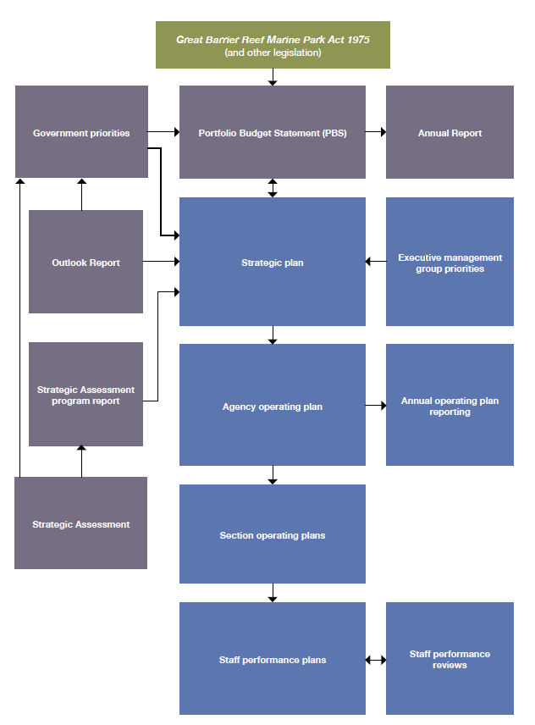

Figure 16: The Great Barrier Reef Marine Park Authority’s strategic planning process

STRATEGIC AND OPERATIONAL PLANS
The agency carries out planning at the strategic and operational levels. In 2013–14, the agency’s strategic and operational planning was influenced by the Strategic Assessment of the Great Barrier Reef Region undertaken by the agency. The strategic planning process is shown in Figure 16, page132.

Strategic Plan 2013–2017
The Great Barrier Reef Marine Park Authority’s Strategic Plan 2013–2017 takes into account the Great Barrier Reef Outlook Report 2009 and outlines the direction and priorities of the agency. It focuses on delivering outcomes required by legislation, especially the Great Barrier Reef Marine Park Act 1975, through four objectives:

- To protect and restore the Reef’s biodiversity
- To safeguard the Reef’s heritage values
- To ensure use of the Region is ecologically sustainable and the socio- economic benefits derived from the Reef are maintained
- To maintain a high performing, effective and efficient organisation.

Annual operating plans
The strategic plan is supported by section and agency-level annual operating plans. These plans set out detailed actions to achieve our objectives, as well as relevant performance measures and targets.

Great Barrier Reef Outlook Report 2009
Developing the Great Barrier Reef Outlook Report 2009 was one of the key recommendations from the Review of the Great Barrier Reef Marine Park Act 1975 –

Review Panel Report 2006. The first Outlook Report, which assessed performance of the long-term protection of the Marine Park in an accountable and transparent manner, was completed in 2009. The second Outlook Report was finalised at the end of the reporting period and is due to be released in the latter half of 2014.

Great Barrier Reef strategic assessment and program report
In 2013–14, the Great Barrier Reef Marine Park Authority undertook a strategic assessment of the Great Barrier Reef Region. The strategic assessment examines impacts on relevant matters of national significance as defined in the Environment Protection and Biodiversity Conservation Act 1999, the agency’s management arrangements to deal with such impacts, and actions to improve the agency’s management arrangements through the development of a comprehensive 25-year management program.

These reports have been fundamental in developing the agency’s priority projects and will shape its work program for 2014–15 and subsequent years.

Service charter 2011–2015
The service charter outlines the agency’s goals, aims, customers, and commitments to those customers. The agency aims to provide an appropriate service to meet all of its commitments. These services will continue to develop as new issues arise and the service charter will be reviewed regularly in line with these changes.

The service charter is available on the agency’s website www.gbrmpa.gov.au.

Ethical standards
The Great Barrier Reef Marine Park Authority is committed to the Australian Public Service Values and Code of Conduct set out in the Australian Public Service Act 1999. The Australian Public Service Values and Code of Conduct is an integral part of the people management framework and is incorporated in the agency’s Corporate Plan 2011–2014 and the Enterprise Agreement 2011–2014.

Information on ethical standards is provided to staff through the agency’s intranet, induction procedures and internal newsletter Chairman’s Update.

EXTERNAL SCRUTINY
The Great Barrier Reef Marine Park Authority Audit Committee Charter and other documents reflect the requirements of the audit committees under the Financial Management and Accountability Act 1997.

Benchmark International Group Pty Ltd are contracted to provide internal audit services from September 2012 to August 2015. Internal audit work was undertaken in accordance with an agreed strategic internal audit plan. The agency’s audit committee is reported earlier in this chapter, page 128.

In line with the Australian Government’s focus on accountability and corporate governance, audit activity concentrated on areas of high risk, the adequacy of existing control frameworks and compliance with the provisions of the Financial Management and Accountability Act 1997.

There were no judicial decisions that significantly impacted on the agency’s operations during the 2013–14 period.

In March 2014, the Senate referred “The adequacy of the Australian and Queensland governments’ efforts to stop the rapid decline of the Great Barrier Reef” to the Environmental and Communications References Committee for inquiry and report. Submissions were due by 2 June 2014 and public hearings were expected to be held in July 2014.

In October last year the Minister for the Environment ordered an inquiry into allegations of potential conflicts of interest involving two board members of the Great Barrier Reef Marine Park Authority. Independent legal expert Robert Cornall AO carried out the inquiry and provided a report.

The report found that allegations of conflict of interest were unfounded. The report found that the two board members had at no time breached their public duty in regard to their position with the Great Barrier Reef Marine Park Authority.

Key findings from the inquiry surrounding Mr. Tony Mooney and Mr. Jon Grayson include:

  - both board members appropriately disclosed their financial and personal interests

  - Mr Mooney’s position as an employee of a coal explorer that does not mine or export coal and has no immediate plans to do so, does not amount to a material personal interest

  - Mr Grayson, the Queensland Government’s nominee to the board, declared his personal interests to the Integrity Commissioner and the interests do not conflict with his public duty

  - the board members’ employment and assets, which they declared, are not considered real or apparent conflict of interest under the Australian Public Service Code of Conduct

  - neither board member has links to the Obeid family.

Mr Cornall recommended that the Marine Park Authority take no further action in this matter.

Australian National Audit Office reports
Moore Stephens, under contract to the Australian National Audit Office, undertook the external audit of the agency’s 2013–14 financial statements (see Finances chapter, page 143).

The agency was included in the following Auditor-General’s reports tabled in Parliament during 2013–14:

- No. 13 — Audits of the financial statements of Australian Government entities for the period ended 30 June 2013

The following Auditor-General reports of 2013–14 may contain recommendations of relevance to the agency:

- No. 4 — Confidentiality in government contracts: Senate order for departmental and agency contracts (calendar year 2012 compliance)
- No. 14 — Explosive ordnance and weapons security incident reporting
- No. 21 — Pilot project to audit key performance indicators
- No. 33 — Indigenous employment in Australian Government entities
- No. 39 — Compliance effectiveness methodology
- No. 43 — Managing compliance with Environment Protection and Biodiversity Conservation Act 1999 conditions of approval
- No. 44 — Interim phase of the audits
- of the financial statements of major general government sector agencies for the year ending 30 June 2014
- No. 47 — Managing conflicts of interest in Financial Management and Accountability Act agencies
- No. 49 — The management of physical security
- No. 50 — Cyber-attacks: Securing agencies’ information and communications technology systems
- No. 54 — Establishment and use of multi-use lists.

Commonwealth Ombudsman
No complaints were made to the Ombudsman in the 2013–14 financial year.

MANAGEMENT OF HUMAN RESOURCES
People management effectiveness
The people management section provides a range of payroll, recruitment, work health and safety, and dive services to employees. Higher level advice is also provided to managers and supervisors regarding workforce planning, performance management and workplace relations matters.

People management proactively supports line areas to meet business objectives as outlined in annual operating plans.

During 2013–14, the people management section:

- maintained high standards in service delivery of core functions from recruitment and payroll areas in a resource limited environment
- provided employees with access to timely and comprehensive information on employment-related activities through the use of the agency’s intranet
- implemented the 2014 agency restructure
- successfully integrated Australian Public Service interim recruitment arrangements
- conducted quarterly workplace inspections to identify hazards and treat the associated risks across 33 work units in the agency
- implemented mandatory corporate training and included this aspect in all performance agreements.

Training and staff development
The agency spent $126,000 on learning and development and study assistance in 2013–
This included the costs of specific training courses, conference attendance, formal qualifications, study fee reimbursements, professional memberships and all associated travel and accommodation costs.

Refresher training was provided for health and safety representatives. Other specialised training included first aid, dive and resuscitation, emergency response and a variety of field-based skills training.

Individual employee learning and development opportunities continued to be identified through the annual employee performance and development agreements.

The agency maintains its support of employees’ professional development with time off for face-to-face study and reimbursement of professional fees upon successful completion of a semester of study.

Work health and safety
The agency’s working environment varies from contemporary office to remote camping. Officers conduct extensive field work which includes boat patrols, diving surveys, underwater construction, engineering and water quality management. The agency’s broad community consultation sees officers liaising with schools, landholders, tourist operators, the fishing industry and remote Traditional Owners.

Twenty-six incident reports were lodged by employees during 2013–14. One claim for compensation was accepted by Comcare.

The agency continues to provide an employee assistance program to enable support for work and family matters, with 24 staff and family members using this service between 1 July 2013 and 30 June 2014.

Quarterly workplace inspections have been conducted by the agency’s 33 work units and reports were provided to the work health and safety committee and executive management group. Comcare inspectors conducted an inspection of the Townsville compliance operations facility and reviewed the agency’s quad bike operations. Comcare inspectors provided positive feedback regarding the quality of the risk assessments undertaken and the standard operating procedures developed.

During the reporting period, significant investment was put into revising and updating general work health and safety arrangements including providing five sit/ stand workstations across the agency.

Forty-two employees received emergency response officer, first aid, and health and safety representative training. Emergency procedures were reviewed and fire drills were conducted.

Ninety-five employees were provided with free influenza vaccinations in 2014. In addition, occupational therapists conducted workstation assessments and provided specified ergonomic equipment and furniture for staff with specific needs.

Dive safety and operations
A revised edition of the diving operations manual was released in July 2013, following internal and external consultation. An in- house dive safety audit of all agency diving operations was also completed. Emphasis was placed on annual diver rescue refresher courses as well as mandatory attendance of on-site dive supervisors.

Ongoing training of dive supervisors, mandatory annual diver rescue skills refreshers, training and certification for specified plant use and first aid training for field officers all contributed to low incident rates. In-house, Reef HQ Aquarium task specific rescue training, coupled with the implementation of new emergency protocols, strengthened response capabilities.

A rigid schedule of mandatory servicing was put in place for all diving and related emergency equipment. An exhaustive stocktake and audit of scuba equipment resulted in the disposal and replacement of some equipment.

Documentation was also reviewed to streamline and simplify dive planning procedures, in addition to increasing compliance with Australian standards and workplace health and safety regulations.

A suite of standard dive plans was developed in order to codify routine diving procedures at Reef HQ Aquarium and ensure compliance with Australian standards.

A Defence and Civil Institute of Environmental Medicine (DCIEM) dive tables training tool was developed, following internal and external consultation. The tool facilitates employee compliance with the diving operations manual. One diving incident report was lodged during 2013–14. The findings of the investigation ruled out diving-related injuries or causes.

Staffing statistics
The agency had a total of 214 staff employees as at 30 June 2014. Of these, 150 people were employed at Australian Public Service levels 1–6; 60 were employed at Executive Level 1 or 2; and four were employed at Senior Executive Service levels, including the Chief Executive. More information is provided in the staffing overview table in Appendix B, page 211.

Workplace diversity
Workplace diversity data for the agency employees is provided in Appendix B, page 211.

The agency’s workplace diversity program seeks to ensure:

- annual operating plans (section) and longer term strategic plans (corporate) acknowledge the diverse backgrounds of employees and their current and potential contribution to the agency
- the suite of terms and employment conditions enshrined in the Great Barrier Reef Marine Park Authority Enterprise Agreement 2011–2014 assist employees in balancing their work, family, caring and lifestyle responsibilities and preferences
- the Australian Public Service values remain central to the agency’s culture.

Providing access for people with disabilities
Since 1994, Commonwealth departments and agencies have reported on their performance as policy adviser, purchaser, employer, regulator and provider under the Commonwealth Disability Strategy. In 2007–08, reporting on the employer role was transferred to the Australian Public Service Commission’s State of the Service Report and the APS Statistical Bulletin. These reports are available at www.apsc.gov.au. From 2010–11, departments and agencies have no longer been required to report on these functions.

The Commonwealth Disability Strategy has been overtaken by the National Disability Strategy 2010–2020, which sets out a 10- year national policy framework to improve the lives of people with disability, promote participation and create a more inclusive society. A high level two-yearly report will track progress against each of the six outcome areas of the strategy and present a picture of how people with disability are faring. The first of these reports will be available in late 2014, and can be found at www.dss.gov.au.

The Great Barrier Reef Marine Park Authority’s disability action plan includes applying the principle of reasonable adjustment to office access and accommodation. Ergonomic assessments are conducted and equipment provided to suit the needs of the individual.

The agency’s main building in Townsville, which includes the field management office, conference room, meeting rooms and Reef HQ Aquarium are wheelchair accessible. The Rockhampton and Canberra offices are also wheelchair accessible.

The 2013–14 workplace diversity data identifies 1.9 per cent of employees as having some form of disability.

Employment agreements
The Great Barrier Reef Marine Park Authority Enterprise Agreement 2011–2014 was introduced in November 2011. Negotiations for the next enterprise agreement are well progressed with implementation of the agreement expected in late 2014.

Consistent with government policy, all non-senior executive service employees are covered by the enterprise agreement. The current agreement provides salaries to cover classifications ranging from an Australian Public Service 1 to Executive Level 2, including a specific legal officer classification.

The salary range for non-senior executive service employees is $34,970 for Australian Public Service 1 to $132,801 for Executive Level 2.
Non-salary benefits provided to employees include:

- payment of one work-related professional association membership fee for ongoing employees, exempt from fringe benefits tax
- access to salary packaging of vehicles and superannuation for all ongoing employees, exempt from fringe benefits tax
- a healthy lifestyle allowance of $150 per financial year to help meet the cost of activities or equipment that maintain health and fitness.

Senior executive remuneration
At 30 June 2014 all Senior Executive Service (SES) employees were remunerated by way of section 24(1) determinations under the Public Service Act 1999. The average salary for employees covered by a section 24(1) determination was $206,260.

More information on senior executive remuneration is included in the Finances chapter on page 186.

Performance pay
The agency does not operate a performance pay scheme.

ASSETS MANAGEMENT

There are four significant components of the agency’s asset management:

- Reef HQ Aquarium
- Commonwealth islands
- office fit-out
- information communications technology.

During 2013–14 work on Reef HQ Aquarium was funded and completed under the departmental capital budget. Work continued on the implementation of major information communications technology projects.

The agency has in place asset management plans for office fit-out, information communications technology, and major equipment and purchases.
PURCHASING

Delegations
The Financial Management and Accountability Act 1997 and the Financial Management and Accountability Regulations 1997 confer powers and functions of the chief executives that may be delegated. The Chief Executive has, in writing, delegated certain powers and functions to officials. The delegate does not have the power to sub-delegate without a specific provision in legislation.

Chief Executive’s instructions
Chief Executive’s instructions are the primary mechanism for a chief executive to set out the processes to promote the proper use of Commonwealth resources, including public money and property by agency officials.

The agency’s Chief Executive’s instructions comply with requirements of the Financial Management and Accountability Act 1997 and ensure compliance with Commonwealth procurement guidelines.

Consultants and contracts
Annual reports contain information about actual expenditure on contracts for consultancies. Information on the value of contracts and consultancies is available on the AusTender website www.tenders.gov.au.

Consultancies
During 2013–14, 60 new consultancy contracts were entered into involving total actual expenditure of $7.352 million. In addition, 15 ongoing consultancy contracts were active during the 2013–14 year, involving total actual expenditure of $1.856 million.

Consultancy services in 2013–14 included marine research, organisational management advice, information technology services and the development of Traditional Use of Marine Resources Agreements. Figure 17, below, shows the trend in new and ongoing consultancy services since 2010–11.

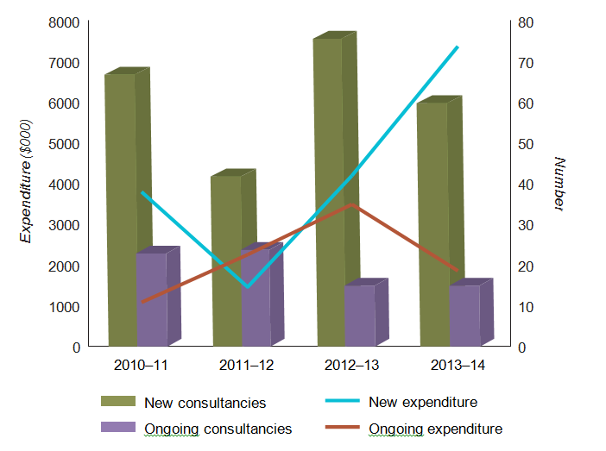

Figure 17: This graph shows the trend in new and ongoing consultancy services since 2010–11.
*Before 2010–11 the annual report did not include details of consultancies below $10,000

Competitive tendering and contracting
In accordance with the Commonwealth Procurement Rules 2012 and the agency’s purchasing guidelines, and depending on the estimated values of the tenders, the selection and engagement of consultants may involve open tender, pre-qualified tender, limited tender or, where appropriate, direct engagement of a recognised and pre-eminent expert.

Consultants are engaged when specialist expertise is not available within the agency or where an independent assessment is considered desirable.

Exempt contracts
During 2013–14 no contract was exempted by the chief executive from publication in AusTender.

Access by Auditor-General
All contracts provided for the Auditor-General to have access to the contractor’s premises.
GRANT PROGRAMS
Information on grants awarded by the Great Barrier Reef Marine Park Authority during the period 1 July 2013 to 30 June 2014 is available at www.gbrmpa.gov.au. During 2013–14 the agency administered the following grants programs:

- International Coral Reef Initiative grants program
- Ripples of Change — Reef Guardian Schools award
- Science for Management Awards.

ANNUAL REPORT

Finances

2013-14

FINANCIAL STATEMENTS 2013–14

TABLE OF CONTENTS

Figure Page

Independent auditor’s report 143

Statement by Chief Executive and Chief Financial Officer 145

Statement of comprehensive income 146

Statement of financial position 147

Statement of change in equity 148

Cash flow statement 149

Schedule of commitment 150

Administered schedule of comprehensive income 152

Administered schedule of assets and liabilities 153

Administered reconciliation schedule 154

Administered cash flow statement 155

Administered schedule of commitments 156
Table of contents — notes 157

Notes to and forming part of the financial statements 158-206

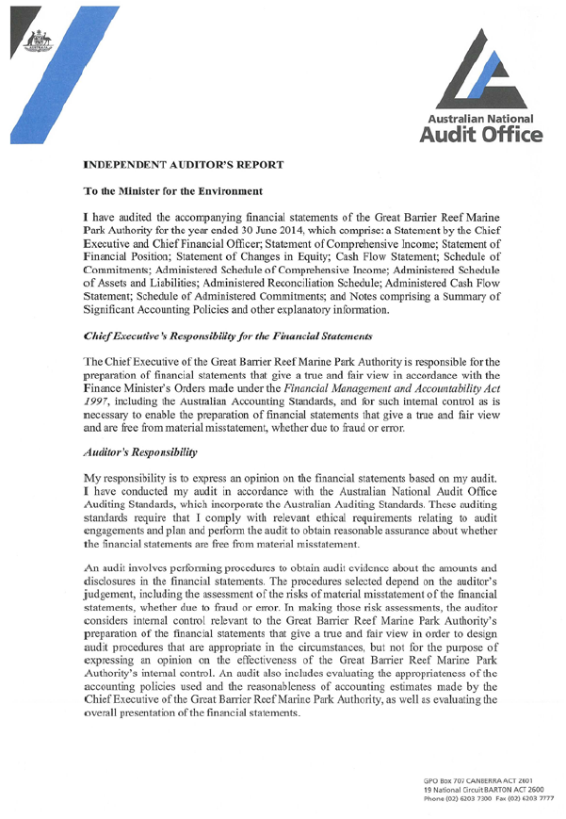

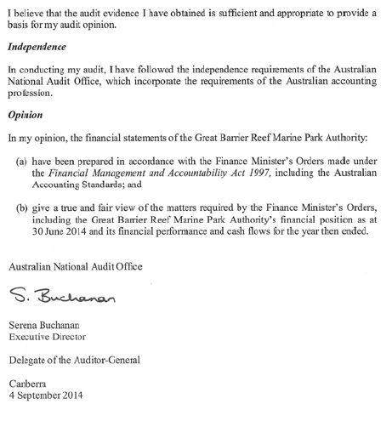

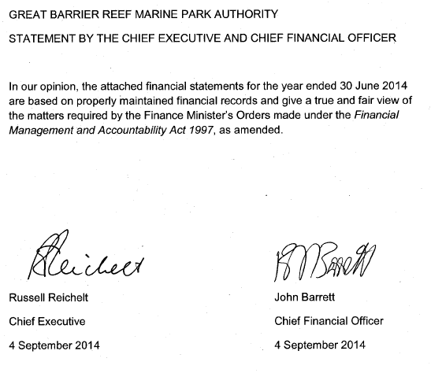

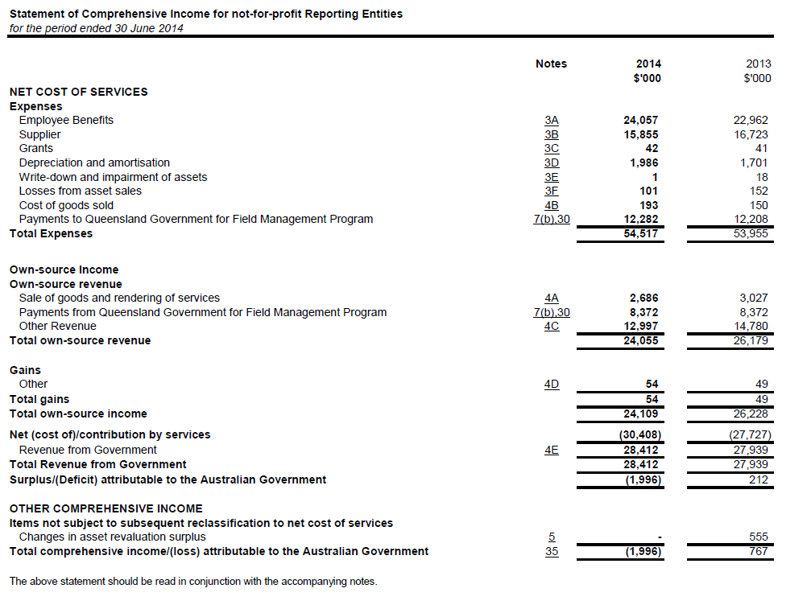

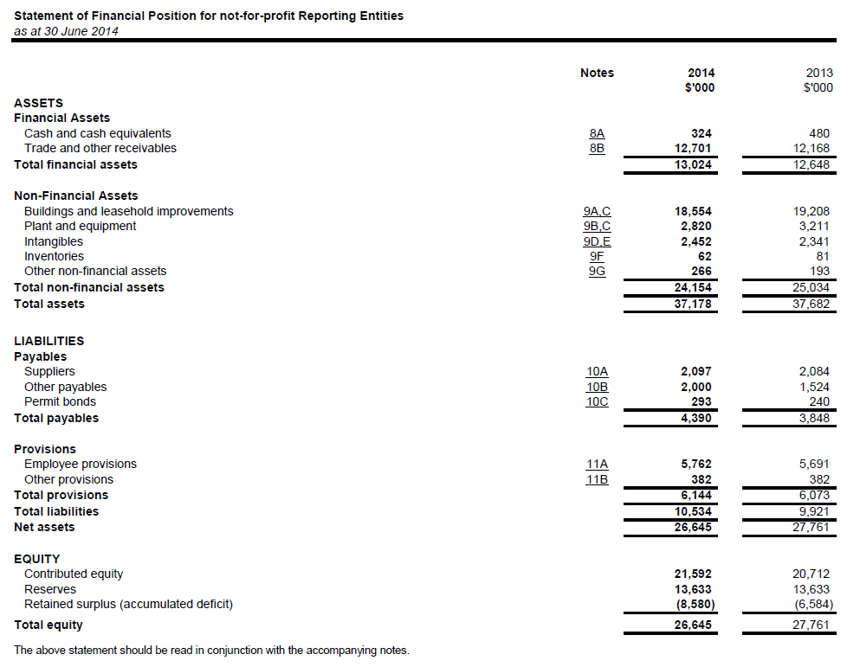

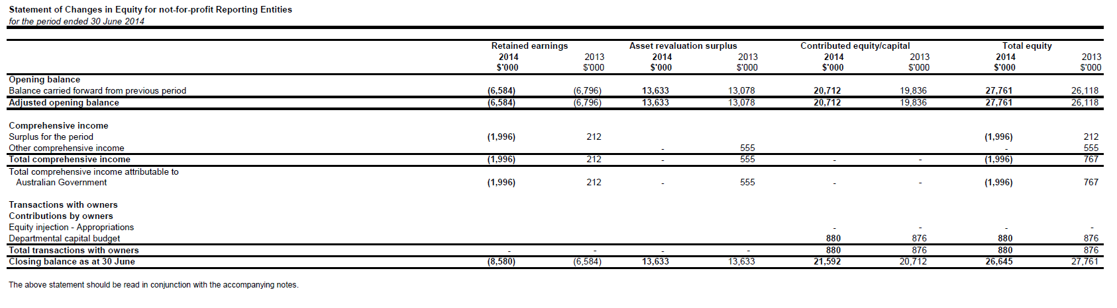

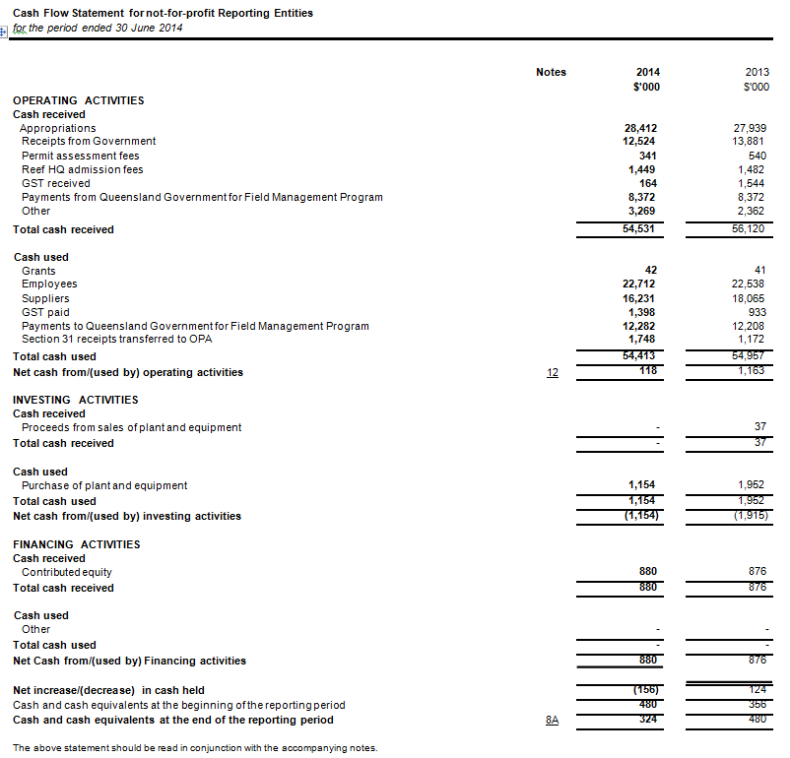

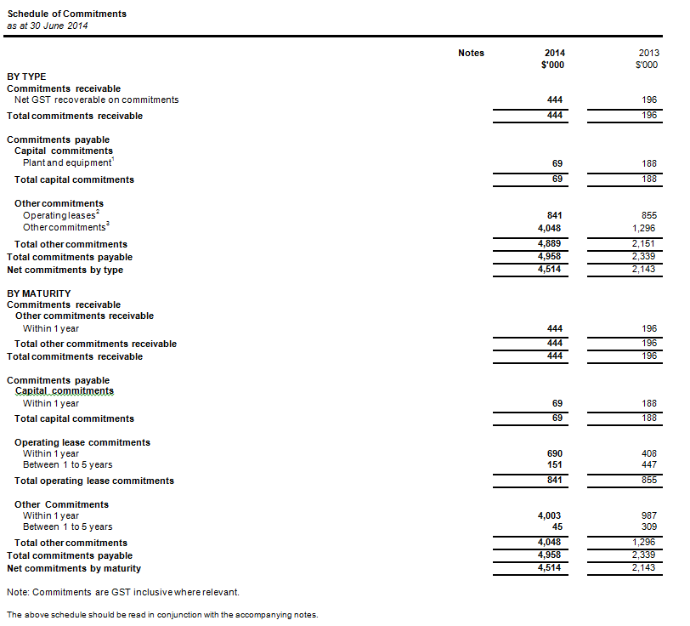

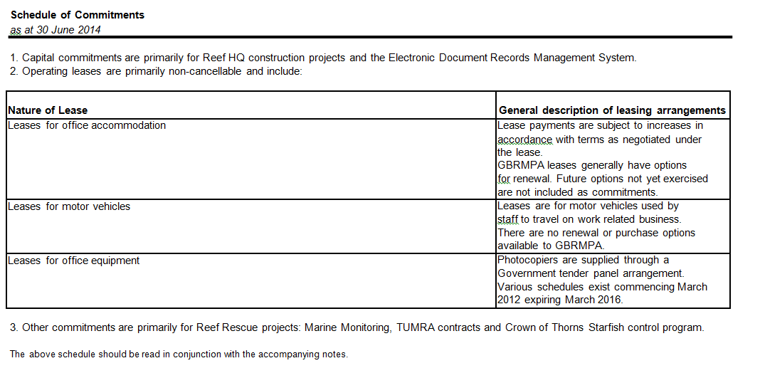

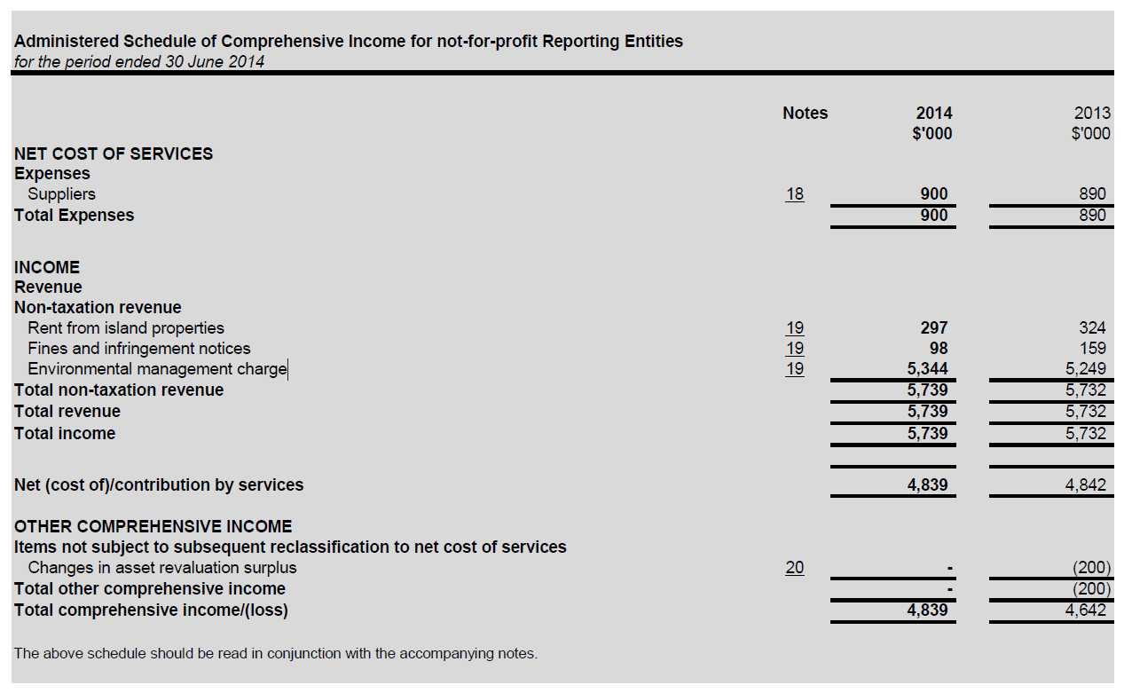

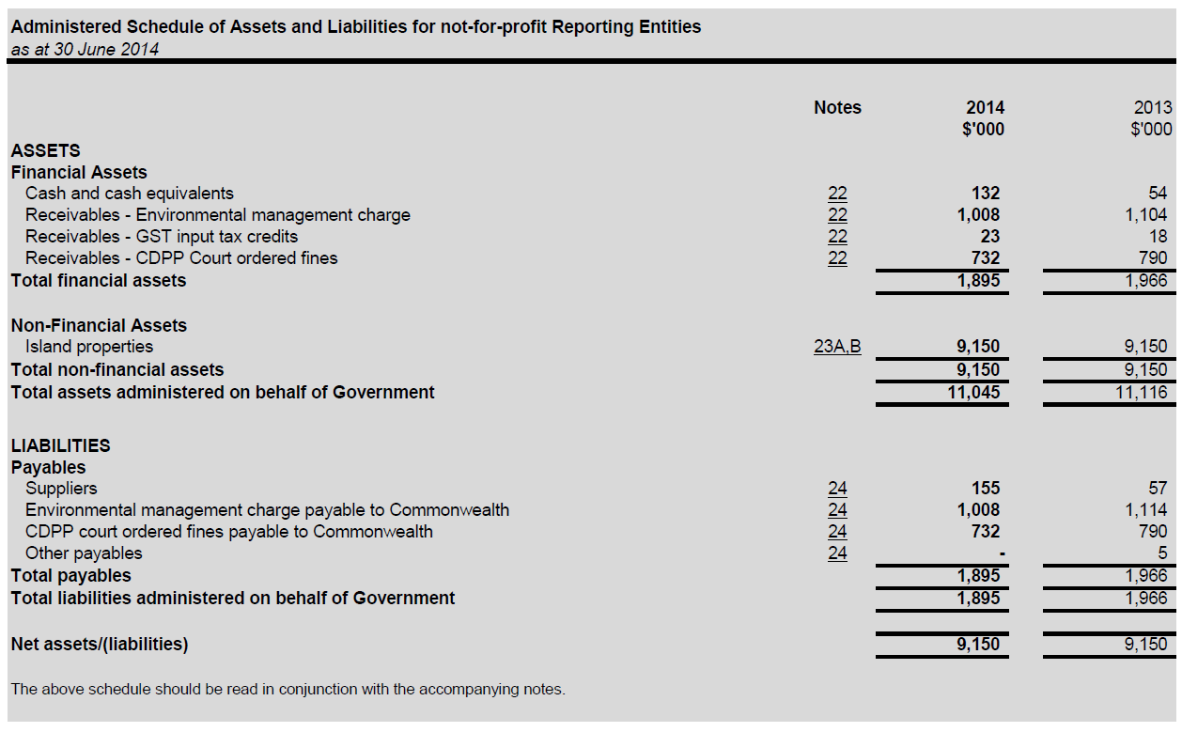

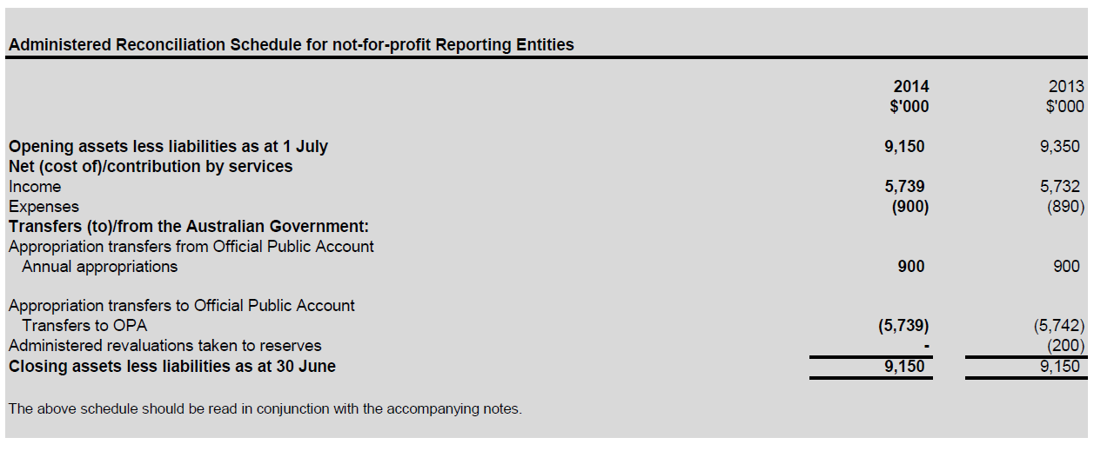

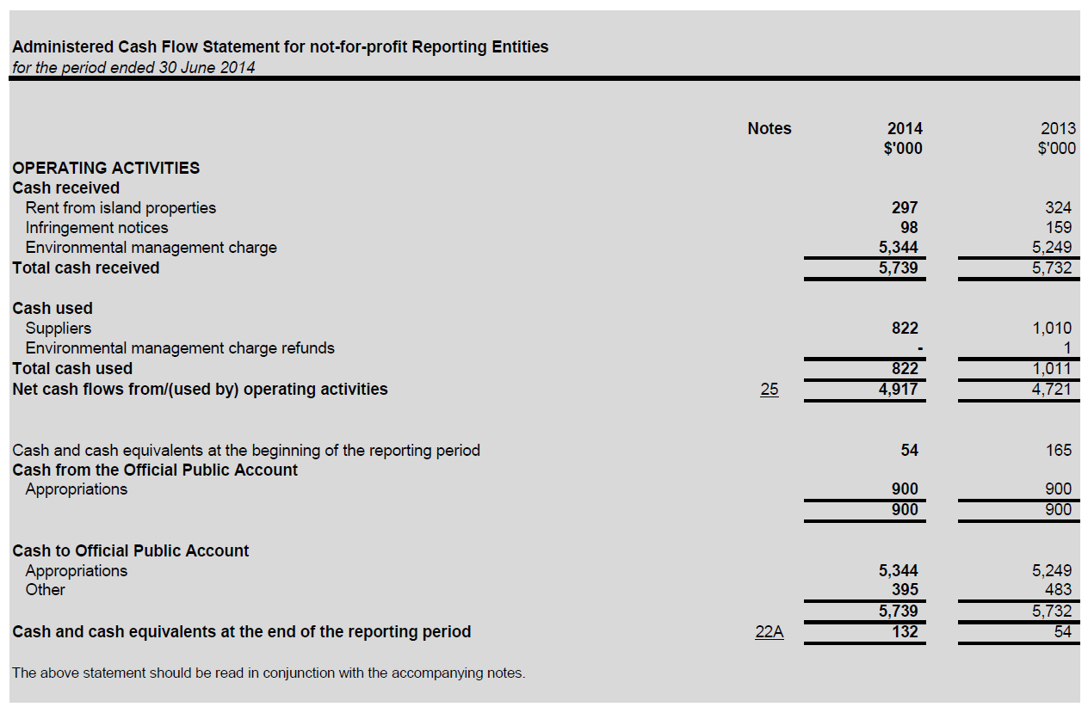

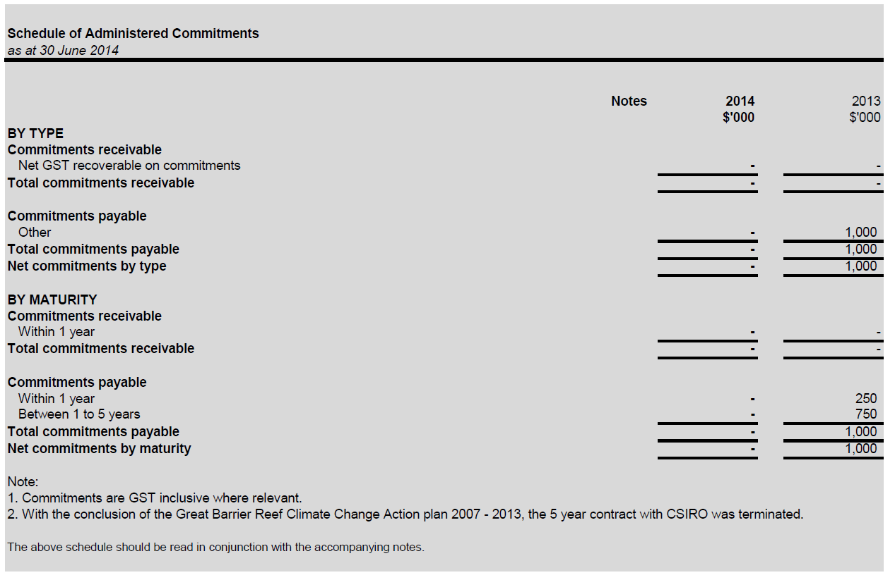

TABLE OF CONTENTS – NOTES

Notes Page
Note 1: Summary of significant accounting policies 158
Note 2: Events after the reporting period 167
Note 3: Expenses 168
Note 4: Income 170
Note 5: Other comprehensive income 170
Note 6: Fair value measurements 171
Note 7: Field Management Program of the Great Barrier Reef Marine Park 174
Note 8: Financial assets 175
Note 9: Non-financial assets 177
Note 10: Payables 182
Note 11: Provisions 183
Note 12: Cash flow reconciliation 184
Note 13: Contingent assets and liabilities 185
Note 14: Senior Executive remuneration 186
Note 15: Remuneration of auditors 188
Note 16: Financial instruments 188
Note 17: Financial assets reconciliation 190
Note 18: Administered – expenses 191
Note 19: Administered – income 191
Note 20: Administered – other comprehensive income 191
Note 21: Administered – fair value measurements 192
Note 22: Administered – financial assets 193
Note 23: Administered – non-financial assets 193
Note 24: Administered – payables 195
Note 25: Administered – cash flow reconciliation 195
Note 26: Administered – contingent assets and liabilities 195
Note 27: Administered – financial instruments 196
Note 28: Administered – financial assets reconciliation 197
Note 29: Appropriations 198
Note 30: Special accounts 203
Note 31: Compensation and debt relief 204
Note 32: Assets held in trust 204
Note 33: Reporting of outcomes 205
Note 34: Cost recovery summary 206
Note 35: Net cash appropriation arrangements 206

Note 1: Summary of Significant Accounting Policies
1.1 Objectives of the Great Barrier Reef Marine Park Authority
The Great Barrier Reef Marine Park Authority (GBRMPA) is an Australian Government controlled entity. It is a not-for-profit entity. The objective of the GBRMPA under the Great Barrier Reef Marine Park Act 1975 is to manage one of the world's premier natural resources through the care and development of the Great Barrier Reef Marine Park.

The GBRMPA is structured to meet the following outcome: The long-term protection, ecologically sustainable use, understanding and enjoyment of the Great Barrier Reef for all Australians and the international community through the care and development of the Marine Park. This outcome is supported by three objectives:
- Protect and restore biodiversity;
- Safeguard heritage values; and
- Ecologically sustainable and the socio-economic benefits derived from the reef are maintained.

The continued existence of the GBRMPA in its present form and with its present programs is dependent on Government policy and on continuing funding by Parliament for the GBRMPA's administration and programs.

GBRMPA activities contributing toward this outcome are classified as either departmental or administered. Departmental activities involve the use of assets, liabilities, income and expenses controlled or incurred by the GBRMPA in its own right. Administered activities involve the management or oversight by the GBRMPA, on behalf of the Government, of items controlled or incurred by the Government.

The GBRMPA conducts the following administered activities:
- Collection of the Environmental Management Charge (EMC); and
- Implementation of the Great Barrier Reef Climate Change Action Plan 2007-2013.

1.2 Basis of Preparation of the Financial Statements

The financial statements are general purpose financial statements and are required by section 49 of the Financial Management and Accountability Act 1997.

The Financial Statements and notes have been prepared in accordance with:
- Finance Minister’s Orders (or FMOs) for reporting periods ending on or after 1 July 2011; and
- Australian Accounting Standards and Interpretations issued by the Australian Accounting Standards Board (AASB) that apply for the reporting period.

The financial statements have been prepared on an accrual basis and in accordance with the historical cost convention, except for certain assets and liabilities at fair value. Except where stated, no allowance is made for the effect of changing prices on the results or the financial position.

The financial statements are presented in Australian dollars and values are rounded to the nearest thousand dollars dollars unless otherwise specified.

Unless an alternative treatment is specifically required by an accounting standard or the FMOs, assets and liabilities are recognised in the statement of financial position when and only when it is probable that future economic benefits will flow to the entity or a future sacrifice of economic benefits will be required and the amounts of the assets or liabilities can be reliably measured. However, assets and liabilities arising under executor contracts are not recognised unless required by an accounting standard. Liabilities and assets that are unrecognised are reported in the schedule of commitments and the schedule of contingencies.

Unless alternative treatment is specifically required by an accounting standard, income and expenses are recognised in Statement of Comprehensive Income when and only when the flow, consumption or loss of economic benefits has occurred and can be reliably measured.

Note 1: Summary of Significant Accounting Policies (cont)
1.3 Significant Accounting Judgements and Estimates

In the process of applying the accounting policies listed in this note, the GBRMPA has made the following judgements that have the most significant impact on the amounts recorded in the financial statements:
The fair value of buildings, plant and equipment has been taken to be the depreciated replacement cost or market value as determined by an independent valuer; and
Leave provisions involve actuarial assumptions based on expected tenure of existing staff, patterns of leave claims and payouts, future salary movements and future discount rates.

No accounting assumptions or estimates have been identified that have a significant risk of causing a material adjustment to the carrying amounts of assets and liabilities within the next reporting period.

1.4 New Australian Accounting Standards

Adoption of New Australian Accounting Standard Requirements
No accounting standard has been adopted earlier than the application date as stated in the standard.

The following new standards/revised standards/Interpretations/amending standards were issued prior to the signing of the statement by the chief executive and chief financial officer, were applicable to the current reporting period and had a material effect on the GBRMPA's financial statements:
AASB 13: Fair Value Measurement - December 2012 (Compilation)
This Standard has been issued as a result of the International Accounting Standards Board (IASB)’s project to ensure consistency of fair value measurement and disclosure within financial statements. AASB 13 defines fair value, sets out a framework for measuring fair value, and requires disclosures about fair value measurements. The definition of fair value focuses on assets and liabilities because they are a primary subject of accounting measurement. However, the Standard does not specify when fair value should be applied. Guidance on when fair value measurements are to be applied is set out in other standards (e.g. AASB 116 Property, Plant and Equipment). Key features included in AASB 13 are the requirement to value non-financial assets at their highest and best use; identification of a principal (or most advantageous) market; and disclosure of all fair value measurements based on the fair value hierarchy.

All other new standards/revised standards/Interpretations/amending standards that were issued prior to the sign off date and are applicable to the current reporting period did not have a material effect, and are not expected to have a future material effect, on the GBRMPA's financial statements.

Future Australian Accounting Standard Requirements
The following new standards/revised standards/Interpretations/amending standards were issued by the Australian Accounting Standards Board prior to the signing of the statement by the chief executive and chief financial officer, which are expected to have a material impact on the GBRMPA's financial statements for future reporting period(s):
AASB 1055: Budgetary Reporting - March 2013 (Principal)
The Australian Accounting Standards Board (AASB) has issued a new AASB 1055. This new Standard requires reporting of budgetary information and explanation of significant variance between actual and budgeted amounts by not-for-profit entities within the General Government Sector. The new Standard applies to reporting periods beginning on or after 1 July 2014.
AASB 2014-1: Amendments to Australian Accounting Standards [Operative dates: Part A Annual Improvements 2010-2012 and 2011-2013 Cycles - 1 Jul 2014; Part B Defined Benefit Plans: Employee Contributions (Amendments to AASB 119) - 1 Jul 2014; Part C Materiality - 1 Jul 2014; Part E Financial Instruments - 1 Jan 2015]
This Standard makes amendments arising from the IASB’s annual improvements process. The Standard clarifies that a balance sheet as at the beginning of the comparative period only needs to be presented where it is materially affected by a retrospective change resulting from an error, changed accounting policy or reclassification. When such a balance sheet is presented, notes to that balance sheet are not necessary, except as required by AASB 108 Accounting Policies, Changes in Accounting Estimates and Errors. The Standard also clarifies that spare parts, stand-by equipment and servicing equipment are accounted for as property, plant and equipment whenever they meet the definition of property, plant and equipment in AASB 116 Property, Plant and Equipment. Otherwise, such items are classified as inventory. Spare parts and servicing equipment are no longer automatically treated as property, plant and equipment because they can be used only in connection with an item of property, plant and equipment.

Note 1: Summary of Significant Accounting Policies (cont)
All other new standards/revised standards/Interpretations/amending standards that were issued prior to the sign off date and are applicable to future reporting period(s) are not expected to have a future material impact on the GBRMPA's financial statements.

1.5 Revenue

Revenue from the sale of goods is recognised when:
- the risks and rewards of ownership have been transferred to the buyer;
- the agency retains no managerial involvement or effective control over the goods;
- the revenue and transaction costs incurred can be reliably measured; and
- it is probable that the economic benefits associated with the transaction will flow to the GBRMPA.

Revenue from rendering of services is recognised by reference to the stage of completion of contracts at the reporting date. The revenue is recognised when:
- the amount of revenue, stage of completion and transaction costs incurred can be reliably measured and
- the probable economic benefits associated with the transaction will flow to the GBRMPA.

The stage of completion of contracts at the reporting date is determined by reference to the proportion that costs incurred to date bear to the estimated total costs of the transaction.

Receivables of goods and services, which have 30 day terms, are recognised at the nominal amount due less any impairment allowance account. Collectability of debts is reviewed as at end of reporting period. Allowances are made when collectability of the debt is no longer probable.

Revenue from Government
Amounts appropriated for departmental appropriations for the year (adjusted for any formal additions and reductions) are recognised as Revenue from Government when GBRMPA gains control of the appropriation, except for certain amounts that relate to activities that are reciprocal in nature, in which case revenue is recognised only when it has been earned. Appropriations receivable are recognised at their nominal amounts.

The GBRMPA, as agent for the Commonwealth, collects an Environmental Management Charge (EMC) from permit holders. Amounts collected are paid into the Official Public Account (OPA). The GBRMPA receives an equivalent amount via a special appropriation for its operations. Special appropriation is recognised when the GBRMPA has the right to receive the revenue and it can be reliably measured. This is deemed to occur when monies are received by the GBRMPA from permit holders.

1.6 Gains

Resources Received Free of Charge
Resources received free of charge are recognised as gains when, and only when, a fair value can be reliably determined and the services would have been purchased if they had not been donated. Use of those resources is recognised as an expense.

Resources received free of charge are recorded as either revenue or gains depending on their nature.

Contributions of assets at no cost of acquisition or for nominal consideration are recognised as gains at their fair value when the asset qualifies for recognition, unless received from another Government agency or authority as a consequence of a restructuring of administrative arrangements (Refer to Note 1.7).

Sale of Assets
Gains from disposal of assets are recognised when control of the asset has passed to the buyer.

Note 1: Summary of Significant Accounting Policies (cont)

1.7 Transactions with the Government as Owner

Equity injections
Amounts appropriated which are designated as 'equity injections' for a year (less any formal reductions) and Departmental Capital Budgets (DCBs) are recognised directly in contributed equity in that year.

Restructuring of Administrative Arrangements
Net assets received from or relinquished to another Government entity or authority under a restructuring of administrative arrangements are adjusted at their book value directly against contributed equity.

Other Distributions to Owners
The FMOs require that distributions to owners be debited to contributed equity unless it is in the nature of a dividend. In 2013-14 there was no transaction of this nature undertaken by the GBRMPA.

1.8 Employee Benefits

Liabilities for 'short-term employee benefits' (as defined in AASB 119 Employee Benefits ) and termination benefits due within twelve months of the end of reporting period are measured at their nominal amounts.

The nominal amount is calculated with regard to the rates expected to be paid on settlement of the liability.

Other long term employee benefits are measured as net total of the present value of the defined benefit obligation at the end of the reporting period minus the fair value at the end of the reporting period of plan assets (if any) out of which the obligation are to be settled directly.

Leave
The liability for employee benefits includes provision for annual leave and long service leave. No provision has been made for sick leave as all sick leave is non-vesting and the average sick leave taken in future years by employees of the GBRMPA is estimated to be less than the annual entitlement for sick leave.

The leave liabilities are calculated on the basis of employees' remuneration at the estimated salary rates that applied at the time the leave is taken, including the GBRMPA's employer superannuation contribution rates to the extent that the leave is likely to be taken during service rather than paid out on termination.

The estimate of the present value of the liability takes into account attrition rates and pay increases through promotion and inflation.

Separation and Redundancy
Provision is made for separation and redundancy benefit payments. The GBRMPA recognises a provision for termination when it has developed a detailed formal plan for the terminations and has informed those employees affected that it will carry out the terminations.

Superannuation
The GBRMPA staff are members of the Commonwealth Superannuation Scheme (CSS), the Public Sector Superannuation Scheme (PSS) or the PSS accumulation plan (PSSap).

The CSS and PSS are defined benefit schemes for the Australian Government. The PSSap is a defined contribution scheme.

The liability for defined benefits is recognised in the financial statements of the Australian Government and is settled by the Australian Government in due course. This liability is reported by the Department of Finance administered schedules and notes.

The GBRMPA makes employer contributions to the employees' superannuation scheme at rates determined by an actuary to be sufficient to meet the current cost to the Government. The GBRMPA accounts for contributions as if they were contributions to defined contribution plans.

The liability for superannuation recognised as at 30 June represents outstanding contributions for the final fortnight of the year.

Note 1: Summary of Significant Accounting Policies (cont)

1.9 Leases
A distinction is made between finance leases and operating leases. Finance leases effectively transfer from the lessor to the lessee substantially all the risks and rewards incidental to ownership of leased assets. An operating lease is a lease that is not a finance lease. In operating leases, the lessor effectively retains substantially all such risks and benefits.

Operating lease payments are expensed on a straight-line basis which is representative of the pattern of benefits derived from the leased assets.

1.10 Cash
Cash is recognised at its nominal amount. Cash and cash equivalents includes:
- cash on hand;
- demand deposits in bank accounts with an original maturity of 3 months or less that are readily convertible to known amounts of cash and subject to insignificant risk of changes in value;
- cash held by outsiders; and
- cash in special accounts.

1.11 Financial Assets
The GBRMPA classifies its financial assets in the following categories:
- loans and receivables.

The classification depends on the nature and purpose of the financial assets and is determined at the time of initial recognition. Financial assets are recognised and derecognised upon trade date.

Effective Interest Method
The effective interest method is a method of calculating the amortised cost of a financial asset and of allocating interest income over the relevant period. The effective interest rate is the rate that exactly discounts estimated future cash receipts through the expected life of the financial asset, or, where appropriate, a shorter period.

Income is recognised on an effective interest rate basis except for financial assets that are recognised at fair value through profit or loss.

Loans and receivables
Trade receivables, loans and other receivables that have fixed or determinable payments that are not quoted in an active market are classified as ‘loans and receivables’. Loans and receivables are measured at amortised cost using the effective interest method less impairment. Interest is recognised by applying the effective interest rate.

Impairment of Financial Assets
Financial assets are assessed for impairment at the end of each reporting period.
Financial assets carried at amortised cost - if there is objective evidence that an impairment loss has been incurred for loans and receivables or held to maturity investments held at amortised cost, the amount of the
loss is measured as the difference between the asset's carrying amount and the present value of estimated future cash flows discounted at the asset's original effective interest rate. The carrying amount is reduced by way of an allowance account. The loss is recognised in the Statement of Comprehensive Income.

Note 1: Summary of Significant Accounting Policies (cont)

1.12 Financial Liabilities

Financial liabilities are classified as either financial liabilities ‘at fair value through profit or loss’ or other financial liabilities. Financial liabilities are recognised and derecognised upon ‘trade date’.

Other financial liabilities
Other financial liabilities, including borrowings, are initially measured at fair value, net of transaction costs. These liabilities are subsequently measured at amortised cost using the effective interest method, with interest expense recognised on an effective yield basis.

The effective interest method is a method of calculating the amortised cost of a financial liability and of allocating interest expense over the relevant period. The effective interest rate is the rate that exactly discounts estimated future cash payments through the expected life of the financial liability, or, where appropriate, a shorter period.

Supplier and other payables are recognised at amortised cost. Liabilities are recognised to the extent that the goods or services have been received (and irrespective of having been invoiced).

1.13 Contingent Liabilities and Contingent Assets

Contingent liabilities and contingent assets are not recognised in the statement of financial position but are reported in the relevant schedules and notes. They may arise from uncertainty as to the existence of a liability or asset or represent an asset or liability in respect of which the amount cannot be reliably measured. Contingent assets are disclosed when settlement is probable but not virtually certain and contingent liabilities are disclosed when settlement is greater than remote.

1.14 Acquisition of Assets

Assets are recorded at cost on acquisition except as stated below. The cost of acquisition includes the fair value of assets transferred in exchange and liabilities undertaken. Financial assets are initially measured at their fair value plus transaction costs where appropriate.

Assets acquired at no cost, or for nominal consideration, are initially recognised as assets and income at their fair value at the date of acquisition, unless acquired as a consequence of restructuring of administrative arrangements. In the latter case, assets are initially recognised as contributions by owners at the amounts at which they were recognised in the transferor's accounts immediately prior to the restructuring.

1.15 Property, Plant and Equipment

Asset Recognition Threshold
Purchases of property, plant and equipment are recognised initially at cost in the statement of financial position, except for purchases costing less than $5,000, which are expensed in the year of acquisition (other than where they form part of a group of similar items which are significant in total).

The initial cost of an asset includes an estimate of the cost of dismantling and removing the item and restoring the site on which it is located. This is particularly relevant to 'make good' provisions in property leases taken up by the GBRMPA where there exists an obligation to restore the property to its original condition. These costs are included in the value of the GBRMPA's leasehold improvements with a corresponding provision for the 'make good' recognised.

Note 1: Summary of Significant Accounting Policies (cont)
Reef HQ
The Reef HQ building was funded as a Commonwealth–State Bicentennial project, through the Great Barrier Reef Wonderland Association Incorporated (the Association) on land leased from the Townsville Port Authority. Following the winding up of the Association in September 2001 the lease arrangement for the land is now between the Great Barrier Reef Marine Park Authority and the Townsville Port Authority.

Revaluations
Fair values for each class of asset are determined as shown below:

Asset Class Fair Value Measurement
Buildings Market selling price
Leasehold Improvements Depreciated replacement cost
Plant and equipment Market selling price

Following initial recognition at cost, property plant and equipment were carried at fair value less subsequent accumulated depreciation and accumulated impairment losses. Valuations are conducted with sufficient frequency to ensure that the carrying amount of assets do not differ materially from the assets' fair values as at the reporting date. The regularity of independent valuations depends upon the volatility of movements in market values for the relevant assets.

Revaluation adjustments were made on a class basis. Any revaluation increment was credited to equity under the heading of asset revaluation reserve except to the extent that it reversed a previous revaluation decrement of the same asset class that was previously recognised in the surplus/deficit. Revaluations decrements for a class of assets were recognised directly in the surplus/deficit except to the extent that they reverse a previous revaluation increment for that class.

Any accumulated depreciation as at the revaluation date is eliminated against the gross carrying amount of the asset and the asset restated to the revalued amount.

Depreciation
Depreciable property, plant and equipment assets are written-off to their estimated residual values over their estimated useful lives to the GBRMPA using, in all cases, the straight-line method of depreciation.

Depreciation rates (useful lives), residual values and methods are reviewed at each reporting date and necessary adjustments are recognised in the current, or current and future reporting periods, as appropriate.

Depreciation rates applying to each class of depreciable assets are based on the following useful lives:

2014 2013
Buildings 50 years 50 years
Leasehold improvements Lease Term Lease Term
Plant and Equipment 1 to 20 years 1 to 20 years

Impairment
All assets were assessed for impairment at 30 June 2014. Where indications of impairment exist, the asset's recoverable amount is estimated and an impairment adjustment made if the asset's recoverable amount is less than its carrying amount.

The recoverable amount of an asset is the higher of its fair value less costs to sell and its value in use. Value in use is the present value of the future cash flows expected to be derived from the asset.
Where the future economic benefit of an asset is not primarily dependent on the asset's ability to generate future cash flows, and the asset would be replaced if the GBRMPA were deprived of the asset, its value in use is taken to be its depreciated replacement cost.

Note 1: Summary of Significant Accounting Policies (cont)

Derecognition
An item of property, plant and equipment is derecognised upon disposal or when no further future economic benefits are expected from its use or disposal.

1.16 Intangibles

The GBRMPA's intangibles comprise purchased software for internal use. These assets are carried at cost less accumulated amortisation and accumulated impairment losses. Intangibles costing less than $5,000 are expensed in the year of acquisition.

Software is amortised on a straight-line basis over its anticipated useful life. The useful lives of the GBRMPA's software is 3 to 8 years (2012-13: 3 to 8 years).

All software assets were assessed for indications of impairment as at 30 June 2014.

1.17 Inventories

Inventories held for sale are valued at the lower of cost and net realisable value.

Inventories acquired at no cost or nominal consideration are initially measured at current replacement cost at the date of acquisition.

1.18 Taxation

The GBRMPA is exempt from all forms of taxation except Fringe Benefits Tax (FBT) and the Goods and Services Tax (GST).

Revenues, expenses and assets are recognised net of GST except:
- where the amount of GST incurred is not recoverable from the Australian Taxation Office; and
- for receivables and payables.

1.19 Comparative Figures

Where necessary, comparative figures have been adjusted to conform with changes in presentation in these financial statements.

1.20 Insurance

The GBRMPA has insured for risks through the Governments insurable managed fund, called 'Comcover'. This includes insurance cover for the operation of Reef HQ. Workers compensation is insured through Comcare Australia.

1.21 Advances for Field Management

Except for expenditure on fixtures upon land owned by or under the direct control of the Commonwealth or the GBRMPA, payments to the Queensland Department of National Parks, Recreation, Sport and Racing (DNPRSR) for the Field Management Program are fully expensed in the year of payment (refer Note 7 and 30 for details).

1.22 High Court Decision

The Australian Government continues to have regard to developments in case law, including the High Court’s most recent decision on Commonwealth expenditure in Williams v Commonwealth [2014] HCA 23 , as they contribute to the larger body of law relevant to the development of Commonwealth programs. In accordance with its general practice, the Government will continue to monitor and assess risk and decide on any appropriate actions to respond to risks of expenditure not being consistent with constitutional or other legal requirements.

Note 1: Summary of Significant Accounting Policies (cont)

Reporting of Administered Activities
Administered revenues, expenses, assets, liabilities and cash flows are disclosed in the administered schedules and related notes.

Except where otherwise stated below, administered items are accounted for on the same basis and using the same policies as for departmental items, including the application of Australian Accounting Standards.

Administered Cash Transfers to and from the Official Public Account
Revenue collected by the GBRMPA for use by the Government rather than the GBRMPA is administered revenue. Collections are transferred to the Official Public Account (OPA) maintained by the Department of Finance. Conversely, cash is drawn from the OPA to make payments under Parliamentary appropriation on behalf of Government. These transfers to and from the OPA are adjustments to the administered cash held by the GBRMPA on behalf of the Government and reported as such in the schedule of administered cash flows and in the administered reconciliation.

Revenue
All administered revenues are revenues relating to the course of ordinary activities performed by the GBRMPA on behalf of the Australian Government. As such, administered appropriations are not revenues of the individual entity that oversees distribution or expenditure of the funds as directed.

The GBRMPA, as agent for the Commonwealth, collects an environmental management charge (EMC) from tourist operators. Amounts collected are paid into the OPA. The GBRMPA receives an equivalent amount via a special appropriation for its operations. Special appropriation is recognised when the GBRMPA has the right to receive the revenue and it can be reliably measured. This is deemed to occur when monies are received by the GBRMPA from permit holders. Refer to note 4E.

Revenue is generated from rent that is charged under leases associated with a number of lighthouse properties. Administered rent revenue is recognised when the amount of revenue can be reliably measured and the transaction has been completed and recorded.

Expenses
All administered expenses are expenses relating to the course of ordinary activities performed by the GBRMPA on behalf of the Australian Government.

Administered expenses are payments for work commissioned by the GBRMPA to better understand the possible impacts of climate change on the Great Barrier Reef and to develop ways to help adapt to these impacts in line with the National Adaption Framework endorsed by the Council of Australian Governments. This programme has concluded as at 30th June 2014.

Loans and receivables
Administered receivables include amounts due to be collected from tourist operators in relation to the Environmental Management Charge and fee and fines payable to the Commonwealth. The QLD Government State Penalties Enforcement Registry (SPER) administer the recovery of debts.

Property, plant and equipment
Administered property, plant and equipment include island properties valued at fair value. Lighthouse properties are depreciated over the life of the lease term (2012-13: lease term).

Liabilities
Administered liabilities include amounts collected from tourist operators in relation to the Environmental Management Charge to be transferred to the OPA and fee and fines to be transferred to the OPA.

Note 2: Events After the Reporting Period

Departmental
There was no subsequent event that had the potential to significantly affect the ongoing structure and financial activities of the GBRMPA.

Administered
There was no subsequent event that had the potential to significantly affect the ongoing structure and financial activities of the GBRMPA.

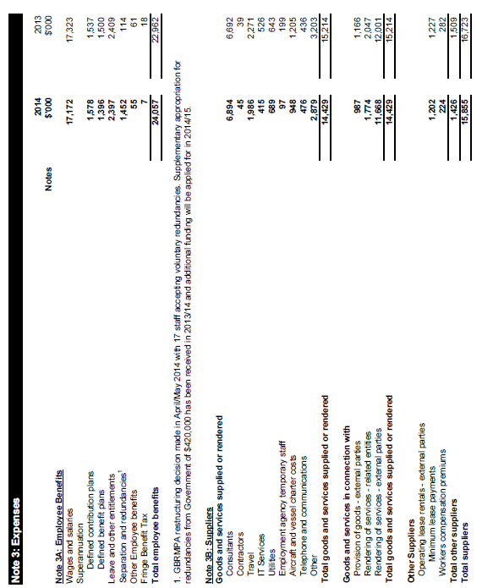

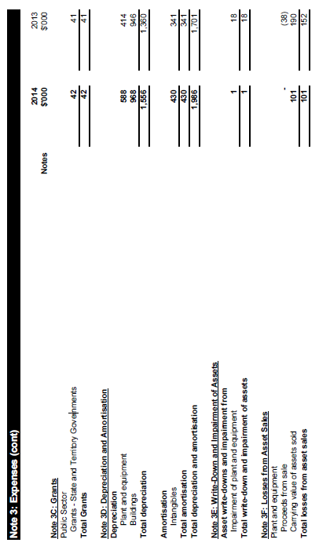
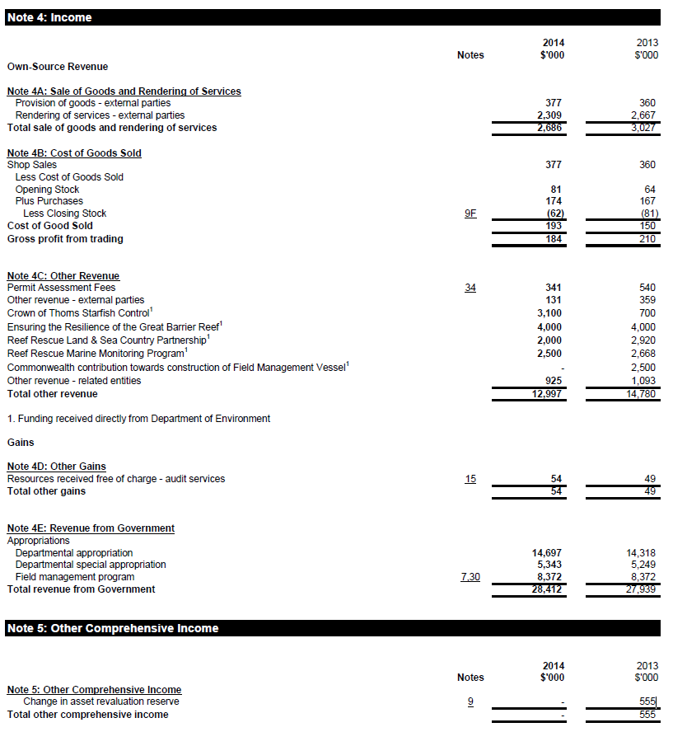

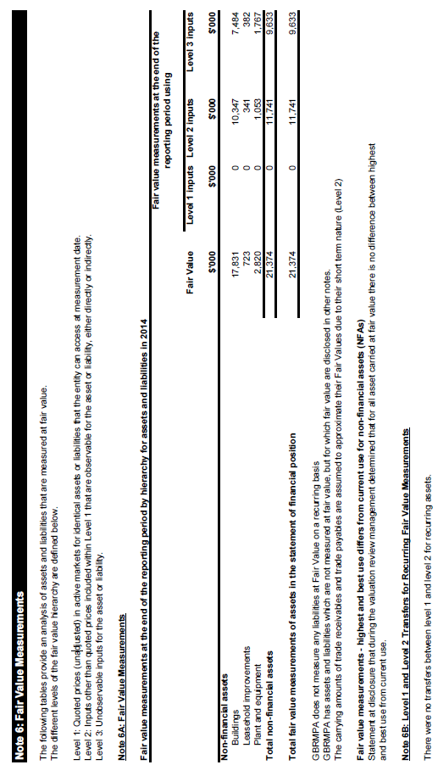

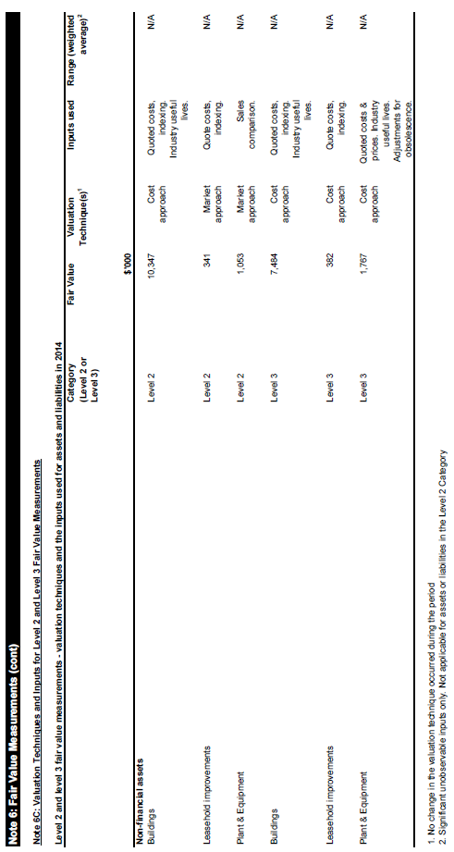
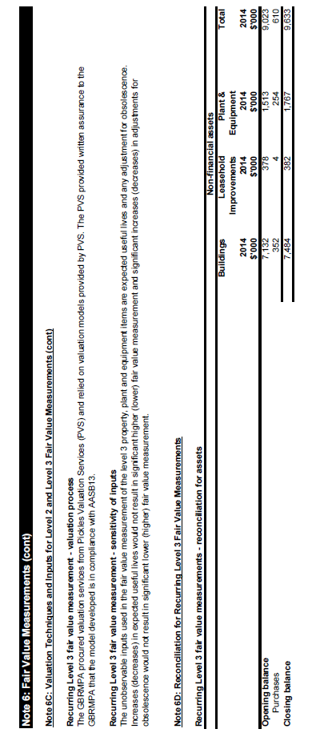

Note 7: Field Management Program of the Great Barrier Reef Marine Park

Note 7A: The guiding principles agreed between the Commonwealth and Queensland Governments under the Great Barrier Reef Intergovernmental Agreement 2009 are:

- A collaborative and cooperative approach is fundamental to the effective long-term protection, conservation and management of the Great Barrier Reef as this is beyond the power and remit of either jurisdiction

- The precautionary principle will be applied to protecting the environmental, World Heritage and National Heritage values of the Great Barrier Reef

- The marine and land environments within and adjacent to the Great Barrier Reef World Heritage Area will be managed in an integrated manner consistent with ecosystem-based management and the principles of ecologically sustainable use

- Economic growth and the long-term health of the Great Barrier Reef ecosystem are interconnected, and actions or changes in one area can impact on the other and must be taken into account, in particular

- population growth and economic development increases the demand for resource and recreational use of the Great Barrier Reef

- land-use activities in the catchment, and urban development can have adverse impacts on the quality of water entering the Great Barrier Reef, and

- regulation of activities that exploit marine resources, measures for protection of marine parks, or initiatives to reduce external pressures on the ecosystem can have regional and local social and economic effects, and improve the long term viability of the region

- Trends in the health, use of and risks to the Great Barrier Reef ecosystem will be regularly monitored and reported to ensure decisions are soundly based

- Co-ordinated long-term monitoring and research and the collection and sharing of marine-based biological, physical, social and economic data is fundamental

- Regular, periodic review of the resources necessary for the long-term management of the marine and national parks within the Great Barrier Reef World Heritage Area will be undertaken

- Initiatives should be delivered through a concerted response across all levels of government with shared funding arrangements of joint Commonwealth-State initiatives agreed on a case-by-case basis

- Expenditure on the Field Management to be in accordance with the Annual Business Plan, and

- The GBRMPA to administer funds provided by the Commonwealth and Queensland for these purposes (Note 30).

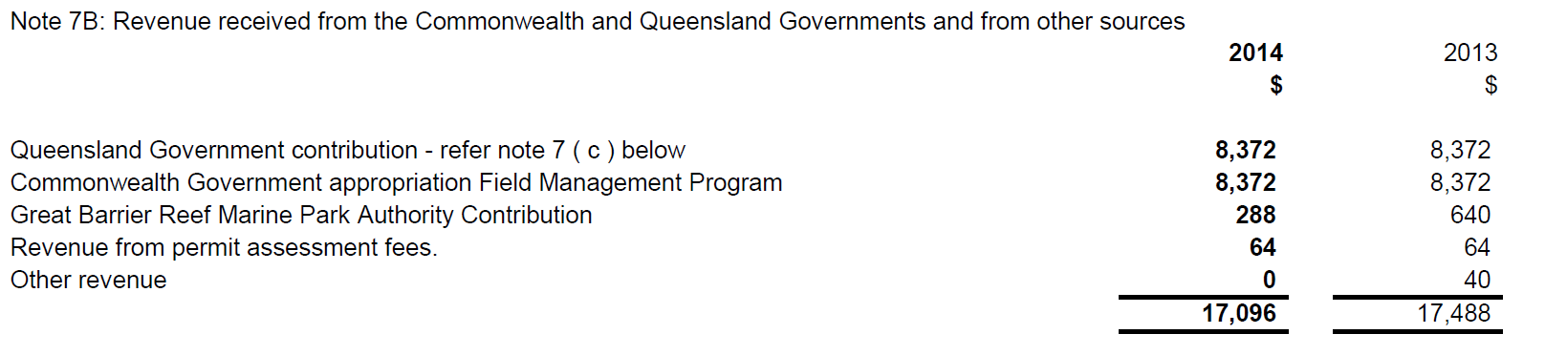

Note 7C: Payments to the Queensland Government for Field Management Program for 2013-14 totalled $12,281,919 (2012-13 $12,307,736).

Note 7D: The balance of funds available is used by the GBRMPA for the operations of the Field Management Co-ordination Unit, and for compliance and enforcement operations.

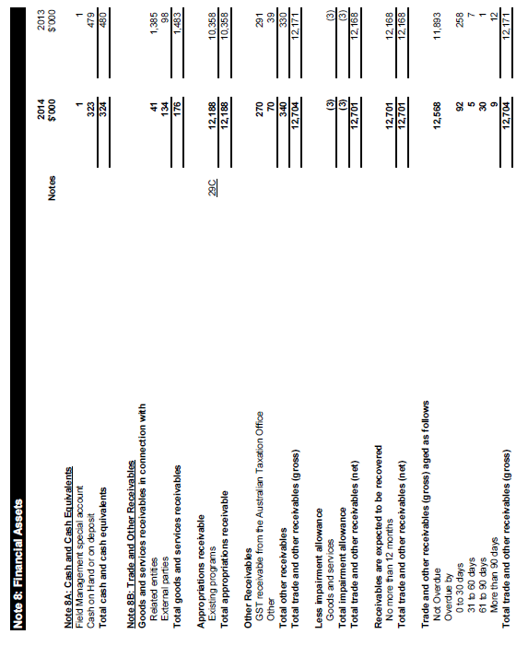

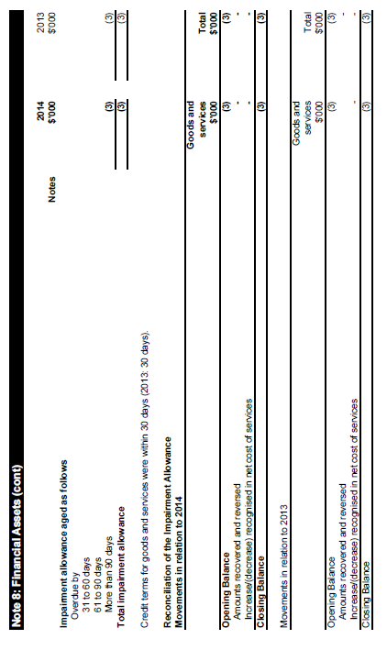
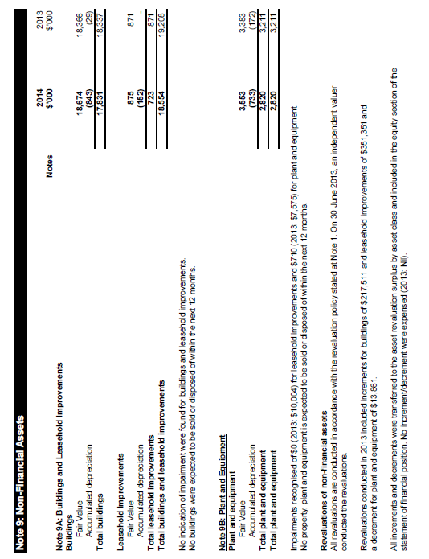

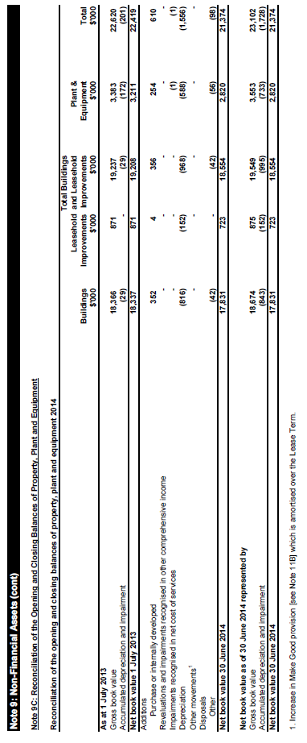

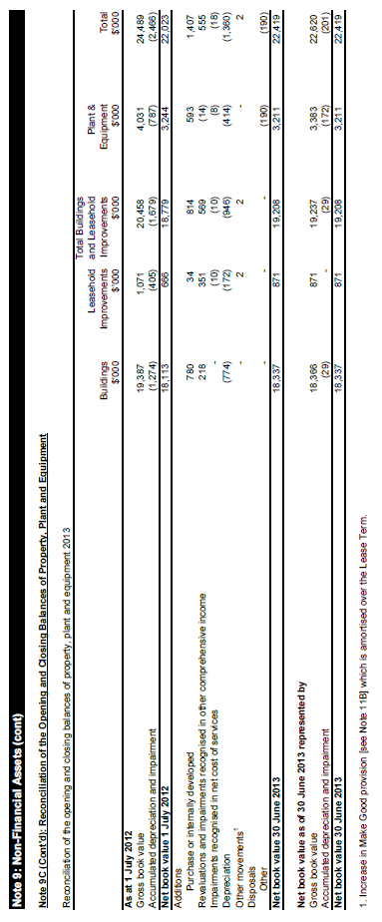
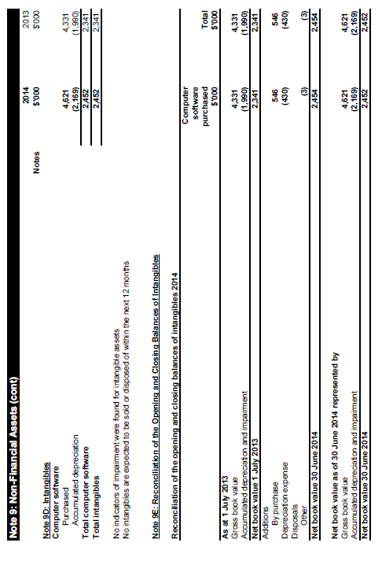

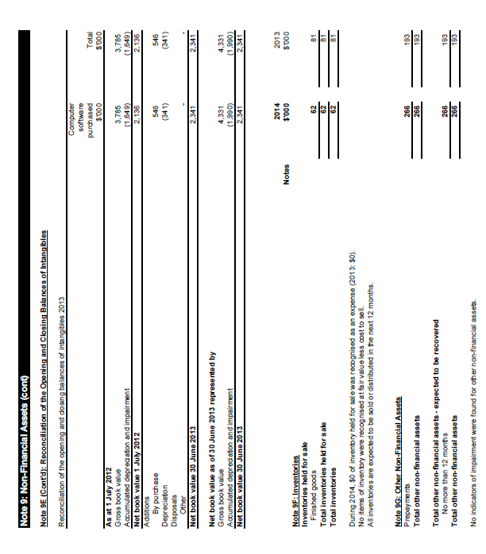

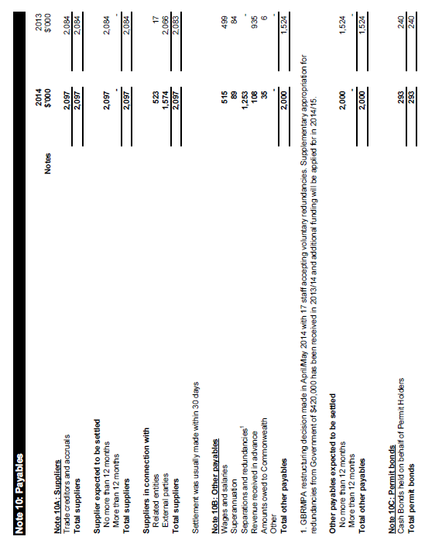

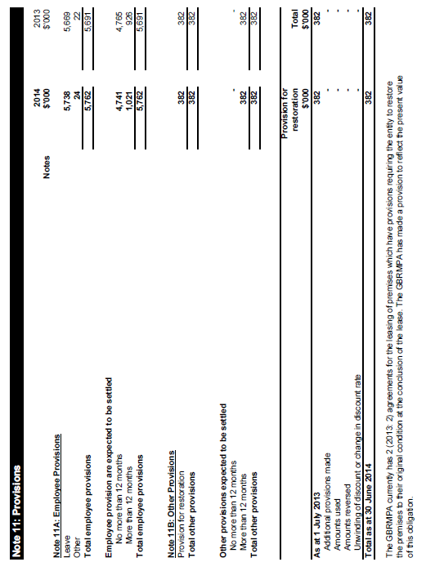

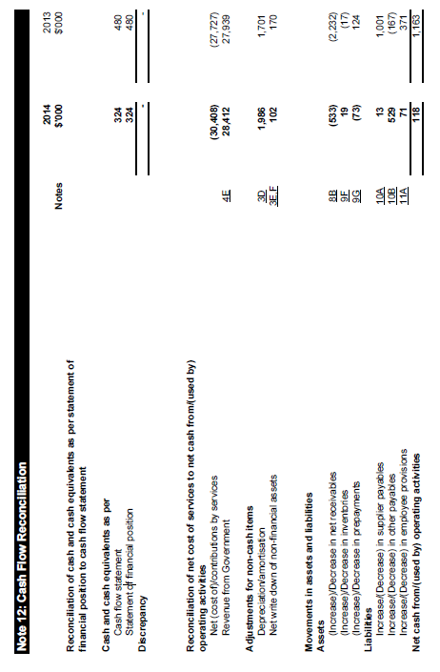

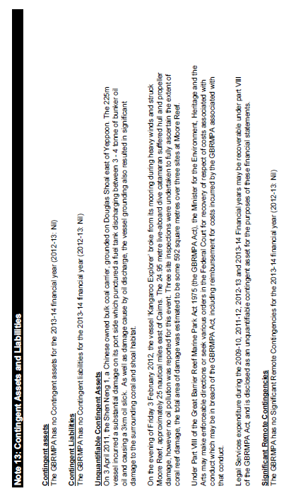
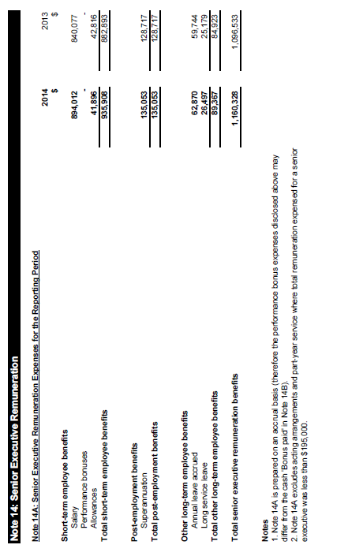

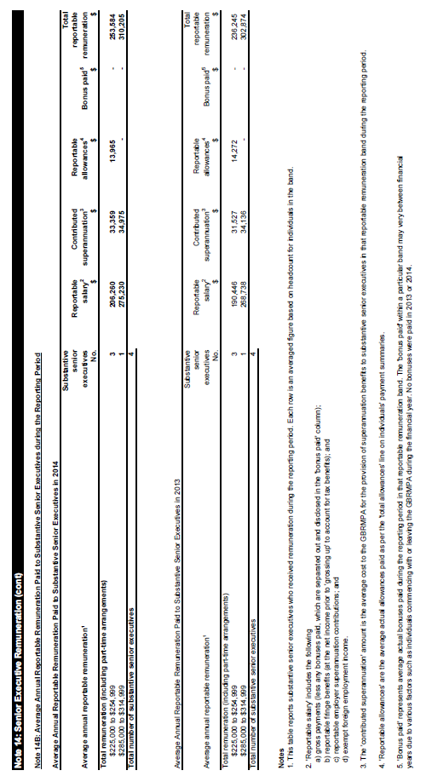

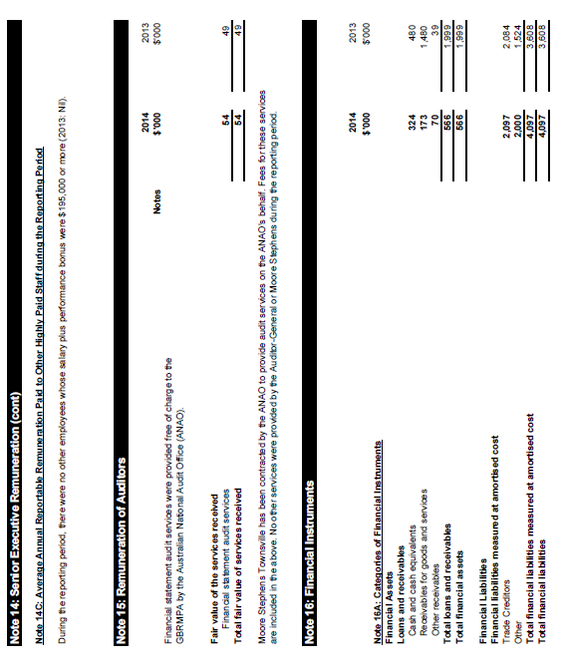

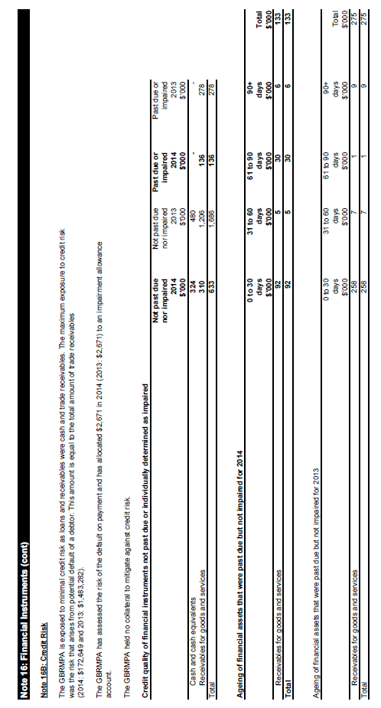

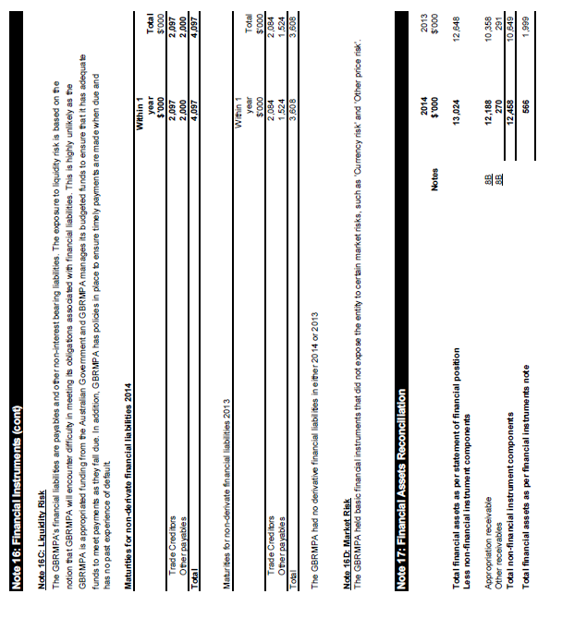

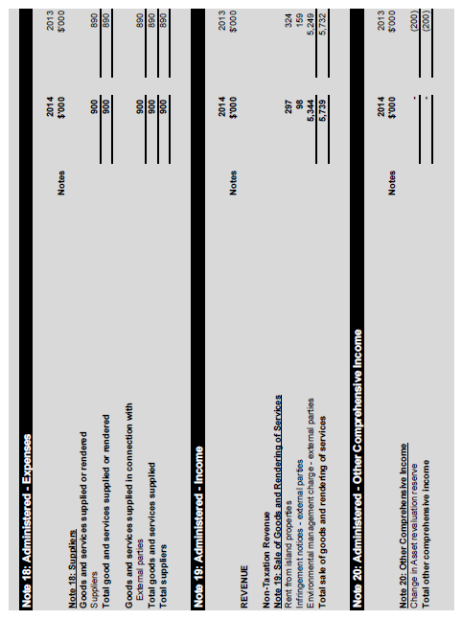

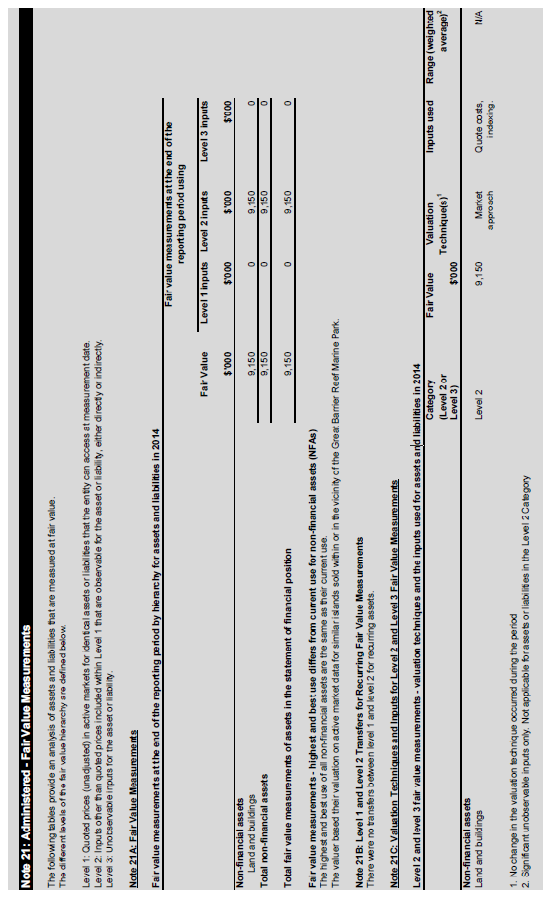

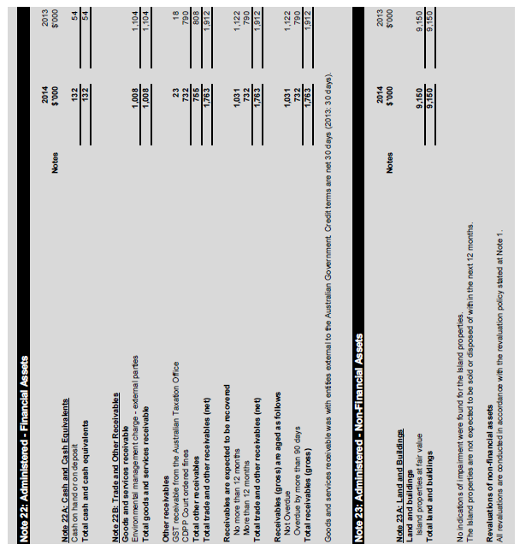

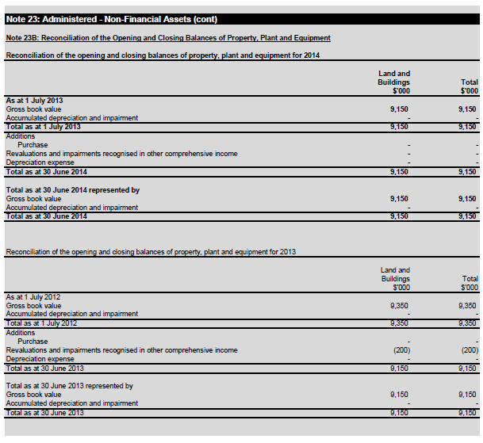

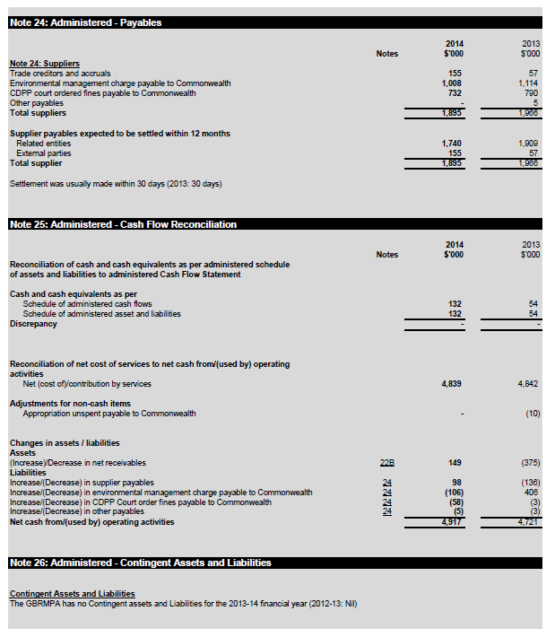

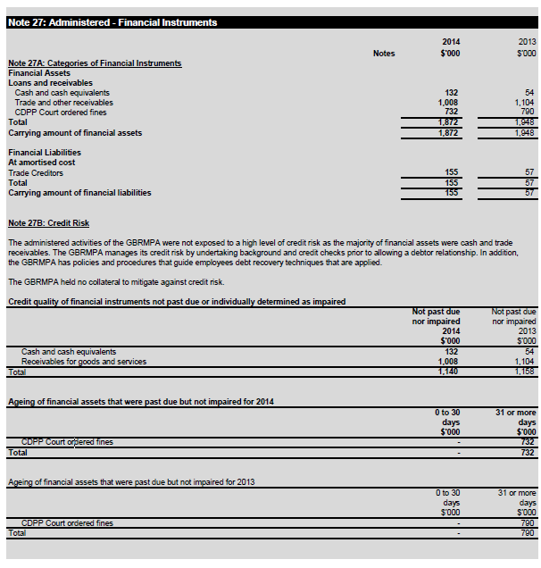

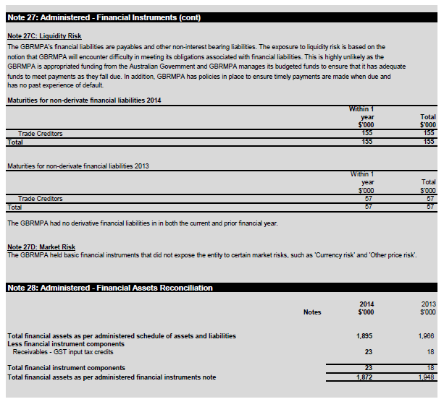

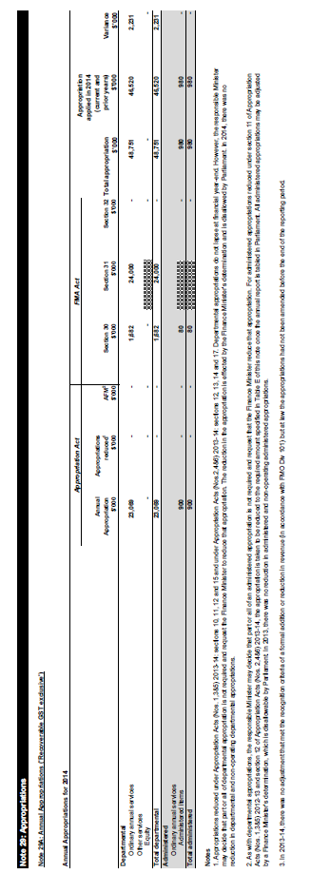
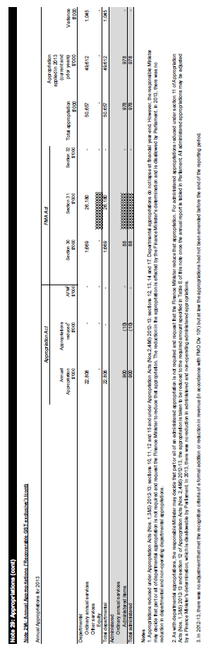
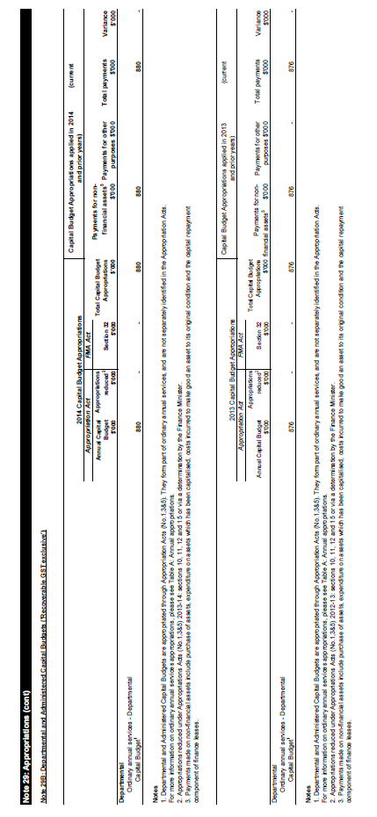
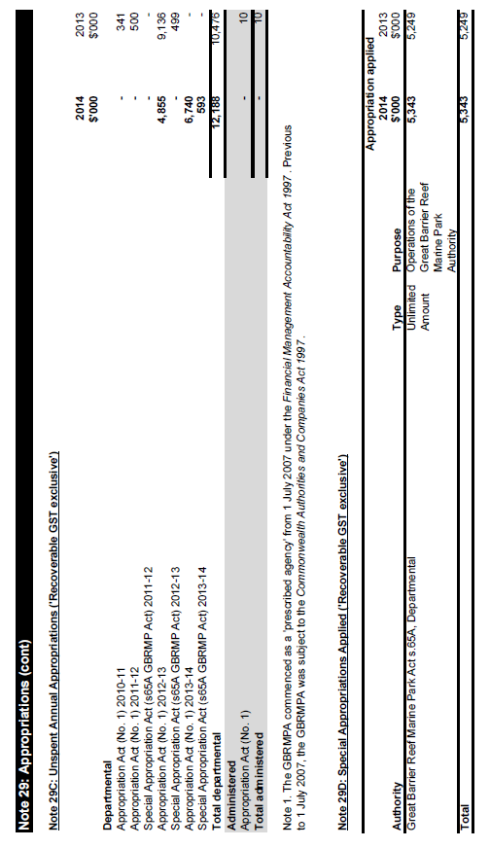

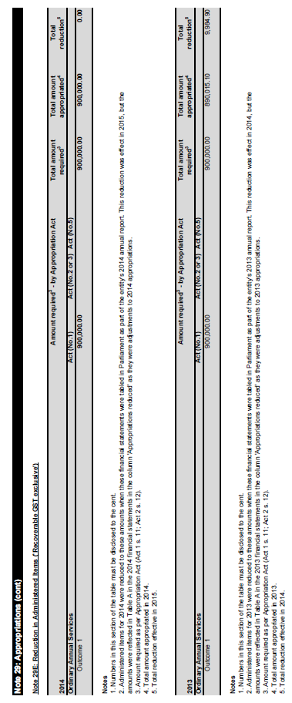
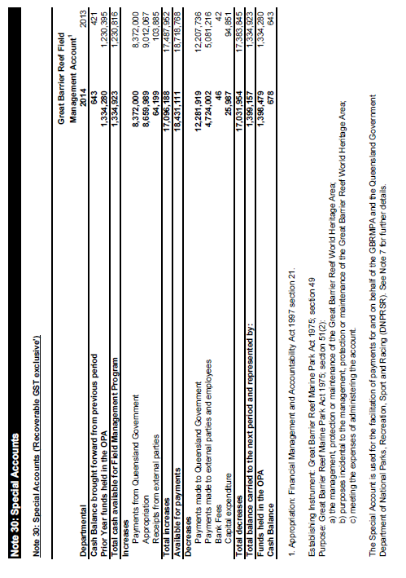

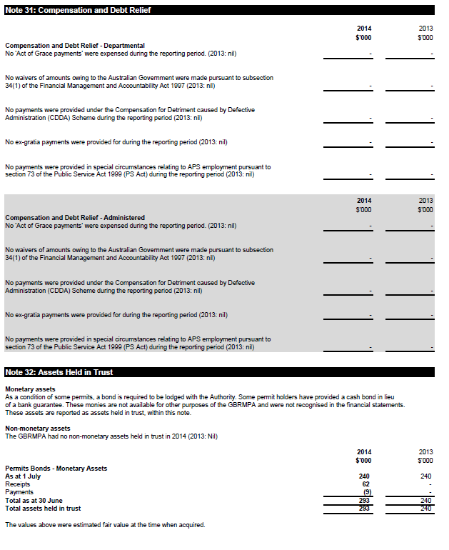
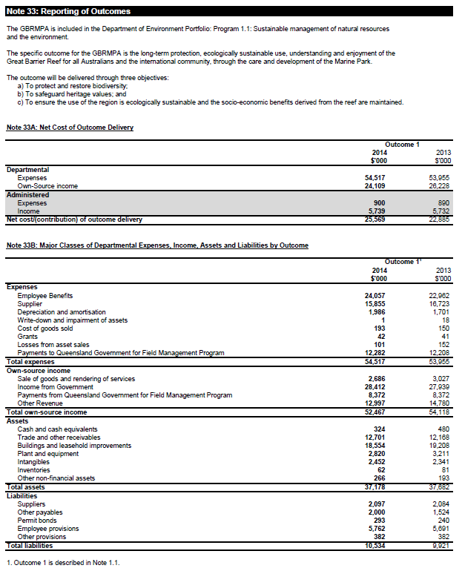
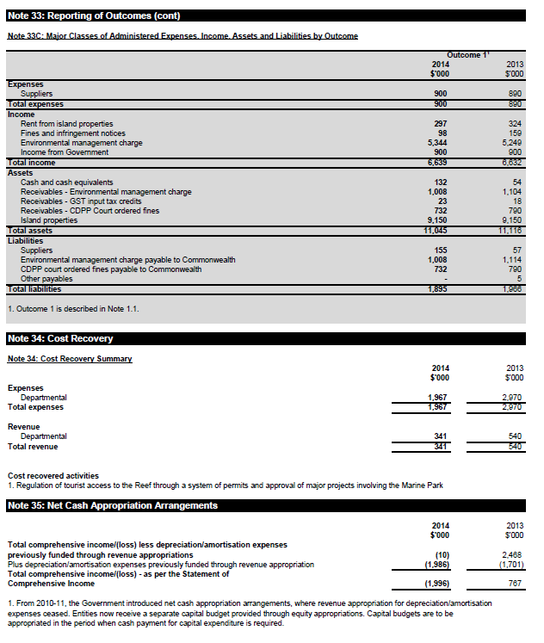

ANNUAL REPORT

Appendices

2013 – 14

APPENDIX A: AGENCY RESOURCE STATEMENT AND RESOURCES FOR OUTCOMES

Table 14a: Great Barrier Reef Marine Park Authority resource statement 2013–14

Actual available Payments made Balance remaining
appropriation 2013-14 $,000 (b) 2013-14 $0,000 (a) - (b)
for 2013-14
$,000 (a)

Ordinary annual services
Department
appropriations 2 49,071 37,958 11,113
Total 49,071 37,958 11,113

Administered expenses
Outcome 1 3 900 900
Total

Total ordinary
annual services A 49,971 38,858

Other services 4
Departmental non-operating
Equity injections 0 0 0
Total 0 0

Total other services B 0 0 0

Total available
annual appropriations
and payments 49,971 38,858

Special appropriations
Special appropriations
limited by criteria/entitlement
Special appropriations Great
Barrier Reef Marine Park Act 5343 5343
Total Special appropriations C 5343 5343

Special accounts 5
Opening balance 1335
Appropriation receipts 6 8660
Non-appropriation
receipts to
Special accounts 8436
Payments made 17,032
Total Special accounts D 18,431 17,032 1399

Total resourcing and payments
A+B+C+D 73,745 61,233
Less appropriations drawn from
Annual or special appropriation above
And credited to special accounts 8660 8660

Total net resourcing and
payments for GBRMPA 65,085 52,573

- Appropriation Bill (No.1) 2013–14. This may also include prior year departmental appropriation and S.31 relevant agency receipts
- Includes an amount of $0.880m in 2013–14 for the departmental capital budget. For accounting purposes this amount has been designated as ‘contributions by owners’
- Includes an amount of $0m in 2013–14 for the administered capital budget. For accounting purposes this amount has been designated as ‘contributions by owners’
- Appropriation Bill (No.2) 2013–14
- Does not include ‘special public money’ held in accounts like other trust monies accounts (OTM). Services for other government and non-agency bodies accounts (SOG), or services for other entities and trust moneys special accounts (SOETM)
- Appropriation receipts from GBRMPA annual and special appropriations for 2013–14 included above.

Table 14b: Expenses and resources for outcome 1

Expenses and resources for outcome 1

Outcome 1: (The long-term protection, ecologically sustainable use, understanding and enjoyment of the Great Barrier Reef for all Australians and the international community, through the care and development of the Marine Park)

Budget Acutal expenses Variation
2013-14 2013-14 2013-14
$,000 $0,000 $0,00(b)
(a) (b) (a) – (b)
Program 1.1:(Great Barrier Marine Park Authority)
Administed expenses
Ordinary annual services
(Appropriation Bill No. 1) 900 900 0

Departmental expenses
Departmental appropriation 1 30,241 30,203 139
Special appropriation 4800 5343 -543
Special accounts 16,784 17,032 -248
Expenses not requiring
approprtiation in the budget year 1749 2040 -291

Total for program 1.1 54,474 55,417 -943

Total expenses for outcome 1 54,474 55,417 -943

2013-14 2013-14
Average staffing level (number) 218 218

Full year budget, including any subsequent adjustment made to the 2013–14 budget
- Departmental appropriation combines “Ordinary annual services (Appropriation Bill No.1)” and “Revenue from independent sources (s31)”.

APPENDIX B: STAFFING OVERVIEW
Table 15: Employee overview as at 30 June 2014
CLASSIFICATION ONGOING EMPLOYEES NON-ONGOING EMPLOYEES

Female Male Total Female Male Total

Full Part Full Part Full Part Full Part
time time time time time time time time
APS1 1 0 1 0 2 1 0 1 0 2
APS2 12 4 3 0 19 5 0 2 0 7
APS3 10 2 2 0 14 0 1 0 0 1
APS4 13 5 7 0 25 1 1 0 2 4
APS5 16 0 7 1 24 1 1 0 2 4
APS6 16 2 20 0 38 7 1 2 0 10
EL1 19 3 20 0 42 1 3 0 0 4
EL2 4 0 10 0 14 0 0 0 0 0
SES1 1 0 2 0 3 0 0 0 0 0
CEO 0 0 0 0 0 0 0 1 0 1
Total 92 16 72 1 181 16 7 6 4 33

As at 30 June 2014 the total number of employees = 214

The total number of employees in 2012-13 was 222, while the total number in 2011-12 was 211.

The agency’s main offices are in Townsville, where 198 employees were based as at 30 June 2014. In addition, there were eight employees in the Cairns office, three employees in Mackay, two employees in Rockhampton and three employees in Canberra.
Table 16: Workplace diversity figures as at 30 June 2014

Classification Total Women ATSI NESB NESB1 NESB2 PWD
CEO 1 0 (0%) 0 (0%) 0 (0%) 0 (0%) 0 (0%) 0 (0%)
APS1 4 2(50%) 0 (0%) 0 (0%) 0 (0%) 0 (0%) 0 (0%)
APS2 26 21(81%) 0 (0%) 1(4%) 7(27%) 7(27%) 0 (0%)
APS3 15 13(87%) 2(13%) 0 (0%) 4(27%) 4(27%) 0 (0%)
APS4 29 19(66%) 1(3%) 2(7%) 15(52%) 16(55%) 0 (0%)
APS5 28 18(64%) 0 (0%) 3(11%) 5(18%) 5(18%) 1(4%)
APS6 48 26 (54%) 5(10%) 2(4%) 14(29%) 15(31%) 1(2%)
EL1 46 26(57%) 1(2%) 5(11%) 14(30%) 13(28%) 2(4%)
EL2 14 5(36%) 1(7%) 1(7%) 3(21%) 2(14%) 0 (0%)
SES1 3 1(33%) 0 (0%) 0 (0%) 1(33%) 0 (0%) 0 (0%)
Total 214 131(61%)10(5%) 14(7%) 63 (29%)62(29%) 4(2%)

ATSI (Aboriginal or Torres Strait Islander)
NESB (Non-English speaking background)
NESB1 (Non-English speaking background, second generation (mother))
NESB2 (Non-English speaking background, second generation (father)) PWD (People with a disability)

APPENDIX C: ADVERTISING AND MARKETING

During 2013–14 the agency conducted advertising campaigns. Details of costs are included in Table 17.

Zoning education: The agency ran print advertisements in the monthly recreational fishing magazine, Fish & Boat, to raise awareness about the zoning rules in place in the Marine Park. This advertising was placed through Adcorp. In addition, targeted advertisements were placed in the Queensland Seafood Industry Association’s magazine which is published every two months. During the reporting period, the agency produced 13 boat ramp signs which were placed at strategic locations along the Great Barrier Reef coastline.

Promotion of Reef HQ Aquarium: A range of promotional advertising was undertaken to promote Reef HQ Aquarium, the national education centre for the Great Barrier Reef.
This included mainstream and social media, direct mail-outs and Yellow Pages.

Strategic assessment advertising: In November 2013, the agency placed a series of public notices in 17 newspapers (metro and regional) to promote the release of the strategic assessment for public consultation and to promote community information sessions. Given the assessment was jointly undertaken by the Australian and Queensland governments, the advertisements were jointly branded with the Queensland Government and costs were shared. The Queensland Government also placed an online advertisement and again the cost was shared. These activities were part of a broader communication plan to promote the consultation.

Table 17: Media advertising organisations used in 2013–14

Advertising program Amount

Zoning education, Queensland $7326
Seafood Industry Association

Zoning education, Signtime $3446

Zoning education, Adcorp $4117

Reef HQ marketing and advertising, $30,795
Universal McCann

Strategic assessment, Adcorp $25,850

Joint strategic assessment online $8547
advertising, Queensland Government

APPENDIX D: FREEDOM OF INFORMATION

The Freedom of Information Act 1982 (FOI Act) provides the community with the right of access to documents held by Australian Government agencies.

This right of access is limited only by certain exceptions and exemptions which are contained in the FOI Act. Under the FOI Act, to request access to information an application must:

- be made in writing
- state that the request is an application for the purposes of the FOI Act
- provide enough information about the document(s) for a responsible officer of the agency to identify it (them)
- provide an address in Australia at which notices under the FOI Act may be sent to the applicant.

FOI requests should be sent to:

The FOI contact officer
c/- Legal Services
Great Barrier Reef Marine Park Authority 2–68 Flinders Street
PO Box 1379
TOWNSVILLE QLD 4810
Australia

Alternatively, they be lodged via email to FOI@gbrmpa.gov.au

Freedom of information requests can also be delivered to the agency’s Townsville office at 2–68 Flinders Street, Townsville QLD 4810.

If the applicant decides to proceed with a request, charges may also be payable for the time spent searching for and retrieving relevant documents, decision-making time, photocopying and postage, etc. In the event that the agency decides that an applicant is liable to pay a charge for processing a request, the applicant would be notified of the preliminary assessment of the charge and have the opportunity to contend that the charge should not be imposed, or should be reduced.

If any difficulty arises in identifying a document or in providing access in the form requested, an officer of the agency will contact the applicant with a view to resolving the difficulty. In consultation with the applicant, documents will be made available by mail to the address specified by the applicant or at the official freedom of information access point.

The authorised decision-makers in respect of a request made under the FOI Act for the agency are the Chairman, the general managers, the director legal services and the senior legal officers.

Documents released under the FOI Act are listed on the agency’s disclosure log, located at www.gbrmpa.gov.au/home/freedom-of- information-requests/foi.

Freedom of information operations
During the 2013–14 financial year, the agency received 14 requests for access to documents under the FOI Act. Of those, seven applications were granted partial access, one was granted full access, one was refused, four were withdrawn and one was deemed invalid.

There were two internal review applications received for decisions made under the FOI Act during 2013–14. One application was granted full access on internal review. The second application had not been finalised by the end of the financial year.

One application was made to the Office of the Australian Information Commissioner for review of a decision made under the FOI Act during 2013–14. The Office of the Australian Information Commissioner closed the application for review under s. 54W(b) of the FOI Act.

No applications were made to the Administrative Appeals Tribunal for review of decisions made under the FOI Act during 2013–14.

There were no applications to amend records under the FOI Act during 2013–14.

A total of $6105.45 was received in charges under the FOI Act during 2013–14.

Part II of the FOI Act — Information Publication Scheme
Amendments to the FOI Act which took effect on 1 May 2011 require that certain information about the agency is to be published through an Information Publication Scheme under Part II of the FOI Act. Since1 May 2011, that information has been available on the agency’s website www.gbrmpa.gov.au/home/ips.

Information required to be published under this scheme includes an agency’s corporate details such as the agency’s structure, functions, official appointments, annual reports, consultation arrangements for specific policy proposals, information routinely provided in response to requests and orders from the Parliament, and operational information.

The agency strives to embrace a pro- disclosure culture and has therefore published additional information to that required under the scheme. The agency’s Information Publication Scheme register is located at www.gbrmpa.gov.au/home/ips/ips- document-register.

The chairman, general managers and directors have power to publish information in accordance with the Information Publication Scheme under Part II of the FOI Act.

APPENDIX E: ECOLOGICALLY SUSTAINABLE DEVELOPMENT AND ENVIRONMENTAL PERFORMANCE

Section 516A of the Environment Protection and Biodiversity Conservation Act 1999 (the EPBC Act) requires Australian Government organisations to report on the organisation’s contribution to ecologically sustainable development as well as the environmental performance of the organisation. Section 516A also promotes development of a framework that integrates environmental, economic and social considerations and helps improve the environmental and ecologically sustainable development performance of Australian Government agencies.

The following is a summary of activities by the agency in 2013–14 in accordance with section 516A of the EPBC Act.

- How the activities of the organisation and the administration of legislation by the organisation accord with the principles of ecologically sustainable development (section 516A(6)(a))

The following activities of the agency accord with the principles of ecologically sustainable development:

- administering and enforcing the Great Barrier Reef Marine Park Act 1975, which explicitly recognises these principles
- working with the Department of the Environment, other agencies and stakeholders to promote ecologically sustainable development focused on:
- ensuring the long-term protection, ecologically sustainable use, understanding and enjoyment of the Great Barrier Reef for all Australians and the international community through the control, care and development of the Great Barrier Reef Marine Park
- providing policy advice to the Environment Minister to ensure the agency’s environment policies are mutually supportive.
The Australian and Queensland governments have been working together to undertake a comprehensive strategic assessment of the Great Barrier Reef World Heritage Area and the adjacent coastal zone. The strategic assessment will collectively look at the Great Barrier Reef Region, development proposals in the area and decision-making processes. It will determine whether management is effective, and make recommendations to improve how the Region is managed.

The strategic assessment will help us identify, plan for and manage risks to the World Heritage Area to protect it for the future. This will be achieved by:

- assessing the multiple impacts arising from current and future planned development in the region on Great Barrier Reef values
- assessing the effectiveness of existing management to protect Reef values from multiple impacts.

The agency has led the marine component of the strategic assessment, which looks at the arrangements in place to manage and protect the Great Barrier Reef Marine Park
and World Heritage Area. During 2013–14 the strategic assessment went through a process of public consultation and that information will be utilised to ensure that the strategic assessment looks at current policy and planning arrangements for a range of uses and their impacts, including:

- the full range of activities in the Marine Park including tourism, fishing, ports and shipping, defence, research, recreation and use by Traditional Owners
- impacts of development within the coastal zone, including urban, industrial, port, marina and aquaculture activities
- water quality policies and controls
- island national parks and protected areas.

The range of activities presented in the Performance chapter of this annual report include activities that accord with the principle of integrating environmental, social, and economic considerations. In addition, the day-to-day business of the agency in ensuring the long-term sustainability of biodiversity of the Great Barrier Reef is achieved by managing the zoning plan introduced on 1 July 2004, in consultation with stakeholders, communities and agencies.

The following activities accord with the principles of ecologically sustainable development, especially by employing or promoting the use of the precautionary principle:

- making decisions under the Great Barrier Reef Marine Park Act 1975
- releasing publications on climate change and the Great Barrier Reef
- making information readily available on the agency’s external website
- working with the Department of the Environment and other agencies to undertake a strategic assessment
- working with the Department of the Environment and other agencies to develop the Long-term Sustainability Plan for the Great Barrier Reef

The following activities accord with the principles of ecologically sustainable development by aiming to promote conservation of the environment for the benefit of future generations:

- Contributing to the conservation of biodiversity, including:
- the development of the Great Barrier Reef Biodiversity Conservation Strategy 2013 which specifically responds to the threats to biodiversity as outlined in the Great Barrier Reef Outlook Report 2009
- a focus on encouraging integrated coastal management and improving knowledge on the role that coastal ecosystems play in the health of the Great Barrier Reef
- continuing to address the remaining impacts of fishing and illegal fishing and poaching
- improving the quality and extent of information on the Great Barrier Reef’s water quality
- continued implementation of the marine monitoring program – a component of the Paddock to Reef program under Reef Plan
- contributing to the conservation of biodiversity in marine ecosystems including through continued implementation of the Representative Areas Program

- Protecting the World Heritage values of Australia’s Great Barrier Reef through:
- regulation, including the consideration of proposed actions predominantly in, or adjacent to, the Great Barrier Reef and the Wet Tropics of Queensland
- communication and education, including the active promotion of the World Heritage values of the Great Barrier Reef
- Working in partnership with stakeholder groups, including:
- expanding the Reef Guardians program to include fishers and farmers
- expanding the Reef Guardian Councils program to encourage councils to get involved in environmental projects
- working with Traditional Owners to develop sustainable traditional use of marine resources practices
- operating various advisory groups to assist in the management of particular issues in marine park locations and operational programs.

The following activities accord with the principles of ecologically sustainable development by aiming to improve valuation, pricing and incentive mechanisms:

- Implementing an accreditation program for tourism operators
- Working in partnership with Great Barrier Reef businesses and industry to improve valuation by industry to include environmental and social costs and benefits. Activities in 2013–14 included:
- having an accounting framework to measure the commercial values of the Great Barrier Reef
- continuing the partnership with industry associations through community monitoring programs
- doing consultation on offsets that
provide a net environmental benefit.

- How the outcomes specified in a relevant Appropriations Act contribute to ecologically sustainable development (section 516A(6)(b))

The outcome for the Great Barrier Reef Marine Park Authority is:

The long-term protection, ecologically sustainable use, understanding and enjoyment of the Great Barrier Reef for all Australians and the international community, through the care and development of the Marine Park.

This outcome is explicit in providing for ecologically sustainable use of the Marine Park and is achieved through the delivery of three objectives:

- To protect and restore biodiversity
- To safeguard heritage values
- To ensure use of the Region is ecologically sustainable and the socio- economic benefits from the Reef are maintained.

A comprehensive assessment of work undertaken under these three objectives during 2013–14 is provided in the Performance chapter of this annual report.

- Effect of the organisation’s activities on the environment (section 516A(6)(c))

The agency is responsible for managing one of the world’s premier natural resources through the care and development of the Great Barrier Reef Marine Park. The agency manages the Marine Park as a multiple- use area, and permits such uses as are ecologically sustainable, and as are permitted by legislation.

In conjunction with its partners, the agency maintained compliance and enforcement activities during 2013–14, with funding provided by both Australian and Queensland governments for field management.

The agency worked with volunteer Local Marine Advisory Committees and Reef Guardian schools to undertake rubbish removal from sensitive sites, reduce dumping and encourage positive environmental behavior.

- Measures being taken by the organisation to minimise the impact of its activities on the environment (section 516A(6)(d))

The agency maintains a strong commitment to continuous improvement of its own environmental performance. The agency conducts environmental audits of its operations to maximise efficient use of resources, reduction of waste, and building of environmental awareness among its employees and volunteers.

Reef HQ Aquarium has benefited from the implementation of three stages of energy reduction including installation of energy efficient lighting, addressing peak demand reduction and investing in renewable energy. The installation of a 153 kilowatt peak photovoltaic system was commissioned in 2011–12 and phase two (44 kilowatts) was commissioned in early 2013–14. The system generated 260,337 kilowatt hours for the 2013–14 financial year. This equates to 236 tonnes of carbon dioxide equivalent avoided for the year. For the 2013–14 financial
year Reef HQ Aquarium reduced its power consumption by 52 per cent from the 2006 baseline year — exceeding the 50 per cent reduction target. A target of 55 per cent should be reached next financial year.

Other measures in place in the last year include:

- continued use and implementation of the environmental management system
- continued utilisation of waste handling systems to reduce the volume of recycling going to landfill
- maintenance of an automated office lighting system in the main Townsville building to reduce energy consumption
- operating a green office committee to raise awareness of environmental management within the office
- maintaining Ecotourism Australia certification of Reef HQ Aquarium for Advanced Ecotourism, Climate Action Business and Respecting our Culture
- choosing building materials used in Reef HQ Aquarium exhibits from environmentally sustainable products
- taking Australian Greenhouse Office specifications on fuel consumption targets into account when making vehicle leasing decisions
- using hybrid energy vehicles for fleet use and using only ethanol inclusive fuels (E10) in those vehicles
- undertaking pest control using methods designed to minimise environmental impacts
- using energy efficient multi-function devices (photocopiers/printers/scanners) and programming them to duplex documents to reduce paper usage
- sending photocopier toner cartridges, disused desktop phones and disused mobile phones for recycling
- collecting fluorescent tubes, batteries and
cardboard waste for recycling
- sending printer toner cartridges for remanufacturing
- actively encouraging staff to recycle office paper and cardboard, which is collected by a local recycling company
- recycling packaging and envelopes
- placing used paper hand towel with cardboard recycling
- printing corporate publications on recycled paper if feasible
- providing documents electronically where possible to reduce paper usage
- using recycled toilet paper and hand towels in toilets, and using dual flush toilets as a water conservation measure.

5. Mechanisms for reviewing and increasing the effectiveness of these measures (section 516A(6)(e))

Close analysis of the energy performance helps the agency determine how it can most effectively adopt the minimum energy performance measures to meet its needs and the Australian Government’s targets. In future this information will be provided directly to the portfolio Minister.

In considering future office accommodation lease arrangements the agency is taking into account the need to include a green lease schedule to improve and be accountable for energy efficiency in the premises and building for any new leases over 2000 square metres or major refurbishment.

The environmental management system provides the foundation for managing the significant environmental aspects and compliance with legal and other requirements, and is a mechanism for continuous improvement in environmental performance.

The Greenhouse Gas Reduction Strategy is based on the agency’s acknowledgment that climate change is a major threat to the long-term resilience of the Reef and its commitment to reduce the organisation’s carbon footprint.

The environmental management system and Greenhouse Gas Reduction Strategy focused on the agency’s business practices, including alterations to:

- waste disposal
- building operations
- business processes
- employee practices
- air conditioning
- travel
- chemical use.
APPENDIX F: PAPERS AND PRESENTATIONS BY AGENCY STAFF

The following staff papers were either published or presented by agency staff during 2013–14. Copies may be obtained at www.gbrmpa.gov.au.
Published papers
Anthony, K.R.N., Dambacher, D.M., Walshe,
T. and Beeden, R. 2013, A framework for understanding cumulative impacts, supporting environmental decisions and informing resilience based management of the Great Barrier Reef World Heritage Area: final report to the Great Barrier Reef Marine Park Authority and Department of the Environment, Great Barrier Reef Marine Park Authority, Townsville.

Augé, A.A., Maughan, M., Pressey, R.L., Brodie, J., Dale, A. and Yorkston, H. 2013, Spatially explicit scenarios for conservation planning in the Great Barrier Reef coastal zone, Australia in Proceedings of the CoastGIS Conference 2013: monitoring and adapting to change on the coast, Victoria, BC, Canada, 18-21 June 2013, pp. 179-182.

Beeden, R., Maynard, J., Johnson, J., Dryden, J., Kininmonth, S. and Marshall, P. (in press), No-anchoring areas reduce coral damage in an effort to build resilience in Keppel Bay, southern Great Barrier Reef, Australasian Journal of Environmental Management. doi: 10.1080/14486563.2014.881307.

Brodie, J., Waterhouse, J., Maynard, J., Bennett, J., Furnas, M., Devlin, M., Lewis, S., Collier, C., Schaffelke, B., Fabricius, K., Petus, C., da Silva, E., Zeh, D., Randall, L., Brando, V., McKenzie, L.J., O’Brien, D., Smith, R., Warne, M.S.J., Brinkman, R., Tonin, H., Bainbridge, Z., Bartley, R., Negri, A., Turner, R.D.R., Davis, A., Bentley, C., Mueller, J., Alvarez-Romero, J.G., Henry, N., Waters, D., Yorkston, H. and Tracey, D. 2013, Assessment of the relative risk of degraded water quality to ecosystems of the Great Barrier Reef: a report to the Department of the Environment and Heritage Protection. Report 13/28, TropWater, Townsville.

Brodie, J., Waterhouse, J., Schaffelke, B., Furnas, M., Maynard, J., Collier, C., Lewis, S., Warne, M., Fabricius, K., Devlin, M., McKenzie, L.J., Yorkston, H., Randall, L., Bennett, J. and Brando, V. 2013, Relative risks to the Great Barrier Reef from degraded water quality, in Synthesis of evidence to support the Reef Water Quality Scientific Consensus Statement 2013, eds J. Brodie et al., Reef Water Quality Protection Plan Secretariat, Brisbane.

Dale, A., Vella, K., Pressey, R.L., Brodie, J., Yorkston, H. and Potts, R. 2013, A method for risk analysis across governance systems: a Great Barrier Reef case study, Environmental Research Letters 8: 1-16.

Fuentes, M.P.B., Chambers, L., Chin, A., Dann, P., Dobbs, K., Marsh, H., Poloczanska, E.S., Maison, K., Turner, M. and Pressey, R.L. (in press), Adaptive management of marine mega-fauna in a changing climate, Mitigation and Adaptation Strategies for Global Change. doi: 10.1007/s11027-014-9590-3.

Garde, L.A., Spillman, C.M., Heron, S.F. and Beeden, R.J. 2014, Reef Temp Next Generation: a new operational system for monitoring reef thermal stress, Journal of Operational Oceanography 7: 21-33.

Grech, A., Bos, M., Brodie, J., Coles, R., Dale, A., Gilbert, R., Hamann, M., Marsh, H., Neil, K., Pressey, R.L., Rasheed, M.A., Sheaves, M. and Smith, A. 2013, Guiding principles for the improved governance of port and shipping impacts in the Great Barrier Reef, Marine Pollution Bulletin 75: 8-20.

Johnson, J.E., Maynard, J.A., Devlin, M.J., Wilkinson, S., Anthony, K.R.N., Yorkston, H., Heron, S.F., Puotinen, M.L. and van Hooidonk, R. 2013, Resilience of Great Barrier Reef marine ecosystems and drivers of change, in Synthesis of evidence to support the Reef Water Quality Scientific Consensus Statement 2013, Reef WaterQuality Protection Plan Secretariat, Brisbane.

Marine Mammal Protected Areas Task Force 2014, Report of the Workshop for the Development of Important Marine Mammal Area (IMMA) Criteria. Marseille, France, 22 Oct. 2013.

Marshall, N.A., Dowd, A.M., Fleming, A., Gambley, C., Howden, M., Jakku, E., Larsen, C., Marshall, P.A., Moon, K., Park, S. and Thorburn, P.J. 2014, Transformational capacity in Australian peanut farmers for better climate adaptation, Agronomy for Sustainable Development 34: 583-591.

Marshall, N.A., Stokes, C.J., Webb, N.P., Marshall, P.A. and Lankester, A.J. 2014, Social vulnerability to climate change in primary producers: a typology approach, Agriculture, Ecosystems & Environment 186: 86-93.

McLeod, E., Anthony, K.R.N., Andersson, A., Beeden, R., Golbuu, Y., Kleypas, J., Kroeker, K., Manzello, D., Salm, R.V., Schuttenberg, H. and Smith, J.E. 2013, Preparing to manage coral reefs for ocean acidification: lessons from coral bleaching, Frontiers in Ecology and the Environment 11: 20-27.

Schmidt-Roach, S., Miller, K.J., Lundgren,
P. and Andreakis, N. 2014, With eyes wide open: a revision of species within and closely related to the Pocillopora damicornis species complex (Scleractinia; Pocilloporidae) using morphology and genetics, Zoological Journal of the Linnean Society 170: 1-33.

Sheaves, M., Brookes, J., Coles, R., Freckelton, M., Groves, P. Johnston, R. and Winberg, P. 2014, Repair and revitalisation of Australia’s tropical estuaries and coastal wetlands: opportunities and constraints for the reinstatement of lost function and productivity, Marine Policy 47: 23-38.

Thébaud, O., Innes, J., Norman-López, A., Slade, S., Cameron, D., Cannard, T., Tickell, S., Kung, J., Kerrigan, B., Williams, L., and Little, L.R. 2014, Micro-economic drivers of profitability in an ITQ-managed fishery: an analysis of the Queensland Coral Reef Fin- Fish Fishery, Marine Policy 43: 200-207.

Torda, G., Lundgren, P., Willis, B.L. and Van Oppen, M.J.H. 2013, Revisiting the connectivity puzzle of the common coral Pocillopora damicornis, Molecular Ecology 22: 5805-5820.

Torda, G., Lundgren, P., Willis, B.L. and Van Oppen, M.J.H. 2013, Genetic assignment of recruits reveals short- and long-distance larval dispersal in Pocillopora damicornis on the Great Barrier Reef, Molecular Ecology 22: 5821-5834.

Udyawer, V., Read, M.A., Hamann, M., Simpfendorfer, C.A. and Heupel, M.R. 2013, First record of sea snake (Hydrophis elegans, Hydrophiinae) entrapped in marine debris, Marine Pollution Bulletin 73: 336-338.

Ward, T., Cork, S., Dobbs, K., Harper, P., Harris, P., Hatton, T., Joy, R., Kanowski, P., Richard, M., McKensie, N. and Wienecke, B. (in press), Framing an independent, integrated and evidence-based evaluation of the state of Australia’s biophysical and human environments. Journal of Environmental Planning and Management. doi:10.1080/09640568.2014.891073.

Waterhouse, J., Maynard, J., Brodie, J., Zeh, D., Randall, L., Lewis, S., Petus, C., Devlin, M., da Silva, E., Furnas, M., Schaffelke, B., Fabricius, K., Brando, V., McKenzie, L., Collier, C., Warne, M.S.J., Smith, R., Henry, N., Yorkston, H. and Tracey, D. 2013, Assessment of the risk of pollutants to ecosystems of the Great Barrier Reef including differential risk between sediments, nutrients and pesticides, and among NRM regions, in Assessment of the relative risk of degraded water quality to ecosystems of the Great Barrier Reef: a report to the Department of the Environment and Heritage Protection. Report 13/28, eds J. Brodie, J. Waterhouse, Maynard and et al., TropWater, Townsville, pp. 18-89.

Presentations
Honchin, C. 2013, ‘Turning guidelines into management’, SETAC-AU Melbourne Conference, Melbourne, 1-3 October 2013.

McCook, L. 2013, ‘Adaptive management of a World Heritage Area under stress: the Great Barrier Reef Strategic Assessment, Strategic Environmental Assessments Workshop, International Marine Protected Areas Congress, Marseille, France, 23 October 2013.

McCook, L. 2013, ‘Adaptive management of the Great Barrier Reef: a World Heritage Area under stress’, Cathedral School, Townsville, 19 November 2013.

McCook, L. 2013, ‘Adaptive, ecosystem- based management of the Great Barrier Reef marine reserve network’, presented to JCU Marine Conservation Course, Townsville, 17 September 2013.

McCook, L. 2013, ‘Have your say: managing the Great Barrier Reef and coastal zone for the future’, Indigenous Stakeholder Briefing: Strategic Assessment, 28 November 2013.

McCook, L. 2013, ‘Student mentoring day: Careers in natural resource management’, ARC Centre of Excellence Student Mentoring Day, Australian Coral Reef Society Annual Meeting, Sydney, 28 August 2013.

McCook, L. 2014, ‘Adaptive management of a World Heritage Area under stress: the Great Barrier Reef Strategic Assessment and Outlook Report’, Australian Coral Reef Society Annual Meeting, Sydney, 29 August 2013.

McCook, L. 2014, ‘Dredge Synthesis: project overview’, Hinchinbrook Local Marine Advisory Committee, 4 June 2014.

McCook, L. 2014, ‘Dredge Synthesis: project overview’, Townsville Local Marine Advisory Committee, 20 February 2014.

McCook, L. 2014, ‘Protection and management of the Great Barrier Reef: introduction’, presentation to visiting Indonesian delegation, GBRMPA, Townsville, 26 May 2014.

McCook, L. 2014, ‘Synthesis of the effects of dredging and dredge spoil disposal on the Great Barrier Reef’, Townsville Local Marine Advisory Committee, 22 May 2014.

Reichelt, R. 2013, ‘Great Barrier Reef Region Strategic Assessment’, RAC Community Consultation Session, Townsville, 12 December 2013.

Reichelt, R. 2013, ‘Great Barrier Reef Region Strategic Assessment’, QRC Working Group, Brisbane, 8 November 2013.

Reichelt, R. 2013, ‘Have your say: managing the Great Barrier Reef and coastal zone for the future’, Strategic Assessment Master Presentation, November 2013.

Reichelt, R. 2013, ‘Managing the Great Barrier Reef Marine Park’, 37th Ministerial Forum, Brisbane, 6 December 2013.

Reichelt, R. 2013, ‘The dual challenge of growth and conservation: how the Strategic Assessment is helping chart a course for the future of the Great Barrier Reef’, 4th Queensland Coastal Conference: Castles in the Sand, Townsville, 2-4 October 2013.

Reichelt, R. 2014, ‘Delivering net benefits from sustainable development in large World Heritage properties’, 38th Session World Heritage Committee, Doha, Qatar, 21 June 2014.

Skeat, A. 2013, ‘The Great Barrier Reef: adaptive management in the face of climate change and other pressures’, International Conference on Climate Change and Coral Reefs, Okinawa, Japan, 29 June-1 July 2013.

Smith, A.K. 2014, ‘ABC of EIA: what I have learned since last century’, GBRMPA, Knowledge Management Seminar, 24 June 2014.

Yorkston, H. 2013, ‘Keynote address: The Great Barrier Reef, its value, health, the importance of water quality and the roles we all play in its management’, Storm Water Industry Association of Queensland Conference, Townsville, August 2013.

Yorkston, H. 2014, ‘Water quality for a healthy Great Barrier Reef’, Cane Growers Nutrient Management Forum, Townsville, 12 February 2014.

APPENDIX G: QUEENSLAND GOVERNMENT FINANCIALS

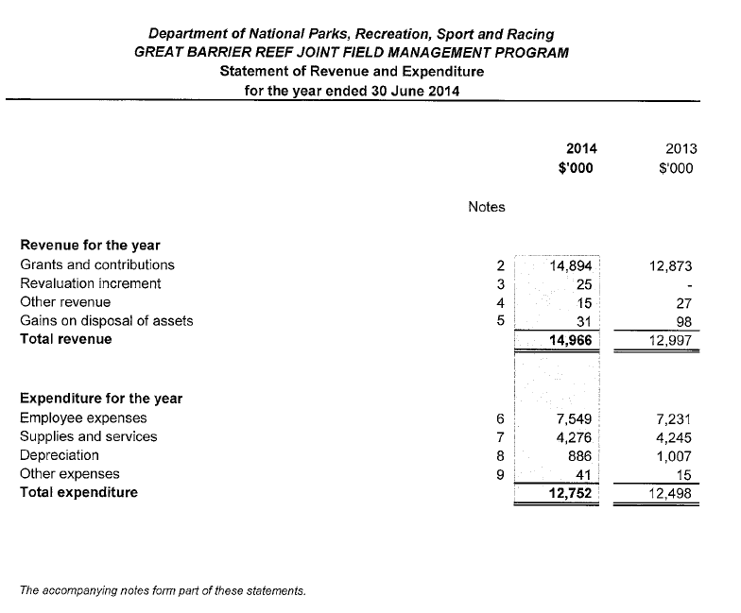

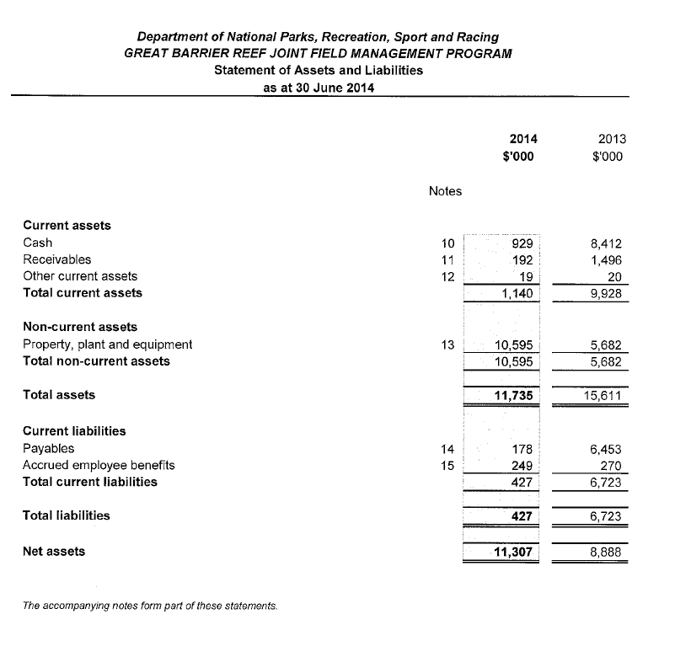

Department of National Parks, Recreation, Sport and Racing GREAT BARRIER REEF JOINT FIELD MANAGEMENT PROGRAM
Notes to and forming part of the financial statements 2013-14

Purpose and Principal Activities
Through the Great Barrier Reef Intergovernmental Agreement 2009 the Commonwealth and Queensland Governments have agreed to co-operatively plan, fund and deliver an integrated, strategically planned and co-ordinated program of field management of marine and national parks within the Great Barrier Reef World Heritage Area.

The Joint Field Management Program wi!l be directed at achieving the following outcomes:
- Protection and conservation of the natural and cultural resources;
- Protection of key vulnerable species, their habitats and ecosystems;
- Effective compliance with relevant Commonwealth and Queensland Jaws related to protection and management of the environmental and cultural values, including through education and understanding;
- Effective permitting systems and associated operational policies under relevant Commonwealth and Queensland laws related to protection and management of the environmental and cultural values;
- Ecologically sustainable public use;
- Understanding and enjoyment of Great Barrier Reef World Heritage Area natural and cultural resources and values by the public;
- Effective engagement of Traditional Owners in management;
- Increasing the effectiveness of the program and the efficient use of resources through the use of technology, analysis of data and the monitoring of trends, including for scientific, biological, recreational and commercial matters; and
- Capacity to respond to environmental incidents, including through coordinated clean up and rehabilitation programs.

The Commonwealth and Queensland governments agree to provide ongoing base funding (recurrent and capital) for this Joint Management Field Program shared on a 50:50 basis. The contributions by both parties will be administered by the Great Barrier Reef Marine Park Authority.

1. Summary of Significant Accounting Policies

Statement of Compliance
The Department of National Parks, Recreation, Sport and Racing has prepared the financial statements in accordance with the Treasurer's determination whereby compliance with certain provisions of the Financial and Performance Management Standard 2009 issued under the Financial Accountability Act 2009 was exempted. The financial statements are therefore special purpose financial statements that have been prepared in order to meet the needs of the Great Barrier Reef Ministerial Council.

These financial statements have been prepared on an accrual basis in accordance with Australian Accounting Standards and Interpretations.

Grants and Contributions
Grants and contributions that are non-reciprocal in nature are recognised as revenue in the year in which the department obtains control over them which is generally obtained at the time of receipt.

c) Cash
For the purposes of the Statement of Assets and Liabilities, cash assets include all cash and cheques receipted but not banked at 30 June.

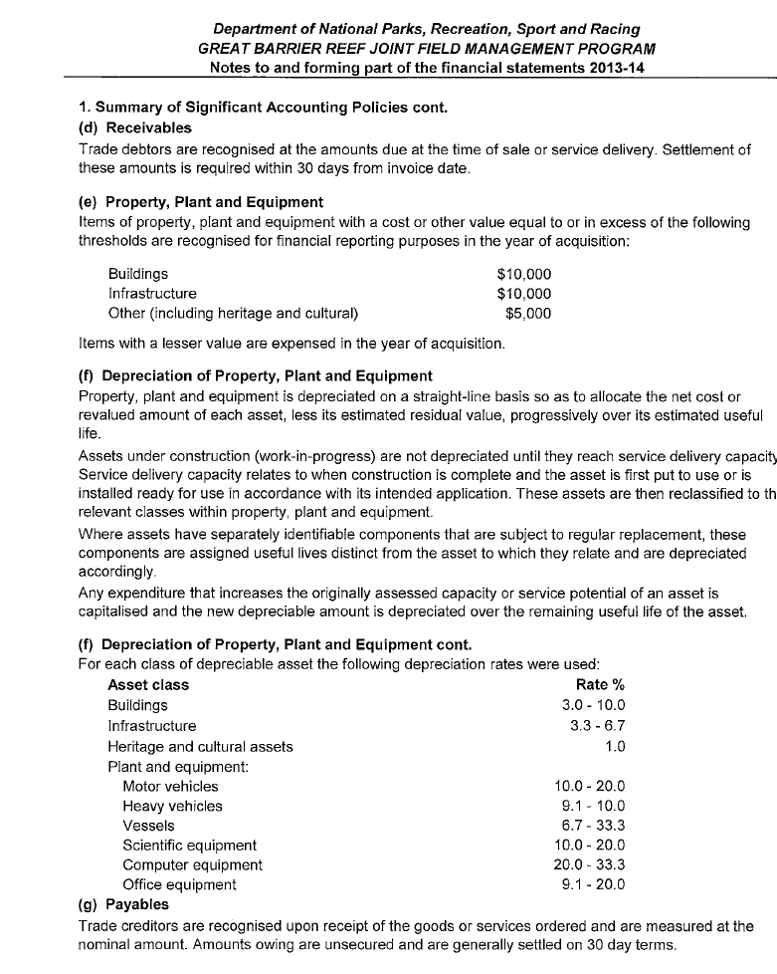

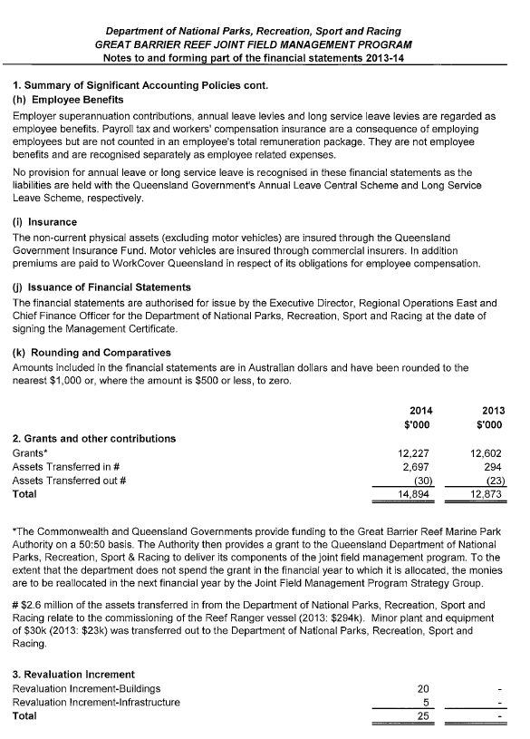

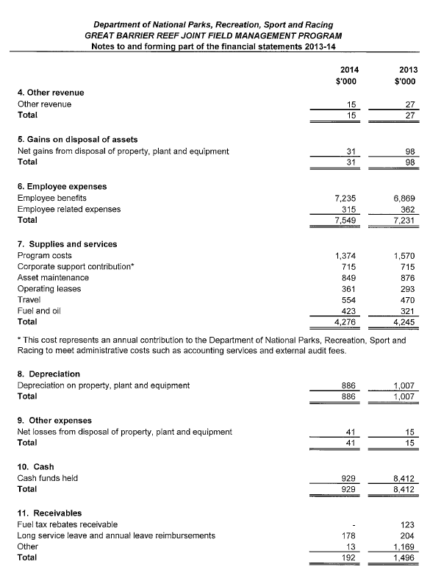

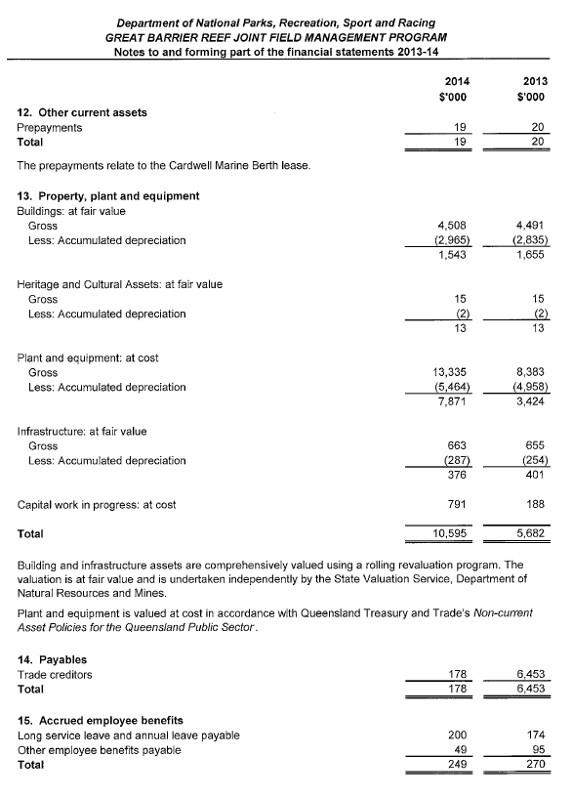

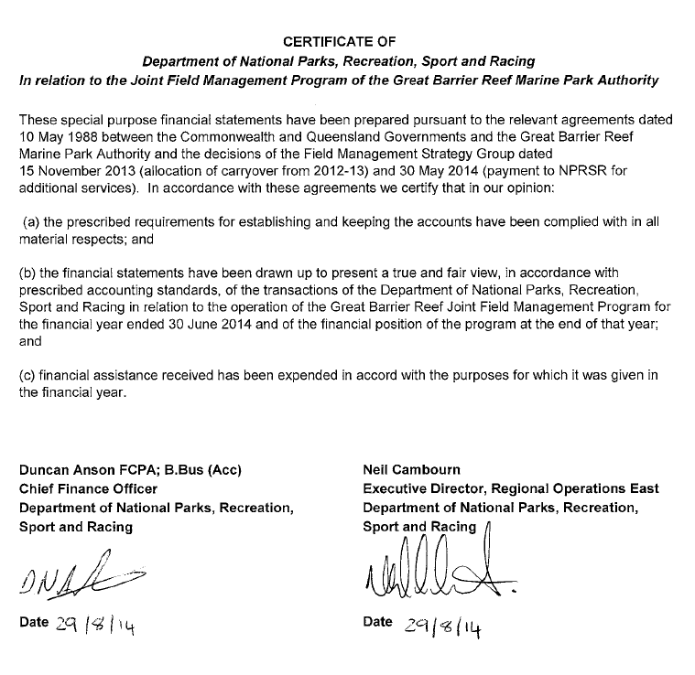

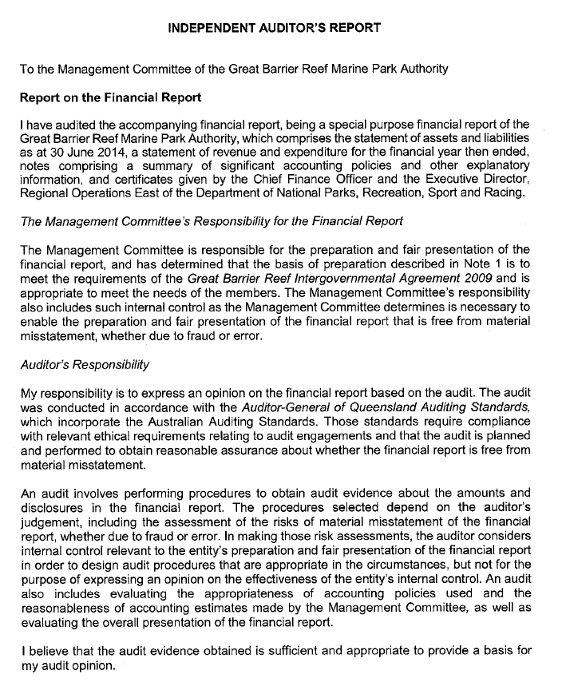

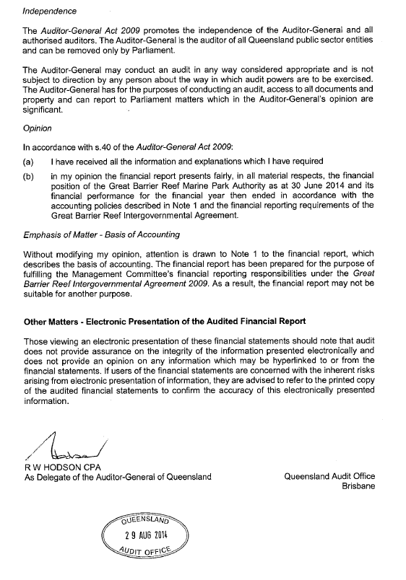

ANNUAL REPORT

Acronyms and index

2013 -14

ACRONYMS

AASB Australian Accounting Standards Board

ANAO Australian National Audit Office

CSS Commonwealth Superannuation Plan

CDAA Compensation for detriment caused by defective administration
CDPP Commonwealth Director of Public Prosecutions
DNPRSR Queensland Department of National Parks, Recreation, Sport and Racing
EMC Environmental management charge
EPBC Act Environment Protection and Biodiversity Conservation Act 1999

FMA Act Financial Management and Accountability Act 1997

FMOs Finance Minister’s orders

FOI Act Freedom of Information Act 1982 GBRMPA Great Barrier Reef Marine Park Authority
GIS Geographic information system
GPS Global positioning system

GST Goods and services tax

IASB International Accounting Standards Board

NFAs Non-financial assets

OPA Official public account

PSS Public Sector Superannuation Scheme

PVS Pickles Valuation Services

REEFVTS Great Barrier Reef and Torres Strait Vessel Traffic Service
ROC certification Respecting Our Culture certification
SES Senior Executive Service

SPER State Penalties Enforcement Registry

TUMRA Traditional Use of Marine Resources Agreement

GLOSSARY

Appropriation — public funds appropriated for a specific purpose

Biodiversity — the variability among living organisms from all sources including terrestrial, marine and other aquatic ecosystems, and the ecological complexes of which they are part

Bycatch — the unwanted fish, sea creatures, etc., caught in nets along with the targeted
species

Chlorophyll a — a green pigment, present in all green plants and in cyanobacteria, which is responsible for the absorption of light to provide energy for photosynthesis

Ecosystem resilience — the capacity of an ecosystem to recover from disturbance or withstand ongoing pressures

El Niño-Southern Oscillation — the oscillation between El Niño and La Niña conditions. El Niño is the negative phase of the El Niño-Southern Oscillation, and refers to the extensive warming of the central and eastern tropical Pacific which leads to a major shift in weather patterns across the Pacific. La Niña is the positive, or opposite, phase of the El Niño-Southern Oscillation. It refers to the extensive cooling of the central and eastern tropical Pacific Ocean, often accompanied by warmer than normal sea surface temperatures in the western Pacific, and to the north of Australia

Environmental management charge — a charge associated with some commercial activities in the Great Barrier Reef Marine Park, including tourism operations, non-tourist charter operations, and facilities. The activities are undertaken with permission granted by the Great Barrier Reef Marine Park Authority

Guano mining — the harvesting of accumulated seabird excrement for use as a phosphate-rich fertiliser

Legislative instrument — a law on matters of detail made by a person or body authorised to do so by an Act of the Parliament

Magnetometer — a scientific instrument used to measure the strength and/or direction of a magnetic field. They are widely used in geophysical surveys to detect magnetic anomalies of various types. They are also used to detect archaeological sites, shipwrecks and other buried or submerged objects

Outstanding universal value — Under the World Heritage Convention a property is considered to have outstanding universal value if it is of ‘cultural and/or natural significance which is so exceptional as to transcend national boundaries and to be of common importance for present and future generations of all humanity’

Plan of management — a plan prepared for intensively used, or particularly vulnerable, groups of islands and reefs and for the protection of vulnerable species or ecological communities

Portfolio Budget Statement — a statement to inform Senators, Members of Parliament and the public of the proposed allocation of resources to government outcomes by agencies within the portfolio

Traditional Use of Marine Resources Agreement — a formal agreement which describes how a Traditional Owner group works in partnership with the Australian and Queensland governments to manage traditional use activities on their sea country

Vulnerability assessment — a risk assessment and decision-support tool that evaluates sensitivity, exposure, and adaptive capacity of systems to inform adaptation planning

