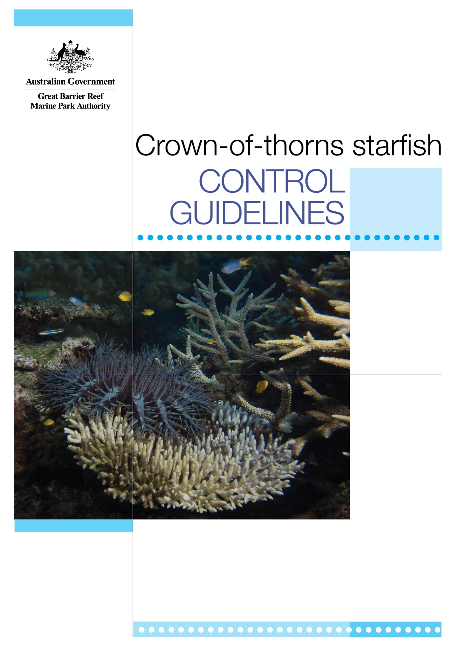

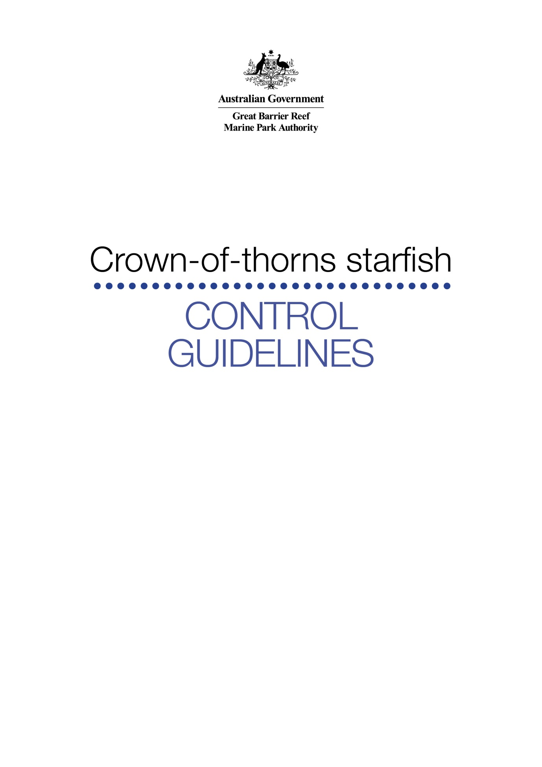
Copyright © Great Barrier Reef Marine Park Authority 2014
Published by the Great Barrier Reef Marine Park Authority, Townsville, Australia
This work is copyright. Apart from any use as permitted under the Copyright Act 1968,
no part may be reproduced by any process without the prior written permission of the
Great Barrier Reef Marine Park Authority.

National Library of Australia Cataloguing-in-Publication entry:
Crown-of-thorns starfish control guidelines / Great Barrier Reef Marine Park Authority.
ISBN 978 1 922126 42 9 (ebook)
Includes bibliographical references.

Crown-of-thorns starfish--Queensland--Great Barrier Reef.
Coral reef ecology--Queensland--Great Barrier Reef.

Great Barrier Reef Marine Park Authority, issuing body.
593.9309943
Acknowledgements:
We thank Daniel Schultz and Jennifer Wilmes for their assistance in updating these guidelines and also acknowledge the Queensland Parks and Wildlife Service, the Association of Marine Park Tourism Operators and Morgan Pratchett who provided helpful comments on the guidelines.
This publication should be cited as:
Great Barrier Reef Marine Park Authority 2014, Crown-of-thorns starfish control guidelines,
GBRMPA, Townsville.
Available from:
2-68 Flinders St
PO Box 1379
Townsville Qld 4810 Australia
Tel +61 7 4750 0700
Fax: +61 7 4772 6093
Email: web-tourism@gbrmpa.gov.au

Also available at the Great Barrier Reef Marine Park Authority website (http://www.gbrmpa.gov.au)

Table of contents
Introduction 1
1. Control methods 2
1.1 Single-shot vs multi-shot methods 2
1.2 Equipment and maintenance for single and multi-shot methods 3
1.3 Single-shot method (bile salts) 5
1.4 Multi-shot method (sodium bisulphate) 6
2. Implementing a control program 7
2.1 Commitment, tips and training 7
2.2 Permits and reporting 9
2.3 Health and safety 9
2.4 Outbreaks and outbreak indicators 9
2.5 Planning and executing your dive 11
2.6 Searching and injecting 12
3. Biology and ecology 14
3.1 Anatomy 14
3.2 Habitat 14
3.3 Predators 15
3.4 Feeding behaviour and preferences 15
3.5 Reproduction and lifecycle 17
4. References 19

Introduction

Important: Carrying out a crown-of-thorns starfish control program may involve inherent risk. A marine parks permit is required before commencing a control program in the Great Barrier Reef. The permit requires you to have public liability insurance and insurance under the Workers Compensation and Rehabilitation Act 2003. A Deed of Agreement is also part of the permit to indemnify the Great Barrier Reef Marine Park Authority and the Queensland Parks and Wildlife Service.
The crown-of-thorns starfish (Acanthaster planci), or COTS, is a coral-eating starfish or sea star native to coral reefs in the Indo-Pacific region. COTS feed on the fastest growing corals such as staghorns and plate corals, allowing slow growing corals to form colonies. This increases coral diversity. When COTS numbers are low, coral reefs can recover more readily from damage caused by COTS feeding. COTS control is not required in this situation as this is a naturally occurring event.
However, COTS densities can increase to a point where a coral reef can no longer recover from the damage caused — this is termed ‘an outbreak’. Outbreaks pose a significant threat to the health and resilience of the ecosystem. This document provides:
- information on the two endorsed methods for controlling COTS in the Great Barrier Reef, including suggestions on the equipment to use
- permit requirements
- health and safety considerations
- guidance on how to implement and conduct a COTS control program including how to effectively search and inject the starfish
- additional reading on the biology and ecology of COTS.

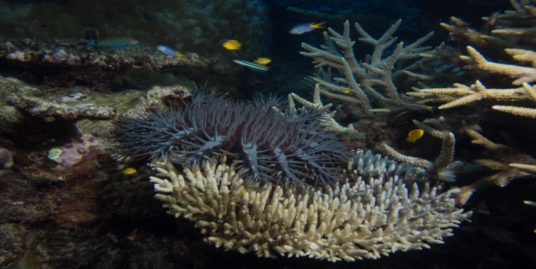
Further information on the management and history of COTS outbreaks on the Great Barrier Reef can be found on the Great Barrier Reef Marine Park Authority website.

Control methods
The best practice method for undertaking COTS control is to use a modified drench gun to inject the starfish, using either the single-shot bile salts or the multi-shot sodium bisulphate method (refer to Section 1.4). These injection methods minimise the risk of breaking corals, and are safer than manual removal which is not recommended due to the risk of spiking.
Although direct injection of bile salts and sodium bisulphate are toxic to COTS, these solutions are not known to have a residual environmental impact. Sodium bisulphate has been used in the multi-shot method in the Great Barrier Reef for more than 15 years. Comprehensive laboratory (Rivera-Posada, et. al. 2014) and field surveys were undertaken prior to the large-scale use of the single-shot bile salts in the Great Barrier Reef in 2013, and no immediate flow-on effects on reef fish, corals, and other benthic invertebrates were observed.

1.1 Single-shot vs multi-shot methods
The single-shot bile salts injection is far more time efficient than the multi-shot method, especially when COTS numbers are particularly high or when control activities are carried out on a large and regular basis. Trials of the single-shot method indicate it is three times more efficient than the multi-shot method. However, when COTS numbers are low and/or control is not carried out on a regular basis or at a large scale, the multi-shot method has economic and logistical advantages as the sodium bisulphate solution has a longer shelf life after it has been prepared (mixed with water). As a result, the multi-shot sodium bisulphate is ideal for maintaining low numbers of COTS at a specific site.
Sodium bisulphate, however, is less potent than bile salts and requires up to 25 injections depending on the size of the starfish (injections should be approximately 3–4 cm apart from each other). By comparison, bile salts only need to be injected once and it can be anywhere in the body and arms of the starfish, though field studies suggest placement in the arm is more effective. (Refer to section 2.6 on recommended injection placement).
The table below summarises features of the two methods.
Single-shot method (bile salts) | Multi-shot method (sodium bisulphate)
One injection per starfish | 10–25 injections per starfish (depends on size)
10 mL of solution per COTS | Average of 180 mL per COTS (depends on size)
Five-day shelf life | 30-day shelf life
Approximately three cents per COT (based on solution only) | Approximately nine cents per COT (based on solution only)
More effective for large aggregations (i.e. more than one COTS per minute of searching) | More effective for patchy outbreaks and small aggregations
Sharper needle — more care needed | Blunt needle — no needle stick injury risk

How-to videos for COTS control can be viewed on the GBRMPA website. The videos cover equipment assembly, pre-dive preparations (solution mixing, dive preparation) and in-water search and injection techniques.

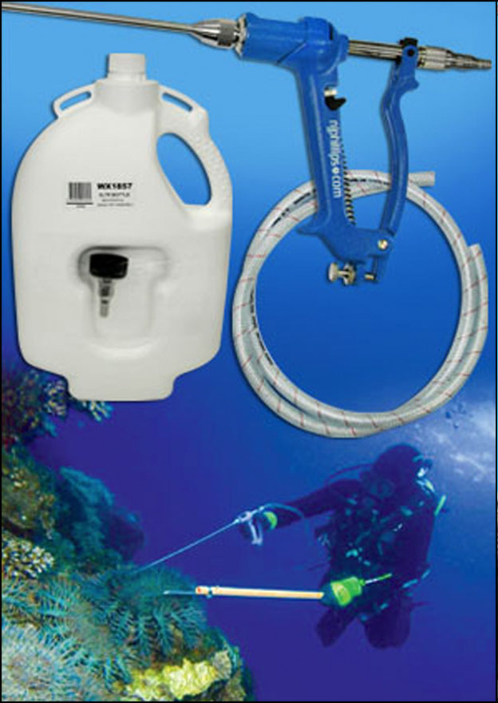
1.2 Equipment and maintenance for single and multi-shot methods

The equipment used to inject COTS consists principally of an applicator (the gun), a five-litre plastic bottle containing the injection solution and a hook (which can be used to house the applicator when not in use). Figure 1 shows the equipment the Association of Marine Park Tourism Operators (AMPTO) control team uses to inject COTS. Alternative types of modified drench guns have also been used effectively by researchers.
Figure 1 COTS cull kit including applicator, five litre backpack, spear and hook. © NJ Phillips

1.2.1 Applicators and their assembly
In 2013, Australian-based manufacturing company NJ Phillips designed two types of applicators for injecting COTS:
- The 10 mL bile salts applicator has specifically been designed by scientists, AMPTO and NJ Phillips for injecting bile salts. A veterinary needle needs to be mounted at the tip of the gun applicator.
- The 20 mL sodium bisulphate applicator can only be used for injecting sodium bisulphate. Because the solution is directly injected into the starfish through four small openings at the spear tip, the applicator does not require an additional veterinary needle.
Assembly
The assembly of the 10 mL bile salts applicator and the 20 mL sodium bisulphate applicator is almost identical. The main difference is that a sharp veterinary needle has to be mounted to the 10 mL bile salts applicator, while the blunt sodium bisulphate applicator already forms part of the gun. Detailed instructions are provided with the products and on the how-to videos on the GBRMPA website. Pictures showing the correct assembly of applicator parts are provided in Figure 2.
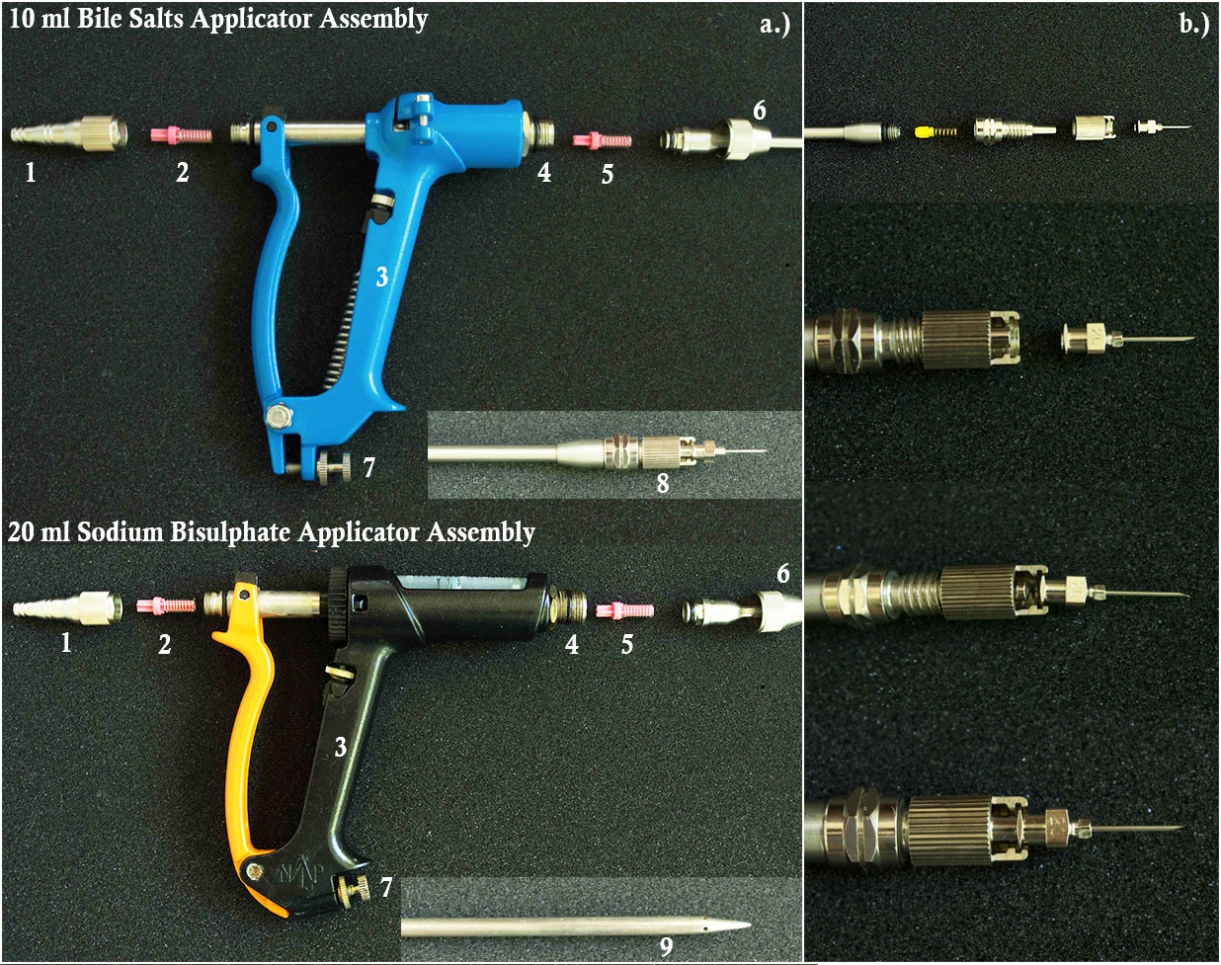
Figure 2 Assemblage of the two applicators. a) 1: inlet adaptor, 2: inlet valve assembly, 3: hand piece, 4: delivery valve cage, 5: delivery valve assembly, 6: spear nut, 7: dose adjustor screw, 8: lock nut and veterinary needle, 9: tip of the spear of the sodium bisulphate applicator; b) Step-by-step sequence showing the correct assembly of the lock nut and the veterinary needle of the bile salts applicator. © Daniel Schultz

1.4.2 Bottle and hook
The bottle is a five-litre plastic backpack that needs to be attached to the diver in some way — how this is done is up to the control diver. One tried and tested method is to attach the bottle to the control person’s weight belt with a rope. One end of the rope should be spliced to one side of the bottle; and the other end of the rope to a stainless clip (see Figure 3). In this way, the bottle can be easily attached and detached.
When filling the bottle, ensure it is not completely filled with the injection solution so that an air pocket remains. This allows the bottle to sit in an upright position when underwater. While the bottle holding the solution is interchangeable between methods, ensure the bottle is triple rinsed in fresh water between solutions to prevent cross-contamination.
The applicator should be kept away from the body and/or placed in a protective sheath when not in use to reduce the likelihood of the diver spiking themselves or others in the water.
To reduce impacts to corals and risks to the control diver, a hook device with a hollow handle is recommended (see example on page 5). The hook allows divers and/or snorkelers to pull COTS out from crevices without the need to touch the coral. It also provides stability when injecting and acts as a sheath for the applicator when not in use. The hook handle should be approximately 65 cm long to enable the entire spear to be housed inside the sheath.

An inexpensive hook can be made using electrical conduit, a cable tie and wire. An example of the rope attachment and hook is provided in Figure 3.
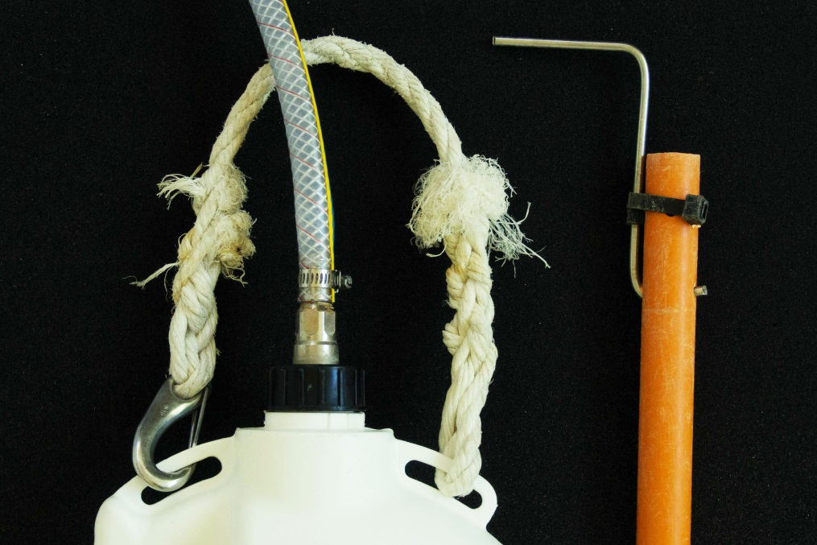
Figure 3 Hook and bottle with spliced rope and clip. © Daniel Schultz

1.2.3 Maintenance
The following steps should be carried out on the vessel after each day of diving to keep your equipment properly functioning for the longest time possible:
- Remove the spear, needle and valve assemblies (delivery and inlet). Place all items into a container of water and vinegar (approximately one cup of vinegar to four litres of freshwater) and let it soak.
- Flush the spear using a hose with a stream of water.
- Leave the parts in the open air to dry.
- Reassemble the applicator.
- Lubricate the cylinder and piston with the lubricant provided in the kit.
- Grease all screws and nuts.

Purchased kits and the how-to videos on the GBRMPA website also contain detailed information on equipment maintenance.

1.3 Single-shot method (bile salts)
Bile salts (sodium cholate C₂₄H₃₉NaO₅ (NaC) and sodium deoxycholate C₂₄H₃₀NaO₄ (NaD)) are derivatives of bile collected as a by-product from cattle during the standard abattoir process. Cattle are not killed specifically for bile salts. Bile salts are purchased as a very fine white powder and should be kept in a tightly closed container in accordance with the material safety data sheet. Bile salts can be an irritant when ingested, inhaled or if contact with skin or eyes occurs. Appropriate safety equipment including protective eyewear, clothing (for example gloves) and respiratory equipment (for example, vapour and dust respirators) are recommended in accordance with the material safety data sheet.
Mixing bile salts
The solution should be prepared on land as it is difficult to get an accurate reading from the balance on a moving vessel. Weighing fine powders in a sheltered area also eliminates the risk of them blowing away. Appropriate protective gear should be worn at all times when handling bile salts, in accordance with the material safety data sheet.
To be effective, the bile salts solution needs to be concentrated at 10g per litre. While onshore, bile salts powder can be prepacked into 50g lots in plastic ziplock bags. Once offshore, fill a five-litre bottle with freshwater (fill only to the top of the clear window on the side of the bottle to ensure an air pocket remains), and add a few drops of food colouring (preferably red). Then, use a funnel to add the pre-packed powder (50g). Close the lid, ensure the hose is blocked and shake the bottle until all powder is dissolved. Red food colouring is not harmful to the environment and helps the diver see the solution underwater. In this way the diver can see if the applicator is working correctly underwater and if the injection was successful.
Naturally occurring bacteria in the water (especially in seawater) will act to breakdown the bile salts, rendering the solution ineffective after five days. When bile salts have reached their expiry date, the injection solution will appear milky and opaque. The unused bile salts solution should be treated and disposed of in the same way as sewage under the relevant Commonwealth and State legislation. Specifically:
• dilute the solution as much as is possible in onboard containers
• disposal to the marine environment must occur while the vessel is underway
• disposal can only start once you are more than one nautical mile (1.85 km) from the nearest reef, island, mainland or an aquaculture facility.
When injecting starfish, it is important to administer the 10 mL dose in a slow and steady flow, especially in small (less than 10 cm diameter) starfish, otherwise much of the solution will be forced out of the body. For very large starfish (more than 40 cm in diameter) it may be necessary to administer at least two injections of the bile salts solution.

Supplier
Bile salts are a specialised product. For further information on suppliers, please contact GBRMPA.

1.4 Multi-shot method (sodium bisulphate)
Sodium bisulphate (NaHSO₄), also called dry acid, is a white powder and is commonly used in swimming pools to balance the pH of the water. It should be stored in a dry, tightly closed container in a cool, well-ventilated area in accordance with the material safety data sheet. Like bile salts, sodium bisulphate can be an irritant when ingested, inhaled or if contact with skin or eyes occurs. Appropriate safety equipment including protective eyewear, clothing (such as gloves) and respiratory equipment (for example vapour and dust respirators) should be used to limit exposure in accordance with the sodium bisulphate material safety data sheet.
Remember…any control of COTS requires a permit and adherence to these guidelines.

Mixing sodium bisulphate
Sodium bisulphate needs to be mixed with freshwater until the solution becomes saturated and no more sodium bisulphate can dissolve. This occurs when the sodium bisulphate remains at the bottom of the container. The recommended dose is two cups of sodium bisulphate to five litres of freshwater, and a few drops of food colouring. Once precipitation occurs (when the sodium bisulphate will no longer dissolve and excess remains at the bottom of the container) the right concentration has been reached. Be careful not to add too much as the undissolved sodium bisulphate can obstruct the applicator. Close the lid, block the hose and shake the bottle until all powder is dissolved.
The sodium bisulphate solution can be used for approximately one month after it has been mixed with water. Any unused sodium bisulphate solution should be treated and disposed of in the same way as sewage, under the relevant Commonwealth and State legislation. Specifically:
• dilute the solution as much as is possible in onboard containers
• disposal to the marine environment must occur while the vessel is underway
• disposal can only start once you are more than one nautical mile (1.85 km) from the nearest reef, island, mainland or an aquaculture facility.

Supplier
Sodium bisulphate can be purchased from chemical suppliers or pool suppliers.
Please note: No other solutions are endorsed for use to control COTS in the Great Barrier Reef Marine Park.

2. Implementing a control program

2.1 Commitment, tips and training

What should be considered prior to commencing a control program?
Tourism operators, organisations or individuals who identify the need for a COTS control program at a site are encouraged to consider the following points to ensure the program is viable:
- the socio-economic and ecological value of the site
- whether a control program can be run successfully, based on the size of the site
- whether adequate resources (time, people and equipment) can be allocated.

Remember:
- Coral health surveys need to be conducted regularly during and after the program to monitor success. It is recommended you use permanent reference sites so coral cover and diversity can be compared over time.
- Collecting and reporting control program data is important and an obligation under your permit.
- Cleared areas must be visited regularly (initially every four to five days) to 'mop up' starfish that were missed and any new starfish to the area.
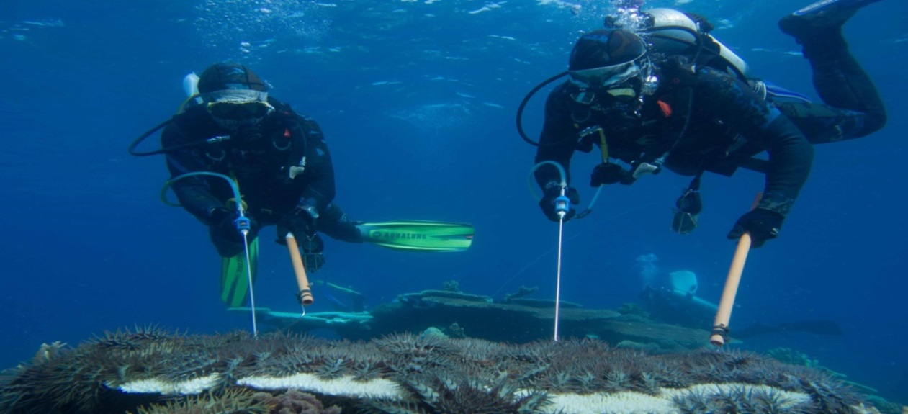
- Effective control requires a multi-year commitment to reduce the COTS population to a level where coral reefs are able to cope and recover.
Photo by Daniel Schultz © GBRMPA

Useful information
Prior to starting, ensure staff are familiar with these guidelines and trained to carry out COTS control. Experience makes a vast difference as inexperienced divers will find less than five per cent of COTS at a site (Aiello 2006).
To eliminate duplication, conduct systematic searches and keep a large-scale map or aerial photograph recording the areas which have already been checked and the number of visits each time. Each site will require multiple searches to minimise the number of starfish missed.
Once affected sites are identified, the best method for locating and controlling individual starfish is through scuba diving or snorkelling. For the control program to be successful at managing an outbreak, all of the COTS in the affected area will need to be injected. Sites made up of patch reefs are more easily checked if several divers work around the sides of the patches at different depths.
COTS can be very cryptic and difficult to see, and tend to hide during the day time. Fresh scars on the coral clearly indicate that COTS are present, so look for these first. Efforts are best concentrated in a one to four metre radius around the freshest scars, checking crevices in and under the reef. See section 2.6 for further details on searching.
A COTS control program is a multi-year commitment requiring finances and trained personnel. Contact GBRMPA for further information on training providers.
Checklist — before commencing a COTS control program (adapted from Aiello 2006)
DO YOU HAVE A COTS OUTBREAK?
□ Have you seen COTS scars at your site?
□ Are COTS out in the open during the day?
□ Are COTS clumping together in groups of more than two or three?
□ Are you finding small and large COTS?
□ Is there more than one COTS during a 20-minute swim?

SHOULD YOU START A COTS CONTROL PROGRAM?
□ Do you have the capacity to support an ongoing program?
□ Have you identified the most important site/s for protection?
□ Do you have regular (weekly) access to your site/s?

ARE YOU READY?
□ Do you have a permit to control COTS?
□ Have participants been trained and read these guidelines?
□ Do you have a detailed map of your site?
□ Do you have the necessary equipment?
□ Have you chosen your control method?

2.2 Permits and reporting
Permits to undertake COTS control can be obtained from GBRMPA. The name of the permission is ‘A program for the taking of animals, which pose a threat to the use and amenity of a particular area’. Information on how to apply is on the GBRMPA website. It should be noted that the standard application process may take at least two months.
A return of zero is an important result and it also needs to be recorded.
Please note: Undertaking a crown-of-thorns starfish control program may involve inherent risk. Permittees will be required to obtain appropriate insurance to cover their program and all participants, and indemnify GBRMPA.
As part of permit requirements, you need to submit data showing the number of COTS culled on a six-monthly basis. A simple Excel spreadsheet can be used to record this information. It is important this data is accurate as it is used by GBRMPA and the Queensland Parks and Wildlife Service for management purposes. Reporting requirements are included in permit conditions. Attachment A is an example of the report form.

2.3 Health and safety
COTS have hundreds of long needle-like toxic spines covering their bodies and arms, presenting a health threat to people who interact with them. Individuals undertaking COTS control activities need to take suitable precautions to avoid being spiked and should be instructed on the appropriate first aid treatment.
Most injuries to humans from COTS occur on the hands and feet. Symptoms range from intense pain (which may last several hours), through to nausea and vomiting. Frequently, the area around the puncture turns a dark blue and begins to swell. The swelling may persist for a number of days. Where the victim has suffered multiple wounds, the whole limb may stiffen and swell. In these cases, the patient may experience numbness around the wound(s) and the swollen area may become extremely itchy. Some victims may also respond in an allergic manner (Moran 1988). Persons affected by a spiking should immediately advise their supervisor and/or others on the control team and, if necessary, seek medical assistance.
Precautions should always be taken to minimise the risk of contact with COTS spines, particularly as the toxins can bio-accumulate. Ideally, divers should cover their skin as much as possible by wearing full wetsuits, gloves, booties, hoods and facemasks. AMPTO has been undertaking a COTS control program for many years and, as a precaution, will not allow control divers to participate in the program if they have been spiked twice.
It is not known what effect injections of bile salts or sodium bisulphate would have on humans, so ensure the needles are covered, especially during entry and exit from the water.

2.4 Outbreaks and outbreak indicators
COTS are natural inhabitants on coral reefs, typically occurring at very low densities (fewer than one starfish per hectare) (Moran 1986; Baird et al. 2013). A COTS outbreak occurs when their density is at a point where their feeding rate exceeds the typical long-term average growth rate of coral (Fabricius 2013).
COTS outbreaks represent the most significant biological disturbance on tropical coral reefs throughout much of the Indo-Pacific region. For example, on the Great Barrier Reef it is estimated that of the 50 per cent decline in live coral cover over the past 27 years, approximately 42 per cent of that loss was due to COTS (De’ath et al., 2012).
There have been four major outbreaks on the Great Barrier Reef since the 1960s (each starting in the 1960s, late 1970s, early 1990s and 2010) and the time between the start of each outbreak has been 15–17 years. The fourth and current outbreak began in 2010.

Densities
Keesing and Lucas (1992) estimated 10 to 15 COTS per hectare could be sustained in areas with 20 to 50 per cent coral cover. Generally, if you see more than 15 starfish per hectare (that is, two starfish per 20-minute swim) then the density has reached an outbreak level.
For management purposes, GBRMPA considers a catch per unit effort of 0.05 (the number of COTS killed per minute) as an active outbreak when coral cover is below 40 per cent. When coral cover is above 40 per cent, a catch per unit effort of 0.1 is considered an outbreak. Control efforts should endeavour to keep COTS below this threshold. An example on how to calculate catch per unit effort is included in Section 2.5.
The following signs indicate a COTS outbreak has begun or is underway at a reef, and that control measures might be appropriate:
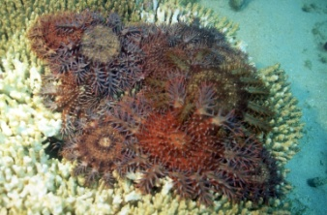
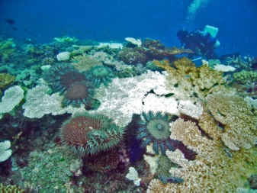
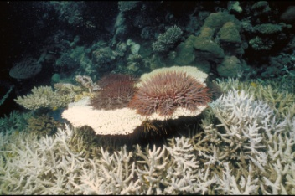
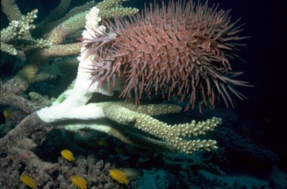
4. COTS are aggregating in large numbers.

1. There are COTS feeding scars (bare coral skeleton with all the tissue removed). Fresh scars will appear snow white in colour, with details of the skeletal structure of the coral still visible.
2. COTS of different size are present, including juveniles (size of your hand) and adults (larger than the size of your hand).
3. Generally, when snorkelling or diving, more than one COTS is sighted every 20 minutes.
Increased level of concern

2.5 Planning and executing your dive
Dive brief
When planning a control dive, predefine the area that you want to cover. Tools such as maps, Google Earth spatial outputs and a portable handheld global positioning system (GPS) can be useful for this, to allow quantitative comparisons over time. In general, divers should be able to cover a distance of approximately 400 metres in a 40-minute dive, however this may vary depending on factors such as COTS density, weather and tidal conditions, and sea state. It is important to note entry and exit points of each dive with a GPS to avoid overlapping surveyed areas and to accurately record areas where COTS control has occurred. It is best not to revisit the same area within three to four days, so as to allow enough time for fresh scarring to fade. This will prevent divers searching for COTS that have already been injected.
The bottle combined with the weight belt can be cumbersome and heavy. Assistance should be given to support the diver/snorkelers exit from the water.
Before entering the water, ensure all participants are aware of the approved dive plan. To avoid COTS being injected twice by different divers and to maximise the area being covered on each dive, it is imperative that divers swim next to each other, keeping a horizontal line, approximately five metres apart. This is especially important when using the 10 mL bile salts applicator, as the injection scar is so small that it becomes difficult to differentiate between injected and non-injected COTS. When COTS numbers are particularly high, turn COTS over after they are injected to avoid this issue.
In most cases, COTS start moving and retreating into crevices once injected. As a result, an increase in activity indicates a starfish has been injected. However, uninjected COTS have also been observed to start moving once adjacent starfish have been injected.
Dive entry
Steps to take once the injection solution has been prepared on board the vessel:
- The control diver should attach the bottle of solution to their weight belt (or preferred alternative position). Ensure enough weight is carried, as the bottle increases overall buoyancy.
- Attach the hose to the applicator.
- Place the applicator into the hook or some other protective sheath to ensure it is kept away from the body.
- Enter the water, ensuring a firm hold on the applicator and hook.
- Once underwater, prime the applicator (squeeze it several times under the water) until the cylinder is full with solution and contains no air bubbles.

Dive exit
Follow these steps at the end of the dive, when you are ready to ascend:
- Remove the hose from the applicator.
- Tie a knot into the hose (this prevents seawater from compromising the solution).
- Place the applicator into the hook.
- Pump the trigger until the coloured solution is flushed out.
- On board the vessel, record details of the cull efforts, in accordance with permit reporting requirements. See Attachment A.
- Maintain the equipment as outlined in Section 1.2.3.

What is catch per unit effort and how do I calculate it?
The catch per unit of effort is calculated by adding up the total number of injected starfish and dividing the figure by the total dive minutes. See example below.
COTS control dives on Roxy’s reef — Site 1 —17/05/14
Dive Number | Total dive minutes (all divers) | Total number of starfish injected (all divers)
1 | 240 | 55
2 | 440 | 121
3 | 160 | 99
4 | 320 | 420
TOTAL | 1160 | 750

Catch per unit effort is 750/1160 = 0.65 (rounded up to two decimal places)

2.6 Searching and injecting
Search techniques
An in-water video detailing all technical aspects of this section can be viewed on GBRMPA’s website.
As mentioned previously, it is important that all participants keep to the predefined plan, swimming in a line next to each other and not behind each other.
To increase your success rate, look for the scars not the animals!
COTS are generally cryptic during the day, making them difficult to find. Their spines and colour can match their surroundings perfectly, especially when hiding at the bases of staghorn corals.

When searching for COTS, it is more efficient to search for feeding scars (see Figure 7) than the COTS themselves:
- Fresh scarring is bright white and the fine detail of the coral skeleton is still visible. When scarring is just a few hours old, you may be able to see thin threads of mucus still attached to the coral. In general, COTS can be found within five metres of the scar. Look around, especially in crevices, underneath plate corals and at the bases of staghorn corals.
- Older scarring appears yellowish-brown in colour, as it has been overgrown by algae. In general, the older the scarring, the darker the colour and the harder to distinguish the details of the coral skeleton. When you see old COTS scarring, try to find more recent scarring in the surrounding area. If there is no fresh scarring, it is likely the COTS have already left the area.
The stomach of a COTS is about the size of its central disc, so the size of the scar is a good indication of the size of the COTS present. Large areas of scarring may indicate more than one COTS is present.
COTS scarring may be confused with Drupella snail scarring, diseases (for example, white syndromes and brown band disease) and/or coral bleaching. However, they may also be simultaneously present on diseased corals or corals which are infested with Drupella. For more information on how to differentiate between Drupella scarring, diseases and coral bleaching, see Beeden et al. (2008).

Injecting COTS
The placement and number of injections depend on the injection solution used.
- Bile salts require a single shot injection. However, two injections are needed for COTS larger than 40 cm. The injection is best placed in the middle of any arm. If this can’t be reached, the injection can be made elsewhere, however it will take longer for the starfish to die. For juveniles, the injection is best placed in the central disc. Trials have indicated some starfish can expel the solution when injected into the central disc.
- Sodium bisulphate: Multiple injections need to be placed in the central disc of the starfish, spaced at approximately 3 to 4 cm from each other. If you can’t access the entire central disc, try to bring the COTS out in the open with your hook. Otherwise try to inject it in as many different places as possible. When COTS are less than 8 cm in size it may be easier to directly collect them with tweezers or tongs for later disposal. This is not recommended for starfish greater than 8 cm in diameter. For COTS that are the size of a dinner plate (about 25–30cm) you will need to perform 12–15 injections; those larger than a dinner plate will need at least 15 injections, and up to 25 if it is particularly large.
When injecting a starfish always ensure the needle does not go through the starfish. You should also take care to pull the trigger gently to allow the full dosage to be injected into the starfish’s body.
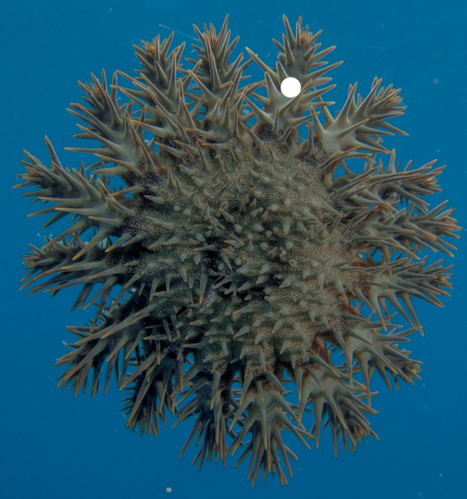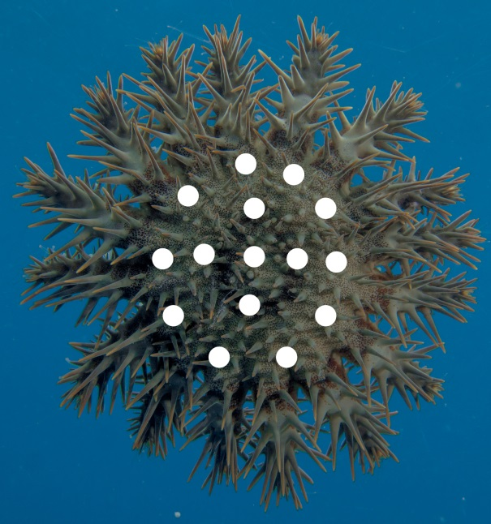
Figure 4 Injection placement (white dot/s) for use of bile salts (left) and sodium bisulphate (right). © Daniel Schultz
Once injected, starfish generally die within 24 hours. Starfish injected with sodium bisulphate tend to decompose more quickly than those injected with bile salts.

3. Biology and ecology

COTS occur naturally throughout the Indo-Pacific region. Like all starfish, sea urchins, sea cucumbers, feather stars and brittle stars, they belong to the phylum Echinodermata (from Greek: echinos meaning hedgehog and derma meaning skin).

3.1 Anatomy
COTS are multi-coloured and can range in colour from purplish-blue with red tipped spines, to green with yellow-tipped spines. Adults have a varying number of arms (generally 14–18; and up to 21) and may shed arms when stressed. They can also lose them to predators, however they are able to regrow arms in about six months (Moran 1988).
The mouth of the starfish is located on the lower side of the body in the centre of the disc. Grooves radiate from the central disc to the tip of each arm. Within each groove there are two rows of retractable tube feet (see Figure 5). Mobile spines run along the edges of the grooves.
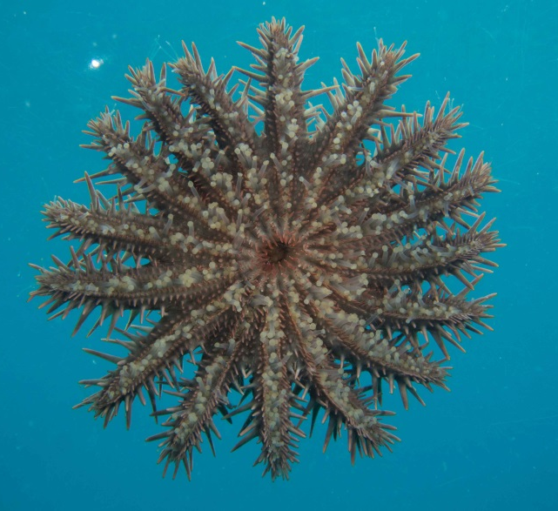  Mouth  Podia (Tube Feet) | 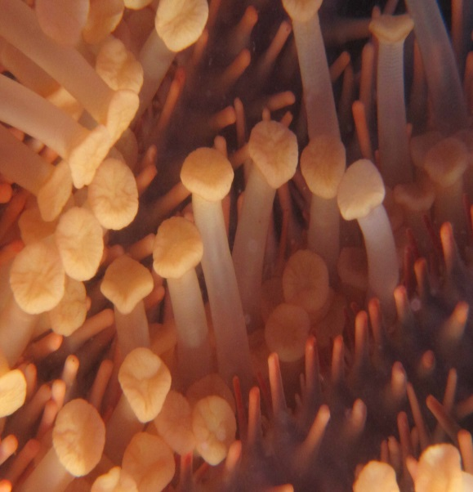  b)
Figure 5 a) oral side © Daniel Schultz; b) close up of feet © Jennifer Wilmes
Although COTS normally range in size from 25 to 35 cm in diameter, individuals as large as 80 cm have been found. As with most echinoderms, the size is determined by what they eat, food availability and their population levels (Moran 1988).

3.2 Habitat
COTS seem to prefer to live in sheltered areas such as lagoons, and in deeper water along reef fronts. They generally avoid shallow water on the tops of reefs where the water conditions are likely to be more turbulent. Occasionally they may feed in these areas, particularly when the weather is calm (Moran 1988). During major outbreaks it is important to search all habitat types.

3.3 Predators
While large individuals appear to escape predation due to their long spines and body size, the cryptic behavior of small individuals during the day suggests predation may be higher in juveniles (Birkeland and Lucas 1990).
The predators most commonly observed to feed on COTS are: triton’s trumpet, the starry and white spotted puffer fish, two species of triggerfish (titan triggerfish and yellow margin triggerfish), the harlequin shrimp and the lined fireworm — see some examples at Figure 6. Each has been recorded to feed on juveniles and small adults (Moran 1988).
The question of how predation regulates COTS populations still remains poorly understood (Rivera-Posada et al. 2014).
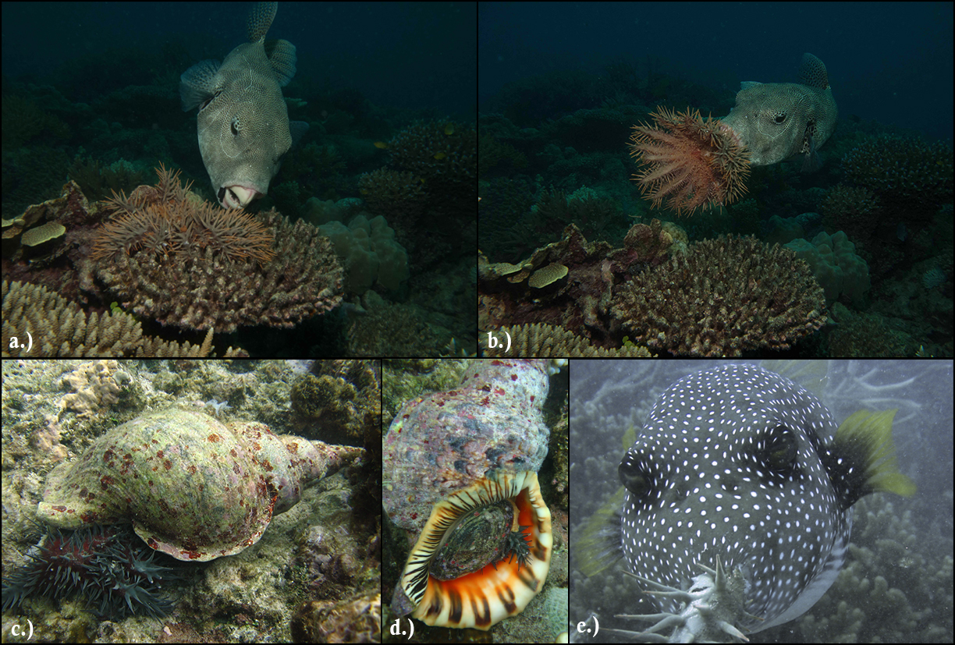
Figure 6 COTS predators a) and b) starry pufferfish; c) and d) triton's trumpet; e) white-spotted pufferfish. © Daniel Schultz

3.4 Feeding behaviour and preferences
COTS are well known for their ability to alter coral community structure by preferentially feeding on certain species of hard corals (scleractinian corals). Adults almost exclusively feed on scleractinian corals (90–95 per cent). The main non-scleractinian food items are soft corals, zoanthids and coralline algae. Non-coral prey is taken in, thereby increasing abundance in areas of low coral availability (Keesing 1990).
To feed, COTS turn their stomach outwards through their mouths, spreading it over the surface of the coral using their tube feet. After about four to six hours of feeding, the starfish moves on, leaving behind a white feeding scar of exposed coral skeleton (Fabricius 2013).
Figure 7 shows a number of new (bright white) and old (yellow-brown) COTS feeding scars on a variety of corals.
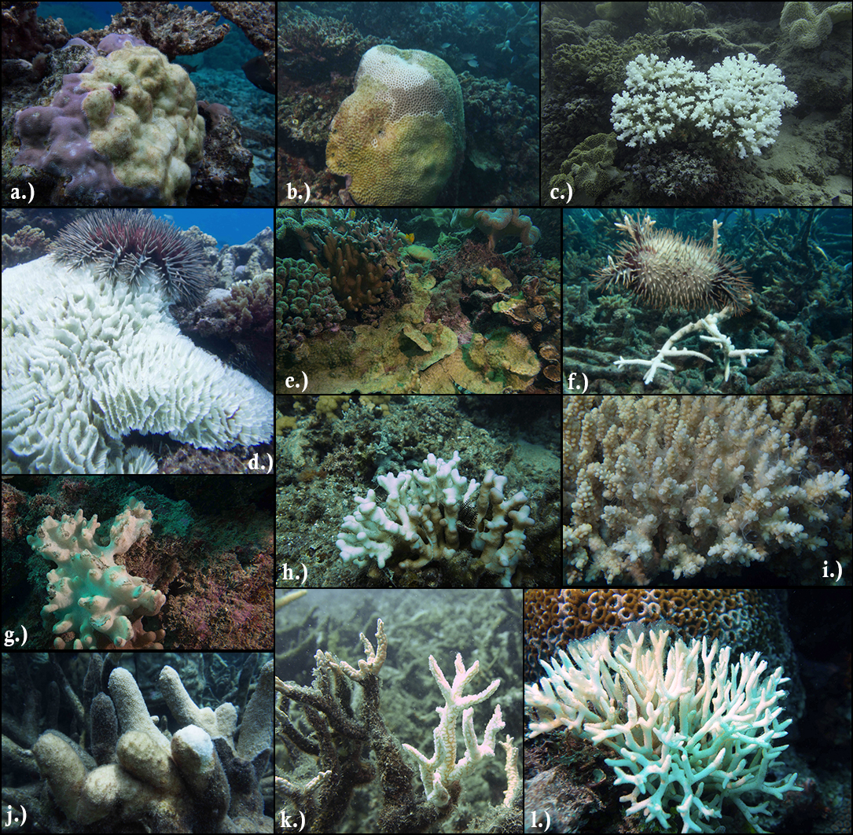
Figure 7 Old and fresh feeding scars on different species of coral. Old and fresh COTS feeding scars on: a.) Porites sp., b.) Goniastrea sp., c.) Pocillopora sp., d.) Pectinia sp., e.) Echinopora sp., f.) Acropora sp., g.) Soft coral, h.) Stylophora sp., i.) Acropora sp. with thin threads of COTS mucus, j.) Isopora sp., k.) Hydnophora sp., l.) Seriatopora sp.. © Daniel Schultz.
During the planktonic life stage, COTS larvae feed on phytoplankton. Once larvae settle, they change into juvenile starfish and start feeding on crustose coralline algae (the pinkish cement-looking cover on coral rubble/rocks). About four to six months after spawning, the starfish gradually starts feeding on scleractinian corals (Refer to Figures 8).
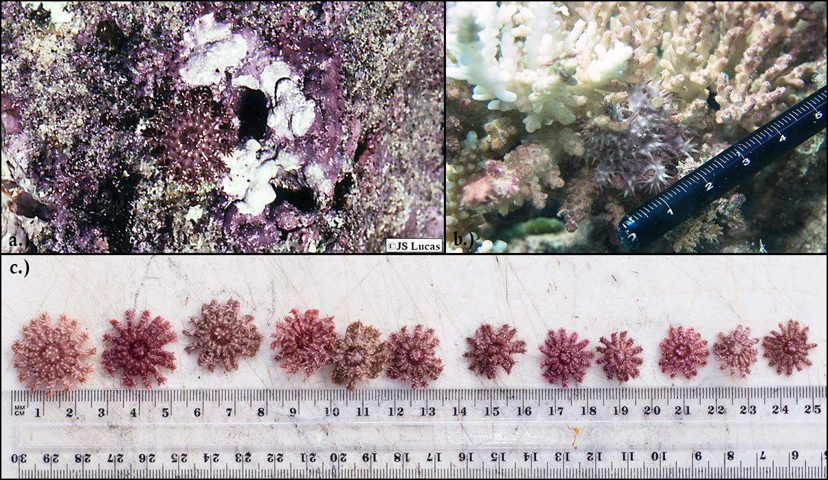
Figure 8 a) Juvenile COTS feeding on crustose coralline algae © JS Lucas; b) Juvenile COTS feeding on coral (Acropora sp.)
© Daniel Schultz ; c) COTS juveniles found feeding on coral © Daniel Schultz
Small adult starfish (less than 20 cm) are highly cryptic during the day, emerging to feed only at night. Large starfish (40 cm or greater) feed during the day and show little tendency for cryptic behavior (Moran 1988) (Keesing 1990). Intermediate-sized starfish show a varied response suggesting they have a transition period Keesing (1990). Keesing (1990) has suggested the observed behavior has evolved as a predator avoidance strategy, with large starfish achieving a refuge through their size.
COTS feeding rates are dependent on starfish size and season. Rates are greatest before the summer spawning season. Keesing (1990) calculated the average feeding rate in winter as 66 cm² coral per day (for COTS 20–39 cm), and 478 cm² coral per day in summer (COTS at 40 cm or more). The reduced feeding rates in winter are thought to be related to water temperature.

3.5 Reproduction and lifecycle
COTS reproduce sexually. During spawning, females shed eggs into the water column; sperm released from nearby males then fertilise the eggs. Both male and female starfish normally adopt a bell-shaped posture during spawning (Moran 1988).
Fertilisation may be synchronised among small aggregated groups of starfish. A chemical compound (pheromone) has been isolated from spawning females; this is thought to induce males close by to release sperm. Synchronisation and aggregation of spawning starfish are likely to be extremely important in promoting increased fertilisation of eggs and settlement of large numbers of larvae. Scientific studies have found disproportionate increases in fertility as the size of COTS increases. A large female starfish (about 40 cm in diameter) may produce up to 65 million eggs per season (Conand 1984, Kettle and Lucas 1987), while starfish less than 30 cm in size may produce 0.5–2.5 million eggs per year (Kettle and Lucas 1987).
Consequently, a very small increase in the survival rate of larvae (for example two per cent) can result in a big increase in the adult population (for example, two per cent of 60 million equals 1.2 million adults) (Moran 1988). Of note though is the high mortality of juvenile COTS, thought to be approximately 99.3 per cent for those aged 8–23 months (Zann et al. 1987), and approximately 75 per cent for starfish aged 22–34 months (Doherty & Davidson 1988).
The spawning season for COTS on the Great Barrier Reef is from October to February (with a peak in December) when warm water temperatures coincide with a high probability of monsoonal rainfall. It is not known whether the individual starfish spawn at regular intervals, or only once during this period (Pratchett et al. 2014). To improve management responses, GBRMPA is working with researchers to determine this and other knowledge gaps.
A diagrammatic representation of the COTS life cycle is shown below in Figure 9.
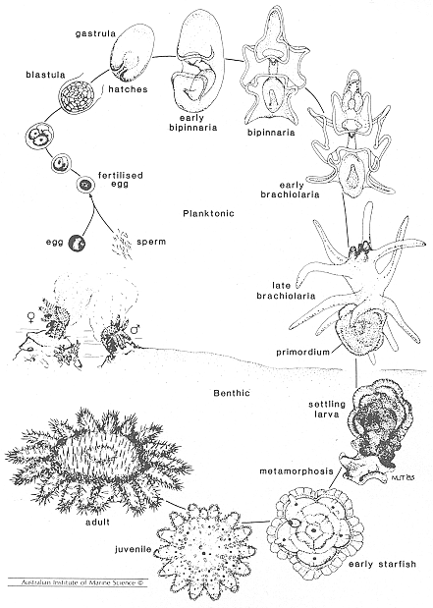
Figure 9 Diagrammatic representation of the life cycle of the crown-of-thorns starfish (as illustrated in Moran, 1988).

4. References
Aiello, R. 2006, Crown-of-thorns starfish a step by step guide – developing effective control programs, Oceans Antics Consulting.
Baird A.H., Pratchett M.S., Hoey A.S., Herdiana Y, Campbell S.J. 2013, Acanthaster planci is a major cause of coral mortality in Indonesia, Coral Reefs 32:803-812.
Beeden R., Willis B.L., Raymundo L.J., Page C.A., Weil E. 2008, Underwater cards for assessing coral health on Indo-Pacific reefs. Available online at www.gefcoral.org.
Birkeland .C, Lucas J. 1990. Acanthaster planci: major management problem of coral reefs, Boca Raton, Florida, CRC Press, p. 257.
Conand, C. 1984, Distribution, reproductive cycle and morphometric relationships of Acanthaster planci (Echinodermata: Asteroidea) in New Caledonia, western tropical Pacific. Proceedings of the Fifth International Echinoderm Conference, 499–506.
De’ath G, Fabricius K.E., Sweatman H, Puotinen M. 2012, The 27-year decline of coral cover on the Great Barrier Reef and its causes. Proceedings of the National Academy of Sciences 109(44).
Doherty P.J., Davidson J. 1988, Monitoring the distribution and abundance of juvenile Acanthaster planci in the central Great Barrier Reef. Proceedings of the 6th International Coral Reef Symposium, Australia, Vol. 2.
Fabricius, K. 2013, Acanthaster planci, in: Lawrence, J.M. (Ed. 2013). Starfish: Biology and ecology of the Asteroidea, pp. 132–141.
Keesing, J.K. 1990, Feeding biology of the crown-of-thorns starfish, Acanthaster planci (Linnaeus). PhD thesis, James Cook University of North Queensland, Townsville.
Keesing J.K., Lucas J.S. 1992, Field measurement of feeding and movement rates of the crown-of-thorns starfish Acanthaster planci. Journal Experimental Marine Biology and Ecology, 156:89–104.
Kettle, B.T. & Lucas, J.S. 1987, Biometric relationships between organ indices, fecundity, oxygen consumption and body size in Acanthaster planci (Echinodermata; Asteroidea). Bulletin of Marine Science 41, 541–551
Moran P.J. 1986, The Acanthaster phenomenon. Oceanography and Marine Biology: An annual review, 24:379–480.
Moran P.J. 1988, Australian Institute of Marine Science. Crown-of-thorns starfish questions and answers.
Pratchett M.S., Caballes C.F, Rivera-Posada J.A., Sweatman H.P.A. 2014, Limits to understanding and managing outbreaks of crown-of-thorns starfish (Acanthaster spp.). Oceanography and Marine Biology: An annual review 52:133–200.
Rivera-Posada J., Caballes C.F, Pratchett M.S., 2014, Size-related variation in arm damage frequency in the crown-of-thorns sea star, Acanthaster planci. Journal of Coastal Life Medicine, 2(3): 187–195. Doi: 10.12980/JCLM.2.2014J52.
Rivera-Posada J., Pratchett M.S., Aguilar, C., Grand, A., Caballes C.F, 2014, Bile salts and the single-shot lethal injection method for killing crown-of-thorns sea stars (Acanthaster planci), Ocean and Coastal Management (online 2 September 2014).
Zann L., Brodie J., Berryman C., Naqasima M. 1987, Recruitment, ecology, growth and behavior of juvenile Acanthaster planci (L.) Bulletin of Marine Science 41: 561–575.
Crown-of-thorns starfish control program report form (guide only)
Marine Parks permit:
Permittee:
Vessel:
Contact name:
Contact email:
Contact phone:
Date submitted:

Please note:
- An electronic copy of this report form will be sent to the primary contact for this permit. This form can be submitted via email or web.
- Cumulative monthly effort can be submitted or alternatively permittees can provide finer detail (e.g. daily effort) by inserting more rows in the table.

2014 | Reef name | Reef ID | Site name | GPS latitude | GPS longitude | Datum | # of dives | Max depth | Total bottom time (mins) | Total number of crown-of-starfish culled |  |  |  | Injection method used
 |  |  |  |  |  |  |  |  |  | <15cm | 15-25cm | 25-40cm | >40cm
Example | Moore Reef | 16-071 | Sunlover pontoon | -16.88818 | 146.19163 | GDA94 | 5 | 7m | 360 | 2 | 10 | 11 | 5 | Multi-shot sodium bi-sulphate
January
February
March
April
May
June
July
August
September
October
November
December

Current at the time of calculation (July 2014)
Available at http://www.sciencelab.com/msds.php?msdsId=9927340
Available at https://www.sciencelab.com/msds.php?msdsId=9927267

