Protecting the future of the
GREAT BARRIER REEF
GREAT BARRIER REEF REGION STRATEGIC ASSESSMENT
As part of a comprehensive strategic assessment, the Great Barrier Reef Marine Park Authority developed a 25-year program to protect and restore the values of the Great Barrier Reef.
PREFACE
Australia’s Great Barrier Reef is a maze of reefs and islands, stretching more than 2300 kilometres along the Queensland coast. It is an amazing natural treasure and one of the most biologically diverse areas on Earth.
It is a place of great significance to its Traditional Owners who have a unique and continuing connection with the area.
The Great Barrier Reef is critical to the cultural, economic and social wellbeing of the more than one million people who live in its catchment, and is valued by the national and international community.
The Reef’s importance is recognised through its listing as a world heritage area and through its protection as a marine park.
Like many coral reefs worldwide, the Great Barrier Reef is under pressure. Climate change, catchment run-off, coastal development, some remaining impacts of fishing, and outbreaks of crown-of-thorns starfish are among the most serious threats to the Reef.
The strategic assessment, including its community consultation, provided a valuable opportunity to examine cumulative impacts on the Reef and the effectiveness of the Authority’s management arrangements to address them.
The assessment found the outstanding universal value of the Great Barrier Reef World Heritage Area remains largely intact and the Reef remains one of the most resilient tropical marine ecosystems in the world. However, the accumulation of impacts through time and over an ever-increasing area is diminishing the Reef’s health.
The assessment has informed a 25-year management program for the Great Barrier Reef Marine Park Authority. To achieve the long-term protection and conservation of the Reef’s environment, biodiversity and heritage values, the Authority will boost and expand its existing foundational work and implement a range of new initiatives.
A key component of this forward program will be continuing partnerships across all levels of government, and with Traditional Owners, stakeholders, industry and the broader community. These partnerships will be fundamental to addressing issues within the Reef and those beyond its boundaries.
The complete set of reports, including the final strategic assessment and program reports, is available online at www.gbrmpa.gov.au.
signed
Russell Reichelt
Chairman and Chief Executive Officer
Great Barrier Reef Marine Park Authority

A comprehensive assessment of the Reef
A comprehensive strategic assessment of the Great Barrier Reef World Heritage Area and adjacent coastal zone was undertaken by the Australian and Queensland governments between 2012 and 2014. It was an opportunity to examine the values of the Great Barrier Reef, threats to those values and actions required to protect them.
There are two parts to the comprehensive strategic assessment:
- Great Barrier Reef Region Strategic Assessment, led by the Great Barrier Reef Marine Park Authority, looking at the marine component and improvements to management and protection of the Great Barrier Reef Region.
- Great Barrier Reef Coastal Zone Strategic Assessment, led by the Queensland Government, focusing on management arrangements in coastal areas adjacent to the Region.
The assessments were carried out under Part 10 of the Environment Protection and Biodiversity Conservation Act 1999. They form part of the Australian Government’s response to the World Heritage Committee’s concerns about development impacts on the World Heritage Area.
Each assessment comprises a strategic assessment report and a program report. Comments received during public consultation on drafts of each report plus from independent reviews have been incorporated into the final reports, and are detailed in supplementary reports for each assessment.
The outcomes of the assessments are informing development of a long-term sustainability plan for the Great Barrier Reef World Heritage Area.
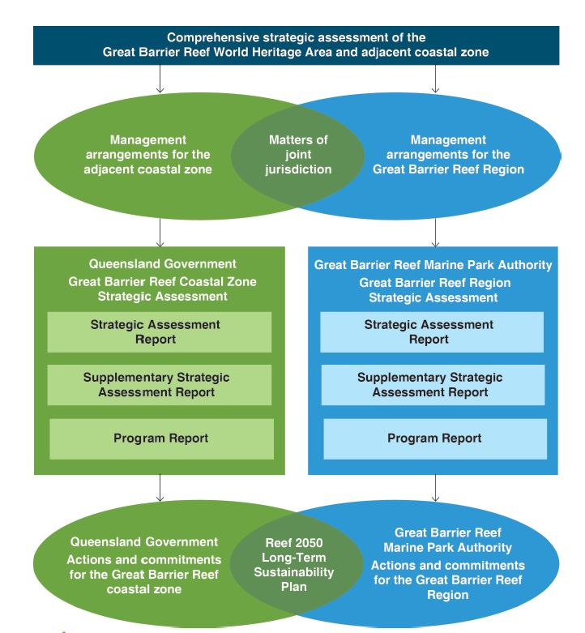
The comprehensive strategic assessment sets out future management programs for both the Great Barrier Reef Region and the adjacent coastal zone designed to secure the long-term future of the Reef.

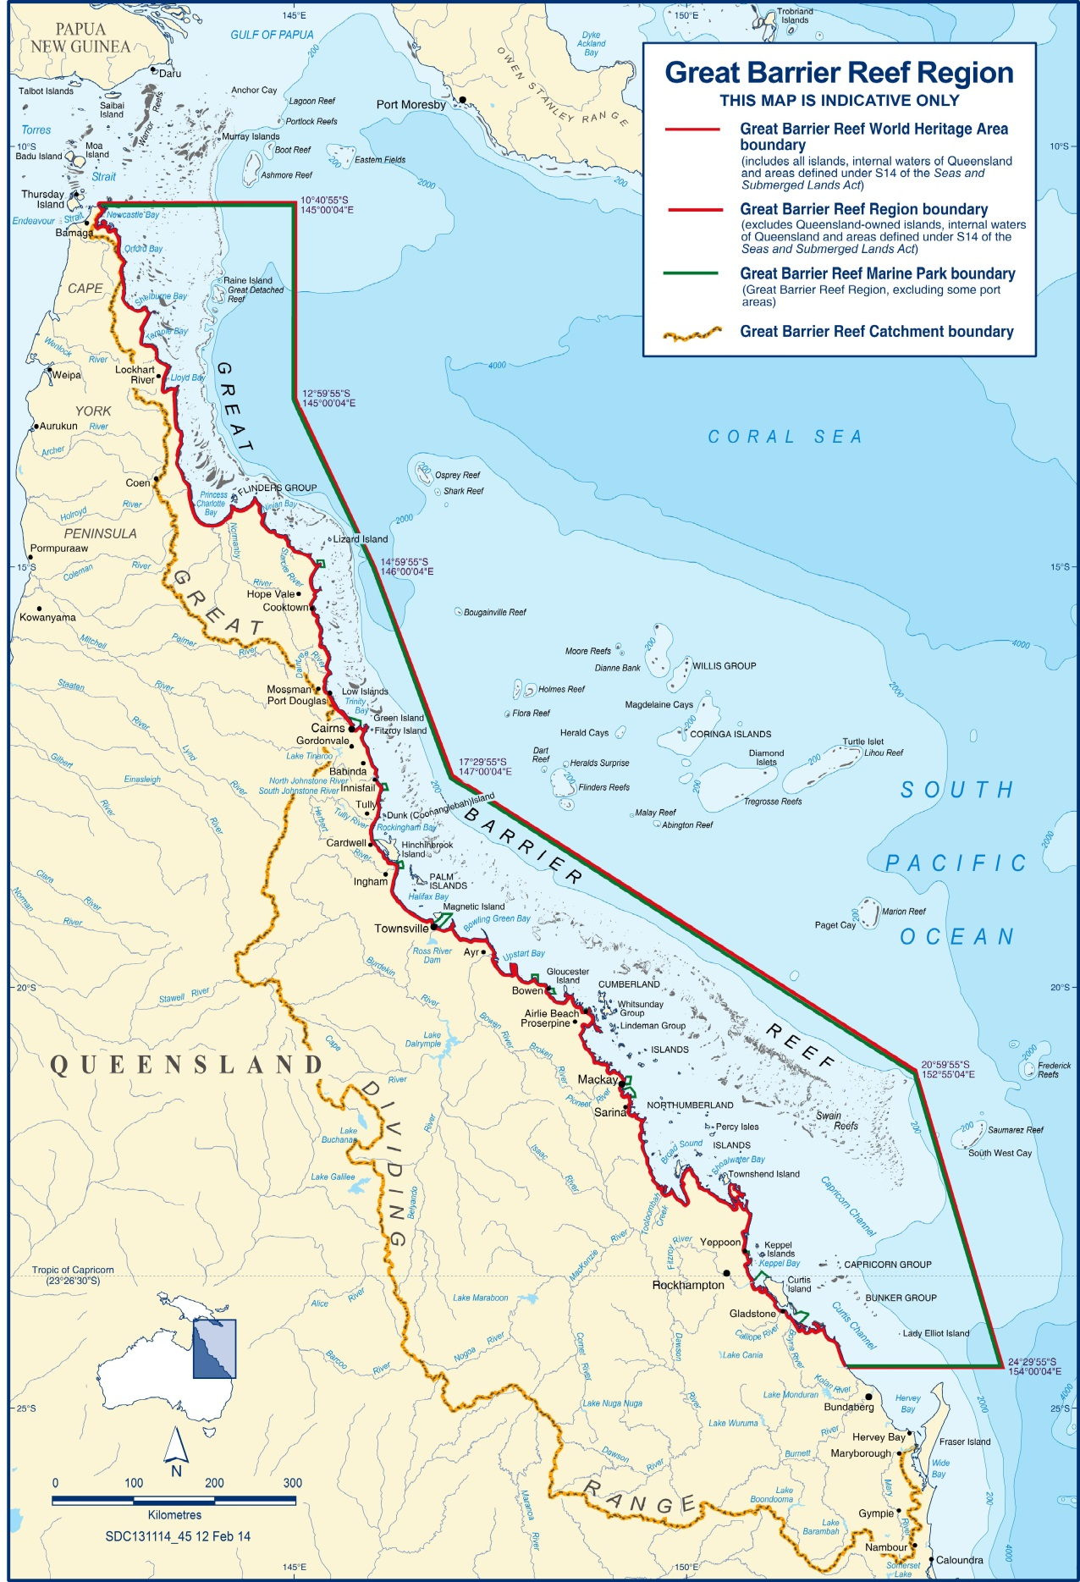
[Map of Great Barrier Reef Region, World Heritage Area and Marine Park] Caption: The strategic assessment undertaken by the Great Barrier Reef Marine Park Authority focuses on the Great Barrier Reef Region plus places beyond the Region’s boundaries where actions may affect it.

Great Barrier Reef  Region | Great Barrier Reef  World Heritage Area | Great Barrier Reef  Marine Park
Established 1975 | Inscribed 1981 | Declared in sections between 1979 and 2001; amalgamated into one section in 2003
346,000 km² | 348,000 km² | 344,400 km²
Includes:  - approximately 70 Commonwealth islands  - all waters seaward of low water mark (excluding Queensland internal waters)  Does NOT include:  - internal waters of Queensland  - Queensland islands (about 980) | Includes:  - all islands within outer boundary (about 1050)  - all waters seaward of low water mark (including internal waters of Queensland and port waters)  - all 12 trading ports | Includes:  - approximately 70 Commonwealth islands  - all waters seaward of low water mark (excluding Queensland internal waters)  Does NOT include:  - internal waters of Queensland  - Queensland islands (about 980)  - 13 coastal exclusion areas

An assessment of the Reef’s values and their future

A systematic and comprehensive approach
The strategic assessment process for the Great Barrier Reef Region was guided by terms of reference and aligned with the Queensland Government’s assessment for the adjacent coastal zone through a joint technical framework.
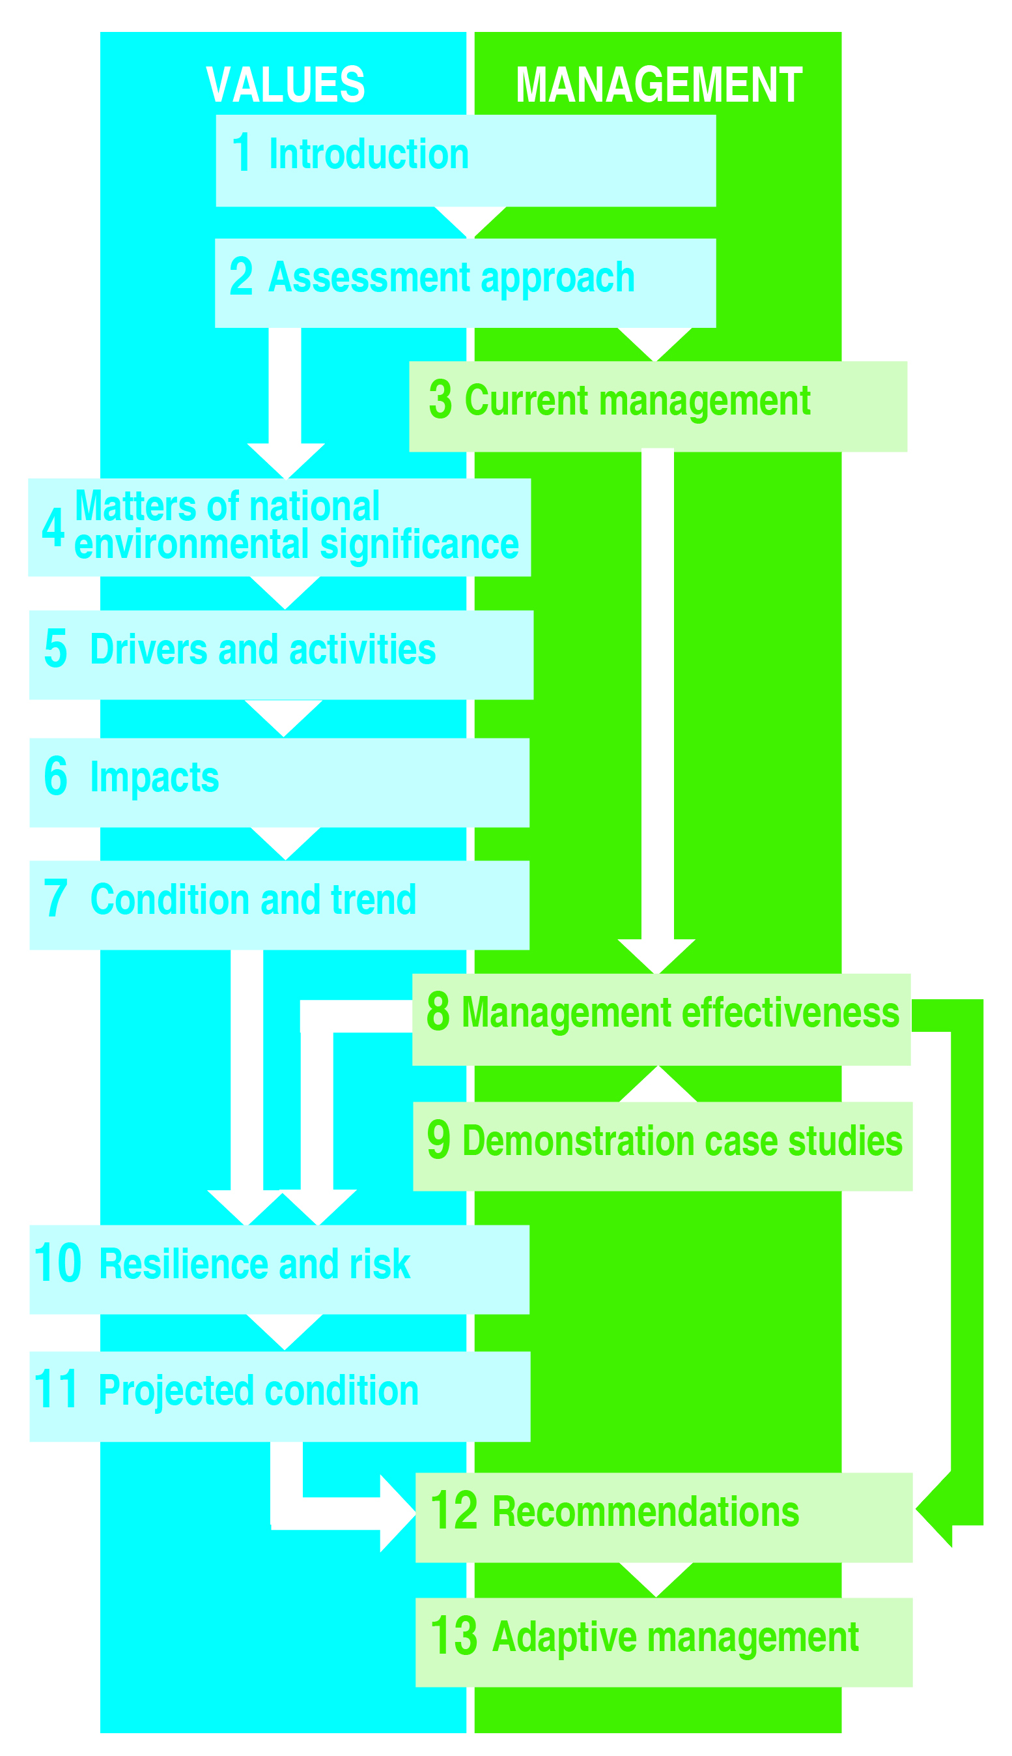
[Diagram of steps in the assessment process] Caption: The Strategic Assessment Report comprises a series of chapters where the values underpinning matters of national environmental significance are considered along with management of those values. Recommendations to improve management are provided and avenues for adaptive management outlined.
Grading statements were used to standardise the assessments of the condition of values, impacts on values, management effectiveness and risk. For most assessments, trend was determined using the Outlook Report 2009 as a baseline. A longer timeframe was adopted in assessing outstanding universal value so that it is benchmarked with the world heritage property’s condition at the time of listing in 1981.
To reflect differences within the Region, the descriptions and assessments often distinguish between four broad areas — the northern third, inshore and offshore, and the southern two-thirds, inshore and offshore — with the north-south dividing line in the vicinity of Port Douglas. Similar divisions are made for the Region’s catchment.
The strategic assessment was based on the best available information as at June 2013, including scientific data, expert opinion, and Traditional Owner and stakeholder knowledge. The report is fully referenced.
Throughout the assessment process, the Authority consulted with its expert and community advisory groups. There were also opportunities for input from broader Traditional Owner and stakeholder groups through purpose-designed workshops and follow-up surveys, plus meetings with a range of interested organisations, groups and individuals. Public consultation on the draft strategic assessment and program reports for both the Region and the coastal zone took place over a three-month period from November 2013.
Management effectiveness was independently assessed by a team of three assessors with comprehensive knowledge of protected area management, particularly in the Queensland marine environment. In addition, independent consultants reviewed the draft strategic assessment and program reports.

How the Reef is managed today
Both the Australian and Queensland governments have direct legislative responsibilities for management of the Great Barrier Reef. Through an intergovernmental agreement, the Australian and Queensland governments work together for its long-term protection and conservation. A Ministerial Forum made up of two ministers from each government oversees implementation of the agreement.
A number of Australian and Queensland government agencies have specific responsibilities to regulate access and to control or mitigate impacts.
In addition, many other organisations and individuals directly participate in Reef protection and management through partnership and stewardship arrangements in the Region and its catchment. Examples include:
- Traditional Owners — working with the Authority to protect cultural and heritage values, conserve biodiversity and enhance the resilience of the Great Barrier Reef
- local governments — responsible for local planning and development decisions and providing public services such as local roads, waste removal and water treatment within the catchment
- natural resource management bodies — supporting natural resource management activities in the catchment
- research institutions — providing improved knowledge about the Great Barrier Reef and advice on its implications for management
- industries, community groups and individuals — organising and participating in programs that contribute to protection and management
- schools — educating and engaging students in marine activities and conservation.
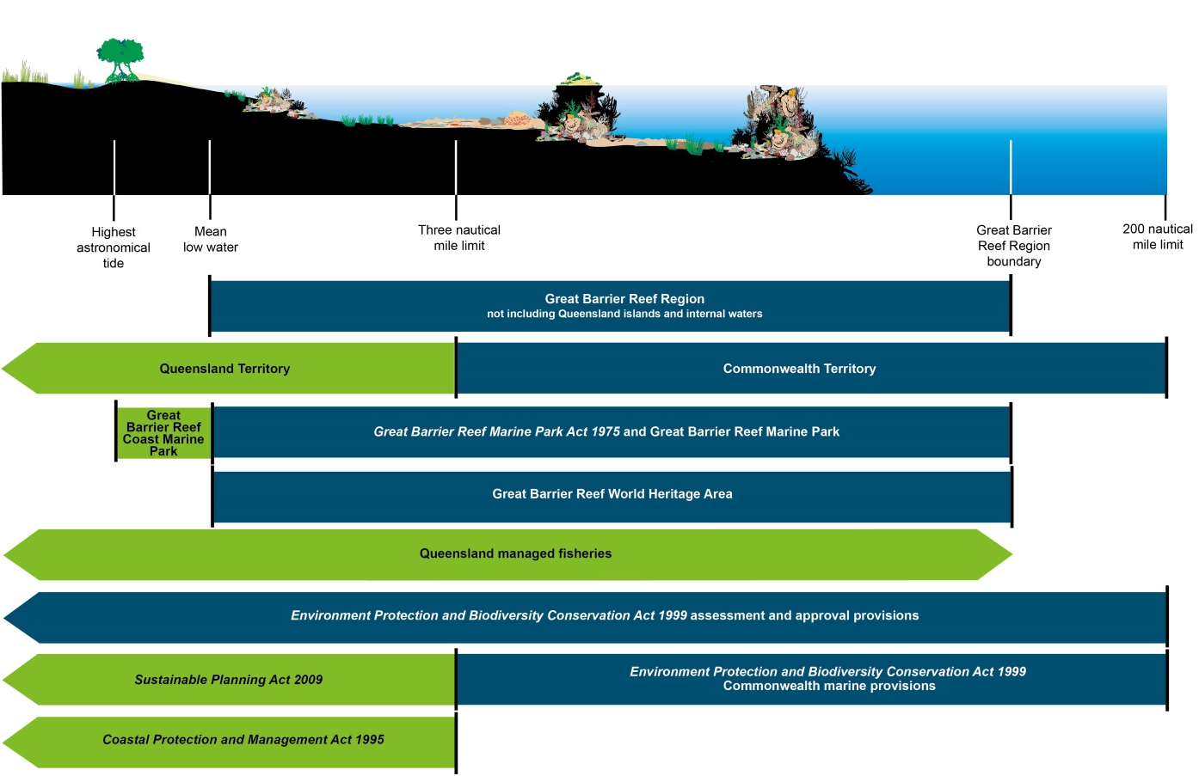
[Diagram of jurisdictional boundaries for the Great Barrier Reef Region] Caption: Jurisdictional arrangements for the Great Barrier Reef are complex, involving both Commonwealth and Queensland responsibilities. An agreement to jointly manage marine parks ensures integrated field management of the Great Barrier Reef Marine Park, the adjacent Great Barrier Reef Coast Marine Park and island national parks. Fisheries management, within the Region and beyond, is a Queensland Government responsibility. The assessment and approval provisions of the Environment Protection and Biodiversity Conservation Act apply throughout the Region; however, its Commonwealth marine area provisions apply only in Commonwealth Territory.
The Authority’s management focus is the protection and conservation of the Great Barrier Reef Region. It also assists in meeting Australia’s international responsibilities in relation to the environment and protection of the world heritage properties. In managing the Region, the Authority must have regard to, and seek to act in a way that is consistent with, the objects of the Great Barrier Reef Marine Park Act 1975, the protection of the world heritage values, and the principles of ecologically sustainable use.
Over the past four decades, the Authority has established strong and comprehensive management arrangements to protect the Reef and has progressively adapted them in response to emerging issues and improved understanding.
[Start of breakout box]
TOOLS FOR MANAGING THE REEF
The Great Barrier Reef Marine Park Act 1975 and its supporting regulations are the principal legislation for protection and management of the Great Barrier Reef.
The Authority uses a wide range of management tools to achieve the Reef’s long-term protection, ecologically sustainable use, understanding and enjoyment:
- Acts and regulations
- Zoning Plan
- plans of management
- permits (including environmental impact assessment)
- fees and charges
- Traditional Owner agreements
- compliance
- site infrastructure
- policy
- partnerships
- stewardship and best practice
- education and community awareness
- research and monitoring
- reporting.
[End breakout box]

Understanding matters of national environmental significance
The Environment Protection and Biodiversity Conservation Act 1999 focuses on protecting and managing matters of national environmental significance — Australia’s most prized environmental assets. Seven matters are relevant to the Great Barrier Reef Region and were considered in the strategic assessment:
- World heritage properties — the Great Barrier Reef was inscribed on the World Heritage List because of its outstanding universal value. This recognises the Reef’s evolutionary history, natural beauty and natural phenomena, ecological and biological processes, and habitats for the conservation of biodiversity; together with the strong ongoing links between Aboriginal and Torres Strait Islander peoples and their sea country.
- Great Barrier Reef Marine Park — a marine protected area managed to protect and conserve the Reef’s environment, biodiversity and heritage values including social, economic and cultural aspects.
- National heritage places — based on those values identified in the Reef’s world heritage listing.
- Commonwealth marine areas — all parts of the Region beyond state waters, and extending into the Torres Strait, Coral Sea and to the south of the Region.
- Listed migratory species — comprising six marine turtle species, 11 mammal species, five species of shark, 54 species of shorebirds and seabirds, and the estuarine crocodile.
- Listed threatened species and ecological communities — comprising six marine turtle species, five marine mammal species, seven shark and ray species, and six seabird and shorebird species.
- Wetlands of international importance — the Shoalwater and Corio Bays Area, a relatively undisturbed habitat for significant plants and animals, and the Bowling Green Bay Area, a regionally unique area important for its diversity and extent of marine, estuarine and freshwater habitats.
All of the matters of national environmental significance — from the World Heritage Area and the Great Barrier Reef Marine Park to listed species and wetlands of international importance — are interconnected and overlap. They are distributed throughout the Region.
The strategic assessment included a comprehensive analysis of the values and attributes that underpin the matters of national environmental significance. It identified a suite of over 60 key values and 20 key environmental processes, grouped into four broad categories:
- biodiversity, including the Region’s habitats and species — some of which are listed migratory or threatened species or are part of a wetland of international importance
- geomorphological features
- Indigenous and historic heritage
- community benefits of the environment, comprising the cultural, social and economic benefits derived.
[Photographs of a whale shark, mangrove roots, a beach in Shoalwater Bay, a vegetated cay, a coral reef, flatback turtle, red-footed boobies, the Blue Hole at Cockatoo Reef off Mackay and a lighthouse. ] Caption: The Reef’s biodiversity, geomorphological features, and Indigenous and historic heritage, combined with the community benefits they provide, underpin matters of national environmental significance in the Region. They are all considered in the strategic assessment.

Drivers and activities affecting the Reef
The strategic assessment examined five major overarching drivers that directly and indirectly cause changes in the Reef environment:
- climate change
- economic growth
- population growth
- technological development
- societal attitudes.
The assessment also examined activities undertaken both within the Region and beyond its boundaries that can affect the condition of its values.
Activities adjacent to the Region:
- agriculture
- aquaculture
- urban development
- industrial development and resource extraction
- port activities.
Activities within the Region:
- traditional use of marine resources
- tourism
- fishing — commercial
- fishing — recreational
- recreation
- shipping
- defence activities
- research activities.
Some activities are directly dependent on the Region’s natural resources (Reef-dependent) and others are carried out regardless of the natural environment. Examples of Reef-dependent activities are traditional use of marine resources, tourism, fishing (commercial and recreational), recreation and research.
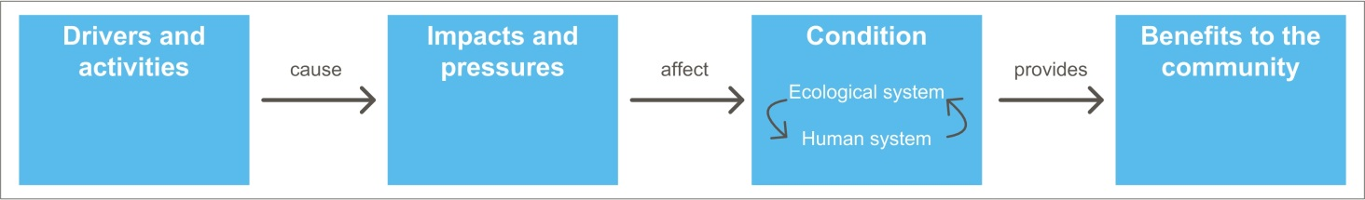
[Diagram of the influence of drivers and activities] Caption: There is a chain of cause and effect from external drivers and activities both within the Region and beyond its boundaries, to their resulting impacts and effects on the condition of the Region’s values, in turn affecting the quality of the benefits those values provide.

The combined effects of impacts
The strategic assessment examined the effects of impacts arising from activities conducted within and adjacent to the Region, including the legacy effects of historical activities. Of the 40 impacts examined, 25 were assessed as having high or very high effects on the Region’s values including increased sea temperature, cyclone activity, sediments from catchment run-off, nutrients from catchment run-off and their link to crown-of-thorns starfish outbreaks, modifying supporting terrestrial habitats, and several impacts of direct use, such as death of discarded species, dredging, dumping and resuspension of dredge material, illegal fishing and poaching.
The assessment found that several of the most significant impacts (for example those related to catchment run-off and extreme weather) operate at broad scales affecting large areas of the Reef.
For almost all the major impacts considered, the intensity of effect is greatest in inshore areas in the southern two-thirds of the Region.
Activities historically undertaken in the Region and its catchment, such as commercial harvesting of iconic species and catchment clearing, are still having an effect and are reducing the Reef’s ability to recover from current impacts. Some of these issues go back decades, even to the late 1880s, and their effects are likely to continue long into the future.
The combined effects of increased nutrients and sediments, together with a recent cluster of floods, temperature extremes and cyclones, have seriously affected key habitats such as coral reefs and seagrass meadows.
Past and some current impacts from fishing in the Region are affecting its values. Over the past two decades significant progress has been made in addressing its environmental impacts. However, a number of high risks remain and continue to affect the Region’s values. There are increasing cumulative impacts on species targeted in both recreational and commercial fisheries and illegal fishing is eroding the benefits of no-take marine park zones.
Species of conservation concern continue to be at risk, primarily due to degradation of inshore and estuarine habitats, loss of connectivity, legacy impacts and some past and present fishing activities.
Port operations and further port development will require capital and maintenance dredging, potentially involving much larger volumes. While dredging and disposal does not introduce additional sediment loads to the Region, these activities resuspend and redistribute sediments in areas already subject to multiple pressures.
The Region’s Indigenous heritage values have been significantly affected, and these effects are intensified by the closeness of Traditional Owners’ relationship to the environment. Traditional Owners emphasise that changes in their sea country have affected their culture.
Most impacts were assessed as increasing into the future, driven mainly by climate change, economic growth and population growth. The future impacts of climate change are predicted to be very serious as greenhouse gas concentrations continue to rise.
The success of recent initiatives to improve the quality of catchment run-off entering the Region means related impacts are likely to be reduced in the future. Such initiatives will be critical to securing the Reef’s health and building resilience.
[Photograph of crown-of-thorns starfish] Caption: Crown-of-thorns starfish are a major cause of loss of coral cover. One line of evidence suggests their populations are significantly affected by the concentration of nutrients in Great Barrier Reef waters.
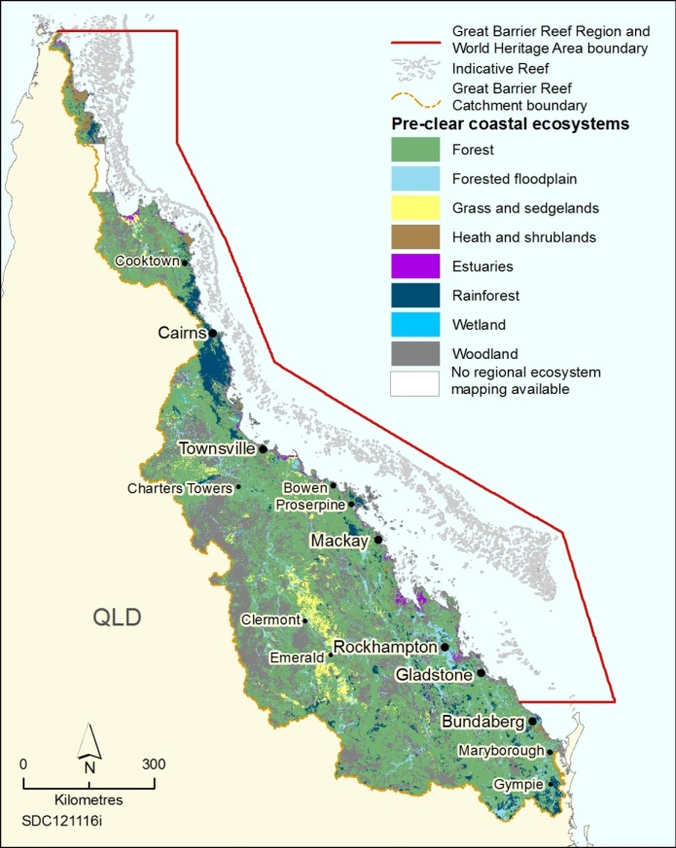 | 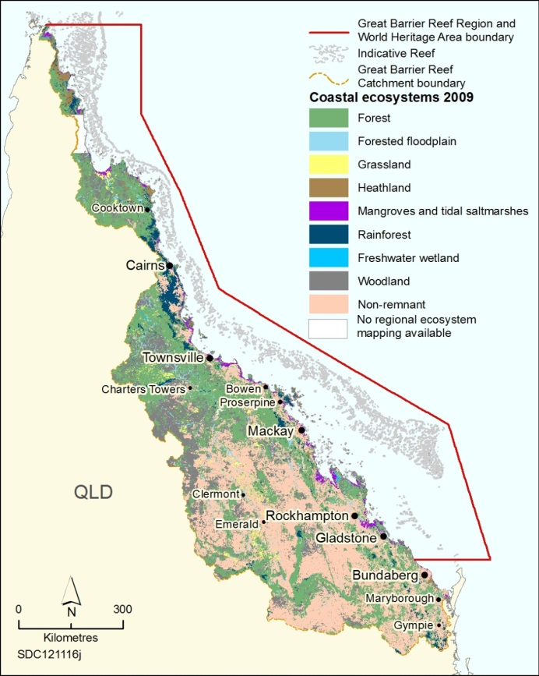
[Maps of coastal ecosystems of the Great Barrier Reef catchment] Caption: Before European settlement there were extensive areas of forests, woodlands and forested floodplains across much of the catchment (left-hand map). Much of the natural vegetation has now been modified (pink areas on the right-hand map), particularly in the south of the catchment.
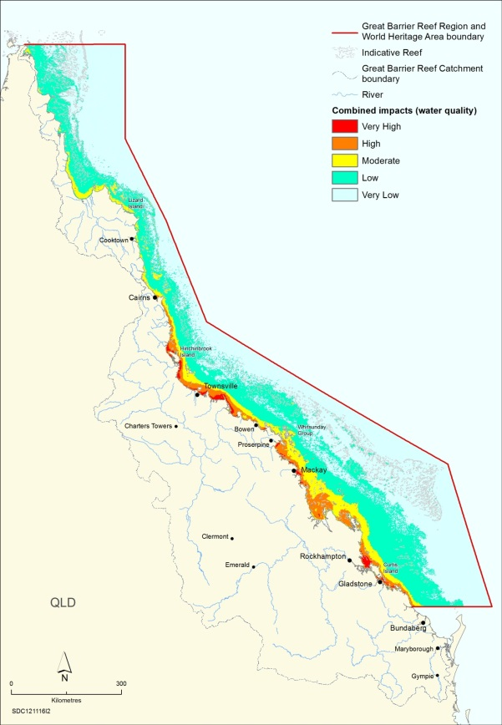 | 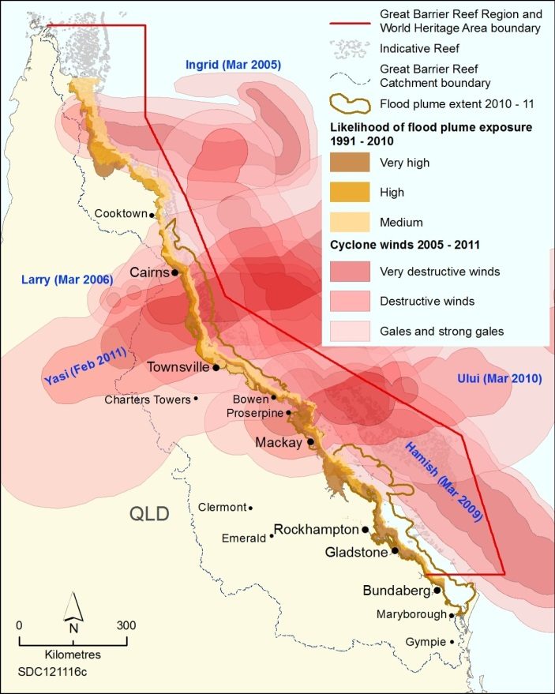
[Maps of water quality impacts and cyclonic winds] Caption: The cluster of floods and cyclones in recent years has seriously affected the condition of many Reef habitats and species. The effects of sediments, nutrients and pesticides in catchment run-off (left-hand map) are highest inshore in central and southern areas. The effects of cyclones (right-hand map) have been more widespread.
Source of left hand map: Brodie et al. 2013, Assessment of the relative risk of water quality to ecosystems of the Great Barrier Reef: A report to the Department of the Environment and Heritage Protection, Centre for Tropical Water and Aquatic Ecosystem Research, James Cook University, Townsville

Condition and trend of the Region’s values
The strategic assessment examined the effects of past and present impacts on the current condition and trend of the Region’s biodiversity, geomorphological features and Indigenous and historic heritage values. It also analysed the flow-on effects to community benefits. The results helped inform assessments of the effectiveness of current management, resilience and the likely future condition of the Reef.
The assessment found that, while the outstanding universal value of the World Heritage Area remains largely intact, the overall health of the Reef ecosystem, especially inshore in the southern two-thirds of the Region, has declined significantly and critical habitats such as coral reefs and seagrass meadows are in poor condition. Habitats in the north, further offshore and in deeper water, have been subject to fewer impacts and are believed to remain in good condition and are able to support dependent species.
At the same time, a number of natural processes vital to the healthy functioning of the marine environment, such as sedimentation, nutrient cycling and connectivity, are also in decline, particularly in central and southern inshore areas. However, recent improvements in land management and agricultural practices are likely to reduce impacts on these processes in the future.
A decade of extreme weather, including severe cyclones and floods, has contributed to the decline in Reef health, and reduced the capacity of the ecosystem to recover from these and other disturbances.
Terrestrial habitats, such as wetlands and connecting water bodies, along the Great Barrier Reef coast have been substantially modified, particularly south of about Port Douglas. This has reduced their ability to support the healthy functioning of the Reef.
Traditional Owners with connections to the Region maintain their cultural practices and customs. However, because Indigenous heritage values are closely tied to land and sea country, many have deteriorated as changes in the environment reverberate through their culture.
Heritage values are being maintained or restored at some lightstations, but most places of historic significance are poorly recorded or their condition is not well understood.
The Great Barrier Reef retains the amazing natural beauty for which it is famous. However, its underwater aesthetic value has been reduced in some areas — largely as a result of coral declines.
Community benefits are dependent on the condition of the biophysical values of the Great Barrier Reef. Economic benefits and employment remain relatively stable; however, impacts such as extreme weather, poor water quality and crown-of-thorns starfish have affected values such as access to reef resources and enjoyment.
[Photograph of corals] Caption: Since 1986, average hard coral cover on the Great Barrier Reef is estimated to have declined from 28 to 13.8 per cent with the decline speeding up in recent years. At a Reef-wide scale, the two biggest direct causes of the loss are cyclones and crown-of-thorns starfish outbreaks. Importantly, such large long-term declines imply corals in some areas are failing to recover fully after disturbances, or their recovery is being interrupted by subsequent disturbances. Catchment run-off is likely to have been a major contributor to such loss of resilience, particularly in inshore areas.

An independent assessment of management
As part of developing its future management program, the Authority commissioned an independent assessment of the effectiveness of its current management arrangements to protect values and reduce impacts.
The assessors considered fourteen management topics using a structured framework, examining the full management cycle from understanding the issues to achieving outcomes. The effectiveness of specific management measures to protect values, address impacts and protect matters of national environmental significance was also analysed.
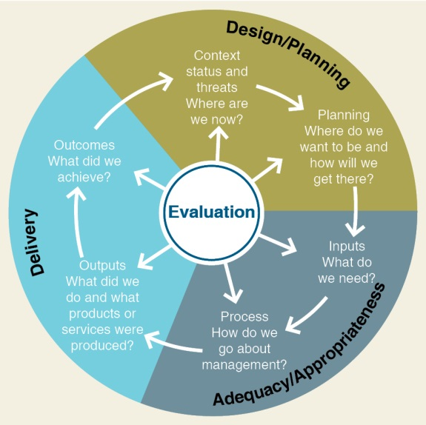
[Diagram of framework for assessing management effectiveness of protected areas] Caption: The effectiveness of the Authority’s management was independently assessed in relation to six elements in the management cycle. The full range of the Authority’s management tools, from the Zoning Plan to education and community awareness, were considered.
The independent assessment concluded that, while the Authority’s management of activities within the Region is generally effective, more is required to halt and reverse declines in Reef health, especially in addressing impacts arising outside the Region.
Addressing cumulative impacts across jurisdictions, applying socio-economic and Indigenous knowledge, and setting targets to benchmark performance were found to be problematic for most management areas examined.

Demonstration cases
A series of demonstration case studies were undertaken as part of the strategic assessment so that the management of particular species, places and activities could be more closely examined and the effectiveness of individual management tools analysed.
The case studies highlighted that, while there is a suite of common issues affecting the Reef (such as impacts from extreme weather, catchment run-off, degradation of coastal ecosystems and direct use), values, impacts and risks varied along the length of the Region. Case studies also highlighted that connectivity within and between terrestrial and marine ecosystems are critical to the health and resilience of the Reef.
The finer detail assessments demonstrated that a suite of regional and local approaches based on local knowledge and actions will be central to protecting and managing values. For each of the case studies, enhancing protection and restoration, minimising direct impacts and improving adaptive management were common themes for potential improvements.
The case studies highlighted:
- the advantages of being proactive in tackling the issues facing the Reef
- the importance of partnerships — including across all levels of government, and with Traditional Owners, industry and the broader community — to strengthen efforts to improve water quality, address impacts at a local scale and implement regionally or sector-specific best practice management solutions
- the value of foundational activities to underpin management, such as long-term integrated monitoring and improved understanding of heritage values and community benefits derived from the Region.
[Aerial photograph of Lady Elliot Island] Caption: Lady Elliot Island, a Commonwealth island in the south of the Region. The case study on islands demonstrated that they are likely to remain in good condition, but pressures will increase. Islands throughout the Region will likely be affected by climate change and pressures are likely to continue on islands where there are development activities.
[Start of breakout box]
[Photograph of dugong]
DUGONGS — A CASE STUDY
Ongoing and effective management action is required to protect dugong populations and, critically, to halt and reverse the decline in the southern population. A fundamental management action is to maintain, enhance and restore the health of seagrass meadows, the primary habitat of dugongs. It is also important that direct impacts on dugongs (such as incidental catch in fishing nets, illegal poaching and vessel strike) are minimised. Regular monitoring, evaluation and review of dugong populations and seagrass meadows, and continuous improvement of relevant practices and standards will enable adaptive management of this iconic species.
[End of breakout box]
[Start of breakout box]
[Photograph of children playing on rocks]
PRINCESS CHARLOTTE BAY — A CASE STUDY
Princess Charlotte Bay is located at the base of Cape York Peninsula and is recognised for its high biodiversity values. Due to its remoteness, the area has been protected from many of the impacts experienced elsewhere in the Region. However, the projected increase in economic development of the adjacent catchment is likely to increase pressure on the bay’s biodiversity and heritage values. The Lama Lama people are the Traditional Owners of the land and sea country from the Massey River, around Princess Charlotte Bay, to the Normanby River. Building on a long history of sea country management and custodianship, Lama Lama Traditional Owners recently had a Traditional Use of Marine Resources Agreement (TUMRA) accredited by the Authority and the Queensland Government. The Authority provides support to Traditional Owner groups to implement TUMRAs through a range of sea country management activities, including developing compliance plans.
[End of breakout box]

Resilience and future risks to the Reef
Assessments of both the current resilience of the ecosystem and the likely future risks to the Region’s values were an important component of determining their likely future condition.
The assessment found that the Region remains one of the most resilient tropical marine ecosystems in the world; however, there is increasing evidence that its resilience is being seriously eroded. The loss cannot be attributed to any single cause, but is almost certainly the consequence of impacts from the different activities and direct drivers, and their accumulation through time.
Coral reefs, seagrass meadows and other inshore habitats have lost some of their resilience due to declines in condition, continuing impacts and a loss of connectivity. Dugongs have lower resilience due to historic depletion, low rates of reproduction and loss of seagrass habitats.
The emerging loss of ecosystem resilience is particularly critical given the projected major increase in the severity of impacts related to climate change.
A risk assessment of the impacts affecting the Region was based on the likelihood and consequence of each predicted impact on the Region’s biodiversity values, geomorphological features, and Indigenous and historic heritage values.
The assessment found that the impacts likely to be of highest risk have their origin in a number of factors — some well beyond the Region’s boundaries.
The impacts assessed as presenting a high or very high future risk were:
- climate change
  - cyclone activity
  - increased sea temperature
  - ocean acidification
  - rising sea level
- catchment run-off
  - increased freshwater inflow (also linked to climate change)
  - nutrients in catchment run-off
  - outbreaks of crown-of-thorns starfish, linked to higher concentrations of nutrients
  - sediments in catchment run-off
  - urban and industrial discharge
  - pesticides in catchment run-off
- degradation of coastal ecosystems
  - artificial barriers to flow
  - modifying supporting terrestrial habitats
  - coastal reclamation
- direct use of the Region
  - extraction — death of discarded species
  - wildlife disturbance
  - dredging
  - dumping and resuspension of dredge material
  - extraction — lower trophic orders, lower order predators and top order predators
  - extraction — fishing spawning aggregations
  - illegal fishing and poaching
  - marine debris
  - noise pollution.

Likely future for the Reef
Based on the assessments of current condition and trend of the Region’s values, the effectiveness of current management, resilience and risk, the likely projected condition was developed for the matters of national environmental significance and the values that underpin them.
The assessment concluded the health of the Great Barrier Reef is likely to continue to decline, particularly inshore in central and southern areas, and management is not keeping pace with the impacts that are acting on the system. Without additional management intervention, there is a risk of further declines in the condition of biodiversity and heritage values and the community benefits they support.
- Biodiversity values in the Region are likely to deteriorate further in the absence of additional management intervention. A decade of extreme weather events has severely affected many habitats and species, and has reduced the capacity of the Reef to recover from these and other ongoing impacts. Modelling of coral reef habitats and their cumulative impacts adds weight to the projection that climate change variables, such as ocean warming and the increased intensity of storm events, are likely to substantially affect the future condition of reefs in the Region.
- Geomorphological features such as coral reefs, islands, shorelines and river deltas will likely deteriorate over the next 25 years based on the condition of the related biological systems. The long time periods associated with changes to other geomorphological features mean any changes may take many decades. Deeper, more distant features, such as submarine canyons and channels, are likely to be less affected.
- Indigenous heritage values are likely to continue to deteriorate, based on the inextricable connections between Indigenous culture and the Reef environment, and the increasing pressures of coastal development.
- Historic heritage values such as lightstations are well studied and are likely to remain in good condition. Limited knowledge about other historic heritage values means their projected condition is difficult to predict.

Recommended changes to management
The strategic assessment presents a series of recommended improvements to the Authority’s management arrangements, as well as recommended improvements to related local, state and national government programs.
It concludes that managing the multiple impacts affecting the Reef requires a multi-pronged approach.
A concerted international effort to reduce global climate change, combined with action at national, state and local levels to build the Reef’s resilience by reducing impacts across all sources, is vital to protecting the Great Barrier Reef and its outstanding universal value.
There is a need to maintain and restore the Region’s biodiversity. In the southern two-thirds of the Region, management actions need to focus on restoring Reef health and halting and reversing impacts on its values.
Understanding and protection of the Region’s rich heritage values and community benefits needs to be improved and better integrated into planning and assessment decision making.
Critically, managing cumulative impacts needs to be improved and mechanisms developed which will deliver net environmental benefits across the Region.
These improvements will be vital to protecting the Reef’s outstanding universal value and restoring the Reef’s health and resilience for generations to come.
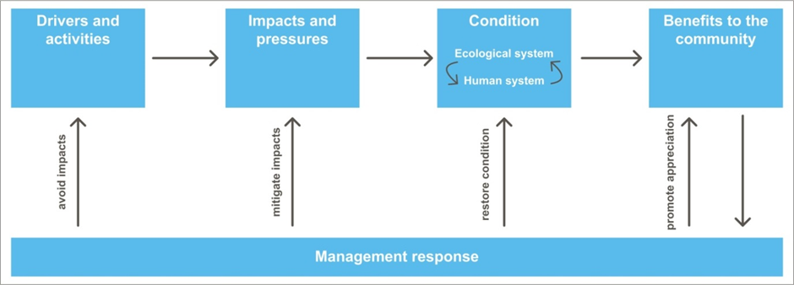
[Diagram of pathways of management intervention] Caption: The Authority will adopt a comprehensive and coordinated approach to its management of impacts, with responses that avoid and mitigate impacts, restore condition and promote appreciation.

Future improvements to management
The findings and recommendations of the Strategic Assessment Report have informed a 25-year management program for the Authority. Management arrangements to protect the Reef and provide for ecologically sustainable use are set out in the Program Report.
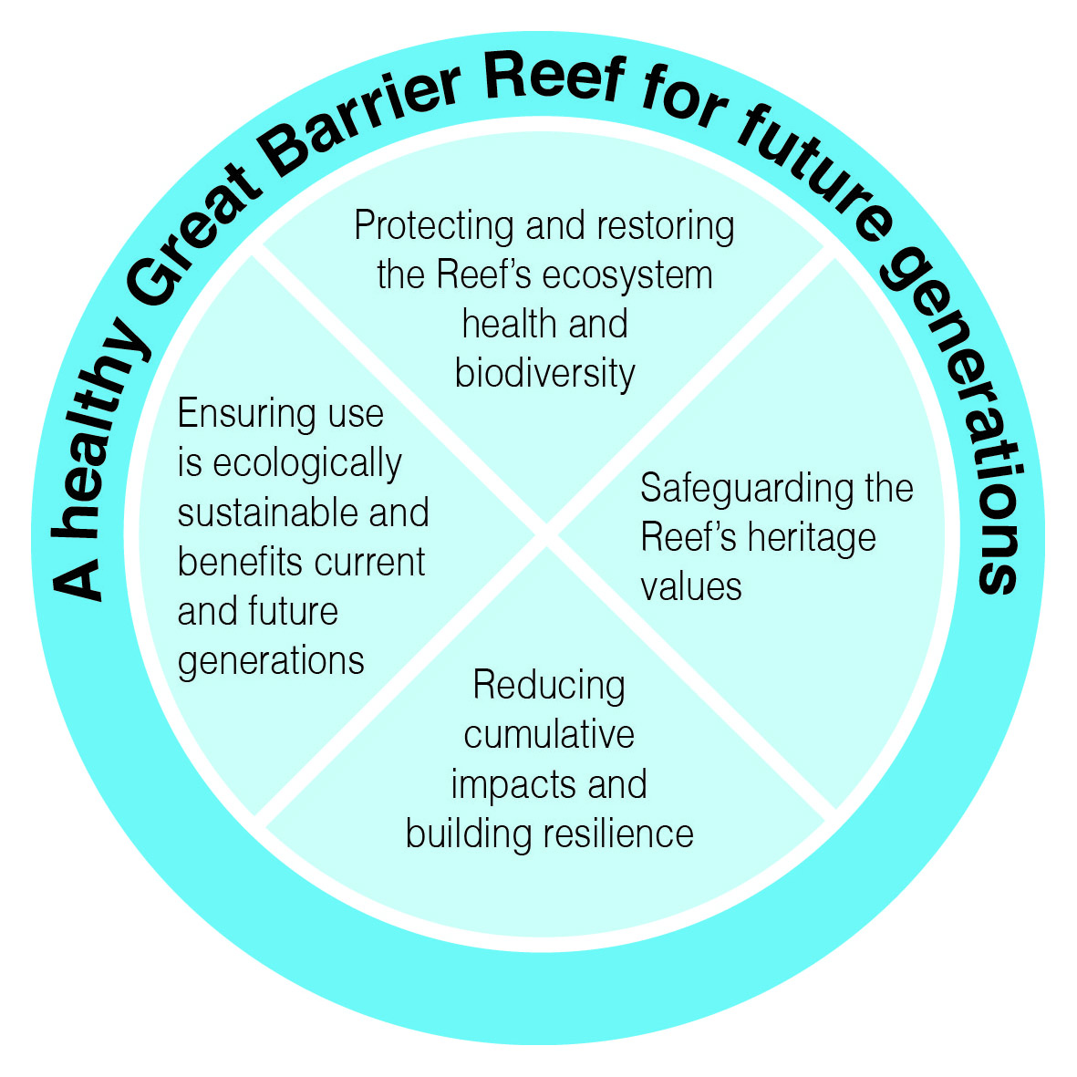
[Diagram of vision and goals] Caption: The Great Barrier Reef is a national and international environmental asset for current and future generations. The Authority’s comprehensive management program is designed to protect and restore the Reef’s ecosystem, safeguard its heritage values, reduce cumulative impacts, build resilience, and ensure use is ecologically sustainable.

Building on a strong foundation
The Authority’s management program builds on the strong management arrangements already in place. It is structured around three foundational management areas:
- Environmental regulation — the Authority employs a range of planning and management tools such as regulations, the Great Barrier Reef Zoning Plan, plans of management, permits, compliance and statutory reporting.
- Engagement — the Authority recognises that protection of the Great Barrier Reef requires local, national and international effort and works with partner agencies, Traditional Owners, communities, industry and local government to find pragmatic solutions to secure the Reef’s future.
- Knowledge, integration and innovation — the Authority strives to base its management on the best available science from a network of science providers, as well as drawing on traditional ecological knowledge and information from the wider community.

Strengthening management
Based on the recommendations of the Strategic Assessment Report, many of the existing management arrangements will be strengthened. Examples include: developing regionally based standards for ecosystem health; strengthening guidelines; improving incident response capacity; supporting best practice and stewardship; improving consultation arrangements; improving protection of Indigenous heritage values; and improving alignment and coordination of research priorities.
Addressing the challenges of managing cumulative impacts is a key driver behind many of the measures to strengthen management.
Five new initiatives will be progressively developed and implemented to strengthen management:
- Management framework based on outcomes and targets to guide decision making and the actions required to maintain and restore the condition of values. The targets for management will be developed in collaboration with partner agencies, Traditional Owners, industry and stakeholder groups. Outcomes and targets will be collaboratively reviewed and updated after 12 months and then every five years as part of the Authority’s Outlook Report and Reef Plan reporting, as well as more frequently as understanding improves and circumstances change.
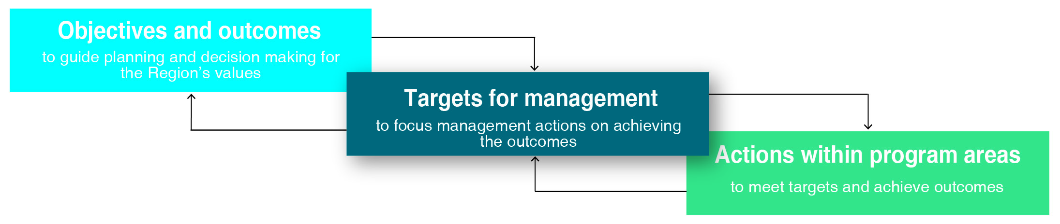
[Diagram showing role of targets for management] Caption: Targets for management will provide a critical link between the Authority’s objectives and outcomes and actions within each of its program areas and those of its partners.
- Cumulative impact assessment guidelines to support a transparent, consistent and systematic approach to assessing cumulative impacts from activities within and adjacent to the Region. The guidelines will inform management decisions about planning and assessment, and improve transparency of decision-making processes.
- Net benefit policy to guide actions required to restore ecosystem health, improve the condition of values and guide financial contributions to that recovery. While avoiding and mitigating impacts will remain the primary focus of the Authority’s management of impacts, these approaches are not sufficient on their own. A more comprehensive approach is needed, including delivering offsets and working for a net improvement in the condition of the Region’s values.
- Reef recovery program to cooperatively maintain and restore sites of high environmental value. In the northern third of the Region, the focus will be on safeguarding values and maintaining the area in a natural state. Further south, the focus will be on restoring the condition of values and reducing impacts on those values, while continuing to provide for a range of sustainable use.
- Reef-wide integrated monitoring and reporting program which directly links to the outcomes-based management framework and underpins the Authority’s adaptive management. The program will improve integration and coordination of existing monitoring programs through the development and implementation of protocols for information collection, collation and data sharing. It will improve synthesis of information from different sources and the capability for data from local, regional and Reef-wide scales to be compared and combined.
These initiatives will drive the actions required to build a healthy and resilient Great Barrier Reef and enhance protection of matters of national environmental significance. The immediate focus will be on outcomes and targets to guide decision making, cumulative impact assessment guidelines, a net benefit policy and actions to maintain and restore the Region’s values.
Measures to strengthen management | Within  12 months | Within two years | Within five years | Ongoing | Annually | Five-yearly
New initiatives
Outcomes and targets
Offset guidelines and net benefit policy
Cumulative impact assessment guidelines
Reef recovery program
Integrated monitoring and reporting program
Measures to strengthen management
Environmental regulation
Developing regionally-based standards for ecosystem health
Facilitating a whole-of-government policy on dredging and dredge material disposal
Strengthening guidelines (for example water quality)
Enhancing alignment of permission system with Environment Protection and Biodiversity Conservation Act assessment processes
Streamlining, harmonising and enhancing management tools
Improving assessment of matters of national environmental significance
Further developing operational activities that support recovery and build resilience
Improving certainty for planning and management
Strengthening protection of heritage values
Improving compliance
Improving incident response capacity
Engagement
Influencing drivers and activities affecting the Region
Supporting best practice and stewardship
Improving consultation arrangements
Establishing a peak Reef advisory committee
Knowledge, innovation and integration
Improving identification and understanding of matters of national environmental significance
Improving identification of Indigenous heritage values
Developing a historic heritage database
Improving understanding of community benefits
Improving alignment and coordination of research priorities
Increasing emphasis on use of modelling
Better integrating knowledge into management
Forward commitments
Reef 2050 Long-Term Sustainability Plan
Adaptive management — review cycles
Governance (Ministerial Forum)
Over the next five years, the Authority will focus its management efforts on implementing the suite of measures identified in the Program Report. These are designed to strengthen protection and, where relevant, restore the Region’s values.

Management that adapts to change
The constantly changing nature of the Great Barrier Reef requires the Authority’s management program to be sufficiently focused to consistently deliver results, yet agile enough to respond to emerging issues. This adaptive management approach is embedded in the Authority’s operations.
In protecting and restoring the Region’s values, the program will focus on the highest risk impacts and the cumulative effects of multiple impacts. By structuring its future program around outcomes, rather than outputs, the Authority will have the flexibility to continually adapt its management arrangements.
The Authority’s management actions will be based on an up-to-date and comprehensive understanding of the status and trend of the Region’s values, the impacts that may be affecting them and the benefits being derived.
The Authority will continue to use its five-yearly Great Barrier Reef Outlook Report to examine the current status, future risks and likely outlook for the Region. The outcomes of each report will inform the Authority’s future priorities and be the principal guide to adaptive management.
The Authority will actively work with all its partners — government, industry and communities — to address the current challenges and ensure the Great Barrier Reef remains healthy and resilient for future generations.

