Heritage values
Chapter 4
‘an assessment of the current heritage values…’ of the Great Barrier Reef Region, Section 116A(2)(a) of the Great Barrier Reef Marine Park Regulations 1983
< Photograph of exposed reef, beach and a lighthouse on front cover, Copyright Chris Jones.

2014 Summary of assessment
Heritage values not assessed in 2009 — trend not provided
Indigenous heritage values | Traditional Owners with connections to the Region maintain their cultural practices and customs. Places of Indigenous heritage values have not been systematically identified and many have deteriorated, especially around developed areas and on islands. Some species of cultural significance are under pressure. Story, language and songlines are being affected by activities in the Region. | Poor
Historic heritage values | There is good understanding and recording of some aspects of historic heritage in the Region, for example known historic shipwrecks, a small number of World War II features and lightstations. Heritage values are being maintained or restored at heritage-listed lightstations. Most other places of historic significance are poorly recorded and their condition is not well understood. | Good
Other heritage values | The Region’s social and scientific heritage is being maintained. The Great Barrier Reef continues to have great scientific significance. People continue to value and connect with its environment and its natural beauty is widely appreciated. Declines in environmental condition in the central and southern inshore areas have reduced underwater aesthetic values. | Good
World heritage values and national heritage values | The outstanding universal value of the world heritage property remains in good condition, however the overall condition of some key attributes is poor and many have deteriorated since the property’s listing in 1981. Those related to coral reef and seagrass meadow habitats, marine turtles, seabirds and dugongs are assessed as being in poor condition overall. The Region remains a globally outstanding example of an ecosystem that has evolved over the millennia. The natural beauty of most of the Region remains, however its underwater aesthetic value has declined in central and southern inshore areas. External pressures are affecting the property’s integrity. | Good
Commonwealth heritage values | The five places in the Region that are included on the Commonwealth Heritage List retain the values for which they were listed. The Shoalwater Bay Military Training Area and the four historic lightstations have been well recorded, retain their integrity and are in good condition. Low Island retains its importance as part of Indigenous tradition. | Good
Natural heritage values | Most of the Region’s natural heritage values remain in good condition, but some are in decline, especially in its southern two-thirds. Values in poor condition include coral reefs and corals, seagrasses, seabirds, sedimentation, nutrient cycling and sea temperature. Populations of some iconic species such as dugongs and marine turtles are also in poor condition. | Good
Full assessment summary: see Section 4.8

Heritage values

Background
An assessment of heritage values of the Great Barrier Reef Region (the Region) was introduced as a legislative requirement for the Great Barrier Reef Outlook Report in late 2013. It was not part of the first Outlook Report in 2009.
The requirement reflects the 2008 amendment of the Great Barrier Reef Marine Park Act 1975 (the Act) to include protection and conservation of the heritage values of the Region in its main object and responds to a 2012 recommendation by the World Heritage Committee.
As defined in the Act, for the purposes of the Outlook Report, the heritage values of the Region include:
- Indigenous heritage values: the heritage values of a place that are of significance to Aboriginal and Torres Strait Islander persons in accordance with their practices, observances, customs, traditions, beliefs or history
- other heritage values: a place’s natural and cultural environment having aesthetic, historic, scientific or social significance, or other significance, for current and future generations of Australians
- world heritage values: the natural heritage and cultural heritage of a property that is internationally recognised as being of outstanding universal value
- national heritage values: the values of a place that are of national significance as recognised through placement on the National Heritage List
- Commonwealth heritage values: the values of a place that are specified in its placement on the Commonwealth Heritage List.
The values of the Region encompassed by these legally defined categories are interconnected and overlapping and there are many ways to group them.
In this chapter and throughout the report, the Region’s heritage values are grouped into:
- Indigenous heritage values
- historic heritage values
- other heritage values (comprising social, scientific and aesthetic heritage values)
- world heritage and national heritage values
- Commonwealth heritage values
- natural heritage values (assessed in Chapters 2 and 3 and summarised in Section 4.7).

Current state and trends of Indigenous heritage values
Indigenous heritage recognises the heritage of Aboriginal and Torres Strait Islander peoples who are the First Australians and the Traditional Owners of the Great Barrier Reef. It is an important element in Indigenous custom and its preservation ensures continued recognition and respect for past generations of Traditional Owners and the ancestral beings that shaped the land, seas and waterways.¹
Indigenous heritage is a unique, dynamic and diverse living heritage. Traditional Owners express their cultural heritage through their relationships with country, people, beliefs, knowledge, lore, language, symbols, ways of living, sea, land and objects. All of these arise from Indigenous spirituality and the responsibility of Traditional Owners to maintain their connection to their heritage through customary practices. Many traditional cultural practices include plants, animals and the environment, making nature inseparable from cultural identity.
‘The sea, its natural resources and our identity as Traditional Owners, are inseparable… Our ancestors have hunted and fished in this sea country since time immemorial…’ ²
The strong ongoing links between Traditional Owners and their sea country is one of the attributes recognised as contributing to the outstanding universal value of the Great Barrier Reef as a world heritage property.
There are more than 70 Traditional Owner groups who are responsible for maintaining the cultural values of their land and sea country in and adjacent to the Region. This includes a small number of Torres Strait Islander groups who express traditional and spiritual connection in the northernmost area of the Region. While Aboriginal and Torres Strait Islander peoples have some common heritage values, there are also many unique expressions of heritage for each.
Throughout this chapter Indigenous heritage values are grouped into four broad components:
- cultural practices, observances, customs and lore
- sacred sites, sites of particular significance and places important for cultural tradition
- stories, songlines, totems and languages
- Indigenous structures, technology, tools and archaeology.
While this chapter presents information on Indigenous heritage values under discrete headings, in reality they cannot be separated. In addition, the natural heritage values described in Chapters 2 and 3 are fundamental to Traditional Owners and their connection to land and sea country. All values are connected and interrelated and the descriptions of each value should be viewed in this context.

Cultural practices, observances, customs and lore
Key message: Traditional Owners are maintaining their cultural practices and transferring them to future generations.
Cultural practices, observances, customs and lore are comprised of intangible features such as skills, folklore, rituals, religious beliefs and intellectual traditions, passed down from generation to generation. They are an intrinsic part of custom and continue to be observed by Indigenous people in their sea country.
Throughout the Region, Traditional Owners maintain their cultural practices and customs and pass information and knowledge across generations. Practices and customs are an integral part of their sea country management. For example, controlling use of and access to sea country estates by Traditional Owners regulates resource use based on cultural practices and belief systems. It is consistent with the recognition of traditional customs, practices and lore.
Seasonal and cultural use of marine resources and the opening or closing of harvesting seasons according to ecological events (for example, flowering of particular plants or the arrival of migratory bird species) continue to be practised by Great Barrier Reef Traditional Owners.³ Important skills and traditional ecological knowledge are passed down from one generation to the next, enabling Aboriginal and Torres Strait Islander peoples to follow the same seasonal patterns as their ancestors. The transfer of these skills and knowledge means different resources continue to be exploited at different times of the year.⁴
[Photograph of large boulders sitting in the ocean.. Caption: Indigenous heritage values associated with these sacred rocks include protection over sea country areas. Photograph by Kathi Gibson-Steffensen]

Sacred sites, sites of particular significance and places important for cultural tradition
Key message: Some known sites of cultural significance are under pressure, including from coastal development and severe weather events.
Sacred sites, sites of particular significance and places of cultural tradition are tangible aspects of the Region’s Indigenous heritage. Sacred sites are significant heritage places for Indigenous people and their enduring traditions. For example, they may be creation or resting places for ancestral spirits, places that contain healing water and medicinal plants, burial grounds, traditional tracks of Aboriginal peoples’ movements or sites associated with special events.⁵
Many sites of significance are areas of great importance for the conservation of biodiversity across land and sea country, and many communities are unable to separate the reasons for protecting the spiritual connections between people and the earth from the reasons for conserving biodiversity. In most cases, natural and cultural heritage values of sites form a continuum rather than being separate entities.⁶
As on land, sea country contains evidence of events that occurred during the Dreaming through which all geographic features, animals, plants and people were created. Sacred sites often relate to creation events, Dreaming tracks or songlines travelled by spiritual beings during the creation period. A defining feature of sacred natural sites is that Aboriginal people have known about and cared for them since time immemorial. Aboriginal and Torres Strait Islander peoples have custodial responsibilities as part of their lore which connect them to country, thereby ensuring the maintenance of spiritual, cultural, biological and other values of such sites.⁶
There are sacred sites, sites of particular significance and places important for cultural tradition along the length of the Region, often linking land and sea. Some examples include:
- There are fish traps on Hinchinbrook Island, a system of stone-walled pools that flood at high tide, trapping fish as the tide goes out.
- Worrungu Bay (near Cape Upstart) is a significant area for the Juru people. The bay is a women’s meeting area. Traditionally, Juru women collect shellfish from the swamp and walk to the sand dunes to cook them on a fire.⁷
- Cape Hillsborough National Park is known to contain burial grounds of the Yuibera clan and is a sacred place for Aboriginal spirits. Mangrove areas along its coast are still used for men’s ceremonies in the early wet season and the eastern area of the beach contains fish traps that can only be seen during a very low tide.⁸
It can be predicted that the Region contains significant underwater Indigenous sites⁹ from tens of thousands of years ago when sea levels were up to 130 metres lower than current levels and past generations of Traditional Owners lived and moved over parts of what is now the Great Barrier Reef seafloor. Such sites can be expected to provide unique insights into past peoples’ uses of the land. None have yet been discovered. The previous occupation of the continental shelf is reflected in some Aboriginal place names for marine areas. For example, for speakers of Yidiny, just south of Cairns, there is a place halfway between Fitzroy Island and King Beach called mudaga (pencil cedar) after the trees which grew there — the area is now completely submerged.¹⁰
There are many places, especially in coastal systems and on islands, where there is pressure on sacred sites and other sites of cultural significance. This is particularly around areas of development or intensive use and those exposed to severe weather events. Other sites are intact and are being managed by Traditional Owners.

Stories, songlines, totems and languages
Key message: Some coastal activities and uses in the Region are affecting stories, songlines, totems and languages.
Expressive social activities such as stories, songlines, totems and languages, as well as music and dance, are part of Indigenous heritage and everyday life and are an integral aspect of ceremonies.³ For Aboriginal and Torres Strait Islander peoples all that is sacred is in the land, water, air and sea. Knowledge of the environment and the responsibility to maintain all living species, places or objects in a sustainable manner is passed down the generations through these mediums. Stories, songs, dance, dress, art and language connect people to a place or time. They provide history, learning and perspective.
Examples of places in the Region that have important stories associated with them include:
- The Kuku Yalanji people believe the Low Islets and Snapper Island (Minya Gambyi), the mouth of the Daintree (Binda) and Cape Kimberley (Baku) were once part of a united landmass that became separated during the Dreamtime. These three sites would be visited regularly by Traditional Owners to maintain contact with important Dreaming sites and stories.¹¹ This significance to Traditional Owners as part of their Dreaming is recognised by the inclusion of traditional values in the listing of Low Island and Low Islets Lightstation on the Commonwealth Heritage List.
- Lizard Island is a sacred place, known as Jiigurru (or Dyiigurra), to the Dingaal (or Dingiil) Aboriginal people of Cape York Peninsula. The group of islands was formed during the Dingaal Dreamtime. The group of islands is thought to be a stingray, with Jiigurru being the body and the other islands forming the tail.¹²
Story, language, and songlines are affected by a range of activities that disrupt flow and connections between areas. For example, Clump Point near Mission Beach is a culturally important story place with part of the story involving the shape of the bay and headland. Changes due to coastal development mean the storyline is now broken.¹³ Also, ship groundings are likely to have affected the cultural heritage of Piper Reef, an important story place for its Kuuku Y’au Traditional Owners.
Some plants and animals of particular significance — referred to as ‘cultural keystone species’ — play a fundamental role in Traditional Owner culture, including through diet, materials, medicine, totems and stories¹⁴.
Some Aboriginal and Torres Strait Islander peoples can be identified by their totems, which can be any animal, plant or object. Examples include birds, marine turtles, dugongs, sharks, crocodiles and fishes¹⁵. Totems are an important part of cultural identity and they can be incorporated in song, dance, music and on cultural implements.¹⁵ Most Aboriginal and Torres Strait Islander people’s customs forbid eating the animal that is their totem, while some make exceptions for special occasions such as ceremonies.¹⁵ For other groups and individuals, their totems are their favoured form of sustenance.
In the Region, populations of many cultural keystone species have been significantly reduced and are under pressure, especially in areas south of Cooktown — examples include dugongs, green turtles, some sharks and some bony fishes (see Chapter 2). This in turn affects the Region’s Indigenous heritage values.
When Jajikal Warra Traditional Owner Marie Shipton was asked about seeing marine turtles nesting along the beaches of her sea country between Cedar Bay and Cape Tribulation, she replied “… no we don’t anymore … we used to have a lot of turtle and dugong but it’s very few now, but we don’t know where they’re gone”¹⁶.
[Photograph of a crocodile swimming. Copyright S. Whiting. Caption: The estuarine crocodile is a totem of some Traditional Owners.]

Indigenous structures, technology, tools and archaeology
Key message: Indigenous structures and archaeology have not been systematically identified; many are under pressure.
Indigenous structures, technology, tools and archaeology are perhaps the more well-known features of Indigenous heritage. While some structures and sites are located within the Region, many that are located on the adjacent coast and islands are important to the Region’s heritage significance.
Tools, implements and technologies reflect the geographic location of each group and their trading interactions with other groups. There are distinct differences in the materials used in implements for daily activities (such as hunting, cooking and collecting) as people used the resources available to them. For example:
- Mandingalbay Yidinji Traditional Owners, like other coastal Aboriginal groups in the Cairns area, developed a wide range of technologies from local material for use in hunting, fighting, making substantial shelters, baskets, fish traps and tools. Well into the twentieth century, single outrigger canoes were used extensively for fishing, hunting and travelling.¹⁷
- Nywaigi people from the area south of the Herbert River have found many stone axes and grinding stones on their country that people had been using for thousands of years. The stones were traded with neighbouring tribes from the mountains where the stones originated.⁷
- Traditional Owners of the Whitsunday Islands, the Ngaro peoples, built sturdy three-piece bark canoes that were capable of open sea journeys.¹⁷
Archaeological sites in and adjacent to the Region include:
- occupation (residential) sites: areas containing stone tools, food remains, ochre, charcoal, cooking stones and shells
- middens: deposits of food refuse, usually shellfish
- stone quarries: areas known to have produced high-quality stone tools
- grinding grooves and stone chipping areas: evidence of tool making or food processing found on flat sections of rock
- fish traps: constructed to harness the tides in catching fish
- rock art (which often tells Dreaming stories and sometimes provides pictorial evidence of past rituals central to the lives of Traditional Owners)
- scarred trees as a result of bark being removed for food or to make canoes, water containers, shields or huts.
Archeological sites document past Aboriginal use of the Region and its islands and coast. For example, research shows that the Ngaro people have inhabited the Whitsundays for at least the past 9000 years. Evidence of occupation includes numerous fish traps, a stone quarry and rock art at Nara Inlet on Hook Island. Archaeological sites also show the connections between coastal and hinterland Aboriginal people, such as trade links.
Ancient rock art sites help chronicle the history and heritage of Indigenous people, while oral histories transferred through time deliver traditional knowledge and understanding about tools or technology. The rock art at Cape Ferguson, which has been documented by the Bindal Traditional Owners from the Townsville area, is an example of knowledge and information transfer.⁷ The rock art in the Flinders group of islands provides evidence of sightings by Aboriginal people of early sailing ships travelling through the Region.
Indigenous structures, tools, technologies and archaeology, although well known to Traditional Owners, have not yet been systematically identified by managing agencies and therefore may be vulnerable to coastal development and other land use activities. They are also vulnerable to rises in sea level and severe weather events. Some specific sites, such as the Hinchinbrook Island fish traps, are managed by the Traditional Owners of the area.
[Photograph of hands fixing a spear. Caption: Tools and implements are part of Traditional Owner cultural heritage.]

Current state and trends of historic heritage values
For the purposes of this report, historic heritage values relate to the occupation and use of the Region since the arrival of European and other migrants. They illustrate the way many cultures of Australian people have modified, shaped and created the cultural environment of the Region. By its very nature, historic heritage will continue to evolve, representing the flow of history and changing community perceptions.¹⁸ While some specific aspects of the Reef’s historic heritage have been well documented, knowledge of many historic places or events is limited.
The following summary of the Region’s historic heritage values is grouped into four broad components:
- historic voyages and shipwrecks
- historic lightstations
- World War II features and sites
- other places of historic significance.

Historic voyages and shipwrecks
Key message: Many significant voyages of discovery sailed through the Region.
Key message: There is no structured monitoring of wrecks.
As an island nation, ships and shipping activity have played a pivotal role in Australia’s history. The north-east coast is an unavoidable part of the route between Australia’s eastern ports and much of the rest of the world, forcing ships to travel either inside or outside the Great Barrier Reef. The hazards of operating ships through the maze of reefs have amplified the historical maritime significance of the Region.
A number of significant voyages of discovery were made through the Great Barrier Reef during the colonial period of Australia’s history, especially to chart the coast and reefs. Some of the more significant voyages are summarised in Table 4.1.

Table 4.1 Historic voyages of discovery
Some of the voyages of great significance to Australia’s early colonial history travelled through the Great Barrier Reef.
European explorer | Date | Significance
Louis de Bougainville | 1768 | First European to sight the Great Barrier Reef
Lieutenant James Cook | 1770 | First European to navigate inside the Great Barrier Reef up to Lizard Island where he left the inner Reef to avoid what he called the ‘labyrinth’
Commanding Lieutenant William Bligh | 1789 | After a mutiny on HMB Bounty, Bligh and 18 crew sailed in a small boat from Tofua in the South Pacific to Timor. He entered the Great Barrier Reef at Bligh Boat Entrance and sailed through it to the north
Captain Edward Edwards | 1791 | Charged with finding and returning the mutineers of the Bounty, his vessel HMS Pandora was wrecked in the northern Great Barrier Reef
Lieutenant Matthew Flinders | 1801 | First to circumnavigate Australia, though he avoided much of the Great Barrier Reef by going on its outside from Flinders Passage, south of Townsville
Lieutenant Phillip Parker King | 1817–1822 | Charted the substantial area of the inner Reef passage avoided by Cook and Flinders

Throughout Australia’s history, navigating the Great Barrier Reef has been recognised as a treacherous undertaking, especially during the era of sail when accurate charts were not available. Of the more than 1300 historic shipwrecks known to be in Queensland waters¹⁹, the majority are likely to be located in the Region (Figure 4.1). Research continues to locate known wrecks in the Region and new wrecks are discovered regularly.
Shipwrecks and their associated relics older than 75 years (termed historic shipwrecks) are protected through the Historic Shipwrecks Act 1976 (Cth), regardless of whether their location is known. More recent shipwrecks may also be declared as historic and protected under the Act if they are considered significant. Historic shipwrecks are protected for their heritage values and maintained for recreational, scientific and educational purposes. Most historic shipwreck sites can be accessed, but relics must not be removed from the wreck or the surrounding site and the physical fabric of the wreck must not be disturbed, for example through anchor damage.

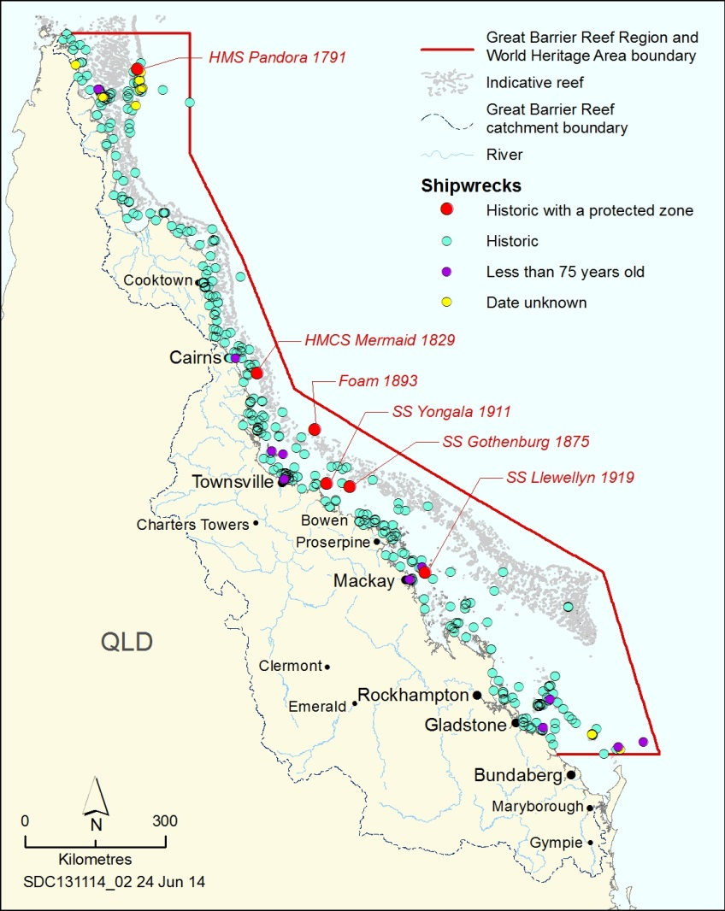
Figure 4.1 Shipwrecks
There are several hundred shipwrecks in the Region which are over 75 years old, including six with a declared protected zone which may only be entered with permission. Source: Queensland Department of Environment and Heritage Protection

There are six historic shipwrecks in the Region for which a protected zone has been declared under the Historic Shipwrecks Act (Table 4.2). A protected zone is declared where additional protection is needed to reduce the risk of damage to a significant historic shipwreck. Sizes vary from 50 to 797 metres radius around the wreck. A protected zone can only be entered with permission under the Act.
While the wrecks of the HMS Pandora and the SS Yongala are well documented, there is no structured monitoring of the condition of any of the historic wrecks within a protected zone, or any of the other wrecks in the Region.

Table 4.2 Historic shipwrecks for which a protected zone is declared
Under the Commonwealth Historic Shipwrecks Act, a protected zone has been declared around six historic shipwrecks in the Region. The zone can only be entered with permission.
Ship | Wrecked | Location | Significance
HMS Pandora | 1791 | Pandora Entrance near Raine Island | Example of British naval vessel and fittings from the Georgian era. Associated with an iconic maritime event (mutiny on the Bounty). Exemplary evidence of early Pacific exploration by the British including extensive collections of ‘curiosities’ representing Polynesian heritage.
HMCS Mermaid | 1829 | Flora Reef | Used by the first Australian-born explorer, Lieutenant Phillip Parker King, to chart the inner Barrier Reef route and large parts of the Australian continent. Pivotal to the development of northern Australian ports as a supply ship. Representative of early colonial exploration within the Great Barrier Reef.
SS Gothenburg | 1875 | Old Reef | Representative of three-masted iron screw steamer used for coastal trade in the late nineteenth century. Loss of 103 people. Carried £43,000 of gold which was recovered by a diver in standard dress (brass helmet and canvas suit), making it also significant in the history of diving.
Foam | 1893 | Myrmidon Reef | Involved in ‘blackbirding’ of South Sea Islander peoples, a significant practice providing cheap labour in establishing north Queensland agriculture. Contains evidence of this era, including trade items.
SS Yongala | 1911 | off Cape Bowling Green | Representative of a steam vessel involved in early twentieth century coastal trade, such as mail, freight and passenger transport. Wrecked in a cyclone with loss of 122 lives. Strong link to north Queensland communities with living first degree relatives.
SS Llewellyn | 1919 | off St Bees Island | Representative of a vessel involved in early twentieth century coastal trade. Recently discovered, not yet fully surveyed or assessed.

[Photograph of shipwreck items on the seafloor. Copyright Queensland Parks and Wildlife Service. Caption: Double boilers of the SS Gothenburg.]

[Photograph of an anchor overgrown with coral. Copyright Silentworld Foundation, photograph by Xanthe Rivett. Caption: Anchor of the HMCS Mermaid on Flora Reef.]

Historic lightstations
Key message: Heritage values are well recorded and maintained at heritage-listed lightstations.
The Region’s historic lightstations, comprising the lighthouse, accommodation and other infrastructure, are associated with the shipping and navigational history of the Great Barrier Reef.
There is a range of lightstations along the Reef on Commonwealth and Queensland islands and along the coast. They include Commonwealth and state heritage-listed lightstations built in the 1800s (Figure 4.2), ‘concrete tower’ aids to navigation dating from between the 1920s and the 1960s, and ‘steel frame’ aids to navigation. The locations and values of the listed lightstations, including the lighthouses and ancillary structures, are generally well recorded.^{21,22}
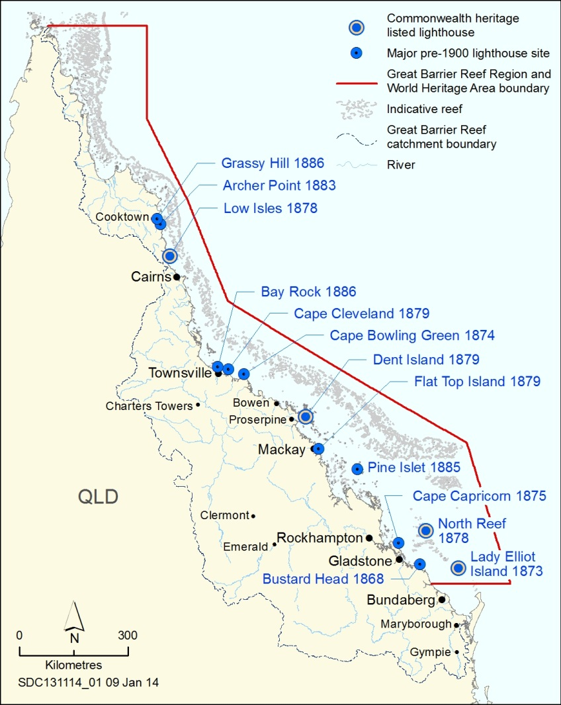
Figure 4.2 Early lighthouses
Thirteen lighthouses were installed in or adjacent to the Great Barrier Reef before 1900. While some are still in place, others have been removed. Those on Low Isles, Dent Island, North Reef and Lady Elliot Island are within the Region and are on the Commonwealth Heritage List.

Four lightstations located within the Region — Low Isles, Dent Island, North Reef and Lady Elliot Island — are listed Commonwealth heritage places (Section 4.6.2). They are important examples of the technically innovative and economically constructed navigational facilities built by Queensland authorities between 1859 and 1901. They are reminders of the early development of Queensland coastal areas after the colony’s separation from New South Wales. Each of these lightstations remains in good and stable condition and is generally well maintained.
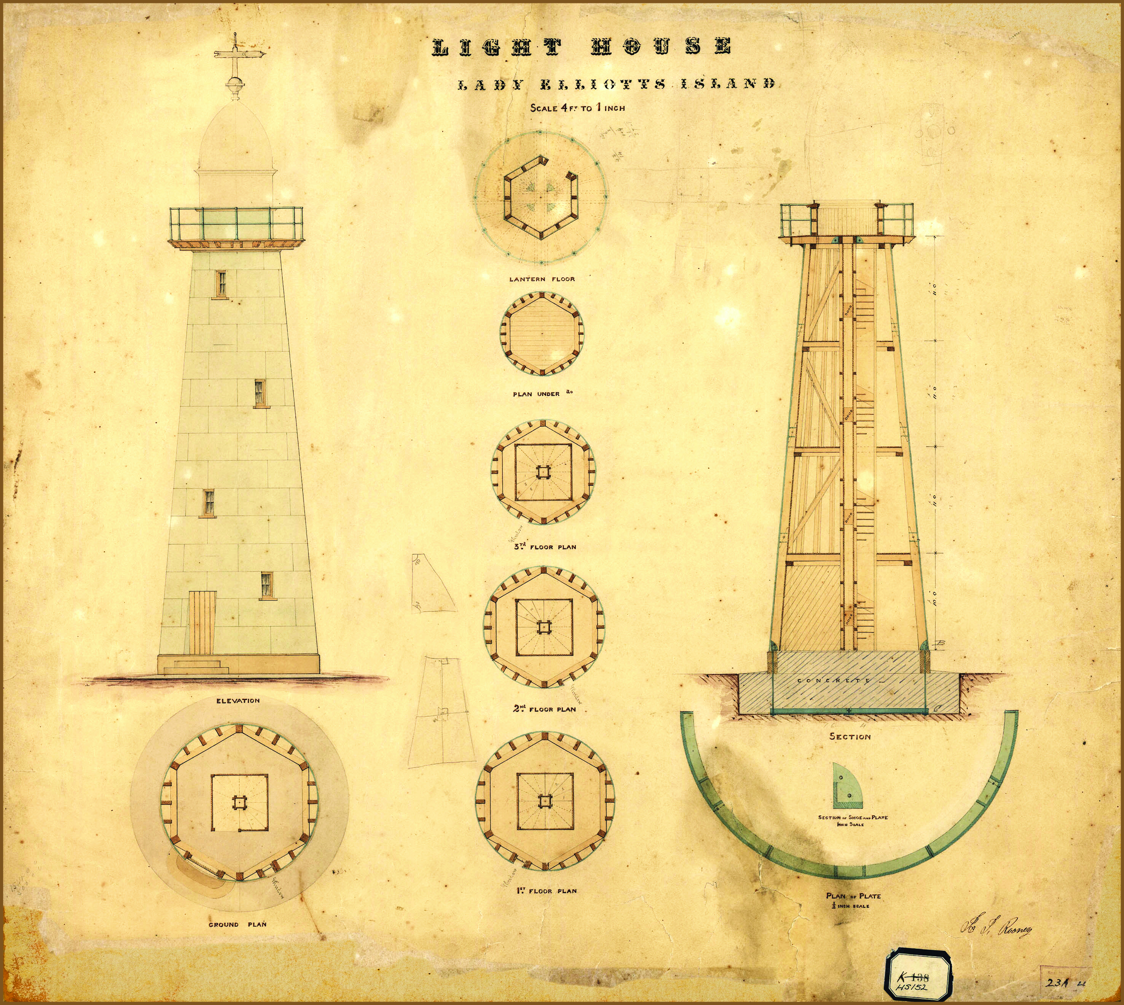
Contract drawing of Lady Elliot Island lighthouse
For Lady Elliot Island, a new composite form of construction was developed, combining the economy of timber framing with the weather-tightness and durability of iron plating. This contract drawing for the lighthouse was signed in 1872. Source: National Australian Archives: J2775, HS152

There are some other aids to navigation originally built in the 1920s and 1930s on islands within the Region. These are maintained as working facilities by the Australian Maritime Safety Authority. While not heritage-listed, they demonstrate a phase in the evolution of aids to maritime navigation through the Reef.
Pine Islet lightstation, built in 1885 in the southern Great Barrier Reef, has fallen into major disrepair with some structures collapsing.
While not a lighthouse, the historic navigation beacon on Raine Island, a Queensland island in the northern Great Barrier Reef, is a significant historic structure adjacent to the Region. It is on the Register of the National Estate and the Queensland Heritage Register. Built in 1844 by a party of convicts transported to the island by HMS Bramble and HMS Fly, the beacon is significant as a monument in Queensland’s maritime landscape and assisted the colony's early economic development. Conservation works on the beacon were carried out in 1988.²¹

[START COLOURED BOX]
Evolution of the Dent Island lightstation
The Dent Island lightstation is an important example of the historical development of maritime aids to navigation in Australia and was placed on the Commonwealth Heritage List in 2004. The lighthouse, erected on the island in 1879, was one of a series of 12 lighthouse towers of a distinctive type, built between 1873 and 1890. These timber-framed towers clad with riveted iron were designed by officers of the Queensland colonial government, to meet the particular needs of the colony, in a form that was not used anywhere else in the world. The lighthouse is now fitted with solar-powered lighting equipment and operates automatically as a part of the national network of navigation aids. Near the lighthouse tower are two houses, a workshop, a derrick crane, a winch house, a trolley way, and a fowl house. All are privately leased. Significant works were carried out on these buildings during 2013–14 to prevent further degradation. A heritage management plan for the lightstation was registered in January 2014.

[Photograph of the Dent Island lightstation and nearby building. A locator map is superimposed and shows the location of Dent island as being in the central area of the Region]

[END COLOURED BOX]

World War II features and sites
Key message: While many World War II features and sites have been identified, little is known of their condition.
The Region was part of the Pacific theatre of World War II and several major support facilities, including airbases from which pivotal battles were launched, were on the adjacent coast. Many significant features and sites from that period remain in the Region. Incomplete databases suggest that more than 140 submerged aircraft wrecks survive, representing most known aircraft wrecks in the Region. These span a wide inventory of World War II aircraft including Kittyhawks, Catalinas, Dakota, B-25D Mitchells and Beaufort Bombers. Other World War II features and sites include shipwrecks, support structures such as refuelling barges, unexploded ordnances and structures on islands. While some of these features and sites have been identified, most are yet to be located and little is known of their condition.
Some of the aircraft wrecks are the resting place of service personnel. It is estimated that over 150 allied air crew (including from Australia, America and Holland) could have gone missing in action in planes wrecked and sunk in the Region.²³
In 2011, the wreck of a Catalina PBY 5 flying boat, A 24 24, was found off Bowen. The Royal Australian Air Force acknowledges this wreck as the resting place of the 14 personnel who went missing-in-action in the wrecking incident. The wreck of another Catalina, A 24 25, was discovered in 2013 off the Frankland Islands south of Cairns and may hold the remains of a further 11 personnel. An aerial heritage survey conducted in January 2014 located three World War II P39 Airacobra aircraft wrecks in various states of deterioration in shallow water along the coast of the Region.
Unlike shipwrecks, there are no formal arrangements to protect aircraft wrecks other than the provisions of the Great Barrier Reef Marine Park Act. Some aircraft, such as the Catalina off the Frankland Islands, are protected to some extent because they are located in a Marine National Park (green) Zone, but there has been some degradation and damage. Catalina A 24 24 off Bowen is located within a General Use (light blue) Zone and has suffered damage from trawling, anchoring and as a result of line fishing.

[Photograph of an engine sitting on the seafloor. Copyright Kevin Coombes. Caption: Catalina A 24 25 motor, off the Frankland Islands.]

[Photograph of semi-submerged plane wreck. Caption: P39 Airacobra, Margaret Bay.]

Other places of historic significance
Key message: Other places of historic significance are poorly recorded and their condition is not well understood.
Other places of historic significance include sites where historic events occurred. Examples range from Endeavour Reef where Captain Cook ran aground over two centuries ago to Ellison Reef, a pivotal location in the modern fight to protect the Reef. In 1967, a team of volunteers surveyed Ellison Reef to prove that it was ‘alive’ in order to protect it from being mined for limestone. The campaign raised the national profile of the Great Barrier Reef and a subsequent Royal Commission paved the way for development of the Great Barrier Reef Marine Park Act and Authority.²⁴
Most places of historic significance in the Region are either not recorded or their records have not been recovered. Their condition is not well understood.
While most Great Barrier Reef islands are not within the Region, they have played a major role in its history, including places connected with Reef identities such as the author and naturalist Edmund Banfield on Dunk Island and Mrs Watson, an early pioneer and folk hero, on Lizard Island. Places that illustrate changes in use of the Great Barrier Reef are also significant — from early guano mining on islands, green turtle factories on islands, to limestone and granite mining, and oil exploratory leases.²⁴
Green Island and its surrounding reef have been a popular tourist site for over 100 years, with organised pleasure cruises since 1890 and a passenger ferry since 1924.²⁵ Other locations such as Magnetic Island, Low Isles and Newry Island all played significant roles as tourism evolved in the Region.

Current state and trends of other heritage values

Social heritage values
Key message: The wonder of the Reef and a history of personal experiences have built its social significance.
In accordance with the Act, the definition of heritage values includes reference to ‘a place’s natural and cultural environment having … social significance … for current and future generations of Australians’.
For Traditional Owners, the Region’s natural and cultural environment has inherent social significance (Section 4.2). This section describes and assesses the range of other social heritage values of the Region.
Many aspects of the Region’s natural and cultural environment have social significance. The perception of significance varies according to societal attitudes (see Section 6.2.4), as well as an individual’s personal perspectives and their relationship to the Reef. The Reef has social significance nationally and internationally as demonstrated by continued global interest in its protection. At the broadest level, most values of social significance can be traced back to the extraordinary beauty, biodiversity, natural abundance and remoteness of the Region. Its social value can be independent of people visiting the area, but is augmented by the personal experiences they have had there.
From the beginnings of European exploration and settlement, navigation and use of the Reef have presented significant challenges and opened up new horizons — playing a role in shaping Queensland society. The ways in which people have responded to the challenges and taken up the opportunities have added to the social significance of the Reef. Examples include the intrepid journeys of early explorers; the discoveries and descriptions of the Reef ecosystem by early scientists; the experiences of hardship and survival, such as those of shipwreck survivors; and early interactions with the Reef’s Traditional Owners.
In addition, the history of commerce on the Reef has resulted in some places of social significance. Examples include the Cod Hole — an iconic dive site and one of the first parts of the Great Barrier Reef to receive marine park protection; John Brewer Reef — the site of the only ever floating hotel in the Region; and Whitehaven Beach — a spectacular and high-profile white sand beach in the Whitsundays.
On a more personal level, particular aspects of the Region’s natural and cultural environment (such as a place, a species or an activity) can be of social significance to an individual, a family or a community. This may be as a result of employment, stewardship activities, recreational experiences, or family, personal or spiritual connections. This social significance builds personal connection to the Reef.
Continued education about and interpretation of the Reef and its history, combined with its ongoing use by generations of people, act to preserve and enhance the social significance of its natural and cultural environment.

[START COLOURED BOX]

Human wellbeing and Reef connections
The Great Barrier Reef plays an important role in community life. Human wellbeing — a state of happiness, good health and prosperity — is inextricably linked to environmental health.²⁶ Many individuals and communities have strong connections with the Reef, through culture, occupation, or familiarity, and these connections contribute to their wellbeing.²⁷ In a 2013 national survey, the Great Barrier Reef was rated as Australia’s most inspiring landscape by about 43 per cent of respondents, while 86 per cent feel proud that the Great Barrier Reef is a world heritage area.²⁸ For those who are part of Reef-dependent industries, the connection is particularly strong with their work forming a core of the way they think about themselves and their role in society. For example, commercial fishers and marine tourism operators depend on the Reef for their livelihoods, but their connections to the Reef are often stronger than economic dependency.^{29,30} One commercial fisher captures this connection:
” … it’s an income to me but there’s also those sort of things…go out and swim all day, watching the whales. I’m just as much of a kid going out there and seeing a couple of humpbacks jumping around with the calf as catching a hundred mackerel for the day.”³¹
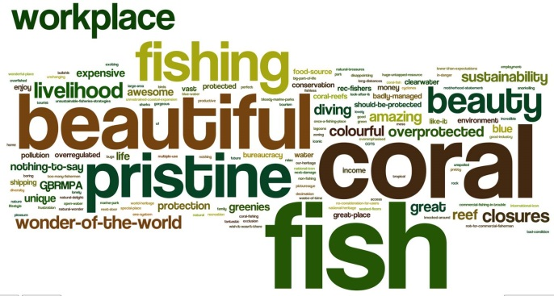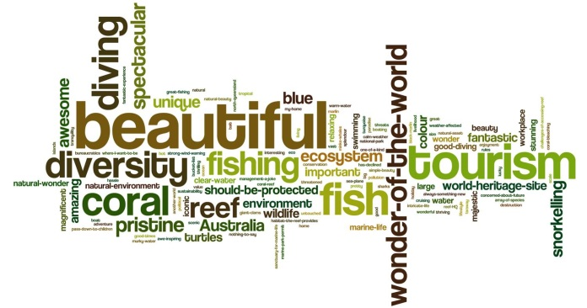
Commercial fishers
Tourism operators
[Image of a side-by-side pair of images (‘wordles’) showing words (of different sizes) representing the values held by commercial fishers and tourism operators. For fishers, the values ‘fish, coral, beautiful, pristine, fishing, beauty and workplace’ are most prominent. For tourism operators, the values ‘beautiful, tourism, diving, coral, diversity, fishing, fish and wonder-of-the-world’ are the most prominent.]
Values held by commercial fishers and tourism operators about the Great Barrier Reef. The bigger the word, the more often it was recorded. Source: Tobin et al. 2014²⁹, Curnock et al. 2014³⁰
[END COLOURED BOX]

Aesthetic heritage values
Key message: The Region continues to have great natural beauty; underwater aesthetic values have declined.
Over recent decades, some of the local-scale aesthetic values of the Great Barrier Reef and its coastal landscapes have been recognised and documented, for example through development of Coastal Management Plans³². Until recently, there has been little focused study of the aesthetic values of the Region as a whole. In 2013 they were broadly defined and assessment methods were documented.³³ The outcomes informed this section.
It is recognised that culture, knowledge, expectations and past experience mediate peoples’ perceptions and experiences. As a result, aesthetic responses are linked to both the characteristics of an environment and culturally or personally derived preferences. For natural features such as the Great Barrier Reef, aesthetic values are generally associated with the outstanding natural values and attributes of the environment.³³
The environmental attributes of the Region identified as enhancing aesthetic value include: the Reef as an entity; coral reefs; continental islands; beaches; coral cays; water (clarity, calmness, intensity of colour); marine animals (abundance, diversity, colour, size); blue holes; lagoon floors; mangroves; seagrass meadows; shoals; cliffs and rocky shores; bays; estuaries; rainforest; birds; and butterflies.³³
The experiential attributes of the Region that enhance aesthetic value were identified as: beauty, naturalness, tranquillity, solitude, remoteness, discovery, and inspiration.³³
The aesthetic values of the Great Barrier Reef are experienced and described from a variety of perspectives:
- Panoramic: the Great Barrier Reef from above, including remotely from space, from the air or high lookout points. This perspective shows the Reef as a pattern of waters, reefs, cays and islands, and as a vast landscape.
- At water or land level: the Great Barrier Reef at eye level, as sky, water, and land emerging from water, and with a sense of a world beneath the water.
- Below water: the Great Barrier Reef as an underwater landscape. The three-dimensional qualities of the underwater landscape, its relative intimacy (with long-distance views rarely experienced), and the position of the viewer ‘floating’ above and within the landscape are all distinctive. The aesthetic experience is also enhanced because this perspective is not part of everyday human experience.³³
For the early European visitors to the Reef, its natural beauty was appreciated at the water or land level, with an emphasis on the vistas of bays and islands and what could be seen through the water. An example is Matthew Flinders during his voyage on the Investigator in 1802. As an early European explorer, Flinders knew little of the Reef, other than its potential perils, and was focused on mapping its navigational hazards.³⁴ Nonetheless he was struck by its underwater beauty:
“We had wheat sheaves, mushrooms, stags horns, cabbage leaves and a variety of other forms, glowing under water with vivid tints of every shade betwixt green, purple, brown and white; equalling in beauty and excelling in grandeur the most favourite parterre [ornamental garden] of the curious florist.”³⁵
Over the subsequent centuries, changes in how people access the Reef and developments in underwater technology (for example glass-bottomed boats, underwater observatories, snorkelling, scuba diving, underwater cameras) have changed the ways in which people experience the Reef and appreciate its aesthetic values (Figure 4.3). From images featuring land-based aesthetic experiences, the emphasis has shifted to include its underwater beauty. Being able to view the Reef from the air has also changed peoples’ understanding of its size and beauty.

[Photograph of snorkelers watching a marine turtle swim past. Copyright Chris Jones. Caption: Developments in underwater technology have made it easier to visit and appreciate the Reef environment.]
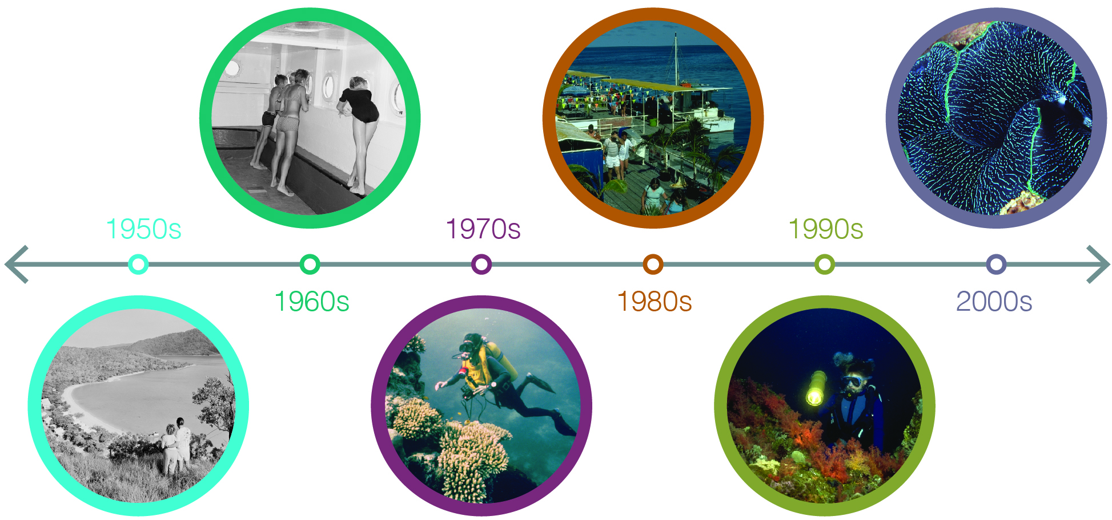
Figure 4.3 Changing experiences of aesthetic values
Over the decades, developments in technology have changed the ways people experience the Reef’s natural beauty. Experiences based on panoramas of islands and beaches (such as that depicted in the left-hand image taken in the 1950s), have been augmented by those in glass-bottomed boats and observatories from the 1960s, and then by underwater experiences — most recently including opportunities for high quality close-up photography. Source: 1950s–1970s: National Archives of Australia³⁶, 1990s: Ken Anthony

The Region’s natural beauty is generally intact, especially for offshore coral reefs and aerial vistas, as well as for neighbouring islands (many of which are national parks). However, increasing human infrastructure along the coastline and on islands, and increased shipping traffic have affected some of the values that contribute to the Region’s aesthetic values, for example its natural coastal vistas and tranquillity. In addition, marine debris has diminished aesthetics in some areas.³⁷ Water clarity is one of the Reef’s features most valued by visitors.³⁷ It is affected by increased turbidity from sediment and nutrients from land-based run-off and the resuspension of dredge material. Declining coral cover in the southern two-thirds of the Region has reduced underwater aesthetic values.

Scientific heritage values
Key message: Many ground-breaking scientific advances have happened in the Region.
The Reef has been an area of scientific exploration, discovery and monitoring since the voyage of the Endeavour in 1770 with Joseph Banks on board — the scientist credited with introducing the western world to eucalypts, acacias and banksias (the genus named after him). Subsequently, naturalists and geologists on European voyages through the Reef plus amateur naturalists collected, recorded, reported and interpreted the natural environments of the Reef.³⁸ The work of these observers and collectors contributed to early scientific understanding of coral reef ecosystems and their geological origins. Examples include Joseph Jukes on the Fly during its survey of the Great Barrier Reef from 1842 to 1845. On islands such as Lady Musgrave and Lizard and reefs throughout the Region, Jukes closely studied and described the structure and biodiversity of coral reefs, wondering at their complexity and origins.
Later in the century, fisheries scientist William Saville-Kent became a key figure in early Reef science. With the starting point of the commercial potential of the Reef, he collected and recorded hundreds of Reef species and advocated for teaching marine biology and establishing research stations.³⁹ Also important to scientific understanding of the Reef was the Great Barrier Reef Expedition to Low Isles in 1928–29 when a party of scientists led by C.M. Yonge conducted a 10-month investigation of the Reef environment — the first detailed scientific study of the Reef covering geography, biology, geology and coral taxonomy⁴⁰.

[Photograph of a map surrounded by old books. Caption: Map of Low Isles by the Great Barrier Reef Expedition, 1928-29. Low Isles has historical scientific significance as the base for the Great Barrier Reef Expedition undertaken in 1928–29, the first detailed scientific study of the Reef environment.]

Since these early scientific undertakings, the scientific significance of the Reef’s environment has increased through ongoing research in tropical marine ecosystems, development of a network of research stations along the Reef, creation of the Australian Institute of Marine Science and establishment of marine science programs at various universities.
Many ground-breaking scientific advances have happened in the Region. Examples include research about: mass coral spawning⁴¹; larval dispersion^{42,43,44}; and water quality^{45,46}. For coral research alone, there have been about 3000 scientific journal articles relating to the Great Barrier Reef in the 10 years since 2004 which have been cited over 50,000 times.⁴⁷ Reef research has also contributed to protection and management of tropical marine systems throughout the world, including through improving understanding of the importance of marine protected areas.^{48,49} The statement of outstanding universal value for the Great Barrier Reef as a World Heritage Area recognises its enormous scientific importance.⁵⁰
The scientific value of monitoring activities undertaken over extended periods (such as those for marine turtles, dugongs, seabirds and corals) continues to increase as the timespan for each study grows.
The scientific heritage values of the Region are generally being maintained. Sites of significant historic scientific research and monitoring are known. The findings and the locations of the work undertaken are generally recorded in scientific publications and databases.

Current state and trends of world heritage and national heritage values
The Great Barrier Reef is listed on both the World Heritage List and the National Heritage List and therefore contains both world heritage values and national heritage values. The two categories of heritage values are combined in this assessment as the area’s national heritage listing is based on its recognition as a world heritage property — meaning that its national heritage values correspond to its world heritage values.
The Great Barrier Reef World Heritage Area covers 348,000 square kilometres and includes both marine areas and all the Great Barrier Reef islands contained inside its boundary. The property has the same boundary as the Great Barrier Reef Region, except that it also includes the internal waters and islands of Queensland.
The Great Barrier Reef was inscribed on the World Heritage List in 1981 and on the National Heritage List in 2007. It was the first coral reef ecosystem in the world to be listed as world heritage and today is one of only 46 marine world heritage areas. Its world heritage listing recognised the area was of outstanding universal value.
‘Outstanding universal value is defined as cultural and/or natural significance which is so exceptional as to transcend national boundaries and to be of common importance for present and future generations of all humanity.’⁵¹
A property is considered to be of outstanding universal value if it meets one or more of 10 world heritage criteria and is inscribed on the World Heritage List.⁵¹ In addition, to be deemed to be of outstanding universal value ‘a property must also meet the conditions of integrity and/or authenticity and must have an adequate protection and management system to ensure its safeguarding’.⁵¹
Recognition of the Great Barrier Reef’s outstanding universal value was based on all the four natural world heritage criteria in place at the time of listing — acknowledging the Reef’s natural values, together with the strong ongoing links between Aboriginal and Torres Strait Islanders and their sea country⁵². The criteria have been amended and renumbered since the Reef was inscribed (Table 4.3).
Only those attributes of the Region that are consistent with the four criteria for which the Great Barrier Reef was inscribed are its world heritage values. A Statement of the outstanding universal value of the Great Barrier Reef World Heritage Area⁵⁰ is the official statement adopted by the World Heritage Committee outlining how the property met the criteria for outstanding universal value, integrity and protection and management at the time of listing.
Given the broad scope of the criteria under which it was listed, almost all attributes of the Reef’s environment are relevant to the criteria and contribute to its outstanding universal value (Appendix 3). This includes the Region’s biodiversity, geomorphology, Traditional Owner connections to the area, ecological processes, aesthetic values and natural phenomena. The notable exceptions are historic (for example, shipwrecks and lightstations), social and scientific heritage values which are not encompassed by the natural criteria.

[Photograph of a large fish on a coral reef. Copyright Matt Curnock. Caption: The Great Barrier Reef has natural significance of common importance for all humanity.]
Table 4.3 World heritage criteria relevant to the Great Barrier Reef
The world heritage criteria have been modified since listing of the Great Barrier Reef in 1981.
Short title | Current criteria | Criteria at time of listing
Natural beauty and natural phenomena | (vii) contain superlative natural phenomena or areas of exceptional natural beauty and aesthetic importance | (iii) unique, rare or superlative natural phenomena, formations or features or areas of exceptional natural beauty, such as superlative examples of the most important ecosystems to man
Major stages of the Earth’s evolutionary history | (viii) be outstanding examples representing major stages of Earth's history, including the record of life, significant ongoing geological processes in the development of landforms, or significant geomorphic or physiographic features | (i) outstanding examples representing the major stages of the Earth’s evolutionary history
Ecological and biological processes | (ix) be outstanding examples representing significant ongoing ecological and biological processes in the evolution and development of terrestrial, fresh water, coastal and marine ecosystems and communities of plants and animals | (ii) outstanding examples representing significant ongoing geological processes, biological evolution and man’s interaction with his natural environment
Habitats for conservation of biodiversity | (x) contain the most important and significant natural habitats for in situ conservation of biological diversity, including those containing threatened species of outstanding universal value from the point of view of science or conservation | (iv) habitats where populations of rare or endangered species of plants and animals still survive

In 2012 and 2013, the World Heritage Committee expressed concerns about the impact of development on the property’s outstanding universal value and integrity. The Australian Government, as the responsible state party, is coordinating a range of actions to address these concerns. In particular, in 2013 the Australian and Queensland governments undertook a comprehensive strategic assessment of the property⁵³ and adjacent coastal zone⁵⁴, including an outline of proposed measures to strengthen protection and management arrangements^{55,56}.
The following assessment of the world heritage values (and national heritage values) of the Region is based on the attributes identified in the statement of outstanding universal value. It draws on the evidence and assessments presented in this chapter and in the previous chapters on biodiversity (Chapter 2) and ecosystem health (Chapter 3).

Natural beauty and natural phenomena
Key message: The Region retains its spectacular natural beauty; aesthetic values are diminished in some areas.
Key message: Many natural phenomena remain intact; declines in species have affected some.
The natural beauty of large areas of the property remains spectacular, especially for northern and offshore coral reefs and aerial vistas, as well as for neighbouring islands (many of which are national parks). The Reef remains visible from space and technological advances make these images more detailed and more accessible to the community.
Since 1986 — five years after world heritage listing — hard coral cover averaged over the entire Region has declined, principally in the southern two-thirds of the Region.⁵⁷ This has reduced underwater aesthetic value, as has increasing turbidity in inshore areas. The natural beauty of the property is also being affected by the presence of marine debris, especially on beaches.^{37,58} Increasing infrastructure along the coastline and on islands, and increased shipping traffic, have degraded some of the attributes identified as contributing to top-rating views⁵⁹.
The scenic beauty of the Reef’s islands is part of the property’s natural beauty. While the majority of the Whitsunday Islands are protected and managed as national parks, there have been some changes to island scenery, such as on resort islands. Hinchinbrook Island is protected and managed as a national park and retains its spectacular natural scenery.
While many of the natural phenomena identified in the statement of outstanding universal value remain intact, others are likely to have deteriorated (see Chapter 2). Nesting numbers of at least two species of marine turtle have declined but are now recovering; there are signs of decline for nesting populations of some other marine turtle populations and some seabirds. There are anecdotal reports of severe declines in the number and condition of potato cod at the Cod Hole — a site famous for the species. In contrast, the number of migrating humpback whales is increasing. Protection of known fish spawning aggregations has improved, but most sites are unknown.

Major stages of the Earth’s evolutionary history
Key message: The Region remains an outstanding example of evolutionary history.
The Great Barrier Reef is the world’s largest coral reef ecosystem. While its overall condition has deteriorated, it remains an outstanding example of an ecosystem that has evolved over millennia. It represents the major stages in the Earth’s history, the record of life, geological processes in the development of landforms, and geomorphic and physiographic features.⁶⁰
Coral reefs are one of the Region’s key geomorphological features and it contains examples of all stages of reef development. The diversity of reef shape and size (for example fringing, shelf, ribbon and deltaic reefs, Figure 4.4) can be a function of substrate size, depth and, to a lesser extent, relative sea level history and carbonate productivity.^{61,62} Submerged reefs are important recorders of sea level change⁶³, the Earth’s evolutionary history⁶³ and environmental change⁶⁴. Some corals are showing signs of decreased calcification rates, which has long-term implications for their future as geomorphological structures.⁶⁵
Other geomorphological features in the Region that represent major stages of the Earth’s evolutionary history include:
Palaeochannels — past river channels that have been filled in over hundreds of thousands of years by sediment and later inundated by sea level rise. They comprise channel depressions and the associated sedimentary processes of erosion and deposition. They are now an element of groundwater flows from the Region’s catchment.⁶⁶
Karstic features — landforms shaped by the dissolution of layers of soluble bedrock, such as limestone. In the Region, there are karstic channels on reefs that have been exposed during geological periods of low sea level.^{61,67} In addition, ‘blue holes’ — deep circular depressions with steep sides — are a rare karstic landform in the Region.⁶⁸

[Photograph of a blue hole from the air. Caption: The Blue Hole at Cockatoo Reef in the Pompey Complex, east of Mackay.]

Submarine canyons — occur along the shelf edge (Figure 4.4) and can modify oceanography to produce upwellings.⁶⁹ They also preserve information about sea level change, and sediment and tectonic movements.^{70,71,72}
Turbidite deposits — at the base of the continental shelf (Figure 4.4). They are the result of sediment transport from the continental shelf and are responsible for distributing vast amounts of sediment into the deep ocean. They provide historical records about sedimentation in the adjacent shelf area, tectonic movements and responses to sea level change.⁷³
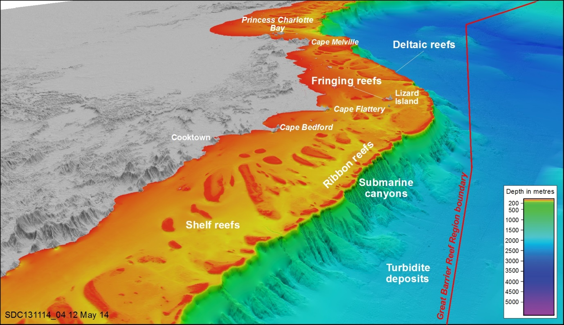
Figure 4.4 Geomorphological features
The area adjacent to Cooktown and Princess Charlotte Bay contains many of the Region’s geomorphological features. These occur on the continental shelf, down the shelf edge and in the deeper water beyond. Image courtesy of Dr Robin Beaman, www.deepreef.org

Almost all geomorphological processes remain intact. Examples of all stages of reef development remain although the overall health of reefs, especially in the southern two-thirds of the property, has declined. Although little is known about geomorphological features such as palaeochannels, karstic features, submarine canyons and turbidite deposits, their depth and distance from shore mean they are likely to be rarely affected by direct use or flow-on effects from the catchment.

Ecological and biological processes
Key message: Some ecosystem processes such as sedimentation, nutrient cycling and recruitment are declining.
Key message: Traditional Owners with connections to the Great Barrier Reef maintain their ongoing links to sea country.
Most geomorphic, physical, chemical and ecological processes remain in good condition but some are deteriorating, especially in the inshore southern two-thirds of the Region. Processes associated with groups of species in decline (for example, corals and seagrasses) have likely also declined. Particularly in the inshore southern two-thirds, processes such as connectivity, nutrient cycling and sedimentation have deteriorated, principally associated with adjacent land-based activities. There is increasing evidence of intensified flow and accelerated warming in the East Australian Current.⁷⁴
The diversity of the Reef ecosystem reflects the maturity of an ecosystem that has evolved over millennia.⁷⁵ The Region’s species diversity remains high, but some species are in poor condition, especially inshore in the southern two-thirds of the Region.
Birds continue to play a role in seed dispersal and plant colonisation on cays and continental islands.^{76,77} Introduced weeds have affected the native vegetation on a number of islands within the Region.⁷⁸
Halimeda banks are an example of active calcification and accretion over thousands of years. They are poorly studied, but are likely to be in very good condition given their isolation from land-based impacts and their level of zoning protection from trawling.
The strong ongoing links between Aboriginal and Torres Strait Islanders and their sea country are recognised in the description of the property’s outstanding universal value.⁵⁰ Traditional Owners with connections to the Great Barrier Reef maintain links to their sea country in the Region. Many Indigenous heritage values are under pressure, including sites of significance, stories, songlines, totems and structures (Section 4.2).

Habitats for conservation of biodiversity
Key message: Habitat declines are affecting their ability to support dependent species, including those of conservation concern.
The Great Barrier Reef remains a complex ecosystem, containing a rich mosaic of habitats. Some key habitats are under pressure, especially in the southern two-thirds of the Region where land-based run-off has affected inshore habitats and a combination of severe weather and outbreaks of crown-of-thorns starfish has affected coral cover⁵⁷ (see Chapter 2). There have been no records of species extinction, though the speartooth shark has not been recorded in or near the Region since 1983.
The Region’s mangrove forests remain very diverse with at least 39 mangrove species and hybrids recorded.^{76,79,80,81}
There have been significant declines in seagrass meadows in the southern two-thirds of the Region over the last five years, due especially to severe weather events and ongoing chronic impacts. This decline is reflected in an unprecedented number of stranded dugongs reported in the Great Barrier Reef, especially in 2011. Of the habitats that support marine turtles, the condition of seagrass meadows and coral reefs have declined significantly. While nesting habitats are generally in good condition, projected changes to environmental conditions such as sea level rise⁸² and increasing air temperature⁸³ are predicted to affect them in the future.⁸⁴
While the nesting habitats for seabirds remain in generally good condition, declines have been recorded for some seabird populations, in part related to declines in vegetation in nesting areas (for example on Gannet Cay) and food supplies to support reproduction (see Section 2.4.13).
Two inshore dolphin species are known to be at risk, including through deterioration of their habitats. The humpback whale population is recovering strongly after being decimated by commercial whaling.⁸⁵ Within the Region, their calving habitats are well protected.
Plant diversity is generally well protected, with about one-third of the islands contained within national parks.

Integrity
Key message: Major impacts on the world heritage values arise from external pressures.
Integrity is an important prerequisite of outstanding universal value. At the time of inscription it was considered that to include virtually the entire Great Barrier Reef ecosystem within the property was a way of ensuring the integrity of the coral reefs in all their diversity.
The property is of sufficient size to ensure the complete representation of the features and processes which convey its significance. It is vast, covering 14 degrees of latitude and extending 80 to 250 kilometres from the coast. Except for some small exclusions and about 600 of the 1050 islands, almost all of the World Heritage Area is within marine or national parks, and is therefore afforded a high level of protection and management. While some habitats, populations and processes are under pressure, the attributes of outstanding universal value remain largely intact overall. Factors external to the property — climate change, coastal development and land-based run-off — are affecting the ecosystem as are some impacts of direct use.
Activities within the property are comprehensively managed and direct use is generally sustainable; the remoteness of some of the property poses challenges for managing agencies.

Benchmarking outstanding universal value
Key message: The Reef continues to include all attributes necessary to express its outstanding universal value.
Key message: The condition of many attributes has deteriorated since 1981.
Many of the attributes identified in the official statement of outstanding universal value of the world heritage property (Appendix 3) remain in good or very good condition. Those related to coral reef and seagrass meadow habitats, marine turtles, seabirds and dugongs are assessed as being in poor condition overall, but areas of good condition are still present in the Region (Chapters 2 and 3). Attributes relevant to Traditional Owner’s interaction with the environment are also assessed as being in generally poor condition (Section 4.2).
The condition of about two-thirds of the 38 attributes identified as contributing to outstanding universal value has been assessed as having deteriorated since 1981.⁵³ Examples include:
- superlative natural beauty above and below the water
- spectacular and globally important breeding colonies of seabirds and marine turtles
- ongoing ecological processes such as upwellings, larval dispersal and migration
- vegetation on cays and continental islands, exemplifying the important role of birds in seed dispersal and plant colonisation
- human interaction with the natural environment illustrated by the strong ongoing links between Aboriginal and Torres Strait Islanders and their sea country
- the world’s most complex expanse of coral reefs
- large ecologically important interreefal areas and many seagrass species
- major feeding grounds for one of the world’s largest populations of the threatened dugong.
Populations of humpback whales, estuarine crocodiles, loggerhead turtles and green turtles (southern stock) are recovering from historical declines.
With regard to the requirement for integrity, the area of the world heritage property has remained at about 348,000 square kilometres, recognising minor changes as a result of reclamation along the coast (approximately eight square kilometres). The property continues to include all attributes necessary to express its outstanding universal value. Since 1981, the system of protection and management for the property has improved substantially. While most of the island national parks in the area were declared by that time, only a small proportion of the area was declared as marine park. Only the Capricornia Section of the Great Barrier Reef Marine Park had been proclaimed by 1981, comprising about 3.4 per cent of what is now included in that marine protected area. The resources devoted to protection and management have also increased substantially since the property’s listing. For example, in 1981 the budget of the Great Barrier Reef Marine Park Authority was $2.1 million and it had a staff of about 40 people.⁵² Three decades later, with the Great Barrier Reef Marine Park fully declared and comprehensive management in place, its 2013–14 budget was over $50 million and it had about 220 employees. In addition, in 1981 there was no funding for direct day-to-day management⁵², compared to about $17 million for the program in recent years.

Current state and trends of Commonwealth heritage values
The Commonwealth Heritage List is a list of natural, Indigenous and historic heritage places owned or controlled by the Australian Government. It includes places connected to defence, communications, customs and other government activities that reflect Australia’s development as a nation. There are five places in the Region which are on the Commonwealth Heritage List and therefore have Commonwealth heritage values: Shoalwater Bay Military Training Area (part of the area, Figure 4.5); Low Island and Low Islets lightstation; Dent Island lightstation; North Reef lightstation and Lady Elliot Island lightstation. The lightstations are mapped in Figure 4.2.
Listing of a Commonwealth place is based on its heritage values being tested against nine criteria, seven of which are represented by the listed places in the Region (Table 4.4).²¹
Table 4.4 Commonwealth heritage values
The five Commonwealth heritage places in the Region are recognised under seven of the nine listing criteria.
Commonwealth Heritage List criteria | Shoalwater Bay Military Training Area | Low Island and Low Islets lightstation | Dent Island lightstation | North Reef lightstation | Lady Elliot Island lightstation
Processes: importance in the course, or pattern, of Australia's natural or cultural history
Rarity: possession of uncommon, rare or endangered aspects of Australia's natural or cultural history
Research: potential to yield information that will contribute to an understanding of Australia's natural or cultural history
Characteristic values: importance in demonstrating the principal characteristics of a class of Australia's natural or cultural places or a class of Australia's natural or cultural environments
Aesthetic characteristics: importance in exhibiting particular aesthetic characteristics valued by a community or cultural group
Technical achievement: importance in demonstrating a high degree of creative or technical achievement at a particular period
Social value: strong or special association with a particular community or cultural group for social, cultural or spiritual reasons
Significant person: special association with the life or works of a person, or group of persons, of importance in Australia's natural or cultural history
Indigenous tradition: importance as part of Indigenous tradition

Shoalwater Bay Military Training Area
Key message: The Shoalwater Bay Training Area retains its Commonwealth heritage values.
Shoalwater Bay Military Training Area contains a range of coastal, sub-coastal and aquatic landscapes and ecosystems which occur in a relatively natural state with a high degree of integrity and diversity. It is of national importance to the maintenance and demonstration of geomorphological, ecological and biological processes of the coastal and hinterland environment.²¹ The high integrity of much of the area, together with its steep environmental gradients, makes it a significant benchmark area for scientific research.²¹ The area is one of the most important foraging areas in the southern part of the Region for threatened and vulnerable species, such as dugongs and green turtles.²¹

The area’s very good condition can be attributed mainly to its restricted access as a defence training area. Military use of the site is strictly controlled, managed and monitored and has not caused any known changes to the ecological character of the site. The Department of Defence has pest animal management programs for the site and a regional oil spill response plan is in place.⁸⁶
A 2009 state of the environment report for the area⁸⁶ concluded that the significant environmental and heritage values are in the same condition as when they were first recognised — in some cases, in better condition.
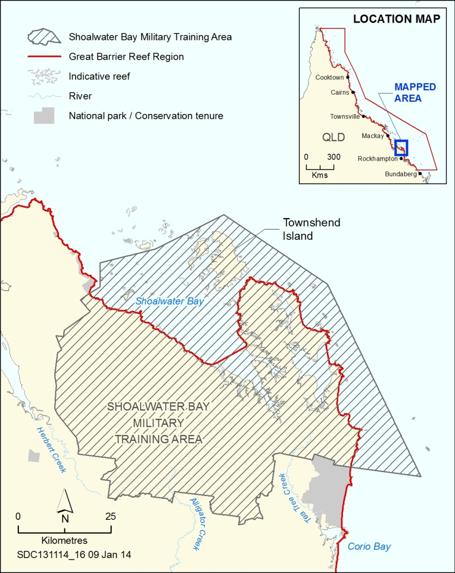
Figure 4.5 Shoalwater Bay Military Training Area Commonwealth heritage place
The Shoalwater Bay Military Training Area is a Commonwealth heritage place. Some of it is within the Region.

Lightstations and islands
Key message: Low Island retains its importance as part of the sea country of its Traditional Owners.
Key message: The lightstations with Commonwealth heritage values are generally well maintained.
Low Island and Low Islets lightstation The lightstation was constructed in 1878 and was the first in the north of the Reef. Its location inside the Great Barrier Reef was the first attempt to address the dangers to shipping approaching newly established ports, including Cairns and Port Douglas, from the north.²¹ Low Island has heritage significance to Kuku Yalanji and Yirriganjdji Traditional Owner groups as part of their Dreamings. A heritage management plan for Low Isles and Low Islets lightstation is being developed.
Dent Island lightstation was constructed in 1879. It is characteristic of a light tower built in response to the dramatic expansion of regular coastal shipping along the inner route of the Great Barrier Reef, following economic development in northern Queensland. ²¹ The lightstation is well maintained and a heritage management plan is in place.
North Reef lightstation was built in 1878. It is recognised for its rarity as one of the few lighthouses built on a coral reef, incorporating a residence at the base of the tower. The technical achievement of incorporating a rain water tank underneath the structure is also recognised.²¹
Lady Elliot Island lightstation demonstrates the historical development of a lightstation complex over time, with changes made in lighthouse technology and accommodation, and the addition of other service buildings. The lighthouse was built in 1873, using a timber-framed substructure and cast iron external cladding. The use of timber framing for the staircase is a rare example of this construction method in lighthouses in Australia.²¹ The lightstation is also recognised for its aesthetic characteristics as a landmark feature which, along with the island, marks the southern end of the Great Barrier Reef Marine Park.²¹ A heritage management plan is in place.
For the heritage-listed lightstations and islands, their values are well recorded. There has been extensive maintenance in recent years which has substantially improved the condition of the structures.

Current state and trends of natural heritage values
Key message: Natural heritage values are generally in good condition; some are in decline.
The natural heritage values of the Region are based on its biodiversity (Chapter 2) and its ecosystem processes (Chapter 3). The findings of these chapters demonstrate that natural heritage values are generally in good condition, but some are in decline, especially in the inshore southern two-thirds of the Region.

Assessment summary — Heritage values
Section 116A(2)(a) of the Great Barrier Reef Marine Park Regulations 1983 requires ‘… an assessment of the current heritage value...’ of the Great Barrier Reef Region. This assessment is based on six assessment criteria:
- Indigenous heritage values
- historic heritage values
- other heritage values
- world heritage and national heritage values — the assessment of world heritage values and national heritage values are combined as the area’s national heritage listing is based on its recognition as a world heritage property
- Commonwealth heritage values
- natural heritage values (assessed in Chapters 2 and 3).

Indigenous heritage values
Outlook Report 2009: Not assessed
Assessment component | Assessment summary | 2009 grade | 2014 grade | Confidence
 |  |  |  | Grade
Cultural practices, observances, customs and lore | Traditional Owners are maintaining their cultural practices and transferring them to future generations. | Not assessed | Good | Limited
Sacred sites, sites of particular significance, and places important for cultural tradition | Many sites of cultural significance are in good condition; others are under pressure, including from coastal development and severe weather. | Not assessed | Poor | Limited
Stories, songlines, totems and languages | Some coastal activities and uses within the Region are affecting stories, songlines, totems and languages, especially in central and southern areas. | Not assessed | Poor | Limited
Indigenous structures, technology, tools and archaeology | Indigenous structures, tools, technologies and archaeology have not been systematically identified and many are under pressure. | Not assessed | Poor | Limited
Indigenous heritage values | Traditional Owners with connections to the Region maintain their cultural practices and customs. Places of Indigenous heritage values have not been systematically identified and many have deteriorated, especially around developed areas and on islands. Some species of cultural significance are under pressure. Story, language and songlines are being affected by activities in the Region. | Not assessed | Poor

Grading statements
Very good | Heritage values have been systematically and comprehensively identified and included in relevant inventories or reserves. Known heritage values are well maintained and retain a high degree of integrity.
Good | Heritage values have been mostly identified and included in relevant inventories or reserves. Known heritage values are generally maintained and retain much of their integrity.
Poor | Heritage values have not been systematically identified. Known heritage values are degrading and generally lack integrity.
Very poor | Heritage values have not been identified. Known heritage values are degraded and lack integrity.
Trend since 2009
New assessment for this report; no trend provided
Confidence
Adequate | Adequate high-quality evidence and high level of consensus
Limited | Limited evidence or limited consensus
Inferred | Inferred, very limited evidence

Historic heritage values
Outlook Report 2009: Not assessed
Assessment component | Assessment summary | 2009 grade | 2014 grade | Confidence
 |  |  |  | Grade
Historic voyages and shipwrecks | Many significant voyages of discovery sailed through the Region. Two historic shipwrecks are well documented. While hundreds have been mapped, many others remain to be located and assessed. There are no structured monitoring arrangements for any historic wrecks. Some have been affected by cyclones. | Not assessed | Poor | Adequate
Historic lightstations | Heritage values are being maintained at heritage-listed lightstations, their values are well recorded and there has been extensive maintenance in recent years. Other historic lightstations in the Region that remain in service are well maintained. | Not assessed | Good | Adequate
World War II features and sites | While some World War II features and sites have been identified, most have not. Little is known of the condition of these features and sites. In addition to normal deterioration, some are being damaged by activities around the site. There is increasing awareness of these historic values. | Not assessed | Poor | Limited
Other places of historic significance | Other places of historic significance are poorly recorded and their condition is not well understood. | Not assessed | Poor | Inferred
Historic heritage values | There is good understanding and recording of some aspects of historic heritage in the Region, for example known historic shipwrecks, a small number of World War II features and lightstations. Heritage values are being maintained or restored at heritage-listed lightstations. Most other places of historic significance are poorly recorded and their condition is not well understood. | Not assessed | Good

Grading statements
Very good | Heritage values have been systematically and comprehensively identified and included in relevant inventories or reserves. Known heritage values are well maintained and retain a high degree of integrity.
Good | Heritage values have been mostly identified and included in relevant inventories or reserves. Known heritage values are generally maintained and retain much of their integrity.
Poor | Heritage values have not been systematically identified. Known heritage values are degrading and generally lack integrity.
Very poor | Heritage values have not been identified. Known heritage values are degraded and lack integrity.
Trend since 2009
New assessment for this report; no trend provided
Confidence in condition and trend
Adequate | Adequate high-quality evidence and high level of consensus
Limited | Limited evidence or limited consensus
Inferred | Inferred, very limited evidence

Other heritage values
Outlook Report 2009: Not assessed
Assessment component | Assessment summary | 2009 grade | 2014 grade | Confidence
 |  |  |  | Grade
Social heritage  values | Many aspects of the Region’s natural and cultural environment have social significance, built around a history of personal experiences. Continued education and interpretation combined with ongoing use serve to maintain the Reef’s social significance. The condition of some iconic sites has declined. | Not assessed | Good | Limited
Aesthetic heritage values | Most of the Reef’s aesthetic values are derived from the natural environment. The Region generally continues to be an area of great natural beauty; however, coastal infrastructure, marine debris, reduced water clarity and declining coral cover, especially in central and southern inshore areas, have reduced underwater aesthetic values. | Not assessed | Good | Limited
Scientific heritage values | The long history of study of the Great Barrier Reef makes it of great scientific significance. Many ground-breaking scientific advances have happened in the Region. The findings and locations of scientific studies are generally well recorded. The significance of long-term studies continues to increase. | Not assessed | Good | Adequate
Other heritage values | The Region’s social and scientific heritage is being maintained. The Great Barrier Reef continues to have great scientific significance. People continue to value and connect with its environment and its natural beauty is widely appreciated. Declines in environmental condition in the central and southern inshore areas have reduced underwater aesthetic values. | Not assessed | Good

Grading statements
Very good | Heritage values have been systematically and comprehensively identified and included in relevant inventories or reserves. Known heritage values are well maintained and retain a high degree of integrity.
Good | Heritage values have been mostly identified and included in relevant inventories or reserves. Known heritage values are generally maintained and retain much of their integrity.
Poor | Heritage values have not been systematically identified. Known heritage values are degrading and generally lack integrity.
Very poor | Heritage values have not been identified. Known heritage values are degraded and lack integrity.
Trend since 2009
New assessment for this report; no trend provided
Confidence in condition and trend
Adequate | Adequate high-quality evidence and high level of consensus
Limited | Limited evidence or limited consensus
Inferred | Inferred, very limited evidence

World heritage values and national heritage values
Outlook Report 2009: Not assessed
Assessment component | Assessment summary | 2009 grade | 2014 grade | Confidence
 |  |  |  | Grade
Natural beauty and natural phenomena | The Region retains its spectacular natural beauty; aesthetic values are diminished in some areas. Many natural phenomena remain intact; declines in species have affected some phenomena. | Not assessed | Good | Adequate
Major stages of the Earth’s evolutionary history | The Region remains an outstanding example of evolutionary history; coral reef health has declined in some areas. | Not assessed | Very good | Limited
Ecological and biological processes | Many ecosystem processes remain in good condition; some, such as sedimentation, nutrient cycling and recruitment have deteriorated. Traditional Owners with connections to the Great Barrier Reef maintain their ongoing links to sea country. | Not assessed | Good | Limited
Habitats for conservation of biodiversity | The Reef remains a mosaic of habitats; some are under pressure. Habitat declines, especially in central and southern inshore areas, are affecting their ability to support dependent species, including those of conservation concern. | Not assessed | Good | Limited
Integrity | The property is large enough to ensure the representation of its world heritage values. External factors are affecting the resilience of the ecosystem in some areas. The property is comprehensively managed. | Not assessed | Good | Limited
World heritage values and national heritage values | The outstanding universal value of the world heritage property remains in good condition, however the overall condition of some key attributes is poor and many have deteriorated since the property’s listing in 1981. Those related to coral reef and seagrass meadow habitats, marine turtles, seabirds and dugongs are assessed as being in poor condition overall. The Region remains a globally outstanding example of an ecosystem that has evolved over the millennia. The natural beauty of most of the Region remains, however its underwater aesthetic value has declined in central and southern inshore areas. External pressures are affecting the property’s integrity. | Not assessed | Good

Grading statements
Very good | All elements necessary to maintain the outstanding universal value are essentially intact, and their overall condition is stable or improving. Available evidence indicates only minor, if any, disturbance to this element of outstanding universal value.
Good | Some loss or alteration of the elements necessary to maintain the outstanding universal value has occurred, but their overall condition is not causing persistent or substantial effects on this element of outstanding universal value.
Poor | Loss or alteration of many elements necessary to maintain outstanding universal value has occurred, which is leading to a significant reduction in this element of the outstanding universal value.
Very poor | Loss or alteration of most elements necessary to maintain the outstanding universal value has occurred, causing a major loss of the outstanding universal value.
Trend since 2009
New assessment for this report; no trend provided
Confidence in condition and trend
Adequate | Adequate high-quality evidence and high level of consensus
Limited | Limited evidence or limited consensus
Inferred | Inferred, very limited evidence

Commonwealth heritage values
Outlook Report 2009: Not assessed
Assessment component | Assessment summary | 2009 grade | 2014 grade | Confidence
 |  |  |  | Grade
Processes | All five sites continue to demonstrate their importance in the course of Australia’s history. | Not assessed | Good | Adequate
Rarity | The Shoalwater Bay Military Training Area continues to support vulnerable and endangered species. The rare attributes of Lady Elliot Island and North Reef lightstations remain. | Not assessed | Good | Adequate
Research | The Shoalwater Bay Military Training Area retains the values that make it a significant scientific benchmark area. | Not assessed | Good | Adequate
Characteristic values | Dent Island and Lady Elliot Island lightstations continue to demonstrate the adaptation of lighthouse construction. | Not assessed | Good | Adequate
Aesthetic characteristics | Lady Elliot Island lightstation continues to be a landmark feature. | Not assessed | Good | Adequate
Technical achievement | The attributes of Lady Elliot Island and North Reef lightstations that demonstrate technical achievement remain. | Not assessed | Good | Adequate
Indigenous tradition | Low Island retains its importance as part of the sea country of its Traditional Owners. | Not assessed | Good | Adequate
Commonwealth heritage values | The five places in the Region that are included on the Commonwealth Heritage List retain the values for which they were listed. The Shoalwater Bay Military Training Area and the four historic lightstations have been well recorded, retain their integrity and are in good condition. Low Island retains its importance as part of Indigenous tradition. | Not assessed | Good

Grading statements
Very good | Heritage values have been systematically and comprehensively identified and included in relevant inventories or reserves. Known heritage values are well maintained and retain a high degree of integrity.
Good | Heritage values have been mostly identified and included in relevant inventories or reserves. Known heritage values are generally maintained and retain much of their integrity.
Poor | Heritage values have not been systematically identified. Known heritage values are degrading and generally lack integrity.
Very poor | Heritage values have not been identified. Known heritage values are degraded and lack integrity.
Trend since 2009
New assessment for this report; no trend provided
Confidence in condition and trend
Adequate | Adequate high-quality evidence and high level of consensus
Limited | Limited evidence or limited consensus
Inferred | Inferred, very limited evidence

Natural heritage values
Outlook Report 2009: Not assessed
Assessment component | Assessment summary | 2009 condition | 2014 condition
Natural heritage values | Most of the Region’s natural heritage values remain in good condition, but some are in decline, especially in its southern two-thirds. Values in poor condition include coral reefs and corals, seagrasses, seabirds, sedimentation, nutrient cycling and sea temperature. Populations of some iconic species such as dugongs and marine turtles are also in poor condition. | Not assessed | Good

Grading statement
Very good | Heritage values have been systematically and comprehensively identified and included in relevant inventories or reserves. Known heritage values are well maintained and retain a high degree of integrity.
Good | Heritage values have been mostly identified and included in relevant inventories or reserves. Known heritage values are generally maintained and retain much of their integrity.
Poor | Heritage values have not been systematically identified. Known heritage values are degrading and generally lack integrity.
Very poor | Heritage values have not been identified. Known heritage values are degraded and lack integrity.
Trend since 2009
New assessment for this report; no trend provided
Confidence in condition and trend
Adequate | Adequate high-quality evidence and high level of consensus
Limited | Limited evidence or limited consensus
Inferred | Inferred, very limited evidence

[Photograph of children playing on the shore. Caption: Children playing at Starcke River.]

Overall summary of heritage values
An assessment of heritage values of the Region was introduced as a legislative requirement for the Great Barrier Reef Outlook Report in late 2013. It reflects the 2008 amendment of the main object of the Great Barrier Reef Marine Park Act 1975 to include protection and conservation of the heritage values.
Traditional Owners with connections to the Region maintain their cultural practices and customs. For them, nature and culture combine to make a living heritage, with the natural environment fundamental to their culture and their connections to land and sea country. As a result, impacts on natural heritage values also affect Indigenous heritage values. Other factors are also placing these values under pressure, for example coastal development activities and uses within the Region.
The aesthetic heritage values of the Region are also closely linked to its natural attributes, such as coral reefs, islands, water clarity and calmness, and marine animals. While the Region generally continues to be an area of great natural beauty, declines in the natural environment, especially in inshore areas of its southern two-thirds, have reduced underwater aesthetic values.
The Great Barrier Reef has been a feature of Australia’s history since Lieutenant James Cook’s exploration of its ‘coral labyrinth’ in the late eighteenth century. This continuing history of discovery, appreciation and use has resulted in places of historic significance, such as lighthouses and shipwrecks. It has also built the social significance of the Reef. Most historic heritage values are generally in good condition, although many potential historic heritage values are yet to be located and recorded. Ongoing global interest in the Reef, combined with its use by generations of people, serves to preserve and enhance the social significance of the Region’s environment.
There is also a long history of scientific studies in the Region. From early natural history observations to present-day research, findings from the Region have helped inform global understanding of tropical marine ecosystems.
Commonwealth heritage-listed places in the Region retain the values for which they were listed. They are well recorded, retain their integrity and are in good condition. Natural heritage values close to the populated coast are more likely to have declined due to more intensive human activity in the adjacent catchment. Those that are more remote and occurring at greater depths are more protected from impact.
Informed by the assessments of biodiversity, ecosystem health and the range of heritage values in the Region, it is concluded that the outstanding universal value of the world heritage property remains in good condition, however the overall condition of some key attributes is poor and many attributes have deteriorated since the property’s listing in 1981. This has affected some aspects of the Region’s natural beauty and natural phenomena, ecological and biological processes, and habitats for the conservation of biodiversity. Traditional Owners with connections to the Great Barrier Reef maintain their ongoing links to sea country; however, other aspects of their interaction with the environment are under pressure. The Region remains an outstanding example of the Earth’s evolutionary history.
An overarching theme of all aspects of the Region’s heritage values is that they are poorly recorded and rarely monitored. This has contributed to the grades assigned to the condition of many values and directly affects the ability to protect and manage them.

[Photograph of small fish on a coral reef. Caption: The diversity of colours and shapes is recognised as one of the Reef’s world heritage attributes]

References
1. Indigenous Heritage Section of the Australian Heritage Commission 2002, Ask first: a guide to respecting Indigenous heritage places and values, Australian Heritage Commission, Canberra.
2. Girringun Aboriginal Corporation 2005, Girringun Region Sea Country statement; TUMRA accreditation manuscript for the Great Barrier Reef Marine Park Authority, Girringun Aboriginal Corporation, Cardwell.
3. Smyth, D. 2001, Management of Sea Country: Indigenous people's use and management of marine environments, in Working on Country: contemporary indigenous management of Australia's lands and coastal regions, eds. R. Baker, et al., Oxford University Press, Melbourne, pp. 60-73.
4. Gray, F. and Zann, L. 1988, Traditional knowledge of the marine environment in northern Australia, in Workshop Series, eds. Anonymous, Great Barrier Reef Marine Park Authority, Townsville, pp. 196.
5. Wild, R. and McLeod, C. (eds) 2008, Sacred natural sites: Guidelines for protected area managers, Series No 16, International Union for the Conservation of Nature, Gland, Switzerland.
6. Aplin, G. 2002, Heritage: Identification, conservation and management, Oxford University Press, Melbourne.
7. NQ Dry Tropics 2008, Healthy Land Yarn: A landholder guide to Aboriginal cultural heritage in the Burdekin Dry Tropics NRM region, NQ Dry Tropics, Townsville.
8. Reef Catchments Mackay Whitsunday 2010, Working together on country, Reef Catchments Mackay Whitsunday, Queensland, <http://reefcatchments.com.au/files/2013/02/WorkingTogetherOnCountry.pdf>.
9. Flatman, J., Staniforth, M., Nutley, D. and Shefi, D. 2005, Submerged cultural landscapes, in Understanding cultural landscapes: Symposium, eds. Anonymous, Flinders University, Adelaide, pp. 1-14.
10. Dixon, R. 1996, Origin legends and linguistic relationships, Oceania 67(2): 127-139.
11. Department of the Environment 2014, Low Island and Low Islets Lightstation, Low Island via Port Douglas, QLD, Australia, Commonwealth of Australia, <http://www.environment.gov.au/cgi-bin/ahdb/search.pl?mode=place_detail;search=state%3DQLD%3Blist_code%3DCHL%3Blegal_status%3D35%3Bkeyword_PD%3D0%3Bkeyword_SS%3D0%3Bkeyword_PH%3D0;place_id=105367>.
12. Pring, A. 2002, Astronomy and Australian Indigenous Peoples (draft), Astronomic Society of South Australia, Adelaide, <http://www.assa.org.au/media/2912/aaaip.pdf>.
13. Pentecost, P. 2007, Indigenous cultural significance assessment, Mission Beach: An initiative of FNQ NRM Ltd, Girringun Aboriginal Corporation, Cardwell.
14. Garibaldi, A. and Turner, N.J. 2004, Cultural keystone species: Implications for ecological conservation and restoration, Ecology and Society 9(3): art 1.
15. Great Barrier Reef Marine Park Authority 2013, Language, totems and stories, GBRMPA, Townsville, <http://www.gbrmpa.gov.au/our-partners/traditional-owners/traditional-owners-of-the-great-barrier-reef/language-totems-and-stories>.
16. Barry, G. 2012, 'Transcript of an interview with Marie Shipton, Jajikal Warra Traditional Owner'.
17. Great Barrier Reef Marine Park Authority 2014, Traditional Owners of the Great Barrier Reef, GBRMPA, Townsville, <http://www.gbrmpa.gov.au/our-partners/traditional-owners/traditional-owners-of-the-great-barrier-reef>.
18. State of the Environment 2011 Committee Australia state of the environment 2011: Independent report to the Australian Government Minister for Sustainability, Environment, Water, Population and Communities, Department of Sustainability, Environment, Water, Population and Communities, Canberra.
19. Department of the Environment 2013, Australian national shipwreck database, Department of the Environment, Canberra, <http://www.environment.gov.au/heritage/shipwrecks/database.html>.
20. Environmental Policy and Planning Division 2013, The impact of severe tropical cyclone Yasi on the wreck of the SS Yongala, Department of Environment and Heritage Protection, Brisbane.
21. Department of the Environment 2013, Australia's Commonwealth Heritage List, Australian Government, <http://www.environment.gov.au/topics/heritage/heritage-places/commonwealth-heritage-list>.
22. Department of Environment and Heritage Protection 2013, Queensland Heritage Register, State of Queensland, <http://www.ehp.qld.gov.au/heritage/qld-register/index.html>.
23. Great Barrier Reef Marine Park Authority 2014, Heritage database: Aircraft wrecks. GBRMPA, Townsville.
24. Daley, B. 2005, Changes in the Great Barrier Reef since European settlement: Implications for contemporary management, PhD thesis, James Cook University, Townsville.
25. Zeppel, H. 2011, Managing tourism on Green Island, Great Barrier Reef Marine Park: Conservation, commerce and compromises, in Island tourism: Sustainable perspectives, ed. J. Carlsen and R. Butler, CABI Publishing, Wallington, UK, pp. 38-53.
26. Millenium Ecosystem Assessment 2005, Ecosystems and human well-being: Synthesis, Island Press, Washington DC.
27. Scherl, L., Marshall, N., Bohensky, E., Curnock, M., Goldberg, J., Gooch, M., Pert, P., Stone-Jovicich, S. and Tobin, R. 2013, SELTMP 2013: Well-being. Report to the National Environmental Research Program, Reef and Rainforest Research Centre Limited, Cairns.
28. Goldberg, J., Marshall, N.A., Gooch, M., Birtles, A., Bohensky, E., Curnock, M., Parry-Husbands, H., Pert, P., Stone-Jovicich, S., Tobin, R.C. and Villani, C. 2013, National Environmental Research Program SELTMP 2013: the Great Barrier Reef national survey, CSIRO, Canberra.
29. Tobin, R., Bohensky, E., Curnock, M., Goldberg, J., Gillet, S., Gooch, M., Marshall, N., Nicotra, B., Pert, P., Scherl, L. and Stone-Jovicich, S. 2014, The social and economic long-term monitoring program (SELTMP) 2013. Commercial fishing in the Great Barrier Reef. Report to the National Environmental Research Program, Reef and Rainforest Research Centre Limited, Cairns.
30. Curnock, M., Marshall, N., Tobin, R., Stone-Jovicich, S., Bohensky, E., Pert, P., Goldberg, J., Gooch, M., Gillet, S. and Scherl, L. 2014, The social and economic long term monitoring program (SELTMP) 2013. Tourism in the Great Barrier Reef. Report to the National Environmental Research Program, Reef and Rainforest Centre Limited, Cairns.
31. Stone-Jovicich, S., Marshall, N., Bohensky, E., Curnock, M., Goldberg, J., Gooch, M., Pert, P., Scherl, L., and Tobin, R. 2013, SELTMP 2013. Commercial fishing in the Great Barrier Reef: a case study. Report to the National Environmental Research Program, CSIRO, Canberra.
32. Environmental Protection Agency 2002, State Coastal Management Plan: Queensland's Coastal Management Policy, EPA, Brisbane.
33. Context Pty Ltd 2013, Defining the aesthetic values of the Great Barrier Reef, Department of Sustainability, Environment, Water, Population and Communities, Canberra.
34. McCalman, I. 2013, The reef: a passionate history, Penguin Australia.
35. Flinders, M. 1814, A voyage to Terra Australis. Vol. II, 1966 facsimile edn, G. and W. Nicol, London.
36. National Archives of Australia 'Photographs - NAA: A1200, L13625; NAA: A1200, L96186; NAA: A8746, KN598026'.
37. Stoeckl, N., Farr, M. and Sakata, H. 2013, What do residents and tourists value most in the GBRWHA? Project 10-2 Socioeconomic systems and reef resilience: Interim report on residential and tourist data collection activities including descriptive data summaries, Reef and Rainforest Research Centre Limited, Cairns.
38. Bowen, J. 2004, Through the labyrinth: analysing the history of Great Barrier Reef scientific investigation (keynote), in Proceedings of the 30th Annual Conference of the International Association of Aquatic and Marine Science Libraries and Information Centers (IAMSLIC), eds. J. W. Markham and A. L. Duda, IAMSLIC, Fort Pierce, Florida, pp. 9-30.
39. Bowen, J. and Bowen, M. 2002, The Great Barrier Reef: history, science and heritage, Cambridge University Press, Melbourne, Australia.
40. Bowen, J. 1994, The Great Barrier Reef: towards conservation and management, in Australian Environmental History, ed. S. Dovers, Oxford University Press, Melbourne, pp. 234-256.
41. Harrison, P.L., Babcock, R.C., Bull, G.D., Oliver, J.K., Wallace, C.C. and Willis, B.L. 1984, Mass spawning in tropical reef corals, Science 223(4641): 1186-1189.
42. Harrison, H.B., Williamson, D.H., Evans, R.D., Almany, G.R., Thorrold, S.R., Russ, G.R., Feldheim, K.A., van Herwerden, L., Planes, S., Srinivasan, M., Berumen, M.L. and Jones, G.P. 2012, Larval export from marine reserves and the recruitment benefit for fish and fisheries, Current Biology 22(11): 1023-1028.
43. Jones, G.P., Planes, S. and Thorrold, S.R. 2005, Coral reef fish larvae settle close to home, Current Biology 15: 1314-1318.
44. Almany, G.R., Berumen, M.L., Thorrold, S.R., Planes, S. and Jones, G.P. 2007, Local replenishment of coral reef fish populations in a marine reserve, Science 316: 742-744.
45. Reef Science Panel 2002, Summary statement of the Reef Science Panel: regarding water quality in and adjacent to the Great Barrier Reef, Commonwealth of Australia and Queensland Government, Canberra.
46. Department of the Premier and Cabinet 2013, 2013 Scientific Consensus Statement - Land use impacts on Great Barrier Reef water quality and ecosystem condition, DPC, Brisbane.
47. Web of Science 2014, Results from a search across the Web of Science bibliographic database performed on 7 May 2014.
48. Day, J.C. 2002, Zoning - lessons from the Great Barrier Reef Marine Park, Ocean and Coastal Management 45(2-3): 139-156.
49. McCook, L.J., Ayling, T., Cappo, M., Choat, H., Evans, R.D., De Freitas, D.M., Heupel, M., Hughes, T.P., Jones, G.P. and Mapstone, B. 2010, Adaptive management of the Great Barrier Reef: A globally significant demonstration of the benefits of networks of marine reserves, Proceedings of the National Academy of Sciences 107(43): 18278-18285.
50. Department of Sustainability, Environment, Water, Population and Communities 2012, Statement of Outstanding Universal Value: Great Barrier Reef World Heritage Area, DSEWPaC, Canberra.
51. UNESCO Intergovernmental Committee for the Protection of the World Cultural and Natural Heritage 2012, Operational guidelines for the implementation of the World Heritage Convention, UNESCO, <http://whc.unesco.org/archive/opguide12-en.pdf>.
52. Great Barrier Reef Marine Park Authority 1981, Nomination of the Great Barrier Reef by the Commonwealth of Australia for inclusion in the World Heritage List, GBRMPA, Townsville.
53. Great Barrier Reef Marine Park Authority 2013, Great Barrier Reef Region strategic assessment: Strategic Assessment Report. Draft for public comment, GBRMPA, Townsville.
54. Department of State Development, Infrastructure and Planning 2013, Great Barrier Reef coastal zone strategic assessment 2013: Strategic Assessment Report. Draft for consultation, DSDIP, Brisbane.
55. Department of State Development, Infrastructure and Planning 2013, Great Barrier Reef coastal zone strategic assessment 2013: Program Report. Draft for public consultation, DSDIP, Brisbane.
56. Great Barrier Reef Marine Park Authority 2013, Great Barrier Reef Region strategic assessment: Program Report. Draft for public comment, GBRMPA, Townsville.
57. De'ath, G., Fabricius, K.E., Sweatman, H. and Puotinen, M. 2012, The 27–year decline of coral cover on the Great Barrier Reef and its causes, Proceedings of the National Academy of Sciences 109(44): 17995-17999.
58. Reisser, J., Shaw, J., Wilcox, C., Hardesty, B.D., Proietti, M., Thums, M. and Pattiaratchi, C. 2013, Marine plastic pollution in waters around Australia: characteristics, concentrations, and pathways, PLoS ONE 8(11): e80466.
59. Department of Environment and Heritage Protection 2013, Determining scenic amenity in the coastal zone. Guideline: Sustainable Planning Act 2009, DEHP, Brisbane.
60. Whiteway, T., Smithers, S., Potter, A. and Brooke, B. 2013, Geological and geomorphological features of outstanding universal value in the Great Barrier Reef World Heritage Area: Technical report prepared for the Department of Sustainability, Environment, Water, Population and Communities, Geoscience Australia and James Cook University, Townsville.
61. Hopley, D. 1982, Geomorphology of the Great Barrier Reef: Quarternary development of coral reefs, John Wiley-Interscience, New York.
62. Hopley, D. 1983, Morphological classification of shelf reefs: A critique with special reference to the Great Barrier Reef, in Perspectives on Coral Reefs, ed. D.J. Barnes, Brian Clouston, Canberra, pp. 180-199.
63. Abbey, E., Webster, J.M., Braga, J.C., Jacobsen, G.E., Thorogood, G., Thomas, A.L., Camion, G., Reimer, P.J. and Potts, D.C. 2013, Deglacial mesophotic reef demise on the Great Barrier Reef, Palaeogeography, Palaeoclimatology, Palaeoecology 392: 473-494.
64. Walther, B.D., Kingsford, M.J. and McCulloch, M.T. 2013, Environmental records from Great Barrier Reef corals: inshore versus offshore drivers, PLoS ONE 8(10): e77091.
65. De'ath, G., Lough, J.M. and Fabricius, K.E. 2009, Declining coral calcification on the Great Barrier Reef, Science 323(5910): 116-119.
66. Stieglitz, T. and Ridd, P. 2000, Submarine groundwater discharge from paleochannels? "Wonky Holes" on the Inner Shelf of the Great Barrier Reef, Australia, in Hydro 2000: Interactive hydrology: Proceedings, eds. Anonymous, Institution of Engineers, Australia, pp. 189-194.
67. Hopley, D. 1997, The age of the outer ribbon reef surface, Great Barrier Reef, Australia: implications for hydro-isostatic models, in The Proceedings of the 3rd International Coral Reef Symposium, eds. D. L. Taylor, Miami, Florida, USA, pp. 23-28.
68. Backshall, D., Barnett, J., Davies, P., Duncan, D., Harvey, N., Hopley, D., Isdale, P., Jennings, J. and Moss, R. 1979, Drowned dolines: the blue holes of the Pompey Reefs, Great Barrier Reef, Journal of Australian Geology and Geophysics 4: 99-109.
69. Puga-Bernabeu, A., Webster, J.M., Beaman, R.J. and Guilbaud, V. 2013, Variation in canyon morphology on the Great Barrier Reef margin, north-eastern Australia: Influence of slope and barrier reefs, Geomorphology 191: 35-50.
70. Henrich, R., Cherubini, Y. and Meggers, H. 2010, Climate and sea level induced turbidite activity in a canyon system offshore the hyperarid Western Sahara (Mauritania): The Timiris Canyon, Marine Geology 275(1-4): 178-198.
71. Pierau, R., Hanebuth, T.J.J., Krastel, S. and Henrich, R. 2010, Late Quaternary climatic events and sea-level changes recorded by turbidite activity, Dakar Canyon, NW Africa, Quaternary Research 73(2): 385-392.
72. Pierau, R., Henrich, R., Preiu-Daimler, I., Krastel, S. and Geersen, J. 2011, Sediment transport and turbidite architecture in the submarine Dakar Canyon off Senegal, NW-Africa, Journal of African Earth Sciences 60(3): 196-208.
73. Webster, J.M., Beaman, R.J., Puga-Bernabéu, Á, Ludman, D., Renema, W., Wust, R.A.J., George, N.P.J., Reimer, P.J., Jacobsen, G.E. and Moss, P. 2012, Late Pleistocene history of turbidite sedimentation in a submarine canyon off the northern Great Barrier Reef, Australia, Palaeogeography, Palaeoclimatology, Palaeoecology 331–332: 75-89.
74. Ridgway, K. and Hill, K. 2012, East Australian Current, in A marine climate change impacts and adaptation report card for Australia 2012, ed. E.S. Poloczanska, et al., CSIRO, Canberra, pp. 47-60.
75. Veron, J.E.N. 2008, A reef in time: the Great Barrier Reef from beginning to end, Harvard University Press, Cambridge, USA.
76. Great Barrier Reef Marine Park Authority 2012, Informing the outlook for Great Barrier Reef coastal ecosystems, GBRMPA, Townsville.
77. Card, M.A. 2001, Vegetation dynamics of Milman Island, northern Great Barrier Reef, Australia, School of Tropical Biology, James Cook University, Townsville.
78. Batianoff, G.N., Naylor, G.C., Olds, J. and Neldner, V.J. 2009, Distribution patterns, weed incursions and origins of terrestrial flora at the Capricorn-Bunker Islands, Great Barrier Reef, Australia, Cunninghamia 11(1): 107-121.
79. Lovelock, C. and Clarke, S. 1993, Field guide to the mangroves of Queensland, Australian Institute of Marine Science, Townsville.
80. Wolanski, E., Mazda, Y., Furukawa, K., Ridd, P., Kitheka, J., Spagnol, S. and Stieglitz, T. 2001, Water circulation in mangroves and its implications for biodiversity, in Oceanographic processes of coral reefs: physical and biological links in the Great Barrier Reef, ed. E. Wolanski, CRC Press, Boca Raton, Florida, USA, pp. 53-76.
81. Duke, N.C. 2006, Australia's mangroves: the authoritative guide to Australia's mangrove plants, University of Queensland, Brisbane.
82. Fuentes, M.M.P.B., Limpus, C.J., Hamann, M. and Dawson, J. 2010, Potential impacts of projected sea-level rise on sea turtle rookeries, Aquatic Conservation: Marine and Freshwater Ecosystems 20(2): 132-139.
83. Fuentes, M.M.P.B., Hamann, M. and Limpus, C.J. 2010, Past, current and future thermal profiles of green turtle nesting grounds: Implications from climate change, Journal of Experimental Marine Biology and Ecology 383(1): 56-64.
84. Hamann, M., Limpus, C.J. and Read, M.A. 2007, Vulnerability of marine reptiles in the Great Barrier Reef to climate change, in Climate change and the Great Barrier Reef: a vulnerability assessment, ed. J.E. Johnson and P.A. Marshall, First edn, Great Barrier Reef Marine Park Authority and the Australian Greenhouse Office, Townsville, pp. 465-496.
85. Noad, M.J., Dunlop, R.A., Cato, D. and Paton, D. 2008, Abundance estimates of the east Australian humpback whale population: Final report for the Australian Department of the Environment, Water, Heritage and the Arts, University of Queensland, Brisbane.
86. O'Neill, P. 2009, State of the Environment Report for Shoalwater Bay Training Area 2008, Department of Defence, Canberra.

