Factors influencing the Region’s values
Chapter 6
‘an assessment of the factors influencing the current and projected future environmental, economic and social values…’ of the Great Barrier Reef Region, Section 54(3)(g) of the Great Barrier Reef Marine Park Act 1975
‘an assessment of the factors influencing the current and projected future heritage values…’ of the Great Barrier Reef Region, Section 116A(2)(e) of the Great Barrier Reef Marine Park Regulations 1983
< Photograph of Townsville foreshore from the air, looking from Pallarenda towards the central business district.
2014 Summary of assessment
Impact on ecological values | Climate change has already affected the Great Barrier Reef ecosystem. Its effects are compounding the ongoing impacts from land-based run-off and coastal development, particularly loads of sediments and nutrients entering the Region and the modification of supporting coastal habitats. Direct uses contribute to a range of impacts; most are localised. Economic and population growth will likely mean more use of the Region, increasing the likelihood of impacts. The combined influence of the four factors is concentrated in inshore central and southern areas. | High impact,  Increased, Increasing
Impact on heritage values | Impacts on the ecosystem are reflected in declines in related heritage values, especially Indigenous heritage, natural heritage and world and national heritage values. Attributes of outstanding universal value relating to natural beauty, natural phenomena, ecological processes, and habitats and species are being affected. For built heritage, the threats from climate change and direct use are the most serious. | High impact,  Increasing
Impact on economic values | Changes to the Great Barrier Reef ecosystem have serious economic implications for Reef-dependent industries, such as tourism and fishing, and for adjacent communities. Perceptions about the health of the ecosystem affect its attractiveness for tourism and recreation. An increasing coastal population is likely to increase the economic value of direct uses. | High impact, Increased, Increasing
Impact on social values | Declining ecosystem condition, especially inshore adjacent to the developed coast, from the cumulative effects of many factors mean people’s attachment to and enjoyment of the Region may lessen in the future. This may have flow-on effects on Reef-dependent industries. Predicted increasing use may mean more instances of incompatible use. | Low impact, Increased, Increasing
Full assessment summary: see Section 6.7

Factors influencing the Region’s values

Background
Outlook Report 2009: Overall summary of factors influencing the Reef’s values
Factors external to the Great Barrier Reef itself are playing an increasing role in determining its condition. Threats from climate change have already been witnessed and all parts of the ecosystem are vulnerable to its increasing effects with coral reef habitats the most vulnerable. Coastal development, primarily driven by mining, industry and population growth, is still significantly affecting coastal habitats that support the Great Barrier Reef and the water quality of the Great Barrier Reef. Despite improvements in local land management, the quality of catchment run-off entering the Great Barrier Reef continues to cause deterioration in the water quality in the Great Barrier Reef Region.
Currently, changes in the use made of the Great Barrier Reef Region are mainly driven by external factors such as global economic conditions plus regional economic development and population growth. As many uses of the Region are based on the resources of the Great Barrier Reef ecosystem, the health of that ecosystem may become an increasingly important determinant of use.
Many of the threats from both the external factors and those from direct use within the Great Barrier Reef are combining to cause serious impacts on the ecosystem. All these factors are significant to the ecosystem's future functioning and resilience.
The Great Barrier Reef Region (the Region) comprises a diverse range of ecosystem and heritage values, described in Chapters 2 to 4. The condition of those values determines the quality of the social and economic benefits the community derives from the Region (such as income, appreciation and enjoyment). A number of factors influence their condition and therefore the quality of the benefits they provide. These influencing factors are themselves affected by broadscale drivers of change (Figure 6.1).
The purpose of this chapter is to examine influences on the Region’s values. It begins with an examination of four overarching drivers of change relevant to the Region: economic growth; population growth; technological development; and societal attitudes (Figure 6.1).
This informs assessments of the four main factors directly influencing the Region:
- climate change, having both direct effects on values and indirect effects mediated by other processes
- coastal development
- land-based run-off
- direct use of the Region.
The trends in each influencing factor are described as well as its effect on the ecosystem, heritage values, and regional communities. This approach provides a basis for predicting future risks to the Region and its long-term outlook (Chapter 9 and Chapter 10). While direct use occurs within the Region (see Chapter 5), the other three influencing factors are largely external to the Region.
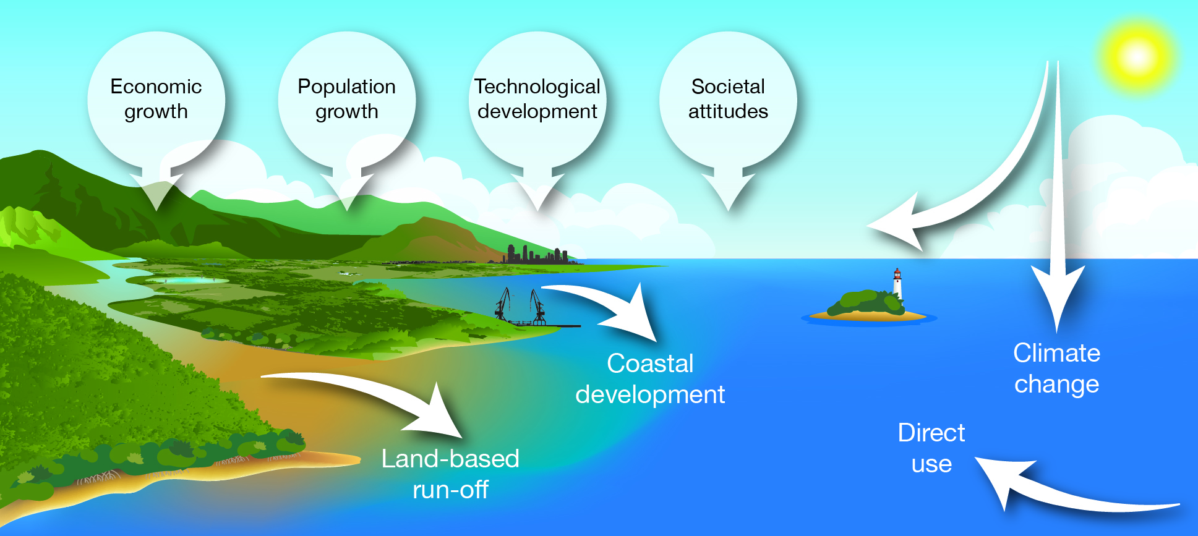
Figure 6.1 Drivers of change and factors influencing the Region’s values
The Region’s values are influenced by four main factors, climate change, coastal development, land-based run-off and direct use. These are, in turn, affected by broader drivers of change. Climate change has both direct and indirect effects.

Drivers of change
Drivers are underlying causes of change in the environment. The drivers examined in this report were identified from the Australia State of the Environment 2011¹ and the draft Strategic Assessment of the Great Barrier Reef Region Report 2013².
Drivers can operate across a range of scales, both in time and space, and they are interlinked, with each one influencing the others. For example, technological developments can play a role in economic growth, population growth and societal attitudes. Similarly, population growth can affect economic growth and societal attitudes.

Economic growth
Key message: Queensland has had Australia’s highest economic growth for over 20 years.
Key message: Growth in the resources sector has altered land use in the catchment.
Queensland's economy is based principally on mining, construction, tourism and agriculture.^{3,4} The state’s economy has had an average annual growth rate of 4.2 per cent over the last decade (Figure 6.2) and has outpaced the economic growth rate of both the rest of Australia and the Organisation for Economic Co-operation and Development group of nations for the past 20 years.³ While the effects of the recent global financial crisis were evident in Queensland, particularly in 2009, they were minor in comparison to the rest of the world and the economy has subsequently recovered (Figure 6.2). Over the 35-year period 2015–16 to 2050–51, Queensland’s annual economic growth is projected to be between 1.6 and 2.4 per cent.⁵
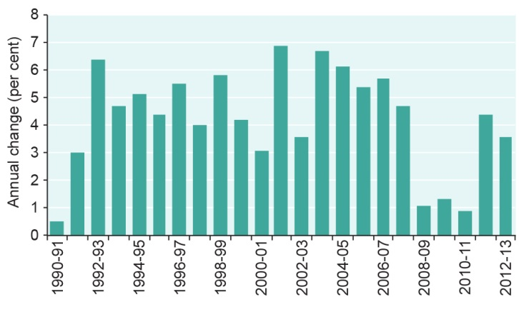
Figure 6.2 Economic growth in Queensland, 1990–91 to 2012–13
The Queensland economy has grown at rates above the national average for the past two decades. The graph shows the annual percentage change in the Queensland gross state product (chain volume measure) for financial years. Source: Australian Bureau of Statistics 2013⁶

The underlying causes of this growth are global events, such as changes in the value of the Australian dollar⁷ and the global financial crisis; and domestic growth in the mining industry over the past ten years.
The Australian dollar has appreciated strongly against the American dollar over the past decade and has remained strong since October 2010, when it reached parity with the American dollar.⁷ The prolonged high value of the Australian dollar has implications for the national economy, economic activity in the catchment and direct use of the Region, in particular for Reef-dependent industries such as tourism and commercial fishing.
Within the Great Barrier Reef catchment, growth in tourism stabilised between 2007 and 2012, with the total number of visitor nights growing by only 4 per cent.⁸ During the same period, international visitor nights declined by around 10 per cent.⁸ The decline in international visitors was offset to some extent by growth in the domestic tourism market.⁸ Growth in the commercial fishing sector has been less than anticipated. The strong Australian dollar has affected the price of seafood, as Reef-based seafood operators compete with imported product.⁹
Much of Queensland’s economic activity takes place in the Great Barrier Reef Region and its catchment, supported by a network of infrastructure (Figure 6.3). The state's strong export trade is dominated by mining and agriculture. About 80 per cent of the world’s seaborne metallurgical coal exports are from Queensland³, shipped through the Great Barrier Reef.
The scale and scope of growth in the resources sector has led to changes in land use within the Great Barrier Reef catchment, particularly in the Fitzroy, Burdekin and Mackay–Whitsunday areas.¹⁰ It has also created unprecedented demands for water, power and new infrastructure including roads, railways and large-scale ports.¹⁰ In November 2013, the Queensland Government released the draft Cape York Regional Plan¹¹. The plan identifies areas where economic development activities are prioritised as well as strategic environmental areas where development will be supported if the development outcome is demonstrated to not present a risk of irreversible or widespread impacts to the ecological integrity of the areas. The plan is yet to be finalised.
Over the past six years, there have been fewer catchment residents employed in manufacturing, agriculture, forestry and fishing, and more employed in the mining and minerals sector, particularly in the Gladstone and Isaac local government areas.^{3,8}
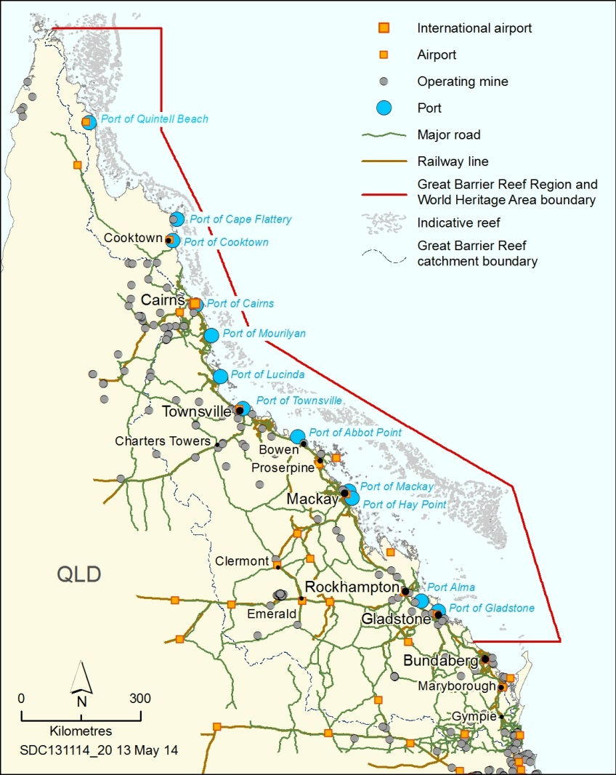
Figure 6.3 Infrastructure in the catchment and beyond
Economic activity in the Region, its catchment and beyond has resulted in a network of supporting infrastructure such as airports, ports, roads and railways.

Population growth
Key message: Annual population growth is forecast at 1.6 per cent or higher for much of the catchment.
Population growth in the catchment is likely to continue to drive changes in a number of factors influencing the Region’s values. These could range from an increase in direct use of the Region to effects on coastal habitats that support the Reef ecosystem.
At the time of writing the Outlook Report 2009, the population of the Region’s catchment was 1,115,000. By 30 June 2012, this had increased by about two per cent to 1,165,115. The fastest growing urban centres in the catchment have continued to be Townsville (2.4 per cent in 2011) and Cairns (1.6 per cent in 2011).¹² These cities also had the highest populations — 184,526 and 165,388 respectively in 2012.¹³
Over the next 20 years, much of the Great Barrier Reef catchment is forecast to experience annual population growth of 1.6 per cent or higher (Figure 6.4), particularly in the southern half of the catchment.¹⁴ In comparison, the national rate of population growth is projected to slow, but remain above one per cent per annum over the next 20 to 40 years.¹⁵
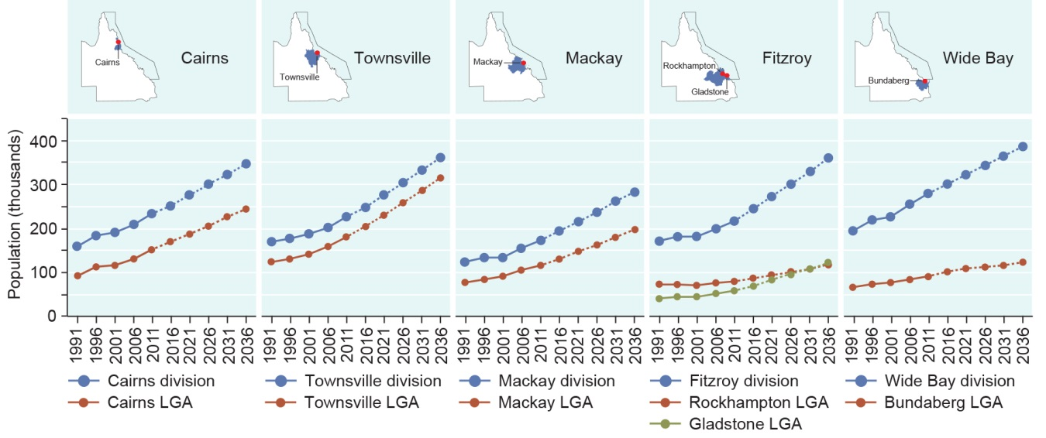
Figure 6.4 Population and forecast increases in the Great Barrier Reef catchment, 1991–2036
Over the last decade, populations have grown steadily along the coast of the Great Barrier Reef. Populations are predicted to continue growing in the statistical divisions (SA4 level) and the main local government areas (LGAs) within the catchment. Source: Department of Treasury and Trade (Qld) 2014 ^{16,17} and Australian Bureau of Statistics¹⁸ 2013

The fastest population growth will continue to be in the coastal regional centres of the catchment.¹⁹ The Gladstone and Isaac local government areas are expected to expand particularly rapidly, due to increased activity in the resources sector.¹⁷ In contrast, the population of Charters Towers, an inland regional centre, is projected to remain static over the next 25 years.¹⁷
With an increasing population comes intensification of coastal development in urban areas to accommodate residents and provide supporting services. For example, Townsville’s population is projected to grow to 314,000 by 2036.¹⁷ As a result, its number of dwellings is predicted to increase from an estimated 71,000 in 2011 to about 130,500 over the 35 years.²⁰
Population growth is likely to increase use of the Region, indicated by increasing vessel ownership in the catchment²¹ (see Figure 5.19). In turn, there is likely to be increasing demand for coastal infrastructure to access the Region (for example, roads, marinas and boat ramps) including in previously undeveloped sections of the coast.
New residents moving into coastal areas adjacent to the Region may have less knowledge of its management arrangements than longer term residents, although this is yet to be quantified.

Technological development
Key message: Technology has changed understanding, management and use of the Region.
Technological development refers to the application of knowledge to create tools to solve specific social, economic or environmental problems. Technological advances have brought major changes to the way people communicate, work, learn, travel and spend leisure time. Technology has changed understanding, management and use of the Region. It can drive both positive and negative changes. Examples of its influence include:
- Global positioning systems allow safer navigation of the Reef and the ability to more reliably locate sites and share locations with others. This technology also provides opportunities for sharing spatial information about the Reef and how it is used, and is providing an increasing number of spatial datasets for management.
- Researchers use state-of-the-art satellite imagery, oceanographic instruments, laboratory equipment, numerical modelling and portable weather stations to better understand, explain and predict changes in Reef condition and the factors that affect it, significantly improving understanding of the Region and contributing to its management.
- The combination of depth sounders and global positioning systems have improved fishers’ ability to find fish, accurately relocate previous fishing sites and target deep shoals, wrecks and fish aggregation areas.
- In the catchment, advances in farming technology are reducing the use of fertilisers and pesticides, and reducing soil disturbance and erosion. This is helping to slow and reverse negative trends in Reef water quality with economic benefits for farmers.^{22,23}
- Continuing advances in communication technology have resulted in increased education, awareness and involvement of the public in environmental monitoring of the Region, for example through use of the Eye on the Reef smart phone application.
Into the future, technological developments which better guide and monitor shipping traffic, enhance visitor experiences, reduce carbon emissions, monitor Reef use, spatially represent values and impacts, and contribute to the collective understanding of the Reef, will enable the environment to be better protected and managed. Changing vessel and navigational technology is likely to change the spatial patterns of fishing, tourism and recreational use, including allowing vessels to safely reach new, more distant locations and better focus their use on preferred locations.

Societal attitudes
Key message: Societal attitudes influence people’s attitudes and actions in relation to the Reef.
Societal attitudes operate at international, national and local scales, and are shaped by cultural and social norms, institutional arrangements, economic imperatives and politics. They may be strongly influenced by external sources, particularly the mass media.²⁴ Societal attitudes influence individual actions and community outcomes, for example the potential for an individual, group or community to take action to help conserve natural assets such as the Great Barrier Reef.
Societal attitudes about the Reef have changed dramatically through time and will continue to do so into the future. Today, most Australians, even those who have not visited the Region, feel proud that the Great Barrier Reef is a world heritage area; many believe the Reef is part of their Australian identity and feel a strong sense of responsibility to protect it.²⁵
For thousands of years, societal attitudes about the Reef were those held by the Traditional Owner groups whose customary estates include sea country within the Region. Their culture and lore was reflected in ongoing stewardship and custodianship of the Reef environment. Traditional Owners continue to maintain a close and dynamic connection to their sea country, which integrates nature, heritage and culture.
The attitudes of early European explorers were principally shaped by their anxiety about being shipwrecked, due to the sheer size and complexity of the coral reef system. By the late 1800s, non-Indigenous Australians saw the Reef as a bountiful resource to exploit, for example through dugong and turtle harvesting, pearling and commercial fishing. It was not until the early part of the twentieth century that they also began to explore its natural wonders in earnest, through science, recreation and tourism. This appreciation of the Reef flourished during the 1940s, 1950s and 1960s, and continues today.²⁶
By the mid-1960s, Australians were beginning to express concerns about the future of the Great Barrier Reef, particularly with respect to outbreaks of crown-of-thorns starfish and the possibility of drilling for oil.²⁶ Growing public affinity for the Reef and a sense of responsibility for its future led to proclamation of the Great Barrier Reef Marine Park Act 1975 and subsequent progressive protection of the Great Barrier Reef as a marine park. Members of the community now take an active interest in the Reef and its protection, for example through expressing their opinion on major changes to management, such as zoning arrangements or permit decisions. Strong community concern around dredging and dredge material disposal was expressed during 2013 and early 2014. By January 2014, there was a combined total of over 1.5 million signatures on related petitions.^{27,28,29}
Governance arrangements — a reflection of societal attitudes — play a major role in shaping the condition of the Region’s ecosystem and heritage values, for example through legislation, non-regulatory incentives for behaviour change, and international agreements and conventions (such as the World Heritage Convention and trade agreements).
Education and awareness of the Reef and its values influence societal attitudes. Stewardship actions driven by community and industry are critically important in modelling both changed attitudes and actions that people can take to support management initiatives and maintain and enhance the Region’s values. Education and stewardship are central tenets of many management programs for the Region. The growing interest in stewardship programs reflects shifts in thinking towards ecologically sustainable development, human wellbeing and a healthy, vibrant Great Barrier Reef.

[Photograph of tourism staff in the water learning how to perform reef health surveys. Caption: Inspired to help monitor the Reef, tourism staff learn how to perform reef health surveys.]

Climate change

Climate change directly affects the Region through physical and chemical impacts on the ecosystem and heritage values. It also has indirect effects on these values by changing the way people interact with the Region and by affecting the other factors (such as land-based run-off) that influence the Region’s values.
The rate and extent of increases in global greenhouse gas concentrations drive climate change. Increased concentrations of greenhouse gases (particularly carbon dioxide) in the atmosphere result in more heat being trapped, increasing the Earth’s temperature. Increasing carbon dioxide levels in the atmosphere also cause ocean acidification, a gradual reduction in the pH of seawater.³⁰ Both these consequences (global warming and ocean acidification) are considered together in this assessment under the influencing factor ‘climate change’.

Trends in climate change
Key message: The climate is changing, with significant implications for the Region.
Key message: The ocean is already getting warmer and pH is decreasing.
The 2013 Working Group I contribution to the Intergovernmental Panel on Climate Change (IPCC) fifth assessment report concludes that ‘warming of the climate system is unequivocal and, since the 1950s, many of the observed changes are unprecedented over several millennia. The atmosphere and oceans have warmed, the amounts of snow and ice have diminished, sea level has risen, and the concentrations of greenhouse gases have increased’.³¹
A number of climate change variables are already changing and, based on a combination of global and regional climate models and observations, are projected to alter substantially in the Great Barrier Reef over the next 50 years.^{31,32,33,34} It is likely that climate change will drive global changes in prominent weather characteristics and events such as cyclones, heavy rainfall, droughts, air temperature and prevailing winds.^{31,35,36} For example, while cyclones and other extreme weather events are a natural part of the weather cycle in tropical areas (see Section 3.2.2), the global climate system is now warmer and moister than it was 50 years ago, and this is increasing the chances of intense weather events.^{37,38}
Concentrations of carbon dioxide have increased by 40 per cent since 1750, primarily from fossil fuel emissions and secondarily as a result of changes in land use.^{39,40} The mean rates of increase in atmospheric concentrations of carbon dioxide, methane and nitrous oxide over the past century are unprecedented in the last 22,000 years, and are now at concentrations unprecedented in at least the last 800,000 years.⁴⁰ Over the last five years, global carbon dioxide levels have continued to increase at a rate similar to that of the last 50 years, increasing from 386 to 397 parts per million from July 2008 to December 2013 (Figure 6.5).⁴¹
Four representative concentration pathways (RCPs) for atmospheric greenhouse gases were developed for use in the fifth assessment report of the Intergovernmental Panel on Climate Change. Of these, the RCP 4.5 represents a ‘radiative forcing is stabilised before 2100’ scenario and RCP 8.5 represents a ‘radiative forcing is stabilised after 2100’ (very high emissions) scenario.^{31,42} Projections indicate carbon dioxide levels of around 435 (RCP 4.5) to 758 (RCP 8.5) parts per million by 2030, and around 531 (RCP 4.5) and 758 (RCP 8.5) by 2080.⁴³
(a)
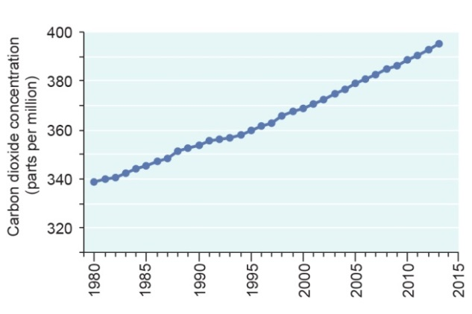
(b)
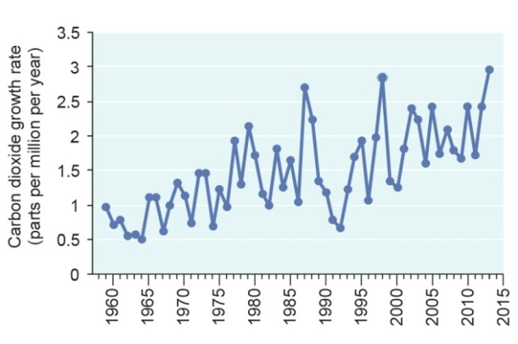
Figure 6.5 Changes in global atmospheric carbon dioxide concentrations
Global carbon dioxide concentrations in the atmosphere have been rising. Both (a) global carbon dioxide concentrations (1980–2013) and (b) the annual mean carbon dioxide growth rate (1959–2013) are rising. Trends shown are based on globally averaged marine surface data. Source: Dlugokencky and Tans 2014⁴¹

More than half the observed increase of 0.6 degrees Celsius in global mean surface (air) temperature from 1951 to 2010 is very likely due to anthropogenic greenhouse gas emissions; it is likely that anthropogenic influence has made a substantial contribution to surface temperature increases over Australia.⁴⁴ Globally, each of the past three decades has been significantly warmer than all the previous decades in the instrumental record and the first decade of the twenty-first century has been the warmest.³⁹ Regionally, mean temperatures are increasing. Projections based on RCP 4.5 and RCP 8.5 suggest temperature will rise by around one to two degrees Celsius by 2030, and by one to over three degrees by 2080.^{34,44}
Sea surface temperatures in north-eastern Australia have warmed, on average, by 0.12 degrees Celsius per decade since 1950.³⁴ In the Coral Sea over the past century, 15 of the 20 warmest years have been in the past 20 years (see Section 3.2.6).⁴⁵ Following on from record sea surface temperatures in October to December 2010 for many areas of tropical Australia^{45,46}, records were set again in the summer of 2012–13 when the hottest sea surface temperatures for the Australian region were recorded.³⁷

Strong ocean warming is projected for tropical regions.³⁰ Whatever climate scenario is used, it is predicted that by 2035 the average sea surface temperature will be warmer than any previously recorded, and by 2100 average sea temperatures off north-eastern Australia could be about 2.5 degrees Celsius warmer than the present average.^{32,34,38,45}
Global average sea level has risen by 0.18 centimetres per year from 1961 to 2003.⁴⁷ The total rise from 1901 to 2010 was 19 centimetres.⁴⁸ Around Australia, and in the Great Barrier Reef, the fastest rates of sea level rise are in the north (Figure 6.6 and see Section 3.2.5).^{49,50} The frequency of extreme sea level events (storm-driven waves and surge) increased by a factor of about three during the twentieth century. ⁵⁰ Projections based on RCP 4.5 and RCP 8.5 are for global sea level to rise by around 26 to 29 centimetres by 2030, and by around 47 to 62 centimetres by 2080.⁴⁸
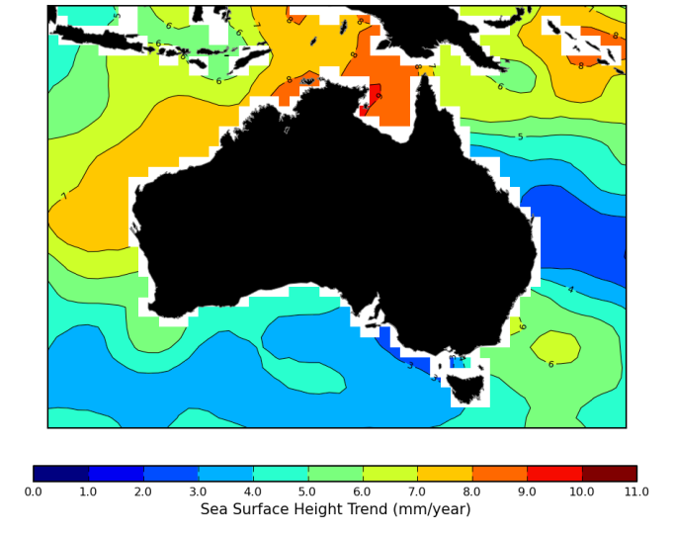
Figure 6.6 Rates of sea level rise in Australia, 1993–2013
Rates of sea level rise are highest in northern Australia. The map shows the rate of sea surface height rise measured by satellite observations. Note: satellite observations have had the seasonal signal removed and small corrections applied for changes in atmospheric pressure. Source: Australian Baseline Sea Level Monitoring Project and CSIRO, map adapted from Bureau of Meteorology 2014⁴⁹

Ocean uptake of carbon dioxide will increase ocean acidification, continuing the observed trends of past decades and reducing pH within the Region’s waters (see Section 3.3.2).^{30,51} Global ocean surface pH is currently 8.1 and there is high confidence that it has decreased by 0.1 since 1750.³⁰ Projections based on RCP 4.5 and RCP 8.5 are for further reductions in pH of around 0.05 to 0.2 by 2030, and around 0.05 to 0.3 by 2080.⁴⁰
Currents There is increasing evidence of changes in the East Australian Current adjacent to the Region’s southern coast (see Section 3.2.1). Its flow is expected to increase off south-east Australia with a compensating decrease off north-east Australia.⁵² There is little information about the Hiri Current, another of the Region’s prominent currents.
Both tropical cyclones and east coast lows can produce extreme wind speeds and heavy rainfall.⁵³ Over the last decade, particularly between 2005 and 2012, there have been a number of severe tropical cyclones in the Region (see Section 3.2.2). Most of the Region has been exposed to severe cyclonic winds during that time; with the area between Cairns and Townsville particularly affected (Figure 6.7). There is low confidence in determining changes in cyclones over a century scale³⁹, but the frequency of eastern Australian land-falling cyclones has possibly declined since the late nineteenth century.^{39,53} The frequency of tropical cyclones is likely to decrease or remain unchanged, though there is a possible trend towards more intense storms^{39,54}; however, confidence is low in regional projections^{55,56}. An increase in intensity would increase the proportion of severe tropical cyclones (categories three, four and five). A small poleward shift in storm tracks is likely.⁵⁵
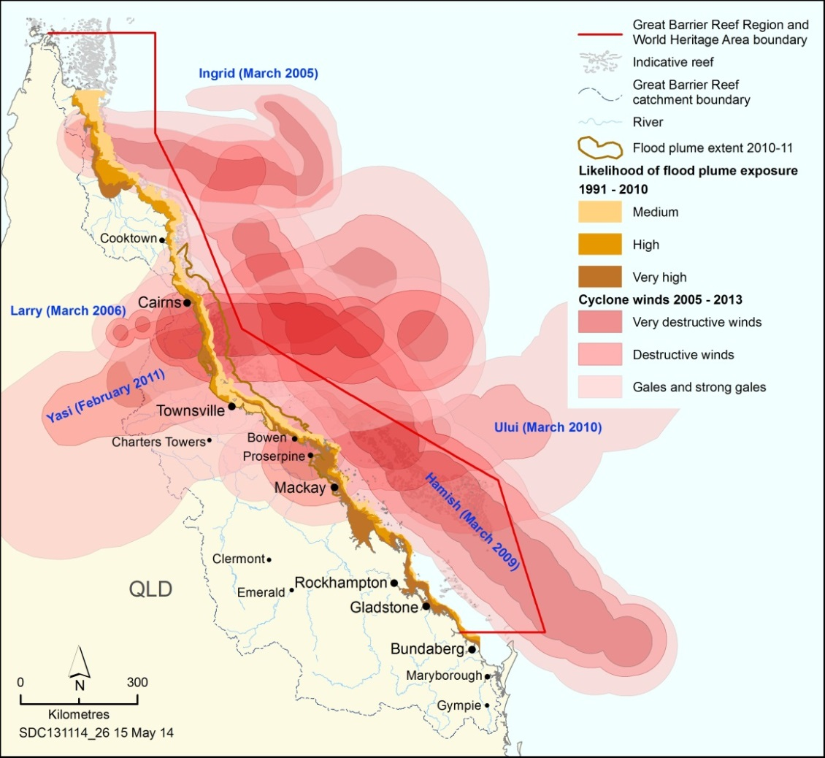
Figure 6.7 Cyclonic wind (2005–2013) and flood plume (1991–2010) exposure
The cluster of severe cyclones and flood events in recent years has significantly affected the condition of many Great Barrier Reef habitats and species. Winds shown are those associated with category 4 and 5 cyclones. The likelihood of flood plume exposure (brown areas) is a cumulative assessment of multiple flood plumes based on remotely sensed conditions at the sea surface. The flood plume extent for 2010–11 (brown line) indicates the distribution of the flood plume as a result of the extreme weather events experienced over that summer. Source: Bureau of Meteorology 2013⁵⁷ (cyclones) and Devlin et al. 2011⁵⁸ (flood plume exposure)

North-east tropical rainfall is concentrated during the summer and is variable from year to year. Indicators of flood events, dating back to late seventeenth century show that wet and dry extremes have become more frequent since the late nineteenth century.⁶⁰ Between late 2010 and early 2011, one of the strongest La Niña events on record since the late 1800s was observed⁶¹ resulting in record high rainfall and widespread flooding in many areas (see Section 3.2.3).
[Photograph of small waves breaking on a beach. Caption: The global average sea level has risen about 19 centimetres since 1901.]
Across Australia, heavy rainfall events and associated flooding are likely to become more frequent as air temperatures increase.³⁷ In northern Australia average monsoon rainfall may increase.⁵⁵ There will be a tendency for more large freshwater inflows to the marine environment. Rainfall is likely to become more variable, and the direction and magnitude of change in eastern and northern Australia remains a key uncertainty.⁵⁵
The El Niño–Southern Oscillation is the most important driver of natural climate variability in the Region and is likely to remain so.^{55,62,63,64} Extreme El Niño events occurred during 1982–83 and 1997–98 with widespread coral bleaching observed.^{64,65,66,67} There is no consensus on observed long-term changes in the El Niño–Southern Oscillation, and low confidence in projected change in its variability.⁵⁵ Extreme El Niño occurrences are projected to increase.³⁸

Vulnerability of the ecosystem to climate change
Key message: Rising sea temperatures will damage coral and affect other animals.
Key message: Changes to ocean currents may disrupt transport of nutrients and larvae.
Key message: Weather pattern shifts may increase frequency and distribution of disturbance.
Key message: Ocean acidification threatens physiological processes for a wide range of organisms.
Current and future climate change related threats to the Region’s ecosystem include sea temperature increases, altered ocean currents, changed weather patterns, ocean acidification and sea level rise. Potential effects for populations of species and groups of species and habitats are considered in many recent scientific studies.^{34,68,69,70,71,72} The effects, both individually and combined, are likely to have far-reaching consequences for the Region’s ecosystem and its outstanding universal value as a world heritage area.
The 2013 water quality scientific consensus statement⁷³ concluded that ‘key Great Barrier Reef ecosystems are showing declining trends in condition due to continuing poor water quality, cumulative impacts of climate change and increasing intensity of extreme events’.
For most ecosystem values, knowledge regarding the range and extent of impacts is limited, but growing steadily. However, the projected vulnerability of a number of the Region’s habitats and species indicates not all components are affected equally.⁷² Corals and seabirds are considered to be some of the most vulnerable species^{68,71,72,74} — both key attributes of the area’s outstanding universal value.
Continued increases in air and sea temperature pose significant risks over the coming decades across the whole Region, influencing a range of physical, chemical and biological conditions and processes and, hence, many different habitats and species.⁷⁵ Seabird nesting and shorebird roosting sites are at risk and increasing sea temperatures are affecting food availability for offshore and pelagic-foraging seabirds.^{76,77} Sea temperature extremes considered to be caused by climate change (see Section 3.2.6) have already had some serious effects, including mass coral bleaching in 1998 and 2002^{78,79} and reduced growth rates in massive corals across the Region.^{68,79,80,81,82}
Under a scenario where radiative forcing stabilises before 2100 (RCP 4.5)⁴², bleaching conditions are predicted to start to occur twice a decade in 2018 for most of the Great Barrier Reef, with these conditions beginning slightly later (between 2033 and 2043) in the inshore southern Reef.⁸³ In the same scenario, annual bleaching conditions are predicted to start occurring in the period from 2052 to 2067 with earlier annual bleaching conditions (2047) in the southern inshore Reef and later (after 2067) in some parts on the central Reef.⁸³
Pelagic–foraging seabirds are highly vulnerable to changes in ocean currents.⁷⁴ There is evidence that climate change has driven the ranges of Australian seabirds further south, reduced breeding success and altered breeding timing for some species.⁷⁴ Altered ocean circulation patterns may also affect the transport of eggs and larvae of many animals within and among Great Barrier Reef habitats and influence species distributions. The movement of marine turtle hatchlings away from nesting beaches may be affected⁸⁴, as may coral larval dispersal. Projected increases in ocean stratification — the vertical layers in the water column — are predicted to affect the supply of nutrients and oxygen into deeper pelagic and seafloor ecosystems with implications for the organisms that live there.⁵¹
As the climate changes, the capacity of hard corals to grow and reproduce will be increasingly compromised with flow-on effects on other species dependent on coral reefs. Reef-building corals are highly vulnerable to increasing sea temperature, ocean acidification and increased intensity of cyclonic activity and other weather pattern changes. For example, modelling predicts severe cyclones have been responsible for about half of the total coral cover loss in the Great Barrier Reef since 1985⁶⁸ due, in part, to the associated high intensity waves (Figure 6.8). In another study, for places where declines in live coral cover were observed, around a third of the decline was attributed to the effects of storms.⁸⁵ Abnormally high rainfall and associated flood events can have negative effects such as low salinity bleaching and mortality in corals⁸⁶ or widespread damage to seagrass meadows^{87,88,89,90}.
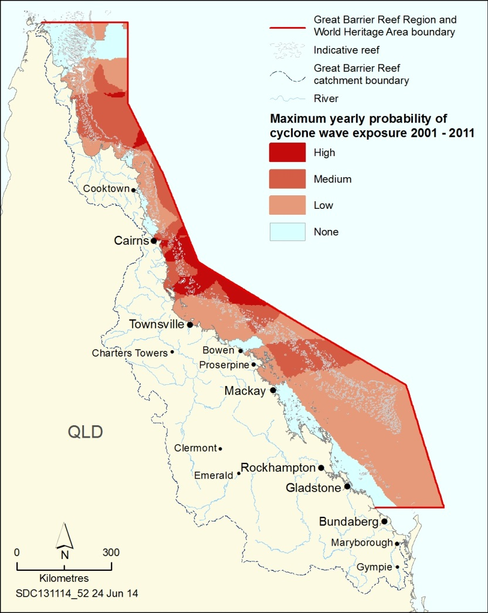
Figure 6.8 Cyclone wave exposure, 2001–2011
For the Region, a significant wave height of four metres is likely to damage many species. The map presents the probability that four metre significant wave heights formed for at least an hour in a given year for the period from the summer of 2000–01 to the summer of 2010–11.⁵⁹ Gradings are scaled based on a maximum yearly probability of 31.7 per cent: low (less than 11 per cent chance), medium (11 to 22 per cent chance) and high (22 to 31.7 per cent chance). Source: Maynard et al. 2014⁵⁹

Tropical habitats such as coral reefs, seagrass meadows and islands have a natural resilience to physical disturbances from weather events such as storms and cyclones, intense rainfall and heatwaves. However, climate change induced shifts in weather patterns that affect the frequency, intensity or distribution of disturbance events will have important implications for the Region.^{45,68,91,92,93} Additionally, it is thought the cumulative effect of multiple severe weather events and anthropogenic threats over the past decade may reduce the Reef’s resilience, in particular its ability to recover.^{85,93,94,95,96,97} Changes in wind patterns and intensity may have implications for the resuspension of sediments in the Region, including those delivered from the catchment and those disposed of during dredging activities.
It is predicted that ocean acidification could ultimately affect most marine life through habitat destruction or modification, food web deterioration and disruption of physiological processes.⁹⁸ In addition, the effects of global warming and ocean acidification may magnify each other⁹⁹ and may not occur uniformly from place to place and over time.¹⁰⁰ Even relatively small decreases in ocean pH reduce the capacity of corals to build skeletons, which in turn reduces their capacity to create habitat for reef biodiversity in general.^{99,101} Additionally, if coral skeletons are weakened they may have lowered capacity to resist and recover from physical damage caused by cyclones.¹⁰² Reef development is thought to cease at pH 7.8.¹⁰³ Field observations at natural carbon dioxide seeps have found more acidic oceanic conditions do not necessarily affect coral cover but reduce species diversity and structural complexity.¹⁰³ Decreasing pH is likely to reduce the capacity of coralline algae, a species vital to reef building, to cement reef debris into solid limestone.^{70,104} It is also likely to affect coral recruitment and establishment.⁷⁰ Other biota such as phytoplankton, foraminifera and molluscs are also at risk.^{104,105,106} The sensory systems, behaviours, and larval development and survival of a number of reef fish species including coral trout have been shown to be sensitive to increased temperature and acidity.¹⁰⁷ Some seagrass and non-calcifying macroalgae may benefit from future ocean acidification.^{103,108,109}
Rises in sea level are significant for the Great Barrier Reef ecosystem as some habitats are shallow and strongly influenced by sea level. In particular, because much of the land adjacent to the Great Barrier Reef is low lying, small changes in sea level will mean increased erosion and land inundation, causing significant changes in tidal habitats such as mangroves, and saltwater intrusion into low-lying freshwater habitats.^{110,111} Brackish saltmarsh habitats are being displaced by mangroves.¹¹² Turtle and seabird nesting beaches, including on islands, are particularly vulnerable to rising sea levels, which exacerbate beach erosion¹¹³ and inundate nests¹¹⁴.
As well as its direct effects on the Region’s ecosystem, climate change will also have indirect effects on the Reef’s resilience through amplifying the effects of other influencing factors such as coastal development and land-based run-off. For example, flood events carry pulses of nutrients, sediments, pesticides and other pollutants from the catchment, which have significant effects on inshore Great Barrier Reef habitats and species.¹¹⁵ Extreme weather events such as those in 2010–11 result in large amounts of marine debris washing or blowing into the Region from the catchment.^{116,117}
Additionally, engineering solutions to improve the resistance of coastal assets to rising sea levels and increased storm intensities may interfere with the connectivity of coastal and marine systems or cause damage or loss of coastal habitats.^{118,119,120}

Vulnerability of heritage values to climate change
Key message: Altered weather patterns and sea level rise increase risks to built structures.
Section 6.3.2 has demonstrated the very high vulnerability of the Region’s ecosystem to climate change. The vulnerability flows through to dependent heritage values. The Region’s world and national heritage values, including those attributes relating to Traditional Owners’ interaction with the natural environment, are underpinned by the ecosystem and directly affected by changes to it. Indigenous heritage values are particularly vulnerable because, as described in Chapter 4, the natural environment is fundamental to Traditional Owner connections to their land and sea country. The cultural landscape of the Region, and climate change threats to it, cannot be fully understood without recognising this.
Many aspects of Indigenous heritage such as cultural practices, sacred sites, sites of particular significance, stories, songlines, totems, language, technology, tools and archaeology will be affected by global warming and ocean acidification. Some impacts will come as a result of ecosystem effects, while others will occur directly. Historic heritage places and artefacts are at risk too, along with social, aesthetic and scientific values.
Heritage sites on beaches and in the intertidal zone are likely to be particularly vulnerable to sea level rise. Traditional Owners have observed impacts on the fish traps in Girringun country (Cardwell) from rising sea levels.¹²¹ Once culturally significant sites are affected, stories and songlines are compromised and customary practice may have to be changed.
As weather patterns change, the impacts on the Region’s heritage values of storms, cyclones, high rainfall events, heatwaves and droughts may increase. Severe weather events can lead to adjustments in traditional use of marine resources, for example moratoria on collecting certain species.^{122,123} In turn, this can mean places important for cultural tradition may not be visited, or stories and songlines might not be practiced or passed down to younger generations, because those aspects are directly related to fishing, collecting or hunting activities.
Cyclones change land and seascapes and can affect places of heritage significance including Indigenous¹²⁴ and historic heritage structures and sites, both those on land (such as lightstations) and submerged (such as historic shipwrecks). An example is cyclone Yasi’s exacerbation of the deterioration of the wreck of the SS Yongala (see Section 8.5.3).¹²⁵ Built heritage such as lightstations are at risk of physical damage from infrequent but intense weather events like cyclones, but may also be degraded by more chronic subtle changes such as wind pattern shifts that accelerate weathering or other deterioration.¹²⁶
[Photograph of Low Island featuring the lighthouse. Caption: Indigenous and historic heritage values such as those on Low Island are vulnerable to changes in weather patterns.]
If altered weather patterns result in increased marine debris (Section 6.3.2) in the water and on the Region’s beaches, aesthetic values will be diminished.¹²⁷ Aesthetic value could also be affected if island and other terrestrial habitats change as a result of a shifted climate.¹²⁸
While the spatial locations of important scientific discoveries are unalterable, the habitats and species fundamental to that history are not. In many instances the relevant ecosystem values, and therefore the scientific heritage values associated with them, are likely to become significantly degraded through the effects of global warming and ocean acidification.

Implications of climate change for regional communities
Key message: Climate change effects on the ecosystem are expected to have major economic consequences for Reef-dependent industries.
Key message: Deteriorating Reef condition may reduce visitor satisfaction with their Reef experiences.
Many Australians are concerned about the Great Barrier Reef being damaged or threatened by climate change.^{25,129} Climate change is likely to affect the way people interact with the Region and the social and economic benefits they derive from it. For example, foreshores and coastal infrastructure such as ports¹³⁰, and the benefits communities derive from them, will be influenced by climate change impacts on the catchment and the Region. Climate change will also have implications for health and disaster risk management.^{131,132,133,134}
The effects of climate change on coral reef ecosystems are predicted to be widespread and irreversible.¹³⁵ Therefore, climate change poses one of the greatest risks to the future economic value of Reef-dependent industries such as tourism, fishing and recreation. While the implications of climate change for the economic value of Reef-dependent industries are numerous and there is an improved understanding of these⁹¹, they remain difficult to accurately quantify.¹³⁶
The tourism industry is very concerned about the impacts of climate change on its businesses and livelihoods, including through degradation of reef sites, poor recovery of bleached sites as a result of other stresses, and a loss of marketing appeal as a high-quality reef destination.¹³⁷ A healthy and resilient Reef is fundamental to the success of many tourism operations and deteriorating Reef conditions may reduce visitor satisfaction. In a 2013 survey of visitors to the Region the most important motivations for their visit were those relating to the state of the ecosystem — for example, clarity of water, iconic species, healthy reef fish and healthy coral reefs (see Section 5.2.2).¹²⁷
It is likely fishing activities will also be highly sensitive to climate change, including as a result of projected changes in fish abundance, survivorship^{138,139,140}, size and distribution, disruptions to shallow-water nurseries and loss of coral reef habitats, as well as changes in cyclone and storm activity.^{72,141,142}
Extreme weather events may provide a window into the future for predicting impacts of climate change on coastal communities, especially the flow-on effects of major ecosystem disturbances. In 2010–11 the Queensland coastline experienced high levels of flooding and was exposed to several cyclones, resulting in widespread damage to road and rail networks, and port and airport closures.¹⁴³ Reef-based tourism operators were disadvantaged by public perceptions that the whole of the Great Barrier Reef was damaged by cyclone Yasi.¹⁴³ Local fishers experienced difficulties going fishing and in getting their produce to market. Ongoing poor weather and damage to property and infrastructure in the Cassowary Coast left local fishers feeling uncertain about their capacity to fully recover, as they had only just recovered from cyclone Larry in 2006.¹⁴³
The vulnerability of commercial fishers and tourism operators to climate change will depend on their exposure and sensitivity to the associated impacts, as well as the ability of the individuals or operators to anticipate and adapt to change.⁹³ Although severe weather events such as floods and higher intensity cyclones may interrupt Reef-based businesses and decrease visitor satisfaction, the level of identity with, and attachment to, the Great Barrier Reef by Reef-based industry and community members is likely to remain high.^{144,145}
[Photograph of a shelter building on a beach foreshore being impacted by high water levels. Caption: Damage to foreshore and coastal infrastructure affects people’s use of the Region.]

Coastal development
Aboriginal people have lived along the coast of the Great Barrier Reef for over 40,000 years. Europeans first settled the area in the 1850s and since that time an increasing number of people have lived and earned their livelihoods there, often based around the natural resources of the Great Barrier Reef.
For the purposes of this report, the term coastal development includes all development activities within the Great Barrier Reef catchment. Uses of the catchment relevant to the Region are agriculture, mining, urban and industrial development, port activities and island development. The influence of coastal development on the Region arises from both the legacy of past development actions, such as broadscale clearing of catchment habitats for agriculture, and current and future actions, such as smaller scale clearing and reclamation for urban and industrial development.
Since the Outlook Report 2009, a large body of work has been synthesised to better understand the influence of modifications to coastal ecosystems on the Region’s values (see Section 3.5).
Diffuse source pollutants from the catchment, principally as a result of agricultural activity, and their influence on water quality entering the Great Barrier Reef is discussed in the land-based run-off section (Section 6.5).

Trends in coastal development
Key message: The overall extent of agricultural land use has remained stable in recent years.
Key message: Resource extraction activities in Queensland have continued to expand.
Key message: Increases in urban and industrial land use are expected; their current footprint is small.
Key message: There has been major growth in port activity along the Region’s coast.
Agriculture The majority of land in the catchment is used for grazing, cropping, dairy and horticulture, with more than 80 per cent of the Great Barrier Reef catchment supporting some form of agriculture. Cattle grazing is the most extensive land use, occurring in more than 74 per cent of the catchment (Figure 6.9).^{10,146} It is particularly extensive in the larger, drier catchments — the Fitzroy and Burdekin — but is a significant portion of most catchments, even the Wet Tropics.^{10,146} Smaller coastal catchments support more intensive agricultural uses such as cropping (mostly sugarcane). They also support forestry activities, which are undertaken in about five per cent of the catchment.^{10,146} Agricultural uses of the catchment have not changed substantially in the past decade, with the last major expansions in the 1990s.¹⁰
As with other sectors of the Queensland economy, there is a degree of uncertainty around future trends in agriculture, especially in relation to global economic trends and the value of the Australian dollar.^{4,147}
Future development scenarios have been predicted to place even further pressure on the Great Barrier Reef through higher pollutant loads from multiple sources.⁴
The 2008 scientific consensus statement on water quality¹⁴⁸ concluded that implementation of the Vegetation Management Act 1999 (Qld) was responsible for reducing the extensive land clearing of the previous decades. This legislation was identified as a critical element in beginning to address the impacts of land use on Reef water quality that had been reported from the 1970s to the late 1990s.
In 2013, the Queensland Government proposed changes to the Vegetation Management Act including repealing regulations that apply to clearing high value regrowth on freehold and Indigenous lands; allowing broadscale clearing for ‘high value’ intensive agricultural production; and promoting self-assessment of areas that contain remnant or high value regrowth.¹⁴⁹ Risks associated with changes to the legislation include the potential intensification of coastal agricultural development, with subsequent increases in pollutant loads.¹⁵⁰ The effect of these changes is unknown as the regulatory reform process is still underway.
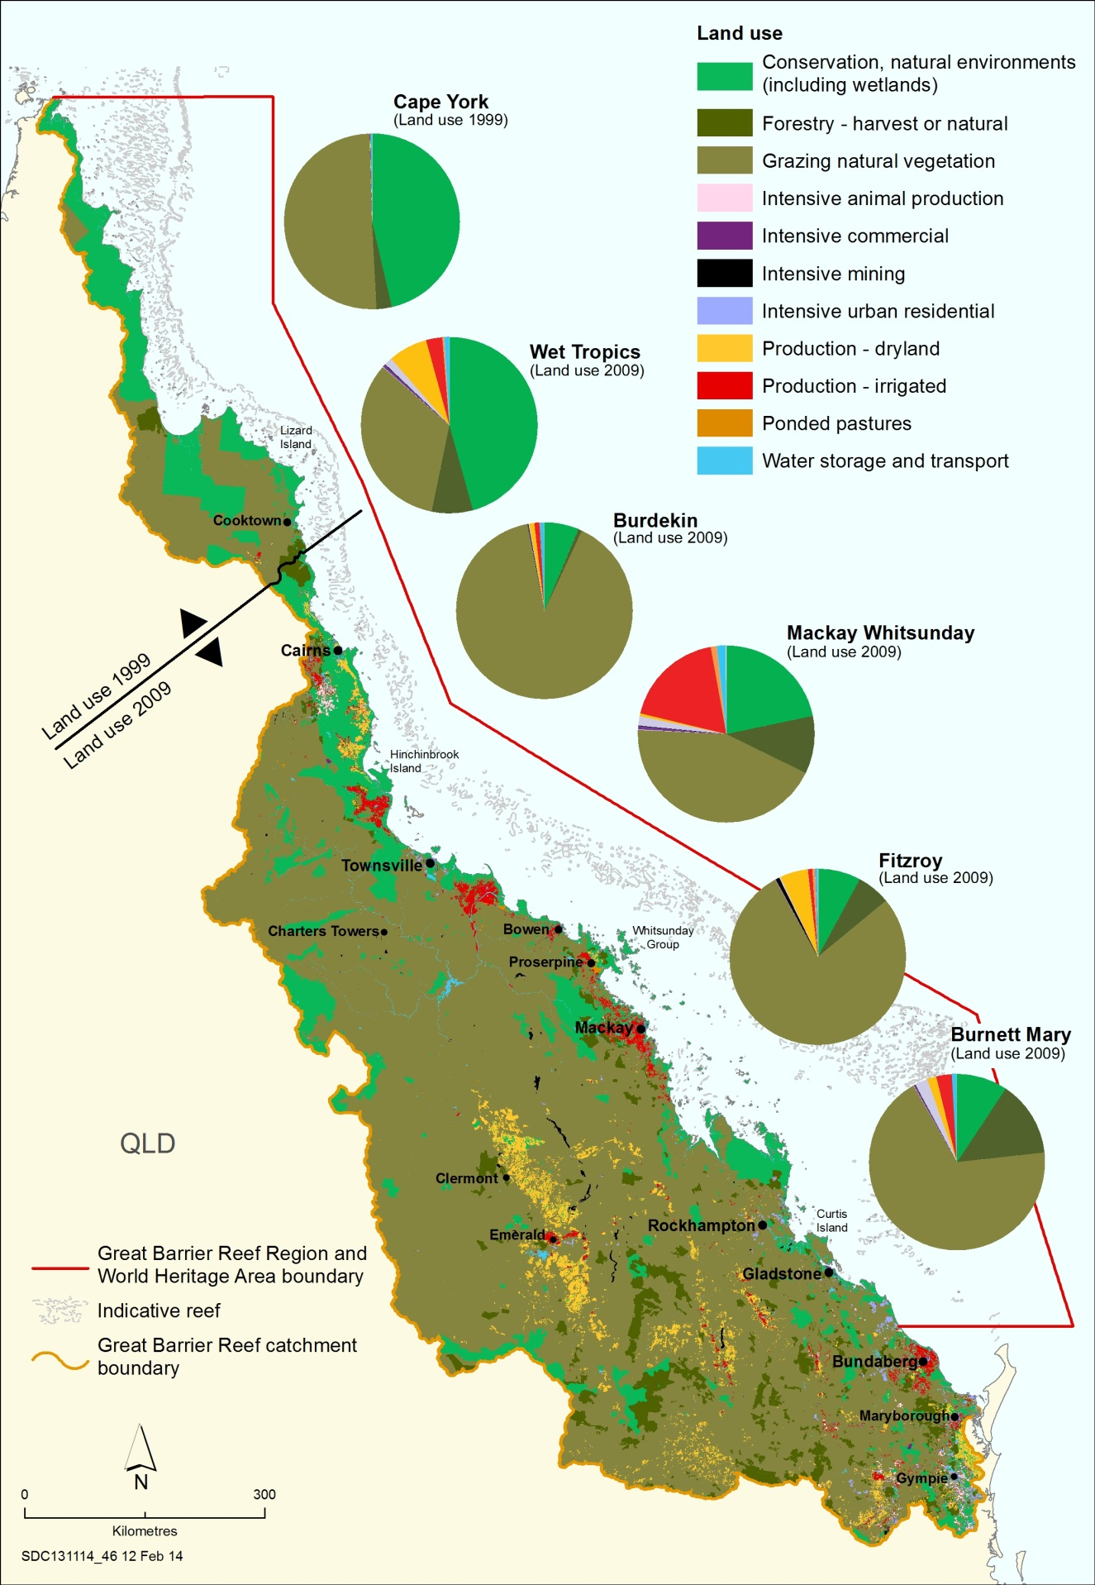
Figure 6.9 Land use in the catchment, 2009 and 1999
Grazing is the predominant land use in the catchment. Intensive agriculture is confined to a relatively small area, mainly close to the coast. For much of the catchment, comprehensive land use mapping was undertaken in 2009. For the Cape York natural resource management area, the most recent information is from 1999. Source: Queensland Government 2014¹⁴⁶
Mining The Great Barrier Reef catchment is rich in mineral resources and has long supported significant mining activity.¹⁵¹ Historically, there have been extensive small-scale mining operations through much of the catchment, including gold, tin, nickel and uranium mines.^{152,153}
More recently, the continued and increasing global demand for coal¹⁵⁴ has resulted in mine expansions, new mines and additional mine proposals within the catchment and in areas further inland. Production of saleable coal in Queensland has more than doubled since the early 1990s (Figure 6.10) and the Region is now associated with some of the world’s largest mines and coal ports^{155,156}, along with the connecting infrastructure required to support them (Figure 6.3).
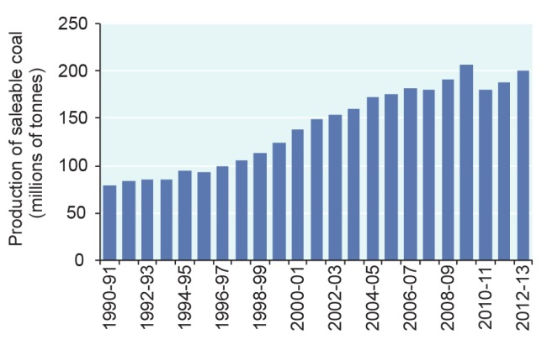
Figure 6.10 Production of saleable coal in Queensland, 1990–91 to 2012–13
Production of saleable coal in Queensland has increased two and a half-fold since 1990–91. Source: Australian Bureau of Statistics 1994¹⁵⁷, 1998¹⁵⁸, 2000¹⁵⁹, 2013¹⁶⁰ (ABS data used with permission from the Australian Bureau of Statistics)

The projected Queensland export volumes for coal in 2025 range from 79 to 185 million tonnes for thermal coal and 226 to 262 million tonnes for metallurgical coal.¹⁶¹ Over this period, coal production is projected to increase significantly in the Bowen, Surat and Galilee basins which export coal through the Great Barrier Reef.¹⁶¹ Coal exports affect the Region’s ecosystem and heritage values in two ways. The continued use of fossil fuels globally is the major driver of climate and ocean change, and servicing the export of coal is the major driver of port expansion along the Region’s coast and population growth in the catchment.
Queensland has 98 per cent of Australia’s proven coal seam gas reserves and economic activity associated with the development of coal seam gas projects has grown substantially over the last decade (Figure 6.11). A 2012 report anticipates that Australia will become the world’s largest liquid natural gas exporter by 2020 with a projected export of between 25 and 33 million tonnes for Queensland.¹⁶¹ Curtis Island, within the Great Barrier Reef World Heritage Area, is the site for the world’s first project converting coal seam gas to liquefied natural gas.³
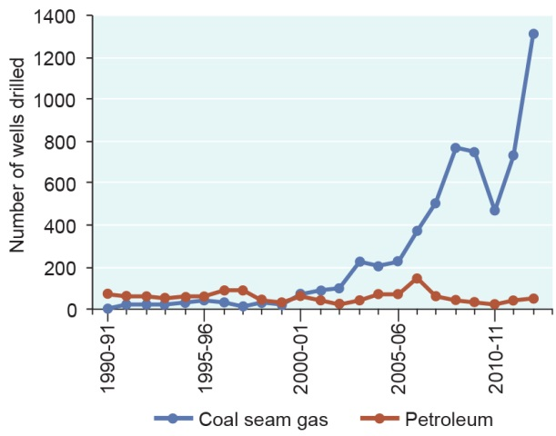
Figure 6.11 Wells drilled in Queensland, 1990–91 to 2012–13
Activity associated with coal seam gas has grown substantially over the last decade. Source: Department of Natural Resources and Mines (Qld) 2013¹⁶² and 2014¹⁶³

Recent revocation of uranium¹⁵² and shale oil mining bans¹⁶⁴ in Queensland may result in an increase in these mining activities in the catchment and transportation of material through the Region.
The area used for mining activities in the catchment almost doubled from 74,847 hectares in 1999 to 125,579 hectares in 2009.¹⁴⁶ There are a number of resource development projects proposed or under assessment. Changing global economic circumstances mean it is difficult to predict the number that will reach construction and production.
Urban and industrial development Urban and industrial development, excluding mining, in the Great Barrier Reef catchment is not extensive; however, future economic projections (Section 6.2.1) suggest an increase in both land uses. Continued population growth in coastal areas (Section 6.2.2) is increasing the demand for infrastructure and services such as roads, water, sewerage and power. If poorly planned and implemented, urban and industrial development can further modify coastal habitats and affect critical hydrological processes and ecological connections to the Great Barrier Reef.
Although urban areas occupy only a small proportion of the catchment (less that 0.01 per cent), much of the development is located on floodplains and within the coastal zone adjacent to the Region. This includes development of additional coastal infrastructure to improve access to the marine environment, either through the expansion of already popular facilities or the construction of new facilities in undeveloped sites.
Urban and industrial development within the coastal zone, and some activities associated with agriculture¹⁶⁵, can also result in the exposure of potential acid sulphate soils. These soils are found along the Region’s coast in mangroves, saltmarshes, floodplains, swamps, wetlands, estuaries, and brackish or tidal lakes.¹⁶⁶ When they are disturbed and exposed to air they produce sulphuric acid, often releasing toxic quantities of iron, arsenic, aluminium and heavy metals.¹⁶⁷
Port development Activities associated with ports span jurisdictional boundaries, occurring on land, as well as in the Region. The land-based aspects of port development are assessed in this section. Those port activities undertaken directly in the Region are described and assessed in Section 5.5 and summarised in Section 6.6.
Port development has been the major reason for coastal reclamation — infilling areas of ocean, wetlands or other water bodies — along the Great Barrier Reef coast. For example, 14 million cubic metres of dredge material has been disposed to the Fisherman’s Landing reclamation area in Gladstone Harbour as part of the development of Gladstone’s port facilities. The total area reclaimed within the Great Barrier Reef World Heritage Area since its listing in 1981 is approximately eight square kilometres, based on a comparison of spatial information from the 1980s and best available data. The majority of this area is in the Gladstone region (approximately 5.5 square kilometres).
Port development can also create artificial barriers to freshwater flow, such as bund walls and infrastructure in waterways.
There is a small risk of atmospheric and aquatic pollution from coal dust in areas where coal is handled or open to wind erosion.¹⁶⁸
Aquaculture Land-based aquaculture occurs in the catchment, principally for prawns, barramundi, redclaw and freshwater fishes.^{169,170} Aquaculture operations are located close to the coast in a number of areas in the southern half of the catchment, typically where there is access to good water supply. While over the last decade there has been little spatial expansion of land-based aquaculture adjacent to the Region, overall production has increased.¹⁶⁹ Before 2010–11, prawn aquaculture experienced strong annual production increases; however production fell by 25 per cent in that year mainly due to cyclones.¹⁶⁹
There has been limited marine-based aquaculture within the Region and no facilities are in operation at present.
Island development Some of the Great Barrier Reef islands support residential areas and tourism resorts. Island developments can influence the Region’s environment, and island residents and tourists undertake activities in the Region.
The principal residential islands are Palm Island and Magnetic Island, with populations of about 2400 and 2200 respectively.¹⁷¹
There are tourism resort developments on 27 Great Barrier Reef islands, including Lady Elliot Island, a Commonwealth island within the Region. Resort islands are located along the length of the Reef, with most in the Whitsundays (for example on Hamilton, Hayman, Lindeman, South Molle and Long islands).
Over the last decade, many island resorts have felt the effects of the economic downturn and extreme weather events, and some have stopped operating for a period. For example, the resort on Dunk Island remains closed after cyclone Yasi in 2011. Most island resorts have infrastructure extending into the Region including jetties, marinas, sewage outfall pipes, inlet pipes and cables — some of these are in poor condition or nearing the end of their working life. There are current proposals to redevelop some, for example replacement of the jetty at Orpheus Island.
A major redevelopment of Great Keppel Island resort was approved in 2013, including a hotel, villas, apartments, a golf course, a marina, plus services and facilities, including underwater power, water and communication. There is also a current proposal to redevelop Hook Island resort which is currently closed.
[Photograph of Hamilton Island from the air, featuring the airstrip, marina and various buildings. Copyright Chloe Schauble. Caption: Hamilton Island in the Whitsundays is a major tourism resort.]

Vulnerability of the ecosystem to coastal development
Key message: Coastal habitat changes and reduced connectivity affect the Region.
Changes in land use over the last two centuries have determined the extent and condition of remaining natural ecosystems in the catchment. Overall, approximately 60 per cent of pre-clear vegetation — classified as remnant vegetation — remains intact in the catchment (see Figure 3.12).¹⁰ However, the status of coastal ecosystems varies greatly across basins (see Section 3.5).
Coastal development continues to modify coastal ecosystems (see Section 3.5) and their functions. This has flow-on implications for the Great Barrier Reef ecosystem and its outstanding universal value as a world heritage area.
Clearing or modifying of coastal habitats (such as saltmarshes, freshwater wetlands, forested floodplains and estuaries) close to the Region has significant effects on the feeding and reproduction of many marine species, as well as diminishing dry season refuges.¹⁰ For example, where forested floodplains have been lost through changes in land use, the areas no longer provide nesting habitat or roosts for waterbirds and shady migratory pathways for aquatic species with connections to the Great Barrier Reef.¹⁰ Another example is the replacement of coastal grasslands with intensive agriculture or urban settlements, reducing breeding habitat for many bird and reptile species, including estuarine crocodiles.^{10,172,173}
The volume and speed of freshwater inflow can also be increased through coastal development activities such as clearing vegetation, hardening surfaces and straightening channels.¹⁷⁴ These effects are likely to be amplified as the climate changes.
Coastal reclamation has local effects on the Region’s environment, for example removing coastal habitats, permanently destroying marine habitats (such as seagrass meadows), altering small-scale local currents, impeding natural drainage from the catchments, altering groundwater flows and diminishing local aesthetic values. If not properly managed, reclamation works can affect water quality in adjacent waters and potentially expose acid sulphate soils.
Artificial barriers to riverine and estuarine flow, such as dams, weirs, barrages, gates, levees, ponded pastures and weeds are widespread in the catchment. They affect the natural hydrology of the catchment and those Great Barrier Reef species that move between freshwater habitats and the sea. Many marine and estuarine fish species use the freshwater systems for part of their life cycle¹⁷⁵ and can be affected by changes in water flow and the presence of artificial barriers. Artificial barriers have disrupted sediment supply to some beaches.
The mobilisation of large quantities of iron and aluminium and heavy metals in surface and groundwater following the exposure of potential acid sulphate soils can affect many species at a local scale, both immediately and through accumulation in food chains. Examples include mangroves, seagrass meadows, invertebrates and fishes. In addition, south of the Region, exposure of the soils has been linked to algal blooms such as the toxic Lyngbya species.¹⁷⁶ The effects are often long term and difficult to reverse.^{177,178}
The localised presence of artificial light, sometimes exacerbated by removal of beachfront vegetation and topography, affects some species. They can be attracted to or deterred from light or become disorientated, and foraging, reproduction, communication and other critical behaviours can be disrupted.¹⁷⁹ Artificial lighting can disorient nesting female turtles and their hatchlings by reducing the dominance of natural lighting cues.^{180,181} Seabird fledglings have been found to be attracted to artificial light, causing them to land and stay in urban areas.¹⁸²
[Photograph of the port of Townsville from the air. Caption: Development of ports such as Townsville has involved reclamation of marine areas.]
Due to the relatively minor and localised urban and industrial development along the Region’s coast, atmospheric pollution (excluding the contribution to climate change of gases such as carbon dioxide) is currently not a threat to the ecosystem. There is growing evidence about the potential threat of coal dust in the marine environment.^{183,184} The increase in coal handling has increased the likelihood of coal dust entering the Region’s ecosystem and there is a lack of knowledge around its potential chemical and physical effects.¹⁸⁵ Australian coal has relatively low trace element concentrations.¹⁶⁸

Vulnerability of heritage values to coastal development
Key message: Coastal development has affected Indigenous heritage values.
As many of the Region’s heritage values are connected with a place, species or the whole ecosystem, impacts from coastal development on the ecosystem (Section 6.4.2) are relevant to assessing the vulnerability of heritage values — particularly natural heritage values, Indigenous heritage values and the Reef’s outstanding universal value. The following are additional examples of their vulnerability to coastal development.
Indigenous heritage values and world heritage attributes relating to Traditional Owners’ interaction with the environment are vulnerable to clearing and modifying of terrestrial habitats. For example:
- timbers that were once abundantly available to make tools are no longer found along much of the coastline¹⁸⁶
- in Dharumbal country, coastal pandanus was and still is used for making baskets and matting, but its distribution and abundance has been greatly reduced¹⁸⁷
- the distribution and abundance of the corkwood tree, a well-used and important tree for Wulgurukaba Traditional Owners, has been reduced¹⁸⁸
- a traditional burial site, including 40 human remains, was disturbed in the late 1990s when a dam was built on the north side of Palm Island¹⁸⁹
- traces of the ‘big Murri camps’ are ‘long gone’ along the shores of Cleveland Bay and Ross River¹⁹⁰.
Any changes to land and seascapes are changes to Traditional Owners’ country and are likely to diminish culture and heritage values such as story places, songlines and sacred sites.
Modifying habitats directly adjacent to the Region also degrades the scenic amenity of the Region, recognising that people identify natural scenes of the ocean, rocks, white sand and natural coastal vegetation without any evident development as top-rating views¹⁹¹.
Development of island resorts can affect the Region’s heritage values — a factor taken into account in relevant impact assessments. Traditional Owners’ cultural values and world heritage attributes relating to their interaction with the environment, as well as people’s personal attachment more broadly, can be diminished by the scale and nature of the built infrastructure and the resulting increasing use, for example the development of island resorts. World heritage values may be affected by changing the naturalness and integrity of an area.
Historically, some coastal reclamation has been undertaken without proper engagement or consultation with Traditional Owners, resulting in effects on Indigenous heritage values. For example:
- in the Nelly Bay harbour development on Magnetic Island there was an incident that involved digging up of human remains¹⁹²
- Bindal Traditional Owners have reported that Ross Creek fish traps have disappeared due to reclamation, meaning it is no longer possible to pass on this traditional practice to future generations¹⁹³
- at Clump Point near Mission Beach — a culturally important story place — changes due to development mean the storyline involving the shape of the bay and headland is broken and the significant cultural site has been affected¹⁹⁴.
In addition, historic heritage values can be affected by modification of coastal landscapes and reclamation of the coast. For example, there is the chance that unidentified wrecks may have been buried or disturbed in previous coastal reclamation projects and there is the potential for historically significant landscapes to be affected, such as places recorded or visited by early explorers. Built heritage, underwater wrecks and historic sites that are more remote within the Region are likely to be less affected by coastal development.
Species that are of cultural significance to Traditional Owners can be impacted by coastal development. Marine turtles and seabirds can be affected by artificial light, and some fish species are affected by artificial barriers to flow.

Implications of coastal development for regional communities
Key message: Access to the Region improves through development of coastal infrastructure.
Key message: Economic and social benefits depend on healthy coastal and marine ecosystems.
Coastal development can have a range of positive and negative effects on the social and economic values of the Region. The construction of coastal infrastructure such as marinas and boat ramps will improve access and is likely to increase the number of people that derive enjoyment, appreciation and understanding of the Region’s values through direct experience of the Region. It is also likely to cause increases in the economic value of Reef-dependent activities, for example by improving both tourism operators’ ability to access the Region and visitors’ ability to reach regional tourism nodes. Development of island resorts has the potential to provide greater access to the Region and to improve economic wellbeing of local communities by providing employment and income.
It may be assumed, however, that the benefits of coastal development will only remain positive if the ecosystem services provided by adjacent terrestrial and island ecosystems are not diminished. For example, the clearing of coastal habitats and installation of artificial barriers to flow can have negative effects on the economic value of the Region’s fisheries.^{195,196} Barriers to flow can prevent some migrating fishes, such as barramundi¹⁹⁷, from accessing their breeding grounds, potentially resulting in declines in fish replenishment and ultimately catch rates. Island resorts can also negatively affect social values, for example by disrupting established use patterns and affecting the aesthetic values of an area.

Land-based run-off
Key message: Legacy actions and contemporary land use continue to influence run-off to the Region.
A range of land uses occur within the catchment (and on islands) (Section 6.4). Associated practices such as pest control, the application of fertilisers, stocking rates, stormwater and sewage management, and earthworks influence the quality and amount of freshwater that flows into the Region. Components of run-off known to affect the Region’s values include nutrients, sediments, pesticides and other pollutants such as heavy metals and plastic debris. Some land uses result in diffuse contributions, while others have a more point-source signature. While the contribution of pollutants from terrestrial point source discharges, such as mining and industrial releases, sewage, wastewater and stormwater, is relatively small compared to diffuse pollutant sources, discharges can be locally significant.⁷³

Trends in land-based run-off
Key message: Inshore areas are particularly at risk from poor water quality.
Key message: There have been reductions in the nutrient loads delivered to the Region.
Key message: Many sewage treatment plants along the coast have been upgraded.
Key message: Sediment load to the Region has been reduced but ecosystem results will not be seen immediately.
Key message: Communities are working to reduce stormwater contributions to marine debris.
Key message: Inshore areas have recently been exposed to significant freshwater flow events.
Declining water quality associated with legacy and contemporary land-based run-off continued to be a major influence on the Region’s values over the past five years. In response, the Australian and Queensland governments have committed to continue delivery of the updated Reef Water Quality Protection Plan 2013¹⁹⁸ (Reef Plan) to work towards the 2020 goal ‘that the quality of water entering the reef from broadscale land use has no detrimental impact on the health and resilience of the Great Barrier Reef’.
As a result of the continued investment by the Australian and Queensland governments, with support from regional natural resource management bodies, industry groups, participating landholders and other organisations, there has been significant progress by the agricultural community towards land management practices that improve land-based run-off to the Great Barrier Reef.⁷³ Between 2009 and 2013, 49 per cent of sugarcane growers, 30 per cent of graziers and 59 per cent of horticulture producers within the Great Barrier Reef catchment adopted improved practices.^{199,200} The 2013 scientific consensus statement⁷³ concluded that ‘water quality modelling, supported by appropriate validation, indicates that early adopters of best practice land management have reduced total pollutant loads — a significant step towards the goal of halting and reversing the decline in water quality to the reef.’ This has improved since the 2008 scientific consensus statement¹⁴⁸ which concluded that ‘current management interventions are not effectively solving the water quality problem on the Great Barrier Reef’.
However, the Reef Plan¹⁹⁸ also notes that ‘while progress in the adoption of improved practices on the ground has been encouraging, it will take time for these achievements to translate into improved conditions in the marine environment. In fact, the marine condition has declined in recent years because of the impact of larger and more frequent floods and episodic events in adjacent catchments. The flood events are thought to have triggered another crown-of-thorns starfish outbreak’.

Understanding the cumulative effect of multiple pollutant sources is critical to protecting the Region’s values. A 2013 water quality risk assessment²⁰¹ identified inshore areas, particularly those south of Cairns, have been most at risk of poor water quality. Areas along the coast in the vicinity of Hinchinbrook Island, Townsville and Gladstone showed a very high combined water quality risk, whereas the water quality risk in areas north of Cairns and in offshore areas was distinctly lower (Figure 6.12).
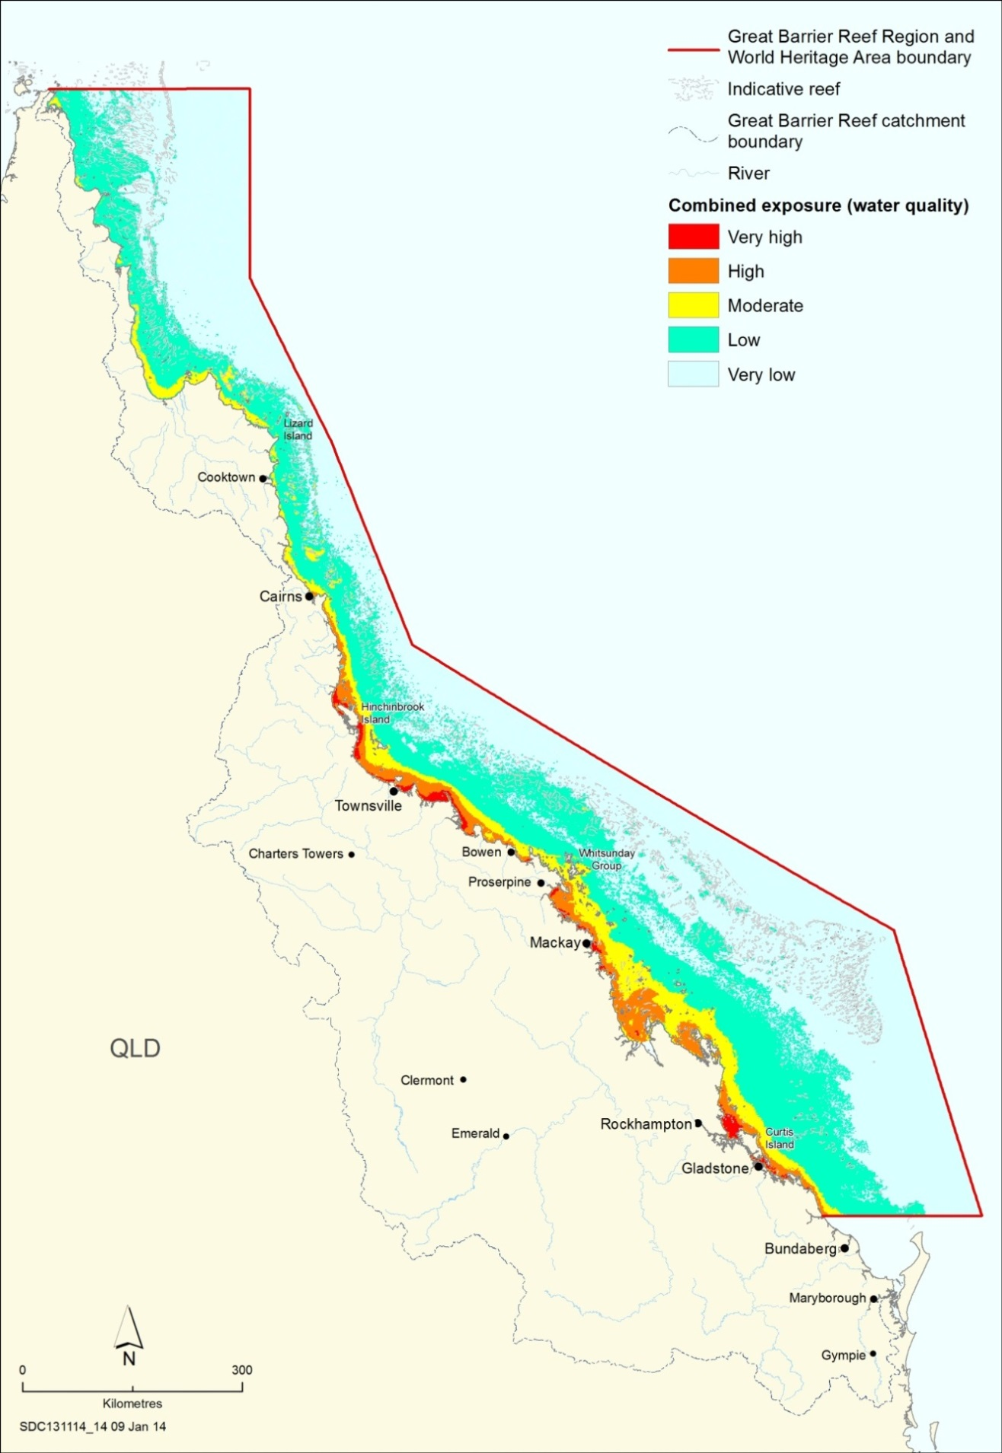
Figure 6.12 Exposure to key water quality factors
The map illustrates a combined assessment of: total suspended sediments (exceedance of 2 milligrams per litre and 6 milligrams per litre thresholds, 2002–2012, and average annual surface exposure, 2007–2011); nutrients (chlorophyll exceedance of 0.45 micrograms per litre thresholds, 2002–2012, and dissolved inorganic nitrogen average annual surface exposure, 2007–2011); PSII herbicide exposure, 2010–2011; and crown-of-thorns starfish initiation zone. Source: Brodie et al. 2013²⁰²
Nutrients Sources for nutrients into the Great Barrier Reef system include river discharges²⁰³, urban run-off^{204,205}, atmospheric input²⁰⁶, nitrogen fixation by marine organisms²⁰⁷, deep ocean supply from upwellings²⁰⁸, deposition of dust from storms and wind²⁰⁹, and resuspension of nearshore sediments^{210,211}. Of these, the single largest source is dissolved inorganic nutrients in river discharges²¹², largely derived from fertilisers lost through run-off. Nutrients are also transported as part of the sediment load bound to particulates (particulate nutrients).²¹³ More than 90 per cent of the river discharges occur during the wet season.^{205,214,215}
The nutrient load delivered to the Great Barrier Reef from its catchment is mainly derived from high intensity land use, fertilised cropping and urban areas. In particular, high intensity cropping is the major contributor of dissolved inorganic nitrogen. Particulate nitrogen, often bound to fine sediments, is by far the largest load of nitrogen entering the Great Barrier Reef.²¹⁶ When re-mineralised it becomes readily available for uptake in marine ecosystems.
Dissolved inorganic nitrogen and phosphorous continue to enter the Great Barrier Reef ecosystem at greatly enhanced levels compared to those prior to European settlement. Estimates based on 2013 modelling suggest the total nitrogen discharge into the Great Barrier Reef ecosystem has increased from 20,077 tonnes annually before European settlement (late 1800s) to 35,053 tonnes annually.²¹⁷ Similarly, it is estimated that total phosphorus discharge has increased from pre-European settlement loads of 2727 annually to 5849 based on 2013 modelling.²¹⁷
While the inshore ecosystem has always been exposed to higher concentrations of nutrients than further offshore, exposure inshore has substantially increased and is extending further offshore.^{202,218} Contemporary exposure of the Region to the nutrient nitrogen is presented in Figure 3.9.
Nutrients in the marine environment can be estimated by measuring chlorophyll concentrations, as the amount of planktonic algae containing chlorophyll in the water column is proportional to nutrient concentrations. Monitoring and modelling indicate that chlorophyll concentrations have exceeded the Water Quality Guidelines for the Great Barrier Reef Marine Park²¹⁹ in up to 10 to 15 per cent of the Region over the last decade (Figure 6.13).²²⁰ For much of the central and southern inshore environment, concentrations are frequently above the annual guidelines, with some areas more than double.

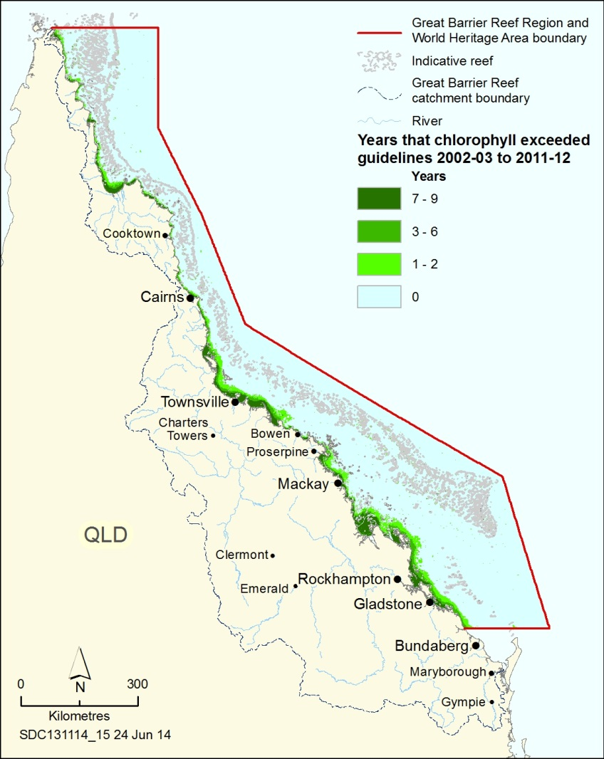
Figure 6.13 Years that chlorophyll concentrations exceeded guidelines, 2002–03 to 2011–12
The water quality guidelines for the Great Barrier Reef Marine Park use chlorophyll concentration as an indicator for nutrient concentrations in open waters. The guideline trigger value is an annual mean of 0.45 micrograms of chlorophyll per litre — an important ecological threshold for macroalgal cover and coral species richness. The map shows the number of years that the guideline value was exceeded between 2002–03 and 2011–12. Source: Brodie et al. 2012²⁰²

A key target of Reef Plan 2013¹⁹⁸ is to achieve a 50 per cent reduction in dissolved inorganic nitrogen loads entering the Great Barrier Reef by 2018. Total fertiliser use on farming lands in the catchment has been reduced in recent years (Figure 6.14) and monitoring and modelling show current initiatives are successfully reducing nutrient concentrations in land-based run-off. There was an estimated ten per cent reduction in nitrogen and a thirteen per cent reduction in total phosphorous loads as at June 2013, compared to the 2009 baseline year.²⁰⁰
Early evidence shows reductions in the load entering the marine system has resulted in reduced nutrient concentrations in open waters.^{221,222}
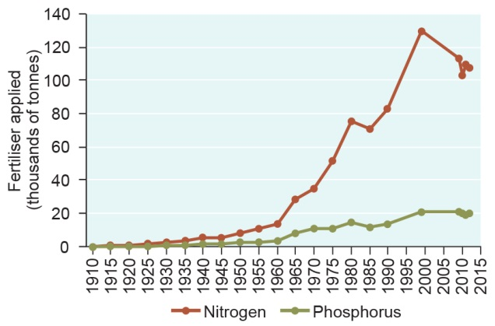
Figure 6.14 Fertiliser use in the catchment, 1910–2012
After decades of increasing fertiliser use in the Great Barrier Reef catchment, calculations indicate the amounts used are now lower or at least stabilising. Sources: The 1910 to 1990 data was derived from Pulsford 1996.²²³ The 1999 and 2009 to 2012 data points were estimated using 1999 and 2009 Queensland Land Use Mapping Program data²²⁴, the 2000 Fertilizer Industry Association of Australia application rates for different land uses²²⁵,and 1999–2012 Incitec Pivot published figures estimates of nutrient application rates in sugar production.²²⁶

However, the trajectory of reduction in the nutrient loads suggests that the present best management practices are unlikely to achieve the targets needed to address the impacts of the nutrients on the Great Barrier Reef ecosystem. The 2013 scientific consensus statement noted that ‘while current management interventions are starting to address water quality…. in addition to continuous improvement, transformational changes in some farming practices may be necessary to reach some targets’.²¹⁶
Sewage treatment plants occur along the length of the southern and central Great Barrier Reef coast. The Outlook Report 2009 highlighted that under Queensland Government policy all coastal sewage treatment plants that discharge into the coastal and marine waters were required to meet the most stringent treatment standards (tertiary treatment) by 2010. Most of the major population centres adjacent to the Great Barrier Reef, with the exception of Rockhampton, now have upgraded sewage treatment plants. Some upgrades are still underway in smaller population centres. The total cost of these upgrades has been between $600 and $700 million since the early 2000s, with investment from all levels of government and the community.
While inputs of nutrients from sewage treatment plants accounted for only a small percentage of the overall load entering the Region from the catchment¹¹⁰, the reductions gained through upgrades can be quite significant at a local scale. Sewage treatment upgrades in Townsville, for example, reduced the nitrogen load into Cleveland Bay from its catchment (the Black and Ross rivers) by around 42 per cent.^{227,228}
Sediments The Outlook Report 2009 reported estimates of a four to eight-fold increase in sediment loads since European settlement.²²⁹ Recent modelling has improved earlier estimates for both historical and contemporary loads, and suggests the suspended sediment load entering the Reef has increased to 7930 kilotonnes per year from the pre-European settlement load of 2931 kilotonnes.²¹⁷ The increase in sediment load is mainly due to soil erosion, exacerbated by poor land management practices and the highly variable rainfall patterns in some areas. In addition, hardened surfaces and straightened channels, as a result of urban and industrial development and agriculture, mean run-off has more erosive power, increasing stream bank erosion.
Much of the central and southern inshore area of the Region is now frequently affected by increased suspended solids (Figure 6.15 and see Figure 3.4). Most sediment is confined to the inner shelf and settles out of the water column within five to 15 kilometres of the coast^{230,231,232} where it may be later resuspended by wind-generated waves and currents. However, during flood events, suspended sediment may be carried further offshore. For example, during the 2010–11 wet season, when the Burdekin River had highly elevated discharge over 200 days, most sediment initially settled within approximately 10 kilometres of its river mouth, but some fine silt and clay was carried as far as 100 kilometres northward.²³³ These fine sediments also carry nutrients and other contaminants further into the Region.^{234,235}
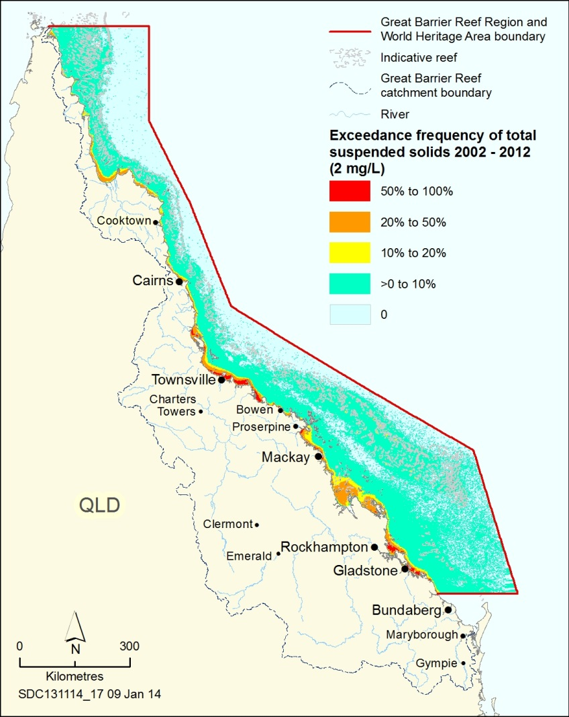
Figure 6.15 Frequency of total suspended solids above guidelines, 2002–2012
The map shows the proportion of valid daily observations that exceeded the total suspended solids guideline of two milligrams per litre in the Region. The period of observations extends from 1 November 2002 to 30 April 2012. Source: Brodie et al. 2013²⁰²

A key target of Reef Plan is to achieve, by 2018, a 20 per cent reduction in sediment loads entering the Region as a result of human activities. Improvements in land management practices have already achieved an eleven per cent decrease in the overall sediment load entering the Great Barrier Reef since 2009.¹⁹⁹ However, it takes time for any changes on land to translate into improved marine condition²³⁶, particularly given the lags in sediment transport and the strong influence of severe weather events in recent years.
Pesticides including herbicides, insecticides and fungicides, are used to kill or control pests and weeds in agricultural and urban environments and would have been absent from the Region’s environment prior to European settlement.²³⁷ It is estimated from 2013 modelling that at least 12,114 kilograms of herbicides are now introduced into the Region each year from diffuse source agricultural run-off.²¹⁷
Systematic monitoring of pesticide residues²³⁸ has shown widespread contamination by a range of pesticides in rivers, streams and estuaries that drain to the Region²³⁷, with the highest exposure around Mackay. This includes frequent exceedances of the Australian and New Zealand Water Quality Guidelines for fresh waters²³⁹ (often 10 to 50 times), for example atrazine and diuron, in some rivers.²⁴⁰ However, a 2013 risk assessment undertaken as part of the review of Reef Plan has shown that in the Region the highest pesticide risks are confined to only a couple of locations (Mackay region and the lower Burdekin area).²⁰² Concentrations of pesticides in waters around reefs remains generally very low.²⁴¹
Elevated herbicide concentrations in the Region (Figure 6.16) have been particularly linked with sugarcane cultivation in the adjacent catchment.^{242,243,244} Irrigation shortly after herbicide application is a major contributor to herbicide loss from farms.²⁴⁵ The sugarcane industry has taken initiatives, many funded through the Australian Government Reef Programme, to reduce herbicides in run-off²⁴⁶; resulting in good progress in reducing pesticide losses to the environment. There has been a 28 per cent pesticide load reduction across the Region and a 42 per cent reduction in the Mackay region, the highest risk area.¹⁹⁹
Other pollutants In addition to nutrients, sediments and pesticides, a number of additional pollutants generally associated with human development are currently, or likely to be, found in Great Barrier Reef waters. Examples include marine debris (including microplastics), pharmaceuticals and personal care products and trace metals.¹⁸⁵ As human populations along the coast grow, input levels may increase. There is little information or marine monitoring for most of these pollutants, other than marine debris.

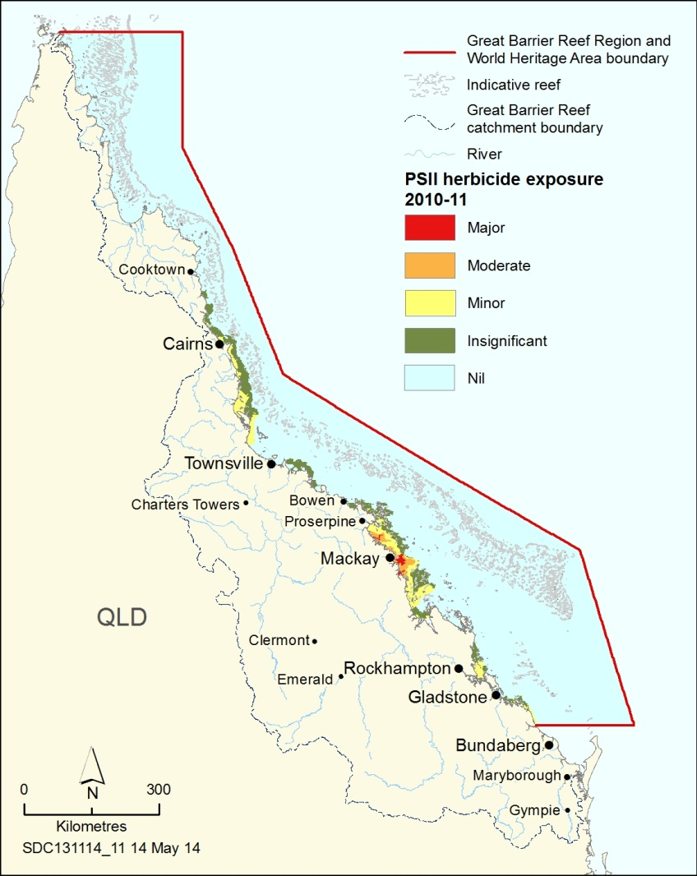
Figure 6.16 Modelled exposure of additive PSII herbicide residues, 2010–11
The map shows risk areas for photosystem II inhibiting (PSII) herbicide residue based on modelling. The model calculated additive PSII herbicide concentrations using end-of-river monitoring data. The established relationship between concentration of dissolved organic matter and salinity was applied to corresponding satellite images of flood plumes to predict the additive PSII concentrations. Conservative mixing processes in the Great Barrier Reef lagoon were assumed. Exposure categories were based on known toxicity thresholds for coral and seagrass species. Source: Lewis et al. 2013²⁴⁷

Common items of marine debris found within the Region are plastic bags, discarded fishing gear, plastic and glass bottles, rubber thongs, aerosols and drink cans.²⁴⁸ Plastic is the most prevalent type of marine debris found on beaches worldwide, comprising between 50 to 90 per cent by number of all debris items recorded.^{249,250,251,252} Between 2008 and March 2014, about 683,000 individual items of marine debris, weighing over 42 tonnes, were collected from the Region’s beaches by volunteers in the Australian Marine Debris Initiative.²⁴⁹ Marine debris from the catchment appears to accumulate and remain confined within the lagoon system of the Reef but with a northward movement.²⁴⁸ At the southern end of the Reef, debris appears to be more ocean-sourced.²⁴⁸ Stormwater run-off receives no treatment (other than gross pollutant traps for some drains) and therefore any chemicals or rubbish it contains can flow into creeks or rivers and into the marine environment. To improve the quality of stormwater and reduce marine debris, local councils are working with their communities and Queensland government agencies to better manage water flow, rubbish disposal and the use of chemicals.
[Photograph of a pavement stormwater drain painted with a colourful stencil stating ‘This drains to the Great Barrier Reef’. Caption: Townsville City Council, a Reef Guardian council, has stencilled entries to stormwater drains.]
Industrial discharge is subject to national, state and Great Barrier Reef-specific water quality guidelines that identify trigger levels on the discharge of chemicals such as metals, metalloids and non-metallic inorganics in wastewater.¹¹⁰ However, many facilities were built decades ago, with long-term permits containing a variety of conditions.
Marine pollutant benchmarking work in 2004 did not identify any significant toxic trace (‘heavy’) metal concentrations in the inshore waters of the Great Barrier Reef, especially when compared to levels in other Australian locations. Within the Region elevated levels of toxic trace metals have been reported at some sites around harbours and ports, but these are not necessarily above guideline levels.²³⁶ Trace metals often accumulate in the food chain; testing of tissues from deceased dugongs within the Region has generally found low levels by world standards.²⁵³
In mid-2012, following consecutive years of above average freshwater flow in the Burdekin region, 102 marine turtles stranded in a short period of time in Upstart Bay. Of these, 82 were already dead. Severe neurological symptoms were common in the turtles found alive. Exploratory testing of blood and tissue samples²⁵⁴ revealed cobalt levels potentially high enough to cause acute effects based on case studies in mammals^{255,256,257}; comparative information for reptiles is limited²⁵⁸. The source of the cobalt and the circumstances under which the exposure occurred are not yet known.
Some pollutants from historical mining activity in the catchment have reached the marine environment through land-based run-off, especially after periods of heavy rainfall. Sediment cores from inshore areas near Townsville have shown a spike in mercury of 25 times the background levels (before European settlement) that coincides with a period of intense gold mining in the adjacent catchment area (between 1870 and the early 1900s) when mercury was used in gold processing.²⁵⁹
Some small-scale extractive mining operations have previously released toxicants that have had severe effects, at least locally, in streams and creeks, for example arsenic associated with tin mining near Herberton.²⁶⁰ An emerging issue is the volume of water requiring disposal at mines and refineries after high rainfall events. A pilot program of allowing coal mine wastewater releases during flood conditions was implemented in the 2012–13 wet season for four coal mines in the catchment. This has subsequently been expanded to all coal mines within the Fitzroy basin.²⁶¹ It is anticipated that the results of monitoring associated with these releases²⁶² will improve understanding of the extent of any effects on water quality in the Region.
Freshwater flows La Niña conditions increased average annual rainfall and flood events between 2008 and 2012 (see Figure 3.3)³⁵, resulting in inshore areas of the Region being exposed to freshwater. Heavy rainfall events could become more frequent in future as the climate changes (Section 6.3.1)³⁷. Modifications to terrestrial habitats within the catchment (see Section 3.5) have affected the magnitude and timing of freshwater flows to the Region. For example natural flow has been altered and the velocity of discharges increased by infilling of wetlands, clearing of forests and woodlands, and constructing dams, levee banks, roads and stormwater drains.
Both the intensity and amount of rainfall and the velocity of freshwater flow affect how much sediment, nutrient, pesticide, plastic and other debris enters the Region from the land.

Vulnerability of the ecosystem to land-based run-off
Key message: Links between poor water quality and ecosystem health are now better understood.
Key message: Nutrient cycle imbalances are affecting the ecosystem.
Key message: Elevated sediment loads and resuspension reduce light and smother plants and animals.
Key message: Ecosystem effects of long-term exposure to pesticides are not well understood.
Key message: Marine debris washed from the land continues to affect the Region’s ecosystem.
Declining marine water quality, influenced by land-based run-off, is recognised as one of the most significant threats to the long-term health and resilience of the Great Barrier Reef.⁷³ It is contributing to declines in many of the attributes that make up the outstanding universal value of the world heritage property, particularly those related to coral reefs and seagrass meadows.
The 2013 scientific consensus statement⁷³ concluded that ‘the decline of marine water quality associated with terrestrial run-off from the adjacent catchments is a major cause of the current poor state of many of the key marine ecosystems of the Great Barrier Reef. ... The greatest water quality risks to the Great Barrier Reef are from nitrogen discharge, associated with crown-of-thorns starfish outbreaks and their destructive effects on coral reefs, and fine sediment discharge which reduces the light available to seagrass ecosystems and inshore coral reefs. Pesticides pose a risk to freshwater and some inshore and coastal habitats’.
Since the Outlook Report 2009, understanding of the effects of water quality changes on Great Barrier Reef species and habitats has continued to improve.⁷³ Research has strengthened evidence for causal relationships between water quality change and the ecosystem health of corals, seagrasses and mangroves, and for the effects of increased nutrients and sedimentation on the health and resilience of coral reefs.⁷³
Nutrients from land-based run-off are considered one of the greatest threats to the Reef ecosystem.²¹⁶ Once dissolved inorganic nutrients enter the marine system, they are taken up by phytoplankton, bacteria and seafloor plants such as macroalgae and seagrasses. The addition of excess nutrients, to a certain level, can increase productivity across large areas and if the conditions are right can increase the survival rates of certain species.^{213,263} This includes a variety of plants and animals in the marine system such as phytoplankton²⁶⁴, macroalgae that compete with corals^{220,265} and epiphytes that compete with seagrass²⁶⁶. An excess of nutrients can even lead to a change in the trophic status of an area of the marine environment and it is believed that this eutrophication is happening more regularly in the inshore waters of the Great Barrier Reef.^{213,267,268}
Examples of the consequences of imbalances in the nutrient cycle as a result of elevated nutrients include:
- extensive, observable phytoplankton blooms in flood discharges and likely shifts in the species composition of phytoplankton^{213,269}
- links to an increase in the frequency of crown-of-thorns starfish outbreaks (see Section 3.6.2)
- may contribute to a shift in the balance between macroalgal and coral abundance
- may make corals more sensitive to temperature stress^{270,271}
- may facilitate disease outbreaks in coral by increasing the virulence of their pathogens or reducing their immune responses^{272,273}; the nutrient organic carbon contributes to this effect²⁷⁴
- increased growth of phytoplankton, macroalgae and algal epiphytes that lower ambient light levels, thus increasing competition for light and reducing photosynthesis in seagrass²⁷⁵ and corals (particularly in deeper waters).
Sediments in land-based run-off have far-reaching effects on the Great Barrier Reef ecosystem. For example:
- Heavier erosion sediments infill freshwater stream beds and deep waterholes, with the reduced water depth affecting the distribution, abundance and recruitment of many freshwater species and some marine-related species such as sawfish²⁷⁶.
- Increases in suspended sediment are significantly altering light regimes — lower light levels reduce primary production in both the water column and on the seafloor.^{277,278}
- Increased amounts of sediments are settling on seafloor organisms such as seagrass and corals, making it harder or impossible for them to grow, survive and reproduce.^{279,280} This has significant flow-on effects to organisms and animals dependent on these habitats.
- In some areas increased fine sediments from land-based run-off have resulted in mangrove forests replacing beaches.³³
- The suspension and resuspension of sediments is increasing the turbidity of open waters and releasing additional nutrients previously bound up or buried in sediments.^{269,278,281}
Inshore areas, particularly in the southern two-thirds of the Region, frequently exceed the water quality guidelines threshold for suspended sediment concentrations of two milligrams per litre²¹⁹ (Figure 6.15). This threshold correlates strongly with declines in ecosystem condition such as increased growth of macroalgae.²⁸² Concentrations above 6.6 milligrams per litre have been linked with coral stress²⁸³, declines in seagrass cover²⁸⁴, fish habitat changes²⁸⁵, and home range movement²⁸⁶.
Pesticides in land-based run-off can have a negative impact on marine plants and animals.^{240,242} Herbicide concentrations in flood plumes that extend into the marine environment can exceed concentrations shown to have negative effects on certain species of coral, seagrass and microalgae and present risks to marine mammals.^{253,287,288,289,290} Despite this, current levels of pesticides are considered to be a low to moderate threat to inshore coral reefs generally, but the consequences of long-term exposure are not understood. The threat is likely to be higher in some regions, especially when pesticides are present in combination with other pollutants and stressors.²¹⁶
Generally, natural freshwater flows enhance estuarine productivity, provide connectivity between freshwater habitats and the sea, and improve fish recruitment and growth.²⁹¹ Maintaining natural freshwater flows can have positive effects, for example on breeding and recruitment of estuarine and marine fishes of commercial and recreational value including barramundi and king threadfin.^{292,293} However, increased freshwater inflow can have negative effects, for example low salinity bleaching and mortality in inshore corals⁸⁶ and widespread damage to seagrass meadows⁹⁵. Investigations show that the poor health observed in a range of fish species in Gladstone harbour during 2011 was likely to be the result of multiple pressures, but in particular overcrowding of fish after an overspilling of Awoonga Dam during a high flow event.¹⁵⁵ Examination of a 17-year dataset for the urban coast of Queensland found peak mortality of dugongs followed sustained periods of freshwater discharge and low air temperature.⁹⁶
While the contribution of key pollutants from terrestrial point source discharge is relatively small when compared to diffuse pollutant sources, the impacts can be locally significant.⁷³ There is no specific evidence linking pollutants such as heavy metals to declines in marine species in the Region, however they can persist for decades in the marine environment and have been shown elsewhere to disrupt reproduction, impair immune systems, affect neurological systems and cause cancers²⁹⁴.
Marine debris, including that introduced into the marine environment through land-based run-off, poses a significant threat to wildlife, including species of conservation concern. They can choke on it, ingest it, become entangled in it, or absorb chemicals from it.²⁹⁵ In Australia, plastic waste, including discarded fishing gear (for example nets, lines and ropes), is potentially one of the most harmful types of debris to marine wildlife because of ingestion and entanglement.^{296,297,298,299} Marine debris of all sorts can affect species and habitats throughout the Region.
Land-based run-off also plays a role in transporting terrestrial weed species onto islands within the Region.
[Photograph of debris washed up on a beach — with plastic bottles and other rubbish an obvious component. Copyright Chris Jones. Caption: Marine debris poses a significant threat to wildlife.]

Vulnerability of heritage values to land-based run-off
Key message: Many heritage values are vulnerable to the effects of land-based run-off.
Many of the Region’s heritage values, such as world and national heritage values, natural heritage values and Indigenous heritage values are vulnerable to the threats associated with land-based run-off through their effects on the ecosystem (Section 6.5.2). The threats associated with land-based run-off have affected many attributes that contribute to the outstanding universal value of the Reef, for example its coral reef and seagrass habitats and its underwater beauty.
Particularly in inshore areas of the southern two-thirds of the Region, underwater aesthetic values are being affected by overall declines in ecosystem condition. These values are also being diminished by increases in turbidity as a result of sediments and nutrients in land-based run-off, combined with marine debris. It is likely that increased sedimentation is also affecting underwater historic heritage such as shipwrecks and World War II artefacts.
Cultural practices have been affected by concerns about heavy metal contamination of species of cultural significance, resulting from terrestrial point source discharges. High levels of heavy metals have been detected in the livers of turtles in the Torres Strait³⁰⁰ and dugongs²⁵³, which could pose health risks to Indigenous people. In the Gladstone region, some Traditional Owners consider the health of turtles to be so poor they have stopped taking them as part of their cultural practices.³⁰¹

Implications of land-based run-off for regional communities
Key message: Ecosystem declines from poor water quality, particularly in inshore areas, affect Reef-dependent industries.
Key message: Enjoyment of the Region is likely being affected by water quality declines.
Declines in the ecosystem as a result of land-based run-off are likely to be affecting the income of Reef-dependent industries, especially commercial fishing and commercial marine tourism. Tourism operations are particularly affected by declines in coral reef ecosystems, such as those caused by increased sedimentation and increased nutrient concentrations. In addition, crown-of-thorns starfish outbreaks can diminish the biodiversity and natural beauty of high value tourism sites and therefore their attractiveness as a tourism destination. Increased turbidity may also affect the tourism industry as clear water is one of the main attributes valued by international and domestic visitors.¹²⁷
Land-based run-off can also affect social values such as the personal connections, enjoyment and appreciation of an area. In a 2013 survey of visitors to the Region, the most important motivations for their visit were those relating to the state of the ecosystem, for example clarity of water, iconic species, healthy reef fish and healthy coral reefs (see Figure 5.6).¹²⁷ Marine debris, especially on islands and beaches, is a major factor determining people’s enjoyment of the Reef environment. Catchment residents and tourists surveyed in 2013 regarding what they value about the Great Barrier Reef indicated a lack of rubbish as one of the most important aspects.¹²⁷
The need to improve the quality of land-based run-off flowing into the Great Barrier Reef is the major impetus for many community-based stewardship programs such as farmers and graziers taking actions to improve river habitats, minimise erosion and improve the effectiveness of fertiliser applications; local governments improving the quality of run-off from urban areas; and students building sustainable gardens and revegetating habitats.

Direct use
Direct use of the Region includes commercial marine tourism, defence activities, fishing, ports, recreation, research and educational activities, shipping and the traditional use of marine resources. The trends in direct uses are summarised from the relevant sections in Chapter 5. The analysis of the vulnerability of the Region’s values to direct use as a whole and its implications for regional communities are based on the evidence and assessments presented in Chapters 2, 3, 4 and 5.

Trends in direct use
Key message: Direct use activities continue to be a significant influence on the Region.
Commercial marine tourism From 2005 to 2011, the number of tourism visits to the Region generally decreased and in 2011 it was the lowest it had been for 13 years. Tourism visits have subsequently increased. Tourism activities and their associated threats to the Region’s values continue to be concentrated in a few popular, intensively managed areas. Despite the increasing financial pressures on the industry, there continues to be an increasing trend towards the achievement of high operating standards (environmental, economic and social), more tourists choosing to visit the Region on high standard operators, and contributions to monitoring and Reef stewardship. For all of Queensland, over the next decade, domestic tourism is predicted to grow at about 0.8 per cent annually³⁰² and international tourism at 4.2 per cent, with India and China as the principal drivers³⁰³. Most growth is likely to take place in regional areas³⁰³ such as the Great Barrier Reef.
Defence activities The Region is likely to remain an important training area for defence activities. The Australian Defence Force is enhancing its capabilities in amphibious landings. As a result, more frequent and intensive amphibious training exercises are expected in the Region, particularly in Shoalwater Bay and Cowley Beach training areas. The United States of America has shifted its global military focus to enhance its capabilities in the Asia–Pacific region. This will likely increase the frequency and intensity of combined training exercises. The importance of Shoalwater Bay and other sites in the Region for major exercises will also increase.
Fishing The Region is likely to continue to be an important resource for Queensland fisheries. Global fisheries trends influence those for the Great Barrier Reef. As wild-caught fisheries throughout the world continue to be fully exploited or over exploited³⁰⁴, the economic value of the Region’s fisheries resources, the pressure to exploit them (legally and illegally) and the demand for intensive aquaculture may increase.¹¹⁰ In addition, fishing effort may spread northwards in the Region to take advantage of catch availability and improving market access (due to improved infrastructure), or to offset other factors such as impacts of extreme weather and increasing recreational use close to urban areas. Economic factors such as fuel prices³⁰⁵ and the strength of the Australian dollar also influence patterns of commercial fishing operations.
The continuing increase in the number of registered vessels in the catchment, reflecting population and economic growth, is likely to translate into increases in recreational fishing effort. Likely ongoing improvements in vessel safety and navigation mean recreational fishers will be able to fish more remote areas.
Ports There has been major growth within ports in and adjacent to the Region over the past few decades and especially in recent years. From 2007–08 to 2011–12, trade volumes grew by over seven percent from 186 to 200 million tonnes per annum.³⁰⁶ The worldwide trend towards longer, deeper draft ships³⁰⁷ affects port access requirements, including increasing the need for dredging and infrastructure.
In relation to ports in and adjacent to the Region, the 2014 Queensland Ports Strategy³⁰⁸ sets out the Queensland Government’s intention to concentrate development in five nominated priority port development areas of which four are adjacent to the Region — Port of Gladstone, ports of Hay Point and Mackay, Port of Abbot Point and Port of Townsville. The aim is to maximise efficiencies and economic outcomes, while minimising environmental impacts. There is also a commitment to prohibit capital dredging for the development of any additional deepwater port facilities outside of the long-established major port areas until 2024.
Recreational use (not including fishing) The number of recreational visits from residents in the catchment appears to have risen substantially in recent years, most likely as a result of: population growth, an increase in the proportion of the population visiting the Region and a rise in the average number of visits each person makes.³⁰⁹ Continuing increases in the population in coastal areas adjacent to the Region and in the number of recreational vessels²¹ are likely to result in continued growth in recreational use. In addition, access to more isolated locations has been improved by developments in vessel safety and navigational technology.
Research and educational activities The Region is likely to continue to be an area of high scientific interest because of its ecological diversity, geomorphology and cultural heritage. Research will continue to make a substantial contribution to the way the Reef is understood, managed and used over coming decades. Technological changes are likely to continue to change both the way research and monitoring are conducted and the analysis of its results.
Continuing and expanding monitoring will play a key role in tracking trends in the Region’s values, the factors that are influencing them and the effectiveness of management actions.
Shipping The number of ship voyages undertaken through the Region has increased substantially over the past 10 years. Shipping in the Region is predicted to significantly increase over the next 10 to 15 years, with the number of vessel calls forecast to more than double by 2032.³¹⁰ This will be driven mainly by growth in the mining and liquefied natural gas industry which subsequently drive port expansions and increases in trade.¹⁵⁴
Traditional use of marine resources Traditional Use of Marine Resources Agreements and a marine Indigenous Land Use Agreement apply to approximately 13 per cent of the Region. This is likely to increase into the future given that additional Traditional Owner groups are working to develop agreements. With increased development in remote areas and changes to infrastructure, there is potential for the level and type of traditional use along the coast to change.
[Photograph of a marina full of yachts, taken from the air. Copyright Susan Sobtzick. Caption: Use of the Region for recreation is likely to increase with population growth.]

Vulnerability of the ecosystem to direct use
Key message: Understanding of threats from direct use has improved.
Key message: Dredging and disposal directly affect local areas; uncertainty remains around broader effects.
Key message: Fishing continues to affect the Region’s values, including discarded catch, incidental take and illegal fishing.
Key message: Increasing use of the Region will increase the likelihood of impacts.
Since the Outlook Report 2009, understanding of the threats associated with direct use has improved as has knowledge of some of their cumulative effects on the Region’s values. For example, recent modelling indicates that dredged material disposed at sea may be travelling further than previously expected.³¹¹ There is also better understanding of the risks of trawl fishing in the Region showing that, while the risks are generally low, some higher risks remain.³¹²
Except for activities associated with fishing and ports, direct uses of the Region are likely to be having relatively minor effects on the ecosystem on a Reef-wide scale. However, their cumulative effects can be significant on a local scale, especially when concentrated inshore and next to developed areas. Some uses continue to have positive benefits through improving understanding about the ecosystem and contributing to management.
Seagrass and lagoon floor habitats are removed, damaged or smothered at the sites of both dredging and disposal of dredge material. These activities can also cause behavioural changes, injury and mortality in dependent species, including in species of conservation concern. Habitats such as coral reefs, seagrass meadows and the lagoon floor and their dependent species are vulnerable to increases in the turbidity as a result of dredge sediment plumes and the resuspension of dredge material. The disposal of additional dredge material into the Region increases the risk of effects on vulnerable habitats and species.
[Photograph of a scoop lifting sediment out of the water as part of dredging operations. Caption: Dredging at the Port of Hay Point.]
Targeted species from various trophic levels are directly affected by extraction with flow-on effects in the ecosystem. Almost half the retained catch of the Region’s fisheries are predators. In addition to affecting the abundance of the targeted predator species in fished areas^{313,314}, their removal is likely to have long-term effects³¹⁵, including direct and indirect effects on the food chain³¹⁶. While there is currently only a small take of herbivores, significant increases could lead to effects higher up the food chain and changes in the abundance of plants, in turn affecting the balance of coral and algae for example. The ecosystem is still affected by the legacy of earlier commercial harvesting of larger herbivores such as dugongs and marine turtles. There can also be ecosystem-wide effects of extraction from unprotected spawning aggregations.³¹⁷
The benefits to the ecosystem from zoning and other management arrangements can be undermined by illegal fishing and poaching — a focus of compliance activities in the Region. In a number of areas dugongs, inshore dolphins and turtles are at risk of entanglement and drowning particularly because of illegal commercial netting.
Death and injury of discarded catch and the incidental catch of species of conservation concern during fishing operations, such as in the trawl and inshore net fisheries and the Queensland shark control program, can have severe effects on species and the broader ecosystem. Vulnerable species include dugongs, inshore dolphins and some species of sea snakes, seahorses, marine turtles, sharks and rays. Management requirements, such as bycatch reduction and turtle excluder devices in the trawl fishery, have reduced but not eliminated the risks to these species. Even low levels of mortality may cause population declines in species of conservation concern and compromise the ability of depleted populations to recover.
Various elements of the ecosystem are vulnerable to physical damage caused by direct use. The grounding of a large vessel can have significant and long-lasting environmental effects on a local area. As well as direct physical damage to the grounding site, toxic substances may be released including from antifouling paint and any cargo or oil spills. These can have damaging or lethal effects on marine life, significantly prolonging recovery times. Recognising the management and best practice arrangements in place, groundings of small vessels and the physical damage of reef structure caused by activities such as diving, snorkelling and anchoring are likely to cause only minor localised effects on the surrounding habitats.
Physical damage to seafloor is mainly caused by trawling and, more locally, anchoring. Seafloor habitats and seabed plants and animals are vulnerable to trawling, which may remove or damage a substantial proportion of seabed plants and animals in intensely trawled areas, with some taking decades to recover.^{318,319} However, few areas of the Region are trawled intensively, and overall habitat-level risks are generally low for seafloor habitats in lagoon areas.^{312,319} Sea floor habitats including seagrass meadows are vulnerable to the chronic localised impact of ships anchoring.³²⁰
Both large chemical spills and large oil spills could have regional and long-lasting effects on the ecosystem, including physical smothering and persistent effects on the health, growth, reproduction, development and survival of a range of marine plants and animals.³²¹ The vulnerability of the ecosystem to the effects of small spills varies depending on the type of spill and the local environmental conditions. They can be toxic on a local scale.
The ecosystem is vulnerable to a number of threats associated with vessel use. Surface-breathing marine animals such as marine turtles, dugongs, dolphins and whales are typically affected by vessel strikes, often resulting in injury or death. Waste discharged from vessels increases nutrients in the water column, but this is likely to be only a small portion of the additional nutrients in the system, resulting in only minor effects. Exotic species introduced on vessels could have regional effects on the ecosystem — the nature of those effects would depend on the species introduced. Some species can be affected by artificial light around vessels, for example pelagic fishes.³²²
A range of wildlife is vulnerable to marine debris, particularly plastics. They can become entangled in the debris or ingest it, potentially leading to choking, starving or absorbing leached chemicals.^{295,323,324,325,326} Plastic makes up about 90 per cent of the marine debris ingested by marine turtles in Queensland.²⁹⁹
Sound is extremely important to many marine animals, and increased underwater noise has been shown elsewhere to have a range of potential effects, including behavioural changes, hearing loss, physical injury and mortality.³²⁷

Vulnerability of heritage values to direct use
Key message: Indigenous heritage values are vulnerable to depletions in culturally significant species and incompatible uses.
Indigenous heritage values and cultural practices as well as natural heritage values and world heritage attributes relating to Traditional Owners’ interaction with the environment are severely affected by the declines in culturally significant species, partly attributable to past and present use of the Region. Examples of these species include dugongs, marine turtles, sea snakes, sharks, rays, some fish species, crayfish, oysters and clams. To varying degrees, these species are vulnerable to being injured or dying as incidental catch in fishing activities; direct extraction through commercial and recreational fishing; illegal fishing and poaching; vessel strike on wildlife; wildlife disturbance; and ingestion and entanglement in marine debris.
Cultural practices, the continuation of many types of Indigenous heritage values, and world heritage attributes relating to Traditional Owners’ interaction with the environment are vulnerable to increases in incompatible use in the Region, such as where other activities conflict with Traditional Owner cultural use of marine resources in the sea country areas where they express their native title rights.³²⁸
The lack of identification and management for many underwater wrecks and Indigenous sites of significance, story places and songlines makes them vulnerable to activities that cause damage to reef structures, damage to the seafloor or modify coastal habitats.
The aesthetic value of seascapes and islands may be diminished as a result of marine debris and spills.³²⁹ Attributes such as tranquillity, solitude and remoteness are affected by artificial light and noise pollution³²⁹, including that arising from vessel activity and in anchorage areas³²⁰.
The vulnerability of those attributes that make up the world heritage property’s outstanding universal value matches that described for the ecosystem (Section 6.6.2) and for Indigenous heritage values and aesthetics above.

Implications of direct use for regional communities
Key message: Use of the Region maintains people’s connections to it.
Key message: If predicted increases in use are not well managed, instances of incompatible uses will rise.
The economic and social components of the Great Barrier Reef are intrinsically linked to its ecosystem — the future of each depends on the future of the others.
For the Reef-dependent industries, their economic benefit is derived from the Region’s natural resources, either through extraction of those resources or through tourism and recreation focused on its ecosystem and heritage values. Any future declines in the condition of those values are likely to have economic implications for those industries. As a result, they are particularly vulnerable to threats that affect the long-term health of the Region. For example, the tourism industry continues to be concerned about overall declines in the ecosystem and the potential loss of the Reef’s world heritage status. Most recently, they have expressed particular concern about the effects of port development, including dredging and the disposal of dredge material³³⁰.
For other uses, such as ports and shipping, there is less likely to be a direct connection between them and the Region’s values and they are therefore unlikely to be directly affected by changes in Reef condition. Their economic value is largely driven by factors external to the Region such as global demand for resources.
Most local residents visit the Region.¹⁴⁴ Use of the Region for recreation, traditional use of marine resources, fishing and commercial marine tourism is the way many of the social benefits, such as understanding and appreciation, enjoyment, personal connection, and health benefits, are realised. Many individuals and communities maintain strong connections with the Reef, through culture, occupation or familiarity.³³¹ Aboriginal and Torres Strait Islander culture and connections are kept alive in large part by visiting and caring for their land and sea country.
If not properly managed, predicted increases in use of the Region may result in incompatible uses at particular sites becoming an emerging issue. For example, there are reports of incompatibility between the high density of ships in anchorage areas and fishing and tourism activities.³²⁰

Assessment summary — Factors influencing the Region’s values
Section 54(3)(g) of the Great Barrier Reef Marine Park Act 1975 requires '… an assessment of the factors influencing the current and projected future environmental, economic and social values…' of the Great Barrier Reef Region. Regulation 116A(2)(e) of the Great Barrier Reef Marine Park Regulations 1983 requires ‘… an assessment of the factors influencing the current and projected future heritage values…’ of the Great Barrier Reef Region.
The assessment is based on four assessment criteria:
- impacts on ecological values
- impacts on heritage values
- impacts on economic values
- impacts on social values.

Impacts on ecological values
Outlook Report 2009: Assessment summary
Climate change, particularly rising sea temperatures and ocean acidification, has already affected the Great Barrier Reef ecosystem and over the next 50 years it is likely to significantly affect most components of the ecosystem. The Great Barrier Reef, especially much of its inshore area, is being affected by increased nutrients, sediments and other pollutants in catchment runoff, mainly from diffuse agricultural sources, despite recent advances in agricultural practices. Coastal development is contributing to the modification and loss of coastal habitats that support the Great Barrier Reef. As the coastal population continues to grow there will be increasing use of the Great Barrier Reef and therefore the potential for further damage. Direct use of the Region is impacting on some environmental values.

Assessment component | Assessment summary | Grade 2009 | Grade 2014 and trend since 2009 | Future trend | Confidence
 |  |  |  |  | Grade | Trend
Climate change | Climate change is predicted to continue to have far-reaching consequences for the Reef ecosystem and over the next 50 years it is likely to significantly affect most components. Future predictions indicate sea level rises and temperature increases will continue, the pH of the ocean will gradually decline and weather will be more severe. | Very high impact | Very high impact,  Increased | Increasing | Adequate | Adequate
Coastal development | Modification of terrestrial habitats that support the Great Barrier Reef is likely to continue based on the projected changes in the catchment. Changes to coastal habitats and reductions in connectivity affect the Region’s ecosystem. | High impact | High impact,  Increased | Increasing | Adequate | Adequate
Land-based run-off | Inshore areas are particularly at risk from poor water quality. Agricultural practices in the catchment are improving and there have been reductions in the nutrient, sediment and pesticide loads from the catchment entering the Region. There is likely to be a significant lag before water quality improvements are measured in the Region. Marine debris continues to affect the ecosystem — including species of conservation concern. | High impact | High impact,  Decreased | Decreasing | Adequate | Adequate
Direct use | Fishing continues to affect the Region's values such as through discarded catch; incidental catch of species of conservation concern; overfishing and illegal fishing. Increasing port activities directly affect local areas; uncertainty remains around ecosystem effects. Increasing regional populations and economic development will likely increase direct use and therefore the likelihood of impacts. | Low impact | Low impact,  Increased | Increasing | Limited | Limited
Impact on ecological values | Climate change has already affected the Great Barrier Reef ecosystem. Its effects are compounding the ongoing impacts from land-based run-off and coastal development, particularly loads of sediments and nutrients entering the Region and the modification of supporting coastal habitats. Direct uses contribute to a range of impacts; most are localised. Economic and population growth will likely mean more use of the Region, increasing the likelihood of impacts. The combined influence of the four factors is concentrated in inshore central and southern areas. | High impact | High impact  Increased | Increasing

Grading statements
Very low impact | Few or no impacts have been observed and accepted predictions indicate that future impacts on the Region’s ecological values are likely to be minor.
Low impact | Some minor impacts have already been observed and there is concern that, based on accepted predictions, there will be significant but localised impacts on the Region’s ecological values.
High impact | Current and predicted future impacts are likely to significantly affect the Region’s ecological values. Concern about serious ecosystem effects within next 20–50 years.
Very high impact | Current and predicted future impacts are likely to irreversibly destroy much of the Region’s ecological values. Widespread and serious ecosystem effects likely within next 10–20 years.
Trend
Trend since 2009: Increased, Stable, Decreased, No consistent trend
Future trend: Increasing, Stable, Decreasing, No consistent trend
Confidence in impact and trend
Adequate | Adequate high-quality evidence and high level of consensus
Limited | Limited evidence or limited consensus
Inferred | Inferred, very limited evidence

Impacts on heritage values
Outlook Report 2009: Not assessed

Assessment component | Assessment summary | Grade 2009 | Grade 2014 and trend since 2009 | Future trend | Confidence
 |  |  |  |  | Grade | Trend
Climate change | The vulnerability of the ecosystem to climate change flows through to dependent heritage values, especially the Reef’s outstanding universal value, natural heritage values and Indigenous heritage values. Altered weather patterns and sea level rise increase the risks to built structures such as lightstations, shipwrecks and fish traps. | Not assessed | Very high impact | Increasing | Limited | Limited
Coastal development | Modification of coastal areas affects the Reef’s outstanding universal value, altering supporting habitats and connecting processes, and affecting scenic vistas. Coastal development has affected Indigenous heritage values. Unidentified nearshore historic heritage values are vulnerable to modification and reclamation of the coast, dredging and disposal of dredge material. | Not assessed | High impact | Increasing | Limited | Limited
Land-based run-off | Many of the Region’s heritage values, including its outstanding universal value, are vulnerable through the ecosystem effects of land-based run-off, especially in central and southern inshore areas. Water quality declines and marine debris are likely to be diminishing the Region’s natural beauty. Increased sedimentation may be affecting underwater wrecks. | Not assessed | High impact | Decreasing | Adequate | Limited
Direct use | Uses such as fishing and ports are affecting some attributes that contribute to the outstanding universal value of the world heritage property. Heritage values are affected by physical damage and pollution as a result of direct use. Indigenous heritage values are especially vulnerable to depletions in culturally significant species and incompatible uses. | Not assessed | Low impact | Increasing | Adequate | Limited
Impact on heritage values | Impacts on the ecosystem are reflected in declines in related heritage values, especially Indigenous heritage, natural heritage and world and national heritage values. Attributes of outstanding universal value relating to natural beauty, natural phenomena, ecological processes, and habitats and species are being affected. For built heritage, the threats from climate change and direct use are the most serious. | Not assessed | High impact | Increasing

Grading statements
Very low impact | Few or no impacts have been observed and accepted predictions indicate that future impacts on the Region’s heritage values are likely to be minor.
Low impact | Some minor impacts have already been observed and there is concern that, based on accepted predictions, there will be significant but localised impacts on the Region’s heritage values.
High impact | Current and predicted future impacts are likely to significantly affect the Region’s heritage values. Concern about serious effects on the Region’s heritage values within next 20–50 years.
Very high impact | Current and predicted future impacts are likely to irreversibly destroy much of the Region’s heritage values. Widespread and serious effects on the Region’s heritage values likely within next 10–20 years.
Trend
Trend since 2009: New assessment for this report; no trend provided.
Future trend: Increasing impact, Stable impact, Decreasing impact, No consistent trend
Confidence in impact and trend
Adequate | Adequate high-quality evidence and high level of consensus
Limited | Limited evidence or limited consensus
Inferred | Inferred, very limited evidence

Impacts on economic values
Outlook Report 2009: Assessment summary
Changes to the Great Barrier Reef ecosystem are likely to have serious economic implications for reef-dependent industries, such as tourism and fishing, and for adjacent communities. Perceptions about the health of the ecosystem also affect its attractiveness for tourism and recreation and, thus, its marketability. An increasing coastal population is likely to increase the economic value of Reef-based activities. The economic benefits of direct use will be affected by the impacts of external factors.

Assessment component | Assessment summary | Grade 2009 | Grade 2014 and trend since 2009 | Future trend | Confidence
 |  |  |  |  | Grade | Trend
Climate change | Climate change effects on the ecosystem are expected to have major economic consequences for Reef-dependent industries. . | High impact | High impact,  Increased | Increasing | Limited | Adequate
Coastal development | An increasing coastal population and improved coastal infrastructure is likely to increase the economic worth of uses in the Region. The loss of ecosystem services provided by coastal habitats will ultimately affect the value of Reef-dependent industries. | Low impact | Low impact,  No consistent trend | No consistent trend | Limited | Limited
Land-based run-off | Ecosystem declines from poor water quality, particularly in inshore areas, affect Reef-dependent industries. Outbreaks of crown-of-thorns starfish can affect the viability of tourism operations. | High impact | High impact,  Decreased | Decreasing | Limited | Limited
Direct use | Direct use of the Region continues to be a significant contributor to regional and national economies. The future value of many uses depends on a healthy, intact ecosystem. | Very low impact | Very low impact,  Stable | Stable | Adequate | Limited
Impact on economic values | Changes to the Great Barrier Reef ecosystem have serious economic implications for Reef-dependent industries, such as tourism and fishing, and for adjacent communities. Perceptions about the health of the ecosystem affect its attractiveness for tourism and recreation. An increasing coastal population is likely to increase the economic value of direct uses. | High impact | High impact, Increased | Increasing

Grading statements
Very low impact | Few or no impacts have been observed and accepted predictions indicate that future impacts on the Region’s economic values are likely to be minor.
Low impact | Some minor impacts have already been observed and there is concern that, based on accepted predictions, there will be significant but localised impacts on the Region’s economic values.
High impact | Current and predicted future impacts are likely to significantly affect the Region’s economic values. Concern about serious effects on the Region’s economic values within next 20–50 years.
Very high impact | Current and predicted future impacts are likely to irreversibly destroy much of the Region’s economic values. Widespread and serious effects on the Region’s economic values likely within next 10–20 years.
Trend
Trend since 2009: Increased impact, Stable impact, Decreased impact, No consistent trend
Future trend: Increasing impact, Stable impact, Decreasing impact, No consistent trend
Confidence in impact and trend
Adequate | Adequate high-quality evidence and high level of consensus
Limited | Limited evidence or limited consensus
Inferred | Inferred, very limited evidence

Impacts on social values
Outlook Report 2009: Assessment summary
An increasing coastal population is likely to increase recreational use of the Region and change people’s experiences of the Great Barrier Reef with increased congestion at popular recreation locations and competition for preferred sites. A decline in inshore habitats as a result of polluted water will have social implications for dependent industries and coastal communities. Traditional Owners are concerned about rising temperatures altering the seasonality and availability of marine resources as well as the potential loss of totemic species.

Assessment component | Assessment summary | Grade 2009 | Grade 2014 and trend since 2009 | Future trend | Confidence
 |  |  |  |  | Grade | Trend
Climate change | Climate-related changes to the ecosystem could affect patterns of use of the Great Barrier Reef and visitor satisfaction. People’s awareness of the potential effects of climate change is increasing their concern about the ecosystem. The vulnerability of Reef-dependent individuals and businesses depends on their ability to anticipate and adapt to change. | High impact | High impact  Increased | Increasing | Limited | Limited
Coastal development | Access to the Region improves through development of coastal infrastructure. Social benefits such as enjoyment, appreciation and understanding of the Reef’s values depend on healthy coastal and marine ecosystems. | Low impact | Low impact  Stable | Stable | Limited | Limited
Land-based run-off | The effects of land-based run-off on the ecosystem can influence social values such as the aesthetics, personal connection, enjoyment and appreciation. | Low impact | Low impact  Decreased | Decreasing | Limited | Limited
Direct use | The Great Barrier Reef continues to be valued well beyond its local communities, with strong national and international interest. Use of the Region maintains people’s connections to it. If predicted increases in use are not well managed, instances of incompatible uses will rise. | Low impact | Low impact  Stable | Stable | Limited | Limited
Impact on social values | Declining ecosystem condition, especially inshore adjacent to the developed coast, from the cumulative effects of many factors mean people’s attachment to and enjoyment of the Region may lessen in the future. This may have flow-on effects on Reef-dependent industries. Predicted increasing use may mean more instances of incompatible use. | Low impact | Low impact, Increased | Increasing

Grading statements
Very low impact | Few or no impacts have been observed and accepted predictions indicate that future impacts on the Region’s social values are likely to be minor.
Low impact | Some minor impacts have already been observed and there is concern that, based on accepted predictions, there will be significant but localised impacts on the Region’s social values.
High impact | Current and predicted future impacts are likely to significantly affect the Region’s social values. Concern about serious effects on the Region’s social values within next 20–50 years.
Very high impact | Current and predicted future impacts are likely to irreversibly destroy much of the Region’s social values. Widespread and serious effects on the Region’s social values likely within next 10–20 years.
Trend
Trend since 2009: Increased impact, Stable impact, Decreased impact, No consistent trend
Future trend: Increasing impact, Stable impact, Decreasing impact, No consistent trend
Confidence in impact and trend
Adequate | Adequate high-quality evidence and high level of consensus
Limited | Limited evidence or limited consensus
Inferred | Inferred, very limited evidence

Overall summary of factors influencing the Region's values
The factors influencing the Region’s ecosystem and its heritage values remain the same as the Outlook Report 2009, namely climate change, coastal development, land-based run-off and direct use of the Region. Understanding of their current and likely future effects has improved, especially for coastal development and land-based run-off.
The threats arising from these multiple factors, both those external to the Great Barrier Reef as well as within the Region, are having increasing and cumulative effects on the ecosystem as well as heritage, economic and social values. Coastal development and land-based run-off are having a high impact on ecological and heritage values. The influence of direct use activities within the Region is notable, but is assessed to be of lower impact overall. The projected, far-reaching, impacts from climate change are likely to ultimately overshadow the effects of other factors and uses. Addressing the other factors, which can be more directly managed, will improve the resilience of the Region’s values to any future impacts of a changing climate.
Climate change is already affecting the Region’s physical, ecological and social environment. Climate change will drive global changes in ocean pH and prominent weather events and characteristics such as temperature, cyclones, heavy rainfall, droughts, and prevailing winds. The global climate system is now warmer and moister than it was 50 years ago, and this influences the likelihood of significant weather events. Recent cyclones, hot spells and high rainfall events have demonstrated the capacity that ongoing changes to the Region’s climate have to significantly affect ecosystem and heritage values. In addition, climate change has implications for all the other influencing factors and their trends into the future.
The continuing increasing trends in climate change variables means that it is likely to bean increasingly important factor in the Region. Addressing the other, more directly managed, factors influencing the Region’s values will improve the resilience of these values to any future impacts of a changing climate.
Coastal development continues to be associated with modification and loss of coastal habitats and disruption to ecological connectivity. Additionally, while there have not been broadscale changes in land use patterns in recent years, the legacy effects of past land clearing and associated practices are still a significant influence on the Region. Activities related to resource extraction have continued to expand and, as a result, there has been major growth in port activity. Coastal development can provide social and economic benefits through improved infrastructure and ability for more people to experience the Region.
Sediments, nutrients, pesticides and other pollutants entering the Region in land-based run-off remain key issues for the Region. Valuable advances have been made in reducing contemporary inputs from diffuse agricultural sources. At a point-source scale, almost all major sewage treatment plants have been upgraded. The legacy of past land management practices continues to be an ongoing impact. Knowledge has increased around marine debris and its implications for the Region. Multiple stewardship programs and activities in the catchment and the Region are focused on monitoring and improving water quality and reducing the impacts of threats like marine debris.
A multitude of direct use activities occur in the Region. Most are likely to be having relatively minor effects on the Region’s values at a Reef-wide scale. However, their contribution to cumulative effects can be significant. Fishing occurs across much of the Region. It affects both the species extracted and those that are discarded (particularly species of conservation concern). This results in flow-on effects for other levels in the food web and other parts of the ecosystem.
There is an increased understanding of the drivers of change in the use of the Great Barrier Reef catchment and Region. Many of these have positive and negative flow-on effects to the Region’s values. There is also an increased recognition and understanding of social and economic values associated with the Region.
Continued population growth, driven in part by a strong economy, is predicted to lead to increased, mainly recreational, use of the Region. However this also brings challenges with increases in illegal activities and, the potential for people’s enjoyment to be compromised by incompatible uses at popular sites. Conversely, an increase in recreational use is likely to drive positive economic effects in regional economies from the flow-on purchases associated with visiting the Reef.

References
1. State of the Environment 2011 Committee Australia state of the environment 2011: Independent report to the Australian Government Minister for Sustainability, Environment, Water, Population and Communities, Department of Sustainability, Environment, Water, Population and Communities, Canberra.
2. Great Barrier Reef Marine Park Authority 2013, Great Barrier Reef Region strategic assessment: Strategic Assessment Report. Draft for public comment, GBRMPA, Townsville.
3. Queensland Department of Employment, Economic Development and Innovation 2012, Queensland in the 21st Century, DEEDI, Brisbane, <http://www.business.qld.gov.au/invest/benefits-business-queensland/queenslands-pro-business-economy>.
4. Binney, J. 2012, The economic and social impacts of protecting environmental values in the Great Barrier Reef catchment waterways and the reef lagoon, Report prepared for Queensland Department of Environment and Heritage Protection, Marsden Jacob Associates, Brisbane.
5. Queensland Government 2013, Queensland Commission of Audit, Queensland Government, Brisbane.
6. Australian Bureau of Statistics 2013, Australian National Accounts: State Accounts, 2012-13. Table 1. Gross State Product, chain volume measures and current prices. Time series spreadsheet, cat. no. 5220.0, ABS, Canberra. This material has been used under a Creative Commons Attribution 2.5 Australia licence.
7. Garton, P., Gaudry, D. and Wilcox, R. 2012, Understanding the appreciation of the Australian dollar and its policy implications, Key Themes from Treasury's Business Liaison Program (79): 39-61.
8. Deloitte Access Economics 2013, Economic contribution of the Great Barrier Reef, Great Barrier Reef Marine Park Authority, Townsville.
9. Perez, E., Jenkins, H., Price, L., Donnelly, R. and Conn, W. 2011, Joint submission to the productivity commission issues paper: Barriers to effective climate change adaptation, Queensland Seafood Industry Association, Brisbane.
10. Great Barrier Reef Marine Park Authority 2012, Informing the outlook for Great Barrier Reef coastal ecosystems, GBRMPA, Townsville.
11. Department of State Development, Infrastructure and Planning 2013, Cape York Region Plan. Draft for consultation, DSDIP, Brisbane.
12. Office of Economic and Statistical Research 2012, Population and dwelling profile: Townsville City Council, Queensland Treasury and Trade, Brisbane.
13. Queensland Treasury and Trade 2013, Estimated resident population by local government area (LGA) Queensland, 2002-2012, Queensland Government, <http://www.oesr.qld.gov.au/products/tables/erp-lga-qld/index.php>.
14. Government Statistician 2013, Queensland Regional Profile: GBR LGAs Region, Queensland Treasury and Trade, Brisbane.
15. Australian Bureau of Statistics 2013, 3222.0 - Population projections, Australia, 2012 (base) to 2101, ABS, Canberra. This material has been used under a Creative Commons Attribution 2.5 Australia licence
16. Queensland Government Statistician's Office 2014, Queensland Government population projections, 2013 edition (data from 2011 to 2036), Queensland Treasury and Trade, Brisbane, Brisbane.
17. Queensland Government Statistician's Office 2014, Queensland Regional Database: population estimates 1991 to 2012 and population projections 2011 to 2036: local government areas (2014) and Statistical Area Level 2, Queensland Treasury and Trade, Brisbane, <http://www.qgso.qld.gov.au/products/qld-regional-database/qld-regional-database/index.php>.
18. Australian Bureau of Statistics 2013, Regional population growth, Australia. 2012-13 cat no. 3218.0,Australian Bureau of Statistics, Canberra. This material has been used under a Creative Commons Attribution 2.5 Australia licence., <http://www.abs.gov.au/AUSSTATS/abs@.nsf/ProductsbyCatalogue/797F86DBD192B8F8CA2568A9001393CD?OpenDocument>.
19. Queensland Government Statistician's Office 2014, Projected population by (medium series), by five-year age group (males, females, and persons), by local government area, Queensland, 2011 to 2036, Queensland Treasury and Trade, Brisbane, <http://www.qgso.qld.gov.au/products/tables/proj-pop-medium-series-age-group-sex-lga-qld/index.php>.
20. Office of Economic and Statistical Research 2013, Data tables: Project dwellings (medium series) by local government area, Queensland, 30 June, 2006 to 2031, Queensland Treasury and Trade, Brisbane, <http://www.oesr.qld.gov.au/products/tables/proj-dwellings-medium-series-lga-qld/index.php>.
21. Queensland Government (Unpublished data), 'Vessel Registration Data by LGA for December 2000, 2006 and 2011. Vessel Registration Data by Postcode for 2007, 2009, 2011. Data retrieved from Department of Transport and Main Roads (DTMR) Transport Registration And Integrated Licensing System (TRAILS)'.
22. Reef Water Quality Protection Plan Secretariat 2013, Great Barrier Reef second report card 2010, Reef Water Quality Protection Plan Secretariat, Brisbane.
23. Oliver, D.P., Anderson, J.S., Davis, A., Lewis, S., Brodie, J. and Kookana, R. 2014, Banded applications are highly effective in minimising herbicide migration from furrow-irrigated sugar cane, Science of the Total Environment 466: 841-848.
24. McCombs, M. 2004, Setting the agenda: The mass media and public opinion, Polity Press, Cambridge, UK.
25. Goldberg, J., Marshall, N.A., Gooch, M., Birtles, A., Bohensky, E., Curnock, M., Parry-Husbands, H., Pert, P., Stone-Jovicich, S., Tobin, R.C. and Villani, C. 2013, National Environmental Research Program SELTMP 2013: the Great Barrier Reef national survey, CSIRO.
26. Trigger, D., Schubert, M. and Meurk, C. Unpublished, Shifting baselines in the non-scientific literature, Great Barrier Reef Marine Park Authority, Townsville.
27. Greenpeace 2014, Petition against the expansion of the coal industry and its effects on the Great Barrier Reef, <http://www.savethereef.org.au/>.
28. Get up 2014, Petition to prevent the current dredging project from damaging the Great Barrier Reef and threatening its status as a World Heritage Site, <https://www.getup.org.au/campaigns/coal-seam-gas/great-barrier-reef/save-the-reef>.
29. Avaaz 2014, Petition to protect the Great Barrier Reef from damaging dredging and dumping including the Abbot Point port extension and other similar projects, Avaaz, <https://secure.avaaz.org/en/australian_coal_disaster_global/>.
30. Rhein, M., Rintoul, S.R., Aoki, S., Campos, E., Chambers, D., Feely, R., Gulev, S., Johnson, G., Josey, S., Kostianoy, A., Mauritzen, C., Roemmich, D., Talley, L. and Wang, L. 2013, Chapter 3. Observations: Ocean, in Climate Change 2013: The physical science basis. Contribution of Working Group I to the Fifth Assessment Report of the Intergovernmental Panel on Climate Change, ed. T.F. Stocker, D. Qin, G.-K. Plattner, M. Tignor, S.K. Allen, J. Boschung, A. Nauels, Y. Xia, V. Bex and P.M. Midgley, Cambridge University Press, UK, pp. 255-315.
31. Intergovernmental Panel on Climate Change 2013, Summary for Policymakers, in Climate Change 2013: The Physical Science Basis. Contribution of Working Group I to the Fifth Assessment Report of the Intergovernmental Panel on Climate Change, ed. T.F. Stocker, et al., Cambridge University Press, Cambridge, United Kingdom, pp. 1-27.
32. Hoegh-Guldberg, O., Cai, R., Brewer, P.G., Fabry, V.J., Hilmi, K., Jung, S., Poloczanska, E., Bell, J., Brown, C.J., Burrows, M.T., Cao, L., Donner, S., Eakin, C.M., Eide, A., Halpern, B., McClain, C.R., McKinnell, S., O'Connor, M., Parmesan, C., Perry, R.I., Richardson, A.J., Schoeman, D., Signorini, S., Skirving, W., Stone, D., Sydeman, W., Zhang, R. and Hooidonk, R. 2014, Chapter 30. The ocean, in Climate Change 2014: Impacts, Adaptation, and Vulnerability. Contribution of Working Group II to the Fifth Assessment Report of the Intergovernmental Panel on Climate Change, pp. 138.
33. Field, C.B., Barros, V.R., Mastrandrea, M.D., Mach, K.J., Abdrabo, M.A., Adger, W.N., Anokhin, Y.A., Anisimov, O.A., Arent, D.J., Barnett, J., Burkett, V.R., Cai, R., Chatterjee, M., Cohen, S.J., Cramer, W., Dasgupta, P., Davidson, D.J., Denton, F., Doll, P., Dow, K., Hijioka, Y., Hoegh-Guldberg, O., Jones, R.G., Jones, R.N., Kitching, R.L., Kovats, R.S., Lankao, P.R., Larsen, J.N., Lin, E., Lobell, D.B., Losada, I.J., Magrin, G.O., Marengo, J.A., Markandya, A., McCarl, B.A., McLean, R.F., Mearns, L.O., Midgley, G.F., Mimura, N., Morton, J.F., Niang, I., Noble, I.R., Nurse, L.A., O'Brien, K.L., Oki, T., Olsson, L., Oppenheimer, M., Overpeck, J.T., Pereira, J.J., Poloczanska, E.S., Porter, J.R., Portner, H., Prather, M.J., Pulwarty, R.S., Reisinger, A.R., Revi, A., Ruppel, O.C., Satterthwaite, D.E., Schmidt, D.N., Settele, J., Smith, K.R., Stone, D.A., Suarez, A.G., Tschakert, P., Valentini, R., Villamizar, A., Warren, R., Wilbanks, T.J., Wong, P.P., Woodward, A. and Yohe, G.W. 2014, Summary for policymakers, in Climate Change 2014: Impacts, adaptation, and Vulnerability. Contribution of Working Group II to the Fifth Assessment Report of the Intergovernmental Panel on Climate Change, pp. 1-44.
34. Reisinger, A., Kitching, R., Chiew, F., Hughes, L., Newton, P., Schuster, S., Tait, A., Whetton, P., Barnett, J., Becken, S., Blackett, P., Boulter, S., Campbell, A., Collins, D., Davies, J., Dear, K., Dovers, S., Finlay, K., Glavovic, B., Green, D., Gunasekera, D., Hales, S., Handmer, J., Harmsworth, G., Hobday, A., Howden, M., Hugo, G., Jones, D., Jackson, J., King, D., Kirschbaum, M., Luck, J., MsDonald, J., McInnes, K., Maru, Y., Mustelin, J., Norman, B., Pearce, G., Peoples, S., Preston, B., Reser, J., Reyenga, P., Stafford-Smith, M., Wang, X. and Webb, L. Chapter 25. Australasia, in Climate Change 2014: Impacts, Adaptation, and Vulnerability. Contribution of Working Group II to the Fifth Assessment Report of the Intergovernmental Panel on Climate Change, ed. B. Fitzharris and D. Karoly, pp. 1-101.
35. Johnson, J.E., Maynard, J.A., Devlin, M.J., Wilkinson, S., Anthony, K.R.N., Yorkston, H., Heron, S.F., Puotinen, M.L. and van Hooidonk, R. 2013, Resilience of Great Barrier Reef marine ecosystems and drivers of change, in Synthesis of evidence to support the Reef Water Quality Scientific Consensus Statement 2013, Department of the Premier and Cabinet, Brisbane.
36. Emanuel, K. 2003, Tropical cyclones, Annual Review of Earth and Planetary Sciences 31: 75-104.
37. Steffen, W., Hughes, L. and Karoly, D. 2013, The critical decade: Extreme weather, Climate Commission Secretariat, Canberra.
38. Cai, W., Borlace, S., Lengaigne, M., van Rensch, P., Collins, M., Vecchi, G., Timmermann, A., Santoso, A., McPhaden, M.J., Wu, L., England, M.H., Wang, G., Guilyardi, E. and Jin, F. 2014, Increasing frequency of extreme El Niño events due to greenhouse warming, Nature Climate Change 4: 111-116.
39. Hartmann, D.L., Klein Tank, M.G., Rusticucci, M., Alexander, L.V., Bronnimann, S., Charabi, Y.A., Dentener, F.J., Dlugokencky, E.J., Easterling, D.R., Kaplan, A., Soden, B.J., Thorne, P.W., Wild, M. and Zhai, P. 2013, Observations: atmosphere and surface, in Climate Change 2013: The Physical Science Basis. Contributions of Working Group I to the Fifth Assessment Report of the Intergovernmental Panel on Climate Change, ed. T.F. Stocker, et al., Cambridge University Press, UK, pp. 159-254.
40. Ciais, P., Sabine, C., Bala, G., Bopp, L., Brovkin, V., Canadell, J., Chhabra, A., DeFries, R., Galloway, J., Heimann, M., Jones, C., Le Quere, C., Myneni, R.B., Piao, S. and Thornton, P. 2013, Carbon and other biogeochemical cycles, in Climate Change 2013: The Physical Science Basis. Contributions of Working Group I to the Fifth Assessment Report of the Intergovernmental Panel on Climate Change, ed. T.F. Stocker, et al., Cambridge University Press, UK, pp. 465-570.
41. Dlugokencky, E. & Tans, P. 2014, Trends in atmospheric carbon dioxide: Recent global CO₂, Earth System Research Laboratory, National Oceanic and Atmospheric Administration, <http://www.esrl.noaa.gov/gmd/ccgg/trends/global.html>.
42. Moss, R., Babiker, M., Brinkman, S., Calvo, E., Carter, T., Edmonds, J., Elgizouli, I., Emori, S., Erda, L., Hibbard, K., Jones, R., Kainuma, M., Kelleher, J., Lamarque, J.F., Manning, M., Matthews, B., Meehl, J., Meyer, L., Mitchell, J., Nakicenovic, N., O’Neill, B., Pichs, R., Riahi, K., Rose, K.S., Runci, P., Stouffer, R., van Vuuren, D., Weyant, J., Wilbanks, T., van Ypersele, J.P. and Zurek, M. 2008, Towards new scenarios for analysis of emissions, climate change, impacts, and response strategies, Intergovernmental Panel on Climate Change, Geneva.
43. Prather, M., Flato, G., Friedlingstein, P., Jones, C., Lamarque, J.F., Liao, H. and Rasch, P. 2013, Annex II: Climate system scenario tables, in Climate Change 2013: The Physical Science Basis. Contributions of Working Group I to the Fifth Assessment Report of the Intergovernmental Panel on Climate Change, ed. T.F. Stocker, et al., Cambridge University Press, UK, pp. 1395-1445.
44. Whetton, P. 2011, Chapter 3: Future Australian climate scenarios, in Climate Change: Science and Solutions for Australia CSIRO, pp. 35-44.
45. Lough, J., Gupta, A.S. and Hobday, A.J. 2012, Temperature, in A marine climate change impacts and adaptation report card for Australia 2012, ed. E.S. Poloczanska, et al., CSIRO, Canberra, pp. 1-26.
46. Australian Government Bureau of Meteorology and CSIRO 2014, State of the climate report 2014, Commonwealth of Australia.
47. Intergovernmental Panel on Climate Change 2007, Climate change 2007 synthesis report, Summary for policymakers, IPCC Secretariat, Gland, Switzerland.
48. Church, J.A., Clark, P.U., Cazenave, A., Gregory, J.M., Jevrejeva, S., Levermann, A., Merrifield, M.A., Milne, G.A., Nerem, R.S., Nunn, P.D., Payne, A.J., Pfeffer, W.T., Stammer, D. and Unnikrishnan, A.S. 2013, Sea level change, in Climate Change 2013: The Physical Science Basis. Contributions of Working Group I to the Fifth Assessment Report of the Intergovernmental Panel on Climate Change, ed. T.F. Stocker, et al., Cambridge University Press, UK, pp. 1137-1216.
49. Australian Government Bureau of Meteorology 2014, Annual climate report 2013, Commonwealth of Australia, Melbourne.
50. Church, J.A., White, N.J., Hunter, J.R. and McInnes, K.L. 2012, Sea level, in A marine climate change impacts and adaptation report card for Australia 2012, ed. E.S. Poloczanska, et al., CSIRO, Canberra, pp. 27-46.
51. Hobday, A.J. and Lough, J.M. 2011, Projected climate change in Australian marine and freshwater environments, Marine and Freshwater Research 62(9): 1000-1014.
52. Ridgway, K. and Hill, K. 2012, East Australian Current, in A marine climate change impacts and adaptation report card for Australia 2012, ed. E.S. Poloczanska, et al., CSIRO, Canberra, pp. 47-60.
53. Dowdy, A.J., Mills, G.A., Timbal, B. and Wang, Y. 2013, Changes in the risk of extratropical cyclones in Eastern Australia, Journal of Climate 26: 1403-1417.
54. Abbs, D. 2012, The impact of climate change on the climatology of tropical cyclones in the Australia region, Working Paper No.11, CSIRO Climate Adaptation Flagship.
55. Christensen, J.H., Kanikicharla, K.K., Aldrian, E., An, S., Cavalcanti, I.F.A., de Castro, M., Dong, W., Goswami, P., Hall, A., Kanyanga, J.K., Kitoh, A., Kossin, J., Lau, N., Renwick, J., Stephenson, D.B., Xie, S. and Zhou, T. 2013, Climate phenomena and their relevance for future regional climate change, in Climate Change 2013: The Physical Science Basis. Contributions of Working Group I to the Fifth Assessment Report of the Intergovernmental Panel on Climate Change, ed. T.F. Stocker, et al., Cambridge University Press, UK, pp. 1217-1308.
56. Kirtman, B., Power, S.B., Adedoyin, A.J., Boer, G.J., Bojariu, R., Camilloni, I., Doblas-Reyes, F., Fiore, A.M., Kimoto, M., Meehl, G., Prather, M., Sarr, A., Schar, C., Sutton, R., van Oldenborgh, G.J., Vecchi, G. and Wang, H. 2013, Near-term climate change: projections and predictability, in Climate Change 2013: The Physical Science Basis. Contributions of Working Group I to the Fifth Assessment Report of the Intergovernmental Panel on Climate Change, ed. T.F. Stocker, et al., Cambridge University Press, UK, pp. 953-1028.
57. Bureau of Meteorology 2013, 'Unpublished data - past tropical cyclone tracks. http://www.bom.gov.au/cyclone/history/index.shtml'.
58. Devlin, M., Harkness, P., McKinna, L. and Waterhouse, J. 2011, Mapping the surface exposure of terrestrial pollutants in the Great Barrier Reef. Report to the Great Barrier Reef Marine Park Authority, Australian Centre for Tropical and Freshwater Research, Townsville.
59. Maynard, J.A., Johnson, J.C., Beeden, R., Puotinen, M., Devlin, M., Dryden, J. and Marshall, P. 2014, Historic and projected future exposure of habitats in the Great Barrier Reef Marine Park to disturbances. Draft Report, Great Barrier Reef Marine Park Authority, Townsville.
60. Lough, J.M. 2011, Great Barrier Reef coral luminescence reveals rainfall variability over northeastern Australia since the 17th century, Paleoceanography 26(2): PA2201.
61. Bureau of Meteorology 2013, The 2010-11 La Niña: Australia soaked by one of the strongest events on record, Bureau of Meteorology, <http://www.bom.gov.au/climate/enso/feature/ENSO-feature.shtml>.
62. Holbrook, N.J., Brown, J.N., Davidson, J., Feng, M., Hobday, A.J., Lough, J.M., McGregor, S., Power, S.B. and Risbey, J.S. 2012, El Niño-Southern Oscillation, in A marine climate change impacts and adaptation report card for Australia 2012, ed. E.S. Poloczanska, et al., CSIRO, Canberra, pp. 81-112.
63. Redondo-Rodriguez, A., Weeks, S.J., Berkelmans, R., Hoegh-Guldberg, O. and Lough, J.M. 2012, Climate variability of the Great Barrier Reef in relation to the tropical Pacific and El Niño-Southern Oscillation, Marine and Freshwater Research 63(1): 34-47.
64. Oliver, J.K., Berkelmans, R. and Eakin, C.M. 2009, Coral bleaching in space and time, in Coral bleaching: Patterns, processes, causes and consequences, ed. M.J.H. van Oppen and J.M. Lough, Springer, Berlin, pp. 21-40.
65. Spillman, C.M., Alves, O. and Hudson, D.A. 2011, Seasonal prediction of thermal stress accumulation for coral bleaching in the tropical oceans, Monthly Weather Review 139: 317-331.
66. Goreau, T., McClanahan, T., Hayes, R. and Strong, A. 2000, Conservation of coral reefs after the 1998 global bleaching event, Conservation Biology 14(1): 5-15.
67. Hoegh-Guldberg, O. 1999, Climate change, coral bleaching and the future of the world's coral reefs, Marine and Freshwater Research 50(8): 839-866.
68. De'ath, G., Fabricius, K.E., Sweatman, H. and Puotinen, M. 2012, The 27–year decline of coral cover on the Great Barrier Reef and its causes, Proceedings of the National Academy of Sciences 109(44): 17995-17999.
69. Koch, M., Bowes, G., Ross, C. and Zhang, X. 2013, Climate change and ocean acidification effects on seagrasses and marine macroalgae, Global Change Biology 19(1): 103-132.
70. Doropoulos, C., Ward, S., Diaz-Pulido, G., Hoegh-Guldberg, O. and Mumby, P.J. 2012, Ocean acidification reduces coral recruitment by disrupting intimate larval-algal settlement interactions, Ecology Letters 15(4): 338-346.
71. Poloczanska, E.S., Brown, C.J., Sydeman, W.J., Kiessling, W., Schoeman, D.S., Moore, P.J., Brander, K., Bruno, J.F., Buckley, L.B., Burrows, M.T., Duarte, C.M., Halpern, B.S., Holding, J., Kappel, C.V., OConnor, M.I., Pandolfi, J.M., Parmesan, C., Schwing, F., Thompson, S.A. and Richardson, A.J. 2013, Global imprint of climate change on marine life, Nature Climate Change 3: 919-925.
72. Johnson, J.E. and Marshall, P.A. (eds) 2007, Climate change and the Great Barrier Reef: a vulnerability assessment, Great Barrier Reef Marine Park Authority and Australian Greenhouse Office, Townsville.
73. Brodie, J., Waterhouse, J., Schaffelke, B., Kroon, F., Thorburn, P., Rolfe, J., Johnson, J., Fabricius, K., Lewis, S., Devlin, M., Warne, M. and McKenzie, L.J. 2013, 2013 Scientific Consensus Statement: Land use impacts on Great Barrier Reef water quality and ecosystem conditions, Reef Water Quality Protection Plan Secretariat, Brisbane.
74. Chambers, L.E., Devney, C.A., Congdon, B.C., Dunlop, N., Woehler, E.J. and Dann, P. 2011, Observed and predicted effects of climate on Australian seabirds, Emu 111(3): 235-251.
75. Lough, J. 2007, Climate and climate change on the Great Barrier Reef, in Climate change and the Great Barrier Reef: A vulnerability assessment, eds. J.E. Johnson and P.A. Marshall, Great Barrier Reef Marine Park Authority and Australian Greenhouse Office, Townsville, pp. 15-50.
76. Peck, D.R., Smithers, B.V., Krockenberger, A.K. and Congdon, B.C. 2004, Sea surface temperature constrains wedge-tailed shearwater foraging success within breeding seasons. Marine Ecology Progress Series 281: 259-266.
77. Chambers, L.E., Dann, P., Devney, C., Dunlop, N. and Woehler, E.J. 2012, Seabirds, in A marine climate change impacts and adaptation report card for Australia 2012, ed. E.S. Poloczanska, et al., 2012 Report Card, CSIRO, Canberra.
78. Cantin, N.E. and Lough, J.M. 2014, Surviving coral bleaching events: Porites growth anomalies on the Great Barrier Reef, PLoS One. 9(2): e8872.
79. Berkelmans, R., De'ath, G., Kininmonth, S. and Skirving, W.J. 2004, A comparison of the 1998 and 2002 coral bleaching events on the Great Barrier Reef: Spatial correlation, patterns and predictions, Coral Reefs 23(1): 74-83.
80. De'ath, G., Lough, J.M. and Fabricius, K.E. 2009, Declining coral calcification on the Great Barrier Reef, Science 323(5910): 116-119.
81. De'ath, G., Fabricius, K. and Lough, J. 2013, Yes: Coral calcification rates have decreased in the last twenty-five years! Marine Geology 346: 400-402.
82. Hoegh-Guldberg, O., Mumby, P.J., Hooten, A.J., Steneck, R.S., Greenfield, P., Gomez, E., Harvell, C.D., Sale, P.F., Edwards, A.J., Caldeira, K., Knowlton, N., Eakin, C.M., Iglesias-Prieto, R., Muthiga, N., Bradbury, R.H., Dubi, A. and Hatziolos, M.E. 2007, Coral reefs under rapid climate change and ocean acidification, Science 318: 1737-1742.
83. van Hooidonk, R., Maynard, J.A. and Planes, S. 2013, Temporary refugia for coral reefs in a warming world, Nature Climate Change 3(4): 508-511.
84. Hamann, M., Grech, A., Wolanski, E. and Lambrechts, J. 2011, Modelling the fate of marine turtle hatchlings, Ecological Modelling 222: 1515-1521.
85. Osborne, K., Dolman, A.M., Burgess, S.C. and Johns, K.A. 2011, Disturbance and the dynamics of coral cover on the Great Barrier Reef (1995–2009), PLoS ONE 6(3): e17516.
86. Berkelmans, R., Jones, A.M. and Schaffelke, B. 2012, Salinity thresholds of Acropora spp. on the Great Barier Reef, Coral Reefs 31: 1103-1110.
87. Pollard, P.C. and Greenway, M. 2013, Seagrasses in tropical Australia, productive and abundant for decades decimated overnight, Journal of Biosciences 38(1): 157-166.
88. Petus, C., Collier, C., Devlin, M.J., Rasheed, M. and McKenna, S. 2014, Using MODIS data for understanding changes in seagrass meadow health: a case study in the Great Barrier Reef (Australia), Marine Environmental Research 98: 68-85.
89. Collier, C., Devlin, M.J., Langlois, L., Petus, C., McKenzie, L. and Waycott, M. In Review, Thresholds and indicators of declining water quality as tools for tropical seagrass management. Report to the National Environmental Research Program, Reef and Rainforest Research Centre Limited, Cairns.
90. McKenzie, L.J., Collier, C. and Waycott, M. 2014, Reef Rescue Marine Monitoring Program: Inshore seagrass. Annual report for the sampling period 1st July 2012 - 31st May 2013, TropWATER, James Cook University, Cairns.
91. Poloczanska, E.S., Hobday, A.J. and Richardson, A.J. 2012, Marine climate change in Australia, impacts and adaptation responses. 2012 report card, CSIRO, Canberra.
92. Bustamante, R.H., Skewes, T.D., Hobday, A., Williams, K.J., Dunlop, M. and Poloczanska, E. 2012, Queensland's biodiversity under climate change: coastal and marine ecosystems. Climate Adaptation Flagship Working Paper #12E, CSIRO.
93. Jones, A.M. and Berkelmans, R. 2014, Flood impacts in Keppel Bay, Southern Great Barrier Reef in the aftermath of cyclonic rainfall, PLoS ONE 9(1): e84739.
94. Roff, G., Clark, T.R., Reymond, C.E., Zhao, J., Feng, Y., McCook, L.J., Done, T.J. and Pandolfi, J.M. 2013, Palaeoecological evidence of a historical collapse of corals at Pelorus Island, inshore Great Barrier Reef, following European settlement, Proceedings of the Royal Society B: Biological Sciences 280(1750): 2012-2100.
95. McKenzie, L.J., Collier, C. and Waycott, M. 2012, Reef Rescue Marine Monitoring Program: Inshore seagrass, annual report for the sampling period 1st July 2010 – 31st May 2011, Fisheries Queensland, Cairns.
96. Meager, J.J. and Limpus, C. 2014, Mortality of inshore marine mammals in Eastern Australia is predicted by freshwater discharge and air temperature, PLoS ONE 9(4): e94849.
97. Folke, C., Carpenter, S., Walker, B., Scheffer, M., Elmqvist, T., Gunderson, L. and Holling, C. 2004, Regime shifts, resilience, and biodiversity in ecosystem management, Annual Review of Ecology, Evolution, and Systematics 35: 557-581.
98. Doney, S.C., Fabry, V.J., Feely, R.A. and Kleypas, J.A. 2009, Ocean acidification: the other CO₂ problem, Annual Review of Marine Science 1: 169-192.
99. Anthony, K.R.N., Kline, D.I., Diaz-Pulido, G., Dove, S. and Hoegh-Guldberg, O. 2008, Ocean acidification causes bleaching and productivity loss in coral reef builders, Proceedings of the National Academy of Sciences 105(45): 17442-17446.
100. Pandolfi, J.M., Connolly, S.R., Marshall, D.J. and Cohen, A.L. 2011, Projecting coral reef futures under global warming and ocean acidification, Science 333(6041): 418-422.
101. Anthony, K.R.N. and Marshall, P. 2012, Coral Reefs, in A marine climate change impacts and adapation report card Australia 2012, ed. E.S. Poloczanska, et al., CSIRO, Canberra, pp. 259-280.
102. van Hooidonk, R., Maynard, J.A., Manzello, D. and Planes, S. 2014, Opposite latitudinal gradients in projected ocean acidification and bleaching impacts on coral reefs, Global Change Biology 20(1): 103-112.
103. Fabricius, K.E., Langdon, C., Uthicke, S., Humphrey, C., Noonan, S., De'ath, G., Okazaki, R., Muehllehner, N., Glas, M. and Lough, J.M. 2011, Losers and winners in coral reefs acclimatized to elevated carbon dioxide concentrations, Nature Climate Change 1: 165-169.
104. Howard, W.R., Nash, M., Anthony, K., Schmutter, K., Bostock, H., Bromhead, D., Byrne, M., Currie, K., Diaz-Pulido, G., Eggins, S., Ellwood, M., Eyre, B., Haese, R., Hallegraeff, G., Hill, K., Hurd, C., Law, C., Lenton, A., Matear, R., McNeil, B., McCulloch, M., Muller, M.N., Munday, P., Opdyke, B., Pandolfi, J.M., Richards, R., Robersts, D., Russell, B.D., Smith, A.M., Tilbrook, B., Waite, A. and Williamson, J. 2012, Ocean acidification, in A marine climate change impacts and adaptation report card for Australia 2012, ed. E.S. Poloczanska, et al., CSIRO, Canberra, pp. 113-150.
105. Anthony, K.R.N., Maynard, J.A., Diaz-Pulido, G., Mumby, P.J., Marshall, P.A., Cao, L. and Hoegh-Guldberg, O. 2011, Ocean acidification and warming will lower coral reef resilience, Global Change Biology 17: 1798-1808.
106. Morison, A.K. and Pears, R.J. 2012, Assessment of the ecological vulnerability of the East Coast Otter Trawl Fishery to climate change: a brief synthesis of information and results of an expert workshop, Great Barrier Reef Marine Park Authority, Townsville.
107. Pratchett, M., Messmer, V., Reynolds, A., Clark, T., Munday, P., Tobin, A.J. and Hoey, A. 2013, Effects of climate change on reproduction, larval development, and adult health of coral trout (Plectopomus spp). FRDC project No:2010/554, Fisheries Research and Development Coorporation.
108. Johnson, V.R., Russell, B.D., Fabricius, K.E., Brownlee, C. and Hall‐Spencer, J.M. 2012, Temperate and tropical brown macroalgae thrive, despite decalcification, along natural CO2 gradients, Global Change Biology 18(9): 2792-2803.
109. Porzio, L., Buia, M.C. and Hall-Spencer, J.M. 2011, Effects of ocean acidification on macroalgal communities, Journal of experimental marine biology and ecology 400(1): 278-287.
110. Great Barrier Reef Marine Park Authority 2009, Great Barrier Reef outlook report 2009, GBRMPA, Townsville.
111. Department of Environment and Resource Management 2011, Queensland coastal processes and climate change, Queensland Climate Change Centre of Excellence, Brisbane.
112. Rogers, K., Saintilan, N. and Copeland, C. 2012, Modelling wetland surface elevation dynamics and its application to forecasting the effects of sea level rise on estuarine wetlands, Ecological Modelling 244: 148-157.
113. Fuentes, M.M.P.B., Limpus, C.J., Hamann, M. and Dawson, J. 2010, Potential impacts of projected sea-level rise on sea turtle rookeries, Aquatic Conservation: Marine and Freshwater Ecosystems 20(2): 132-139.
114. Chambers, L.E., Hughes, L. and Weston, M.A. 2005, Climate change and its impact on Australia's avifauna, Emu 105: 1-20.
115. Brodie, J., Binney, J., Fabricius, K., Gordon, I., Hoegh-Guldberg, O., Hunter, H., O’Reagain, P., Pearson, R., Quirk, M., Thorburn, P., Waterhouse, J., Webster, I. and Wilkinson, S. 2008, Scientific consensus statement on water quality in the Great Barrier Reef, Reef Water Quality Protection Plan Secretariat, Brisbane.
116. Great Barrier Reef Marine Park Authority 2011, Extreme weather and the Great Barrier Reef, GBRMPA, Townsville.
117. Great Barrier Reef Marine Park Authority and Queensland Parks and Wildlife Service 2011, Field management program annual report 2010-11: field operations in the Great Barrier Reef World Heritage Area., Great Barrier Reef Marine Park Authority and Queensland Parks and Wildlife Service.
118. Schlacher, T.A., Dugan, J., Schoeman, D.E., Lastra, M., Jones, A., Scapini, H., McLachlan, A. and Defeo, O. 2007, Sandy beaches at the brink, Diversity and Distributions 13(5): 556-560.
119. Hadwen, W.L., Capon, S.J., Poloczanska, E., Rochester, W., Martin, T., Bay, L., Pratchett, M., Green, J., Cook, B., Berry, A., Lalonde, A. and Fahey, S. 2011, Climate Change responses and adaptation pathways in Australian coastal ecosystems: Synthesis Report, National Climate Change Adaptation Research Facility, Australia.
120. Lucrezi, S., Schlacher, T. and Robinson, W. 2010, Can storms and shore armouring exert additive effects on sandy-beach habitats and biota? Marine and Freshwater Research 61(9): 951–962.
121. Rist, P. 2011, Students learn first hand impacts of climate change on Indigenous communities, Media release, Great Barrier Reef Marine Park Authority, Townsville, <http://www.gbrmpa.gov.au/archive/archive-media-releases/media-releases-2009/students-learn-first-hand-impacts-on-climate-change-on-indigenous-communities>.
122. Fairfax Media 2011, Clans agree to stop dugong hunting, September 9, Sydney Morning Herald, Sydney.
123. Pickrell, J. 2011, Aboriginal groups impose dugong hunting ban, September 13, Australian Geographic Society, Sydney.
124. Bird, M.K. 1992, The impact of tropical cyclones on the archaeological record: An Australian example, Archaeology in Oceania 27(2): 75-86.
125. Environmental Policy and Planning Division 2013, The impact of severe tropical cyclone Yasi on the wreck of the SS Yongala, Department of Environment and Heritage Protection, Brisbane.
126. Australian National University 2009, Implications of climate change for Australia’s World Heritage properties: A preliminary assessment, A report to the Department of Climate Change and the Department of the Environment, Water, Heritage and the Arts. Fenner School of Environment and Society, the Australian National University, Canberra.
127. Stoeckl, N., Farr, M. and Sakata, H. 2013, What do residents and tourists value most in the GBRWHA? Project 10-2 Socioeconomic systems and reef resilience: Interim report on residential and tourist data collection activities including descriptive data summaries, Reef and Rainforest Research Centre Limited, Cairns.
128. Williams, K.J., Dunlop, M., Bustamante, R.H., Murphy, H.T., Ferrier, S., Wise, R.M., Liedloff, A., Skewes, T., Harwood, T.D., Kroon, F., Williams, R.J., Joehnk, K., Crimp, S., Stafford Smith, M., James, C. and Booth, T. 2012, Queensland's biodiversity under climate change: impacts and adaptation – synthesis report. A report prepared for the Queensland Government, Brisbane, CSIRO Climate Adaptation Flagship, Canberra.
129. The Climate Institute 2013, Climate of the Nation 2013: Australian attitudes on climate change, The Climate Institute, Sydney.
130. McEvoy, D. and Mullett, J. 2013, Enhancing the resilience of seaports to a changing climate: Research synthesis and implications for policy and practice. Work Package 4 of Enhancing the resilience of seaports to a changing climate report series, National Climate Change Adaptation Research Facility, Gold Coast.
131. Queensland Government 2010, Disaster Management Strategic Policy Framework, The State of Queensland (Emergency Management, Department of Community Safety) 2010, Brisbane.
132. National Climate Change Adaptation Research Facility 2013, Policy Guidance Brief 10: Emergency management and climate change adaptation, National Climate Change Adaptation Research Facility, Gold Coast.
133. Kinnear, S., Patison, K., Mann, J., Malone, E. and Ross, V. 2013, Network governance and climate change adaptation: Collaborative responses to the Queensland floods, National Climate Change Adaptation Research Facility, Gold Coast.
134. National Climate Change Adaptation Research Facility 2013, Policy Guidance Brief 9: Managing heatwave impacts under climate change, National Climate Change Adaptation Research Facility, Gold Coast.
135. Baker, A.C., Glynn, P.W. and Riegl, B. 2008, Climate change and coral reef bleaching: an ecological assessment of long-term impacts, recovery trends and future outlook, Estuarine, Coastal and Shelf Science 80(4): 435-471.
136. Miles, R.L., Kinnear, S., Marshal, C., O'Dea, G. and Greer, L. 2009, Assessing the socio-economic implications of climate change (coral bleaching) in the Great Barrier Reef catchment. Synthesis report prepared for the Marine and Tropical Sciences Research Facility, Reef and Rainforest Research Centre Limited, Cairns.
137. Tourism Industry Council 2008, Climate change response manual for Great Barrier Reef Marine Park operators, TIC, Brisbane.
138. Kikkawa, T., Kita, J. and Ishimatsu, A. 2004, Comparison of the lethal effect of carbon dioxide and acidification on red sea bream (Pagrus major) during the early developmental stages, Marine Pollution Bulletin 48(1-2): 108-110.
139. Ishimatsu, A., Kikkawa, T., Hayashi, M., Lee, K. and Kita, J. 2004, Effects of carbon dioxide on marine fish: larvae and adults, Journal of Oceanography 60(4): 731-741.
140. Guinotte, J.M. and Fabry, V.J. 2008, Ocean acidification and its potential effects on marine ecosystems, Annals of the New York Academy of Sciences 1134(1): 320-342.
141. Fenton, M., Kelly, G., Vella, K. and Innes, J. 2007, Climate change and the Great Barrier Reef: industries and communities, in Climate change and the Great Barrier Reef: a vulnerability assessment, eds. J.E. Johnson and P.A. Marshall, Great Barrier Reef Marine Park Authority and Australian Greenhouse Office, Townsville, pp. 745-771.
142. Tobin, A.J., Schlaff, R., Tobin, R., Penny, A., Ayling, T., Ayling, A., Krause, B., Welch, D., Sutton, S., Sawynok, B., Marshall, N.A., Marshall, P.A. and Maynard, J.A. 2010, Adapting to change: minimising uncertainty about the effects of rapidly-changing environmental conditions on the Queensland Coral Reef Fin Fish Fishery, Final Report to the Fisheries Research and Development Corporation, Project 2008/103, James Cook University, Townsville.
143. Gooch, M., Vella, K., Marshall, N.A., Tobin, R. and Pears, R. 2012, A rapid assessment of the effects of extreme weather on two Great Barrier Reef industries, Australian Planner 50(3): 198-215.
144. Marshall, N.A., Bohensky, E., Curnock, M., Goldberg, J., Gooch, M., Pert, P., Scherl, L., Stone-Jovicich, S. and Tobin, R.C. 2013, National Environmental Research Program: the social and economic long term monitoring program for the Great Barrier Reef: key findings, SELTMP, 2013. Report to the National Environmental Research Program, Reef and Rainforest Research Centre Limited, Cairns.
145. Marshall, N.A., Tobin, R.C., Marshall, P.A., Gooch, M. and Hobday, A.J. 2013, Social vulnerability of marine resource users to extreme weather events, Ecosystems 16(5): 797-809.
146. Queensland Government 2014, Queensland land use mapping program, Queensland Government, <http://www.qld.gov.au/environment/land/vegetation/mapping/qlump/>.
147. Department of Agriculture, Fisheries and Forestry 2012, Queensland's agriculture strategy: A 2040 vision to double the value of production, Discussion paper for consultation, DAFF, Brisbane.
148. Department of the Premier and Cabinet 2008, Scientific consensus statement on water quality in the Great Barrier Reef, DPC, Brisbane.
149. Queensland Government 2013, Vegetation Management Framework Amendment Bill 2013, Queensland Government, Brisbane, <http://www.legislation.qld.gov.au/Bills/54PDF/2013/VegeMgmtFramwkAB13.pdf>.
150. Joo, M., Raymond, M.A.A., McNeil, V.H., Huggins, R., Turner, R.D.R. and Choy, S. 2012, Estimates of sediment and nutrient loads in 10 major catchments draining to the Great Barrier Reef during 2006-2009, Marine Pollution Bulletin 65: 150-166.
151. Department of Natural Resources and Mines 2013, Queensland's significant mineral mines, advanced mineral projects and new intersections, DNRM, Brisbane.
152. Department of Natural Resources and Mines 2013, Uranium resources in Queensland, DNRM, Brisbane.
153. Productivity Commission 2003, Industries, land use and water quality in the Great Barrier Reef catchment: research report, Productivity Commission, Canberra.
154. Great Barrier Reef Marine Park Authority 2012, Ports and shipping information sheet, GBRMPA, Townsville.
155. Department of Sustainability, Environment, Water, Population and Communities 2013, Independent review of the Port of Gladstone, Commonwealth of Australia, Canberra.
156. Bureau of Infrastructure, Transport and Regional Economies 2013, Australia's bulk ports, Department of Transport and Infrastructure, Canberra.
157. Australian Bureau of Statistics 1994, Mineral production, Australia, 1992-93. Cat. no. 8405.0, ABS, Canberra.
158. Australian Bureau of Statistics 1998, Australian Mining Industry, 1995-96. Cat. no. 8414.0, ABS, Canberra.
159. Australian Bureau of Statistics 2000, Australian Mining Industry, 1998-99. Cat. no. 8414.0, ABS, Canberra.
160. Australian Bureau of Statistics 2013, Mining commodities 2001-02 to 2011-12, data cube: Excel Spreadsheet, cat. no. 8415.0, ABS, Canberra. This material has been used under a Creative Commons Attribution 2.5 Australia licence, <http://www.abs.gov.au/AUSSTATS/abs@.nsf/DetailsPage/8415.02011-12>.
161. Bureau of Resources and Energy Economics 2012, Australian bulk commodity exports and infrastructure: outlook to 2025, BREE, Canberra.
162. Department of Natural Resources and Mines 2013, Wells drilled in Queensland 1954-2011, DNRM, Brisbane, <http://mines.industry.qld.gov.au/mining/production.htm>.
163. Department of Natural Resources and Mines 2014, Queensland's petroleum. Exploration, development and potential 2012-13, DNRM, Brisbane.
164. Department of Natural Resources and Mines 2013, Queensland's oil shale policy, DNRM, <http://mines.industry.qld.gov.au/mining/746.htm>.
165. Russell, D.J. and Helmke, S.A. 2002, Impacts of acid leachate on water quality and fisheries resources in northern Australia, Marine and Freshwater Research 53(1): 19.
166. National Working Party on Acid Sulfate Soils 2000, National strategy for the management of coastal acid sulfate soils, Agricultural and Resource Management Council of Australia and New Zealand, Canberra.
167. Sammut, J., Callinan, R. and Fraser, G. 1996, An overview of the ecological impacts of acid sulfate soils in Australia, in Proceedings of the 2nd National Conference on Acid Sulfate Soils, Coffs Harbour, 4-6 Sept, 1996, eds. Anonymous, NSW Agriculture, Wollongbar, NSW, pp. 140-145.
168. Toki, B., Baheerathan, R., Richardson, D. and Bothelho, D. 2012, Abbot Point Cumulative Impact Assessment Technical Report: Assessment of potential impacts of coal dust on the marine environment at the Port of Abbot Point, Abbot Point Working Group, BMT WBM Pty Ltd, Brisbane.
169. Wingfield, M. 2012, Ross Lobegeiger Report to Farmers: Aquaculture productivity survey Queensland 2010-2011, Department of Agriculture, Fisheries and Forestry, Brisbane.
170. Department of Agriculture, Fisheries and Forestry 2012, Aquaculture industry profile, DAFF, Brisbane, <http://www.daff.qld.gov.au/28_15105.htm>.
171. Australian Bureau of Statistics 2013, Census of Population and Housing 2011: Data and analysis, ABS, Canberra, <http://www.abs.gov.au/websitedbs/censushome.nsf/home/quickstats?opendocument&navpos=220>.
172. Read, M.A., Miller, J.D., Bell, I.P. and Felton, A. 2004, The distribution and abundance of the estuarine crocodile, Crocodylus porosus, in Queensland, Wildlife Research 31(5): 527-534.
173. Read, M.A. 2012, Estuarine crocodile, in Queensland's Threatened Animals, eds. L.K. Curtis, et al., CSIRO Publishing, Collingwood, pp. 185-186.
174. Wong, T., Breen, P. and Lloyd, S. 2000, Water sensitive road design: Design options for improving stormwater quality of road run-off, CRC for Catchment Hydrology, Canberra.
175. Veitch, V. and Sawynok, B. 2005, Freshwater wetlands and fish: importance of freshwater wetlands to marine fisheries resources in the Great Barrier Reef, Great Barrier Reef Marine Park Authority, Townsville.
176. Ahern, K.S., Udy, J.W. and Pointon, S.M. 2006, Investigating the potential for groundwater from different vegetation, soil and landuses to stimulate blooms of the cyanobacterium, Lyngbya majuscula, in coastal waters, Marine and Freshwater Research 57: 177-186.
177. Sammut, J., White, I., Melville, M.D. and Melville, M.D. 1996, Coastal in-stream impacts and assessment of acid sulfate soils, Research report 63, Water Research Foundation of Australia, Canberra.
178. Powell, B. and Martens, M. 2005, A review of acid sulfate soil impacts, actions and policies that impact on water quality in Great Barrier Reef catchments, including a case study on remediation at East Trinity, Marine Pollution Bulletin 51: 149-164.
179. Longcore, T. and Rich, C. 2004, Ecological light pollution, Frontiers in Ecology and the Environment 2(4): 191-198.
180. Witherington, B.E. 1992, Behavioral responses of nesting sea turtles to artificial lighting, Herpetologica 48(1): 31-39.
181. Lohmann, K.J. and Lohmann, C.M.F. 1998, Migratory guidance mechanisms in marine turtles, Journal of Avian Biology 29: 585-596.
182. Rodriguez, A. and Rodriguez, B. 2009, Attraction of petrels to artificial light in the Canary Islands: effects of the moon phase and age class, Ibis 151(2): 299-310.
183. Johnson, R. and Bustin, R.M. 2006, Coal dust dispersal around a marine coal terminal (1977-1999), British Columbia: the fate of coal dust in the marine environment, International Journal of Coal Geology 68: 57-69.
184. Burns, K. and Brinkman, D. 2011, Organic biomarkers to describe the major carbon inputs and cycling of organic matter in the central Great Barrier Reef region, Estuarine, Coastal and Shelf Science 93(2): 132-141.
185. Berry, K., O'Brien, D., Burns, K. and Brodie, J. 2013, Unrecognised pollutant risks to the Great Barrier Reef, Centre for Tropical Water and Aquatic Ecosystem Research, (TropWATER) James Cook University, Townsville, Queensland.
186. Kamminga, J. 2002, Australian Aboriginal Timber Quick Search, Australian Institute of Aboriginal and Torres Strait Islander Studies, Canberra.
187. Mann, M. 2013, Personal Communication, Dharumbal Traditional Owner.
188. Allan, R. and Barnett, B. 2010, Caring for our Coast Community Resource Book, NQ Dry Tropics, Townsville.
189. Department of Sustainability, Environment, Water, Population and Communities 2013, Commonwealth marine reserves, Department of the Enviroment, Canberra, <http://www.environment.gov.au/marinereserves/management.html>.
190. Bird, M. and Heijm, N. 2009, Appendix R1: Indigenous cultural heritage report, in Port Expansion Project EIS Port of Townsville, Townsville, pp. 79-84.
191. Department of Environment and Heritage Protection 2013, Determining scenic amenity in the coastal zone. Guideline: Sustainable Planning Act 2009, DEHP, Brisbane.
192. News Limited 2011, Forensics examines skeleton, November 30, Townsville Bulletin, Townsville.
193. Tapim, J. 2013, Personal communication, Manager, Indigenous Partnerships Group, Great Barrier Reef Marine Park Authority, Townsville.
194. Pentecost, P. 2007, Indigenous cultural significance assessment, Mission Beach: An initiative of FNQ NRM Ltd, Girringun Aboriginal Corporation, Tully.
195. Lawrence, M., Sully, D., Beumer, J. and Couchman, D. 2009, Targeted collection of inventory data for wetlands fish barriers of the Great Barrier Reef catchment, Department of Primary Industries and Fisheries, Brisbane.
196. Lawrence, M., Sully, D., Beumer, J. and Couchman, D. 2010, Fisheries guidelines for conducting an inventory of instream structures in coastal Queensland (revised version), Fish habitat guideline FHG 007 update edn, Department of Employment, Economic Development and Innovation, Brisbane.
197. Sawynok, B. 1998, Fitzroy River effects of freshwater flows on fish: impact on barramundi recruitment, movement and growth, Infofish Services, Rockhampton.
198. Department of the Premier and Cabinet 2013, Reef water quality protection plan 2013, Reef Water Quality Protection Plan Secretariat, Brisbane.
199. Reef Water Quality Protection Plan Secretariat 2014, Great Barrier Reef report card 2012 and 2013, Reef Water Quality Protection Plan. Report card key findings, Reef Water Quality Protection Plan Secretariat, Brisbane.
200. Reef Water Quality Protection Plan Secretariat 2014, Great Barrier Reef report card 2012 and 2013, Reef Water Quality Protection Plan (detailed results), Reef Water Quality Protection Plan Secretariat, Brisbane.
201. Brodie, J., Waterhouse, J., Schaffelke, B., Furnas, M., Maynard, J., Collier, C., Lewis, S., Warne, M., Fabricius, K., Devlin, M., McKenzie, L.J., Yorkston, H., Randall, L., Bennett, J. and Brando, V. 2013, Relative risks to the Great Barrier Reef from degraded water quality, in Synthesis of evidence to support the Reef Water Quality Scientific Consensus Statement, eds. J. Brodie et al., Reef Water Quality Protection Plan Secretariat, Brisbane.
202. Brodie, J., Waterhouse, J., Maynard, J., Bennett, J., Furnas, M., Devlin, M., Lewis, S., Collier, C., Schaffelke, B., Fabricius, K., Petus, C., da Silva, E., Zeh, D., Randall, L., Brando, V., McKenzie, L.J., O’Brien, D., Smith, R., Warne, M.S.J., Brinkman, R., Tonin, H., Bainbridge, Z., Bartley, R., Negri, A., Turner, R.D.R., Davis, A., Bentley, C., Mueller, J., Alvarez-Romero, J.G., Henry, N., Waters, D., Yorkston, H. and Tracey, D. 2013, Assessment of the relative risk of water quality to ecosystems of the Great Barrier Reef: A report to the Department of the Environment and Heritage Protection, Centre for Tropical Water & Aquatic Ecosystem Research, James Cook University, Townsville.
203. Mitchell, A.W., Bramley, R.G.V. and Johnson, A.K.L. 1997, Export of nutrients and suspended sediment during a cyclone-mediated flood event in the Herbert River catchment, Australia, Marine and Freshwater Research 48: 79-88.
204. Brodie, J.E. 2000, The problem of nutrients and eutrophication in the Australian marine environment, in The marine envirnoment: the state of the marine environment report for Australia, Technical Annex 2: Pollution, ed. L. Zann and D.C. Sutton, Department of the Environment, Sport and Territories, Ocean Rescue, Canberra, pp. 1-29.
205. Mitchell, A.W. and Furnas, M.J. 1997, Terrestrial inputs of nutrients and suspended sediments to the Great Barrier Reef lagoon, in Proceedings of the Great Barrier Reef, Science, Use and Management: A National Conference: Vol 1, eds. N. Turia and C. Dalliston, Great Barrier Reef Marine Park Authority, Townsville, pp. 59-71.
206. Furnas, M., Mitchell, A.W. and Skuza, M. 1995, Nitrogen and phosphorus budgets for the central Great Barrier Reef shelf, Great Barrier Reef Marine Park Authority, Townsville.
207. Furnas, M. and Brodie, J. 1996, Current status of nutrient levels and other water quality parameters in the Great Barrier Reef, in Downstream effects of landuse, eds. H.M. Hunter, et al., Department of Natural Resources, Brisbane, pp. 9-21.
208. Furnas, M. and Mitchell, A. 1986, Oceanographic conditions on the north Queensland shelf after passage of cyclone Winifred, in Proceedings of the Workshop on the offshore effects of cyclone Winifred , 20 June 1986, Townsville, ed. I. M. Dutton, Great Barrier Reef Marine Park Authority, Townsville.
209. Shaw, C.M., Lam, P.K.S. and Muller, J.F. 2008, Photosystem II herbicide pollution in Hong Kong and its potential photosynthetic effects on corals, Marine Pollution Bulletin 57(6): 473-478.
210. Gagan, M.K., Sandstrom, M.K. and Chivas, A.R. 1987, Restricted terrestrial carbon input to the continental shelf during Cyclone Winifred: implications for terrestrial runoff to the Great Barrier Reef province, Coral Reefs 6(2): 113-119.
211. Walker, T.A. and O'Donnell, G. 1981, Observations on Nitrate, Phosphate and Silicate in Cleveland Bay, Northern Queensland, Australian Journal of Marine and Freshwater Research 32: 877-887.
212. Furnas, M.J., Mitchell, A. and Skuza, M. 1997, Shelf scale nitrogen and phosphorus budgets for the Central Great Barrier Reef (16 - 19 S), in Proceedings of the 8th International Coral Reef Symposium, Panama, 24-29 June 1996, eds. H. A. Lessios and I. G. Macintyre, Smithsonian Tropical Marine Research Institute, Balboa, Republic of Panama, pp. 809-814.
213. Brodie, J.E., Devlin, M., Haynes, D. and Waterhouse, J. 2011, Assessment of the eutrophication status of the Great Barrier Reef lagoon (Australia), Biogeochemistry 106(2): 281-302.
214. Packett, R., Dougall, C., Rohde, K. and Noble, R. 2009, Agricultural lands are hot-spots for annual runoff polluting the southern Great Barrier Reef lagoon, Marine Pollution Bulletin 58(7): 976-986.
215. Mitchell, C., Brodie, J.E. and White, I. 2005, Sediments, nutrients and pesticide residues in event flow conditions in streams of the Mackay Whitsunday Region, Australia, Marine Pollution Bulletin 51(1-4): 23-36.
216. Department of the Premier and Cabinet 2013, 2013 Scientific Consensus Statement - Land use impacts on Great Barrier Reef water quality and ecosystem condition, DPC, Brisbane.
217. Waters, D.K., Carroll, C., Ellis, R., Hateley, L., McCloskey, J., Packett, R., Dougall, C. and Fentie, B. 2014, Modelling reductions of pollutant loads due to improved management practices in the Great Barrier Reef catchments: Whole GBR, Volume 1, Department of Natural Resources and Mines, Brisbane.
218. Maughan, M., Brodie, J. and Waterhouse, J. 2008, Reef exposure model for the Great Barrier Reef lagoon, Australian Centre for Tropical Freshwater Research, Townsville.
219. Great Barrier Reef Marine Park Authority 2010, Water quality guidelines for the Great Barrier Reef Marine Park, GBRMPA, Townsville.
220. De'ath, G. and Fabricius, K.E. 2008, Water quality of the Great Barrier Reef: Distributions, effects on reef biota and trigger values for the protection of ecosystem health, Great Barrier Reef Marine Park Authority, Townsville.
221. Schaffelke, B., Carleton, J., Doyle, J., Furnas, M., Gunn, K., Skuza, M. and Zagorskis, I. 2011, Reef Rescue Marine Monitoring Program, Final report of AIMS Activities 2010/11: Inshore water quality monitoring, Report for the Great Barrier Reef Marine Park Authority, Australian Institute of Marine Science, Townsville.
222. Schaffelke, B., Carleton, J., Doyle, J., Furnas, M., Gunn, K., Skuza, M., Wright, M. and Zagorskis, I. 2010, Reef Rescue Marine Monitoring Program: Final report of AIMS activities 2009/10: Inshore water quality monitoring, Australian Institute of Marine Science, Townsville.
223. Pulsford, J.S. 1996, Historical nutrient usage in coastal Queensland river catchments adjacent to the Great Barrier Reef Marine Park, Great Barrier Reef Marine Park Authority, Townsville.
224. Department of Environment and Resource Management 2012, Queensland Land Use Mapping Program, DERM, Brisbane, <http://www.derm.qld.gov.au/science/lump/>.
225. Fertilizer Industry Federation of Australia 2000, Application rates, FIFA, Canberra, <http://www.fertilizer.org.au/>.
226. Incitec Pivot Fertilisers 2013, Incitec Pivot Fertilisers, IPF, Melbourne, <http://www.incitecpivotfertilisers.com.au/>.
227. Townsville City Council 2010, Black Ross (Townsville) Water Quality Improvement Plan: Improving Water Quality from Creek to Coral, Townsville City Council: Creek to Coral, Townsville 2010, TCC, Townsville.
228. Townsville City Council (Unpublished), Sewage discharge data, Townsville.
229. Brodie, J., McKergow, L.A., Prosser, I.P., Furnas, M., Hughes, A.O. and Hunter, H. 2003, Sources of sediment and nutrient exports to the Great Barrier Reef World Heritage Area, James Cook University, Townsville.
230. Wolanski, E., Fabricius, K.E., Cooper, T.E. and Humphrey, C. 2008, Wet season fine sediment dynamics on the inner shelf of the Great Barrier Reef, Estuarine, Coastal and Shelf Science 77(4): 755-762.
231. Devlin, M.J. and Brodie, J. 2005, Terrestrial discharge into the Great Barrier Reef lagoon: Nutrient behaviour in coastal waters, Marine Pollution Bulletin 51(1-4): 9-22.
232. Wolanski, E., Jones, M. and Williams, W.T. 1981, Physical properties of Great Barrier Reef lagoon waters near Townsville. II. Seasonal variations, Australian Journal of Marine and Freshwater Research 32: 321-334.
233. Bainbridge, Z.T., Wolanski, E., Álvarez-Romero, J.G., Lewis, S.E. and Brodie, J.E. 2012, Fine sediment and nutrient dynamics related to particle size and floc formation in a Burdekin River flood plume, Australia, Marine Pollution Bulletin 65(4): 236-248.
234. Weber, M., Lott, C. and Fabricius, K.E. 2006, Sedimentation stress in a scleractinian coral exposed to terrestrial and marine sediments with contrasting physical, organic and geochemical properties, Journal of Experimental Marine Biology and Ecology 336: 18-32.
235. Bannister, R., Battershill, C. and de Nys, R. 2012, Suspended sediment grain size and mineralogy across the continental shelf of the Great Barrier Reef: Impacts on the physiology of a coral reef sponge, Continental Shelf Research 32: 86-95.
236. Brodie, J., Wolanski, E., Lewis, S. and Bainbridge, Z. 2012, An assessment of residence times of land-sourced contaminants in the Great Barrier Reef lagoon and the implications for management and reef recovery, Marine Pollution Bulletin 65: 267-279.
237. Brodie, J.E., Kroon, F.J., Schaffelke, B., Wolanski, E.C., Lewis, S.E., Devlin, M.J., Bohnet, I.C., Bainbridge, Z.T., Waterhouse, J. and Davis, A.M. 2012, Terrestrial pollutant runoff to the Great Barrier Reef: An update of issues, priorities and management responses, Marine Pollution Bulletin 65: 81-100.
238. Carroll, C., Waters, D., Vardy, S., Silburn, D.M., Attard, S., Thorburn, P.J., Davis, A.M., Halpin, N., Schmidt, M. and Wilson, B. 2012, A Paddock to Reef monitoring and modelling framework for the Great Barrier Reef: Paddock and catchment component, Marine Pollution Bulletin 65(4-9): 136-149.
239. Australian and New Zealand Environment and Conservation Council and Agriculture and Resource Management Council of Australia and New Zealand 2000, Australian and New Zealand guidelines for fresh and marine water quality, National Water Quality Management Strategy Paper No 4, ANZECC and ARMCANZ, Canberra.
240. Smith, R., Middlebrook, R., Turner, R., Huggins, R., Vardy, S. and Warne, M. 2012, Large-scale pesticide monitoring across Great Barrier Reef catchments: Paddock to Reef Integrated Monitoring, Modelling and Reporting Program, Marine Pollution Bulletin 65(4-9): 117-127.
241. Martin, K., Schaffelke, B., Thompson, A., McKenzie, L.J., Muller, J., Bentley, C., Paxman, C., Collier, C., Waycott, M. and Brando, V. 2014, Reef Rescue Marine Monitoring Program Synthesis Report 2010/11, Great Barrier Reef Marine Park Authority, Townsville.
242. Lewis, S.E., Brodie, J.E., Bainbridge, Z.T., Rohde, K.W., Davis, A.M., Masters, B.L., Maughan, M., Devlin, M.J., Mueller, J.F. and Schaffelke, B. 2009, Herbicides: A new threat to the Great Barrier Reef, Environmental Pollution 157(8-9): 2470-2484.
243. Davis, A., Lewis, S., Bainbridge, Z., Brodie, J. and Shannon, E. 2008, Pesticide residues in waterways of the lower Burdekin region: challenges in ecotoxicological interpretation of monitoring data, Australasian Journal of Ecotoxicology 14(2-3): 89-108.
244. Bainbridge, Z.T., Brodie, J., Faithful, J.W., Sydes, D.A. and Lewis, S.E. 2009, Identifying the land-based sources of suspended sediments, nutrients and pesticides discharged to the Great Barrier Reef from the Tully-Murray Basin, Queensland, Australia, Marine and Freshwater Research 60(11): 1081-1090.
245. Davis, A.M., Thorburn, P.J., Lewis, S.E., Bainbridge, Z.T., Attard, S.J., Milla, R. and Brodie, J.E. 2013, Environmental impacts of irrigated sugarcane production: Herbicide run-off dynamics from farms and associated drainage systems, Agriculture, Ecosystems and Environment 180(1): 123-135.
246. Queensland Government 2013, Sugarcane farmer of the year reducing run-off, Queensland Government, Brisbane.
247. Lewis, S., Smith, R., O'Brien, D., Warne, M., Negri, A., Petus, C., da Silva, E., Aeh, D., Turner, R.D.R., Davis, A., Mueller, J. and Brodie, J. 2013, Chapter 4. Assessing the risk of additive pesticide exposure in Great Barrier Reef ecosystems, in Assessment of the relative risk of water quality to ecosystems of the Great Barrier Reef: supporting studies. A report to the Department of the Environment and Heritage Protection, Queensland Government, ed. J. Waterhouse, TropWATER, James Cook University, Townsville.
248. Taylor, H. and Smith, W. 2009, 2009 Far north Queensland marine debris project report, Tangaroa Blue Ocean Care Society, Port Douglas.
249. Tangaroa Blue Foundation 2014, Australian Marine Debris Initiative Great Barrier Reef Data Report 2014, <http:www.tangaroablue.org>.
250. Simmonds, M.P. 2012, Cetaceans and Marine Debris: The Great Unknown, Journal of Marine Biology 2012: 684279.
251. Coe, J.M. and Rogers, A.B. (eds) 1997, Marine Debris. Source, Impacts and Solutions, Springer-Verlag, New York.
252. United National Environment Program 2005, Marine Litter: An analytical overview, UNEP, Kenya.
253. Haynes, D., Carter, S., Gaus, C., Muller, J. and Dennison, W. 2005, Organochlorine and heavy metal concentrations in blubber and liver tissue collected from Queensland (Australia) dugong (Dugong dugon), Marine Pollution Bulletin 51(1-4): 361-369.
254. Gaus, C. Unpublished, Review of cobalt sources, fate and toxicity in the context of Upstart Bay turtle exposure., Report for the Great Barrier Reef Marine Park Authority.
255. Dickson, J. and Bond, M. 1974, Cobalt toxicity in cattle, Australian Veterinary Journal 50: 236.
256. Andrews, E. 1965, Cobalt poisoning in sheep, New Zealand Veterinary Journal 13: 101.
257. Catalani, S., Rizzetti, M., Padovani, A. and Apostoli, P. 2012, Neurotoxicity of cobalt, Human & Experimental Toxicology 31: 421.
258. Gaus, C., Grant, S., Ling Jin, N., Goot, K., Chen, L., Villa, A., Neugebauer, F., Qi, L. and Limpus, C. 2012, Investigation of contaminant levels in green turtles from Gladstone, National Research Centre for Environmental Toxicology, University of Queensland, Brisbane.
259. Walker, G.S. and Brunskill, G.J. 1997, A history of anthropogenic mercury input into the Great Barrier Reef lagoon, Australia, in Proceedings of the 8th International Coral Reef Symposium Vol. 2. Smithsonian Tropical Research Institute, Panama, eds. H. A. Lessios and I. G. Macintyre, Smithsonian Tropical Research Institute, Panama, pp. 1889-1892.
260. Brodie, J., Pearson, R., Lewis, S.E., Bainbridge, Z.T., Waterhouse, J. and Prange, J. 2009, Water quality research: baseline synthesis and year 1 summary, Report to the Marine and Tropical Sciences Research Facility, Reef and Rainforest Research Centre Limited, Cairns.
261. Department of Environment and Heritage Protection 2013, Central Queensland mines water releases 2012: Pilot program, DEHP, Brisbane, <http://www.ehp.qld.gov.au/land/mining/water-release-pilot.html>.
262. Department of Environment and Heritage Protection 2014, Operational policy: Release of mine-affected water under enhanced Environmental Authority conditions and Management of Cumulative Impacts in the Fitzroy Basin, Department of Environment and Heritage Protection, Brisbane.
263. Sheaves, M., Brookes, J., Coles, R., Freckelton, M., Groves, P., Johnston, R. and Winberg, P. 2014, Repair and revitalisation of Australia's tropical estuaries and coastal wetlands: opportunities and constraints for the reinstatement of lost function and productivity, Marine Policy 47: 23-38.
264. Brodie, J., De'ath, G., Devlin, M., Furnas, M. and Wright, M. 2007, Spatial and temporal patterns of near-surface chlorophyll a in the Great Barrier Reef lagoon, Marine and Freshwater Research 58(4): 342-353.
265. Jompa, J. and McCook, L.J. 2002, The effects of nutrients and herbivory on competition between a hard coral (Porites cylindrica) and a brown alga (Lobophora variegata), Limnology and Oceanography 47: 527-534.
266. Walker, D.I. and McComb, A.J. 1992, Seagrass degradation in Australian coastal waters, Marine Pollution Bulletin 25(5-8): 191-195.
267. Brodie, J. and Waterhouse, J. 2012, A critical review of environmental management of the 'not so Great' Barrier Reef, Estuarine, Coastal and Shelf Science 104-105: 1-22.
268. Bell, P.R., Elmetri, I. and Lapointe, B.E. 2014, Evidence of large-scale chronic eutrophication in the Great Barrier Reef: quantification of chlorophyll a thresholds for sustaining coral reef communities, Ambio 43(3): 361-376.
269. Furnas, M., Mitchell, A., Skuza, M. and Brodie, J.E. 2005, In the other 90%: Phytoplankton responses to enhanced nutrient availability in the Great Barrier Reef lagoon, Marine Pollution Bulletin 51: 253-265.
270. Wooldridge, S.A. and Done, T.J. 2009, Improved water quality can ameliorate effects of climate change on corals, Ecological Applications 19: 1492-1499.
271. Wiedenmann, J., D’Angelo, C., Smith, E.G., Hunt, A.N., Legiret, F., Postle, A.D. and Achterberg, E.P. 2013, Nutrient enrichment can increase the susceptibility of reef corals to bleaching, Nature Climate Change 3: 160-164.
272. Haapkylä, J., Unsworth, R.K.F., Flavell, M., Bourne, D.G., Schaffelke, B. and Willis, B.L. 2011, Seasonal rainfall and runoff promote coral disease on an inshore reef, PLoS ONE 6(2): e16893.
273. Vega Thurber, R.L., Burkepile, D.E., Fuchs, C., Shantz, A.A., McMinds, R. and Zaneveld, J.R. 2013, Chronic nutrient enrichment increases prevalence and severity of coral disease and bleaching, Global Change Biology doi: 10.1111/gcb.12450.
274. Kline, D.I., Kuntz, N.M., Breitbart, M., Knowlton, N. and Rohwer, F. 2006, Role of elevated organic carbon levels and microbial activity in coral mortality, Marine Ecology Progress Series 314: 119-125.
275. Walker, D., Dennison, W.C. and Edgar, G.J. 1999, Status of Australian seagrass research and knowledge, in Seagrass in Australia: Strategic Review and Development of an R & D Plan, ed. A.J. Butler and P. Jernakoff, CSIRO Publishing, Collingwood, pp. 1-25.
276. Great Barrier Reef Marine Park Authority 2012, A vulnerability assessment for the Great Barrier Reef: Sawfish, GBRMPA, Townsville.
277. Fabricius, K.E., Logan, M., Weeks, S. and Brodie, J. 2014, The effects of river run-off on water clarity across the central Great Barrier Reef, Marine Pollution Bulletin DOI: 10.1016/j.marpolbul.2014.05.012.
278. Fabricius, K.E., De'ath, G., Humphrey, C., Zagorskis, I. and Schaffelke, B. 2013, Intra-annual variation in turbidity in response to terrestrial runoff on near-shore coral reefs of the Great Barrier Reef, Estuarine, Coastal and Shelf Science 116: 57-65.
279. Baird, A.H., Babcock, R.C. and Mundy, C.P. 2003, Habitat selection of larvae influences the depth distribution of six common coral species, Marine Ecology Progress Series 252: 289-293.
280. Fabricius, K.E., De'ath, G., McCook, L.J., Turak, E. and Williams, D.M. 2005, Changes in algal, coral and fish assemblages along water quality gradients on the inshore Great Barrier Reef, Marine Pollution Bulletin 51(1-4): 384-398.
281. Walker, T.A. 1981, Dependence of phytoplankton chlorophyll on bottom resuspension in Cleveland Bay, northern Queensland, Australian Journal of Marine and Freshwater Research 32: 981-986.
282. De'ath, G. and Fabricius, K.E. 2010, Water quality as a regional driver of coral biodiversity and macroalgae on the Great Barrier Reef, Ecological Applications 20(3): 840-850.
283. Cooper, T.F., Ridd, P.V., Ulstrup, K.E., Humphrey, C., Slivkoff, M. and Fabricius, K.E. 2008, Temporal dynamics in coral bioindicators for water quality on coastal coral reefs of the Great Barrier Reef, Marine and Freshwater Research 59: 703-716.
284. Collier, C.J., Waycott, M. and McKenzie, L.J. 2012, Light thresholds derived from seagrass loss in the coastal zone of the northern Great Barrier Reef, Australia, Ecological Indicators 23: 211-219.
285. Wenger, A.S., Johansen, J.L. and Jones, G.P. 2011, Suspended sediment impairs habitat choice and chemosensory discrimination in two coral reef fishes, Coral Reefs 30: 879-887.
286. Wenger, A.S. and McCormick, M.I. 2013, Determining trigger values of suspended sediment for behavioral changes in a coral reef fish, Marine Pollution Bulletin 70(12): 73-80.
287. Gaus, C., O'Donohue, M. and Connell, D. 2004, An assessment of risks to dugongs from exposure to dioxins, in Proceedings of the Catchment to Reef: Water Quality Issues in the Great Barrier Reef Region Conference, 9-11 March 2004, Townsville, eds. D. Haynes and B. Schaffelke, CRC Reef Research Centre, Townsville.
288. Gaus, C., O'Donohue, M., Connell, D., Muller, J., Haynes, D. and Papke, O. 2004, Exposure and potential risks of dioxins to the marine mammal dugong, Organohalogen Compounds 66: 1559-1566.
289. McMahon, K., Nash, S.B., Eaglesham, G., Muller, J.F., Duke, N.C. and Winderlich, S. 2005, Herbicide contamination and the potential impact to seagrass meadows in Hervey Bay, Queensland, Australia, Marine Pollution Bulletin 51(1-4): 325-334.
290. Lewis, S.E., Schaffelke, B., Shaw, M., Bainbridge, Z.T., Rohde, K.W., Kennedy, K., Davis, A.M., Masters, B.L., Devlin, M.J. and Mueller, J.F. 2012, Assessing the additive risks of PSII herbicide exposure to the Great Barrier Reef, Marine Pollution Bulletin 65(4-9): 280-291.
291. Halliday, I. and Robins, J. 2007, Environmental flows for sub-tropical estuaries: understanding the freshwater needs of estuaries for sustainable fisheries production and assessing the impacts of water regulation, Final Report FRDC Project No. 2001/022 , Fisheries Research and Development Corporation, Canberra.
292. Staunton-Smith, J., Robins, J.B., Mayer, D.G., Sellin, M.J. and Halliday, I.A. 2004, Does the quantity and timing of fresh water flowing into a dry tropical estuary affect year-class strength of barramundi (Lates calcarifer)? Marine and Freshwater Research 55(8): 787-797.
293. Robins, J.B., Halliday, I., Staunton-Smith, J., Mayer, D.G. and Sellin, M.J. 2005, Freshwater-flow requirements of estuarine fisheries in tropical Australia: a review of the state of knowledge and application of a suggested approach, Marine and Freshwater Research 56(3): 343-360.
294. Tanabe, S., Iwata, H. and Tatsukawa, R. 1994, Global contamination by persistent organochlorines and their ecotoxicological impact on marine mammals, Science of the Total Environment 154(2-3): 163-177.
295. Barnes, D.K., Galgani, F., Thompson, R.C. and Barlaz, M. 2009, Accumulation and fragmentation of plastic debris in global environments, Philosophical Transactions of the Royal Society B: Biological Sciences 364(1526): 1985-1998.
296. Udyawer, V., Read, M.A., Hamann, M., Simpfendorfer, C.A. and Heupel, M.,R. 2013, First record of sea snake (Hydrophis elegans, Hydrophiinae) entrapped in marine debris, Marine Pollution Bulletin 73: 336-338.
297. Lavers, J.L., Bond, A.L. and Hutton, I. 2014, Plastic ingestion by flesh-footed shearwaters Puffinus carneipes: Implications for fledgling body condition and the accumulation of plastic-derived chemicals, Environmental Pollution 187: 124-129.
298. Verlis, K.M., Campbell, M.L. and Wilson, S.P. 2013, Ingestion of marine debris plastic by the wedge-tailed shearwater Ardenna pacifica in the Great Barrier Reef, Australia, Marine Pollution Bulletin 72: 244-249.
299. Schuyler, Q., Hardesty, B.D., Wilcox, C. and Townsend, K. 2012, To eat or not to eat? Debris selectivity by marine turtles, PLoS ONE 7(7): e40884.
300. Harris, A.N.M., Kwan, D. and Williams, G. 2000, Torres Strait Turtles, Australian Fisheries Management Authority, Canberra.
301. Blackman, C. 2012, Personal Communication, Gurang Traditional Owner.
302. Hajkowicz, S., Cook, H. and Boughen, N. 2013, The future of tourism in Queensland: Megatrends creating opportunities and challenges over the coming twenty years, CSIRO, Australia.
303. Tourism Forecasting Committee 2013, Tourism Forecast Queensland, Forecast 2013 Issue 1 - regional forescast tables, Tourism and Events Queensland, <http://www.tq.com.au/research/aviation-economic-and-forecast-data/aviation-economic-and-forecast-data_home.cfm>.
304. Food and Agriculture Organization 2007, The state of the world's fisheries and aquaculture 2006, FAO, Rome, Italy.
305. Australian Institute of Petroleum Ltd, Facts about diesel prices, AIP, Canberra, <http://www.aip.com.au/pricing/facts/Facts_about_Diesel_Prices.htm>.
306. Department of Transport and Main Roads 2013, Trade statistics for Queenland ports for the five years ending 30 June 2012, State of Queensland, Brisbane.
307. Rodrigue, J.P., Comtois, C. and Slack, B. 2013, The Geography of Transport Systems, Hofstra University, Department of Global Studies and Geography, <http://people.hofstra.edu/geotrans>.
308. Department of State Development, Infrastructure and Planning 2014, Queensland Ports Strategy, State of Queensland, Brisbane.
309. Lawrence, K., van Putten, I. and Fernbach, M. 2010, Profiles of Recreational Use of the Great Barrier Reef Marine Park, Great Barrier Reef Marine Park Authority, Townsville.
310. Polglaze, Griffin, Miller and Associates 2012, Great Barrier Reef shipping: Review of environmental implications, PGM Environment, Safety Bay, Western Australia.
311. Sinclair Knight Merz Pty Ltd and Asia-Pacific Applied Science Associates 2013, Improved dredge material management for the Great Barrier Reef Region, Great Barrier Reef Marine Park Authority, Townsville.
312. Pears, R.J., Morison, A.K., Jebreen, E.J., Dunning, M.C., Pitcher, C.R., Courtney, A.J., Houlden, B. and Jacobsen, I.P. 2012, Ecological risk assessment of the East Coast Otter Trawl Fishery in the Great Barrier Reef Marine Park: Technical report, Great Barrier Reef Marine Park Authority, Townsville.
313. McCook, L.J., Ayling, T., Cappo, M., Choat, J.H., Evans, R.D., DeFreitas, D.M., Heupel, M., Hughes, T.P., Jones, G.P., Mapstone, B., Marsh, H., Mills, M., Molloy, F.J., Pitcher, C.R., Pressey, R.L., Russ, G.R., Sutton, S., Sweatman, H., Tobin, R., Wachenfeld, D. and Williamson, D. 2010, Adaptive management of the Great Barrier Reef: A globally significant demonstration of the benefits of networks of marine reserves, Proceedings of the National Academy of Sciences 107(43): 18278-18285.
314. Williamson, D.H., Russ, G.R. and Ayling, A.M. 2004, No-take marine reserves increase abundance and biomass of reef fish on inshore fringing reefs of the Great Barrier Reef, Environmental Conservation 31(2): 149-159.
315. Stevens, J.D., Bonfil, R., Dulvy, N.K. and Walker, P.A. 2000, The effects of fishing on sharks, rays and chimaeras (chondrichthyans), and the implications for marine ecosystems, ICES Journal of Marine Science 57: 476-494.
316. Hughes, T.P., Rodrigues, M.J., Bellwood, D.R., Ceccarelli, D., Hoegh-Guldberg, O., McCook, L.J., Moltschaniwskyj, N.A., Pratchett, M.S., Steneck, R.S. and Willis, B. 2007, Phase shifts, herbivory, and the resilience of coral reefs to climate change, Current Biology 17(4): 360-365.
317. Russell, M. and Pears, R.J. 2007, Management and science of fish spawning aggregations in the Great Barrier Reef Marine Park, summary of workshop held 17-20 July 2007, Museum of Tropical Queensland, Great Barrier Reef Marine Park Authority, Townsville.
318. Pears, R.J., Morison, A.K., Jebreen, E.J., Dunning, M.C., Pitcher, C.R., Courtney, A.J., Houlden, B. and Jacobsen, I.P. 2012, Ecological risk assessment of the East Coast Otter Trawl Fishery in the Great Barrier Reef Marine Park: summary report, Great Barrier Reef Marine Park Authority, Townsville.
319. Pitcher, C.R., Doherty, P., Arnold, P., Hooper, J., Gribble, N.A., Bartlett, C., Browne, M., Campbell, N., Cannard, T., Cappo, M., Carini, G., Chalmeres, S., Cheers, S., Chetwynd, D., Colegax, A., Coles, R., Cook, S., Davie, P., De'ath, G., Devereux, D., Done, B., Donovan, T., Ehrke, B., Ellis, N., Ericson, G., Fellegara, I., Forcey, K., Furey, M., Gledhill, D., Good, N., Gordon, S., Haywood, M., Hendricks, M., Jacobsen, I., Johnson, J., Jones, M., Kininmonth, S., Kistle, S., Last, P., Leite, A., Marks, S., McLeod, I., Oczkowicz, S., Robinson, M., Rose, C., Seabright, D., Sheils, J., Sherlock, M., Skelton, P., Smith, D., Smith, G., Speare, P., Stowar, M., Strickland, C., Van der Geest, C., Venables, W., Walsh, C., Wassenberg, T.J., Welna, A. and Yearsley, G. 2007, Seabed biodiversity on the continental shelf of the Great Barrier Reef World Heritage Area. AIMS/CSIRO/QM/QDPI CRC Reef Research Task final report, CSIRO Marine and Atmospheric Research, Hobart.
320. GHD Pty Ltd 2013, Ship anchorage management in the Great Barrier Reef World Heritage Area, Great Barrier Reef Marine Park Authority, Townsville.
321. Aston, J. 2006, Shipping and oils spills, in The State of the Great Barrier Reef Online, ed. A. Chin, Great Barrier Reef Marine Park Authority, Townsville.
322. Levenez, J.J., Gerlotto, F. and Petit, D. 1990, Reaction of tropical coastal pelagic species to artificial lighting and implications for the assessment of abundance by echo integration, in Proceedings of the International Symposium on Fisheries Acoustics, eds. Anonymous, Seattle, WA, USA.
323. Pemberton, D., Brothers, N. and Kirkwood, R. 1992, Entanglement of Australian fur seals in man-made debris in Tasmanian waters, Wildlife Research 19: 151-159.
324. Slip, D.J. and Burton, H.R. 1991, Accumulation of fishing debris, plastic litter, and other artifacts on Heard and Macquarie Islands in the Southern Ocean, Environmental Conservation 18(3): 249-254.
325. Chatto, R. 1995, Sea turtles killed by flotsam in northern Australia, Marine Turtle Newsletter 69(April): 17-18.
326. Laist, D. 1996, Marine debris entanglement and ghost fishing: A cryptic and significant type of bycatch? in Proceedings of the Solving Bycatch Workshop: Considerations for today and tomorrow, Report No 96-03, 25-27 September 1995, Seattle, WA, eds. Alaska Sea Grant, Alaska Sea Grant College Program, Fairbanks, Arkansas, pp. 33-39.
327. Richardson, W.J., Greene, C.R., Malme, C.I. and Thomson, D.H. 1995, Marine mammals and noise, Academic Press, San Diego.
328. Packham, L. 2013, Calls for action on traditional turtle hunting after tourists witness slaughter on Green Island, April 23, The Cairns Post, Cairns.
329. Context Pty Ltd 2013, Defining the aesthetic values of the Great Barrier Reef, Department of Sustainability, Environment, Water, Population and Communities, Canberra.
330. Queensland Tourism Industry Council 2014, QTIC joins industry associations’ plea to GBRMPA over the issuing of dredge spoil permit, Queensland Tourism Industry Council, <http://www.qtic.com.au/news/qtic-joins-industry-associations%E2%80%99-plea-gbrmpa-over-issuing-dredge-spoil-permit>.
331. Scherl, L., Marshall, N., Bohensky, E., Curnock, M., Goldberg, J., Gooch, M., Pert, P., Stone-Jovicich, S. and Tobin, R. 2013, SELTMP 2013: Well-being. Report to the National Environmental Research Program, Reef and Rainforest Research Centre Limited, Cairns.

