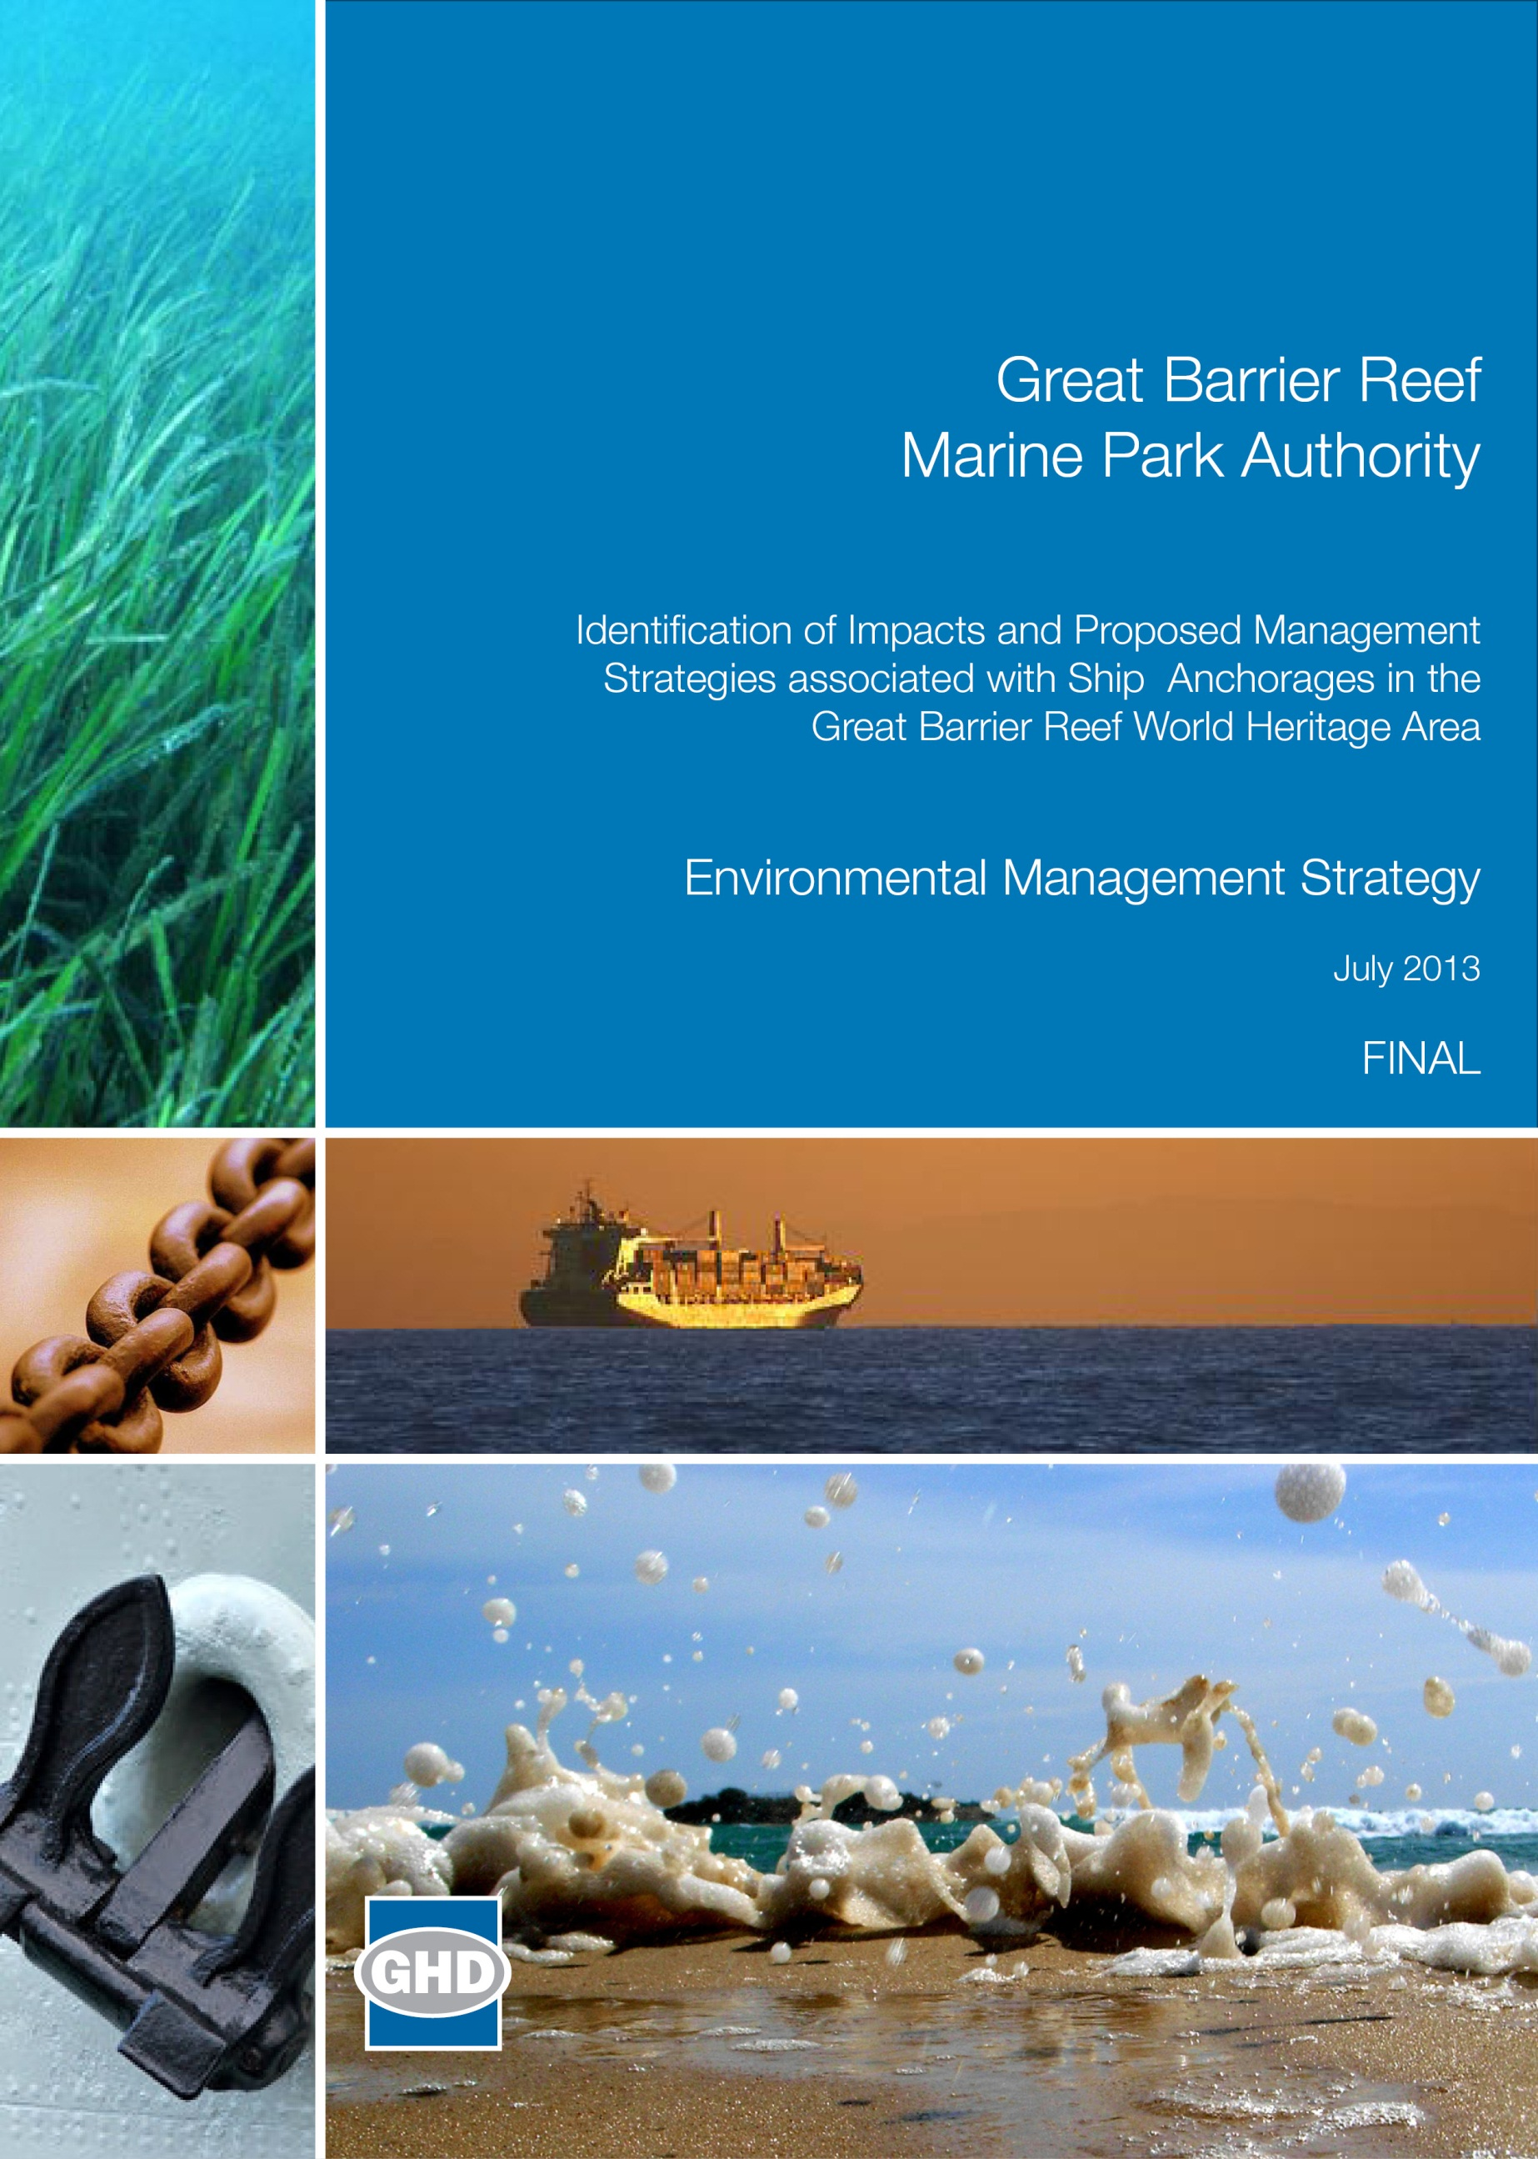
Great Barrier Reef Marine Park Authority

Contents
EXECUTIVE SUMMARY iii
ACRONYMS/Glossary xi
1. INTRODUCTION 1
1.1 Relationship of this project to the comprehensive Strategic Assessment 1
1.2 Background to this project 1
1.3 The project 2
1.4 Study area 4
1.5 The structure of this report 8
2. Governing legislation 9
2.1 Legislation governing the management of the Great Barrier Reef 9
2.2 Legislation governing the management of shipping, ports and anchorages 12
3. Anchorages in the Five Major ports in Queensland 19
3.1 How ships use anchorages 19
3.2 Drivers of demand for anchorages 30
3.3 Future total demand for ship anchorages 30
3.4 Ability to control ship anchoring demand and use 34
4. Environmental impacts of anchorages 35
4.1 Key environmental values 35
4.2 Actual and potential environmental impacts 36
5. Management of Anchorages at the Five Major Ports 43
5.1 Management options 43
5.2 Port specific management options 46
5.3 Summary of management options 50
6. Environmental Ship anchorage management Strategy for the FIVE MAJOR PORT Anchorages 53
6.1 Introduction 53
6.2 Objective 1: Manage existing anchorages with the aim of protecting environmental values 54
6.3 Objective 2: Optimise use of existing anchorages in the Marine Park 59
6.4 Objective 3: Minimise environmental impacts from future anchorage designations 65
6.5 Implementation and evaluation 69
7. Summary 73
8. References 75

TABLE INDEX
Table 1-1: Great Barrier Reef Region vs Marine Park vs World Heritage Area 4
Table 1-2: Bounds (latitude and longitude) and area (in ha) of the anchorage areas at each of the five major ports (Latitudes and longitudes are provided by point number. Point 1 is top left corner, Point 2 is top right corner, Point 3 is bottom left corner and Point 4 is bottom right corner of a bounded area) 7
Table 2-1: Management of major ports 16
Table 3-1: Ship types using anchorages 1, 2, 3 and 6 at the Port of Cairns 22
Table 3-2: Ship types using anchorages at the Port of Townsville 24
Table 3-3: Ship types using anchorages at Port of Gladstone 30
Table 3-4: Overview of current and future anchorage demand for the five major ports 32
Table 3-5: Summary of current and future anchorage use at each port 33
Table 4-1: Environmental impacts from anchorage activities 37
Table 4-2: Potential environmental impacts at each port 41
Table 5-1: Management options that exist or are recommended for each of the identified impact 44
Table 5-2: Summary of management options for each port 51
Table 6-1: Summary of objectives and outcome for each port 67
Table 6-2: Targets for achieving actions 69

FIGURE INDEX
Figure 1-1: Overview of ports in the Great Barrier Reef Marine Park and World Heritage Area 5
Figure 3-1: Anchorage area of the Port of Cairns 21
Figure 3-2: Anchorage area of the Port of Townsville 23
Figure 3-3: Anchorage area of the Port of Abbot Point 25
Figure 3-4: Anchorage area of the Port of Hay Point 27
Figure 3-5: Anchorage area of the Port of Gladstone 29
Figure 6-1: Conceptual model of the whole of supply chain 62

EXECUTIVE SUMMARY
Introduction to the project
The Great Barrier Reef (the Reef) is the world’s largest coral reef ecosystem, spanning more than 348,000 km² of the continental shelf of Queensland. The Reef has significant value which is recognised by its inclusion as a Marine Park, a World Heritage Area, a National Heritage Place and a Commonwealth Marine Area. The recognition of these significant values carries an obligation and responsibility to protect and conserve the values for the future.
The Australian and Queensland Governments are working together on a comprehensive strategic assessment (the Strategic Assessment) of the Great Barrier Reef World Heritage Area (World Heritage Area) and adjacent coastal zone. The Strategic Assessment will include an overall assessment of the effectiveness of management arrangements to protect the environmental, social, cultural and heritage values of the World Heritage Area and other matters of national environmental significance (MNES) protected under the Environmental Protection and Biodiversity Conservation Act 1999 (EPBC Act). The goal is to ensure these matters, including the World Heritage values of the Reef, are protected while creating a long-term plan for sustainable development in the region.
The Strategic Assessment comprises two elements: The Great Barrier Reef Coastal Zone Strategic Assessment to be undertaken by the Queensland Government; and The Great Barrier Reef Region Strategic Assessment of the marine component to be undertaken by the Great Barrier Reef Marine Park Authority (GBRMPA). The marine component will examine the values, the condition and trend of those values, impacts on those values, what is being done to protect those values (i.e. current management arrangements) and the effectiveness of the management arrangements. Once this is established the likely condition and trend of values will be estimated and future management arrangements will be identified. Ports and shipping are two such activities where concern about impacts on the values has been expressed.
The study reported here supports the marine component of the Strategic Assessment by completing works to achieve the “identification of impacts and proposed management strategies associated with ship anchorages in the Great Barrier Reef World Heritage Area”. Three phases of work facilitate the project:
- Identification of the environmental, social, cultural and heritage impacts of anchoring associated with the five major ports in the World Heritage Area: Cairns, Townsville, Abbot Point, Hay Point, and Gladstone.
- Socio-economic costs and benefits associated with different anchorage strategies.
- Anchorage management strategies that could be used to avoid, mitigate, offset or adaptively manage identified impacts.
The project, in its entirety, will complement other projects delivered in support of the Strategic Assessment, including development of improved information upon which to base decisions in relation to dredge spoil management. This report focusses on the Environmental Management Strategy (EMS) phase of the project.
Project study area
Under predicted population growth and industrial expansion in coming years and considering Queensland port industry vessel forecasts, vessel visitation across all ports within or adjacent to the Great Barrier Reef Marine Park or World Heritage Area is predicted to increase from around 4000 per annum currently to over 10,000 per annum by 2032 (PGM 2012).
These predicted shipping increases are driven primarily by bulk commodity exports from ports located between Cairns and Gladstone. Accordingly, to inform the Strategic Assessment, this project is considering the risks from trading vessel anchorages associated with the five major ports namely:
- Port of Cairns
- Port of Townsville
- Port of Abbot Point
- Port of Hay Point
- Port of Gladstone.
Approach
This report presents the findings of phase 3 of this project, the environmental ship anchorage management strategies that could be used to avoid, mitigate, offset or adaptively manage identified impacts. Knowledge developed during phases 1 and 2 of this project support this phase.
Actual and potential impacts of anchorages that may be experienced at each of the five major ports were identified through earlier work phases to be:
- Disturbance to seabed and supported biodiversity
- Release of emissions or pollutants/wastes
- Altered aesthetic value
- Interference with access to resources
- Marine pest introduction
- Interference with species behaviour.
Based on review of available information from the desktop study (completed in phase 1 of this project) current anchorages are generally located in areas that have little effect on the majority of the biodiversity values for which the Reef is recognised. They are located in open seabed systems and anchor drop or chain drag do not, therefore, impact on sensitive habitats such as coral reef systems. With regard to many of the Reefs biodiversity values, the anchorage areas are, therefore, apparently well positioned.
Phase 2 works, which examined the socio-economic costs and benefits associated with different anchorage strategies, identified that the anchorage areas in use across the five major ports are able to support current demand requirements and, with the exception of Hay Point and Gladstone, are predicted to be able to support future demand requirements. The predicted growth of anchorage demand under increasing vessel visitation will test the current capacity of the designated anchorages at Hay Point and Gladstone.
Works to date have, however, also identified that there are opportunities across all port anchorages to improve management of anchorages to reduce impact potential and achieve environmental benefits.
Management options for anchorage areas
The potential impacts of anchorages are currently managed through the implementation of existing legislation. There are also a number of additional current management options and future options that exist and are recommended for each of the identified impacts, including:
- Pilotage
- Designated anchorages
- Zoning
- Port procedures (where location of anchorages means these are applicable)
- Monitoring/Inspections
- Vessels are required to adhere to existing regulations governing emissions releases.
- Maintenance of engine and combustion equipment in a state of readiness
- Aggregate anchorages at each port
- Designated anchorages where currently not in place
- Site selection criteria to take into account the potential influences that increased levels of disturbance may have with consideration of proximity to sensitive receptors
- Anchorage selection to take into account species pathways
- Reduce time at anchor
- Introduction and implementation of new legislation (e.g. Biosecurity Act)
- Have procedures to carry out an orderly departure from a busy anchorage when all ships have to depart simultaneously due to imminent bad weather
- Consider the introduction of a Vessel Arrival System (VAS) (like the Port of Newcastle).
The management options mentioned above for each of the five ports have been used during all phases of this project to direct the development of a targeted environmental ship anchorage management strategy.
Environmental ship anchorage management strategy
This environmental ship anchorage management strategy and the underpinning actions are driven by an overarching objective to minimise environmental and social impacts associated with anchorage use. This is achievable by minimising the number of vessels that sit at anchor while maintaining efficient operation of port import and export requirements. The strategy, therefore, provides for improved environmental management of the existing port anchorages which has comparable social benefits.
Three explicit Objectives support the strategy to improve future management of ship anchorages and actions are designed to achieve each of these Objectives:
Objective 1: Manage existing anchorages with the aim of protecting environmental values
Outcome 1-1: Provide guidance and education for key stakeholders in environmental management of anchorages and ships while at anchor for improved environmental outcomes
Outcome 1-2: Obtain better understanding of environmental condition of anchorages and their use near ports to enable adaptive management under changing conditions
Outcome 1-3: Further enhance environmental performance at ship anchorages for improved environmental outcomes
Objective 2: Optimise use of existing anchorages in the Marine Park
Outcome 2-1: Restrict shipping industry users of the Marine Park to anchor only in designated anchorage areas
Outcome 2-2: Minimise the need for further anchorages in the Marine Park
Objective 3: Minimise environmental impacts from future anchorages and anchorage relocations
Outcome 3-1: Ensure environmental criteria are considered when selecting future anchorages
For successful implementation of the management strategies proposed in this document, it is recommended that the GBRMPA work with other agencies to:
- Develop implementation plans for each of the actions, including resource requirements, schedules and key milestones.
- Review the management strategies in the context of existing programs and proposed initiatives and adjust timeframes, where required.
- Identify resource availability (personnel and finance).
- Develop a framework for stakeholder engagement, including identification of stakeholders for each of the actions and mode of engagement (e.g. through industry groups or directly).
- Engage with stakeholders early to identify where opportunities for collaboration or shared resources exist.
- Engage with stakeholders comprehensively.
A summary for each of the five ports is included in table E-1. The summary addresses:
- Current and future use of anchorages
- Existing management of anchorages
- Adequacy of existing anchorages to meet future demand for anchorages
- Management options to be considered in order to meet the current and future needs for environmental protection of the Reef
- Environmental ship anchorage management strategy Objectives and outcomes relevant at each port.
Ongoing communication and education regarding potential environmental impacts from anchorage use, how these influence the values of the Reef and opportunities to ameliorate or minimise impacts will support sustainable use of the World Heritage Area.
The environmental ship anchorage management strategy aims to be applicable to the current and future use of the port anchorages and underpin ongoing sustainable use of the anchorages in the World Heritage Area without putting at risk the values for which the area is recognised.

Table E-1: Summary of the current and future use of anchorage areas, current management, management options and management strategy Objectives and outcomes supported by information developed under phases 1 and 2 of this study
 | Cairns | Townsville | Abbot Point | Hay Point | Gladstone
Current Anchorage use | Multi commodity port | Multi commodity port | Single commodity port | Single commodity port | Multi commodity port
 | 500 ship arrivals per year | 730 ship arrivals per year | 180 ship arrivals per year | 800 ship arrivals per year | 1500 ship arrivals per year
 | Less than one ship call per day sits at anchor | One ship call per day sits at anchor | Less than one ship call per day sits at anchor | Two to three ship calls per day sit at anchor | Three ship calls per day sit at anchor
 | Average time at anchor – 12 hours | Average time at anchor – three days | Average time at anchor – three days | Average time at anchor – 19 days | Average time at anchor – four days
Current Management of Anchorages | Sufficient physical capacity  Environmental impacts from existing anchorage practices considered to be not significant  Designated anchorages. | Sufficient physical capacity  Environmental impacts from existing anchorage practices considered to be not significant.  No designated anchorages. | Sufficient physical capacity  Environmental impacts from existing anchorage practices considered to be not significant.  No designated anchorages. | High demand for anchorages, nearly all ships (99%) proceed directly to anchor from sea to await a berth.  Environmental impacts from existing anchorage practices considered to be not significant.  Designated anchorages. | Sufficient physical capacity.  Environmental impacts from existing anchorage practices considered to be not significant.  Designated anchorages.
Future Demand (next 20 years)* | Low growth in ship calls (2% p.a.) | Low growth in ship calls (2% p.a.) | Significant growth in future ship calls (11% p.a.) | Moderate growth in future ship calls (5-6% p.a.) | Moderate growth in future ship calls (3-4% p.a.)
 | No change to ship calls per day | Less than two ship calls per day | 2.5 ship calls per day | 6.5 ship calls per day | Six ship calls per day
Future adequacy (prediction)** | No need to expand | No need to expand existing anchorage location | No need to expand existing anchorage location | Requirement for expansion of anchorages by around 30% if no change in management | No need to expand
Management Options | Continue current practices of ship anchoring  Improve current anchorage management practices  Optimise the use of existing anchorages  Investigate impacts of ship anchorages on aesthetic values at the Port of Cairns | Continue current practices of ship anchoring  Improve current anchorage management practices  Consider implementing designated anchorage areas  Investigate impacts of ship anchorages on aesthetic values at the Port of Townsville | Continue current practices of ship anchoring  Improve current anchorage management practices  Consider implementing designated anchorage areas  Consider scheduled ship arrivals if and when anchorage demand dictates | Consider more efficient use of existing anchorages  Improve current anchorage management practices  Further investigate impacts of ship anchorages on aesthetic values at the Port of Hay Point  Consider scheduled arrivals in combination with designated anchorages to avoid need to expand anchorage areas | Continue current practices of ship anchoring  Improve current anchorage management practices  Optimise the use of existing anchorages  Investigate impacts of ship anchorages on aesthetic values at the Port of Gladstone  If waiting times increase beyond four days, consider redesignating some anchorages as coal ship anchorages, and consider feasibility of VAS
Objective and Outcome | Objective 1  Outcome 1-1  Outcome 1-2  Outcome 1-3  Objective 2  Outcome 2-1 | Objective 1  Outcome 1-1  Outcome 1-2  Outcome 1-3  Objective 2  Outcome 2-1  Objective 3  Outcome 3-1 | Objective 1  Outcome 1-1  Outcome 1-2  Objective 2  Outcome 2-1  Outcome 2-2  Objective 3  Outcome 3-1 | Objective 1  Outcome 1-1  Outcome 1-2  Objective 2  Outcome 2-1  Outcome 2-2  Objective 3  Outcome 3-1 | Objective 1  Outcome 1-1  Outcome 1-2  Objective 2  Outcome 2-1  Outcome 2-2
*As assessed by phase 2 of this study.
**As assessed with regard to the anchorage area studied by this project.

ACRONYMS/Glossary
ASA | Australian Ship Owners Association
AMSA | Australian Maritime Safety Authority
APM | Associated Protective Measures
AQIS | Australian Quarantine and Inspection Service
CBA | Cost Benefit Analysis
CIF | Cost Insurance and Freight
Cwth | Commonwealth
DAFF | Department of Agriculture, Fisheries and Forestry
DSA | Designated Shipping Area
DSEWPaC | Department of Sustainability, Environment, Water, Population and Communities
DSDIP | Department of State Development, Infrastructure and Planning
DTMR | Department of Transport and Main Roads
EIA | Environmental Impact Assessment
EMS | Environmental Management Strategy
EPBC Act | Environment Protection and Biodiversity Conservation Act 1999
GBRMPA | Great Barrier Reef Marine Park Authority
GBRMPA Act | Commonwealth Great Barrier Reef Marine Park Act 1975
GOC | Government-Owned Corporations
GPS | Global Positioning System
ha | hectares
IMO | International Maritime Organization
km | kilometres
km² | square kilometres
LAT | lowest astronomical tide
LNG | liquefied natural gas
LWM | low water mark
m | metres
the Marine Park | the Great Barrier Reef Marine Park
MEPC | Marine Environment Protection Committee
MNES | Matters of National Environmental Significance
MSQ | Maritime Safety Queensland
NQBP | North Queensland Bulk Ports Corporation
OUV | Outstanding Universal Value
PSSA | Particularly Sensitive Sea Area
Qld | Queensland
the Reef | the Great Barrier Reef
RHM | Regional Harbour Master
UNCLOS | United Nations Convention on Law of the Sea
UNESCO | United Nations Educational, Scientific and Cultural Organisation
VAS | Vessel Arrival System
VTS | Vessel Traffic Service
the World Heritage Convention | Convention concerning the Protection of the World Cultural and Natural Heritage
World Heritage Area | Great Barrier Reef World Heritage Area

INTRODUCTION

Relationship of this project to the comprehensive Strategic Assessment
The Great Barrier Reef Marine Park Authority (GBRMPA) is the principal advisor to the Commonwealth Government on the conservation, care and utilisation of the Great Barrier Reef Marine Park (the Marine Park). The Marine Park is a multiple-use marine park that supports a range of activities, industries, communities and businesses. The GBRMPA’s goal is to provide for the long-term protection, ecologically sustainable use, understanding and enjoyment of the Great Barrier Reef (the Reef) for all Australians and the international community through the care and development of the Marine Park.
The Australian and Queensland Governments are working together on a comprehensive Strategic Assessment of the Great Barrier Reef World Heritage Area (World Heritage Area) and the nearby coastal zone. The Strategic Assessment is an overall assessment of the effectiveness of management arrangements to protect the environmental values of the World Heritage Area. The goal is to ensure the World Heritage values of the Reef are protected while creating a long-term plan for sustainable development in the region (DSDIP 2012, GBRMPA 2012a).
The Strategic Assessment will identify planned and potential future development that could impact on the World Heritage Area’s Outstanding Universal Value (OUV) and inform long-term planning for sustainable development. The Strategic Assessment will examine the pressures, including the cumulative impacts of actions, such as shipping, on the World Heritage Area, other relevant matters of national environmental significance (MNES), and the management arrangements to deal with such impacts.
The Strategic Assessment comprises two elements: The Great Barrier Reef Coastal Zone Strategic Assessment to be undertaken by the Queensland Government; and The Great Barrier Reef Marine Strategic Assessment to be undertaken by the GBRMPA.
The marine assessment will examine the uses of the Marine Park and the impacts of these uses as well as examining the controls on those uses and policies and assessing the effectiveness of those controls. Of the activities in the Marine Park, ports and shipping is one area where concern about impacts has been expressed (GBRMPA 2012b). This project supports the marine assessment by completing works to achieve the “identification of impacts and proposed management strategies associated with ship anchorages in the Great Barrier Reef World Heritage Area”. Findings from the project will inform the comprehensive strategic assessment of the Reef and associated regional sustainability planning.

Background to this project
There is a predicted increase in shipping traffic within the Marine Park and World Heritage Area. Over the next 10 years this is primarily driven by bulk commodity exports. This increase is focused around existing and future port expansions at Queensland ports between Cairns and Gladstone. The proposed port expansions may have far reaching and long-lasting implications for the health of the Marine Park and in particular the in-shore biodiversity of the Great Barrier Reef Region.
The International Maritime Organisation (IMO) designated the Reef as a Particularly Sensitive Sea Area (PSSA) in 1990. A PSSA is an area that needs special protection though action by IMO because of its significance for recognised ecological, socio-economic, or scientific attributes where such attributes may be vulnerable to damage by international shipping activities. With this declaration, the Australian Government was able to implement a number of measures to protect the Reef, including ship routing, traffic management, shore based monitoring, emergency response arrangements and pilotage.
The Great Barrier Reef Marine Park Zoning Plan 2003 designates where ships may navigate; which is only within the Designated Shipping Areas (DSA) and the General Use Zone. The definition of navigate includes moor, or anchor, in the course of navigation. This indicates that ships are allowed to navigate (including anchor) in the DSA and the General Use Zone in the Marine Park.
The projected increase in shipping has the potential to increase both the number and size of anchorage areas adjacent to ports. The management of shipping anchorage associated with port activities in the Great Barrier Reef Region is achieved by a number of agencies responsible for safe operation of shipping within the Region. The Queensland Department of Transport and Main Roads (DTMR), through Maritime Safety Queensland (MSQ), provide guidance to mariners to ensure orderly management of shipping in areas adjacent to ports, with the focus on safety and navigation. Environmental and multiple-use considerations for those areas are not a required consideration as part of the process, however, every effort is made to minimise shipping impacts within the Reef and maintain equitable access for all users where it is safe to do so.

The project
The current project will develop understanding of the environmental impacts, risks, costs and benefits of ship anchorage adjacent to major ports operating in the Reef and synthesise relevant strategies for managing anchorage to reduce potential impacts. Through this, the project will provide information to support best practice environmental management of ships anchoring in the Reef and inform future policy and planning outcomes, including the Strategic Assessment, Regional Sustainability Planning and the North East Shipping Management Plan.
The project is being delivered across three phases of work:
- Identification of the environmental impacts of anchoring associated with the five major ports in the World Heritage Area: Cairns, Townsville, Abbot Point, Hay Point, and Gladstone.
- Socio-economic costs and benefits associated with different anchorage strategies.
- Anchorage management strategies that could be used to avoid, mitigate, offset or adaptively manage identified impacts.
The project will directly inform the following Strategic Assessment deliverables, as set out under the Terms of Reference for the Great Barrier Reef Region Strategic Assessment (GBRMPA 2012a):
- Item 3.1 Assessment of actual and potential impacts including direct, indirect, consequential and cumulative impacts
- Item 4.1.1 (c) Consider environmental, social, cultural and economic issues
- Item 4.1.1 (d) Avoid, mitigate, offset and adaptively manage impacts
- Item 4.1.1 (e) Address uncertainty and risk
- Item 4.1.1 (f) Provide certainty regarding where uses may occur etc.
- Item 4.2 relevant Demonstration Cases
- Item 5 Describe projected condition of relevant matters of national environmental significance
- Item 6 Recommendations for changes to the Program
Key benefits of the project are identified to be:
- Assist the GBRMPA and the Department of Sustainability, Environment, Water, Population and Communities (DSEWPaC) in providing high level scientific and environmental advice and strategies for improved ship anchorage management for the Great Barrier Reef Region.
- Assist with addressing potential environmental issues related to anchoring, including cumulative impacts, due to increases in ports and shipping activities in the Great Barrier Reef Region (i.e. port expansions and associated increases in shipping volumes).
- Assist in the identification of improved management and protective measures to protect values that underpin MNES (such as the Marine Park) and those values identified in the GBRMPA Outlook Report 2009 (GBRMPA 2009), which include biodiversity, ecosystem health, heritage values, human use and aesthetics.
- Improved guidance for ports and mariners concerning anchoring arrangements and selection of future anchoring areas that support the orderly management of shipping through safety, navigation, environmental and multiple-use considerations.
- Likely administrative reductions for the GBRMPA, other regulatory agencies and ports due to improved guidance and through the development of policies that streamline environmental assessment processes.
- The project's expected outputs have potential to support the interests of other commercial and non-commercial users of the Marine Park by reducing the risk of user conflict.
The project, in its entirety, will complement other projects being delivered in support of the Strategic Assessment, including development of improved information upon which to base decisions in relation to dredge spoil management. This report prescriptively pertains to the Environmental Management Strategy (EMS) phase of the project.

Study area
In 1975 the Great Barrier Reef Region was established and today provides for the long-term protection and conservation of the environment, biodiversity and heritage values of the Great Barrier Reef Region. Australia's Reef is the largest coral reef ecosystem on earth, with the Great Barrier Reef Region extending more than 2300 kilometres (km) along the Queensland coastline and covering 346,000 square kilometres (km²).
In 1981 the area was listed as a World Heritage property for its OUV and in 2007 it was listed as a National Heritage property. The property was the first coral reef ecosystem in the world to be nominated on the basis of all four natural criteria. The Great Barrier Reef Region and World Heritage Area have the same outer boundary. However, the Great Barrier Reef Region does not include internal waters of Queensland or Queensland islands, which are included in the World Heritage Area.
The Marine Park was declared in sections (between 1979 and 2001) and today covers the majority (99.5 per cent) of the Great Barrier Reef Region (or just under 99 per cent of the World Heritage Area). As sections of the Marine Park were declared, various ports and harbours were not included; today 13 ports are not part of the Marine Park but are within the World Heritage Area (figure 1-1, table 1-1).
Table 1-1: Great Barrier Reef Region vs Marine Park vs World Heritage Area
Great Barrier Reef Region | Marine Park | World Heritage Area
Proclaimed 1975 | Declared in sections between 1979 and 2001; made into one amalgamated section in 2004 | Inscribed 1981
346,000 km² | 344,400 km² | 348,000 km²
Great Barrier Reef Region does not include:  - Internal waters of Queensland  - 980 Queensland islands | Marine Park does include 70 Commonwealth owned islands  Marine Park does NOT include:  - Internal waters of Queensland  - 980 Queensland islands  - 13 ports in 12 exclusion areas | Does include:  - All islands within outer boundary (1050)  - All waters seaward of low water mark (LWM) of coast (including internal waters of Queensland and port waters)

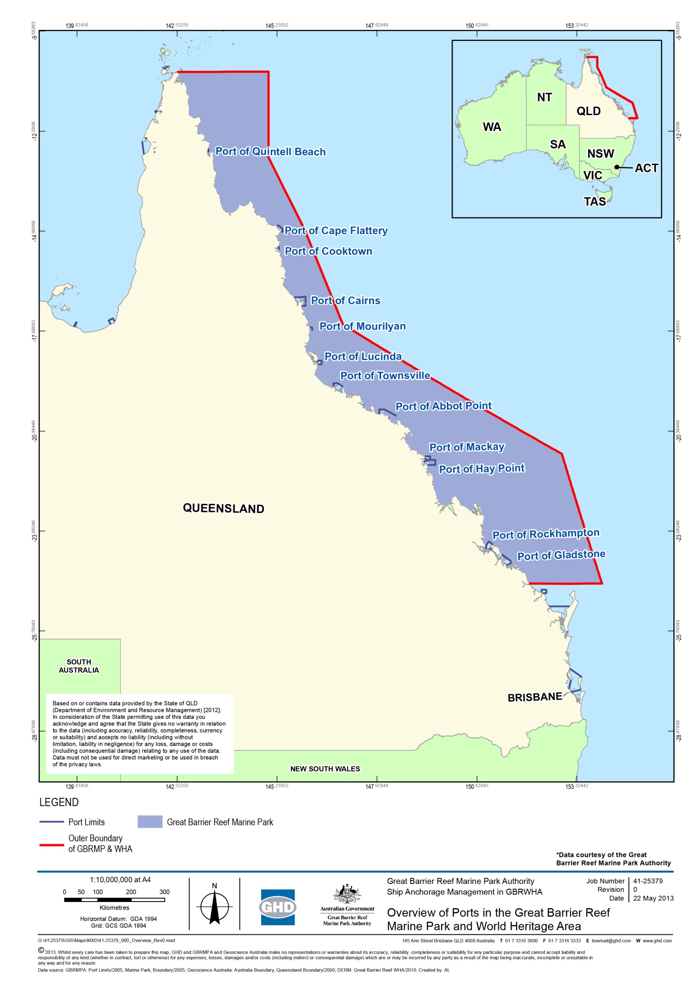
Figure 1-1: Overview of ports in the Great Barrier Reef Marine Park and World Heritage Area

As noted under section 1.2, the predicted increase in shipping traffic within the Marine Park and World Heritage Area in coming years is driven primarily by bulk commodity exports from ports located between Cairns and Gladstone. Accordingly, to inform the GBRMPA Strategic Assessment, this project is considering the risks from trading vessel anchorage associated with the five major Queensland ports of:
- Port of Cairns
- Port of Townsville
- Port of Abbot Point
- Port of Hay Point
- Port of Gladstone.
Anchorage areas are designated on navigational charts for only three of these locations; Cairns, Hay Point and Gladstone. Vessels may also anchor outside of designated areas at the discretion of the ship’s Master as long as they are compliant with relevant zoning and legislative protection measures for the World Heritage Area. Management and direction for anchorage in each of the ports is provided to bulk cargo and other trading vessels by the Regional Harbour Master (RHM).
This project involves investigation of impacts associated with anchorages of the five major ports. A key step, therefore, has been to define the existing areas being used for anchorage by trading vessels working to each of the nominated ports. This was achieved through consultation with each port’s RHM to confirm designated areas and, for locations without charted anchorages, to define an area within which vessels are known or directed to anchor. Where specific anchor drop points are mapped a conservative approach of considering the entire area across which anchor drop may occur has been used to define the anchorage area of a port. This has provided an envelope of seabed adjacent each of the five ports within which anchorage currently occurs. The bounds of the ship anchorage areas (Global Positioning System (GPS) coordinates) at each of the ports and the total area (in hectares (ha)) of each ship anchorage are provided in table 1-2 and the anchorage areas are presented in figure 3-1, figure 3-2, figure 3-3, figure 3-4 and figure 3-5.
These spatial areas provide the footprint of investigation adjacent each port addressed by this study.

Table 1-2: Bounds (latitude and longitude) and area (in ha) of the anchorage areas at each of the five major ports (Latitudes and longitudes are provided by point number. Point 1 is top left corner, Point 2 is top right corner, Point 3 is bottom left corner and Point 4 is bottom right corner of a bounded area)
Port | Point 1 | Point 2 | Point 3 | Point 4 | Area (ha)
Cairns | -16.809302  145.77560 | -16.75466  145.86635 | -16.97995  145.96195 | -16.95247  146.01798 | 24,118
Townsville | -19.01963  146.80780 | -19.02737  147.03623 | -19.13087  146.90595 | -19.13266  147.06002 | 23,762
Abbot Point | -19.65923  147.98337 | -19.67425  148.28264 | -19.81606  147.98092 | -19.87983  148.22934 | 58,818
Hay Point | -21.17225  149.31492 | -20.97303  149.81436 | -21.29850  149.31236 | -21.29862  149.95951 | 157,284
Gladstone inner anchorage | -23.83373  151.29568 | -23.82218  151.31167 | -23.87902  151.35518 | -23.86798  151.36551 | 1403
Gladstone outer anchorage | -23.83195  151.42357 | -23.76377  151.49485 | -23.94741  151.59231 | -23.87346  151.66395 | 22,722

The structure of this report
This report presents the findings of phase 3 of the project, the environmental ship anchorage management strategies that could be used to avoid, mitigate, offset or adaptively manage identified impacts. A review of the shipping demand forecast, existing site conditions and impacts, and comparative analysis of management strategies has been completed under phases 1 and 2 of the project. Those works demonstrate that options exist to implement new, or adapt and improve existing anchorage management actions to avoid further impacts on the World Heritage Area, particularly under future shipping demand.
The phase 1 Environmental Impact Assessment (EIA) was completed in November 2012 (GHD 2012). The EIA drew on information collated during a desktop review and stakeholder consultation conducted in late 2012. This work identified the existing environmental, social, cultural and heritage conditions of each anchorage area.
The environmental assessment included a risk analysis which considered the risks and consequences of any impacts being realised on the values of the World Heritage Area from ship anchorage using the GBRMPA Environmental Assessment and Management Risk Management Framework.
The EIA identified actual and potential impacts on the values of the World Heritage Area and MNES and their significance. Possible management options to be considered to reduce any impacts in these areas were also presented.
The phase 2 Cost Benefit Analysis (CBA) was completed following the conclusion of the EIA, with a report issued in February 2013. The CBA drew together findings from the EIA, the forecasts of future anchorage demand, and the results of the assessment of the relevance of various ship anchorage management options. Stakeholder consultation information on social issues for each of the five major ports in the study area was also included in the CBA. This work considered the socio-economic costs and benefits associated with different anchorage management options for the five major ports.
The structure of this phase 3 report comprises sections on:
- Governing legislation – summary of the regulatory framework that governs the management of the Reef, shipping, ports and anchorages at a State and Commonwealth level.
- Anchorages at the Five Major Ports - current and expected future demand for anchorages at each of the five major ports.
- Environmental impacts of anchorages – identifies the actual and potential impacts of anchorages on the environmental values at the five major ports.
- Management of anchorages - identifies the management options for each of the five major ports and considers which options are relevant to each port.
- Ship anchorage management strategy - developed based on the findings from the previous phases.

Governing legislation

Legislation governing the management of the Great Barrier Reef
The management of the Great Barrier Reef Region is supported by a complex regulatory framework at State and Commonwealth level. The Marine Park is managed by the Commonwealth GBRMPA in accordance with the Great Barrier Reef Marine Park Act 1975. The Great Barrier Reef Coast Marine Park is managed by the Queensland Government under the Marine Parks Act 2004. The management of the World Heritage Area is governed by an intergovernmental agreement between the Australian and Queensland governments.
The following sections describe the international conventions, Acts and regulations that apply to the management of the Reef and anchorages within the study area.
Key legislation applicable to the management of the Reef includes:
- World Heritage Convention
- Great Barrier Reef Marine Park Act 1975 (Commonwealth (Cwth))
  - Marine Parks (Great Barrier Reef Coast) Zoning Plan 2004
- Environment Protection and Biodiversity Act 1999 (Cwth)
- Marine Parks Act 2004 (Queensland (Qld))
  - Great Barrier Reef Coast Marine Park (Marine Parks (Great Barrier Reef Coast)) Zoning Plan 2004.
Summary descriptions are provided below with reference to key bodies and how they are related to the legislation.

International Conventions
World Heritage Convention
In 1981, the Reef was declared a World Heritage Area by the United Nations Educational, Scientific and Cultural Organisation (UNESCO) under the World Heritage Convention. At time of inscription on the World Heritage List, the Reef was recognised for the following values:
- Outstanding example representing a major stage of the earth’s evolutionary history given the Reef is the largest single collection of coral reefs in the world.
- Outstanding example representing significant ongoing geological processes, biological evolution and man’s interaction with his natural environment given the Reef represents a mature system which has been in existence for millions of years.
- Containing unique, rare and superlative natural phenomena, formations and features and areas of exceptional natural beauty.
- Providing habitats where populations of rare and endangered species of plants and animals survive.
Examples of these values or attributes identified by the World Heritage Committee include the biodiversity and interconnectedness of species and habitats along the Reef, and ecosystem processes such as physical, geomorphological, chemical and ecological processes.
In 2009, an intergovernmental agreement was signed by the Australian and Queensland governments to formalise the approach to manage marine and land environment within the World Heritage Area (Commonwealth of Australia and the State of Queensland 2009). The implementation of the Intergovernmental Agreement is driven by the Great Barrier Reef Ministerial Forum, which comprises of two ministers each from the Australian and Queensland governments.

Commonwealth legislation
Great Barrier Reef Marine Park Act 1975
The Commonwealth Great Barrier Reef Marine Park Act 1975 (GBRMP Act) establishes the GBRMPA as the principal advisor to the Commonwealth Government on the conservation, care and utilisation of the Marine Park. The GBRMPA’s goal is to provide for the long-term protection, ecologically sustainable use, understanding and enjoyment of the Reef for all Australians and the international community through the care and development of the Marine Park.
The Marine Park forms part of the World Heritage Area and generally extends over Queensland State coastal waters to the low-water mark. The Marine Park is a multiple use area, supporting a wide range of social and economic uses that are considered as values of the Reef. The GBRMP Act also provides for the preparation of zoning plans and plans of management. The entire Marine Park is covered by the Great Barrier Reef Marine Park Zoning Plan 2003 that identifies where particular activities are permitted and where some are not permitted.
The GBRMPA aims to protect all values of the Marine Park; some of these values include the biodiversity of the Reef, as well as its ecosystem processes. This is a critical role for the maintenance of a healthy Reef which is better able to recover and adapt to impacts and stressors, as well as providing essential resources for numerous species and human use.
The management of the Marine Park is through a collaborative approach. GBRMPA is continually engaged with various State and Commonwealth agencies, such as the Queensland Parks and Wildlife Service, State and Commonwealth marine safety authorities.
Environment Protection and Biodiversity Act 1999
The Commonwealth Government is responsible, under the Environment Protection and Biodiversity Conservation Act 1999 (EPBC Act) for regulating activities having or likely to have a significant impact on MNES as defined by the EPBC Act, and on the environment within Commonwealth land and waters.
Of the eight MNES to which the EPBC Act applies, six are directly relevant to the management of anchorage impacts:
- Threatened species
- Migratory species
- the Marine Park
- World Heritage Areas
- National Heritage properties
- Commonwealth Marine Area.
The EPBC Act provides additional protection of World Heritage values and other environmental values. Any development which may have significant impacts on MNES will require a significant environmental impact assessment process, including public consultation. Following the assessment of a proposed action, the Commonwealth Environment Minister will decide whether to:
- Approve an action
- Approve an action subject to constraints (e.g. Will impose conditions on the action)
- Not approve an action, if the risk to MNES is considered to be unacceptable.
In 2009, the Marine Park was also included as an MNES to the EPBC Act. GBRMPA are legislated to undertake joint assessments with DSEWPaC when the Marine Park is triggered. The EPBC Act also provides for any actions that have, or are likely to have, a significant impact on the environment of the Marine Park. The GBRMPA may undertake assessments on behalf of DSEWPaC when the Marine Park is the only trigger (i.e. when an action does not trigger other MNES, such as Commonwealth Marine Areas, Threatened species etc.)

Queensland legislation
Marine Parks Act 2004
The Marine Parks Act 2004 provides for the declaration of a Marine Park in an area of Queensland waters and provides for zoning plans and management plans. The Great Barrier Reef Coast Marine Park is one of the three state marine parks managed by the Queensland Government. The Marine Parks Act 2004 is administered by the Queensland Department of National Parks, Recreation, Sport and Racing.
The area of the Great Barrier Reef Coast Marine Park includes the Marine Park as well as the intertidal area between low and high water marks and many of the waters within the jurisdictional limits of Queensland.
A zoning system has been established for the Great Barrier Reef Coast Marine Park (Marine Parks (Great Barrier Reef Coast) Zoning Plan 2004 (Qld)) which aims to provide protection of the Reef's unique biodiversity, while continuing to provide opportunities for the use of and access to the marine park.
The Great Barrier Reef Coast Marine Park complements the Marine Park through adopting similar zone objectives, and entry and use provisions. While the activities that can be carried out within the Great Barrier Reef Coast Marine Park and Marine Park are generally the same, there are some Queensland-specific provisions that may apply.

Legislation governing the management of shipping, ports and anchorages
The management of shipping and anchorages within the study area is governed by following conventions, Acts and regulations:
- International Conventions
  - International Convention for the Prevention of Pollution from Ships (MARPOL)
  - International Convention for the Control and Management of Ships’ Ballast Water and Sediments (the Ballast Water Management Convention)
  - International Convention on the Control of Harmful Anti-fouling Systems on Ships
  - United Nations Convention on the Law of the Sea.
- Commonwealth Legislation
  - Navigation Act 2012 (Cwth)
  - Australian Maritime Safety Authority Act 1990 (Cwth)
  - Protection of the Sea (Prevention of Pollution from Ships) Act 1983 (Cwth)
  - Protection of the Sea (Harmful Anti-fouling Systems) Act 2006 (Cwth)
  - Quarantine Act 1908 (Cwth).
- Queensland Legislation
  - Transport Infrastructure Act 1994 (Qld)
  - Government Owned Corporations Act 1993 (Qld)
  - Maritime Safety Queensland Act 2002 (Qld)
  - Transport Operations (Marine Safety) Act 1994 (Qld)
  - Transport Operations (Marine Pollution) Act 1995 (Qld)
  - Environmental Protection Act 1994 (Qld).
Summary descriptions are provided below with reference to key bodies and how they are related to the legislation.

International Conventions

United Nations Convention on the Law of the Sea
The United Nations Convention on Law of the Sea (UNCLOS) is an international agreement that defines the rights and responsibilities of nations in their use of the world’s oceans. The Convention establishes guidelines for businesses, the environment and the management of marine natural resources.
International Convention for the Prevention of Pollution from Ships (MARPOL)
The IMO is the United Nations specialised agency with responsibility for the safety and security of shipping and the prevention of marine pollution by ships. One of IMO’s most important conventions is MARPOL. MARPOL aims to regulate and prevent pollution of the marine environment by ships. The Marine Environment Protection Committee (MEPC) is the International Maritime Organisation's senior technical body concerned with the prevention and control of pollution from ships.
The legislation giving effect to MARPOL in Australia is the Pollution Protection of the Sea (Prevention of Pollution from Ships) Act 1983 and the Navigation Act 1912, and in Queensland, the Transport Operations (Marine Pollution) Act 1995.
IMO designated the Reef (and Torres Strait) as a PSSA in 1990. A PSSA is an area of the marine environment that needs special protection through action by IMO because of its significance for recognised ecological, socio-economic, or scientific attributes where such attributes may be vulnerable to damage by international shipping activities.
The Associated Protective Measures (APM) for the PSSA includes IMO-recommended compliance with Australian system of pilotage and mandatory ship reporting.
International Convention for the Control and Management of Ships’ Ballast Water and Sediments
IMO adopted the International Convention for the Control and Management of Ships’ Ballast Water and Sediments (the Ballast Water Management Convention) in 2004. The Convention aims to prevent the spread of harmful aquatic organisms from one region to another, by establishing standards and procedures for the management and control of ships' ballast water and sediments.
Currently, there is no legislation in Australia that gives effect to the Ballast Water Management Convention. The Biosecurity Bill 2012 tabled in 2012 identifies the requirements Australia will apply to management of ballast water risks in accordance with the IMO Convention.
Currently, ports refer to the IMO guidelines relating to ballast water, the Guidelines for control and management of ships’ ballast water to minimize the transfer of harmful aquatic organisms and pathogens.
International Convention on the Control of Harmful Anti-fouling Systems on Ships
IMO adopted the International Convention on the Control of Harmful Anti-fouling Systems on Ships in 2001. In 2007, Australia ratified the Convention through the establishment of the Protection of the Sea (Harmful Anti-fouling Systems) Act 2006.
Under the Convention, it is an offence for any ship bearing harmful chemical compounds on their hulls or external parts or surfaces to enter Australian port, shipyard or offshore terminal, unless the ship bears a coating to prevent such compounds leaching into the water.

Commonwealth legislation
Navigation Act 2012
The Navigation Act 2012 is Australia’s primary legislation regulating ship and seafarer safety, shipboard aspects of protection of the marine environment and employment conditions for Australian seafarers.
Australian Maritime Safety Authority Act 1990
The Australian Maritime Safety Authority Act 1990 establishes the Australian Maritime Safety Authority (AMSA). AMSA aims to enhance the efficient and safe operation of the Australian maritime industry and protection of the marine environment from pollution from ships and other environmental damage caused by shipping (AMSA 2011).
AMSA represents the Australian Government at the IMO and other international forums in the development, implementation and enforcement of international standards including those that govern ship safety and the protection of the marine environment.
AMSA’s National Plan for Maritime Environmental Emergencies is a national integrated government and industry organisational framework, enabling effective response to marine pollution incident and marine casualties. Current protection measures in the Reef also administered by AMSA include:
- Coastal pilotage services through the Reef
- Implementation of the Associated Protective Measures formulated by IMO for the PSSA to be applied to vessels that transit the area
- The REEF Vessel Traffic Service (VTS), which provides near-real time monitoring of shipping movements in the Marine Park. It is compulsory for vessels to report while in the area.
- Port State Control inspections, where AMSA monitors and enforces compliance of ships in Australian waters with internationally agreed standards for seaworthiness, safety and pollution prevention.
Protection of the Sea (Prevention of Pollution from Ships) Act 1983
AMSA also administers the Commonwealth Pollution Protection of the Sea (Prevention of Pollution from Ships) Act 1983. This Act gives effect to the operational requirements of MARPOL in Australia. Queensland has implemented complementary MARPOL legislation (Transport Operations (Marine Pollution) Act 1995).
Protection of the Sea (Harmful Anti-fouling Systems) Act 2006
The Australian Government implemented the International Convention on the Control of Harmful Anti-fouling Systems on Ships in Australian legislation through the Protection of the Sea (Harmful Anti-fouling Systems) Act 2006. The Act commenced on 17 September 2007.
Quarantine Act 1908
The Commonwealth Department of Agriculture, Fisheries and Forestry (DAFF) manage quarantine controls at Australia’s borders to minimise the risk of introducing exotic pests and diseases into the country.
The Australian Quarantine and Inspection Service (AQIS) administers the Quarantine Act 1908 in order to protect Australia's animal, plant and human health status and to maintain market access for Australian food and other agricultural exports.
The Quarantine Act 1908 provides for quarantining of every overseas vessel until pratique has been granted or until it has been released from quarantine. The pratique is a permission granted by AQIS once they are satisfied that the vessel and people on board a free from quarantinable diseases.
Before the Director of Quarantine makes any decision which may lead to a significant risk of harm to the environment, the Environment Minister who administers the EPBC Act is required to be consulted (s 11C of Quarantine Act 1908). The advice provided by the Environment Minister needs to be taken into account in the decision making process.
The Quarantine Act is planned to be replaced by new legislation. DAFF has introduced the Biosecurity Bill 2012 into Parliament in 2012. The Bill aims to provide for better management of the risks of animal and plant pests and diseases entering, establishing, spreading in Australia and considers the International Convention for the Control and Management of Ships’ Ballast Water and Sediments.

Queensland legislation
Transport Infrastructure Act 1994
The overall objective of the Transport Infrastructure Act 1994 is to provide a regime that allows for, and encourages, effective integrated planning and efficient management of a system of transport infrastructure.
Section 275 of the Act states the function of the Port Authorities is: “to establish, manage, and operate effective and efficient port facilities and services in its port.”
Port limits are defined for each port in the Transport Infrastructure (Ports) Regulation 2005.
Under the Act, port authorities have the power to publish a port notice to control activities or conduct in the port area if the activity or conduct is considered to cause damage to the environment. Port notices may be applied to moving or mooring ships within its port area (s282A). Each of the five ports has a set of port notices which can be found on their respective website:
Government Owned Corporations Act 1993 (Qld)
The five major Queensland ports are currently managed by four Government-Owned Corporations (GOC) The four GOC port authorities are companies operated under Corporations Act 2001 (Cwth) and the Government Owned Corporations Act 1993 (Qld). The Queensland DTMR is a shareholding Department providing oversight of the Queensland’s four GOCs, including:
- North Queensland Bulk Ports Corporation (NQBP)
- Port of Townsville Limited
- Gladstone Ports Corporation Limited
- Far North Queensland Ports Corporation Limited.
The GOC legislative framework provides that ports operate, as far as practicable, on a commercial basis in a competitive environment. Table 2-1 outlines which GOC manages each of the five major ports in Queensland.
Table 2-1: Management of major ports
Port | Government-Owned Port Corporation
Port of Cairns | Far North Queensland Ports Corporation Limited
Port of Townsville | Port of Townsville Limited
Port of Abbot Point | NQBP
Port of Hay Point | NQBP
Port of Gladstone | Gladstone Ports Corporation Limited
Maritime Safety Queensland Act 2002
The Maritime Safety Queensland Act 2002 provides for the creation of MSQ as a government body advising on marine safety, ship-sourced pollution and related matters. MSQ is a government agency of the DTMR. Acts and regulations administered by MSQ include:
- Transport Operations (Marine Safety) Act 1994
- Transport Operations (Marine Pollution) Act 1995
Transport Operations (Marine Safety) Act 1994
The Transport Operations (Marine Safety) Act 1994 aims to provide a system that achieves an appropriate balance between regulating the marine industry to ensure marine safety and enabling the effectiveness and efficiency of the Queensland maritime industry to be further developed.
The Act imposes a general safety obligation to ensure seaworthiness and other aspects of marine safety. In order to achieve this, the Act provides for the establishment of harbour masters and pilotage areas. A harbour master has the authority to direct the master of a ship to navigate or operate a ship in a prescribed way to ensure safety in or near a marine incident or pilotage area. Regional Harbour Masters
Queensland is divided up into six regions, five of which are controlled by a RHM and the sixth by a manager. These persons are all officers of MSQ who, under the Transport Operations (Marine Safety) Act 1994, are responsible for:
- Improving maritime safety for shipping and small craft through regulation and education
- Minimising vessel sourced waste and providing response to marine pollution
- Providing essential maritime services such as port pilots and aids to navigation
- Encouraging and supporting innovation in the maritime industry.
Collectively, the RHM and the port authority have responsibility for managing the safe and efficient operation of a port.
It is an offence not to comply with regional harbour master directions without a reasonable excuse. A harbour master must consult with the port authority, if the harbour master exercises a power that may affect the functions of a port authority.
Pilotage Areas
Pilotage areas have been gazetted around designated ports and maritime areas to ensure the safe and efficient movement of shipping. Schedule 5 of the Transport Operations (Marine Safety) Regulation 2004 describes the extent of pilotage areas in Queensland. These areas encompass the approaches, main shipping channel and waters of the port.
Each port has a Port Procedures and Information for Shipping Manual that defines the standard procedures to be followed in the pilotage area of the port. It contains information and guidelines to assist masters, owners and agents of vessels arriving at and traversing the area. The manual provides details of services, regulations and procedures to be observed. The manual also includes information about designated anchorage areas, where available.
Under the Transport Operations (Marine Safety) Act 1994, a ship of a length of 50 m or more cannot be navigated in a compulsory pilotage area without a pilot. The Transport Operations (Marine Safety) Regulation 2004 provides for reporting requirements of ship movements of all ships of 35 metres (m) length and more to VTS when moving within, entering and leaving the pilotage area.
Transport Operations (Marine Pollution) Act 1995
The Transport Operations (Marine Pollution) Act 1995 provides a legislative framework to enforce the provisions of MARPOL in Queensland. The Act applies to all ships in coastal waters. The pollutants regulated through the Act include oil, noxious liquid substances in bulk, package harmful substances, sewage and garbage (also referred to as waste in this report).
Environmental Protection Act 1994
Under the Queensland Environmental Protection Act 1994 it is an offence to cause environmental nuisance. Environmental nuisance is defined in the Act as “an unreasonable interference or likely interference with an environmental value caused by aerosols, fumes, light, noise, odour particles or smoke, an unhealthy, offensive or unsightly condition because of contamination; or another way prescribed by regulation”.

Anchorages in the Five Major ports in Queensland

How ships use anchorages
Ship anchorages in the study area, and elsewhere around Australia, are effectively extensions of port infrastructure which serve the export and import trades of various commodities. Ship anchorages in the study area are used in a number of ways by commercial ships:
- Waiting upon arrival from sea after notification that a berth slot will be available with set movement hours, or date for mobilisation, from anchorage to port berth once it becomes available.
- Waiting upon arrival from sea based on speculation that a cargo could be booked for the ship – time at anchorage can be several days or weeks with the possibility that without cargo the vessel departs out to sea again.
- Waiting as part of a port removal from one berth to a subsequent berth (where a ship temporarily leaves the port to wait to move to a subsequent berth in the same port, sometimes back to the same berth) driven by the handling of different cargoes and the temporary lack of berth availability – time at anchorage typically hours or a few days.
- Waiting upon arrival from sea for the high tide to allow sufficient channel water depth for the vessel to enter the port – time at anchorage would be no more than 12 hours.
- Temporary mooring facility (using ship’s own anchors vs permanent mooring) to accommodate a ship that may be either too large for the port or when the port does not have the required facilities or sufficient capacity to service all the ships calling. An example includes the larger cruise-ships at the Port of Cairns which moor at a designated anchorage with passengers/crew tendered to/from shore. After anchoring for around 12-24 hours the ships depart the anchorage and travel out to sea.
- Minor ship maintenance by the crew can also occur when waiting times at anchorages are several days or weeks, as can the opportunistic supply of the ship with consumables for the crew.
- Safe area or temporary refuge for a stricken/damaged ship to be surveyed, repaired or salvaged in order to prevent or minimise the risk of further incidents to environmentally sensitive areas and/or to the safety of the crew – time at anchorage can be days or weeks.
It is important to note that not all ships arriving at a port go first to an anchorage. In many cases, where there are no queues for berths or where ships operate on a fixed calling schedule, ships arriving from sea go directly to a berth in a port. This is the case for some container ships and some domestic vessels.
Previous phases of work profiled each of the port anchorages with regard to environmental site conditions, current anchor use and predicted future demand requirements. Details are reported in GHD (2013) and GHD (2012). A summary of information is provided below to support development of a management strategy framework.

Port of Cairns
The Port of Cairns is situated 1750 km north of Brisbane and 11 km to the west of Cape Grafton in a naturally-protected harbour in Trinity Inlet. Cairns is the principal port in far north Queensland, the main industries being sugar and tourism (figure 3-1). Imports include refined fuel products, fertilizers and general cargo. Exports include raw sugar, molasses, frozen beef and tallow. Regular shipping services have been established to service the small communities in the Gulf of Carpentaria and the Torres Strait as well as the mining communities in Papua New Guinea and Indonesia (Port of Cairns 2012).
Cairns is a regular port of call for cruise ships and is a base for Royal Australian Navy patrol boats and a large fishing fleet. Cairns is also home to a large fleet of prawn trawlers with mooring facilities for 94 vessels. There are several large marinas catering for super yachts and the Great Barrier Reef tourism industry. A ship building industry which specialises in the construction of small naval vessels up to 3000 tonnes has also been established.
Anchorage points for ships servicing the Port of Cairns are principally located at the mouth of Trinity Inlet, to the north-north-east of the port and the city of Cairns (essentially all within the port limits of Cairns). A single designated anchorage also occurs to the south of Cairns, approximately 3 km to the south-west of Fitzroy Island. The anchorage area is relatively large at 24,118 ha. However, the southern designated anchorage point is rarely used, which reduces the effective anchorage area to approximately half the size.
In 2011, the designated anchorages used by ships were:
- Admiralty Anchorage
- Cairns Anchorages 1, 2, 3 and 6
- Cairns Passenger Ship Anchorages 1 (Yorkeys Knob) and 2 (Cairns).
Of these anchorages, only Cairns Anchorages 1, 2, 3 and 6 are used by large cargo vessels. These designated anchorages are located within the Marine Park. Table 3-1 shows the ship types which use these anchorages (GHD 2013, MSQ 2012).

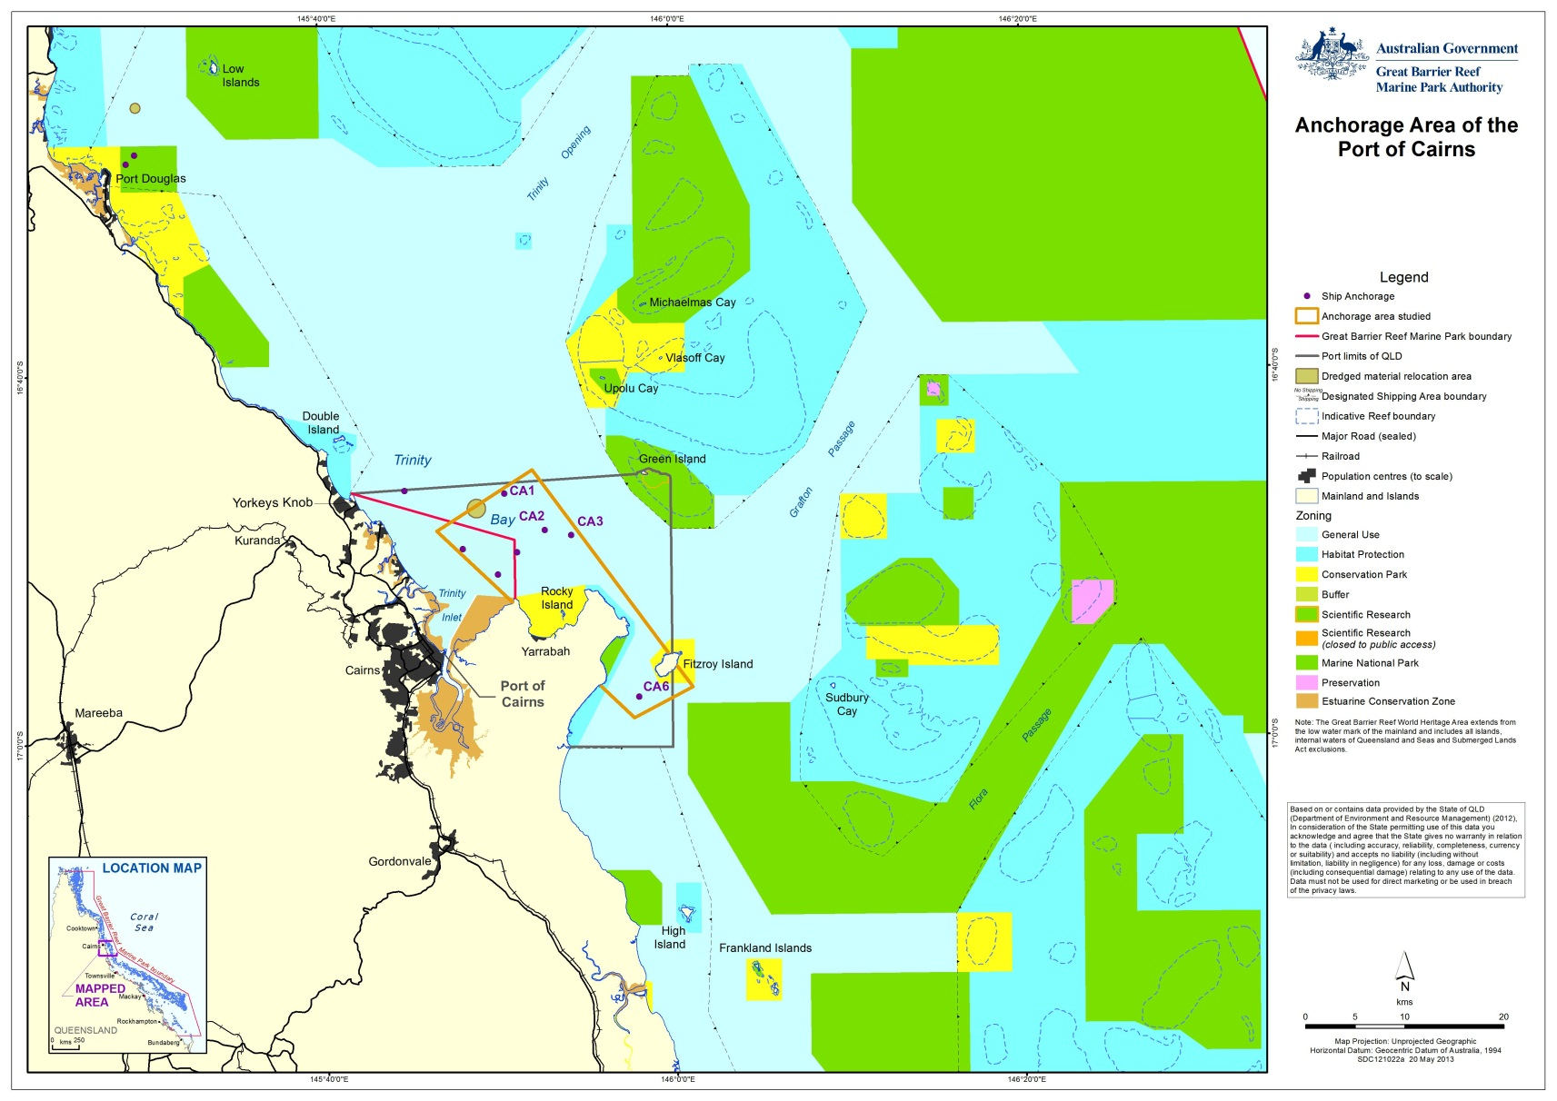
Figure 3-1: Anchorage area of the Port of Cairns

Table 3-1: Ship types using anchorages 1, 2, 3 and 6 at the Port of Cairns
Ship types | Percentage of total users of anchorages 1,2,3 and 6
General cargo | 40%
Bulk carrier | 18%
Tanker | 18%
Passenger | 15%
Others (drill-ship, tug/offshore supply, naval, and landing-craft) | 9%

Currently around a total of 500 ship arrivals per year at the Port of Cairns, of which around 15 per cent involve ships proceeding directly to anchor. This number includes a number of cruise-ships. Typically, ships spent no more than 12 hours at anchor reflecting the general use of the anchorages at the Port of Cairns for either short cruise-ship visits or waiting for tidal assistance to enter the port (GHD 2013, MSQ 2012).
However, of the ships that proceed directly to anchor, a number do not proceed on to berth at Cairns but depart out to sea again. These are typically (large) cruise-ships which anchor at the designated passenger ship anchorage at Yorkeys Knob and typically only remain at anchor for 9 to 10 hours. The current scale of the use of ship anchorages at the Port of Cairns can be summarised as minor with an average of less than one ship call per day using the anchorages for typically stays of only several hours.

Port of Townsville
Townsville is Queensland's third largest commercial port, situated 1360 km north of Brisbane (Port of Townsville 2013). The port is managed by the Port of Townsville Limited who maintain the dredging, security, berths and port control operations at the port.
The main imports are refined fuel products, nickel ore, motor vehicles, cement and general cargo. Exports include raw sugar, copper and zinc concentrates refined lead, copper, zinc and nickel, high analysis fertiliser in bulk, molasses, frozen beef and live cattle. Townsville is also a regular port of call for cruise ships and naval vessels.
The anchorage area servicing the Port of Townsville is located within the Marine Park. It is also situated approximately 17 km north-east of the port and the city of Townsville and to the east-south-east of Magnetic Island. The Port of Townsville anchorage area is 23,762 ha and does not currently have any designated anchorage points (figure 3-2). Therefore, the spatial footprint of the anchorage is not well defined.

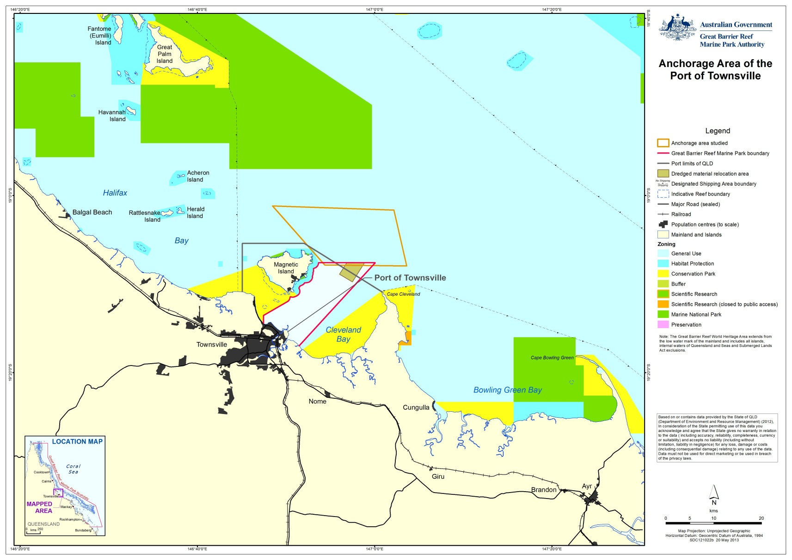
Figure 3-2: Anchorage area of the Port of Townsville

There are currently around 730 ship arrivals per year at the Port of Townsville. This number includes a number of naval vessel arrivals as well as cruise-ships. In 2011 and 2012, around 55-60 per cent of ship arrivals proceeded directly to anchor, compared to 40 per cent of vessels in 2010 (GHD 2013, MSQ 2012). Some passenger (cruise) ships also only anchor for a short period and then proceed to sea without entering port.
The anchorage area was used by a range of ship types in 2011 as shown in table 3-2 (MSQ 2012).
Table 3-2: Ship types using anchorages at the Port of Townsville
Ship types | Percentage of total users of anchorages | Time spent at anchor (in days)
Bulk carrier | 46% | 3.5
General cargo | 24% | 2
Tanker | 9% | 1.5
Vehicles carrier | 7% | 1
Container ship | 5% | 1
Others (cement carrier, gas tanker, livestock carrier, passenger ship, supply vessel, ro-ro cargo, and landing craft) | 10% | various

The Townsville anchorage is also used on occasion for port removals, where a ship temporarily leaves the port to await a move to a subsequent berth in the same port, and for a temporary wait at anchor after departing the port on route to sea. The reason for this is unclear, but could be related to the ship master awaiting instructions on next destinations or weather-related factors.
It is worth noting that two out of nine operational berths at the Port of Townsville have been offline since October 2011 and are due to come back on line again in 2013. This may have altered anchorage demand reviewed to date and may influence future requirements.
The current scale of the use of ship anchorages at the Port of Townsville can be summarised as minor with an average of around one ship call per day (including removals and departures) using the anchorages for typically stays of only several days (average of three days for all ships in 2011).

Port of Abbot Point
The Port of Abbot Point is situated 25 km north of Bowen. The port is a single commodity port, comprising facilities for coal export.
The anchorage area servicing the Port of Abbot Point is located approximately 5 km north-north-west of the port and within the Marine Park boundary (figure 3-3).
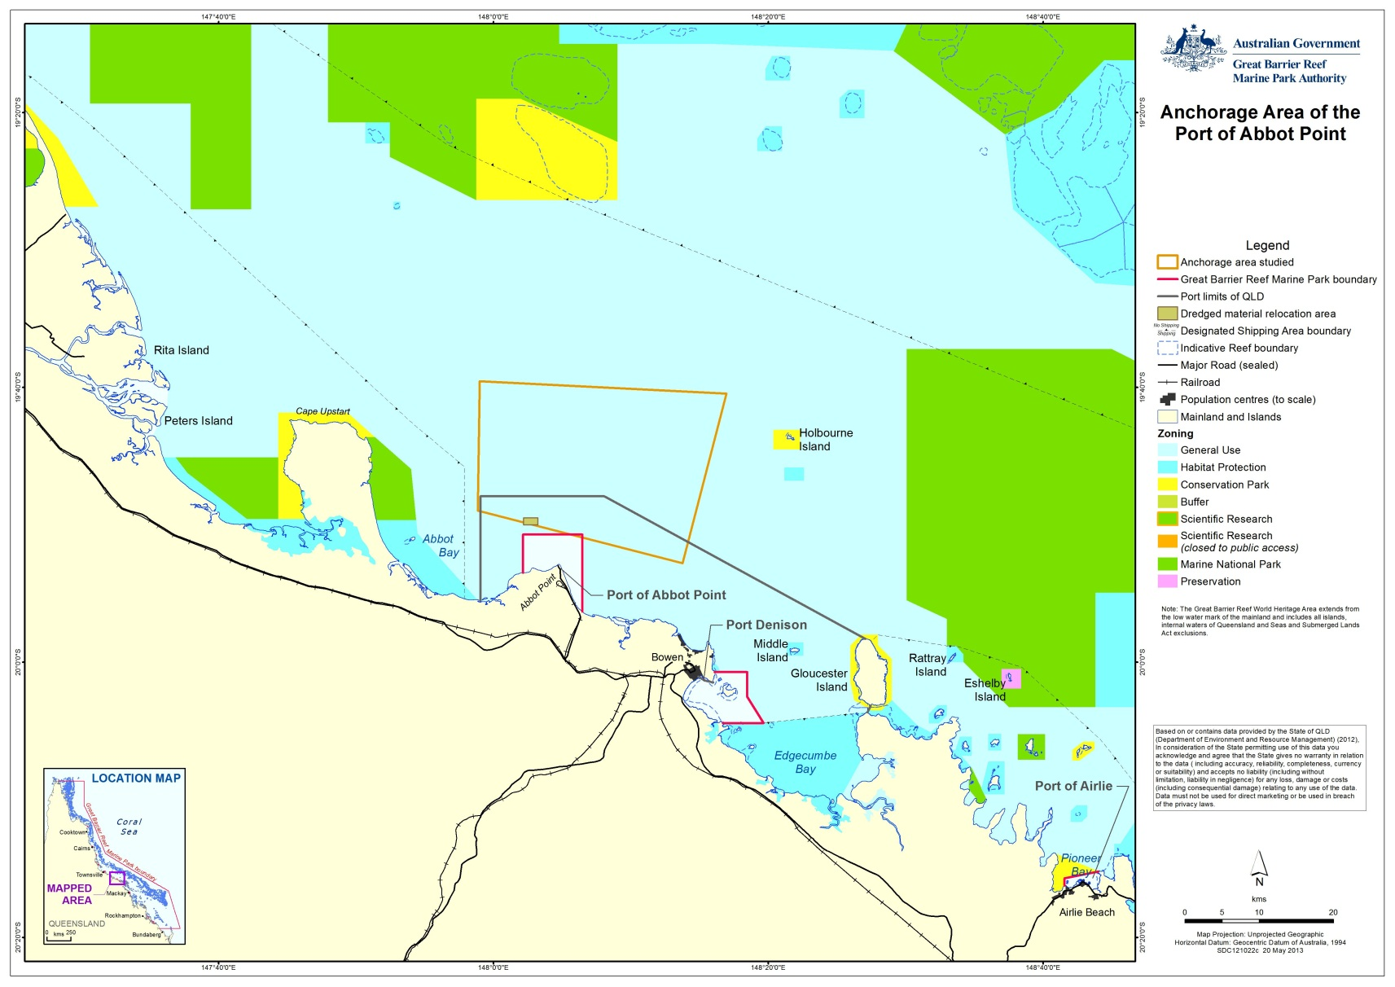
Figure 3-3: Anchorage area of the Port of Abbot Point

The Port of Abbot Point does not have any designated anchorage points. The ship anchorage area is estimated at 58,818 ha.
The anchorage area is transited principally by commercial vessels servicing the Port of Abbot Point and fishing vessels returning to ports north or south of Abbot Point, but is not typically transited by tourism operators accessing the Reef. There are currently around 180 ship arrivals per year at the Port of Abbot Point. All of these vessels were bulk carriers (arriving to load coal for export) (GHD 2013, MSQ 2012).
The ships spent three days on average in anchor (in 2011), however, there were eight instances of anchorage between 13-19 days.
The current scale of the use of ship anchorages at the Port of Abbot Point can be summarised as minor with an average of less than one ship call per day for typically stays of only several days (average of three days for all ships in 2011).

Port of Hay Point
The Port of Hay Point is the largest coal export port within the World Heritage Area. It is situated 40 km south of Mackay and within the Marine Park. It services the central Queensland coal mines and is managed by the NQBP, who maintain the dredging, security, berths and operations at the port.
At 157,285 ha Hay Point has the largest anchorage area of the five major ports and has 102 designated anchorage points (figure 3-4). Aurecon (2012) however notes that on average only 37 of these anchorages is currently used. Remaining anchorages facilitate management of peak demand requirements when ship arrivals exceed availability of coal or terminal capacity. The spatial footprint of the anchorage has been defined taking account of vessel visitation drivers, such as product being traded by the port, in conjunction with navigational safety needs.
The anchorage area is likely to be transited by only a low volume of tourism operators accessing the Reef and islands within the World Heritage Area. The Hay Point anchorage area is, however, transited by commercial and recreational fishing vessels.
In 2011, the designated anchorages used by ships were:
- North Anchorages (1-29)
- Offshore Anchorages (1-59)
- South Anchorage (1-14).
There are currently around 800 ship arrivals per year at the Port of Hay Point, with all of the vessels being bulk carriers (collecting coal for export). Of the ship calls 99 per cent proceed directly to anchor from sea to await berth. This means that Hay Point has the highest requirement of the five ports for anchoring (GHD 2013, MSQ 2012).

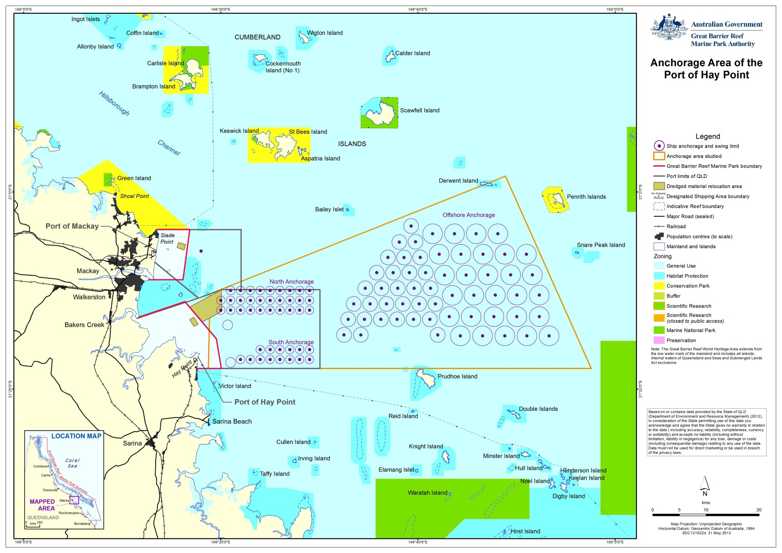
Figure 3-4: Anchorage area of the Port of Hay Point

Typically, ships spent on average 19 days at anchor. In some cases, ships (generally large bulk carriers) remain at anchor for between one and two months and there are some instances with ships moving from one anchorage to another within the Port of Hay Point. Ships are also moved from berths to anchor then back to berth and some ships proceed back to sea from anchor without proceeding to a berth. .
The current scale of the use of ship anchorages at the Port of Hay Point can be summarised as significant compared to other ports within the World Heritage Area, with 102 dedicated points for ships to anchor in organised, dedicated anchorage areas. On average there are two to three ship calls per day using 37 anchorages with stays of between days to weeks and in some instances up to two months. As noted above, anchorage use facilitates management of peak demand requirements when ship arrivals exceed availability of coal or terminal capacity.

Port of Gladstone
The Port of Gladstone is located 160 km north of Hervey Bay and 525 km north of Brisbane. There are currently fifteen operational wharves at six wharf centres.
Ship anchorage at the Port of Gladstone is considered to be typical of a port with multiple trades and visited by multiple ship types requiring operational flexibility. The majority of anchorages servicing the Port of Gladstone are located in an area east-south-east of Facing Island, outside of Gladstone Harbour (referred herein to as the outer anchorage area). A smaller anchorage area, herein referred to as the inner anchorage area, is located to the west of Facing Island within Gladstone Harbour (figure 3-5). The outer anchorage is located within the Marine Park while the inner anchorage is outside of the Marine Park boundary but within the port limits.
The outer anchorage area is located more than 20 km from the Port of Gladstone, outside of the port limits and in an area of open seabed approximately -15 m to -22 m lowest astronomical tide (LAT). The inner anchorage area is located within the port limits and approximately 5 km from the main Port of Gladstone in approximately -11 to -16 m LAT, situating it outside of the Marine Park.
In 2011, the designated anchorages used by ships were:
- East Anchorage (outer)
- North Anchorage (outer)
- Inner Anchorage.
There are currently around 1500 ship arrivals per year at the Port of Gladstone, of which around 80 per cent involve ships proceeding directly from sea to anchor to await berth. Typically stays of only several days occur at the Port of Gladstone with an average of four days for all ships in 2011 (GHD 2013, MSQ 2012).

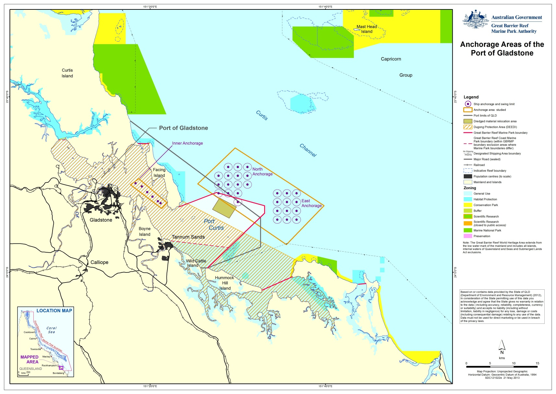
Figure 3-5: Anchorage area of the Port of Gladstone

The Gladstone anchorages were used in 2011 by a range of ship types with the majority of ships being bulk carriers (coal and ores) followed by general cargo, tankers and other types of ships (table 3-3) (MSQ 2012).
Table 3-3: Ship types using anchorages at Port of Gladstone
Ship types | Percentage of total users of anchorages
Bulk carrier coal | 46%
Bulk Carrier liquefied natural gas (LNG) | 10%
Other | 44%

The outer anchorages were used on occasion for removals from port, and temporary wait at anchor after departing the port on route to sea. The inner anchorage was also used for intra-port movements of dredgers and barge carriers.
The current scale of the use of ship anchorages at the Port of Gladstone can be summarised as moderate with 32 dedicated points for ships to anchor in organised designated anchorage areas with an average of around three ship calls per day (including removals and departures) using the anchorages.

Drivers of demand for anchorages
The drivers of the demand for anchorages are essentially the growth developments in the underlying cargo trades and the supply and operation of port capacity. Ship numbers for each port, therefore, reflect the growth and cyclical nature of imports and exports through that port.
When port berth utilisations become high (e.g. in excess of 60-80 per cent depending on the commodity-mix handled) then ship queuing will occur and grow rapidly. Queuing requires the use of anchorages. Anchorage demand will reduce from increasing shipment and ship sizes as less ship calls are required to carry a given amount of cargo.

Future total demand for ship anchorages
The expected future total demand for ship anchorages covering the five major ports in the study area will be primarily driven by a combination of the forecast number of ship calls, the average percentage use of anchorages by the ships calling (including removals from port when transferring between berths or awaiting additional cargoes), and the average time required by ships to be at anchor.
It can be assumed that the average time required by ships to be at anchor will not change compared with present. However, the percentage of ship calls requiring anchoring in the future may change depending on the nature of any new and expanded trades emerging.
The expected future demand for ship anchorages in the study area is summarised in table 3-4 for each of the five major ports (GHD 2013). In phase 2 of the project it was determined that only the Port of Hay Point and Port of Gladstone may need to consider expanding there anchorage areas to meet future demand requirements. Additional or different management options may reduce the need to expand the anchorage areas.
At the Port of Hay Point there is the potential for better scheduling if coal producers use the proposed new terminal at Dudgeon Point. If, through scheduling, the average ship time at anchor is reduced there could still be sufficient anchorage space under future demand negating the need for expansion.
At the Port of Gladstone the future demand for ship anchorages will not increase at the same rate as expected ship calls due to designated shipping and berthing operations for LNG export, whereby ships can be scheduled to call at an LNG berth direct from sea.
Table 3-5 summarises the current anchorage and future demand at each of the five major ports.

Table 3-4: Overview of current and future anchorage demand for the five major ports
Ports: | Cairns |  | Townsville |  | Abbot Point |  | Hay Point |  | Gladstone
 | Current | Future* | Current | Future* | Current | Future* | Current | Future* | Current | Future*
Ship calls per year | 476 | 501 | 726 | 1161 | 179 | 1640 | 796 | 2380 | 1510 | 3029
Average per cent direct to berth | 85% | >85% | 44% | Uncertain | 20% | Uncertain | 1% | 1% | 20% | Uncertain
Average per cent direct to anchor | 15% | <15% | 56% | Uncertain | 80% | Uncertain | 99% | 99% | 80% | Uncertain
Number of anchor locations (if designated) | 8 | Possibly not > current | - | Possibly not > current | - | Possibly not > current | 102 | Possibly 129 | 32 | Possibly not > current
Average waiting days | 0.5 | Uncertain | 3 | Uncertain | 3 | Uncertain | 19 (sample) | Uncertain | 4 | Uncertain
* source: GHD 2013 as at year 2032.

Table 3-5: Summary of current and future anchorage use at each port
 | Cairns | Townsville | Abbot Point | Hay Point | Gladstone
Current anchorage use | Multi commodity port | Multi commodity port | Single commodity port | Single commodity port | Multi commodity port
 | 500 ship arrivals per year | 730 ship arrivals per year | 180 ship arrivals per year | 800 ship arrivals per year | 1500 ship arrivals per year
 | Less than one ship call per day | One ship call per day | Less than one ship call per day | Two to three ship calls per day | Three ship calls per day
 | Average time at anchor – 12 hours | Average time at anchor – three days | Average time at anchor – three days | Average time at anchor – 19 days | Average time at anchor – four days
Future demand | Low growth in ship calls (2%) over next 20 years. | Low growth in ship calls (2%) over next 20 years | Significant growth in future ship calls (11%) over the next 20 years | Relatively moderate growth in future ship calls (5-6%) over the next 20 years | Relatively moderate growth in future ship calls (3-4%) over the next 20 years
 | No change to ship calls per day | Less than two ship calls per day | 2.5 ship calls per day | 6.5 ship calls per day | Six ship calls per day

Ability to control ship anchoring demand and use
It is difficult for a port authority or RHM to control the use of ship anchorages beyond designating anchorage sites and to control their ultimate capacity. Shipping movements (and therefore anchorage) are influenced by other stakeholders with differing commercial objectives and they are summarised below:
- The product exporter may have control over the arrangement of shipping if the contract terms between the seller (e.g. the Australian exporter) and the buyer (e.g. the overseas importer) include delivery by ship to the overseas port destination. This currently does not happen that often in Queensland.
- The product importer may have control over the arrangement of shipping if the contract terms between the seller (e.g. the Australian exporter) and the buyer (e.g. the overseas importer) require the exporter to deliver the cargo to port and load it only onto the ship nominated by the importer (versus a ship controlled by the exporter). This is generally current practice.
- The shipping company and the ship’s master has the discretion when to arrive for cargoes. This can include arriving just-in time for a booked load, arrive in advance of the loading schedule or opportunistically waiting at a loading point (at anchor) for the chance of loading a cargo. Opportunistic arrivals are not a practice that currently occurs for ships servicing the five major ports of Queensland (P. Quirk (MSQ) pers. comm., 20 May 2013).
- The terminal operating company, in conjunction with the port authority, may operate queuing rules, notifications and priorities which affect the behaviour of ships at anchor and their proceeding towards anchor from sea.
This complexity remains a challenge for effective management of anchorages. The different drivers of shipping trade and commercial arrangements across different ports and exporters/importers mean that no single ship anchorage management strategy will be applicable to all port anchorages.
Other commercial shipping arrangements that may influence shipping movements and the use of anchorages are:
- Cost Insurance and Freight (CIF) which means the shipper/trader has to pay the cost of shipment up to the ship, insurance cost of cargo and freight cost up to destination port.
- Free On Board which means the shipper/trader pays only costs up to the ship and insurance cost, but freight charges are paid by the Buyer/Consignee.

Environmental impacts of anchorages

Key environmental values
The key environmental values that are known to occur within the anchorage study areas are MNES protected under the EPBC Act, the OUV for the World Heritage property and cultural heritage values.

Matters of National Environmental Significance
MNES protected by the EPBC Act that are of relevance to this assessment are defined by the Terms of Reference for the Strategic Assessment to be:
- World Heritage properties
- National Heritage places
- Wetlands of international importance
- Listed threatened species and ecological communities
- Listed migratory species
- Commonwealth marine areas
- The Great Barrier Reef Marine Park.

Outstanding Universal Value
The World Heritage Area was recognised for its OUV. Examples of these values or attributes identified by the World Heritage Committee include the biodiversity and interconnectedness of species and habitats along the Reef, and ecosystem processes such as physical, geomorphological, chemical and ecological processes.
OUV is the central idea of the World Heritage Convention. Broadly, its meaning follows the common sense interpretation of the words:
- Outstanding: For properties to be of outstanding universal value they should be exceptional, or superlative – they should be the most remarkable places on earth.
- Universal: Properties need to be outstanding from a global perspective. World heritage does not aim to recognise properties that are remarkable from solely a national or regional perspective. Countries are encouraged to develop other approaches to recognise these places, such as through national heritage listing process.
- Value: What makes a property outstanding and universal is its “value”, or the natural and/or cultural worth of a property. This value is determined based on standards and processes established under the World Heritage Convention’s Operational Guidelines.
To be considered of OUV, a property needs to:
- Meet one or more of ten criteria
- Meet the conditions of integrity
- If a cultural property, meet the conditions of authenticity
- Have an adequate system of protection and management to safeguard its future.
The World Heritage Area was inscribed on the World Heritage List in 1981 in recognition of its outstanding universal value in terms of natural heritage. The World Heritage Area meets all four of the natural heritage criteria for world heritage listing which, broadly speaking are aesthetic, geological, ecological and biological. These values are described in the property’s statement of outstanding universal value, which also describes how the World Heritage Area meets the conditions for integrity and management. Australia has an international obligation to identify, protect, conserve, and present the World Heritage Area’s OUV.

Cultural Heritage Values
The Reef also has significant heritage and cultural value, including indigenous cultural importance for Aboriginal and Torres Strait Islanders. In addition, non-indigenous heritage values are represented and include mapped historic shipwrecks and lighthouses which occur throughout the Reef. These heritage and cultural values of the Reef, along with its biological diversity, represent features that are of outstanding national heritage value to Australia which led to the Reef being registered as a place of National Heritage in May 2007.

Actual and potential environmental impacts
In phase 1 of the project, the EIA (GHD 2012), the environmental, OUV and cultural values of each of the five major ports were identified. The action of anchoring and the presence of vessels at anchor within the World Heritage Area actually impact or have the potential to impact on the values of the World Heritage Area. Actual and potential impacts of anchorages are:
- Disturbance to seabed and supported biodiversity
- Release of emissions or pollutants/wastes
- Altered aesthetic value
- Interference with access to resources
- Marine pest introduction
- Interference with species behaviour.
The key impacts identified during phase 1 of the project (GHD 2012) were:
- Altered aesthetic values: anchorage areas are visible to residents and tourists from land during both the day and night at all ports, with the exception of Abbot Point.
- Interference with access to resources: A high density of vessels at anchor can interfere with another user’s ability to effectively use that area, such as interferences with commercial fishing activities, recreational fishing and boating, and tourism activities.
A summary of the environmental impacts identified during phase 1 and how they relate to ship anchorages is provided in table 4-1. The significance rankings provided were determined using a risk based assessment, as described under phase 1 reporting (refer GHD 2012), taking into account both likelihood of an impact occurring and consequence of that impact. Accordingly, impacts like ship grounding that are unlikely events but which have a severe consequence receive a medium significance rating.
Two studies commissioned by NQBP have informed risk rankings. These studies relate to an investigation into the impacts of ship anchorages on aesthetic values and an investigation into the impacts of anchoring on seabed biodiversity for the Port of Hay Point (refer Cardno Chenoweth 2013 and WorleyParsons 2012).
Table 4-1: Environmental impacts from anchorage activities
Impact | Description
Disturbance to seabed and supported biodiversity | Activity:  Anchor and chain drag as a vessel is dropping anchor. Chain swing while ship at anchor. Anchor drag if ship breaks anchor.  Potential environmental impact:  Anchor and chain drag may create furrows or divots across the seabed. This may remove any biota in the pathway of the chain and anchor, and the resultant altered topography has ability to influence further recruitment.  Impacts to seabed biodiversity could occur from ship grounding (direct and indirect) within or adjacent an anchorage if vessels within the anchorage area collided or if a vessel broke anchor.  Significance:  The effects of anchoring across all ports (except Gladstone inner area) are unable to be readily discerned. A study from Hay Point (WorleyParsons 2012) indicates anchoring may have a low potential of impacting the habitat. Disturbance from anchoring is, however, a chronic impact expected to increase in frequency.  The resultant risks to the biodiversity values of the seabed areas across all ports except Gladstone are therefore considered to be low. As the inner anchorage of Gladstone supports higher biodiversity than other anchorages, the risk to the biodiversity of this area from anchoring is considered to be medium.
Release of emissions or pollutants/wastes | Air Emissions:  Activity:  Vessels at anchor will release emissions associated with the combustion of carbon-based liquid fuels including marine diesel oil and heavy fuel. Typically this is in relation to operation of auxiliary engines from which the vessel draws power as opposed to propulsion.  Potential environmental impact:  Emissions generated by vessels can impact the air quality of the local environment and may have flow on affects to local marine environs or wider geographies, including onshore communities. The release of emissions is a chronic impact that may increase.  Significance:  The potential for environment impacts from pollution release under current controls is considered to be medium.  Release of emissions to water and seabed:  Activity:  Single large scale release, such as an oil spill or due to a ship grounding  Individual small scale releases, occurring over time  Accidental release may occur while a ship is at anchor or if a ship were to break anchor.  Potential environmental impact:  Single large scale releases may realise a significant impact both at a spatial and temporal scale, covering a broad area and taking years to clean up. Accidental release may occur while a ship is at anchor or if a ship were to break anchor. Pollution impacts can also be realised if a navigational accident, including collision, were to occur. Although unlikely to occur the consequences are severe. Under a worst case scenario a major pollution spill could include widespread impact to the World Heritage Area.  Given current management regimes, potential consequence for impacts to be realised from minor releases is considered to be minor as individual releases may not have a detectable affect. Undetected releases of small waste materials may occur year round within the World Heritage Area (e.g. Wilson 2011) and, as such, this activity is considered to be a low level chronic impact. Cumulative effects do not appear to be well understood (Eco logical Australia and Open Lines 2012).  Significance:  The risk associated for impacts to be realised from minor releases is considered medium given the chronic release of low levels of pollution/wastes.  The risk associated with a large scale pollutant release is considered medium.
Altered aesthetic value | Activity:  Anchorages located within view from land and adjacent to vessel passage routes.  Potential environmental impact:  The presence of anchored vessels has potential to detract from the natural state of the vista.  Significance:  Whether the use of anchorages creates an impact to the vista of the reef is subjective. Investigation of the impacts of ship anchorages on aesthetic values at the Port of Hay Point noted that visual impacts on coastal and ocean scenic values at this location will be limited and are considered minor under proposed future ship movements (Cardno Chenoweth 2013). However, that study also reported that Hay Point anchorage does not express or represent any of the World Heritage aesthetic values for which the Reef is recognised. This area was, therefore, considered to be unlike more scenic coastline sections.  Across all coastal vistas that characterise the five major ports there is a lack of knowledge regarding how the presence of ships at anchor affects the aesthetics of the World Heritage Area and whether or not impacts are consistent across all of the five port anchorage areas. Due to this uncertainty, and given findings of consultation to date, the risk is considered high.
Interference with access to resources | Activity:  A high density of vessels at anchor can interfere with another user’s ability to effectively use that area.  Potential environmental impact:  Both marine tourism and the fishery sector (commercial, charter and recreational) may seek access to the same resources occupied by the ship anchorage areas. That access is not prohibited; however, vessels sitting at anchor can interfere with other users passage or use of an area.  Significance:  The preclusion of other users is considered to pose a medium risk to the values which the anchorage areas are recognised for.
Marine pest introduction | Activity:  Vessels at anchor introducing marine pests as biofouling, within ballast water, ballast chambers, sea chests or internal seawater cooling systems.  Potential environmental impact:  Impact on biodiversity and commercial fishing.  Significance:  It is considered unlikely that pest species would be introduced to deep water anchorages. The consequence of a successful introduction is considered to be catastrophic. Therefore, the significance of this impact is high.
Interference with species behaviour | Activity:  Vessels sitting at anchor and vessels generating noise or light.  Potential environmental impact:  Displacement of species from habitat  Altered species behaviour from light and noise  Contact with megafauna  Significance:  Medium significance

The impacts of ship anchorages that are relevant to the five major ports were identified during phase 1 of the project (GHD 2012). A summary of the environmental impacts for each port is provided in table 4-2.
Table 4-2: Potential environmental impacts at each port
Port | Potential environmental Impacts
Port of Cairns | A reduction in the aesthetic value of the coastal vista  Generation of small turbidity plumes from anchor drop and chain drag  Disturbance to seabed biodiversity from anchor drop and chain drag*  Minor releases of emissions/pollutants/wastes from ships  Interference with other users access to resources of the World Heritage Area  Introduction of marine pest species  Interference with species behaviour
Port of Townsville | A reduction in the aesthetic value of the coastal vista  Generation of small turbidity plumes from anchor drop and chain drag  Disturbance to seabed biodiversity from anchor drop and chain drag*  Minor releases of emissions/pollutants/wastes from ships  Interference with other users access to resources of the World Heritage Area  Introduction of marine pest species  Interference with species behaviour
Port of Abbot Point | A reduction in the aesthetic value of the coastal vista  Generation of small turbidity plumes from anchor drop and chain drag  Disturbance to seabed biodiversity from anchor drop and chain drag*  Minor releases of emissions/pollutants/wastes from ships  Interference with other users access to resources of the World Heritage Area  Introduction of marine pest species  Interference with species behaviour
Port of Hay Point | A reduction in the aesthetic value of the coastal vista  Generation of small turbidity plumes from anchor drop and chain drag  Disturbance to seabed biodiversity from anchor drop and chain drag*  Minor releases of emissions/pollutants/wastes from ships  Interference with other users access to resources of the World Heritage Area  Introduction of marine pest species  Interference with species behaviour
Port of Gladstone | A reduction in the aesthetic value of the coastal vista  Generation of small turbidity plumes from anchor drop and chain drag  Disturbance to seabed biodiversity from anchor drop and chain drag*  Minor releases of emissions/pollutants/wastes from ships  Interference with other users access to resources of the World Heritage Area  Introduction of marine pest species  Interference with species behaviour
* Note: study completed for Hay Point indicates the distribution of seabed habitats is not affected by anchorage activities (refer WorleyParsons 2012). This study did not, however, consider potential temporal differences in biodiversity or anchorages beyond Hay Point.

Management of Anchorages at the Five Major Ports

Management options
The potential for some of the impacts identified in section 4.2 to occur is currently managed through the implementation of existing legislation described in section 2 (e.g. MARPOL identifies provisions for pollutant risk management). There are also a number of additional management options that exist or are recommended for each of the identified impacts, these are listed in table 5-1 and expanded upon in the following sections with detail around implementation of management options provided in section 6. Provision of information to the shipping industry to raise awareness of options to reduce impacts is pivotal to any management action having affect. That is also addressed in section 6

Table 5-1: Management options that exist or are recommended for each of the identified impact
Impact | Current Management Controls | Future Management Options
Disturbance to seabed and supported biodiversity | Pilotage  Designated Anchorages  Zoning  Port procedures  Inspections  Legislation | Aggregate anchorages at each port  Site section criteria to take into account the potential influences that increased levels of disturbance may have. Relevant assessments should be conducted to select areas at low risk of being affected by anchoring activities
Release of emissions or pollutants/wastes | Vessels are required to adhere to existing regulations governing emissions releases.  Maintenance of engine and combustion equipment  Designated anchorages  Port procedures  Inspections | Aggregate anchorages at each port  Reduce time at anchor  Designated anchorages where currently not in place  Consideration to proximity to sensitive receptors should be given if expansion of relocation of anchorage areas is proposed
Interference with access to resources | Port procedures  Designated anchorages | Aggregate anchorages at each port  Reduce time at anchor  Designated anchorages where currently not in place
Marine pest introduction | Existing legislation  Port procedures  Zoning  Monitoring/inspections | Introduction and implementation of new legislation (Biosecurity Act)  Aggregate anchorages at each port  Reduce time at anchor
Interference with species behaviour | Existing legislation and guidelines  Zoning  Monitoring/inspections | Aggregate anchorages at each port  Reduce time at anchor  Anchorage selection to take into account species pathways

Port specific management options

Port of Cairns
The following issues for the management of the Port of Cairns anchorage have been identified through phases 1 and 2 of the project as:
- Demand of anchorages related to tidal access of port.
- Low growth in ship calls (2 per cent) over next 20 years.
- Current practices of ship anchoring were considered to have minimal future impact for the environment and other users beyond that which has already occurred at the designated anchorage site.
- Plans to improve channel and port access, the Cairns Shipping Development Project (Port of Cairns 2013) will reduce demand for additional anchorages by facilitating access to the port.
- The close proximity of the anchorage to the port provides opportunity to manage ship safety and rapidly respond to any maritime incident.
- Results of the Economic Appraisal suggest that the current practice of anchoring at the Port of Cairns within the designated areas is likely to produce the least cost for the desired net environmental outcome over the next 30 years.
Management options - Cairns:
- Continue current practices of ship anchoring.
- Improve current anchorage management practices to protect environmental values.
- Optimise the use of existing anchorages.
- Investigate impacts of ship anchorages on aesthetic values at the Port of Cairns.

Port of Townsville
The following issues for the management of the Port of Townsville anchorage have been identified through phases 1 and 2 of the project as:
- Ship anchorage at the Port of Townsville requires operational flexibility due to multiple trades and visits by multiple ship types.
- Most of the current anchorage area is outside of the port limits and it is undesignated.
- Low growth in ship calls (two per cent) over next 20 years.
- The current practices of ship anchoring were considered to have minimal future impact for the environment and other users beyond that which has already occurred.
- The close proximity of the anchorage to the port provides opportunity to manage ship safety and rapidly respond to any maritime incident.
- Environmental, economic and social benefits may, however, be realised if anchorage areas were designated at this port.
- The current practice of anchoring at the Port of Townsville, with the improvement of implementing organised designated areas, is likely to produce the least cost for the desired net environmental outcome over the next 30 years.
Management options - Townsville:
- Continue current practices of ship anchoring.
- Improve current anchorage management practices to protect environmental values.
- Consider implementing designated anchorage areas, particularly recognising that future ship call growth will be possibly underpinned by bulk carriers requiring anchorage.
- Investigate impacts of ship anchorages on aesthetic values at the Port of Townsville.

Port of Abbot Point
The following issues for the management of the Port of Abbot Point anchorage have been identified through phases 1 and 2 of the project as:
- Part of the current anchorage area is inside of the port limits and anchorage drop points are undesignated.
- Significant growth in future ship calls (11 per cent) supports improving current anchorage practices by implementing designated anchorage areas.
- The option of scheduled arrivals with designated anchorages was also considered to be relevant.
- The current practices of ship anchoring with the current size of port operations were considered to have minimal impact for the environment and other users beyond that which has already occurred.
- The close proximity of the anchorage to the port provides opportunity to manage ship safety and respond to any maritime incident.
- Environmental and economic benefits may, however, be realised if anchorage areas were designated at this port.
Management options – Abbot Point
- Continue current practices of ship anchoring.
- Improve current anchorage management practices to protect environmental values.
- Consider implementing designated anchorage areas.
- Consider scheduled ship arrivals if and when anchorage demand dictates.

Port of Hay Point
The following issues for the management of the Port of Hay Point anchorage have been identified through phases 1 and 2 of the project as:
- Ship anchorage at the Port of Hay Point was considered to be typical of a single commodity coal export port. However, there are currently two sets of terminal operations, each requiring anchorage demand. This is expected to increase to a third set in the future with planned expansion at Dudgeon Point also requiring anchorage use.
- It was noted that the current inner anchorage area is inside of the port limits, and that anchorages are designated.
- The expected relatively moderate growth in future ship calls (five to six per cent) at the Port of Hay Point, from a relatively large base, was considered likely to put pressure on the existing capacity of the current designated anchorage areas.
- Current practices with designated anchorage areas were envisaged as relevant if future demand can be accommodated by the existing capacity of the designated anchorage areas.
- It is predicted that the peak anchorage demand over the period 2012-2032 at Hay Point will not be able to be accommodated by the current anchorage area. To accommodate peak demand anchorage at the Port of Hay Point is predicted to require expansion by around 30 per cent by 2032 unless more efficient use is made of current anchorages. This being considered under the master planning for the port (Aurecon 2012).
- Expansion of the existing anchorage would realise environmental and other impacts and alternative anchorage management options to avoid expanding the anchorage area should be considered.
- The anchorage option of “Scheduled Arrivals with designated Anchorages” could provide the greatest net social welfare gain for a period of the next 30 years. The main driver of the net gain is the estimated savings in ship fuel costs assumed when ships are scheduled.
- Implementation of a vessel arrival system (VAS) at the Port of Hay Point may also realise benefits for the Port of Abbot Point if a VAS was also considered for that location given the commonalities in management governing each location.
- The proximity of the anchorage to the port provides opportunity to manage ship safety and rapidly respond to any maritime incident.
- In the scenario where future demand cannot be met by the current anchorage capacity, then scheduled arrivals in combination with dedicated anchorages and/or anchorage pricing were envisaged as relevant anchorage management options for the Port of Hay Point.
Management options – Port of Hay Point
- Continue current practices of ship anchoring.
- Improve current anchorage management practices to protect environmental values.
- Further investigate impacts of ship anchorages on aesthetic values at the Port of Hay Point considered different anchorage management strategies building off the recently completed study that noted visual impacts on coastal and ocean scenic values will be limited and are considered minor under proposed future ship movements (Cardno Chenoweth 2013).
- Further investigate suitability of scheduled arrivals in combination with designated anchorages for meeting future demand.

Port of Gladstone
The following issues for the management of the Port of Gladstone anchorage have been identified through phases 1 and 2 of the project as:
- Ship anchorage at the Port of Gladstone is considered to be typical of a port with multiple trades and visited by multiple ship types requiring operational flexibility.
- Ship calls are forecast to grow by three to four per cent per year over the next 20 years.
- The current practice of anchorage management at the Port of Gladstone is likely to produce the least economic cost for the desired net environmental outcome over the next 30 years. However, this finding is sensitive to the assumed (i.e. current) average waiting times of ships at anchor.
- The close proximity of the inner anchorage to the port provides opportunity to manage ship safety and rapidly respond to any maritime incident.
- Expansion of the existing designated anchorages would not be considered an environmentally beneficial solution to increased demand. There is no predicted need to expand the existing anchorages.
- If average waiting times increase in future then options to improve anchorage management would need to be considered. This may include designating specific anchorages for coal vessels and adopting a partial VAS for those anchorages.
Management options – Port of Gladstone
- Continue current practices of ship anchoring.
- Improve current anchorage management practices to protect environmental values.
- Optimise the use of existing anchorages.
- Investigate impacts of ship anchorages on aesthetic values at the Port of Gladstone.
- If waiting times increase beyond four days, strategies to manage existing anchorages to avoid requirement to expand could include redesignating some anchorages as exclusive coal ship anchorages and adopting a VAS only for those anchorages.

Summary of management options
A summary of the management options for each of the five ports is included in table 5-2. The summary addresses:
- Existing management of anchorages at the five ports
- Adequacy of existing anchorages to meet future demand for anchorages
- Management options to be considered in order to meet the current and future needs for environmental protection of the Reef.
A strategy to implement actions to achieve identified management options is described in section 6.

Table 5-2: Summary of management options for each port
 | Cairns | Townsville | Abbot Point | Hay Point | Gladstone
Current Management of Anchorages | Sufficient physical capacity  Environmental impacts from existing anchorage practices considered to be not significant.  Designated anchorages. | Sufficient physical capacity  Environmental impacts from existing anchorage practices considered to be not significant.  No designated anchorages. | Sufficient physical capacity  Environmental impacts from existing anchorage practices considered to be not significant.  No designated anchorages. | High demand for anchorages, nearly all ships (99%) proceed directly to anchor from sea to await a berth.  Environmental impacts from existing anchorage practices considered to be not significant.  Designated anchorages. | Sufficient physical capacity.  Environmental impacts from existing anchorage practices considered to be not significant.  Designated anchorages.
Future Demand* | Low growth in ship calls (2%) over next 20 years. | Low growth in ship calls (2%) over next 20 years. | Significant growth in future ship calls (11%) over the next 20 years | Relatively moderate growth in future ship calls (5-6%) over the next 20 years | Relatively moderate growth in future ship calls (3-4%) over the next 20 years
Future adequacy | No predicted need to expand. | No predicted need to expand. | No predicted need to expand. | Requirement for expansion of anchorages by around 30% predicted to accommodate peak demand | No predicted need to expand.
Management Options | Continue current practices of ship anchoring  Improve current anchorage management practices to protect environmental values  Optimise the use of existing anchorages  Investigate impacts of ship anchorages on aesthetic values at the Port of Cairns | Continue current practices of ship anchoring.  Improve current anchorage management practices to protect environmental values  Consider implementing designated anchorage areas  Investigate impacts of ship anchorages on aesthetic values at the Port of Townsville | Continue current practices of ship anchoring.  Improve current anchorage management practices to protect environmental values  Consider implementing designated anchorage areas.  Consider scheduled ship arrivals if and when anchorage demand dictates | Consider more efficient use of existing anchorages*  Improve current anchorage management practices to protect environmental values  Further investigate impacts of ship anchorages on aesthetic values at the Port of Hay Point  Consider scheduled arrivals in combination with designated anchorages to avoid need to expand anchorage areas | Continue current practices of ship anchoring  Improve current anchorage management practices to protect environmental values  Optimise the use of existing anchorages  Investigate impacts of ship anchorages on aesthetic values at the Port of Gladstone  If waiting times increase beyond four days, consider redesignating some anchorages as coal ship anchorages, and consider feasibility of VAS
*Already under consideration in the draft port master plan (refer Aurecon 2012)

Environmental Ship anchorage management Strategy for the FIVE MAJOR PORT Anchorages

Introduction
Review of shipping demand forecast, existing site conditions and impacts and comparative analysis of management strategies has been completed under phases 1 and 2 of the project. Those works demonstrate that options exist to implement new, or adapt and improve existing anchorage management actions to avoid further impacts on the World Heritage Area, particularly under future shipping demand.
This section describes an EMS for all five major ports of the World Heritage Area which will enable improved management of anchorages to protect and minimise impacts on environmental values to be achieved. This EMS also has relevance to those locations within the Marine Park which are not designated anchorages associated with ports but which are zoned as general use and are, therefore, able to be used by ships for anchoring activities. This strategy identifies actions to facilitate implementation of the management requirements identified in previous sections. Through this strategy, improved and consistent environmental ship anchorage management at each of the ports will be achieved during the next 25 years as shipping demand increases.
This environmental ship anchorage management strategy and the underpinning actions are driven by an overarching objective to minimise environmental and social impacts associated with anchorage use. This is achievable by minimising the number of vessels that sit at anchor while maintaining efficient operation of port import and export requirements. The strategy, therefore, provides for improved environmental management of the existing port anchorages which has comparable social benefits.
Three explicit Objectives support the strategy to improve future management of ship anchorages and actions are designed to achieve each of these Objectives:
Objective 1: Manage existing anchorages with the aim of protecting environmental values
Objective 2: Optimise use of existing anchorages in the Marine Park
Objective 3: Minimise environmental impacts from future anchorages and anchorage relocations
The following sections present the outcomes for each of the Objectives, the action plans which support achievement of those outcomes and the timeframes within which the action plans are to be achieved. The relevance of each of the Objectives to the management of each of the five port anchorages is also discussed. Given vessels may anchor anywhere within the Marine Park general use zone and DSA, this strategy has been deliberately structured to achieve each of the desired Objectives to provide relevancy to those vessels that may not be making use of port prescribed anchorages.

Objective 1: Manage existing anchorages with the aim of protecting environmental values

Outcomes of Objective 1
At four of the five major ports current practices of ship anchorages were considered to have minimal impact to the environment. However, all ports will benefit from the implementation of Objective 1, which will improve current anchorage management practices by strengthening the understanding of, and management options available for, activities that cause or have the potential to cause environmental impacts within ship anchorages. Objective 1 is applicable to and should be implemented for all five major port anchorages within the World Heritage Area, to improve the protection of environmental values.
The implementation of actions under this objective will achieve the following outcomes:
Outcome 1-1: Provide guidance and education for key stakeholders in environmental management of anchorages and ships while at anchor for improved environmental outcomes
Outcome 1-2: Obtain better understanding of environmental condition of anchorages and their use near ports to enable adaptive management under changing conditions
Outcome 1-3: Further enhance environmental performance at ship anchorages for improved environmental outcomes

Action Plan for Outcome 1-1: Guidance and education for stakeholders
Although all existing anchorages are located in open, soft seabed environs, with low biodiversity (refer section 3) these habitats are of value to the continuity and integrity of the World Heritage Area. Minimising fragmentation of these habitats and reducing risk of environmental impacts from ships at anchor is desirable for best environmental management.
Current anchorage management practices are improved by strengthening the understanding of shipping agents, ship masters, RHM, MSQ and other relevant parties of how anchoring may impact the environment and what management measures are available for impact mitigation. Current anchoring controls in ports described by port notices and in port manuals relate to the safe operation of ports or anchorages which does have an objective of environmental management and does not prescriptively consider best practice management of the environment of the anchorages. Information available to the shipping industry in regards to anchorage use from AQIS, port control officers or RHM addresses quarantine requirements or anchoring safe operation and navigational requirements.
It is recommended to:
- Develop an environmental management guideline for anchorages in the Marine Park
- Develop port specific environmental management guidelines for anchorage use in the Marine Park and adjacent areas.
Environmental management guidelines
Review to date indicates there is no specific environmental guideline relating to ships at anchor within the five major ports of the World Heritage Area. In addition, the ships at anchor may not be familiar with current jurisdictions and environmental management controls available to them whilst at anchor in the World Heritage Area.
It is recommended for the GBRMPA to develop environmental guidelines relating specifically to ships at anchor which could then be used to communicate with ship owners and masters of ships. These environmental guidelines could also be extended to ships other than those accessing the five major port anchorages.
The guidelines should make reference to relevant Conventions and legislation that are applicable across Queensland ports for environmental protection, thus strengthening the implementation of legislation. The guidelines would address:
- A description of environmental values to be protected during anchoring
- Activities while anchoring that may impact on the environmental values
- Potential and actual environmental impacts from anchoring
- Best practice for anchoring with least environmental impact
- Waste management procedures while at anchor
- Light spill and noise considerations for ships while at anchor
- Biofouling and ballast water management of relevance to anchorage use
- Storage and management of hazardous substances while at anchor.
The environmental management measures should aim at minimising the following impacts identified as relevant to each of the five ports:
- Disturbance to seabed and supported biodiversity
- Release of emissions or pollutants/wastes
- Altered aesthetic value (or perception thereof)
- Interference with access to resources
- Marine pest introduction
- Interference with species behaviour.
The guidelines should be developed in collaboration with key stakeholders, including port authorities, MSQ and AMSA to capture and cross reference all relevant jurisdictional requirements.
Details of the guidelines may be incorporated in port notices, which are legally binding under the Transport Infrastructure Act 1994. This would require negotiations with and approval by the port authorities.
The environmental management guidelines may also be made applicable to anchorage and general use areas within the World Heritage Area and elsewhere within the Marine Park which are not associated with the five major ports. This could be achieved through the development of marine notices through AMSA if relevant parties were in agreement. Compliance with marine notices is not legislated. But the use of a specific Marine Notice may be included in legislation, such as zoning plans. Further investigations to identify legislative mechanisms for implementation of environmental management guidelines in the World Heritage Area should be conducted to identify whether reference to an anchoring guideline for best environmental management under the existing zoning plan is appropriate.
If a legislative approach is found to be not desired or practicable, the guidelines should be communicated to ship owners, shipping agents and ship masters via an education and public awareness program. This program may include online distribution (via GBRMPA website), pre-entry notification to international ship traffic via existing portals, such as AQIS or the REEFVTS or similar, presentations to the key stakeholders (e.g. Shipping Australia) and media publicity.

Action Plan for Outcome 1-2: Environmental condition monitoring
The environmental condition of anchorage sites is not currently subject to routine monitoring to understand whether existing management actions are being effective, to confirm that transient sensitive habitats (e.g. seagrasses or corals) are not at risk from anchoring activities, or identify whether adaptive and improved management is needed. This is likely because current management is not specifically targeted at environmental objectives. Targeted, regular environmental monitoring of the areas used for anchoring will improve understanding of the environmental condition and enable adaptive management intervention to be considered if controls are found to be ineffective.
Environmental monitoring program at ship anchorage sites
It is recommended that the GBRMPA monitor the environmental conditions of each anchorage site and its vicinity at appropriate intervals for the following parameters:
- Biodiversity and presence of marine pests
- Seabed conditions (habitat type, rugosity)
- Sediment type and quality
- Underwater noise
- Air quality
- Waste accumulation.
To achieve this, the GBRMPA will need to undertake a process to design a monitoring program of relevance to each of the five port anchorages. Considerations during design should be given to anchorage use patterns (both current and future), environmental risks at each port and sampling intensity needed to have confidence of detecting any change in conditions. Consideration should also be given to identify what other parameters would need to be assessed to detect drivers of change. As the program would seek to detect changes in condition at each port, the monitoring program is unlikely to be identical for each of the port anchorages.
In designing the program the GBRMPA should take into account monitoring programs already in operation in the areas concerned. There may be opportunities for sharing information or for minor amendments to existing programs to achieve the desired outcomes. Collaboration with research centres and industry may play an important role in the success of the program.
The GBRMPA should review findings from ongoing monitoring to provide important information on changes in environmental conditions and efficacy of existing management arrangements. Data can be interpreted to provide an early warning system to implement corrective actions in a timely manner if environmental site condition degradation is identified. It may also provide information on whether small scale releases of pollutants from ships at anchor occur and, if so, whether they impact on the environment in a cumulative sense.
Reporting from this monitoring program should be achieved by the GBRMPA to inform the Outlook Report, DSEWPaC, Shipping Australia and other industry bodies and the IMO. This would support ongoing review and improvement of the international conventions and legislative tools (described in section 2) that govern activities which have the potential to impact upon the World Heritage Area.

Action Plan for Outcome 1-3: Enhanced environmental performance
To support review of relevancy of current environmental controls for anchorages it is appropriate to audit adherence of vessels to the controls they are required to abide by. This should be achieved in conjunction with measuring environmental conditions (Objective 1-2) to enable differentiation between natural and anthropogenic drivers of change which may be observed during monitoring of anchorage sites.
To achieve Objective 1-3 it is recommended that the GBRMPA:
- Develop and implement environmental inspection and audit programs for ships at anchor in the Marine Park in collaboration with ports, the shipping industry, AMSA, AQIS and MSQ.
- Provide reports of audit findings to industry and management bodies to support initiatives that aim at reducing air emissions from shipping, such as switch to low emission fuels used while at anchor.
- Determine the impact of anchorage areas on aesthetic values by considering how different stakeholder groups value a vista which does and does not include ships at anchor.
Inspection program for ships at anchor to monitor environmental performance
Review and consultation completed under this project did not identify any dedicated audit program which is targeted at taking record of the different impacts associated with vessels anchoring in the World Heritage Area across criteria including emissions to air, management of hazardous substances and waste releases at each of the five ports. Vessels are required to adhere to legislative requirements and only through reporting are incidents recorded and investigated.
It is recommended that the GBRMPA review current ship inspection programs to consider whether they adequately validate and demonstrate vessels adherence to legislative environmental management requirements. If current inspection programs do not address all relevant management requirements, the GBRMPA should consider what additional information is needed and whether existing inspection programs are able to be adapted to collate that information or whether additional programs are required. Existing inspection activities may only target quarantine matters and may not facilitate collection of data of relevance to anchorages and management of the environmental values of those locations.
If current inspections are found to lack in their ability to detect whether vessels adhere to required environmental management requirements while at anchor with regard to wastes, emissions and hazardous substances the GBRMPA should consider mechanisms to address this gap in collaboration with relevant stakeholders. It is anticipated these stakeholders would include AMSA, AQIS, MSQ, and other parties involved in vessel entry control and management.
The action plan for an inspection program should include:
- A desktop review of current inspection programs conducted at each of the five ports
- Discussions with port authorities, AMSA, AQIS and MSQ on the scope, frequency, and record keeping of inspections that are currently being conducted for ships at anchor and in anchorage areas
- Discussions with shipping industry representatives regarding what environmental inspections are being conducted by the shipping industry or what environmental data is collated by the shipping industry for ships while at anchor
- Gap analysis to determine adequacy and consistent implementation of current inspection programs
- Identification of key improvements to existing inspection programs and a mechanism for implementing those improvements
- Communication and collaboration with key stakeholders on changes to existing inspection programs and how any improvements may be able to be implemented.
It is likely that the shipping industry would, through daily vessel management and logbook reporting, collate information that demonstrates adherence to environmental legislative requirements. Accordingly, adaptation of how information is reported may be required to achieve this objective.
Provide reports of audit findings to industry and management bodies
Following the implementation of the improved inspection program, the GBRMPA may want to regularly audit to what extent the stakeholders adhere to the implementation of the inspection program, such as
- Checking that inspections are being completed at the intervals proposed
- Records are being kept and managed in the proposed way
- Any non-conformances identified during the inspections are dealt with in the agreed manner.
Information from this program would support the review of data collected under Outcome 1-2.
Determine impacts of anchorage areas on aesthetic values
Phase 1 of the project found that the relative impact of ships at anchor on the aesthetic values of the World Heritage Area is unquantified (GHD 2012). To adequately manage potential impacts to the World Heritage Area it is necessary to benchmark conditions and measure deviations and drivers of change through on-going monitoring.
It is, therefore, recommended that the GBRMPA design and conduct a targeted assessment which seeks to identify how the presence of vessels visible at anchor influences the aesthetic value of the World Heritage Area across geographies including the major population centres, the five major ports and minor population centres. This could include development of standards for aesthetic value assessment and impact analysis in consultation with experts and stakeholders.
The outcomes of these investigations could provide a standard framework for aesthetic value impact analysis and inform GBRMPA’s position on site selection criteria for any proposed expansions or relocations of anchorage sites. It will also provide key information regarding a sustainable level of visible anchorage which does not denigrate the aesthetic experience of the World Heritage Area. This information will be of use (aligned with other environmental and economic data) in defining the maximum number and arrangement of vessels able to be sustained at anchor. Findings should be shared with industry for improved management of anchorage areas.
Consideration should also be given to establishing on-going monitoring of potential impacts on aesthetic values. The need for this, including frequency, would be informed by baseline assessment. Outcomes could be used to demonstrate whether aesthetic values are improved by any management actions. As aesthetic values can be subjective information provided through education and awareness may provide opportunity to positively influence perceptions of level of impact to aesthetic values from anchorage use.

Objective 2: Optimise use of existing anchorages in the Marine Park
Implementing Objective 2 will optimise the use of existing anchorages and minimise the need to expand anchorage areas or designate new anchorage areas under increased demand. Objective 2 is applicable to and should be implemented for all five major port anchorages within the World Heritage Area.
The implementation of actions under this objective will achieve the following outcomes:
Outcome 2-1: Restrict shipping industry users of the Marine Park to anchor only in designated anchorage areas
Outcome 2-2: Minimise the need for further anchorages in the Marine Park

Action Plan for Outcome 2-1: Restrict users to designated anchorage areas
The use of designated anchorages enables efficient management of anchorages at ports, not only from an environmental point of view but also with regards to safety. Environmental considerations should also be embedded in key decision making processes with respect to the management of anchorages and ships while at anchor, especially, as the GBRMPA is not directly involved in making decisions regarding ship anchorage.
Assign designated anchorages in each port
Minimising fragmentation of habitats is currently achieved for the anchorages of Cairns, Hay Point and Gladstone through the use of designated anchor drop points as this reduces the overall area of seabed affected by chronic anchor disturbance. Further, the anchorages of Townsville and Abbot Point do not have designated anchor drop points and, therefore, there are no designated habitat impact controls for anchoring at these locations.
At Townsville and Abbot Point anchorage is managed by the RHM with regard to safe navigation and operation of vessels moving into/out of and sitting at anchor. Without use of designated ship anchor drop points there is increased potential of seabed fragmentation and potential for impacts to be realised across a larger spatial footprint than if the anchorage area was designated.
Currently, anchorages are managed by MSQ. Therefore, the GBRMPA should collaborate with port authorities and MSQ to designate anchorages in both Townsville and Abbot Point. Consideration of minimising potential environmental impacts which can result from ship anchorage could be achieved by giving regard to minimising the area needed for safe anchorage, minimising the number of vessels that are required to anchor and using defined anchor drop points to minimise the area of seabed affected by anchoring. Anchor drop points and the anchorage area should be designated with regard to providing the highest level of protection to the OUV of the World Heritage Area and should take into account existing zoning and other measures in place for environmental protection. Designation of anchorages does not preclude ships from being able to anchor within the general use zone or DSA, but does provide opportunity to minimise area of chronic impact.
Investigate options to reduce footprint of existing anchorages
Reducing the footprint of existing anchorages reduces the extent of the Reef exposed to habitat impacts and pollutant risk. It also facilitates a response to any incident or audit and inspection of ships at anchor.
It is recommended that the GBRMPA work with the port and shipping industry, including the maritime safety authorities, to identify the minimum anchorage footprint required for all five ports under future shipping demand scenarios. To identify the minimum anchorage footprint required safe, efficient operation and ship navigation under future anchorage use (demand) requirements should be considered. The sites which can be used with the least environmental impacts and which anchorage areas should be designated as emergency use options only should be identified. This study should also be completed with regard to the actions proposed to achieve Objective 2-2.

Action Plan for Outcome 2-2: Minimise need for further anchorages
The actions proposed for Outcome 2-2 are further investigations to define mechanisms to achieve:
- Improvements in supply chain management at the single commodity ports, including scheduled vessel arrivals with designated anchorages and a VAS for the Port of Hay Point, Abbot Point and Gladstone.
Further investigate improvements in whole of supply chain management for single commodities, especially coal
The whole of supply chain includes a single exporter fully controlling an integrated supply-chain from mine to terminal to overseas port with the exporter also controlling the shipping (on CIF sales terms, meaning all the way to the destination port) (figure 6-1).

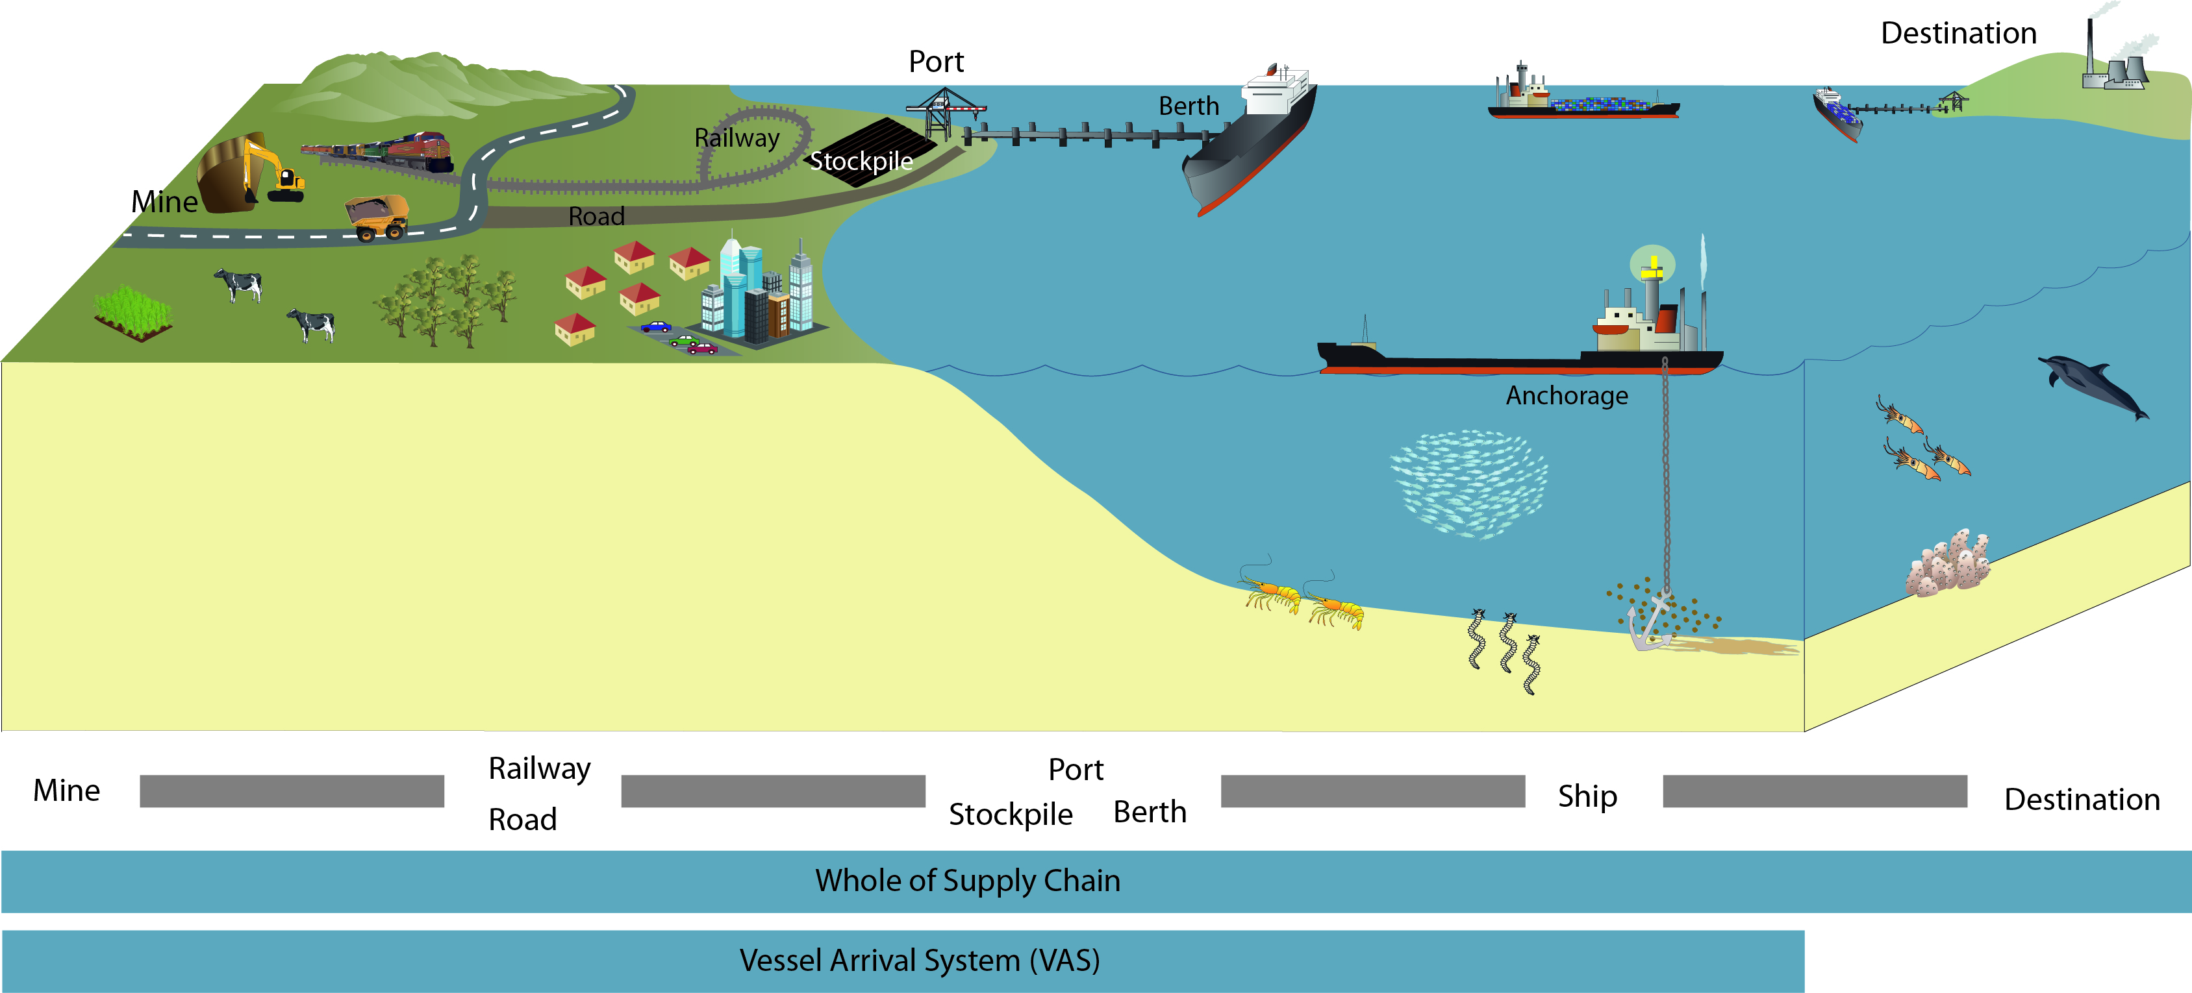
Figure 6-1: Conceptual model of the whole of supply chain

Improvements in whole of supply chain management may lead to a more efficient use of existing anchorage sites. For instance, ships may not be required to anchor if they can proceed direct to loading/unloading berths on arrival in the port. Alternatively time spent at anchor may be reduced if supply chain logistics are aligned to provide the most efficient operation. As identified during phase 2 of the project, such improvements could negate the need to increase anchorages in the future, improve opportunity to reduce existing number of required anchorages and set up mechanisms to achieve optimal use of designated anchorages. Given the complexity of supply chain logistics, improvements in efficiency are most likely to be achieved by focusing on supply chain management of a single commodity, such as coal.
It is recommended that the GBRMPA collaborate with the exporter (mine), port and shipping industry, including the maritime safety authorities, to conduct a study of supply chain management for the three ports where coal is a key commodity. These ports are the Port of Hay Point, Port of Abbot Point and Port of Gladstone. The study should focus on optimising anchorage use in the near future as opposed to catering for increased demand over the next 30 years.
The study can then be used to identify what changes could be made to further optimise use of anchorages. Any changes would require involvement of key stakeholders, including port authorities, infrastructure owners and coal companies.
Further investigation in vessel arrivals systems
In order to prevent the need for additional anchorages with increasing ship calls, single commodity ports may benefit most from a scheduled VAS (in combination with designated anchorages). A VAS provides an avenue for improved supply chain management. Elsewhere use of VAS enables ships to call straight to berth upon arrival in a port or minimises time spent at anchor. Phase 2 of the project identified that a VAS would be an appropriate management strategy for the port of Hay Point under future shipping demand and may also be applicable to the ports of Gladstone and Abbot Point. This management option is expected to reduce demand for anchorages and may realise economic benefits for exporters and shipowners. The Port of Newcastle currently operates a VAS and provides a case study from which lessons of relevance to the Marine Park could be obtained.
The possible benefits of a VAS to the coal ports and the environment include:
- Instead of having to expand anchorages to meet demand, with possible subsequent incremental negative environmental impacts, anchorage demand can be contained to existing areas.
- Economic benefits for coal exporters (less demurrage) and shipowners (reduced fuel costs and improved ship productivity).
- Reduced ship fuel greenhouse gas and other emissions.
The main issues of implementing a VAS are:
- Potential flow-on risks to ship safety and the environment in other locations outside of the coal ports, including across borders (beyond the Marine Park/World Heritage Area and nationally).
- Queensland’s complexity of coal ports owned/managed by different entities or ports handling coal ships in addition to other trades.
- Likely need for regulatory approval and legislation.
- Cost of managing a VAS for one or more ports (note – the existence of the ship monitoring systems operated for the Reef may provide some capability required for a VAS; this requires further investigation).
However, during this project a number of concerns with scheduled VAS have been raised, including the flow-on effects on ship safety and the environment (e.g. ships anchoring at distance from ports, making emergency response more difficult). Phase 2 also found that cost and governance of such a system within the multi-jurisdictional environment of the World Heritage Area would require further investigation.
Implementing a VAS is considered to be a preferential outcome than expanding anchorage areas to support future demand requirements. Ultimately, a VAS forms part of a complex process of whole of supply chain management which involves a great number of stakeholders, including the exporter (mine), port authorities, third party owners of part infrastructure, ship owners and buyers. Adopting a VAS is, therefore, likely to be most easily implemented where a single agency has control over the entire supply chain: mine supply, rail delivery, export berth and destination.
Any changes to existing systems would require strong drivers, such as economic incentives or regulatory changes. It is considered that the GBRMPA has only limited influence on these processes and, as such, should work closely with other regulators and industry to achieve the required outcomes of sustainable use of the World Heritage Area. Corporations who have mine interests and are seeking to operate whole of supply chain export operations in Queensland (e.g. coal companies) should, therefore, be consulted during this process. Currently the direct influence the GBRMPA has on ship anchoring in the Marine Park is via the zoning plan. Ships are able to anchor within general use areas and DSA. As motivation for industry to adopt changed management the GBRMPA could seek to limit the availability of anchorages within the Marine Park designated under the zoning plan, however, this would need careful consideration and may not be in the interest of the overall protection of the Reef. Collaboration across relevant agencies during review of change management requirements and risks involved in VAS implementation will support identification of best outcome for environmental benefit.
It is recommended that the GBRMPA conduct further investigations to better understand the risks involved in the introduction of a VAS in the context of marine safety and environmental protection of the Reef. The investigations could include:
- Identification of flow-on risks to ship safety and the environment in locations outside of the coal ports and potentially across jurisdictional borders
- Identification of controls for any flow-on risks identified
- Steps to be taken for the implementation of a VAS across current regulatory and management arrangements of the existing anchorages
- Impediments to the implementation of a VAS across regulatory, current management arrangements of existing anchorages
- Estimation of costs of managing a VAS for one or more ports and responsibility for servicing the costs
- Capacity of current vessel movement monitoring systems to be adopted for VAS
- Legislative and management responsibilities for adoption of a VAS at each of the relevant ports.
The investigation into a VAS should be conducted in collaboration with key stakeholders, including the ports, ship owner and shipping agents representatives, and coal companies. The outcomes of the investigations will provide further direction on whether a VAS is a feasible management option for the coal export ports in Queensland.
The Port of Newcastle’s VAS for coal ships provides a case study (described in the phase 2 report, GHD 2013) on the operation of such anchorage management systems of relevance to Queensland ports. The review of the Port of Newcastle’s VAS highlighted some issues, and provided guidance, on how such a strategy could be applied to the management of anchorages at the main coal ports in Queensland if future demand is demonstrated to outstrip anchorage availability.

Objective 3: Minimise environmental impacts from future anchorage designations
Shipping within the World Heritage Area is forecast to increase in the next 25 years and, accordingly, anchorage demand is also forecast to increase. Ships accessing the five major ports will require access to anchorage and strategies identified in preceding sections seek to minimise the need to expand those anchorages. There may, however, be need to relocate anchorages or designate anchorages for reasons other than future demand. For instance, port developments or tourism operations may require designation of anchorages over and above those currently identified. Implementing Objective 3 will minimise the environmental risk associated with declaration of new anchorages in future.
In the short term Objective 3 is most applicable to the Port of Townsville, Port of Abbot Point and Port of Hay Point. However, the objective should be applied to any new or relocation of anchorages.
The implementation of actions under this objective will achieve the following outcomes:
Outcome 3-1: Ensure environmental criteria are considered when selecting future anchorages.

Action Plan for Outcome 3-1: Environmental criteria for anchorage site selection
Environmental impacts from new anchorages can be minimised if they are appropriately sited to minimise impacts to critical habitat, minimise interactions with other users and restrict chance of interaction with protected species. It is therefore recommended to develop site selection criteria for anchorages that include environmental considerations, where new designations, expansion or relocation of anchorages cannot be avoided.
It is recommended that the GBRMPA in collaboration with MSQ and the port authorities develop a set of site selection criteria and embed them in the current management practices. These could include, but not be limited to:
- Minimising the spatial footprint required for safe and efficient operation of the anchorage
- Considering the needs of all users to access marine resources
- Protection of seabed biodiversity and sediment conditions (including understanding of site conditions pre designation of an anchorage area)
- Considering impacts on aesthetic values
- Considering proximity to sensitive receptors with regards to noise, light and other potential pollution sources
- Maintaining the intact integrity of the World Heritage Area and adjacent coastal environs.
The site selection criteria could be integrated into existing management processes used by the port authorities, such as environmental management plans, the RHM or the GBRMPA for reference during identification and review of any proposed new anchorages.
It is also recommended that the GBRMPA develop guiding principles regarding anchorage site selection in the Marine Park, including risk assessment and impact assessment guidelines. These would provide guidance on the information which would need to support any submission for anchorage declaration.
Table 6-1 summarises the relevant objectives and outcomes for each port.
Table 6-1: Summary of objectives and outcome for each port
 | Cairns | Townsville | Abbot Point | Hay Point | Gladstone
Future adequacy | No predicted need to expand. | No predicted need to expand. | No predicted need to expand. | Requirement for expansion of anchorages by around 30% predicted | No predicted need to expand.
Management Options | Continue current practices of ship anchoring.  Improve current anchorage management practices to protect environmental values  Optimise the use of existing anchorages  Investigate impacts of ship anchorages on aesthetic values at the Port of Cairns. | Continue current practices of ship anchoring.  Improve current anchorage management practices to protect environmental values  Consider implementing designated anchorage areas.  Investigate impacts of ship anchorages on aesthetic values at the Port of Townsville. | Continue current practices of ship anchoring.  Improve current anchorage management practices to protect environmental values  Consider implementing designated anchorage areas.  Consider scheduled ship arrivals if and when anchorage demand dictates | Consider more efficient use of existing anchorages  Improve current anchorage management practices to protect environmental values  Consider scheduled arrivals in combination with designated anchorages to avoid need to expand anchorage areas. | Continue current practices of ship anchoring.  Improve current anchorage management practices to protect environmental values  Optimise the use of existing anchorages  If waiting times increase beyond four days, consider redesignating some anchorages as coal ship anchorages, and consider feasibility of VAS.
Objective and Outcome | Objective 1  Outcome 1-1  Outcome 1-2  Outcome 1-3  Objective 2  Outcome 2-1 | Objective 1  Outcome 1-1  Outcome 1-2  Outcome 1-3  Objective 2  Outcome 2-1  Objective 3  Outcome 3-1 | Objective 1  Outcome 1-1  Outcome 1-2  Objective 2  Outcome 2-1  Outcome 2-2  Objective 3  Outcome 3-1 | Objective 1  Outcome 1-1  Outcome 1-2  Objective 2  Outcome 2-1  Outcome 2-2  Objective 3  Outcome 3-1 | Objective 1  Outcome 1-1  Outcome 1-2  Objective 2  Outcome 2-1  Outcome 2-2

Implementation and evaluation
The completion dates and measurable evidence to demonstrate achievement of actions identified under the outcomes for each of the Objectives are identified in table 6-2.
Table 6-2: Targets for achieving actions
Action | Completion by | Evidence achieved
Outcome 1-1: Provide guidance and education for key stakeholders in environmental management of anchorages and ships while at anchor
Develop overarching environmental management guidelines for existing anchorages in the Marine Park | Q4 2014 | Guidelines available online via GBRMPA website
Develop port specific environmental management guidelines for anchorages | Q4 2014 | Guidelines available online via GBRMPA website  Guidelines linked to via port authorities’ website or documentation (e.g. ports manual)
Outcome 1-2: Obtain better understanding of environmental condition of anchorages and their use near ports
Develop and implement environmental monitoring program to monitor conditions of anchorages in the vicinity | Q2 2014 | Environmental monitoring program implemented.
Outcome 1-3: Further enhance environmental performance at ship anchorages
Develop and implement environmental inspection and audit programs for ships at anchor | Q2 2014 | Environmental inspection program implemented.
Determine impacts of anchorage areas on aesthetic values | Q4 2013 | Assessment report on impacts on aesthetic values
Outcome 2-1: Restrict shipping industry users of the Marine Park to anchor only in designated anchorage areas
Collaborate with port authorities and MSQ to review, investigate and assign designated anchorages for all ports. | Q4 2014 | Anchorage areas that give regard to environmental, socio-economic impacts as well as safety designated for all ports.
Investigate options to reduce footprint of existing anchorages. Designate reduced areas of anchorage at ports as appropriate | Q4 2014 | Designated anchorages occupy least environmental footprint with regard to safe operation
Outcome 2-2: Minimise the need for further anchorages in the Marine Park
Further investigate and identify improvements in supply chain management for single commodities, especially coal to identify what, how and when improvements can be implemented. | Q4 2014 | Report that defines the supply chain logistics and improvement strategies of relevance to reduced anchorage demand.
Further investigation into vessel arrival system for the Port of Hay Point, Abbot Point and Gladstone to define when and how a VAS could be implemented at these locations | Q4 2015 | Report that defines the structure of a VAS of relevance to identified ports, when and how it could be implemented.
Outcome 3-1: Ensure environmental criteria are considered when selecting future anchorages
Develop site selection criteria for new anchorages in collaboration with safety authorities (AMSA and MSQ) and Queensland port authorities for each port. | Q2 2014 | Selection criteria and minimum required information to support anchorage site designation within the Marine Park defined and accessible through GBRMPA website

For successful implementation of the management strategies proposed in this document, it is recommended that the GBRMPA:
- Develop implementation plans for each of the actions, including resource requirements, schedules and key milestones
- Review the management strategies in the context of existing programs and proposed initiatives and adjust timeframes, where required
- Identify resource availability (personnel and finance)
- Develop a framework for stakeholder engagement, including identification of stakeholders for each of the actions and mode of engagement (e.g. through industry groups or directly)
- Engage with stakeholders early to identify where opportunities for collaboration or shared resources exist
- Engage with stakeholders comprehensively.
Existing implementation programs which may influence port management strategies for example, the implementation program for marine safety and marine pollution prevention and response (MSQ 2011) will need to be taken into consideration. The key stakeholders that should be engaged in the implementation of the of the ship anchorage management strategy are identified following.

North-East Shipping Management Group
North-East Shipping Management Group aim to facilitate the efficient coordination of diverse maritime activities and uses of water space within the Great Barrier Reef, Torres Strait and the Coral Sea.
The North-East Shipping Management Group is comprised of representatives from:
- Australian Maritime Safety Authority
- Maritime Safety Queensland
- Great Barrier Reef Marine Park Authority
- Australian Government Department of Infrastructure and Transport
- Australian Government Department of Sustainability, Environment, Water, Population and Communities
- Australian Government Department of Resources, Energy and Tourism
- Australian Government Department of Agriculture, Fisheries and Forestry.
This group is working closely with industry and other stakeholders to ensure that decisions about the safety of shipping into the future will meet the expectations of the Australian public, including protecting the marine environment and supporting sustainable economic growth.
AMSA is leading the development of the North-East Shipping Management Plan which assesses the effectiveness of current safety and management measures with a view to identifying additional or enhanced measures that may be needed in the future. The GBRMPA contributes to the development of this plan.

Australian Ship Owners Association
The Australian Ship Owners Association represents Australian companies who own or operate international and/or domestic trading ships, cruise ships, domestic towage and salvage tugs, scientific research vessels and offshore oil and gas support vessels (ASA 2013).
The Australian Ship Owners Association Environment Panel was established with the key aim to develop and promote environmental initiatives within the industry, to keep members ahead of emerging environmental issues.

Shipping Australia Limited
Shipping Australia Limited is a peak industry body representing shipowners and shipping agents in areas of shipping policy, environmentally sustainable practices and safe ship operation. Steering groups liaise closely with AMSA in a broad range of issues, including environmental management.

National Introduced Marine Pests Coordination Group
The National Introduced Marine Pests Coordination Group is an Australian Government group which sits within the DAFF. It was formed under the National System for the Prevention and Management of Marine Pest Incursions (National System) to implement the system. The National System aims to prevent new marine pests arriving, guide responses when a new pest does arrive and minimise the spread and impact of pests already established in Australia.
Under the National System, a number of management guidelines have been developed, including those aiming at management of biofouling on commercial fishing vessels and commercial vessels. Other publications include:
- National control pans for specific marine pests
- Australian emergency marine pest plan
- Australian marine pest monitoring manual and guidelines.
The GBRMPA should review progress on the proposed action plans that underpin this EMS at regular intervals. Progress on the implementation of the actions is recommended to be reported at six monthly intervals.
Reporting of findings from the action plans and how they support the EMS for improved management of anchorages within the World Heritage Area should also be included in the Great Barrier Reef Outlook Report.

Summary
This report presents the findings of phase 3 of the project, the environmental ship anchorage management strategies that could be used to avoid, mitigate, offset or adaptively manage identified impacts.
A review of the shipping demand forecast, existing site conditions and impacts, and comparative analysis of management strategies completed under phases 1 and 2 of the project were used to develop an environmental ship anchorage management strategy which determines the options which exist to implement new, or adapt and improve existing anchorage management actions to avoid further impacts on the World Heritage Area, particularly under future shipping demand.
This project review indicates that there are a number of values for which the World Heritage Area is designated that have potential to be impacted by ship anchorage associated with each of the five major Queensland ports. The location and management of anchorage areas have the potential to impacts the OUV of the World Heritage Area.
The potential impacts of anchorages are currently managed through the implementation of existing legislation. There are also a number of additional current management options and future opportunities that exist or are recommended for each of the identified impacts. The management options for each of the five ports have been used to direct the development of the environmental ship anchorage management strategy.
The environmental ship anchorage management strategy and the underpinning actions are driven by an overarching objective to minimise environmental and social impacts associated with anchorage use. This is achievable by minimising the number of vessels that sit at anchor while maintaining efficient operation of port import and export requirements. The strategy, therefore, provides for improved environmental management of the existing port anchorages which has comparable social benefits.
Three explicit Objectives support the strategy to improve future management of ship anchorages and actions are designed to achieve each of these Objectives:
Objective 1: Manage existing anchorages with the aim of protecting environmental values
Outcome 1-1: Provide guidance and education for key stakeholders in environmental management of anchorages and ships while at anchor for improved environmental outcomes
Outcome 1-2: Obtain better understanding of environmental condition of anchorages and their use near ports to enable adaptive management under changing conditions
Outcome 1-3: Further enhance environmental performance at ship anchorages for improved environmental outcomes
Objective 2: Optimise use of existing anchorages in the Marine Park
Outcome 2-1: Restrict shipping industry users of the Marine Park to anchor only in designated anchorage areas
Outcome 2-2: Minimise the need for further anchorages in the Marine Park
Objective 3: Minimise environmental impacts from future anchorages and anchorage relocations
Outcome 3-1: Ensure environmental criteria are considered when selecting future anchorages
For successful implementation of the management strategies proposed in this document, it is recommended that the GBRMPA:
- Develop implementation plans for each of the actions, including resource requirements, schedules and key milestones.
- Review the management strategies in the context of existing programs and proposed initiatives and adjust timeframes, where required.
- Identify resource availability (personnel and finance).
- Develop a framework for stakeholder engagement, including identification of stakeholders for each of the actions and mode of engagement (e.g. through industry groups or directly).
- Engage with stakeholders early (e.g. within the next six months) to identify where opportunities for collaboration or shared resources exist.
- Engage with stakeholders comprehensively.
The environmental ship anchorage management strategy aims to be applicable to the current and future use of the port anchorages and underpin ongoing sustainable use of the anchorages in the World Heritage Area without putting at risk the values for which the area is recognised.

References
Australian Ship Owners Association (ASA), viewed 28/03/2013, http://www.asa.com.au/.
Aurecon 2012, Draft Final Port of Hay Point Ten Year Development Master Plan, prepared for North Queensland Bulk Ports Corporation Limited.
Australian Maritime Safety Authority (AMSA) 2011, Assessment of the Risk of Pollution from Marine Oil Spills in Australian Ports and Waters, Det Norske Veritas, prepared for AMSA.
Cardno Chenoweth 2013, ‘Dudgeon Point Coal Terminals Project Visual Impact Assessment’, prepared for North Queensland Bulk Ports Corporation Limited through WorleyParsons. Unpublished report provided to GHD by North Queensland Bulk Ports Corporation Limited in support of this project.
Commonwealth of Australia and the State of Queensland 2009, Great Barrier Reef Intergovernmental Agreement, Commonwealth of Australia and the State of Queensland.
Department of State Development, Infrastructure and Planning (DSDIP) 2012, Great Barrier Reef Coastal Zone Strategic Assessment – Background and Final Terms of Reference, Queensland Government, Brisbane.
Eco logical Australia and Open Lines 2012, Abbot Point Cumulative Impact Assessment: Part C – Impact Assessment, Chapter 11 – World and National Heritage, prepared for North Queensland Bulk Ports Corporation Limited.
GHD 2012, Environmental Impact Assessment – Identification of Impacts and Proposed Management Strategies associated with Ship Anchorages in the Great Barrier Reef World Heritage Area, prepared for the Great Barrier Reef Marine Park Authority.
GHD 2013, Cost-Benefit Analysis - Identification of Impacts and Proposed Management Strategies associated with Ship Anchorages in the Great Barrier Reef World Heritage Area, prepared for the Great Barrier Reef Marine Park Authority.
Great Barrier Reef Marine Park Authority (GBRMPA) 2009, Great Barrier Reef Outlook Report 2009, Commonwealth of Australia.
Great Barrier Reef Marine Park Authority (GBRMPA) 2012a, Great Barrier Reef Region Strategic Assessment – Terms of Reference, Commonwealth of Australia.
Great Barrier Reef Marine Park Authority (GBRMPA) 2012b, Ports and Shipping Information Sheet, released by the Great Barrier Reef Marine Park Authority, August 2012 (available from http://www.gbrmpa.gov.au/__data/assets/pdf_file/0009/26775/Ports-and-Shipping-Information-sheet-Aug-2012.pdf).
Maritime Safety Queensland (MSQ) 2011, Maritime Safety Queensland Implementation Programs 2011-12, MSQ, Queensland.
Maritime Safety Queensland (MSQ) 2012, Ship arrivals per port to anchor data for period 2009 to September 2012, provided by MSQ for the five ports assessed by this project.
Port of Cairns 2012, Port Procedures and Information for Shipping – Cairns, December 2012).
Port of Cairns 2013, Cairns Shipping Development Project, Ports North, viewed 27/04/2013, http://www.cairnsport.com.au/content/portsnorth-standard2.asp?name=Cairns_Shipping_Development_Project.
Port of Townsville 2013, Port Procedures and Information for Shipping – Townsville, Queensland Government.
PGM Environment 2012, Review of the environmental implications of existing and projected future shipping activities in the Great Barrier Reef region, draft report to BHP Billiton, report provided to GHD by North Queensland Bulk Ports Corporation Limited in support of this project.
Wilson, S. 2011, Gladstone Healthy Harbour Marine Debris Study: Final Report for 2011, Central Queensland University, Gladstone.
WorleyParsons 2012, Dudgeon Point Coal Terminals Project: Anchorage Benthic Habitat Study, draft report prepared for North Queensland Bulk Ports Corporation Limited.

GHD
145 Ann Street Brisbane QLD 4000
GPO Box 668 Brisbane QLD 4001
T: (07) 3316 3000 F: (07) 3316 3333 E: bnemail@ghd.com.au

G:\41\25379\WP\6. Environmental Management Strategy\EMS Rev A 11April13.docx
Document Status
Rev No. | Author | Reviewer |  | Approved for Issue
 |  | Name | Signature | Name | Signature | Date
Rev A | S Walker | K Neil | On file | D Petch | On file
Rev O | S. Walker | K. Neil | On file | K. Neil | On file | 17/5/2013
Rev 1 | Edits amended by K. Neil and C. Sims | K. Neil | On file | K. Neil | On file | 21/5/13
Rev 2 | C. Sims | K. Neil | On file | K. Neil | On file | 28/5/13
Rev 3 | C. Sims  K. Neil | K. Neil | On file | K. Neil | On file | 18/06/2013

