Improved Dredge Material Management for the Great Barrier Reef Region

APPENDIX F
Sensitive Receptor Risk Assessment of Alternative and Current Dredge Material Placement Sites

Sinclair Knight Merz Pty Ltd (SKM)
Asia-Pacific Applied Science Associates (APASA)

Revision 2.3
10 July 2013
© Commonwealth of Australia 2013
Published by the Great Barrier Reef Marine Park Authority 2013

ISBN 978 1 922126 14 6 (ebook)

This work is copyright. You may download, display, print and reproduce this material in unaltered form only (appropriately acknowledging this source) for your personal, non-commercial use or use within your organisation. Apart from any use as permitted under the Copyright Act 1968, all other rights are reserved.

Disclaimer
The views and opinions expressed in this publication are those of the authors and do not necessarily reflect those of the Australian Government or the Minister for Sustainability, Environment, Water, Population and Communities.

While reasonable efforts have been made to ensure that the contents of this publication are factually correct, the Australian Government does not accept responsibility for the accuracy or completeness of the contents, and shall not be liable for any loss or damage that may be occasioned directly or indirectly through the use of, or reliance on, the contents of this publication.

National Library of Australia Cataloguing-in-Publication entry

Sinclair Knight Merz (Firm).

Improved dredge material management for the Great Barrier Reef Region / Sinclair Knight Merz Pty Ltd (SKM); Asia-Pacific Applied Science Associates (APASA).

ISBN 978 1 922126 14 6 (ebook)

Dredging spoil--Environmental aspects--Queensland--Great Barrier Reef.
Dredging spoil--Queensland--Great Barrier Reef--Management.
Spoil banks--Environmental aspects--Queensland--Great Barrier Reef.
Spoil banks--Queensland--Great Barrier Reef--Management.
Dredging--Environmental aspects--Queensland--Great Barrier Reef.
Dredging--Risk management--Queensland--Great Barrier Reef.
Water quality management--Queensland--Great Barrier Reef.
Hydrodynamic receptors.

Asia-Pacific Applied Science Associates.
Great Barrier Reef Marine Park Authority.

363.7284

This publication should be cited as:
SKM 2013, Improved dredge material management for the Great Barrier Reef Region, Great Barrier Reef Marine Park Authority, Townsville.

Acknowledgement
This report was supported with funding from the Department of Sustainability, Environment, Water, Population, and Communities through the Sustainable Regional Development Program.

Requests and enquiries concerning reproduction and rights should be addressed to:

Great Barrier Reef Marine Park Authority
2-68 Flinders Street (PO Box 1379)
Townsville QLD 4810, Australia

Phone: (07) 4750 0700
Fax: (07) 4772 6093
Email: info@gbrmpa.gov.au
www.gbrmpa.gov.au
Document history and status
Revision | Date issued | Author(s) | Reviewed by | Approved by | Date approved | Revision type
A | 05/12/12 | C Bailey  D Smith  M Yeates  L Wells | Mike Huber | Mike Huber | 05/12/12 | Draft
B | 06/12/12 | C Bailey  D Smith  M Yeates  L Wells | Mike Huber | Mike Huber | 06/12/12 | Draft
0 | 07/12/12 | C Bailey  D Smith  M Yeates  L Wells | Mike Huber | Mike Huber | 07/12/12 | Draft for client comment
1 | 24/04/13 | C Bailey  D Smith  M Yeates  L Wells | Mike Huber | Mike Huber | 26/04/13 | Revised draft for client comment
2 | 26/06/13 | C Bailey  D Smith  M Yeates  L Wells | Mike Huber | Miles Yeates | 26/06/13 | Final
2.1 | 28/06/13 | C Bailey  D Smith  M Yeates  L Wells | Miles Yeates | Miles Yeates | 28/06/13 | Revised final
2.2 | 04/07/13 | C Bailey  D Smith  M Yeates  L Wells | Miles Yeates | Miles Yeates | 04/07/13 | Revised final
2.3 | 10/07/13 | C Bailey  D Smith  M Yeates  L Wells | Miles Yeates | Miles Yeates | 10/07/13 | Revised final

Contents
Acronyms xi
GLOSSARY xiii
Acknowledgments xvi
RELIANCE statement xvii
Summary 1
Port of Gladstone 6
Rosslyn Bay State Boat Harbour 6
Port of Hay Point 7
Port of Abbot Point 8
Port of Townsville 8
Port of Cairns 9
Introduction 10
Background 10
Purpose and Scope 12
What Does "Long-term" Mean? 12
Methods 14
Stakeholder Engagement 14
Literature Review and Identification of Model Case Sites 15
Sediment Plume and Long-Term Migration Modelling 15
Risk Assessment 17
Context for Using this Report 20
Model Assumptions and Limitations 20
Hydrodynamic Modelling 21
Dredge Plume and Material Migration Modelling 25
Relative Influence of Terrestrial and Dredging Sediment Inputs 28
Presentation of Results 33
Ecological Considerations 35
Values Presented in Model Outputs 35
Monitoring of Previous Dredging Campaigns 41
Results and Discussion 51
Generic Risk Register 51
Port of Gladstone 54
Suspended Sediment Plumes 54
Sedimentation Rate 54
Total Sedimentation 55
Risk Assessment 71
Ecological Monitoring in Relation to Dredging 75
Environmental Condition 76
Rosslyn Bay State Boat Harbour 79
Suspended Sediment Plumes 79
Sedimentation Rate 79
Total Sedimentation 79
Risk Assessment 96
Ecological Monitoring in Relation to Dredging 101
Environmental Condition 102
Port of Hay Point 104
Suspended Sediment Plumes 104
Sedimentation Rate 104
Total Sedimentation 105
Risk Assessment 123
Ecological Monitoring in Relation to Dredging 128
Environmental Condition 131
Port of Abbot Point 134
Suspended Sediment Plumes 134
Sedimentation Rate 134
Total Sedimentation 135
Risk Assessment 154
Ecological Monitoring in Relation to Dredging 158
Environmental Condition 158
Port of Townsville 161
Suspended Sediment Plumes 161
Sedimentation Rate 161
Total Sedimentation 161
Risk Assessment 180
Ecological Monitoring in Relation to Dredging 185
Environmental Condition 187
Port of Cairns 190
Suspended Sediment Plumes 190
Sedimentation Rate 190
Total sedimentation 191
Risk Assessment 207
Ecological Monitoring in Relation to Dredging 211
Environmental Condition 212
Conclusions, Knowledge Gaps, Further Research and Management Strategies 215
Modelling Sensitivity Analysis 215
Inter-annual Variability 216
Sediment Resuspension and Consolidation 216
Ambient Background 217
Incorporation of Large-Scale Currents 217
Shallow Water Processes 217
Presentation and Interpretation of Modelling Results 218
Direct Sediment Resuspension and Consolidation Studies 218
Improved Understanding of Operational Mitigation Measures 219
A Strategic Approach to Monitoring 219
Methods to Assess Cumulative Impacts and Resilience 220
REFERENCES 221

FIGURES
Figure 1. Snapshot of predicted current fields with (top) and without (bottom) including large-scale current forcing in the Gladstone study area. The high current speeds south of Gladstone reflect forcing by tides and waves. The high current speeds to the north in the top figure reflect the influence of the large-scale currents as well as tides and local winds. The dramatic decrease in current speeds near shore in the top panel results from the cut-off in applying large-scale current forcing at the 10 m depth contour. 22
Figure 2.Total sedimentation at day 30 of the Abbot Point placement scenario at the current placement site, including large-scale current forcing. 23
Figure 3.Total sedimentation at day 30 of the Abbot Point placement scenario at the current placement site, without large-scale current forcing. 24
Figure 4. Imaginary zoomed-in view of a section of the model grid. The number in each cell represents the per cent of time during the model run each cell experiences a TSS concentration of 5 mg/L. The blue line shows the 50th percentile contour for 5mg/L TSS. 34
Figure 5. Presentation of the imaginary results in figure 34 as a shaded area. Areas in the darker blue area experience 5 mg/L TSS more than 50 per cent of the time, those in the light blue area less than 50 per cent of the time. 35
Figure 6. Total sedimentation (top) and sedimentation rate (bottom) at Abbot Point Time Series 1 site (see figure 69). 39
Figure 7. Total sedimentation (top) and sedimentation rate (bottom) at Abbot Point Time Series 2 Site (see figure 69). 40
Figure 8. Gladstone: dredging period (133 days) TSS distribution, Model Case 1 - 95th percentile. 56
Figure 9. Gladstone: dredging period (133 days) TSS distribution, Model Case 2 - 95th percentile. 57
Figure 10. Gladstone: dredging period (133 days) TSS distribution, Model Case 3 - 95th percentile. 58
Figure 11. Gladstone: dredging period (133 days) sedimentation rate, Model Case 1 - 50th percentile. 59
Figure 12. Gladstone: dredging period (133 days) sedimentation rate, Model Case 1 - 95th percentile. 60
Figure 13. Gladstone: dredging period (133 days) sedimentation rate, Model Case 2 - 50th percentile. 61
Figure 14. Gladstone: dredging period (133 days) sedimentation rate, Model Case 2 - 95th percentile. 62
Figure 15. Gladstone: dredging period (133 days) sedimentation rate, Model Case 3 - 50th percentile. 63
Figure 16. Gladstone: dredging period (133 days) sedimentation rate, Model Case 3 - 95th percentile. 64
Figure 17. Gladstone: dredging period (133 days) total sedimentation and bottom thickness, Model Case 1. 65
Figure 18. Gladstone: dredging period (133 days) total sedimentation and bottom thickness, Model Case 2. 66
Figure 19. Gladstone: dredging period (133 days) total sedimentation and bottom thickness, Model Case 3. 67
Figure 20. Gladstone: long-term (12 months) total sedimentation and bottom thickness, Model Case 1. 68
Figure 21. Gladstone: long-term (12 months) total sedimentation and bottom thickness, Model Case 2. 69
Figure 22. Gladstone: long-term (12 months) total sedimentation and bottom thickness, Model Case 3. 70
Figure 23. Rosslyn Bay: dredging period (90 days) TSS distribution, Model Case 1 - 100th percentile. 81
Figure 24. Rosslyn Bay: dredging period (90 days) TSS distribution, Model Case 2 - 100th percentile. 82
Figure 25. Rosslyn Bay: dredging period (90 days) TSS distribution, current site - 100th percentile. 83
Figure 26. Rosslyn Bay: dredging period (90 days) sedimentation rate, Model Case 1 - 50th percentile. 84
Figure 27. Rosslyn Bay: dredging period (90 days) sedimentation rate, Model Case 1 - 95th percentile. 85
Figure 28. Rosslyn Bay: dredging period (90 days) sedimentation rate, Model Case 2 - 50th percentile. 86
Figure 29. Rosslyn Bay: dredging period (90 days) sedimentation rate, Model Case 2 - 95th percentile. 87
Figure 30. Rosslyn Bay: dredging period (90 days) sedimentation rate, current site - 50th percentile. 88
Figure 31. Rosslyn Bay: dredging period (90 days) sedimentation rate, current site - 95th percentile. 89
Figure 32. Rosslyn Bay: dredging period (90 days) total sedimentation and bottom thickness, Model Case 1. 90
Figure 33. Rosslyn Bay: dredging period (90 days) total sedimentation and bottom thickness, Model Case 2. 91
Figure 34. Rosslyn Bay: dredging period (90 days) total sedimentation and bottom thickness, current site. 92
Figure 35. Rosslyn Bay: long-term (12 months) total sedimentation and bottom thickness, Model Case 1. 93
Figure 36. Rosslyn Bay: long-term (12 months) total sedimentation and bottom thickness, Model Case 2. 94
Figure 37. Rosslyn Bay: long-term (12 months) total sedimentation and bottom thickness, current site. 95
Figure 38. Hay Point: dredging period (155 days) TSS distribution, Model Case 1 - 95th percentile. 106
Figure 39. Hay Point: dredging period (155 days) TSS distribution, Model Case 2 - 50th percentile. 107
Figure 40. Hay Point: dredging period (155 days) TSS distribution, Model Case 2 - 95th percentile. 108
Figure 41. Hay Point: dredging period (155 days) TSS distribution, current site - 50th percentile. 109
Figure 42. Hay Point: dredging period (155 days) TSS distribution, current site - 95th percentile. 110
Figure 43. Hay Point: dredging period (155 days) sedimentation rate, Model Case 1 - 50th percentile. 111
Figure 44. Hay Point: dredging period (155 days) sedimentation rate, Model Case 1 - 95th percentile. 112
Figure 45. Hay Point: dredging period (155 days) sedimentation rate, Model Case 2 - 50th percentile. 113
Figure 46. Hay Point: dredging period (155 days) sedimentation rate, Model Case 2 - 95th percentile. 114
Figure 47. Hay Point: dredging period (155 days) sedimentation rate, current site - 50th percentile. 115
Figure 48. Hay Point: dredging period (155 days) sedimentation rate, current site - 95th percentile. 116
Figure 49. Hay Point: dredging period (155 days) total sedimentation and bottom thickness, Model Case 1. 117
Figure 50. Hay Point: dredging period (155 days) total sedimentation and bottom thickness, Model Case 2. 118
Figure 51. Hay Point: dredging period (155 days) total sedimentation and bottom thickness, current site. 119
Figure 52. Hay Point: long-term (12 months) total sedimentation and bottom thickness, Model Case 1. 120
Figure 53. Hay Point: long-term (12 months) total sedimentation and bottom thickness, Model Case 2. 121
Figure 54. Hay Point: long-term (12 months) total sedimentation and bottom thickness, current site. 122
Figure 55. Abbot Point: dredging period (56 days) TSS distribution, Model Case 1 - 50th percentile. 136
Figure 56. Abbot Point: dredging period (56 days) TSS distribution, Model Case 1 - 95th percentile. 137
Figure 57. Abbot Point: dredging period (56 days) TSS distribution, Model Case 2 - 50th percentile. 138
Figure 58. Abbot Point: dredging period (56 days) TSS distribution, Model Case 2 - 95th percentile. 139
Figure 59. Abbot Point: dredging period (56 days) TSS distribution, current site - 50th percentile. 140
Figure 60. Abbot Point: dredging period (56 days) TSS distribution, current site - 95th percentile. 141
Figure 61. Abbot Point: dredging period (56 days) sedimentation rate, Model Case 1 - 50th percentile. 142
Figure 62. Abbot Point: dredging period (56 days) sedimentation rate, Model Case 1 - 95th percentile. 143
Figure 63. Abbot Point: dredging period (56 days) sedimentation rate, Model Case 2 - 50th percentile. 144
Figure 64. Abbot Point: dredging period (56 days) sedimentation rate, Model Case 2 - 95th percentile. 145
Figure 65. Abbot Point: dredging period (56 days) sedimentation rate, current site - 50th percentile. 146
Figure 66. Abbot Point: dredging period (56 days) sedimentation rate, current site - 95th percentile. 147
Figure 67. Abbot Point: dredging period (56 days) total sedimentation and bottom thickness, Model Case 1. 148
Figure 68. Abbot Point: dredging period (56 days) total sedimentation and bottom thickness, Model Case 2. 149
Figure 69. Abbot Point: dredging period (56 days) total sedimentation and bottom thickness, current site. 150
Figure 70. Abbot Point: long-term (12 months) total sedimentation and bottom thickness, Model Case 1. 151
Figure 71. Abbot Point: long-term (12 months) total sedimentation and bottom thickness, Model Case 2. 152
Figure 72. Abbot Point: long-term (12 months) total sedimentation and bottom thickness, current site. 153
Figure 73. Townsville: dredging period (45 days) TSS distribution, Model Case 1 - 100th percentile. 163
Figure 74. Townsville: dredging period (45 days) TSS distribution, Model Case 2 - 95th percentile. 164
Figure 75. Townsville: dredging period (45 days) TSS distribution, Model Case 2 - 100th percentile. 165
Figure 76. Townsville: dredging period (45 days) TSS distribution, current site - 95th percentile. 166
Figure 77. Townsville: dredging period (45 days) TSS distribution, current site - 100th percentile. 167
Figure 78. Townsville: dredging period (45 days) sedimentation rate, Model Case 1 - 50th percentile. 168
Figure 79. Townsville: dredging period (45 days) sedimentation rate, Model Case 1 - 95th percentile. 169
Figure 80. Townsville: dredging period (45 days) sedimentation rate, Model Case 2 - 50th percentile. 170
Figure 81. Townsville: dredging period (45 days) sedimentation rate, Model Case 2 - 95th percentile. 171
Figure 82. Townsville: dredging period (45 days) sedimentation rate, current site - 50th percentile. 172
Figure 83. Townsville: dredging period (45 days) sedimentation rate, current site - 95th percentile. 173
Figure 84. Townsville: dredging period (45 days) total sedimentation and bottom thickness, Model Case 1. 174
Figure 85. Townsville: dredging period (45 days) total sedimentation and bottom thickness, Model Case 2. 175
Figure 86. Townsville: dredging period (45 days) total sedimentation and bottom thickness, current site. 176
Figure 87. Townsville: long-term (12 months) total sedimentation and bottom thickness, Model Case 1. 177
Figure 88. Townsville: long-term (12 months) total sedimentation and bottom thickness, Model Case 2. 178
Figure 89. Townsville: long-term (12 months) total sedimentation and bottom thickness, current site. 179
Figure 90. Cairns: dredging period (38 days) TSS distribution, Model Case 1 - 95th percentile. 192
Figure 91. Cairns: dredging period (38 days) TSS distribution, Model Case 2 - 95th percentile. 193
Figure 92. Cairns: dredging period (38 days) TSS distribution, current site - 95th percentile. 194
Figure 93. Cairns: dredging period (38 days) sedimentation rate, Model Case 1 - 50th percentile. 195
Figure 94. Cairns: dredging period (38 days) sedimentation rate, Model Case 1 - 95th percentile. 196
Figure 95. Cairns: dredging period (38 days) sedimentation rate, Model Case 2 - 50th percentile. 197
Figure 96. Cairns: dredging period (38 days) sedimentation rate, Model Case 2 - 95th percentile. 198
Figure 97. Cairns: dredging period (38 days) sedimentation rate, current site - 50th percentile. 199
Figure 98. Cairns: dredging period (38 days) sedimentation rate, current site - 95th percentile. 200
Figure 99. Cairns: dredging period (38 days) total sedimentation and bottom thickness, Model Case 1. 201
Figure 100. Cairns: dredging period (38 days) total sedimentation and bottom thickness, Model Case 2. 202
Figure 101. Cairns: dredging period (38 days) total sedimentation and bottom thickness, current site. 203
Figure 102. Cairns: long-term (12 months) total sedimentation and bottom thickness, Model Case 1. 204
Figure 103. Cairns: long-term (12 months) total sedimentation and bottom thickness, Model Case 2. 205
Figure 104. Cairns: long-term (12 months) total sedimentation and bottom thickness, current site. 206

TABLES
Table 1. Relationship between mass per unit area and thickness of sediment deposited on the bottom. 17
Table 2. Consequence scale, environment-ecosystem level (GBRMPA 2009). 18
Table 3. Likelihood of the consequence occurring (GBRMPA 2009). 18
Table 4. Hazard risk grade (GBRMPA 2009). 19
Table 5. Estimated TSS inputs (kt/y) from ten major river catchments. 29
Table 6.Volumes and dry mass of dredged material envisioned over 25 years at the six locations. 30
Table 7. Summary of comparisons of dredging volumes as a relative increase over river inputs, based on the estimates of Kroon et al. (2009, 2012). Relative increases would be slightly smaller using the river input estimates of Joo et al. (2012). 32
Table 8. Summary of ecological monitoring of dredging and material placement in the six locations. 42
Table 9.Generic Risk Register - Placement of dredged material at sea. 52
Table 10. Comparative risk assessment for the Port of Gladstone based on modelling results (figure 8 to figure 22). 72
Table 11. Summary of annual mean turbidity (NTU) data from turbidity sensors at Fitzroy water quality locations from the RRMMP¹. 76
Table 12. Reporting trigger values developed for the WBDDP placement site from ambient water quality data. 77
Table 13. RRMMP monitoring score for overall inshore coral health for the Fitzroy region from 2009-2011 (Thompson et al. 2011a, b). 78
Table 14. Comparative risk assessment for Rosslyn Bay State Boat Harbour based on modelling results (figure 23 to figure 37). 98
Table 15. Summary of annual mean turbidity (NTU) data from turbidity sensors at Fitzroy water quality locations from the RRMMP¹. 102
Table 16. RRMMP monitoring score for overall inshore coral health for the Fitzroy region from 2009-2011 (Thompson et al. 2011a, b). 103
Table 17.Comparative risk assessment for the Port of Hay Point based on modelling results (figure 38 to figure 54). 125
Table 18. Summary of annual mean turbidity (NTU) data from turbidity sensors at Mackay and Whitsunday water quality locations from the RRMMP¹. 131
Table 19. Baseline turbidity and TSS measured over variable periods between 2005 and 2010 (BMA 2010). 132
Table 20. RRMMP monitoring score for overall inshore coral health for the Mackay and Whitsunday region from 2009-2011 (Thompson et al. 2011a, b). 132
Table 21. Summary of AIMS Long Term Monitoring Program inshore sites for Whitsunday region³. 133
Table 22.Comparative risk assessment for the Port of Abbot Point based on modelling results (figure 55 to figure 72). 155
Table 23. Summary of annual mean turbidity (NTU) data from turbidity sensors at Burdekin region water quality locations from the RRMMP¹. 158
Table 24. Baseline turbidity and TSS at the Port of Abbot Point. 158
Table 25. RRMMP monitoring score for overall inshore coral health for the Burdekin region from 2009-2011 (Thompson et al. 2011a, b). 159
Table 26. Comparative risk assessment for the Port of Townsville based on modelling results (figure 73 to figure 89). 182
Table 27. Summary of annual mean turbidity (NTU) data from turbidity sensors at Burdekin region water quality locations from the RRMMP¹. 187
Table 28. Baseline turbidity at the Port of Townsville. 187
Table 29. RRMMP monitoring score for overall inshore coral health for the Burdekin region from 2009-2011 (Thompson et al. 2011a, b). 188
Table 30 Summary of AIMS Long Term Monitoring Program inshore sites for the Townsville region³. 188
Table 31. Comparative risk assessment for the Port of Cairns based on modelling results (figure 90 to figure 104). 208
Table 32. Summary of annual mean turbidity (NTU) from turbidity sensors at Wet Tropics region water quality locations from the RRMMP¹. 212
Table 33. RRMMP monitoring score for overall inshore coral health for the Wet Tropic region from 2009-2011 (Thompson et al. 2011a, b). 213
Table 34 Summary of AIMS Long Term Monitoring Program inshore sites for the Cairns region¹. 213

Acronyms
AIMS | Australian Institute of Marine Science
APASA | Asia-Pacific Applied Science Associates Pty Ltd
BACI | Before-After/Control-Impact
DEMP | Dredging Environmental Management Plan
DMPA | Dredge Material Placement Area
DPA | Dugong Protection Area
DSEWPaC | Department of Sustainability, Environment, Water, Population and Communities
DTMR | Department of Transport and Main Roads
EAM | Environmental Assessment and Management
EPBC Act | Environment Protection and Biodiversity Conservation Act
FHA | Fish Habitat Area
GBRMPA | Great Barrier Reef Marine Park Authority
GPC | Gladstone Ports Corporation Ltd
H | Shannon-Weiner Diversity Index
HPCT | Hay Point Coal Terminal
HPX3 | Hay Point Coal Terminal Expansion Project Phase 3
MSQ | Maritime Safety Queensland
NQBP | North Queensland Bulk Port Corporation Pty Ltd
NTU | Nephelometric turbidity units
PAR | Photosynthetically Active Radiation
PCQ | Ports Corporation Queensland
POTL | Port of Townsville Ltd
PSD | Particle size distribution
RRMMP | Reef Rescue Marine Monitoring Program
SKM | Sinclair Knight Merz Pty Ltd
TOC | Total organic carbon
TSS | Total suspended solids

GLOSSARY
Bathymetry The study of underwater depth of ocean floors. Bathymetric (or hydrographic) charts are typically produced to support safety of surface or sub-surface navigation, and usually show seafloor relief or terrain as contour lines (called depth contours or isobaths) and selected depths (soundings), and typically also provide surface navigational information.
Bed-shear stress Forces exerted by the ocean on bed sediments (at rest). When bed shear stress exceeds the critical shear stress for the bed sediments, the sediments will become transported by the ocean.
Clumping When sediment particles form a clustered mass, or lump of sediment.
Dredge footprint A designated area or areas where dredging operations of bottom sediments are proposed to, or will, occur.
Dredging- Capital Dredging for navigation, to create new or enlarge existing channel, port, marina and boat harbour areas. Dredging for engineering purposes, to create trenches for pipes, cables, immersed tube tunnels, to remove material unsuitable for foundations and to remove overburden for aggregate.
Dredging- Maintenance Dredging to ensure that previously dredged channels, berths or construction works are maintained at their designated dimensions.
Entrainment Where suspended sediment is carried along by a current.
Ephemeral (seagrass) Ephemeral seagrass has short, transitory life cycles. The life cycle is timed to exploit a short period when resources are freely available.
Flocculation The process of sediments forming naturally or by the addition of flocculants larger aggregates, agglomeration or clusters of sediment particles.
Hydrodynamics The movement (dynamics) of water due to the action of tides, waves, winds and other influences.
Hydrographic The physical and chemical features of the oceans.
Hydrodynamic models Hydrodynamic models are generated by computer softwares. A two-dimensional hydrodynamic model, although useful in many situations, is limited to depth-averaged equations and therefore unable to resolve stratification or vertical gradients. A three-dimensional model can determine the vertical distribution of currents. It provides the most complete solution for any hydrodynamic system including the formulation for the effects of bottom shear stress and surface wind shear stress. A 3D hydrodynamic model is highly recommended as best practice because it provides realistic simulation of the marine environment.
Photosynthetically Active Radiation (PAR) The amount of light available for photosynthesis, which is light in the 400 to 700 nanometer wavelength range. PAR changes seasonally and varies depending on the latitude and time of day. Factors that reduce the amount of PAR available to plants include anything that reduces sunlight, such as cloud cover, pollution and sedimentation.
Redox layer A zone of rapid transition between areas of aerobic and anaerobic decomposition in oceanic sediments. Its depth within the sediment depends on the quantity of organic matter available for decomposition and the rate at which oxygen can diffuse down from the overlying water. For example, in organic muds, relatively impermeable to oxygen-carrying water, the upper aerobic layer may only be a couple of millimetres deep, while in permeable sands with a low rate of organic input aerobic conditions can extend for tens of centimetres.
Scavenging when chemical elements in the ocean are rapidly sorbed onto sinking particles and removed to the sediments. The concentrations of scavenged elements generally decrease with time. External processes will markedly change the concentration of these elements because inputs or outputs are large relative to rates of mixing.
Scour changes on the bed of the ocean. The frequent movement of water can lead to a scouring effect.
Sedimentation The deposition or accumulation of sediment either on the seabed or in the water column. Deposition on the seabed is calculated as a probability function of the prevailing bottom stress, local sediment concentration and size class. Sediment that is deposited may subsequently be resuspended into the lower water column if critical levels of bottom stress are exceeded.
Sediment consolidation is important in cohesive sediment transport. Primary consolidation is caused by the self-weight of sediment, as well as the deposition of additional materials. Primary consolidation begins when the self-weight of the sediment exceeds the seepage force induced by the upward flow of pore water from the underlying sediment. Primary consolidation ends when the seepage force has completely dissipated. Secondary consolidation is caused by the plastic deformation of the seabed under a constant overburden. It begins during the primary consolidation and may last for weeks or months.
Sediment resuspension threshold The critical bed shear-stress necessary to resuspend sediment particles of a given size into the water column.
Sediment transport The movement of solid particles (sediment), typically due to a combination of the force of gravity acting on the sediment, and the movement of the fluid in which the sediment is entrained. Sediment transport is affected by a range of oceanographic factors including waves, currents and tides.
Sedimentation rate (mg/cm²/d). The amount of sediment depositing or accumulating on the ocean floor per unit time, in milligrams per square centimetre per day.
Sediment plume spatial extents For this project spatial extents of sediment plumes associated with dredge material placement are modelled and expressed as median (50th percentile) and 95th percentile contours of a range of values of TSS (mg/L) and sedimentation rate (mg/cm²/d). Median (50th percentile) contours represent “average” conditions, for example a 5 mg/L TSS median contour shows locations where 5 mg/L is predicted to occur 50 per cent of the time during the modelling period. Areas enclosed by the contour are predicted to experience TSS concentrations ≥ 5 mg/L more than half the time. Areas outside the contour are predicted to experience 5 mg/L TSS less than half the time during the modelling period. The 95th percentile contours represent conditions 5 per cent of the time. For example, areas outside the 95th percentile contour for 10 mg/cm²/d sedimentation rate are predicted to experience sedimentation of this intensity less than 5 per cent of the time during the dredge material placement campaign.
Sediment transport rate For this project sediment transport rates were calculated using a hydrodynamic model applying the influences of large-scale current model predictions, tides and local winds. The influences of these variables on hydrodynamics and sediment transport were incorporated into the model by including vectors (the direction or course followed).
Suspended sediment concentration Total Suspended Solids (TSS) (mg/L) The concentration of sediment suspended in seawater (not dissolved), expressed in milligrams of dry sediment per litre of water-sediment mixture (mg/L).
Sensitive Receptors (sensitive marine environmental receptors) Certain key reef marine organisms, habitats and communities are sensitive to dredging and at-sea dredge material placement activities. Coral reefs, seagrass, macroalgal and macroinvertebrate communities are ‘sensitive receptors’ that occur within the vicinity of Great Barrier Reef Region ports. Impacts can result from both direct effects, for example burial by dredge material and indirect effects such as reductions in light availability to corals or seagrasses due to elevated suspended sediment concentrations in the water column. Reduced health of these sensitive receptors could negatively impact on the world heritage values of the Great Barrier Reef.
Total sedimentation (mg/cm²) The amount of dredge material deposited on the seabed in milligrams per square centimetre. For example, total sedimentation of 5 mg/cm² equates to a sediment thickness of 0.05 mm.
Trigger values In relation to Sensitive Receptors. For a given environmental parameter, such as, for example TSS or turbidity caused by dredging or dredge material placement; the trigger value is the level in the environment at which, if a Sensitive Receptor is exposed, it would not be resilient to disturbance. Trigger values may also refer to levels of environmental parameters that, if exceeded, require a defined management response during dredging and material placement operations.
Turbidity Turbidity is a measure of the degree to which the water loses its transparency due to the presence of suspended particulates. The more total suspended solids in the water, the higher the turbidity. There are various parameters influencing the cloudiness of the water. Some of these are: sediments, phytoplankton, resuspended sediments from the bottom, waste discharge, algae growth and urban runoff.
Turbidity is measured in NTU: Nephelometric Turbidity Units using a nephelometer, which measures the intensity of light scattered at 90 degrees as a beam of light passes through a water sample.
Wave-induced liquefaction is an important factor for analysing the seabed and designing marine structures. As waves propagate and fluctuate over the ocean surface, energy is carried within the medium of the water particles. This energy could be transmitted to the seabed, which results in the complex mechanisms of marine sediment stability and behaviour and significantly affects the stability of the seabed.
Wind forcing (wind load) The speed of the wind or wind velocity acts as pressure when it meets with a structure. The intensity of that pressure is the wind load. Wind load (force) is calculated with the general formula:
Windload (force) = Area x Wind Pressure x drag coefficient.

Acknowledgments
The Department of Sustainability, Environment, Water, Population and Communities (DSEWPaC) funded the work contained in this report and the Great Barrier Reef Marine Park Authority is gratefully acknowledged for commissioning and defining the scope of work and for their assistance during the project. We would also like to thank all of the attendees at the risk assessment workshops for the six port locations (Gladstone, Rosslyn Bay, Hay Point, Abbot Point, Townsville and Cairns) for their input and engagement, provision of data and information, and prompt feedback.

RELIANCE statement
This report has been prepared pursuant to the Contract between Sinclair Knight Merz Pty Limited (SKM) and the Great Barrier Reef Marine Park Authority (the Client) dated 18 September 2012 as varied on 21 November 2012, 14 March 2013 and 17 June 2013 (the Contract). The scope of this report and associated services performed by SKM was developed with the Client to meet the specific needs of the project.
In preparing this report, SKM has relied upon, and presumed accurate, information (or confirmation of the absence thereof) provided by the Client and/or other sources including port authorities. Except as otherwise stated in the report, SKM has not attempted to verify the accuracy or completeness of such information. If the information relied upon by SKM as at the date of issue of this report is subsequently determined to be false, inaccurate or incomplete, then it is possible that the accuracy of SKM’s observations and conclusions expressed in this report may be affected.
SKM warrant that it has prepared this report in accordance with the usual care and thoroughness of the consulting profession, by reference to applicable standards, guidelines, procedures and practices and information sourced at the date of issue of this report. No other warranty or guarantee, whether expressed or implied, is made as to the data, observations, and findings expressed in this report, to the extent permitted by law except as provided for in the Contract between SKM and the Client.
SKM strongly recommends that this report should be read in full and no excerpts be interpreted as representative of the findings. Except as provided for in the Contract, no responsibility is accepted by SKM for use of any part of this report in any other context.
This report has been prepared on behalf of, SKM’s Client, and is subject to, and issued in accordance with, the provisions of the Contract between SKM and the Client. SKM accepts no liability or responsibility whatsoever for any use of, or reliance upon, this report by any third party but this does not affect the obligation on SKM to indemnify the Client in accordance with the terms of the Contract.

Summary
The Australian and Queensland Governments have agreed to undertake a comprehensive strategic assessment to identify, plan for, and manage risks within the Great Barrier Reef World Heritage Area (World Heritage Area) and adjacent coastal zone. The comprehensive strategic assessment comprises two elements. One is the Great Barrier Reef Coastal Zone Strategic Assessment, being undertaken by the Queensland Government. The other is the Great Barrier Reef Region Strategic Assessment being led by the Great Barrier Reef Marine Park Authority (GBRMPA). The comprehensive strategic assessment considers direct, indirect and cumulative impacts of actions on matters of national environmental significance as defined by the Environment Protection and Biodiversity Conservation Act 1999, the effectiveness of existing environmental management arrangements, and the need for improved management strategies.
The GBRMPA commissioned Sinclair Knight Merz (SKM) and Asia-Pacific Applied Science Associates (APASA) were commissioned to complete the ‘Improved Dredge Material Management for the Great Barrier Reef Region’ project, which encompasses three tasks:
- Task 1. Perform a literature review and cost analysis that synthesises the available literature on the environmental and financial costs associated with land-based re-use and land-based disposal options for dredge material at six locations (Port of Gladstone, Rosslyn Bay State Boat Harbour, Port of Hay Point, Port of Abbot Point, Port of Townsville, and Port of Cairns)
- Task 2. Develop a generic water quality monitoring framework that can be applied to developing a water quality monitoring and management program for any dredge material placement site
- Task 3. Identify potential alternative dredge material placement areas (DMPAs) within 50 km of the six locations, based on environmental, socioeconomic, and operational considerations, as well as hydrodynamic modelling of bed shear-stress. Within these alternative areas, identify 13 model case sites (two for each port except Gladstone, for which three model cases were identified, recognising that currently approved projects will use the remaining capacity of the site) for hydrodynamic modelling of sediment migration and turbidity plumes, and assessment of risks to environmental values. This study makes no assumption that the alternative areas identified provide intrinsic environmental or socioeconomic benefits compared to the current placement sites, and the modelling and risk assessment consider the current and alternative sites equally.

As a sub-task of Task 3, SKM APASA (2013b) previously identified alternative DMPAs and model case sites. SKM APASA (2013c) modelled the sediment plumes generated by dredged material placement, and the long-term (12-month) migration of dredge material after placement at the 13 identified model case sites.
This report is the final component of Task 3 of the project. It examines modelling of total suspended solids (TSS), sedimentation rate, and total sedimentation in the six study areas in relation to the relative risks to sensitive receptors that result from placement of dredge material in potential alternative site as well as the currently used placement site. The current material placement site at Gladstone was not modelled because currently approved projects will use the remaining capacity of the site.
The study compares the implications of placing dredge material at hypothetical alternative cases as well as the currently used sites (except for Gladstone) for hypothetical scenarios developed in cooperation with the port authority and GBRMPA. The primary objective of the modelling component of the study was to provide insight into the dispersal of dredged material from alternative placement sites, using a consistent modelling approach applied over large spatial and temporal scales. The purpose of the sensitive receptor risk assessment, the subject of this report, was to characterise the relative ecological implications, risks and uncertainties of placement at alternative sites.
The focus in using this report should be on comparing alternatives, not on detailed assessments of individual alternatives. In this sense, the study constitutes a screening-level “sensitivity analysis” of the relative merits, if any, of potential alternative placement areas. The study serves as a tool to guide the selection and assessment of options for ocean placement of dredge material; it does not and should not be interpreted as recommending specific sites. This research is not an Environmental Impact Assessment (EIA) of any specific project, nor does it replace EIAs that have been conducted for previous and currently proposed projects. In fact, this research has further reinforced the need for detailed, project-specific EIAs in the World Heritage Area.
This pilot study is the first to incorporate the effects of large-scale currents in the Great Barrier Reef Region (the Region) in modelling the migration of dredge material over the long-term (12 months). One of the most important results of the study is that dredge material placed at sea has the potential to migrate on much greater spatial and temporal scales than has previously been appreciated, largely because the influence of large-scale currents has not previously been included in modelling of dredge material transport.
Another key finding of the study is that placement of material in deeper water further offshore in the Reef lagoon than the currently used placement sites does not necessarily result in reduced migration of dredge material. In fact, because of the effects of large-scale currents, material placed offshore may be more mobile than if placed in the current sites closer to shore. There was little difference in the predicted retentiveness of the existing inshore placement sites and the modelled alternative sites offshore. However, in general material from the inshore sites migrated more in the coastal zone nearer the placement site, whereas material placed further offshore moved further distances to the north-west before reaching the coastal zone, and was more likely to impinge upon receptors further offshore. Material placed further offshore also tended to move further in the long-term (12-month) modelling, often beyond the model boundary. This reinforces the need for detailed case-by-case assessment of existing and proposed placement sites in relation to potentially affected sensitive receptors.
The modelling and environmental risk assessment for the six study areas has evaluated relative potential risks and benefits from placement of dredge material at alternative model case sites. Overall, risks related to increased suspended sediment concentrations were low for most modelled sites. The primary risks to sensitive receptors identified were related to increased sedimentation rates and total sedimentation. Risks are summarised on a port-by-port basis in following sections.
Mitigation measures associated with individual material placement projects will depend on the specific project. At the initial screening level of this study, the first step in risk mitigation would be more detailed assessment of any proposed alternative placement site, which has been done in conjunction with proposals for new placement areas at several of the six locations. Again, this reinforces the need for detailed, project-specific EIAs of proposed dredging and material placement projects.
An important result of the study has been to identify key knowledge gaps and research areas in relation to developing improved management strategies for dredge material in the Region. Given the time and financial constraints on the study, and the ambitious undertaking of applying a novel approach (including the influence of large scale currents and modelling over a full 12 months after commencement of dredging) at the scale of the entire Reef, necessitated a number of simplifying assumptions. These, and their potential implications, are described in the body of the report. An important result of considering the assumptions has been to identify key knowledge gaps and topics for further research.
Many of these knowledge gaps and topics for further research involve further studies to determine the sensitivity of the model predictions to the study’s assumptions. This sensitivity analysis would be invaluable in developing improved models to provide the best possible predictive assessment of dredge material movement in the World Heritage Area. Model sensitivity analysis would also help set priorities for field and laboratory research, by identifying which parameters are most critical to quantify. Perhaps most importantly, the results are needed to help clarify the range of variability and uncertainty in model predictions of dredge material migration. Key topics for model sensitivity analysis include:
- Inter-annual variability. The modelling in this study used from 2011, which was a strong La Niña year and had the most energetic conditions (i.e. highest current speeds) of the 2004-2011 period of data examined. Understanding how the model would predict sediment migration in El Niño or neutral years would improve understanding of different energetic conditions.
- Sediment resuspension. Sediment resuspension was modelled using uniform estimates based on accepted published values. Additional model runs varying these estimates would elucidate the sensitivity of the model predictions to this parameter.
- Sediment consolidation. The model did not take into account the consolidation of dredge material on the bottom after initial deposition (SKM APASA 2013c). Again, the importance of this assumption, and thus the priority of studies to quantify consolidation, could be tested through model sensitivity studies.
- Ambient background. The study modelling predicted "above background" TSS and sedimentation, a standard approach but with important implications. These include the potential for small increases above background to cause additional stress or even tip the system over a tolerance threshold; conversely it is possible that the above-background increase will be very small relative to the ambient background, that is, that the ambient regime will predominate over the effects of dredge material placement. Model that incorporates resuspension of ambient sediment will reduce uncertainty regarding long-term migration of sediment and also be a direct contribution to improved capabilities for cumulative impact assessment.
- How to incorporate large-scale currents. The modelling in this study incorporated the influence of large-scale currents on sediment transport through a process of vector addition, that is, overlaying the effects of large-scale currents on local conditions (SKM APASA 2013c). To improve understanding of the most appropriate way to include the influence of large-scale currents in predictive modelling, studies using a different approach, specifically modelling that applies the influence of large-scale currents as boundary conditions rather than a simple overlay, is recommended.
- Shallow-water processes. Constraints on the study prevented the inclusion of shallow-water processes, specifically shallow wave effects and tidal pumping of sediment into mangroves and estuaries, in the modelling (SKM APASA 2013c). Predictions of relatively high sediment deposition on the exposed windward sides of islands and reefs that do not take these processes into account are unlikely to occur. If the study is used for the intended purpose, comparison of the relative outcomes of placing material in different locations, and not to predict impacts on specific receptors, this is not a critical assumption. Detailed EIAs, however, need to consider shallow water processes.
- Presentation of results. Model results presented as maps of percentiles of occurrence of various TSS concentrations and sedimentation rates are sometimes difficult to understand and interpret. SKM and APASA believe it would be beneficial to initiate a process to address questions such as: a) What is the best way to represent model output? b) What should be industry standards or what is considered best practice when reporting modelling results? c) How should the technical/regulatory community interpret modelling results?
In addition to sensitivity analysis of the model predictions, direct field studies are needed both to validate the model and conversely to better quantify the parameters that the sensitivity analysis indicates are most critical. Subject to the sensitivity analysis, priority areas for field studies are:
- Direct measurements of resuspension. The model predictions of significant sediment resuspension in offshore areas deeper than 20 m are an unexpected result. Field measurements of bed shear-stress and/or sediment resuspension would help validate the model and also improve understanding of the implications of placing dredge material at new sites in deeper water, further offshore, than at present. It is possible that existing data collected for measuring current speeds could be “data mined” and reprocessed to provide at least preliminary data on actual resuspension.
- Material consolidation studies. The modelling did not take into account the consolidation (natural compaction of material with time) of sediment after initial deposition on the seabed after release. Consolidation is known to occur and potentially has a large effect on the modelling predictions of this study. Field and laboratory studies such as Wolanski et al. (1992) examining consolidation and resuspension in terms of sediment concentrations in the water column in relation to currents would be useful in quantifying consolidation and its effects on resuspension. Consolidation of seabed sediments can also be measured directly with advanced techniques such as sediment profile imagery (SPI).

The model in this study assumed material was released randomly over the sites. Operational measures during dredge material placement have the potential to reduce loss of dredge material from a placement site, and further modelling and/or direct studies of sediment consolidation and resuspension in relation to placement methodology would provide improved understanding of the potential effectiveness of such measures. Navigational considerations, hydrodynamic and habitat effects of altered bathymetry, operational constraints, and other factors also need to be considered in designing the placement methodology. Port- and project-specific EIAs are required to identify and assess specific operational mitigation measures.
The finding that dredge material has the potential to migrate on larger spatial and temporal scales than previously appreciated indicates a strong need for a more strategic approach to water quality and ecological monitoring in the Region with regard to sediment-related impacts. Key aspects of such an approach include:
- The monitoring should operate at multiple spatial scales, up to the scale of the Region as a whole
- The monitoring should be a long-term (i.e. permanent) program
- The program should be designed to maximise the ability to differentiate sources of sediments in relation to water quality conditions
- The program should be designed to support assessment of cumulative impacts and ecosystem resilience.

The detailed scientific design of such a strategic monitoring program will require considerably improved understanding of the long-term behaviour of dredge material, as well as sediment from other sources, including through the research recommended above. The process for developing the program, however, should commence as soon as possible and not wait for the outcomes of future research.
The results of this study clearly identify the need for better understanding of the cumulative impacts of coastal development activities, including dredging and dredge material placement, on water quality and thereby the ecosystems of the Region. It must also be recognised that there are multiple stresses on the Reef ecosystem in addition to sediment-related effects. Some of these stresses, most importantly climate change and ocean acidification, cannot be managed at the regional level. Management of dredge material must therefore occur in the context of maintaining ecosystem resilience to broader-scale stresses. Robust, objective, and science-based methodologies are needed, in the first instance to design a strategic monitoring program, but much more broadly to define, assess, and manage cumulative impacts and ecosystem resilience in the Region, and to assess the effectiveness of management interventions.
The modelling predicted the spatial extent of a range of levels of TSS, sedimentation rate, and total sedimentation without regard to potential impacts. As the purpose of the study was to compare and contrast potential advantages and disadvantages of alternative material placement locations, the values presented in the output maps were selected with regard both to ecological relevance and also to select values that provided contour maps useful for comparative purposes. Ecologically relevant thresholds vary widely, between regions, ecosystem types (e.g. reefs, seagrass meadows), and depend on a considerations such as background water quality, species composition, ecosystem resilience, and other existing natural and anthropogenic stresses. The model output values used in this study did take into account available information on species tolerances to sediment-related stress and their variability.
Modelling for dredging projects in the World Heritage Area is most often conducted with regard to impacts on corals. Tolerance to chronic TSS concentrations in coral communities ranges from < 10 mg/L for offshore communities in clear waters to > 100 mg/L for some nearshore reefs (Erftemeijer et al. 2012). Measured tolerances of individual coral species to more acute exposures to TSS range from TSS concentrations of < 30 mg/L to as high as 1000 mg/L TSS for exposures in the order of several weeks. Measured tolerance thresholds to sedimentation rate in individual coral species range from < 10 mg/cm²/d to > 400 mg/cm²/d (Erftemeijer et al. 2012). Thresholds for light-related impacts in seagrasses are generally measured in terms of absolute light levels or a percentage of surface irradiance, which could not be related to TSS concentrations in the scope of this study. Time scales for light deprivation impacts on seagrasses are weeks to months.
The contoured values for total sedimentation (the total amount of sediment resting on the bottom, including on organisms living there) are again most relevant to corals. Impacts on corals have been observed at a total sedimentation as low as 0.14 mg/cm² and as high as 234 mg/cm², and for studies that measure total sedimentation as the thickness of sediment on the bottom, from 2–5 mm. There have been relatively few studies of total sedimentation thresholds in corals. The maximum value of 250 mg/cm² contoured in this study, corresponding to a bottom thickness of 2.63-4.10 mm, depending on the study area modelled in this report, is well below the lowest published impact thresholds for seagrasses (15 mm; Erftemeijer & Lewis 2006).
Many other receptors (seagrasses, macroalgae, microphytobenthos, soft corals, ascidians, sponges, anemones, giant clams, and other invertebrates with photosynthetic symbionts) can be affected by TSS and sedimentation, but tolerance thresholds are poorly known.
Given the wide range of potential receptor tolerances, a range of values for TSS (5-50 mg/L), sedimentation rate (5-250 mg/cm²/d) and total sedimentation (5-250 mg/cm², or 0.05 to 4.10 mm, depending on study area) are presented in the modelling output maps. These ranges can generally be considered precautionary, especially for receptors other than corals, and are also useful in comparing the implications of placement options. It is stressed that the main purpose of this study is not to assess impacts on specific receptors, but rather to compare the relative risks and benefits, if any, of material placement at different locations.

Port of Gladstone
- Modelling results for TSS for all model cases pose low risk to sensitive receptors in the area with infrequent (95th percentile) concentrations of 10 mg/L predicted
- Modelling results for sedimentation rate were similar for all model cases. Results showed sustained (50th percentile) sedimentation rate would generally remain within Model Case boundaries. Infrequent episodes (95th percentile) of high sedimentation along the coast north of Gladstone extending north of the Keppel Islands with medium risks identified for coral reefs, FHAs and Non-General Use Zones.
- Modelling results for total sedimentation were similar for all model cases, with sediment deposited along the coast north of Gladstone extending north of the Keppel Islands. This reflects the repeated settlement and resuspension of sediments until they arrive at natural depositional environments.
- The three model cases have similar patterns TSS, sedimentation rate, and total sedimentation. Model Case 1 was assessed to pose the lowest risk to sensitive receptors, with risks rated as low to medium.
- Current environmental conditions in the Fitzroy region are monitored through the Reef Rescue Marine Monitoring Program (RRMMP), which involves water quality and reef health. Monitoring has found waters in the area demonstrate a clearly declining inshore to offshore gradient, with annual median TSS values of 5 mg/L in inshore waters declining to < 0.5 mg/L in midshelf waters. There is also gradient of approximately 5 mg/L to 1 mg/L moving north from the mouth of the Fitzroy River The area has received a moderate TSS paddock to reef rating since 2002, although turbidity has increased since 2008 (Brando et al. 2011; Schaffelke et al. 2011). Reef health around the Keppel Islands has been declining since 2009, receiving a poor rating in 2011 (Thompson et al. 2011a, b).

Rosslyn Bay State Boat Harbour
- Modelling results for TSS, sedimentation rate, and total sedimentation indicated that demonstrated that material placement at Model Cases 1 and 2 and the current site would pose low to medium risks sensitive receptors. The medium risks for Model Case 1 and the current site result from the location of the current site in a Conservation Park Zone, and the close proximity of Model Case 1. The medium risk for Model Case 2 results from low levels of total sedimentation both during the dredging period and after 12 months in the Corio Bay Fish Habitat Area (FHA).
- Modelling results predicted there would be no environmental benefit in moving the current material placement site east to Model Case 1 or north-east to Model Case 2. While Model Case 1 is located outside of the Conservation Park Zone, the 100th percentile TSS contours predicted a slightly more severe suspended sediment plume for this placement site than for the current site, which is located within the Conservation Park Zone.
- Current environmental conditions in the Fitzroy region are monitored through the RRMMP. Monitoring has found waters in the area demonstrate a clearly declining inshore to offshore gradient with annual median TSS values of 5 mg/L in inshore waters. The area has received a moderate TSS paddock to reef rating since 2002, although turbidity has increased since 2008 (Brando et al. 2011; Schaffelke et al. 2011). Reef health around the Keppel Islands has been declining since 2009, receiving a poor rating in 2011 (Thompson et al. 2011a, b).

Port of Hay Point
- Modelling of TSS predicted sediment plumes of low intensity, with risks assessed as low for all but two receptors for the current site, assessed as medium risk to a non-General Use Zones and coral reefs. Risks from TSS plumes were assessed as low for Model Cases 1 and 2.
- Modelling for the current site predicted elevated sedimentation rates and total sedimentation along the coast and around islands located in a line running parallel with the coast, 20 km east of the mainland. Coastal sedimentation is avoided for Model Cases 1 and 2 due to the offshore location, however, total sedimentation is higher at islands to the north than for the current site. Material was predicted to be more mobile if places at Model Cases 1 and 2, and after 12 months sediment deposited at the end of the dredging period had moved beyond the model domain. Risks were assessed as being medium to high for coral reefs across all model cases.
- Model Cases 1 and 2 may provide a lower level of environmental risk than the current site. There may therefore be merit in further investigating the offshore alternative material placement sites at Hay Point, as a means of reducing sediment-related environmental risks from placement activities at the current site on inshore coral reef and soft bottom communities between Hay Point and Airlie Beach.
- Current environmental conditions in the Mackay and Whitsunday region are monitored through the RRMMP. Monitoring has found waters in the area demonstrate a clearly declining inshore to offshore gradient with annual median TSS values of 5 mg/L in inshore waters. The area has generally received improving TSS paddock to reef ratings since 2002, although turbidity has increased since 2008 (Brando et al. 2011; Schaffelke et al. 2011). Reef health in the Mackay and Whitsunday Islands has remained stable since 2009 with a moderate rating (Thompson et al. 2011a, b). Data from the Australian Institute of Marine Science (AIMS) Long Term Monitoring Program show coral cover in the Whitsundays inshore monitoring sites has generally increased since 1993 (AIMS 1996-2013).

Port of Abbot Point
- Suspended sediment plumes generally posed a low risk to sensitive receptors for Model Cases 1 and 2, while the current site was generally assessed as having medium risks
- Modelling for the current site predicted high sedimentation rates and total sedimentation at Cape Upstart, which has high environmental values, resulting in high risk ratings for some receptors. Risks to the Burdekin FHA were assessed as high for all three placement sites due to predicted increases in sedimentation rate and total sedimentation.
- Model Cases 1 and 2 appear to have a lower level of environmental risk than the current site due to their distance offshore
- Current environmental conditions in the Burdekin region are monitored through the RRMMP. Monitoring has found waters in the area demonstrate a clearly declining inshore to offshore gradient with annual median TSS values of 5 mg/L in inshore waters. The area has generally received improving TSS paddock to reef ratings since 2002, although turbidity has increased since 2008 (Brando et al. 2011; Schaffelke et al. 2011). Reef health in the Burdekin region has remained declined since 2009 with a poor rating in 2011 (Thompson et al. 2011a, b).

Port of Townsville
- Environmental risks associated with suspended sediment plumes are predicted to be low for Model Cases 1 and 2. Modelled plumes from the current site received medium risk ratings as plumes infrequently (95th percentile) have the potential to impact on a number of sensitive receptors (coral, seagrass and tourism).
- Modelling predicted some infrequent (95th percentile) short-term (dredging period) sedimentation across the Townsville region, with sedimentation coinciding with island and reef communities of Great Palm and Magnetic Islands. However, that under average (50th percentile) conditions during the dredging period, sedimentation rates only increased around the extent of the material placement sites.
- During the dredging period the model predicted higher total sedimentation sediment accumulation along the coast, particularly in Cleveland Bay and the east side of Magnetic Island, and less deposition offshore, for the current site compared to Model Cases 1 and 2. After 12 months most sediment had moved north, except small amounts of residual sedimentation along the coast as far north as Hinchinbrook Island for the current site.
- The study did not identify a compelling case for use of any particular material placement site over the others, with each material placement site having its own risks
- Current environmental conditions in the Burdekin region are monitored through the RRMMP. Monitoring has found waters in the area demonstrate a clearly declining inshore to offshore gradient with annual median TSS values of 5 mg/L in inshore waters. The area has generally received improving TSS paddock to reef ratings since 2002, although turbidity has increased since 2008 (Brando et al. 2011; Schaffelke et al. 2011). Reef health in the Burdekin region has declined since 2009 with a poor rating in 2011 (Thompson et al. 2011a, b). Data from the AIMS Long Term Monitoring Program show coral cover in the Townsville area has generally declined since 1993 (AIMS 1996-2013).

Port of Cairns
- Low and infrequent (95th percentile) elevations of TSS were generally predicted during the dredging period, with no plumes impinging on sensitive receptors. Accordingly all risks related to TSS were assessed as low
- Infrequent (95th percentile) periods of relatively high sedimentation rates were predicted to occur in extensive coastal areas for all three model cases during the dredging period. For the current site these occurred along the coast between Cairns and Cooktown over larger areas and at higher rates than for the other two alternative sites, and for Model Case 2 elevated sedimentation rates in this area were predicted to not impinge upon sensitive receptors. All three model cases were predicted to result in elevated sedimentation rates. Under average conditions (50th percentile), sedimentation rates were confined to areas within close proximity to the material placement sites.
- The study indicated that there may be a marginal environmental benefit in using either Model Case 1 or 2 instead of the current material placement site, with some reduction in sedimentation along the northern beaches of Cairns expected from use of placement sites further offshore.
Current environmental conditions in the Wet Tropics region are monitored through the RRMMP. Remote sensing shows waters in the area demonstrate a clear inshore to offshore gradient of declining surface TSS, with annual median TSS values of 5 mg/L in inshore waters declining to < 0.5 mg/L in midshelf waters. The area has generally received improving TSS paddock to reef ratings since 2002 with good ratings in 2011 (Brando et al. 2011; Schaffelke et al. 2011). Reef health in the Wet Tropics region has declined since 2009, receiving a moderate rating in 2011 (Thompson et al. 2011a, b). Data from the AIMS Long Term Monitoring Program show coral cover at sites in Cairns region has fluctuated since monitoring began, with net increases in hard coral cover from 1993 to 2011 at two sites (Green and Fitzroy Islands) and a net decrease at Low Isles (AIMS 1996-2013).

Introduction

Background
The Australian and Queensland governments have agreed to undertake a comprehensive strategic assessment to identify, plan for, and manage risks within the Great Barrier Reef Marine Park (Marine Park), Great Barrier Reef World Heritage Area (World Heritage Area) and adjacent coastal zone. This assessment is in part a response to the World Heritage Committee’s request for Australia to undertake a strategic assessment of future developments that could impact on the reef’s values, and to enable long-term planning for sustainable development (World Heritage Committee June 2011). The comprehensive strategic assessment comprises two elements. One is the Great Barrier Reef Coastal Zone Strategic Assessment, being undertaken by the Queensland Government. The other is the Great Barrier Reef Region Strategic Assessment being led by the Great Barrier Reef Marine Park Authority (GBRMPA). The comprehensive strategic assessment considers direct, indirect and cumulative impacts on matters of national environmental significance, as defined by the Environment Protection and Biodiversity Conservation Act 1999, from existing, planned and potential future coastal development activities including those associated with increased shipping and port infrastructure development. The strategic assessment also considers the effectiveness of existing environmental management arrangements and the need for improved management strategies.
Queensland’s mining and resource sectors are currently in a phase of significant planned expansion, with a number of new or expanded export facilities proposed along the Queensland coast to meet the future needs of the sector. Port expansions have also been proposed to meet the growing needs of the tourism, naval and other economic sectors in general. Port expansions involve significant works within and adjacent to the World Heritage Area and its adjacent coastal zone. Such expansions often involve significant capital dredging to create new or deeper shipping channels and/or berth areas. Similarly, the regular maintenance dredging for maintaining safe access for ships into ports is another consideration in the management of the Region.
Dredging itself and the placement of dredge material at sea have the potential to have impacts on sensitive marine receptors such as coral reefs, seagrass, macroalgal, and macroinvertebrate communities. Such impacts can result from both direct effects, for example burial by the dredge material, and indirect effects such as reductions in light availability to corals or seagrasses due to elevated suspended sediment concentrations in the water column.
The GBRMPA commissioned Sinclair Knight Merz (SKM) and Asia-Pacific Applied Science Associates (APASA) to complete the ‘Improved Dredge Material Management for the Great Barrier Reef Region’ project. The research is funded under the Australian Government’s Sustainable Regional Development program, which aims to secure a sustainable future for Australia’s high-growth regional areas through regional sustainability planning and strategic assessments. The project comprised three main tasks:
- Task 1. Perform a literature review and cost analysis that synthesises the available literature on the environmental and financial costs associated with land-based re-use and land-based disposal options for dredge material at six locations (Port of Gladstone, Rosslyn Bay State Boat Harbour, Port of Hay Point, Port of Abbot Point, Port of Townsville, and Port of Cairns)
- Task 2. Develop a generic water quality monitoring framework that can be applied to developing a water quality monitoring and management program for any dredge material placement site
- Task 3. Identify potential alternative dredge material placement areas (DMPAs) within 50 km of the six locations, based on environmental, socioeconomic, and operational considerations, as well as hydrodynamic modelling of bed shear-stress. Within these alternative areas, identify 13 model case sites (two for each port except Gladstone, for which three model cases were identified, recognising that currently approved projects will use the remaining capacity of the site) for hydrodynamic modelling of sediment migration and turbidity plumes, and assessment of risks to environmental values, including socioeconomic values derived from ecosystems such as tourism and fisheries. This study makes no assumption that the alternative areas identified provide intrinsic environmental or socioeconomic benefits compared to the current placement sites, and the modelling and risk assessment consider the current and alternative sites equally.

The project has focused on six study areas within 50 km of:
- Port of Gladstone
- Rosslyn Bay State Boat Harbour
- Port of Hay Point
- Port of Abbot Point
- Port of Townsville
- Port of Cairns.

This report is the final component of Task 3. It examines modelling of total suspended solids (TSS), sedimentation rate, and total sedimentation in the six study areas in relation to the relative risks to sensitive receptors that result from placement of dredge material in potential alternative site as well as the currently used placement site. The current material placement site at Gladstone was not modelled because currently approved projects will use the remaining capacity of the site. The steps in completing Task 3 leading up to this report were:
- Hydrodynamic modelling of bed shear-stress in the six areas, as well as within 50 km of six Queensland ports in addition to the six areas that were the main focus of this study (SKM APASA 2013a)
- Identification of broad alternative areas in the six study areas considered most suitable for dredge material placement on the basis of bed shear-stress modelling as well as environmental, operational, and economic considerations (SKM APASA 2013b)
- Within these alternative areas, identification of three hypothetical model case sites for Gladstone, and two model case sites at the other five locations, (13 sites in total) for sediment migration and disposal plume modelling (SKM APASA 2013b). The current dredge material placement site at Gladstone was not modelled because it lacks capacity for dredge material beyond the requirements of currently approved projects.
- In consultation with the six port operators, definition of detailed dredge material placement scenarios to be modelled, including type of dredging (capital or maintenance), season and duration of placement, placement methodology, and the in-situ volume, dry mass, and particle size distribution of the dredge material (SKM APASA 2013b, c). These hypothetical scenarios were selected to be most relevant to long-term planning for each study area from a long-term (25-year) perspective.

Purpose and Scope
The GBRMPA seeks to improve understanding of the risks, environmental impacts, and future management arrangements associated with the placement of dredge material in the Region, through the completion of port-specific assessments. The purpose of the 'Improved Dredge Material Management for the Great Barrier Reef Region’ study is to support a strategic, long-term approach for improved management of dredge material in the Region.
It is important to understand that the purpose of the study is to compare the implications of placing dredge material placement at indicative, alternative locations. The study is not, and is not intended as, an Environmental Impact Assessment (EIA) of any specific placement site. The study does not recommend specific sites for future dredge material placement because the scope did not allow the level of detailed impact assessment needed to support such recommendations. These considerations are explained in further detail in ‘Context for Using this Report’, page 20.
The report also identifies knowledge gaps and areas for further research, and related strategies for improved management of dredge material in the Region (see ‘Conclusions, Knowledge Gaps, Further Research and Management Strategies', page 215.
The study was based entirely on existing information and data available to SKM and APASA. No field surveys of the existing environment were conducted to support the results. The risk assessments were based entirely on hypothetical model cases and material placement scenarios, and not specific, actual dredging projects, though as noted above the placement scenarios were developed in consultation with the port operators to be representative and relevant of anticipated placement campaigns.

What Does "Long-term" Mean?
Consideration of time scale is essential at all levels of risk assessment and environmental management. In this study, carried through to this report, "long-term" has applied on two different time scales in two different contexts, which may be thought of as strategic and technical:
- Strategic: The overall context of the study is aligned to the Strategic Assessment, i.e. the study has adopted a 25-year outlook. This 25-year perspective was adopted in consultation with the GBRMPA and port operators. The 25-year time frame has been used to develop outlooks for capital and maintenance dredging needs, and consequently the most relevant dredge material placement scenarios for investigation. SKM recognises that ports are expected to continue to operate on longer time scales of 50 years and beyond. It was not practical, however, to anticipate dredging requirements and other port-associated coastal developments on such a long time scale.
- Technical: The technical outputs of the study revolve around hydrodynamic modelling of the movement of dredged sediments. In this context, "long-term" refers to modelling over a period of 12 months from the commencement of the hypothetical placement scenario. This is the first study to incorporate the influence of large-scale currents to model dredge material movement over 12 months. Modelling dredge material movement on the 25-year strategic time scale is far beyond current technical capabilities.

The other time scale applied in the study is that of the material placement campaign scenarios for the individual study areas, which vary from 38 to 155 days. This variation reflects the situation most relevant to each location; there would be no benefit or purpose in standardising across the locations or comparing one location to another.

Methods
SKM and APASA examined the model predictions of sediment plumes and long-term migration of sediments in the six port areas in relation to sensitive receptors (for example, coral reefs, seagrass, macroalgal, macroinvertebrate communities) identified in previous reports produced as part of Task 2 of the project (SKM APASA 2013a, 2012b). This report presents the results of high-level ecological risk assessments for three alternative model case sites (two hypothetical alternative sites and the current site for locations except Gladstone, and three hypothetical alternative sites for Gladstone).
SKM APASA performed the following tasks in performing the risk assessment:
- Collaborate with relevant port operators to obtain available information on benthic communities surrounding the six locations
- Overlay the modelling outputs produced by SKM APASA (2013c) on baseline maps of receptors generated in the identification of alternative areas and model case sites by SKM APASA (2013b)
- Collate and review available results of ecological monitoring and other information on the ecological impacts of previous dredge material placement in the six locations
- Establish a risk register of hazards to ecological values that could potentially arise from the mobilisation of sediments by dredge material placement
- Conduct an ecological risk assessment based on the likelihood and consequences of potential impacts associated with the identified hazards
- Identify the relative benefits and risks associated with alternative model sites for placement of dredge material under the assumed modelling scenario for each port.

Stakeholder Engagement
A teleconference was held with each of the port operators shortly after project inception to explain and receive feedback on SKM APASA’s approach to the project, to identify information the port operators could provide and establish a process to obtain the information. This initial consultation was followed by further telephone and email consultation as required.
On 25 September 2012, SKM participated in a collective workshop with representatives of the GBRMPA, port operators, Maritime Safety Queensland (MSQ) and Australian Maritime Safety Authority. The Queensland Department of Transport and Main Roads (DTMR), operator of Rosslyn Bay State Boat Harbour were unable to attend. The workshop provided an overview of the project in the context of the broader Strategic Assessment of the World Heritage Area and adjacent coastal zone, as well as the project scope and timeframe. It also provided an opportunity to discuss SKM APASA’s approach to the project and information that should be considered in the study. The workshop discussed criteria relevant to the assessment of land-based placement of dredge material, another component of the overall project scope.
Between 9 and 16 October 2012, SKM conducted a series of port-specific workshops with each of the port operators. The workshops discussed approaches to identifying broad areas within each study location that are potentially suitable for dredge material placement. They also discussed potential options and technical feasibility of beneficial reuse or land disposal of dredge material. In addition to the port operators, some workshops were also attended by representatives of the GBRMPA, Queensland Government and local councils.
On 11 February 2013, SKM and APASA hosted a workshop with representatives of the GBRMPA and Queensland Ports Association, facilitated by Dr Richard Brinkman of the Australian Institute of Marine Science, to discuss the approaches to modelling methodology and sensitive receptor risk assessment in light of early drafts of SKM APASA (2013c) and this report.

Literature Review and Identification of Model Case Sites
SKM APASA (2013b) conducted a desktop literature review to identify and map potential sediment-sensitive receptors in the six study areas, including coral, seagrass, macroalgal, and macroinvertebrate communities, as well as designated areas of special interest such as Fish Habitat Areas (FHAs) and non-general Use Zones of the Marine Park. No presumption was made that designated areas of special interest are necessarily sensitive to elevated suspended sediments or sedimentation. These areas were identified simply for further consideration in subsequent model case identification and risk assessment.
Using multiple criteria, SKM APASA (2013b) identified broad areas within the 50 km study areas of the six ports deemed suitable for locating alternative dredge material placement sites. Model-predicted bed-shear stress (SKM APASA 2013a) was one of the criteria but, because predicted shear-stress was relatively uniform in most locations it was of relatively low value in discriminating among different parts of the study areas. Alternative areas for dredge material placement were identified largely on the basis of environmental (ecological receptors, Marine Park zoning and designated management areas) and human-use (shipping traffic, anchorages, trawl fisheries) criteria.
Having identified broad alternative areas for dredge material placement, SKM APASA (2013b) identified hypothetical model case sites within the alternative areas for further modelling of suspended sediment plumes, sedimentation, and long-term migration of placed material associated with dredge material placement. The total modelling period spanned 12 months. At Gladstone, three alternative model cases, but not the current placement site, were modelled, because dredge material placement projects already approved at Gladstone will use the remaining capacity of the current site. Thus, modelling the current site would not contribute to improved future management of dredge material in the Region. At the other locations, two hypothetical model case sites and the current placement site were modelled.

Sediment Plume and Long-Term Migration Modelling
SKM APASA 2013a developed a three-dimensional hydrodynamic model and a wave model for the Region. The hydrodynamic model incorporates the influence of large-scale currents as well as local winds, waves, and tides (SKM APASA 2013a, c). The current and wave outputs were used to predict bed shear-stress within 50 km of twelve port locations in the Region (SKM APASA 2013a), including the six locations considered further in SKM APASA (2013c) and herein. It is important to note that the model domains, and resultant current and shear-stress predictions, are not limited to the 50 km radius around the six study locations.
Detailed dredge material placement scenarios to be modelled at each of the six study locations were developed in SKM APASA (2013b) and refined in SKM APASA (2013c).The scenarios included whether the material was generated by capital or maintenance dredging, the in situ volume, dry mass and particle size distribution of dredged material, placement methodology, and the season and duration of the placement campaign. The scenarios were selected to be most relevant to each location from a long-term (25-year) perspective and do not represent specific projects, actual or proposed. The placement campaign scenarios were developed in close consultation with the six port operators. At each study location, modelling of the alternative placement site options assumed the same campaign duration and number of placement cycles per day. It is recognised that this would not be realistic for an actual dredging and material placement program because, other things being equal, alternatives at greater distances from the dredging site would have longer cycle times, and therefore fewer placement cycles per day, over a longer duration, than sites close to the dredging site. Since the study is focused on a comparative evaluation of placement at different locations, and not assessment of an actual dredging campaign or placement site, the assumptions were held constant for all alternative sites to provide like-for-like comparison.
SKM APASA (2013c) then modelled the spatial extent of sediment plumes associated with dredge material placement, as median (50th percentile) and 95th percentile contours of a range of values of total suspended solids (TSS; mg/L) and sedimentation rate (mg/cm²/d). These contours were modelled for the duration of each port-specific placement campaign scenario, and for all ports for 12 months from commencement of placement. SKM APASA (2013c) also generated maps of total sedimentation, the total amount of sediment on the bottom (including benthic organisms such as coral and seagrass) both as a mass per unit area (mg/cm²) and as sediment thickness (mm) at the end of each modelling period. That is, the total sedimentation plots show the predicted amount of sediment on the bottom in the last step of the modelling runs for the placement period and the 12-month period. The modelling methodology is described in detail in SKM APASA (2013c); assumptions of the modelling and their implications are described in 'Model Assumptions and Limitations', page 20.
The median contours represent “average” conditions, for example the 5 mg/L TSS median contour shows locations where 5 mg/L TSS is predicted to occur half (50 per cent) of the time during the modelling period. Areas enclosed by the contour are predicted to experience TSS concentrations ≥ 5 mg/L more than half the time; areas outside the contour are predicted to experience 5 mg/L TSS less than half the time. Similarly, areas outside the 95th percentile contour for, say, 10 mg/cm²/d sedimentation rate are predicted to experience a sedimentation rate of 10 mg/cm²/d less than 5 per cent of the time during the placement campaign, those inside the contour more than 5 per cent of the time. Further explanation of the contours is provided in ‘Presentation of Results’, page 33.
In some instances, model outputs did not generate 50th and/or 95th contours for identified values of TSS or sedimentation rate. This was because those values were not predicted occur 50 per cent and/or 5 per cent of the time. In particular, for both TSS and sedimentation rate even the lowest contoured values (5 mg/L and 5 mg/cm²/d, respectively) did not occur at any location as often as 5 per cent of the time over the 12-month model run; therefore model outputs for TSS and sedimentation are provided only for the dredging period. There are additional cases where the model did not predict the occurrence of a given level of TSS or sedimentation at a given frequency; these are explained below on a case-by-case basis.
In addition to modelling TSS and sedimentation rate, SKM APASA (2013c) modelled the total sedimentation (mg/cm²) of dredge material on the bottom at the end of the placement campaign scenario and at the end of the long-term (12-month) modelling period. This is the predicted amount of sediment on the bottom at the last step of each respective model run and not a percentile value over the run. This prediction is intended to reflect the total accumulation of sediment, and a frequency of occurrence of a certain level of accumulation would not be useful. Total sedimentation in mg/cm² was converted to bottom thickness, the thickness (mm) of the sediment layer on the bottom including on any organisms living on the bottom, on a port-specific basis depending on the nature of the dredge material in the modelled scenario. The relationship between total sedimentation and bottom thickness is shown in table 1.
The ecological relevance of the contoured values for TSS, sedimentation rate, and total sedimentation is discussed in ‘Ecological Considerations’ page 35.
Table 1. Relationship between mass per unit area and thickness of sediment deposited on the bottom.
Total sedimentation  (mg/cm²) | Bottom thickness (mm)
 | Gladstone | Rosslyn Bay | Hay Pt | Abbot Pt | Townsville | Cairns
5 | 0.05 | 0.06 | 0.05 | 0.05 | 0.06 | 0.08
10 | 0.10 | 0.11 | 0.10 | 0.11 | 0.11 | 0.16
25 | 0.24 | 0.28 | 0.26 | 0.26 | 0.28 | 0.41
50 | 0.48 | 0.56 | 0.51 | 0.53 | 0.56 | 0.82
100 | 0.97 | 1.11 | 1.03 | 1.05 | 1.11 | 1.64
250 | 2.42 | 2.78 | 2.56 | 2.63 | 2.78 | 4.10

All modelling has been done as above background; modelling of ambient TSS and sedimentation rates is beyond the scope of the project. The implications of the above-background assumption are discussed in ‘Dredge Plume and Material Migration Modelling’, page 25, and ‘Ambient Background’, page 217.

Risk Assessment
An environmental risk assessment for each model case was conducted using a risk management framework adapted from the Environmental Assessment and Management (EAM) Risk Management Framework (GBRMPA 2009) and the Australian Standards for Risk Management (AS ISO 31000:2009). Impacts on values that underpin Matters of National Environmental Significance including the Outstanding Universal Value of the World Heritage Area and the values identified in the GBRMPA Outlook Report 2009, including biodiversity, ecosystem health, heritage values, human use and aesthetics have been considered in the environmental risk assessment. The primary way in which the risk assessment in this report was adapted from the EAM framework is that the latter is based on a standard risk assessment approach of assessing unmitigated risk, identifying mitigation measures, and then assessing the residual risk. Because the scope of this study is restricted to a screening-level assessment of relative risk posed by hypothetical alternative options, the risk assessment was restricted to evaluating the likelihood and consequence of impacts from sediment mobilisation by dredge material placement, without specifying mitigation measures or evaluating residual risk.
The risk assessment included analysis of the likelihood and consequence of impacts from identified hazards. A consequence scale ranging from insignificant to catastrophic as indicated in table 2 was used. The consequences in table 2 are the environment (ecosystem) consequences definitions in the EAM Framework (GBRMPA 2009), and not the environmental perception consequences. Environmental (ecosystem) consequences were applied to socioeconomic environmental values such as tourism and fisheries in the context of effects on those human uses that might result from ecological degradation. The likelihood of impact from the hazard was assessed following the scoring detailed in table 3.
Table 2. Consequence scale, environment-ecosystem level (GBRMPA 2009).
Description | Definition
Catastrophic | Impact is clearly affecting the nature of the ecosystem over a wide area  OR impact is catastrophic and possibly irreversible over a small area or to a sensitive population or community  Recovery periods of greater than 20 years likely  OR condition of an affected part of the ecosystem irretrievably compromised.
Major | Impact is significant at either a local or wider level or to a sensitive population or community.  Recovery periods of 10-20 years are likely.
Moderate | Impact is present at either a local or wider level.  Recovery periods of 5-10 years anticipated.
Minor | Impact is present but not to the extent that it would impair the overall condition of the ecosystem, sensitive population or community in the long-term.
Insignificant | No impact or, if impact is present, then not to an extent that would draw concern from a reasonable person.  No impact on the overall condition of the ecosystem.

Table 3. Likelihood of the consequence occurring (GBRMPA 2009).
Description | Frequency | Probability
Almost certain | Expected to occur more or less continuously throughout a year (e.g. more than 250 days per year | 95-100 per cent chance of occurring
Likely | Expected to occur once or many times in a year (e.g. 1 to 250 days per year) | 71-95 per cent chance of occurring
Possible | Expected to occur once or more in the period of 1 to 10 years | 31-70 per cent chance of occurring
Unlikely | Expected to occur once or more in the period of 10 to 100 years | 5-30 per cent chance of occurring
Rare | Expected to occur once or more over a timeframe greater than 100 years | 0-5 per cent chance of occurring

Having determined the likelihood and consequence, the Hazard Risk Grade (HRG) was determined using the methodology outlined in table 4 to determine a priority order for dealing with the risks identified although it should be noted that these risk grades have no absolute value and so should not be used for strict ranking purposes across risk domains. A risk assessment table was compiled for each model case at each port, and the potential benefits and risks of each alternative were summarised.
Table 4. Hazard risk grade (GBRMPA 2009).
Likelihood | Consequence rating
 | Insignificant | Minor | Moderate | Major | Catastrophic
Almost certain | M | M | H | E | E
Likely | M | M | H | H | E
Possible | L | M | H | H | E
Unlikely | L | L | M | M | H
Rare | L | L | M | M | M

The comparative risk assessments for each location were conducted purely on the basis of the above-background model outputs relative to sensitive receptors. The scope of this study did not allow risk assessment for any specific receptors, for example if the model predictions showed impingement of a sediment plume on a known receptor (e.g. mapped reef, non-General Use Zones) it was not possible to assess the sensitivity of that receptor in relation to ambient conditions.

Context for Using this Report
The 'Improved Dredge Material Management for the Great Barrier Reef Region’ study is intended to support a strategic, long-term approach for improved management of dredge material in the Region. The study provides tools for decision making regarding dredge material placement at the six study locations.
In this context, the study has compared the implications of placing dredged material at broadly suitable hypothetical alternative sites, as well as the currently used sites (except in the case of Gladstone, where currently approved projects will use the remaining capacity of the site). The analysis is based on hypothetical scenarios for the type of dredging (capital or maintenance), dredged material volumes and characteristics, dredging campaign season and duration, and dredging equipment. These scenarios were developed in cooperation with the port authority and the GBRMPA to be most relevant to long-term port development envisioned at each location. They do not represent specific past or proposed dredging campaigns.
The primary objective of the modelling component of the study was to provide insight into the dispersal of dredged material from alternative placement sites, including current sites, using a consistent modelling approach applied over large spatial and temporal scales. The purpose of the sensitive receptor risk assessment was to characterise the relative ecological implications, risks and uncertainties of placement at alternative sites.
The most important benefit of the study lies in comparing the implications of dredge material placement at alternative, indicative locations, rather than specific predictions regarding individual sites. The focus in using this report should be on comparing alternatives, not on detailed assessments of individual alternatives. In this sense, the study constitutes a screening-level “sensitivity analysis” of the relative merits, if any, of potential alternative placement areas. The study serves as a tool to guide the selection and assessment of options for ocean placement of dredge material; it does not and should not be interpreted as recommending specific sites.
The purpose and scope of the hydrodynamic modelling and environmental risk assessment reported herein are explicitly not intended to provide a comprehensive EIA of specific, individual dredging projects at a level of rigour and detail needed for best-practice management commensurate with the iconic status of the World Heritage Area. Therefore, the results should not be interpreted as concrete predictions of environmental impact from dredge material placement at specific sites, for specific projects, or upon specific receptors.
Crucially, this study has reinforced the need for detailed, project-specific EIAs for dredging projects in the World Heritage Area, and in no way does it supplant those that have been conducted for previous and currently proposed projects.
Another benefit of the study has been to identify additional information requirements for improved management of dredging material (see ‘Conclusions, Knowledge Gaps, Further Research and Management Strategies’, p. 215).

Model Assumptions and Limitations
This study is the first to incorporate the influence of large-scale currents, including the East Australian Current (EAC) as well as the general north-west drift currents driven by the south-east trade winds, on dredged material transport. These have been shown to have a significant effect on currents in the Reef lagoon (Brinkman et al. 2001; Lambrechts et al. 2008; Wolanski 1994).
This is also only the second study to model dredged material migration in the Region over 12 months after the commencement of dredged material placement. In the first (BMT WBM 2012a) predicted dredged material migration extended beyond the boundary of the local modelling domain. This study also indicates the potential for dredge material to move long distances after placement; the larger spatial scale of the model domains used herein provide a better indication of the patterns of long-term sediment migration than previous models, but even so modelled migration extends in some cases beyond the model domains.

Hydrodynamic Modelling
Crucially, this study is the first to incorporate both large-scale ocean currents and long-term (12-month) sediment migration at the scale of the entire Region. This ambitious undertaking, given the project's time and resource constraints, necessitated approaches and assumptions appropriate for this first-order screening study that would not be appropriate for detailed modelling for an EIS. Where there was uncertainty the assumptions are generally conservative, that is, adopt a "maximum credible" approach, providing an outer bound for sediment transport rates and distances.
Selecting the most energetic year (2011) of the eight-year period examined (SKM APASA 2013c) to drive the model is possibly the most conservative of these assumptions. The use of 2011 conditions to drive the model is likely to be particularly important with regard to predictions of extreme conditions, i.e. the 95th percentiles of TSS and sedimentation rates, again reflecting the "maximum credible" approach of the study. It should be noted, however, that cyclonic conditions were not incorporated in the modelling. Modelling under less-energetic conditions and consideration of how climate change might affect the frequency of 2011 conditions are beyond the scope of the study.
No attempt was made to adjust the combined tide, local wind and large-scale current forcing to improve the fit of model outputs to measured data, however comparison of the unadjusted model predictions to measured data shows reasonably good agreement. Given that large-scale currents operate on time scales of days, and local winds and tides on hourly scales, there was no double-forcing of wind effects in the model.
The influences of large-scale currents, tides and local winds on hydrodynamics and sediment transport were incorporated into the model by vector addition. It would be preferable to instead use the large-scale current model predictions to establish boundary conditions for the local hydrodynamic model, so that all three forcings were at the same spatial (700 m) and time (hourly) scales. This was beyond the project scope but would be a useful area for future research (see ‘Incorporation of Large-Scale Currents’, p. 217).
Including the influence of large-scale currents in the model significantly increases predicted current speeds flowing to the north-north-west (figure 1). As a result, predictions of the spatial extent of sedimentation are dramatically different in simulations conducted with and without large-scale currents (figure 2 and figure 3). This is expected, given that large-scale currents are known to have a significant effect on circulation in the Reef lagoon (Brinkman et al. 2001; Lambrechts et al. 2008; Webster et al. 2007; Wolanski 1994).
Cyclonic conditions were not represented in the modelling. Cyclones are relatively rare, brief, extreme, and unpredictable events; data collected during cyclonic conditions are scarce and may be compromised by instrument failure.
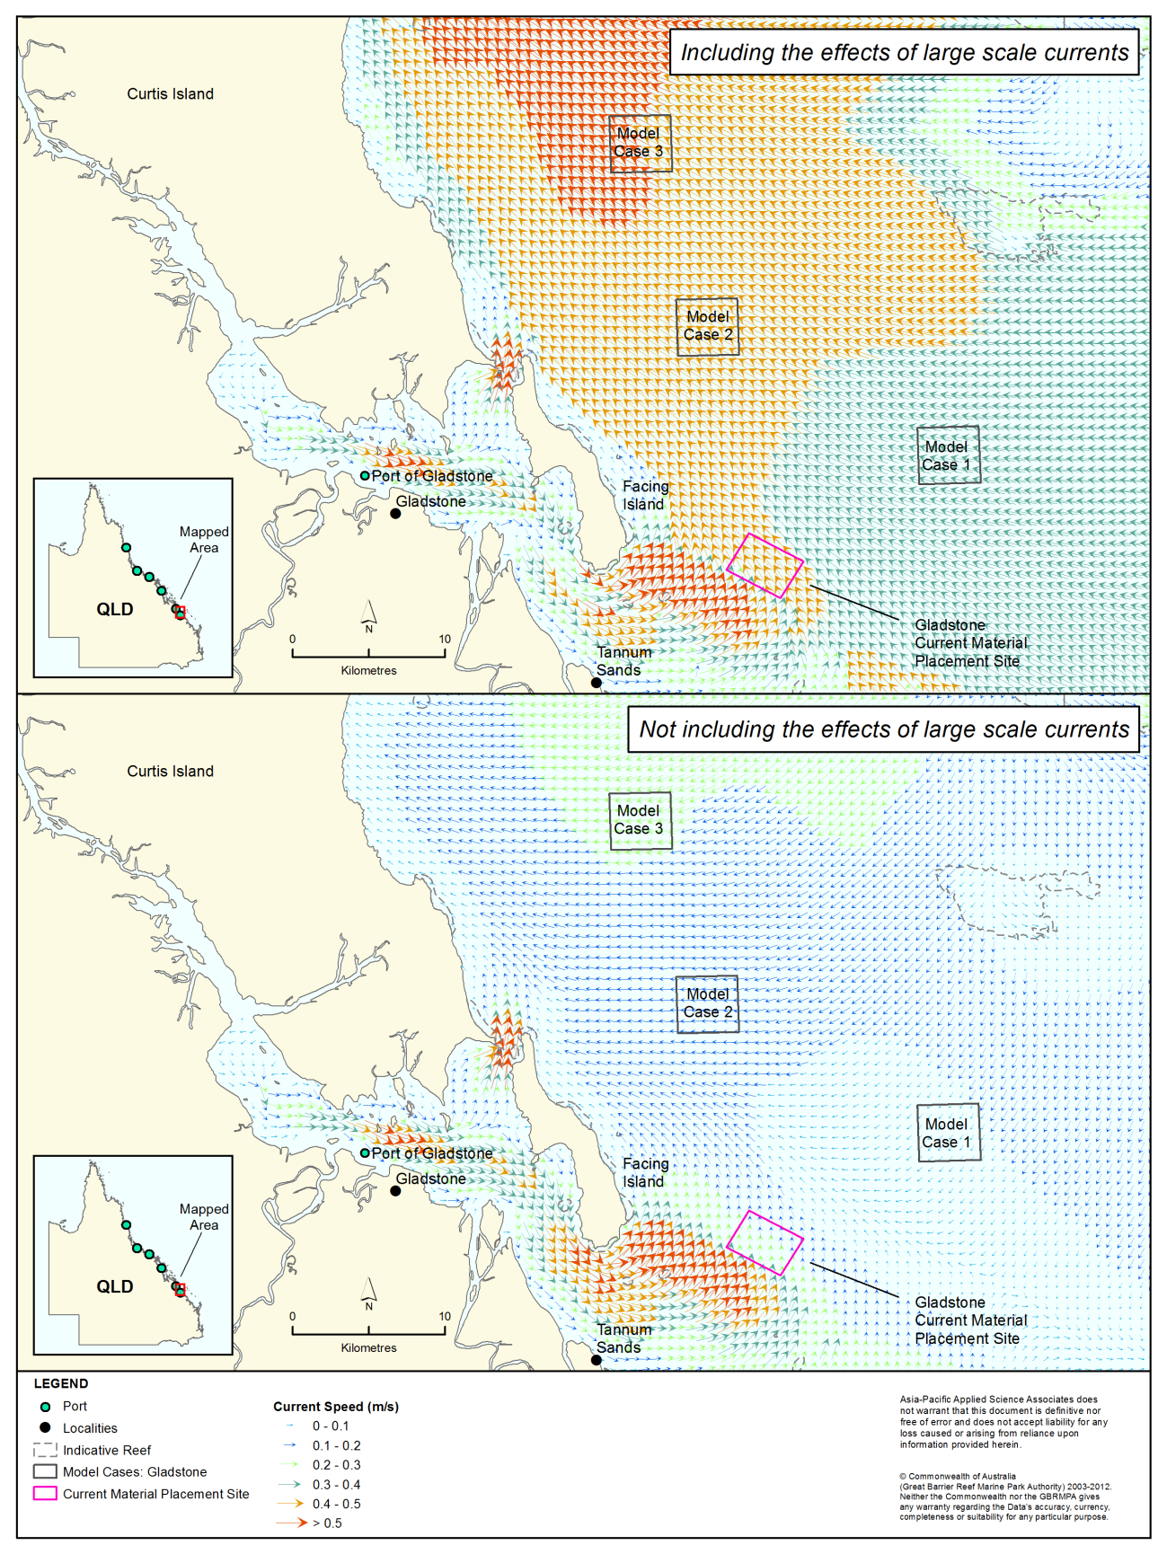
Figure 1. Snapshot of predicted current fields with (top) and without (bottom) including large-scale current forcing in the Gladstone study area. The high current speeds south of Gladstone reflect forcing by tides and waves. The high current speeds to the north in the top figure reflect the influence of the large-scale currents as well as tides and local winds. The dramatic decrease in current speeds near shore in the top panel results from the cut-off in applying large-scale current forcing at the 10 m depth contour.

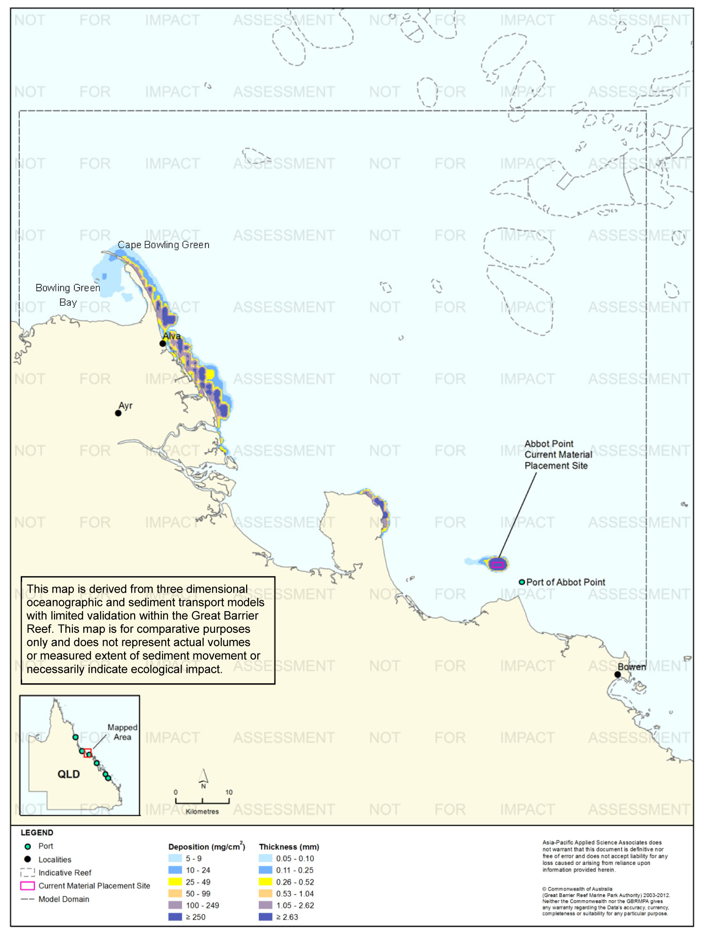
Figure 2.Total sedimentation at day 30 of the Abbot Point placement scenario at the current placement site, including large-scale current forcing.

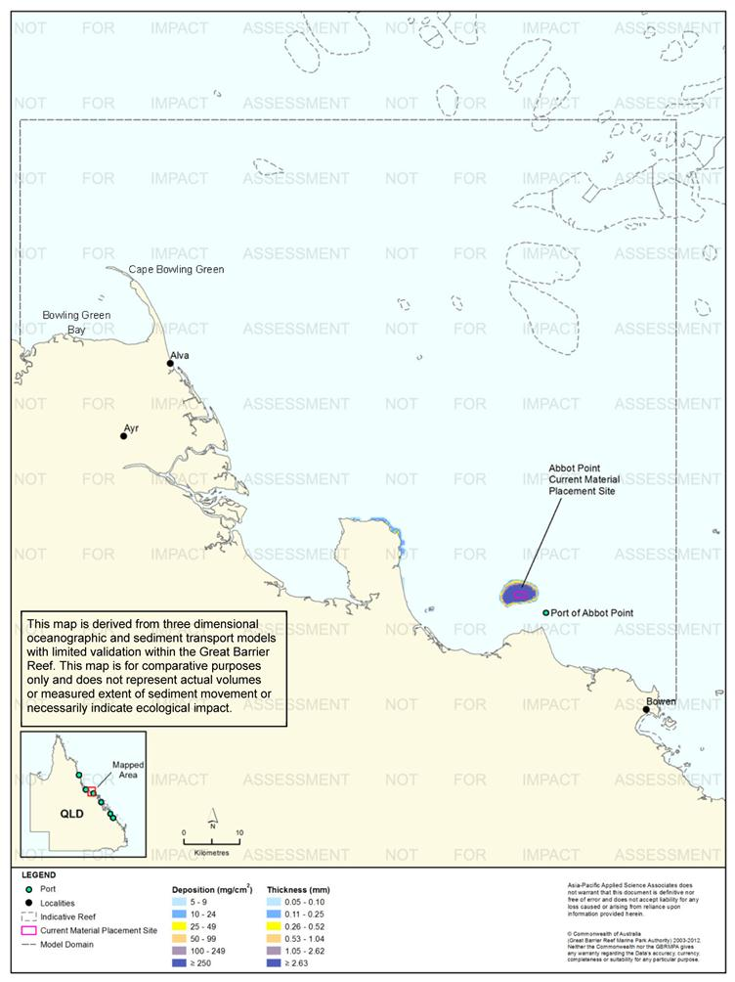
Figure 3.Total sedimentation at day 30 of the Abbot Point placement scenario at the current placement site, without large-scale current forcing.

The general long-term movement of dredged material to the north-west within the coastal zone predicted by the model when large-scale current forcing is included is consistent with studies of the transport of river inputs of fine sediment (Bainbridge et al. 2012; Lambeck & Woolfe 2000; Mathews et al. 2007; Orpin et al. 1999, 2004). As shown in figure 2, the model predicts some sediment will move into Bowling Green Bay, in the opposite direction to the dominant transport to the north-west. This movement of sediment into quiescent, north-facing bays is also consistent with other studies. For example, Orpin et al. (2004) estimate that most sediment from the Burdekin River moves northward in the coastal zone to be deposited in Bowling Green Bay.
Figure 2 is also useful in demonstrating that model outputs should not be examined and interpreted in minute detail. Figure 2 shows sediment moving across land at the northern tip of Cape Bowling Green. This is an artefact of the size of the model grids: at the northern tip of Cape Bowling Green most of a 700 x 700 m grid cell will be water and treated as such in the model. It is important to understand that the model predictions cannot be interpreted at such minute scales.
The influence of large-scale currents becomes progressively weaker moving toward the coast, and is non–existent in enclosed bays and estuaries (King & Wolanski 1992). Therefore, the inclusion of forcing by large-scale currents from the 10 m contour outward resulted in an abrupt decrease in modelled current speeds, and therefore sediment movement, in areas shallower than 10 m (figure 1). Given that the influence of large-scale currents will actually decline over a gradient of water depth approaching the coast, the model is likely to over-predict sedimentation inshore of the 10 m depth contour relative to deeper depths, because modelled sediment particles enter a different model environment when they move into shallow depths. This also means the model may tend to under-estimate resuspension and subsequent transport from areas < 10 m depth.
In addition, the model did not incorporate the effects of local-scale, shallow-water wave action and resultant sediment resuspension, or the tidal pumping and trapping of fine sediments into estuaries and mangroves. These processes are known to be important in governing nearshore turbidity and sedimentation (Alongi & McKinnon 2005; Furukowa & Wolanski 1996; Webster et al. 2007; Wolanski et al. 1997, 2005). High predicted sedimentation in nearshore areas needs to be interpreted in this context. For example, the relatively high sedimentation predicted on the exposed windward sides of islands and reefs do not take these processes into account and are unlikely to be realistic. Again it is emphasised that the primary benefit of the study is comparison of the broad implications of placement at relative sites, rather than assessment of local-scale impacts of placement at individual alternative sites. Modelling for predictive impact assessment for specific individual projects needs to take shallow-water processes into account.

Dredge Plume and Material Migration Modelling
The modelling scenarios (capital or maintenance dredging, volume and particle size distribution of dredge material, duration and time of year of placement, and operational parameters) for each of the six locations are presented in SKM APASA 2013c. Certain assumptions made for all six locations should be kept in mind in interpreting the modelling results, particularly regarding placement methodology and the subsequent behaviour of dredge material.
The model assumed that dredged material was released randomly over the defined material placement sites, spreading it over a large area. In reality, dredged material placement will differ for the six areas and between projects. Material may be placed in a grid pattern to spread it across the placement site, or concentrated in a mound. Individual releases of dredged material may occur while the dredge or barge is stationary or underway, and if underway moving in a straight line or turning. The placement methodology will affect the thickness and spatial extent of dredge material on the bottom immediately after release, and hence its subsequent resuspension. Accounting for such port-specific operations was beyond the scope of this study. Consideration of placement methodology at a level required for a port- and project-specific EIS offers opportunities for mitigation of sediment-related impacts from dredge material placement (see ‘Improved Understanding of Operational Mitigation Measures’, p. 219). Navigational considerations, hydrodynamic and habitat effects of altered bathymetry, and other factors also need to be considered in designing the placement methodology.
During the material relocation period, the sediment plume was calculated on a 200 m x 200 m horizontal resolution, which limited the ability to assess the very near thickness accumulation of sediments on the material placement site. Therefore, the thickness of sediment deposits immediately over the material placement site will be higher for actual projects than predicted by the modelling herein. Again, the model represents “maximum credible” scenarios for dredge material migration from the placement site.
There is considerable uncertainty in quantifying two key parameters in the sediment plume model: the sediment resuspension threshold and the consolidation rate. The authors have addressed the uncertainties regarding the sediment resuspension threshold by drawing on experience from past field studies and available literature. Though sediment resuspension will be site- and project-specific, the modelling applied uniform sediment resuspension thresholds for each particle size class, (as the complexity of quantifying specific sediment resuspension threshold constants for each of the six dredging scenarios) was far beyond the scope of the project. The van Rijn resuspension method applied in the DREDGEMAP model used is widely accepted. The model has been used to predict ambient suspended sediment concentrations in Port Curtis over 6 months, and compares well with actual current measurements from permanent water quality monitoring sites. The van Rijn method includes the effect of armouring, which occurs when fine sediment is winnowed from the very surface of the sediment to leave a layer of relatively coarse material that protects underlying fines from being resuspended. The assumption of random placement over the entire placement site is significant in this regard, as armouring will be less important for thin, widely distributed layers of dredge material than for less extensive, thicker layers.
The model assumed that dredge material on the bottom remains unconsolidated, that is, there is no allowance for the compaction of material over time. Consolidation will in fact occur and will reduce sediment resuspension. There is insufficient information on the rates of consolidation of dredge material to credibly quantify it in the modelling. Quantification of a generic consolidation rate, much less site-specific rates for the six locations, would require significant field and laboratory studies, such as that conducted by Wolanski et al. (1992) during a disposal program in Townsville. Wolanski et al. (1992) describe the consolidation rates as well as events that undid the process; there seemed to be not just one event of consolidation but episodes of consolidation and resuspension. Wave-induced liquefaction of consolidated ambient sediment, as opposed to dredge material, can be an important driver of TSS levels (Lambrechts et al. 2010). Further studies of consolidation would be a useful complement to future dredge material modelling studies.
Settling of mixtures of sediment particles is a complex process due to interaction of the different size classes, some of which tend to be cohesive and thus clump together to form larger particles that have different fall rates than would be expected from their individual sizes. Enhanced settlement rates due to flocculation and scavenging are particularly important for clay and fine-silt sized particles (Swanson et al. 2004) and these processes have been implemented in DREDGEMAP based on previous United States Army Corp of Engineers Studies (USACE; Teeter 1998).
The DREDGEMAP model employs five material classes based on sediment particle sizes. The classes are biased toward the finer materials, not only because these are typically the most dispersive and responsible for the greatest turbidity increases in the water column, but also because they have the greatest impacts when settling on corals. Minimum sinking rates were calculated using Stokes equations, based on the size and density of the particle. However, sinking rates of finer classes (representing clay and silt-sized particles) are increased based on the local concentration of the same and larger particles, to account for clumping and entrainment. Deposition on the seabed is calculated as a probability function of the prevailing bottom stress, local sediment concentration and size class. Sediment that is deposited may subsequently be resuspended into the lower water column if critical levels of bottom stress are exceeded. Mixing of re-suspended sediment into higher levels of the water column is a dynamic balance between estimates of the sinking rate and vertical mixing induced by turbulence (as specified by vertical mixing coefficients).Values for sediment deposition, sediment resuspension and sediment settling velocities are all based on peer-reviewed literature (van Rijn 1989; Teeter 1998; Soulsby & Whitehouse, 1997; Soulsby 1998).
TSS concentrations based on the release of particles of dredge material are most amenable to modelling, and the basis of nearly all predictive modelling for dredging and material placement proposals. TSS per se is not usually the direct mediator of ecological impacts, nor is elevated turbidity that results from TSS. For most dredging and material placement projects the primary concern is the effects of TSS and turbidity in reducing the light available to light-dependent organisms. SKM (2013b) concluded that in such cases photosynthetically active radiation (PAR) is the appropriate parameter for reactive water quality monitoring in dredging and material placement. Considerable progress has been made in predictive modelling of effects of elevated TSS on light availability and light quality, which is appropriate for environmental impact assessment as well as reactive monitoring. Light modelling was beyond the scope of the present study.
The modelling predicted "above background" TSS and sedimentation, meaning that dredge material is considered in isolation from ambient conditions. This inherently assumes that the effects of dredge material placement are simply additive to whatever ambient levels exist at any point in time. This is a standard approach often used in modelling dredge material placement and a necessary assumption given the time and financial constraints of the study.
Modelling above-background TSS and sedimentation has important implications. If ambient TSS or sedimentation are already at or near levels causing ecosystem stress, relatively small increases above background could increase stress, leading to cumulative impacts, and potentially tip the system over a tolerance threshold. Conversely, if the above-background contribution from dredge material is small relative to ambient background, it could be difficult to measure any incremental increase attributable to dredging. An important aspect of the “above background" assumption in relation to the model predictions is in regard to dredge material resuspension, which is the primary driver of the long-range migration predicted by the model. As described above, the modelling incorporates the effects of armouring of the dredge material after it settles on the seabed. The model does not, however, include interactions between dredge material and ambient sediments after resuspension events, in particular the potential mixing of dredge material with resuspended ambient sediment, potentially followed by burial of significant amounts of dredge material under ambient sediment upon re-deposition.
The modelling did not set any operational limits on material placement, which was assumed to continue regardless of weather. In actuality, material placement will be constrained by strong winds and waves, conditions in which sediment mobility will be greatest.

Relative Influence of Terrestrial and Dredging Sediment Inputs
As noted above, the modelled north-westerly migration of dredge material in this study is consistent with previous studies of transport of sediment input from rivers. It is impossible to make like-for-like comparisons of river inputs of sediment to potential mobilisation of sediments by dredge material placement (and it is important to recognise that the scope of this study was restricted to material placement and not dredging itself). Nonetheless, it is instructive to consider long-term quantities of dredge material in the context of riverine inputs. It is also critically important to recognise that TSS inputs from rivers are estimated to have increased more than five-fold since pre-European times (Kroon et al. 2009).
Table 5 shows recent estimates of TSS inputs, in kilotonnes (kt) of dry mass, from the 10 major catchments draining into the study area by Joo et al. (2012) and Kroon et al. (2009, 2012). Using the estimates of Kroon et al. (2012), these 10 catchments account for 72 per cent of current (i.e. post-European) TSS inputs to the Reef lagoon. Joo et al. (2012) did not estimate total inputs to the lagoon but instead focused on these 10 catchments because they have been identified as priority catchments for ReefPlan (Carroll et al. 2012).
Joo et al. (2012) derived their estimates from end-of-river monitoring of TSS concentrations over three years (2006/07, 2007/08 and 2008/09), coupled with modelling. The estimates of Kroon et al. (2009. 2012) were based on available estimates of river inputs, including monitoring data, and catchment modelling. Kroon et al. (2012) provide refined estimates for six catchments (Pioneer, Burdekin, Herbert, Tully, Johnstone and Barron) using additional monitoring data and model corrections. Kroon et al. (2012) present estimated inputs on the basis of annual means, while Joo et al. (2012) present estimates for the three individual years. For comparison, table 5 shows the mean over the three years of Joo et al.’s (2012) estimates, as well as the range, as an indication of inter-annual variability.
There are substantial differences in predicted TSS inputs from individual rivers, which are likely to result from differences in methodology, and the years of monitoring data used in deriving the estimates. The very low TSS input estimates for the Burnett River by Joo et al. (2012), for example, reflect the absence of a high-flow event during the monitoring period used in that study. There are additional uncertainties in these estimates, including the possibility of significant TSS inputs from over-bank flows during floods that are not captured in monitoring data (Darnell et al. 2012; Wallace et al. 2012). Nonetheless, they represent a useful context for considering river inputs of sediment in relation to dredge material quantities.

Table 5. Estimated TSS inputs (kt/y) from ten major river catchments.
 | Joo et al. (2012) |  | Kroon et al. (2009, 2012)
River | Range 2006/07 - 2008/09 | Annual Mean | Annual Mean Total
Burnett¹ | 0-5 | 2 | 1400
Fitzroy¹ | 320-4751 | 1825 | 4100
Pioneer | 111-255 | 174 | 50
O’Connell¹ | 24-121 | 65 | 630
Burdekin | 6503-12,700 | 9606 | 4000
Herbert | 220-1888 | 815 | 380
Tully | 88-116 | 106 | 92
Johnstone | 132-241 | 178 | 320
Barron | 30-397 | 197 | 100
Normanby¹ | 59-211 | 125 | 1100
Totals | n/a | 13,093 | 12,172
1: Kroon et al. estimate is from Kroon et al. (2009) rather than Kroon et al. (2012)

Table 6 shows estimates of projected quantities of proposed dredge material placement at the six locations over 25 years as determined in this study, in terms of both in situ volumes of material, the quantity used in dredging approvals, and dry mass, the quantity comparable to the river input estimates and that used for sediment plume and migration modelling. The estimates in table 6 were derived as follows:
- The total estimated 25-year dredging volumes were developed in consultation with the port authorities as described in SKM APASA (2013b). The anticipated volume of capital dredging, originally estimated at 25,000,000 m³, has subsequently been reduced to 20,000,000 m³, which is reflected in table 6
- For most of the six locations the estimates of capital versus maintenance dredging volumes were also developed through consultation with the port authorities. For Gladstone, the long-term maintenance dredging requirement was based on BMT WBM (2009) and the capital dredging requirement determined by subtraction
- The conversion from in situ volumes to dry mass was calculated using a factor of 1 m³ = 0.8 t/m³ for capital dredging and 1 m³ = 0.7 t/m³ for maintenance dredging; these factors were developed from geotechnical data and dredging records in consultation with the port authorities. The dry mass per tonne for the in situ (that is, material on the seabed before dredging) is a function of the water content of the combined sediment/water mixture in situ and the density of the dry sediment. The masses in tonnes are converted into kilotonnes in table 6 for comparison with table 5
- Since the total volumes in table 6 represent different proportions of capital and maintenance dredging, with different conversion factors to dry mass, total volumes were not converted into dry mass. Instead, the total dry mass of dredge material relocation over 25 years can be determined from the sum of capital and maintenance dredging dry mass estimates.

Table 6.Volumes and dry mass of dredged material envisioned over 25 years at the six locations.
Location | Units | Total (25 years) | Total capital (25 years) | Capital - mean per year | Indicative Capital campaign | Total Maintenance (25 years) | Maintenance - mean per year | Typical maintenance dredging interval (years) | Indicative maintenance campaign
Gladstone | Volume (m³) | 80,000,000 | 72,500,000 | 2,900,000 | 6,000,000 | 7,500,000 | 300,000 | 1 | 300,000
 | Dry Mass (kt) | n/a | 58,000 | 2320 | 4800 | 5250 | 210 |  | 210
Rosslyn Bay | Volume (m³) | 250,000 | 0 | 0 | 0 | 250,000 | 10,000 | 3 | 30,000
 | Dry Mass (kt) | n/a | 0 | 0 | 0 | 175 | 7 |  | 21
Hay Point | Volume (m³) | 28,000,000 | 20,000,000 | 800,000 | 8,500,000 | 8,000,000 | 320,000 | 3 | 960,000
 | Dry Mass (kt) | n/a | 16,000 | 640 | 6800 | 5600 | 224 |  | 672
Abbot Point | Volume (m³) | 8,500,000 | 3,500,000 | 140,000 | 3,500,000 | 5,000,000 | 200,000 | 5 | 1,000,000
 | Dry Mass (kt) | n/a | 2800 | 112 | 2800 | 3500 | 140 |  | 700
Townsville | Volume (m³) | 24,000,000 | 6,900,000 | 276,000 | 3,500,000 | 17,100,000 | 684,000 | 1 | 684,000
 | Dry Mass (kt) | n/a | 5520 | 221 | 2800 | 11,970 | 479 |  | 479
Cairns | Volume (m³) | 20,000,000 | 5,000,000 | 200,000 | 5,000,000 | 15,000,000 | 600,000 | 1 | 600,000
 | Dry Mass (kt) | n/a | 4000 | 160 | 4000 | 10,500 | 420 |  | 420
Total for six locations | Volume (m³) | 165,750,000 | 107,900,000 | 4,516,000 | 26,500,000 | 52,850,000 | 2,114,000 | n/a | 3,574,000
 | Dry Mass (kt) | n/a | 86,320 | 3453 | 21,200 | 36,995 | 1480 |  | 2502

A high-level comparison of table 5 and table 6 indicates that the estimated annual dry mass of dredge material from the six locations (4933 kt/y, the sum of the annual dry masses from capital and maintenance dredging) represents about 38-41 per cent of the total estimated annual terrestrial sediment input from the ten major catchments.
In this regard, it is important to differentiate capital from maintenance dredging. Maintenance dredging represents the relocation of material that is already mobile in the ambient sedimentary regime and has been trapped in areas that are already dredged. Thus, relocation of material from maintenance dredging does not represent a new input of sediment to the lagoon. If only capital dredging is considered, annual bulk sediment inputs from dredge material relocation reduce to about 26-28 per cent of annual river inputs from the 10 catchments to the lagoon, averaged over 25 years.
Capital dredging material is dominated by relatively coarse material (sand and coarser), whereas TSS input from rivers is dominated by fine clay and silt. More than 70 per cent of TSS in Burdekin River flood plumes, for example, consists of clay and fine silt < 16 µm (Amos et al. 2004; Bainbridge et al. 2012). By contrast, in the three capital dredging scenarios developed for this study (Gladstone, Hay Point, Abbot Point; SKM APASA 2013c), sands > 75 µm constituted more than 60 per cent of the material, and fine material < 35 µm less than 30 per cent. Finer sediments are more mobile than coarser material, setting aside the consolidation of sediment on the bottom as was assumed in this study. Perhaps more importantly, fine sediments generally have the greatest impacts on corals and seagrasses (Erftemeijer & Lewis 2006; Falkowski et al. 1990; Piniak 2007; Weber et al. 2006). Using the approximation that 70 per cent of river sediment inputs are fine sediments, compared to about 30 per cent of capital dredging material inputs, mean annual inputs of fine sediment from relocation of capital dredging material at the six locations represent around 11-12 per cent of mean annual inputs of fine sediments from the 10 major rivers, and 8 per cent of total inputs to the Reef based only on Kroon et al.’s estimates for total river inputs. These various estimates are summarised in table 7.
Table 7. Summary of comparisons of dredging volumes as a relative increase over river inputs, based on the estimates of Kroon et al. (2009, 2012). Relative increases would be slightly smaller using the river input estimates of Joo et al. (2012).
Volume type | Amount | Dredging | River inputs  (10 catchments) | River inputs  (total)
Total sediment | Amount | 4933 kt/y | 12,172 | 17,000
 | Relative amount (10 catchments) | 41% | - | -
 | Relative amount (all catchments) | 29% | - | -
Capital dredging only | Amount | 3453 kt/y | 12,172 | 17,000
 | Relative amount (10 catchments) | 28% | - | -
 | Relative amount (all catchments) | 20% | - | -
Estimated fines content |  | 30% | 70% | 70%
Only fines, capital dredging only | Amount | 1000 kt/y | 8500 | 11,900
 | Relative amount (10 catchments)¹ | 12% | - | -
 | Relative amount (all catchments)¹ | 8% | - | -
1 – Relative amounts estimated to nearest 100 kt/y
Long-term averages are not necessarily an appropriate context for considering dredge material relocation relative to the river inputs, because impacts can potentially occur from individual dredging campaigns that do not correspond to long-term averages. This is particularly true for capital dredging projects involving the relocation of large amounts of material over a relatively short period (one or two years) of time. In addition to 25-year means, table 6 shows indicative volumes and dry masses of solids that might be relocated by dredging in a given year. The indicative capital dredging campaigns in table 6 reflect the modelled scenarios for Gladstone, Hay Point, and Abbot Point. The indicative campaign for Cairns reflects the proposed Cairns Shipping Development Project, and that for Townsville reflects Stage 2 of the proposed Port Expansion Project. Inspection of table 6 indicates that, on time scales of one or a few years, major dredging projects can indeed mobilise fine sediments in comparable quantities to river inputs.
It must also be recognised that inputs at the scale of the entire Great Barrier Reef lagoon will not reflect relative inputs of sediment from dredge material relocation and rivers at the scale of the six locations, nor are annual inputs necessarily relevant given the strong seasonality of river inputs. Detailed review of regional and seasonal patterns of river inputs relative to dredge material placement is beyond the scope of this study.
This high-level comparison of the amounts of material potentially mobilised by dredging with river inputs provides useful context, but is not directly relevant if turbidity and sedimentation in the Region are not controlled by sediment inputs. For the purpose of determining catchment management targets to reduce TSS concentrations in the lagoon, it has been assumed that lagoon TSS concentrations are directly proportional to river inputs (Brodie et al. 2009; Kroon 2012). There are differing views, however, on the extent to which TSS and turbidity on the Reef are controlled by sediment inputs rather than resuspension of ambient sediment. Both Brodie et al. (2009) and Kroon (2012) acknowledge considerable uncertainty in this regard. There is evidence that turbidity regimes on the reef are driven primarily by sediment resuspension (Lambrechts et al. 2010; Larcombe et al. 1995; Larcombe & Woolfe 1999; Orpin et al. 1999; Orpin & Ridd 2012; Webster & Ford 2010). If so, then new sediment inputs from dredge material placement would not be expected to directly affect TSS or turbidity regimes appreciably. Amos et al. (2004) and Fabricius et al. (2013), however, present evidence that turbidity is indeed limited by the supply of new sediment inputs.
As noted by Brodie et al. (1999), however, even if sediment inputs do not directly control TSS and turbidity in the Reef lagoon, they could indirectly increase turbidity by depositing surface layers of sediment that are more easily resuspended than more consolidated ambient sediments. Placement of dredge material could have a similar effect and make dredge material more susceptible to resuspension than it was prior to dredging. This again points to the desirability of better understanding post-disposal consolidation.
Another factor that could lead to changes in turbidity regimes even if they are not directly controlled by sediment inputs is that placement of dredge material may move sediment from one sedimentary regime to another. The inner shelf is dominated by a wedge of terrestrial sediment, out to around the 20 m depth contour in the south and middle Reef, tending to narrow to about the 10 m contour in the north (Belpario 1983; Lambeck & Woolfe 2000; Mathews et al. 2007). Placement of dredge material beyond this zone moves predominantly terrestrial sediments to the middle shelf, which is more dominated by sediment of marine origin and has a different sediment transport regime. This should be considered in detailed EIAs of proposed dredge material placement projects not only with regard to turbidity but also to other ecological implications of placing terrigenous sediment in environments further offshore.
To the extent that turbidity regimes on the reef are driven not by sediment inputs, but rather by sediment resuspension, then the appropriate comparison would be the amount of dredge material mobilised against the quantity of ambient sediment available for resuspension. This study made no attempt to quantify those relative amounts, and all model outputs are "above back ground". Thus, resuspension of ambient sediment from the seabed is taken to be zero, and interactions between particles of dredge material and ambient sediment are not taken into account. In reality, resuspension events will mix dredge material with ambient sediment, and deposition will tend to bury the dredge material, reducing its availability for subsequent resuspension. Again, the modelling presents maximum credible predictions of dredge material migration. The need for further consideration of ambient sediment resuspension is discussed in ‘Ambient Background’ p. 217.

Presentation of Results
The modelling results are presented as maps showing the frequency of occurrence as percentiles, of specified levels of TSS and sedimentation rate that occurred during the dredge material placement period. Percentiles of TSS and sedimentation rate are not presented for the 12-month period because the model predicted that the lowest values presented for the dredging period would not occur either 50 per cent or 5 per cent of the time over the 12 months.
Additionally, total sedimentation and bottom thickness maps are presented for single points in time, at the end of the specified dredge material placement scenario and at the end of 12 months after commencement of the modelled placement.
SKM and APASA have found during the course of the study that in some cases the presentation of results can be difficult to interpret. Perhaps the best analogy for the presentation of the percentile results is the depth contours on a nautical chart, on which contours of given depths are drawn around individual depth soundings. In the case of the model results, the model predicts how frequently, as a percentage of time, a given condition will occur in each cell of the model grid during the modelling period. Figure 4 presents an imaginary portion of the model grid, zoomed in to a close-up view. The number in each of the model cells is the per cent of the time during the model run that the condition being represented - say for example 5 mg/L TSS - occurs. Using these data, a contour line can be drawn representing the boundary at which 5 mg/L occurred 50 per cent of the time in the model output. Areas on one side of the line, down and to the right in the imaginary example in figure 4, experienced 5 mg/L TSS less than 50 per cent of the time and areas on the other side of the line experienced this condition more than 50 per cent of the time. The blue line is thus the 50th percentile contour for 5 mg/L TSS. Similarly, 95th percentile contours represent the boundary of areas that experience a given water quality condition either more or less than 5 per cent of the time, i.e. 95 per cent of the time TSS or sedimentation is less than the contoured value.
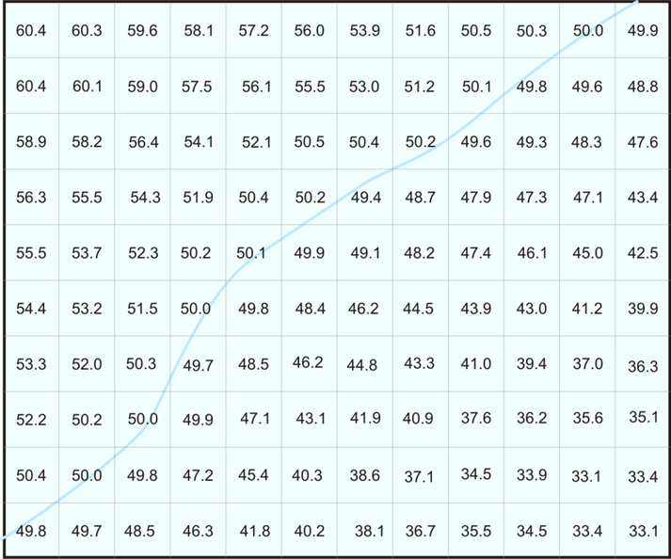
Figure 4. Imaginary zoomed-in view of a section of the model grid. The number in each cell represents the per cent of time during the model run each cell experiences a TSS concentration of 5 mg/L. The blue line shows the 50th percentile contour for 5mg/L TSS.

In this report, the model outputs are shown as contour lines as depicted in figure 4 so as not to obscure underlying data layers. The detailed modelling report (SKM APASA 2013c) presents the modelling results more visually, as shaded areas. The boundary between shaded areas of different colour corresponds to the contour lines produced as described above. Figure 5 shows the imaginary example in figure 4 presented as a shaded area; the contour in figure 4 is the boundary of the shaded area.
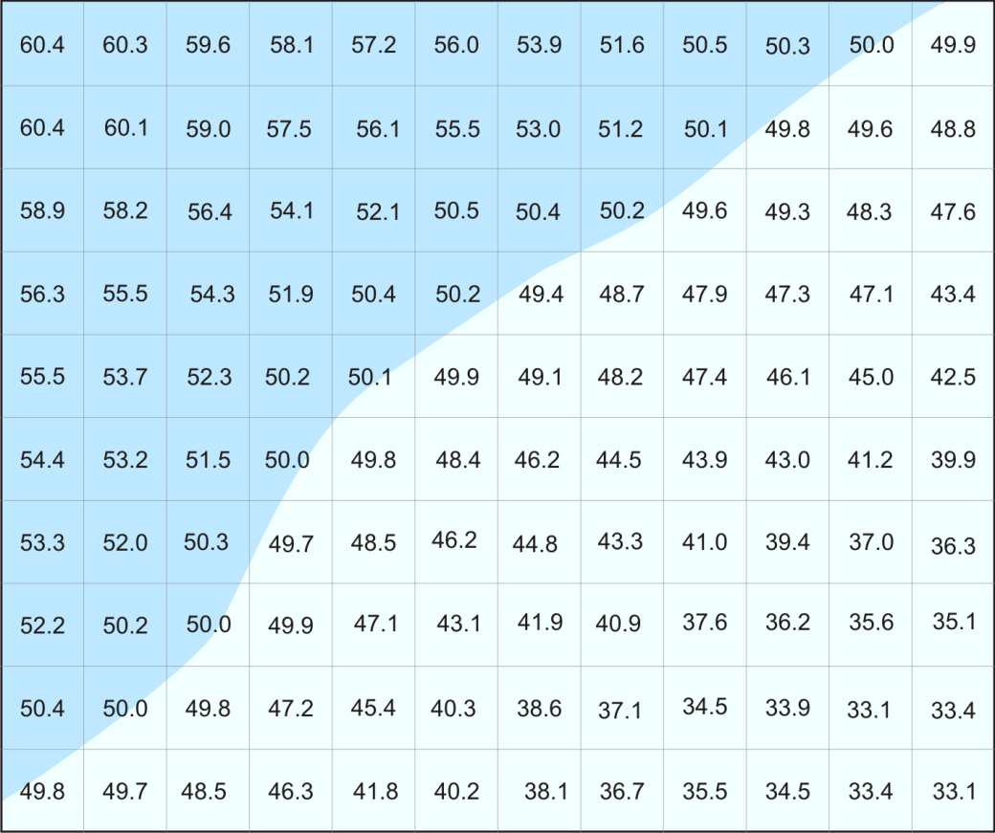
Figure 5. Presentation of the imaginary results in figure 34 as a shaded area. Areas in the darker blue area experience 5 mg/L TSS more than 50 per cent of the time, those in the light blue area less than 50 per cent of the time.

Ecological Considerations

Values Presented in Model Outputs
The GBRMPA modelling guidelines for dredging projects (GBRMPA 2012) encourage the application of “zones of impact” in which modelling is used to predict the spatial extent of zones of high impact, moderate impact, and influence. To model zones of impact, quantitative impact thresholds for TSS and sedimentation must be established, which in turn requires an understanding of the habitat type, species composition, and sensitivities of the environmental receptors likely to be affected.
The present project is an example of a situation discussed by SKM (2013b) where there was too much uncertainty regarding the receptors potentially affected by dredge material placement to feasibly establish scientifically valid impact threshold criteria. The study involved both hypothetical model cases for which there is no prior experience of material placement and also, as discussed above, the novel application of a long-term model including the influence of large-scale currents. The likely spatial scales of sediment migration in the model outputs could not be confidently predicted in advance. Therefore the habitat type (e.g. coral vs. seagrass communities), potential sensitivities (e.g. potential changes in reef sensitivity along the inshore-offshore gradient), or site-specific TSS and sedimentation regimes were not known in advance either. This made it impossible to establish quantitative criteria for zones of impact and influence. Therefore, the modelling predicted the spatial extent of a range of levels of TSS, sedimentation rate, and total sedimentation. This corresponds to the first step in the iterative approach recommended by SKM (2013b) to identify receptors of interest and then establish impact criteria.
The purpose of the study was to compare and contrast potential advantages and disadvantages of placing dredge material at potential alternative sites (including the current sites except at Gladstone). The values presented in the output maps were not necessarily selected solely on the basis of ecological relevance. Consideration was also given to using contour values that would provide useful comparisons among alternative placement locations. Preliminary results suggested that higher values than those selected sometime were predicted to occur infrequently enough that they would not be useful for comparative purposes, that is, they tended to produce almost blank maps that did not represent comparative transport of material from alternative sites satisfactorily. In some cases this also occurred for low values, as discussed below.
That said, the model output values did take into account available information on species tolerances to sediment-related stress and their variability. Tolerance to chronic TSS concentrations in coral communities, for example, ranges from <10 mg/L for offshore communities in clear waters to > 100 mg/L for some nearshore reefs (Erftemeijer et al. 2012). There is even greater variation in measured tolerances of individual coral species to more acute exposure to elevated TSS, from concentrations of < 30 mg/L to as high as 1000 mg/L TSS for exposures in the order of several weeks. Measured thresholds to sedimentation rate in individual coral species range from < 10 mg/cm²/d to > 400 mg/cm²/d (Erftemeijer et al. 2012). The exposure duration needed to cause impact in different coral species ranges from days to five or six weeks or more for elevated TSS and from < 24 hours to four weeks for sedimentation rate (Erftemeijer et al. 2012). Inshore coral communities generally experience more turbid conditions, and have higher tolerance to elevated turbidity, TSS, and sedimentation rate, than communities in clear offshore waters (Erftemeijer et al. 2012; Gilmour et al. 2006), and reefs with high coral cover and diversity can persist in highly turbid environments on the Reef on geological time scales (Browne et al. 2012).
Most information regarding coral sensitivity to sedimentation is in terms of the sedimentation rate. This is because most corals can clear sediment from their surfaces, and therefore the impact of settling sediment depends on the balance between how fast sediment arrives on the coral and how fast they can clear it and the energetic costs of doing so, which can reduce survival, growth, and reproduction.
Fewer studies have examined the impacts of sediment in terms of total sedimentation, which is the total amount of sediment on the bottom in mass per unit area (mg/cm²) or thickness (mm). As for TSS and sedimentation rate, there is a wide range in sensitivity to total sedimentation. Some corals can survive complete burial for two weeks or more, but small amounts of sediment on the bottom (including corals) can have impacts, especially on larval settlement and newly recruited corals. Hodgson (1990) found that a 1 mm layer of sediment covering the bottom prevented larvae of the coral Pocillopora damicornis from settling. Fabricius et al. (2003) observed 33 per cent mortality of new recruits of the coral Acropora willisae after 43 hours of application of 14 mg/cm² of muddy coastal sediment when the sediment was enriched with organic material similar to that commonly produced by plankton, but no elevated mortality if the sediment was not organically enriched. Organic enrichment of inorganic sediment through aggregation with mucus produced by marine plankton is known to be common in Reef waters and have greater impacts on corals than inorganic sediment alone (Fabricius & Wolanski 2000).
In older corals, Gilmour (2002) found that a layer of 2 mm of sediment applied every two days caused injury to small (3-5 cm) polyps within days. Larger polyps were resistant to repeated applications of 2 mm sediment layers but were damaged by the repeated application of 5 mm and 10 mm sediment layers. Riegl & Branch (1995) observed that 200 mg/cm² of sediment severely reduced photosynthesis in four species of hard corals and five species of soft corals. Experiments by Stafford-Smith (1993) showed that most of the 22 species tested could shed a one-off application of 200 mg/cm² of sandy sediment within two days, but three species were unable to clear the sediment and suffered tissue death within two to six days. Two other species, in the genus Porites, did not clear the sediment and did not suffer tissue death; tissue under the sediment was bleached after six days but recovered after the sediment was removed. Philipp & Fabricius (2003) found that total sedimentation in the range of 79-234 mg/cm² had increasing impacts on photosynthetic efficiency in 9 of 12 coral species studied, but the other three species were not affected. In the species affected by these levels of total sedimentation, effects on photosynthesis were observed after 22 hours and photosynthetic efficiency was severely depressed after 36 hours. The effects increased with both the amount to total sedimentation and duration, and at higher levels of sedimentation coral tissue death occurred within 36 hours.
Modelling for dredging projects in the World Heritage Area is most often conducted with regard to impacts on corals, but other receptors can be affected by TSS and sedimentation. Seagrass communities are the receptors of most concern at Abbot Point and within Port Curtis in the Gladstone study area, for example, and are also of concern in other locations. Thresholds for light-related impacts on seagrasses are generally measured in terms of absolute light levels or a percentage of surface irradiance, which could not be related to TSS concentrations in the scope of this study. Time scales for light deprivation impacts on seagrasses are weeks to months, generally much longer than for corals. Sedimentation impacts on seagrasses relate primarily to burial, and thus total sedimentation. Seagrasses generally have higher tolerance to total sedimentation than corals, in the range of accumulation thicknesses in the order of 1.5-13 cm/y (Erftemeijer & Lewis 2006).
TSS, sedimentation rate, and total sedimentation tolerance thresholds for other benthic organisms in the Region, including macroalgae, microphytobenthos, soft corals, ascidians, sponges, anemones, giant clams and other invertebrates with photosynthetic symbionts, are poorly known.
Given the wide range of potential receptor tolerances, a range of values for TSS (5–50 mg/L), sedimentation rate (5-250 mg/cm²/d) and total sedimentation (5–250 mg/cm², corresponding to 0.05 to 4.10 mm of accumulation, depending on study area) are presented in the modelling outputs maps.
The range for TSS is probably most relevant to corals and other organisms with relatively low TSS tolerance, but preliminary modelling showed that higher levels of TSS than those presented were not predicted to occur as often as 5 per cent of the time in the modelling runs. In some cases, even the lowest TSS concentration presented in the model outputs did not occur at any location even 5 per cent of the time. As noted in 'Dredge Plume and Material Migration Modelling', 100th percentile contours are presented, representing areas that experienced the contoured levels of TSS in any single one-hour step in the model run. It is stressed that this study is not intended to be an impact assessment, and no impacts are ascribed to particular TSS concentrations or their frequency of occurrence. The 100th percentile contours for TSS are presented to allow comparisons between different alternative sites, which is the purpose of the study, when predicted TSS levels were too low to generate 95th percentile contours. This was not done for study areas where the model generated 95th percentiles because there is no point in comparisons of different study areas.
The contoured values for sedimentation rate are also most relevant to corals, and reflect a tolerance range from sensitive to relatively tolerant coral species. Tolerance thresholds to elevated sedimentation rates have not been established for other groups of organisms, including seagrasses.
The contoured values for total sedimentation are again most relevant to corals, and the maximum value contoured value of 250 mg/cm², corresponding to a bottom thickness of 2.63-4.10 mm, depending on the study area, is well below the lowest published impact thresholds for seagrasses (15 mm; Erftemeijer & Lewis 2006). Thus, the contoured ranges can be considered precautionary, especially for receptors other than corals, but are useful in comparing the implications of placement options, which is the purpose of the study. It is recognised that the lowest values contoured, 5 and 10 mg/cm² (corresponding to 0.05-0.08 mm and 0.10-0.16 mm, respectively) may be difficult to measure in the field. Again it is stressed that the main purpose of this study is not to assess impacts on specific receptors, but rather to compare the relative risks and benefits, if any, of material placement at different locations.
Sediment-related impacts from dredging and dredge material placement depend on the intensity, frequency, and duration of adverse changes in water quality, as discussed by SKM (2013b). The contour maps are indicative for intensity, but only partially so with regard to frequency and duration. A median occurrence of a given value, for example, indicates that the value occurred half the time, but not whether this occurred in one or a few events of long duration or repeated, short-term events. These could have different impacts, depending on the receptor.
In addition to predicting the spatial extent of water quality changes, modelling can be used to predict the time course of such changes at particular sites. Generating such time series at representative sites for all six study locations was beyond the scope of the study, but example time series are instructive. Figure 6 and figure 7 show the accumulation of sediment on the bottom and the sedimentation rate through the modelled dredging period at two sites in the Abbot Point study area that are shown in figure 69. The mass of sediment on the seabed at the end of the dredging at Time Series 1 (i.e. ~700 mg/cm²) corresponds to a bottom thickness of approximately 7 mm, while that at Time Series 2 corresponds to a bottom thickness of approximately 27 mm (i.e. ~2750mg/cm²). At both sites, sediment arrives at the seabed in a relatively few pulses, including pulses of very high sedimentation rates.
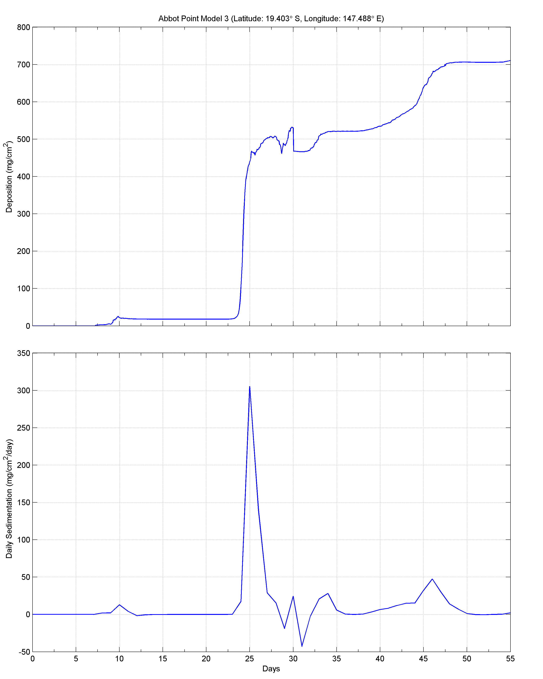
Figure 6. Total sedimentation (top) and sedimentation rate (bottom) at Abbot Point Time Series 1 site (see figure 69).

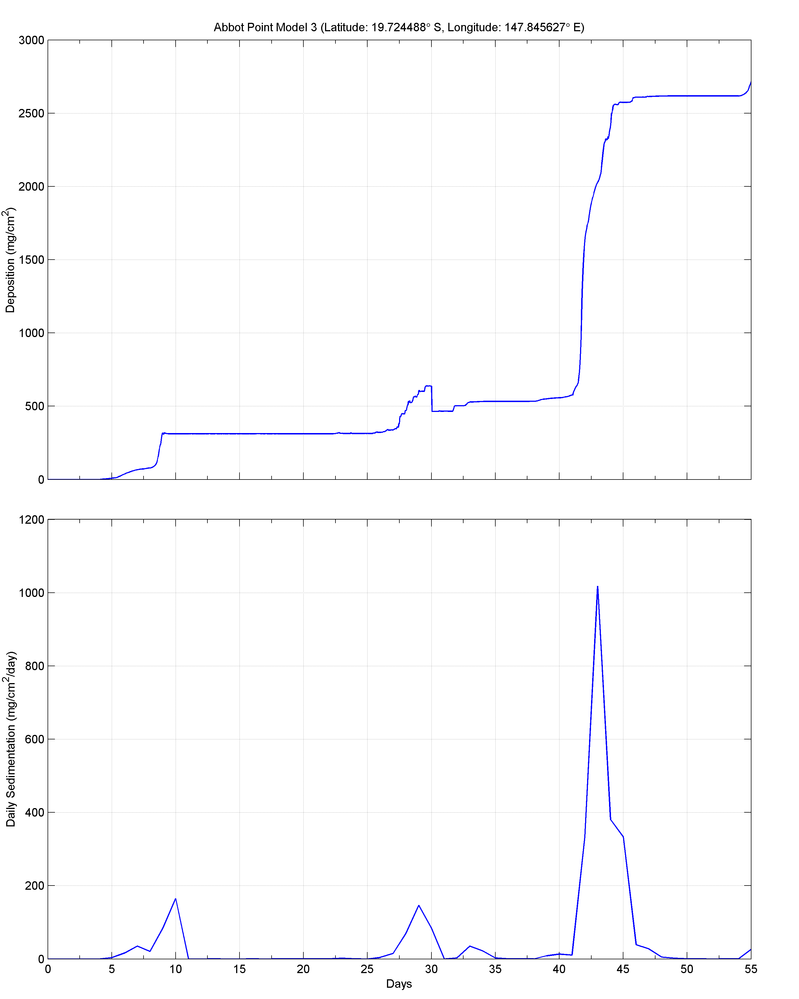
Figure 7. Total sedimentation (top) and sedimentation rate (bottom) at Abbot Point Time Series 2 Site (see figure 69).

At the site Time Series 1 (figure 69) there is a pulse of 300 mg/cm²/d lasting approximately two days, and a pulse of 50 mg/cm²/d for about three days. The impacts on these pulses would probably not expected to be more than minor on adult corals and other receptors. The accumulation of sediments on the bottom could impair the recruitment of larvae of hard-bottom species, but is well within known tolerance limits of seagrass.
At the site Time Series 2 (see figure 69) there are pulses of sedimentation that are of longer duration and higher intensity (up to > 1000 mg/cm²/d and over 200 mg/cm²/d for more about three days), which could have moderate to major impacts on corals. The accumulation of 27 mm of sediment on the bottom could also have up to major impacts on corals, especially on larval settlement and survival of young recruits, and is well above the tolerance threshold range for sensitive seagrass species (Erftemeijer & Lewis 2006).
Figure 6 and figure 7 exemplify how modelled time series can be valuable tools in assessing potential impacts on identified sediment-sensitive receptors. The discussion in the previous two paragraphs regarding potential impacts on corals and seagrass is to provide context; in fact the GIS database developed in this study does not indicate the presence of coral reef or seagrass communities at either of the two time series sites.
Predictive modelling is invaluable in assessing potential impacts of proposed dredging and material placement projects but, as discussed by SKM (2013b), monitoring not only of changes in water quality during actual dredging and placement operations, but also their ecological impacts, is critical. Ecological monitoring of acute impacts from individual dredging projects in the World Heritage Area has generally detected no more than minor impacts, as summarised in the following section. This does not mean that management measures for future projects can be relaxed, since the apparent lack of impact could be a result of the management measures applied. Also, monitoring designed to detect acute impacts from individual campaigns, as is often the case for reactive monitoring programs, are unlikely to detect long-term, large-scale changes in Reef ecosystems.
Hanley (2011) found that coral mortality due to dredging and placement plumes on the north-west shelf of Western Australia was less than predicted by modelling (Hanley 2011). Hanley (2011) considers this largely a result of unrealistically precautionary impact threshold criteria used in predictive modelling of zones of impact.

Monitoring of Previous Dredging Campaigns
SKM APASA reviewed information available during study regarding ecological monitoring programs for previous dredging and material placement projects in the six study areas. The monitoring programs reviewed are summarised in table 8, as well as in the individual sections for each study area in 'Results and Discussion', p. 51. Monitoring of coral reef and infauna communities has typically occurred before, after, and sometime during, single dredging campaigns at receptor sites in relatively close proximity to dredging and placement sites compared to the potential spatial scales of dredge material migration indicated by the present study. This is also true of some seagrass monitoring programs. Assessment of impacts on infauna communities has sometimes not involved monitoring as such, but rather investigation of spatial patterns of change in the communities relative to placement sites. In all six study areas, the areas monitored, including control sites, may have been influenced by previous dredging, which is some cases has been conducted for decades.
Seagrass monitoring programs established in some of the study locations, on the other hand, are designed to detect long-term change in seagrass communities, but again on smaller spatial scales than the sediment migration predicted by this study. Further research to test the modelling results of this study to provide more confidence in the appropriate spatial scales for strategic monitoring is discussed in ‘Conclusions, Knowledge Gaps, Further Research and Management Strategies’, p. 215.

Table 8. Summary of ecological monitoring of dredging and material placement in the six locations.
Project | Receptor | Parameter | Methodology | Monitoring sites and design | Frequency and duration | Study Conclusions | Comments | Reference
Port of Gladstone
Annual maintenance dredging 2002 - 2009 | Seagrass | Above-ground biomass, species composition, meadow area, per cent cover of algae, sediment type | Calibrated visual estimates using quadrats.  Intertidal: quadrats placed by divers or using helicopter  Subtidal: photo quadrats collected using towed underwater video system  Grab samples for qualitative characterisation of sediment type (mud, sand etc.) | 13 permanent meadows in Port Curtis and Rodds Bay selected on the basis of broad-scale mapping in 2002 | Broad-scale mapping conducted in 2002 and 2009  13 selected meadows surveyed annually 2004-09 | 60 ha net seagrass: loss 2002-09: 95 ha loss in northern Port Curtis and 347 ha in Rodds Bay, 312 ha net gain in southern Port Curtis  Climate is primary driver of seagrass change; seagrass communities appeared resilient to maintenance dredging effects over the monitoring period. Port development could, however, affect future resilience and some communities may have already been stressed | Monitoring designed to detect long-term trends, incorporating all influences and not dredging specifically  Dredging prior to 2002 may have influenced seagrass communities in the study area  Regular maintenance dredging occurred prior to establishment of the monitoring program  Statistical power to detect change not reported but not very relevant since statistically significant effects were observed – power analysis describes the reliability of conclusions of no significant impact | Thomas et al. 2010
Annual maintenance dredging and Western Basin Dredging and Disposal Project (WBDDP) 2009 - ongoing | Seagrass | Abundance, species composition, tissue nutrients, reproductive output, productivity  Also light, temperature, river discharge, wind, and rainfall | Visual estimates of per cent cover and above-ground biomass  Measurements of atomic ratio of C:N:P in leaf tissue  Counts of flowers, fruits, and seeds in seagrass collected by coring  Counts of seed in sediment cores (seed bank)  Counts of shoots and rhizome tips  Leaf marking and rhizome tagging to measure growth  Light and temperature loggers  Bureau of Meteorology data | 12 permanent locations; 1 (Pelican Banks North) monitored since 2005, 1 (Rodds Bay) since 2007, 5 since Nov 2009, 1 since Aug 2010, 1 since Dec 2011, 3 since July/Aug 2012  1 site in Rodds Bay to the south-east is considered an out of-port reference site  1 or 2 sites nested within locations and 3 permanent transects nested within sites | Quarterly, with monthly estimates of per cent cover since Sept 11 | Seagrass declines at all sites attributed to high rainfall and flooding events  Light-based monitoring and management during WBDDP capital dredging generally successful in preventing impacts from light reduction  Recovery at Pelican Banks in the outer harbour following floods interpreted as evidence that dredging not having a major impact in the outer harbour  Concluded that seagrass communities generally retained resilience for recovery. Exceptions: at Wiggins Island and Rodds Bay seagrass loss may have caused sediment chemistry changes that slow recovery | Surveys before May 2011 were before start of WBDDP capital dredging but influenced by dredging before and during the surveys  Statistical power to detect change not reported but not very relevant since statistically significant effects were observed – power analysis describes the reliability of conclusions of no significant impact | McCormack et al. 2013
February 2011 maintenance dredging and WBDDP | Infauna | Infauna abundance/diversity/ community structure  Sediment PSD | Sediment grab sampling with BACI design | 2 500 x 500 m direct impact sites within DMPA, 2 near-field sites adjacent to DMPA at distances of approximately 50-100 m, one north-west and one north-east of the DMPA, 2 far-field reference sites one approximately 4.5 km from the DMPA boundary to the north-west and one approximately 5 km from the boundary to the south-east  12 replicate grabs within each site | 3 "baseline" surveys 7 months, 5 months, 1 week before maintenance dredging in Feb 11  1 survey 4 weeks post-maintenance dredging and 4 weeks pre-capital dredging, 1 survey at the onset of capital dredging (survey dates 23-26 May 2011, dredging commenced 24 May) 2 surveys 4.5 and 6.5 months after commencement of capital dredging | Statistically significant differences between the DMPA and near-field sites, which were interpreted as legacy effects from previous maintenance dredging.  BMT WBM (2012b) concluded infauna communities were resilient to further change from 2011 maintenance campaign, but were impacted by capital material placement | “Baseline” surveys reflected effects in DMPA and near field of previous placement of capital and maintenance dredging material  Authors state that power analysis of previous data from the area was using during sampling design but do not report statistical power | BMT WBM 2012b
WBDDP | Coral reef | Per cent cover by category (hard coral, soft coral, sponges, algae)  Hard coral community composition at family level | 50 m line-intercept transects, 4 per site; benthic cover recorded in field, supplemented by photography  Comparison of treatments (control-impact), sites and years for sites surveyed in both 2011 and 2012 using multivariate analysis | Baseline: 3 baseline sites E side of Facing Is, approximately 6-9 km north-west from nearest boundary of DMPA. 3 control sites at Rundle Island, approximately 45 km from DMPA  12 months after start of dredging: as above, plus 2 additional impact sites E side of Facing Is, approximately 10 & 12 km from nearest boundary of DMPA and two additional control sites E side of Curtis Is approximately 30 km from DMPA | Baseline: 1 survey, May 2011 prior to commencement of capital dredging  During dredging: 1 survey, early June 2012, slightly over 1 year after commencement of dredging | Hard and soft coral cover increased slightly impact control sites relative to controls between pre-dredging and during-dredging surveys; difference not statistically significant  Statistically significant increase in algal cover at both control and impact sites, more so at impact sites  Slight increase in sponges at impact but not control sites.  Significant differences among sites within both control and impact groups, and lack of baseline data for added control and impact sites, complicates interpretation.  Authors concluded there was no evidence of dredging impacts | Original control sites had statistically significantly higher hard coral cover in the June 2012 survey, graphically presented data indicate this was also true in May 2011 baseline survey  Statistical methods not reported in detail  Statistical power to detect change not reported  No available information on potential influence of prior dredge material placement on impact or control sites | Oceania Maritime 2011  Sea Research 2012
Rosslyn Bay State Boat Harbour
2006 maintenance dredging | Infauna | Infauna abundance, species richness, Shannon-Weiner Diversity Index (H), species evenness, community structure  Sediment PSD, TOC | Sediment grab sampling with BACI design | Boat Harbour and Marina (dredging locations); Wreck Point and Bluff Rock (adjacent impact locations, approximately 3.5 NW and 2.5 km SSE of DMPA, respectively) and Monkey Point (reference location, approximately 15 km SE at Great Keppel Is)  3 sites within each location except 4 sites within Marina location  Triplicate grabs for infauna, PSD and TOC | Baseline: 1 survey, 1 week before dredging  Post-dredging: 2 surveys, 2 weeks and 1 year post-dredging | Decreases in abundance, species richness, and H, and increase in species evenness, at adjacent impact locations 2 weeks post-dredging, not at reference location. Graphical analysis indicates community structure changed at Wreck Point but not Bluff Rock or Monkey Point  One year post-dredging (based on graphically presented data): Wreck Point - abundance, species richness, H, evenness increased but not to pre-dredging levels; Bluff Rock: abundance decreased further below level at 2 week post-dredging, species richness, H, species evenness increased but not to pre-dredging levels; Monkey Point abundance and species richness increased above pre-dredging levels, H and evenness decreased from 2-week post-dredging but above pre-dredging levels  Authors reports statistically significant change in community structure at Wreck Point one year post-dredging, but none at Bluff Rock or Monkey Point  Overall, authors interpreted results as evidence of impact of maintenance dredging on infauna communities at Wreck Point and Bluff Rock, with some recovery 1 year post-dredging but not to pre-dredging levels | Dredging volume was 31,000 m³  Authors report size of grab sampler as 0.005 m² - smaller than standard samplers (0.25 m² or larger)  Reference location at Monkey Point is in a different sedimentary regime than impact locations  Statistical significance of changes not entirely clear - text, graphical, and table reporting of results not always consistent  Details of statistical design not clear, appears to use separate pre vs. post vs. 1 year tests for each location rather than true BACI (i.e. simultaneous testing of before-after and control-impact in one analysis)  Statistical power not reported | Alquezar & Stratford 2007  Alquezar & Boyd 2008
2006 maintenance dredging | Coral reef | Per cent cover of benthos categories (hard coral, soft coral, macroalgae, hydroids, sponges, dead coral, sand, rubble, etc.); some organisms identified to higher taxonomic levels including to species level | Random point counts from photos taken at 5 m intervals on 50 m transects | Bluff Rock and Monkey Point. ; 3 transects per location | Baseline: 1 survey, 1 week before dredging  Post-dredging: 2 surveys, 2 weeks and 1 year post-dredging - no post-dredging surveys at Bluff Rock | Impacts of dredging not determined - impact location not surveyed post-dredging  No statistically significant change in coral cover, density, or condition at reference site between surveys | Reference site had significantly higher coral cover and different community structure than Bluff Rock in baseline survey, suitability as control doubtful  Metrics used to distinguish coral cover and density, and to define coral condition, not reported  Statistical power not reported | Alquezar & Stratford 2007  Alquezar& Boyd 2008
Port of Hay Point
Apron Areas and Departure Path Capital Dredging Project | Coral reef | Per cent cover of benthos categories  Coral condition: frequency/ degree of coral bleaching, frequency intensity of mucus production by Porites, frequency/intensity of partial/total coral tissue disease & mortality  Thickness of sediment deposits on corals | Per cent cover: Line intercept transects LIT), 20 m transects for per cent cover  Coral condition: counts and scoring of bleached/diseased/ damaged coral and mucus production along permanent transects  Diver measurements of sediment thickness on 20 haphazardly selected corals per transect | Impact locations: Round Top Is (3 km NW of DMPA boundary), Victor Is (21 km S),  Reference locations: Slade Is (11 km NNW), Keswick Is (41 km NNE  6 sites each location, 4 20 m transects each site | LIT for per cent cover:  1 baseline survey: 2-3 weeks before dredging  2 surveys during dredging (6-7 week intervals)  2 surveys post-dredging (5 weeks & 6 months)  Bleaching:  1 baseline survey: 2-3 weeks before dredging  4 surveys during dredging (1st 2 fortnightly, then in conjunction with LIT) - impact sites only except during LIT surveys  2 surveys post-dredging (5 weeks & 6 months)  Porites mucus and sediment on corals:  1 baseline survey: 2-3 weeks before dredging  approx. fortnightly during dredging ) - impact sites only except during LIT surveys  2 surveys post-dredging (5 weeks & 6 months)  Damaged/diseased coral counts:  No baseline  approx. fortnightly during dredging ) - impact sites only except during LIT surveys  2 surveys post-dredging (5 weeks & 6 months) | Statistically significant decline in hard coral cover between baseline (Apr06) and first during-dredging LIT survey (July). Pattern of decline not significantly different between locations. no statistically significant difference in pattern of decline between April and June  No significant change in coral cover from Jun06 to Nov06 (5 weeks post-dredging)  Overall, statistically significant decrease in coral cover between Apr and Nov06 due to observed decrease between April and July  GHD (2006b) reported net decline in coral cover April 2006 to Nov06 (6 months post-dredging) at impact (Round Top Is -3%, Victor Is -7%) and control sites (Slade Is -7%, Keswick Is -12%). Trimarchi & Keane (2007) graphically report slight increases in coral cover at Round Top, Victor, and Slade Is from Nov06 to Apr07, and a decrease at Keswick Is. Quantitative data not available to SKM.  Maximum of 4% (Round Top) and 6.5% (Victor Is) with partial mortality due to sedimentation. No whole-colony mortality observed. A maximum of 17% of corals at any location during the dredging campaign were affected by sediment including observations of sediment on colony surface  Declines in Turbinaria and siderastrid cover at all locations due to disease and unexplained decline in Goniopora at Keswick Is  GHD (2006b) reported fine sediment from dredging still being resuspended at impact sites 5 weeks post-dredging (Nov06)  Trimarchi & Keane (2007) report 80% power to detect 20% change in hard coral cover | Dredging of 8.6 million m³  Study area may have been influence by previous dredging  Turbid plumes from dredging and dredge material placement extended over a greater distance than predicted, as far as 46 km to the north (Islam et al 2007), potentially compromising reference locations  Statistical analysis of changes in coral cover appears to compare all locations individually, no apparent test of control vs. impact | GHD 2006b  Trimarchi& Keane 2007
Apron Areas and Departure Path Capital Dredging Project | Fish communities | Numerical abundance and taxonomic identity of fishes | Visual counts of strip transects | Impact locations: Victor Is, Round Top Is  Reference locations: Slade Is, Keswick Is  20 x 5 m strip transects (large fishes) and 20 x 1 m strip transects (small fishes) each site | 1 baseline survey: 2-3 weeks before dredging  2 surveys during dredging (6-7 week intervals)  2 surveys post-dredging (5 weeks & 6 months) | No statistically significant impacts on fish communities | Statistical power not reported | GHD 2006b  Trimarchi& Keane 2007
Apron Areas and Departure Path Capital Dredging Project | Seagrass | Above-ground biomass, per cent cover of seagrass  Area of seagrass meadow  Qualitative density of macroalgae | Calibrated visual estimates from photoquadrats captured with towed underwater video system | 2 impact locations (1 dredging, 1 material placement), 2 control locations (inshore, offshore)  3 permanent sampling blocks within each location  3 100 m video transects per block | 3 baseline surveys (July 04, Dec 05, Mar06)  5 surveys during dredging (May, July, Aug, Sept, Oct 06)  8 post-dredging surveys (approx. quarterly Nov 06 - June 08) | Dredging and material placement likely prevented normal seasonal recruitment in July-Sept recruitment period in 2006  Initial recovery observed in normal seasonal recruitment period 9 months after dredging, with recruitment occurring by July 2007 | Control sites potentially compromised by greater than expected spatial extent of turbidity plumes | Chartrand et al. 2008
Apron Areas and Departure Path Capital Dredging Project | Seagrass-associated epibenthic invertebrates | Numerical abundance  Taxonomic composition | Real-time counts during seagrass video tows  Specimens collected in net on seagrass video tow sled | 2 impact locations (1 dredging, 1 material placement), 2 control locations (inshore, offshore)  3 beam trawls within each location  3 100 m video transects per block | No baseline surveys  2 surveys during dredging (May, Aug, 06)  8 post-dredging surveys (approx. quarterly Nov 06 - Jun 08) | Increase in macroinvertebrates seen during Aug-Oct 06 at offshore control but not impact or inshore control sites; macroinvertebrate abundance was consistently lower in the DMPA than other locations. Chartrand et al. (2008) concluded that macroinvertebrates were impacted in the DMPA. Sessile invertebrates appeared more affected than motile ones | Control sites potentially compromised by greater than expected spatial extent of turbidity plumes  No statistical tests | Chartrand et al. 2008
Apron Areas and Departure Path Capital Dredging Project | Seagrass-associated fish and penaied prawns | Numerical abundance  Taxonomic composition | Beam trawls | 2 impact locations (1 dredging, 1 material placement), a control locations (inshore)  3 permanent sampling blocks within each location  3 100 m trawls per location | 1 baseline survey (Mar 06)  5 surveys during dredging (May, July, Aug, Sept, Oct 06)  5 post-dredging surveys (Nov 06 - Feb 08) | Penaied prawn densities at all monitoring sites were low throughout the program compared to other seagrass beds in Queensland; Chartrand et al. (2008) did not comment on dredging impacts  Chartrand et al (2008) concluded there was no apparent impact of dredging on seagrass-associated fish communities | Control sites potentially compromised by greater than expected spatial extent of turbidity plumes  No statistical tests | Chartrand et al. 2008
Hay Point Coal Terminal Expansion Project Phase 3 (HPX3) | Coral reef | Per cent cover of benthos categories | Random point counts from photo frames selected randomly along 20 m permanent video transects | 1 impact site (Hay Reef, 1.5 km WSW of dredging site, 5.6 km S of nearest DMPA boundary)  1 reference site (Dudgeon Pt. 6 km NW of dredging site, 5 km SW of DMPA)  10 x 20 m transects per site | 1 baseline survey April 2010  1 post-dredging survey Oct/Nov 2011 | Moderate but statistically insignificant declines in hard coral cover at both impact and control sites. Control site had significantly higher coral cover both before and after dredging  Major, statistically significant, increases in macroalgal cover at both impact and control sites. Proportional increase at control site was significantly greater than at impact site  No difference in pattern of change between impact and controls, thus no detectible impact of dredging  Authors concluded changes probably driven primarily by cyclone and flood effects | Impact and reference location relevant to dredging but not material placement; baseline surveys conducted at potentially impacted reefs at Round Top Is, Slade Is, and Victor Is, but no post dredging surveys conducted because water quality monitoring using continuous turbidity loggers, remote sensing, and vessel-based measurements indicated no detectible turbidity plumes at those sites  Baseline survey conducted immediately after Cyclone Ului passed through area  Statistical power not reported | BMA 2011, 2012
Hay Point Coal Terminal Expansion Project Phase 3 (HPX3) | Seagrass | Per cent cover  Species composition | Visual estimates from photoquadrats captured with towed underwater video system  Methodology followed that of Chartrand et al. (2008) | 1 impact location(HPX3 placement site), 1 previous disturbance location (previously used for dredge material placement, 1-2 km SW of DMPA) 1 control 6 km SE of DMPA  Also surveyed 4 locations monitored by Chartrand et al. (2008; see above)  3 permanent sampling blocks within each location  3 100 m video transects per block | No baseline surveys  First survey November/December 2010, quarterly surveys (January, April, July and October) since then, except January 2011 survey was postponed to early February due to flooding This includes periods of material placement from April - Sept 2011 | Seagrass scarce (< 1% cover) or absent at all sites throughout the monitoring period). Seagrass present in 3 of 9 surveys (Nov/Dec10, Oct11, Oct12)  Seagrass only observed once in impact location (Jan12), however seagrass had never been observed there in previous surveys. Seagrass not observed another locations in Jan12 (1st observation of deepwater seagrass in Hay Point area in January)  Seagrass present at five locations, but not HPX3 impact or control locations in October 2012  BMA (2013) concluded there was evidence of recovery commencing by 2012, no evidence of ecologically significant impacts of dredging and spoil disposal on deep water seagrass communities in the Hay Point area  Patterns of change probably driven by cyclone and flood effects- deepwater seagrass scarce on most of Queensland coast during most of monitoring period due to flooding and cyclones  Monitoring scheduled to continue through 2016 | Monitoring specifically targeted material placement, not dredging  Baseline surveys not conducted. Project approval and commencement was during April-May period when seagrass known to be absent at Hay Point, reference location selected in part on basis of broad-scale mapping not completed until October 2010 (Thomas & Rasheed 2010)  Seagrass absent during most of monitoring period; this occurred on much of QLD coast due to cyclones and floods  No statistical analysis as seagrass was not present during most of monitoring period  Statistical power not reported | BMA 2012, 2013
Hay Point Coal Terminal Expansion Project Phase 3 (HPX3) | infauna | Infauna abundance, family richness, taxonomic composition  Sediment PSD, TOC | Grab sampling  Infauna identified to family level | 1 impact area(HPX3 placement site), 1 previous disturbance area (previously used for dredge material placement) 2 undisturbed area  Sampling locations in previous disturbance and undisturbed areas at distances of 250 m and 2 km on axis radiating N, SW, and SE from impact area  4 sites within each of the 7 locations  8 grabs for infauna, 2 for PSD/TOC at each site | 1 baseline survey (late March-early April 2010)  2 post-dredging surveys: 1 month (Oct 11) and 1 year (Sept-Oct 12) post-dredging | Order-of-magnitude increase in infauna abundance and tripling of family richness, and statistically significant changes in community structure, from baseline to 1st post-dredging survey, much smaller increases between the post dredging surveys  Spatial patterns of abundance, species richness, and community structure do not indicate any clear relationship to material disposal  No impacts detected from disposal of dredge material  Results probably reflect recovery from effects of Cyclone Ului | Baseline survey conducted immediately after Cyclone Ului passed through area  Severely compromised baseline makes valid before-after comparisons impossible  Statistical power not reported | BMA 2012, 2013
Port of Abbot Point
SKM was unable to obtain reports of ecological monitoring during dredging and material placement campaigns in the Port of Abbot Point
Port of Townsville
Eastern Port Development capital dredging, Jan-Apr 1993 | Seagrass | Per cent cover  Spatial distribution of meadows  Species composition | Aerial photography  Ground-truthing surveys (intertidal and divers) recording species composition and recording uncalibrated visual estimates of per cent cover | Two areas surveyed: E side of Cleveland Bay and SW side of Magnetic Island  Baseline survey: 25 ground-truthing sites Cleveland Bay, 19 Magnetic Is  Post-dredging survey: 11 ground-truthing sites Cleveland Bay, 4 Magnetic Is  Ground truthing sites permanent but accuracy of GPS at the time was 30-50 m; divers did swims around each site to compensate by characterising a relatively large area around each location | 1 baseline survey one month before dredging (Dec 92)  1 survey during dredging (Mar 93)  1 survey 1 month post-dredging (May 93) | No changes in seagrass communities attributable to dredging  Decreases in seagrass cover at some ground-truthing sites, increases at others  No evidence of adverse sedimentation in post-dredging survey | Results reported on qualitative basis only – no statistical comparisons  Fewer ground-truthing sites in post-dredging survey than baseline – greater reliance on aerial photography  No monitoring beyond 1 month post-dredging  Influence of previous dredging not known | Goldsworthy et al. 1994
Eastern Port Development capital dredging, Jan-Apr 1993 | Coral reef | Short-term coral health (bleaching, partial mortality, sediment on corals)  per cent cover of benthos | Coral Health:  Photographs and diver sketches of tagged corals  Video transects:  Fixed point counts from photo frames selected at 6 s intervals on 20 m transect | Coral Health:  3 primary impact locations, 2 subsidiary impact locations, 2 control locations  20 tagged colonies of each of 4 coral species for short-term coral health monitoring at each location  Video transects:  4 impact locations, 1 control location  6 sites within each location  4 permanent 20 m transects at each site | Coral health: twice-weekly surveys at primary impact locations, weekly at control locations during dredging; subsidiary impact locations surveyed twice during dredging period. 1 survey June/July 93 several weeks following bed levelling  Video transects: three surveys of video transects of community composition prior to dredging, post dredging, and several months following the completion of dredging. | Coral health:  Partial mortality at principle impact locations did not exceed 12%, generally < 5%; investigative trigger (Immediate Response Group) bleaching trigger exceeded on several occasions but no exceedances of higher-level triggers for action. Complete mortality of one colony at one impact location one colony occurred but was not considered dredging-related. At least one species was considered close to sedimentation/ turbidity tolerance threshold.  Video transects:  Declines in favid and soft corals consistent with dredging impacts; declines in other corals at control location not consistent with dredging impacts. Greater seasonal declines in macroalgae at impact locations, however, macroalgae cover at control location was low prior to dredging | Monitoring only extended several months after dredging  Detailed reporting of statistical power. Power to detect change at family level in corals ranged from 15% probability of detecting 120% change to > 99% probability of detecting 11% change. Power to detect change in Sargassum spp. was 14% probability of detecting 281% change (Kaly et al. 1994) | Kaly et al. 1994  Stafford-Smith et al. 1994
Annual maintenance dredging, 1998 - 2000 | Infauna | Infauna: numerical abundance, species composition and richness, community structure  Sediment: PSD | Grab samples | 28 sampling sites, 4 within DMPA in use, 22 on 4 transects radiating WNW, WSW, ESE and SSE to a distance of 15 km from DMPA, 2 reference sites  5 grabs at each site | 6 surveys, before and after 3 maintenance dredging campaigns | Short-term impacts within DMPA from 1999 campaign, rapid recovery  No detectable long-term impacts from maintenance dredging on infauna | Pre-dredging survey was 6 months after 1997 maintenance dredging  Not all sites sampled in Aug 99, June & Sept 2000  Analysis was entirely multivariate techniques to visualise similarity/dissimilarity of community structure – no tests of statistical significance (e.g. BACI) | Cruz Motta 2000  Crus-Motta & Collins 2004
Annual maintenance dredging, 2008-2011 | Seagrass | Above-ground biomass, species composition, meadow area, per cent cover of algae, depth (for subtidal meadows  Sediment type | Broad-scale mapping from helicopter at spring low tide  Calibrated visual estimates using quadrats.  Intertidal: visual quadrats placed from helicopter  Subtidal: real ranked by free divers or images collected using underwater video camera drops  Grab sampling for sediment type | 11 permanent meadows selected on the basis of broad-scale mapping in Nov/Dec07 and Feb08  High-density ~haphazard sites, not permanent. Sit numbers vary, typically in the order of 550-650 sites per survey | Wet and dry season baseline surveys in Nov/Dec07 and Feb08 to select permanent monitoring meadows  Annual surveys since October 2008, 2 surveys in 2011 (Oct & Dec) | Total meadow area declined for 4th consecutive year in 2011. Declines in 2007-2010 relatively modest, but many statistically significant. Drastic decline in 2011, statistically significant difference from all other years except 2010 in some meadows. Total meadow area down 84% since 2007  Mean above-ground biomass within meadows similar to 2010 but the lowest since 2007  Declines were similar to other areas on eastern QLD coast  Shift in species composition to ephemeral, pioneering species (Halophila)  Concluded most likely cause was consecutive years of high rainfall and flooding  Concluded there were initial signs of recovery  Did not attribute declines to dredging, however seagrass meadows in a highly vulnerable state and one of four locations in QLD with highest risk (Rasheed at al. 2007) | Monitoring designed to detect long-term trends in seagrass health, incorporating all influences and not dredging specifically, but potential long-term effects of dredging the major reason for implementing the program  Regular dredging occurred in Townsville for decades before baseline survey. However, Rasheed & Taylor 2008 reviewed spatial extent of meadows from mapping in 1987 & 1996. 2007 extent similar to 1996 and greater than 1987  Statistical power not reported | Rasheed & Taylor 2008  Unsworth et al. 2009  Taylor & Rasheed 2011  McKenna and Rasheed 2012
Port of Cairns
Long-term annual maintenance dredging | Infauna  Epibenthic flora and fauna | Sediment PSD  Infauna: numerical abundance, family richness  Epibenthic: Numerical abundance, taxonomic richness | Grab sampling  Real-time counts during seagrass video tows  Specimens collected in net on seagrass video tow sled | 3 areas: current DMPA and similar areas centred 2 km NW (downstream) and SE (upstream)  18 sites on grid within each area  Grid in NW and SE sites subdivided into strata at increasing distance from DMPA at 200 m intervals  2 infauna grabs, 1 PSD grab, 1 100 m video transect at each site | 1 survey, April/May 2003 | No statistically significant difference in taxonomic richness among the 3 main locations, but some significant differences with increasing distance from DMPA with the locations  Concluded there has been a long-term impact of material placement on infauna communities, based on gradient of change from upstream to downstream  Concluded that the impact is minor, affects rare taxa, and decays downstream  Epibenthic flora and fauna sparse at all locations, Neil et al. 2003 did not describe difference between locations or reach conclusions re impacts on epibenthic flora and fauna  Noted desirability of surveying before-during-after dredging campaigns | 2 grabs per site is considered low replication for infauna  Impact inferred from spatial pattern (change with distance from DMPA), no before-after or other temporal comparisons  Analysed for infauna taxonomic richness only – no reporting of differences in infauna abundance or community structure among sampling locations or strata  Effects could occur on larger spatial scales than 2 km, however gradients were detected on these scales  Statistical power not reported | Neil et al. 2003
Long-term annual maintenance dredging | Infauna | Infauna: numerical abundance, family composition and richness, community structure  Sediment: PSD | Grab sampling | 3 locations: within current DMPA, NW (downstream) axis, SE (upstream) axis  5 sites evenly distributed in DMPA, 5 sites on each axis at distances from 50 m – 2 km from DMPA boundary  3 infauna grabs, 1 PSD grab at each site | 1 survey, May 2009 | Small but statistically significant differences in infauna community structure within and possibly at 50 m from DMPA boundary  Concluded results are consistent with a long-term impact of material placement on infauna communities  Characterise difference in infauna communities at possible impacted sites from other sites as minor DMPA | Impact inferred from spatial pattern (change with distance from DMPA), no before-after or other temporal comparisons  Impacts on larger spatial scales possible  Statistical power not reported | Worley Parsons 2009
Long-term annual maintenance dredging  2002-2011 | Seagrass | Above-ground biomass, species composition, meadow area, per cent cover of algae, depth (for subtidal meadows), sediment type | Broad-scale mapping from helicopter at spring low tide  Calibrated visual estimates using quadrats.  Intertidal: quadrats placed using helicopter  Subtidal: photo quadrats collected using towed underwater video camera drops | 5 permanent meadows selected on the basis of broad-scale mapping in December 2001, 1 added 2006  Varying numbers of sites (386 in 2011 survey) distributed over seagrass habitat in Cairns Harbour | Annual surveys since 2001, conducted in December (time of peak seagrass occurrence) | Total meadow area declined for 4th consecutive year in 2011, with further decline after dramatic decrease in 2010. Total meadow area 211 ha in 2011, compared to 663 ha in 2001 and 1488 ha in 2007 when meadows were the most extensive observed by the program.  Above-ground biomass 2nd , lowest since 2001, 2010 lowest  One meadow not present for first time since 2001  Shift in species composition to ephemeral, pioneering species (Halophila) in some meadows  Appeared to be some signs of recovery since 2010 based on increases in above-ground biomass in some meadows  Concluded that decline is due high rainfall, flooding, and Cyclones Yasi, port activities unlikely to have had significant impacts  Seagrass communities in highly vulnerable state in 2011, Cairns already identified as one of four locations in QLD at highest risk (Rasheed et al. 2007). Resilience to anthropogenic stresses could be reduced. | Monitoring designed to detect long-term trends, incorporating all influences and not dredging specifically | Reason et al. 2012

Results and Discussion

Generic Risk Register
A generic risk register is presented in table 9 for application across all locations, summarising the risks associated with the following three hazards:
- Increased TSS concentrations
- Increased sedimentation rates
- Increased total sedimentation, i.e. the amount of dredge material deposited on the bottom.

In principle, the risk register applies to both the short term (dredging period) and long-term (12-month) modelling results. As described above, however, predicted increases in TSS and sedimentation rate in the 12-month model run were below the minimum values contoured, so in application the risk register relates to dredging period risks. The risk register for total sedimentation relates to both the dredging-period and 12-month results.
All risks were evaluated in terms of risk away from the material placement site. Clearly, material placement will have direct impacts on the placement site itself, which would be assessed as part of the site selection process.

Table 9.Generic Risk Register - Placement of dredged material at sea.
Hazard | Effect | Description of factors important in assessing consequence and likelihood | Potential impacts
An increase in TSS concentration and turbidity in waters surrounding the material placement site. | Reduced levels of incident light available to photosynthetic organisms in the water column and on the sea floor.  Elevated levels of suspended sediment in the water column. | Water depth in areas of elevated TSS.  Local hydrodynamic processes that may influence the degree of mixing and flushing of water with entrained sediment.  Location of sensitive receptors such as coral reefs and seagrass meadows in relation to areas of elevated TSS.  Time of year of placement activities in relation to seasonal sensitivities of receptors.  Background TSS and turbidity levels and magnitude of the difference between background levels and increases due to material placement.  Duration and frequency of elevated TSS/reduced light relative to background duration and frequency of such conditions.  The inherent resilience of sensitive receptors to disturbance associated with periods of reduced light levels or elevated TSS.  The presence of other environmental stressors (unrelated to dredging) which may contribute to a larger, cumulative impact on sensitive receptors than otherwise would occur in their absence. | Death of benthic organisms dependent upon photosynthesis, including hard and soft corals, seagrass, algae, and some sponges, anemones, ascidians, giant clams and other invertebrates.  Reduction in the metabolic effectiveness of benthic organisms dependent upon photosynthesis, including corals, seagrass and some anemones.  Reduction in the nutritional quality of seagrass for foraging animals such as green turtles and dugong.  Displacement of mobile marine fauna to alternative sites unaffected by turbidity plumes.  Increased environmental stress on corals, causing bleaching, partial colony death and/or lowered resistance to disease or parasites.  Reduced reproductive success due to reduced gamete production or fertilisation rate and/or increased larval mortality in the water column.  Reduced benthic community diversity, caused by species loss or an increase in the abundance of species that are tolerant of low light levels at the expense of light-dependent species.  Interference with migration, navigation or settlement cues for a range of marine fauna.  Reduced levels of recreational amenity value (e.g. SCUBA diving).  Interference with commercial activities (e.g. tourism operations where clean water is desirable, commercial aquarium fish collectors).  Reduction in primary production, causing changes in ecological processes and/or pathways.
Increase in the rate of sediment deposition on the sea bed in areas surrounding the material placement site. | Deposition of sediment on biota at higher rates than they can clear or otherwise cope with the sediment. | Local hydrodynamic processes that may influence sediment deposition rates.  Location of sensitive receptors such as coral reefs and seagrass in relation to depositional environments.  Time of year of placement activities in relation to seasonal sensitivities of receptors.  Particle size distribution of sediment deposited as a result of material placement activities.  Background sedimentation rates and the magnitude of the difference between background levels and levels during material placement activities.  Duration and frequency of elevated sedimentation rates relative to background duration and frequency of such rates.  The inherent resilience of sensitive receptors to tolerate and recover from periods of high sedimentation rate.  The presence of other environmental stressors (unrelated to dredging) which may contribute to a larger, cumulative impact on sensitive receptors than otherwise would have occurred in their absence. | Death of benthic fauna and flora due to fouling or smothering of tissues, gills and/or other structures, preventing feeding and/or respiration.  Reduction in the metabolic effectiveness of benthic organisms, due to fouling of their tissues, gills and mucous, preventing feeding and/or respiration.  Reduction in the nutritional quality of seagrass for foraging animals such as green turtles and dugong, due to smothering from sediment.  Displacement of mobile marine fauna to alternative locations unaffected by increases in sedimentation.  Increased metabolic stress, due to energetic costs of clearing or otherwise coping with elevated sedimentation rates, leading to decreased reproductive output or resistance to disease or parasites.  Partial death of corals or other biota due to short term accumulation of sediment on organisms' surface.  Reduced reproductive success caused by a reduction in gamete production and/or increased mortality for larvae during the settlement phase of their life cycle.  Reduced benthic community diversity, caused by species loss or an increase in the abundance of species that are tolerant of depositional environments, at the expense of intolerant species.  A change in ecological conditions or processes associated with increased levels of sedimentation, such as the depth of the redox layer within the sediment profile or the effectiveness of nutrient cycling processes.  Reduced levels of recreational amenity value (e.g. SCUBA diving).  Interference with commercial activities (e.g. tourism operations where clean water or unsedimented bottom are desirable, commercial aquarium fish collectors).  Reduction in primary production, causing changes in ecological processes and/or pathways.
Accumulation of sediments on the sea bed. | Increase in the thickness of sediments on the seabed.  Change in the nature of substrate, such as conversion of hard substrate to soft or a change in particle size distribution on soft bottoms.  Expansion in the size of soft bottom habitats within existing depositional environments. | Amount of material deposited on biota and the seabed.  Particle size distribution of sediments deposited in relation to ambient.  Nature of seabed in the depositional area (hard or soft bottom, sediment characteristics on soft bottoms)  Quantities of sediment deposited in the area through natural processes such as river input and coastal sediment transport.  The nature of habitats in depositional areas and their inherent resilience to sediment accumulation. | Long-term change in substrate such as conversion of hard to soft habitat or altered characteristics of sedimentary habitat.  Death of benthic fauna and flora due to fouling or smothering of tissues, gills and/or other structures, preventing feeding and/or respiration.  Creation of anoxic micro-environments on the surface of biota, leading to tissue death and/or reduced resistance to disease or parasites.  Creation of pool of sediment susceptible to subsequent resuspension, leading to downstream increases in turbidity and sedimentation.  Reduction in larval settlement on hard substrates.  Smothering of biota such as seagrass, mangroves, corals, other benthic invertebrates.  Interference with feeding by filter feeders and grazers.  Change in the nature of habitats, for example from hard- to soft-bottom communities or from filter-feeding to deposit-feeding communities.  Reduction in benthic community diversity, caused by the species loss or an increase in the abundance of species that are tolerant of depositional environments, at the expense of intolerant species.  Creation of additional dredging requirements if the area of increased sedimentation coincides with a navigation or port area requiring maintenance dredging.  A change in ecological processes associated with sediment deposition, such as depth of the redox layer within the sediment profile or the effectiveness of nutrient cycling.

Results of the long-term (12 month) sediment deposition modelling at all six ports showed that there were no places where sedimentation rates were predicted to be 5 mg/cm²/d or higher, even under the most extreme conditions (95th percentile). Other modelling results varied on a port-by-port basis, and are described in the following sections.

Port of Gladstone
Sensitive receptors in the vicinity of the three material placement sites modelled for Gladstone include fringing and mid-shelf reefs, coastal seagrass habitats, Fish Habitat Areas (FHAs), and turtle nesting beaches on the east side of Curtis and Facing Islands. Rundle Reef and Bass Shoals are the reefs nearest the modelled placement sites, located down-current in a north-west direction from the sites. Waters surrounding the northern part of Curtis Island have a low to moderate probability of seagrass occurrence. The most important turtle nesting sites in the Gladstone region occur at the south-east tip of Curtis Island and on the east side of Facing Island. Further afield, the Keppel Islands are approximately 100 km down-current (north) of the material placement sites and support coral reef, seagrass, and sandy bottom habitats.

Suspended Sediment Plumes
Figure 8, figure 9, and figure 10 show the predicted 95th percentile TSS concentration contours for the modelled cases. The 95th percentile TSS modelling predicted the dispersion of sediment plumes to the north-west for all model case sites. Modelled TSS concentrations of 25 mg/L never occurred for 5 per cent of the time at any location, hence contours for TSS values of 25 mg/L and above are not shown. Median (50th percentile) contours are not presented because TSS concentrations ≥ 5 mg/L never occurred for 50 per cent of the model run. This probably reflects the low frequency of material placement (three per day).
There were only minor differences in the results for the three model cases. The 5 mg/L contour for Model Case 1 encloses much of Rundle Reef (45 km north-west), for Model Case 2 it encloses both Rundle Reef and Bass Shoals (26 km north-west, and for Model Case 3 it just impinges on the northern edge of Rundle Reef. For Model Case 1, the predicted 5 mg/L contour extends to a point due east of the northern tip of Curtis Island (49 km north-west), with a small area on Hummocky Reef (55 km north-west) further to the north-east also enclosed by the 5 mg/L contour. For Model Cases 2 and 3, the main area enclosed by the 5 mg/L contour extends slightly further north-east, impinging on Ship Rock Reef (43 km north-north-west of Model Case 2); again small areas on Hummocky Reef are also enclosed by the 5 mg/L contour. The 5 mg/L contour for Model Case 2 (and to a lesser extent, Model Case 1) also encloses parts of a Marine National Park Zone of the Marine Park located east of Curtis Island. The equivalent contour for Model Case 3 is generally confined to a General Use Zone of the Marine Park, apart from a small area approximately 1 km² in area at the north eastern extent of a Conservation Park Zone at Rundle Reef.

Sedimentation Rate
Figure 11, figure 12, figure 13, figure 14, figure 15, and figure 16 show the predicted 50th and 95thpercentile sedimentation rate contours for the model cases. The 50th percentile contours were largely confined to the material placement sites for all three model cases. For Model Case 1 there is also a small area of median deposition predicted of 5 mg/cm²/d at Hummocky Reef. The model predicts somewhat larger areas of median deposition at Hummocky Reef, to 25 mg/L for Model Case 2 and 10 mg/L for Model Case 3. Only Model Case 2 predicts median deposition at Rundle Reef, up to 25 mg/cm²/d. Shallow-water wave resuspension, not accounted for in the model, would in reality probably prevent sedimentation at these rates at Hummocky and Rundle Reefs. The 50th percentile contours suggest that sedimentation rates would generally not increase at locations outside of the material placement areas under average conditions.
The 95th percentile sedimentation rate contours were similar for the three model cases, and encompassed waters east of Curtis Island and parts of the Keppel Islands north of the Fitzroy River, extending up to 100 km north-west of the material placement sites. Contours of up to 100 mg/cm²/d were predicted in south-facing bays of Great Keppel Island (91 km north-west of Model Case 1) and North Keppel Island (105 km north-west of Model Case 1) for all three model cases. A range of sensitive environmental receptors such as inshore coral reefs, seagrass and soft bottom habitats are present in such areas, along with Marine National Park Zones (e.g. adjacent to Great Keppel Island and North Keppel Island) and FHAs (e.g. at Corio Bay and north of the Fitzroy River entrance).
The 95th percentile results predict that during the dredging period, for Model Case 3 compared to Model Cases 1 and 2, there would be a marginally smaller area of elevated sedimentation rate on the north end of Curtis Island, but marginally larger areas of elevated sedimentation further north, notably at the mouth of Corio Bay (101 km north-west of Model Case 3). This reflects the injection of dredge material in the model environment further north than in Model Cases 1 and 2.

Total Sedimentation
The model predicts that at the end of the dredging period (figure 17, figure 18,
figure 19) areas of total sedimentation > 5 mg/cm² (> 0.05 mm) would extend some 120 km to the north, with small areas of predicted deposition > 250 mg/cm² (> 2.42 mm) along the coast as far as the mouth of Corio Bay and around the Keppel Islands. The model predicts that there would be some cross-shelf (eastward) movement of dredge material during the placement campaign; deposition to the east of the prevailing north-west transport decreases from Model Case 1 (southernmost site) to Model Case 3 (northernmost site). This pattern is consistent with dominant northward sediment transport, with a lesser cross-shelf (eastward) component; with the cross-shelf component being less represented in the model space the farther north sediment is injected.
After 12 months (figure 20, figure 21, figure 22), the model predicts considerably less total sediment on the bottom along the mainland coast than at the end of the dredging period. This is consistent with well-established northward coastal sediment transport - the modelled sediment simply migrated out of the model domain as part of the active coastal sediment transport system. Predicted sediment accumulation within the model domain after 12 months decreases from Model Case 3 (northernmost) to Model Case 1 (southernmost). Almost certainly, this is simply a reflection of how long it takes for particles to move beyond the model domain boundaries; in the active coastal system sediment is continually migrating north along the coast, and at the 12-month "snapshot" represented in figure 20, figure 21, and figure 22 sediment will have moved beyond the model space for the northernmost site (Model Case 3) but still be in transit for the southernmost (Model Case 1).
The model predicts elevated total deposition around the Keppel Islands both during the dredging period and, to a lesser extent, after 12 months. This decrease in total deposit thickness over time might be relevant to assessing the duration of potential environmental risk, but as noted in 'Hydrodynamic Modelling', p.21, the modelling does not take into account shallow-water waves, which would considerably reduce sedimentation on the island reefs, especially the windward (south-east facing) sides.
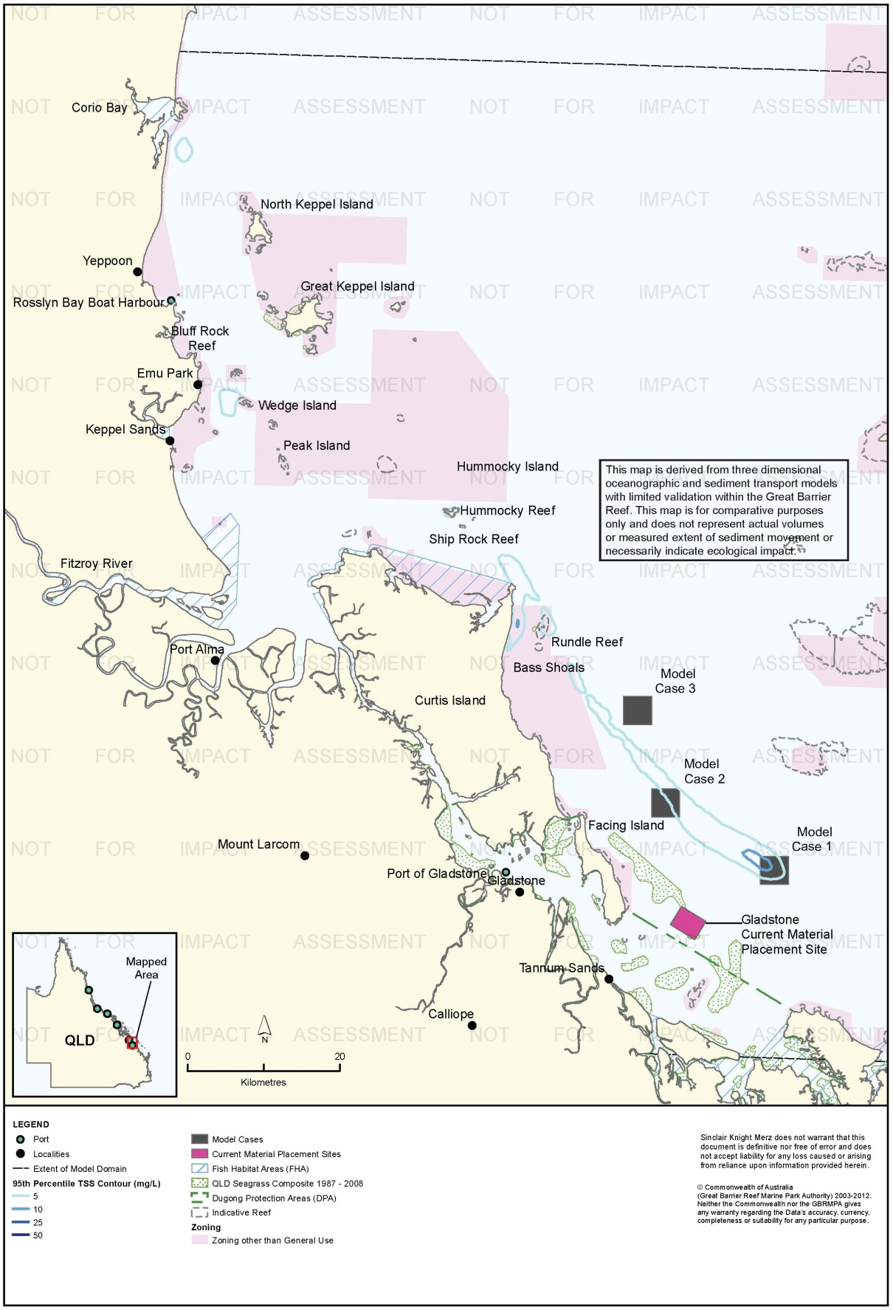
Figure 8. Gladstone: dredging period (133 days) TSS distribution, Model Case 1 - 95th percentile.

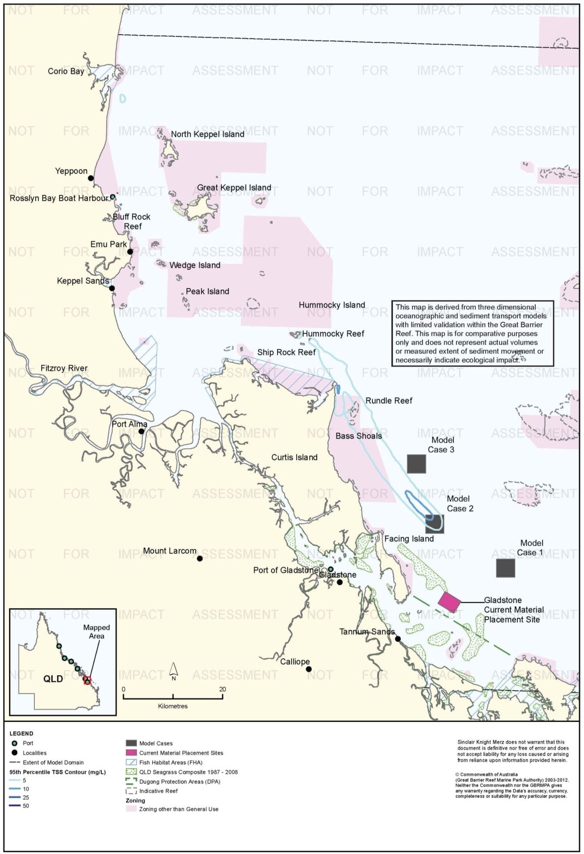
Figure 9. Gladstone: dredging period (133 days) TSS distribution, Model Case 2 - 95th percentile.

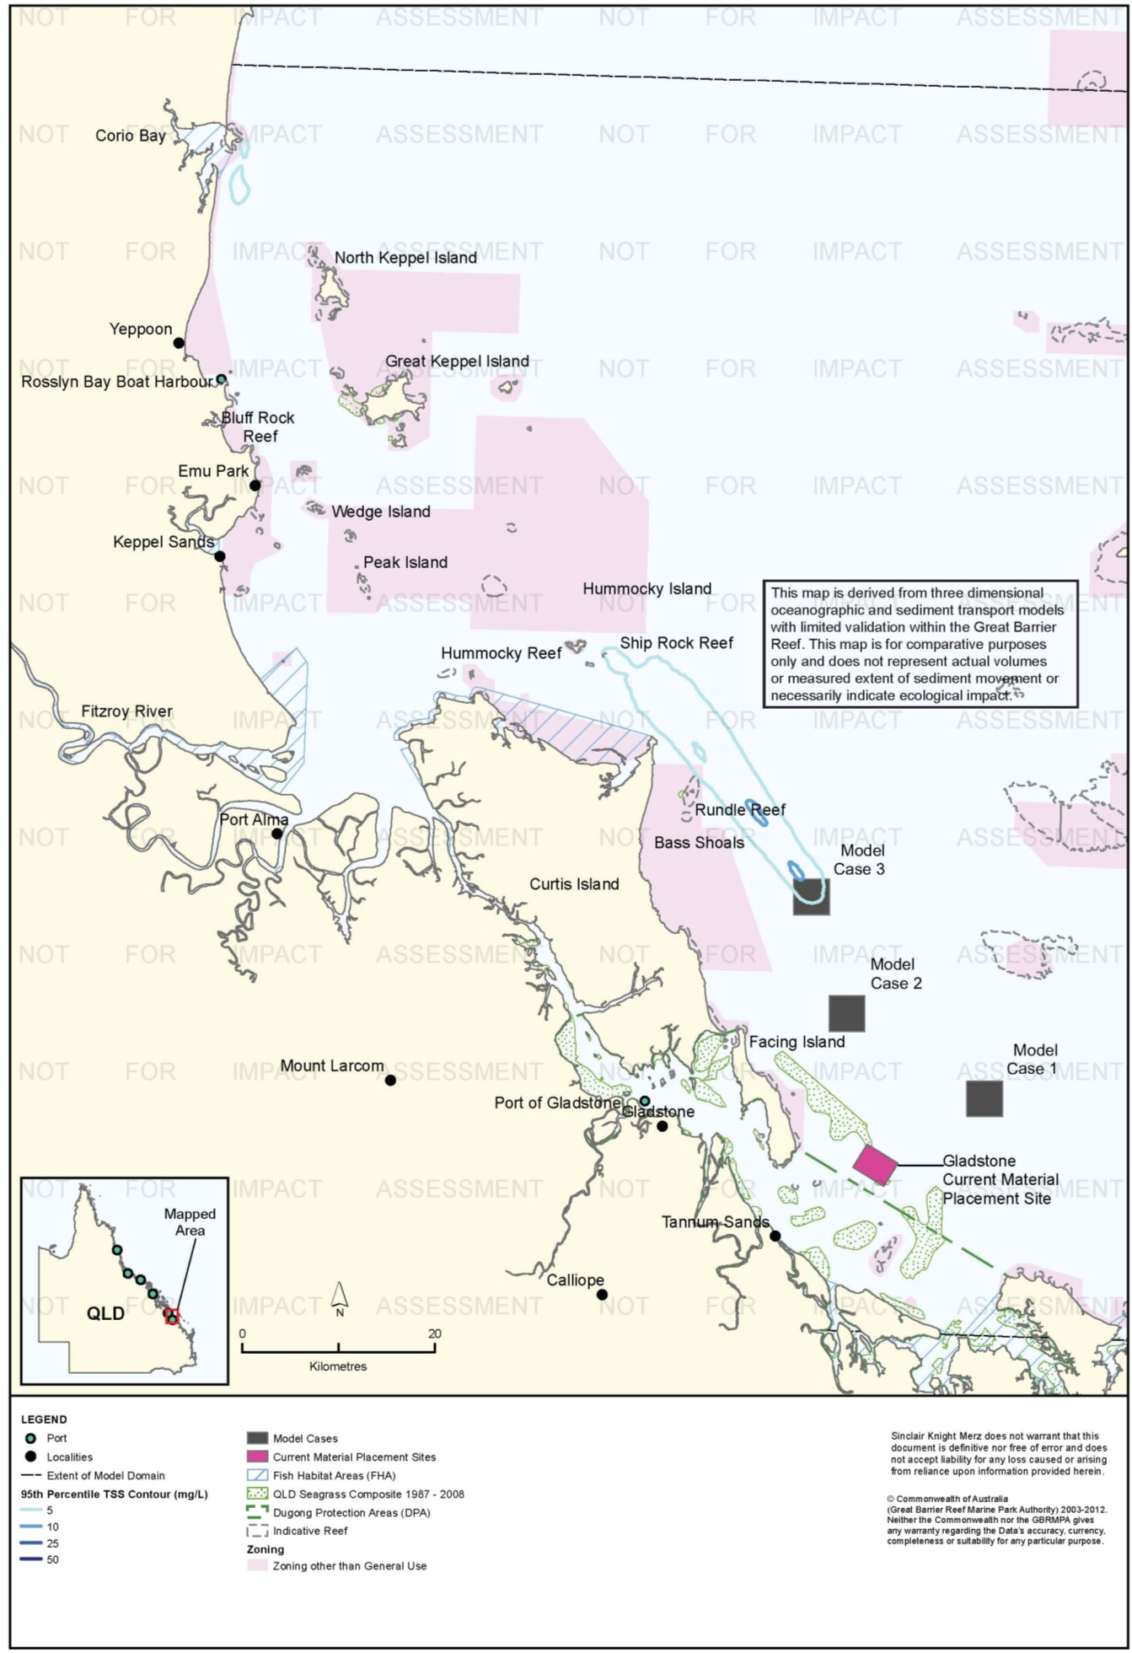
Figure 10. Gladstone: dredging period (133 days) TSS distribution, Model Case 3 - 95th percentile.

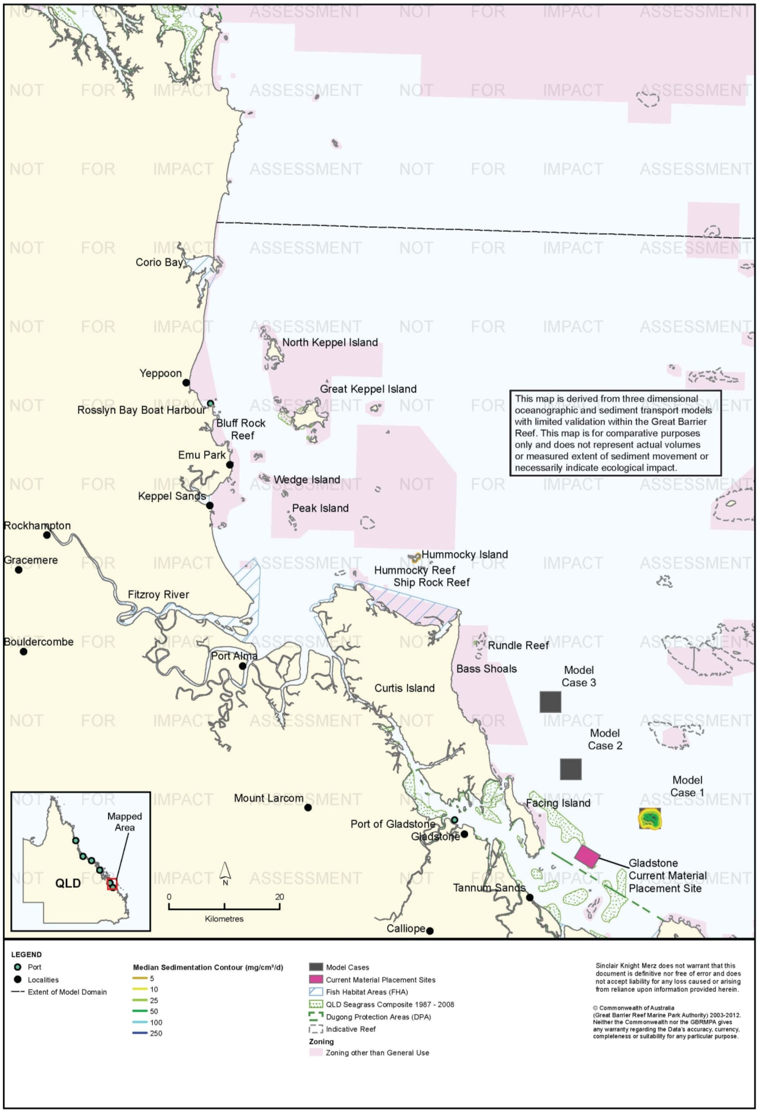
Figure 11. Gladstone: dredging period (133 days) sedimentation rate, Model Case 1 - 50th percentile.

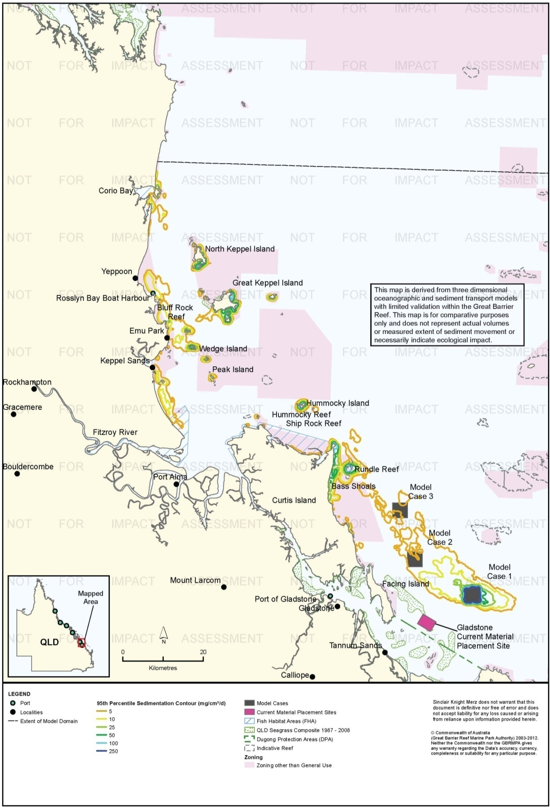
Figure 12. Gladstone: dredging period (133 days) sedimentation rate, Model Case 1 - 95th percentile.

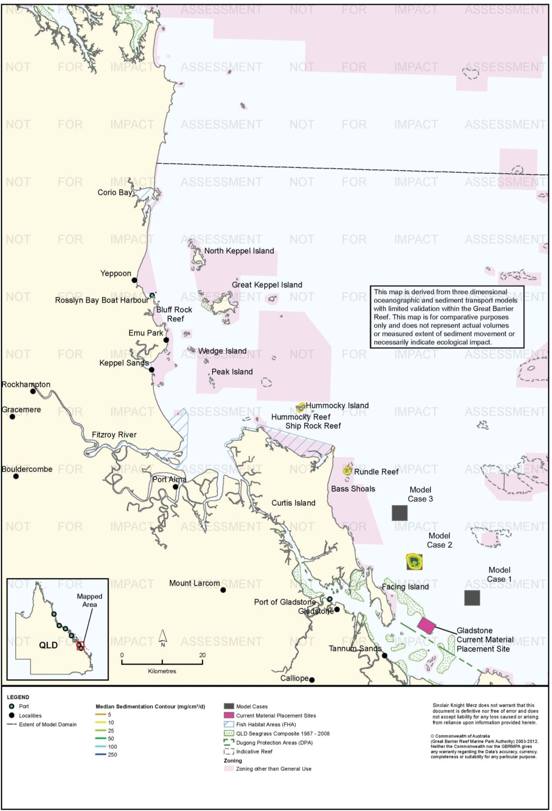
Figure 13. Gladstone: dredging period (133 days) sedimentation rate, Model Case 2 - 50th percentile.

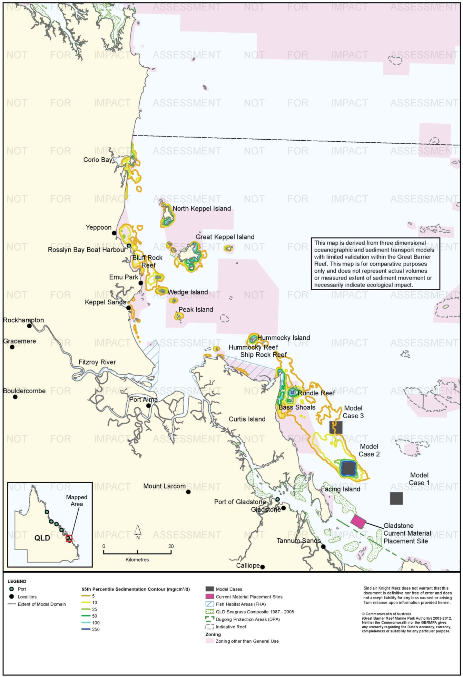
Figure 14. Gladstone: dredging period (133 days) sedimentation rate, Model Case 2 - 95th percentile.

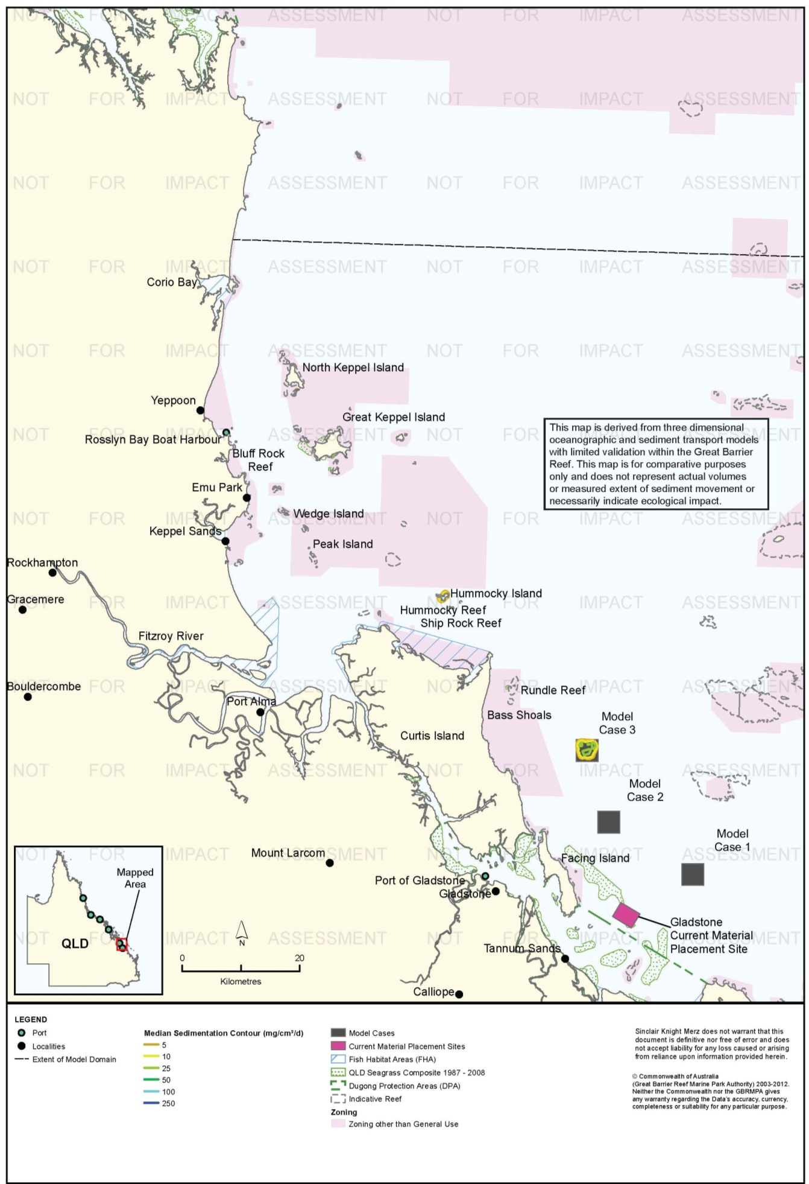
Figure 15. Gladstone: dredging period (133 days) sedimentation rate, Model Case 3 - 50th percentile.

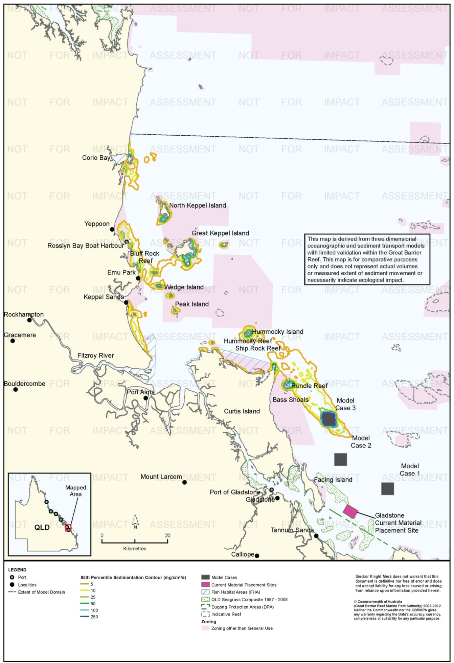
Figure 16. Gladstone: dredging period (133 days) sedimentation rate, Model Case 3 - 95th percentile.

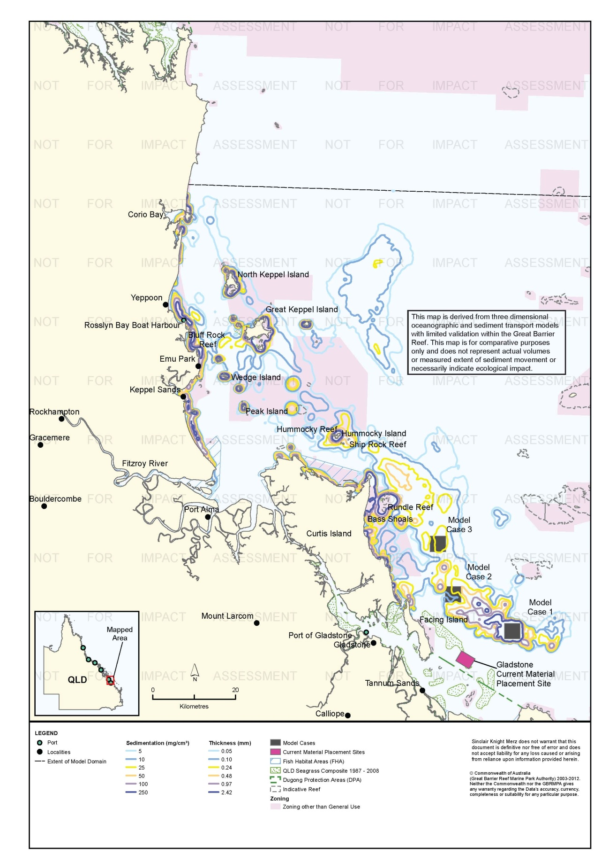
Figure 17. Gladstone: dredging period (133 days) total sedimentation and bottom thickness, Model Case 1.

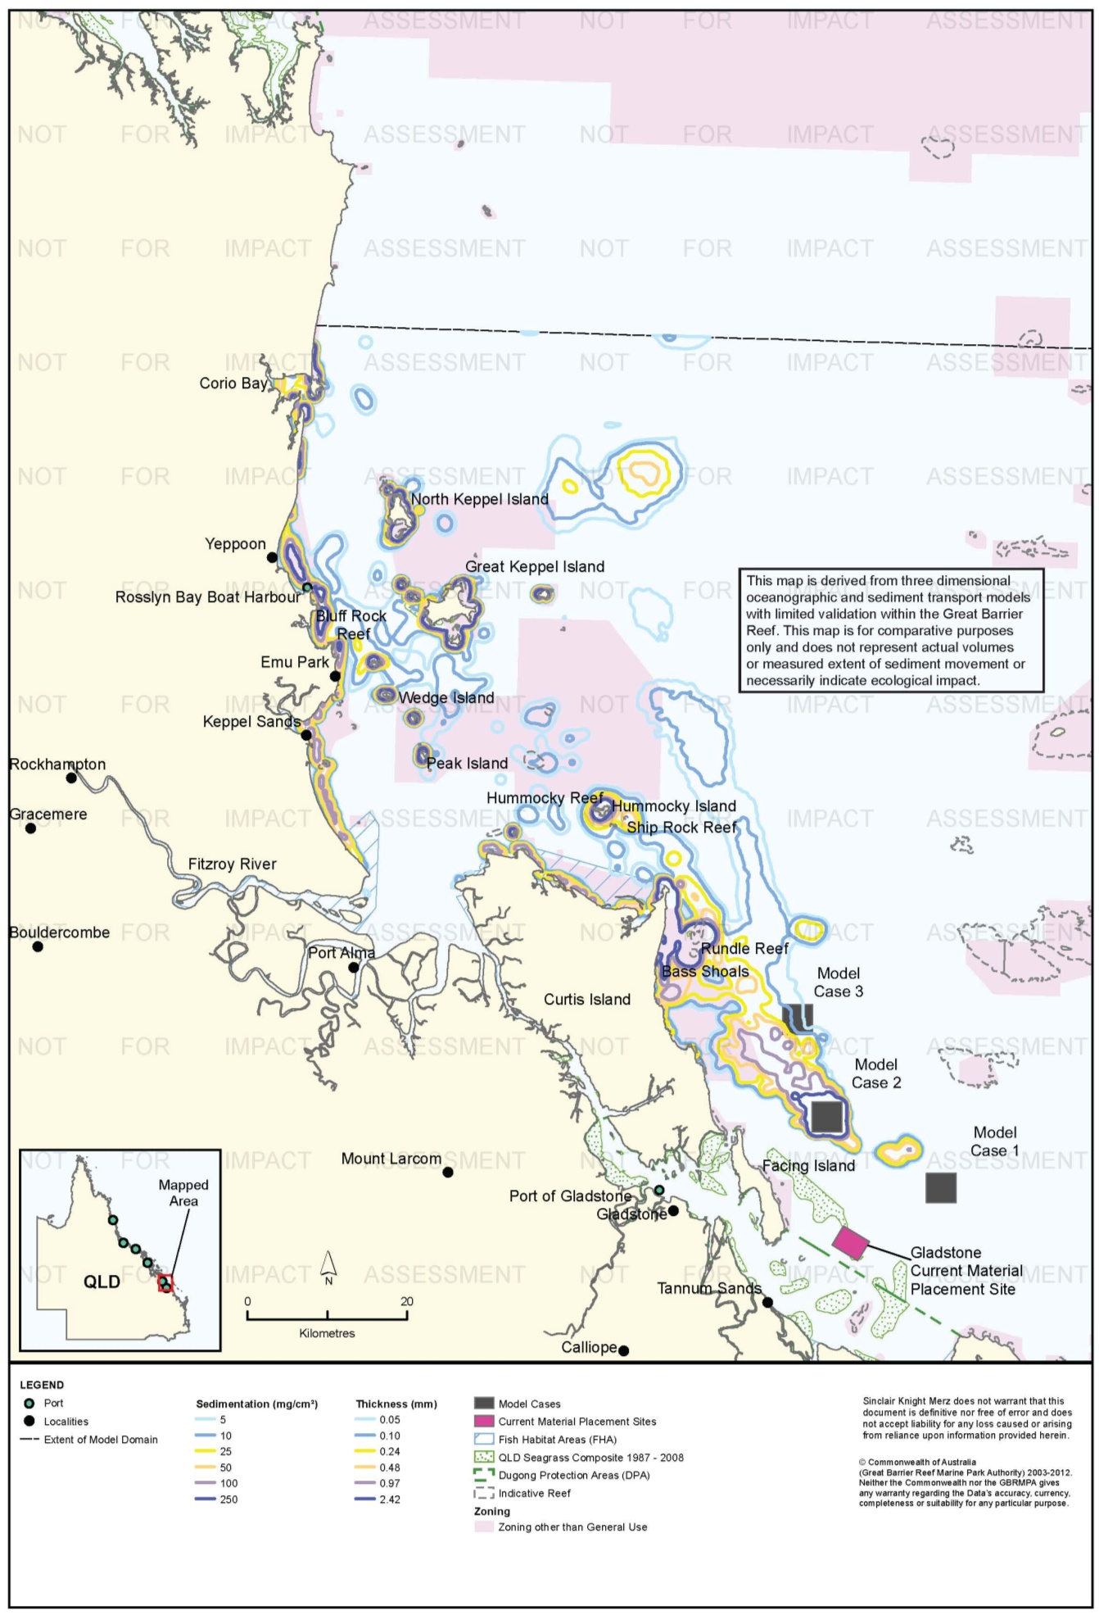
Figure 18. Gladstone: dredging period (133 days) total sedimentation and bottom thickness, Model Case 2.

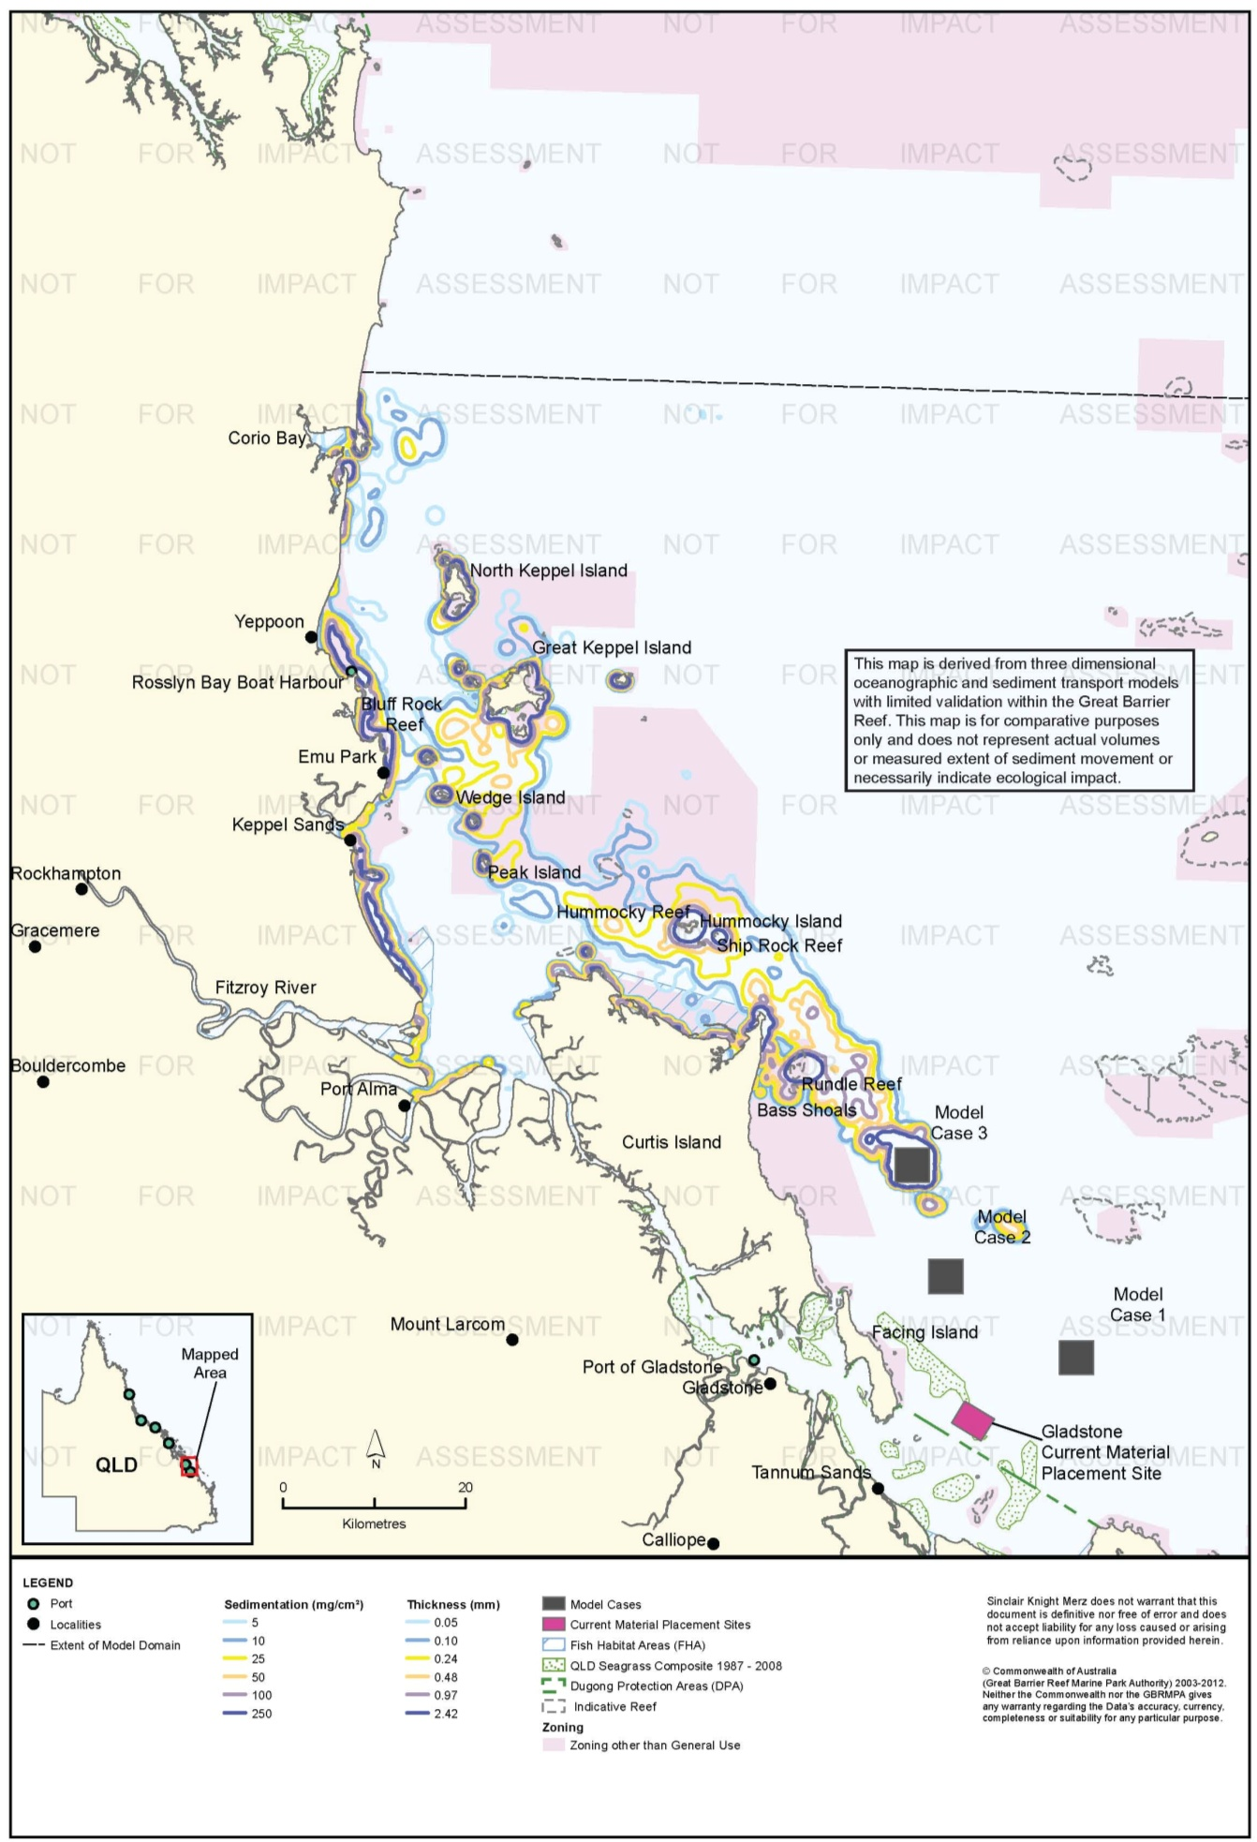
Figure 19. Gladstone: dredging period (133 days) total sedimentation and bottom thickness, Model Case 3.

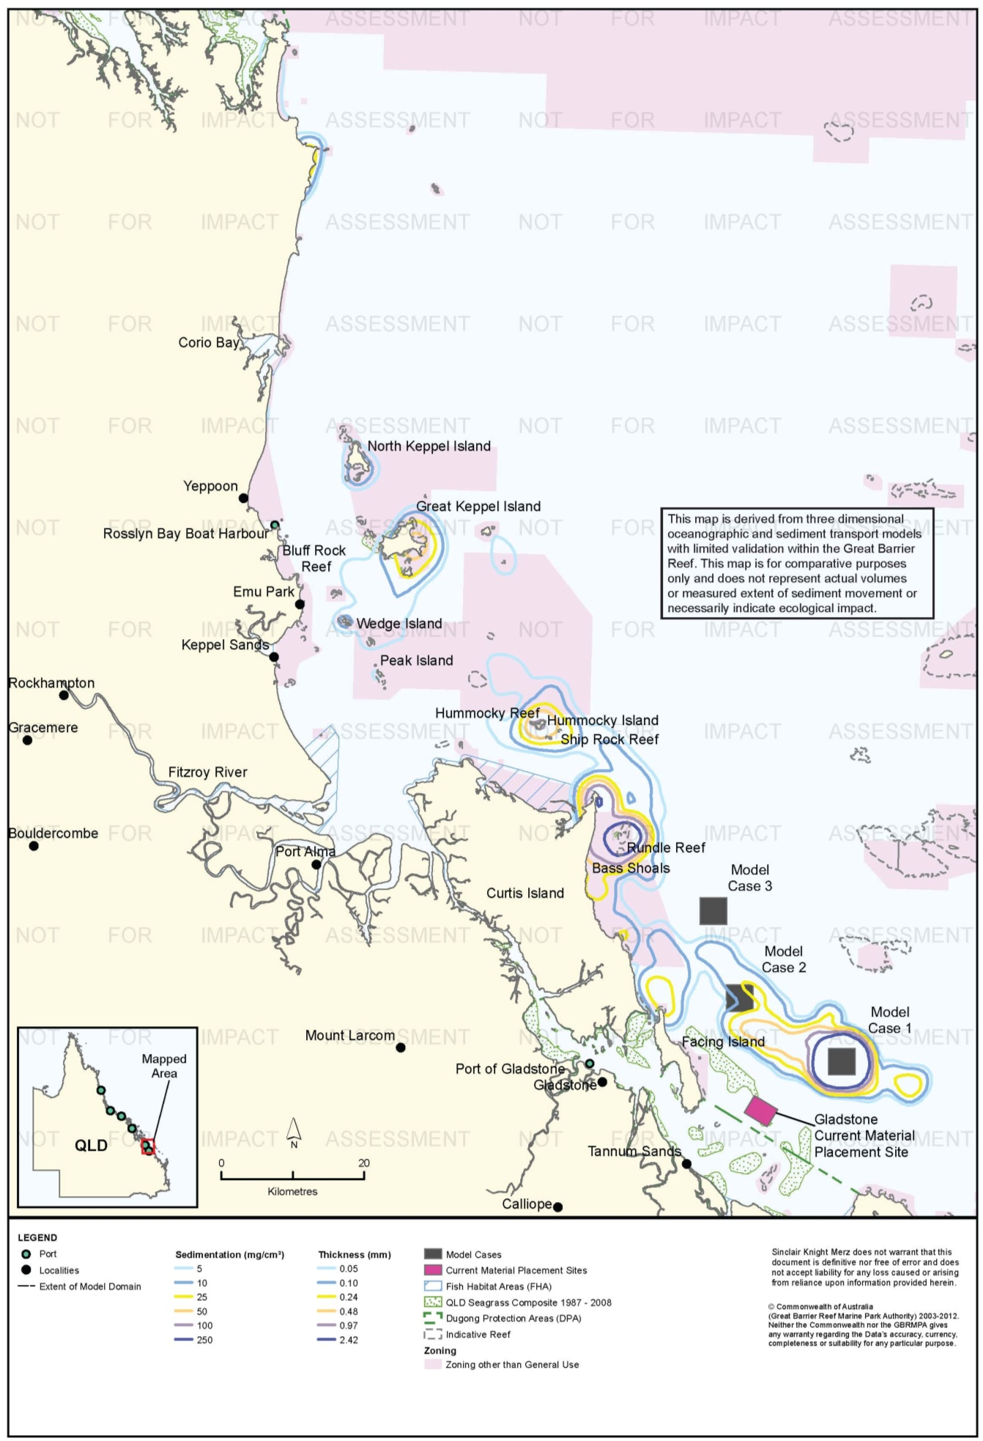
Figure 20. Gladstone: long-term (12 months) total sedimentation and bottom thickness, Model Case 1.

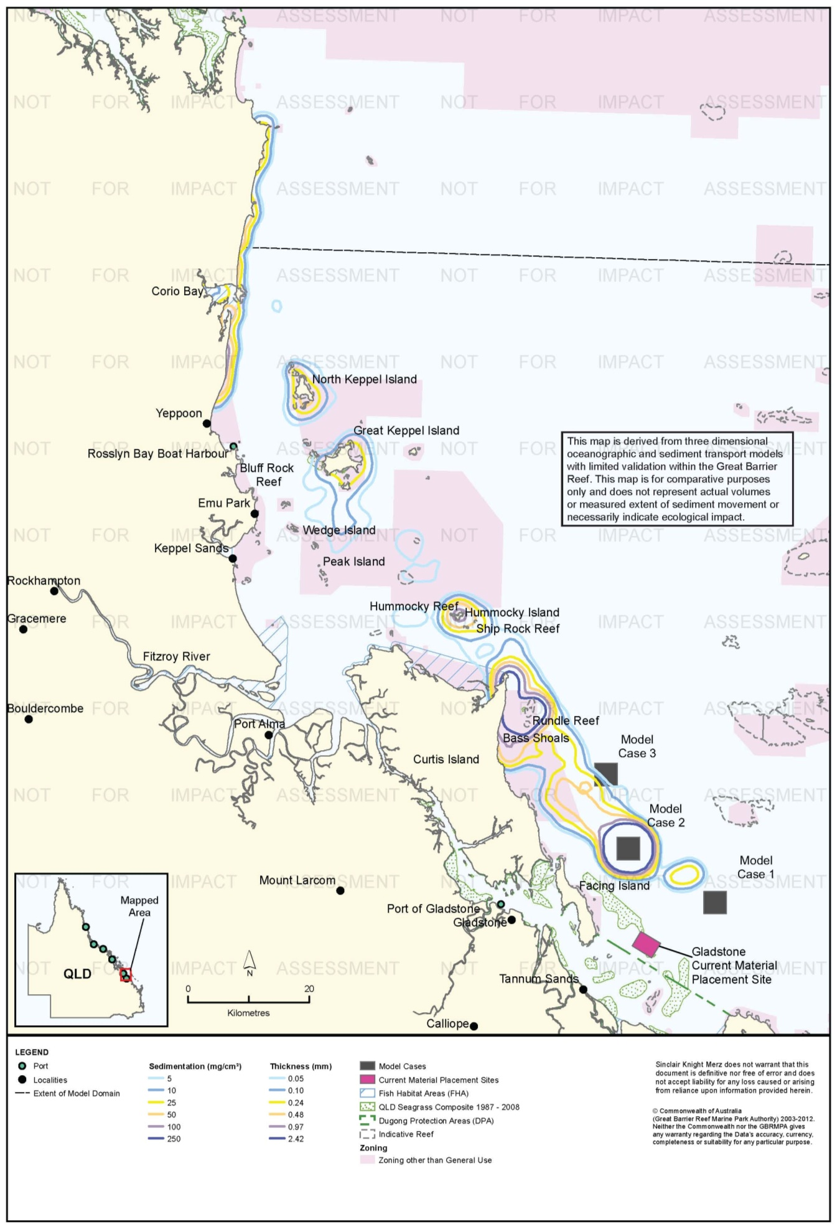
Figure 21. Gladstone: long-term (12 months) total sedimentation and bottom thickness, Model Case 2.

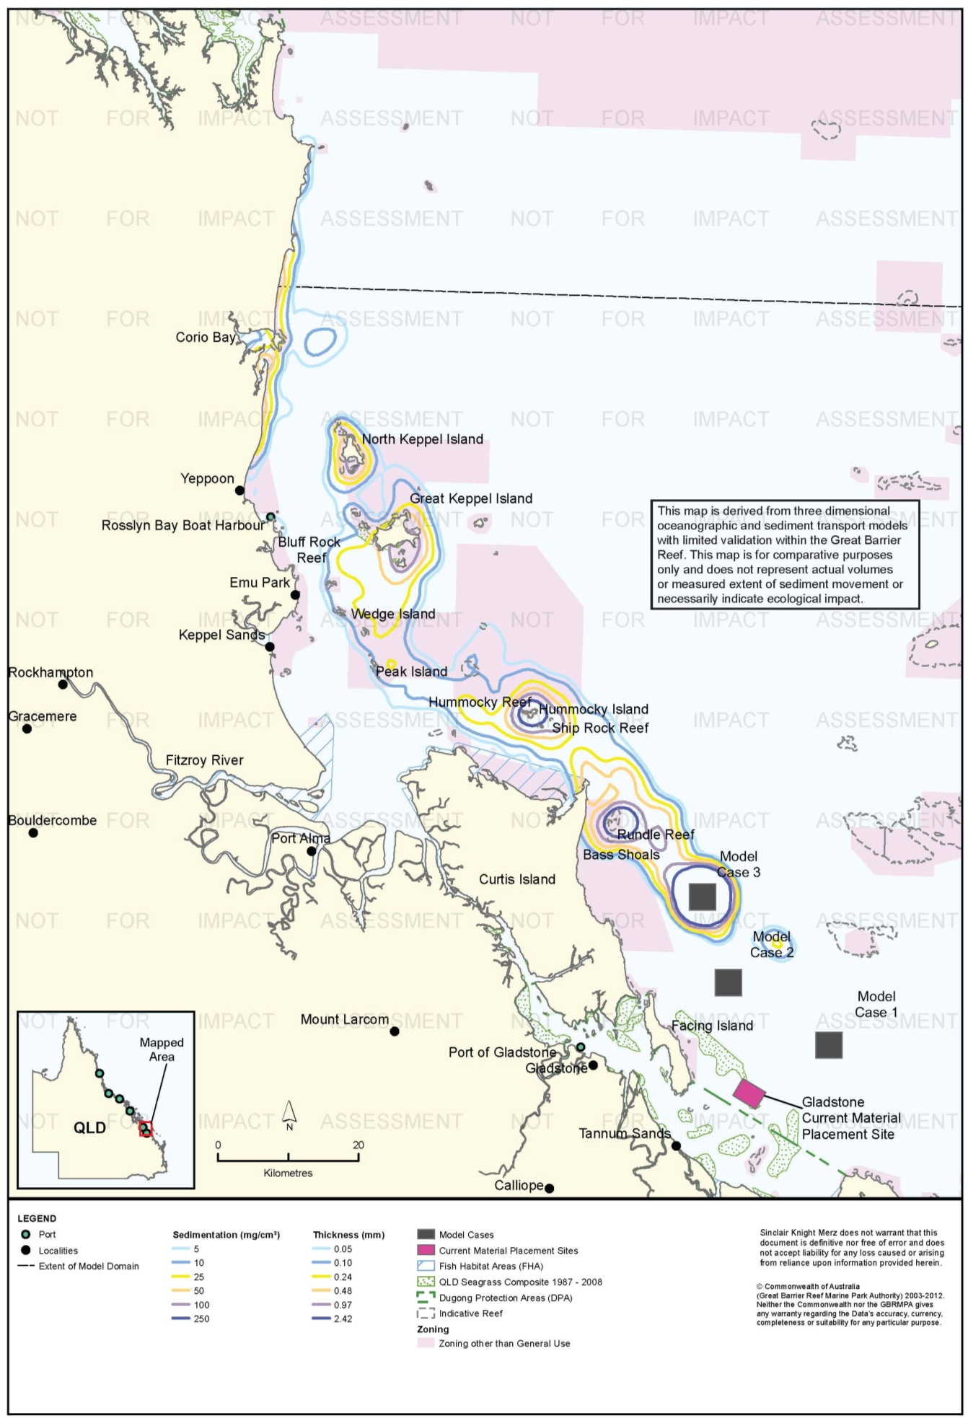
Figure 22. Gladstone: long-term (12 months) total sedimentation and bottom thickness, Model Case 3.

Risk Assessment
The results of the risk assessment are presented in table 9. Suspended sediment plumes posed a medium risk to coral reefs at Rundle Reef and Bass Shoal for Model Cases 1 and 2, given the predicted levels of TSS. However, environmental risk related to sensitive receptors from elevated TSS was assessed to be low for Model Case 3, due to the predicted turbidity plume being located slightly east of reef receptors. The risk to non-General Use Zones for Model Case 2 was also assessed to be medium, with Model Cases 1 and 3 assessed to be low.
The model did not predict sustained (50th percentile) increases in sedimentation rate for any of the model cases. Infrequent (95th percentile) episodes of high sedimentation were predicted along the coast north of Gladstone, including the Keppel Islands. Some medium risks have therefore been identified for coral reefs, FHAs and non-General Use Zones. However, environmental risk was not assessed to vary considerably among model cases, as modelling predicted similar sedimentation rates for all three model cases in FHAs, areas zoned non-General Use and at locations comprising coral habitats.
The predicted accumulation of sediment (total sedimentation) was also similar for all three model cases. The primary differences during the dredging period were sediment accumulation along coastal areas north of Yeppoon (88 km north-west of Model Case 3) for Model Cases 2 and 3, and the accumulation of sediments at Facing Island and southern sections of Curtis Island for Model Case 1. Over 12 months, the model predicts less sediment accumulation along the coast from Yeppoon to north of Corio Bay for Model Case 1 compared to Model Cases 2 and 3; this may reflect the time scale of sediment transport rather than longer-term outcomes, i.e. if the model was run for a longer period the results would likely show less deposition for Model Cases 1 and 2 because sediment would move past the domain boundary, while sediment from Model Case 3 would reach the coast north of Yeppoon.
These results reflect the repeated settlement and resuspension of sediments until they arrive at natural depositional environments, where bed shear-stress is relatively low and sediments transported from elsewhere in the Great Barrier Reef lagoon are ultimately deposited until remobilised by extreme events. The large distances over which sedimentation was predicted should be interpreted with some caution when considering the potential risk for sensitive receptors, particularly given that other sources of large quantities of sediments, in particular the Fitzroy River (50 km west of Model Case 3), are present in the Gladstone region and are located closer to the sensitive receptors in the Keppel Islands. The large volumes of sediment input to Keppel Bay by the Fitzroy are exported to the Great Barrier Reef lagoon (Margvelashvili et al. 2006).
In summary, the three modelled material placement sites at Gladstone have similar distribution patterns of TSS, sedimentation rate, and total sedimentation in the short and long term. While differences among the three sites are subtle, Model Case 1 is assessed to pose the lowest risk to sensitive receptors in the Gladstone region, in part by virtue of its location farthest south and therefore at the greatest distance from sensitive coral reef receptors. Risks associated with the modelled material placement scenarios were assessed as low to medium, in part informed by consideration of the natural depositional environments where sediment deposition is predicted.
The results of the risk assessment are presented in table 10.

Table 10. Comparative risk assessment for the Port of Gladstone based on modelling results (figure 8 to figure 22).
Hazard | Sensitive Receptor | Site | Likelihood | Consequence | Risk Rating
An increase in TSS concentration and turbidity in waters surrounding the material placement site. | Coral Reefs | Model Case 1 | Possible | Minor | Medium
 |  | Model Case 2 | Possible | Minor | Medium
 |  | Model Case 3 | Unlikely | Minor | Low
 | Seagrass. | Model Case 1 | Unlikely | Minor | Low
 |  | Model Case 2 | Unlikely | Minor | Low
 |  | Model Case 3 | Unlikely | Minor | Low
 | Fish Habitat Areas | Model Case 1 | Rare | Insignificant | Low
 |  | Model Case 2 | Rare | Insignificant | Low
 |  | Model Case 3 | Rare | Insignificant | Low
 | Non-General Use Zones | Model Case 1 | Unlikely | Minor | Low
 |  | Model Case 2 | Possible | Minor | Medium
 |  | Model Case 3 | Unlikely | Insignificant | Low
 | Commercial fisheries | Model Case 1 | Rare | Insignificant | Low
 |  | Model Case 2 | Rare | Insignificant | Low
 |  | Model Case 3 | Unlikely | Minor | Low
 | Tourism and recreational values | Model Case 1 | Rare | Insignificant | Low
 |  | Model Case 2 | Rare | Insignificant | Low
 |  | Model Case 3 | Unlikely | Minor | Low
Increase in the rate of sediment deposition on the sea bed in areas surrounding the material placement site. | Coral Reefs | Model Case 1 | Possible | Minor | Medium
 |  | Model Case 2 | Possible | Minor | Medium
 |  | Model Case 3 | Possible | Minor | Medium
 | Seagrass. | Model Case 1 | Unlikely | Minor | Low
 |  | Model Case 2 | Unlikely | Minor | Low
 |  | Model Case 3 | Unlikely | Minor | Low
 | Fish Habitat Areas | Model Case 1 | Possible | Minor | Medium
 |  | Model Case 2 | Possible | Minor | Medium
 |  | Model Case 3 | Possible | Minor | Medium
 | Non-General Use Zones | Model Case 1 | Possible | Minor | Medium
 |  | Model Case 2 | Possible | Minor | Medium
 |  | Model Case 3 | Possible | Minor | Medium
 | Commercial fisheries | Model Case 1 | Unlikely | Minor | Low
 |  | Model Case 2 | Unlikely | Minor | Low
 |  | Model Case 3 | Unlikely | Minor | Low
 | Tourism and recreational values | Model Case 1 | Unlikely | Minor | Low
 |  | Model Case 2 | Unlikely | Minor | Low
 |  | Model Case 3 | Unlikely | Minor | Low
Accumulation of sediments on the sea bed. | Coral Reefs | Model Case 1 | Possible | Minor | Medium
 |  | Model Case 2 | Possible | Minor | Medium
 |  | Model Case 3 | Possible | Minor | Medium
 | Seagrass. | Model Case 1 | Unlikely | Minor | Low
 |  | Model Case 2 | Unlikely | Minor | Low
 |  | Model Case 3 | Unlikely | Minor | Low
 | Fish Habitat Areas | Model Case 1 | Rare | Insignificant | Low
 |  | Model Case 2 | Possible | Minor | Medium
 |  | Model Case 3 | Possible | Minor | Medium
 | Non-General Use Zones | Model Case 1 | Possible | Minor | Medium
 |  | Model Case 2 | Possible | Minor | Medium
 |  | Model Case 3 | Possible | Minor | Medium
 | Commercial fisheries | Model Case 1 | Rare | Minor | Low
 |  | Model Case 2 | Unlikely | Minor | Low
 |  | Model Case 3 | Unlikely | Minor | Low
 | Tourism and recreational values | Model Case 1 | Unlikely | Minor | Low
 |  | Model Case 2 | Unlikely | Minor | Low
 |  | Model Case 3 | Unlikely | Minor | Low

Ecological Monitoring in Relation to Dredging
Long-term monitoring of seagrass meadows in Port Curtis and Rodds Bay has been conducted since 2002 (Amies et al. 2013; McCormack et al. 2013; Thomas et al. 2010). From 2002 to 2009 monitoring was conducted at 13 sites in Port Curtis and Rodds Bay selected on a broad-scale survey of the area (Thomas et al. 2007). There was a net loss of 60 ha of seagrass meadows (losses of 95 ha and 312 ha in northern Port Curtis and Rodds Bay, respectively, gain of 312 ha in southern Port Curtis) from 2002-2009 (Thomas et al. 2010). Thomas et al. (2010) attributed the loss to climate variability, particularly elevated freshwater inputs and temperature, and did not attribute the decline in seagrass area to the effects of regular maintenance dredging. They noted, however, that some meadows already stressed by climate variability could be more vulnerable to other stresses. It is also noted that regular maintenance dredging had been conducted since the mid-1990s prior to the establishment of long-term monitoring. Further details are provided in table 8.
Long-term seagrass monitoring was established in Port Curtis for the WBDDP in 2009 (McCormack et al. 2013). Two sites, North Pelican Banks and Rodds Bay, were established in 2005 and 2007, respectively for Seagrass Watch - RRMMP monitoring. Five sites expected to be most vulnerable to WBDDP dredging impacts were established in 2009, with additional sites established in 2010 and 2011 and three additional sites in 2012 (McCormack et al. 2013). There have been statistically significant declines in seagrass abundance at all sites during the monitoring program (McCormack et al. 2013). McCormack et al. (2013) attribute the losses to flood events. They interpret substantial post-flood recovery that occurred at Pelican Banks, the major area of seagrass at Gladstone, as evidence that dredging was not having a major impact on seagrass in the outer harbour. McCormack et al. (2013) also concluded that light-based monitoring and reactive management of dredging operations was generally effective in preventing impacts on seagrass from light reduction, and that most meadows retained resilience for recovery from climate disturbances. Exceptions were at Wiggins Island and Rodds Bay, where the dramatic loss of seagrass after recent floods have been so severe that changes in sediment chemistry that impede recovery may have occurred. Further details are provided in table 8.
Benthic macroinvertebrates were surveyed at the current placement site located south-east of Facing Island over a 15-month period encompassing both maintenance dredging and the WBDDP capital dredging (BMT WBM 2012b; see table 8). Three surveys were conducted before the 2011 maintenance dredging campaign, seven months, five months, and one week prior to dredging. Another survey was conducted four weeks after the end of maintenance dredging and four weeks before commencement of WBDDP capital dredging. Another survey was conducted at the commencement of WBDDP capital dredging, from 23-26 May 2011 (dredging commenced on 24 May). Finally, surveys were repeated 4.5 and 6.5 months after commencement of WDBBP dredging.
The infauna monitoring was conducted by grab sampling at two sites within the DMPA, at two near-field sites immediately adjacent to (boundaries separated by approximately 50-100 m) the DMPA, one to the north-west and one to the north-east, and at two reference sties, one approximately 4.5 km to the north-west and one 5 km to the south-east (BMT WBM 2012b). Further details are provided in table 8.
BMT WBM (2012b) reported that data analysis of the DMPA, near-field, and reference sites differed greatly to each other at the beginning of monitoring, before 2011 maintenance dredging. BMT WBM (21012b) do not report levels of statistical significant, but graphically presented data support this conclusion. BMT WBM (2012b) concluded that these differences reflect legacy impacts, that is, impacts of dredge material placement from prior dredging campaigns. BMT WBM (2012b) found significant differences in infauna communities within the DMPA before and after capital dredging compared to the reference sites, but not before and after maintenance dredging. At the near-field sites, there were no statistically significant differences in infauna communities relative to reference sites before and after either maintenance or capital dredging. BMT WBM (2012b) concluded that the already highly modified communities at the near-field sites are resistant to further change due to placement of dredge material, and that infauna communities within the DMPA, again already highly modified by past dredge material placement, are resistant to further change from maintenance material placement but were impacted by capital material placement. BMT WBM (2012b) also concluded that the effect of the 2011 Queensland floods was greater than the effect of maintenance material placement. BMT WBM (2012b) reported that power analysis of previous data from the area was used in the sampling design but do not report statistical power.
Sea Research (2012) surveyed coral reefs south and east of Facing Island, north-west of the DMPA for the WBDDP in May 2011, prior to project commencement, and again in June 2012, during placement operations slightly over one year after commencement. The pre-dredging surveys were conducted at three impact sites approximately 6-9 km from the DMPA, and three control sites approximately 45 km from the DMPA. Sea Research (2012) reported that multivariate analysis showed no significant change in hard or soft coral cover between the pre- and during-dredging surveys at impact sites relative to control sites. There was a statistically significant increase in algal cover at the impact sites, and a greater increase at the control sites. There was a smaller, but statistically significant, increase in sponge cover at impact sites relative to controls. Sea Research (2012) concluded that there were no detectible impacts of dredging and material placement operations at the monitored sites during the survey period. Sea Research (2012) did not report the statistical analysis methods in detail and did not report the power to detect change. Sea Research (2012) did not provide information on potential effects of previous placement campaigns. Further details are provided in table 8.

Environmental Condition
Water quality in the Fitzroy region, which includes the Port of Gladstone, is monitored by the RRMMP (Schaffelke et al. 2011). The water quality aspect of the monitoring program includes inshore permanent monitoring sites (water quality loggers) and remote sensing techniques. Permanent monitoring sites have been established in the Fitzroy region since 2007. No permanent monitoring sites are within 50 km of the Port of Gladstone, with the nearest locations (Barren, Pelican, and Humpy Island) approximately 90 km north. Regionally, water quality in the Fitzroy has been declining since 2007 with the annual mean increasing at logger sites (table 11; Schaffelke et al. 2011). Logger sites also demonstrate a clear inshore to offshore gradient for all years (Schaffelke et al. 2011). Annual and seasonal turbidity means for Pelican Island were above the suggested 5 NTU limit for severe coral photo-physiological stress (Schaffelke et al. 2011).
Table 11. Summary of annual mean turbidity (NTU) data from turbidity sensors at Fitzroy water quality locations from the RRMMP¹.
Site | 2007-2008² | 2008 to 2009² | 2009-2010² | 2010-2011³
Barren Island | 0.37 | 0.46 | 0.47 | 0.52
Humpy Island | 0.88 | 0.89 | 1.26 | 1.57
Pelican Island | 5.08 | 3.42 | 5.50 | 9.80
1 Data extracted from Schaffelke et al. 2011. 2 – Years are from October to September 3 – October to June
Remote sensing is used to monitor TSS concentrations for the entire Marine Park at a spatial resolution of 1 km (Brando et al. 2011). Since 2002/2003 the Fitzroy region has received moderate TSS ratings using the paddock to reef index. Data from May 2010 to April 2011 for the Port of Gladstone and surrounding areas showed a clear declining gradient from inshore to offshore with median TSS values of 5 mg/L at inshore areas such as the narrows and Port Alma (Brando et al. 2011). Areas from the Fitzroy River to Emu Park demonstrating a clear south north gradient from 5 mg/L to 1 mg/L. Annual median TSS values at the locations of Model Cases 1, 2 and 3 ranged from approximately 0.25 mg/L to 0.50 mg/L.
For the WBDDP, water quality has been monitored since February 2010 by in situ telemetered loggers and manual sampling. Investigations have concluded that water quality conditions are consistent with historical trends, apart from the extreme wet season of 2010/2011, which affected most of Queensland (DEHP 2012). Water quality monitoring between September 2011 and March 2012 reported no water quality issues of significant environmental concern (DEHP 2012).
The Water Quality Management Plan for the WBDDP established trigger values
(table 12) for two monitoring sites north-west of the current placement site, based on the 80th and 95th percentiles of baseline data collected by fixed loggers.
Table 12. Reporting trigger values developed for the WBDDP placement site from ambient water quality data.
Site | Wet season based on 80th percentile |  | Wet season based on 95th percentile |  | Dry season based on 80th percentile |  | Dry season based on 80th percentile
 | Turbidity (NTU) | TSS (mg/L) | Turbidity (NTU) | TSS (mg/L) | Turbidity (NTU) | TSS (mg/L) | Turbidity (NTU) | TSS (mg/L)
SGM1 | 4 | 4 | 7 | 8 | 2 | 2 | 5 | 6
SGM2 | 6 | 7 | 7 | 8 | 4 | 4 | 5 | 6

The TSS values in table 12 are derived from the turbidity – TSS relationship adopted by the project (GHD 2009s), which was
- TSS=1.12 * NTU for turbidity ≤ 7 NTU
- TSS =3.68 * NTU -17.92 for turbidity > 7

Reef health in the Fitzroy region is monitored by the RRMMP. No long-term monitoring sites are within 50 km of the Port of Gladstone with the closest monitoring sites are approximately 80 km north surrounding the Keppel Islands. As such no specific long term condition data is available for the Gladstone region. For the Fitzroy region six reefs have been monitored since 2005 with hard coral cover showing a general pattern of decline since monitoring began with overall RRMMP coral scores also declining (table 13; Thompson et al. 2011). Thompson et al. (2011a) assessed the overall condition of Fitzroy communities as poor due to the low densities of juvenile colonies and low coral cover both overall and during periods free of acute disturbances (Thompson et al. 2011).
Table 13. RRMMP monitoring score for overall inshore coral health for the Fitzroy region from 2009-2011 (Thompson et al. 2011a, b).
Year | RRMMP score
2009 | Moderate
2010 | Poor
2011 | Poor

Reefs are also monitored throughout the Reef by the AIMS Long Term monitoring program, which has been in operation since 1992 (Sweatman et al. 2005). No information is provided for this monitoring program as the reefs monitored are approximately 60 km east of the Port of Gladstone and are well away from any predicted sedimentation or TSS influence from any of the three Model Cases.
An intertidal assessment of seagrass in the Fitzroy region was conducted in 2011 as part of the Seagrass Vulnerability Assessment for the Great Barrier Reef (Commonwealth of Australia 2011). The assessment identified seagrass status in the Fitzroy was in poor condition although cover in the Fitzroy region had generally either increased or remained stable. Specifically in seagrass in the Port of Gladstone decreased in 2011 to its lowest level since 2002 (Commonwealth of Australia 2011) and while not fully recovered it has increased since this event (Sankey et al. 2012)
The 2010 Great Barrier Reef Report Card rated the overall condition of inshore water quality and seagrass as moderate, with the first improvement in seagrass health since 2005/2006 (State of Queensland 2013). Coral health has remained in poor condition since 2005, with poor recruitment of juvenile coral (State of Queensland 2013).
While sponges, macroalgae and macroinvertebrate assemblages are known to occur in the area very little is known about the condition of these receptors, with further study required.

Rosslyn Bay State Boat Harbour
Sensitive receptors in the vicinity of the three material placement sites modelled for Rosslyn Bay include reefs, seagrass communities, and turtle nesting beaches. Reef habitats closest to the modelling sites include those of the Keppel Islands to the east (approximately 16 km) and Bluff Rock Reef to the south (approximately 5 km). Small areas of seagrass are known to occur around Great Keppel Island, and shallow (< 15 m) coastal waters are modelled to have a low to moderate probability of seagrass occurring. The most important turtle nesting site occurs at Peak Island, which is a very high priority nesting location for flatback turtles.

Suspended Sediment Plumes
Figure 23, figure 24, and figure 25 show the predicted 100th percentile TSS concentration contours for the modelled cases. The 100th percentile contours are shown because the modelling predicted that no parts of the study area would experience TSS levels as high as 5 mg/L for even five per cent of the time, so 50th and 95th percentiles are not presented. The 100th percentile contours enclose areas where TSS concentrations of 5, 10 or 25 mg/L were predicted to occur at any time (i.e. for a single one-hour time step) in the model run. The contours thus provide for an extremely conservative (risk-adverse) assessment.
The model predicts that under conditions most conducive to producing suspended sediment plumes (100th percentile), slightly turbid plumes (5 mg/L) would move north from all three model case sites, with the 5 mg/L contour from Model Case 2 extending dramatically farther to the north, as far as Corio Bay (18 km north). It should be kept in mind that the contours in figure 23, figure 24, and figure 25 represent the maximum extent of turbid plumes at any one-hour step in the model. Predicted occurrences of TSS of 10 mg/L covered small areas that did not impinge on identified sensitive receptors for Model Cases 1 and 2, and no areas around the current placement site were predicted to experience TSS as high as 10 mg/L at any time. A small 25 mg/L contour less than 1 km in diameter was predicted for Model Case 2, but not at the current site or Model Case 1.

Sedimentation Rate
Figure 26, figure 27, figure 28, figure 29, figure 30, and figure 31 show model predictions of sedimentation rates above background during the modelled placement campaign. For all three model cases, predicted increases in sedimentation rates would be confined to within 1 km of the material placement sites for both the 50th and 95th percentile scenarios. This indicates that environmental risks associated with increased sedimentation rates during placement activities are highly constricted spatially, and confined only to habitats immediately surrounding the placement sites. Sensitive receptors located further than 1 km from the placement sites were not predicted to experience increases in the sedimentation rate, even under median conditions (50th percentile).

Total Sedimentation
The model predicted that during the dredging period the bulk of material would remain at the placement site for all three model cases. For Model Case 1 and the existing site the modelled migration of material leaving the placement site is to the north-west, as far as slightly north of Yeppoon (6 km north). For Model Case 2, by contrast, the modelled migration does not impinge considerably on the coast during the dredging period until reaching the mouth of Corio Bay, where the model predicts deposition and entrainment of sediment into Corio Bay. This is consistent with current understanding of the natural sedimentary regime, with a northward migration of sediments along coastal areas of the Great Barrier Reef (Lambeck & Woolfe 2000; Mathews et al. 2007). Model Case 2 does result in a modelled deposition of dredge material in the Corio Bay Fish Habitat Area during the dredging period. For all three model cases, the long-term (12 month) modelling, predicts that sediment deposition would migrate north. Notably, for Model Case 2 the model predicts a net export after 12 months of sediment deposited in Corio Bay during the dredging period. Thus, sediment placed at Model Case 2 is predicted to only temporarily reside within Corio Bay, before continuing its movement north along the coast within 12 months of the dredging period.
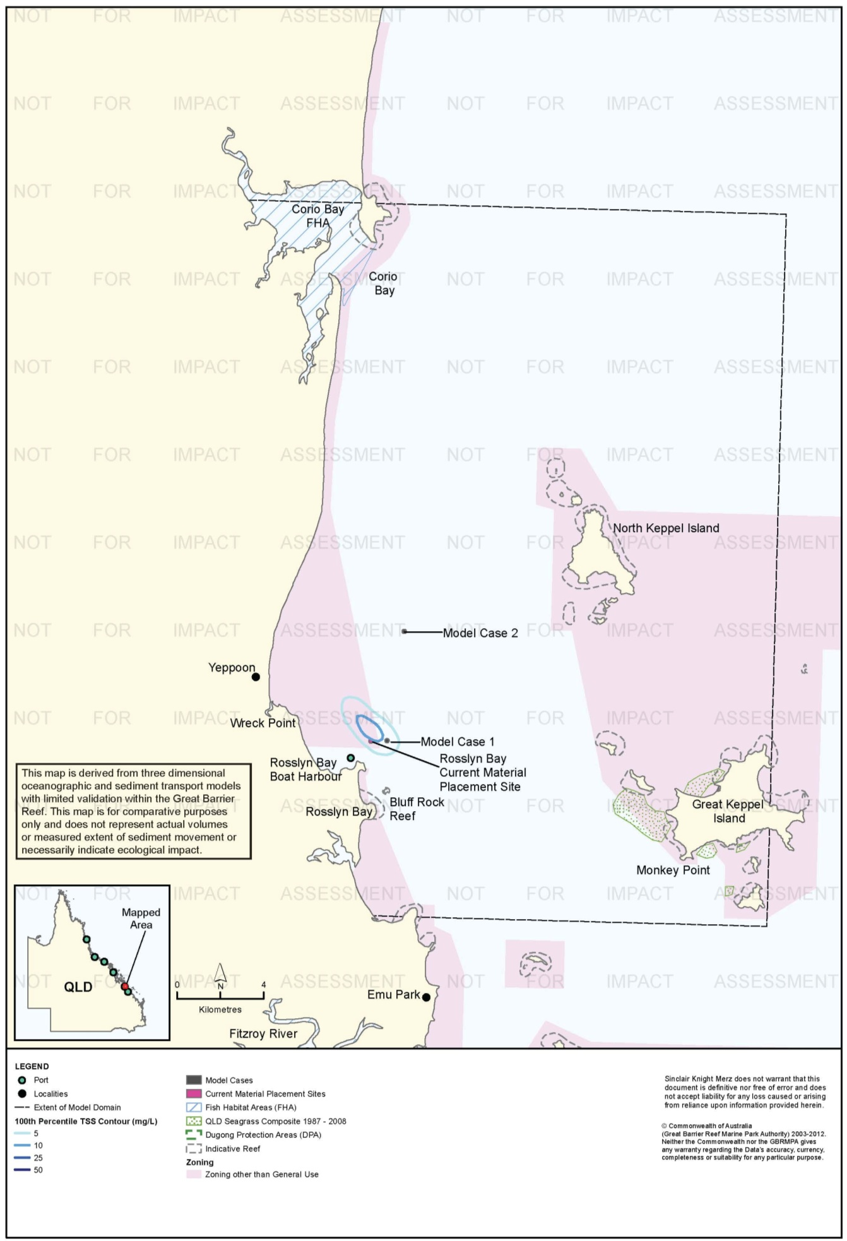
Figure 23. Rosslyn Bay: dredging period (90 days) TSS distribution, Model Case 1 - 100th percentile.

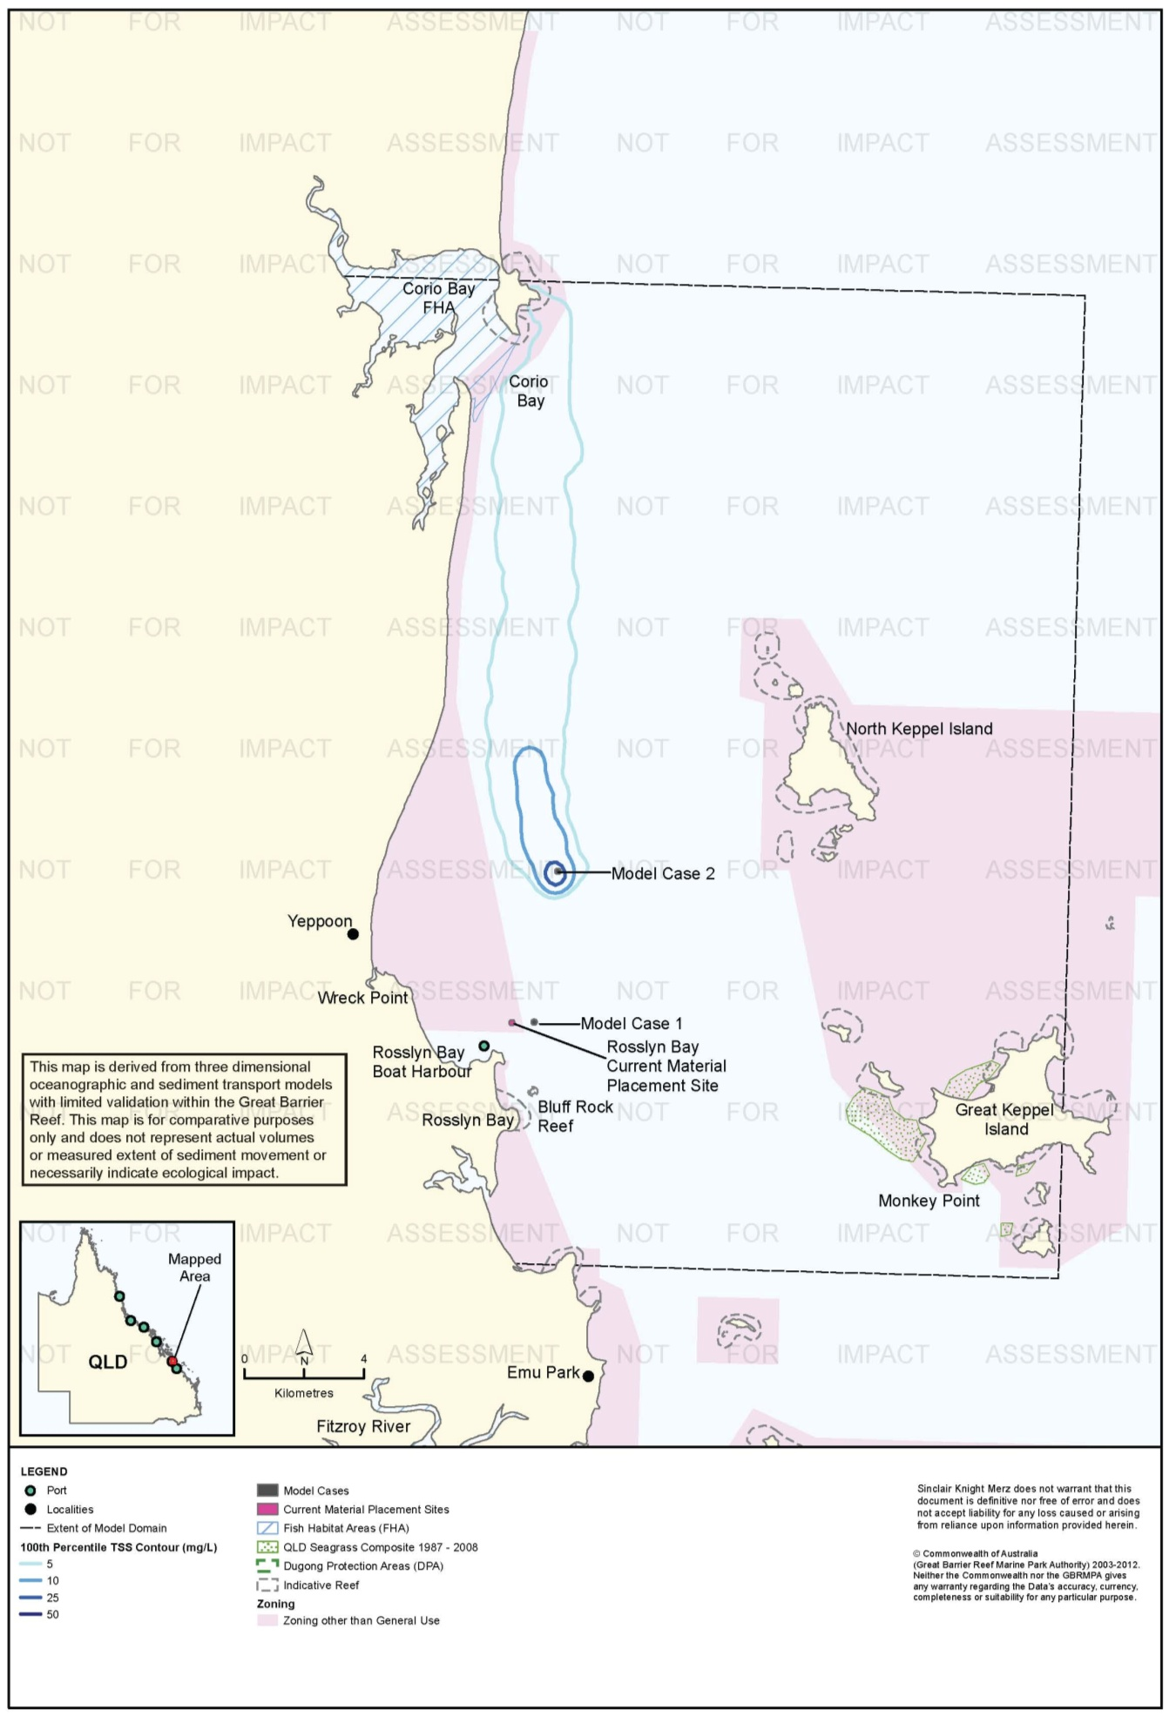
Figure 24. Rosslyn Bay: dredging period (90 days) TSS distribution, Model Case 2 - 100th percentile.

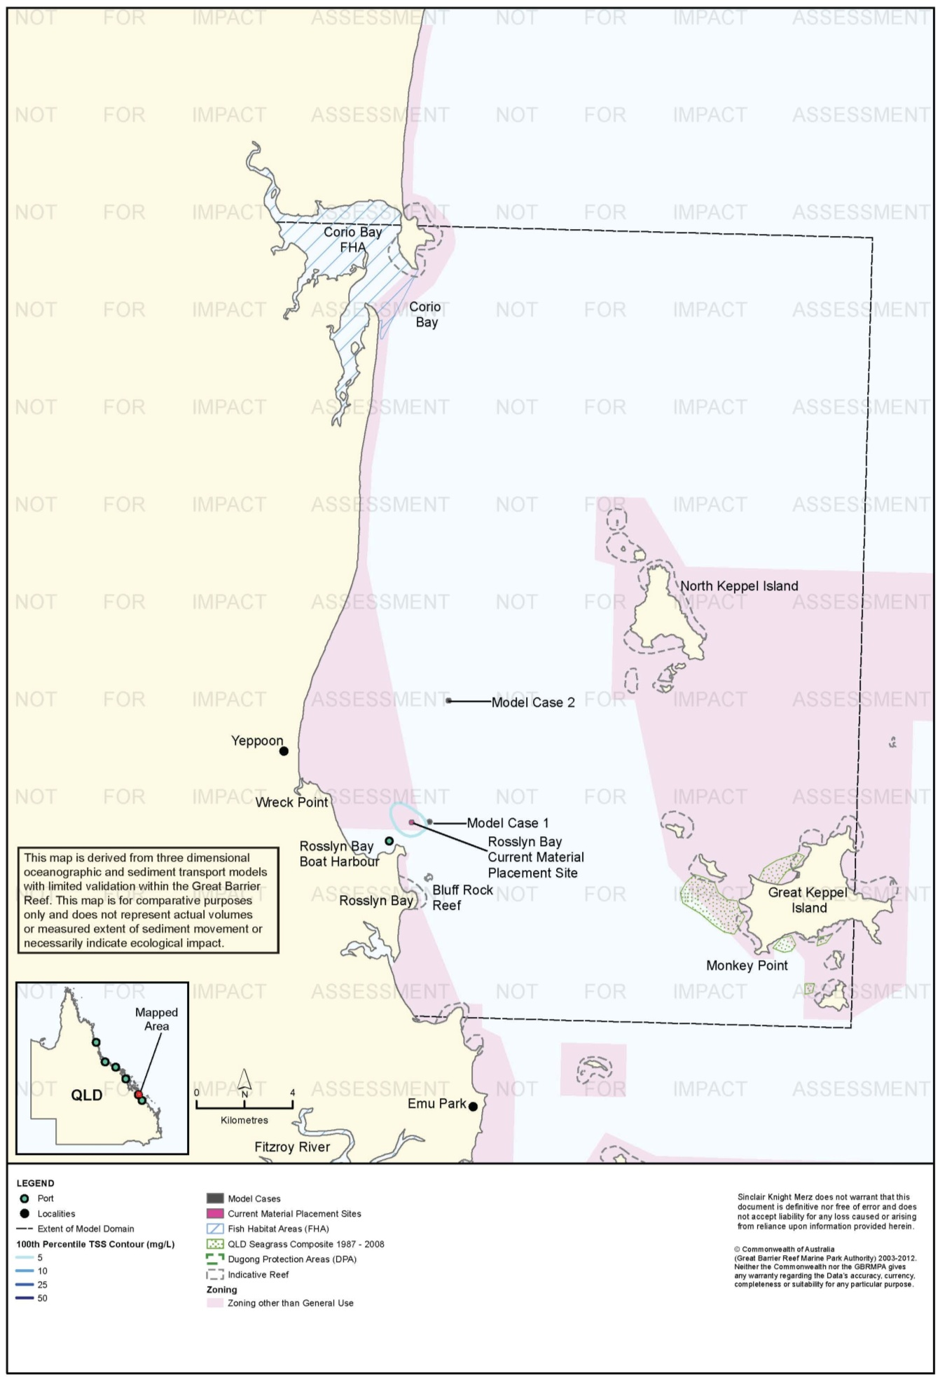
Figure 25. Rosslyn Bay: dredging period (90 days) TSS distribution, current site - 100th percentile.

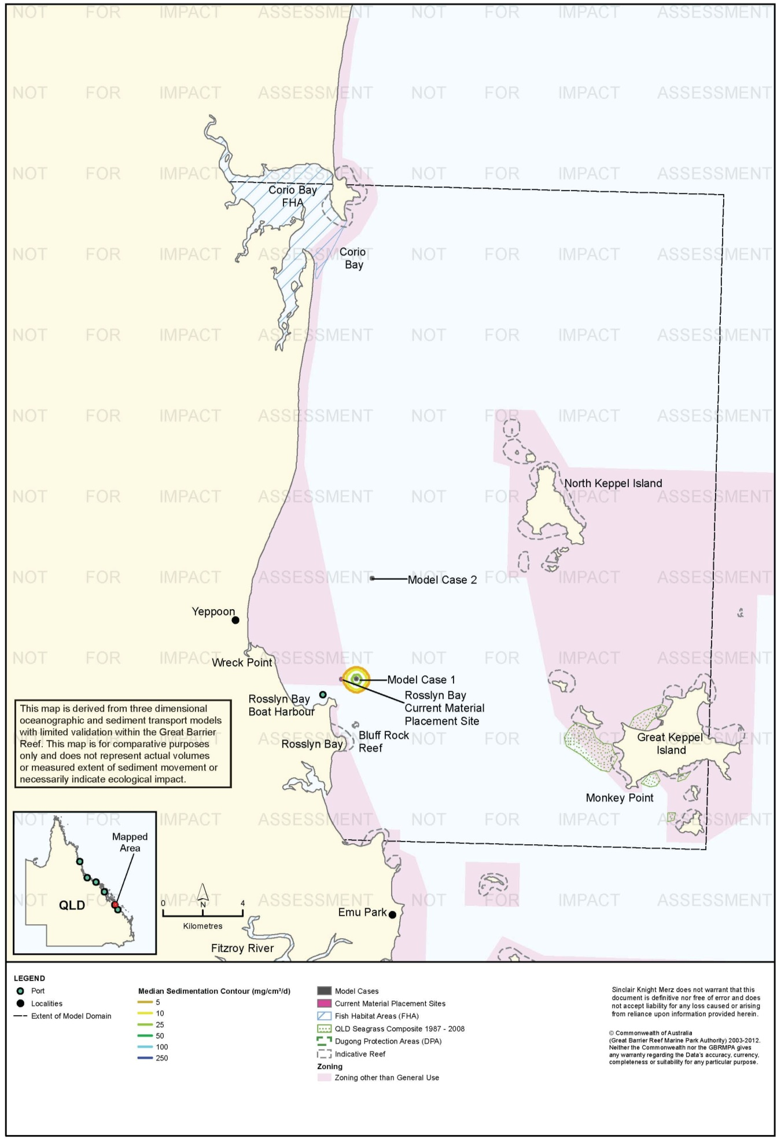
Figure 26. Rosslyn Bay: dredging period (90 days) sedimentation rate, Model Case 1 - 50th percentile.

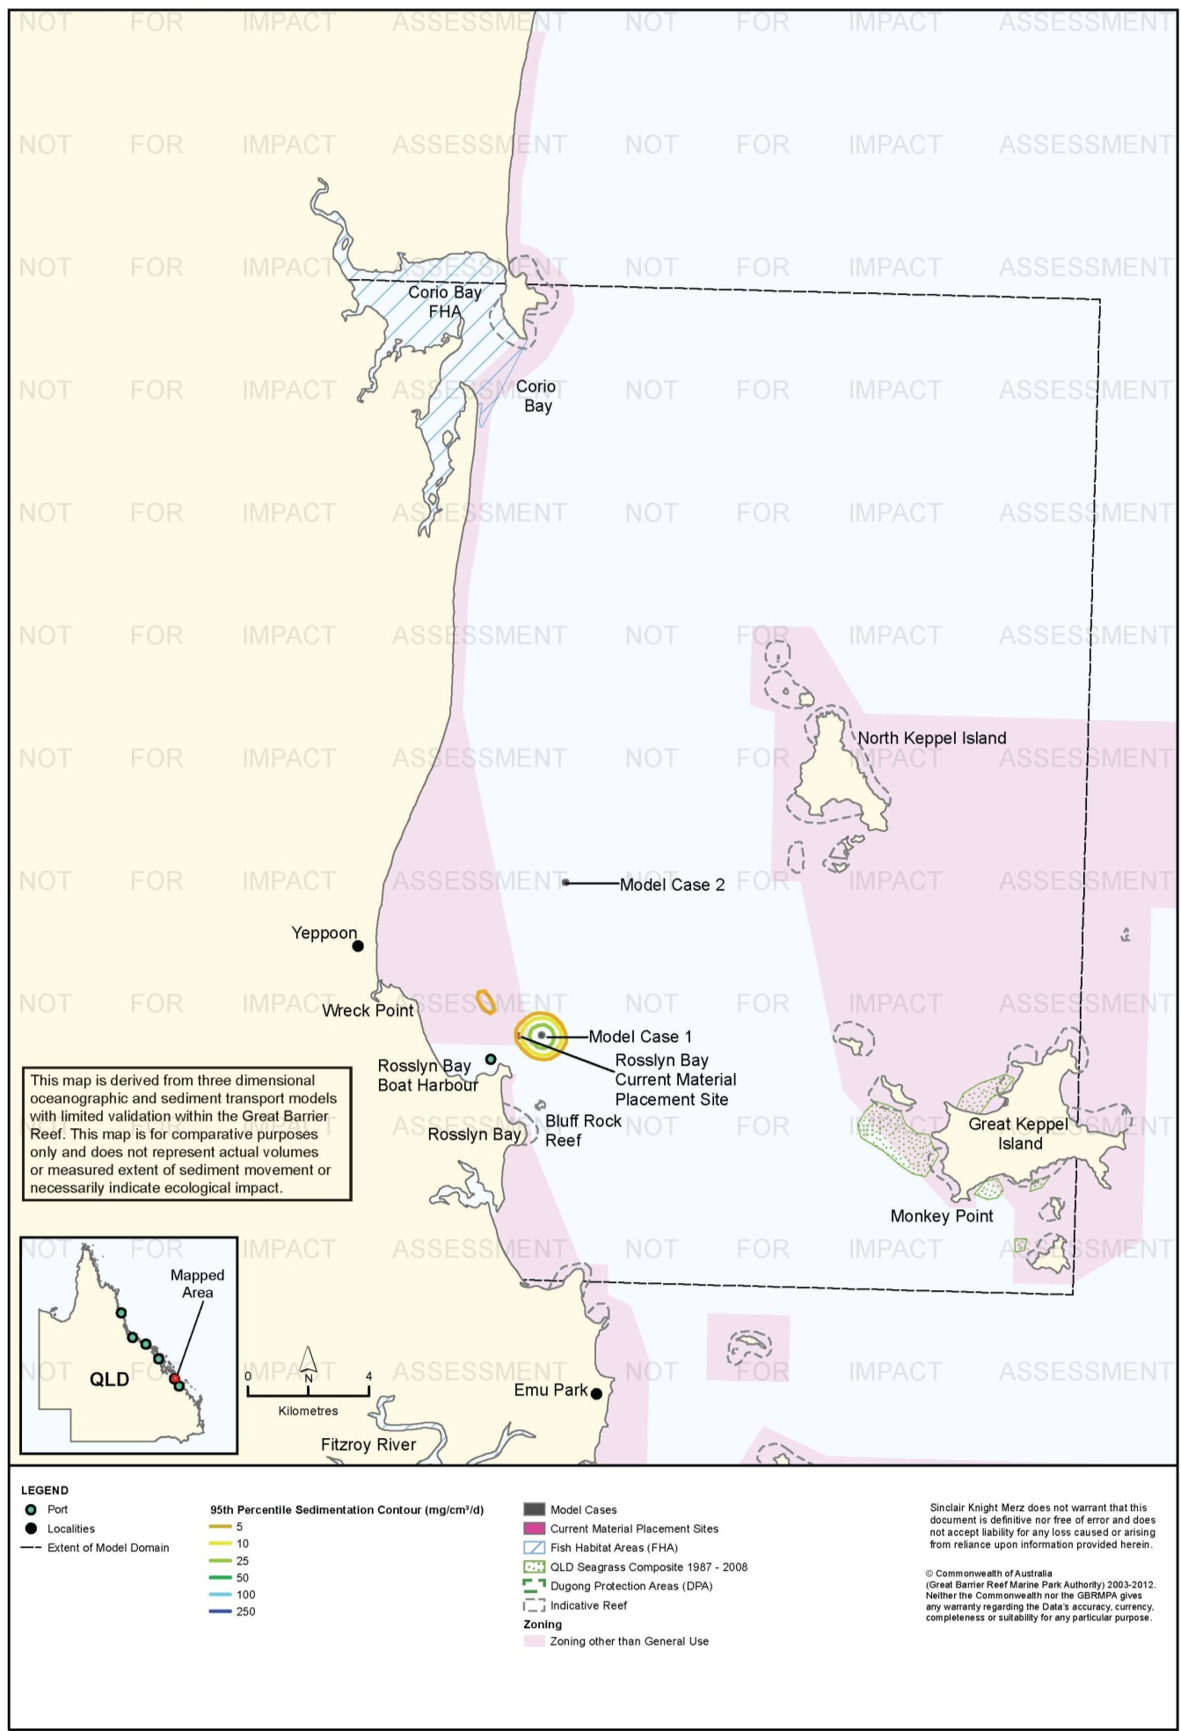
Figure 27. Rosslyn Bay: dredging period (90 days) sedimentation rate, Model Case 1 - 95th percentile.

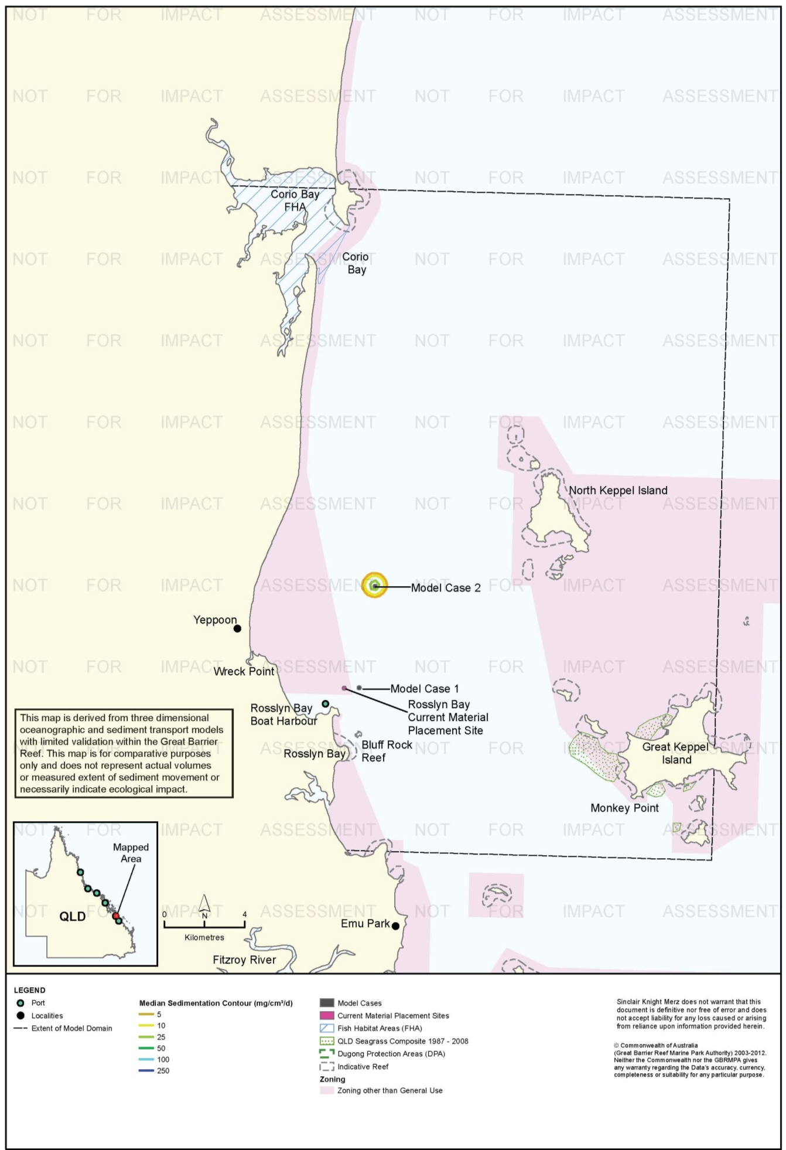
Figure 28. Rosslyn Bay: dredging period (90 days) sedimentation rate, Model Case 2 - 50th percentile.

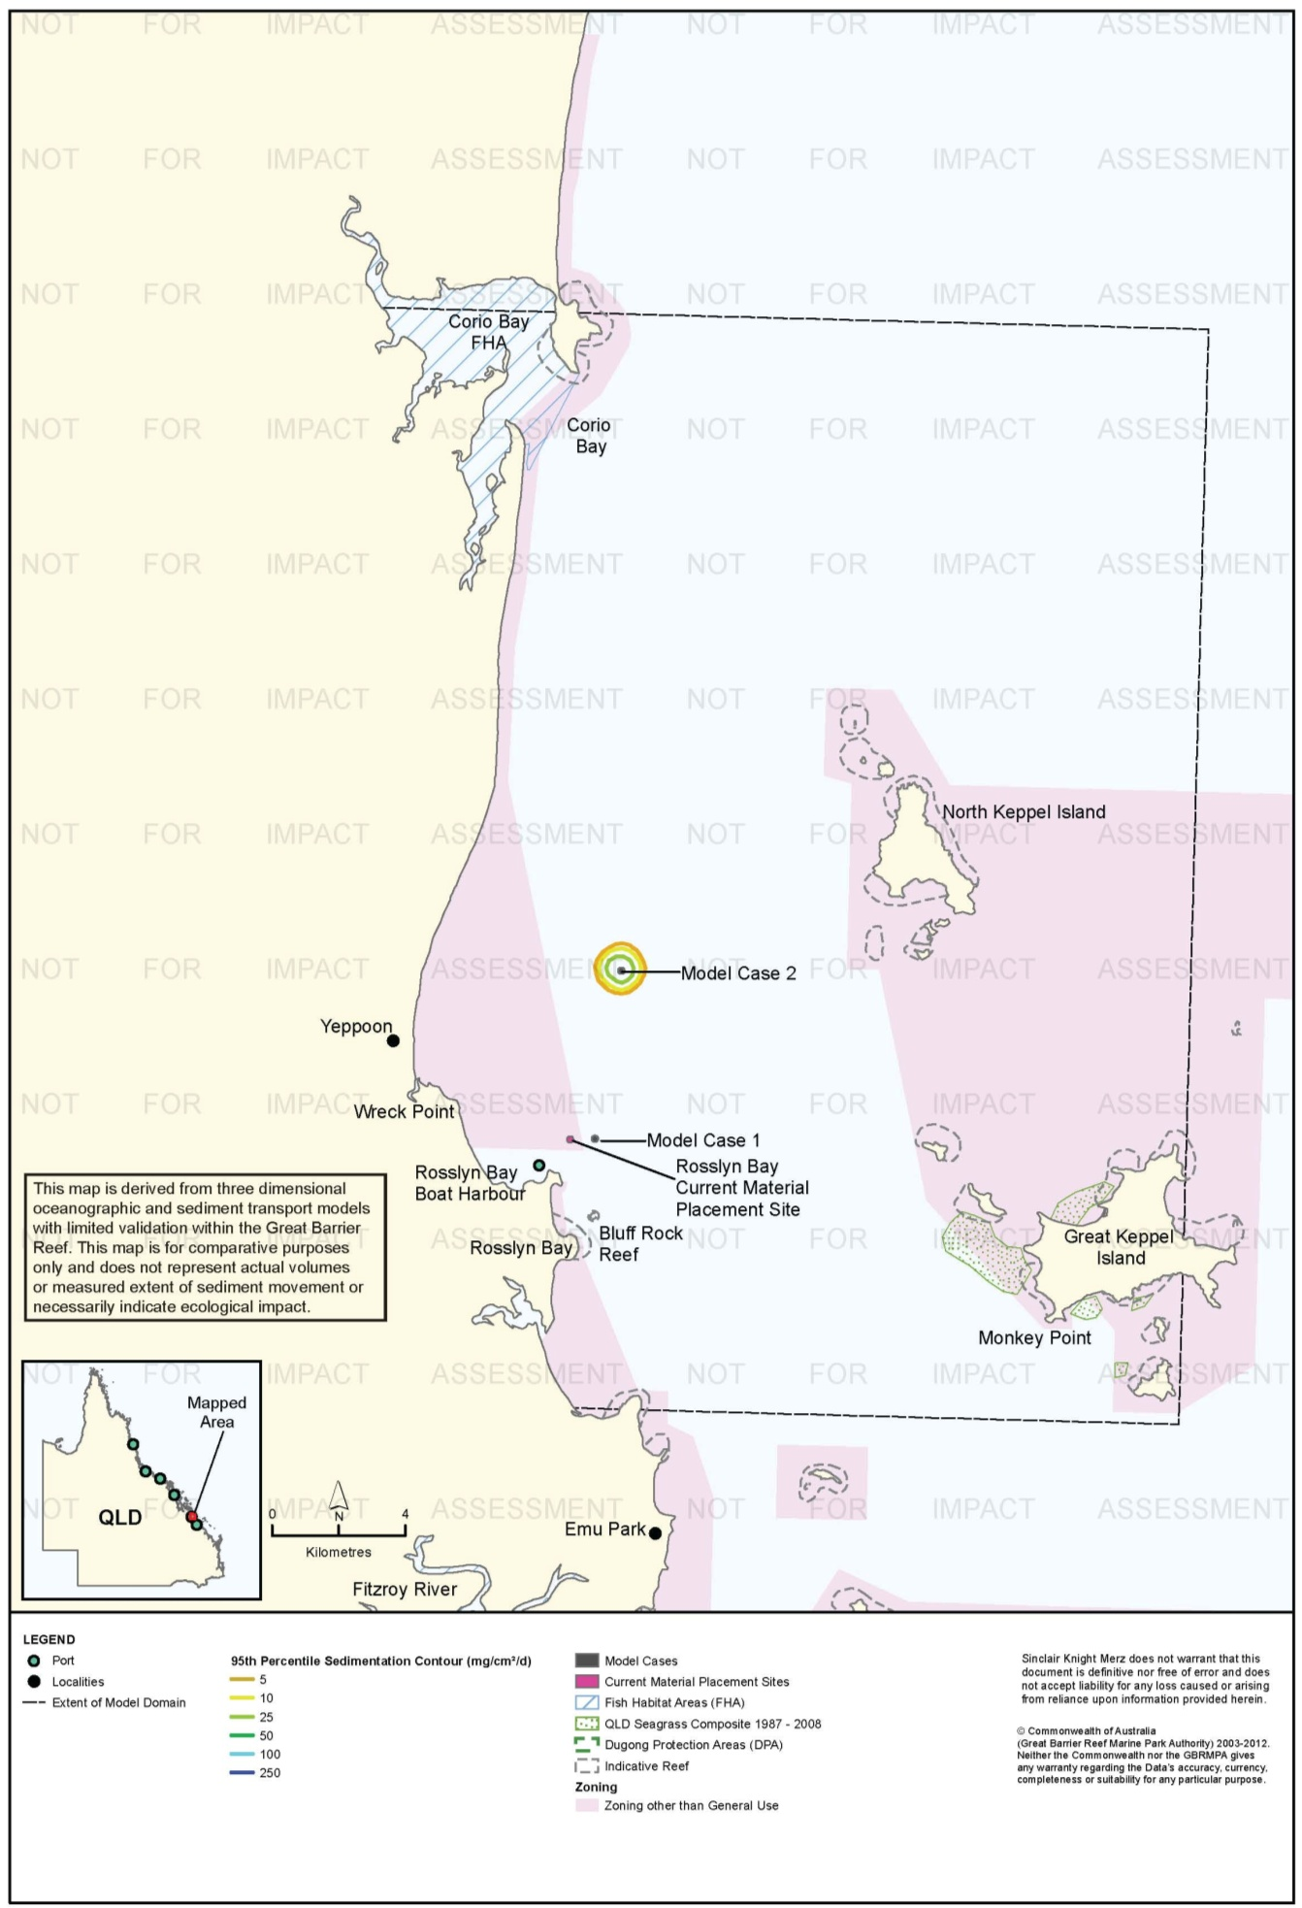
Figure 29. Rosslyn Bay: dredging period (90 days) sedimentation rate, Model Case 2 - 95th percentile.

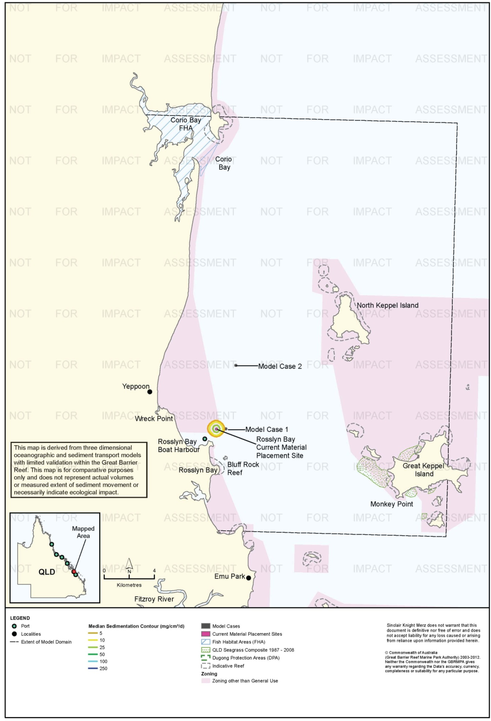
Figure 30. Rosslyn Bay: dredging period (90 days) sedimentation rate, current site - 50th percentile.

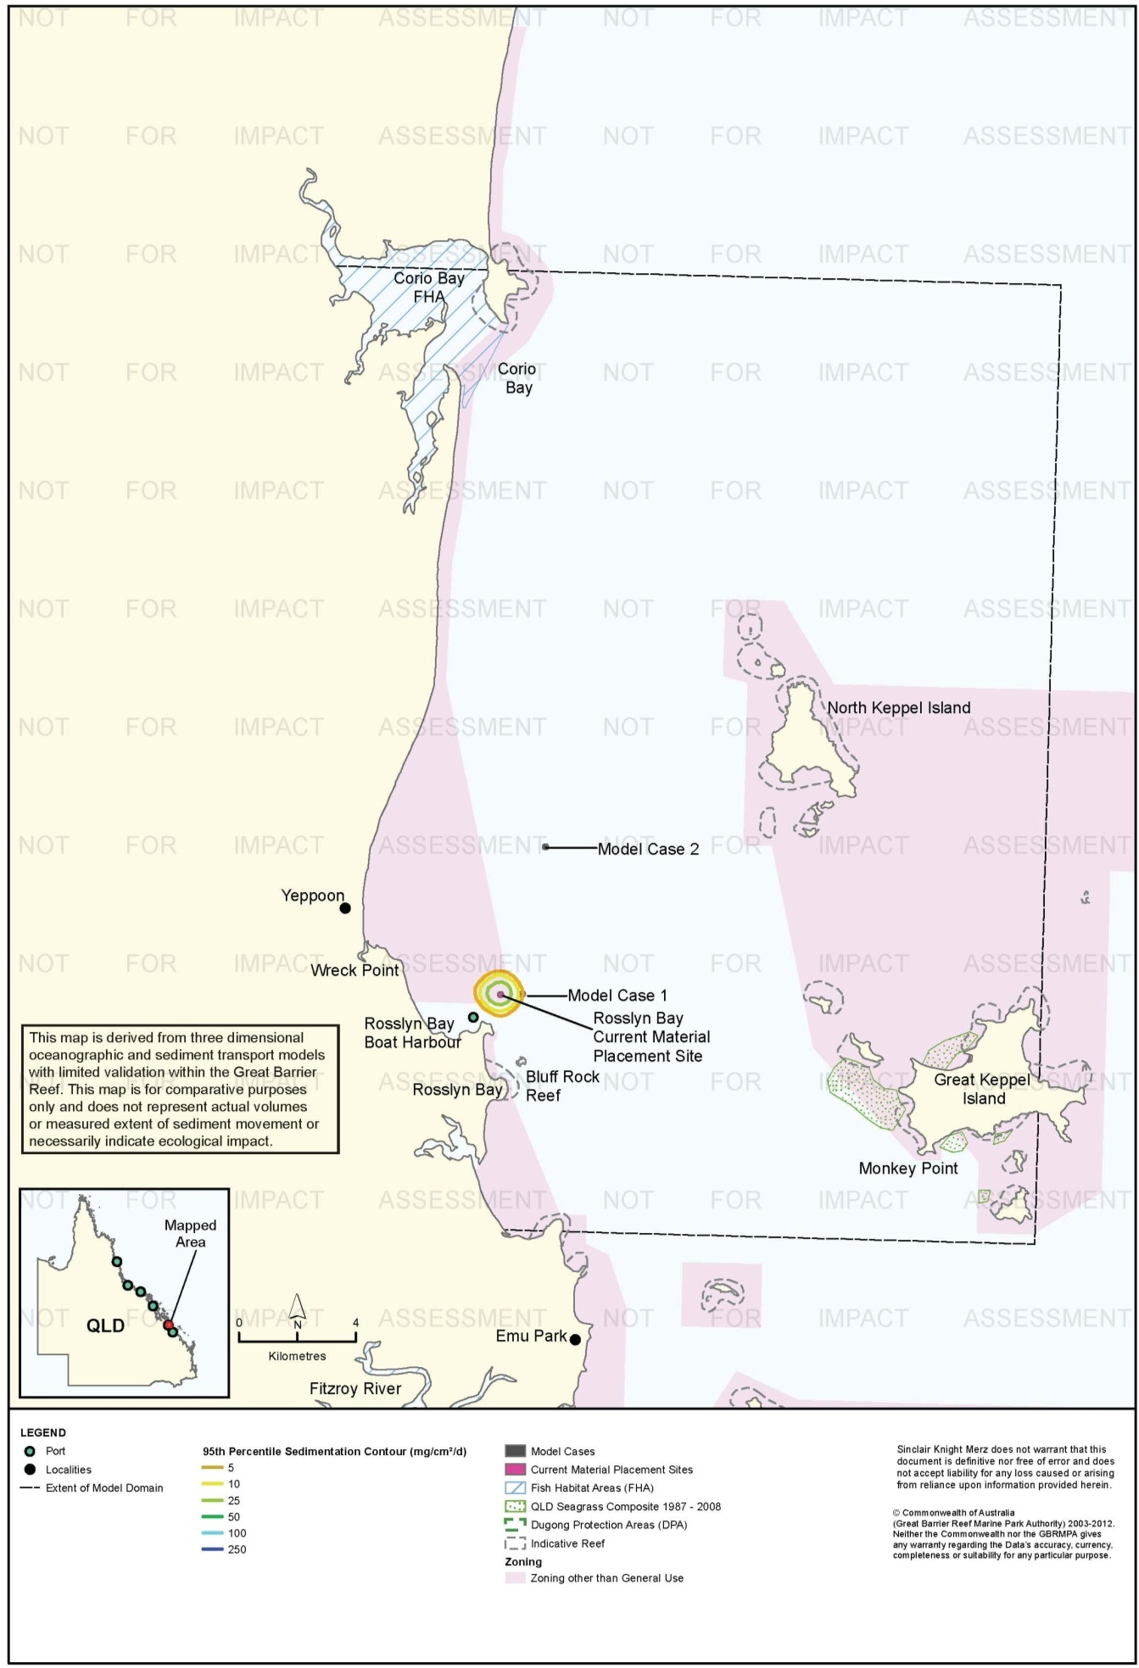
Figure 31. Rosslyn Bay: dredging period (90 days) sedimentation rate, current site - 95th percentile.

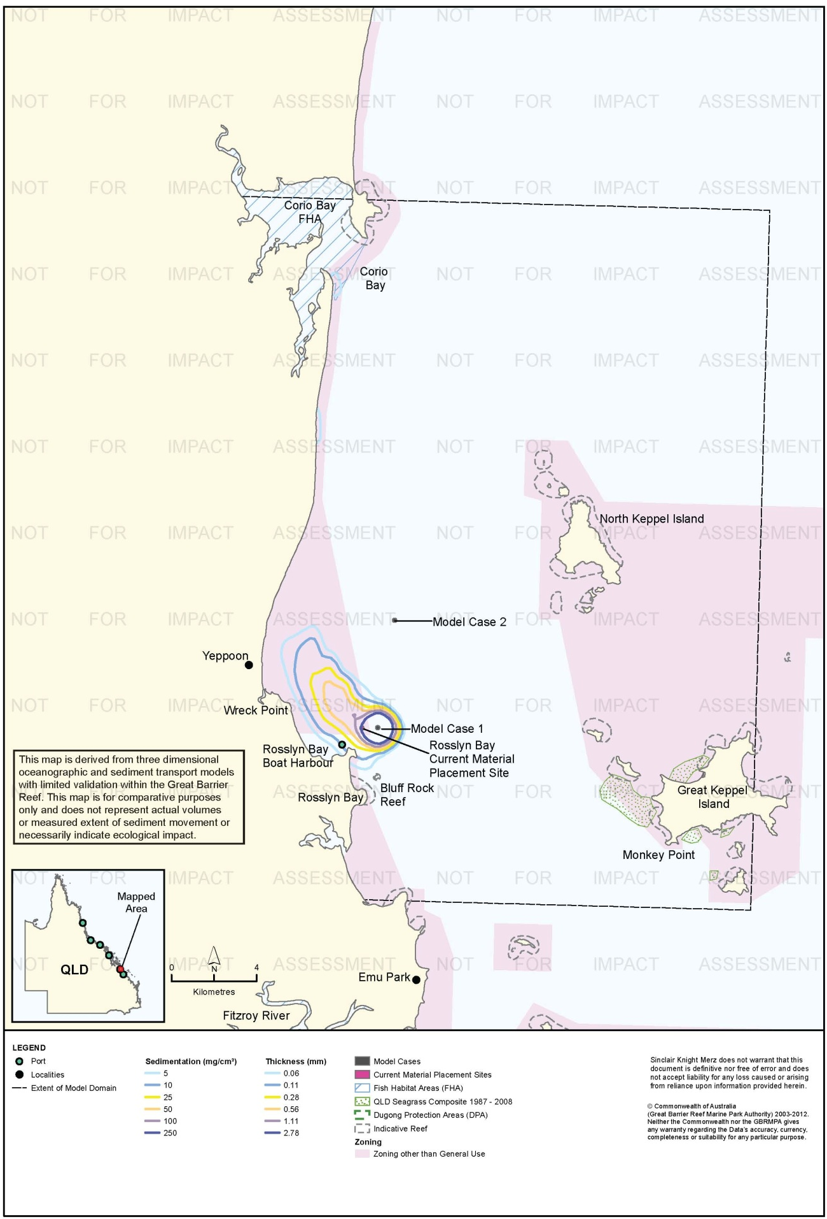
Figure 32. Rosslyn Bay: dredging period (90 days) total sedimentation and bottom thickness, Model Case 1.

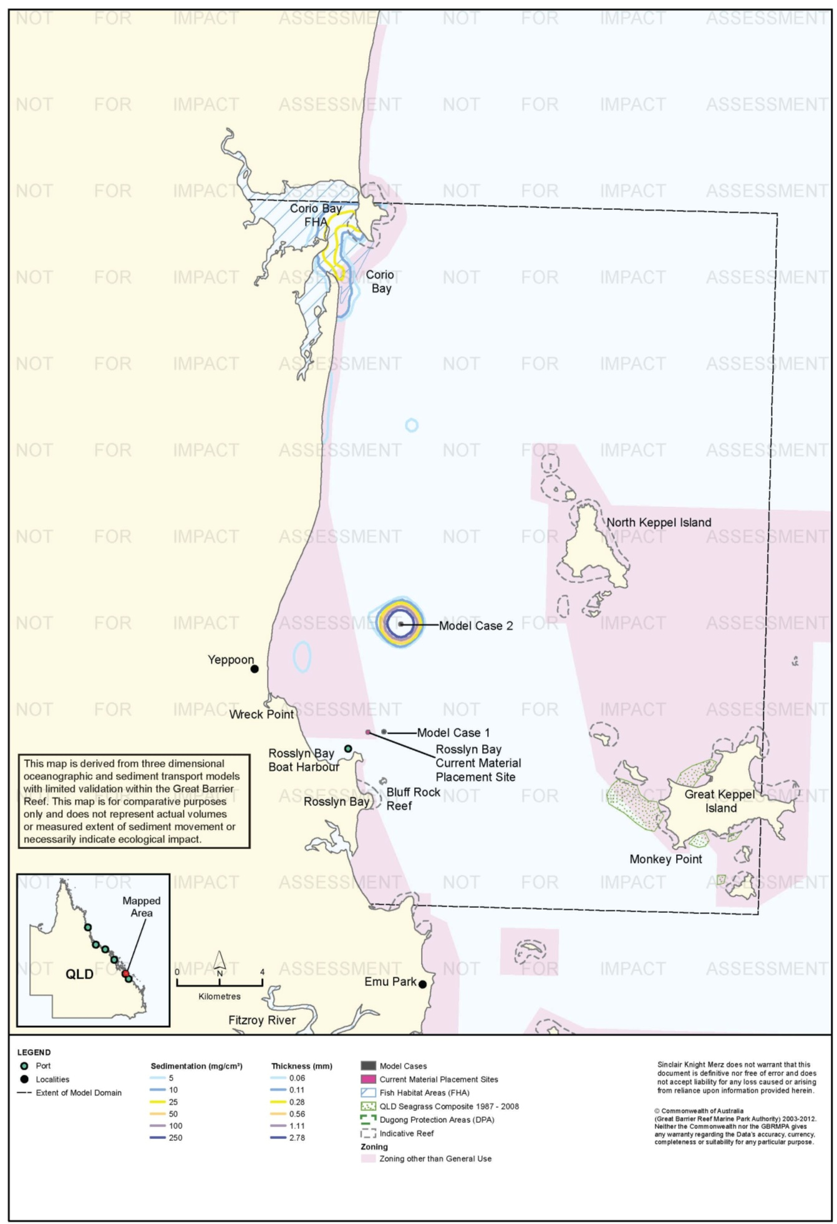
Figure 33. Rosslyn Bay: dredging period (90 days) total sedimentation and bottom thickness, Model Case 2.

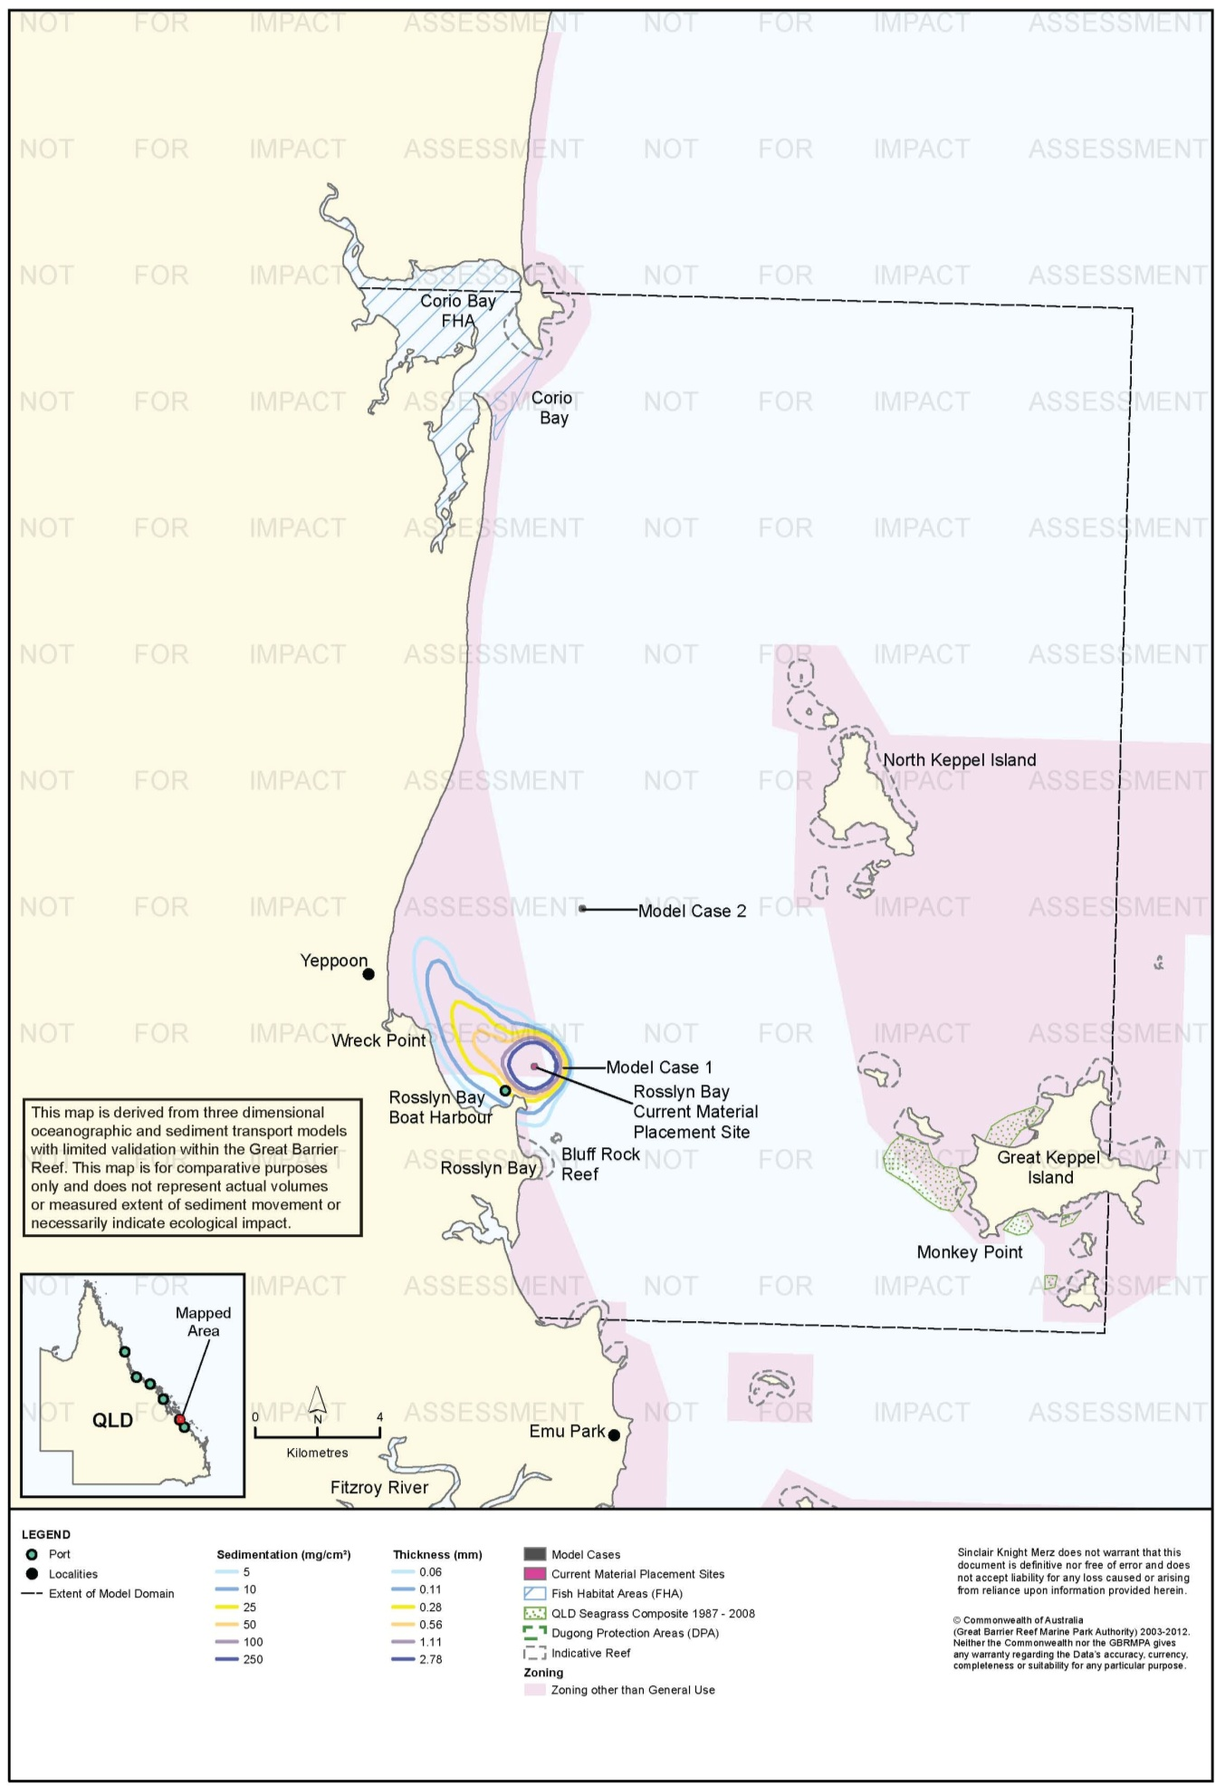
Figure 34. Rosslyn Bay: dredging period (90 days) total sedimentation and bottom thickness, current site.

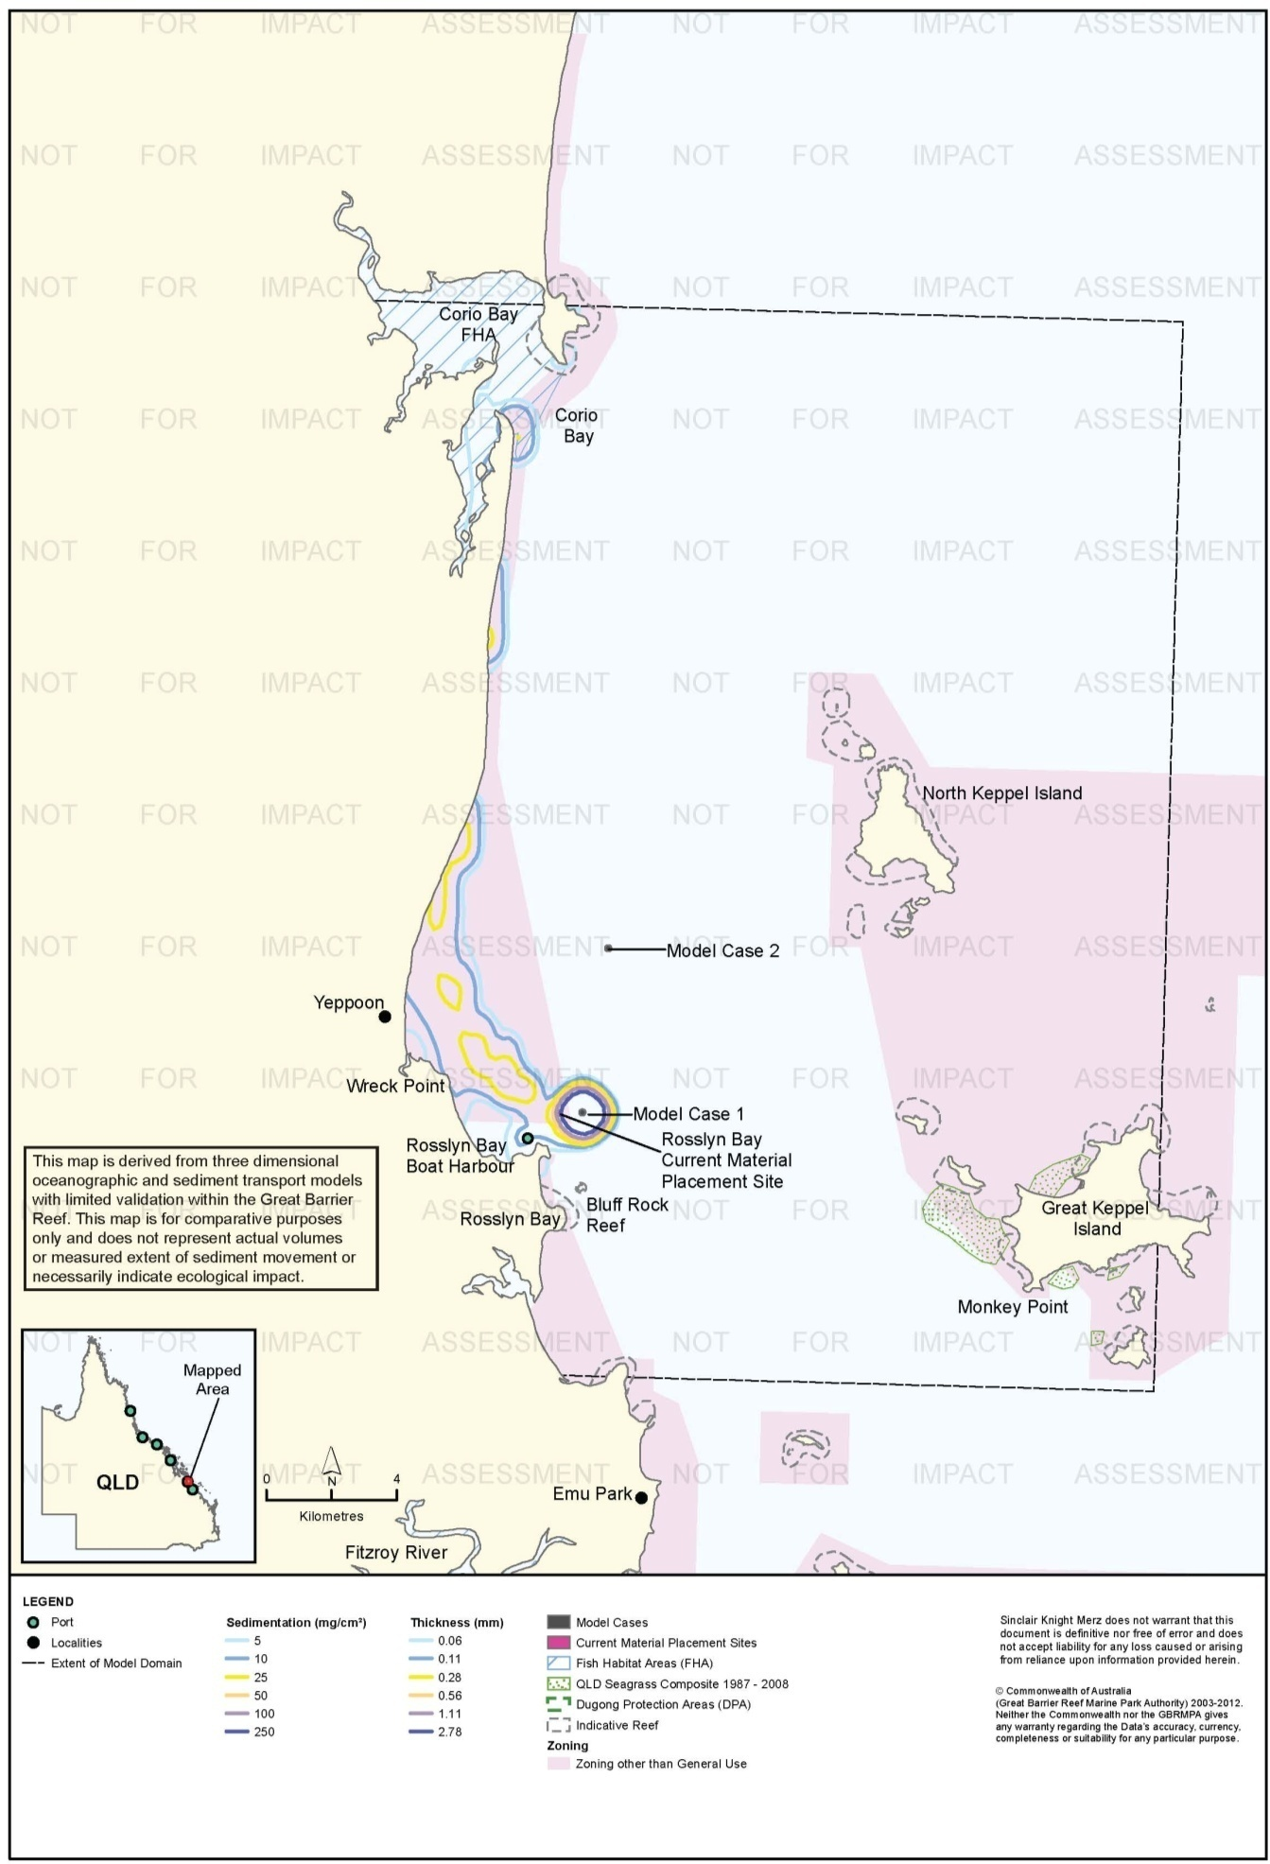
Figure 35. Rosslyn Bay: long-term (12 months) total sedimentation and bottom thickness, Model Case 1.

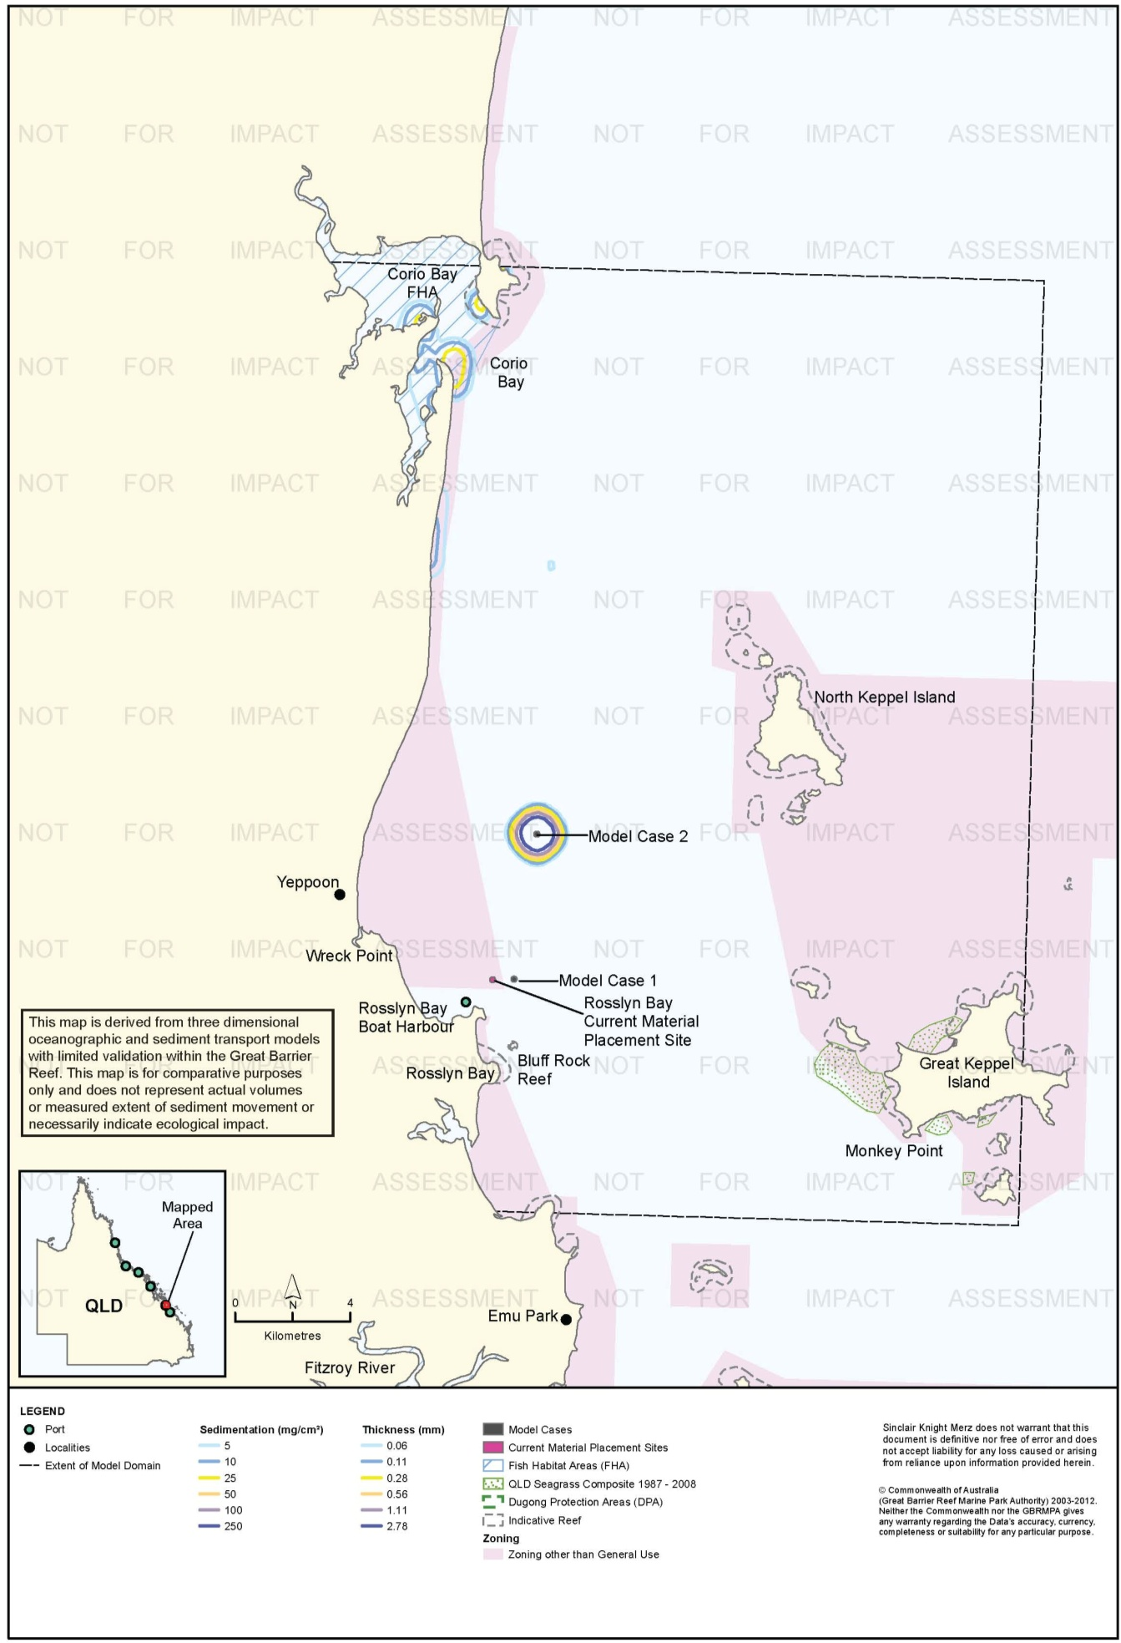
Figure 36. Rosslyn Bay: long-term (12 months) total sedimentation and bottom thickness, Model Case 2.

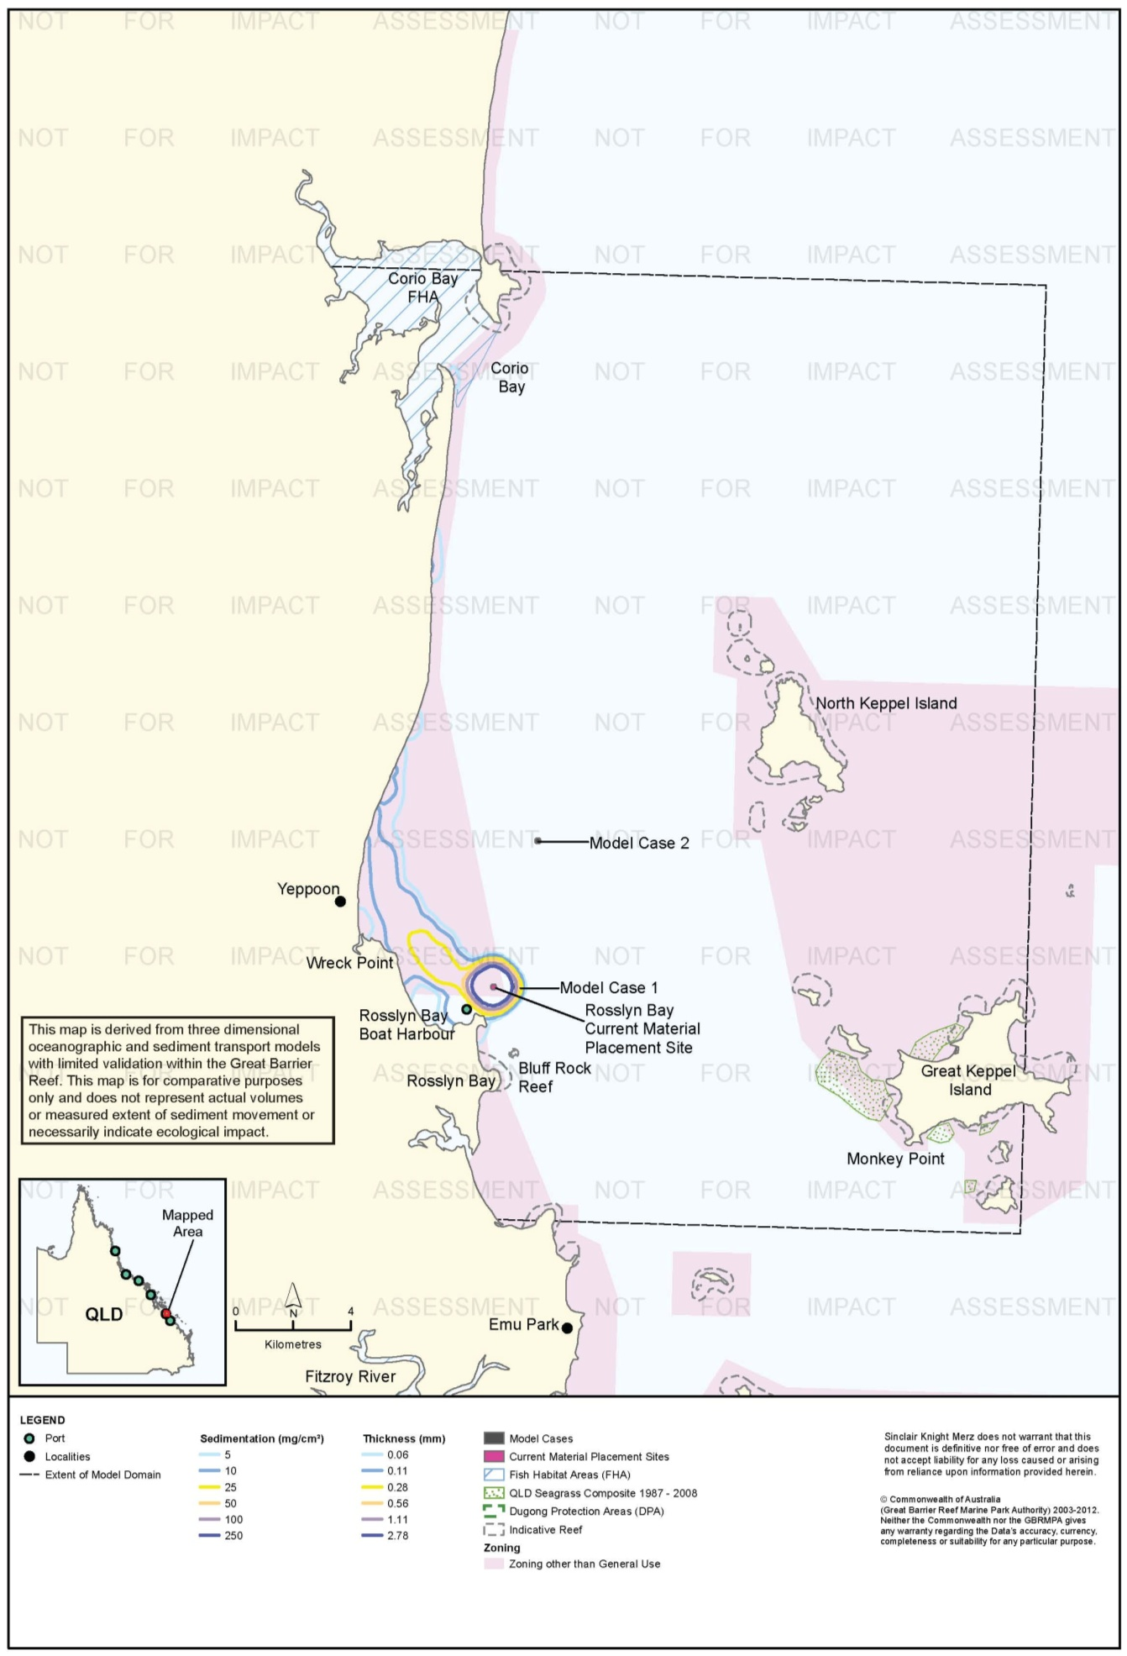
Figure 37. Rosslyn Bay: long-term (12 months) total sedimentation and bottom thickness, current site.

Risk Assessment
The results of the risk assessment are presented in table 13. Based on the modelling results, risks from material placement at the current site and at Model Case 1 are assessed as low to medium in terms of TSS and resultant light deprivation. Indeed, only the maximum TSS concentration (100th percentile, or areas experiencing the contoured value for 1 hour in the 45-day model run) could be presented, as the lowest contoured TSS concentration (5 mg/L) was not predicted to occur even 5 per cent of the time. The model did predict small areas that would experience 10 mg/L (100th percentile) for Model Case 1 and 2, and for Model Case 2 a small area of 25 mg/L immediately around the placement site. The consequences of these incursions are rated insignificant as TSS at these levels for only one hour duration are unlikely to have effects, and no light-dependent receptors are known in the areas where elevated TSS was predicted. The 100th percentile contours for Model Case 1 and the current site extend into a Conservation Park Zone of the Marine Park, inevitable in the case of the current site because it lies within the Conservation Park Zone. The 5 mg/L also extends into this Conservation Park Zone further to the north, however this is near the northern extreme of the contour so the incursion was considered less likely than for Model Case 1 and the present site. The results also indicate that there is no environmental benefit derived from placing dredged material at Model Case 2 compared with the current placement site or Model Case 1. Indeed, suspended plumes and total sedimentation contours for Model Case 2 extended further afield from the material placement site and had a higher degree of overlap with sensitive receptors located near Corio Bay than did the current site or Model Case 1.
Accordingly, all but four of the risks have been assessed as low due to the small magnitude of predicted changes to suspended sediment and sedimentation regimes. Environmental risk associated with suspended sediment plumes on non-General Use Zones were assessed as medium for the current site and Model Case 1. This was a consequence of the placement sites being located either within (current site) or immediately adjacent to (Model Case 1) a Conservation Park Zone of the Marine Park. While the likelihood of suspended sediment plumes affecting the zone was therefore ranked as ‘likely’ for Model Case 1 and ‘almost certain’ for the current site, the consequence was assessed as minor, since the 100th percentile model was necessary to visualise TSS plumes of only 5 mg/L (current site) and up to 10 mg/L (Model Case 1). This indicates that any TSS plumes generated within the Conservation Park Zone will be small in magnitude.
Environmental risk for sedimentation was also assessed as medium for the current site, by virtue of its location within a Conservation Park Zone of the Marine Park. While an increase in total sedimentation was predicted at Corio Bay, and assessed as a medium risk, this tidal creek entrance habitat is likely to experience constant sediment movement associated with natural coastal and riverine processes. In this context, the Corio Bay FHA is not expected to be particularly sensitive to increases in sedimentation of 10 mg/cm² (0.11 mm) during the dredging period or over 12 months. Modelling results showed there would be no environmental benefit in moving the current site east to the location of the nearby Model Case 1, or offshore to Model Case 2. While Model Case 1 is located outside of the Conservation Park Zone, the 100th percentile TSS model predicted a slightly more severe suspended sediment plume for this placement site than for the current site located within the Conservation Park Zone.
Comparison of the total sedimentation maps for the dredging period and after 12 months indicates long-term northward movement of sediment for Model Case 1 and the current site, which is consistent with other modelling of the current site (BMT WBM 2012a). Northward movement is not as apparent for Model Case 2 but it is likely that some sediment moved out of the model domain over 12 months.

Table 14. Comparative risk assessment for Rosslyn Bay State Boat Harbour based on modelling results (figure 23 to figure 37).
Hazard | Sensitive Receptor | Site | Likelihood | Consequence | Risk Rating
An increase in TSS concentration and turbidity in waters surrounding the material placement site. | Coral Reefs | Current Site | Rare | Minor | Low
 |  | Model Case 1 | Rare | Minor | Low
 |  | Model Case 2 | Unlikely | Minor | Low
 | Seagrass. | Current Site | Unlikely | Minor | Low
 |  | Model Case 1 | Unlikely | Minor | Low
 |  | Model Case 2 | Unlikely | Minor | Low
 | Fish Habitat Areas | Current Site | Rare | Insignificant | Low
 |  | Model Case 1 | Rare | Insignificant | Low
 |  | Model Case 2 | Unlikely | Minor | Low
 | Non-general Use Zones | Current Site | Likely | Minor | Medium
 |  | Model Case 1 | Likely | Minor | Medium
 |  | Model Case 2 | Unlikely | Minor | Low
 | Commercial fisheries | Current Site | Unlikely | Minor | Low
 |  | Model Case 1 | Unlikely | Minor | Low
 |  | Model Case 2 | Unlikely | Minor | Low
 | Tourism and recreational values | Current Site | Rare | Insignificant | Low
 |  | Model Case 1 | Rare | Insignificant | Low
 |  | Model Case 2 | Unlikely | Minor | Low
Increase in the rate of sediment deposition on the sea bed in areas surrounding the material placement site. | Coral Reefs | Current Site | Rare | Insignificant | Low
 |  | Model Case 1 | Rare | Insignificant | Low
 |  | Model Case 2 | Rare | Insignificant | Low
 | Seagrass. | Current Site | Rare | Insignificant | Low
 |  | Model Case 1 | Rare | Insignificant | Low
 |  | Model Case 2 | Rare | Insignificant | Low
 | Fish Habitat Areas | Current Site | Rare | Insignificant | Low
 |  | Model Case 1 | Rare | Insignificant | Low
 |  | Model Case 2 | Rare | Insignificant | Low
 | Non-general Use Zones | Current Site | Almost certain | Insignificant | Medium
 |  | Model Case 1 | Likely | Insignificant | Medium
 |  | Model Case 2 | Unlikely | Insignificant | Low
 | Commercial fisheries | Current Site | Unlikely | Minor | Low
 |  | Model Case 1 | Unlikely | Minor | Low
 |  | Model Case 2 | Unlikely | Minor | Low
 | Tourism and recreational values | Current Site | Rare | Insignificant | Low
 |  | Model Case 1 | Rare | Insignificant | Low
 |  | Model Case 2 | Rare | Insignificant | Low
Accumulation of sediments on the sea bed. | Coral Reefs | Current Site | Unlikely | Minor | Low
 |  | Model Case 1 | Unlikely | Minor | Low
 |  | Model Case 2 | Unlikely | Insignificant | Low
 | Seagrass. | Current Site | Unlikely | Minor | Low
 |  | Model Case 1 | Unlikely | Minor | Low
 |  | Model Case 2 | Unlikely | Minor | Low
 | Fish Habitat Areas | Current Site | Rare | Insignificant | Low
 |  | Model Case 1 | Unlikely | Minor | Low
 |  | Model Case 2 | Possible | Minor | Medium
 | Non-general Use Zones | Current Site | Unlikely | Minor | Low
 |  | Model Case 1 | Unlikely | Minor | Low
 |  | Model Case 2 | Rare | Minor | Low
 | Commercial fisheries | Current Site | Unlikely | Minor | Low
 |  | Model Case 1 | Unlikely | Minor | Low
 |  | Model Case 2 | Unlikely | Minor | Low
 | Tourism and recreational values | Current Site | Rare | Insignificant | Low
 |  | Model Case 1 | Rare | Insignificant | Low
 |  | Model Case 2 | Unlikely | Minor | Low

Ecological Monitoring in Relation to Dredging
Alquezar & Stratford (2007) and Alquezar & Boyd (2008) monitored infauna communities in the Rosslyn Bay area in relation to the 2006 maintenance dredging campaign in which 31,000 m³ of material were dredged. Four sampling sites were in the Boat Harbour (the dredging area). There were three sampling sites at each of two adjacent impact locations: Wreck Point, 3.5 km north-west of the DMPA, and Bluff Rock, 2.5 km south-south-east of the DMPA. Three sites were also sampled at a reference location, Monkey Point, 15 km south-east at Great Keppel Island. Further details are provided in table 8.
Three replicate grab samples were collected at each site one week before, two weeks after, and one year after dredging. Alquezar & Stratford (2007) and Alquezar & Boyd (2008) report the size of the van Veen grab sampler as 0.005 m², which is much smaller than standard grabs, which are usually 0.25 m² or larger.
Alquezar & Stratford (2007) and Alquezar & Boyd (2008) analysed the samples for the total abundance, species richness, Shannon-Weiner diversity (H), and species evenness. Two weeks after dredging, infauna abundance, species richness, and H decreased, and evenness increased, at both Wreck Point and Bluff Rock, but not at Monkey Point. Most of these changes appear to have been statistically significant, but reporting of results in the text, figures, and tables was not always consistent and it is difficult to determine exactly which of the results were significant. Changes at Wreck Point were small and not statistically significant. Statistical power was not reported.
One year after dredging, Bluff Rock had a further, but not statistically significant, decrease in infauna abundance and H, and a small but not statistically significant increase in total abundance compared to the two week post-dredging survey; evenness was unchanged. None of the parameters had returned to pre-dredging levels. At Wreck Point there were small but not statistically significant increases in abundance, species richness, H, and evenness compared to 2 weeks post-dredging. None of the parameters returned to pre-dredging levels. At the putative reference location, Monkey Point, there were statistically significant increases in infauna abundance and species richness, a non-significant increase in H, and a non-significant decrease in evenness.
Alquezar & Stratford (2007) and Alquezar & Boyd (2008) interpreted these results to indicate an impact of dredge material placement on infauna communities at the two adjacent impact sites, followed by partial recovery.
Alquezar & Stratford (2007) and Alquezar & Boyd (2008) also surveyed coral communities in relation to the 2006 maintenance dredging at Rosslyn Bay one week before, two weeks after, and one year after dredging. Coral communities at Bluff Rock (adjacent impact location) and Monkey Point (control location) two weeks before dredging, but only at Monkey Point in the two post-dredging surveys, therefore no conclusions can be drawn regarding the effect of the dredging on the nominated impact site. Surveys consisted of three 50 m line transects, with photos of the bottom taken at 5 m intervals. Per cent cover of various benthic categories (hard coral, soft coral, macroalgae, hydroids, sponges, dead coral, sand, rubble, etc.) was determined by random point-count analysis of the photos. Some organisms were identified to higher taxonomic levels, some down to species.
Alquezar & Stratford (2007) and Alquezar & Boyd (2008) reported that there were no significant changes in coral cover, density, or condition at Monkey Point before, two weeks after, or one year after dredging. The authors did not report how coral cover and coral density were distinguished, or how coral condition was defined. Further details are provided in table 8.
It should be noted that the Monkey Point site treated by Alquezar & Stratford (2007) and Alquezar & Boyd (2008) as a control site is not representative of the two impact sites, Bluff Rock and Wreck Point. Bluff Rock and Wreck Point lie in the nutrient-rich and relatively turbid coastal strip downstream of the Fitzroy River discharge into Keppel Bay. Benthic communities surveyed at the "adjacent impact" and "control" sites were markedly different in the baseline surveys, confounding impact assessment.

Environmental Condition
Water quality in the Fitzroy region, which includes the Rosslyn Bay State Boat Harbour is monitored by the RRMMP (Schaffelke et al. 2011). The water quality aspect of the monitoring program includes inshore permanent monitoring sites (water quality loggers) and remote sensing techniques. Three permanent monitoring sites were established in the Fitzroy region in 2007 with all monitoring sites no more than 30 km from Rosslyn Bay State Boat Harbour (Barren, Pelican, and Humpy Island). Regionally, water quality in the Fitzroy has been declining since 2007 with the annual mean increasing at logger sites (table 15; Schaffelke et al. 2011). Logger sites also demonstrate a clear inshore to offshore gradient for all years (Schaffelke et al. 2011). Annual and seasonal turbidity means were above for Pelican Island were above the suggested 5 NTU limit for severe coral photo-physiological stress (Schaffelke et al. 2011).
Table 15. Summary of annual mean turbidity (NTU) data from turbidity sensors at Fitzroy water quality locations from the RRMMP¹.
Site | 2007-2008² | 2008 to 2009² | 2009-2010² | 2010-2011³
Barren Island | 0.37 | 0.46 | 0.47 | 0.52
Humpy Island | 0.88 | 0.89 | 1.26 | 1.57
Pelican Island | 5.08 | 3.42 | 5.50 | 9.80
1 Data extracted from Schaffelke et al. 2011. 2 – Years are from October to September 3 – October to June
Remote sensing is used to monitor TSS concentrations for the entire Marine Park at a spatial resolution of 1 km (Brando et al. 2011). Since 2002/2003 the Fitzroy region has received moderate TSS ratings using the paddock to reef index. Data from May 2010 to April 2011 for Rosslyn Bay State Boat Harbour and surrounding areas demonstrates a clear gradient from inshore to offshore locations (Brando et al. 2011). Inshore locations near the Fitzroy River and Corio Bay had had median TSS concentrations of 5 mg/L. There is a clear south-to-north gradient from 5 mg/L at the mouth of the Fitzroy River to 1 mg/L north of Emu Park. Annual median TSS values at the locations of Model Cases 1 and 2 the current material placement site ranged from approximately 1.25 mg/L to 0.75 mg/L.
Baseline turbidity monitoring at two key receptors near the Rosslyn Bay State Boat Harbour placement site, Bluff Rock and Wreck Point, reported 80th percentiles for turbidity of 28.6 and 20.90 NTU. These values were converted to TSS values of 42.9 and 31.4 mg/L, respectively, using a conversion of TSS = NTU * 1.5 established during dredging in 2006 (GHD 2007). Data provided to SKM by the Department of Transport and Main Roads indicate 90th percentile values of 38.3 NTU (57.5 mg/L) for Bluff Rock and 44.1 NTU (66.2 mg/L) at Wreck Point, which are considerable increases over the 80th percentiles.
Coral health in the Fitzroy region has been monitored by the RRMMP since 2005. Six RRMMP monitoring sites are within 30 km of Rosslyn Bay State Boat Harbour. For the Fitzroy region hard coral cover has shown a general pattern of decline since monitoring began with overall RRMMP coral scores also declining (table 16; Thompson et al. 2011). Thompson et al. (2011a) assessed the overall condition of Fitzroy communities as poor due to the low densities of juvenile colonies and low coral cover both overall and during periods free of acute disturbances (Thompson et al. 2011).
Table 16. RRMMP monitoring score for overall inshore coral health for the Fitzroy region from 2009-2011 (Thompson et al. 2011a, b).
Year | RRMMP score
2009 | Moderate
2010 | Poor
2011 | Poor

Reefs are also monitored throughout the Reef by the AIMS Long Term monitoring program, which has been in operation since1992 (Sweatman et al. 2005). No information is provided for this monitoring program as the reefs monitored are approximately 100 km east of the Rosslyn Bay State Boat Harbour and are well away from any predicted sedimentation or TSS influence for Model Case 1, 2 or current material placement site.
An intertidal assessment of seagrass in the Fitzroy region was conducted in 2011 as part of the Seagrass Vulnerability Assessment for the Great Barrier Reef (Commonwealth of Australia 2011). The assessment identified seagrass status in the Fitzroy was in poor condition although cover in the Fitzroy region had generally either increased or remained stable.
The 2010 Great Barrier Reef Report Card rated the overall condition of inshore water quality and seagrass as moderate, with the first improvement in seagrass health since 2005/2006) (State of Queensland 2013). Coral health has remained in poor condition since 2005, with poor recruitment of juvenile coral (State of Queensland 2013).
While sponges, macroalgae and macroinvertebrate assemblages are known to occur in the area very little is known about the condition of these receptors, with further study required.

Port of Hay Point
Sensitive receptors in the vicinity of the Port of Hay Point include seagrass habitats, inshore coral reefs at Round Top Islands (9 km north-west), Flat Top (11 km north-west) and the Downward Patch Reefs (11-16 km north), and Oom Shoal (24 km north). Further north are St Bees (40 km), Keswick (41 km), Brampton (50 km), and Carlisle (52 km) Islands, and then the Whitsundays (116 km). Coastal seagrass occurs in shallow areas to a depth of approximately 15 m, with generally small and ephemeral patches of deep water seagrass occurring further offshore. Three FHAs (Bassett Basin, Sandy Bay, and Repulse Bay) are located in coastal areas between Mackay and Proserpine.

Suspended Sediment Plumes
Figure 38 to figure 42 show the predicted distributions of 50th and 95th percentile TSS contours for the modelled cases. The 50th percentile contours are not presented for Model Case 1 because no place in the model domain reached a TSS concentration as high as 5 mg/L for 50 per cent of the model run. The 95th percentile TSS contours show a general pattern of sediment plume dispersion toward the north-west for all three material placement sites.
The predicted 95th percentile contour for 10 mg/L TSS arising from placement at the existing placement site extends approximately 15 km north, which impinges on the Downward Patches reefs. The 5 mg/L contour extends north to coastal waters off Shoal Point and finishes at the eastern boundary of the Sand Bay FHA (26 km north-north-west of the current site). Modelling predicted 95th percentile contours for Model Case 1 for a concentration of 5 mg/L only extending 12 km north from the model case. TSS of 10 mg/L or more was not predicted to occur even five per cent of the time anywhere around Model Case 1. For Model Case 2, the predicted 95th percentile contour of 5 mg/L extended 15 km north, with the predicted 10 mg/L contour confined to the Model Case 2 boundaries. The contours for Model Cases 1 and 2 did not coincide with any major reef areas.
The 50th percentile TSS contours predict suspended sediment plumes with a similar direction of flow, but more restricted geographically and less intensive, with only 5 mg/L contours predicted (except Model Case 1 where no 50th percentile plume was predicted).

Sedimentation Rate
Figure 43 to figure 48 show the predicted 50th and 95th percentile sedimentation rate contours during the dredging period. There were substantial differences in the sediment deposition contours between the existing material placement site and the two model case sites. In terms of median (50th percentile) conditions, placement at Model Cases 1 and 2 further offshore resulted in small areas with median sedimentation rates to 10 mg/cm²/d on the south-eastern sides of Keswick/St Bees and Brampton/Carlisle Islands that were not predicted for the current placement site. The 95th percentile contours for the existing placement site show widespread sediment deposition in the range of 10-50 mg/cm²/d along the coastal areas to the north-west, encompassing coastal seagrass and fringing coral reef communities, and the Repulse Bay and Sand Bay FHAs. Modelling of placement at Model Cases 1 and 2 showed similar results, but predicted no increase in sedimentation rate along the coast north of Mackay. Rather, the offshore fringing reefs of Brampton, Carlisle, Keswick and St Bees islands were most affected, with contours of up to 50 mg/cm²/d overlapping several reef areas.

Total Sedimentation
Total sedimentation during the dredging period (figure 49, figure 50, figure 51) was predicted to occur primarily around offshore islands as far north as Midge Point (24 km north-north-west of Model Case 1), near the model boundary, for Model Cases 1 and 2, but for the current site more along the coast with reduced transport to the north. This is a generally similar pattern predicted for TSS and sedimentation rate: placement further offshore in the model results in more rapid northward transport of sediment under the influence of large-scale currents. The model predicted greater sediment accumulation during the dredging period around the islands north of Hay Point, as far as the Whitsundays, for Model Cases 1 and 2 than for the current site. Again this should be interpreted in the context that the model does not incorporate the influence of large-scale currents at depths < 10 m, nor the effects of shallow-water waves, which resuspend sediment on windward reefs.
The model predicted that after 12 months there would be little if any residual sediment deposited on the seabed within the model domain for Model Cases 1 and 2, while deposition from placement at the current site would extend northward, and eastward to the islands, compared to the dredging period predictions (figure 52, figure 53, figure 54). This simply reflects the greater mobility of sediments placed offshore in the model - dredge material placed at Model Cases 1 and 2 moved north past the model domain boundary after 12 months, while material placed at the current site was still in transit. Most material placed at the current site in the model moved north along the coast, but some did migrate offshore. This is consistent with studies showing that some inshore sediments input from rivers are transported cross-shelf offshore (Bainbridge et al. 2012; Orpin & Ridd 2012; Wolanski et al. 2008). The differences between the hypothetical model cases and the current site may be largely a function of the time scale of transport.

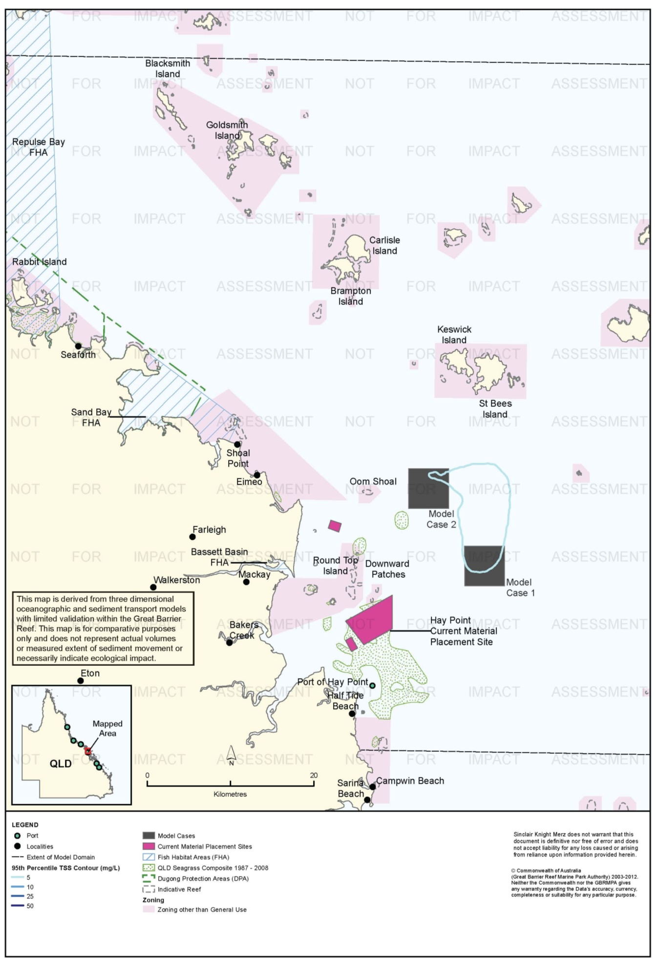
Figure 38. Hay Point: dredging period (155 days) TSS distribution, Model Case 1 - 95th percentile.

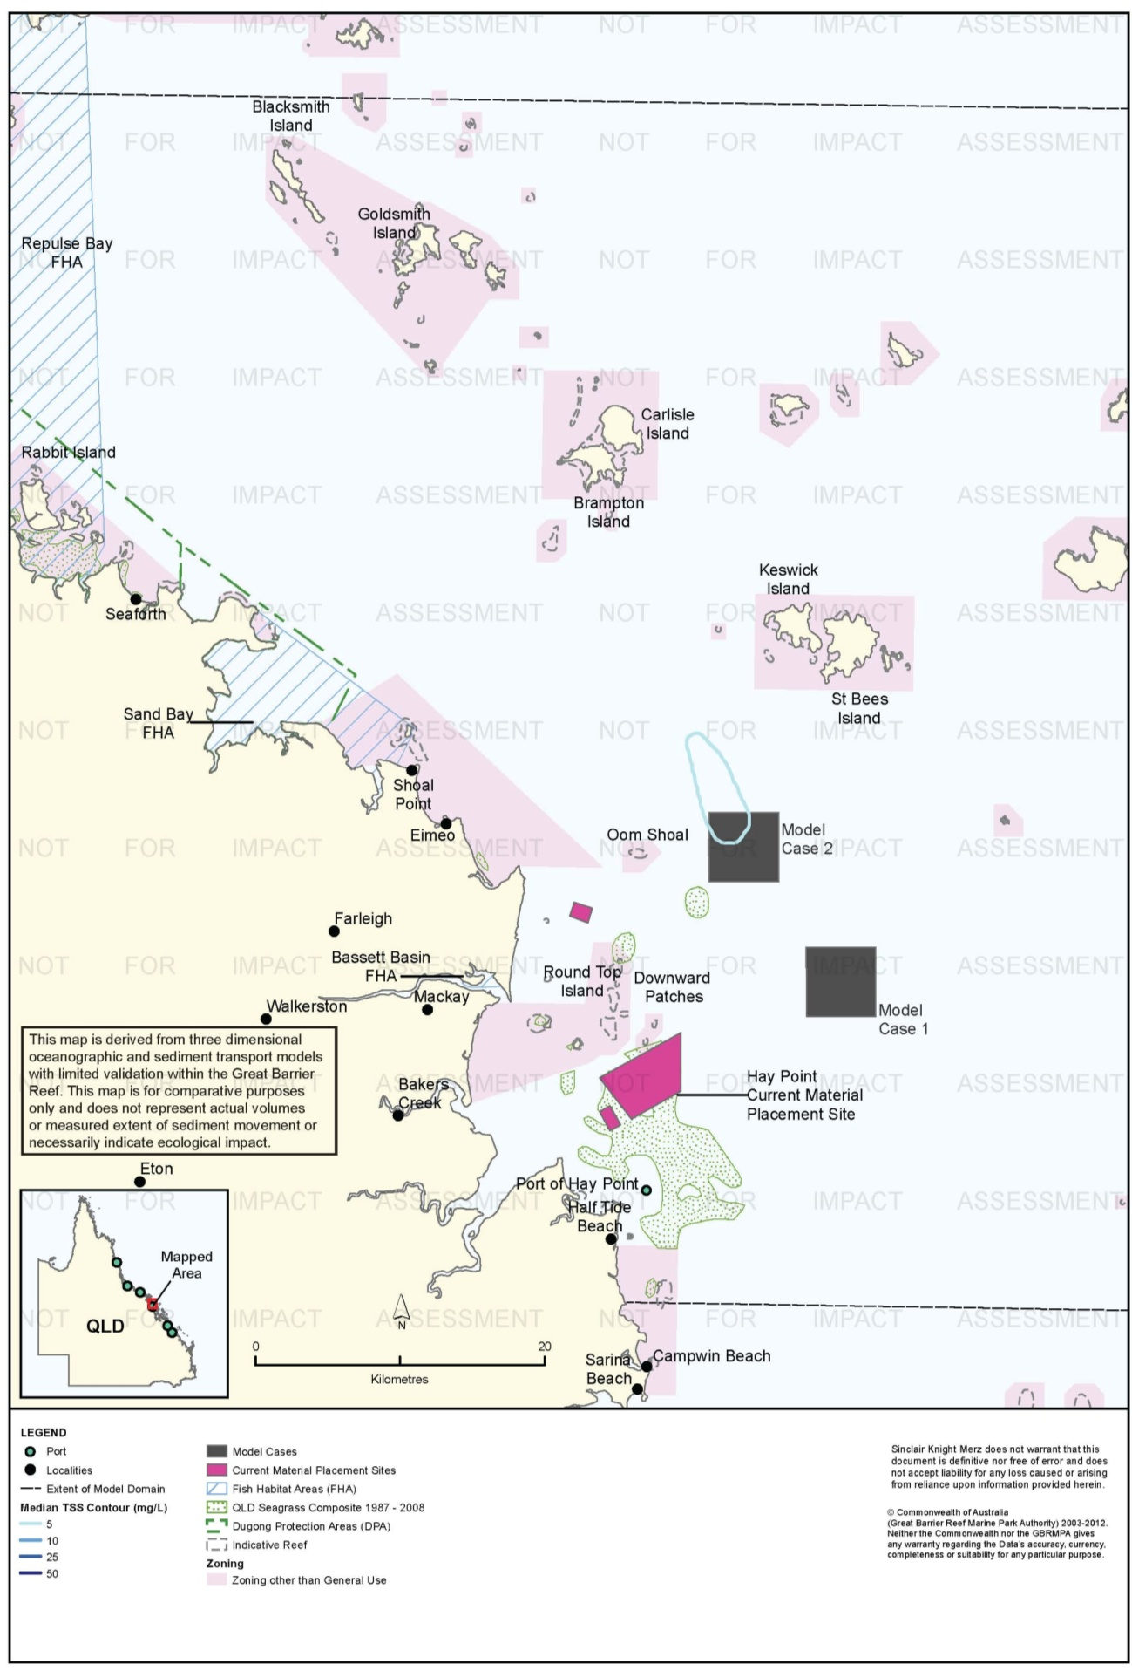
Figure 39. Hay Point: dredging period (155 days) TSS distribution, Model Case 2 - 50th percentile.

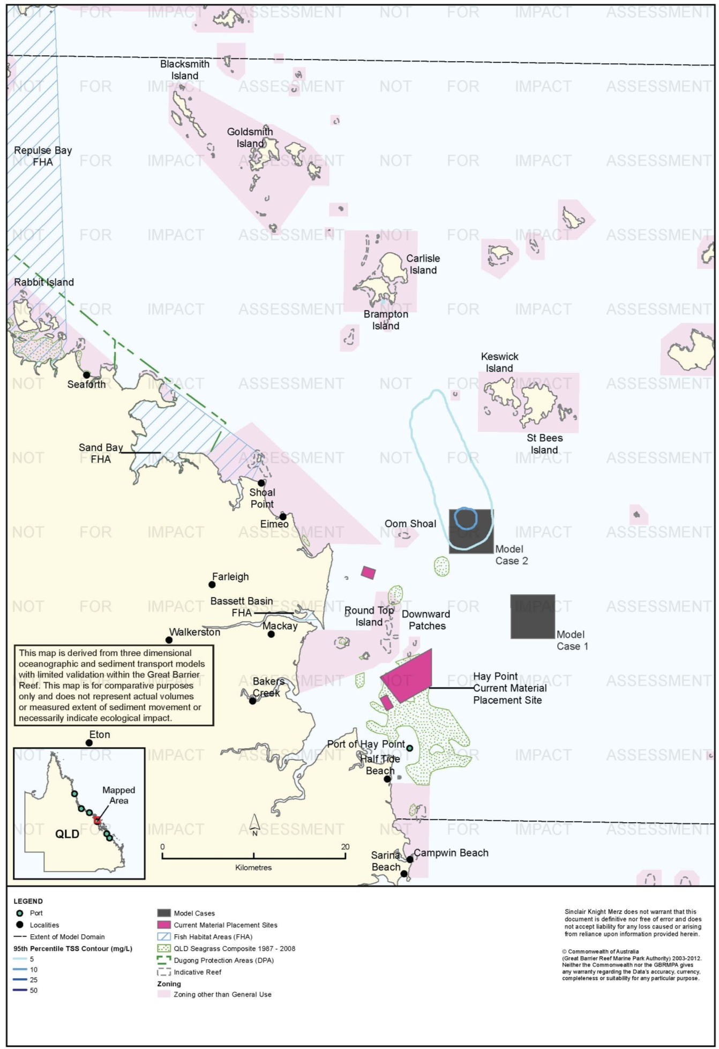
Figure 40. Hay Point: dredging period (155 days) TSS distribution, Model Case 2 - 95th percentile.

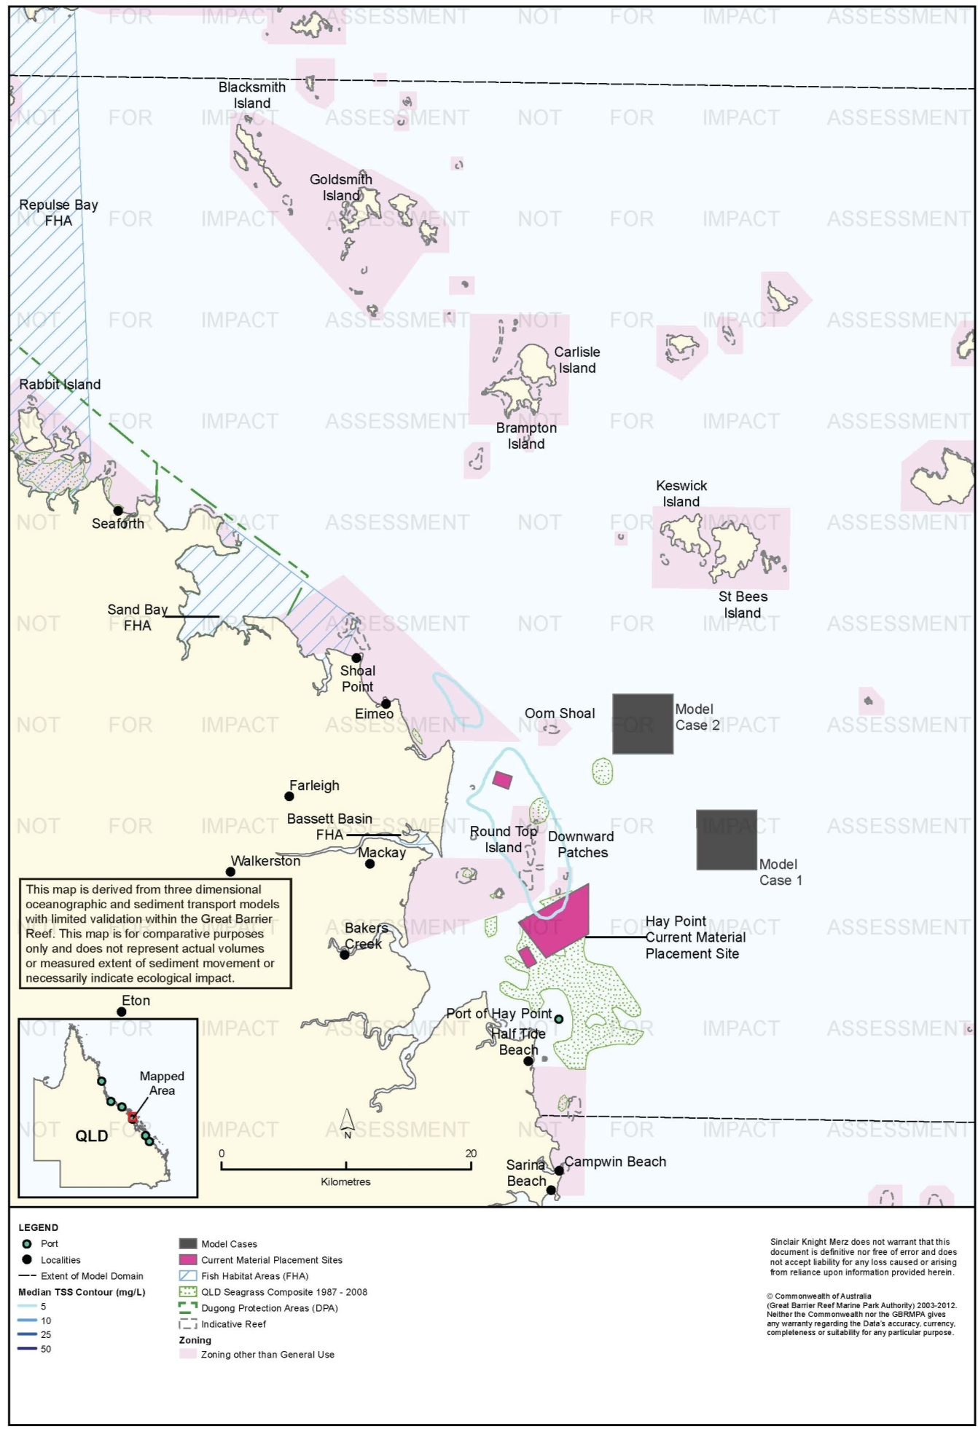
Figure 41. Hay Point: dredging period (155 days) TSS distribution, current site - 50th percentile.

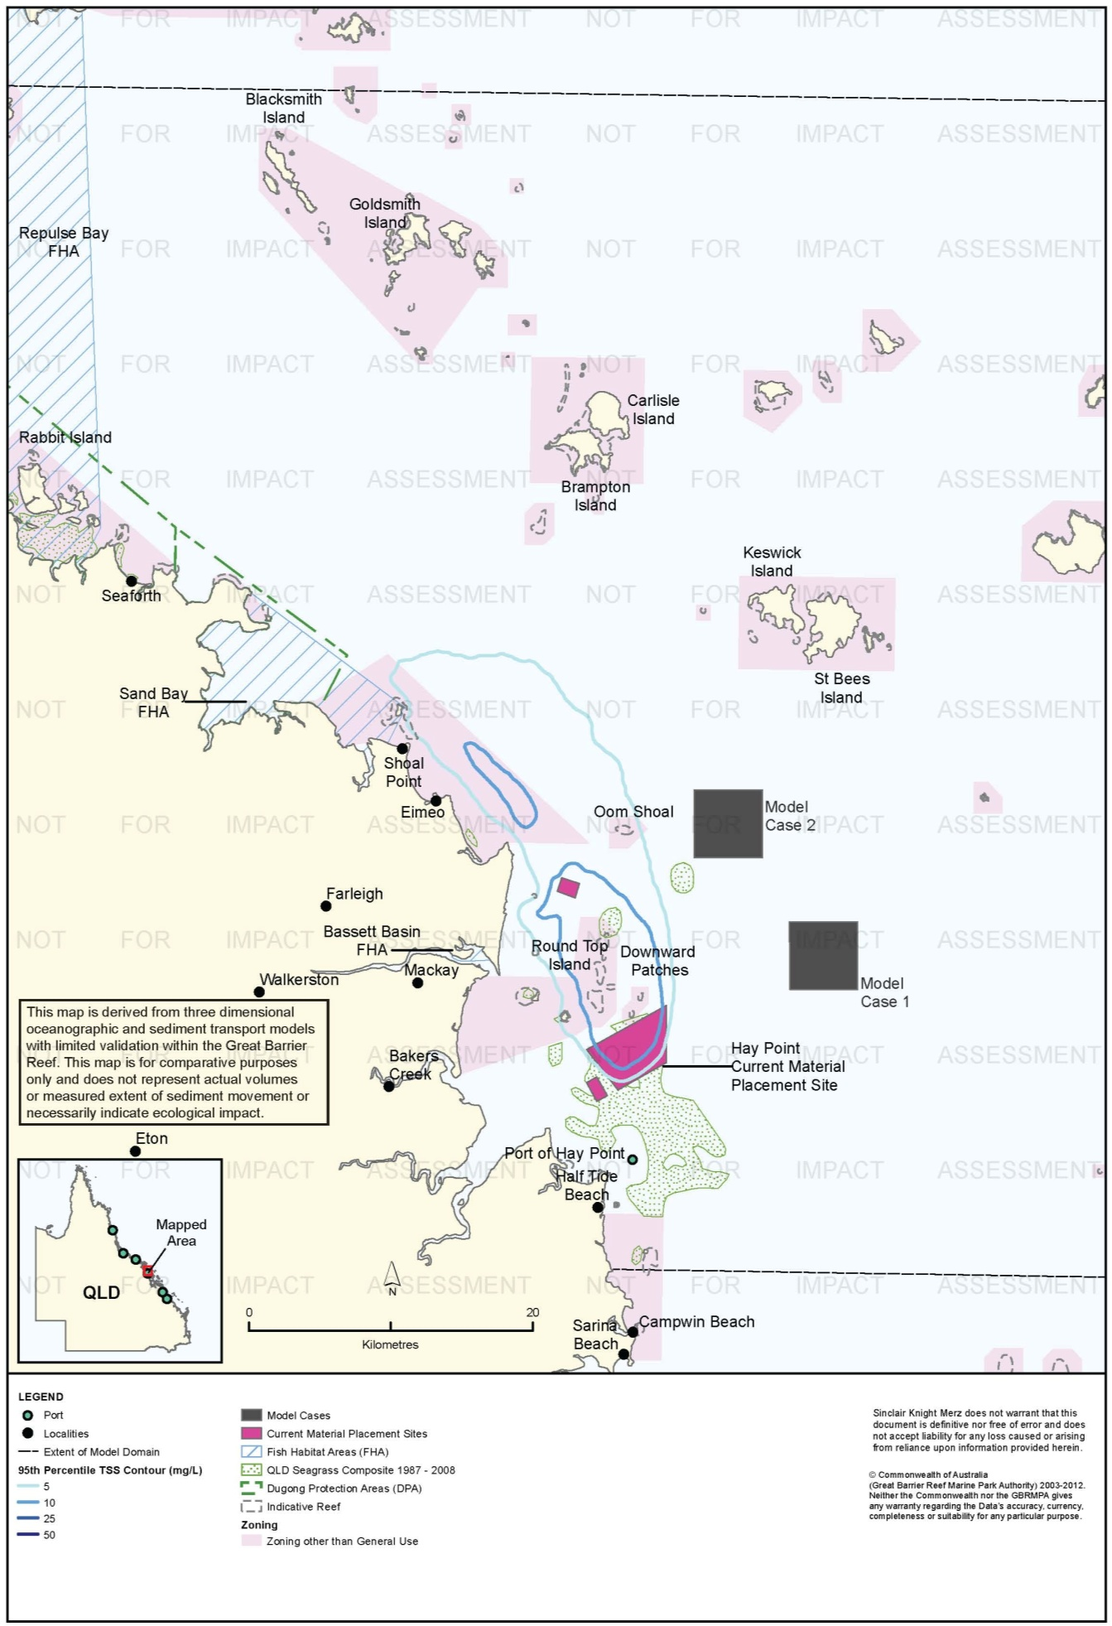
Figure 42. Hay Point: dredging period (155 days) TSS distribution, current site - 95th percentile.

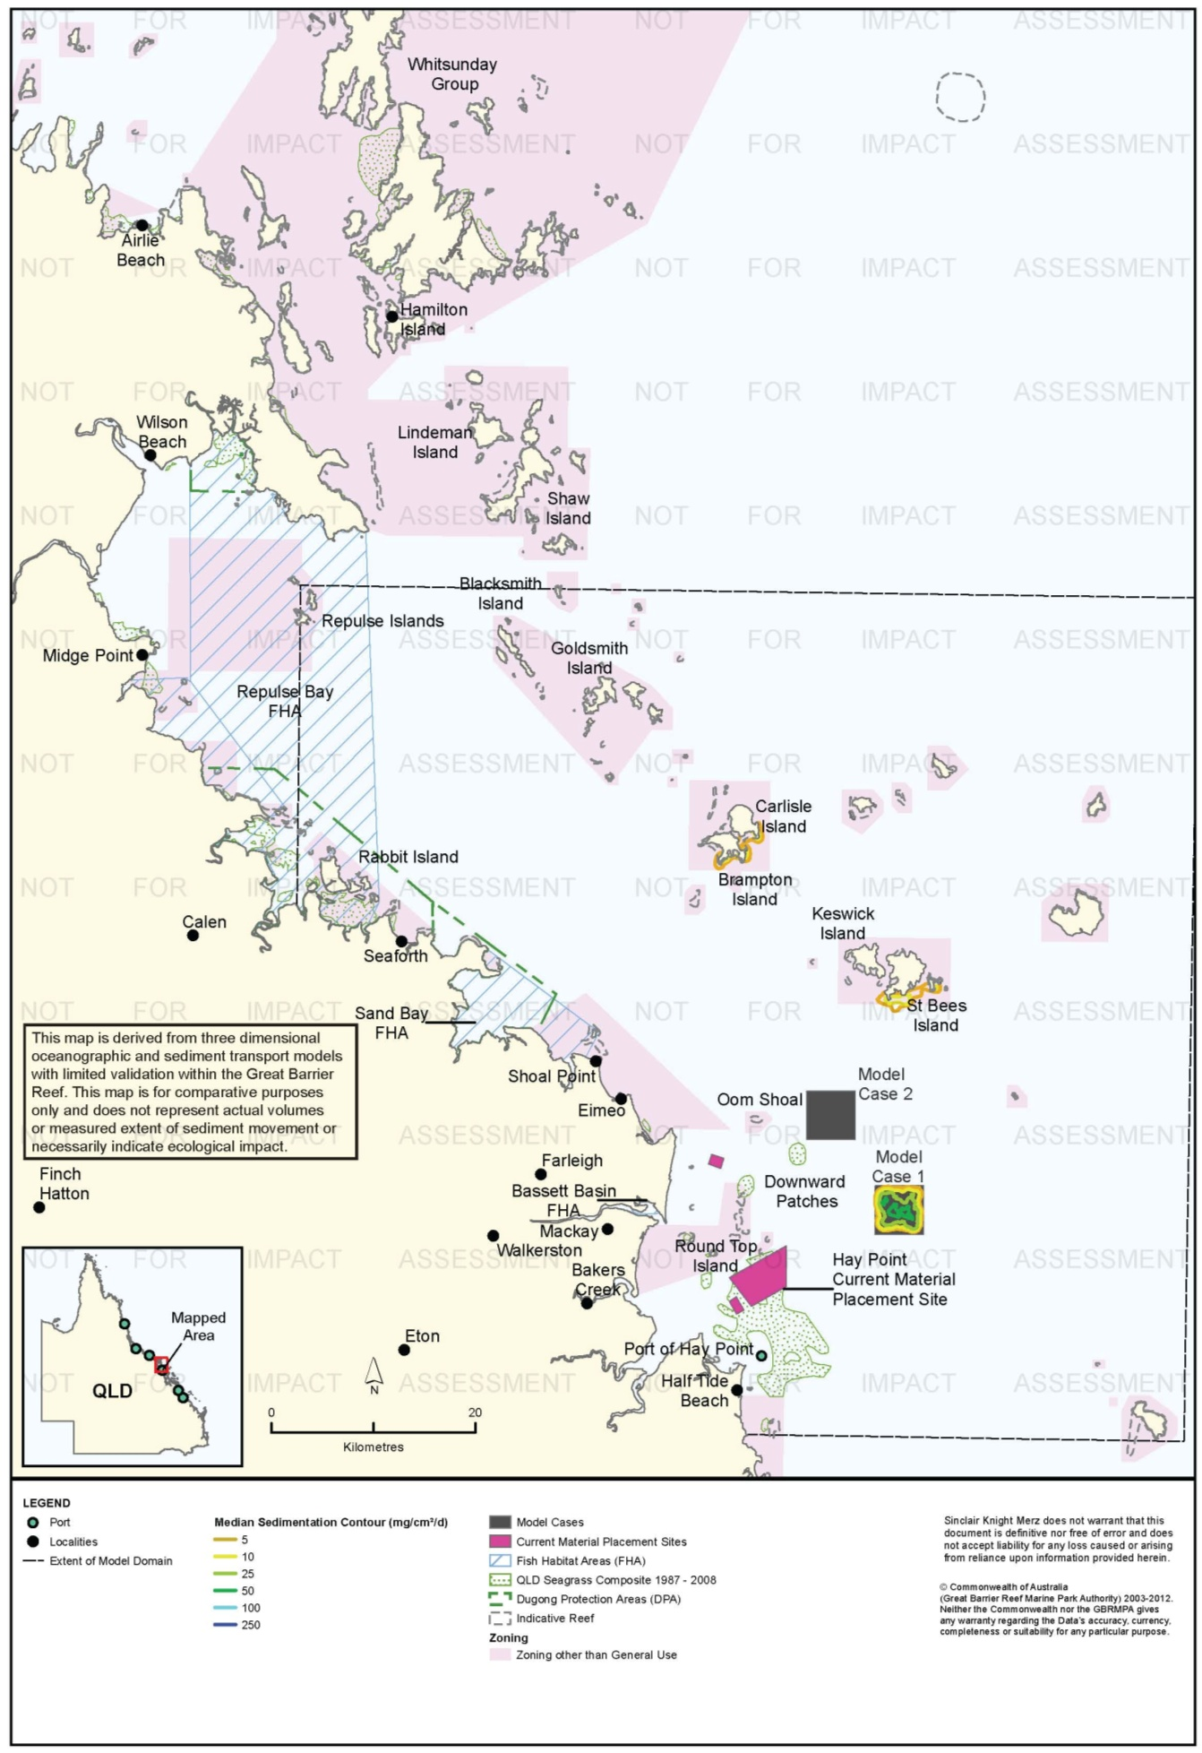
Figure 43. Hay Point: dredging period (155 days) sedimentation rate, Model Case 1 - 50th percentile.

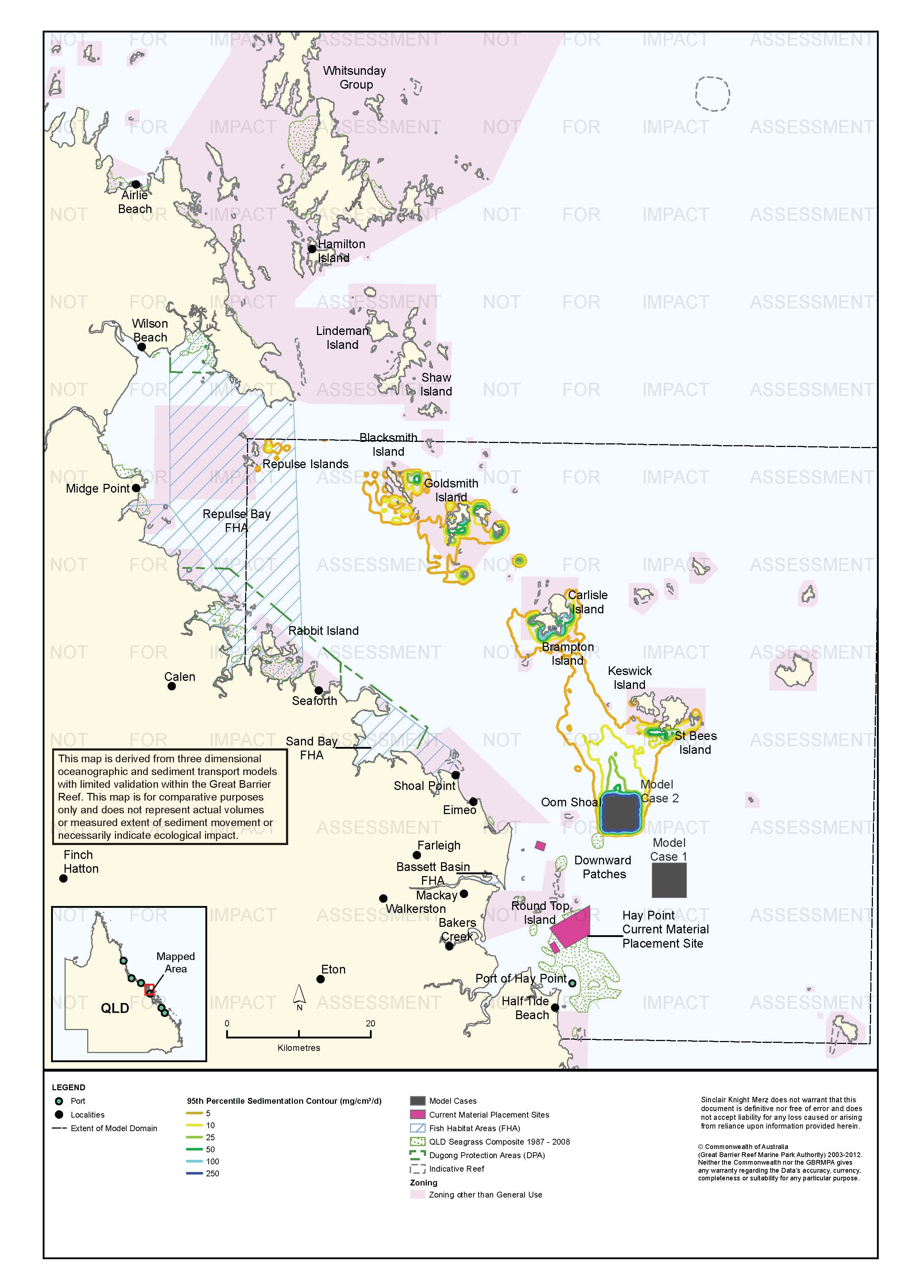
Figure 44. Hay Point: dredging period (155 days) sedimentation rate, Model Case 1 - 95th percentile.

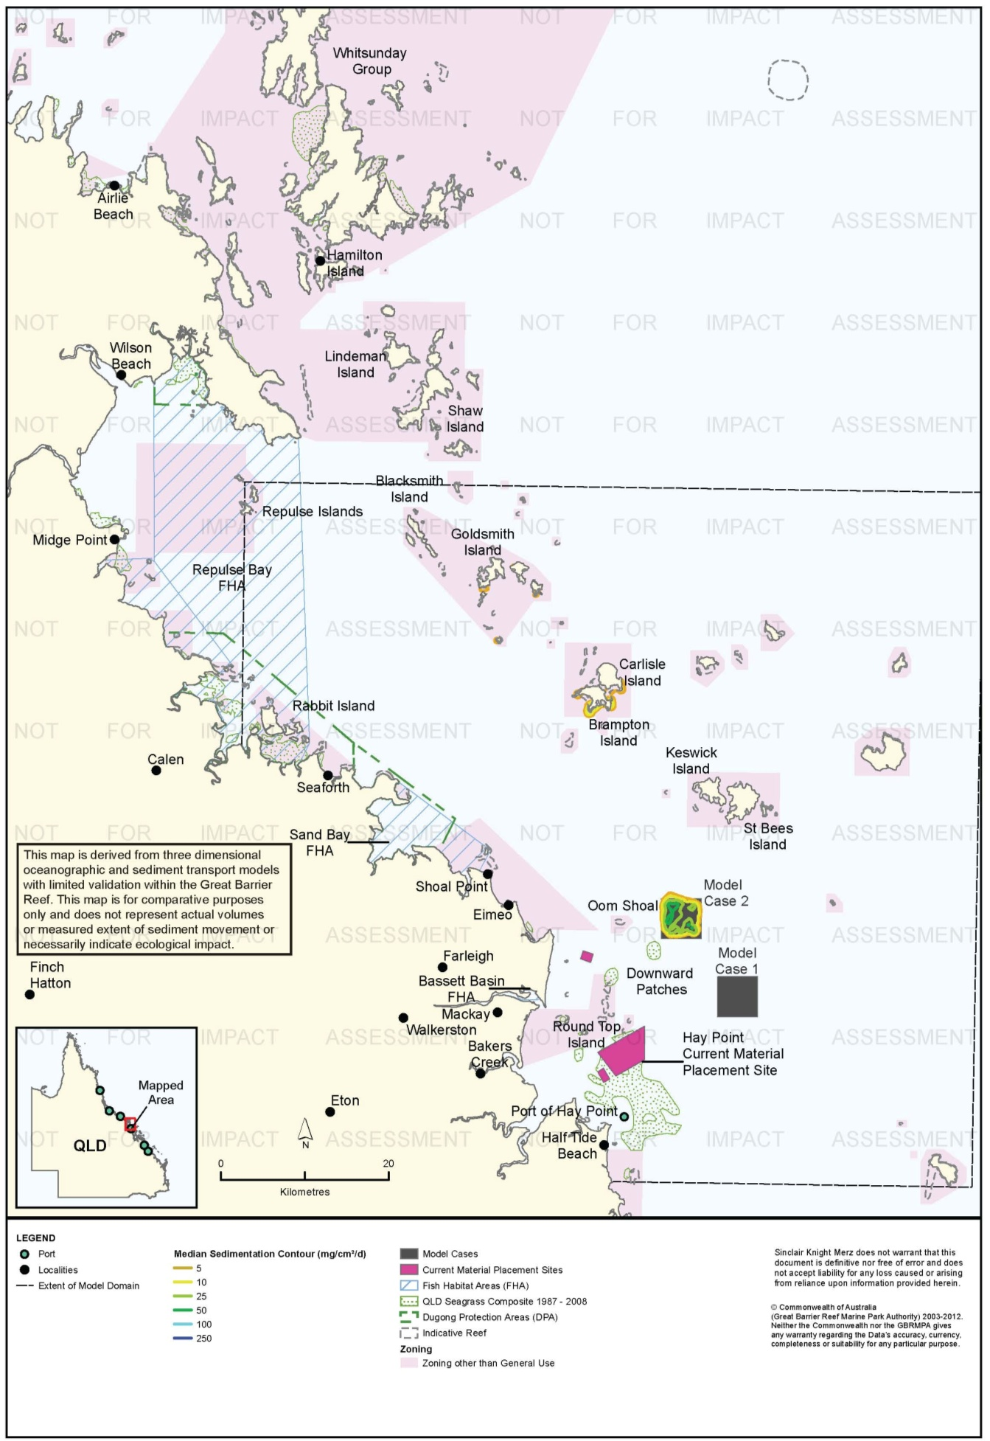
Figure 45. Hay Point: dredging period (155 days) sedimentation rate, Model Case 2 - 50th percentile.

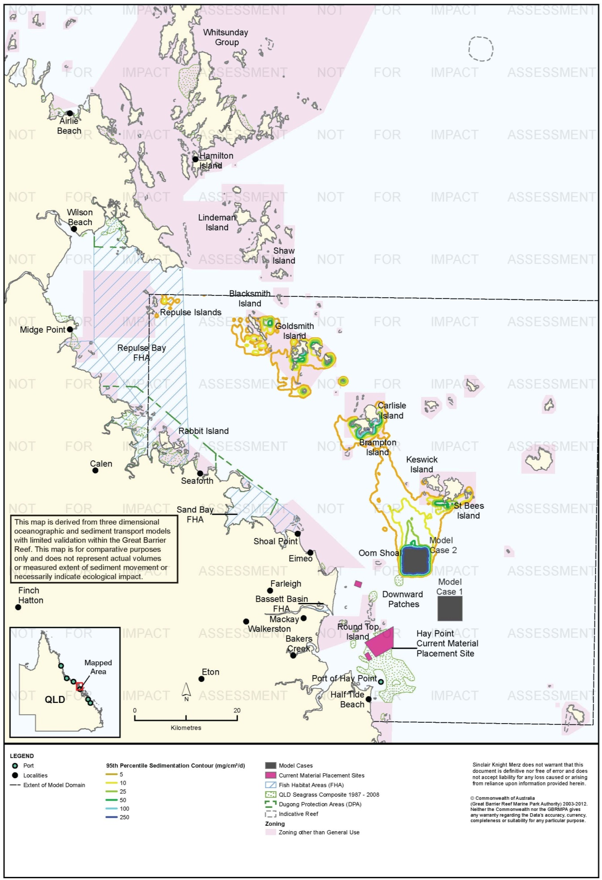
Figure 46. Hay Point: dredging period (155 days) sedimentation rate, Model Case 2 - 95th percentile.

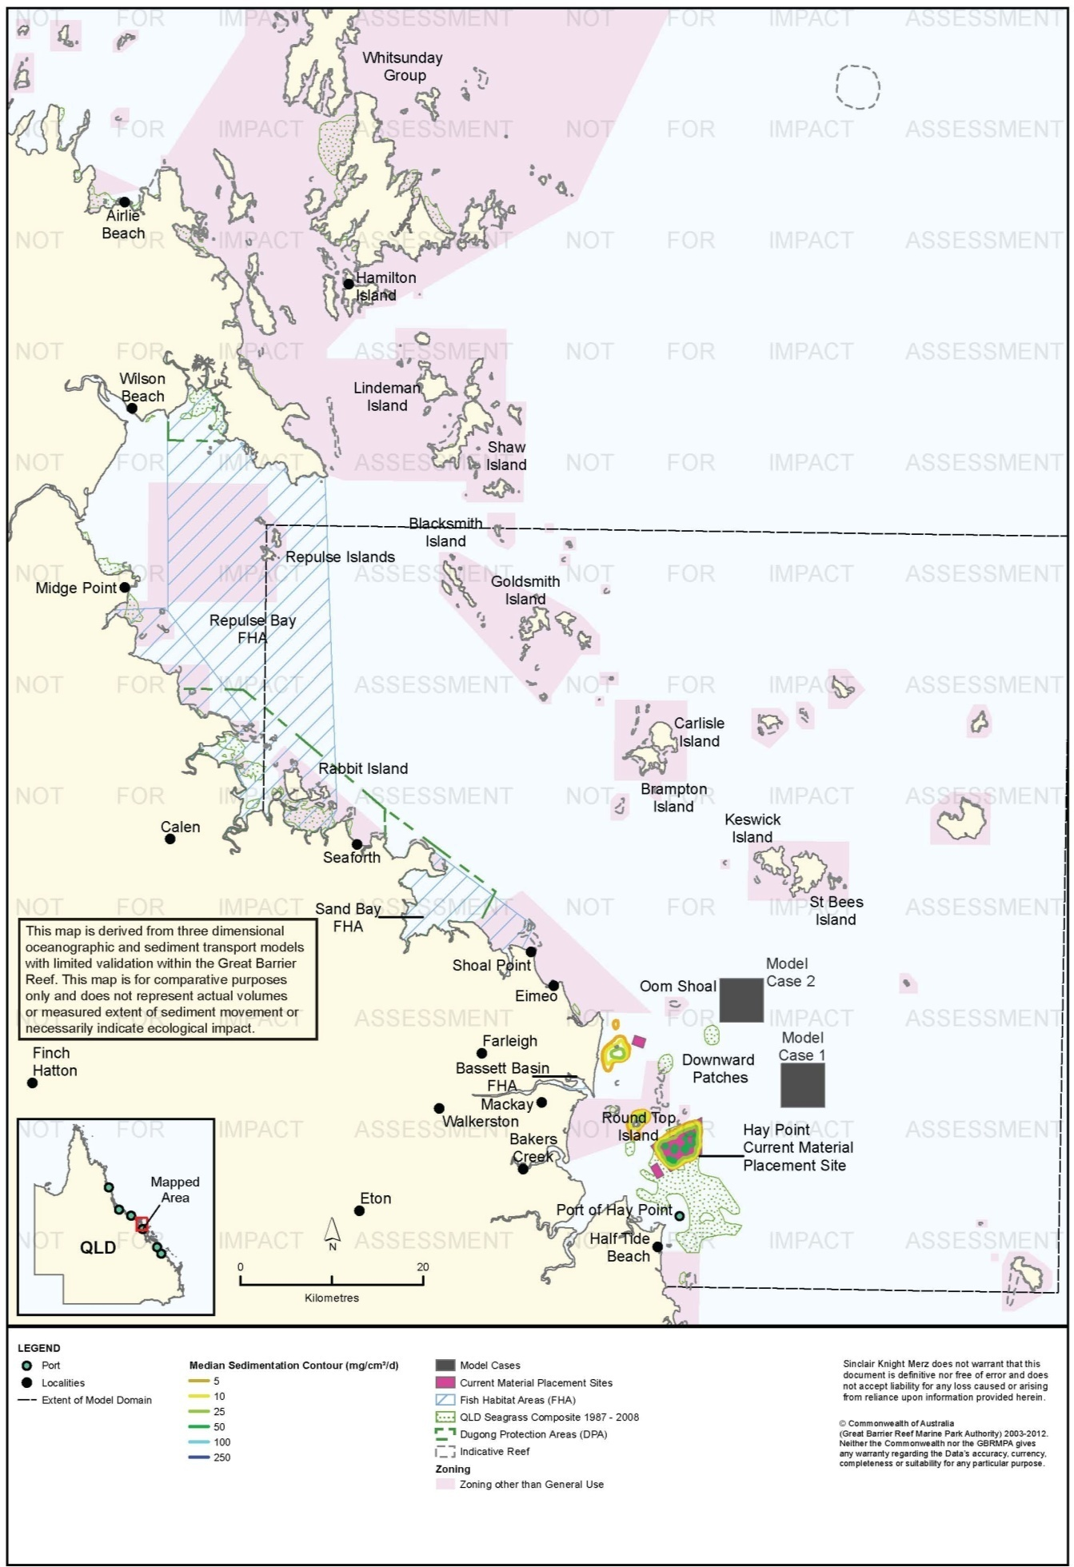
Figure 47. Hay Point: dredging period (155 days) sedimentation rate, current site - 50th percentile.

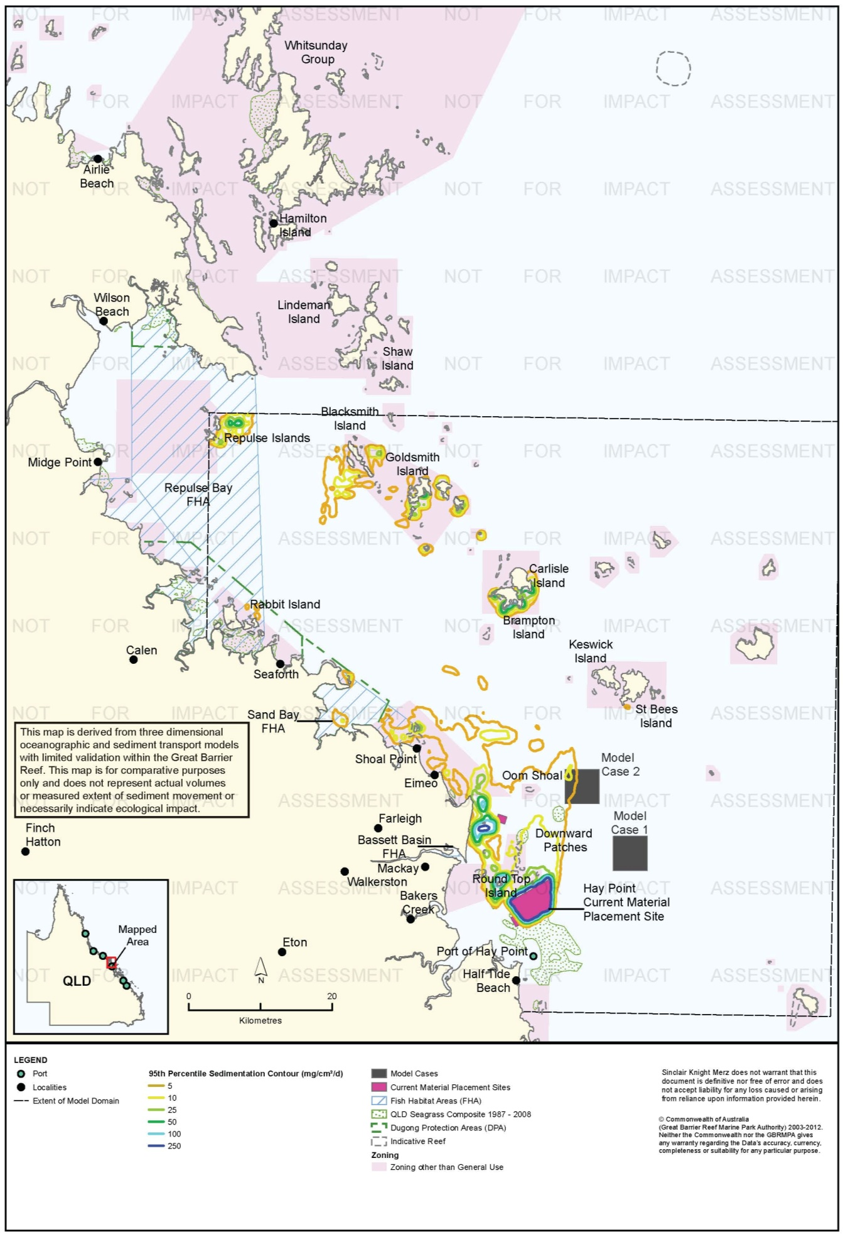
Figure 48. Hay Point: dredging period (155 days) sedimentation rate, current site - 95th percentile.

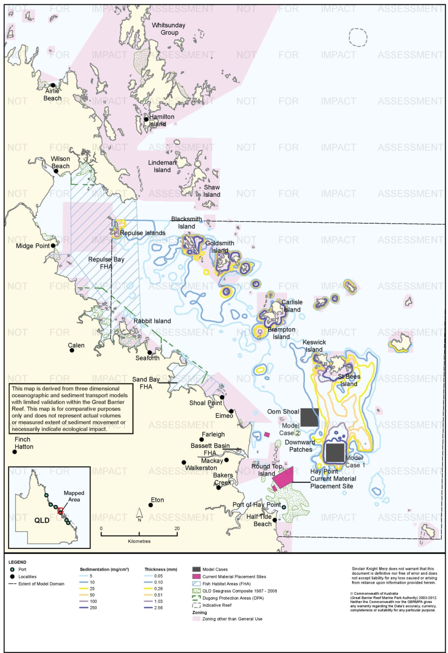
Figure 49. Hay Point: dredging period (155 days) total sedimentation and bottom thickness, Model Case 1.

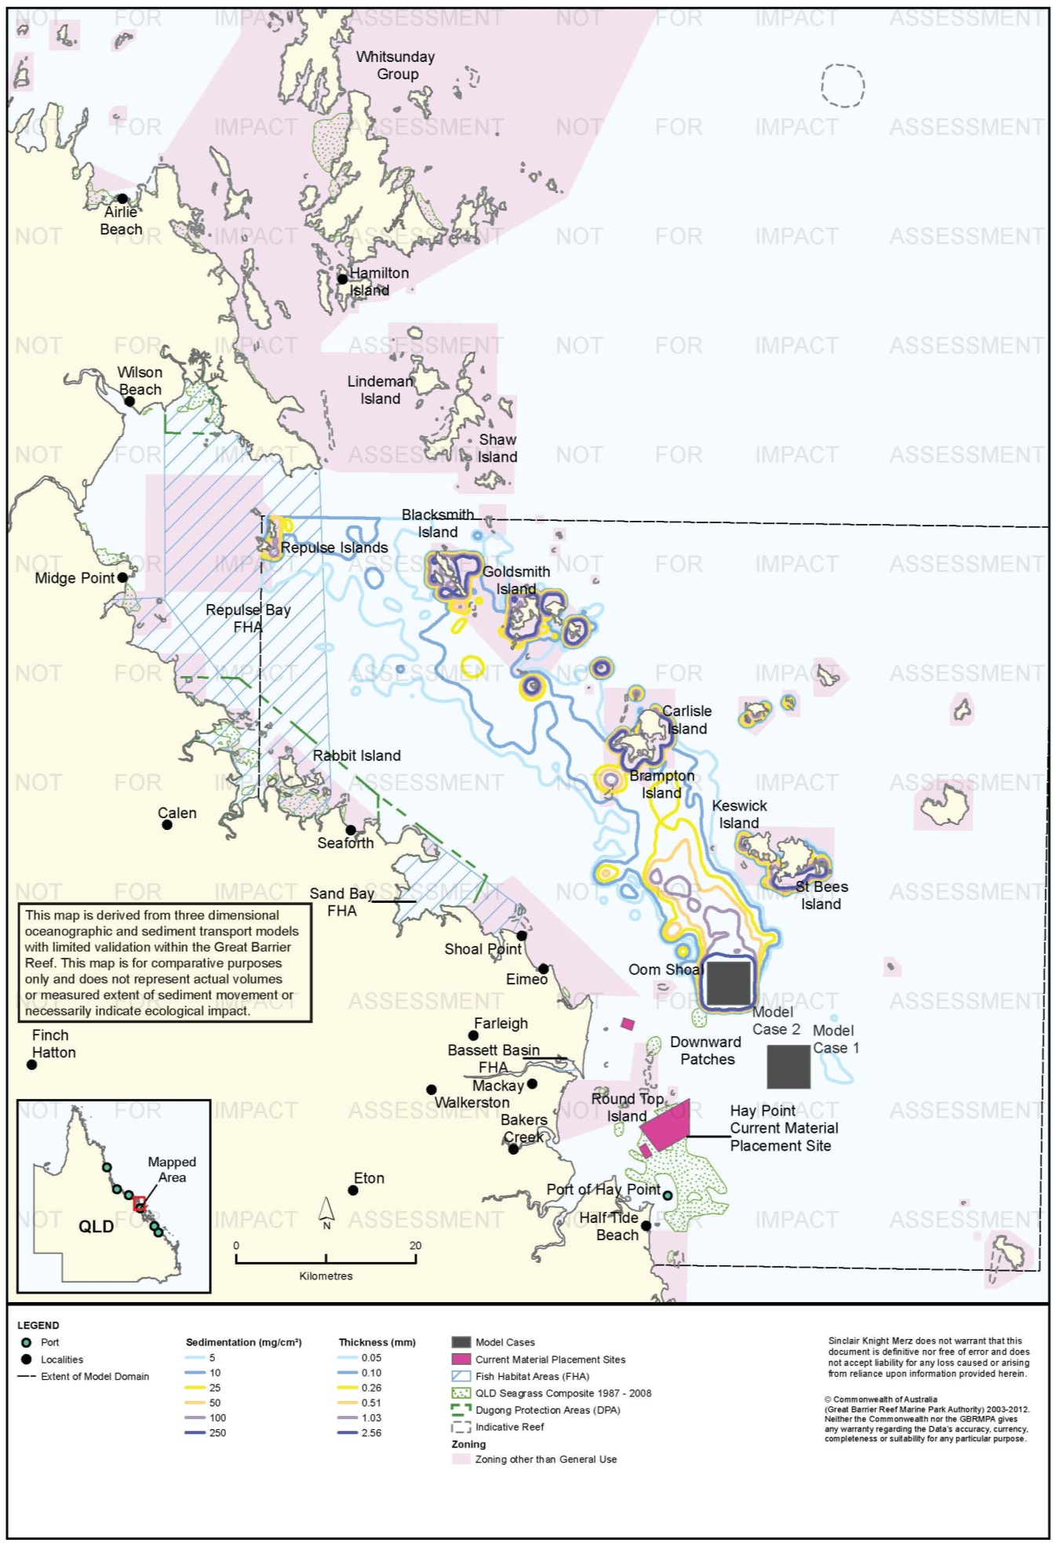
Figure 50. Hay Point: dredging period (155 days) total sedimentation and bottom thickness, Model Case 2.

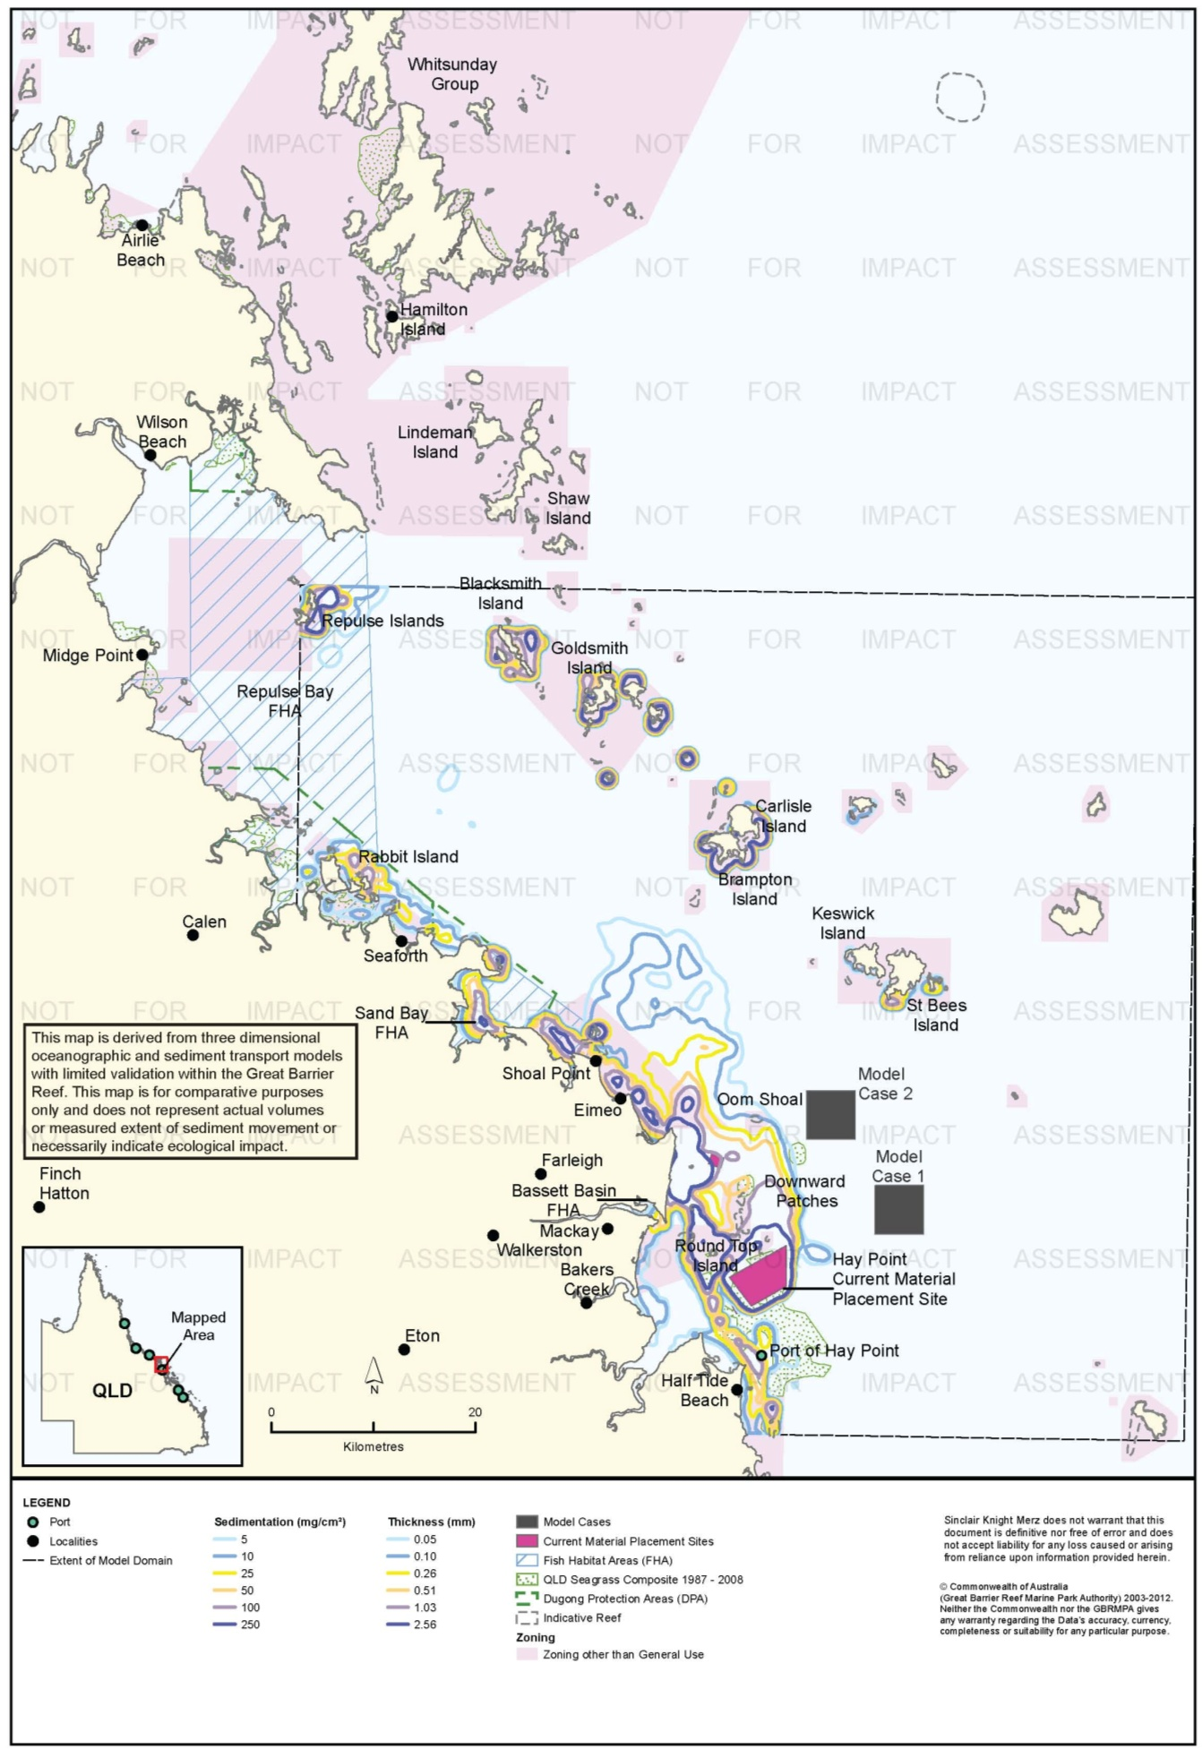
Figure 51. Hay Point: dredging period (155 days) total sedimentation and bottom thickness, current site.

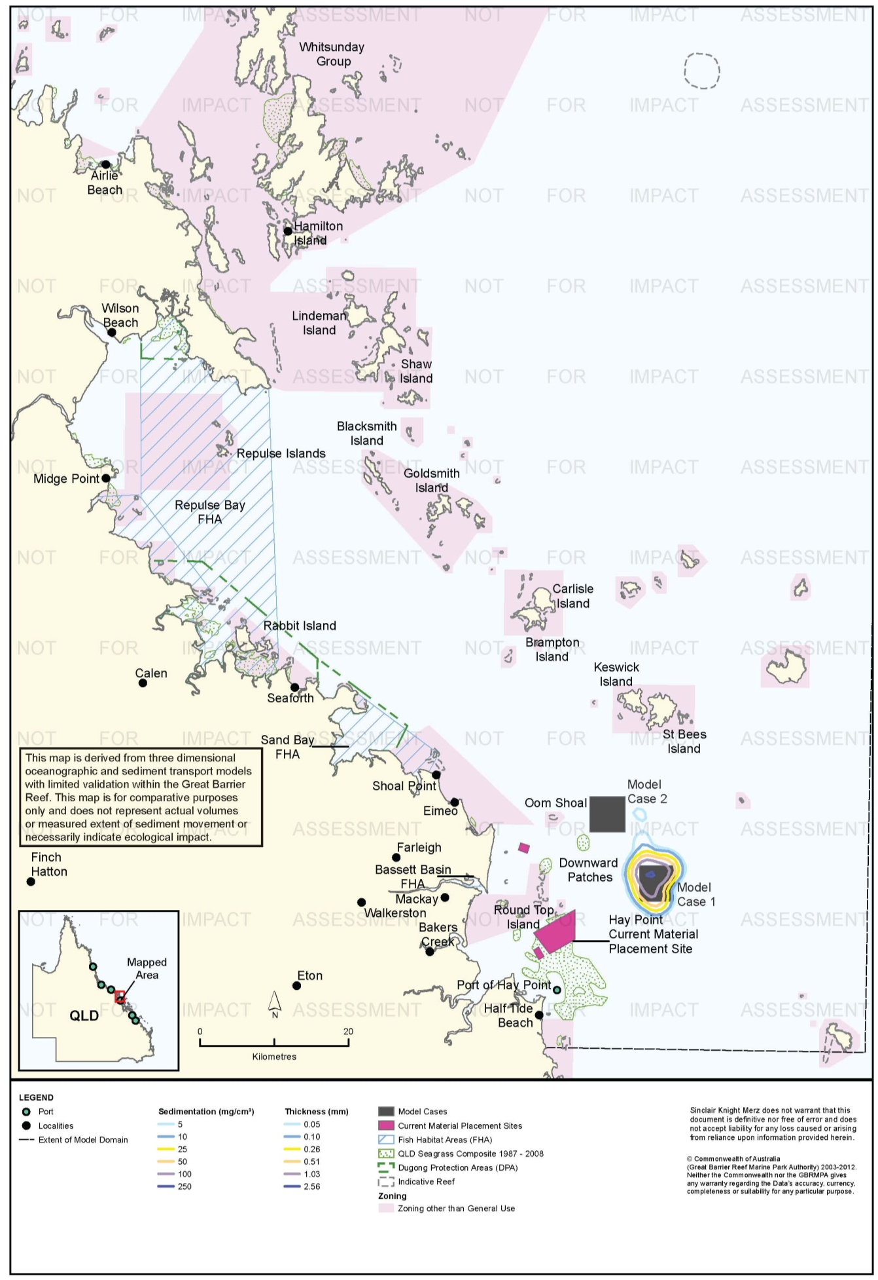
Figure 52. Hay Point: long-term (12 months) total sedimentation and bottom thickness, Model Case 1.

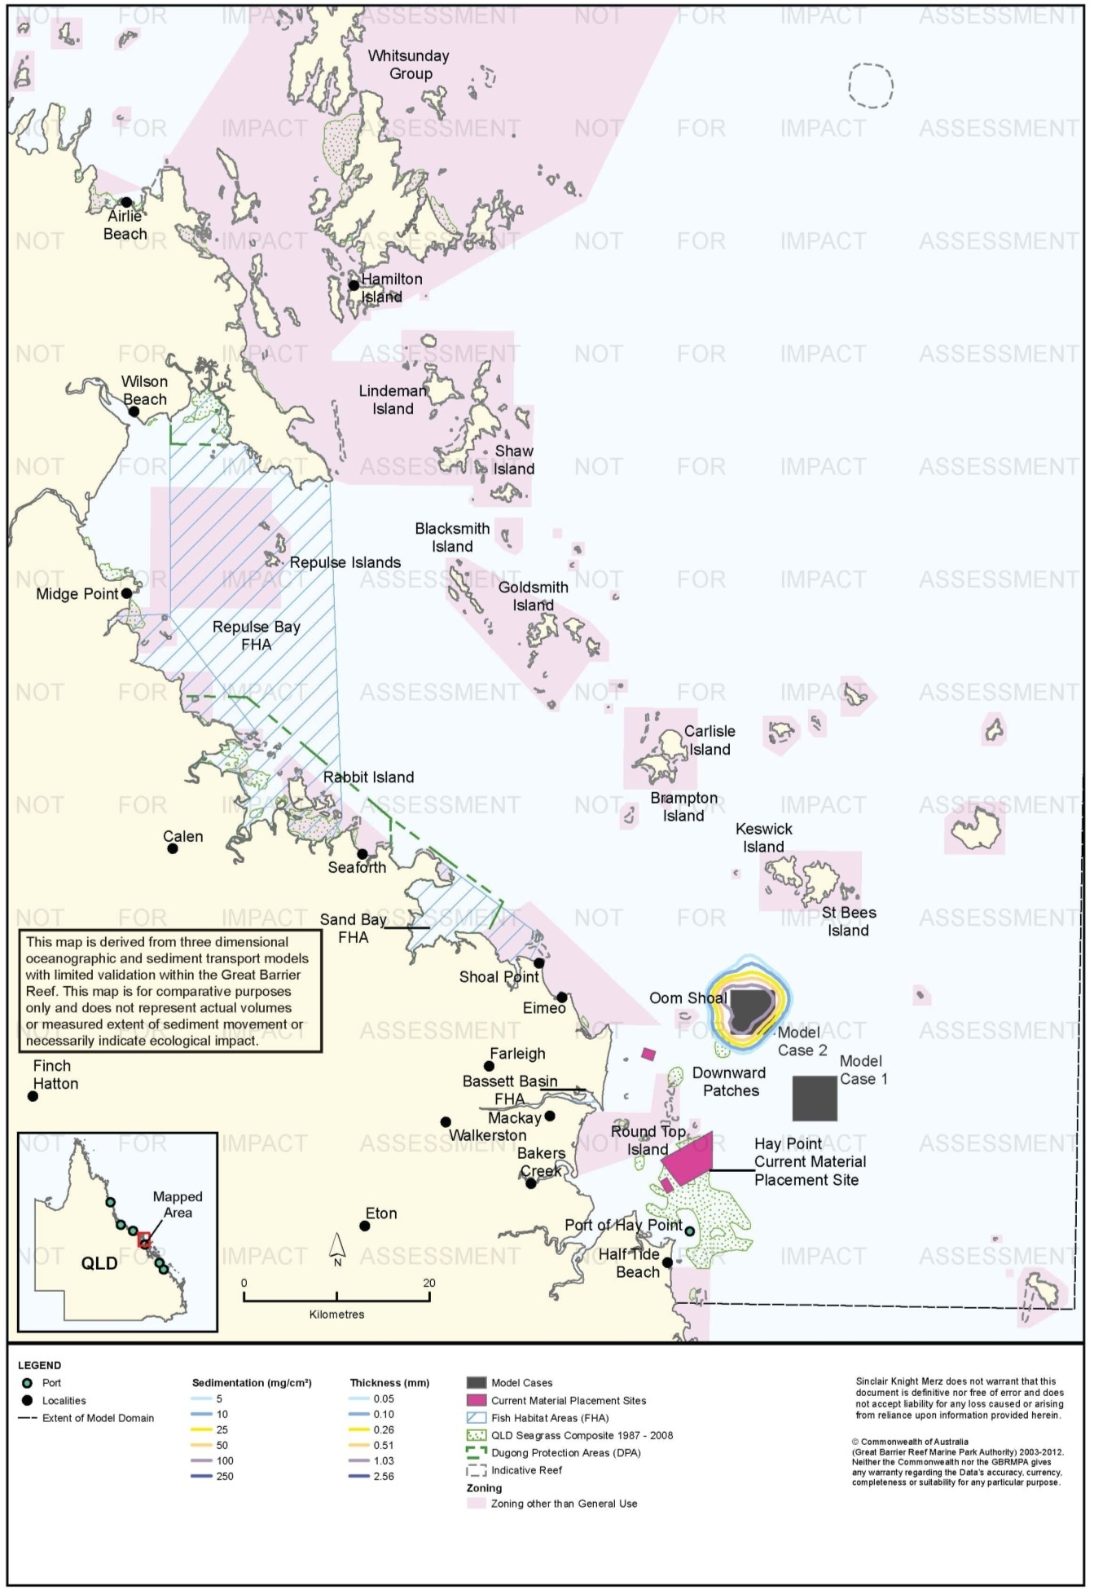
Figure 53. Hay Point: long-term (12 months) total sedimentation and bottom thickness, Model Case 2.

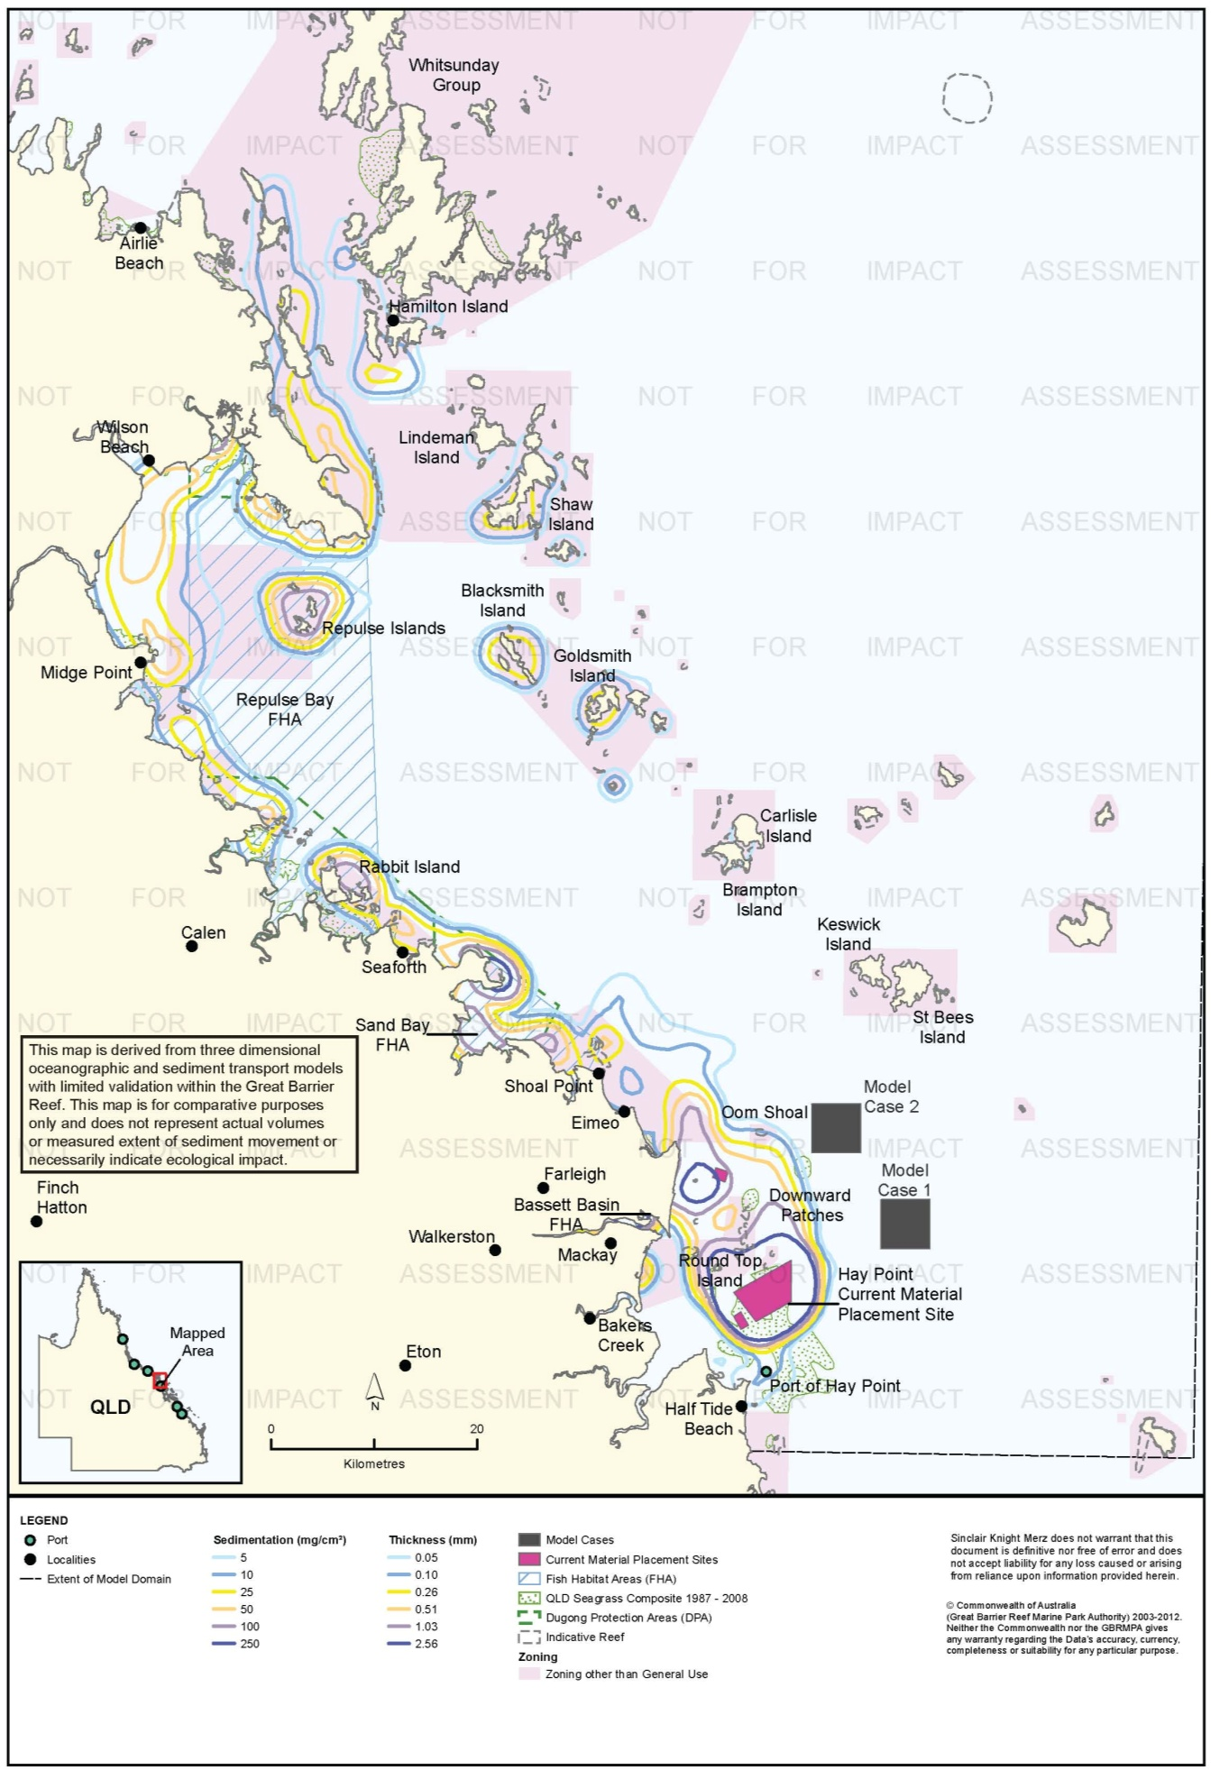
Figure 54. Hay Point: long-term (12 months) total sedimentation and bottom thickness, current site.

Risk Assessment
The results of the risk assessment are presented in table 17. Modelling scenarios predicted suspended sediment plumes of a relatively low intensity for all three material placement sites. For Model Cases 1 and 2, predicted TSS plumes generally did not overlap with sensitive receptors, particularly when the 50th percentile was considered. Inshore coral reefs and non-General Use Zones were the primary sensitive receptor relevant to TSS plumes predicted for the current site. These include the coral communities surrounding Round Top Island and the Downward Patches, a Habitat Protection Zone located immediately north of the current site, and a Conservation Park Zone adjacent to Shoal Point on the mainland. Habitats within these areas are known to comprise inshore coral reef and various soft bottom habitats, which are in a general decline across inshore sections of the Great Barrier Reef. In this context, there were clear advantages for reducing risks associated with TSS plumes by further investigating placement options located further offshore, such as at Model Cases 1 and 2.
The results of sediment deposition modelling suggest that dredged sediment will be deposited within areas of natural deposition along the coast and around islands located in a line running parallel with the coast, 20 km east of the mainland. Modelling for the current site predicted elevated sedimentation rates and total sedimentation along a wide coastal area to the north. In contrast, sediment deposition in these coastal areas was avoided for Model Cases 1 and 2, with deposition predicted around island environments to the north and generally limited only to short timeframes (dredging period), rather than the long term (12 months). This appears to be a consequence of the offshore location of the Model Cases 1 and 2, aligning northward sediment migration with the line of islands further off shore rather than inshore reefs. Dredging-period sedimentation rates around the islands to the north were similar for all model cases, except predicted sedimentation rates around Keswick and St Bees Islands were predicted to be somewhat lower for the current site. Dredging period total sedimentation around the islands to the north was higher for Model Cases 1 and 2, particularly Model Case 1, than for the current site. After 12 months the sediment deposited during the dredging period for Model Cases 1 and 2 moved beyond the model extent, but considerable sediment deposits remained in the model extent for the current site.
These results suggest that the modelled placement activities at the current site can be expected to cause some environmental risk for coastal environments to the north, particularly inshore coral reefs and non-General Use Zones. Modelling indicates some potential benefits of using the alternative material placement sites located further offshore, however, this should be tempered with the absence of any existing data on the impact of placing material at these sites and with infrequent (95th percentile) sedimentation rates up to 50 mg/cm²/d predicted in the short term (during the dredging period) around islands to the north. Total sedimentation on the windward sides of those islands during the dredging period is also predicted to be relatively high, up to 250 mg/cm² (2.56 mm) As noted in ‘Hydrodynamic Modelling’, p. 21, however, the predicted sedimentation on the windward sides of reefs and islands is unlikely to occur in reality because of the effects of shallow-water wave processes, which are not included in the model. The implications of material moving further north, beyond the model extent, also needs to be considered.
Comparison of the total sedimentation maps for the dredging period and after 12 months shows continuing predicted movement of sediment to the north. For Model Cases 1 and 2 the predicted sediment deposits north of the placement sites has moved beyond the model extent after 12 months.
In summary, the results suggest that the Model Cases 1 and 2 may provide a lower level of environmental risk than the current site. There may therefore be merit in further investigating the offshore alternative material placement sites at Hay Point, as a means of reducing sediment-related environmental risks from placement activities at the current site on inshore coral reef and soft-bottom communities between Hay Point and Airlie Beach.

Table 17.Comparative risk assessment for the Port of Hay Point based on modelling results (Figure 38 to Figure 54).
Hazard | Sensitive Receptor | Site | Likelihood | Consequence | Risk Rating
An increase in TSS concentration and turbidity in waters surrounding the material placement site. | Coral Reefs | Current Site | Possible | Minor | Medium
 |  | Model Case 1 | Unlikely | Minor | Low
 |  | Model Case 2 | Unlikely | Minor | Low
 | Seagrass. | Current Site | Unlikely | Minor | Low
 |  | Model Case 1 | Unlikely | Minor | Low
 |  | Model Case 2 | Unlikely | Minor | Low
 | Fish Habitat Areas | Current Site | Unlikely | Minor | Low
 |  | Model Case 1 | Rare | Insignificant | Low
 |  | Model Case 2 | Rare | Insignificant | Low
 | Non-general Use Zones | Current Site | Likely | Minor | Medium
 |  | Model Case 1 | Unlikely | Minor | Low
 |  | Model Case 2 | Unlikely | Minor | Low
 | Commercial fisheries | Current Site | Unlikely | Minor | Low
 |  | Model Case 1 | Unlikely | Minor | Low
 |  | Model Case 2 | Unlikely | Minor | Low
 | Tourism and recreational values | Current Site | Unlikely | Minor | Low
 |  | Model Case 1 | Unlikely | Minor | Low
 |  | Model Case 2 | Unlikely | Minor | Low
Increase in the rate of sediment deposition on the sea bed in areas surrounding the material placement site. | Coral Reefs | Current Site | Possible | Moderate | High
 |  | Model Case 1 | Possible | Minor | Medium
 |  | Model Case 2 | Possible | Minor | Medium
 | Seagrass. | Current Site | Possible | Minor | Low
 |  | Model Case 1 | Rare | Minor | Low
 |  | Model Case 2 | Rare | Minor | Low
 | Fish Habitat Areas | Current Site | Possible | Minor | Medium
 |  | Model Case 1 | Unlikely | Minor | Low
 |  | Model Case 2 | Unlikely | Minor | Low
 | Non-general Use Zones | Current Site | Likely | Minor | Medium
 |  | Model Case 1 | Likely | Minor | Medium
 |  | Model Case 2 | Likely | Minor | Medium
 | Commercial fisheries | Current Site | Possible | Minor | Medium
 |  | Model Case 1 | Rare | Minor | Low
 |  | Model Case 2 | Rare | Minor | Low
 | Tourism and recreational values | Current Site | Rare | Minor | Low
 |  | Model Case 1 | Rare | Minor | Low
 |  | Model Case 2 | Rare | Minor | Low
Accumulation of sediments on the sea bed. | Coral Reefs | Current Site | Possible | Moderate | High
 |  | Model Case 1 | Unlikely | Moderate | Medium
 |  | Model Case 2 | Unlikely | Moderate | Medium
 | Seagrass | Current Site | Possible | Minor | Medium
 |  | Model Case 1 | Rare | Minor | Low
 |  | Model Case 2 | Rare | Minor | Low
 | Fish Habitat Areas | Current Site | Possible | Minor | Medium
 |  | Model Case 1 | Rare | Minor | Low
 |  | Model Case 2 | Rare | Minor | Low
 | Non-General Use Zones | Current Site | Possible | Minor | Medium
 |  | Model Case 1 | Rare | Minor | Low
 |  | Model Case 2 | Unlikely | Minor | Low
 | Commercial fisheries | Current Site | Possible | Minor | Medium
 |  | Model Case 1 | Rare | Minor | Low
 |  | Model Case 2 | Rare | Minor | Low
 | Tourism and recreational values | Current Site | Possible | Minor | Medium
 |  | Model Case 1 | Rare | Minor | Low
 |  | Model Case 2 | Rare | Minor | Low

Ecological Monitoring in Relation to Dredging
Fringing coral reefs were monitored in relation to the Port of Hay Point Apron Areas and Departure Path Capital Dredging Project, which involved dredging and sea disposal of 8.6 million m³ of material. Impact locations were Round Top Island (three km north-west of the DMPA boundary), and Victor Islet (21 km south). The Victor Islet location was selected on the basis of potential dredging, rather than placement, impacts; the dredging site was some 10 km south of the southern boundary of the DMPA and approximately 6 km north of Victor Islet. Monitoring included estimation of per cent cover using line intercept transects (LIT), and surveys of coral condition indicators including counts and severity scoring of bleached, diseased, and damaged coral, mucus production by Porites, and the thickness of sediment resting on the surfaces of coral colonies (GHD 2006b; Trimarchi & Keane 2007). Monitoring was conducted two to three weeks before commencement of dredging, during dredging, and at five weeks and six months after completion of dredging. Details of the design and timing of the different surveys are provided in table 8.
There was a statistically significant decrease in hard coral cover between the baseline (April 2006) and first during-dredging (July 2006) surveys (GHD 2006b). This decline was observed across all sites, and there was no significant difference between locations in the pattern of decline. No statistically significant changes in coral cover from July 2006 to April 2007 (six months post-dredging) were reported (Trimarchi & Keane 2007), but the decline from April to July 2006 led to a significant decline overall. There was no significant difference in the pattern of decline among locations, however the analysis appears to have been a comparison among all locations individually rather than a specific before-after/control-impact comparison. The declines in coral cover were predominantly due to declines in Turbinaria and siderastrid corals. There was also an unexplained decline in Goniopora corals at Keswick Island (Tirimarchi & Keane 2007).
GHD (2006b) reported net declines in coral cover from the baseline (April 2006) to five weeks post-dredging (November 2006) surveys of 3 per cent at Round Top Island and 7 per cent at Victor Island (the two impact sites), and 7 per cent at Slade Island and 12 per cent at Keswick Island (the two control sites). Trimarchi & Keane reported that the monitoring had an 80 per cent power to detect 20 per cent change in coral cover.
Islam et al. (2007) reported that turbidity plumes detectible by satellite imagery during the dredging campaign extend to a maximum of 46 km to the north of the dredging site, which is approximately 35 km north of the northernmost boundary of the DMPA. This potentially encompasses both the Slade Island and Keswick Island control locations. Details of plume direction, and if the plume impinged upon the control locations the intensity, duration, and frequency of such impingements, were not available to SKM APASA, but these excursions of the plume potentially compromised the strict validity of the control sites.
Up to 4 per cent (Round Top Island) and 6.5 per cent (Victor Islet) of coral colonies suffered partial colony mortality due to sedimentation during the dredging campaign (GHD 2006b; Trimarchi & Keane 2007). Up to 17 per cent of corals across the monitoring locations were affected by sediment, including observations of sediment deposits on coral colony surfaces, during the campaign.
Surveys of coral reef fish communities were conducted in conjunction with the coral monitoring for the 2006 Port of Hay Point Apron Areas and Departure Path Capital Dredging Project, using visual strip transects at the coral monitoring sites (GHD 2006b; Trimarchi & Keane 2007). The authors reported that there were no statistically significant changes in fish communities during or after the dredging. The statistical power of the monitoring program was not reported.
Chartrand et al. (2008) monitored seagrass, as well as algae and benthic macroinvertebrates, at Hay Point from July 2004 to June 2008 to assess impacts on seagrass from the Port of Hay Point Apron Areas and Departure Path Capital Dredging Project. They conducted broad-scale mapping of deepwater seagrass before, during, and after dredging, and also established inshore and offshore impact and control sites for repeated before-after/control-impact (BACI) monitoring. Details of the sampling design and timing of the surveys are provided in table 8. The study found that seagrass communities at Hay Point are highly dynamic and variable, with a strong seasonal pattern of peak abundance in winter and spring and seasonal senescence in summer and autumn (Chartrand et al. 2008). Chartrand et al. (2008) concluded that dredging-related turbidity adversely impacted the winter recruitment of seagrasses in 2006. In the first winter survey following dredging, in July 2007, some seagrass recruitment was observed (Chartrand et al. 2008). The control sites established for the BACI seagrass monitoring were subjected to turbidity plumes during dredging due to the greater than predicted spatial extent of the plumes. The intensity, duration, and frequency of such impingements were not available to SKM APASA.
In conjunction with seagrass monitoring, Chartrand et al. (2008) also monitored sessile and motile benthic macroinvertebrates, based on the video method used to survey seagrass as well as specimens collected in a net attached to the video sled, and fish and penaied prawns using beam trawls at the same locations surveyed for seagrass. Increases in macroinvertebrates were recorded at the offshore control site, but not at either the offshore impact or the inshore control site. Chartrand et al. (2008) concluded from this that dredging and material placement affected macroinvertebrate communities. Further details are provided in table 8.
Coral reefs, seagrass communities, and infauna have been monitored for the Hay Point Coal Terminal Expansion Project Phase 3 (HPX3) project (BMA 2012, 2013). Some 260,000 m³, material was dredged; of which 185,000 m³ was placed at sea, over two seasons of capital dredging (26 May-18 November 2010 and 18 April-22 September 2011; BMA 2013), using a backhoe dredge. Coral reef monitoring consisted of 10, 20 m long transects at the impact site (Hay Reef, 1.5 km West-south-west of the dredging site and 5.6 km south of the nearest boundary of the DMPA) and at a control site, (Dudgeon Point, 6 km north-west of the dredging site and 5 km south-west of the DMPA. Per cent cover of standard benthic classification categories (e.g. branching Acropora coral, non-Acropora branching coral, macroalgae, sponge, rubble, dead coral) was determined from stratified random point counts on extracted video frames. Surveys were completed in April 2010, a month before commencement of dredging, and in October/November 2011, within two months of completion of dredging. Further details are provided in table 8.
Coral cover declined slightly at both impact and control sites; the decrease was not statistically significant (BMA 2012). Coral cover at the impact site was significantly greater at the control site both before and after dredging. There was a marked, statistically significant, increase in macroalgal cover at both impact and control sites, and the proportionate increase at the control site was statistically significantly greater than at the impact site. BMA (2012) concluded the observed changes were probably driven by recovery from the impacts of Tropical Cyclone Ului, which had heavily impacted the area a few weeks prior to the baseline survey. The statistical power of the monitoring to detect change was not reported.
The coral reef monitoring targeted the reef nearest the dredging site rather than sites potentially affected by material placement in the DMPA. Baseline surveys were also conducted at Round Top, and Victor Islands, which were considered to be impact and control sites for the DMPA, respectively, as well as Slade Island. Water quality monitoring including vessel-based turbidity monitoring, remote sensing, and continuous turbidity logging at Round Top, Victor, and Slade Islands indicated no detectible turbidity plume reached the island reefs, and prior to the 2011 dredging season the regulator approved termination of water quality monitoring at the island reefs. As a result, no post-dredging monitoring was conducted at those reefs.
Seagrass monitoring for the HPX3 project consisted of quarterly video transect monitoring using the methods of Chartrand et al. (2008). The monitoring specifically targeted impacts of material placement as opposed to dredging. An impact location was established within the DMPA used for the HPX3 project, a previous disturbance location spanning one to two km from the boundary of the HPX3 DMPA, but within the larger DMPA used for capital dredging in 2006, and a control location approximately six km south-east of the HPX3 DMPA. There are three permanent sampling blocks at each location, with three 100 m video transects conducted within each block during each survey. Monitoring commenced in November/December 2010, shortly before and after completion of the first season of dredging. Baseline surveys were not conducted because final project approval and commencement of dredging occurred during the summer/spring period when deepwater seagrass is known to be absent in the Hay Point area (Chartrand et al. 2008); in addition, the reference location was selected partly on the basis of broad-scale mapping of seagrass communities in the area, which was not completed until October 2010 (Thomas & Rasheed 2010).
In addition to the monitoring locations established for the HPX3 project, the program surveyed the four locations previously monitored by Chartrand et al. (2008) from 2004 to 2008. Seagrass was scarce or absent throughout the monitoring through 2012, being present at any location in only three of nine surveys (November/December 2010, October 2011, October 2012), and per cent cover has been < 1 per cent at all locations in all surveys. This reflects the situation along the entire Queensland coast during the monitoring period, as seagrass communities were heavily impacted by floods and cyclones in 2010 and 2011. The presence of seagrass at five of the seven survey locations in October 2012, and reached the highest cover (0.94 per cent, at the historical offshore control location of Chartrand et al. 2008) observed over the monitoring period. BMA 2013 concluded this was an early sign of recovery. Seagrass was only observed on one occasion in the HPX3 DMPA, in January 2012, but seagrass had never been observed there in previous monitoring or mapping which was one reason for selecting the DMPA. Seagrass was not present in either the HPX3 impact (DMPA) or HPX3 control locations in October 2012, when it was present at the other five locations.
BMA (2013) concluded there was no evidence of material placement impacts on seagrass communities. There was no statistical analysis; the absence of seagrass during most surveys and very low abundance when seagrass was present prevented the use of standard statistics.
Infauna monitoring for HPX3 consists of grab sampling in the DMPA and at distances of 250 m and 2 km from the DMPA on axes radiating to the north, south-east, and south-west of the DMPA. A baseline study was conducted in late March/early April 2011, some six weeks prior to dredging. The first post-dredging survey was in October 2011, one month after completion of dredging, and the second in September/October 2012, one year later. The monitoring is focused on long-term patterns of change in infauna communities in relation to dredge material placement. Monitoring locations are located within the HPX3 DMPA, and at distances of 250 m and 2 km from the DMPA on three axes radiating to the north, south-west, and south-east. The south-west axis is in the larger DMPA previously used for capital dredging in 2006 and thus reflects the influence of previous disturbance. Further details are provided in table 8.
There was an order-of-magnitude increase in infauna abundance, a tripling of family richness, and marked changes in community structure, all statistically significant, between the baseline and first post-dredging surveys (BMA 2012, 2013). There was a small but not statistically significant increase in abundance between the first and second post-dredging surveys (BMA 2013), and a statistically significant increase in family richness. There were also statistically significant difference in infauna community structure (families present and their relative abundance) between years (2011 and 2012) and among locations, as well as in the pattern of inter-year change among locations. BMA (2012, 2013) concluded that the observed patterns of change in infauna communities did not show any clear relationship with potential influence of material placement. For example, the DMPA location had the third-highest infauna abundance and family richness in the first post-dredging survey, the higher locations being those 250 m and 2 km to the north. BMA (2012, 2013) concluded that the infauna monitoring results to not appear to be related to HPX3 material placement. BMA (2012, 2013) attributed the marked changes between the baseline and first post-dredging to recovery from severe disturbance by Tropical Cyclone Ului, which strongly affected the Hay Point Area a few weeks before the baseline survey was conducted. This severely compromised baseline makes it impossible to conduct a valid before-after comparison for impact assessment purposes. BMA (2012, 2013) do not report the power of the statistical analyses performed.

Environmental Condition
Water quality in the Mackay and Whitsunday region, which includes the Port of Hay Point, is monitored by the RRMMP (Schaffelke et al. 2011). The water quality aspect of the monitoring program includes inshore permanent monitoring sites (water quality loggers) and remote sensing techniques. Permanent monitoring sites have been established in the Mackay and Whitsunday region since 2007. No permanent monitoring sites are within 50 km of the Port of Hay Point with the nearest locations (Pine, Daydream and Double Cone Islands) approximately 100 km north of the Port of Hay Point (Schaffelke et al. 2011). Regionally, water quality has been declining since 2007 with the annual mean generally increasing at monitoring sites (table 18; Schaffelke et al. 2011).
Table 18. Summary of annual mean turbidity (NTU) data from turbidity sensors at Mackay and Whitsunday water quality locations from the RRMMP¹.
Site | 2007-2008² | 2008 to 2009² | 2009-2010² | 2010-2011³
Double Cone Island | 1.15 | 1.42 | 1.74 | 1.52
Daydream Island | 2.01 | 1.99 | 2.42 | 2.64
Pine Island | 2.87 | 3.11 | 3.20 | 3.68
1 Data extracted from Schaffelke et al. 2011. 2 – Years are from October to September 3 – October to June
Remote sensing is used to monitor TSS concentrations for the entire Marine Park at a spatial resolution of 1 km (Brando et al. 2011). Since 2002/2003 for the entire Mackay and Whitsunday region has slightly improved receiving a TSS paddock to reef index of very poor for all years until 2009/2010 when it increased to poor, in 2010/2011 the rating again decreased to very poor, however this only 2 per cent below a poor rating. Data from May 2010 to April 2011 for the Port of Hay Point and surrounding areas showed a clear declining gradient from inshore to offshore with median TSS values as high as 5 mg/L for shallow coastal areas. Annual median TSS values at the locations of Mode Cases 1 and 2 the current material placement site ranged from approximately 1.75 mg/L to 0.50 mg/L, with the current material placement site having the highest TSS values.
Baseline data (2005 to 2010) from five fringing reef monitoring sites in the Hay Point region was used to identify 95th and 99th percentile values for TSS and Turbidity values (BMA 2010). SKM derived the TSS values in table 19 from a measured turbidity to TSS relationship of TSS = 1.95 * NTU.
Table 19. Baseline turbidity and TSS measured over variable periods between 2005 and 2010 (BMA 2010).
Site | 95th percentile |  | 99th percentile
 | Turbidity (NTU) | TSS (mg/L) | Turbidity (NTU) | TSS (mg/L)
Hay Reef (coastal) | 43 | 89 | 79 | 154
Dudgeon Reef (coastal) | 89 | 174 | 166 | 324
Victor Islet (inshore island) | 232 | 452 | 521 | 1016
Round Top Island (inshore island) | 28 | 55 | 56 | 168
Slade Islet (inshore island) | 17 | 33 | 58 | 113

Reef health in the Mackay and Whitsunday region is monitored at seven monitoring sites by the RRMMP (or equivalent) since 2005, however no locations are within 50 km of the Port of Hay Point. The closest monitoring sites are approximately 100 km north surrounding the Whitsunday Islands (Thompson et al. 2011). Hard coral cover in the region has generally shown a slight decrease since monitoring began in 2005 (Thompson et al. 2011). Thompson et al. (2011a) assessed the overall condition of coral communities as moderate in due to the low densities of juvenile coral and low cover during periods free of acute disturbances (Thompson et al. 2011). The Mackay and Whitsunday region has received moderate RRMMP score for overall coral condition since 2009 (table 20)
Table 20. RRMMP monitoring score for overall inshore coral health for the Mackay and Whitsunday region from 2009-2011 (Thompson et al. 2011a, b).
Year | RRMMP score
2009 | Moderate
2010 | Moderate
2011 | Moderate

Reefs are also monitored throughout the Reef by the AIMS Long Term Monitoring Program which has been in operation since since1992 (Sweatman et al. 2005). While no monitoring sites are within 50 km of the Port of Hay Point, three monitoring sites (Hayman Island, Border Island and Langford Bird Island Reef) are approximately 120 km north of the Port of Hay Point. Modelling suggest these locations may potentially be impacted by disposal activities. Hard coral cover increased from 1993 at Border Island and Langford and Bird Island Reefs (table 21) with a decrease of 9 per cent recorded at Hayman Island. Soft coral communities remained relatively steady with no declined in cover recorded at any locations (table 21).
Table 21. Summary of AIMS Long Term Monitoring Program inshore sites for Whitsunday region³.
Coral type | Site | Per cent cover (1993) | Per cent cover (2011) | Maximum  (Per cent cover - year_ | Comments
Hard coral cover | Hayman Island | 41 | 32 | 51 - 2007 | Remained steady until 2008
 | Border Island | 26 | 31 | 31 - 2011 | Remained steady
 | Langford Bird Island Reef | 17 | 29 | 29 - 2011 | Steady increase since 1993
Soft coral cover | Hayman Island | 14 | 16 | 16 -2011 | Remained steady
 | Border Island | 35 | 35 | 35 - 2011 | Slight decrease in 2002 which recovered
 | Langford Bird Island Reef | 19 | 21 | 21 -2011 | Large decrease in 02/03 increased in 04

3 – sourced from AIMS 1996-2013
An intertidal assessment of seagrass in the Mackay Whitsunday region was conducted in 2011 as part of the Seagrass Vulnerability Assessment for the Great Barrier Reef (Commonwealth of Australia 2011). The assessment identified the overall status of seagrasses in very poor condition with seagrass cover noted as variable throughout the region. Deepwater seagrasses were noted as being relatively stable with variability at a local level.
The 2010 Great Barrier Reef Report Card rated the overall condition of inshore water quality and corals as moderate, with very poor score for resilience and poor density of juvenile coral colonies (State of Queensland 2013). Seagrass was recorded as being in poor condition with poor abundance, poor nutrient cycling and very poor reproductive capabilities (State of Queensland 2013).
While sponges, macroalgae and macroinvertebrate assemblages are known to occur in the area very little is known about the condition of these receptors, with further study required.

Port of Abbot Point
Sensitive receptors in the vicinity of Abbot Point include coastal seagrass located within inshore waters to the east and west, fringing reefs and Marine National Park Zone MNP-19-1105 at Cape Upstart National Park to the west (37 km), the Burdekin and Bowling Green Bay FHAs north-west of Cape Upstart (39 km) and offshore reefs located 40 km to the north of the material placement sites. Algal beds dominated by the calcareous green alga Halimeda spp. are also present, north of the hypothetical material placement sites.

Suspended Sediment Plumes
Figure 55 to figure 60 show the predicted 50th and 95th percentile TSS distributions for the modelled cases. The plumes generally extend to the north-west for all three material placement sites. The model predicted a 95th percentile occurrence of TSS above 25 mg/L extending approximately 5 km to the north-west of the current site, with the 10 mg/L contour extending 15 km and the 5 mg/L contour approximately 90 km. The 95th percentile contour for 5 mg/L for the current site coincided with fringing reef habitat at Cape Upstart (33 km west), a Marine National Park Zone and extensive sections of the Burdekin FHA. In contrast, Model Cases 1 and 2 generated smaller plumes of lower intensity (95th percentile 5 mg/L contours extended 10-15 km north west of the placement sites) and these had minimal overlap with existing sensitive receptors, remaining well clear of coral reefs and seagrass meadows.

Sedimentation Rate
Figure 61 to figure 66 show the predicted 50th and 95th percentile contours for sedimentation rate during the dredging period. The 50th percentiles predict that, under average conditions, increased sedimentation would be confined to the vicinity of the placement site for all three model cases. However, the 95th percentiles of sedimentation rate predict, for all three model cases, elevated sedimentation rates would infrequently (5 per cent of the time) occur along the mainland coast north of the Burdekin River (50 km north-west of current site) to Cape Bowling Green (90 km north-west of current site). This pattern of sediment transport is consistent with studies of transport of Burdekin River sediment inputs (Bainbridge et al. 2012; Orpin et al. 2004). The model also predicted a considerable increase in sedimentation rate for 5 per cent of the time on the east side of Cape Upstart for the current placement site but not Model Cases 1 or 2.
The model predicted that disposal at the current site would result in the highest sedimentation rates along the coast during the dredging period. The model predicted 95th percentile rates above 250 mg/cm²/d at Cape Upstart within a Marine National Park Zone. Areas with high 95th percentile sedimentation rates extended along the coast for a distance of approximately 90 km, overlapping with coastal seagrass and in some areas and with a small intrusion into the Bowling Green Bay FHA. Time-series plots (figure 6, figure 7) of sedimentation at two locations (figure 69) show that sedimentation was predicted to occur in intensive pulses of relatively short duration.
Modelling of Model Cases 1 and 2 predicted 95th percentile sedimentation rates above 5 mg/cm²/d within 15 km (Model Case 2) and 30 km (Model Case 1) of the placement sites. However, there were also large zones of elevated sedimentation rate up to 90 km (Model Case 1) and 80 km (Model Case 2) from the placement sites, with small areas up to 50 mg/cm²/d (Model Case 1) and 100 mg/cm²/d (Model Case 2). These areas include large parts of the Burdekin FHA and extend into the Bowling Green Bay FHA. These areas are likely to have high ambient sedimentation rates due to the influence of the Burdekin River, although it is recognised that river sediment inputs have increased by a factor of five since pre-European time (Kroon et al. 2012). Areas of predicted sediment deposition were well clear of coral reefs located offshore for all placement sites.

Total Sedimentation
Modelling of total sediment accumulation over the dredging period and over 12 months showed broadly similar results for each dredged material placement site. Long-term total sedimentation (sediment accumulation) contours were generally confined to within 5-10 km of each material placement site and in a small area of the mainland coast adjacent to the township of Alva (approximately 60 km north-west of the placement sites). The dredging period sediment accumulation model predicted total sedimentation of up to 250 mg/cm² along the mainland coast for all three model cases, and at Cape Upstart within a Marine National Park Zone for the current site. Accordingly, the total sedimentation profiles for Model Cases 1 and 2 had fewer implications for sensitive receptors than did that for the current site. This is a consequence of the alternative placement sites being located further offshore than the current site and therefore located further away from the main area of sensitive receptors at Cape Upstart.
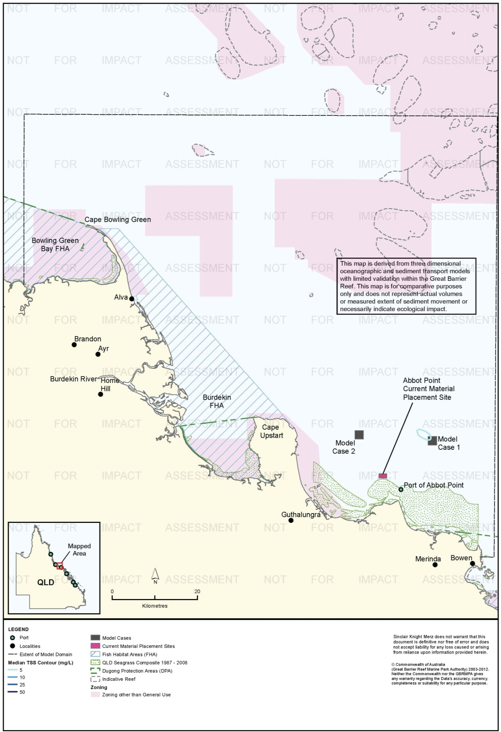
Figure 55. Abbot Point: dredging period (56 days) TSS distribution, Model Case 1 - 50th percentile.

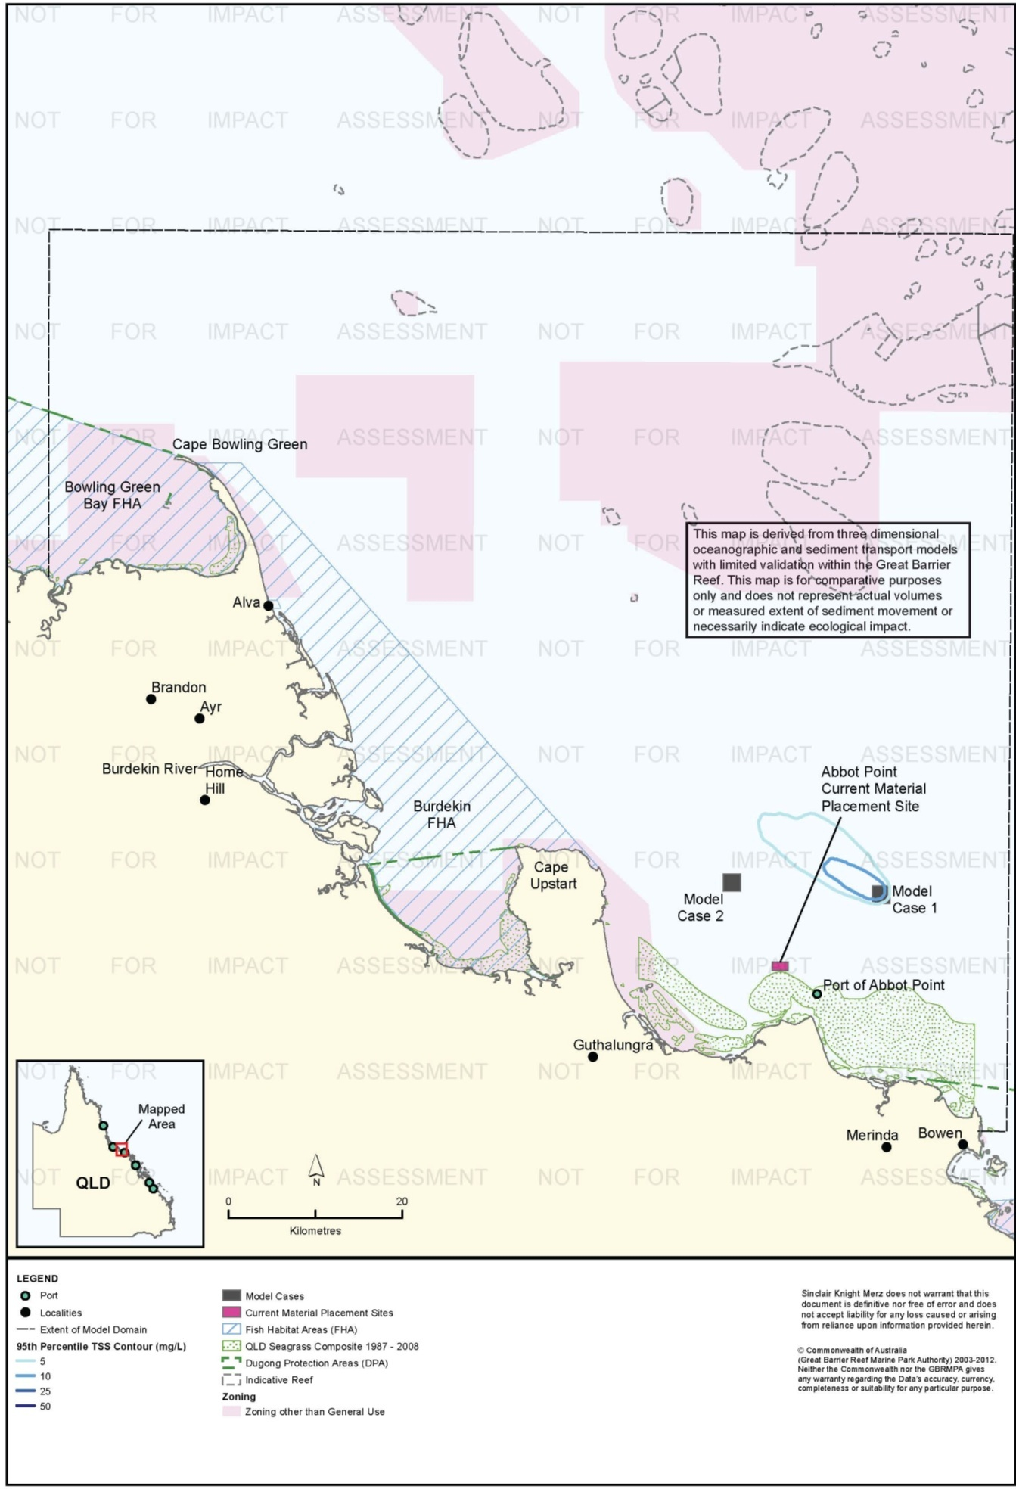
Figure 56. Abbot Point: dredging period (56 days) TSS distribution, Model Case 1 - 95th percentile.

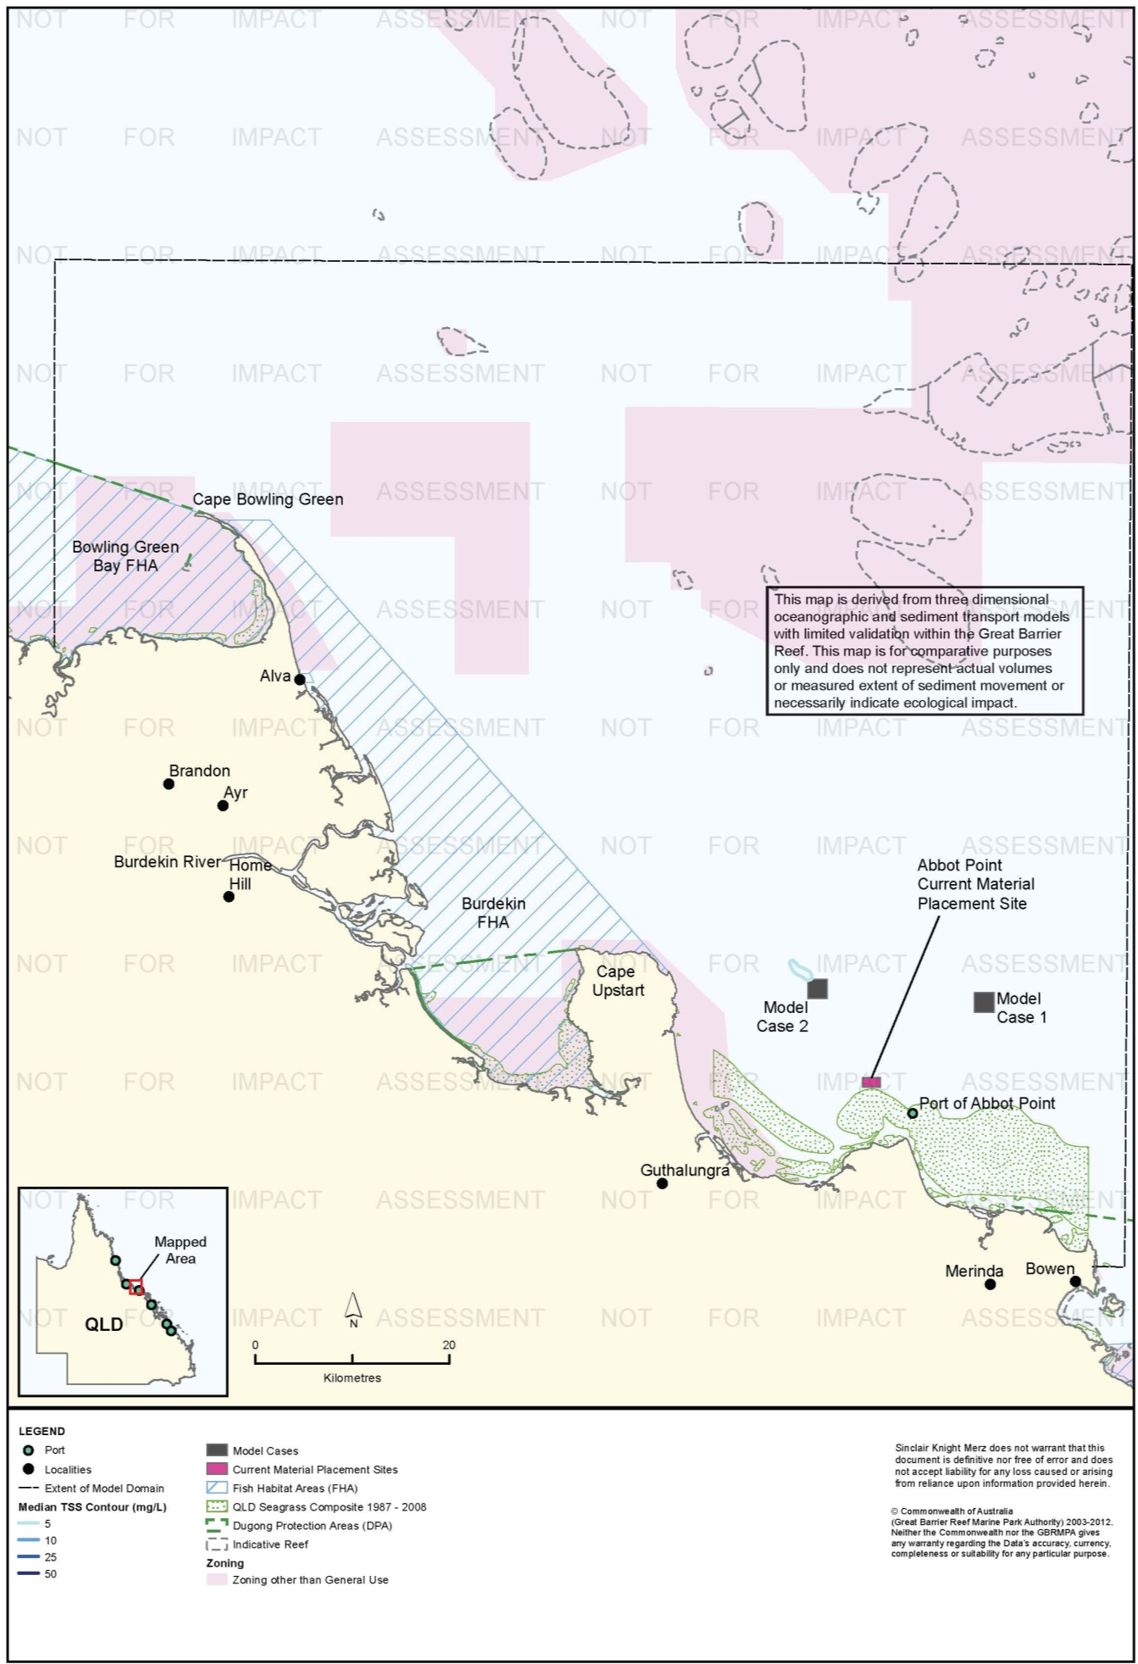
Figure 57. Abbot Point: dredging period (56 days) TSS distribution, Model Case 2 - 50th percentile.

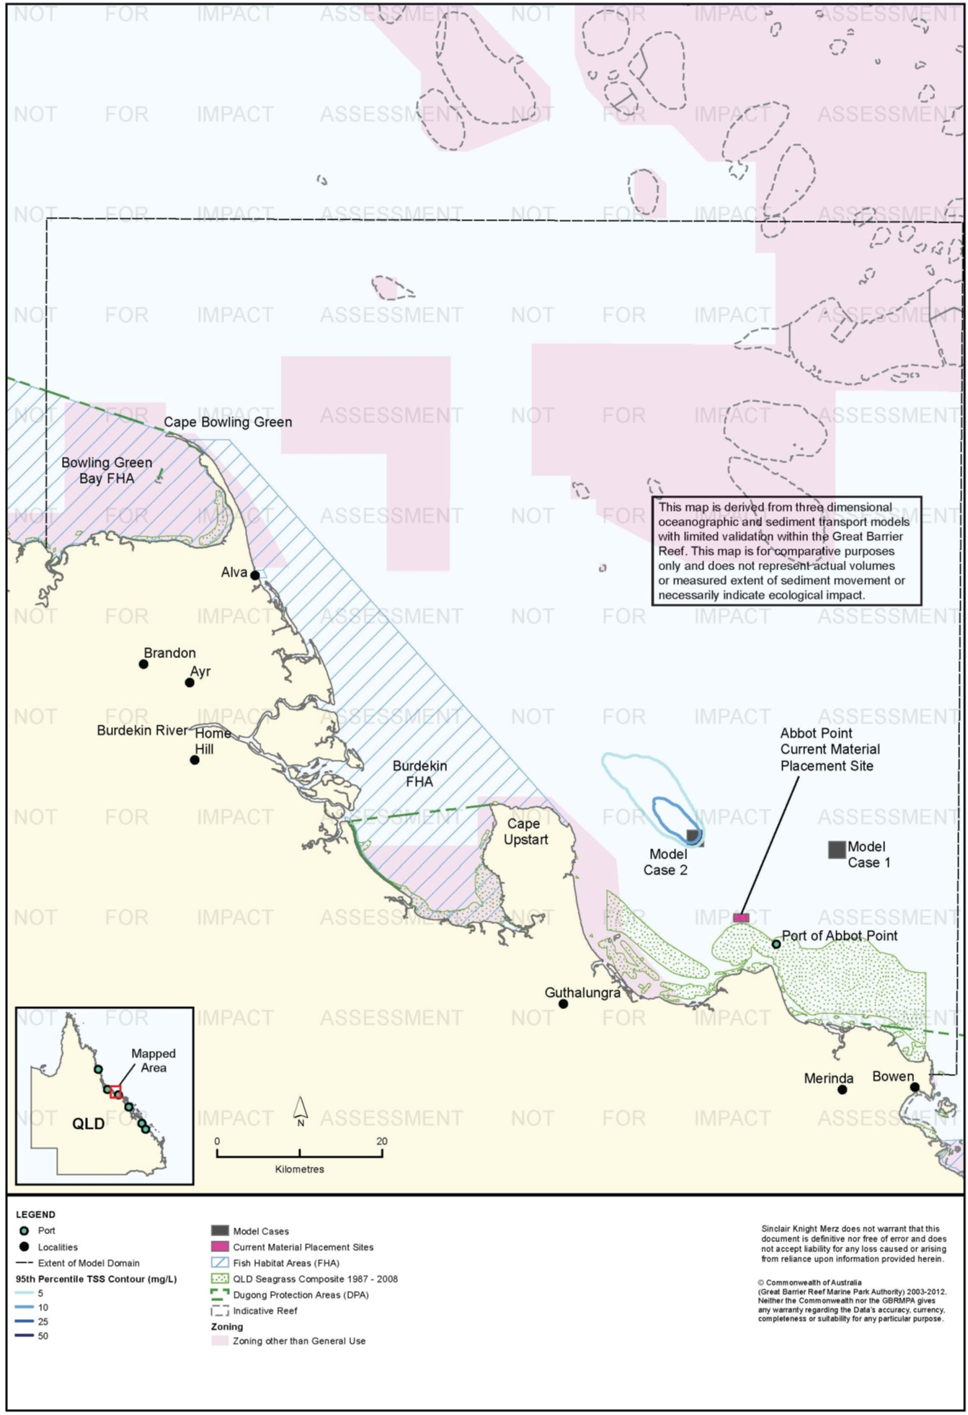
Figure 58. Abbot Point: dredging period (56 days) TSS distribution, Model Case 2 - 95th percentile.

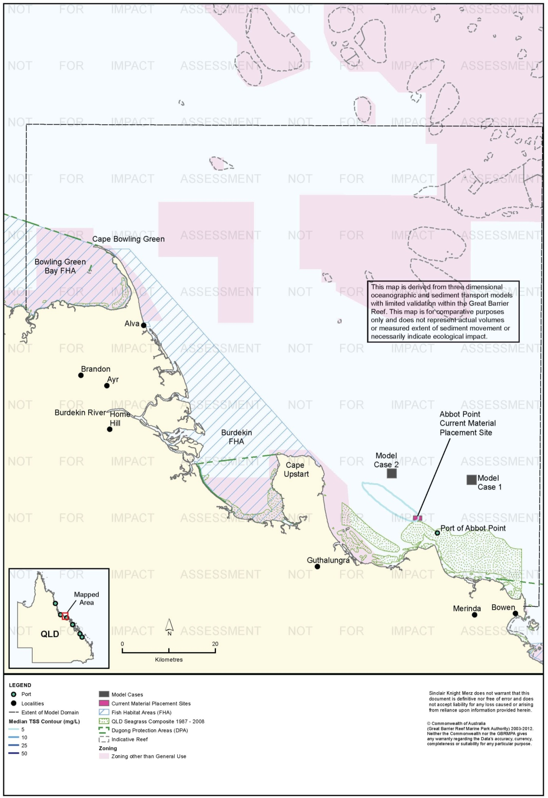
Figure 59. Abbot Point: dredging period (56 days) TSS distribution, current site - 50th percentile.

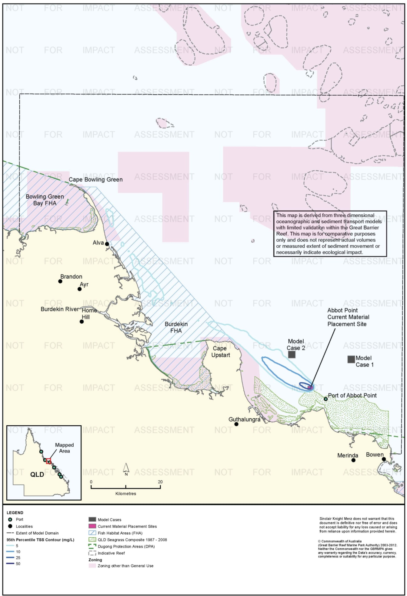
Figure 60. Abbot Point: dredging period (56 days) TSS distribution, current site - 95th percentile.

.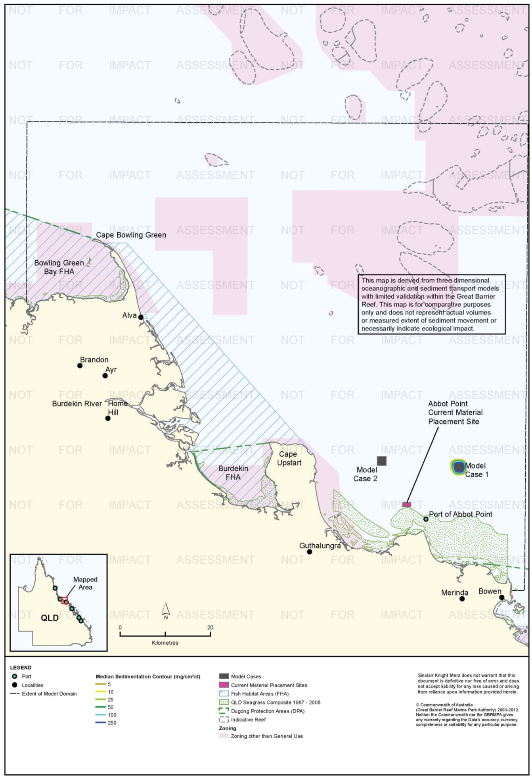
Figure 61. Abbot Point: dredging period (56 days) sedimentation rate, Model Case 1 - 50th percentile.
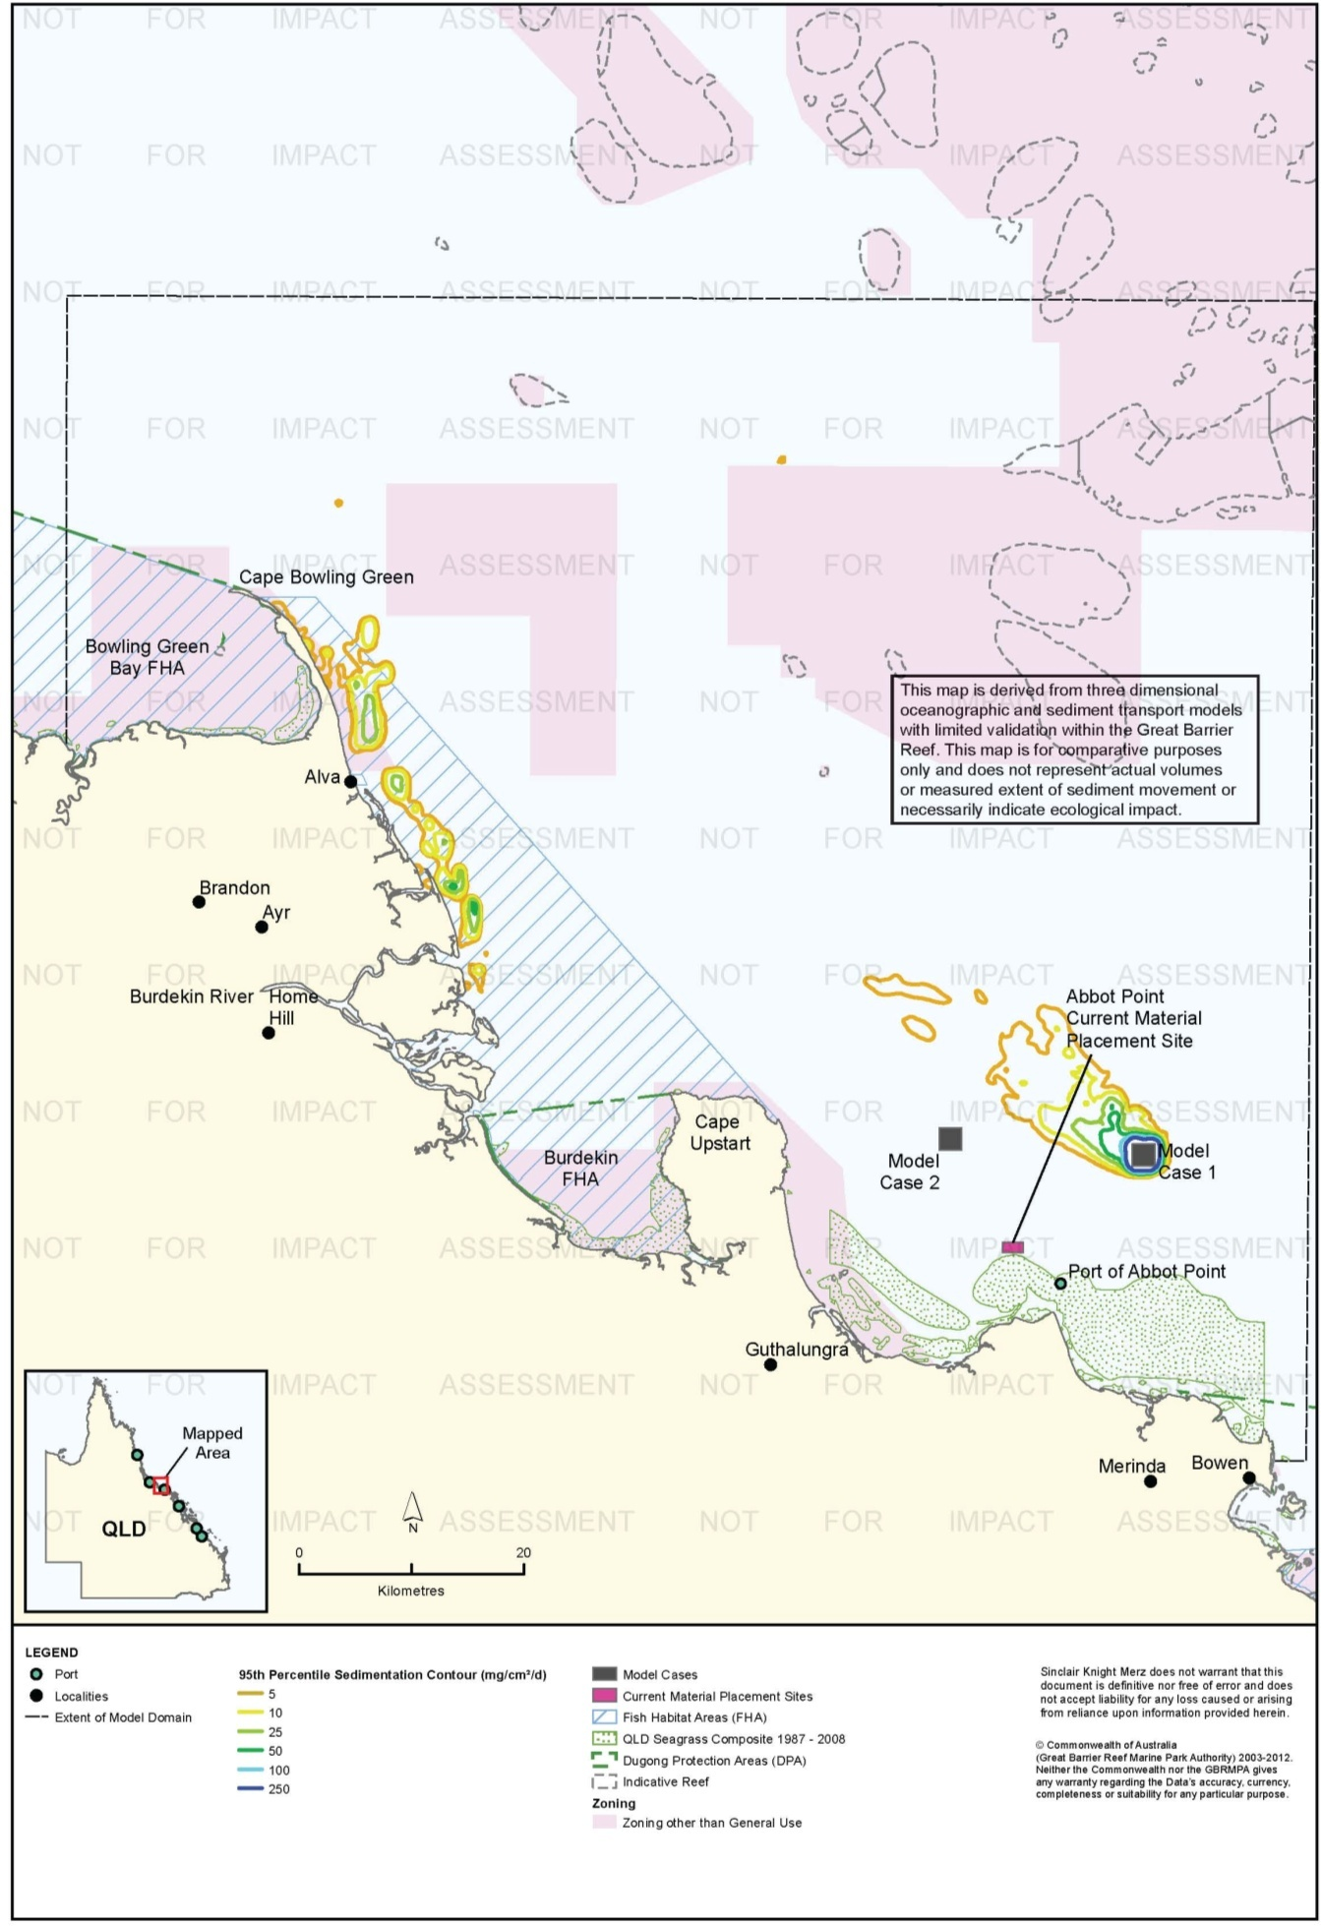
Figure 62. Abbot Point: dredging period (56 days) sedimentation rate, Model Case 1 - 95th percentile.

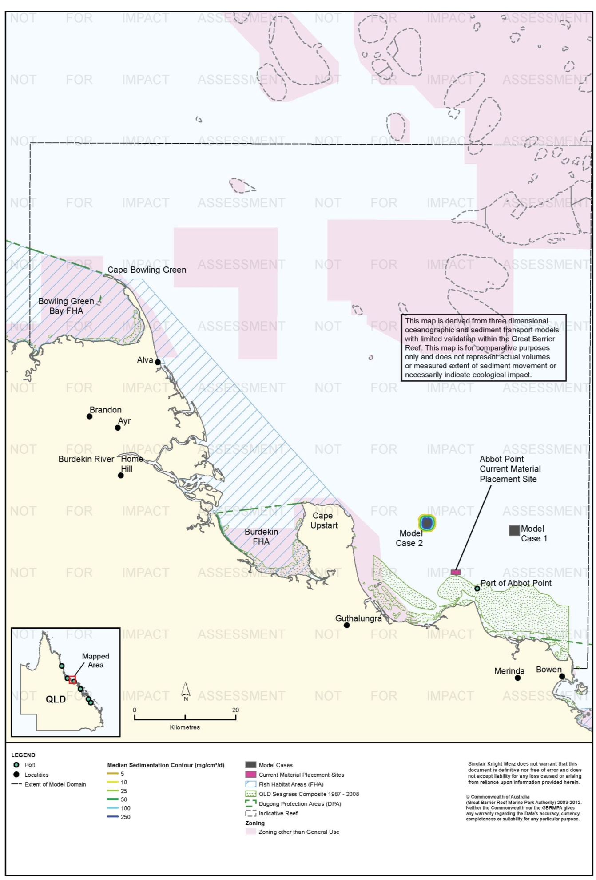
Figure 63. Abbot Point: dredging period (56 days) sedimentation rate, Model Case 2 - 50th percentile.
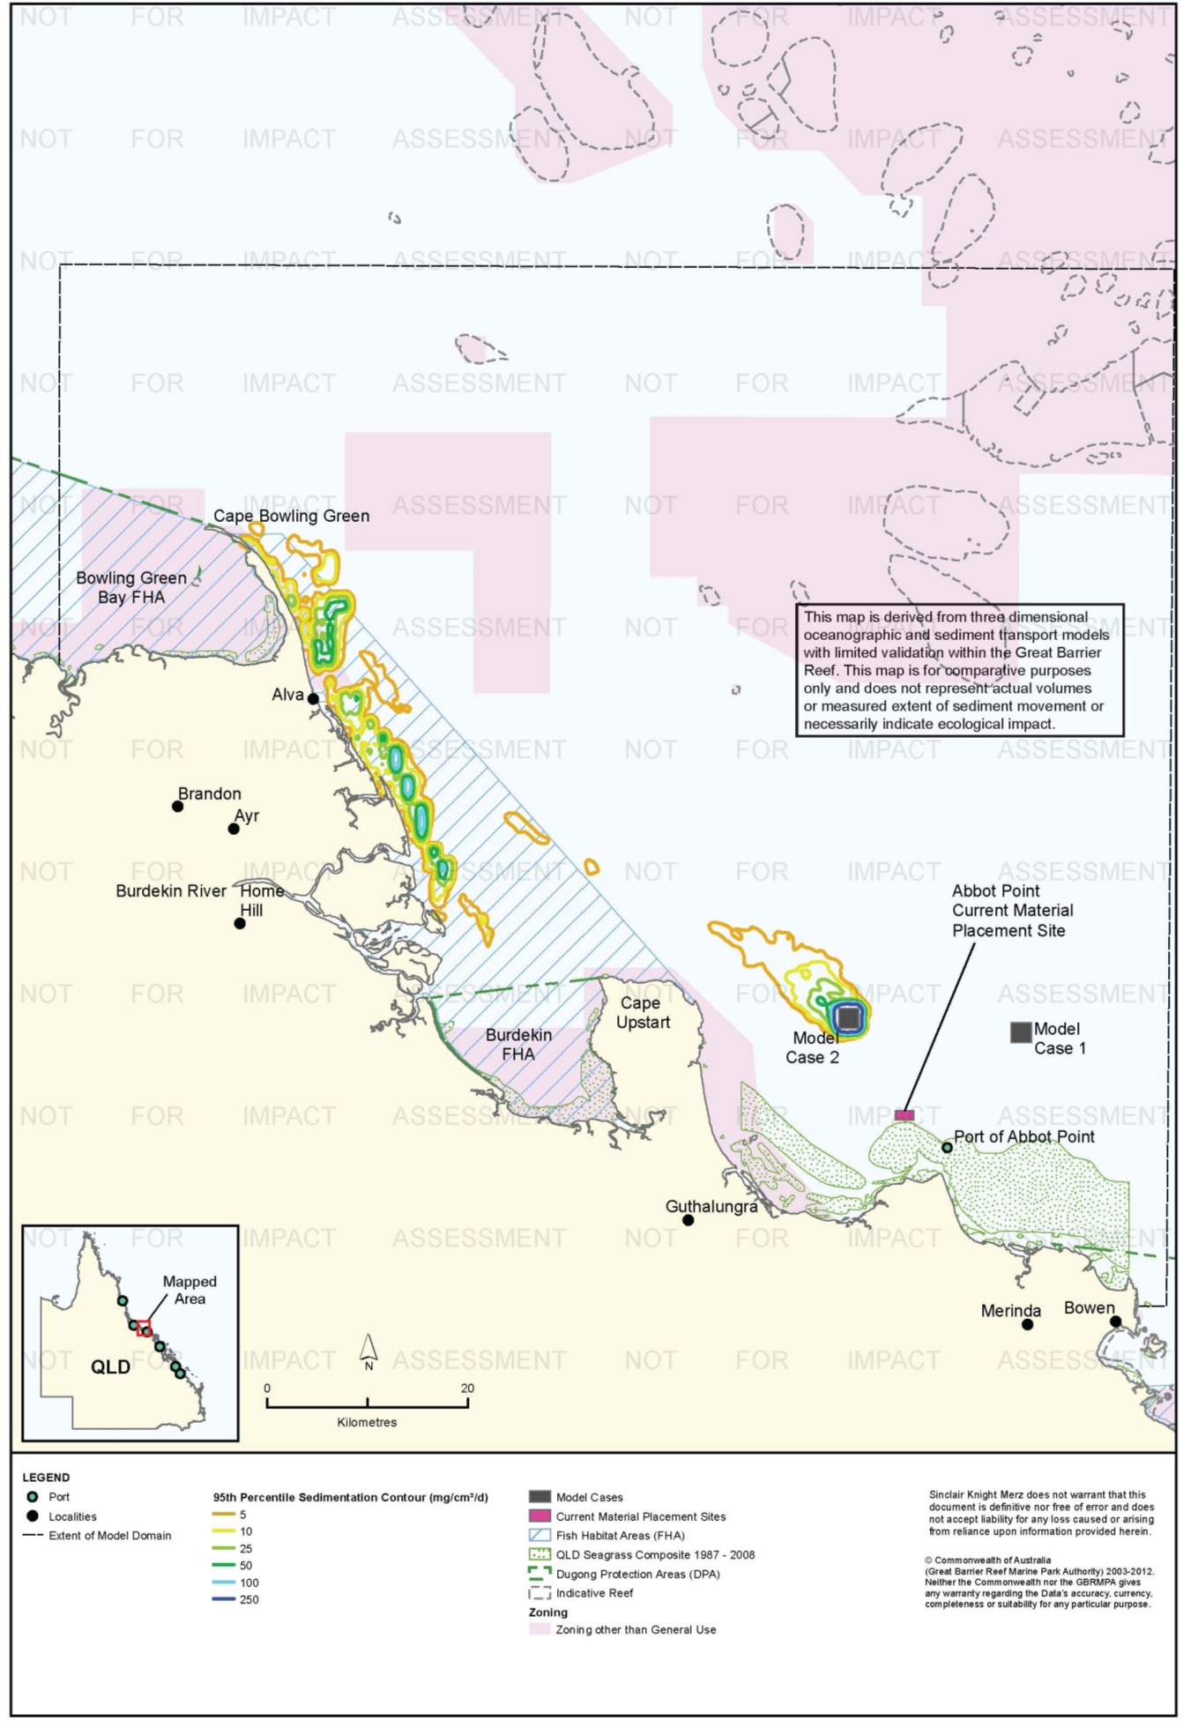
Figure 64. Abbot Point: dredging period (56 days) sedimentation rate, Model Case 2 - 95th percentile.

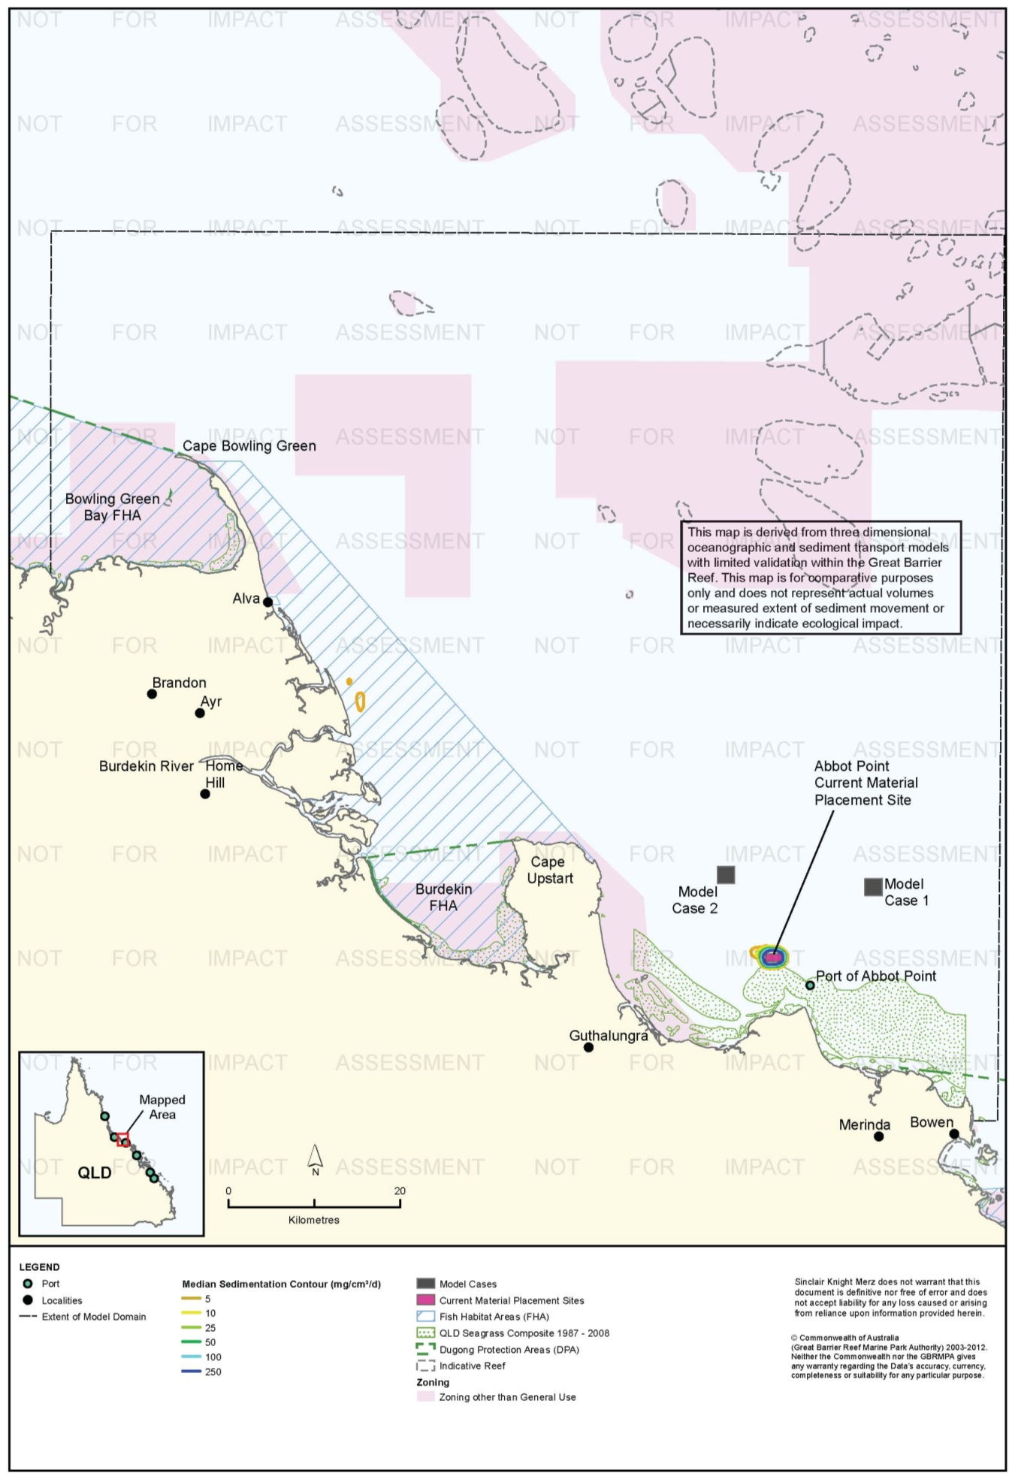
Figure 65. Abbot Point: dredging period (56 days) sedimentation rate, current site - 50th percentile.

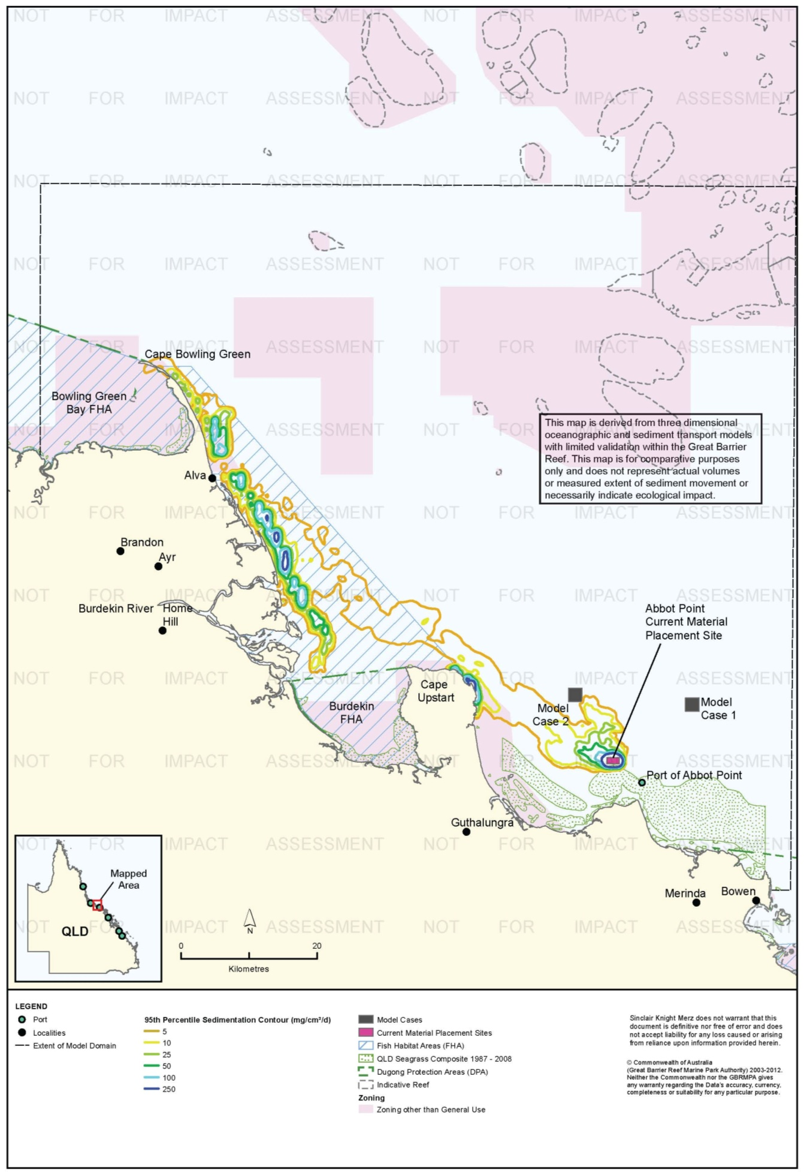
Figure 66. Abbot Point: dredging period (56 days) sedimentation rate, current site - 95th percentile.

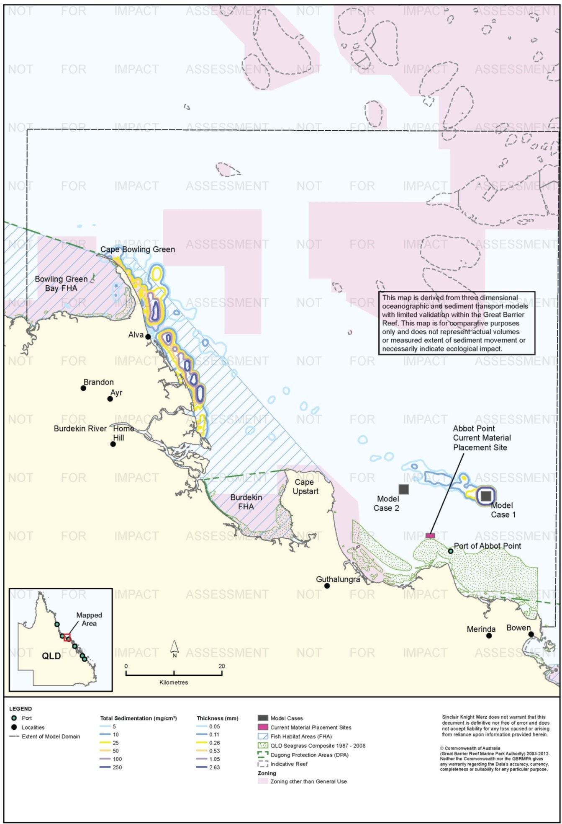
Figure 67. Abbot Point: dredging period (56 days) total sedimentation and bottom thickness, Model Case 1.

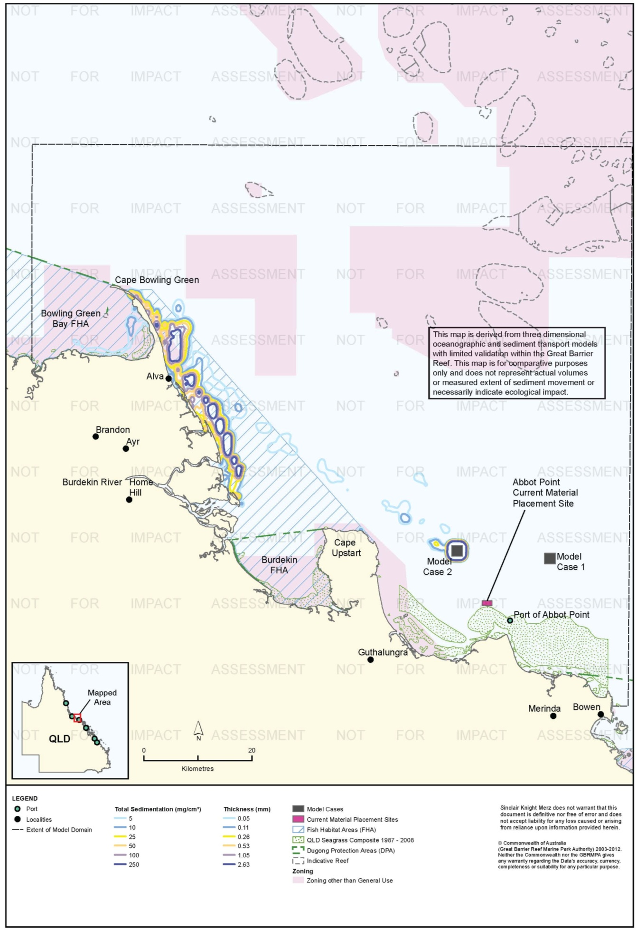
Figure 68. Abbot Point: dredging period (56 days) total sedimentation and bottom thickness, Model Case 2.

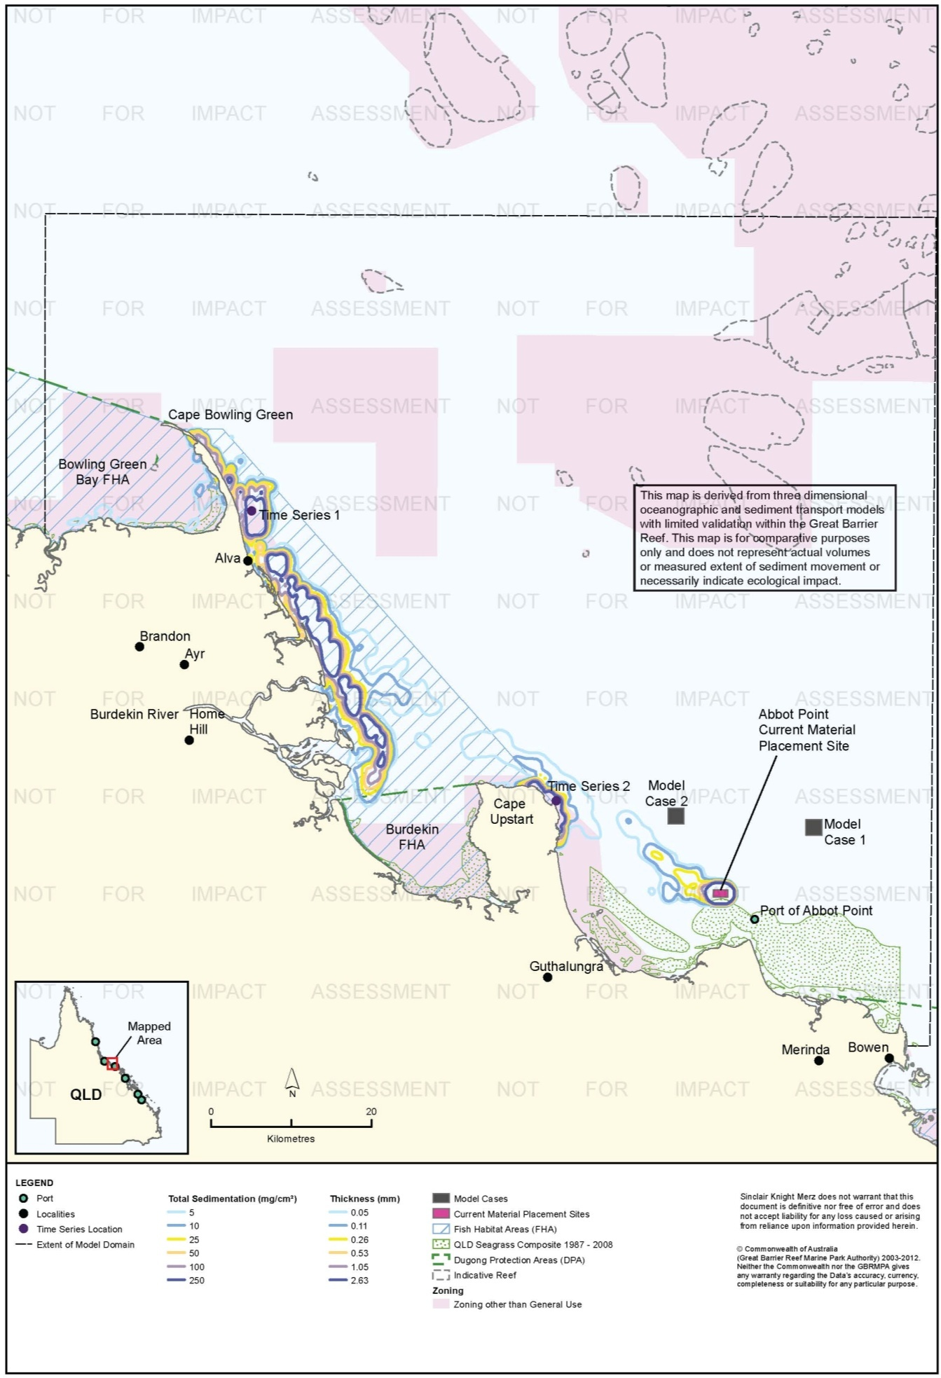
Figure 69. Abbot Point: dredging period (56 days) total sedimentation and bottom thickness, current site.

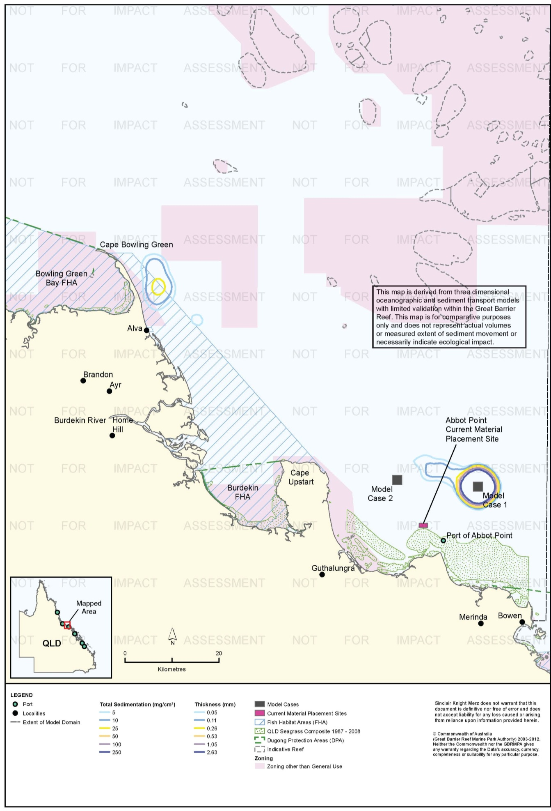
Figure 70. Abbot Point: long-term (12 months) total sedimentation and bottom thickness, Model Case 1.

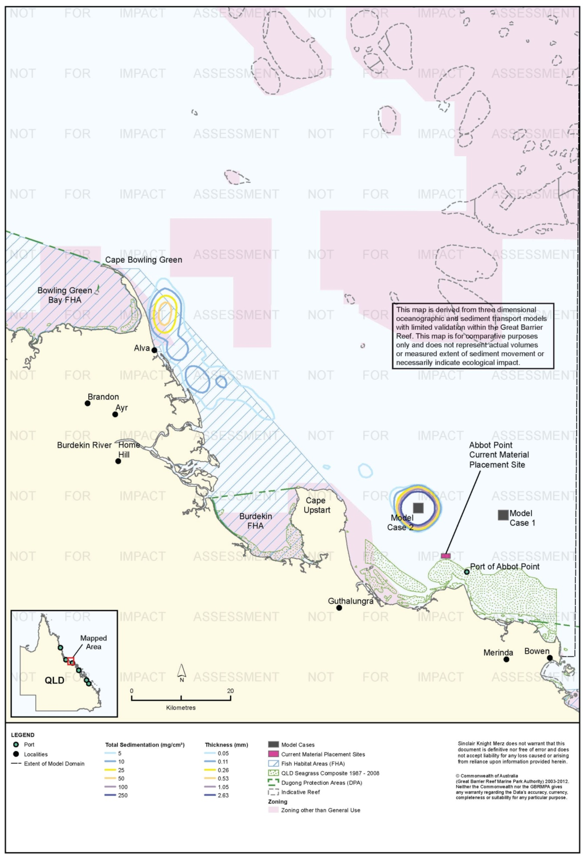
Figure 71. Abbot Point: long-term (12 months) total sedimentation and bottom thickness, Model Case 2.

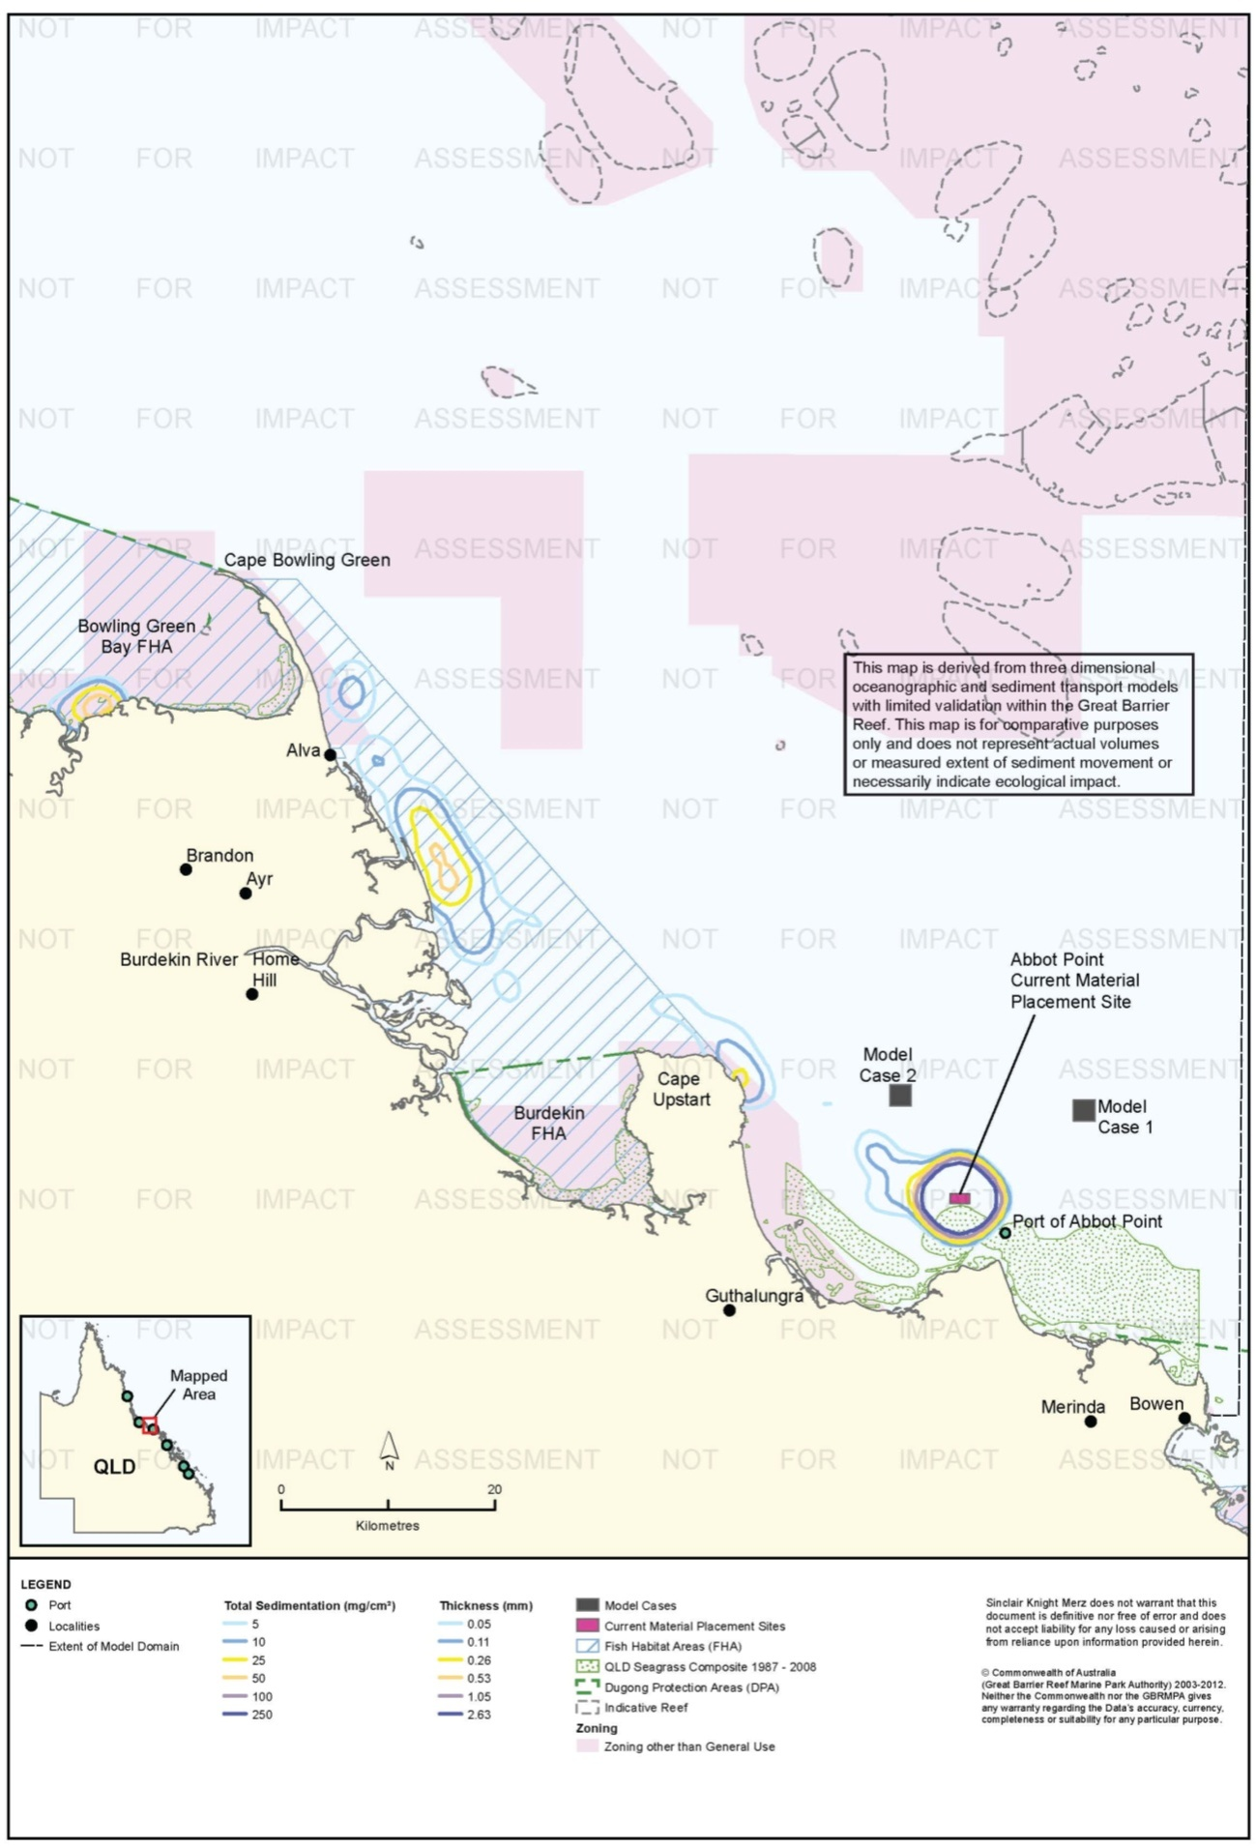
Figure 72. Abbot Point: long-term (12 months) total sedimentation and bottom thickness, current site.

Risk Assessment
The results of the risk assessment are presented in table 22. Suspended sediment plumes are rated a low risk to sensitive environmental receptors for Model Cases 1 and 2, with risks associated with the current site generally assessed as medium. This reflects the shoreward transport of sediment plumes under the 95th percentile scenario, causing minor consequence ratings for some sensitive receptors. It should be noted that the 50th percentile TSS contour for the current site predicts minimal overlap between the suspended sediment plume and sensitive environmental receptors under average (median) conditions, further justifying the risk ratings of medium rather than high.
Modelling predicted infrequent (95th percentile) high sedimentation rates for the current site at Cape Upstart during the dredging period; the 95th percentile corresponds to 2.8 days over the total dredging period when these rates were predicted to occur. Cape Upstart has high environmental values, including rocky reefs with fringing coral, and is gazetted a Marine National Park Zone within the Marine Park. An increase in sedimentation rates at Cape Upstart was not predicted for Model Cases 1 and 2, with sedimentation contours distributed further out to sea and only reaching the mainland further north towards the township of Ayr (50 km north-west of Model Case 2).
Coastal waters north of Cape Upstart up to Cape Bowling Green are predicted to be a highly depositional environment, with sediment placed at all three material placement sites predicted to be deposited there before moving north in long-shore coastal processes typical of the inner Great Barrier Reef (Bainbridge et al. 2012; Orpin et al. 2004). This should be considered in the context of the highly seasonal rainfall and weather conditions experienced in the Abbot Point region, which are likely to create resuspended sediment plumes for reasons unrelated to dredging and placement activities at certain times of the year.
The alternative material placement sites at Abbot Point appear to have a lower level of environmental risk, when compared with the current site, by virtue of their distance offshore away from Cape Upstart. However, such conclusions should be tempered by the absence of any monitoring of previous material placement activities in this region, and the short term duration of increased sedimentation at key sensitive receptors near the current site. Relocation of the placement site offshore may result in new risks to sensitive receptors, and would therefore warrant further investigations to provide greater certainty of any potential environmental risks.
Since placement activities at all three modelled sites were predicted to result in considerable increases in total sedimentation adjacent to Alva within the Burdekin FHA during the dredging period. Further assessment of the environmental values of habitats in this location and their potential sensitivity to material placement activities may be appropriate. Environmental risk to the Burdekin and to a lesser extent Cape Bowling Green FHAs resulting from increased total sedimentation has been assessed as high for all three placement sites.
Modelling of all three model cases predicts significantly reduced total sedimentation after 12 months compared to the end of the dredging period. This reflects the northward movement of sediment beyond the model extent. This was especially the case for Model Case 1. Predicted total sedimentation at the end of the 12 months for the current site includes areas with up to 50 mg/cm² (0.48 mm) total sedimentation in the Bowling Green Bay and Burdekin FHAs.
Table 22.Comparative risk assessment for the Port of Abbot Point based on modelling results (Figure 55 to Figure 72).
Hazard | Sensitive Receptor | Site | Likelihood | Consequence | Risk Rating
An increase in TSS concentration and turbidity in waters surrounding the material placement site. | Coral Reefs | Current Site | Possible | Minor | Medium
 |  | Model Case 1 | Rare | Insignificant | Low
 |  | Model Case 2 | Rare | Insignificant | Low
 | Seagrass. | Current Site | Possible | Minor | Medium
 |  | Model Case 1 | Rare | Insignificant | Low
 |  | Model Case 2 | Rare | Insignificant | Low
 | Fish Habitat Areas | Current Site | Possible | Minor | Medium
 |  | Model Case 1 | Rare | Insignificant | Low
 |  | Model Case 2 | Possible | Insignificant | Low
 | Non-general Use Zones | Current Site | Possible | Minor | Medium
 |  | Model Case 1 | Rare | Insignificant | Low
 |  | Model Case 2 | Rare | Insignificant | Low
 | Commercial fisheries | Current Site | Possible | Minor | Medium
 |  | Model Case 1 | Unlikely | Minor | Low
 |  | Model Case 2 | Unlikely | Minor | Low
 | Tourism and recreational values | Current Site | Unlikely | Minor | Low
 |  | Model Case 1 | Unlikely | Minor | Low
 |  | Model Case 2 | Unlikely | Minor | Low
Increase in the rate of sediment deposition on the sea bed in areas surrounding the material placement site. | Coral Reefs | Current Site | Possible | Moderate | High
 |  | Model Case 1 | Unlikely | Minor | Low
 |  | Model Case 2 | Unlikely | Minor | Low
 | Seagrass. | Current Site | Possible | Minor | Medium
 |  | Model Case 1 | Possible | Minor | Medium
 |  | Model Case 2 | Possible | Minor | Medium
 | Fish Habitat Areas | Current Site | Possible | Moderate | High
 |  | Model Case 1 | Possible | Moderate | High
 |  | Model Case 2 | Possible | Moderate | High
 | Non-general Use Zones | Current Site | Possible | Moderate | High
 |  | Model Case 1 | Possible | Minor | Medium
 |  | Model Case 2 | Possible | Minor | Medium
 | Commercial fisheries | Current Site | Possible | Minor | Medium
 |  | Model Case 1 | Unlikely | Minor | Low
 |  | Model Case 2 | Unlikely | Minor | Low
 | Tourism and recreational values | Current Site | Unlikely | Minor | Low
 |  | Model Case 1 | Unlikely | Minor | Low
 |  | Model Case 2 | Unlikely | Minor | Low
Accumulation of sediments on the sea bed. | Coral Reefs | Current Site | Likely | Moderate | High
 |  | Model Case 1 | Rare | Minor | Low
 |  | Model Case 2 | Rare | Minor | Low
 | Seagrass. | Current Site | Possible | Minor | Medium
 |  | Model Case 1 | Unlikely | Minor | Low
 |  | Model Case 2 | Unlikely | Minor | Low
 | Fish Habitat Areas | Current Site | Likely | Minor | Medium
 |  | Model Case 1 | Likely | Minor | Medium
 |  | Model Case 2 | Likely | Minor | Medium
 | Non-general Use Zones | Current Site | Likely | Moderate | High
 |  | Model Case 1 | Possible | Minor | Medium
 |  | Model Case 2 | Possible | Minor | Medium
 | Commercial fisheries | Current Site | Possible | Moderate | High
 |  | Model Case 1 | Unlikely | Minor | Low
 |  | Model Case 2 | Unlikely | Minor | Low
 | Tourism and recreational values | Current Site | Unlikely | Minor | Low
 |  | Model Case 1 | Rare | Minor | Low
 |  | Model Case 2 | Rare | Minor | Low

Ecological Monitoring in Relation to Dredging
No reports of ecological monitoring conducted during dredging and at sea dredge material placement activities were available to SKM.

Environmental Condition
Water quality in the Burdekin region, which includes the Port of Abbot Point is monitored by the RRMMP (Schaffelke et al. 2011). The water quality aspect of the monitoring program includes inshore permanent monitoring sites (water quality loggers) and remote sensing techniques. Permanent monitoring sites have been established in the Burdekin region since 2007. No permanent monitoring sites are within 50 km of the Port of Abbot Point with the nearest location (Geoffrey Bay) approximately 150 km north. Regionally, water quality in the area has been declining since 2007 with the annual mean increasing from 2007/2008 with values at greater than double at some locations (table 23; Schaffelke et al. 2011).
Table 23. Summary of annual mean turbidity (NTU) data from turbidity sensors at Burdekin region water quality locations from the RRMMP¹.
Site | 2007-2008² | 2008 to 2009² | 2009-2010² | 2010-2011³
Pelorus Island | 0.50 | 0.74 | 0.60 | 1.17
Pandora Reef | 0.97 | 1.17 | 1.10 | 1.85
Magnetic Island (Geoffrey Bay) | 2.12 | 2.33 | 1.79 | 3.00
1 Data extracted from Schaffelke et al. 2011. 2 – Years are from October to September 3 – October to June
Remote sensing is used to monitor TSS concentrations for the entire Marine Park at a spatial resolution of 1 km (Brando et al. 2011). TSS concentrations within the Burdekin region have improved with the TSS paddock to reef index of poor (30 per cent) in 2002/2003 increasing to moderate (57 per cent) in 2010/2011 (Brando et al. 2011). Data from May 2010 to April 2011 for the Port of Abbot Point and surrounding areas recorded a clear declining gradient from inshore to offshore with median TSS values as high as 5 mg/L for shallow coastal area such as Cape Bowling Green, the mouth of the Burdekin River and Cleveland Bay (Brando et al. 2011). Annual median TSS concentrations at the locations of Mode Cases 1 and 2 the current material placement site ranged from approximately 1.00 mg/L to 0.25 mg/L (Brando et al. 2011), with the current material placement site having the highest TSS values.
Baseline data from April 2008 to June 2008 was collected at five locations surrounding the Port of Abbot Point including three near the working Port and two offshore.Table 24 presents the median, 80th percentile and 95th percentile values for turbidity and TSS (SKM 2013).
Table 24. Baseline turbidity and TSS at the Port of Abbot Point.
Site | Median |  | 80th percentile |  | 95th percentile
 | Turbidity (NTU) | TSS (mg/L) | Turbidity (NTU) | TSS (mg/L) | Turbidity (NTU) | TSS (mg/L)
Deepwater west | 2 | 1.2 | 6 | 2.7 | 17 | 7.9
Deepwater east | 1 | 1.2 | 2 | 2.4 | 4 | 4.7
Coastal west | 2 | 5.7 | 6 | 15.7 | 27 | 64.3
Coastal middle | 5 | 9.1 | 18 | 35.2 | 61 | 118.8
Coastal east | 9 | 20.3 | 23 | 53.4 | 90 | 208.5

Reef health in the Burdekin region is monitored at seven monitoring sites by the RRMMP. No monitoring sites are within 50 km of the Port of Abbot Point with the closest monitoring sites approximately 150 km north. Hard coral cover in the region has generally shown a slight decrease since monitoring began in 2005 (Thompson et al. 2011). Thompson et al. (2011a) assessed the overall condition of coral communities as poor due to the low densities of juvenile coral and low cover both overall and during periods free of acute disturbances (Thompson et al. 2011). Table 25 displays the RRMMP score since 2009 which decreased from moderate to poor.
Table 25. RRMMP monitoring score for overall inshore coral health for the Burdekin region from 2009-2011 (Thompson et al. 2011a, b).
Year | RRMMP score
2009 | Moderate
2010 | Poor
2011 | Poor

Reefs are also monitored throughout the Reef by the AIMS Long Term monitoring program, which has been in operation since1992 (Sweatman et al. 2005). No information is provided for this monitoring program as the reefs monitored are approximately 150 km north of the Port of Abbot Point and are well away from any predicted sedimentation or TSS influence.
An intertidal assessment of seagrass in the Burdekin region was conducted in 2011 as part of the Seagrass Vulnerability Assessment for the Great Barrier Reef (Commonwealth of Australia 2011). The overall condition of seagrass was assessed as very poor, with major declines recorded in 2009.
The 2010 Great Barrier Reef Report Card rated the overall condition of inshore water quality as moderate with TSS volumes low enough to receive a good report card rating (State of Queensland 2013). Seagrass and coral health both received poor grader with poor coral cover and very poor seagrass abundance (State of Queensland 2013).
While sponges, macroalgae and macroinvertebrate assemblages are known to occur in the area very little is known about the condition of these receptors, with further study required.
Monitoring of coastal and deepwater seagrass communities at Abbot Point has been occurring since baseline studies were conducted in 2008. The final report of the coastal and deepwater seagrass monitoring program conducted between June 2010 and September 2011 at the Port of Abbot Point found that seagrass meadows are highly dynamic, changing as a function of season and were influenced by weather events during the monitoring period. Seagrass biomass and distribution was lowest at the end of the wet season and highest in the late dry season with significant losses observed after the November 2010 survey particularly in coastal meadows (McKenna & Rasheed 2011). Studies concluded that seagrasses at Abbot Point have the potential to recover from port-related disturbances; however, recovery is dependent on the species present and the availability of seed reserves (McKenna & Rasheed 2011). Halophila spp. resilient and dominant in the offshore meadows of Abbot Point. Inshore seagrass meadows, dominated by Halodule uninervis, are less resilient to long-term impacts. McKenna & Rasheed (2011) note that natural stressors from climatic events and future port expansion have the potential to push seagrass meadows into a vulnerable state.

Port of Townsville
Coastal areas within the Townsville region include coral reefs, coastal seagrass and several offshore islands. Sea turtle feeding sites occur in the region, but there are no known nesting sites. The Cleveland Bay-Magnetic Island DPA lies immediately either side of port limits to the north-west and south-east. All of Bowling Green Bay to the south-east is a Dugong Protection Area. The south-east portion of Cleveland Bay and all of Bowling Green Bay are FHAs. Magnetic Island is a popular tourist location and is located in close proximity to the city of Townsville and its associated port and is located approximately 6 km west of the current site.

Suspended Sediment Plumes
Figure 73 to figure 77 show modelled contours of TSS concentration for the three placement areas. The modelling predicted that, for all three placement sites, TSS of 5 mg/L would not occur for 50 per cent of the time at any location, so no 50th percentile predictions for TSS are presented. The model also predicted that TSS of 5 mg/L would not occur for even 5 per cent of the time for Model Case 1, so no 95th percentile contours are plotted for Model Case 1. Therefore for the purposes of comparing the three alternative placement sites, 100th percentile contours (i.e. the extent of areas experiencing the contoured value for 1 hour at any time in the 45-day model run) are presented for Model Case 1 (figure 73). For comparison with Model Case 1, 100th percentile contours were also generated for Model Case 2 and the current site (figure 75 and figure 77).
The modelling predicted that suspended sediment plumes would be of very low magnitude, and would disperse predominantly to the north-west for all three placement sites. There was also some predicted dispersion to the south-east, driven by tides, in the 100th percentile outputs. It should be remembered that the 100th percentile contours represent the maximum extent of TSS experienced in any one-hour model step, and the dramatic difference between the 95th and 100th percentile contours indicates that elevated TSS concentrations would be highly transient.

Sedimentation Rate
Figure 78 to figure 83 show the predicted 50th and 95th and percentile sedimentation rates for the modelled cases at Townsville.
The 95th percentile sedimentation rate contours for all three model cases extend north-west to Palm Island (50 km north of current site), with the lowest sedimentation predicted for the current placement site. Elevated sedimentation rates on the northern beaches of Magnetic Island were also predicted for all three placement sites. The 95th percentile sedimentation rate contours extended south into Cleveland Bay for the current site, with sedimentation of 5 mg/cm²/d overlapping with seagrass habitat and the Cleveland Bay FHA. The 50th percentile sediment deposition contours for Model Cases 1 and 2 were confined completely within the material placement areas, indicating that there is minimal risk from material placement activities on sensitive receptors of Magnetic Island under average conditions. The predicted 50th percentile contours for the current placement site do impinge on the north-east side of Magnetic Island, at a level of 5 mg/cm²/d; it is well established that small amounts of dredge material from the current site do get transported to Magnetic Island.

Total Sedimentation
Figure 84 to figure 89 show the modelled total amount of sediment deposited on the sea bed at the end of the material placement period and after 12 months. The model predicted higher total sedimentation along the coast, particularly in Cleveland Bay and the east side of Magnetic Island, and less deposition offshore, for the current site compared to Model Cases 1 and 2. Sediment accumulation of 10-25 mg/cm² (0.10-0.24 mm) was predicted to occur during the dredging period for all model case sites and to coincide with seagrass habitats in Cleveland Bay (17 km south of the current site) and to the west of Cape Pallarenda (within a Conservation Park Zone; 21 km of the current site). Coral habitats around Havanah (54 km north-west of current site), Great Palm (51 km north-west of current site), Rattlesnake (37 km west-north-west of current site) and Herald Islands (35 km west-north-west of current site) were also predicted to receive increased sedimentation for all three sites. However, subtle differences were apparent among model cases, with Model Cases 1 and 2 having less sediment accumulation within Cleveland Bay and more around the Palm Islands, than the current site.
Long-term total sedimentation was relatively low for all three model cases, with Model Cases 1 and 2 having 12-month sediment accumulation generally confined to the material placement areas. This represents the migration of mobile sediments north, beyond the model domain boundary from long-shore coastal processes. This was also true for the current site, except for predicted total sedimentation of up to 25 mg/cm² (0.24 mm) of sediment at Rattlesnake and Herald Islands, and 10 mg/cm² at the north-eastern tip of Magnetic Island. It should be kept in mind that this prediction does not take into account the effects of shallow-water waves on these exposed reefs, which is expected to resuspend sediment and displace it to adjacent areas of a lower wave activity (see ‘Hydrodynamic Modelling’, p. 21. Total sedimentation accumulation on the exposed windward sides of reefs is probably over-estimated by the model

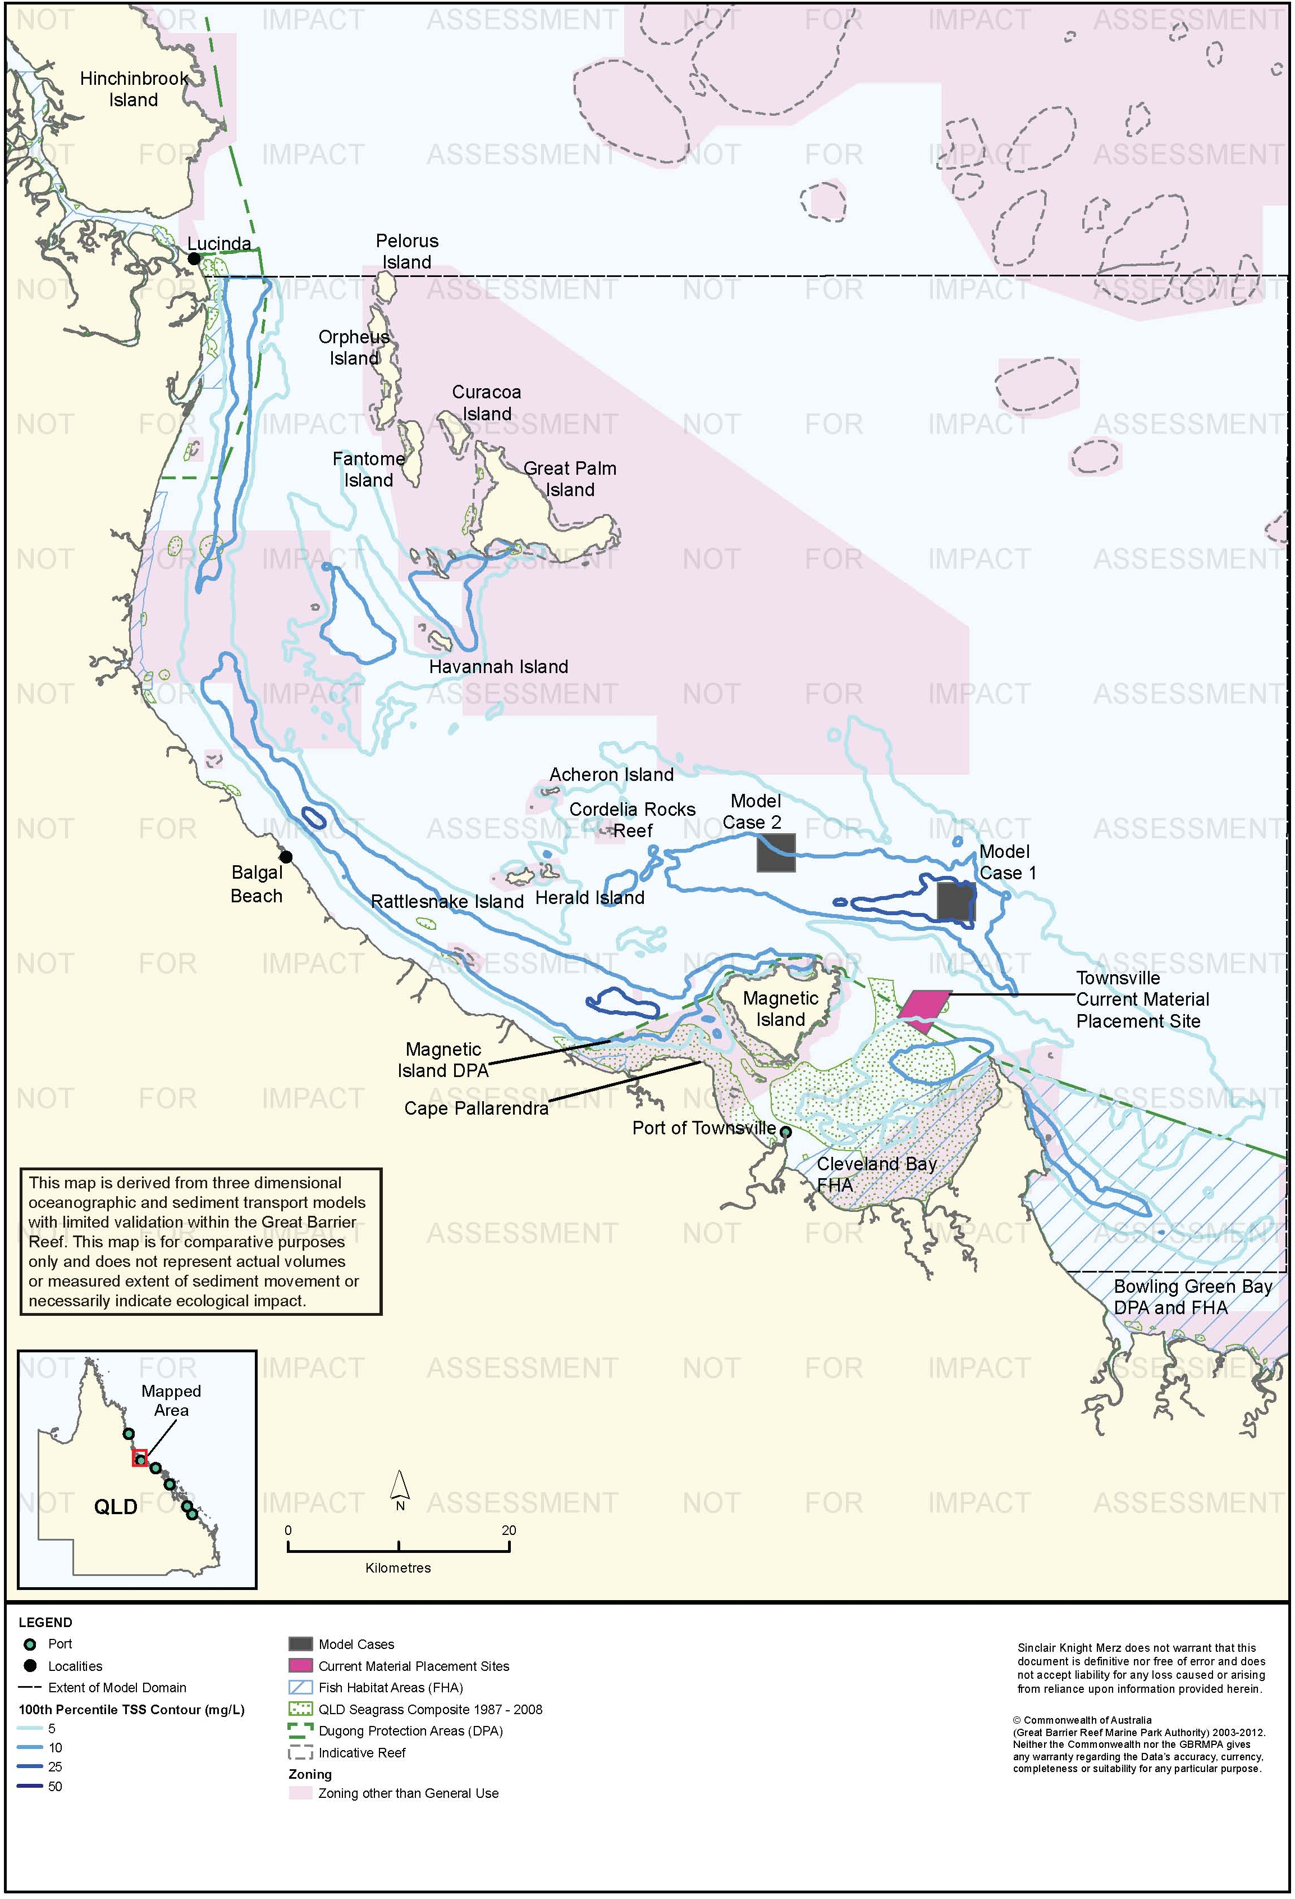
Figure 73. Townsville: dredging period (45 days) TSS distribution, Model Case 1 - 100th percentile.

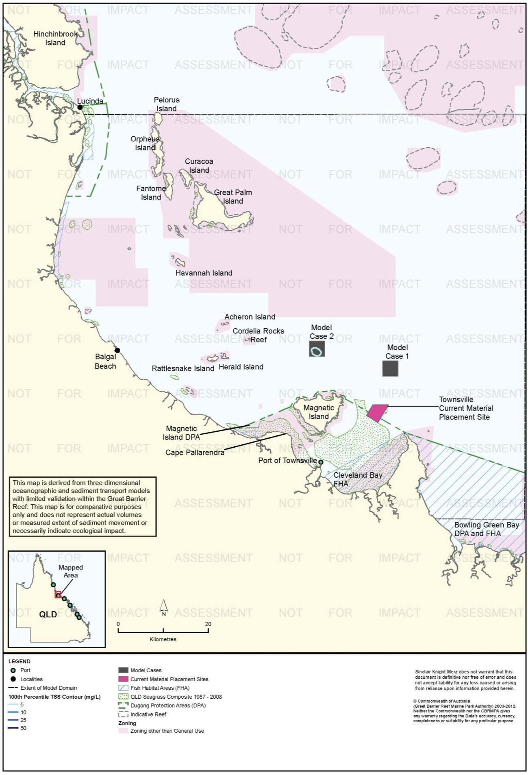
Figure 74. Townsville: dredging period (45 days) TSS distribution, Model Case 2 - 95th percentile.

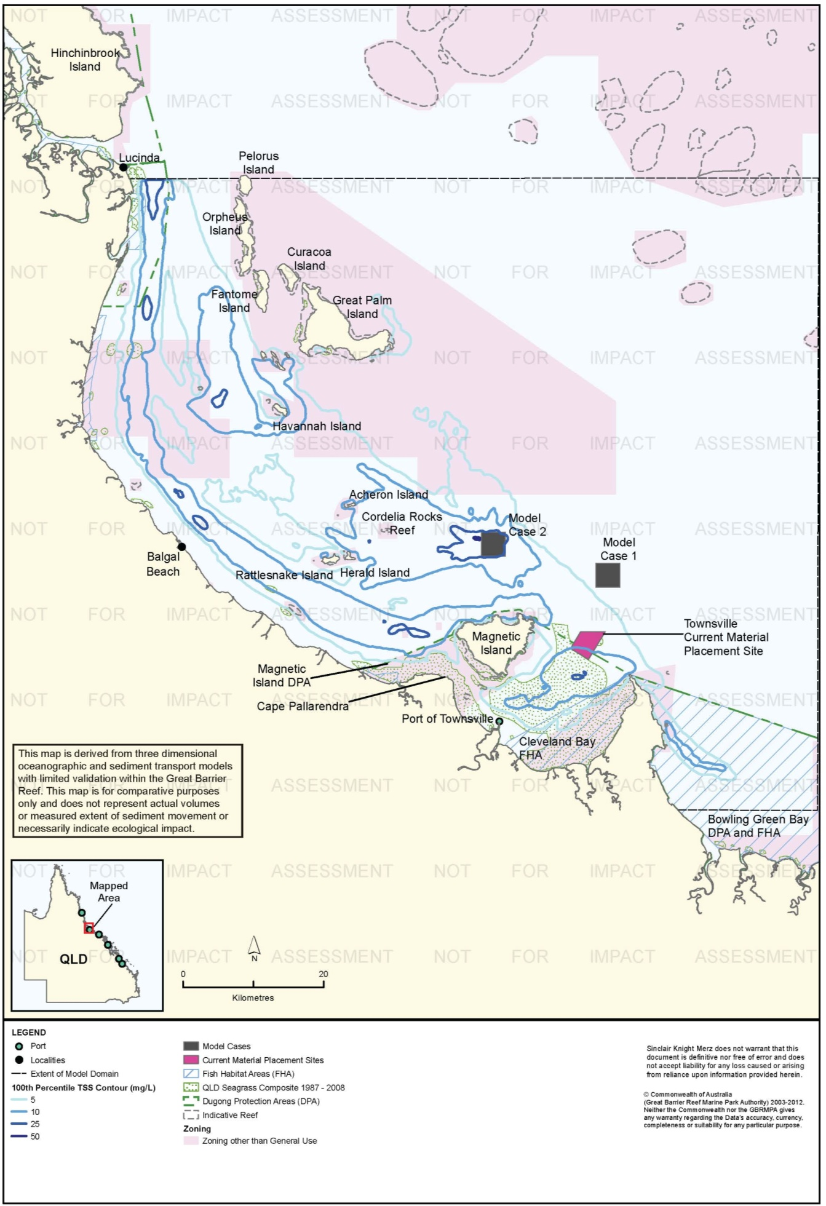
Figure 75. Townsville: dredging period (45 days) TSS distribution, Model Case 2 - 100th percentile.

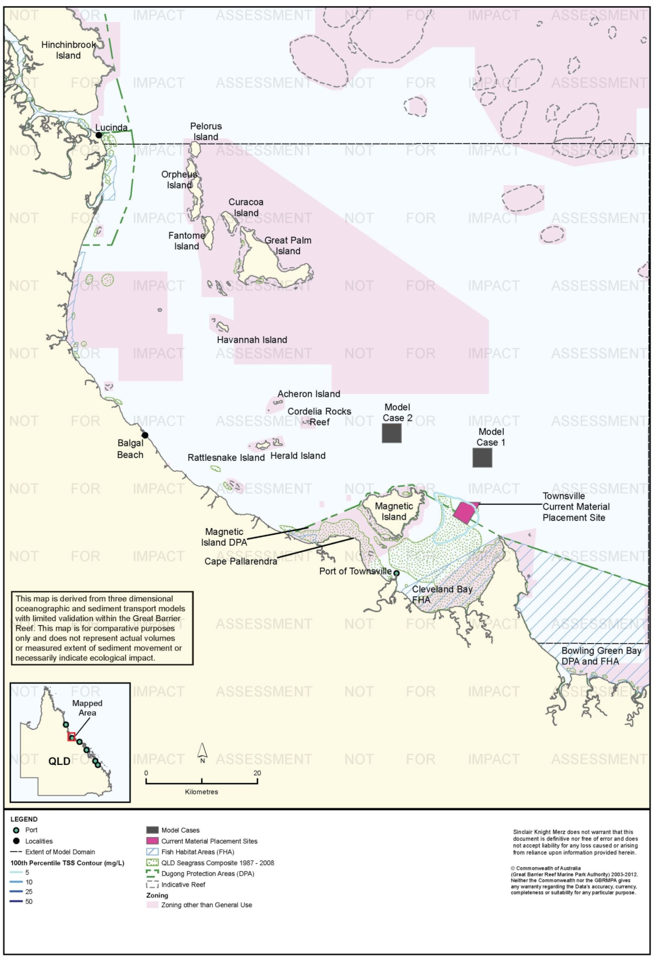
Figure 76. Townsville: dredging period (45 days) TSS distribution, current site - 95th percentile.

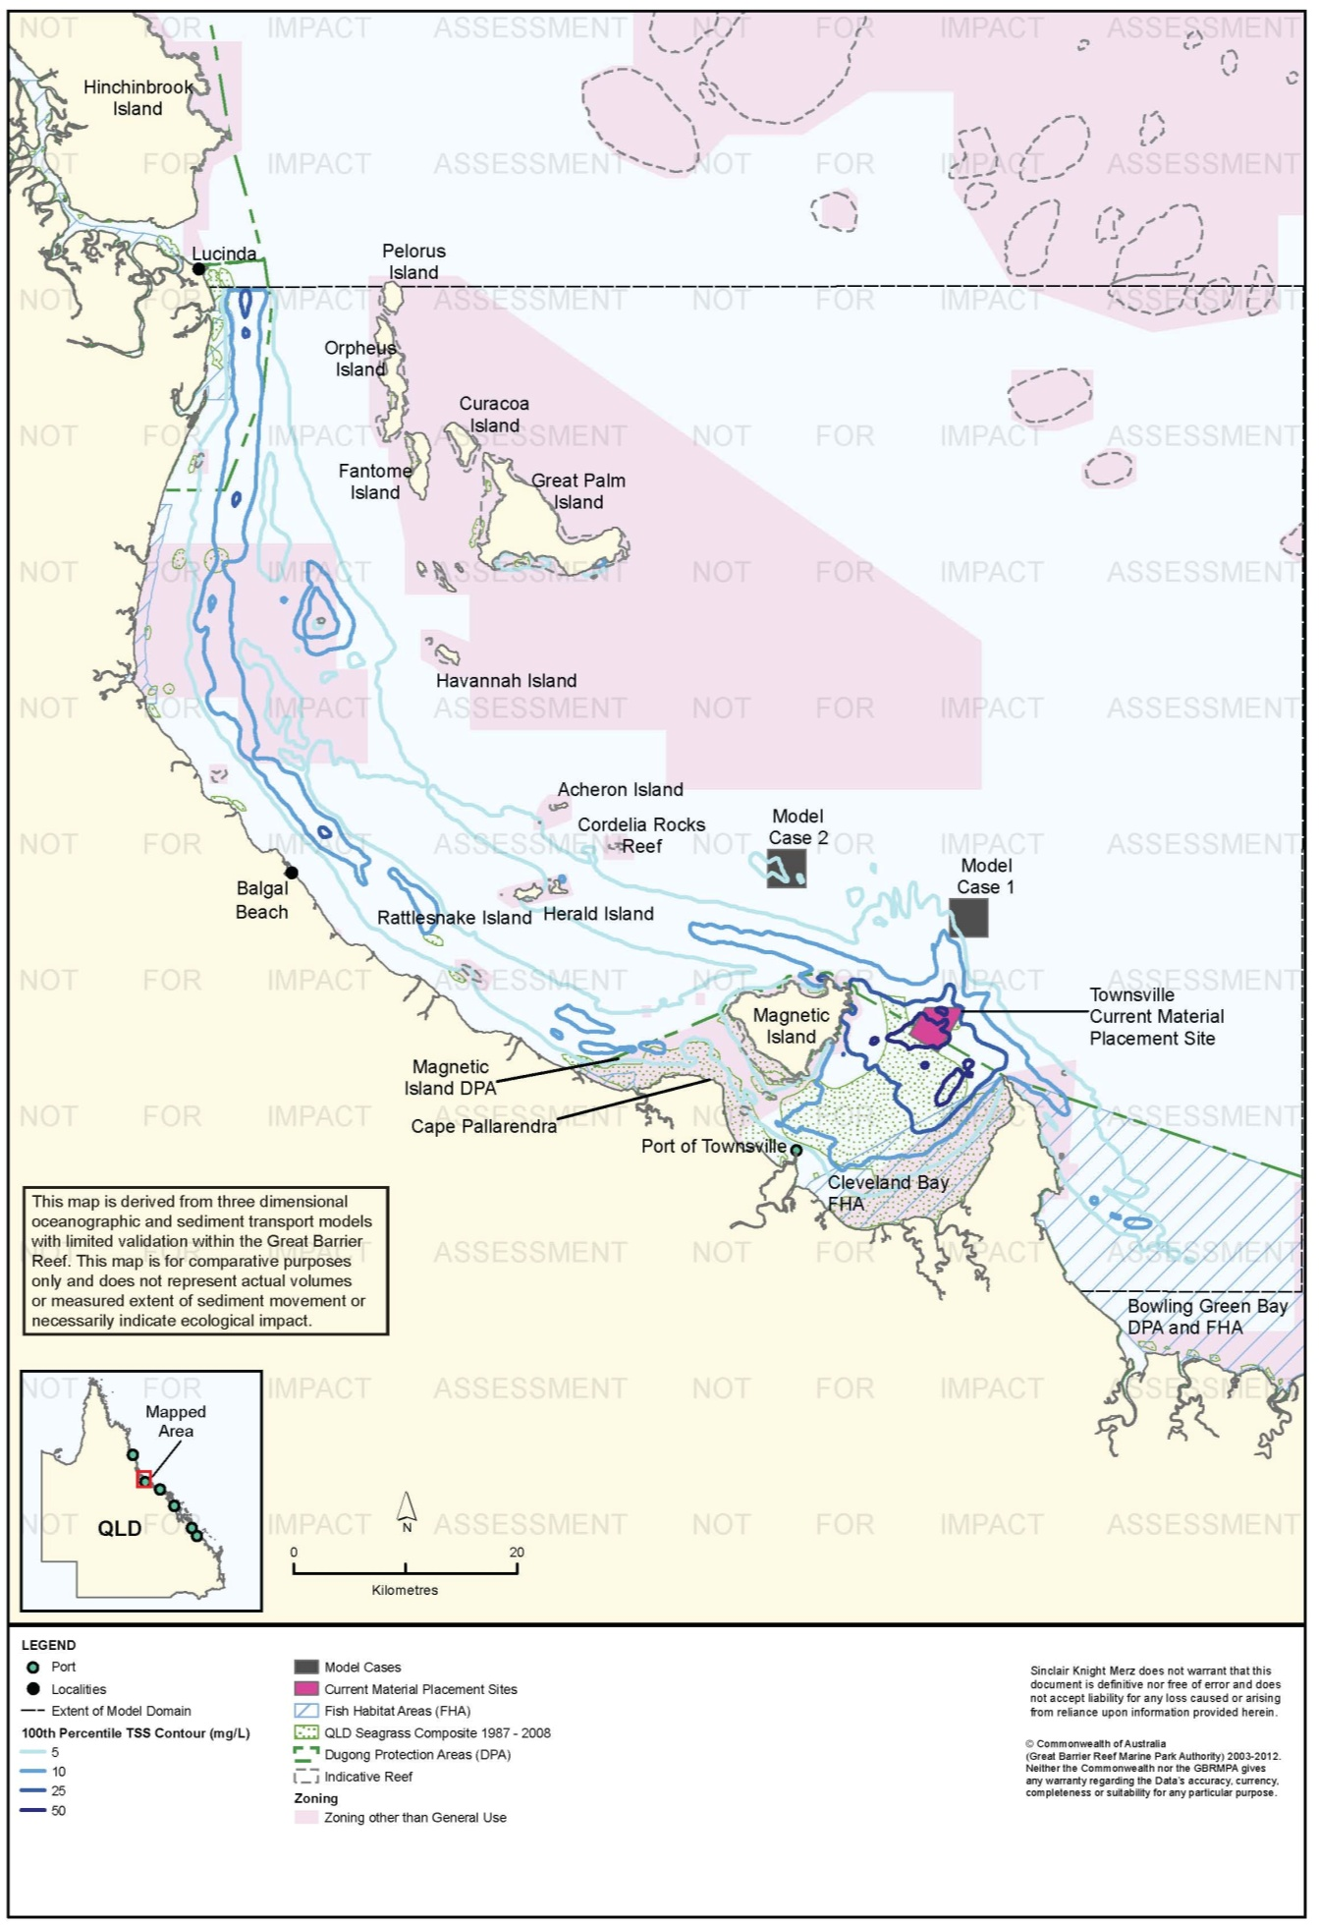
Figure 77. Townsville: dredging period (45 days) TSS distribution, current site - 100th percentile.

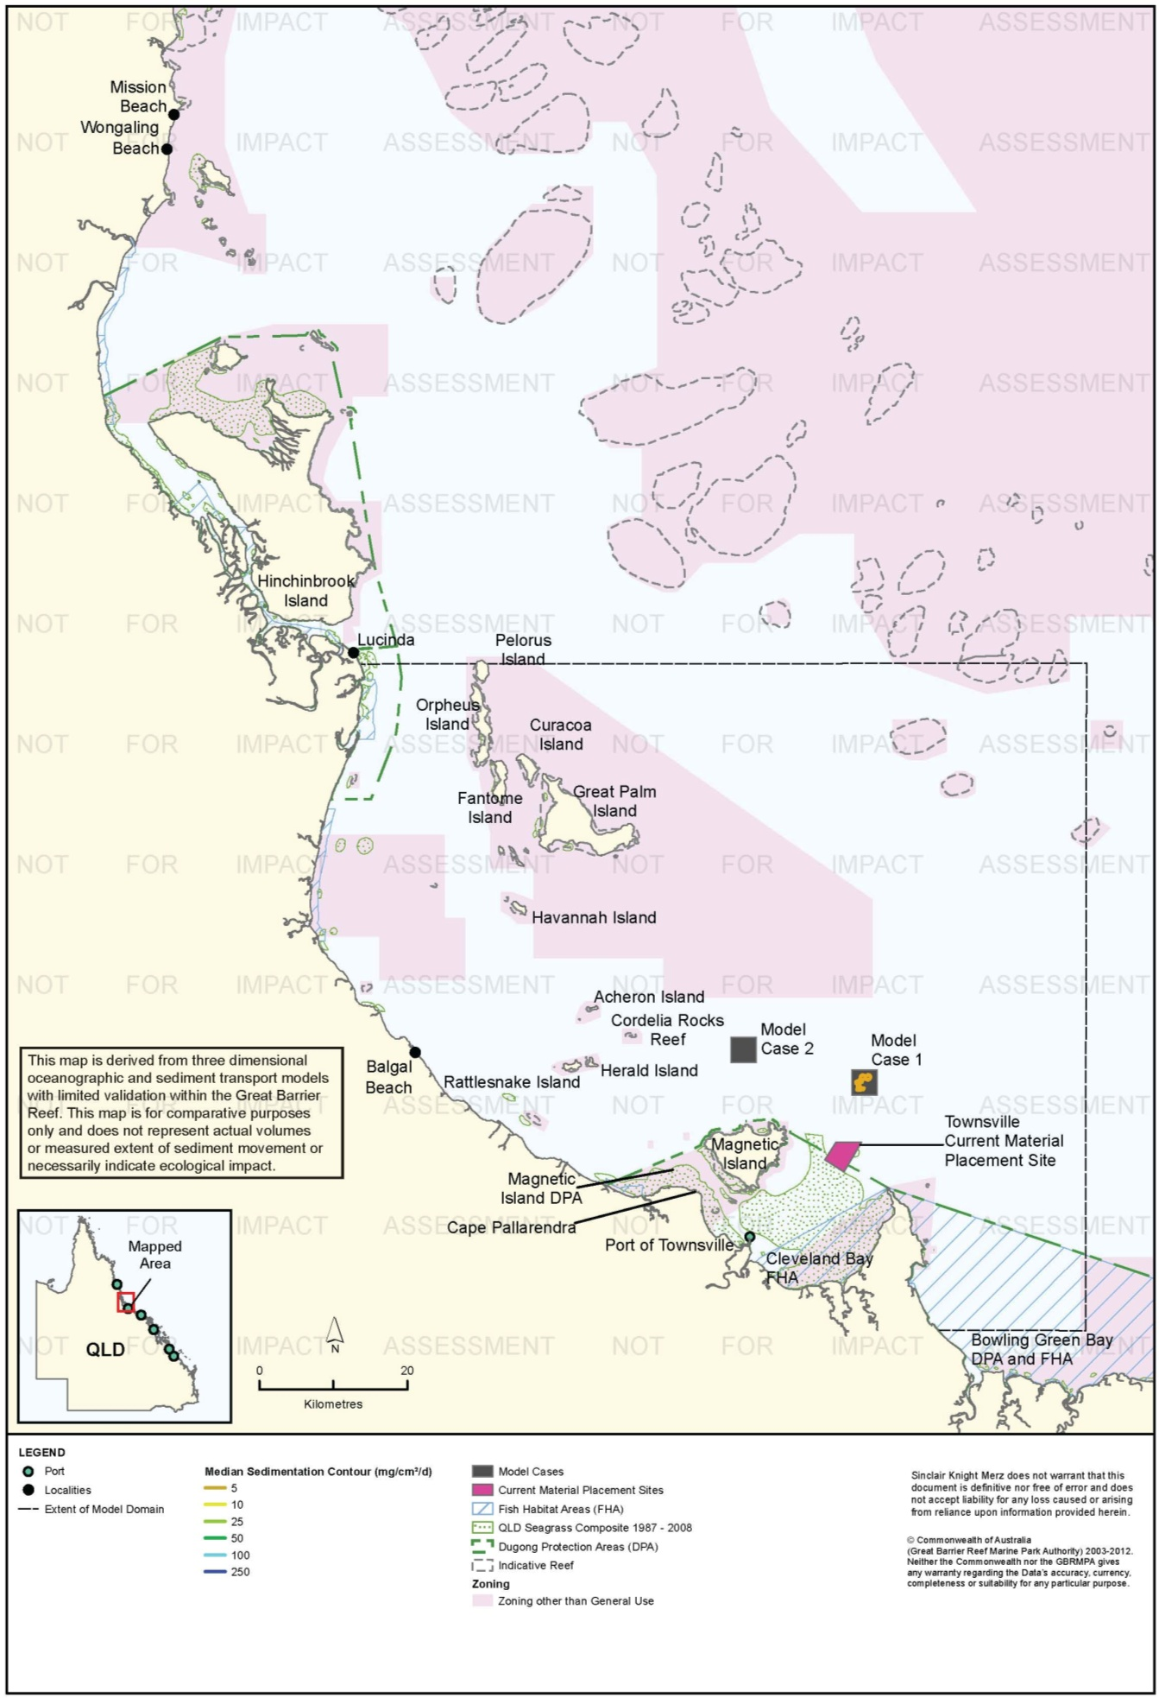
Figure 78. Townsville: dredging period (45 days) sedimentation rate, Model Case 1 - 50th percentile.

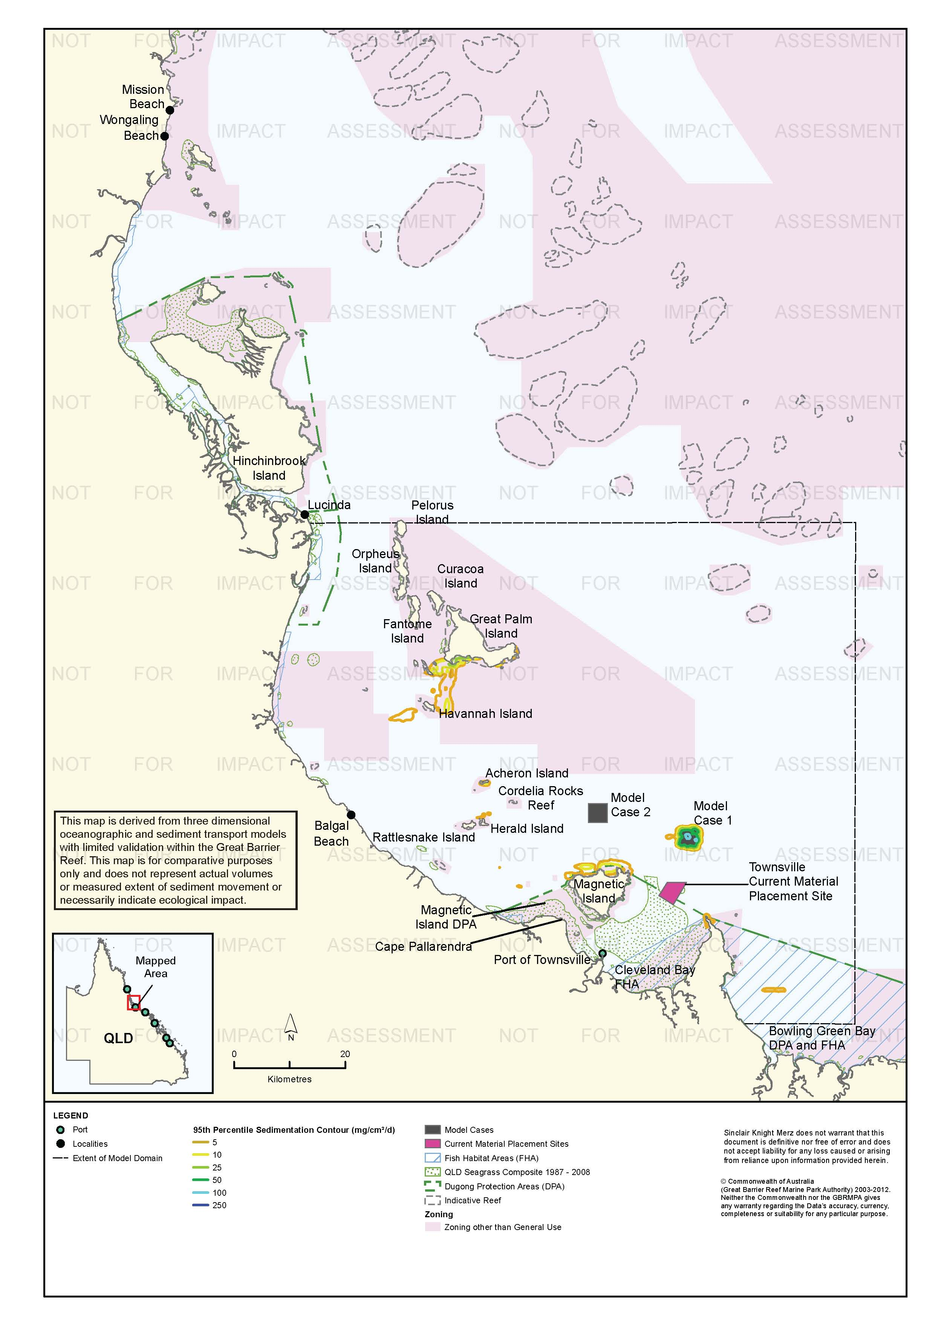
Figure 79. Townsville: dredging period (45 days) sedimentation rate, Model Case 1 - 95th percentile.

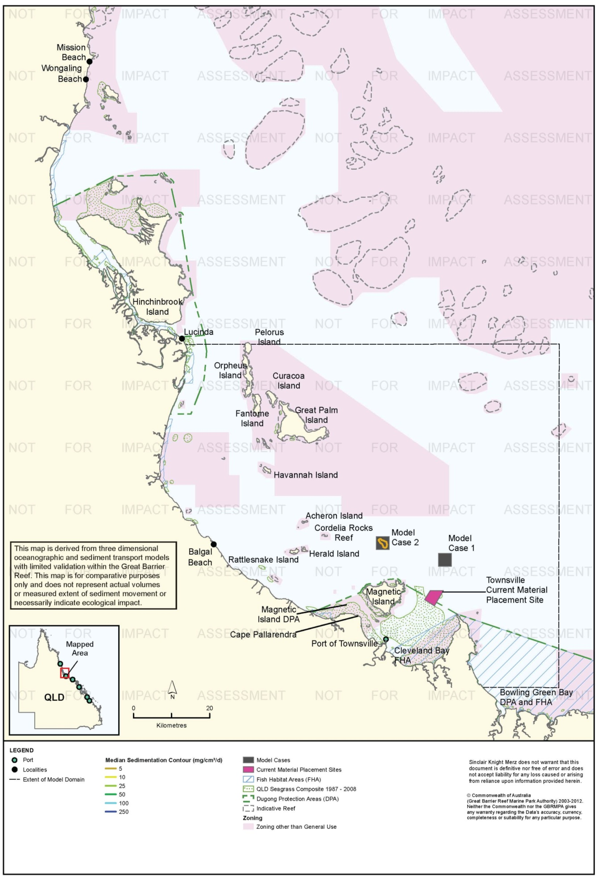
Figure 80. Townsville: dredging period (45 days) sedimentation rate, Model Case 2 - 50th percentile.

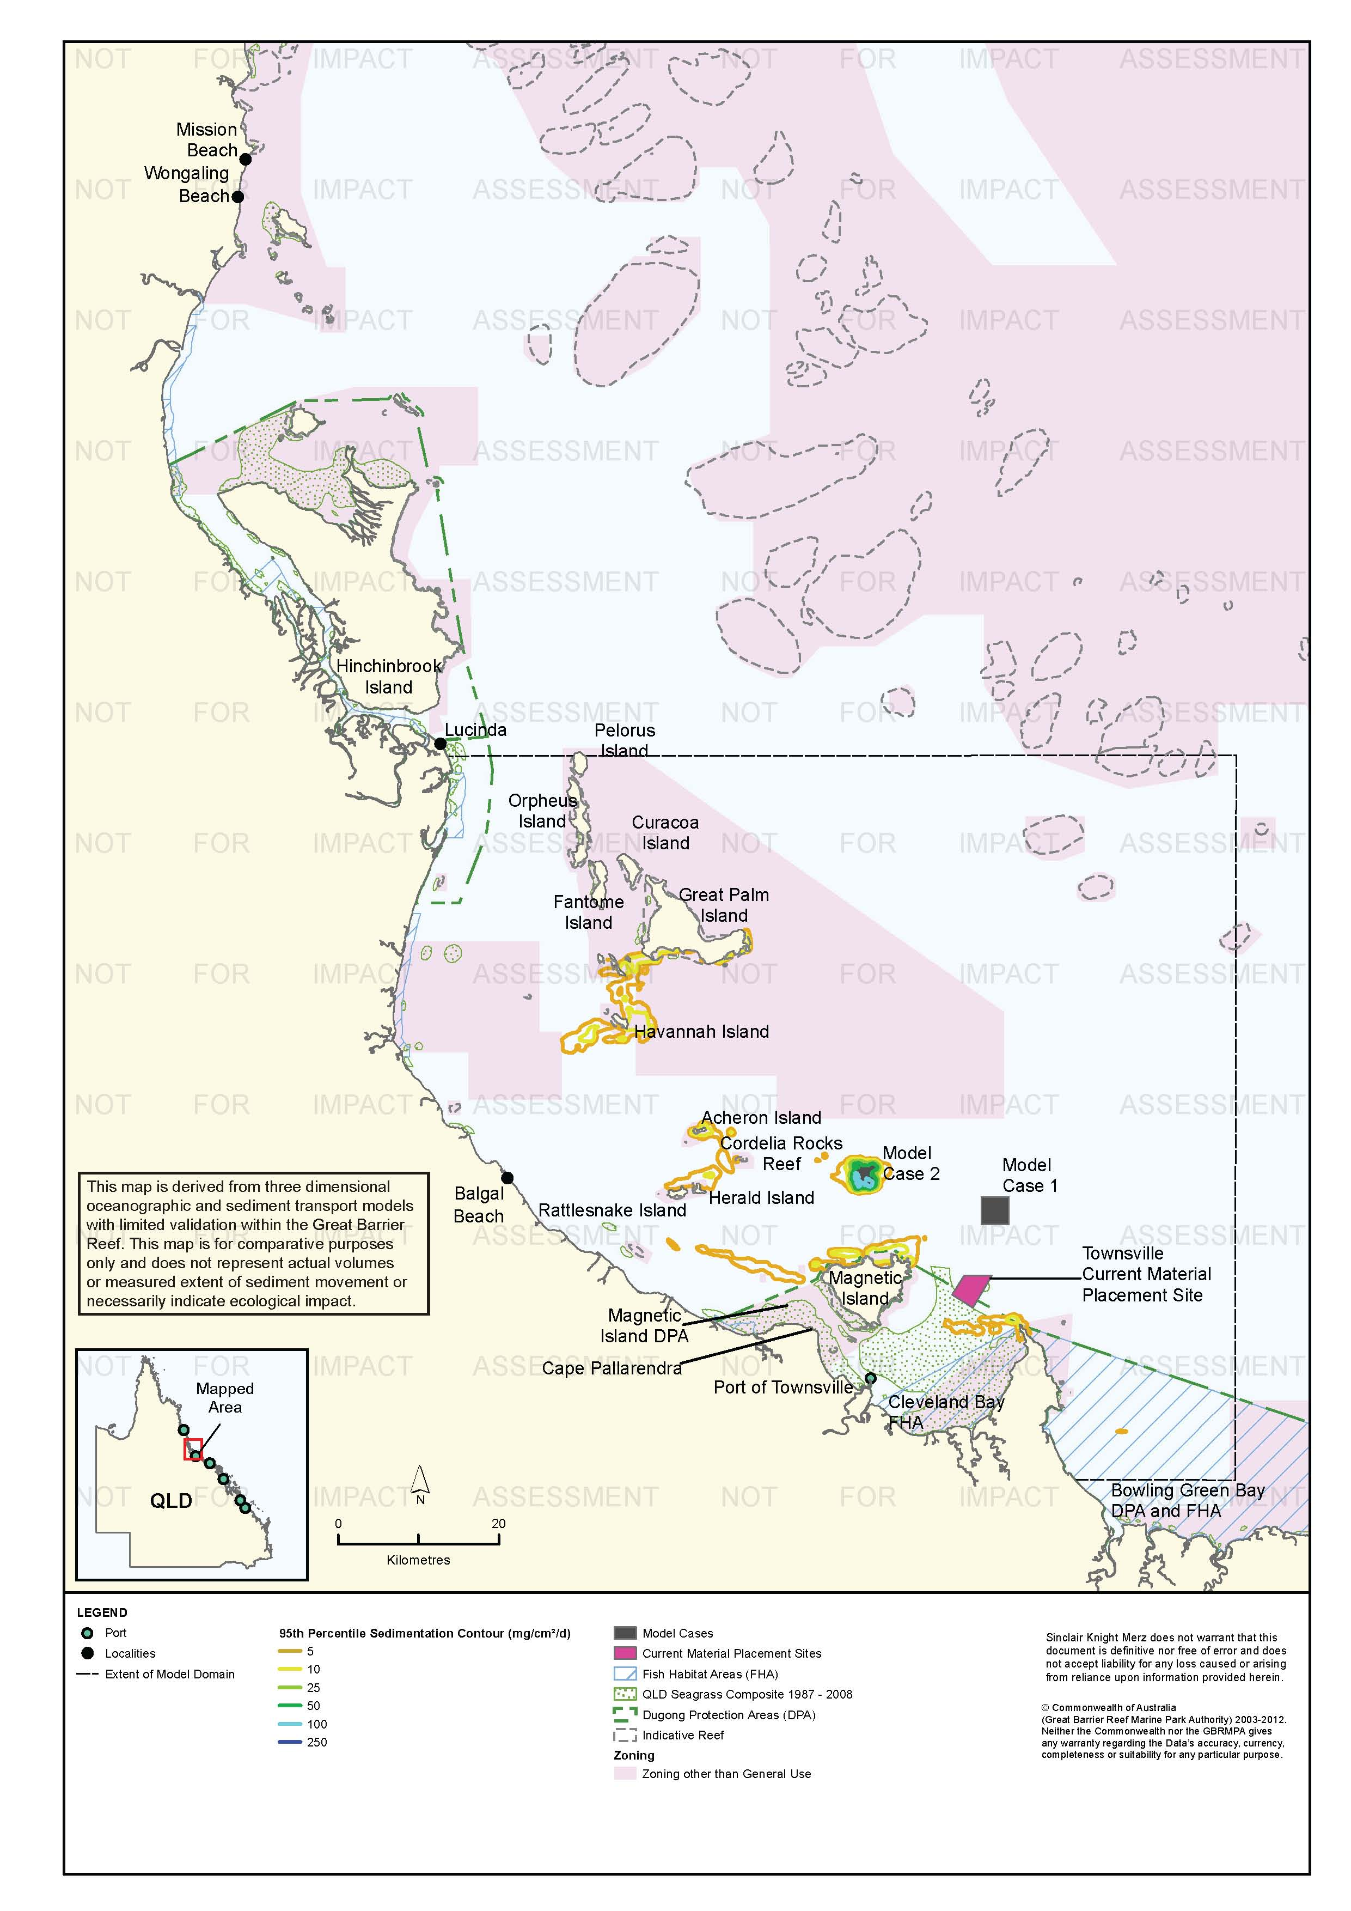
Figure 81. Townsville: dredging period (45 days) sedimentation rate, Model Case 2 - 95th percentile.

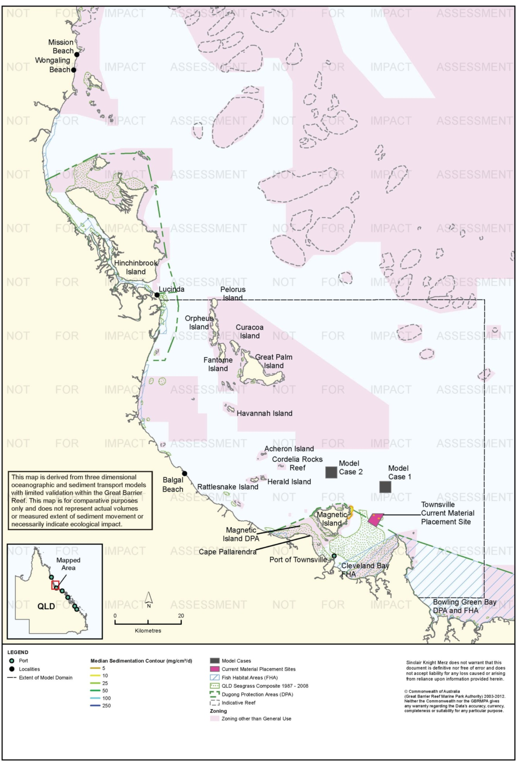
Figure 82. Townsville: dredging period (45 days) sedimentation rate, current site - 50th percentile.

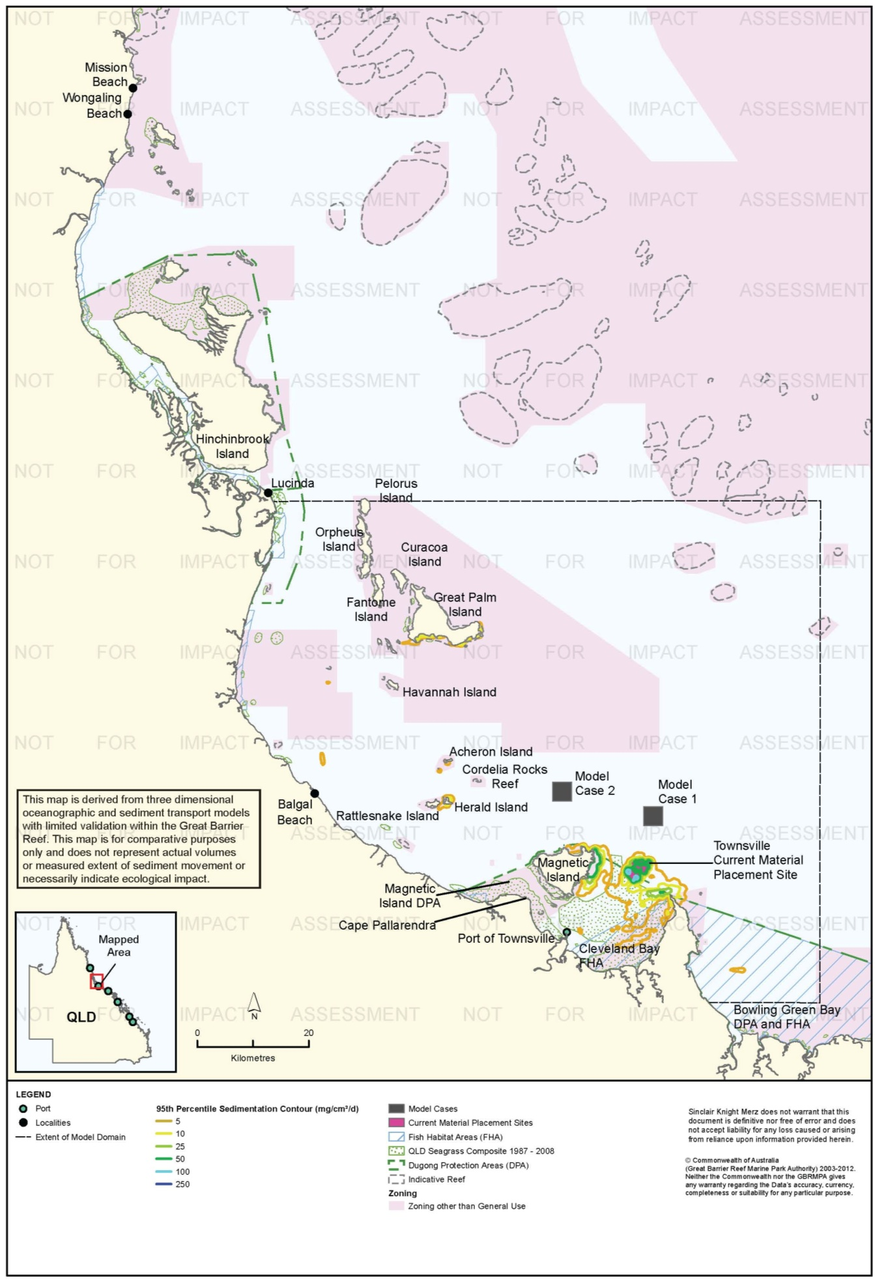
Figure 83. Townsville: dredging period (45 days) sedimentation rate, current site - 95th percentile.

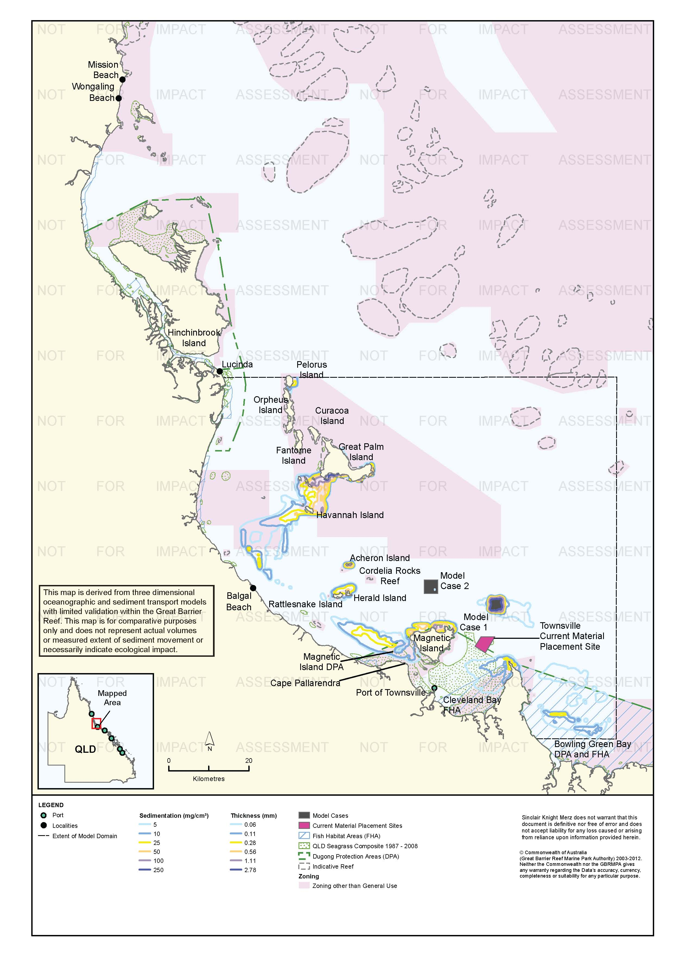
Figure 84. Townsville: dredging period (45 days) total sedimentation and bottom thickness, Model Case 1.

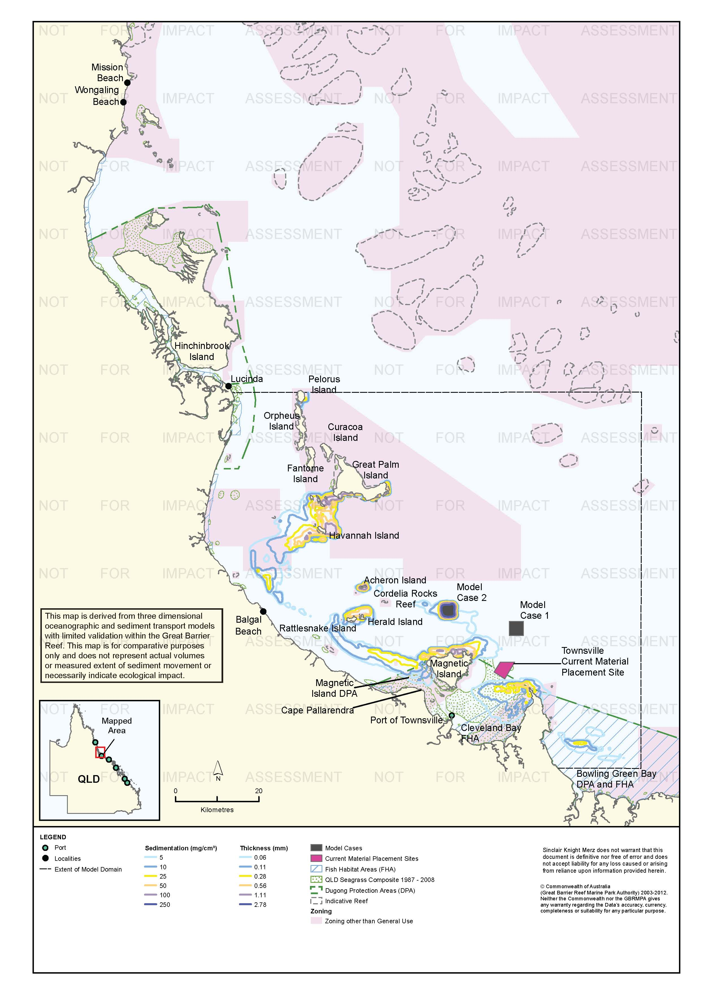
Figure 85. Townsville: dredging period (45 days) total sedimentation and bottom thickness, Model Case 2.

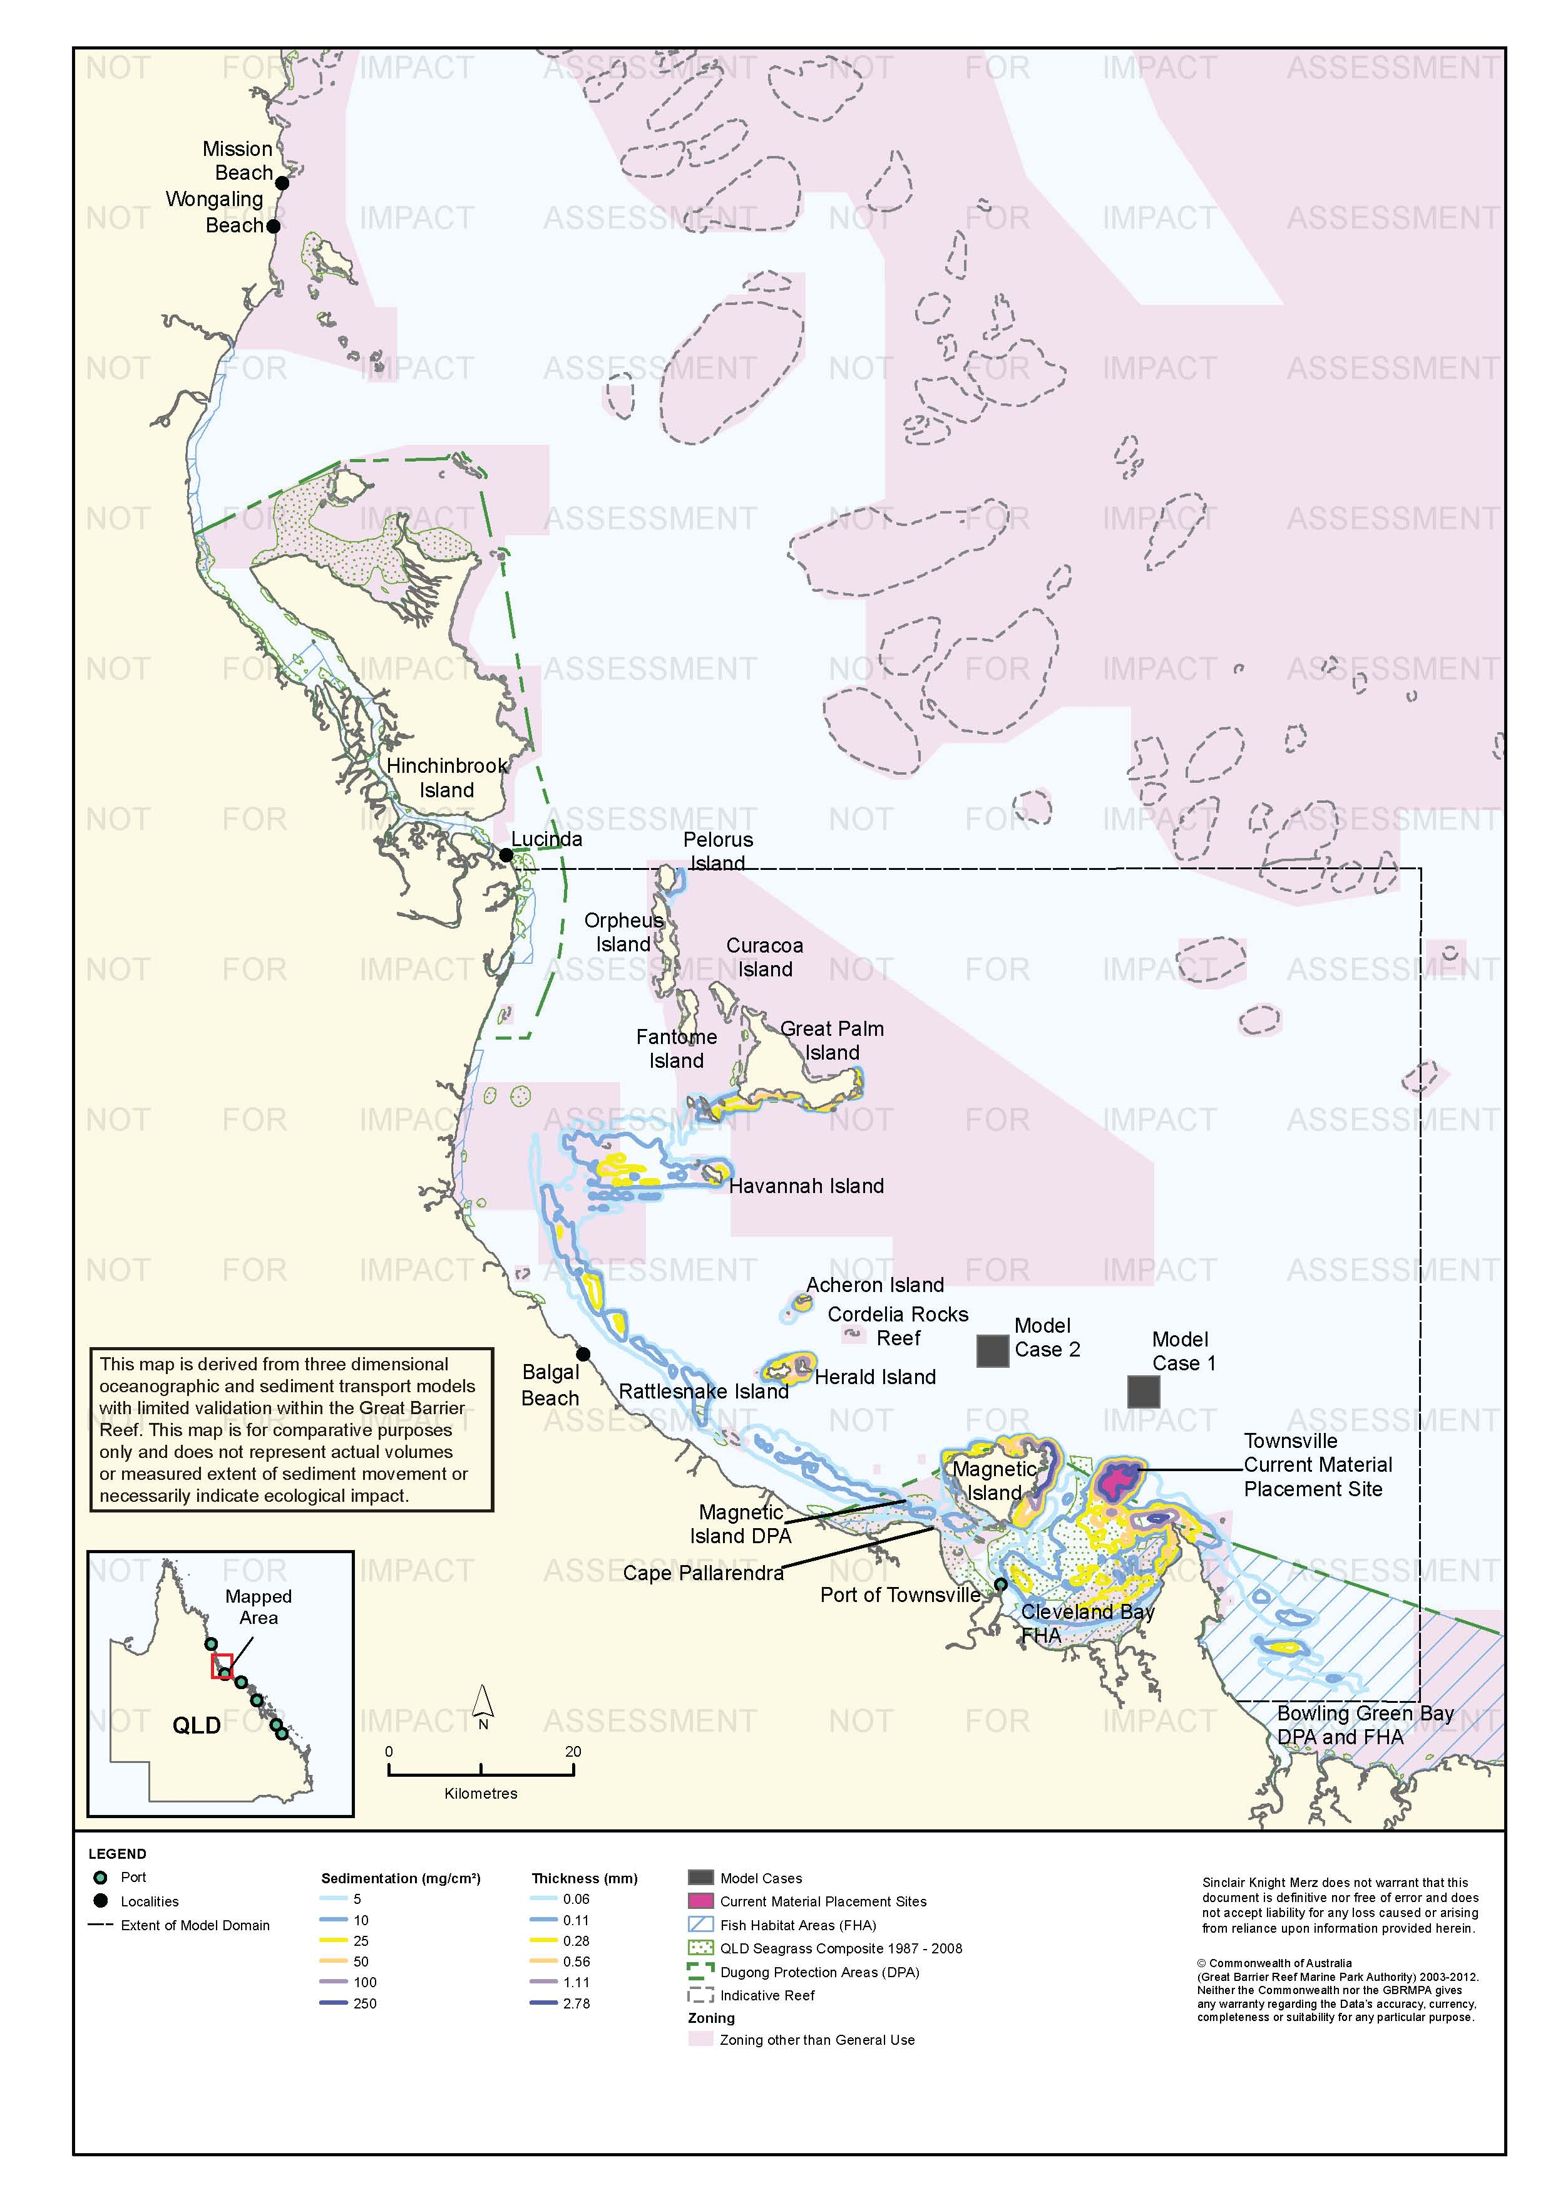
Figure 86. Townsville: dredging period (45 days) total sedimentation and bottom thickness, current site.

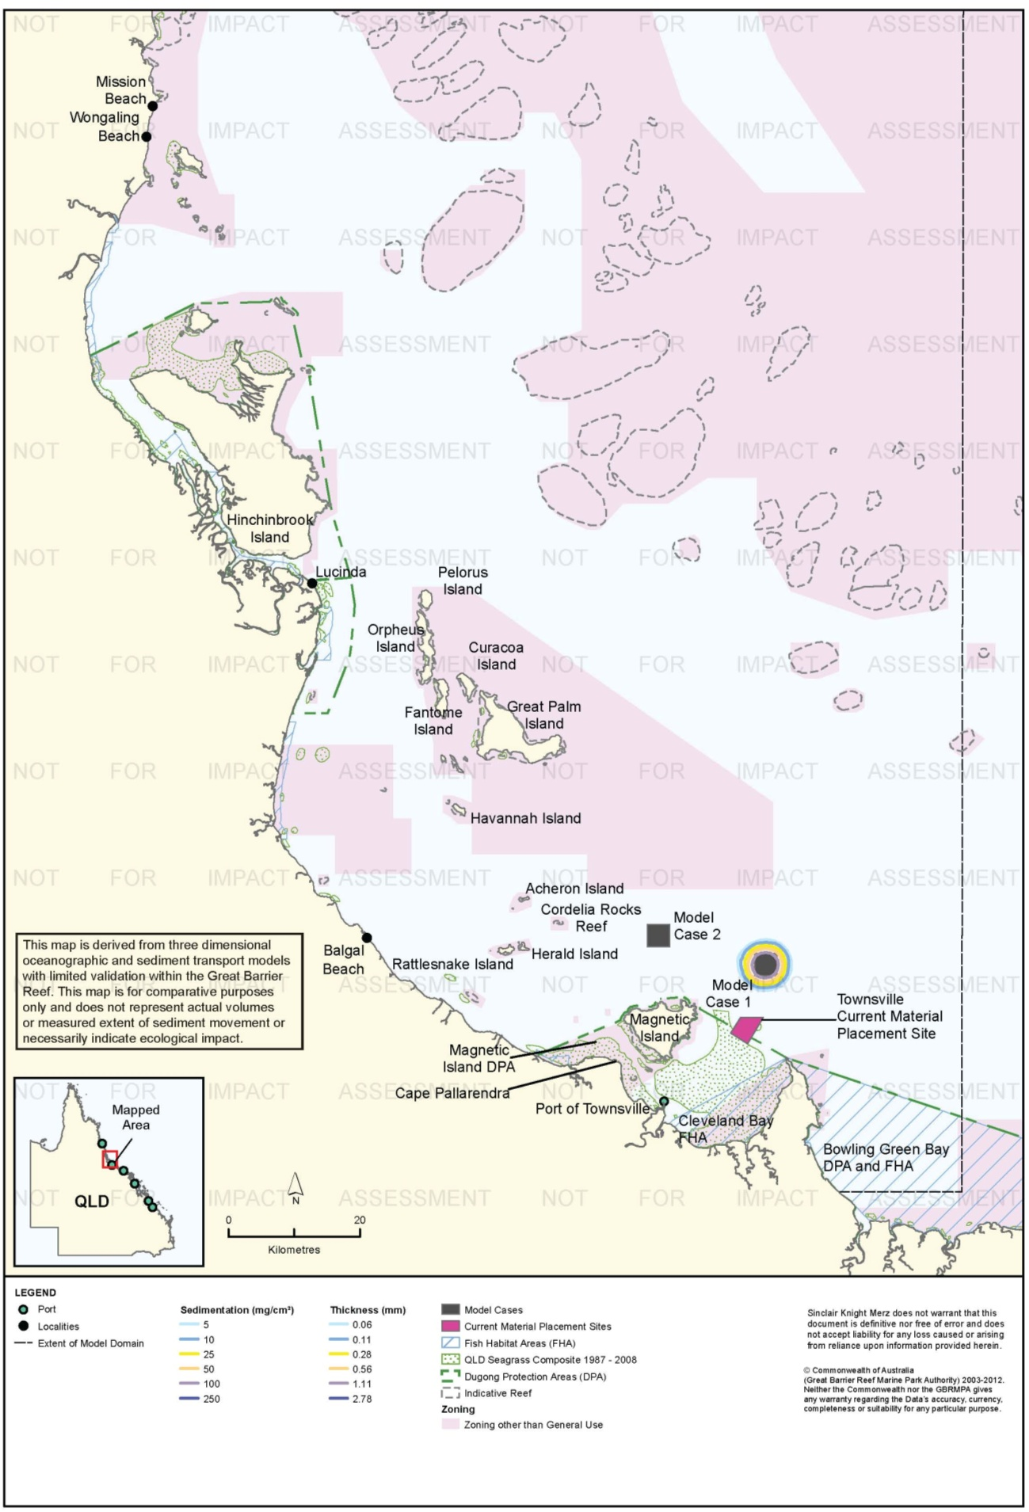
Figure 87. Townsville: long-term (12 months) total sedimentation and bottom thickness, Model Case 1.

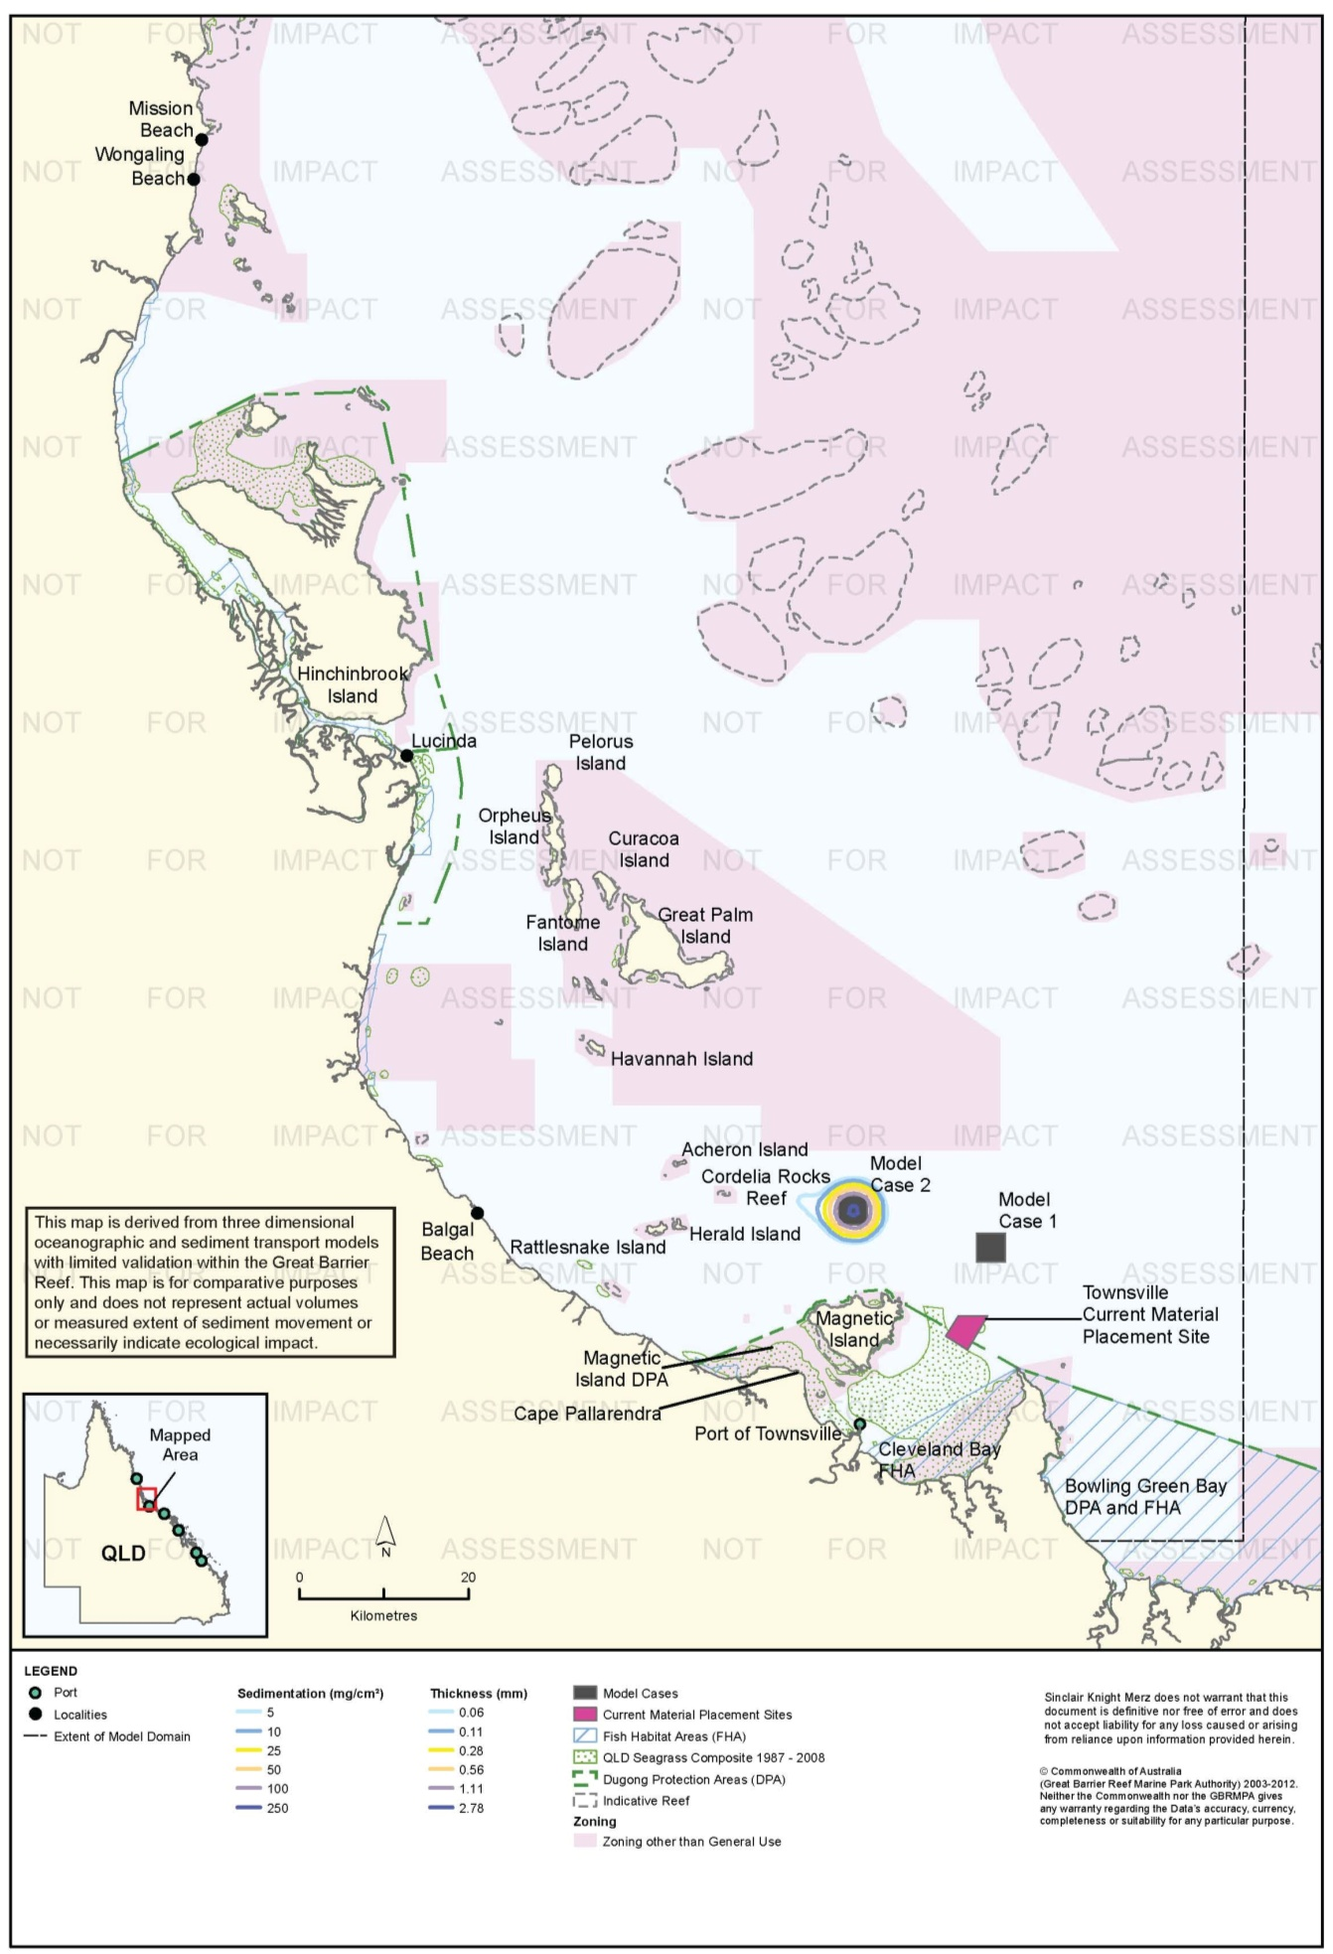

Figure 88. Townsville: long-term (12 months) total sedimentation and bottom thickness, Model Case 2.

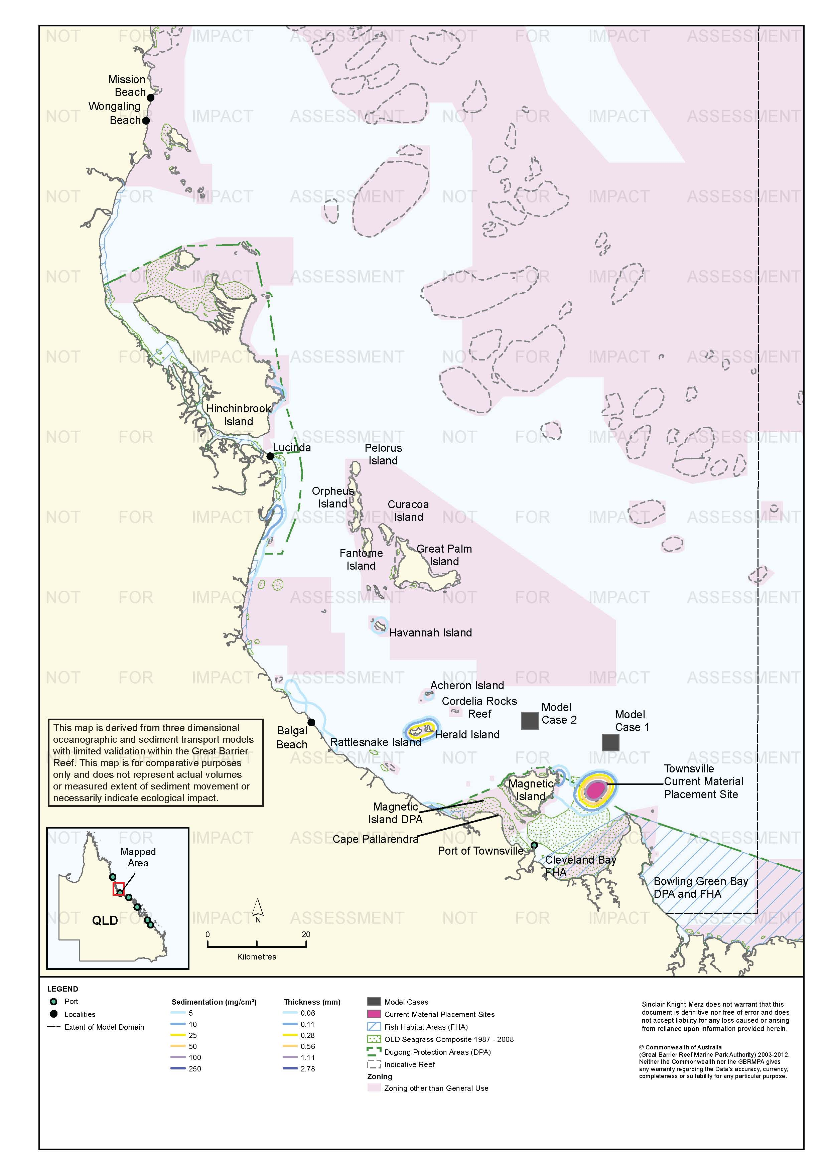
Figure 89. Townsville: long-term (12 months) total sedimentation and bottom thickness, current site.

Risk Assessment
The results of the risk assessment are presented in table 26. The risks to sensitive receptors from suspended sediment plumes are predicted to be relatively low, although 100th percentile plumes for the current site have the potential generate some environmental risk for corals, seagrass and tourism values in the region, most notably at Magnetic Island and Cleveland Bay. However, given that 100th percentile TSS modelling was required to produce comparative results above 5 mg/L for each site, there can be a high degree of confidence that such risks are relatively low. The 95th percentile contour for 5 mg/L TSS for the current site overlays areas in Cleveland Bay that have supported seagrass at least at some time from 1987 and 2008. The 95th percentile for the 45-day placement campaign corresponds to a total period of TSS of 5 mg/L of 2.25 days. Seagrasses can tolerate low-light conditions for continuous periods in the order of a week or more (Chartrand et al. 2012; Collier et al. 2012), however it is recognised that, if present, seagrasses could already be stressed by other factors. The risk assessment produced risk ratings of medium for the current site for seagrass communities, coral reefs, non-General Use Zones and tourism values. These ratings reflect the very close proximity of sensitive receptors to the current site (particularly seagrass habitats), rather than the predicted severity of the TSS plumes, which are relatively minor.
Sediment deposition modelling predicted some sedimentation across the Townsville region for all three material placement scenarios in the short term, but only infrequently (95th percentile). Generally short-term rates of sedimentation of only 5-10 mg/cm²/d coincided with island and reef communities in the vicinity of Great Palm Island (incorporating a Marine National Park Zone to its south) and for the current site, included Magnetic Island. This may in part reflect the distribution of natural depositional environments throughout the Townsville region.
Under average conditions, as predicted by the 50th percentile model outputs, short-term sedimentation rates generally only increased above background levels within the geographic extent of the material placement sites for all three model cases, providing further confidence that environmental risk to sensitive receptors would be relatively minor. The exception to this was a small area at the north east fringe of Magnetic Island, for the current site.
The results of sediment accumulation modelling suggest that the alternative material placement sites offshore (Model Cases 1 and 2) provide a reduced level of environmental risk when compared with the current site. This relates primarily to the predicted rates of sedimentation from use of the current site at nearby Magnetic Island and further afield along coastal areas to the north of Townsville. However, Model Cases 1 and 2 are new sites located further offshore, with predicted short term increases in sediment deposition at a range of sensitive receptors in the vicinity of the Great Palm Island area which are worthy of consideration and further assessment, prior to consideration of relocating the current placement site further offshore.
In summary, there are a range of relatively subtle differences in the environmental risk for the current site when compared with Model Cases 1 and 2, primarily related to the proximity of the current site to inshore sensitive receptors at Cleveland Bay (seagrass, FHA) and Magnetic Island (coral reefs, tourism values). Utilising a placement site further offshore was predicted to reduce some of the environmental risks associated with sedimentation of inshore areas, but may also increase risks to inshore and mid-shelf reefs to the north in the vicinity of Great Palm Island. In this context, this study did not identify a compelling case for use of either of the alternative model cases over the current site, based upon environmental risk. Further, more detailed assessment of the values of modelled deposition sites and the impacts of material placement activities would be necessary to support a strong, evidence-based conclusion on the best location for future material placement activities.
.
Table 26. Comparative risk assessment for the Port of Townsville based on modelling results (Figure 73 to Figure 89).
Hazard | Sensitive Receptor | Site | Likelihood | Consequence | Risk Rating
An increase in TSS concentration and turbidity in waters surrounding the material placement site. | Coral Reefs | Current Site | Possible | Minor | Medium
 |  | Model Case 1 | Rare | Minor | Low
 |  | Model Case 2 | Rare | Minor | Low
 | Seagrass. | Current Site | Likely | Minor | Medium
 |  | Model Case 1 | Rare | Minor | Low
 |  | Model Case 2 | Rare | Minor | Low
 | Fish Habitat Areas | Current Site | Unlikely | Minor | Low
 |  | Model Case 1 | Unlikely | Minor | Low
 |  | Model Case 2 | Unlikely | Minor | Low
 | Non-general Use Zones | Current Site | Likely | Minor | Medium
 |  | Model Case 1 | Rare | Minor | Low
 |  | Model Case 2 | Possible | Minor | Medium
 | Commercial fisheries | Current Site | Rare | Minor | Low
 |  | Model Case 1 | Rare | Minor | Low
 |  | Model Case 2 | Rare | Minor | Low
 | Tourism and recreational values | Current Site | Unlikely | Moderate | Medium
 |  | Model Case 1 | Rare | Minor | Low
 |  | Model Case 2 | Rare | Minor | Low
Increase in the rate of sediment deposition on the sea bed in areas surrounding the material placement site. | Coral Reefs | Current Site | Possible | Minor | Medium
 |  | Model Case 1 | Unlikely | Minor | Low
 |  | Model Case 2 | Possible | Minor | Medium
 | Seagrass. | Current Site | Possible | Minor | Medium
 |  | Model Case 1 | Unlikely | Minor | Low
 |  | Model Case 2 | Unlikely | Minor | Low
 | Fish Habitat Areas | Current Site | Possible | Minor | Medium
 |  | Model Case 1 | Unlikely | Minor | Low
 |  | Model Case 2 | Unlikely | Minor | Low
 | Non-general Use Zones | Current Site | Possible | Minor | Medium
 |  | Model Case 1 | Possible | Minor | Medium
 |  | Model Case 2 | Possible | Minor | Medium
 | Commercial fisheries | Current Site | Unlikely | Minor | Low
 |  | Model Case 1 | Unlikely | Minor | Low
 |  | Model Case 2 | Unlikely | Minor | Low
 | Tourism and recreational values | Current Site | Unlikely | Minor | Low
 |  | Model Case 1 | Unlikely | Minor | Low
 |  | Model Case 2 | Unlikely | Minor | Low
Accumulation of sediments on the sea bed. | Coral Reefs | Current Site | Possible | Moderate | High
 |  | Model Case 1 | Possible | Minor | Medium
 |  | Model Case 2 | Possible | Minor | Medium
 | Seagrass. | Current Site | Possible | Moderate | High
 |  | Model Case 1 | Unlikely | Minor | Low
 |  | Model Case 2 | Possible | Minor | Medium
 | Fish Habitat Areas | Current Site | Likely | Moderate | Medium
 |  | Model Case 1 | Possible | Minor | Medium
 |  | Model Case 2 | Possible | Minor | Medium
 | Non-General Use Zones | Current Site | Possible | Minor | Medium
 |  | Model Case 1 | Possible | Minor | Medium
 |  | Model Case 2 | Possible | Minor t | Medium
 | Commercial fisheries | Current Site | Unlikely | Minor | Low
 | Tourism and recreational values | Current Site | Unlikely | Minor | Low
 |  | Model Case 1 | Unlikely | Insignificant | Low
 |  | Model Case 2 | Unlikely | Insignificant | Low

Ecological Monitoring in Relation to Dredging
An experimental dredging study was completed in 1992 which aimed to examine potential impacts of dredging on the fringing coral reefs of Magnetic Island (Sinclair Knight 1992). A three-day period was allocated to maintenance dredging in an area planned for channel extension as an experiment to determine the potential impact on nearby fringing reefs. The dispersal of sediment plumes generated by dredging was monitored by aerial photography, satellite imagery, and light and turbidity meters. The dredge operated continuously for three days in which it was expected that the plume would reach Magnetic Island. The results found that suspended sediment loads on reefs were below the range at which impacts would be expected. Dredge related plumes reaching Magnetic Island were well below the critical level of 30 mg/L recommended by Mapstone et al. (1989) and adopted by GBRMPA for the control of dredging activities related to the Magnetic Quays Development.
Seagrass monitoring for capital dredging in 1993 assessed seagrass per cent cover, spatial distribution of meadows, and species composition using aerial photography and ground-truthing surveys (inter tidal and diver based surveys; Goldsworthy et al. 1994). Two areas were surveyed: the east side of Cleveland Bay and the south-west side of Magnetic Island one month before dredging, during dredging and one month post-dredging. Goldsworthy et al. (1994) concluded there were no changes in seagrass communities at either location attributable to dredging. They reported decreased seagrass density at some ground-truthing sites, and increased density at others. Goldsworthy et al. (1994) reported there was no evidence of adverse sedimentation in post-dredging surveys and concluded any changes were unlikely to be linked to dredging. They study was a qualitative study only and no statistical comparisons were made. Numbers of ground-truthing sites were reduced in the post-dredging survey, meaning greater reliance on the aerial photography. The post-dredging survey was conducted one month after dredging and there was no monitoring beyond that. Further details are provided in table 8.
Short-term coral health (bleaching, partial mortality, sediment on corals) and per cent cover of benthos (coral communities) surveys were implemented during the 1993 capital dredging project in Cleveland Bay (Stafford-Smith et al. 1994; Kaly et al.1994). Coral health surveys comprised direct observations by divers using photographs and sketches of tagged corals at three primary impact locations, two subsidiary impact locations and two control locations around sensitive fringing reefs of Magnetic Island. Surveys were conducted twice weekly at primary impact locations, weekly at control locations during dredging, with subsidiary impact locations surveyed twice during the dredging period. Video transects were conducted at four impact locations and one control location within Cleveland Bay with six sites surveyed at each location using permanent 20 m transects. Three surveys of video transects were completed: once prior to dredging commencing, once post dredging and once several months following the completion of dredging. Partial mortality at principle impact locations did not exceed 12 per cent and was generally < 5 per cent with the investigative bleaching trigger value exceeded on several occasions but no exceedances of higher-level triggers required action from the Immediate Response Group. Complete mortality of one colony at one impact location occurred but was not considered dredging-related. At least one species was considered close to sedimentation/ turbidity tolerance threshold (Stafford-Smith et al 1994). Video transects analysis found declines in favid and soft corals consistent with dredging impacts and declines in other corals at control location not consistent with dredging impacts. There were greater seasonal declines in macroalgae at impact locations, however, macroalgae cover at the control location was low prior to dredging (Kaly et al 1994). Statistical power to detect change was reported, and varied widely from very high to very low (for details see table 8).
A study analysing the possible effects of dredge material placement on the soft bottom benthic community of Cleveland Bay was conducted during dredging works in 1999 (Cruz Motta 2000). Soft-bottom benthic communities of Cleveland Bay were studied in relation to the source of impact on six occasions (February 1998, November 1998, June 1999, August 1999, June 2000 and September 2000). The studied focussed on numerical abundance, species richness, community structure and species composition. A total of 28 sites were sampled by sediment grab sampling: four sites within the DMPA in use, 22 sites along four transects radiating WNW, WSW, ESE and SSE to a distance of 15 km from the DMPA, and two reference sites. Six surveys were conducted before and after three maintenance dredging campaigns. The pre-dredging survey was six months after the 1997 dredge campaign and not all sites were sampled in the August 1999, June and September 2000 surveys. Short-term impacts were observed inside the material placement site immediately after works and six weeks after (due to burial and smothering of benthic communities), with sampling after 10 months indicating rapid recovery of communities. Cruz Motta (2000) concluded that there were no detectable long-term impacts of maintenance dredge material placement on the soft bottom communities and communities are resilient and able to recover from burial. Conclusions were based entirely on spatial distributions of similarity/dissimilarity in infauna community structure; no statistical hypothesis testing such as testing before-after/ control-impact (BACI) comparisons was conducted. Further details are provided in table 8.
McKenna & Rasheed (2012) summarise the results of annual seagrass monitoring in Townsville from 2007-2011. The monitoring program was established to assist in port management, dredging in particular, but does not target dredging specifically, for example by establishing impact and reference sites. Rather, the program is designed to detect long-term changes in 11 permanent monitoring meadows established on the basis of wet- and dry-season baseline surveys in 2007 and 2008. The monitoring is conducted through broad-scale mapping of the spatial extent of seagrass meadows by helicopter. Within each meadow species composition and visual estimates of above-ground biomass and per cent macroalgal cover are recorded in quadrats. The quadrats are deployed from a helicopter for intertidal meadows and by free diver of drop camera in subtidal meadows (Unsworth et al. 2009). Depth is also recorded at subtidal sites. Sampling sites are located haphazardly within meadows at high density. Site numbers vary but typically in the order of 550-650 sites per survey. Further details are provided in table 7.
McKenna & Rasheed (2012) report that the total area of seagrass meadows declined in 2011 for the fourth consecutive year, with the total area of seagrass meadows reduced by 84 per cent since 2007. Declines from 2007 to 2010 were relatively modest but in a number of cases statistically significant. Seagrass extent in 2011 was statistically significantly lower than all other years except 2010 in some meadows. The statistical power of the tests to detect change is not reported. Mean above-ground biomass in 2011 was similar to 2010 and the lowest recorded since 2007. McKenna & Rasheed (2012) also report a gradual shift in species composition to ephemeral, pioneering species (Halophila spp.) McKenna & Rasheed (2012) report that there were some initial signs of recovery in 2011, with small increases of above-ground biomass in parts of some Magnetic Island meadows.
McKenna & Rasheed (2012) attribute the observed recent declines in seagrass in Townsville to consecutive years of high rainfall and flooding, and note that similar declines have been seen along the Queensland coast. McKenna & Rasheed (2012) do not attribute the declines to dredging or other port-related activities. However, they report that seagrass meadows in Townsville are in a highly vulnerable state and are one of the four locations in Queensland at highest risk (Rasheed et al. 2007).

Environmental Condition
Water quality in the Burdekin region, which includes the Port of Townsville is monitored by the RRMMP (Schaffelke et al. 2011). The water quality aspect of the monitoring program includes inshore permanent monitoring sites (water quality loggers) and remote sensing techniques. Permanent monitoring sites have been established in the Burdekin region since 2007. Three permanent logger sites are within 70 km of the Port of Townsville with the closest location (Magnetic Island) 10 km north east. Regionally, water quality in the area has been declining since 2007 with the annual mean increasing from 2007/2008 with values at greater than double at some locations
(table 27; Schaffelke et al. 2011).

Table 27. Summary of annual mean turbidity (NTU) data from turbidity sensors at Burdekin region water quality locations from the RRMMP¹.
Site | 2007-2008² | 2008 to 2009² | 2009-2010² | 2010-2011³
Pelorus Island | 0.50 | 0.74 | 0.60 | 1.17
Pandora Reef | 0.97 | 1.17 | 1.10 | 1.85
Magnetic Island (Geoffrey Bay) | 2.12 | 2.33 | 1.79 | 3.00
1 Data extracted from Schaffelke et al. 2011. 2 – Years are from October to September 3 – October to June
Remote sensing is used to monitor TSS concentrations for the entire Marine Park at a spatial resolution of 1 km (Brando et al. 2011). TSS concentrations within the Burdekin region have improved with the TSS paddock to reef index of poor (30 per cent) in 2002/2003 increasing to moderate (57 per cent) in 2010/2011 (Brando et al. 2011). Data from May 2010 to April 2011 for the Port of Townsville and surrounding areas recorded a clear declining gradient from inshore to offshore with median TSS values as high as 5 mg/L for shallow coastal area such as Port of Townsville, Cape Bowling Green and Cleveland Bay. Annual median TSS concentrations at the locations of Model Cases 1 and 2 the current material placement site ranged from approximately 2.00 mg/L to 0.25 mg/L, with the current material placement site having the highest TSS values.
Water quality in the Townsville study area has been surveyed biannually since 2004 at 12 sites, with the furthest site approximately 1500 m offshore in Cleveland Bay (GHD 2009c). This site is situated in an area of seagrass meadows at 6 m depth. In addition to spot measurements, water quality at this site was monitored continuously with a fixed logger from September 2008 to February 2009. Median turbidity in the logger measurements was 23 NTU, with an 80th percentile of 57 NTU and a 95th percentile of 109 NTU (table 28).

Table 28. Baseline turbidity at the Port of Townsville.
Site | Turbidity (NTU)
 | Median | 80th percentile | 95th percentile
1500 m offshore | 23 | 57 | 109

Reef health in the Burdekin region is monitored at seven monitoring sites by the RRMMP since 2005 with all monitoring sites no more than 80 km from the Port of Townsville. The closest monitoring site (Magnetic Island) is approximately 10 km north east. Hard coral cover in the region has generally shown a slight decrease since monitoring began in 2005 (Thompson et al. 2011). Thompson et al. (2011a) assessed the overall condition of coral communities as poor due to the low densities of juvenile coral and low cover both overall and during periods free of acute disturbances (Thompson et al. 2011). Table 29 displays the RRMMP score since 2009 which decreased from moderate to poor.

Table 29. RRMMP monitoring score for overall inshore coral health for the Burdekin region from 2009-2011 (Thompson et al. 2011a, b).
Year | RRMMP score
2009 | Moderate
2010 | Poor
2011 | Poor

Reefs are also monitored throughout the Reef by the AIMS Long Term monitoring program, which has been in operation since 1992 (Sweatman et al. 2005). Three monitoring sites (Havannah Island Reef, Pandora Reef and Middle Reef) are within approximately 70 km of the Port of Townsville with Middle Reef approximately 6 km to the north east. Middle Reef is the only location to have increased in hard coral cover from 1993 (table 30) with the maximum cover of 45 per cent recorded in 2011. Havannah Island and Pandora Reefs have both declined in coral cover since monitoring began. Soft coral cover has decreased at all locations with Havannah Island Reef and Middle Reef both having 1 per cent or less soft coral cover (table 30).

Table 30 Summary of AIMS Long Term Monitoring Program inshore sites for the Townsville region³.
Coral type | Site | Per cent cover (1993) | Per cent cover (2011) | Maximum cover (Per cent – year) | Comments
Hard coral cover | Havannah Island Reefª | 37 | 2 | 37 - 1997 | Steep decline until 2002 and then stable
 | Pandora Reef | 48 | 36 | 58 - 1997 | Fluctuated with general decline (bimodal)
 | Middle Reef | 26 | 45 | 45 -2011 | Fluctuated with general increase
Soft coral cover | Havannah Island Reefª | 20 | 1 | 22- 1999 | Fluctuated but general decline
 | Pandora Reef | 20 | 6 | 20 -1993 | General decline
 | Middle Reef | 10 | < 1 | 20 -1997 | Increase until 1998, afterward a general decline
a – First survey for Havannah Island commenced in 1997 3 – sourced from AIMS 1996-2013
An intertidal assessment of seagrass in the Burdekin region was conducted in 2011 as part of the Seagrass Vulnerability Assessment for the Great Barrier Reef (Commonwealth of Australia 2011). The assessment the overall status of seagrass in very poor condition with major declines recorded in 2009.
The 2010 Great Barrier Reef Report Card rated the overall condition of inshore water quality as moderate with TSS volumes low enough to receive a good report card rating (State of Queensland 2013). Seagrass and coral health both received poor grader with poor coral cover and very poor seagrass abundance (State of Queensland 2013).
While sponges, macroalgae and macroinvertebrate assemblages are known to occur in the area very little is known about the condition of these receptors, with further study required.

Port of Cairns
The Cairns region includes a variety of habitats, including coral reefs and seagrass communities in close proximity to the three material placement sites. Coastal areas north of Cairns are generally located down-current from material placement activities and contain a variety of island and reef habitats, including Snapper (73 km north-north-west), Low (61 km north-north-west), Double (22 km north-north-west), and Haycock Islands (20 km north-north-west) and Korea (46 km north-north-west), Yule (50 km north-north-west), Alexander (49 km north-north-west), Wentworth (51 km north-north-west) and Egmont Reefs (34 km north-north-west). While extensive areas of the Marine Park offshore from Cairns are zoned General Use, large sections of Marine National Park Zone and Conservation Park Zone are also in place (e.g. adjacent to Port Douglas and surrounding Low Islands), generally covering areas where sensitive receptors such as reefs exist.

Suspended Sediment Plumes
Figure 90 to figure 92 show the predicted 95th percentile TSS concentrations for the modelled cases. The model did not predict that TSS would reach 5 mg/L for 50 per cent of the model runs at any location, therefore no maps of the 50th percentile TSS distribution are presented.
The 95th percentile TSS modelling predicted sediment plumes to disperse in a north-west direction from all three material placement sites and generally stay well clear of sensitive environmental receptors. For Model Case 1, the 5 mg/L contour extended approximately 10 km without coinciding with any sensitive receptors and a small isolated contour was also predicted at Cape Kimberley (61 km north-west). A similar pattern was predicted for Model Case 2, with the 5 mg/L contour extending about 10 km to an area south of Craiglie and not coinciding with sensitive receptors. Modelling of the current site predicted a contour of 5 mg/L extending towards Double Island and Haycock Island but finishing well clear of the Habitat Protection Zone adjacent to Clifton Beach (14 km east). A small contour of 10 mg/L was also predicted to extend 1 km north-west of the current site.

Sedimentation Rate
Figure 93, figure 94, and figure 95 show the predicted 50th and 95th percentile sedimentation rates for the modelled cases. Predicted 95th percentile sedimentation rates were similar for Model Cases 1 and 2, with sedimentation rates of 100 mg/cm²/d in the vicinity of Cape Kimberley and at Snapper and Low Islands. For the current site, a similar pattern of sedimentation was predicted towards the north-west, but was shifted closer inshore, with sedimentation rates of 100 mg/cm²/d at Double Island and Cape Kimberley. For all three cases, the predicted 95th percentile contours of elevated sedimentation rate to 250 mg/cm²/d. Figure 93, figure 94, and figure 95 show the predicted 50th and 95th percentile sedimentation rates for the modelled cases. Predicted 95th percentile sedimentation rates were similar for Model Cases 1 and 2, with sedimentation rates of 100 mg/cm²/d in the vicinity of Cape Kimberley and at Snapper and Low Islands. For the current site, a similar pattern of sedimentation was predicted towards the north-west, but was shifted closer inshore, with sedimentation rates of 100 mg/cm²/d at Double Island and Cape Kimberley. For all three cases, the predicted 95th percentile contours of elevated sedimentation rate to 250 mg/cm²/d for Model Case 2 and to 100 mg/cm²/d for Model Case 1 and the current site, extended as far as Cape Kimberly, 90 km north-west of the current material placement site.
The 50th percentile results predicted much lower sedimentation rates. Beyond the immediate extent of the material placement sites, only small patches of sedimentation rates above 5 mg/cm²/d were predicted at Low Islands and Cape Kimberly (Model Cases 1 and 2) and Double Island and Cape Kimberley (current site). These coincided with Marine National Park Zones at locations such as Low Islands and Unity Reef, with no clear difference in environmental risk evident among the placement sites.

Total sedimentation
For all three model cases, predicted short-term (dredging period) total sedimentation contours of up to 250 mg/cm² (4.10 mm) extend as far as Cape Kimberly, coinciding with a Habitat Protection Zone of the Marine Park surrounding Cape Kimberley and Snapper Island and a Marine National Park Zone surrounding the Low Islands. Elevated total sedimentation along the coast between Cairns and Port Douglas was highest for the current site, with total sedimentation of up to 250 mg/cm² around Double and Haycock Islands (in a Habitat Protection Zone), Unity Reef (in a Marine National Park Zone), and between Korea and Yule Reefs (in a Conservation Park Zone). The model predicts elevated sedimentation rate contours along the coast between Cairns and Port Douglas for Model Case 1, but less spatially extensive and at generally lower sedimentation rates. Material placement at Model Case 2 is predicted to avoid elevated sedimentation rates along the coast between Cairns and Port Douglas. Dredging-period contours for elevated sedimentation rate for Model Cases 1 and 2 extend further to the north-west than for the current site, to about 65 km north-west of Model Case 2 and 80 km of Model Case 1, with predicted sedimentation rates up to 25 mg/cm²/d.
Figure 102 to figure 104 show long-term (12-month) total sedimentation for the modelled cases. The total sedimentation modelling predicted much lower total sedimentation after 12 months compared to the end of the dredging period, total sedimentation accumulation, with contours > 10 mg/cm² (0.16 mm) confined to within 5 km of all three material placement sites. For Model Cases 1 and 2, areas with up to 10 mg/cm² were predicted on the southern coast of Cape Kimberly, in a Habitat Protection Zone. For the current site, long-term sedimentation contours beyond 10 km of the current site were predicted around Double and Haycock Islands (up to 10 mg/cm²) and around Yule, Korea, Egmont, and Wentworth Reefs (5 mg/cm², or 0.08 mm), in a Conservation Park Zone. The lower levels of total sedimentation after 12 months than at the end of the dredging campaign reflects the northward movement of sediment beyond the model extent.

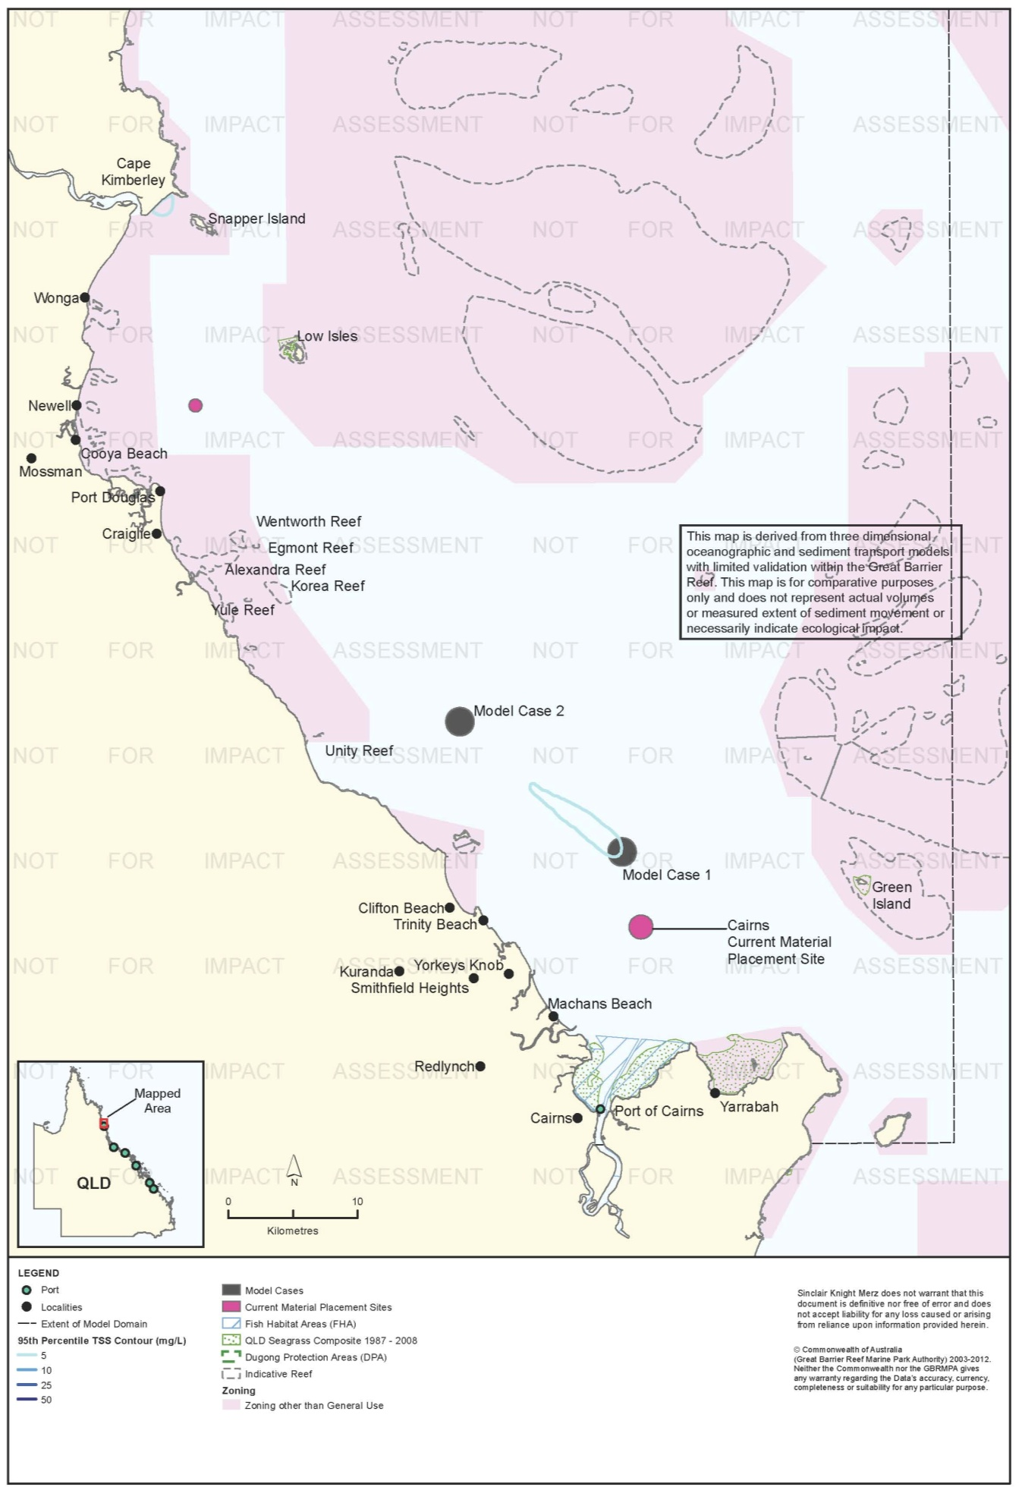
Figure 90. Cairns: dredging period (38 days) TSS distribution, Model Case 1 - 95th percentile.
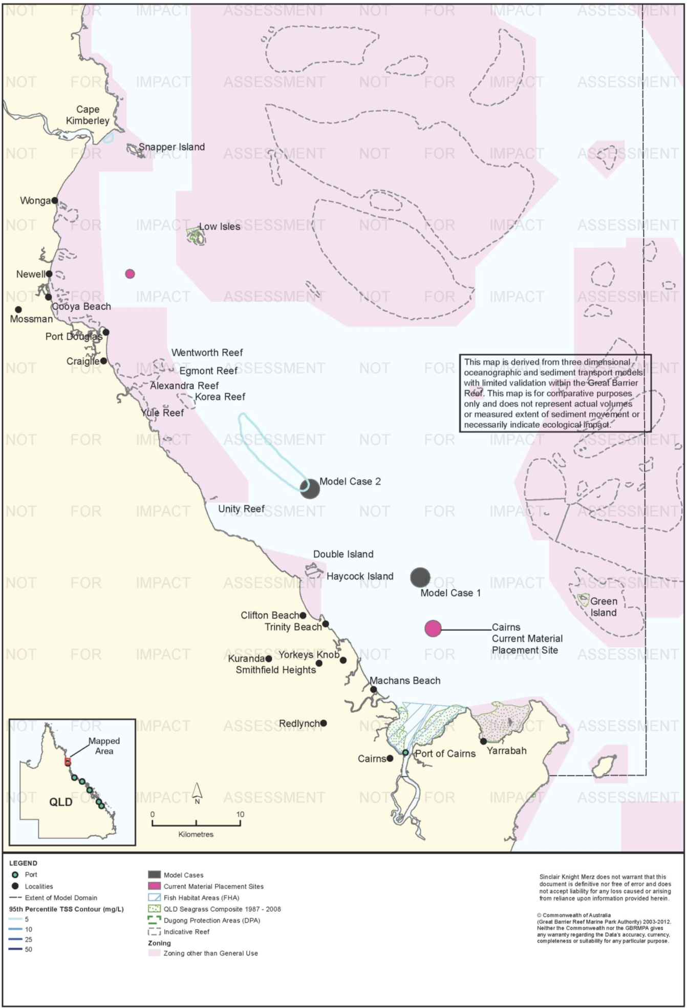
Figure 91. Cairns: dredging period (38 days) TSS distribution, Model Case 2 - 95th percentile.

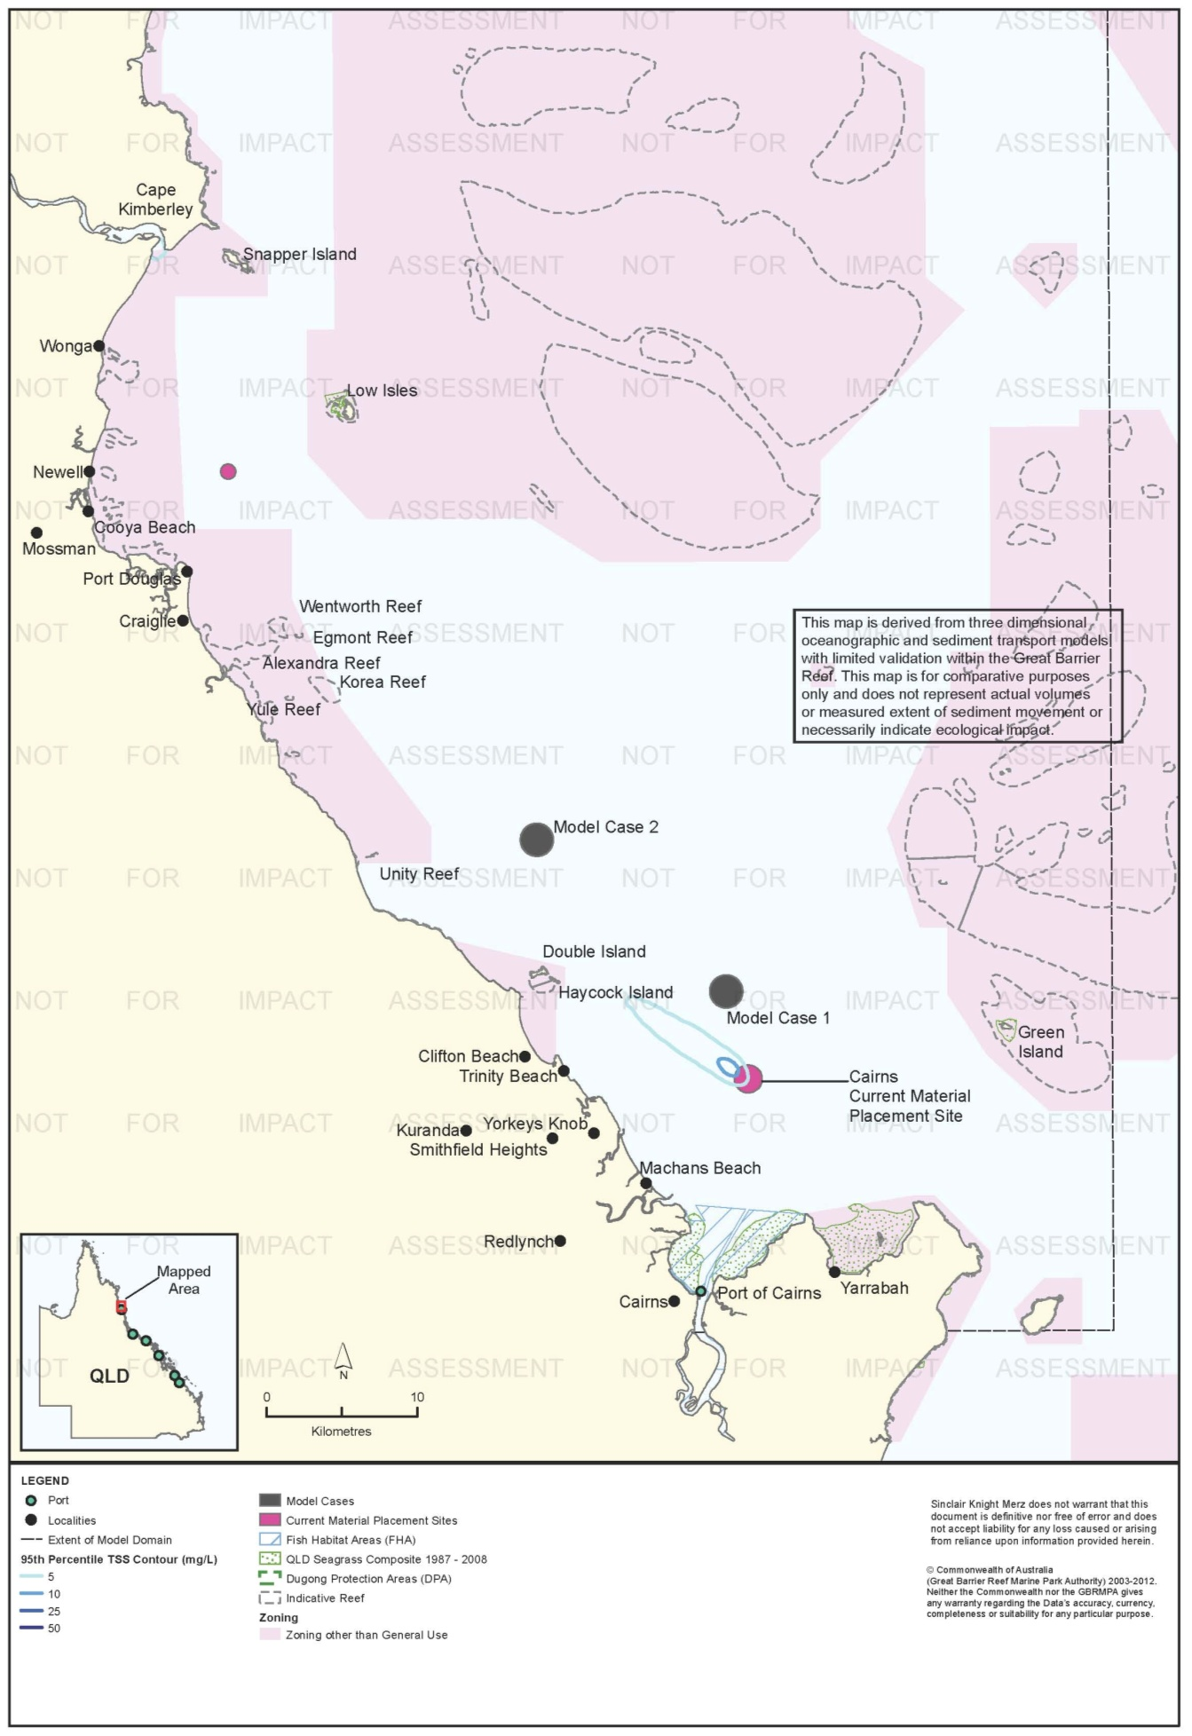
Figure 92. Cairns: dredging period (38 days) TSS distribution, current site - 95th percentile.

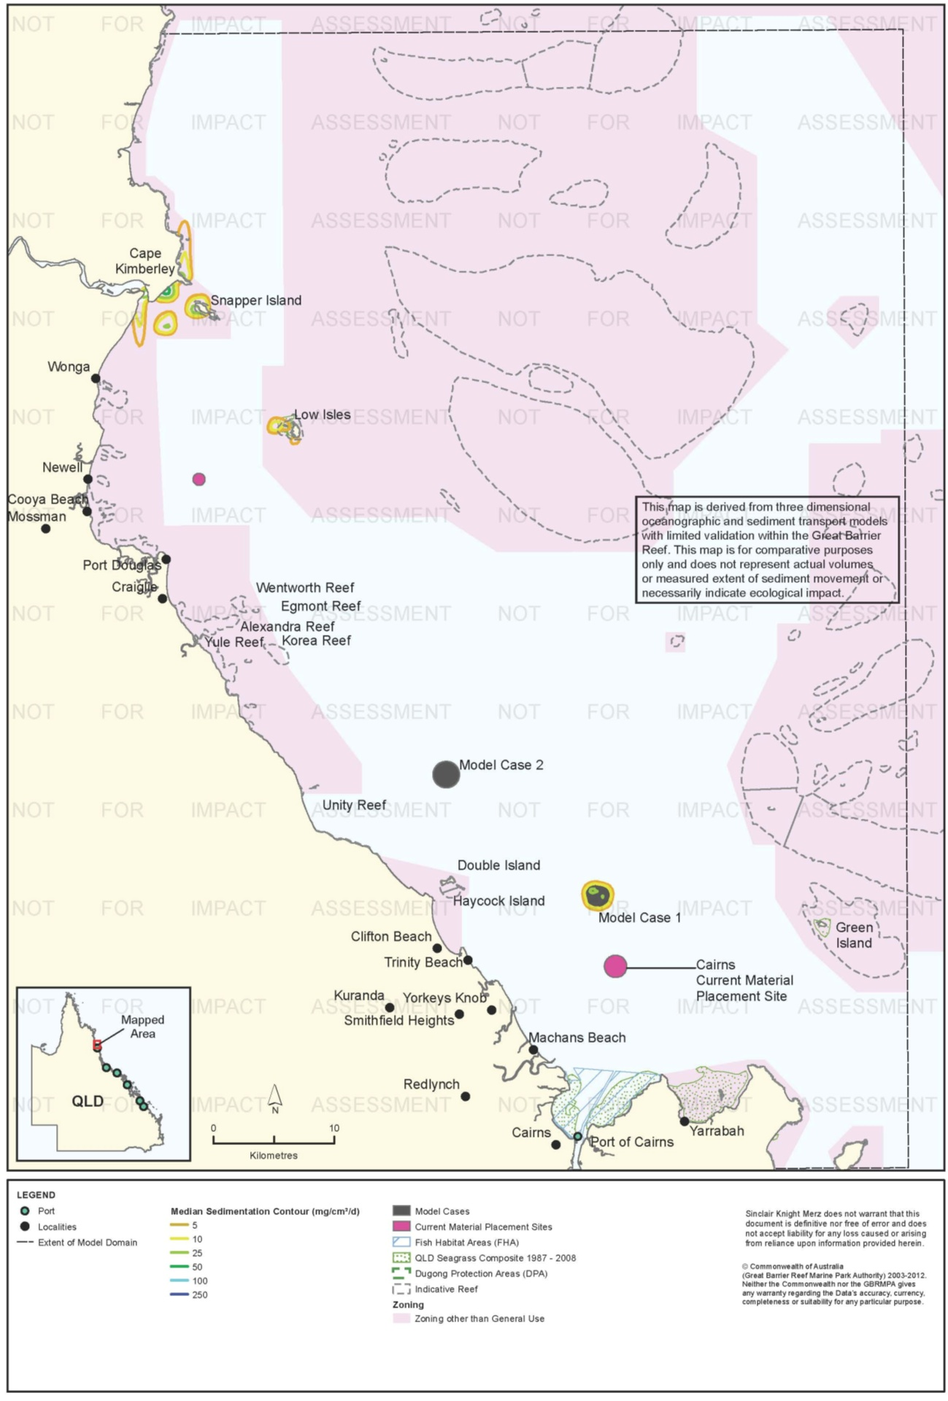
Figure 93. Cairns: dredging period (38 days) sedimentation rate, Model Case 1 - 50th percentile.

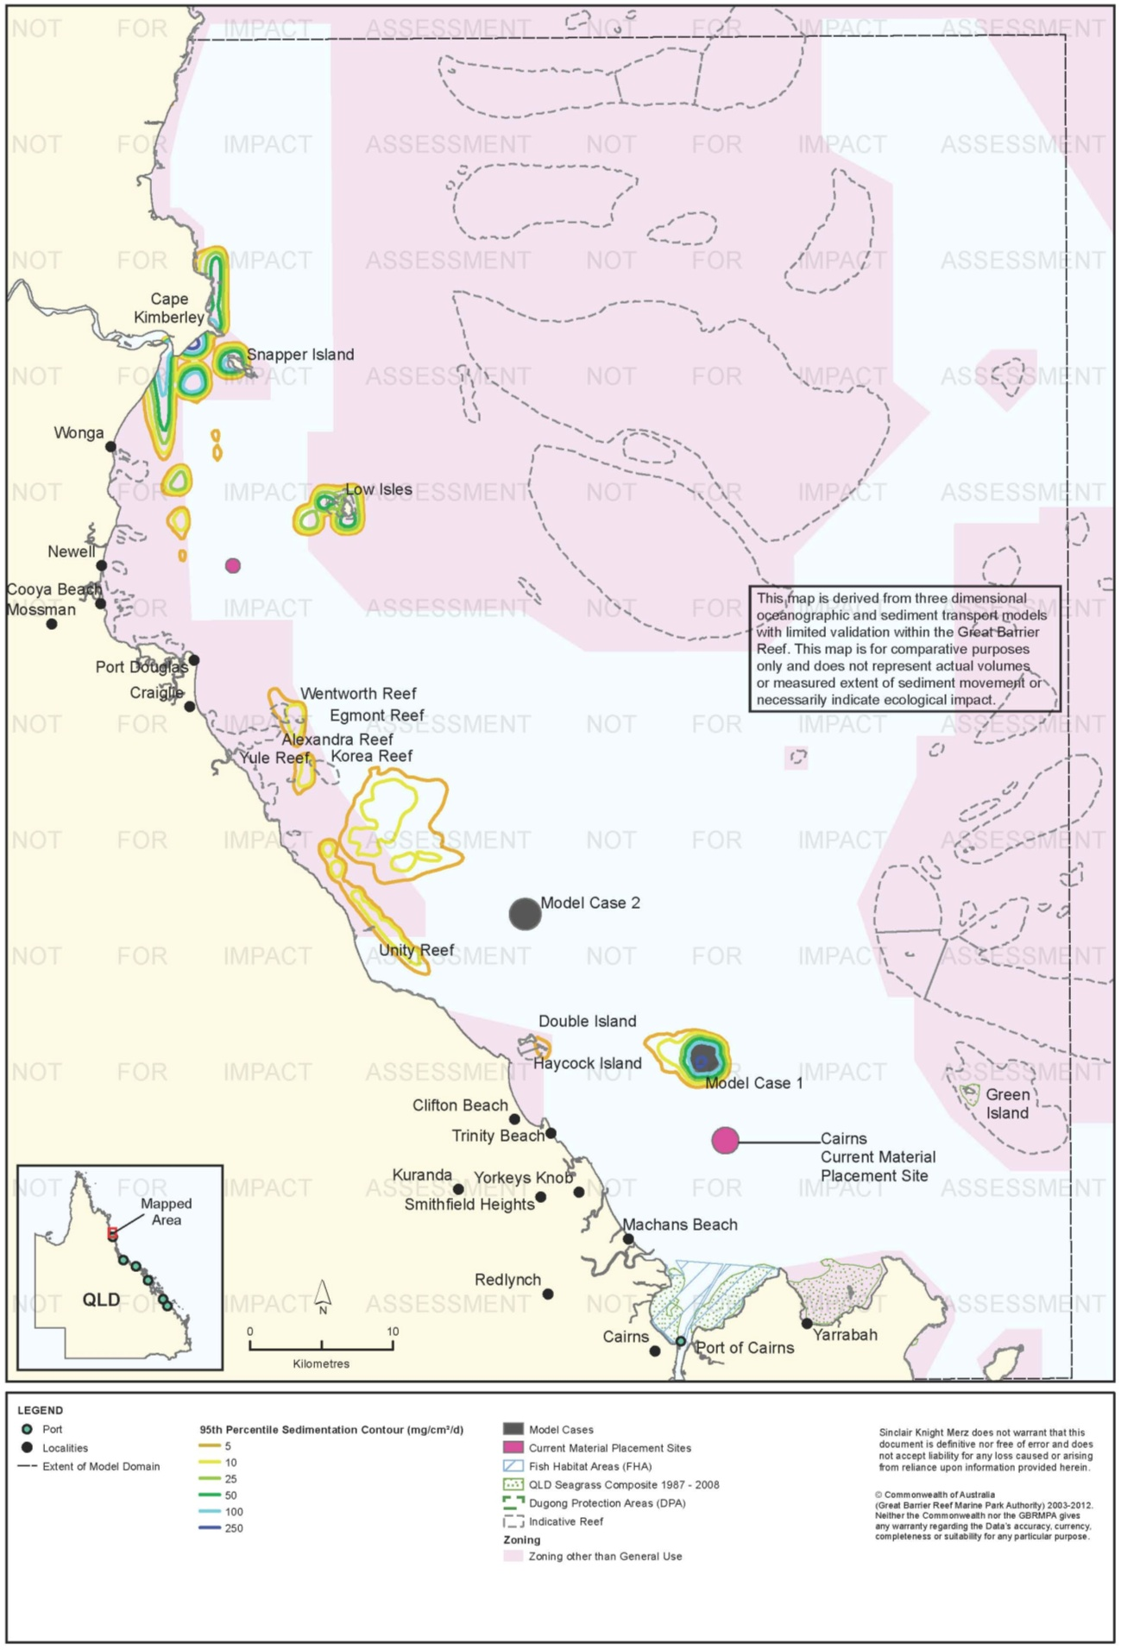
Figure 94. Cairns: dredging period (38 days) sedimentation rate, Model Case 1 - 95th percentile.

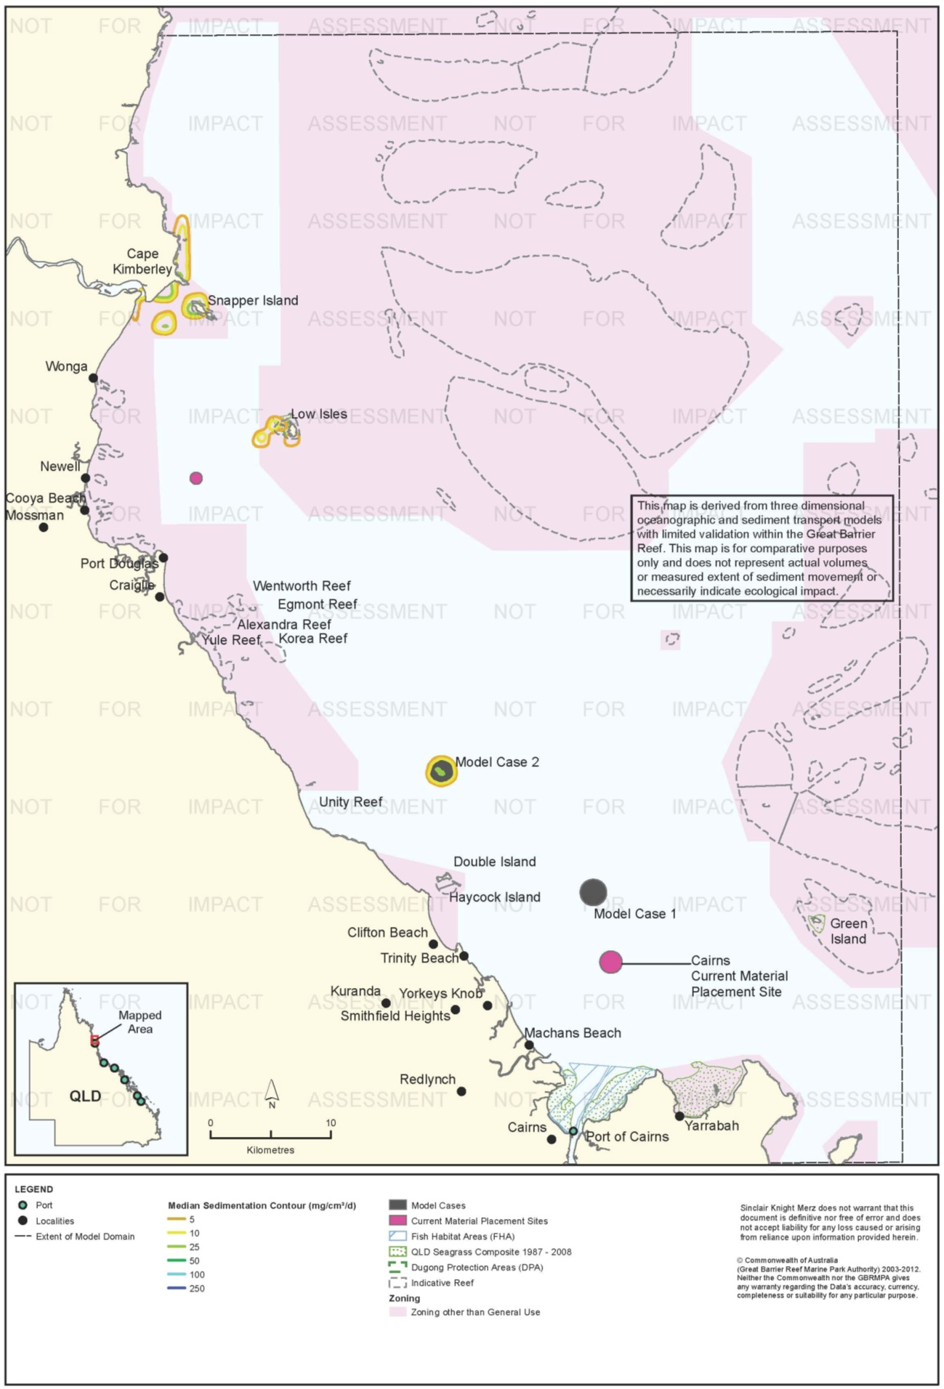
Figure 95. Cairns: dredging period (38 days) sedimentation rate, Model Case 2 - 50th percentile.

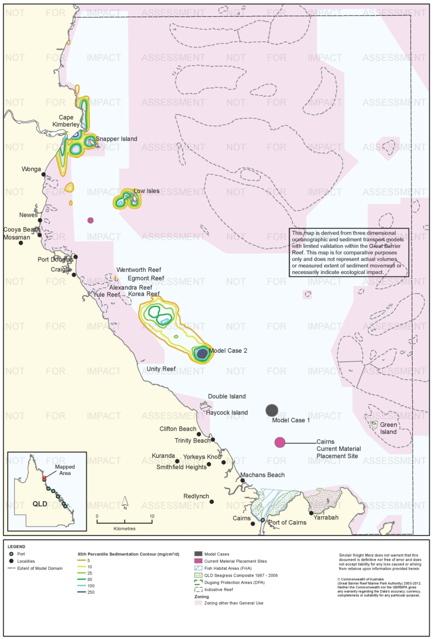
Figure 96. Cairns: dredging period (38 days) sedimentation rate, Model Case 2 - 95th percentile.

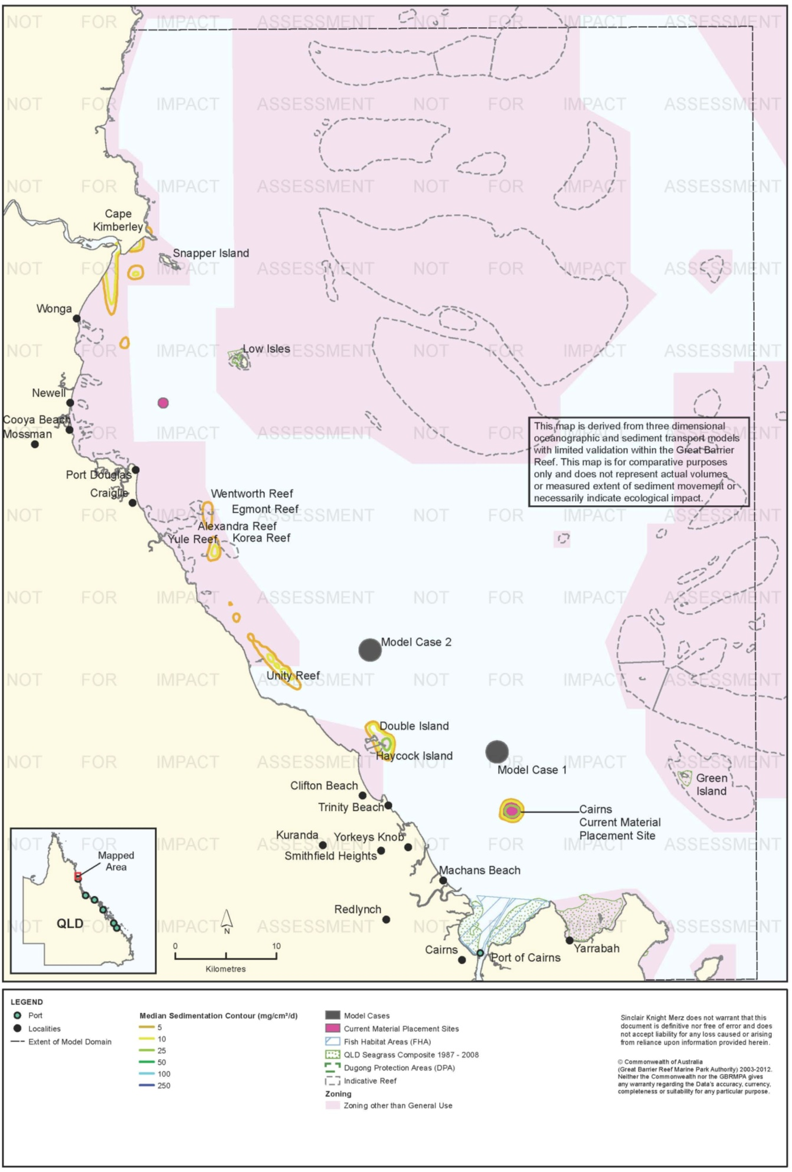
Figure 97. Cairns: dredging period (38 days) sedimentation rate, current site - 50th percentile.

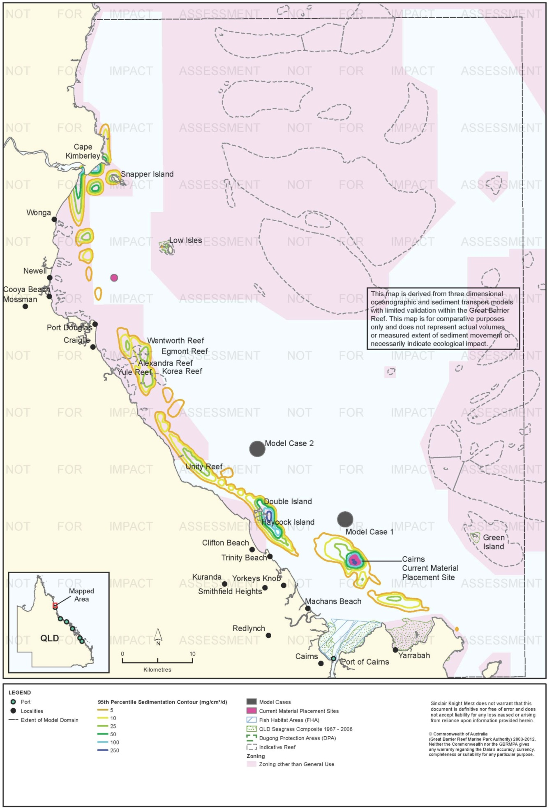
Figure 98. Cairns: dredging period (38 days) sedimentation rate, current site - 95th percentile.

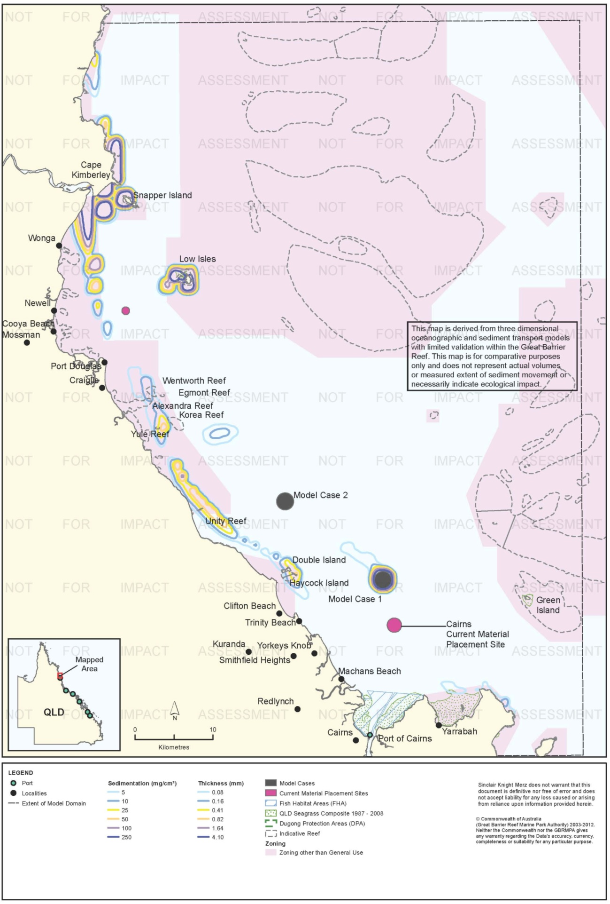
Figure 99. Cairns: dredging period (38 days) total sedimentation and bottom thickness, Model Case 1.

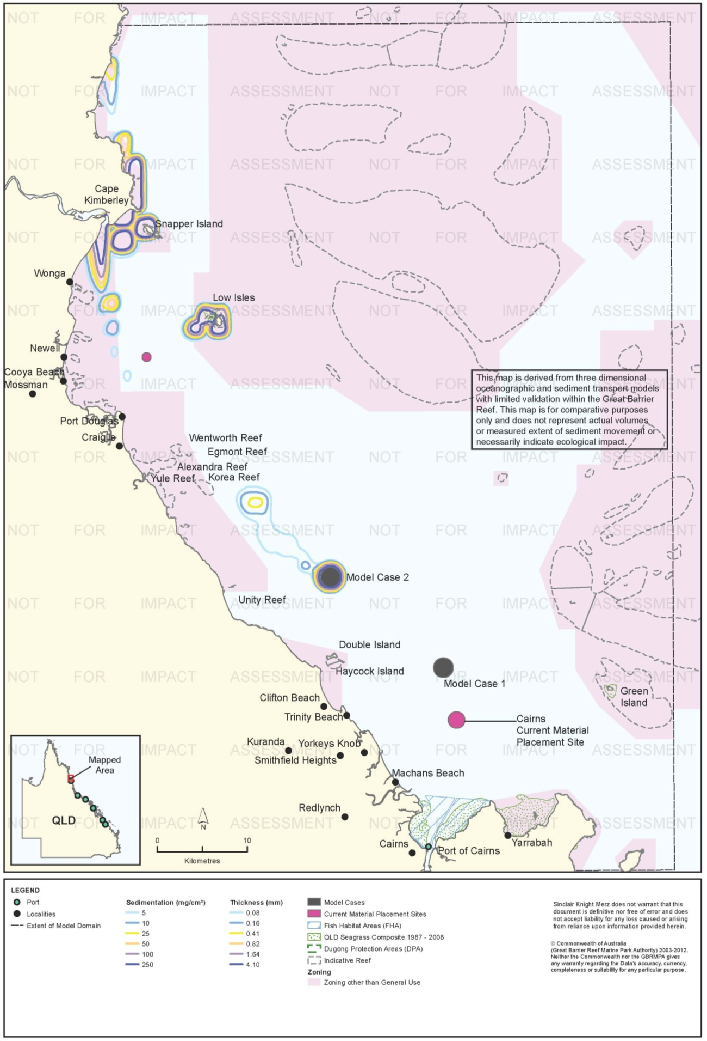
Figure 100. Cairns: dredging period (38 days) total sedimentation and bottom thickness, Model Case 2.

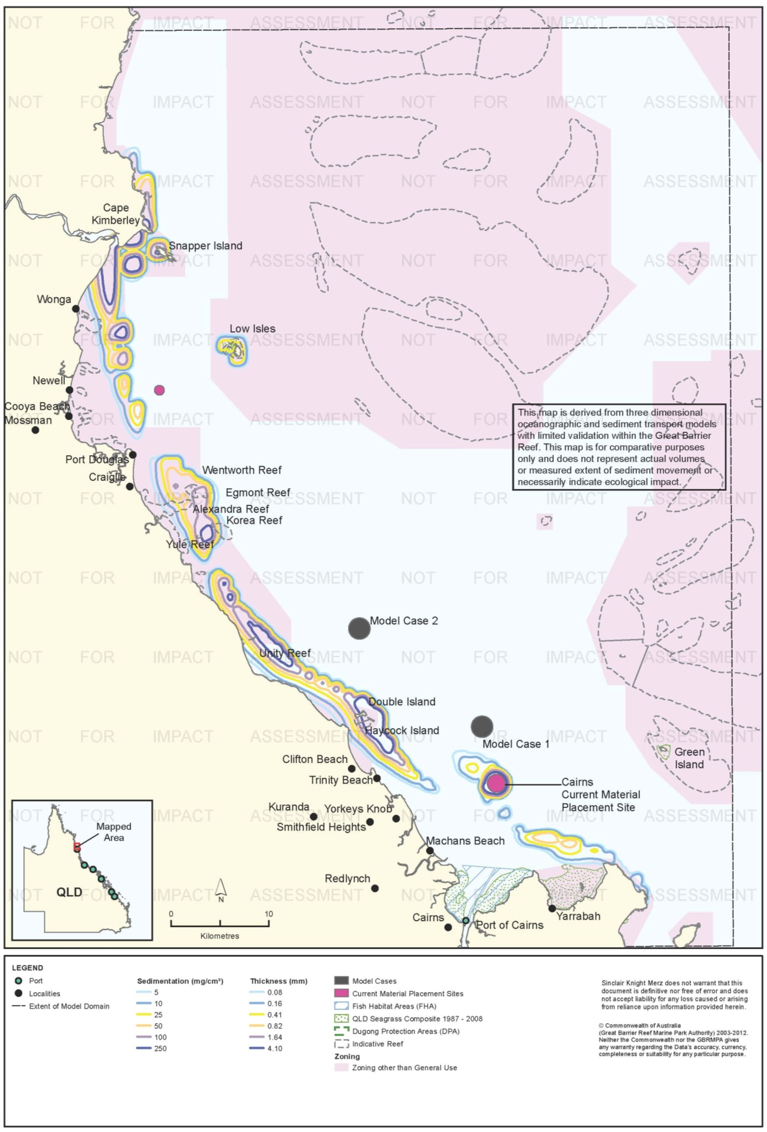
Figure 101. Cairns: dredging period (38 days) total sedimentation and bottom thickness, current site.

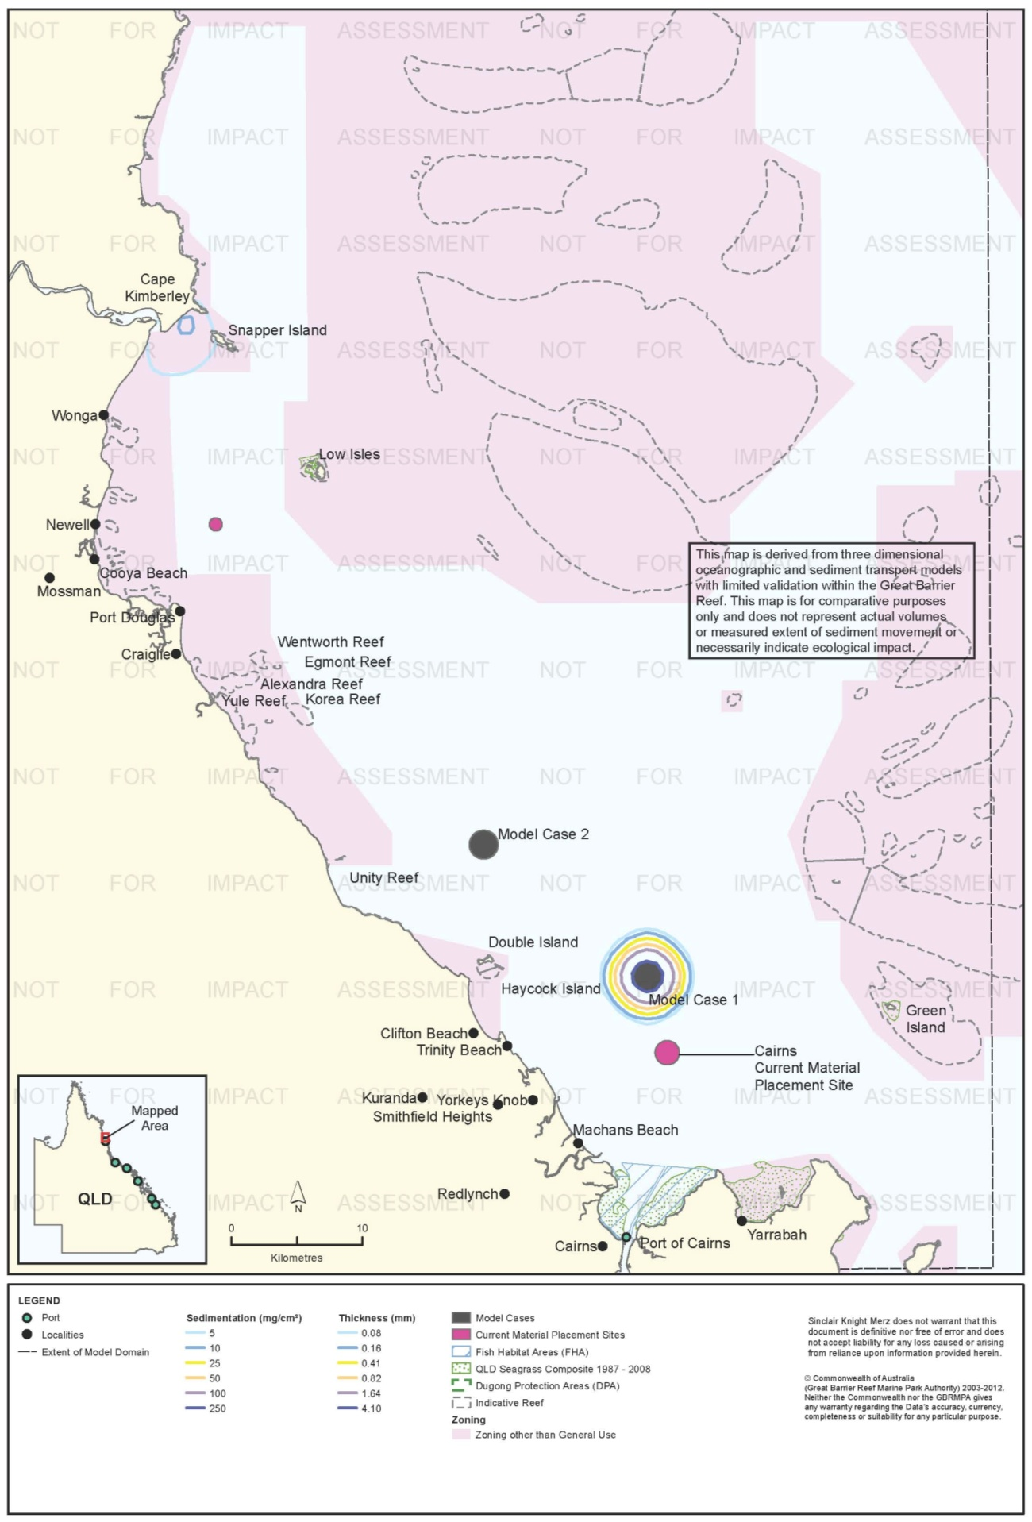
Figure 102. Cairns: long-term (12 months) total sedimentation and bottom thickness, Model Case 1.

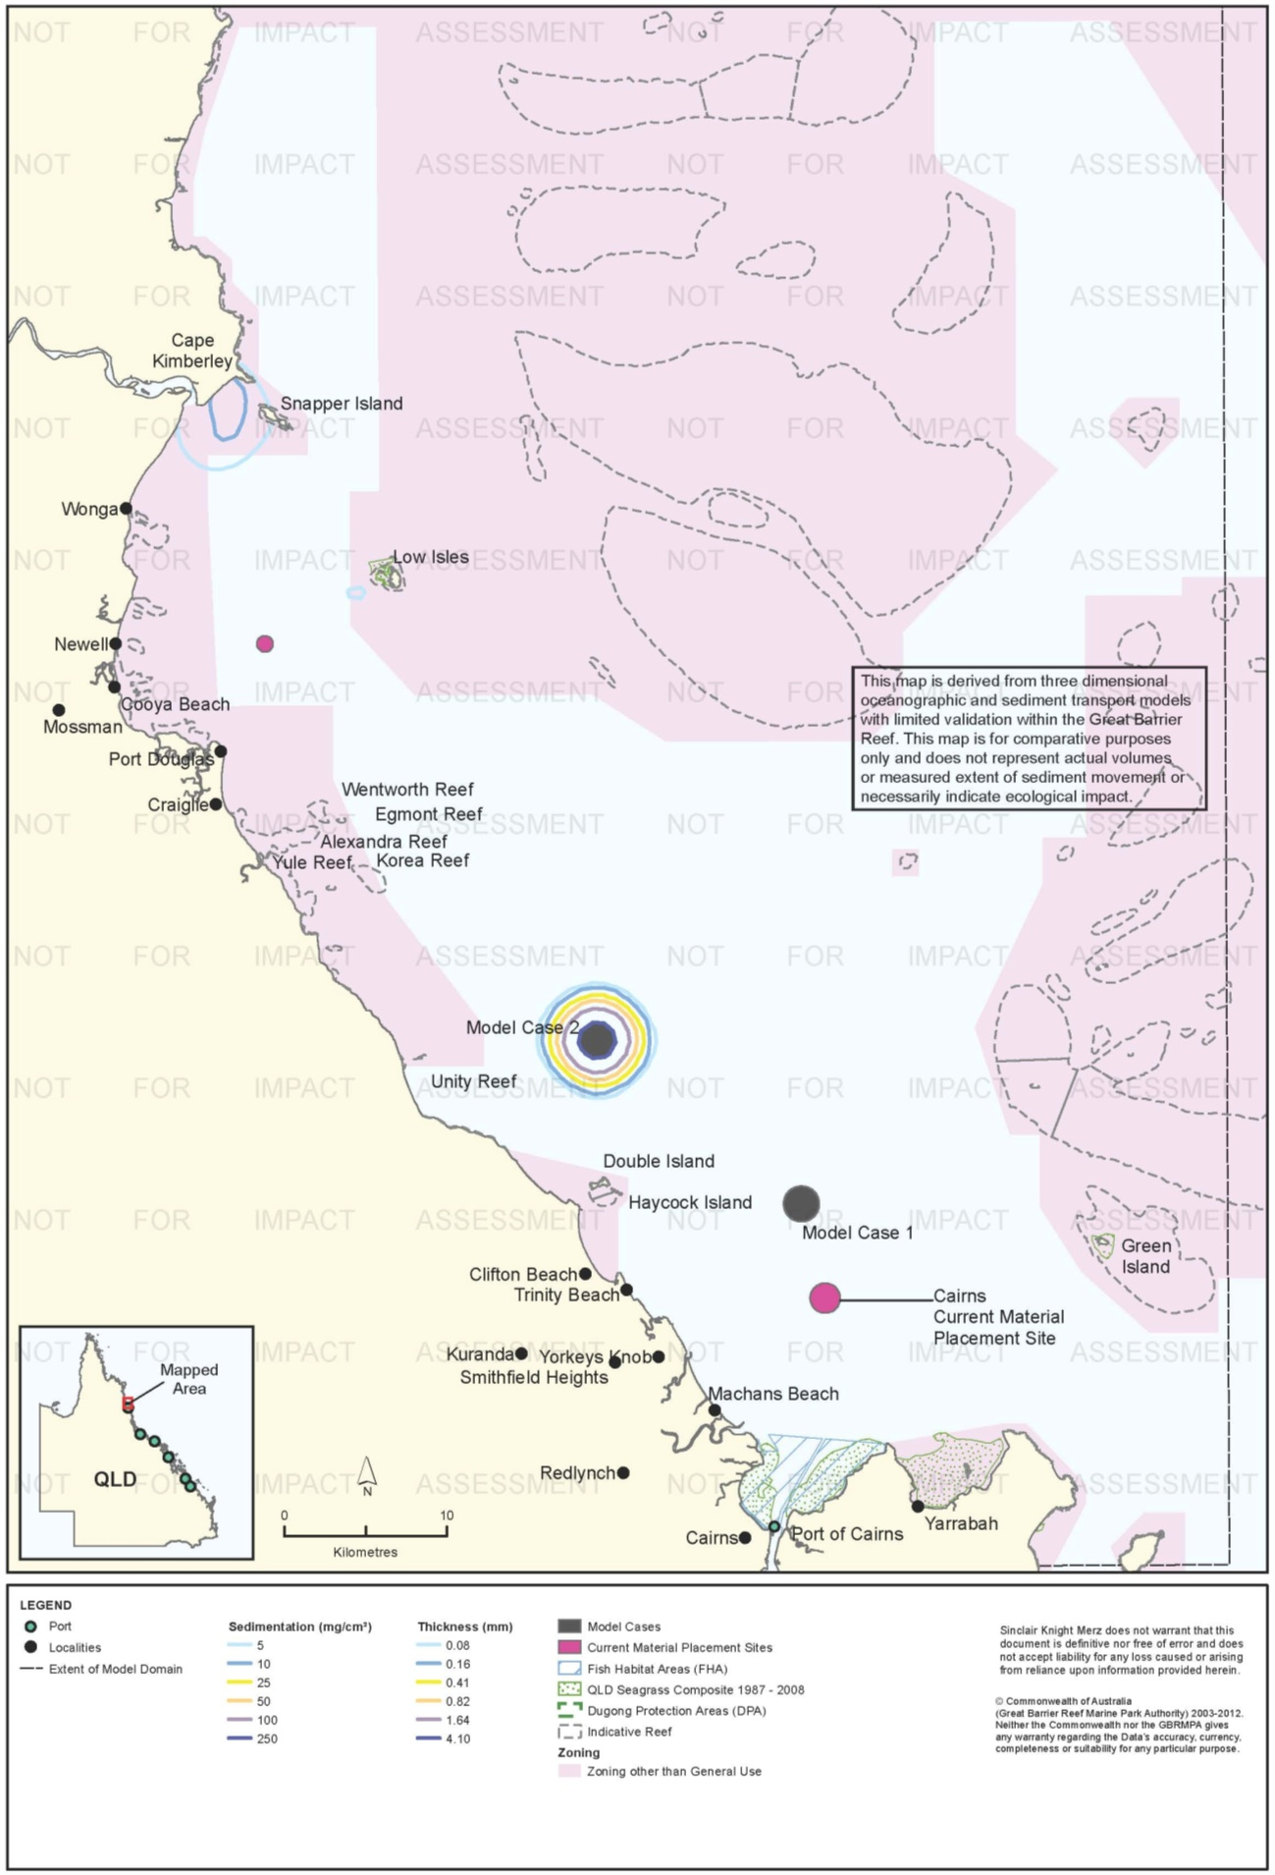

Figure 103. Cairns: long-term (12 months) total sedimentation and bottom thickness, Model Case 2.

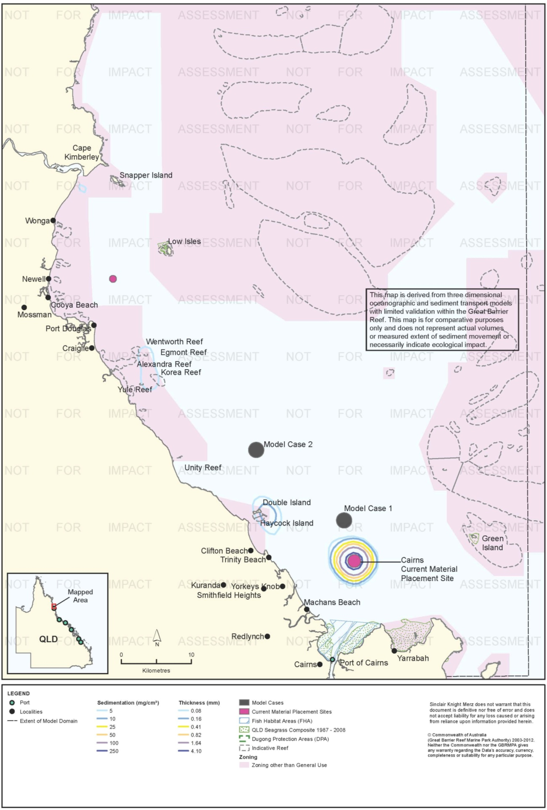
Figure 104. Cairns: long-term (12 months) total sedimentation and bottom thickness, current site.

Risk Assessment
The results of the risk assessment are presented in table 31. Risks associated with suspended sediment plumes were assessed as low for all three material placement sites. Low concentrations of TSS were generally predicted for the 95th percentile scenarios, with the highest predicted TSS a small area within the 10 mg/L contour immediately north-west of the current site. Predicted TSS plumes did not overlap with sensitive receptors such as coral reef or seagrass habitats.
Dredging-period sedimentation rates were relatively high across extensive coastal areas in the 95th percentile plots for all three model cases, with small areas up to 250 mg/cm²/d at Cape Kimberley and up to 100 mg/cm²/d around Low Isles for Model Cases 1 and 2, Cape Kimberly is likely to have high natural rates of sediment deposition given the influence of the Daintree River, which forms the southern boundary of Cape Kimberly. Modelling predicted that use of the current site would result in moderate to high 95th percentile (5 per cent of the time) sedimentation rates along almost the entire coastal region between Cairns and Cape Kimberley. However, under average conditions (50th percentile), increases in sedimentation rate were more localised and of lower magnitude.
Predicted total sedimentation at the end of the dredging period for the current site was high along most of the coast from about Trinity Beach to Cape Kimberly. Model Case 1 had low to moderate total sedimentation (up to 50 mg/cm² or 0.48 mm) along the coast between Cairns and Port Douglas during the dredging period, but up to 250 mg/cm² in areas north of Wonga and around Cape Kimberly, Low Isles, and Snapper Island, and up to 25 mg/cm² (0.41 mm) north of Cape Kimberly. Material placement at Model Case 2 was not predicted to result total sedimentation at sensitive receptors between Cairns and Port Douglas, but north of that had a similar pattern of total sedimentation to Model Case 1. Sediments from all sites were predicted to accumulate in the Cape Kimberley region during the dredging period, most likely reflecting the natural depositional characteristics of this area. Most of the total sediment that accumulated during the dredging period had moved further north beyond the model extent at the end of 12 months.
In summary, the two alternative material disposal sites at the Port of Cairns were assessed as having slightly lower levels of environmental risk than the current site, due to a reduction in sedimentation along coastal areas north of Cairns. Model Case 2 presents an option to reduce sediment deposition arising from material placement activities along the inshore coastal environments north of Cairns, with sediment predicted to drift further north to the Cape Kimberley region before reaching the near shore depositional environment. However, such results need to be tempered with the inherent risk in selecting a new material placement site located further offshore, particularly in the absence of further studies of sensitive receptors that may be affected including those to the north beyond the model extent. A reduction in environmental risk to inshore coastal habitats from utilising a placement site further offshore may in fact increase environmental risk at reefs located further offshore and to the north.
The results of this study indicate that any environmental benefit of using the Model Cases 1 or 2 material placement sites instead of the current site may be marginal. For Model Case 2, such benefits would relate to a reduced environmental risk for sensitive receptors of the near shore environment in the coastal region between Cairns and Port Douglas. Some reduction in total sedimentation along the northern beaches of Cairns might also be predicted from use of placement sites further offshore.
.

Table 31. Comparative risk assessment for the Port of Cairns based on modelling results (figure 90 to figure 104).
Hazard | Sensitive Receptor | Site | Likelihood | Consequence | Risk Rating
An increase in TSS concentration and turbidity in waters surrounding the material placement site. | Coral Reefs | Current Site | Unlikely | Minor | Low
 |  | Model Case 1 | Unlikely | Insignificant | Low
 |  | Model Case 2 | Unlikely | Insignificant | Low
 | Seagrass. | Current Site | Unlikely | Minor | Low
 |  | Model Case 1 | Unlikely | Insignificant | Low
 |  | Model Case 2 | Unlikely | Minor | Low
 | Fish Habitat Areas | Current Site | Rare | Insignificant | Low
 |  | Model Case 1 | Rare | Insignificant | Low
 |  | Model Case 2 | Rare | Insignificant | Low
 | Non-general Use Zones | Current Site | Unlikely | Minor | Low
 |  | Model Case 1 | Rare | Insignificant | Low
 |  | Model Case 2 | Unlikely | Minor | Low
 | Commercial fisheries | Current Site | Unlikely | Minor | Low
 |  | Model Case 1 | Unlikely | Minor | Low
 |  | Model Case 2 | Unlikely | Minor | Low
 | Tourism and recreational values | Current Site | Unlikely | Minor | Low
 |  | Model Case 1 | Unlikely | Minor | Low
 |  | Model Case 2 | Unlikely | Minor | Low
Increase in the rate of sediment deposition on the sea bed in areas surrounding the material placement site. | Coral Reefs | Current Site | Possible | Minor | Medium
 |  | Model Case 1 | Possible | Minor | Medium
 |  | Model Case 2 | Possible | Minor | Medium
 | Seagrass. | Current Site | Unlikely | Minor | Low
 |  | Model Case 1 | Unlikely | Minor | Low
 |  | Model Case 2 | Unlikely | Minor | Low
 | Fish Habitat Areas | Current Site | Rare | Insignificant | Low
 |  | Model Case 1 | Rare | Insignificant | Low
 |  | Model Case 2 | Rare | Insignificant | Low
 | Non-general Use Zones | Current Site | Possible | Moderate | High
 |  | Model Case 1 | Possible | Minor | Medium
 |  | Model Case 2 | Possible | Minor | Medium
 | Commercial fisheries | Current Site | Unlikely | Minor | Low
 |  | Model Case 1 | Unlikely | Minor | Low
 |  | Model Case 2 | Unlikely | Minor | Low
 | Tourism and recreational values | Current Site | Unlikely | Minor | Low
 |  | Model Case 1 | Unlikely | Minor | Low
 |  | Model Case 2 | Unlikely | Minor | Low
Accumulation of sediments on the sea bed. | Coral Reefs | Current Site | Possible | Moderate | High
 |  | Model Case 1 | Possible | Minor | Medium
 |  | Model Case 2 | Possible | Minor | Medium
 | Seagrass. | Current Site | Unlikely | Minor | Low
 |  | Model Case 1 | Unlikely | Insignificant | Low
 |  | Model Case 2 | Unlikely | Insignificant | Low
 | Fish Habitat Areas | Current Site | Rare | Insignificant | Low
 |  | Model Case 1 | Rare | Insignificant | Low
 |  | Model Case 2 | Rare | Insignificant | Low
 | Non-general Use Zones | Current Site | Possible | Moderate | High
 |  | Model Case 1 | Possible | Moderate | High
 |  | Model Case 2 | Possible | Minor | Medium
 | Commercial fisheries | Current Site | Unlikely | Minor | Low
 |  | Model Case 1 | Unlikely | Minor | Low
 |  | Model Case 2 | Unlikely | Minor | Low
 | Tourism and recreational values | Current Site | Unlikely | Minor | Low
 |  | Model Case 1 | Unlikely | Minor | Low
 |  | Model Case 2 | Unlikely | Minor | Low

Ecological Monitoring in Relation to Dredging
Neil et al. (2003) surveyed infauna communities in the Cairns DMPA and at locations 2 km to the NE and SW in April and May 2003. Eighteen sites were sampled on a grid within each area. The grids in the NE and SE locations were subdivided into strata at increasing distances from the DMPA, at 200 m intervals. Sampling consisted of two sediment grabs for infauna and one for PSD, as well as one 100 m towed video transect at each site. Further details are provided in table 8.
Neil et al. (2003) found no significant differences in the taxonomic richness of infauna among the three locations as a whole. They did find some significant differences at the level of the strata, i.e. significant differences with distance from the DMPA. Neil et al. (2003) interpreted these differences as evidence of a long-term impact of material placement on infauna communities. Neil et al. (2003) concluded that these differences were minor, affect mainly rare taxa, and decay downstream of the DMPA. They reported that epibenthic flora and fauna (those that live on the surface of the sediments) were sparse at all sites but did not report spatial differences or possible effects of material placement on benthic flora and fauna.
Neil et al. (2003) analysed infauna results only with regard to taxonomic richness and did not report results for numerical abundance or community structure. It is possible that effects could occur at larger spatial scales than surveyed, although Neil et al. (2003) did demonstrate the ability to detect a spatial gradient in taxonomic richness, with effects decreasing with distance downstream (north-west) of the DMPA. Having only duplicate grabs is considered to be relatively low replication in infauna studies. Neil at al. (2003) do not report the power of the statistical analyses to detect differences between strata or locations.
Worley Parsons (2009) conducted one survey of the DMPA for infauna taxonomic richness and diversity in May 2009 by sediment grab sampling. Three locations were surveyed: one location within the current DMPA, one location on a north-west (downstream) axis and one on a south-east (upstream) axis from the DMPA. Five sites at each location were sampled, evenly distributed within the DMPA and at increasing distance from the DMPA boundary to a distance of two km. Three sediment grabs were taken for infauna analysis and for PSD analysis at each site. Results found subtle differences in infauna communities within and possibly at 50 m from the DMPA boundary, indicating possible minor impacts from dredge material placement on benthic communities within the surrounding DMPA (Worley Parsons 2009). As with the survey conducted in 2003 impact from dredge material placement is inferred from spatial pattern and not from before-after or other temporal comparisons. Impacts on larger spatial scales than surveyed are possible. Statistical power is not reported. Further details are provided in table 8.
Reason et al. (2012) summarise the results of annual seagrass monitoring in Cairns from 2001-2011. The monitoring program does not target dredging specifically, but rather is designed to detect long-term changes from all influences. Monitoring is conducted in six permanent monitoring meadows, five selected on the basis of broad-scale mapping conducted by Campbell et al. (2002) in December 2001. The monitoring is conducted through broad-scale mapping of the boundaries of seagrass meadows by helicopter. Within meadows, species composition and visual estimates of above-ground biomass and per cent macroalgal cover are recorded in quadrats. The quadrats are deployed from a helicopter for intertidal meadows and by drop camera in subtidal meadows (Reason et al. 2012). Depth is also recorded at subtidal sites. Sampling sites are located haphazardly within meadows at high density. Site numbers vary; 386 sites were surveyed in 2011. Further details are provided in table 8.
In 2011 the total area of seagrass meadows declined for the fourth consecutive year to 211 ha, the lowest spatial extent of meadows observed since 2001 (Reason et al. 2012). This compares to 663 ha in 2001 when the monitoring program was established, and 1488 ha in 2007, when seagrass meadows covered the largest area observed by the program. Above-ground biomass was the second-lowest observed since 2001, with 2010 the lowest. One meadow, a Zostera capricorni meadow in Trinity Inlet, was not present for the first time during the monitoring program. Reason et al. (2012) interpreted increases in above-ground biomass in some meadows over 2010 levels as a possible early sign of recovery.
Reason et al. (2012) attribute the recent declines in seagrass in Cairns several years of high rainfall and flooding, and the effects of Cyclone Yasi, which passed through Cairns in February 2011. They concluded that port activities were unlikely to have had impacts. However, Reason et al. report that seagrass meadows in Cairns are in a highly vulnerable state. Previous studies of seagrass communities in the Cairns region identified the area as one of the four regions of the World Heritage Area facing the highest level of risk from anthropogenic impacts (Rasheed et al. 2007). Reason et al. (2012) considered that the resilience of Cairns seagrass meadows to anthropogenic stress may be reduced.

Environmental Condition
Water quality in the Wet Tropics Region, which includes the Port of Cairns, has been monitored since 2007 by the RRMMP (Schaffelke et al. 2011). The water quality aspect of the monitoring program includes permanent monitoring sites (water quality loggers) and remote sensing techniques. A number of monitoring sites are within 50 km of the Port of Cairns, including the Cairns transect which provides long term water quality data for a full suite of water quality parameters (Schaffelke et al. 2011). Regionally, water quality is mostly good when assessed against guideline values (Schaffelke et al. 2011), however water quality has generally declined since 2007/2008 with values generally increasing over time for all locations (table 32).

Table 32. Summary of annual mean turbidity (NTU) from turbidity sensors at Wet Tropics region water quality locations from the RRMMP¹.
Site | 2007-2008² | 2008 to 2009² | 2009-2010² | 2010-2011³
Snapper Island | 2.21 | 1.87 | 3.20 | 2.27
Fitzroy Island | 0.85 | 0.89 | 0.88 | 1.18
High Island | 0.81 | 0.84 | 1.20 | 1.58
Russell Island | 0.49 | 0.63 | 0.71 | 1.19
Dunk Island | 2.02 | 2.31 | 2.67 | 2.94

Remote sensing is used to monitor TSS concentrations for the entire Marine Park at a spatial resolution of 1 km (Brando et al. 2011). TSS concentrations in the Wet Tropics region have declined since 2003/2004 (Brando et al. 2011). The TSS paddock to reef index rating was very poor in 2002/2003 and improved to good in 2010/2011. Remote sensing data from May 2010 to April 2011 (Brando et al. 2011) in and surrounding the Port of Cairns study area showed a clear gradient of decreasing surface TSS from inshore to offshore. Median TSS values for shallow coastal areas such as Trinity Inlet and the Port of Cairns were up to 5 mg/L. Areas surrounding Alexander Reef and Yule Reef had median TSS concentrations of up to 2 mg/L. Annual median TSS concentrations at the locations of Model Cases 1 and 2 and the current material placement site ranged from approximately 1.25 mg/L to 0.25 mg/L, with the current material placement site having the highest TSS values. Annual median TSS in 2010/2011 declined to < 0.5 mg/L in mid-shelf waters (Brando et al. 2011).
Reef health in the Wet Tropics region has been monitored since 2005 Thompson et al. (20011a, b). For coral health the Wet Tropics region is broken into three sub-regions the Barron Daintree, Johnstone Russell-Mulgrave, and Herbert Tully. Two regions, the Barron Daintree and Johnstone Russell-Mulgrave, occur within 50 km of the Port of Cairns or have the potential to be affected by disposal activities according to the modelling results. Hard coral cover in both sub regions has fluctuated since monitoring began in 2005. In the Johnstone Russell-Mulgrave subregion most monitoring sites increased in coral cover until 2011, when cover decreased, most likely due to Tropical Cyclones Tasha and Yasi as well as coral disease at Fitzroy Island (Thompson, 2011b). Coral cover generally increased in the Barron Daintree sub-region, however macroalgal cover generally increased, likely as a short-term response after disturbance by Yasi, and coral disease was observed at Snapper Island. In both sub-regions a decline in juvenile corals from previous years was observed in 2011. Thompson et al. (2011b) assessed the overall condition of both sub-regions as moderate in 2011, which was a decrease from 2009 (table 33).

Table 33. RRMMP monitoring score for overall inshore coral health for the Wet Tropic region from 2009-2011 (Thompson et al. 2011a, b).
Year | RRMMP score
 | Barron Daintree | Johnstone Russell-Mulgrave
2009 | Good | Good
2010 | Good | Good
2011 | Moderate | Moderate

Reefs are also monitored throughout the Reef by the AIMS Long Term monitoring program, which has been in operation since1992 (Sweatman et al. 2005). Three monitoring sites (Green Island, Fitzroy Island and Low Islets) are within approximately 70 km of the Port of Cairns, with Green Island approximately 30 km east. Hard coral cover has fluctuated considerably in response to a number of environmental pressures (including cyclones and crown-of-thorns outbreaks) however cover for Green and Fitzroy Island has increased from 1993 to 2011 (table 34). Soft coral has also fluctuated but has generally recovered to similar levels as those recorded in 1993.

Table 34 Summary of AIMS Long Term Monitoring Program inshore sites for the Cairns region¹.
Coral type | Site | Per cent cover (1993) | Per cent cover (2011) | Maximum cover (Per cent – year) | Comments
Hard coral cover | Green Island | 4 | 20 | 20 - 2009 | Fluctuated increase since 1993
 | Fitzroy Island | 23 | 25 | 36 - 1997 | Fluctuated slight increase
 | Low Isles | 30 | 25 | 40 -1996 | Fluctuated slight decrease
Soft coral cover | Green Island | 6 | 6 | Remained stable at approximately 6% | Remained stable
 | Fitzroy Island | 21 | 20 | 21 -1993 | Fluctuated slight decrease
 | Low Isles | 15 | 14 | 19 -2009 | General decrease then increase
1 – sourced from AIMS 1996-2013
An intertidal assessment of seagrass in the Burdekin region was conducted in 2011 as part of the Seagrass Vulnerability Assessment for the Great Barrier Reef (Commonwealth of Australia 2011). The assessment the overall status of seagrass in poor condition with seagrass in Cairns Harbour and trinity Inlet exhibiting a downward trend since 2005 and in a highly vulnerable state (Commonwealth of Australia 2011).
The 2010 Great Barrier Reef Report Card rated the overall condition of coral and inshore water quality as moderate with high coral cover and TSS volume and macroalgae abundance low enough to receive a good report card rating. Seagrass received a poor grade with very poor reproduction rating.

Conclusions, Knowledge Gaps, Further Research and Management Strategies
This pilot study is the first to incorporate the effects of large-scale currents in the Region in modelling the migration of dredge material over the long term (12 months). As described in 'Model Assumptions and Limitations' p. 20, the modelling represents "maximum credible" predictions of the long-term fate of dredge material after placement at sea. Long-term migration may in fact be less than the model predicts, but arguable the most important finding of the study is that dredge material placed at sea has the potential to migrate on much greater spatial and temporal scales than has previously been appreciated. This is largely because the influence of large-scale currents has not previously been included in modelling of dredge material transport. In addition, only one previous study (BMT WBM 2012a) has modelled the movement of dredge material over a period of 12 months after commencement of placement operations. BMT WBM (2012a) also predicted long-range movement of material, in the case of their study beyond the modelling domain.
Another key finding of the study is that placement of material in deeper water further offshore in the Reef lagoon than the currently used placement sites does not necessarily result in reduced migration of dredge material. In fact, because of the effects of large-scale currents, material placed offshore may be more mobile than if placed in the current sites closer to shore. The study identified varying degrees of reduced environmental risk may be associated with alternative material placement sites located further offshore than the current sites at the Ports of Hay Point, Abbot Point and Cairns. However, in the case of Rosslyn Bay State Boat Harbour, there were clear disadvantages in placing dredge material further offshore than at the current site, with no benefit evident for the Port of Gladstone (where the current site was not modelled) and the Port of Townsville.
The modelling and environmental risk assessment for the six study areas has evaluated relative potential risks and benefits from placement of dredge material at alternative model case sites. Overall, risks related to increased suspended sediment concentrations were low for most modelled sites. The primary risks to sensitive receptors identified were related to increased sedimentation rates and total sedimentation.
Mitigation measures associated with individual material placement projects will depend on the specific project. At the initial screening level of this study, the first step in risk mitigation would be more detailed assessment of any proposed alternative placement site, which has been done in conjunction with proposals for new placement areas at several of the six locations. This study has reinforced the need for detailed, project-specific EIAs of proposed dredging and material placement projects.
The current study's predictions of dredge material migration on large spatial and temporal scales point to a number of key knowledge gaps and research areas in relation to developing improved management strategies for dredge material in the Region.

Modelling Sensitivity Analysis
The study has been particularly ambitious not only in including large-scale currents in modelling dredge material migration over 12 months, but in doing so at the scale of the entire Region, with bed shear-stress modelling for 12 Queensland ports and more detailed dredge material modelling for the six main study areas. Completing these tasks within the time and financial constraints of the study necessarily required a number of simplifying assumptions, which are described in detail by SKM APASA (2013b, 2013c).
In principle it would be possible to further develop and refine the model at the regional scale. At some point it would be advisable to consider whether the best environmental management outcomes are likely to result from further investment in ever more sophisticated modelling. Modelling will never be perfect, and it may be better to invest in more strategic water quality and ecological impact monitoring, or research on receptor sensitivities, improved methods for water quality monitoring or rapid detection of ecological stress, research on the effectiveness of potential mitigation measures, or studies of cumulative impact and ecosystem resilience.
At this stage, however, SKM and APASA’s view is that further research on modelling of dredge material transport, in particular the sensitivity of model predictions to the key parameters identified in this study, is a priority for further developing management strategies. This could be done by varying the key assumptions for one or a few elected model cases to determine the extent to which model predictions are affected by a realistic range of each parameter. This sensitivity analysis would be invaluable in developing improved models to provide the best possible predictive assessment of dredge material movement in the World Heritage Area within the context of the overall sediment dynamics regime. Model sensitivity analysis would also help set priorities for field and laboratory research, by identifying which parameters are most critical to quantify. Perhaps most importantly, the results are needed to help clarify the range of variability and uncertainty in model predictions of dredge material migration. An understanding of this range is needed to guide the development of a strategic approach to water quality and ecological monitoring at the regional scale. For example, in selecting sites for long-term strategic monitoring, it is important to understand how much the spatial pattern of sediment movement might vary from year to year.

Inter-annual Variability
The modelling in this study used wind, wave, tide and current data from 2011. In developing the model, data from the years 2004 to 2011 were examined. The year 2011 was selected because it was the most energetic conditions that is, the highest current speeds, of the eight years examined. This provides an upper bound for sediment transport, in other words ‘maximum credible’ predictions of dredge material migration. The year 2011 was also a strong La Niña year. It would be useful to understand how representative the results of the study are with respect to less-energetic conditions, and to fluctuations in the El Niño-Southern Oscillation cycle, that is, whether the predicted distance and direction of dredge material migration also hold true in El Niño or neutral years. This could be assessed by using data from other years to drive the model while holding other parameters constant.

Sediment Resuspension and Consolidation
Determination of site-specific estimates of critical shear-stresses for resuspension of particles of different sizes was beyond the scope of the study, and resuspension was modelled using uniform estimates based on accepted published values. The estimates for resuspension (i.e. erosion) were based on available literature. Additional model runs varying the assumed 'resuspensibility' of sediments once settled on the bottom, that is, the sediment resuspension thresholds, would elucidate the sensitivity of the model predictions to this parameter.
Similarly, the model did not take into account the consolidation of dredge material on the bottom after initial deposition (SKM APASA 2013a, 2013b, 2013c). This assumption gives an upper bound for subsequent resuspension and migration. Again the importance of this assumption, and thus the priority of studies to quantify the consolidation rate and its effect on sediment resuspension, could be tested through model runs that assume varying rates of consolidation while holding other parameters constant.

Ambient Background
As described in 'Dredge Plume and Material Migration Modelling' p. 25, the study modelling has predicted "above background" TSS and sedimentation, a standard approach but with important implications. These include the potential for small increases above background to cause additional stress or even tip the system over a tolerance threshold; conversely it is possible that the above-background increase will be very small relative to the ambient background, that is, that the ambient regime will override the effects of dredge material placement. In terms of the modelling, the "above background" assumption could change the picture presented in the current study if interactions of dredge material with ambient sediment tend to reduce dredge material migration (see 'Dredge Plume and Material Migration Modelling' p. 25).
Additional modelling that incorporates ambient resuspension to test the sensitivity of model predictions to the effects of ambient sediment resuspension would provide valuable insight into the relative contributions of dredge material and other sources of sediment in the Region, and their subsequent migration. This would be a direct contribution to improved capabilities for cumulative impact assessment.

Incorporation of Large-Scale Currents
The modelling in this study incorporated the influence of large-scale currents on sediment transport through a process of vector addition, that is, overlaying the influence of large-scale currents on local conditions (SKM APASA 2013c). To better understand the significance of this approach, future work could apply the HYCOM (large-scale current model) predictions as boundary conditions to the tidal and local winds model, so that the models are at the same spatial (700 m) and temporal (hourly) resolution. This approach would also verify the influence of large-scale currents in water depths less than 10 m and whether the approach adopted in this research may be an over-estimate of the dredge plume footprints.

Shallow Water Processes
The scope of the project did not permit the inclusion of shallow-water processes on sedimentation, specifically shallow waves (e.g. surge from shoaling waves, surf), or tidal pumping of sediment into mangroves and estuaries (SKM APASA 2013c). If the study is used for the intended purpose, comparison of the relative outcomes of placing material in different locations, and not to predict impacts on specific receptors, this is not a critical assumption. Detailed environmental impact assessment, on the other hand, will need to consider these important shallow water processes. For example, predictions of relatively high sediment deposition on the exposed windward sides of islands and reefs that do not take these processes into account are unlikely to be realistic.
SKM’s view is that the technical requirements to link models of detailed shallow water processes to large-scale processes are not currently justified in the context of strategic consideration of improved management arrangements for dredge material and that other research areas, in particular analysis of model sensitivity to key assumptions described in the sections immediately above, have higher priority. Modelling for predictive impact assessment for specific individual projects, however, needs to take shallow-water processes into account.

Presentation and Interpretation of Modelling Results
In the course of the project it became apparent that model results presented as maps of percentiles of occurrence of various TSS concentrations and sedimentation rates are sometimes difficult to understand and interpret. SKM and APASA believe it would be beneficial to initiate a process to address questions such as: a) What is the best way to represent model output? b) What should be industry standards or what is considered best practice when reporting modelling results? c) How should the technical/regulatory community interpret modelling results?

Direct Sediment Resuspension and Consolidation Studies
Modelling is an indispensable tool in predicative impact assessment and investigating the priorities for field studies, but field validation of model predictions, and quantification of the parameters most critical to improving the accuracy of model predictions, is even more essential. In the context of the current study, SKM APASA consider that the model sensitivity analysis described above is a critical first step that can be implemented relatively quickly, and the outputs would serve to prioritise the direct field studies of critical parameters. Subject to the results of model sensitivity analysis, however, SKM and APASA’s view is that among the highest priorities for direct field studs are measurements of sediment resuspension and consolidation in relation to the predictions of this study.
The model predictions of relatively high bed shear-stress and resultant significant sediment resuspension in deeper waters offshore of the currently used sites are an unexpected result of the study. Studies of sediment resuspension in the Reef lagoon not directly related to dredge material tend to indicate that sediment resuspension is relatively uncommon below a depth of about 20 m (e.g. Larcombe & Woolfe, 1999; Orpin et al. 1999, 2004; Wolanski et al. 2005). Wolanski et al. (2005), for example, found that sediment resuspension during storms did not extend below a depth of 12 m on the windward side of an inner-shelf island, or below 5.5 m on the leeward side.
Previous direct studies of natural sediment resuspension in the Region, however, have tended to focus on sediment resuspension in inshore areas, rather the mid-shelf lagoon, where the present study predicts a strong influence of large-scale currents on bed shear-stress and resultant sediment resuspension. Model sensitivity analysis would provide insight into whether the resuspension parameter assumptions have a critical effect on predicted sediment migration. If so, field measurements of bed shear-stress and/or sediment resuspension would significantly improve understanding of the implications of offshore dredge material placement in relation to the present study’s results. Useful information may already be available from Acoustic Doppler Current Profile (ADCP) current data collected for hydrodynamic modelling in EISs for proposed dredging and material placement projects. ADCP data derive current speeds from the movement of particles in the water column, and can be processed to estimate sediment resuspension. “Data mining” and re-analysis could be a particularly cost-effective exercise for at least preliminary investigation of actual resuspension.
Measurements of resuspension of ambient sediment from the seabed, however, may not be representative of resuspension of dredge material after placement, for example because of differences in particle size distribution or because ambient sediments are more consolidated (compacted) than dredge material, especially when newly placed. Consolidation increases the bed shear-stress required to resuspend sediments. As noted by SKM APASA (2013a, 2013b, 2013c) in relation to maintenance dredging, placement of dredge material has the potential to increase suspended sediment concentrations and sediment mobility, even if not representing a new sediment input to the lagoon, by making the sediment more susceptible to resuspension. Additional studies such as Wolanski et al. (1992), assessing consolidation and its effects on resuspension through field studies of suspended solids concentrations in relation to winds and currents coupled with laboratory experiments, would be useful in refining the model predictions of the present study. It is also possible to directly monitor consolidation, and changes in particle size distribution due to winnowing of fine surface material, with advanced techniques such as sediment profile imagery (SPI). Measurements of sediment consolidation and its effects on resuspension are also needed to inform modelling of the relative resuspension of dredge material and ambient seabed sediments.

Improved Understanding of Operational Mitigation Measures
The model in this study assumed material was released randomly over the sites during the dredging campaign scenarios. Operational measures during dredge material placement have the potential to reduce loss of dredge material from a placement site, and thus potential effects of material migration from the site. For example, placing material from a given dredging campaign over a small part of a long-term placement site to form a thick layer of material, as opposed to spreading a thin layer over an entire disposal site, would be expected to reduce migration from the site. Placement of material in the up-current portion of a placement site as a function of current conditions, so that the current does not carry material outside the placement site, might also reduce sediment migration. Further modelling and/or direct studies of sediment consolidation and resuspension in relation to placement methodology would provide improved understanding of the potential effectiveness of such measures.
Navigational considerations, hydrodynamic and habitat effects of altered bathymetry, operational constraints, and other factors also need to be considered in designing the placement methodology. Port- and project-specific EISs are required to identify and assess specific operational mitigation measures.

A Strategic Approach to Monitoring
Arguably the most important finding of this study has been that dredge material has the potential to migrate on larger spatial and temporal scales than previously appreciated. As described above, further research is needed to clarify uncertainties and variability in dredge material migration, but the results clearly point to a need for a more strategic approach to water quality and ecological monitoring in the Region with regard to sediment-related impacts. Key aspects of such an approach include:
- The monitoring should operate at multiple spatial scales, up to the scale of the Region as a whole
- The monitoring should be a long-term (i.e. permanent) program
- The program should be designed to maximise the ability to differentiate sources of sediments in relation to water quality conditions
- The program should be designed to support assessment of cumulative impacts and ecosystem resilience.

The detailed scientific design of such a strategic monitoring program will require considerably improved understanding of the long-term behaviour of dredge material, as well as sediment from other sources, including through the research identified above. The process for developing the program, however, should commence as soon as possible and not wait for the outcomes of future research.

Methods to Assess Cumulative Impacts and Resilience
The results of this study clearly identify the need for better understanding of the cumulative impacts of coastal development activities, including dredging and dredge material placement, on water quality and thereby the ecosystems of the Region. It must also be recognised that there are multiple stresses on the Reef ecosystem in addition to sediment-related effects. Some of these stresses, most importantly climate change and ocean acidification, cannot be managed at the regional level. Management of dredge material must therefore occur in the context of maintaining ecosystem resilience to broader-scale stresses. Robust, objective, and science-based methodologies are needed, in the first instance to design a strategic monitoring program, but much more broadly to define, assess, and manage cumulative impacts and ecosystem resilience in the Region, and to assess the effectiveness of management interventions.

REFERENCES
AIMS 1996-2013 'Reef monitoring surveys' http://www.aims.gov.au/docs/data-centre/reef-monitoring-surveys.html, last viewed 14 June 2013.
Alongi, D., & McKinnon, A. 2005, ‘The cycling and fate of terrestrially-derived sediments and nutrients in the coastal zone of the Great Barrier Reef shelf’, Marine Pollution Bulletin, 51, 239-252.
Alquezar, R. & Stratford, P. 2007, Rosslyn Bay Boat Harbour – Marine audit and assessment of dredge related impacts, Report to Fitzroy Basin Association and Queensland Transport, September 2007.
Alquezar, R. & Boyd, W., 2008, Dredge related impacts and ecosystem recovery: a one year follow-up study, Report to Fitzroy Basin Association and Queensland Transport, August 2008.
Amos, K., Alexander, J., Horn, A., Pocock, G., Fielding, C. 2004, ‘Supply limited sediment transport in a high-discharge event of the tropical Burdekin River, North Queensland, Australia. Sedimentology, 51, 145-162.
Bainbridge, Z. T., Wolanski, E., Alvarez-Romero, J G., Lewis, S. E., & Brodie, J., E. 2012, ‘Fine sediment and nutrient dynamics related to particle size and floc formation in a Burdekin River flood plume, Australia, Marine Pollution Bulletin, 65, 236-248.
Belperio, A.P. 1983, ‘Terrigenous sedimentation in the central Great Barrier Reef lagoon; a model from the Burdekin region’, BMR Journal of Australian Geology and Geophysics, 8, 179–190.
BMA 2010, Environmental Management Plan (Marine Ecology) for Dredging and Dredged Material Disposal, Hay Point Coal Terminal Expansion Phase 3 (HPX3), Revision 3, May 2010. BHP Billiton Mitsubishi Alliance, Brisbane.
BMA 2011, Annual ecological monitoring summary report 2010, Hay Point Coal Terminal expansion phase 3, revision 2, BM Alliance Coal Operations Pty Ltd.
BMA 2012, Annual ecological monitoring summary report 2011, Hay Point Coal Terminal expansion phase 3, revision 2, BM Alliance Coal Operations Pty Ltd.
BMA 2013, Annual ecological monitoring summary report 2011, Hay Point Coal Terminal expansion phase 3, revision 2, BM Alliance Coal Operations Pty Ltd.
BMT WBM 2009a, Fishermans Landing 152 ha Reclamation Numerical Modelling, Report to Gladstone Ports Corporation.
BMT WBM 2012b, Port of Gladstone Offshore Disposal Monitoring Program, July 2012, Report to Gladstone Ports Corporation.
Brando, V. E Schroeder, T., Blondeau-Patissier, D., Clementson, L., Dekker, A.G., 2011, Reef Rescue Marine Monitoring Program: using Remote Sensing for GBR wide water quality. Final Report for 2010/11 Activities, CSIRO Land and Water, Canberra.
Brinkman, R., Wolanski, E., Deleersnijder, E., McAllister, F. & Skirving, W. 2001, ‘Oceanic inflow from the Coral Sea into the Great Barrier Reef’, Estuarine, Coastal and Shelf Science, 54, 655–668.
Brodie, J., Lewism S., Bainbridge, Z., Mitchell, A., Waterhouse, J., & Kroon, F. 2009, ‘Target setting for pollutant discharge management of rivers in the Great Barrier Reef catchment area’, Marine and Freshwater Research, 60, 1141-1149.
Campbell, S. J., Rasheed, M. A. & Thomas, R. 2002, ‘Seagrass habitat of Cairns Harbour and Trinity Inlet - December 2001’, DPI Information Series QI02059 (DPI, Cairns).
Carroll, C., Waters, D., Vardy, S., Silburn, D., Attard, S., Thorburn, P., Davis, A., Halpin, N., Schmidt, M., Wilson, B., & Clark, A. 2012, ‘A paddock to reef monitoring and modelling framework for the Great Barrier Reef: Paddock and Catchment component', Marine Pollution Bulletin, 65, 136-149.
Chartrand, K., Rasheed, M. and Sankey, T. 2008, Deepwater seagrass dynamics in Hay Point measuring variability and monitoring impacts of capital dredging, Department of Primary Industries and Fisheries.
Chartrand, K. M., Ralph, P. J., Petrou, K. & Rasheed, M.A. 2012, Development of a Light-based Seagrass Management Approach for the Gladstone Western Basin Dredging Program, DAFF Publication, Fisheries Queensland, Cairns.
Commonwealth of Australia 2011, A vulnerability assessment for the Great Barrier Reef, Seagrass. Great Barrier Reef Marine Park Authority, Townsville.
Cruz Motta 2000, Effects of the dumping of dredged material of Townsville port on the soft-bottom benthic community of Cleveland Bay, Report to Townsville Port Authority, November 2000.
Cruz-Motta & Collins 2004, ‘Impacts of dredged material on a tropical soft-bottom benthic assemblage’, Marine Pollution Bulletin, 48, 270-280.
Darnell, R., Henderson, B., Kroon, F., J., & Kuhnert, P. 2012, ‘Statistical power of detecting trends in total suspended sediment loads to the Great Barrier Reef’, Marine Pollution Bulletin, 65, 203-209.
DEHP 2012, Seventh Update on the Water Quality of Port Curtis and Tributaries Including Data Collected in the Week of 2 April 2012, June 2012, Department of Environment and Heritage Protection.
DTMR, 2010, Final environmental report, QT12-124 Rosslyn Bay Boat Harbour maintenance dredging, Department of Transport and Main Roads.
DTMR 2012, Environmental Management Plan (Dredging), Rosslyn Bay Boat Harbour, Department of Transport and Main Roads.
Erftemeijer, P. L. A., Robin-Lewis, R. R. 2006, ‘Environmental impacts of dredging on seagrass: A review’, Marine Pollution Bulletin, 52, 1553-1572.
Erftemeijer, P. L. A., Riegl, B., Hoeksema, B. W., Todd, P.A. 2012, ‘Environmental impacts of dredging and other sediment disturbances on corals: a review’, Marine Pollution Bulletin 64: 1737-1765.
Fabricius, K. E. & Wolanski, 2000, ‘Rapid smothering of coral reef organisms by muddy marine snow’, Estuarine, Coastal and Shelf Science, 50, 115-120.
Fabricius, K., Wild, C., Wolanski, E., & Abele, D. 2003, ‘Effects of transparent exopolymer particles and muddy terrigenous sediments on the survival of hard coral recruits’, Estuarine, Coastal and Shelf Science, 57, 613-621.
Fabricius, K., De’ath, G., Humphrey, C., Zagorskis, I., Schaffelke, B. 2013, ‘Intra-annual variation in turbidity in response to terrestrial runoff at near-shore coral reefs of the Great Barrier Reef. Estuarine Coastal and Shelf Science, 116, 57-65.
Falkowski, P. G., Jokiel, P. L., Kinzie, R.A. 1990, 'Irradiance and corals, pp 89-107 in Ecosystems of the World 25: Coral Reefs, ed Z. Dubinsky, Elsevier, Amsterdam.
Furukawa, K., & Wolanski, E. 1996, ‘Sedimentation in Mangrove Forests, Mangroves and Salt Marshes, 1, 3-10.
GBRMPA 2012, The use of hydrodynamic numerical modelling for dredging projects in the Great Barrier Reef Marine Park, Great Barrier Reef Marine Park Authority, Townsville. GBRMPA External Guideline.
GBRMPA 2013, Great Barrier Reef Biodiversity conservation strategy 2013, GBRMPA, Townsville.
GHD 2002, Cityport Turbidity Monitoring Final Report, Baseline and Reactive Monitoring Protocol Results for 6 June to 18 June 2002. Cairns Port Authority.
GHD 2006a, Roslyn Bay Boat Harbour: Long-term Dredging Strategy, Dredge Management Plan, Report to Department of Transport and Main Roads (formerly Queensland Transport), September 2006.
GHD 2006b, Draft post dredging coral report, Report for the Port of Hay Point Capital Dredging Environmental Monitoring Program, Ports Corporation of Queensland.
GHD 2007, ‘Report for Rosslyn Bay Boat Harbour maintenance dredging, report on dredging outcomes, January 2007’, Report to Department of Transport and Main Roads.
GHD 2009, Townsville Marine Precinct Project Environmental Impact Statement, Appendix J Water and Sediment Quality Assessment, Report to Port of Townsville Ltd.
GHD 2012, Abbot Point, Terminal 0, Terminal 2 and Terminal 3 capital dredging draft public environment report (EPBC 2011/6213/GBRMPA G34897.1), September 2012, Report to North Queensland Bulk Ports Corporation.
Gilmour, J., P. 2002, ‘Acute sedimentation causes size-specific mortality and asexual budding in the mushroom coral, Fungia fungites’, Marine and Freshwater Research, 53, 805-812.
Goldsworthy, I. R., Benson L. J., Butler, P. M. & Oliver, J. (eds) 1994, Townsville Port Authority Capital Dredging Works 1993: Environmental Monitoring Program, Townsville Port Authority, Townsville, November 1994.
Goldsworthy, P.M., 1994, ‘Seagrasses’, pp. 89-124 in Townsville Port Authority Capital Dredging Works 1993: Environmental Monitoring Program, eds L. J. Benson, P. M Goldsworthy, I.R. Butler, & J. Oliver. J., Townsville Port Authority, Townsville, November 1994.
GPC 2011, Port of Gladstone Western Basin strategic dredging and disposal project, QLD (EPBC 2009/4904), annual environmental performance report, November 2011, Gladstone Ports Corporation.
Hanley, J. R. 2011, ‘Environmental monitoring programs on recent capital dredging projects in the Pilbara (2003-10): a review’, APPEA Journal, 273-293.
Hodgson, G. 1990 ‘Sediment and the settlement of larvae of the reef coral Pocillopora damicornis’ Coral Reefs, 9, 41-43.
Islam, A., Wang, L., Smith, C., Reddy, S., Lewis, A. & Smith, A., 2007, 'Evaluation of satellite remote sensing for operational monitoring of sediment plumes produced by dredging at Hay Point, Queensland, Australia', Journal of Applied Remote Sensing, 1(1), 1-15.
Joo, M., Raymond, M., McNeil, V., Huggins, R., Turner, R., & Choy, S. 2012, ‘Estimates of sediment and nutrient loads in 10 major catchments draining to the Great Barrier Reef during 2006-2009’, Marine Pollution Bulletin, 65, 150-166.
Kaly, U. L., Mapstone, B. D., Ayling, A. M. & Choat, J. H. 1994, ‘Coral communities’, pp. 55-87 in Townsville Port Authority Capital Dredging Works 1993: Environmental Monitoring Program, eds L. J. Benson, P. M Goldsworthy, I.R. Butler, & J. Oliver. Townsville Port Authority, Townsville, November 1994.
Kettle. B., Dalla Pozza, R. & Collins, J. 2002, New directions: a review of the impacts of dredging in Cleveland Bay, and research priorities for the next decade, Report to Townsville Port Authority’s Dredge Spoil Disposal Technical Advisory and Consultative Committee.
Kroon, F. J. 2012, ‘Towards ecologically relevant targets for river pollutant loads to the Great Barrier Reef’, Marine Pollution Bulletin, 65, 261-265.
Lambeck, A. & Woolfe, K. J. 2000, ‘Composition and textural variability along the 10 m isobath, Great Barrier Reef: evidence for pervasive northward sediment transport’, Australian Journal of Earth Sciences, 47, 327–335.
Lambrechts, J., Hanert, E., Deleersnijder, E., Bernard, P., Legat, V., Remacle, J., Wolanski, E. 2008, ‘A multi-scale model of the hydrodynamics of the whole Great Barrier Reef’, Estuarine, Coastal and Shelf Science, 79, 143-151.
Lambrechts, J., Humphrey, C., McKenna, L., Gourge, O., Fabricius, K.E., Mehta, A.J., Lewis, S. & Wolanski, E. 2010, ‘Importance of wave–induced bed liquefaction in the fine sediment budget of Cleveland Bay, Great Barrier Reef’, Estuarine, Coastal and Shelf Science, 89, 154–162.
Larcombe, P., Ridd, P., Prytz, A., & Wilson, B. 1995, ‘Factors controlling suspended sediment on inner-shelf coral reefs, Townsville, Australia, Coral Reefs, 14, 163-171.
Larcombe, P., & Wolfe, K. 1999, ‘Increased sediment supply to the Great Barrier Reef will not increase sediment accumulation at most coral reefs. Coral Reefs, 18, 163-169.
Mapstone B. D., Choat, J. H., Cumming, R.L., Oxley, W.G. 1989, The fringing reefs of Magnetic Island: benthic biota and sedimentation a baseline study, Great Barrier Reef Marine Park Authority, Townsville.
Margvelashvili, N., Herzfeld, M. & Webster, I. 2006. Modelling of fine-sediment transport in the Fitzroy Estuary and Keppel Bay, Cooperative Research Centre for Coastal Zone, Estuary & Waterway Management.
Mathews, E., Heap, A., & Woods, M. 2007, Inter-reefal seabed sediments and geomorphology of the Great Barrier Reef, a spatial analysis, Geoscience Australia, Canberra, Australia.
McCormack, C.,Rasheed, M., Davies, J., Carter, A., Sankey, T., & Tol, S. 2013, ‘Long-term seagrass monitoring in Port Curtis Western Basin: Quarterly seagrass assessments and permanent transect monitoring progress report November 2009 to November 2012’, Report No. 13/16. Report to Gladstone Port Corporation Limited.
McKenna, M. A, & Rasheed, S. A. 2011, ‘Port of Abbot Point Long-Term Seagrass Monitoring: Update Report 2008-2011, DEEDI Publication, Fisheries Queensland, Cairns.
McKenna, M. A, & Rasheed, S. A. 2012, Port of Townsville long-term seagrass monitoring, October 2011, DEEDI Publication, Fisheries Queensland, Cairns.
Neil, K.M., Stafford, H., Rose, C. & Thomas, R. 2003, Flora and fauna survey: Cairns Port Authority ocean disposal site, Report to Cairns Port Authority by CRC Reef Research Centre Ports and Shipping Program.
Oceania Maritime Consultants Pty Ltd 2011, Mapping and assessment of seagrass and coral reefs, Report to Gladstone Corporation Limited.
Orpin, A. R., Ridd, P. V., & Stewart, L. K. 1999, ‘Assessment of the relative importance of major sediment-transport mechanisms in the central Great Barrier Reef lagoon’ Australian Journal of Earth Sciences, 46, 883-896.
Orpin, A. R., Brunskill, G. J., Zagorskis, I., & Woolfe, K. J. 2004, ‘Pattern of mixed siliciclastice-carbonate sedimentation adjacent to a large dry-tropics river on the central Great Barrier Reef shelf, Australia’, Australian Journal of Earth Sciences, 51, 665-683.
Philipp, E., & Fabricius, K. 2003, ‘Photophysiological stress in sceractinian corals in response to short-term sedimentation’, Journal of Experimental Marine Biology and Ecology, 287, 57-78.
Piniak, G. A. 2007, ‘Effects of two sediment types on the fluorescence yield of two Hawaiian scleractinian corals’. Marine Environmental Research’ 64, 456–468.
Rasheed, M.A. Taylor, H.A., Coles, R.G. & McKenzie, L.J. 2007, Coastal Seagrass Habitats at Risk from Human Activity in the Great barrier Reef World Heritage Area: Review of Areas to be Targeted for Monitoring, DPI&F Publication PR07-2971, Department of Primary Industries, Cairns.
Rasheed, M. A. & Taylor, H. A. 2008, Port of Townsville Seagrass Baseline Survey Report 2007-2008’, DPI&F Publication PR08-4014, DPI&F, Cairns.
Rasheed, M. A., Thomas, R., Roelofs, A. J., Neil, K. M. & Kerville, S. P. 2003, ‘Port Curtis and Rodds Bay seagrass and benthic macro-invertebrate community baseline survey, November/December 2002’, DPI Information Series QI03058 (DPI, Cairns).
Reason, C., Chartrand, K & Rasheed, M. 2011, Long-term Seagrass Monitoring in Cairns Harbour and Trinity Inlet, September 2011, DEEDI, for Ports North.
Riegl, B., & Branch, G., M. 1995, ‘Effects of sediment on the energy budgets of four scleractinian (Bourne 1900) and five alcyonacean (Lamouroux 1816) corals’ Journal of Experimental Marine Biology and Ecology’, 186, 259-275.
Rohde, K., Masters, B., Fries, N., Noble, R., and Carroll, C. 2008, Fresh and Marine Water Quality in the Mackay Whitsunday Region 2004/05 to 2006/07. Queensland Department of Natural Resources and Water for the Mackay Whitsunday Natural Resource Management Group, Australia.
Sankey, T. L., McCormack, C. V. & Rasheed, M. A. 2012, ‘Gladstone Permanent Transect Seagrass Monitoring July 2012 Update Report’, DAFF Publication, Fisheries Queensland, Cairns.
Schaffelke B., Carleton J., Doyle J., Furnas M., Gunn K., Skuza M., Wright M., & Zagorskis, I., 2011, Reef Rescue Marine Monitoring Program. Final Report of AIMS Activities 2010/11– Inshore Water Quality Monitoring. Report to the Great Barrier Reef Marine Park Authority, Australian Institute of Marine Science, Townsville.
Sea Research, 2012, The impact of dredge spoil dumping on fringing coral reefs around Facing Island, Report to Gladstone Ports Corporation.
Sinclair Knight 1993, Seagrass Final Report, Contract No. 62376.01, Report to Townsville Port Authority.
SKM 1992, Experimental dredging study, Report to Townsville Port Authority, November 1992.
SKM 1993, Long-term dredge spoil disposal studies, Working paper on Engineering Aspects, Report to Townsville Port Authority, November 1993.
SKM 2013a, ‘Improved dredge material management for the Great Barrier Reef Region. Literature review and cost analysis of land-based dredge material re-use and disposal options: report to Great Barrier Reef Marine Park Authority’, Unpublished report.
SKM 2013b, ‘Improved dredge material management for the Great Barrier Reef Region. Water quality review and monitoring framework: report to Great Barrier Reef Marine Park Authority’, Unpublished report.
SKM APASA 2013a, ‘Improved dredge material management for the Great Barrier Reef Region. Modelling of bed shear-stress in the vicinity of Queensland trading ports in the Great Barrier Reef Region: report to Great Barrier Reef Marine Park Authority’, Unpublished report.
SKM APASA 2013b, ‘Improved dredge material management for the Great Barrier Reef Region. Identification of alternative sites for the placement of dredge material at sea: report to Great Barrier Reef Marine Park Authority’, Unpublished Report.
SKM APASA 2013c, ‘Improved dredge material management for the Great Barrier Reef Region. Modelling Sediment Migration from Current and Hypothetical Alternative Placement Sites: report to Great Barrier Reef Marine Park Authority’, Unpublished report.
Soulsby, R.L., 1998. Dynamics of Marine Sands. Thomas Telford, England.
Soulsby, R.L. & Whitehouse, R. J. S. W. 1997, ‘Threshold of sediment motion in coastal environments’ In Proceedings Pacific Coasts and Ports ’97, 149-154. Christchurch, NZ: University of Canterbury.
Stafford-Smith, M. G. 1993, ‘Sediment-rejection efficiency of 22 species of Australian scleractinian corals’, Marine Biology, 115, 229-243
Stafford-Smith, M. G, Kaly, U. L. & Choat, J.H. 1994, ‘Reactive monitoring (short-term responses) of coral species’, pp. 23-53 in Townsville Port Authority Capital Dredging Works 1993: Environmental Monitoring Program, eds L. J. Benson, P. M Goldsworthy, I.R. Butler, & J. Oliver. J., Townsville Port Authority, Townsville.
State of Queensland 2013, Reef Plan Second Report Card Wet Tropics Regional Summary.
State of Queensland 2013, Reef Plan Second Report Card Fitzroy Regional Summary.
State of Queensland 2013, Reef Plan Second Report Card Burdekin Regional Summary.
State of Queensland 2013, Reef Plan Second Report Card Mackay Whitsunday Regional Summary.
Swanson, J., Isaji, T., Clarke, D. & Dickerson, C. 2004, ‘Simulations of dredging and dredged material disposal operations in Chesapeake Bay, Maryland and Saint Andrew Bay, Florida’, Proceedings of the 36th TAMU Dredging Seminar, WEDA XXIV, 6-9 July 2004, Orlando.
Sweatman, H., Burgess, S., Cheal, A., Coleman, G., Delean, S., Emslie, M., McDonald, A., Miller, I., Osborne, K., Thompson, A. 2005, Long-term monitoring of the Great Barrier Reef. Status report number 7, Australian Institute of Marine Science, Australia.
Taylor, H. A. & M. A. Rasheed 2011, Port of Townsville Long-term Seagrass Monitoring, October 2010, DEEDI Publication, Fisheries Queensland, Cairns.
Teeter, A.M., 1998, ‘Cohesive sediment modelling using multiple grain classes, Part 1: settling and deposition’, Proceedings of INTERCOH 98 Coastal and Estuaries Fine sediment Transport: Processes and Applications, South Korea.
Thomas, R. & Rasheed M. 2010, Hay Point and Dudgeon Point Seagrass, Algae, and Benthic Macro-invertebrate Survey - Interim Seagrass Distribution Report - October 2010, Department of Employment, Economic Development and Innovation, Cairns.
Thomas, R., Unsworth, R. K. F, & Rasheed, M.A. 2010, Seagrasses of Port Curtis and Rodds Bay and Long-term Seagrass Monitoring, November 2009, Department of Employment, Economic Development and Innovation, Cairns.
Thompson, A., Davidson, J., Uthicke S., Schaffelke, B., Patel, F. & Sweatman, H. (2011a). Reef Rescue Marine Monitoring Program, Final Report of AIMS Activities 2010 Project 3.7.1b Inshore Coral Reef Monitoring. Report to the Great Barrier Reef Marine Park Authority, Australian Institute of Marine Science, Townsville.
Thompson A., Costello P., Davidson J., Logan M., Schaffelke B., Uthicke S, & Takahashi M. (2011b) Reef Rescue Marine Monitoring Program. Report of AIMS Activities 2011. Inshore Coral Reef Monitoring, Report to the Great Barrier Reef Marine Park Authority, Australian Institute of Marine Science, Townsville.
Trimarchi, S., & Keane, J. 2007, ‘Port of Hay Point Apron Areas and Departure Path Capital Dredging Project, Environmental Review’, EcoPorts Monograph Series No. 24, Ports Corporation of Queensland Ltd.
Unsworth, R., Rasheed, M. & Taylor, H. 2009, Port of Townsville Long Term Seagrass Monitoring, October 2008, DEEDI Publication PR09-4330, QPIF, Cairns.
Van Rijn, L.C. 1989, Sediment Transport by Currents and Waves, Rep. H461, Delft Hydraulics Laboratory, Delft, The Netherlands.
Vision Environment 2012, Western Basin Dredging and Disposal Project water quality monitoring, Report to Gladstone Ports Corporation.
Wallace, J., Karim, F., & Wilkinson, S. 2012, ‘Assessing the potential underestimation of sediment and nutrient loads to the Great Barrier Reef lagoon during floods’, Marine Pollution Bulletin, 65, 194-202.
Webster, I., Brinkman, R., Parslow, J., Prange, J., Steven, A., & Waterhouse, J. 2007, Review and gap analysis of receiving-water water quality modelling in the Great Barrier Reef, Report to Department of Environment and Water Resources.
Weber, M., Lott, C., & Fabricus, K. E. 2006, ‘Sedimentation stress in a scleractinian coral exposed to terrestrial and marine sediments and contrasting physical, organic and geochemical properties’, Journal of Experimental Marine Biology and Ecology, 336, 18-32.
Wolanski, E., Gibbs, R., Ridd, P., & Mehta, A. 1992, ‘Settling of ocean-dumped dredged material, Townsville, Australia’, Estuarine, Coastal and Shelf Science, 35, 473-489.
Wolanski, E. 1994, Oceanographic Processes of the Great Barrier Reef, CRC Press, Boca Raton, Florida.
Wolanski, E., Fabricus, K., Spagnol, S., & Brinkmand, R. 2005, ‘Fine sediment budget on an inner-shelf coral fringed island, Great Barrier Reef of Australia’, Estuarine, Coastal and Shelf Science, 65, 153-158.
Worley Parsons 2009, Benthic macro-invertebrate infauna and introduced marine past monitoring survey 2009, Report to Far North Queensland Ports Corporation.

