Improved Dredge Material Management for the Great Barrier Reef Region

APPENDIX D
Identification of Alternative Sites for the Placement of Dredge Material at Sea

Sinclair Knight Merz Pty Ltd (SKM)

Asia-Pacific Applied Science Associates (APASA)

Revision 1.3
10 July 2013

© Commonwealth of Australia 2013
Published by the Great Barrier Reef Marine Park Authority 2013

ISBN 978 1 922126 14 6 (ebook)

This work is copyright. You may download, display, print and reproduce this material in unaltered form only (appropriately acknowledging this source) for your personal, non-commercial use or use within your organisation. Apart from any use as permitted under the Copyright Act 1968, all other rights are reserved.

Disclaimer
The views and opinions expressed in this publication are those of the authors and do not necessarily reflect those of the Australian Government or the Minister for Sustainability, Environment, Water, Population and Communities.

While reasonable efforts have been made to ensure that the contents of this publication are factually correct, the Australian Government does not accept responsibility for the accuracy or completeness of the contents, and shall not be liable for any loss or damage that may be occasioned directly or indirectly through the use of, or reliance on, the contents of this publication.

National Library of Australia Cataloguing-in-Publication entry

Sinclair Knight Merz (Firm).

Improved dredge material management for the Great Barrier Reef Region / Sinclair Knight Merz Pty Ltd (SKM); Asia-Pacific Applied Science Associates (APASA).

ISBN 978 1 922126 14 6 (ebook)

Dredging spoil--Environmental aspects--Queensland--Great Barrier Reef.
Dredging spoil--Queensland--Great Barrier Reef--Management.
Spoil banks--Environmental aspects--Queensland--Great Barrier Reef.
Spoil banks--Queensland--Great Barrier Reef--Management.
Dredging--Environmental aspects--Queensland--Great Barrier Reef.
Dredging--Risk management--Queensland--Great Barrier Reef.
Water quality management--Queensland--Great Barrier Reef.
Hydrodynamic receptors.

Asia-Pacific Applied Science Associates.
Great Barrier Reef Marine Park Authority.

363.7284

This publication should be cited as:
SKM 2013, Improved dredge material management for the Great Barrier Reef Region, Great Barrier Reef Marine Park Authority, Townsville.

Acknowledgement
This report was supported with funding from the Department of Sustainability, Environment, Water, Population, and Communities through the Sustainable Regional Development Program.
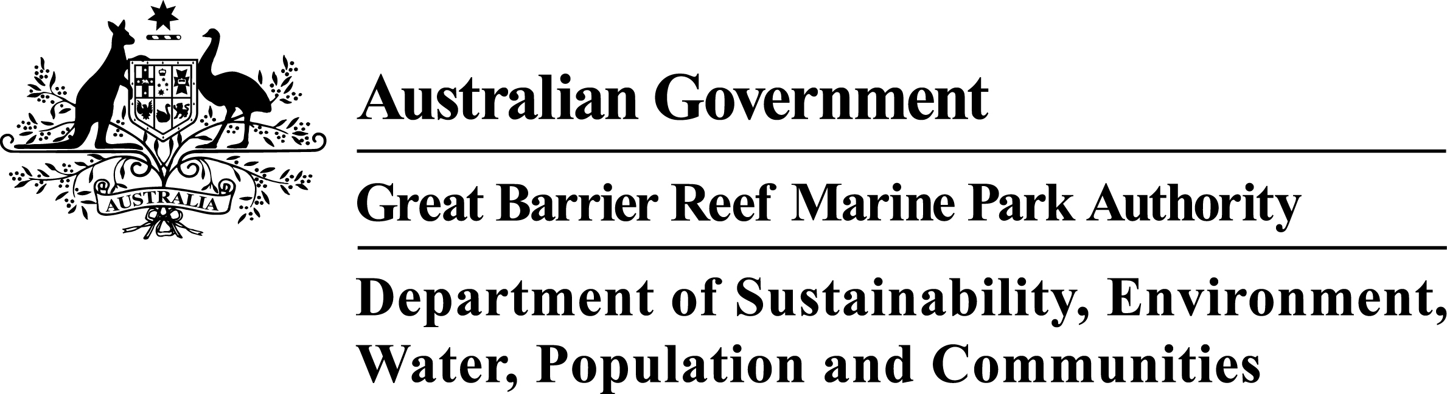

Requests and enquiries concerning reproduction and rights should be addressed to:

Great Barrier Reef Marine Park Authority
2-68 Flinders Street (PO Box 1379)
Townsville QLD 4810, Australia
Phone: (07) 4750 0700
Fax: (07) 4772 6093
Email: info@gbrmpa.gov.au
www.gbrmpa.gov.au

DOCUMENT HISTORY AND STATUS
Revision | Date issued | Author(s) | Reviewed by | Approved by | Date approved | Revision type
A | 25/10/12 | T Elsdon  D Smith  L Wells  M Yeates | B Chatfield | D Smith | 25/10/12 | Draft
B | 26/10/12 | T Elsdon  D Smith  L Wells  M Yeates | M Huber | M Huber | 26/10/12 | Draft
0 | 28/10/12 | T Elsdon  D Smith  L Wells  M Yeates | M Huber | M Huber | 26/10/12 | Issued to client for review
1 | 13/11/12 | T Elsdon  D Smith  L Wells  M Yeates | M Huber | M Huber | 13/11/12 | Final
1.1 | 28/06/13 | T Elsdon  D Smith  L Wells  M Yeates | M Huber | M Yeates | 28/06/13 | Revised final
1.2 | 04/07/13 | T Elsdon  D Smith  L Wells  M Yeates | M Yeates | M Yeates | 04/07/13 | Revised final
1.3 | 10/07/13 | T Elsdon  D Smith  L Wells  M Yeates | M Yeates | M Yeates | 10/07/13 | Revised final

Contents
Glossary ix
Acknowledgments xiii
RELIANCE STATEMENT xiv
Summary 1
Introduction 4
Background 4
Purpose 4
Scope 5
METHODS 8
Port-specific Literature and Data Review 8
Study Limitations 8
Stakeholder Engagement 9
Bed Shear-Stress Modelling 9
Identification of Alternative Dredge Material Placement Areas 10
Identification of Model Cases and Disposal Scenarios 13
PORT-SPECIFIC IDENTIFICATION OF ALTERNATIVE AREAS AND MODEL CASE SITES 16
Port of Gladstone 16
Existing Environment and Constraints 16
Material Placement Sites 17
Rosslyn Bay State Boat Harbour 20
Existing Environment and Constraints 20
Material Placement Sites 21
Port of Hay Point 25
Existing Environment and Constraints 25
Material placement sites 25
Port of Abbot Point 30
Existing Environment and Constraints 30
Material Placement Sites 30
Port of Townsville 34
Existing Environment and Constraints 34
Material Placement Sites 35
Port of Cairns 39
Existing Environment and Constraints 39
Material Placement Sites 40
model case scenarios 44
Port of Gladstone 44
Rosslyn Bay State Boat Harbour 44
Port of Hay Point 44
Port of Abbot Point 45
Port of Townsville 45
Port of Cairns 45
SUMMARY AND CONCLUSIONS 47
REFERENCES 50
Appendix A Port-specific summaries of the Existing Environment 62
The Port of Gladstone 62
Soft Bottom Habitat 63
Seagrass 63
Benthic Communities 64
Reef Habitat 64
Coral Communities 64
Macroalgae Communities 66
Intertidal Communities 66
Invasive Marine Species 66
EPBC-listed Species 67
Fisheries 73
Fish Habitat Areas 74
Marine Park Zoning 74
Special Management Areas 74
Cultural Heritage Values 74
Navigational Constraints 75
Tides and Currents 75
Rosslyn Bay State Boat Harbour 76
Soft Bottom Habitat 77
Seagrass 77
Infauna Communities 78
Reef Habitat 78
Coral Communities 78
Macroalgae Communities 79
Intertidal Communities 79
Invasive Marine Species 80
EPBC-listed Species 80
Bony Fishes 85
Fisheries 86
Fish Habitat Areas 86
Marine Park Zoning 87
Special Management Areas 87
Cultural Heritage Values 87
Navigational Constraints 87
Tides and Currents 87
The Port of Hay Point 88
Soft Bottom Habitat 88
Seagrass 89
Benthic Communities 89
Reef Habitat 90
Coral Communities 90
Macroalgae Communities 91
Intertidal Communities 92
Invasive Marine Species 92
EPBC-listed Species 93
Fisheries 99
Fish Habitat Areas 99
Marine Park Zoning 99
Special Management Areas 99
Cultural Heritage Values 99
Navigational Constraints 100
Tides and Currents 100
The Port of Abbot Point 101
Soft Bottom Habitat 101
Seagrass 102
Benthic Communities 102
Reef Habitat 103
Coral Communities 103
Macroalgae Communities 103
Intertidal Communities 104
Invasive Marine Species 104
EPBC-listed Species 104
Bony Fishes 109
Fisheries 110
Fish Habitat Areas 111
Marine Park Zoning 111
Special Management Areas 111
Cultural Heritage Values 111
Navigational Constraints 111
Tides and Currents 111
The Port of Townsville 112
Soft Bottom Habitat 112
Seagrass 113
Benthic Communities 114
Reef Habitat 114
Coral Communities 115
Macroalgae Communities 117
Intertidal Communities 119
Invasive Marine Species 119
EPBC-listed Species 119
Fisheries 125
Fish Habitat Areas 125
Marine Park Zoning 125
Special Management Areas 125
Cultural Heritage Values 126
Navigational Constraints 126
Tides and Currents 126
The Port of Cairns 127
Soft Bottom Habitat 127
Seagrass 128
Benthic Communities 129
Reef Habitat 129
Coral Communities 129
Macroalgae Communities 133
Intertidal Communities 133
Invasive Marine Species 133
EPBC-listed Species 134
Fisheries 139
Fish Habitat Areas 139
Marine Park Zoning 140
Special Management Areas 140
Cultural Heritage Values 140
Navigational Constraints 140
Tides and Currents 140
Appendix B Sediment Mud and Sand Content Maps (from SKM APASA 2013) 141

FIGURES
Figure 1. Map of the study area showing the six ports considered. 7
Figure 2. Port of Gladstone with bed shear-stress. 18
Figure 3. Port of Gladstone with shipping traffic and commercial trawl fisheries CPUE. 19
Figure 4. Rosslyn Bay State Boat Harbour with bed shear-stress. 23
Figure 5. Rosslyn Bay State Boat Harbour with shipping traffic and commercial trawl fisheries CPUE. 24
Figure 6. Port of Hay Point with bed shear-stress. 28
Figure 7. Port of Hay Point with shipping traffic and commercial trawl fisheries CPUE. 29
Figure 8. Port of Abbot Point with bed shear-stress. 32
Figure 9. Port of Abbot Point with shipping traffic and commercial trawl fisheries CPUE. 33
Figure 10. Port of Townsville with bed shear-stress. 37
Figure 11. Port of Townsville with shipping traffic and commercial trawl fisheries CPUE. 38
Figure 12. Port of Cairns with bed shear-stress. 42
Figure 13. Port of Cairns with shipping traffic and commercial trawl fisheries CPUE. 43

TABLES
Table 1. Summary of model case volumes and modelling scenarios. 15
Table 2. Port-specific modelling scenarios for dredged material placement campaigns. 46
Table 3. Coordinates of the centroids of the 13 identified model case sites. 49
Table 4. Per cent of community cover recorded in Port Curtis in 2009 surveys (BMT WBM 2009). 65
Table 5. EPBC-listed reptile species within the study area. 67
Table 6. EPBC-listed marine mammal species within the study area. 70
Table 7. EPBC-listed shark species within the study area. 72
Table 8. EPBC-listed bony fishes species within the study area. 72
Table 9. Per cent cover of hard coral, soft coral and macroalgae at five locations in the Fitzroy Region in 2011 surveys (Thompson et al. 2011). 78
Table 10. EPBC-listed reptile species within the study area. 81
Table 11. EPBC-listed marine mammal species within the study area. 83
Table 12. EPBC-listed shark species within the study area. 85
Table 13. EPBC-listed bony fishes species in the study area. 85
Table 14. EPBC-listed reptile species within the search area. 93
Table 15. EPBC-listed mammal species potentially occurring within the search area. 95
Table 16. EPBC-listed shark species potentially occurring within the search area. 97
Table 17. EPBC-listed bony fishes species potentially occurring within the search area. 97
Table 18. EPBC-listed reptile species potentially occurring within the study area. 105
Table 19. EPBC-listed marine mammal species potentially occurring within the study area. 107
Table 20. EPBC-listed shark species within the study area. 109
Table 21. EPBC-listed bony fish species within the study area. 109
Table 22. Composition of coral reef communities. Hard coral families (per cent cover) Thompson et al. 2011. 116
Table 23. Composition of coral reef communities. Soft coral families (per cent cover) Thompson et al. 2011. 116
Table 24. Common macroalgal genera and families (per cent cover) Thompson et al. 2011. 118
Table 25. EPBC-listed reptile species potentially occurring within the search area. 119
Table 26.EPBC-listed marine mammals potentially occurring within the search area. 122
Table 27. EPBC-listed shark species within the search area. 123
Table 28. EPBC-listed bony fish species within the search area. 124
Table 29. Composition of coral reef communities. Hard coral families (per cent cover) Thompson et al. 2011. 131
Table 30. Composition of coral reef communities. Common soft coral families (per cent cover) Thompson et al. 2011. 132
Table 31. EPBC-listed reptile species potentially occurring within the search area. 134
Table 32. EPBC-listed marine mammal species potentially occurring within the search area. 136
Table 33. EPBC-listed shark species potentially occurring within the search area. 137
Table 34. EPBC-listed bony fishes species potentially occurring within the search area. 138

ACRONYMS
ABWMAC | Australian Ballast Water Management Advisory Council
ADMPA | Alternative Dredge Material Placement Area
AIMS | Australian Institute of Marine Science
AIS | Automated Identification System
APASA | Asia-Pacific Applied Science Associates Pty Ltd
BMI | Benthic macroinvertebrate
BMT WBM | BMT WBM Pty Ltd
CBD | Central business district
CCIMPE | Consultative Committee on Introduced Marine Pest Emergencies
CPUE | Catch Per Unit Effort
CRIMP | Centre for Research on Introduced Marine Pests
CSIRO | The Commonwealth Scientific and Industrial Research Organisation
DAFF | Queensland Department of Agriculture, Fisheries and Forestry
DSEWPaC | Department of Sustainability, Environment, Water, Population and Communities
EIA | Environmental Impact Assessment
EIS | Environmental Impact Statement
EMP | Environment Management Plan
EPA | Queensland Environment Protection Agency
EPBC | Environment Protection and Biodiversity Conservation Act 1999
FRDC | Fisheries Research and Development Corporation
GBRMPA | Great Barrier Reef Marine Park Authority
GHD | GHD Group Pty Ltd
GIS | Geographic information system
GPC | Gladstone Ports Corporation
HPX3 | Hay Point Coal Terminal Expansion Stage 3 Project
HPCT | Hay Point Coal Terminal
IMS | Invasive Marine Species
IUCN | International Union for Conservation of Nature
MSL | Mean Sea Level
MSQ | Maritime Safety Queensland
NQBP | North Queensland Bulk Port Corporation Pty Ltd
PCCC | The Port of Curtis Coral Coast
POTL | The Port of Townsville Ltd
QCF | Queensland Coral Fishery
RAMSAR | Ramsar Convention on Wetlands (Ramsar, Iran, 1971)
RRMMP | Reef Rescue Marine Monitoring Program
SKM | Sinclair Knight Merz Pty Ltd
SMA | Special Management Area
TSS | Total suspended solids
TUMRA | Traditional Use of Marine Resource Agreement

Glossary
A priori Decisions, knowledge, or statistical analyses made before an event.

Bathymetry The study of underwater depth of ocean floors. Bathymetric (or hydrographic) charts are typically produced to support safety of surface or sub-surface navigation, and usually show seafloor relief or terrain as contour lines (called depth contours or isobaths) and selected depths (soundings), and typically also provide surface navigational information.

Bed-shear stress Forces exerted by the ocean on bed sediments (at rest). When bed shear stress exceeds the critical shear stress for the bed sediments, the sediments will become transported by the ocean.

Beneficial re-use of dredge material Is the practice of using dredge material for another purpose that provides social, economic or environmental benefits.

Non-beneficial re-use Dredge material placement that does not provide a concurrent benefit, such as disposal at a landfill site or dedicated permanent disposal facility.

Biomass The total mass of living matter within a given unit of environmental area.

Bioregion The classification of the Great Barrier Reef World Heritage Area into 70 different habitat types or ‘bioregions’ (30 reef bioregions and 40 non-reef bioregions) were established across the Great Barrier Reef to describe the enormous biological and physical diversity of the area. Boundaries between bioregions (particularly non-reef bioregions) are often ‘fuzzy’ either because there is a continuum in nature, or because the boundaries are difficult to define given current data. Whilst the best information available was used to define the bioregions, the boundaries of bioregions and descriptions may change over time as further information becomes available. The bioregions are a basis for GBRMPA’s Representative Areas Program (RAP).

Cumulative impacts Impacts resulting from the effects of one or more impacts, and the interactions between those impacts, added to other past, present, and reasonably foreseeable future pressures.

Dredging- Capital Dredging for navigation, to create new or enlarge existing channel, port, marina and boat harbour areas. Dredging for engineering purposes, to create trenches for pipes, cables, immersed tube tunnels, to remove material unsuitable for foundations and to remove overburden for aggregate.

Dredging- Maintenance Dredging to ensure that previously dredged channels, berths or construction works are maintained at their designated dimensions.

Dredge footprint A designated area or areas where dredging operations of bottom sediments are proposed to, or will, occur.

Endemic Endemic species are those species which are found exclusively in a particular area. They are naturally not found anywhere else.

EPBC listed species Under the Environment Protection and Biodiversity Conservation Act 1999 (EPBC Act) listed threatened species and ecological communities include those which are vulnerable, endangered, critically endangered, conservation dependant or extinct in the wild.

Ephemeral (seagrass) Ephemeral seagrass has short, transitory life cycles. The life cycle is timed to exploit a short period when resources are freely available.

Epibenthic organisms living on the sea bottom between low tide and 180 metres in depth.

Fish Habitat Area (FHA) The Fisheries Act, 1994 provides for the declaration and management of declared FHAs. Declared FHAs provide a variety of habitat types and are important commercial, recreational and indigenous fishing grounds. Works in declared FHAs require authorisation under both the Fisheries Act and the Queensland Integrated Planning Act 1997.

Hydrodynamics The movement (dynamics) of water due to the action of tides, waves, winds and other influences.

Hydrographic The physical and chemical features of the oceans.

Hydrodynamic models Hydrodynamic models are generated by computer softwares. A two-dimensional hydrodynamic model, although useful in many situations, is limited to depth-averaged equations and therefore unable to resolve stratification or vertical gradients. A three-dimensional model can determine the vertical distribution of currents. It provides the most complete solution for any hydrodynamic system including the formulation for the effects of bottom shear stress and surface wind shear stress. A 3D hydrodynamic model is highly recommended as best practice because it provides realistic simulation of the marine environment.

Infauna are benthic organisms that live within the bottom substratum of a body of water, especially within the bottom-most oceanic sediments, rather than on its surface.

Macroalgae Multicellular algae (seaweed).

Macrofauna Benthic organisms which are retained on a 0.5 mm sieve. Studies in the deep sea define macrofauna as animals retained on a 0.3 mm sieve to account for the small size of many of the taxa.

Metocean Referring to the waves, winds and currents conditions that affect offshore operations.
Necrosis is a form of cell injury that results in the premature death of cells in living tissue. Necrosis is caused by factors external to the cell or tissue, such as infection, toxins, or trauma that result in the unregulated digestion of cell components.

Scour changes on the bed of the ocean. The frequent movement of water can lead to a scouring effect.
Sedimentation The deposition or accumulation of sediment either on the seabed or in the water column. Deposition on the seabed is calculated as a probability function of the prevailing bottom stress, local sediment concentration and size class. Sediment that is deposited may subsequently be resuspended into the lower water column if critical levels of bottom stress are exceeded.

Sediment transport The movement of solid particles (sediment), typically due to a combination of the force of gravity acting on the sediment, and the movement of the fluid in which the sediment is entrained. Sediment transport is affected by a range of oceanographic factors including waves, currents and tides.

Sedimentation rate (mg/cm²/d) The amount of sediment depositing or accumulating on the ocean floor per unit time, in milligrams per square centimetre per day.

Sediment transport rate For this project sediment transport rates were calculated using a hydrodynamic model applying the influences of large-scale current model predictions, tides and local winds. The influences of these variables on hydrodynamics and sediment transport were incorporated into the model by including vectors (the direction or course followed).

Suspended sediment concentration Total Suspended Solids (TSS) (mg/L)
The concentration of sediment suspended in seawater (not dissolved), expressed in milligrams of dry sediment per litre of water-sediment mixture (mg/L).

Sediment plume spatial extents For this project spatial extents of sediment plumes associated with dredge material placement are modelled and expressed as median (50th percentile) and 95th percentile contours of a range of values of TSS (mg/L) and sedimentation rate (mg/cm²/d).

Median (50th percentile) contours represent “average” conditions, for example a 5 mg/L TSS median contour shows locations where 5 mg/L is predicted to occur 50 per cent of the time during the modelling period. Areas enclosed by the contour are predicted to experience TSS concentrations ≥ 5 mg/L more than half the time. Areas outside the contour are predicted to experience 5 mg/L TSS less than half the time during the modelling period.

The 95th percentile contours represent conditions 5 per cent of the time. For example, areas outside the 95th percentile contour for 10 mg/cm²/d sedimentation rate are predicted to experience sedimentation of this intensity less than 5 per cent of the time during the dredge material placement campaign.

Sensitive Receptors (sensitive marine environmental receptors)
Certain key reef marine organisms, habitats and communities are sensitive to dredging and at-sea dredge material placement activities. Coral reefs, seagrass, macroalgal and macroinvertebrate communities are ‘sensitive receptors’ that occur within the vicinity of Great Barrier Reef Region ports. Impacts can result from both direct effects, for example burial by dredge material and indirect effects such as reductions in light availability to corals or seagrasses due to elevated suspended sediment concentrations in the water column. Reduced health of these sensitive receptors could negatively impact on the world heritage values of the Great Barrier Reef.

Total sedimentation (mg/cm²) The amount of dredge material deposited on the seabed in milligrams per square centimetre. For example, total sedimentation of 5 mg/cm² equates to a sediment thickness of 0.05 mm.

Special Management Areas (SMA) SMAs have been developed in the Great Barrier Reef Marine Park to allow implementation of appropriate management strategies in addition to the current Zoning Plans. SMAs include conservation areas such as Dugong Protection Areas, public safety, public appreciation and emergency outbreaks.

Trailing suction hopper dredger (TSHD) Trails its suction pipe when working, and loads the dredge spoil into one or more hoppers in the vessel. When the hoppers are full, the TSHD sails to a disposal area and either dumps the material through doors in the hull or pumps the material out of the hoppers.

Turbidity Turbidity is a measure of the degree to which the water loses its transparency due to the presence of suspended particulates. The more total suspended solids in the water, the higher the turbidity. There are various parameters influencing the cloudiness of the water. Some of these are: sediments, phytoplankton, resuspended sediments from the bottom, waste discharge, algae growth and urban runoff.
Turbidity is measured in NTU: Nephelometric Turbidity Units using a nephelometer, which measures the intensity of light scattered at 90 degrees as a beam of light passes through a water sample.
Turf algae Small, fleshy or filamentous algae that grow in a short, thick turf on the reef flat, performing photosynthesis. Fishes, sea urchins, snails and other marine fauna graze on this algae.

Acknowledgments
The Department of Sustainability, Environment, Water, Population and Communities (DSEWPaC) funded the work contained within this report and the Great Barrier Reef Marine Park Authority is gratefully acknowledged for commissioning and defining the scope of work and for their assistance during the project. We would also like to thank all of the attendees at the risk assessment workshops for the six port locations (Gladstone, Rosslyn Bay, Hay Point, Abbot Point, Townsville and Cairns) for their input and engagement, provision of data and information, and prompt feedback.

RELIANCE STATEMENT
This report has been prepared pursuant to the Contract between Sinclair Knight Merz Pty Limited (SKM) and the Great Barrier Reef Marine Park Authority (the Client) dated 18 September 2012 as varied on 21 November 2012, 14 March 2013 and 17 June 2013 (the Contract). The scope of this report and associated services performed by SKM was developed with the Client to meet the specific needs of the project.
In preparing this report, SKM has relied upon, and presumed accurate, information (or confirmation of the absence thereof) provided by the Client and/or other sources including port authorities. Except as otherwise stated in the report, SKM has not attempted to verify the accuracy or completeness of such information. If the information relied upon by SKM as at the date of issue of this report is subsequently determined to be false, inaccurate or incomplete, then it is possible that the accuracy of SKM’s observations and conclusions expressed in this report may be affected.
SKM warrant that it has prepared this report in accordance with the usual care and thoroughness of the consulting profession, by reference to applicable standards, guidelines, procedures and practices and information sourced at the date of issue of this report. No other warranty or guarantee, whether expressed or implied, is made as to the data, observations, and findings expressed in this report, to the extent permitted by law except as provided for in the Contract between SKM and the Client.
SKM strongly recommends that this report should be read in full and no excerpts be interpreted as representative of the findings. Except as provided for in the Contract, no responsibility is accepted by SKM for use of any part of this report in any other context.
This report has been prepared on behalf of, SKM’s Client, and is subject to, and issued in accordance with, the provisions of the Contract between SKM and the Client. SKM accepts no liability or responsibility whatsoever for any use of, or reliance upon, this report by any third party but this does not affect the obligation on SKM to indemnify the Client in accordance with the terms of the Contract.

Summary
The Great Barrier Reef World Heritage Area has had a rapid increase in the number of proposed new ports and port expansions, which has prompted the Australian and Queensland governments to undertake a strategic review to help identify, plan for, and manage existing and emerging risks. This review was in part a response to the World Heritage Committee’s request to Australia to undertake a strategic assessment of future developments that could affect the World Heritage Area. The Great Barrier Reef Marine Park Authority (GBRMPA) is leading the offshore strategic assessment with the primary aim of determining the likely impact of actions on matters of national environmental significance as defined by the Environment Protection and Biodiversity Conservation Act 1999, the effectiveness of existing management arrangements, and the need for improved management arrangements.
Sinclair Knight Merz (SKM) and Asia-Pacific Applied Science Associates (APASA) were commissioned to complete the ‘Improved Dredge Material Management for the Great Barrier Reef Region’ project, which encompasses three tasks:
- Task 1. Perform a literature review and cost-benefit analysis that synthesises the available literature on the environmental and financial costs associated with land-based re-use and land-based disposal options for dredge material at six ports (Port of Gladstone, Rosslyn Bay State Boat Harbour, the Port of Hay Point, the Port of Abbot Point, the Port of Townsville, and the Port of Cairns)
- Task 2. Develop a generic water quality monitoring framework that can be applied to any dredge material disposal site
- Task 3. Identify potential alternative dredge material placement areas within 50 km of the six ports, based on environmental, socioeconomic, and operational considerations, as well as hydrodynamic modelling of bed shear-stress. Within these alternative areas, identify 13 model case sites (two for each port except Gladstone, for which three model cases were identified recognising that the current placement site has no remaining capacity) for hydrodynamic modelling of sediment migration and turbidity plumes, and assessment of risks to environmental values. This study makes no assumption that the alternative areas identified provide intrinsic environmental or socioeconomic benefits compared to the current placement sites, and the forthcoming modelling and risk assessment will consider the current and alternative sites equally.

This report presents the findings of a sub-task of the third task of the project: the identification of alternative dredge material placement areas, and model case sites within those areas. Within each of the six port study areas, broad areas most suited to dredge material placement have been identified based on available literature and data regarding environmental receptors, fisheries, zoning, cultural heritage, and navigation, as well as on hydrodynamic modelling of bed shear-stress. The report provides the rationale for the selection of alternative areas. The scope of the study was to identify alternatives to the current placement sites, but there is no presumption that the alternative areas are inherently preferable to the current dredge material placement sites.
The scope and timeframe for this study did not allow a detailed, quantitative multi-criteria analysis with agreed scoring and weighting criteria. Given the limitations in scope, the study adopted two sets of criteria: hard (no-go) constraints and “preferential” constraints. The hard (no-go) constraints were:
- All areas not in the General Use Zone of the Marine Park
- Areas within a 2 km buffer zone around coral reefs
- Areas with a 5 km buffer zone around identified turtle feeding and breeding areas
- Existing shipping channels
- Special Management Areas and Fish Habitat Areas.
“Preferential” constraints included:
- Areas of known environmental, tourism, recreational or commercial value were avoided, including seagrass habitat and areas of comparatively high commercial fisheries value as indicated by catch per unit effort (CPUE) in the trawl fishery
- Ship anchorages and pilot boarding locations were avoided
- Dredge material placement sites that would require material transport vessels to cross major shipping lanes were avoided
- Areas with existing sediment characteristics similar to the expected dredge material were preferred, to the extent possible.

Bed shear-stress modelling was conducted as a separate task and the results are detailed in a separate report (SKM APASA 2013). The results of the shear-stress modelling are presented in this report in relation to other environmental factors.
One (for Rosslyn Bay and Hay Point) or two (for Gladstone, Abbot Point, Townsville, and Cairns) alternative dredge material placement areas (referred to on maps as ADMPAs) were identified in the 50 km study areas around the six ports. For each port, two model case sites were identified within the alternative placement areas, except for the Port of Gladstone where 3 model case sites were identified, recognising that the current placement site for Gladstone has no remaining capacity. The next stage of the project will conduct hydrodynamic modelling of sediment plumes generated by dredge material placement during a representative dredging campaign, and subsequent sediment migration over a 12-month period, at the model case sites and (except for Gladstone) the current placement sites.
The current dredge material placement sites are not considered included in this study except as noted, as the scope was to identify alternative sites to the existing ones. It is acknowledged the many of the existing dredge material placement sites are still in use and have not yet reached their full capacity.
Findings for the six ports were:
- Port of Gladstone: Two alternative dredge material placement areas, one to the north-east and one to the north-west of the Gladstone port entrance were identified. These areas minimise interaction with navigational routes, avoid sensitive environmental receptors, are in relatively retentive areas for sediment dispersion, and appear not to overly commercially important fishing grounds. Unlike the other five ports, for which two model case sites each were identified, three model case sites were identified for Gladstone to take into account that the current placement site is already fully committed. Two of the model case sites are in the alternative area to the north-west and one is in the area to the north-east.
- Rosslyn Bay State Boat Harbour: One alternative placement area was identified, to the north-east of Rosslyn Bay State Boat Harbour. This area avoids sensitive areas and is of moderate trawl fisheries value, although it is immediately adjacent to a Conservation Park Zone. Model Case 1 within the alternative placement area is east of the current material placement site and Model Case 2 lies to the north of that.
- Port of Hay Point: One alternative area for dredge material placement was identified, to the north of the shipping channel and anchorages. Additional areas were considered, however, areas to the east have high shipping traffic, and areas to the south have been identified by the Harbour Master as potential areas for future anchorage expansion, and placement to the south has the potential for transport of dredge material back into the channel. The alternative area minimises interaction with navigational routes, avoids sensitive environmental receptors, is relatively retentive of fine and course sands, and has relatively low historical levels of fisheries catch. Model Case 1 lies immediately to the north of the northern anchorages, and Model Case 2 is further to the north-east.
- Port of Abbot Point: Two alternative dredge material placement areas were identified to the north-west and south-east of the port between the 20 m and 40 m depth contours. Both of the identified areas avoid sensitive areas interactions with navigational routes and shipping activity, however the northern area is closer to non-General Use Zones. Both areas have historically had low fisheries catch. One model case site was identified in a part of each area relatively close to the port.
- Port of Townsville: Two alternative areas for dredge material placement were identified to the east and west of the Port of Townsville. Placement of dredge material outside of these areas was constrained by Marine National Park Zones, sensitive environmental receptors, and shipping traffic. The areas minimise interaction with navigation, avoid sensitive receptors, and have historically not been high-value fisheries grounds. One model case was identified in each of the alternative areas.
- Port of Cairns: Two alternative areas for material placement were identified, both to the north-east of the Port of Cairns near the 20 m depth contour. Options for dredge material placement sites at Cairns are very constrained due by reefs, non-General Use Zones, and shipping activity. Both of the alternative areas avoid interactions with sensitive environmental receptors and navigational routes; however, they have consistently high fisheries CPUE.

Introduction

Background
The Australian and Queensland governments are undertaking a strategic assessment of the Great Barrier Reef to identify, plan for, and manage risks within the Great Barrier Reef Marine Park (Marine Park) and World Heritage Area (World Heritage Area). This assessment is in part a response to the World Heritage Committees’ request of Australia to undertake a strategic assessment of future development that could impact on the reef’s values, and to enable long-term planning for sustainable development (World Heritage Committee June 2011). The Great Barrier Reef Marine Park Authority (GBRMPA) is leading the offshore components of the strategic assessment, which involve the identification of potential impacts from development; an evaluation of the effectiveness of existing management arrangements; and the development of strategies for improved management to protect the reef’s unique world heritage values.
Queensland’s mining and resource sectors are currently in a phase of significant expansion, with several new export facilities planned along the Queensland coast. New port expansions have been proposed to meet the increasing export needs of the sector, involving significant works within and adjacent to the Marine Park and its adjacent coastal waters, with projected increases in the magnitude of shipping activities. By necessity, the expansion of ports involves significant capital dredging to create new shipping channels and berth areas to facilitate the transfer of commodities. Similarly, the regular maintenance dredging requirements of ports, both now and in the future, are an important factor in the consideration of improved management of the reef and in the context of coastal development.
Sinclair Knight Merz (SKM) and Asia-Pacific Applied Science Associates (APASA) have been commissioned by the GBRMPA as part of the strategic assessment to provide an independent study on ‘Improved Management of Dredge Material for the Great Barrier Reef Region’. This report is a sub-task of the third task of the project and focuses on:
- Identification of alternative dredge material placement sites on the basis of a review of environmental, socioeconomic, and cultural values, and considering the results of bed shear-stress modelling
- A description of the baseline environmental values of six locations in the Great Barrier Reef Region (Gladstone, Rosslyn Bay, Hay Point, Abbot Point, Townsville, and Cairns).

Purpose
The GBRMPA seeks to improve understanding of the risks, environmental impacts, and future management arrangements associated with the disposal of dredge material in the Great Barrier Reef Region, through the completion of port-specific assessments.
The key objectives of the project as a whole are to:
- Model bed shear-stress within 50 km of 12 Queensland ports, to indicate broad-scale port sediment transport and related scour, natural deposition, and morphology changes
- Review existing environmental data within a 50 km radius offshore of six ports: the Port of Gladstone, Rosslyn Bay State Boat Harbour, Port of Hay Point, Port of Abbot Point, Port of Townsville, and Port of Cairns (figure 1)
- Identify broad alternative dredge material placement areas in the 50 km study area around each port, within which the placement of dredge material appears to represent a low risk of adverse impacts on environmental values. It is stressed that rigorous environmental impact assessment beyond the scope of the present study must precede any placement of dredge material within the identified alternative areas
- Identify three model case sites within the alternative area at Gladstone, and two model case sites at the other five ports, (13 in total) for further sediment migration and disposal plume modelling and risk assessment, based on a review of environmental, management, socioeconomic, and cultural values
- Conduct hydrodynamic modelling studies and environmental risk assessments, to evaluate risks associated with dredge material placement at the 13 identified model sites, as well as the currently used placement sites
- Conduct a review of international and national best practice and examples for the disposal of dredge material on land; and undertake a port-specific cost-benefit analysis of land-based re-use and land-based disposal options for dredge material
- Develop a generic water quality monitoring framework that can be applied to any dredge material placement site.

This report presents the results of the identification of alternative placement areas and model case sites at the six locations (Port of Gladstone, Rosslyn Bay State Boat Harbour, Hay Point, Abbot Point, Townsville, and Cairns). The current dredge material placement sites are not considered included in this study except as noted, as the scope was to identify alternative sites to the existing ones. It is acknowledged the many of the existing dredge material placement sites are still in use and have not yet reached their full capacity.

Scope
The scope of this report is:
- A port-specific compilation of available literature and data regarding environmental conditions and receptors, Marine Park zoning, Special Management Areas (SMAs), uses, and cultural heritage within a 50 km radius of each of the six ports
- Consideration of the results of bed shear-stress modelling (SKM APASA 2013) of the study area in the context of the above factors
- Identification of broad areas suitable for dredge material placement as alternatives to the currently used placement sites, considering environmental, socioeconomic, and operational constraints
- Identification of 13 model case sites within the alternative areas for more detailed modelling of sediment migration after disposal and sediment plumes generated by disposal during a representative dredging scenario for each port. The modelling will be conducted in the next stage of the project.

This report describes the approach used to review and synthesise information and identify the alternative areas and model cases for dredged material placement within a 50 km radius of the ports. The report details the environmental and socioeconomic constraints mapping and desktop study results, and provides the rationale for the selection of alternative areas. The scope of the study was to identify alternatives to the current placement sites, but there is no presumption that the alternative areas are inherently preferable to the current dredge material placement sites. Bed shear-stress modelling was conducted as a separate task and the results are detailed in a separate report (SKM APASA 2013). The study was based entirely on previously existing information and data available to SKM.
No field survey work, new data acquisition, or digitisation of data held in non-digital form was included in the scope of the study.
For the purpose of this study, dredge material is assumed to be uncontaminated. For specific dredging campaigns, the suitability of dredge material for disposal at sea would need to be assessed through the normal Sea Dumping Permit and environmental impact assessment processes.
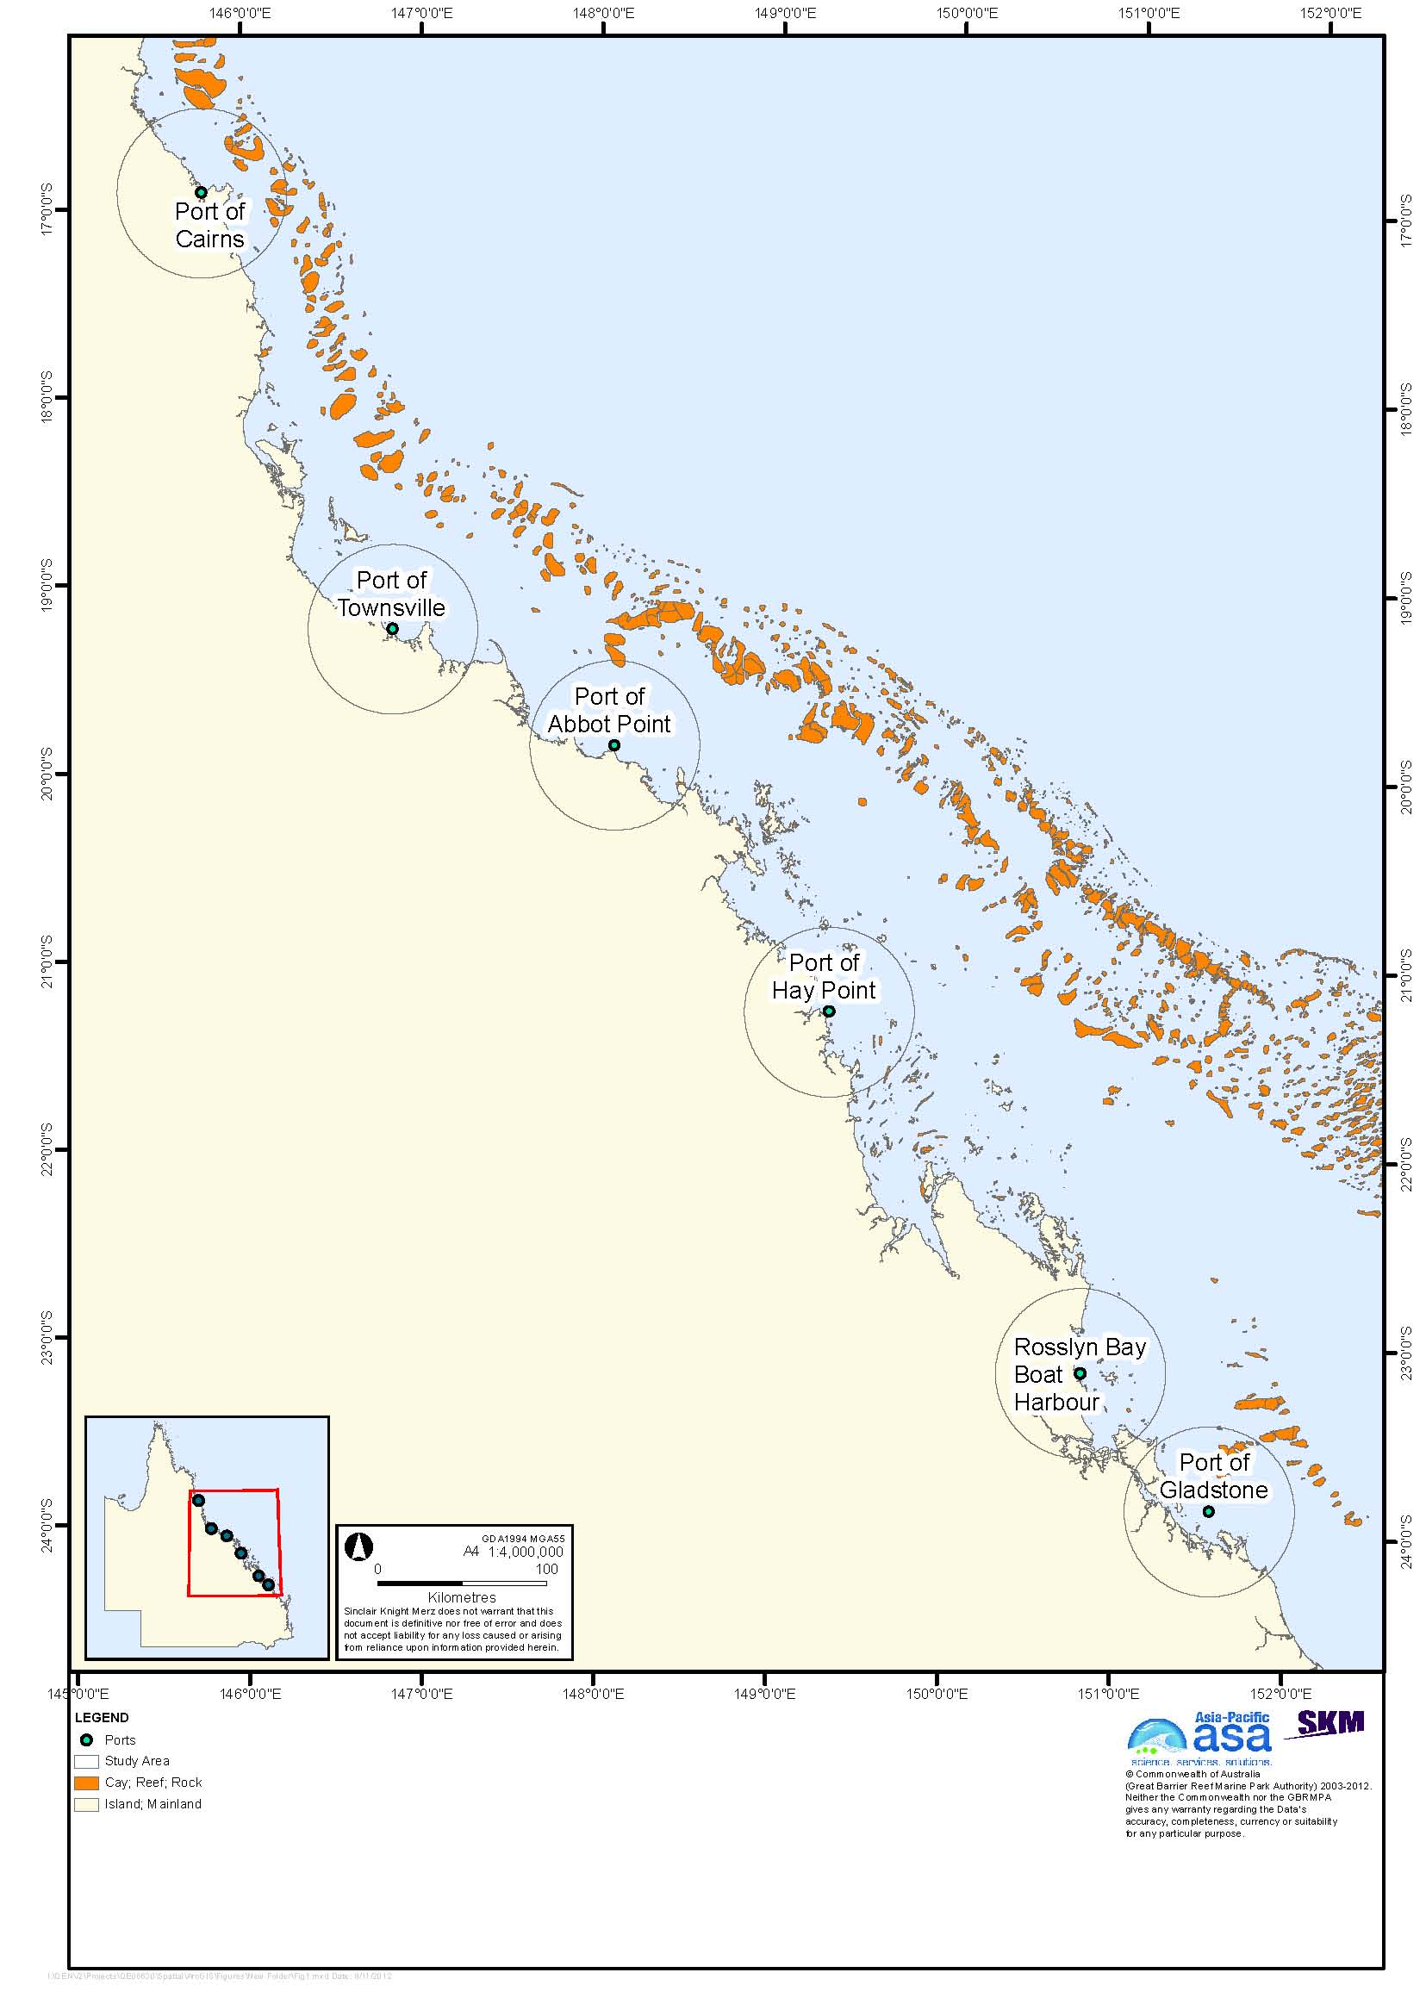
Figure 1. Map of the study area showing the six ports considered.

METHODS
SKM and APASA identified alternative areas for dredge material placement within a 50 km radius of each port (hereafter referred to as the study area), and model cases for more detailed study, through a port-specific process of information and data gathering, review and synthesis, engagement with stakeholders, particularly the port authorities, and bed shear-stress modelling (SKM APASA 2013). Using this information, options and constraints for dredge material placement were identified in light of the long-term requirements for the relocation of dredge material.

Port-specific Literature and Data Review
A review of existing literature and data identified the environmental setting, fisheries, Marine Park zoning, cultural heritage, and navigational constraints. The list of resources included, but was not limited to, spatial data for incorporation into a GIS database, port management plans, previous environmental impact assessment documentation, dredging management plans and environmental monitoring reports, and published papers and reports. Information was obtained on a variety of subjects, including:
- Bathymetry
- Soft sediment habitats, including sediment characteristics and transport and biota
- Seagrass community distribution and species composition
- Modelled probability of seagrass occurrence outside mapped areas
- Benthic communities
- Reef habitats
- Coral community composition
- Macroalgae community composition
- Intertidal community composition and description
- Invasive marine species
- Maps of like-on-like, for dredge material-on-existing benthic material
- Environment Protection and Biodiversity Conservation (EPBC) listed species within each 50 km study area
- Turtle nesting and feeding areas
- Commercial trawl fishery Catch Per Unit Effort (CPUE)
- Marine Park zoning
- SMAs
- Fish Habitat Areas
- Cultural heritage values
- Navigational constraints within the 50 km study area: pilot boarding locations, anchorages, and shipping lanes
- Shipping activity.

Study Limitations
The study was based entirely on existing information and data available to SKM. Field surveys, new data acquisition, or digitisation of data held in non-digital form were not included in the scope of the study. Coastal processes and the impact on water quality from freshwater inflows have not been taken into consideration. Also, it was noted by the Port of Townsville at a workshop that underwater freshwater springs are known to occur in the Townsville study area, however these were not taken into account in the study. A detailed summary of the information collected for each port is presented in Appendix A.

Stakeholder Engagement
A teleconference was held with each of the port authorities shortly after project inception to explain and receive feedback on SKM/APASA’s approach to the project, and to identify available information the authorities could provide and establish a process to obtain the information. This initial consultation was followed up by telephone and email to obtain additional information as required.
On 25 September 2012, SKM participated in a collective workshop with representatives of the GBRMPA, port authorities (except for the Queensland Department of Transport and Main Roads, operator of the Rosslyn Bay State Boat Harbour, who were unable to attend), Maritime Safety Queensland, and Australian Maritime Safety Association. The workshop provided an overview of the project in the context of the broader Strategic Assessment of the Great Barrier Reef Region, as well as the project scope and timeframe. It also provided an opportunity to discuss SKM/APASA’s approach and information that should be considered in the study. The workshop also identified criteria relevant to the assessment of land-based placement of dredge material, another component of the overall project.
Between 9 and 16 October 2012, SKM and APASA conducted a series of port-specific risk assessment workshops with each of the port authorities to present initial results of bed shear-stress modelling and the identification of areas suitable for dredge material placement. The workshops discussed the project component detailed in this report, the identification of areas for placement of dredge material at sea, as well as options for placement on land. In addition to SKM, APASA, and the port authorities, various workshops were also attended by representatives of Queensland and local government.

Bed Shear-Stress Modelling
Bed shear-stress is important in determining sediment transport and stability. Bed shear-stress within 50 km of the six ports was modelled as described by SKM APASA (2013). The shear-stress modelling used a three-dimensional hydrodynamic model that incorporates the effects of oceanic currents, i.e. the East Australian Current, as well as tide- and wind-driven currents and waves. Details of the modelling methodology and model validation are presented in SKM APASA (2013). The model was validated using wind and tide data from the National Tidal Facility, and where current data were available, by comparison of measured and model-predicted currents.
After validation, the model was used to calculate bed shear-stress within a 50 km radius of the six locations over a 12-month period, using metocean data from 2011 as input. The year 2011, a strong La Niña year, was selected as the modelling period because 2011 had the strongest predicted current speeds compared to 2004 (an El Niño year) and 2007 (a neutral year. Thus, based on predicted currents, 2011 represents high-energy conditions.
The model results are presented by categories of bed shear-stress that are sufficient to resuspend sediment of different grain size categories from the bottom. The modelling assumed that the sediments were unconsolidated, and thus is most applicable to recently placed dredge material rather than to existing, consolidated sediments. The shear-stress required to resuspend particles from the bottom is generally higher after consolidation, so finer sediment than predicted by the model may be retained on the seabed if the sediments have consolidated. In this sense, the model is predicting the most dispersive situation, which will occur immediately after dredged material placement, before any sediment consolidation has occurred. The modelling results were presented as maps of shear-stress under median (50th percentile), or average, conditions and of shear-stress under highly energetic, or 95th percentile conditions.
Alternative areas for dredged material placement around the six ports are presented in this report in relation to maps of median shear-stress, rather than 95th percentile shear-stress. Extreme conditions, as represented by maps of the 95th percentile shear stress, will, of course, resuspend coarser material than predicted by median bed shear-stress. Except for the Port of Cairns, the 95th percentile shear-stress modelling predicts that in extreme conditions most of the study areas around the ports will be sufficiently energetic to mobilise sediments up to coarse sands (SKM APASA 2013). Maps of the 95th percentile bed shear-stress are presented in SKM APASA (2013), but not in this report.
The results of bed shear-stress modelling were not as important in identifying alternative areas for dredged material placement as might have been expected, largely because predicted shear-stress was fairly uniform over the study areas of most of the ports, and where there was variation in shear-stress other considerations were often considered more important. It is also stressed that it was not assumed that areas of low shear-stress were necessarily preferred. Assessment of the environmental outcomes associated with dispersive versus retentive placement sites requires detailed consideration of a range of factors, including the nature of the dredged material, natural coastal process and sedimentary regimes, the natural sediment characteristics, the consequences of altered bathymetry resulting from a build-up of dredged material, and the results of environmental monitoring of previous dredged material placement. Such detailed assessment is beyond the scope of the present study. The next stage of the study, however, will model the dispersion of dredge material from alternative and current sites.

Identification of Alternative Dredge Material Placement Areas
One or two alternative areas for dredge material placement were identified for each port using a combination of “hard” constraints that defined no-go areas, and preferential criteria for areas outside no-go areas. As the scope of the project is to evaluate potential alternatives to the current placement areas, the current areas were ruled out by definition. It is stressed, however, that there is no a priori assumption that alternative sites will result in better environmental or other outcomes than the existing sites.A comparison of the outcomes of the potential alternatives with the current sites will be conducted in subsequent stages of the project. .
The GIS database was used to overlay layers of the environmental, economic, and operational spatial data, as well as the modelled bed shear-stress. In addition to the GIS layers, other information regarding receptors, expected direction of sediment transport, and other factors was considered. Key criteria used to select the alternative areas were:
Hard Constraints (no-go areas):
- All areas not in the General Use Zone of the Marine Park were considered no-go areas
- Special Protection Areas including Dugong Protection Areas (DPAs) were considered no-go areas. DPAs have been designated to reduce interactions between dugongs and fishing nets in areas of high dugong abundance, which are generally associated with areas of high seagrass abundance (Marsh and Lawler 2001; Coles et al. 2000, 2002, 2003; Lee Long 1993 cited by Dobbs 2007). DPAs were not established for the purpose of managing dredge material, however the present study assumes that, given a choice, it would be preferable to place dredged material outside rather than inside a DPA to reduce risks to dugongs and/or seagrass beds. Although DPAs are considered to be no-go areas in this study, with more detailed assessment it might be suitable to locate a dredge material placement area within a DPA.
- Fish Habitat Areas were considered no-go areas, based on a similar rationale to that used for DPAs
- Buffer zones of 2 km around all mapped coral reefs were considered no-go areas. It was considered that alternative dredge material placement sites should not be placed in close proximity to reefs, but the 2 km buffer zone is arbitrary. The 2 km buffer was presented at the collective workshop on 25 September 2012 without adverse comment, and draft maps showing the 2 km buffer were presented at the port-specific workshops, although the Port of Townsville has noted that the 2 km buffer was not explicitly presented at the Townsville workshop. The current material placement sites at some ports are less than 2 km from coral reefs and have been used without measurable adverse impacts (e.g. Trimarchi & Keane 2006). With more detailed risk and impact assessment, it may be appropriate to locate dredge material placement areas closer than 2 km to coral reefs; note that the next stages of the project will be hydrodynamic modelling of sediment migration and plumes in relation to sensitive receptors.
- The GBRMPA provided SKM with a GIS data layer delineating a 5 km buffer around sea turtle nesting sites, categorised into nesting sites, high-priority nesting sites, and very high-priority nesting sites. Nesting female turtles use water depths up to 40 m during the inter-nesting period, and habitat up to tens of kilometres from the nesting beach (Bell 2005; Tucker et al. 1996 cited by Dobbs 2007). Some species, for example loggerhead turtles, appear to show quite strong fidelity to inter-nesting habitats (Limpus & Reed 1985; Tucker et al. 1996 cited by Dobbs). For the purpose of the present high-level, strategic assessment, all areas within the 5 km buffer mapped by the GBRMPA around turtle nesting sites were considered no-go areas, on the principle that given a choice it would be preferable to locate alternative dredge material placement areas outside rather than inside the 5 km buffer. It is recognised that this is highly conservative and that a number of measures can be used to mitigate impacts on nesting turtles, and that turtle densities in much of the 5 km buffer may be very low. With detailed risk and impact assessment, it may be appropriate to locate dredge material placement sites within the 5 km buffer, and some current placement sites are in fact within the 5 km nesting buffer zone.
- Similarly, the GBRMPA provided SKM with a GIS data layer delineating seven turtle feeding areas in the Great Barrier Reef Region that are classified as a high priority for inclusion in the network of no-take zones. Turtles are localized feeders, and the GBRMPA mapping delineates a 12 km buffer around priority feeding areas adjacent to the coast and a 1 km buffer around reef boundaries (Dobbs 2007).
- Shipping channels, designated anchorage sites, and undesignated high-use anchorages were considered no-go areas. There is an ongoing study commissioned by the GBRMPA on improved management of ship anchorages five of the six ports considered in this study, Rosslyn Bay State Boat Harbour not being included. The GBRMPA provided SKM with a GIS data layer showing the anchorage study areas at the five ports. The anchorage study is not yet complete, and the large anchorage study areas currently defined do not necessarily preclude the placement of an alternative dredge material placement area. For this reason, the anchorage study areas have not been taken into account in identifying alternative dredge material placement areas. Clearly, the future designation of actual placement sites will need to consider the results of the anchorage study.

Preferential criteria:
- Areas thought to be important seagrass habitat were avoided. Seagrass mapping has generally been conducted in proximity to the ports but not further afield. Consideration of seagrass habitat was based on a composite map of seagrass occurrence in Queensland based on surveys by the Northern Fisheries Centre Marine Ecology Group through 2008, as well as on models of the probability of occurrence of coastal (shallow-water) seagrass communities (Grech & Coles 2010) and subtidal (deepwater) seagrass communities (Coles & McKenzie 2012). It should be noted that Coles & McKenzie (2012) deepwater seagrass model is a broad-scale probability model, and at small spatial scales may indicate a probability of deepwater seagrass communities occurring deeper than the known depth limit based on detailed field surveys. It should also be noted that the occurrence of seagrass communities does not necessarily rule out areas as sites for the placement of dredged material, as seagrass communities are known to recolonise dredge material placement sites on time scales from months to a few years (e.g. Chartrand et al. 2008; Cruz Motta 2000). With detailed risk and impact assessment, locating dredge material placement sites in areas of known seagrass habitat may be appropriate, and this has previously been the case at some of the ports, for example at Hay Point (Chartrand et al. 2008).
- Although it would be ideal to avoid placing alternative dredge material placement areas in areas frequented by humpback whales during their seasonal migration it is difficult to define a particular area. Smith et al. (2012) developed a predictive spatial habitat model of humpback whale occurrence within the Great Barrier Reef Region, based on presence-absence data from aerial surveys (BMT WBM 2012c in draft, unpublished). The model identified two core areas of higher probability of occurrence; offshore of Proserpine extending south to Mackay within the inner reef lagoon region, and the Capricorn and Bunker groups of islands and reefs approximately 100 km east of Gladstone. Smith et al. (2012) suggest that the first area is an important wintering area, whereas the second area represents an important migration route. Predictive modelling suggests that humpback whales are most likely to occur in water depths of 30 to 58 m (Smith et al. 2012 cited by BMT WBM 2012c in draft, unpublished), however they are also known to occur in shallower waters. For this reason, an absolute constraint cannot be defined for whale migration in this report and operational management measures such as marine fauna observers and exclusion zones around dredging vessels may be a better solution to mitigate potential impacts on whales during dredge material placement.
- When available, areas with a sediment particle size composition similar to that of the material expected to be placed there were preferred
- Areas known to be important to tourism and recreation were avoided, however little information on tourism and recreational use was available. The open, soft-sediment habitats suitable for dredge material placement are unlikely in general to be areas of high importance to tourism and recreational use.
- The expected direction of sediment migration in relation to receptors, in advance of the more detailed modelling to be completed in the next phase of the project, was considered. In general the expected direction of migration is to the north-west.
- In general, areas with a consistently high value to commercial trawl fisheries, as indicated by 1-minute CPUE grid data for the years 2007-2009, were avoided. In the study areas of most ports, the CPUE data showed considerable variation from year to year. Data from the commercial trawl fishery were used as an indicator of commercial fisheries value because it is the fishery most likely to occur on the open, soft-sediment habitats suitable for dredge material placement. Although it cannot be assumed that placement of dredged material is necessarily detrimental to the commercial trawl fishery, the stakeholder workshops agreed that avoidance of high-use trawling grounds should be a criterion in the assessment.
- Pilot boarding locations were avoided
- Areas that would result in dredge material transport routes that would result in a high degree of interaction with other shipping were avoided. In particular, the need to cross major shipping lanes was avoided. Automatic Identification System (AIS) vessel traffic data for 2011, provided by GBRMPA, were used as the indicator for shipping traffic patterns. The need to cross shipping lanes was not an absolute constraint, as risks associated with vessel interactions can be mitigated through standard maritime safety procedures, if an area had identifiable environmental benefits as a location for dredged material placement.
- Although the entire 50 km study area for each port was considered, areas nearer to the ports were preferred over more distant areas unless there were identifiable environmental benefits associated with more distant areas. This recognised environmental costs associated with more distant sites, which include the need for longer dredging campaigns and hence a longer duration of any dredging or disposal-related environmental disturbance, as well as increased greenhouse gas and other emissions. More distant placement sites also have higher economic costs than sites closer to the dredging site.

Identification of Model Cases and Disposal Scenarios
Except for the Port of Gladstone which has three, two model case sites for each port were identified within the identified alternative areas for dredge material placement for more detailed hydrodynamic modelling and risk assessment, which will also be conducted for the current placement sites. The current placement site for the Port of Gladstone has no further capacity for dredge material placement beyond the completion of already permitted works, and the risk assessment workshop for Gladstone agreed to identify three model cases.
For ports where a single alternative area was identified (Rosslyn Bay State Boat Harbour and Hay Point), model cases were placed at two distances from the port. As well as considering the criteria used to identify the alternative areas, model cases were spaced somewhat arbitrarily to help assess the spatial variability of sediment migration and disposal plumes in the next stages of the project.
For ports with two identified alternative areas (Gladstone, Abbot Point, Townsville, and Cairns), one model case was identified in each area. Model cases were generally located relatively near the port within the alternative areas, in recognition of the environmental and economic costs of longer-range transport, but at sufficient distance from the current placement sites to allow evaluation of the spatial variability of sediment and plume behaviour.
The port authorities of the six ports provided estimates of expected volumes of capital and maintenance dredging over the next 25 years based on current port planning and historical maintenance dredging requirements. It should be noted that these volumes are best guess estimates based on current port planning and historical maintenance dredging requirements, and should in no way be interpreted as prescribed limits or quotas. The Port of Townsville anticipates that up to 2.7 million m³ of maintenance dredge material will be placed on land; as this was the maximum expected to potentially be placed on land, the estimate of 25-year dredge material placement at sea for the Port of Townsville assumed that half of this volume would go on land. The Port of Townsville also anticipates that if planned capital expansion projects proceed, some 5.4 million m³ of capital dredging material would be placed on land. This has been estimated separately from capital material for placement at sea and is not included in the estimates of 25-year dredge volumes below.
The 25-year volumes of dredge material as estimated by the port authorities were:
- Gladstone: 80 million m³ of capital and maintenance dredge material over 25 years
- Rosslyn Bay: 1 million m³ of maintenance dredge material over 25 years
- Hay Point: 33 million m³ of capital and maintenance dredge material over 25 years
- Abbot Point: 8.5 million m³ of capital and maintenance dredge material over 25 years
- Townsville: 24 million m³ of capital and maintenance dredge material over 25 years
- Cairns: 20 million m³ of capital and maintenance dredge material over 25 years.

These 25-year volumes were used to determine the thickness of deposition of dredged material for model case sites of a given area. The areas of model case sites were determined as a balance between designating model case sites not too dissimilar in area to the current sites, to facilitate comparison of the model cases to the current areas, while maintaining as thin a layer of deposited material as possible. A thin deposit layer was desired for the present study since the forthcoming modelling, with the exception of the Port of Cairns (see below), will be based on current bathymetry, so the hypothetical deposition of a thick layer of dredge material was avoided as it would affect the bathymetry assumed in the modelling. It is recognised that considerably thicker deposits of dredge material may be acceptable, and even preferred in that depositing a thicker layer of dredge material will reduce the area affected by dredge material placement. The deposit thicknesses assumed in this study are purely indicative and in no way a recommendation of allowable or preferred deposit thickness. Any Environmental Impact Assessment of an actual proposed placement site would require more detailed consideration of the trade-offs between deposit thickness and placement site area than the scope of the present study allows. It should also be noted that no allowance was made for dispersion or consolidation of dredge material after placement, both of which will occur. The exception to this was for Rosslyn Bay State Boat Harbour, where it was assumed that dispersion of dredged material at the model case sites would be high, as it is at the current placement site. This assumption was made in order to provide for model case sites of similar size to the current site. It is recognised that placement areas at the other five ports are also likely to be dispersive, at least under certain conditions. Again, the assumed thicknesses are purely indicative, and the lack of allowance for dispersion and consolidation does not affect the conclusions of this study. Dispersion will in any case be modelled in the next phase of the study.
Model case sites were arbitrarily designated as circular for ports whose current sites are circular; otherwise they were designated as squares. It is recognised that there may be advantages in designating placement sites with other shapes or orientations. However assessment of the advantages and disadvantages of different shapes and orientations of placement sites is beyond the scope of this study.

Table 1. Summary of model case volumes and modelling scenarios.
Port | 25-year volume (m³) | Deposit thickness (m) | Placement site dimensions | Dredging type scenario | Modelled disposal campaign volume and duration
Gladstone | 80 million | 2.5 | Square  3.7 x 3.7 km | Capital | 10 million m³ over one year
Rosslyn Bay | 250,000 | n/a | Circle 200 m diameter | Maintenance | 40,000 m³ over three months
Hay Point | 33 million | 1.25 | Square  4.7 x 4.7 km | Capital | 8.5 million m³ over 50 weeks
Abbot Point | 8.5 million | 1.5 | Square  2 x 2 km | Capital | 3.5 million m³ over nine weeks
Townsville | 24 million | 1.5 | Square  3.7 x 3.7 km | Maintenance | 400,000 m³ over five weeks
Cairns | 20 million | 2.5 | Circle 2.2 km diameter | Maintenance (incorporating prior capital) | 580,000 m³ over 21 days

The hydrodynamic modelling of sediment migration and plumes in the next stage of this study will not be conducted on the basis of the total anticipated 25-year dredged material volumes listed above, but rather for single dredging campaign scenario representative of expected dredging works over the next 25 years. The port-specific dredging scenarios are summarised in table 1 above and described in more detail in table 2 on page 46.

PORT-SPECIFIC IDENTIFICATION OF ALTERNATIVE AREAS AND MODEL CASE SITES
The identification and assessment of 13 alternative dredge material model case sites within 50 km of the six port locations was based on examination of hydrodynamic modelling of bed shear-stress and on environmental constraints of those sites against the identified criteria. Summaries of environmental information and data, bed shear-stress modelling, and site selection are presented below. For each port, a general description of the port and area is provided, followed by a description of physical and environmental and socio-economic constraints. Broad alternative areas for dredged material placement are identified for each port, as are specific model case sites for which further hydrodynamic modelling and risk assessment will be conducted. Modelling and risk assessment will also be conducted for the current sites, except for the Port of Gladstone, where the current site has no remaining capacity. A more complete description of the existing environmental and socio-economic constraints for each port is presented in Appendix A.

Port of Gladstone
The Port of Gladstone is located approximately 10 km north of Gladstone’s central business district (CBD). The port limits lie within the boundaries of the World Heritage Area and are immediately adjacent to the Marine Park. The Port of Gladstone lies in an estuarine passage between the mainland and Facing and Curtis Islands.
Gladstone Ports Corporation (GPC) manages and operates the Port of Gladstone, which port caters for the import and export of a variety of raw materials and products (GPC 2011). In the past 30 years the port has rapidly expanded to accommodate major mining projects, mostly coal, and future LNG exports (GPC 2011).

Existing Environment and Constraints
The study area has a generally sandy bottom, with a small contribution of silts and clays (Appendix B). This is consistent with modelled shear-stress modelling, which predicts the mobility of sediments up to coarse sand under average (median) conditions (see below).
Coastal areas within and surrounding the Port of Gladstone harbour a variety of habitats including open soft substrate, reefs, coral, salt marsh, seagrass, mangroves, tidal creeks and intertidal flats (Appendix A). A majority of the seabed habitats within and surrounding the Port of Gladstone lie within the Great Barrier Reef High Nutrient Coastal Strip Non-Reef Bioregion, which is characterised by muddy sediments and elevated nutrients that support extensive mangrove communities. This bioregion supports seagrass communities, composed of species of Zostera, Halodule, Cymodocea, and Halophila, that are both extensive and dense (≥ 50 per cent cover). Habitats directly surrounding the port are primarily sandy or silt with low densities of macroinvertebrates. The study area has 38 islands and numerous rocky reefs that support hard coral communities, the majority of which are understudied. Hard coral cover is generally less than approximately 45 per cent cover.
There are numerous EPBC-listed marine species that potentially occur in the study area, including turtles, crocodile, sea snakes, sharks, pipefishes, and marine mammals including dugong, baleen whales, and toothed whales and dolphins. The study area contains known sea turtle nesting sites, with Curtis Island being one of the main nesting sites in Queensland for flatback turtles (Natator depressus). The importance of Gladstone to dugong populations is reflected in the Dugong Protection Area in Rodds Bay. Areas of the Marine Park surrounding Gladstone include Conservation Park, Habitat Protection, and Marine National Park Zones. In addition, the area has a high level of cultural significance to Traditional Owners, and there is one Traditional Use of Marine Resource Agreement Area (TUMRA) in the Gladstone study area.
A number of commercial fisheries operate in the Gladstone region, including line, net, pot, and trawl fisheries, with the main catches being banana prawns, barramundi, mud crabs, and saucer scallops. Within the Gladstone study area, four areas have been declared as Fish Habitat Areas, including Colosseum Inlet, Rodds Harbour, Euriumbla, and Seventeen Seventy-Round Hill, all of which are south of Gladstone port.

Material Placement Sites
Dredging operations in the Port of Gladstone include works throughout the Narrows, so that material transport vessels may have to travel 20 km or more before reaching waters suitable for dredged material placement. Therefore, the north-east corner of port limits, rather than the port itself, was used as the centre of the 50 km study area. This decision was discussed and agreed at the Risk Assessment Workshop with Gladstone Ports Corporation on 16 October 2012.
Two alternative areas for dredge material placement sites were identified, as shown in figure 2 and figure 3. Bed shear-stress modelling predicts high sediment movement in the Gladstone study area, with unconsolidated material up to coarse sand mobilised under average conditions (figure 2; SKM APASA 2013). There are a few inshore areas with lower predicted shear-stress both east and west of the port entrance figure 2. The higher shear-stress in deeper offshore waters reflects the influence of wind-driven currents (SKM APASA 2013). The sediment composition mapping by Geosciences Australia is consistent with the shear-stress modelling. Net sediment transport is to the north-west. The relative uniformity of the sediments in the study area means that selection of placement areas based on sediment type is not a significant consideration.
The area to the east of the departure channel is not preferred because the probability of occurrence of deepwater seagrass communities increases to the east, the expected migration of relocated material (prior to detailed modelling) may result in material being carried back toward the navigation channel, and much of the material transport route would lie within the eastward shipping lane (figure 3). Material placement in the north-east quadrant of the study area would risk migration of material toward reef and associated receptors, and require long-distance transport, with attendant environmental and economic costs, with no apparent advantage in terms of material retention based on bed-shear modelling. The identification of the two alternative areas also avoided the main shipping lane entering the port from the north-west.
The alternative area north-east of the port entrance minimises interaction with the main navigational routes, and the expected north-westerly migration of placed material in this area would avoid movement toward nearby sensitive receptors.
The alternative area north-west of the anchorages also avoids expected migration toward sensitive receptors, is well away from the 5 km turtle nesting buffer, and minimises interaction with navigation routes. This area is also relatively retentive, although it is recognised that under extreme (95th percentile) conditions the area is as dispersive as the rest of the study area (SKM APASA 2013).

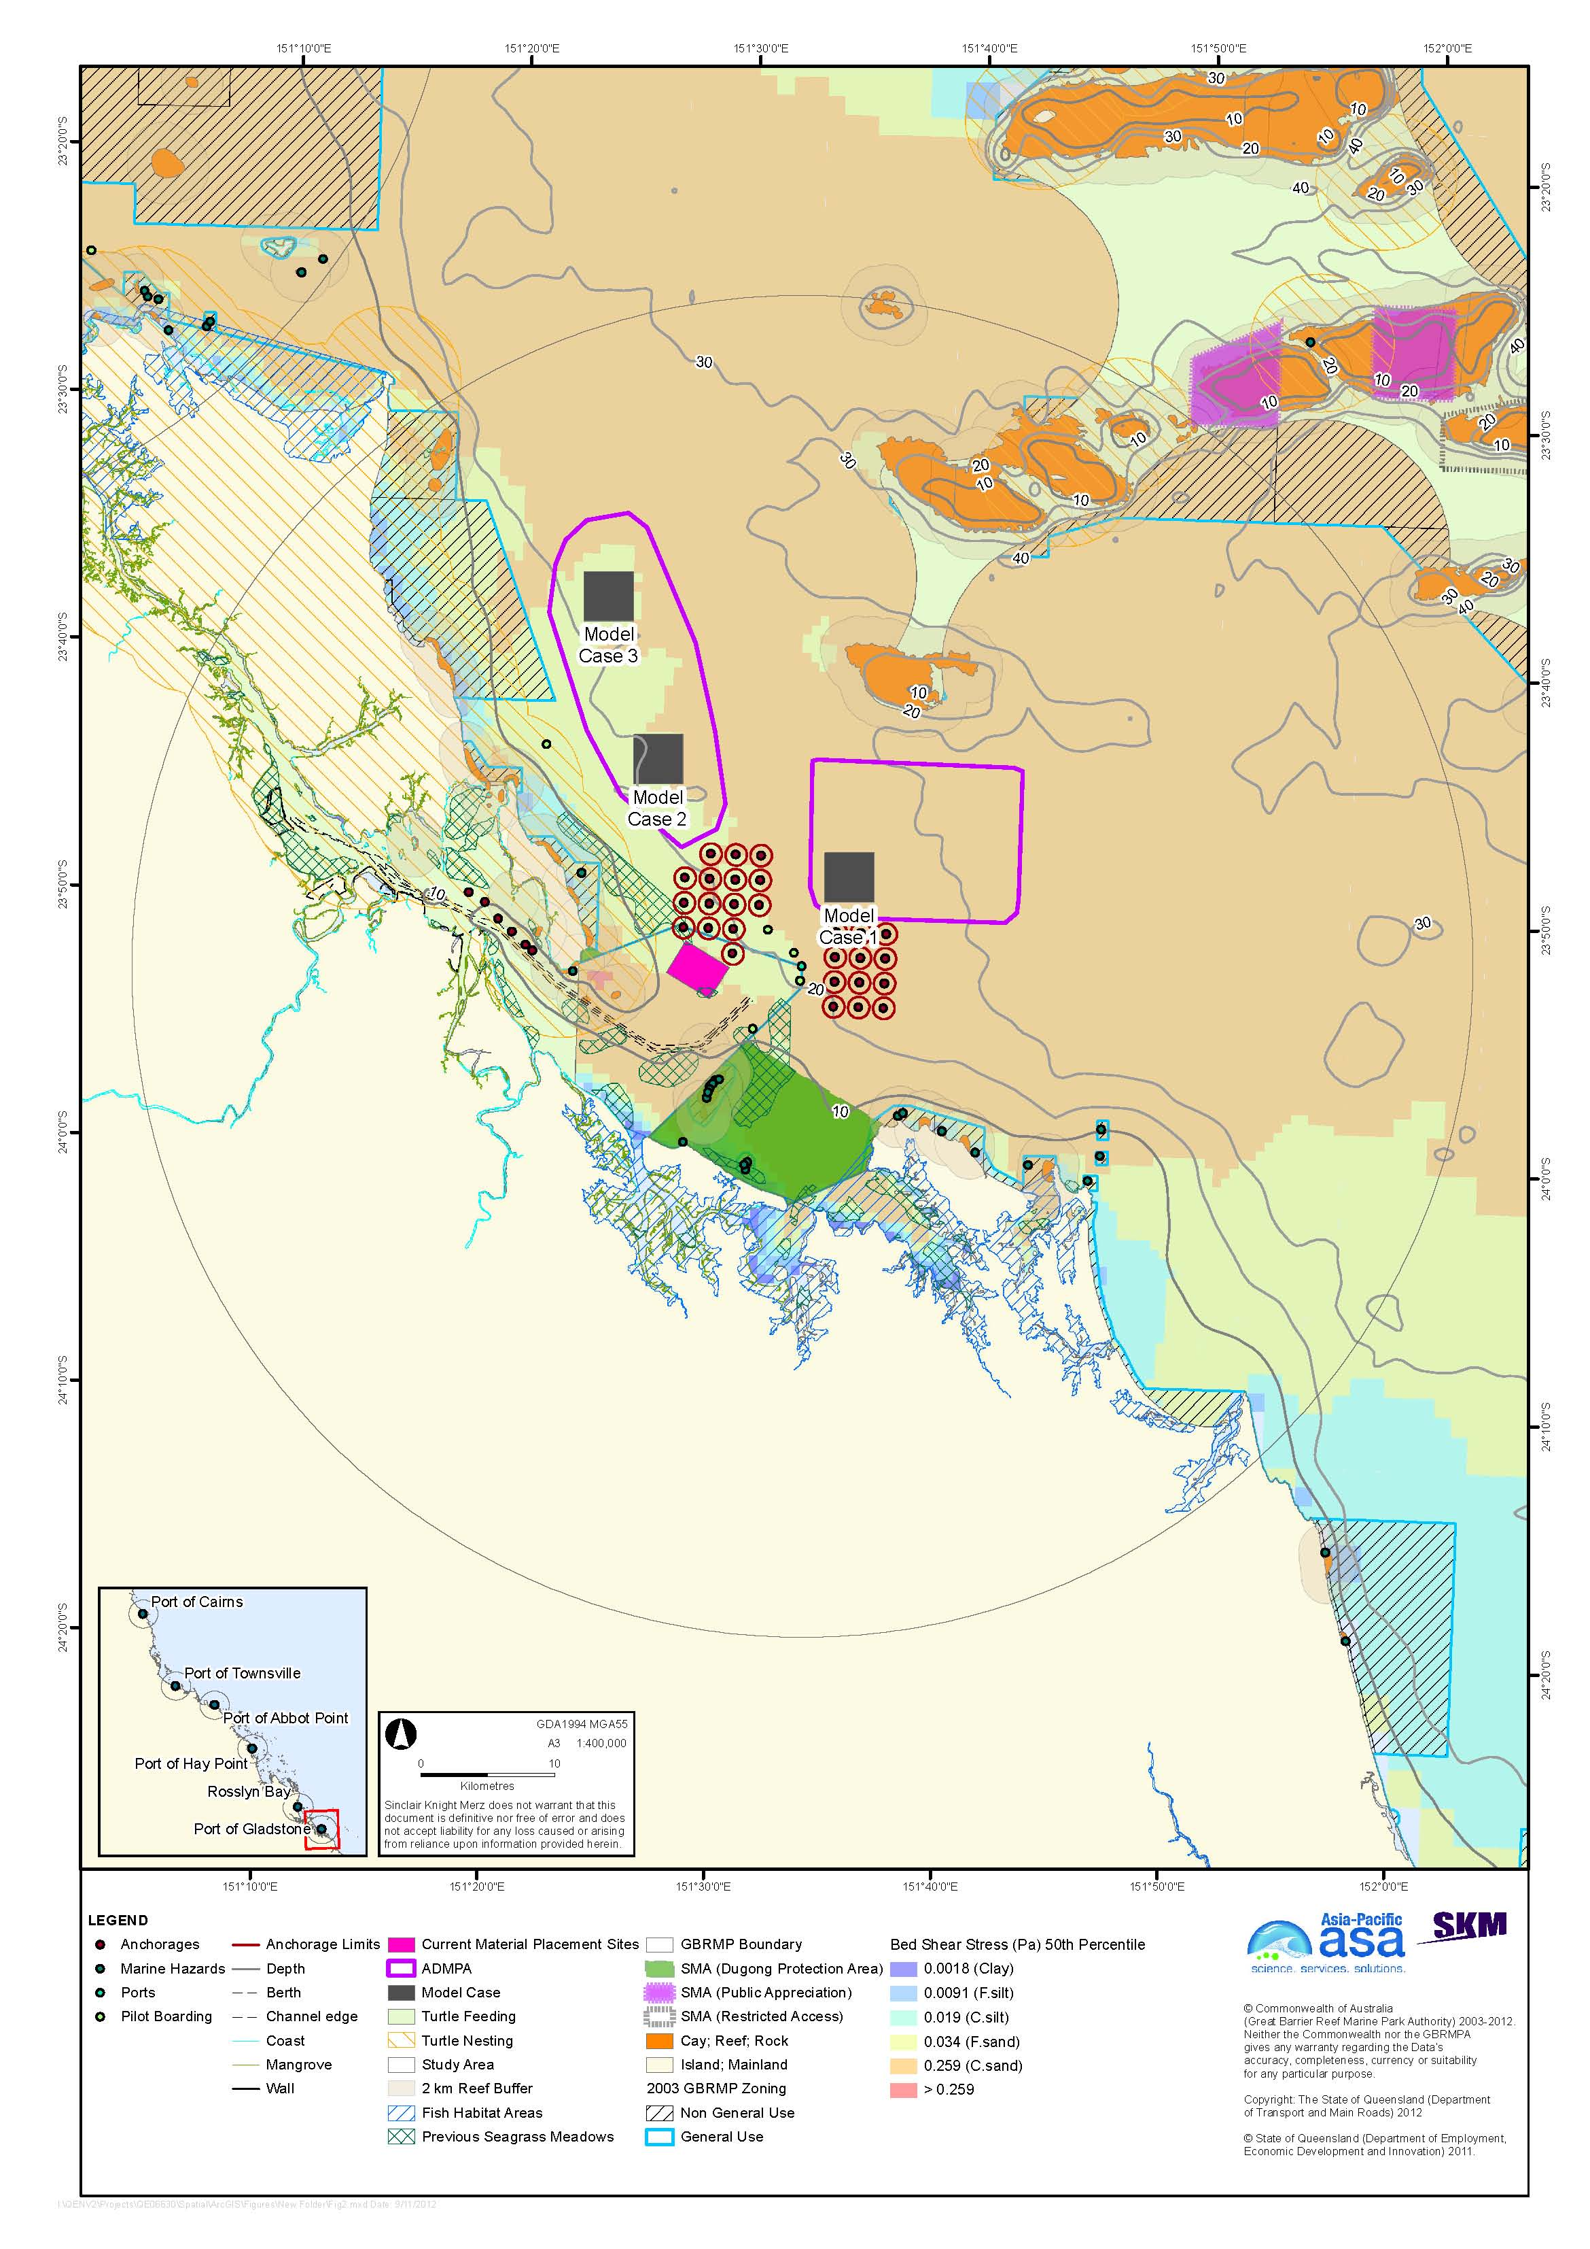
Figure 2. Port of Gladstone with bed shear-stress.

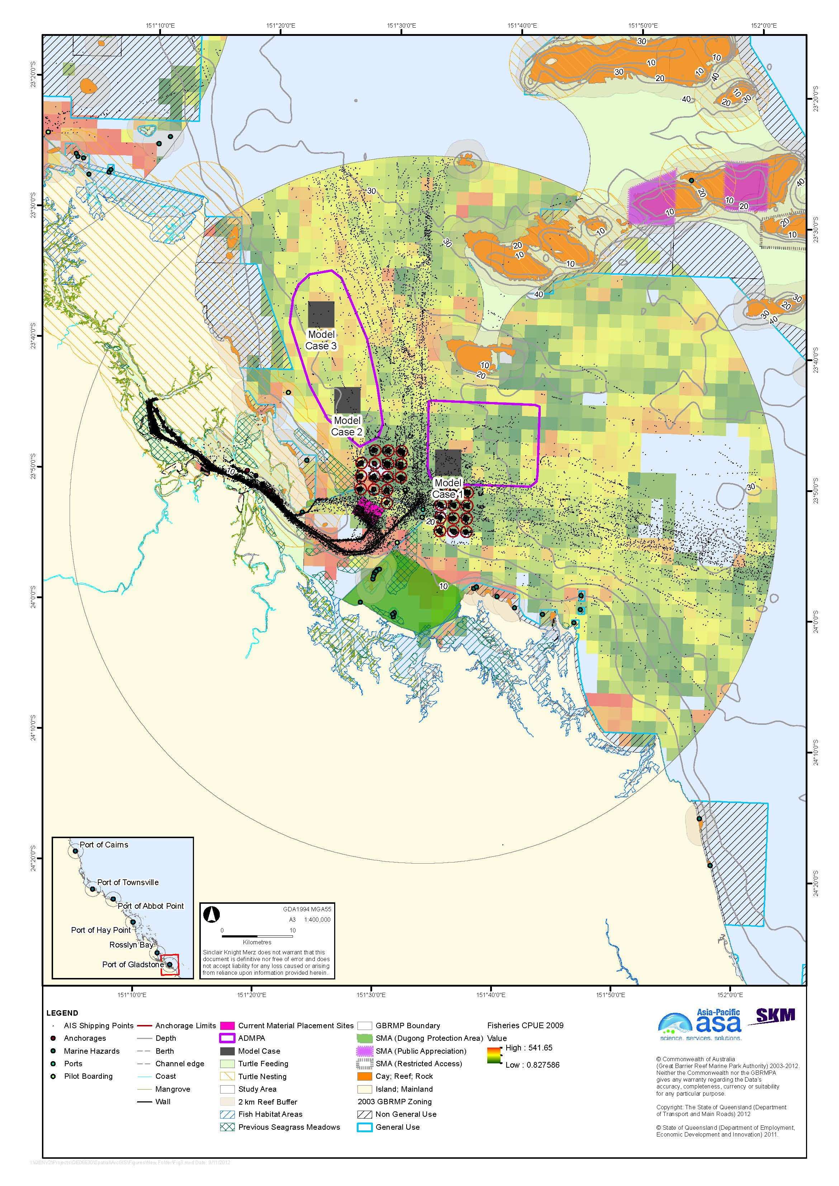
Figure 3. Port of Gladstone with shipping traffic and commercial trawl fisheries CPUE.

The spatial distribution of commercial trawl fishing CPUE varies considerably, based on data from 2007-2009, but neither of the two alternative areas appears to overly trawling grounds of critical importance.
Model cases are based on the relocation of a total of 80,000,000 m³ of dredge material over 25 years. As a compromise between minimising the thickness of deposited material and reducing the increase in placement site over the presently approved site, model cases are based on material placement sites of 3.7 x 3.7 km, based on a deposited thickness of 2.5 m and recognising that material cannot practically be placed to the very edge of the site. This results in model case sites of 13.7 km², compared to 10.3 km² for the present site. All distances used in describing the model cases are straight-line distance from the port entrance.
Model Case 1 lies 10 km north-east of the entrance to Gladstone port channel. Modelled median shear-stress is sufficient to mobilise unconsolidated material up to coarse sands (figure 2). The area avoids pilot boarding locations and anchorage sites (There are no sensitive receptors within 15 km of the site.
Model Case 2 lies 17 km north-west of the entrance of Gladstone port. Predicted average shear-stress is sufficient to mobilise fine to coarse sands in different areas of the site (figure 2). The area avoids pilot boarding locations and anchorage sites. The nearest sensitive receptors are west of the site, with reefs and a Marine National Park Zone, however, these are at considerable distance (11 km to the reef buffer, and 5 km to the Marine National Park Zone).
Model Case 3 lies 29 km north-west of the channel entrance. The site has a predicted sheer-stress sufficient to resuspend unconsolidated material up to fine sand. The area avoids pilot boarding locations and anchorage sites. The nearest sensitive receptor is a Marine National Park Zone 5 km to the west.

Rosslyn Bay State Boat Harbour
Rosslyn Bay State Boat Harbour, also known as Keppel Bay Marina, is located on the central Queensland coast and is approximately 8 km from the central business district (CBD) of Yeppoon. Rosslyn Bay State Boat Harbour is located within the World Heritage Area and borders the Marine Park. It is one of 14 state boat harbours along the Queensland Coast that provide shelter for commercial and recreational vessels.
Rosslyn Bay forms part of Keppel Bay, which extends south from Great Keppel Island to the mouth of the Fitzroy River. The Fitzroy River is the major river discharging into Keppel Bay and is also the largest catchment discharging into the Great Barrier Reef Lagoon. The Fitzroy River deposits considerable volumes of sediment to Keppel Bay each year. This sediment is transported to Rosslyn Bay State Boat Harbour by the south-easterly wave conditions and is the main cause of siltation in Rosslyn Bay. This siltation results in the need for frequent dredging, approximately every three to four years, to enable safe passage of vessels (BMT WBM 2012; TMR 2009, 2012).

Existing Environment and Constraints
The study area has a general sandy benthos, with a small contribution of mud found directly to the north of Fitzroy River, which is a sediment deposition area (Appendix B). This is consistent with modelled shear-stress, which predicts the mobility of sediments up to fine and course sands under average (median) conditions across the majority of the study area (see below).
Coastal areas within and surrounding Rosslyn Bay include a variety of habitats including open soft substrate, coral reefs, salt marsh, seagrass, mangroves, tidal creeks and intertidal flats (Appendix A). A majority of the seabed habitats within and surrounding Rosslyn Bay State Boat Harbour lie within the Great Barrier Reef High Nutrient Coastal Strip Non-Reef Bioregion, which is characterised by muddy sediments and elevated nutrients. In general, the study area, with exception of Great Keppel Island, provides poor habitat for seagrass due to exposure, sediment deposition, and turbidity that limit available light. Great Keppel Island has stands of seagrass, composed of species of Halodule, Halophila, and Syringodium. The bare sediments surrounding the port have taxonomically rich infauna, however, macroinvertebrates are sparse. Rosslyn Bay study area is surrounded by 27 islands and numerous reefs that support macroalgae and coral reef, and Keppel Bay has a high per cent cover of both hard and soft corals.
There are numerous EPBC–listed marine species that potentially occur within the study area, including of turtles, crocodile, sea snakes, shark, pipefish, and marine mammals including dugong, baleen whales, and toothed whales and dolphins. The study area contains known sea turtle nesting sites. There are no dugong sanctuaries within the search areas. Keppel Bay and Port Alma have been identified as important location for Indo Pacific Humpback dolphin. Areas of the Marine Park surrounding Rosslyn Bay include Conservation Park, Habitat Protection, Marine National Park, and Preservation Zones. There are two SMAs within the study area, including Great Keppel Island and Considine Bay. In addition, the area has a high level of cultural significance to Traditional Owners, and has two TUMRA areas.
A number of commercial fisheries operate in the Rosslyn Bay area including line, net, pot, and trawl fisheries, with the main catches being banana prawns, barramundi, king threadfin, mud crabs, and saucer scallops. The area is also used for the collection of marine aquarium fish and coral. The study area has three Fish Habitats Areas including south of Rosslyn Bay, Fitzroy River, and Corio Bay. Cawarral Creek, south of the port, provides fish spawning and nursery functions.

Material Placement Sites
One alternative area for dredge material relocation, north of the current site and west of a Conservation Park Zone, was identified in the Rosslyn Bay study area (figure 4). Bed shear-stress modelling predicts that sediment mobility will increase moving offshore, but due to the predominantly fine material dredged at Rosslyn Bay (typically 75 per cent silts and clays) even the relatively retentive existing site is dispersive, so that little dredged material accumulates. The sand fraction is likely dispersed during periods of high south-easterly winds, as indicated by the 95th percentile shear-stress model results (SKM APASA 2013). The sediment composition in the study area as mapped by Geoscience Australia is consistent with the shear-stress modelling (Geoscience Australia 2007). Net sediment transport is to the north-west.
Placement of dredge material in close proximity to Rosslyn Bay would likely result in the sediment being resuspended and transported back into the Harbour. Placement further south is constrained by a number of islands, Habitat Protection, Marine National Park, and Preservation Zones, and the 5 km turtle nesting buffer. Sites to the east would be nearer the Keppel Islands and associated non-General Use Zones, in areas of higher sediment mobility, and placement east of the Keppel Islands would require navigation in the strong tidal currents between North and Great Keppel Islands, require material to be transported a distance offshore disproportionate to the volume of dredge material, and result in the deposition of predominantly muddy dredge material on a sand bottom, assuming the material reached the bottom after discharge from the hopper barge.
There is a relatively low-energy area further to the north of the alternative area, north of Corio Bay. Again, this, as well as placement in the north-east quadrant of the study area would require long-distance transport of small amounts of dredge material. Although the entire 50 km study area was considered in the analysis, in the particular case of Rosslyn Bay it was deemed unreasonable to consider alternative areas that would require long-distance transport, with attendant environmental and economic costs, in the absence of identifiable environmental advantages.
The alternative area shown in figure 4 includes relative low-energy environments where sediments coarser than coarse silt are expected to be retained under median conditions, and is outside the Conservation Park Zone. The area has a low (20-30 per cent) predicted probability of coastal seagrass occurrence, and a very low (0-1 per cent) probability of deepwater seagrass occurrence. There are, in fact, no known seagrass communities in the area, reflecting the strong influence of coastal sediment transport processes in the Rosslyn Bay area.
Vessel traffic in the area is low and there are no pilot boarding sites. The alternative area does appear to be an area of high commercial trawl CPUE (figure 5), however, this was not considered to be a major constraint given the small size of the relocation area (see below) and that dredging only occurs every three or four years.
Dredging at Rosslyn Bay typically involves 30,000 m³ of dredge material and occurs every three or four years. The cumulative volume of dredged material is assumed to be 250,000 m^{3.} Deposition of this volume of material in a layer 1 m thick would require a relocation site of 0.6 km in diameter. Unlike the other ports considered in this study, however, in which dispersion and consolidation are not taken into account, it was decided that model cases should be based on a relocation area the same size as the current one, which is 0.2 km in diameter. This recognises the high degree of dispersion from the existing site and the relatively long intervals between dredging, and will provide for a more useful comparison between the model cases and the current site in the forthcoming hydrodynamic modelling.
Model Case 1 lies 4 km east of Rosslyn Bay State Boat Harbour and approximately 750 m east of the current placement site. This places it outside, but immediately adjacent to the boundary of the Conservation Park Zone. The bottom at this site has a slightly high mud fraction than the existing site, as mapped by Geoscience Australia (Geoscience Australia 2007). Average modelled bed shear-stress at the site is sufficient to mobilise unconsolidated sediment up to fine silt.
The area is void of pilot boarding locations and anchorage sites (the port is not a commercial shipping port) and shipping traffic is low, with traffic being predominantly offshore at the outer bounds of the port study area (figure 5); no shipping lanes would have to be crossed to reach the material placement site. The site is an area that has historically had moderate fisheries CPUE (figure 5). There are sensitive receptors quite close to the dredge site such as a Habitat Protection Zone to the south and a Conservation Park Zone to the north in Rosslyn Bay.
Model Case 2 lies 6 km north-east of Rosslyn Bay State Boat Harbour. The bottom is primarily sand, with a similar mud fraction to the existing site and slightly lower than Model Case 1. The boundary of the Conservation Park Zone is approximately 2 km to the east and the boundary of the nearest reef buffer is about 5.5 km to the east, however sediment transport is known to be to the north-west. Model Case 2 would preclude using a cutter suction dredge, which has sometimes been used in the past depending on availability. The alternative dredging method that has been used, a small trailer suction dredge, tends to create more visible turbidity plumes in the Harbour.

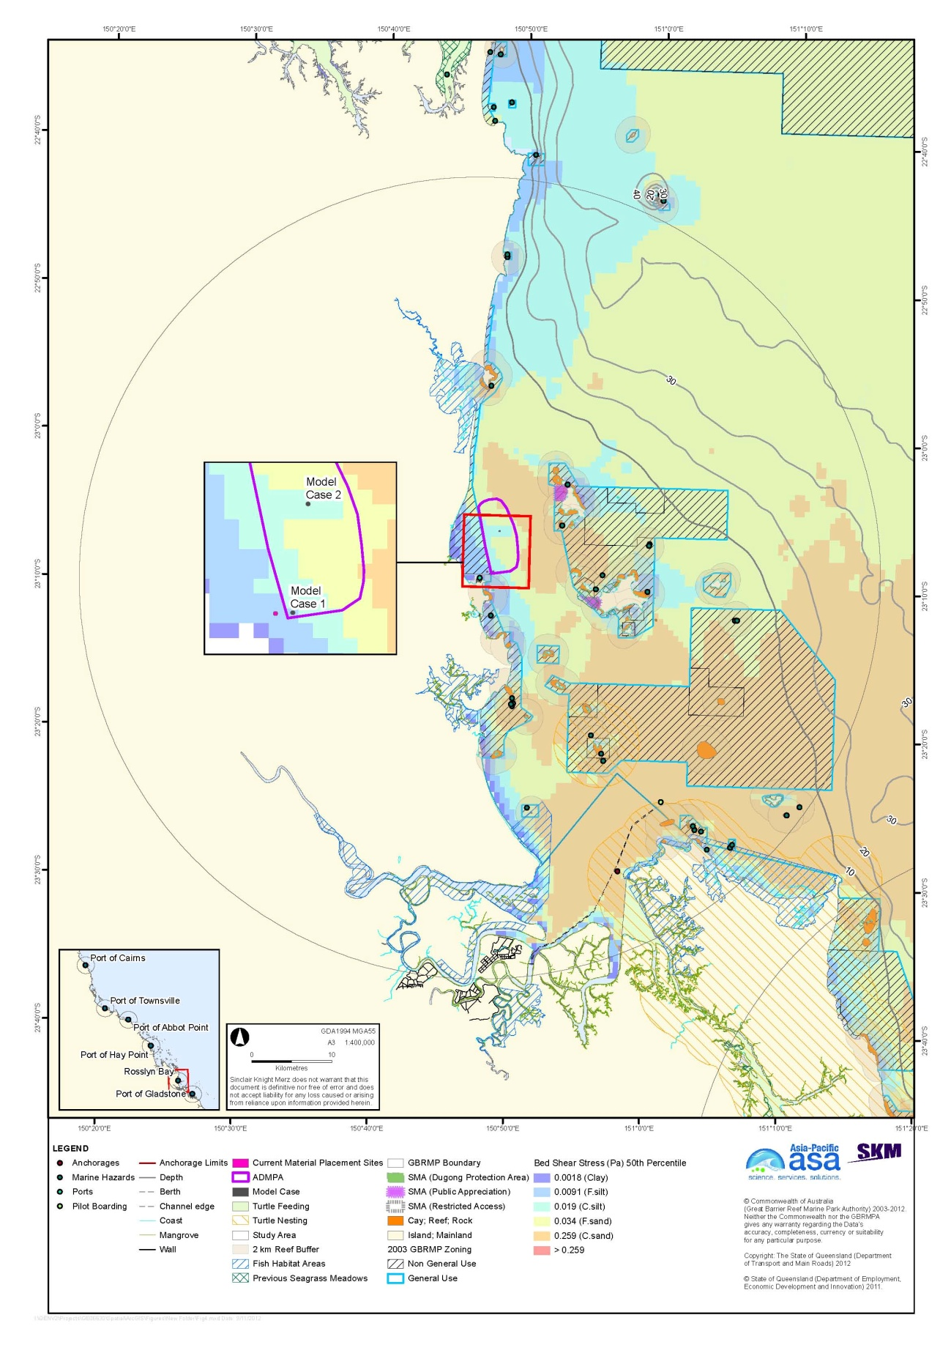
Figure 4. Rosslyn Bay State Boat Harbour with bed shear-stress.

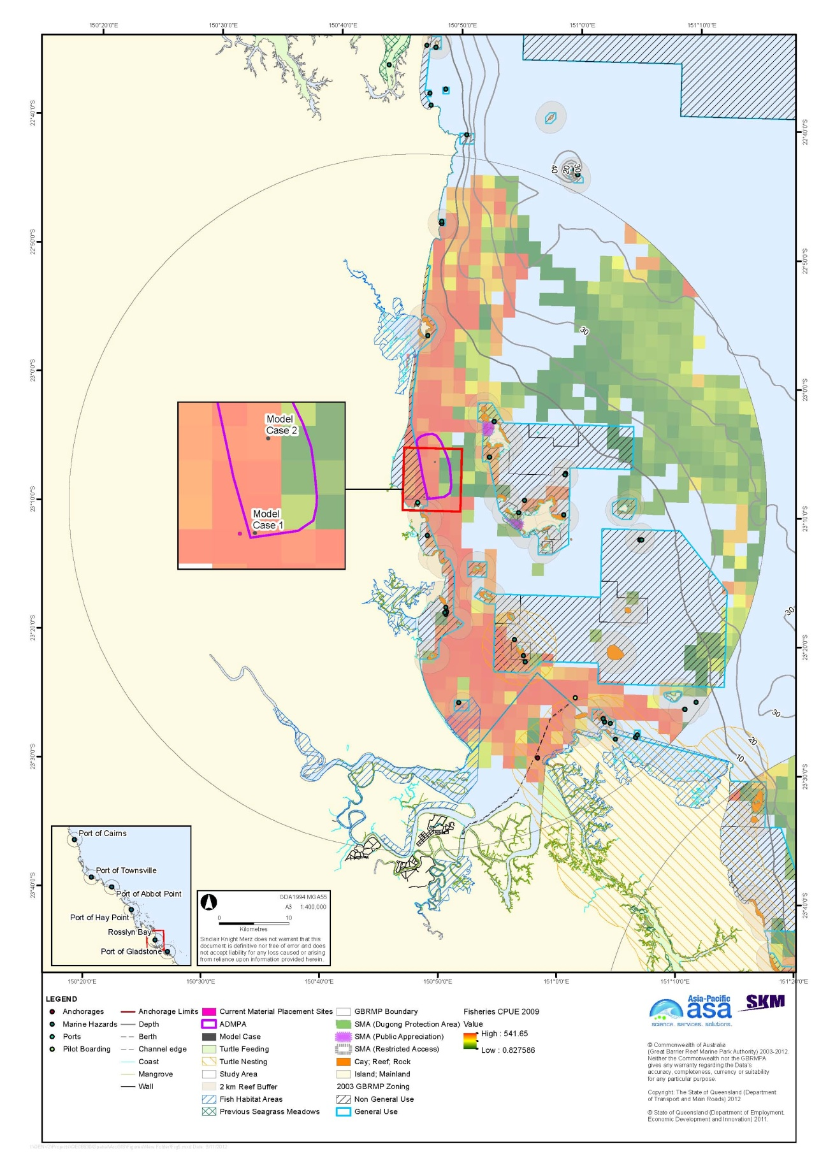
Figure 5. Rosslyn Bay State Boat Harbour with shipping traffic and commercial trawl fisheries CPUE.

Port of Hay Point
The Port of Hay Point lies approximately 38 km south of Mackay in Central Queensland. The Port comprises the Hay Point Coal Terminal and Dalrymple Bay Coal Terminal, which are located outside, but adjacent to the Marine Park. Both coal terminals are located within the World Heritage Area. A third coal terminal is proposed at Dudgeon Point as a future development within the port.

Existing Environment and Constraints
The study area is generally dominated by sands inshore (Appendix B), with mud further offshore to the north-east of the Port of Hay Point. This is consistent with modelled shear-stress, which predicts the mobility of sediments up to course sand under average (median) conditions (see below).
Coastal areas of the Port of Hay Point study are comprise a variety of habitats including open soft substrata, reef, coral, salt marsh, seagrass, mangroves, tidal creeks and intertidal flats (Appendix A). Some of these habitats in Hay Point support a variety of species and contain areas of high conservation status. The mangrove communities within the study area are considered to be of low conservation value, primarily because of the sparseness of trees due to lack of suitable habitat; noting that Hay Point has a wide rocky intertidal zone interspersed with muddy sediments.
The sea bed habitats within and surrounding the Port of Hay Point consist predominantly of open sandy substrate, with occasional patches of rocky reef. There are generally sparse abundances of macroinvertebrates, and the assemblages of invertebrates are generally poorly investigated, but include polychaete worms, molluscs and foraminifera. The distribution of seagrass within the study area is generally sparse, and composed of species of Halophila. Within the study area there are 24 islands, and numerous reefs that support patchy, fringing coral reef and sparse macroalgae communities. In general, hard coral percentage cover is less than 30 per cent.
There are numerous EPBC-listed marine species that potentially occur in the study area include turtles, the estuarine crocodile, sea snakes, sharks, the sawfish, pipefishes, and marine mammals including dugong, baleen whales, and toothed whales and dolphins. The study area contains low-density sea turtle nesting sites. Dugong Protection Areas are designated to the north, at Ball Bay, and south, at Ince Bay and Lewllyn Bay. The area is used by humpback whales during their seasonal migration to calving areas. Areas of the Marine Park surrounding Hay Point include General Use, Conservation Park, Habitat Protection, Marine National Park, and Commonwealth Island Zones. There are no confirmed areas of cultural significance within the study area.
A number of commercial fisheries operate in the study area, including line, net, pot, and trawl fisheries, with the main catches being mud crabs, banana prawns, barramundi, and threadfin. Three areas in the study area have been declared as Fish Habitat Areas, including Bassett Basin, Cape Palmerston to Rocky Dam, and Sand Bay.

Material placement sites
One alternative area for dredge material placement was identified, north of the shipping channel and anchorages (figure 6). Bed shear-stress modelling indicates that most of the study area is energetic enough to mobilise unconsolidated material up to coarse sands, with a less-energetic area north of the channel and anchorages with predicted average shear-stress sufficient to mobilise material up to fine sands. The sediment composition mapped by Geoscience Australia over most of the study area is consistent with the shear-stress modelling, although the Geoscience Australia mapping does show an area with high mud content near the north-east edge of the study area (SKM APASA 2013).
Placement of dredged material in the area immediately to the south of the southern anchorages would be likely to result in transport of the dredge material back into the channel. In addition, SKM was informed at the Risk Assessment Workshop on 9 October 2012 that MSQ wishes to reserve this area for future mooring locations. No information on the eastward extent of the area intended for moorings was provided, and the part of the open area south of the offshore moorings has a consistently high commercial trawl CPUE as indicated by 2007-2009 data. Placement of material further to the south would involve navigation of material transport vessels between reefs and placement of material upstream of the reefs and adjacent to a Marine National Park Zone.
Placement of dredge material east of the shipping channel is constrained by the designated offshore mooring area. The 2011 AIS ship tracking data indicate these moorings are less heavily used than the inshore moorings. However ship traffic in 2011 was depressed as a result of reduced coal output resulting from the 2011 floods. The offshore moorings are more widely spaced than those inshore, and in principle moorings could be relocated to accommodate a material placement site. This area could be re-assessed in light of any future changes in anchoring management, but this area does not appear to provide any clear advantages over the identified alternative area. Placement to the north-east of the alternative area would be upstream of the Conservation Park Zone around Keswick and St Bees islands in the direction of expected sediment migration. There is a small area with reduced bed shear, to a level that would mobilise material only up to coarse silt, at the extreme north-east boundary of the study zone, but it is in close proximity to the Conservation Park Zone around Penrith Island.
Extension of the alternative area further to the north-west was considered. This would result in extension into an area of high shear-stress, and also extend the area nearer Fantome Rocks and Brampton Island along the axis of expected sediment migration. The extension would result in a greater transport distance, with attendant environmental and economic costs as described under ‘Preferential Criteria’ above, with no identifiable environmental benefits. Such an extension would, however, avoid vessel traffic into the Port of Mackay. Ship traffic into Mackay generally involves smaller and more manoeuvrable vessels than that into Hay Point, which is expected to decrease the risk of interactions between dredging plant and vessel traffic. This issue will be assessed in the forthcoming risk assessment phase of the project.
The alternative area has a somewhat lower average bed shear-stress than the rest of the study area, and the expected north-westerly sediment transport will tend to avoid transport into non-General-Use Zones or the 2 km reef buffer. The westernmost extent of the alternative area does approach the minimum 2 km buffer around Oom Shoal. Most of the area has a low (20-31 per cent) predicted probability of deepwater seagrass occurrence, although parts have a somewhat higher (31-41 per cent probability). These probabilities are based on a generalised model; historical mapping indicates that deepwater seagrass communities in the Hay Point area do not extend deeper than 15-18 m LAT (Chartrand et al. 2008) and nearly all of the alternative area is below the 20 m depth contour. Based on 2007-2009 data, the alternative area appears to have relatively low commercial trawl CPUE compare to other parts of the study area where trawling is not constrained by ship traffic and anchorages. The area avoids pilot boarding locations, anchorage sites, and the main shipping lane.
Model cases are based on a total volume of dredge material of 33 million m³ over 25 years, deposition of a layer 1.25 m thick, and 4.7 × 4.7 km (22.1 km²) relocation sites, somewhat larger than the current site of 18.4 km². The larger sites for the model cases reflect the large volume of dredging planned relative to past dredging; detailed assessment of the benefits of using a smaller placement area with a thicker deposited layer are beyond the scope of the present study. Distances referred to in describing the model cases are straight-line distances from the Port of Hay Point as shown in figure 6.
Model Case 1 lies 20 km north-east of the Port of Hay Point. Modelled median shear-stress is sufficient to mobilise unconsolidated material up to fine or coarse sands in different parts of the site. The site is 8.5 km east of the nearest reef buffer (figure 6). The site is located in an area of moderate shipping traffic; the relative importance of traffic to the Port of Mackay or the Port of Hay Point moorings is not known at present.
Model Case 2 lies 25 km north-north-east of the Port of Hay Point. Shear-stress throughout the area is sufficient to mobilise fine sands. The site is 2.2 km east of Oom Shoal, which is a Habitat Protection Zone. Ship traffic is the area is low.

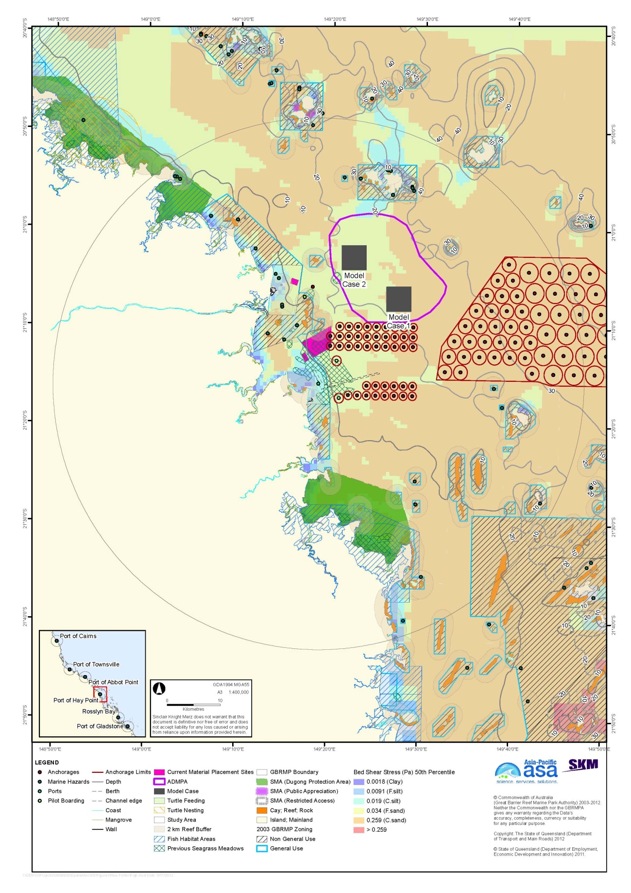
Figure 6. Port of Hay Point with bed shear-stress.

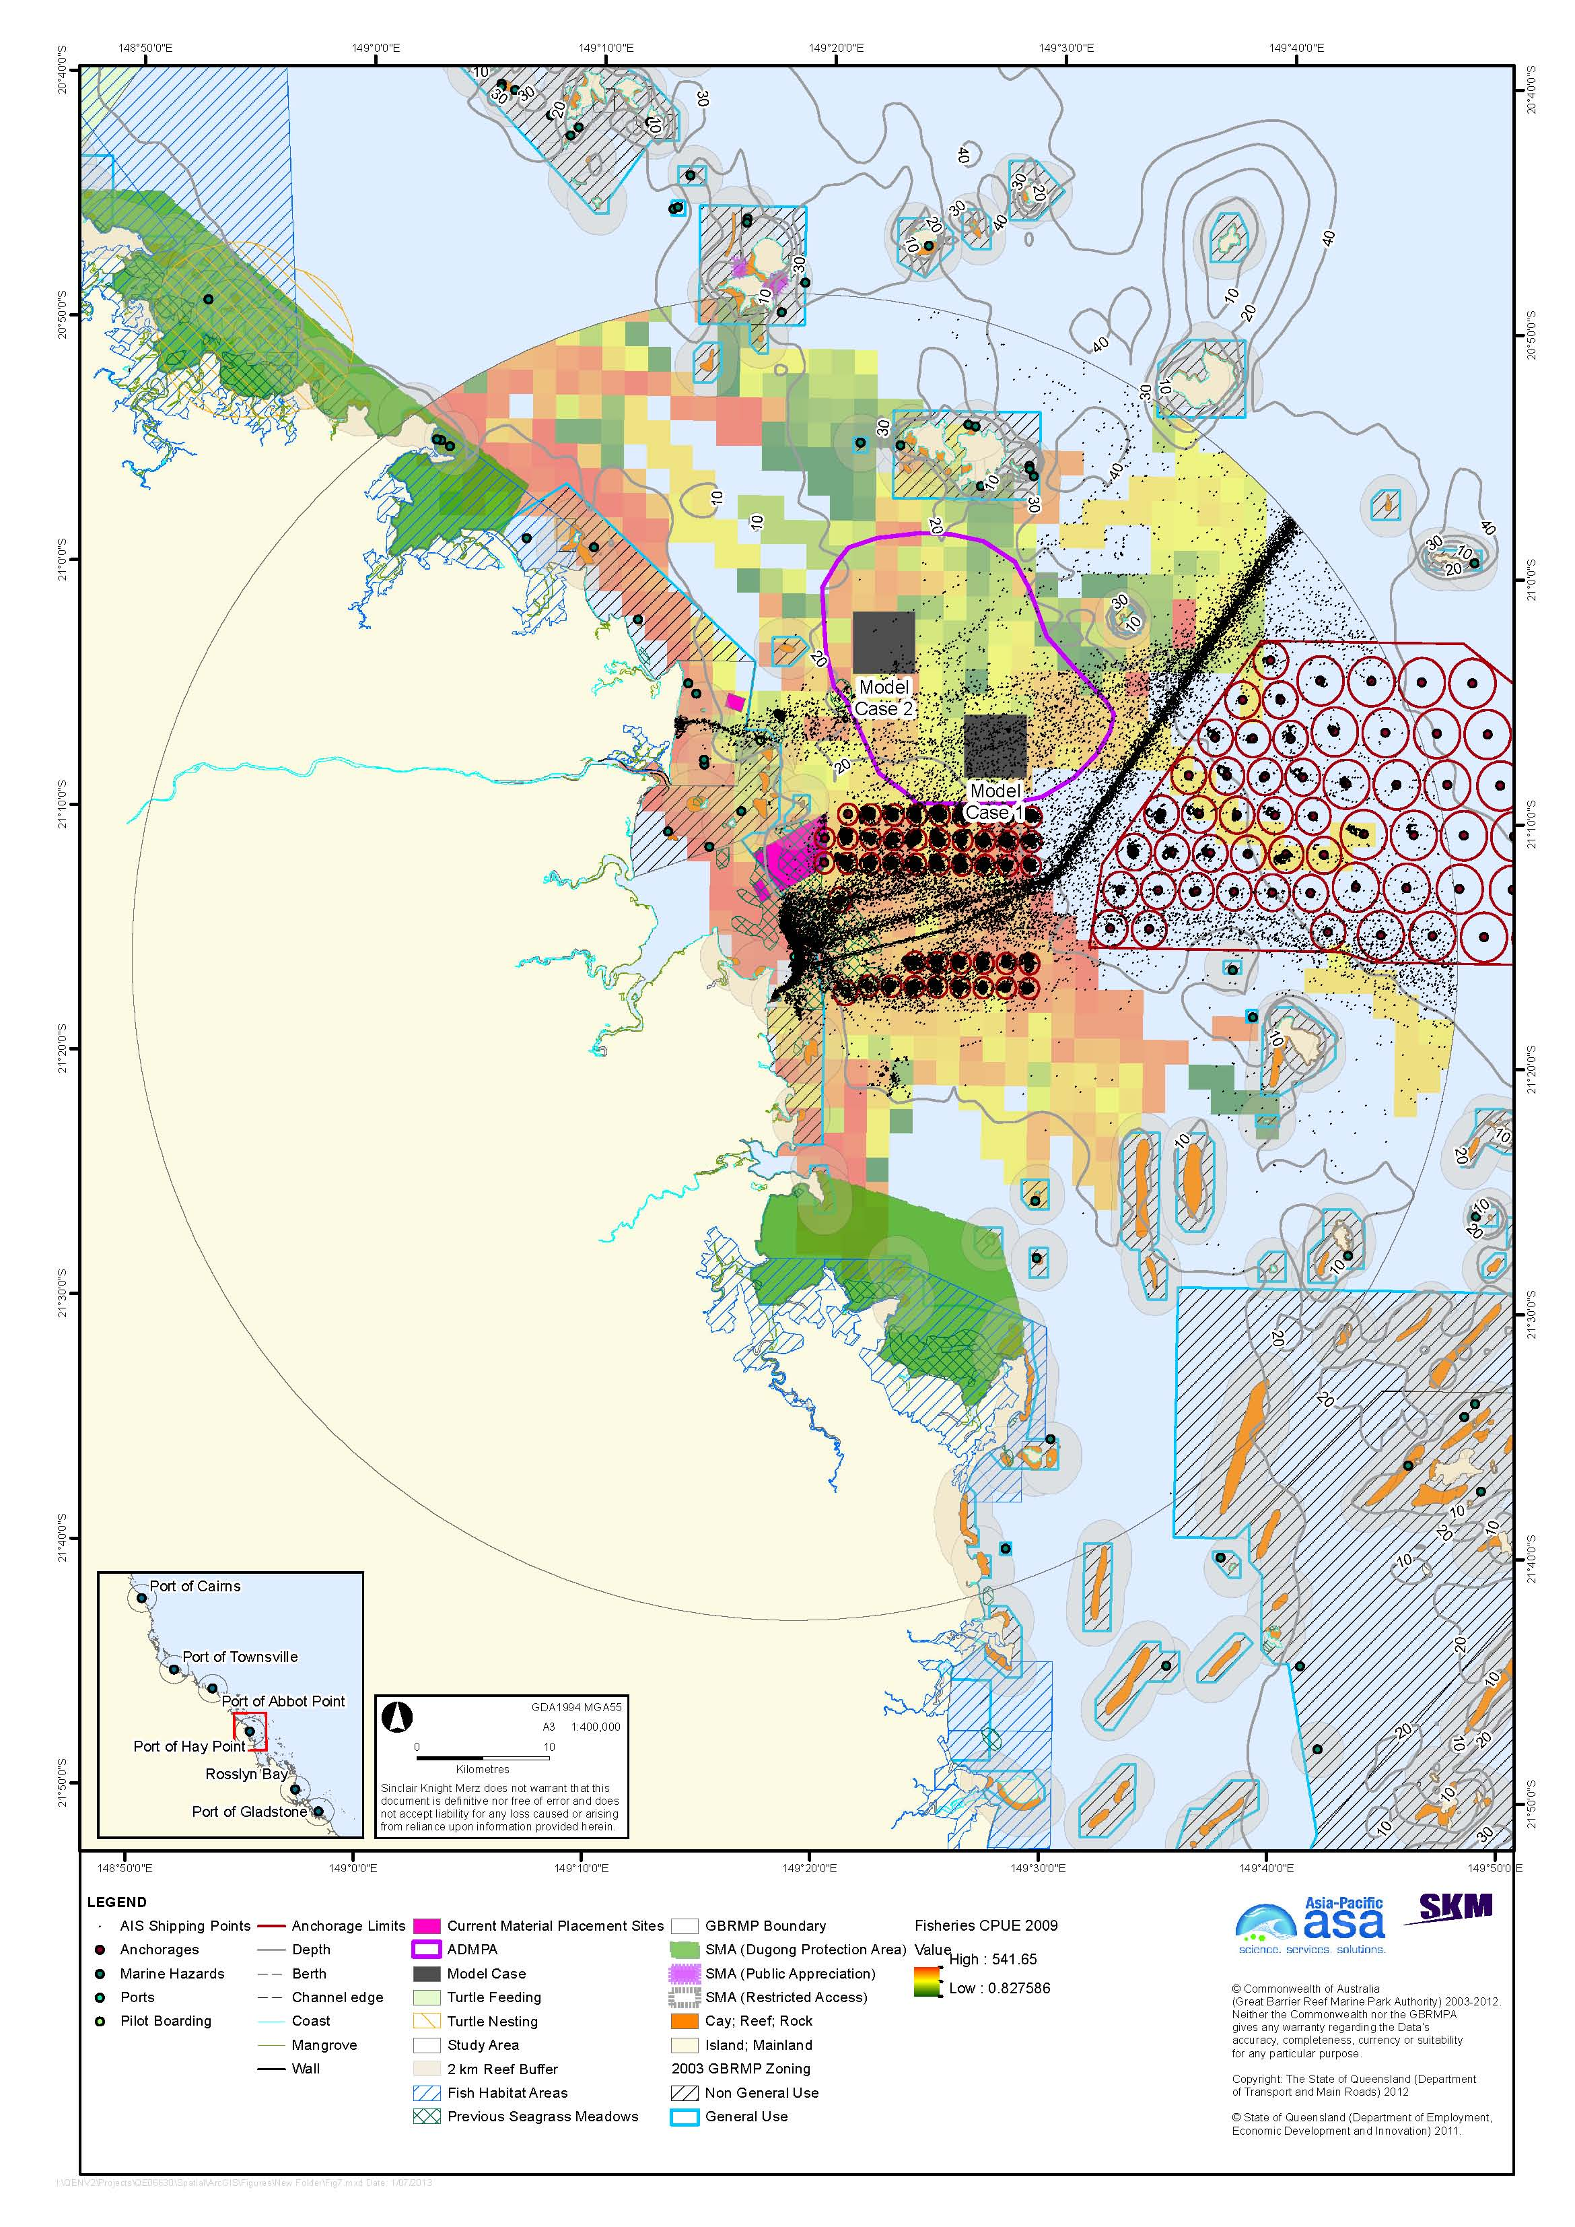
Figure 7. Port of Hay Point with shipping traffic and commercial trawl fisheries CPUE.

Port of Abbot Point
The Port of Abbot Point is located on the central Queensland Coast approximately 25 km north-west of the central business district (CBD) of Bowen. The Port of Abbot Point is located within the World Heritage Area and borders the Marine Park.
The Port of Abbot Point is operated by North Queensland Bulk Port Corporation Pty Ltd (NQBP) and has been identified as a possible location for a major industrial hub on the Queensland coast. Coal is the only commodity shipped from the port, which is the most northerly coal terminal in Australia.

Existing Environment and Constraints
The study area north, south-east, and east of Abbot Point generally has a muddy substrate, and small contributions of sand (Appendix A). The northern most region of the study area generally has a sandy substrate.
Coastal areas within and surrounding Abbot Point include a variety of habitats including open substrate, reefs, coral, salt marsh, seagrass, mangroves, and tidal creeks and intertidal flats (Appendix A). A majority of the seabed habitats within and surrounding the Port of Abbot Point lies within the Great Barrier Reef High Nutrient Coastal Strip Non-Reef Bioregion, which is characterised by muddy sediments and elevated nutrients and there are high sediment depositions from rivers. The study area has extensive seagrass communities, composed of species of Zostera, Cymodocea, Halodule, and Halophila. The base sediments within the study area are relatively devoid of infauna, and other macroinvertebrates. The study area has 12 island and numerous reefs, although less than other regions, they support sparse communities of macroalgae and hard corals.
There are numerous EPBC-listed marine species that potentially occur in the study area including turtles, crocodile, sea snakes, shark, pipefishes, and marine mammals including dugong, baleen whales, and toothed whales and dolphins. The study area contains a known sea turtle foraging area, and a low-density nesting sites of flatback and green turtles. There are two Dugong Protection Areas within the Abbot Point study area, Edgecumbe Bay (approximately 35 km straight-line distance south-east of the port) and Upstart Bay (approximately 35 km straight-line distance north-west of the port, and a considerably greater distance around Cape Upstart). Areas of the Marine Park surrounding Abbot Point include General Use, Conservation Park, Habitat Protection, and Marine National Park Zones. There are three SMAs within the study area, including the Dugong Protection Areas described above and one Public Appreciation SMA at Cape Upstart. In addition, the area has a high level of cultural significance to Traditional Owners, with a number of culturally important aboriginal sites including stone wall fish traps.
A number of commercial fisheries operate in the study area, including line, net, pot and trawl fisheries, with the main catches being scallops, coral trout, mud crabs, mackerel, barramundi, and Moreton Bay bugs. There are two declared Fish Habitat Areas in the study area, Edgecumbe Bay and Burdekin, the nearest portion of which is about 35 km straight-line distance north-west of the port.

Material Placement Sites
Two large alternative areas were identified in the study site, one north of the port and extending to the south-east and one extending north-west of the port (figure 8). Bed shear-stress modelling predicts that the study area is a relatively low-energy environment under average (50th percentile) conditions, with the central portion, extending to the east, having a predicted shear-stress sufficient to mobilise unconsolidated sediments only up to fine silts, and peripheral areas up to coarse silts. Even under 95th percentile conditions, the central area has a predicted shear stress sufficient to mobilise only up to fine sands. Sediment mapping by Geoscience Australia is consistent with the shear-stress modelling, with much of the study area, particularly to the east, having a muddy bottom (SKM APASA 2013). Sediments in the north-west part of the study area have a higher sand fraction, as a result of extensive Halimeda beds to the north-west, which generate coarse carbonate sediments.
Two significant shipping lanes run north-west to south-east offshore of Abbot Point, and areas beyond the shipping lanes were avoided to reduce interactions between material transport vessels and ship traffic, and the attendant navigational risks. In any case, areas beyond the furthermost shipping lane would place dredged material upstream of reef receptors and associated non-General Use Zones, to the extent that dredge material migrates in the expected north-west direction. On the basis of modelling of the current placement site, it is expected that dredged material placed near shore to the east of Abbot Point will tend to migrate westward, back toward the port, and the shear-stress model predicts that material in nearshore areas will be more mobile than offshore.
Both of the alternative areas avoid interactions with shipping, avoid the higher-energy (dispersive) parts of the study area, and do not include pilot boarding locations or anchorage sites. Both areas have a predicted probability of < 41 per cent of deepwater seagrass community occurrence, with the predicted probability increasing northward and eastward from < 1 per cent in the eastern part of the eastern area. Both areas are beyond the 20 m LAT depth contour, reducing the likelihood of deepwater seagrass communities actually occurring. Bottom sediments are sandier in the western alternative area, and given that Abbot Point dredged material has a high sand component, placement in this area could be preferred depending on the relative importance assigned to placing “like-on-like”. This area is, however, nearer the Habitat Protection, Marine National Park, and Conservation Park Zones surrounding Cape Upstart than the eastern alternative area. Commercial trawl CPUE is generally low in both of the alternative areas. In principle, both alternative areas could be extended further towards the boundaries of the study area on the basis of the environmental criteria used to define them. However there are no identifiable environmental benefits to justify the environmental and economic costs of longer-range transport of dredged material.
Model cases are based on a total volume of dredge material of four million m³ over 25 years. Assuming a 1 m thick deposition layer, and allowing for the fact that material cannot practically be placed right to the edge of a placement site, the model case sites have been designated as 2 x 2 km in size (4 km²), more than double the area of the current site (1.7 km²). Detailed assessment of the benefits of using a smaller placement area with a thicker deposited layer is beyond the scope of the present study, but the current assessment on the basis of a relatively large placement site provides for future capacity for currently unforeseen dredging requirements. Distances referred to in describing the model cases are straight-line distances from the Port of Abbot Point as shown in figure 8.
Model Case 1 lies 13 km north-east of Abbot Point and is more than 15 km from any mapped sensitive receptors.
Model Case 2 lies 15 km north-west of Abbot Point. The site is 8 km east of the nearest non-General Use Zones on the east side of Cape Upstart.

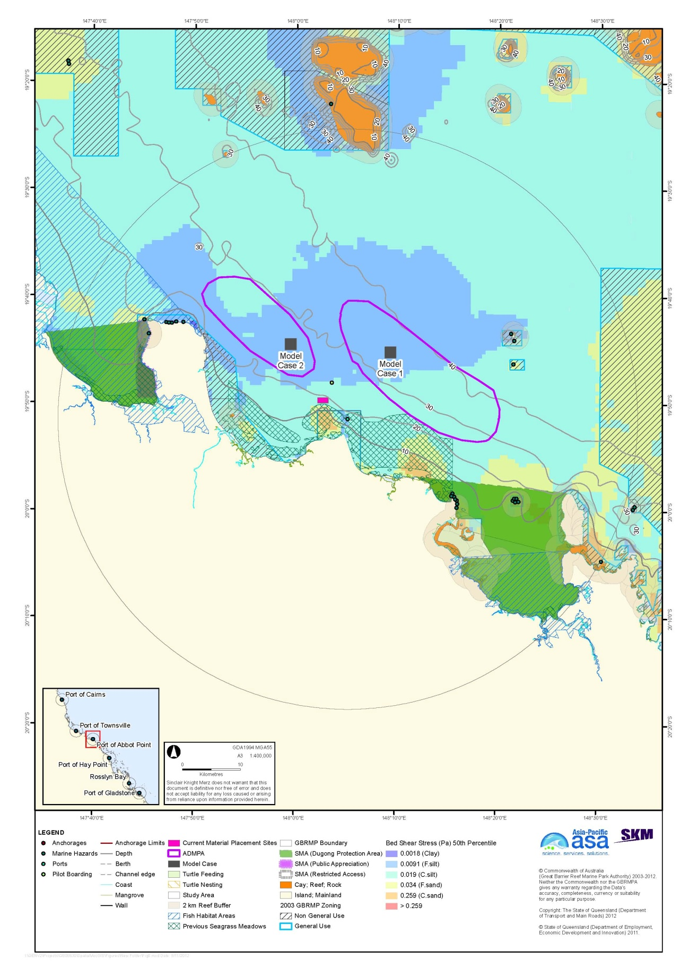
Figure 8. Port of Abbot Point with bed shear-stress.
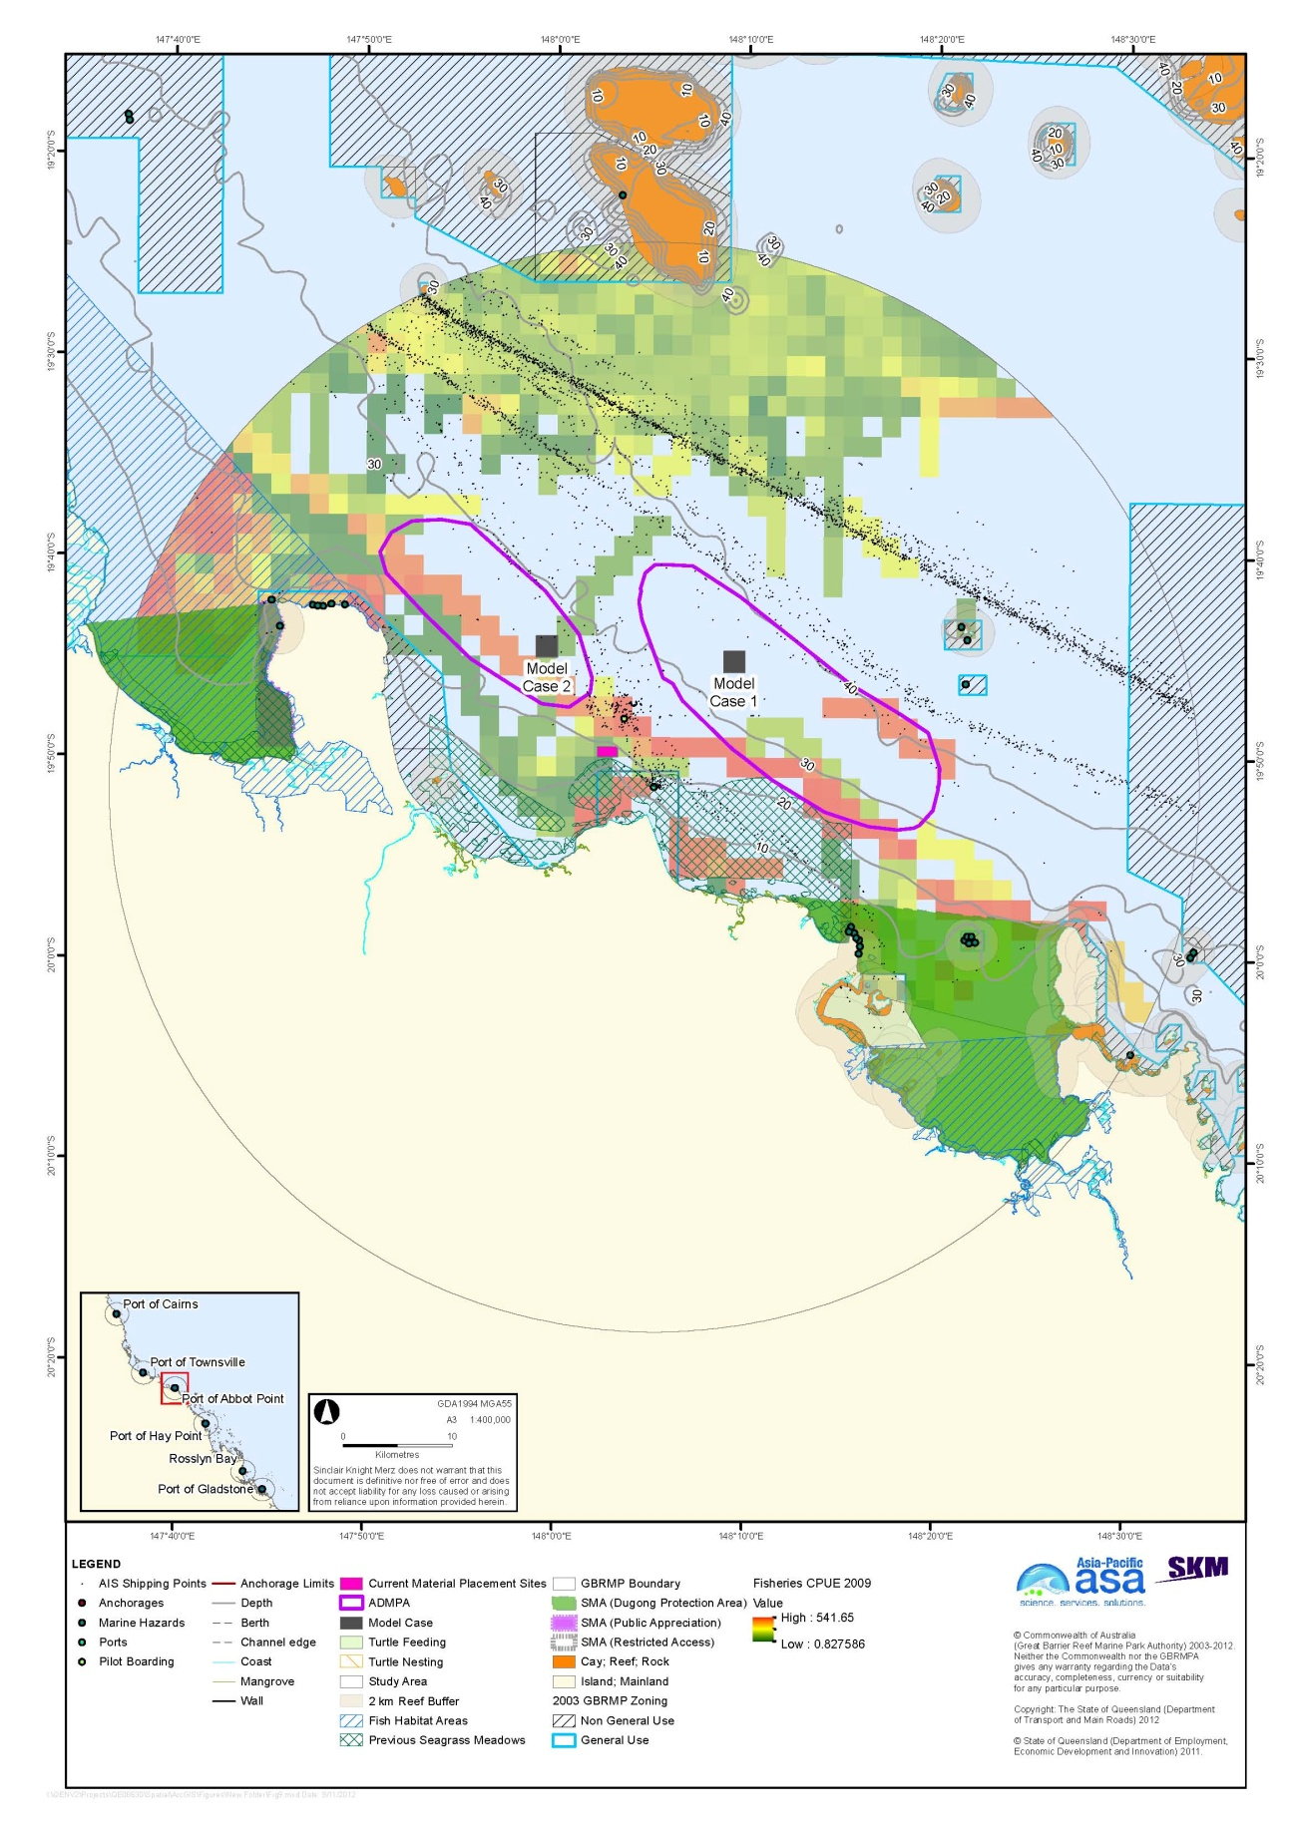
Figure 9. Port of Abbot Point with shipping traffic and commercial trawl fisheries CPUE.

Port of Townsville
The Port of Townsville is a seaport located in Townsville, north Queensland. The port is within Cleveland Bay, which is bound by Cape Cleveland on the east and Cape Pallarenda on the west. Cleveland Bay faces north and lying directly in the entrance of the bay is Magnetic Island. The study area covers the coastline from Balgal beach (north) to Barratta Creek (south) and encompasses a radius of 50 km offshore from the port. Rattlesnake, Herald and Acheron Islands are just within the study area boundary north of Magnetic Island.

Existing Environment and Constraints
The study area is generally dominated by muddy substrate inshore (Appendix B), with sandy substrate dominating offshore to the north-east where sandy substrate is dominant. This is consistent with modelled shear-stress, which predicts the mobility of sediments up to fine sand offshore and up to coarse silt inshore under average (median) conditions (see below). The sediment type mapping by Geoscience Australia (Appendix B) indicates that the sediment in the eastern portion of Cleveland Bay is mixed mud (silt and clay) and sand. Geoscience Australia did not map sediment type within port limits, but detailed acoustic surveys (BMT WBM 2012d, in draft, unpublished) indicate that most of the sampling areas in the western part of Cleveland Bay, and in the vicinity of the current dredge material placement area, are muddy, with occasional sand and gravel and with no clear gradient between inshore areas and the Outer Harbour and the placement site and Sea Channel areas. The BMT WBM (2012d, in draft, unpublished) surveys had a much higher sampling intensity than the Geoscience Australia mapping, and thus are likely to be more reliable.
Coastal areas within the study area include open soft substrate, reef, corals, salt marsh, seagrass, mangroves, and tidal creeks and intertidal flats (Appendix A). The study area lies within the Great Barrier Reef High Nutrient Coastal strip, which is characterised by muddy sediments and elevated nutrients. Soft sediments occupy approximately 80 per cent of the benthic habitat of Cleveland Bay, and support invertebrates and macroinvertebrates. The region supports seagrass, primarily in Cleveland Bay, composed of species of Zostera, Halodule, and Halophila. The study area contains seven islands, and numerous reefs, though many of those reefs are at the study area boundary. Reefs within study area support macroalgae and corals, and the area supports the Great Barrier Reef’s only population of rare soft coral Nephthyigorgia sp. (Appendix A).
There are numerous EPBC-listed marine species that potentially occur within the study area, including turtles, the estuarine crocodile, sea snakes, sawfish, sharks, pipefishes, and marine mammals including the dugong, baleen whales, and toothed whales and dolphins. The study area contains known sea turtle feeding sites, but no known nesting sites. The Cleveland Bay- Magnetic Island Dugong Protection Area lies to the north-west and south-east of port limits, and all of Bowling Green Bay to the south-east is a Dugong Protection Area. No marine mammals are permanently resident Cleveland Bay, though dolphins use the bay year-round. Areas of the Marine Park surrounding Townsville include Conservation Park, Habitat Protection, and Marine National Park Zones. Bowling Green Bay, east of Townsville is listed RAMSAR site, being important habitat for about 50 per cent of the migratory bird species listed on international conservation agreements (EPA, 1999). In addition, the area has a high level of cultural significance to Traditional Owners, and there is one TUMRA within the study area in the greater Hinchinbrook Island area.
There are a number of commercial fisheries in the Townsville study area including line, net, pot, and trawl fisheries, with the main catches being mud crabs, Moreton Bay bugs, tiger, banana, and red spot prawns, barramundi, coral trout, and mackerel. The south-east portion of Cleveland Bay and Bowling Green Bay are Fish Habitat Areas.

Material Placement Sites
Two alternative areas were identified to the east and west of the Port of Townsville (figure 10). Bed-shear stress modelling predicts that much of the study area has a relatively low-energy seabed environment, with shear-stress sufficient to mobilise unconsolidated sediments up to coarse silts. Modelled median shear-stress in the north-eastern part of the study area is sufficient to mobilise fine sands, and the central portion of Cleveland Bay, and the far eastern portion of Bowling Green Bay, have sufficient predicted shear-stress to mobilise coarse sands under average conditions. There is a small area north of Magnetic Island with lower shear-stress, sufficient to mobilise material only up to fine silt. Sediment mapping by Geoscience Australia is generally consistent with the shear-stress modelling, showing muddy sediments in the eastern part of the study area and north of Magnetic Island, and sandier sediments to the north and east. The sediment mapping shows a muddy bottom in the eastern part of Bowling Green Bay, an area predicted to have relatively high shear-stress. This could reflect significant inputs and consolidation of fine material from the creeks draining into Bowling Green Bay, the seaward diversion of longshore transport of sand by Cape Bowling Green, or other sedimentary processes.
Placement of dredged material between and to the north of the two alternative areas is constrained by ship traffic and a Marine National Park Zone. Placement further east is constrained by reefs. Placement further inshore of the alternative areas impinges on the 5 km turtle nesting buffer, and in the case of the western area on reefs and Magnetic Island. Areas within Cleveland Bay were considered unsuitable for material placement due to the presence of sensitive receptors including seagrass and a Dugong Protection Area.
The alternative areas are in relatively low-energy environments at a distance from sediment-sensitive receptors. They do not appear to be high-value trawl grounds based on 2007-2009 fisheries CPUE data. They avoid pilot boarding areas, as well as shipping lanes and high-use anchorage areas as indicated by 2011 AIS data. The eastern area does overlie some locations that appear to have been used as anchorages in the AIS data, but this has been minimised. As noted previously, the 5 km turtle buffer is highly precautionary, and the current spoil ground already lies within this buffer, so with suitable risk and impact assessment it may be appropriate to extend the alternative areas further inshore, particularly the eastern alternative area. As noted, the eastern alternative area was identified to avoid the high-use anchorage area; MSQ stated the intention to formally designate anchorages in this area at the Risk Management Workshop on 10 October 2012. Contingent on anchorage management issues, it may be appropriate to extend the eastern alternative area to the northern boundary of the existing placement site, or to wrap it around the anchorage area to the northern boundary.
Again with more detailed assessment, it may be appropriate to extend the western alternative area into the low-energy area north of Magnetic Island, which in this study has assumed to be constrained by the 2 km reef buffer and Magnetic Island, including visual amenity constraints.
Model cases are based on a total 25-year dredged material volume of 24 million m³. Placement of this volume of material in a layer 1.5 m thick would result in a model placement of site 3.4 x 3.4 km, allowing for the fact that material cannot be placed right to the edge of the site.
Model Case 1 lies 24 km north-east of the Port of Townsville. The closest receptors are those in Cleveland Bay and Magnetic Island, 7.5 km or more away, and the area has a low probability of having deepwater seagrass. The site includes a few locations that appear to have been used as anchorages in the 2011 AIS data.
Model Case 2 lies 24 km north-west of the Port of Townsville (straight-line distance, the navigation route around Magnetic Island is considerably farther). The closest receptors are those at Magnetic Island and the Marine Protection Zone to the north of the site.
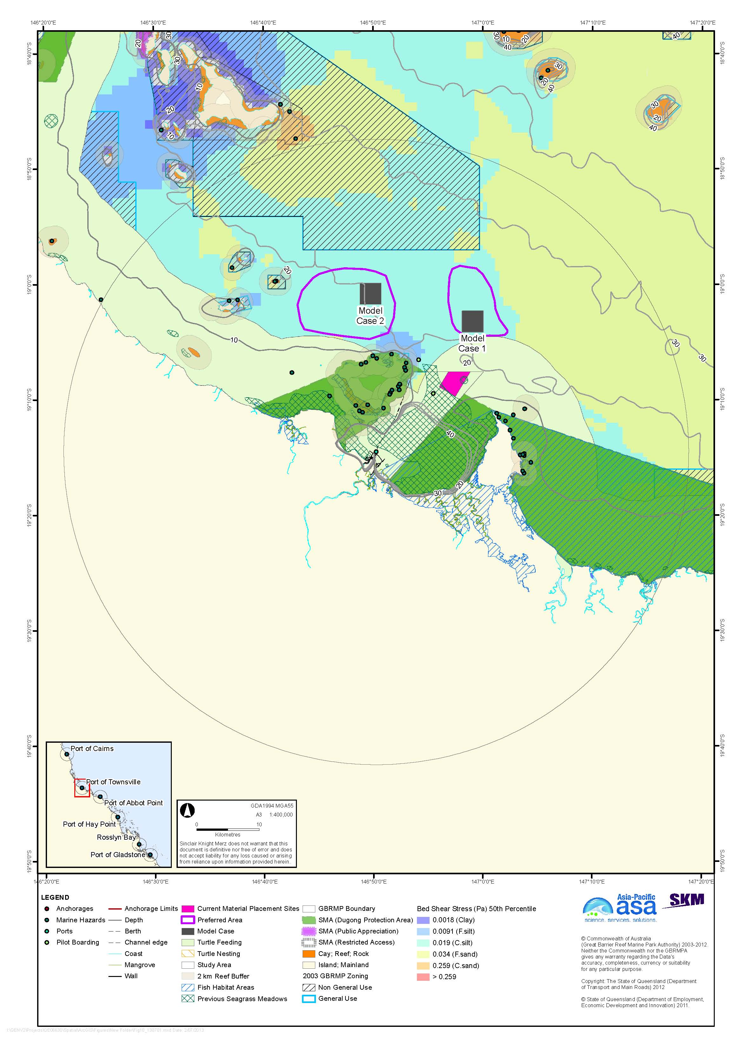
Figure 10. Port of Townsville with bed shear-stress.
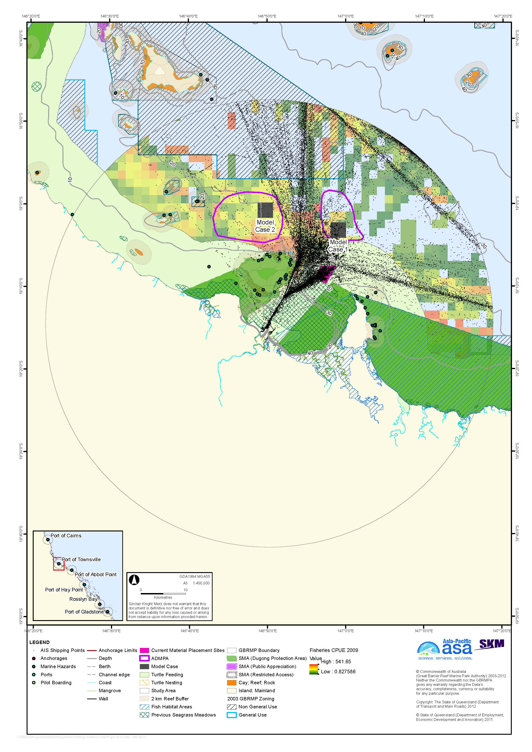
Figure 11. Port of Townsville with shipping traffic and commercial trawl fisheries CPUE.

Port of Cairns
The Port of Cairns is located virtually within the Cairns CBD. The Port of Cairns is the most northern major port on Australia’s eastern seaboard and of the ports considered in this study, and is closest to major coral reefs.
Far North Queensland Ports Corporation Limited (Ports North) manages and operates the Port of Cairns, which is Australia’s busiest cruise port with over 200 internal and domestic cruise ship visits annually (Ports North 2012). The Port of Cairns is a multi-purpose port catering for a wide range of shipping operations including resident and visiting cruise vessels, bulk cargo vessels, commercial tourist craft and privately owned leisure craft. The port has rapidly expanded over the past 10 years to meet demand for commercial private and tourism vessels.

Existing Environment and Constraints
The study area has a generally muddy bottom, with a small contribution of sand offshore and around islands and reefs (Appendix B). This is consistent with the modelled shear-stress, which predicts that inshore areas have median shear-stress sufficient to mobilise only clays to fine silts, with more energetic conditions sufficient to mobilise coarse silt to fine sands under average (median) conditions (see below). The 95th percentile shear-stress modelling predicts conditions energetic enough to mobilise coarse sand in offshore areas (SKM APASA 2013).
Coastal areas in the Cairns study area include a variety of habitats including open soft substrate, coral reefs, salt marsh, seagrass communities, mangroves, tidal creeks and intertidal flats (Appendix A). The majority of seabed habitat in the study area lies within a narrow strip of the Great Barrier Reef High Nutrient Coastal Strip, which is characterised by muddy sediment and high nutrients (GBRMPA 2001). These muddy and sediment habitats support infauna including polychaetes, molluscs, and crustaceans. The study area has extensive seagrass, composed of species of Zostera, Cymodocea, Halodule, and Halophila. Seagrass abundance in the study area has been on a downward trend in recent years, however this has been attributed to climatic conditions such as floods and cyclones and not associated with dredging activities (Fairweather et al. 2011). The study area contains nine islands, and numerous reefs that support significant macroalgae assemblages and both hard and soft corals. Coral communities in the area have a high species richness, but low per cent cover, particularly of soft corals.
There are numerous EPBC-listed marine species that potentially occur in the study area, including turtles, the estuarine crocodile, sea snakes, the sawfish, sharks, and pipefishes, as well as dugong, baleen whales and toothed whales and dolphins. There are no Dugong Protection Areas. Humpback whales calve and breed in the Cairns region. Areas of the Marine Park surrounding Cairns include Conservation Park, Habitat Protection, Marine National Park, Scientific Research, and Commonwealth Island Zones. There are two Public Appreciation SMAs in the study area, at Fitzroy Island Reef and Thetford Reef. The area has a high level of cultural significance to Traditional Owners.
A number of commercial fisheries operate in the Cairns study area including line, net, pot, and trawl fisheries, with the main catches being tiger and endeavour prawns, barramundi, sharks, mackerel, coral trout, mud crabs, and mullet. There are four Fisheries Habitat Areas in the study area: Barr Creek, Half Moon Creek, Trinity Inlet, and Yorkey’s Creek.

Material Placement Sites
Two alternative areas for dredged material placement were identified, both north-east of the Port of Cairns (figure 12). Bed shear-stress modelling predicts relatively low sediment mobility within the Cairns study area, with shear-stress sufficient only to mobilise unconsolidated clays along much of the immediate coastline, grading into shear-stresses sufficient to mobilise fine and coarse silts moving offshore. Only a few reef-associated areas have predicted shear stresses sufficient to mobilise sands (figure 12; SKM APASA 2013). Sediment mapping by Geoscience Australia is generally consistent with the shear-stress modelling; areas with a somewhat higher sand component than might be expected are mainly in proximity to reefs, which are sources of carbonate sands.
Options for alternative material relocation sites for the Port of Cairns are very limited. Placement beyond approximately 15 km offshore is highly constrained by reefs and associated non-General Use Zones, as well as a busy shipping lane which would create a navigation hazard for material transport vessels. Placement to the south is largely outside the General Use Zone and highly constrained by navigational considerations (shipping lane and Fitzroy Island). Given the relatively retentive nature of the inshore study area, placement of material in an inshore area west of the current placement site was considered, between approximately the 8 m and 10 m depth contours. A thickness of deposition inshore of 1 m was assumed for comparative purposes, which given a total expected volume of dredged material of 20 million m³ over 25 years would require a placement area of approximately 19.6 km², compared to 2.7 km² for the current site. It is recognised that the size of an inshore placement site would be considerable reduced by deposition of a thicker layer of dredge material in deeper areas, for example at the 10 m depth contour a 3 m thick layer of material could be deposited before reaching the 7 m depth that has historically been taken to limit the capacity of dredge material placement sites in Cairns. Even allowing for the fact that the current site is not adequate for future requirements, consideration of such an inshore site would require a detailed comparative assessment of placement of a thin layer over a larger area, as opposed to a thicker layer over a smaller footprint. An inshore location would also place material in or near areas of relatively high (40 to 50 per cent during dry season) probability of coastal seagrass occurrence (historical seagrass mapping does not extend to this area). Data from 2007-2009 also show consistently high commercial CPUE in the inshore area. For the purpose of the present study, an inshore alternative area was not identified but with more detailed risk and impact assessment could be appropriate, if not for the entire anticipated 25-year volume of dredge material then possibly for the 5 million m³ of anticipated capital dredging material.
The two alternative areas identified are located between the constraints imposed by reef and seagrass receptors to the west and dense ship traffic to the east. Both have similar shear stress levels to the current site, with similar mud content in the sediments. The alternative area immediately north-east of the current placement site is more exposed to vessel traffic, and does overlap one pilot boarding location, however it is expected that the pilot boarding location could be moved if required. The 2011 AIS data indicate, however, that Cairns traffic and vessels headed further south bifurcates around the current site, with Cairns traffic avoiding the current placement site (traffic to which is clearly indicated in the AIS data). It is assumed that vessel traffic around a placement site in the nearby alternative area would adjust to follow a similar pattern. Worley Parsons (2010) noted that there is a submarine cable 2.9 km north of the current placement site, which needs to be investigated for any placement site in the alternative area near the current site.
Model cases are based on a total volume of dredge material for the Port of Cairns of 20 million m³ of over 25 years. Using a thickness of deposition of 2.5 m as a compromise between minimising the thickness of the deposited layer and reducing the increase in size of the placement area over the current one, model cases are based on a circular placement site 2.2 km in diameter (3.8 km² compared to 2.7 km² for the present site).
Model Case 1 lies 20 km north-north-east of the Port of Cairns. The site is away from sensitive receptors, such as reef, and has a low probability of having deepwater seagrass. It is 4.0 km from the existing placement site, which should avoid the submarine cable, though this would need to be confirmed if the model case site were to be considered for actual use. In considering potential alternative placement sites within this alternative area, it might be better to place the site closer to or contiguous with the current one, however for the purposes of comparing alternatives with currently used sites the model case was placed near the far end of the alternative area.
Model Case 2 lies 32 km north-north-east of the port. The site has moderately high commercial trawl CPUE (figure 13), however the detailed spatial pattern of CPUE varies considerably from year to year and the site is equivalent in area to a single CPUE data grid. The site is away from sensitive receptors, such as reef, and has a slightly higher probability of having deepwater seagrass compared to Model Case 1.
It is recognised that the current placement site lacks sufficient capacity for the expected 25-year volume of dredge material. In order to compare the sediment migration and plume modelling for the model case sites with the current area, the modelling will assume that the current site is expanded to the same size as the model case sites. This is purely for comparative purposes and there is no assumption that such an expansion of the current site would be approved.

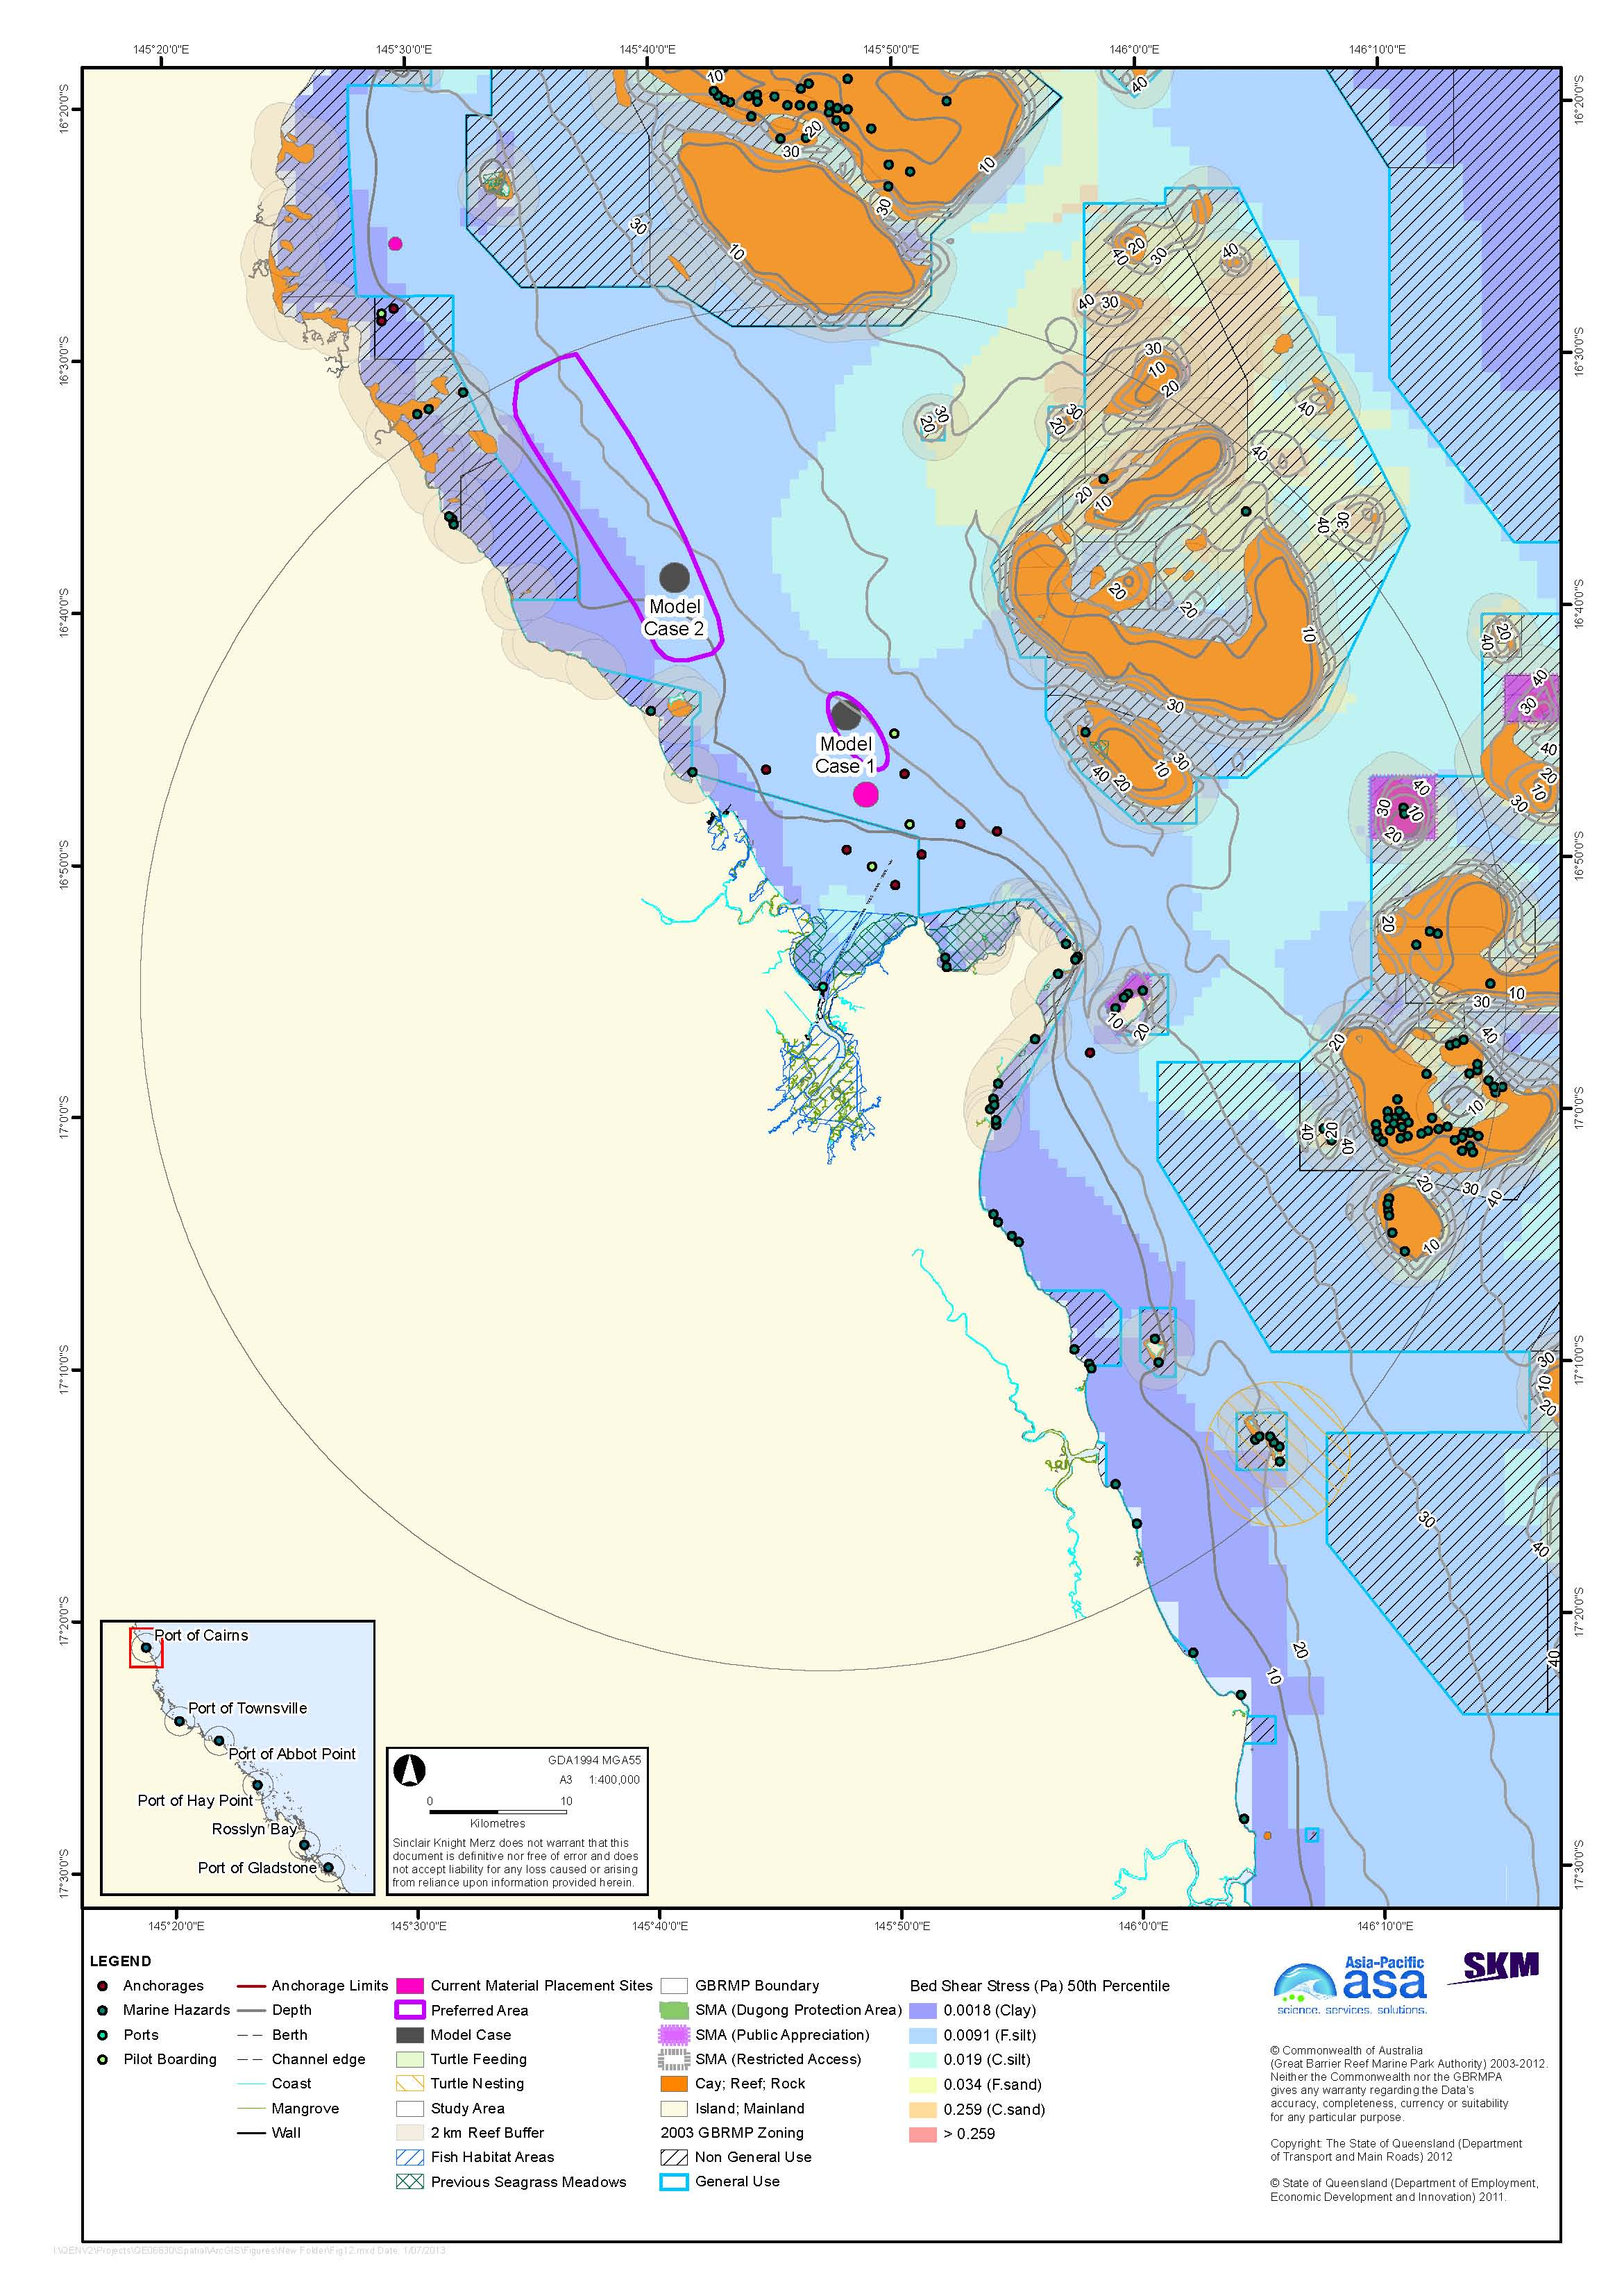
Figure 12. Port of Cairns with bed shear-stress.

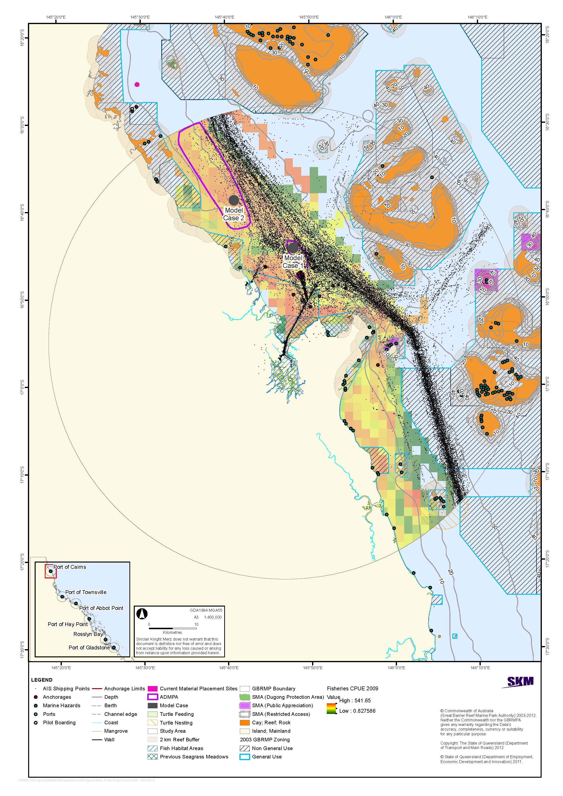
Figure 13. Port of Cairns with shipping traffic and commercial trawl fisheries CPUE.

model case scenarios
The next stage in this component of the project will be to conduct more detailed modelling of turbidity plumes generated by a representative disposal campaign and subsequent long-term (12 month) migration of placed material. The disposal scenarios to be modelled have been discussed with the port authorities to determine the most relevant scenarios for each port, considering:
- Current port plans for capital dredging requirements
- Past and estimated future maintenance dredging requirements
- Representative particle size distributions for capital and maintenance dredging material
- The disposal activities likely to present the greatest risk to the environmental values of the World Heritage Area on a 25-year time scale.

For each port, a relevant disposal campaign scenario to be modelled has been established. The scenario assumptions adopted are generally representative of typical historical campaigns, with a bias toward assumptions likely to generate more extensive turbidity plumes during disposal and more mobile sediments after disposal. In this regard, it is stressed that the objective of the current study is not an Environmental Impact Assessment of a specific dredging project, but rather the high-level strategic assessment of the relative advantages and disadvantages of placement of dredged material in alternative areas from a long-term perspective.

Port of Gladstone
Future requirements at the Port of Gladstone include significant capital expansion, and the risk assessment workshop on 16 October 2012 concluded that a major capital dredging campaign is the most relevant scenario for modelling from a long-term, strategic assessment perspective. Major dredging campaigns in Gladstone can continue year-round. The modelling scenario to be adopted for Gladstone is for 10 million m³ of dredged material relocation over 12 months.

Rosslyn Bay State Boat Harbour
There are no current plans for capital expansion of Rosslyn Bay State Boat Harbour. Maintenance dredging is typically conducted every three to four years, with the volume of dredged material averaging 30,000 m³, although considerably larger volumes may need to be dredged following major events such as floods and cyclones. The scenario to be modelled is for 40,000 m³ of material during a three-month campaign.

Port of Hay Point
Current planning for the Port of Hay Point indicates expected requirements of approximately 25 million m³ of capital dredging over the next 25 years, with about 1 million m³ approximately every three years. The modelling scenario adopted for this study is for a large capital dredging campaign. NQBP, the port authority, has informed SKM and APASA that such a campaign would likely involve some 13 million m³ of dredged material, over 46 weeks of dredging spread across two dredging seasons. The dredging season at Hay Point is typically constrained to the months of April to September to avoid the turtle nesting and hatching seasons. The model scenario to be adopted assumes 8.5 million m³ of capital material to be relocated over a 30-week dredging season.

Port of Abbot Point
Although the assumed total 25-year volume of material used in the present study assumes 5 million m³ of maintenance dredging material, maintenance dredging has only been necessary at Abbot Point once in the last 24 years. Therefore, the scenario to be modelled is for capital dredging, based upon current plans for expansion involving the relocation of 3.5 million m³ of material to be dredged over nine weeks. It was noted that plans for the development of a multi-cargo facility (MCF) at Abbot Point called for considerably larger dredging volumes, however those plans have now been abandoned and dredged material from MCF development was in any case earmarked for use as fill for the development of the facility.

Port of Townsville
Several expansion projects at the Port of Townsville are in various stages of the development and approvals process. The currently anticipated capital dredging volume is for up to 6.9 million m³ of dredged material to be placed at sea. Over the long term, however, opportunities for further port expansion are limited. The anticipated 25-year volume of maintenance dredging, which occurs annually, is 18 million m³, up to 2.7 million m³ of which may be brought to land (in calculating the total 25-year volume of 24 million m³, it was assumed that half of this amount will actually be brought to land). Therefore, from a strategic perspective, the Port of Townsville workshop agreed that modelling of maintenance dredging is most relevant. The scenario to be modelled is for 400,000 m³ of material relocated over a typical five week maintenance dredging campaign. This scenario includes expected increases in maintenance dredging requirements as a result of capital expansion.

Port of Cairns
The Port of Cairns is in the advanced stages of planning for capital expansion to accommodate a cruise ship terminal. Further capital expansion at the Port of Cairns is highly constrained by the available port land, whereas maintenance dredging is expected to occur annually over the long term. Therefore, from a long-term strategic perspective the most relevant modelling scenario is for maintenance dredging, taking into account potential increases in maintenance dredging requirements that may result from development of the cruise ship terminal. The scenario to be modelled is for a maintenance dredging campaign of 580,000 m³ over 35 days. The risk assessment workshop on 15 October 2012 agreed, however, that the modelling scenario should take the planned capital dredging into account. This will be done by assuming that the planned 5 million m³ of capital dredging material is placed and retained on the model case and current sites, and adjusting the assumed bathymetric input to the model accordingly. Also, as described above, for comparative purposes the model scenario will assume that the current placement site is expanded to accommodate the anticipated 25-year dredging volume.
The disposal scenarios to be modelled in the next phase of this component of the project are summarised in table 2. More detailed information regarding assumed wet and dry densities of the dredged material, bulking factors, and whether the volumes assumed reflect wet or dry (i.e. dry solids only) is being collected in collaboration with the port authorities for input into the modelling.

Table 2. Port-specific modelling scenarios for dredged material placement campaigns.
Port |  | Gladstone | Rosslyn Bay | Hay Point | Abbot Point | Townsville | Cairns
Dredging type |  | Capital | Maintenance | Capital | Capital | Maintenance | Maintenance
Per cent composition by particle size class (µm) | Less than 7 (clays) | 5 | 37 | 15 | 27 | 25 | 60
 | 7 to 35 (fine silt) | 5 | 13 | 10 | 3 | 26 | 11
 | 35 to 75 (coarse silt) | 30 | 15 | 10 | 9 | 38 | 11
 | 75 to 130 (fine sand) | 30 | 25 | 10 | 11 | 3 | 13
 | Greater than 130 (coarse sand) | 30 | 10 | 55 | 50 | 8 | 5
Dredged material volume (m³, assumed to be in situ volume |  | 10 million | 40,000 | 8.5 million | 3.5 million | 400,000 | 580,000
Duration of disposal campaign (maximum modelling period is one year) |  | 1 year | 3 months | 30 weeks | 9 weeks | 5 weeks | 35 days
Depth of release of material |  | 11 m | 2 m | Mid-water | Mid-water | 5 m | 11 m
Estimated capacity per load (m³) |  | 15,000 | 400 | 18,000 | 18,000 | 2900 | 2900
Number and type of vessels used for disposal |  | 1 TSHD | 1 TSHD | 1 TSHD | 1 TSHD | 1 TSHD (Brisbane) | 1 TSHD (Brisbane)
Time to release material |  | 20 minutes | 2 minutes | 13 minutes | 13 minutes | 35 minutes | 8 minutes
Number of releases per day |  | 3 | 1 | 5 | 8 | 3 | 8
Total Number of releases |  | 667 | 90 | 722 | 167 | 114 | 167
Total number of days (assuming continuous operations) |  | 222 | 90 | 181 | 21 | 38 | 35
Month of commencement |  | March | March | April | June | September | August

SUMMARY AND CONCLUSIONS
The study has identified broad alternative areas for the placement of dredged material at sea within a 50 km radius offshore of each of the six ports considered (Gladstone, Rosslyn Bay, Hay Point, Abbot Point, Townsville, and Cairns) based on multiple criteria including:
- Bathymetry
- Modelled bed shear-stress
- Soft sediment characteristics and expected transport direction
- Seagrass community distribution
- Modelled probability of seagrass occurrence outside mapped areas
- Reef distribution
- Turtle nesting and feeding areas
- Commercial trawl fishery CPUE
- Marine Park zoning
- SMAs including DPAs
- Fish Habitat Areas
- Cultural heritage values
- Navigational constraints including anchorages, shipping channels and shipping lanes, and pilot boarding locations.

One broad alternative area for dredge material placement each was identified for Rosslyn Bay State Boat Harbour and for Hay Point, and two alternative areas each were identified for Gladstone, Abbot Point, Townsville, and Cairns.
Two (and for Gladstone three) model case sites were identified within the identified alternative areas for each port. The size of the model cases sites was selected to approximate that of the current sites to facilitate comparison of hydrodynamic modelling and risk assessment in the next stage of the project, while also resulting in as thin as possible a layer of deposited dredged material based on the anticipated 25-year dredge material volume. A thin layer of deposition was desired to avoid dramatic changes in bathymetry that could affect the modelling assumptions, but there is no implication that large placement sites are preferred simply to maintain thin deposits of dredge material.
Although predicted bed shear-stress was used as one criterion in the selection of preferred areas and model case sites, shear-stress was a relatively minor factor because the modelled median shear-stress in the study areas of most ports did not vary enough to provide a strong basis for the selection of alternative areas. In general, environmental (proximity to sensitive receptors), socioeconomic (for example distance and cost of transporting the dredge material, public appreciation, tourism values, and commercial fisheries), and operational (for example interference with anchorages and shipping lanes) criteria were considered more important criteria in identifying alternative areas than was shear-stress. Furthermore, given that there was no presumption that retentive sites are favoured over dispersive ones, shear-stress modelling does not provide clear guidance in the select of alternative areas, although it will be critical in modelling the long-term migration of dredge material.
Findings for the six ports were:
- Port of Gladstone: Two alternative dredge material placement areas, one to the north-east and one to the north-west of the Gladstone port entrance were identified. These areas minimise interaction with navigational routes, avoid sensitive environmental receptors, are in relatively retentive areas for sediment dispersion, and appear not to overly commercially important fishing grounds. Unlike the other five ports, for which two model case sites each were identified, three model case sites were identified for Gladstone to take into account that the current placement site is already fully committed. Two of the model case sites are in the alternative area to the north-west and one is in the area to the north-east.
- Rosslyn Bay State Boat Harbour: One alternative placement area was identified, to the north-east of Rosslyn Bay State Boat Harbour. This area avoids sensitive areas and is of moderate trawl fisheries value, although it is immediately adjacent to a Conservation Park Zone. Model Case 1 within the alternative placement area is east of the current material placement site and Model Case 2 lies to the north of that.
- Port of Hay Point: One alternative area for dredge material placement was identified, to the north of the shipping channel and anchorages. Additional areas were considered, however, areas to the east have high shipping traffic, and areas to the south have been identified by the Harbour Master as potential areas for future anchorage expansion, and placement to the south has the potential for transport of dredge material back into the channel. The alternative area minimises interaction with navigational routes, avoids sensitive environmental receptors, is relatively retentive of fine and course sands, and has relatively low historical levels of fisheries catch. Model Case 1 lies immediately to the north of the northern anchorages, and Model Case 2 is further to the north-east.
- Port of Abbot Point: Two alternative dredge material placement areas were identified to the north-west and south-east of the port between the 20 m and 40 m depth contours. Both of the identified areas avoid sensitive areas interactions with navigational routes and shipping activity, however the northern area is closer to non-General Use Zones. Both areas have historically had low fisheries catch. One model case site was identified in a part of each area relatively close to the port.
- Port of Townsville: Two alternative areas for dredge material placement were identified to the east and west of the Port of Townsville. Placement of dredge material outside of these areas was constrained by Marine National Park Zones, sensitive environmental receptors, and shipping traffic. The areas minimise interaction with navigation, avoid sensitive receptors, and have historically not been high-value fisheries grounds. One model case was identified in each of the alternative areas.
- Port of Cairns: Two alternative areas for material placement were identified, both to the north-east of the Port of Cairns near the 20 m depth contour. Options for dredge material placement sites at Cairns are very constrained due by reefs, non-General Use Zones, and shipping activity. Both of the alternative areas avoid interactions with sensitive environmental receptors and navigational routes; however, they have consistently high fisheries CPUE.

Summaries of the model case sites identified and the modelling scenarios to be conducted in the next stage of the study are presented above in table 1 and table 2. Table 3 shows the coordinates of the centroids of the identified model case site for the size ports.
Table 3. Coordinates of the centroids of the 13 identified model case sites.
Area | Name | Latitude | Longitude
Port of Gladstone | Model Case 1 | 23°48'46" S | 151°34'59" E
 | Model Case 2 | 23°44'14" S | 151°26'26" E
 | Model Case 3 | 23°37'43" S | 151°24'3" E
Rosslyn Bay State Boat Harbour | Model Case 1 | 23°9'7" S | 150°48'14" E
 | Model Case 2 | 23°6'22" S | 150°48'37" E
Port of Hay Point | Model Case 2 | 21°2'58" S | 149°22'27" E
 | Model Case 1 | 21°7'8" S | 149°27'22" E
Port of Abbot Point | Model Case 2 | 19°44'32" S | 147°59'29" E
 | Model Case 1 | 19°45'14" S | 148°9'21" E
Port of Townsville | Model Case 2 | 19°1'50" S | 146°49'46" E
 | Model Case 1 | 19°3'14" S | 146°59'4" E
Port of Cairns | Model Case 1 | 16°44'15" S | 145°48'0" E
 | Model Case 2 | 16°38'45" S | 145°40'58" E

REFERENCES
AIMS 2012, ‘Past Bleaching Events on the Great Barrier Reef’, http://www.aims.gov.au/docs/research/climate-change/coral-bleaching/bleaching-events.html Accessed 08/10/2012.
Alquezar, R. 2008, ‘Macroinvertebrate and sediment assessment for the Curtis Island gas pipeline EIS, A report to URS’, Centre for Environmental Management, CQ University Australia, Gladstone Queensland.
ATNS 2012, ‘Dharumbal/Woppaburra Traditional Use Marine Resource Agreement (TUMRA)’, http://www.atns.net.au/agreement.asp?EntityID=4818, Accessed 1/10/2012.
Australia Pacific LNG 2010, ‘Australian Pacific LNG Project Supplemental information to the EIS Marine Ecology Pipeline’, http://www.aplng.com.au/pdf/eis/supp/PipelineMarineEcology.pdf
Ayling, A. M., & Ayling, A. L., 2005, ‘The dynamics of Cairns and Central section fringing reefs: 2005’, Unpublished report submitted to the Great Barrier Reef Marine Park Authority, Townsville.
Bell, I. 2003, ‘Turtle Population Dynamics in the Hay Point, Abbot Point and Lucinda Port Areas’, Report prepared for Ports Corporation of Queensland.
BMA 2009a, ‘Appendix G: Mangrove and Intertidal Survey Report’. Preliminary Documentation. BM Alliance Coal Operations Pty Ltd.
BMA 2009b, ‘Infauna Survey Report, Hay Point Coal Terminal Expansion’, BM Alliance Coal Operations Pty Ltd.
BMA 2009c, ‘Hay Point Coal Terminal Expansion – Underwater Blasting Ecological Impact Assessment, Revision 2’, BHP Billiton Mitsubishi Alliance/Sinclair Knight and Merz, Brisbane.
BMA 2009d, ‘Hay Point Coal Terminal Expansion Project Dredge Disposal Options and Marine Pest Risk Assessment’, BHP Billiton Mitsubishi Alliance/Sinclair Knight Merz, Brisbane.
BMA 2010a, ‘Annual Ecological Monitoring Summary Report, Coral Monitoring, Hay Point Coal Terminal Expansion Project’, BHP Billiton Mitsubishi Alliance/Sinclair Knight Merz, Brisbane.
BMA 2010b, ‘Baseline Infauna Survey Report, Hay Point Coal Terminal Expansion Phase 3 (HPX3) Revision 2’, BHP Billiton Mitsubishi Alliance/Sinclair Knight Merz, Brisbane.
BMA 2010c, ‘Baseline Coral Surveys, Hay Point Coal Terminal Expansion Phase 3 (HPX3) Revision 0’, BHP Billiton Mitsubishi Alliance/Sinclair Knight Merz, Brisbane.
BMA 2010d, ‘Baseline Spoil Ground Invasive Marine Species Survey, Hay Point Coal Terminal Expansion Phase 3 (HPX3)’, BM Alliance Coal Operations Pty Ltd.
BMA 2011a, ‘Annual Ecological Monitoring Summary Report, Hay Point Terminal Expansion Phase 3 (HPX3) Revision 2’, BHP Billiton Mitsubishi Alliance/Sinlcair Knight Merz, Brisbane.
BMA 2011b, ‘Environmental Management Plan (Marine Ecology) for Dredging and Dredged Material Disposal Hay Point Coal Terminal. Hay Point Coal Terminal Expansion Phase 3 (HPX3) Revision 5’, BHP Billiton Mitsubishi Alliance, Brisbane.
BMA 2011c, ‘Environmental Management Plan (Marine Ecology) for Dredging and Dredged Material Disposal, Water Quality Monitoring and Management, Hay Point Coal Terminal Expansion (HPX3) Revision 5.1’, BHP Billiton Mitsubishi Alliance/Sinclair Knight Merz, Brisbane.
BMT WBM 2009, ‘Fisherman’s Landing 152 ha Reclamation Numerical Modelling’, Report prepared for Gladstone Ports Corporation.
BMT WBM 2009, ‘Port Curtis Reef Assessment – Final Report’, BMT WBM, Brisbane.
BMT WBM 2012a, ‘Port of Abbot Point Offshore DMRA Site Selection Report’, Report for NQBP.
BMT WBM 2012b, ‘Rosslyn Bay Boat Harbour Modelling Investigation Draft Report’, Report prepared for Department of Transport and Main Roads, 49pp.
BMT WBM 2012c, Port of Townsville Port Expansion Project EIS – Marine Ecology Chapter (Final Draft Report). R.B17733.006.02.Marine_Ecology Final Draft. September 2012. Prepared by BMT WBM Pty Ltd for Port of Townsville Limited. In draft, unpublished.
BMT WBM 2012d, Acoustic Classes Surrounding the Existing Channel and the Channel Extension Project Area. Port of Townsville Port Expansion Project EIS – Marine Ecology Chapter (Final Draft Report). R.B17733.006.02.Marine_Ecology Final Draft. September 2012. Prepared by BMT WBM Pty Ltd for Port of Townsville Limited. In draft, unpublished.
Bell, I. 2003, ‘Turtle Population Dynamics in the Hay Point, Abbot Point and Lucinda Port Areas’, Report prepared for Ports Corporation of Queensland.
BMA 2009a, ‘Appendix G: Mangrove and Intertidal Survey Report’. Preliminary Documentation. BM Alliance Coal Operations Pty Ltd.
BMA 2009b, ‘Infauna Survey Report, Hay Point Coal Terminal Expansion’, BM Alliance Coal Operations Pty Ltd.
BMA 2009c, ‘Hay Point Coal Terminal Expansion – Underwater Blasting Ecological Impact Assessment, Revision 2’, BHP Billiton Mitsubishi Alliance/Sinclair Knight and Merz, Brisbane.
BMA 2009d, ‘Hay Point Coal Terminal Expansion Project Dredge Disposal Options and Marine Pest Risk Assessment’, BHP Billiton Mitsubishi Alliance/Sinclair Knight Merz, Brisbane.
BMA 2010a, ‘Annual Ecological Monitoring Summary Report, Coral Monitoring, Hay Point Coal Terminal Expansion Project’, BHP Billiton Mitsubishi Alliance/Sinclair Knight Merz, Brisbane.
BMA 2010b, ‘Baseline Infauna Survey Report, Hay Point Coal Terminal Expansion Phase 3 (HPX3) Revision 2’, BHP Billiton Mitsubishi Alliance/Sinclair Knight Merz, Brisbane.
BMA 2010c, ‘Baseline Coral Surveys, Hay Point Coal Terminal Expansion Phase 3 (HPX3) Revision 0’, BHP Billiton Mitsubishi Alliance/Sinclair Knight Merz, Brisbane.
BMA 2010d, ‘Baseline Spoil Ground Invasive Marine Species Survey, Hay Point Coal Terminal Expansion Phase 3 (HPX3)’, BM Alliance Coal Operations Pty Ltd.
BMA 2011a, ‘Annual Ecological Monitoring Summary Report, Hay Point Terminal Expansion Phase 3 (HPX3) Revision 2’, BHP Billiton Mitsubishi Alliance/Sinlcair Knight Merz, Brisbane.
BMA 2011b, ‘Environmental Management Plan (Marine Ecology) for Dredging and Dredged Material Disposal Hay Point Coal Terminal. Hay Point Coal Terminal Expansion Phase 3 (HPX3) Revision 5’, BHP Billiton Mitsubishi Alliance, Brisbane.
BMA 2011c, ‘Environmental Management Plan (Marine Ecology) for Dredging and Dredged Material Disposal, Water Quality Monitoring and Management, Hay Point Coal Terminal Expansion (HPX3) Revision 5.1’, BHP Billiton Mitsubishi Alliance/Sinclair Knight Merz, Brisbane.
BMT WBM 2009, ‘Fisherman’s Landing 152 ha Reclamation Numerical Modelling’, Report prepared for Gladstone Ports Corporation.
BMT WBM 2009, ‘Port Curtis Reef Assessment – Final Report’, BMT WBM, Brisbane.
BMT WBM 2012a, ‘Port of Abbot Point Offshore DMRA Site Selection Report’, Report for NQBP.
BMT WBM 2012b, ‘Rosslyn Bay Boat Harbour Modelling Investigation Draft Report’, Report prepared for Department of Transport and Main Roads, 49pp.
BMT WBM 2012c, Port of Townsville Port Expansion Project EIS – Marine Ecology Chapter (Final Draft Report). R.B17733.006.02.Marine_Ecology Final Draft. September 2012. Prepared by BMT WBM Pty Ltd for Port of Townsville Limited. In draft, unpublished.
BMT WBM 2012d, Acoustic Classes Surrounding the Existing Channel and the Channel Extension Project Area. Port of Townsville Port Expansion Project EIS – Marine Ecology Chapter (Final Draft Report). R.B17733.006.02.Marine_Ecology Final Draft. September 2012. Prepared by BMT WBM Pty Ltd for Port of Townsville Limited. In draft, unpublished.
Coles, R. & McKenzie, L. 2012, ‘Subtidal seagrass distribution’, Queensland Department of Primary Industries and Fishery (QDPIF), http://e-atlas.org.au/content/subtidal-seagrass-distribution-qdpi-f, Accessed 24 September 2012.
Coles, R. G., McKenzie, L. J, Yoshida, R. L. & Mellors, L. J. 2002, ‘Coastal Seagrass Meadows (1984-1988) and Deepwater Seagrass Sites (1994-1999)’, Great Barrier Reef Marine Park Authority Map, ICA0202581, Townsville.
Coles, R. G., McKenzie, L. J., Rasheed, M. A., Mellors, J. E., Taylor, H., Dew, K. McKenna, S., Sankey. T. L., Carter A. B. & Grech A. 2007, ‘Status and Trends of Seagrass Habitats in the Great Barrier Reef World Heritage Area’, Report to the Marine and Tropical Sciences Research Facility, Reef and Rainforest Research Centre Limited, Cairns (122 pp.).
Commonwealth of Australia 2006, ‘Domestic CCIMPE Trigger List’, Consultative Committee on Introduced Marine Pest Emergencies, Emergency Management Working group, Department of Agriculture, Fisheries and Forestry, Commonwealth of Australia.
Connell Hatch 2009, ‘Appendix E: Marine Ecology Assessment, Hay Point Coal Terminal Expansion’, Report by Connell Hatch to BM Alliance Coal Operations Pty Ltd. Rev 6.
Connolly, R. M., Currie, D. R., Danaher, K. F., Dunning, M., Melzer, A., Platten, J. R., Shearer, D., Stratford, P. J., Teasdale, P. R. & Vandergargt, M. 2006, ‘Intertidal wetlands of Port Curtis, an industrialised coastal city in central Queensland, Australia: ecological processes and their implications’, Technical Report 43: CRC for Coastal Zone Estuary and Waterway Management, Brisbane, Queensland, Australia.
Cruz Motta, J. J. 2000, ‘Effects of dumping of dredged material of Townsville Port on the soft-bottom benthic community of Cleveland Bay’. James Cook University report to the Townsville Port Authority.
Currie, D. R. & Small, K. J. 2005, ‘Macrobenthic community responses to long-term environmental change in an east Australian sub-tropical estuary’, Estuarine, Coastal and Shelf Science, 63: 315-331.
Currie, D. R. & Small, K.J . 2006, ‘The influence of dry-season conditions on bottom dwelling fauna of an east Australian sub-tropical estuary’. Hydrobiologia 560: 345-361.
DAFF 2012a, Declared Fish Habitat Area summary – Seventeen –seventy – Round Hill. Department of Agriculture, Fisheries and Forestry website http://www.daff.qld.gov.au/documents/Fisheries_Habitats/FHA-Infosheet-1770-Round-Hill.pdf.
DAFF 2012b, Coastal Habitat Resources Information System 2012 Habitat Management and Planning Interactive Mapping Applications. Department of Agriculture, Fisheries and Forestry.
DAFF 2012c, ‘Declared Fish Habitat Area Network Assessment Report’, Department of Agriculture, Fisheries and Forestry website. http://www.daff.qld.gov.au/documents/Fisheries_Habitats/FHA-Assessment-Report-Final-v2-web-tagged.pdf. Accessed 1/10/2012.
DEEDI 2008, Declared Fish Habitat Area summary – Burdekin. Department of Employment, Economic Development and Innovation website. http://www.daff.qld.gov.au/documents/Fisheries_Habitats/FHA-Infosheet-Burdekin.pdf
DEEDI 2011a, Declared Fish Habitat Area summary – Cawarral Creek. Department of Employment, Economic Development and Innovation website. http://www.daff.qld.gov.au/documents/Fisheries_Habitats/FHA-Infosheet-Cawarral-Creek.pdf
DEEDI 2011b, Declared Fish Habitat Area summary – Fitzroy River. Department of Employment, Economic Development and Innovation website. http://www.daff.qld.gov.au/documents/Fisheries_Habitats/FHA-Infosheet-Fitzroy.pdf
DEEDI 2011c, Declared Fish Habitat Area summary – Corio Bay. Department of Employment, Economic Development and Innovation website. http://www.daff.qld.gov.au/documents/Fisheries_Habitats/FHA-Infosheet-Corio-Bay.pdf
DEEDI 2011d, Declared Fish Habitat Area summary – Colosseum Inlet. Department of Employment, Economic Development and Innovation website. http://www.daff.qld.gov.au/documents/Fisheries_Habitats/FHA-Infosheet-Colosseum.pdf
DEEDI 2011e, Declared Fish Habitat Area summary – Rodds Harbour. Department of Employment, Economic Development and Innovation website. http://www.daff.qld.gov.au/documents/Fisheries_Habitats/FHA-Infosheet-Rodds-Harbour.pdf
DEEDI 2011f, Declared Fish Habitat Area summary – Edgecumbe Bay. Department of Employment, Economic Development and Innovation website. http://www.daff.qld.gov.au/documents/Fisheries_Habitats/FHA-Infosheet-Edgecumbe-Bay.pdf
DEEDI 2011g, Declared Fish Habitat Area Summary - Cleveland Bay. Department of Employment, Economic Development and Innovation. August 2011.
DEEDI 2012a, Declared Fish Habitat Area summary – Eurimbla. Department of Employment, Economic Development and Innovation website. http://www.daff.qld.gov.au/documents/Fisheries_Habitats/FHA-Infosheet-Eurimbula.pdf
DEEDI 2012b, Declared Fish Habitat Area Summary - Bowling Green Bay. Department of Employment, Economic Development and Innovation. January 2012.
DEHP. 2012, Wildlife Online Database. Department of Environment and Heritage Protection.
DEHP 2012, Wildlife Online Database. Department of Environment and Heritage Protection.
Dobbs, K. 2007, Marine turtle and dugong habitats in the Great Barrier Reef Marine Park used to implement biophysical operational principles for the Representative Areas Program. Great Barrier Reef Marine Park Authority, Townsville.
Eberhand, R. 2012, ‘Fitzroy River Estuary Development Proposals-A review of issues’. Prepared for Fitzroy Basin Association.
EPA 1999, ‘Information Sheet on Ramsar Wetlands (RIS), Bowling Green Bay, Queensland’. Environmental Protection Agency.
Fabricius K. E, De’ath G. 2001, Biodiversity on the Great Barrier Reef: large-scale patterns and turbidity-related loss of taxa. In: Wolanski E (ed) Biological–physical links: oceanographic.
Fairweather, C. L., McKenna, S. A. & Rasheed, M. A. 2011, ‘Long term seagrass monitoring in Cairns Harbour and Trinity Inlet – December 2009 and 2010’, DEEDI Publication, (Fisheries Queensland, Cairns), 36 pp.
FRC Environmental 2000, ‘Rosslyn Bay Boat Harbour Dredging Spoil Site Flora and Fauna Study’, Report for Queensland Transport pp 17.
FRC Environmental 2009, ‘Rosslyn Bay Boat Harbour, Sediment Sampling & Analysis’, Prepared for Queensland Transport.
FRC Environmental 2012, ‘Great Keppel Island Resort Revitalisation EIS Aquatic Ecology’, Prepared for Tower Holding Pty Ltd.
GBRMPA 2001, ‘Bioregions of the Great Barrier Reef World Heritage Area’. Great Barrier Reef Marine Park Authority, GBRMPA Map No. C03501, Updated 19 March 2001.
GBRMPA 2012a, ‘Traditional Use of Marine Resource Agreements’, http://www.gbrmpa.gov.au/our-partners/traditional-owners/traditional-use-of-marine-resources-agreements, Accessed 1/10/2012.
GBRMPA 2012b, ‘A Vulnerability Assessment for the Great Barrier Reef – Seagrass’, GBRMPA. Information valid as of Feb 2012.
Geoscience Australia. 2007, ‘Queensland coastal waterways geomorphic habitat mapping, version 2 (1:100 000 scale digital data).
GHD 2005, ‘Rosslyn Bay Boat Harbour – Longterm Dredge Strategy, Marine Biota Survey – October 2004’. Report for Queensland Transport pp 48.
GHD 2008, ‘Baseline Environmental Monitoring for Port of Abbot Point. Benthic Baseline Assessment Report’, Report for Ports Corporation of Queensland.
GHD 2009a, ‘Townsville Marine Precinct Project Environmental Impact Statement. Prepared by GHD on behalf of the Port of Townsville Ltd.
GHD 2009b, ‘Townsville Marine Precinct Project Environmental Impact Statement. Appendix T Benthic Marine Ecology Field Survey Report’. Prepared by GHD on behalf of the Port of Townsville Ltd.
GHD 2009c, ‘Report for Abbot Point X110 Expansions: Infrastructures Development Project’. Preliminary Documentation, Report for NQBP.
GHD 2009d, ‘Report for Western Basin Dredging and Disposal Project, Marine Ecology Assessment, report for Gladstone Port Corporation’, (http://www.westernbasinportdevelopment.com.au/media/pdf/EIS%20Appendix%20Q.pdf
GHD 2011a, ‘Gladstone Ports Corporation Report for Marine Megafauna and Acoustic Monitoring Summer Survey June 2011’.
GHD 2011b, ‘Gladstone Ports Corporation Report for Marine Megafauna and Acoustic Monitoring Autumn Survey November 2011’.
GHD 2012, Abbot Point, Terminal 0, Terminal 2 and Terminal 3 - Capital Dredging. Draft Public Environment Report. (EPBC 2011/6213/GBRMPA G34897.1). Prepared by GHD for NQBP. In draft ,unpublished.
GKI 2012, The Great Keppel Island Revitalisation Plan Environmental Impact Statement, 2012.
GPC 2011, Western Basin Dredging and Disposal Project Environmental Impact Statement, Chapter 1)
GPCL 2005, ‘Port Talk’. Gladstone Ports Authority Ltd. http://www.gpcl.com.au/Portals/0/pdf/Port_Talk/october_2005.pdf
Grech, A. & R. G. Coles, 2010, ‘An ecosystem-scale predictive model of coastal seagrass distribution’, Aquatic Conservation, 20(4), 437-444.
Hancock Coal. 2012, ‘Abbot Point Coal Terminal 3, MNES Preliminary Documentation’. Chapter 3 Environmental Characterisation of the Project Area.
Hewitt, C. L., Campbell, M. L., Moore, K. M., Murfet, N.B. & Robertson, B. 1998, ‘Introduced species survey’. Port of Hay Point, Queensland, CSIRO Centre for Research on Introduced Marine Pests (CRIMP), Report to Ports Corporation of Queensland, Brisbane.
Hopley, D. 1982, ‘The Geomorphology of the Great Barrier Reef: Quaternary Development of Coral Reefs’, John Wiley & Sons, New York.
International Union for Conservation of Nature (IUCN) 2011, ‘The IUCN Red List of Threatened Species Dugong dugon (Dugong) Species Assessment’. [Online] Available at: http://www.iucnredlist.org/apps/redlist/search
JCU 2007a, ‘GBRWHA coastal seagrass habitat model (dry season)’. Currency: Beginning date: 2005 Ending Date:2007
JCU 2007b, ‘GBRWHA coastal seagrass habitat model (wet season)’. Currency: Beginning date: 2005 Ending Date:2007
Johnson, J. E., Brando, V. E., Devlin, M. J., McKenzie, L., Morris, S., Schaffelke, B., Thompson, A., Waterhouse, J. & Waycott, M. 2011, ‘Reef Rescue Marine Monitoring Program: 2009/2010 Synthesis Report’. Report prepared by the Reef and Rainforest Research Centre Consortium of monitoring providers for the Great Barrier Reef Marine Park Authority. Reef and Rainforest Research Centre Limited, Cairns.
Jones A. M., Berkelmans R, & Houston, W. 2011, Species Richness and Community Structure on a High Latitude Reef: Implications for Conservation and Management. Diversity 3: 329-355.
Kettle, B., Dalla Pozza, R. & Collins, J. 2002, ‘A review of the impacts of dredging in Cleveland Bay and research priorities for the next decade’. New Directions Report prepared for Townsville Port Authority’s Dredge Spoil Disposal Technical Advisory Committee.
Kirkwood, A. & Dowling, R. 2002, ‘Investigation of Mangrove Dieback Pioneer River Estuary, Mackay’. Queensland Herbarium Environmental Protection Agency. Project EPA0001, p. 64.
Koskela Group 2009, ‘Hay Point Coal Terminal Expansion Project – Benthic Survey Interim Results’. BHP Billiton Mitsubishi Alliance/Koskela Group, Ashmore.
Lee Long, W.J., Mellors, J.E. & Coles, R.G. 1993, ‘Seagrasses between Cape York and Hervey Bay’, Queensland Australia’, Australian Journal of Marine and Freshwater Research, 44(1) 19 -31.
Limpus, C. J. 2007, ‘A biological review of Australian marine turtles’, Queensland Government.
Limpus, C., McLaren, M., McLaren, G. & Knuckey, B. 2006, ‘Queensland Turtle Conservation Project: Curtis Island and Woongarra Coast Flatback Turtle Studies’, 2005-2006.
Maritime Safety Queensland 2012, ‘Tidal planes’, http://www.msq.qld.gov.au/Tides/Tidal-planes.aspx (accessed 25 October 2012)
Mathews, E. J., Heap, A. D. & Woods, M. 2007, ‘Inter-reefal seabed sediments and geomorphology of the Great Barrier Reef, a spatial analysis’. Geoscience Australia, Record 2007/09, 140pp.
McKenna, S. A. & Rasheed, M. A. 2011, ‘Port of Abbot Point Long-Term Seagrass Monitoring: Update Report 2008-2011’, DEEDI Publication, Fisheries Queensland, Cairns, 48 pp.
McKenna, S. A. & Rasheed, M. A. 2012, ‘Port of Townsville Long-term Seagrass Monitoring, October 2011’, DEEDI Publication, Fisheries Queensland, Cairns, 33pp.
McKenna, S. A., Rasheed, M. A., Unsworth, R. K. F. & Chartrand, K. M. 2008, ‘Port of Abbot Point seagrass baseline surveys – wet & dry season 2008’, DPI&F Publication PR08-4140 (DPI&F, Cairns), 51pp.
McKenzie, L. J., Unsworth, R. K. F. & Waycott, M. 2010, ‘Reef Rescue Marine Monitoring Program: Intertidal Seagrass, Annual Report for the sampling period 1st September 2009 – 31st May 2010’, Fisheries Queensland, Cairns (136pp).
McKenzie, L. J., Waycott, M. & Collier, C. 2011, ‘Rescue Marine Monitoring Program: intertidal seagrass, annual report for the sampling period 1st July 2010 – 31st May 2011’, Department of Employment, Economic Development and Innovation (Fisheries Queensland), Cairns.
McKenzie, L. J., Yoshida, R.L. & Coles, R.G. 2006-2012, ‘Seagrass-Watch’, www.seagrasswatch.org. 228pp.
McKenzie, L., Collier, C., Waycott, M., Unsworth, R., Yoshida, R. & Smith, N. 2012, Monitoring inshore seagrasses of the GBR and responses to water quality. Proceedings of the 12th International Coral Reef Symposium, Cairns, Australia, 9-13 July 2012. 15B Seagrasses and seagrass ecosystems.
Morris P. & Lockington, D. 2002, ‘Geotechnical Compressibility and Consolidation Parameters and Correlations for Remoulded Fine-Grained Marine and Riverine Sediments’, CRC Tourism.
Neil, K.M., Stafford, H., Rose, C. &Thomas, R. 2003, Flora and Fauna Survey: Cairns Port Authority Ocean Disposal Site. CRC Reef Research Centre and Queensland Department of Primary Industries, report to Cairns Port.
Neil, K. M., Hilliard, R., Clark, P. & Russell, B. 2005, ‘A situation and gaps analysis of IMS, vectors, nodes and management arrangements for the Northern Planning Area’, An independent report undertaken for the National Oceans Office by CRC Reef, URS and the MAGNT for National Oceans Office Branch of the Department of Environment and Heritage. 177 pp.
Noad, M., Paton, D. & Rekdahl, M. 2009, ‘Hay Point Whale Survey 2009’, Report for Sinclair Knight Merz, UniQuest Pty Ltd, Brisbane.
Northern Archaeology Consultancies 2009, ‘Cultural Heritage Impact Assessment Study Port Of Abbot Point X110 Infrastructure Development Project’, http://www.ghd.com/X110Expansion/pdf/AppendixI.pdf
NQBP 2010, ‘Environmental Management Plan Port of Abbot Point’, http://www.nqbp.com.au/wp-content/uploads/2012/06/PortofAbbotPointEnvironmentalManagementPlan.pdf Accessed 01/10/2012.
NQBP 2012, http://www.nqbp.com.au/wp-content/uploads/2012/06/PortofAbbotPointEnvironmentalManagementPlan.pdf.
Parra, G.J., Corkeron, P.J. & Marsh, H. 2006, ‘Population sizes, site fidelity and residence patterns of Australian snubfin and Indo-Pacific humpback dolphins: Implications for conservation’. Biological Conservation, 129, 167-180.
PCQ 2005a, ‘Port of Hay Point Apron Area and Departure Path Capital Dredging - Draft Environmental Impact Statement’. July 2005.
PCQ 2005b, ‘Port of Hay Point Apron Areas and Departure Path Capital Dredging Draft Environmental Impact Statement’. Appendix E: Benthic Survey of Fringing Coral Reefs of Victor Islet, Round Top and Flat Top Islands July 2005.
PCQ 2005c, ‘Port of Hay Point Apron Areas and Departure Path Capital Dredging Draft Environmental Impact Statement’. Appendix G: Sediment Sampling and Analysis Report, Brisbane. 2005.
PCQ 2005d, ‘Port of Hay Point Apron Areas and Departure Path Capital Dredging Draft Environmental Impact Statement’. Appendix F: Hydrodynamic and Water Quality Modelling Report, Brisbane. July 2005.
PCQ 2007, ‘Port of Hay Pont Apron Areas and Departure Path Capital Dredging Project, Environmental Review.’ Ecograph Monologue Series No. 24, August 2007.
Pitcher, R., Doherty, P., Arnold, P., Hooper, J. & Gribble, N. 2009, ‘Seabed biodiversity on the continental shelf of the Great Barrier Reef World Heritage Area’, CRC Reef Research Centre, Townsville, viewed 27/04/2012.
QDPIF. 2009, ‘Subtidal seagrass distribution, all seagrass species combined’, http://e-atlas.org.au/content/subtidal-seagrass-distribution-qdpi-f Accessed 10/09/2012.
Rasheed M., Thomas, R. & McKenna, S. 2004, ‘Port of Hay Point seagrass, algae and benthic macro-invertebrate community survey - July 2004’. DEEDI Information Series Q104084, Cairns.
Rasheed, M. A., McKenna, S. A., Taylor, H. A. & Sankey, T. L. 2008, ‘Long term seagrass monitoring in Port Curtis and Rodds Bay’, Gladstone – October 2007, DPI&F Publication PR07- 3271 (DPI&F, Cairns), 32 pp.
Rasheed, M. A., Thomas, R., Roelofs, A. J., Neil, K. M. & Kerville, S. P. 2003, ‘Port Curtis and Rodds Bay seagrass and benthic macro-invertebrate community baseline survey, November/December 2002’, DPI Information Series QI03058 (DPI, Cairns), 47 pp.
Rasheed, M. A. & Taylor, H. A. 2008, ‘Port of Townsville seagrass baseline survey report, 2007 – 2008’, DPI&F Publication PR08-4014 (DPI&F, Cairns), 45 pp.
Rasheed, M. A., Thomas, R. & McKenna, S. A. 2005, ‘Port of Abbot Point seagrass, algae and benthic macro-invertebrate community survey - March 2005’, DPI&F Information Series.
Reason, C. L., Chartrand, K. M. & Rasheed, M. A. 2012, ‘Long-term seagrass monitoring in Cairns Harbour and Trinity Inlet – September 2011’, DEEDI Publication, (Fisheries Queensland, Cairns), 37 pp.
Ryan, D., Brooke, B., Bostock, B., Collins, L., Buchanan, C., Siwabessy, J., Margvelasvili, N., Radke, L., Skene, D. & Hamilton, L. 2006, ‘Geomorphology and sediment transport in Keppel Bay, central Queensland Australia’, Technical Report 49.
Saenger, P. 1996, ‘Ecology of mangroves of Port Curtis: regional biogeography, productivity and demography. In: D Hopley & L Warner (eds) Mangroves – a resource under threat?’, Australasian Marine Science Consortium, James Cook University, Townsville, pp. 23–36.
Sankey, T. L. & Rasheed, M. A. 2011, ‘Gladstone Permanent Transects Seagrass Monitoring Sites – February and March 2011 Update’, DEEDI Publicatiions. Fisheries Queensland, Cairns, 24pp.
Sankey, T. L., McCormack, C. V. & Rasheed, M. A. 2012, ‘Gladstone Permanent Transect Seagrass Monitoring July 2012 Update Report’, DAFF Publication, Fisheries Queensland, Cairns, 12pp.
Scheltinga, D. M. & Heydon, L. 2005, ‘Report on the Condition of Estuarine, Coastal and Marine Resources of the Burdekin Dry Tropics Region’, Cooperative Research Centre for Coastal Zone, Estuary and Waterway Management, Report to the Burdekin Dry Tropics Board.
Scientific Marine 2003, ‘Abbot Bay marine habitat survey’, December 2002, Report for Pacific Reef Fisheries Pty Ltd.
SeaResearch 2012, The impacts of dredge spoil dumping on fringing coral reefs around Facing Island. Report prepared for Gladstone Port Corporation Limited.
DSEWPaC 2012a, ‘Natator depressus’. In: ‘Species Profile and Threats Database’, Department of Sustainability, Environment, Water, Population and Communities, Canberra. Available from: http://www.environment.gov.au/sprat. Accessed Tue, 16 Oct 2012 23:31:55 +1100. QI05044 (DPI&F, Cairns), 27 pp.
DSEWPaC, 2012b, ‘Orcaella heinsohni’ In: ‘Species Profile and Threats Database’, Department of Sustainability, Environment, Water, Population and Communities, Canberra. Available from: http://www.environment.gov.au/cgi-bin/sprat/public/publicspecies.pl?taxon_id=81322. Last updated 13 March 2012.
SKM APASA 2013, ‘Improved dredge material management for the Great Barrier Reef Region. Modelling of bed shear-stress in the vicinity of Queensland trading ports in the Great Barrier Reef Region: report to Great Barrier Reef Marine Park Authority’, Unpublished report.
Smith, J. N., Grantham, H. S., Gales, N., Double, M. C., Noad, M. J., Paton, D., 2012, ‘Identification of humpback whale breeding and calving habitat in the Great Barrier Reef’. Marine Ecology Progress Series, 447:259-272
Stafford, H., Rasheed, M. A., and Neil, K., 2007, ‘Targeted Introduced Marine Pest Survey of the Hay Point Dredging and Ocean Disposal Areas – April 2006 and 2007’, Report to Ports Corporation of Queensland (DPIF) 12 pp.
Sweatman, H., Burgess, S., Cheal, A. J., Coleman, G., Delean, S., Emslie, M., Miller, I., Osborne, K., McDonald, A., & Thompson, A. 2005, Long-term monitoring of the Great Barrier Reef. Status Report No. 7. CD-Rom. Australian Institute of Marine Science, Townsville.
Sweatman, H., Thompson, A., Delean, S., Davidson, J., & Neale, S., 2007, ‘Status of Near-Shore Reefs of the Great Barrier Reef 2004. Marine and Tropical Sciences Research Facility Research Report Series’, Reef and Rainforest Research Centre Limited, Cairns.
Taylor, H. A., Rasheed, M. A. & Thomas, R. 2006, ‘Port Curtis post oil spill seagrass assessment, Gladstone - February 2006’, DPI&F Information Series QI06046 (DPI&F, Cairns), 19 pp.
Taylor, H. A., Rasheed, M. A., Dew, K. & Sankey, T. L. 2007, ‘Long term seagrass monitoring in Port Curtis and Rodds Bay, Gladstone – November 2006’. DPI&F Publication PR07- 2774 (DPI&F, Cairns), 30 pp.
Taylor, H. A. and Rasheed, M. A. 2010, ‘Port of Townsville Long-term Seagrass Monitoring, October 2009’. DEEDI Publication. Fisheries Queensland, Cairns, 32pp.
Taylor, H. A. & Rasheed, M. A. 2011, ‘Port of Townsville Long-term Seagrass Monitoring, October 2011’, DEEDI Publication, Fisheries Queensland, Cairns, 32pp.
Teasdale, P. R. & Vandergragt, M. 2006, ‘Intertidal wetlands of Port Curtis: ecological patterns and processes, and their implications’. Technical Report No. 43, CRC for Coastal Zone, Estuary and Waterway Management, Brisbane.
Thomas, R. & Rasheed, M. A., 2011, ‘Port of Hay Point Seagrass, Algae and Benthic Macro invertebrate Survey – October 2010’, (DEEDI, Cairns).
Thomas, R., Unsworth, R. K. F. & Rasheed, M.A. 2010, ‘Seagrasses of Port Curtis and Rodds Bay and long term seagrass monitoring’, November 2009. (DEEDI, Cairns).
Thompson, A., Costello, P., Davidson, J., Logan, M., Schaffelke, B., Uthicke, S. and Takahashi, M. 2011, ‘Reef Rescue Marine Monitoring Program’. Report of AIMS Activities – Inshore coral reef monitoring 2011, Report for Great Barrier Reef Marine Park Authority. Australian Institute of Marine Science, Townsville. 128 pp.
TMR 2009, Environmental Management Plan (Dredging), ‘Rosslyn Bay Boat Harbour Dredging 2009’, Draft, Version 14
TMR 2011, ‘Environmental Management Plan (Dredging) Rosslyn Bay Boat Harbour Dredging Draft’, Version 1.
TMR 2012, ‘Environmental Management Plan (Dredging) Rosslyn Bay Boat Harbour 2012’, Version 2.3.
Trimarchi, S. & Keane, J. 2007, Port of Hay Point Apron Areas and Departure Path Capital Dredging Project: Environmental Review. Ecoports Monograph Series No. 24, Ports Corporation of Queensland Limited, Brisbane, 56 pp.
Unsworth, R. K. F., Rasheed, M. A. & Taylor, H. A. 2009, ‘Port of Townsville long term seagrass monitoring, October 2008’, DEEDI Publication PR09-4330 (QPIF, Cairns), 30 pp.
Unsworth, R. K. F., McKenna, S. A. & Rasheed, M. A. 2010, ‘Seasonal dynamics, productivity and resilience of seagrass at the Port of Abbot Point: 2008-2010’, DEEDI Publication, Fisheries Queensland, Cairns, 68 pp.
URS 2000, ‘Dalrymple Bay Coal Terminal: Expansion Stages 6 and 7: Draft Environmental Impact Statement’, Prepared for Ports Corporation Queensland.
URS 2008, ‘Environmental Impact Statement for the Gladstone Liquefied Natural Gas Project’, Appendix R1: GLNG Marine Ecology Technical Report.
URS 2009, ‘GLNG Marine Ecology Technical Report’, Prepared for Santos Ltd.
Vang, L. 2002, ‘Distribution, abundance and biology of Group V humpback whales Megaptera novaeangliae: A review’, Conservation Sciences Unit, Environmental Protection Agency.
WBM 2004, Spoil Ground Site Selection Port of Hay Point. Prepared by WBM Oceanics Australia for the Ports Corporation of Queensland.
Williams, D. 1982, ‘Patterns in the distribution of fish communities across the central Great Barrier Reef’, Coral Reefs 1, 35-43.
Worley Parsons. 2010, Cairns Port Long Term Management Plan, Dredging and Dredge spoil Management May 2010. By Worley Parsons for Far North Queensland Ports Corporation.

- Port-specific summaries of the Existing Environment

The Port of Gladstone
The Port of Gladstone is located approximately 10 km north of Gladstone’s central business district (CBD). The port limits lie within the boundaries of the World Heritage Area and are immediately adjacent to the Marine Park. The Port of Gladstone lies within an estuarine passage between the mainland and Curtis Island known as The Narrows.
Gladstone Ports Corporation (GPC) manages and operates the Port of Gladstone, Gladstone Marina and Port Alma Shipping Terminal. The port is Queensland’s largest multi-commodity port and is the world’s largest export terminal with a throughput of approximately 1400 vessels annually (GPC 2011). The port caters for the import of a variety of raw material and export of a variety of products, including (GPC 2011). The port has rapidly expanded over the past 30 years to meet development of major mining project (mostly coal) and will continue to expand in the future with LNG developments (GPC 2011).
Coastal areas within and surrounding the Port of Gladstone are comprised of a variety of habitats including open soft substrate, reefs, salt marsh, mangroves, intertidal creeks, soft coral, macroalgae and seagrass communities (GHD 2011; Thomas et al. 2010; BMT WBM 2009; Chatrand et al. 2009; GHD, 2009; URS 2008; Rasheed et al. 2008; Taylor et al. 2007; Taylor et al. 2006; Matthews et al. 2007; Rasheed et al. 2003). These habitats support a variety of other species and contain areas of high conservation value.
An extensive literature review of the environmental values within 50 km of the Port of Gladstone has been conducted using Federal and State government online resources, published and unpublished sources of information and marine surveys.
Key sources of information reviewed include:
- Seagrasses of Port Curtis and Rodds Bay and long term seagrass monitoring (2003 to 2011)
- Gladstone Permanent Transect Seagrass Monitoring (2009-2012)
- Australian Pacific LNG Project Supplemental information to the EIS Marine Ecology Pipeline (2010)
- Gladstone Ports Corporation Report for Marine Megafauna and Acoustic Monitoring (2011)
- Report for Western Basin Dredging and Disposal Project, Marine Ecology Assessment, report for Gladstone Port Corporation 9 (GHD 2009)
- Western Basin Dredging and Disposal Project Environmental Impact Statement, Chapter 1 (GPC 2011)
- The impacts of dredge spoil dumping on fringing coral reefs around Facing Island. Report prepared for Gladstone Port Corporation Limited (Sea Research 2012)
- Intertidal wetlands of Port Curtis: ecological patterns and processes, and their implications. Technical Report No. 43, CRC for Coastal Zone, Estuary and Waterway Management (Teasdale, P.R. and Vandergragt, M. 2006)
- GLNG Marine Ecology Technical Report. Prepared for Santos Ltd (URS 2009)
- Fitzroy River Estuary Development Proposals- A review of issues. Prepared for Fitzroy Basin Association (Eberhand, R. 2012).

Soft Bottom Habitat
The majority of the seabed habitats within and surrounding the Port of Gladstone lie within the Great Barrier Reef High Nutrient Coastal Strip Non-Reef Bioregion, which is characterised by muddy sediments and elevated nutrients (GBRMPA 2005). These areas have high sediment deposition from surrounding catchments. The remaining area lies within the Capricorn Bunker Lagoon Non-Reef Bioregion. This bioregion supports the green alga Halimeda sp. and a variety of seagrasses with up to 50 per cent cover. It also supports a variety of southern and tropical inshore sponges, which are endemic to the bioregion (GBRMPA 2005).
The seabed habitats within and surrounding the Port of Gladstone are mostly characterised by open sandy/silty substrate with isolated or low-density macroinvertebrates (Matthews et al. 2007; Rasheed et al. 2003). These soft bottom habitats support a variety of macroinvertebrate and macroflora communities such as ascidians, echinoids, bivalves, soft corals, bryozoans and seagrass species (Thomas et al. 2010; Chatrand et al. 2009; GHD 2009; URS 2008; Rasheed et al. 2008; Taylor et al. 2007; Taylor et al. 2006; Rasheed et al. 2003).
Extensive areas of intertidal and subtidal mud and sand flats are present within the Port of Gladstone, which provide habitat for a number of gastropod, bivalve and crustacean species (URS 2009).

Seagrass
Extensive seagrass communities occur within the study area. There have been numerous detailed surveys have been conducted since 1987 including broad scale mapping, fine scale mapping and long term monitoring (Thomas et al. 2010; Chatrand et al. 2009; Rasheed et al. 2008; Taylor et al. 2007; Taylor et al. 2006; Rasheed et al. 2003; Lee et al. 1993). Seagrass has been monitored as part of the Port Curtis Integrated Monitoring Program since 2007 (PCIMP) Additionally, Seagrass Watch, a local community organisation also has six long term monitoring locations within Gladstone waters (McKenzie et al. 2006-2012).
Seagrass surveys have identified seven species of seagrass in the Port Curtis and Rodds Bay region with Zostera capricorni, Halodule uninervis¸ Cymodocea rotundata, Halophila ovalis, Halophila decipiens, Halophila minor and Halophila spinulosa recorded in a 2009 survey (Unsworth et al 2009). Some of the species present, in particular species of the Halophila genus, provide an important food source for local turtle and dugong populations. Seagrass provides important nursery grounds for marine species (including commercial species) and contributes significantly to the primary production of the area (Sankey et al. 2012; Rasheed et al. 2003).
Studies have found that Gladstone has extensive areas of high value seagrass, with coastal (intertidal to < 5 m depth MSL) and deep water meadows found in the region (Rasheed et al. 2003). An initial baseline survey identified 135 coastal and deepwater seagrass meadows (Rasheed et al. 2003). They identified extensive intertidal to shallow subtidal meadows from the Narrows to Rodds Bay with a total area of approximately 7246 hectares. They also identified extensive deepwater seagrass habitat within the Port limits and at offshore locations with a total area of approximately 6232 hectares identified.
Monitoring since 2002 has identified considerable variability in seagrass distribution and abundance. This is most likely due to responses to regional and local climatic factors. A 2011 flooding event resulted in a large decrease in seagrass abundance. However, this decrease was present across the Queensland (McKenzie et al. 2011). Permanent transect monitoring implemented at seven locations within Port Curtis noted seagrass had still not fully recovered from this flood event (Sankey et al. 2012).
Seagrass meadows within Gladstone harbour are likely to be of regional significance as it is the only major area of seagrass between Hervey Bay and Shoalwater Bay (Thomas et al. 2010; Chatrand et al. 2009; Rasheed et al. 2008; Taylor et al. 2007; Taylor et al. 2006; Rasheed et al. 2003). These meadows provide food and habitat for local organisms and those transiting along the Queensland coastline.
Seagrass statistical modelling of coastal (< 15 m depth) seagrass occurrence predicts up to a 0.6 probability (on a scale of 0-1) of seagrass occurring within the study area (JCU 2007a; JCU 2007b). The highest area of probability occurred within the southern areas of the study area. The probability of finding seagrass was higher in the dry season (JCU 2007a; JCU 2007b). The lowest areas of probability occurred to the north-western sections of the study at the most northerly areas of Curtis Island.
Seagrass statistical modelling of deepwater seagrass (> 15 m depth) found up to 0.6 probability (on a scale of 0-1) of seagrass occurring in the study area (QDPIF 2009). The highest probability of occurrence was in the south to north-eastern sections of the search area. The lowest areas of probability occurred to the north-western sections of the search at the most northerly areas of Curtis Island.

Benthic Communities
Infauna studies conducted throughout the Gladstone region including a six-year study by Currie and Small (2005, 2006). These studies have found infauna assemblages within the area are spatially variable with a higher abundance and diversity found within coarser sandy sediments than within fine sediments (FRC 2011; Alquezar 2008; Australia Pacific LNG 2010; Currie and Small 2005).
Filter feeding organisms such as polychaetes, molluscs and crustaceans were the dominate species comprising over 50 per cent of the species abundance and approximately 30 per cent of species richness (Currie and Small 2005). The majority of species in the area (98 per cent) were collected infrequently and contributed to less that 2 per cent of the abundance (Currie and Small 2005).

Reef Habitat
The Gladstone area has several islands and rocky outcrops that are surrounded by fringing coastal reefs and provide habitat for numerous species. Within the Gladstone study area there are 38 islands and 35 reefs. Several of these reefs are located within the Port of Gladstone boundaries. The majority of the study area is located within the Marine Park Coastal Southern Fringing Reef (RE8) Bioregion (GRBMPA 2005), which is characterised by low diversity but high cover of hard coral, soft coral and algae species (GBRMPA 2005). The remaining areas are located within the Capricorn Bunker Mid Reef Shelf (RCB2).

Coral Communities
There are numerous hard coral communities within the Gladstone region including within port limits. There have been relatively few studies of coral communities within the wider study area of the Gladstone region, with those completed mostly associated with port development projects. No known long-term coral monitoring programs) occur within the area.
Inshore reefs exist within the environmental constraints imposed by water quality, tidal range, currents and light levels. Most species are not found below -2 m LAT (WBM 2009). Fringing coral reef communities occur on the eastern side of Curtis Island, Facing Island, Rundle Island and Hummock Hill Island. Benthic surveys conducted by Sea Research on behalf of Gladstone Ports Corporation in 2011 and 2012 with surveys conducted on south-eastern side of Facing Island, Rundle Island and the Eastern side of Curtis Island (Sea Research 2012). Mean coral cover recorded at each location was considerably different with 40 per cent at Rundle Island, 18 per cent at Facing Island and 0.4 per cent at Curtis Island. Acroporid and favid species dominate communities (Sea Research 2012).
BMT WBM (2009) conducted reef assessment on 10 inshore reefs of Port Curtis. Mean coral cover varied considerably from 2 per cent at Diamantina to 48 per cent at Rocky Point South (table 4). Acroporid and favid species dominated communities with cover ranging from 0 per cent cover (Diamantina and Rocky Point North) to 80 per cent cover (Manning Reef).
Table 4. Per cent of community cover recorded in Port Curtis in 2009 surveys (BMT WBM 2009).
Monitoring Location | Acropora | Encrusting | Pocillopora | Porites | Favites | Goniopora | Turbinaria | Cyphastrea | Goniastrea | Total
Oaks North | 11.0 | 3.5 | 0.5 | 0.5 | 0.5 | 0.0 | 15.5 | 0.0 | 0.0 | 31.5
Rat Reef North | 14.3 | 1.3 | 0.3 | 0.3 | 4.3 | 1 | 9.3 | 0.3 | 1.0 | 32.1
Rat Reef South | 14.5 | 0.0 | 0.5 | 2.0 | 1.5 | 0.5 | 11.0 | 0.0 | 0.0 | 30
Farmers Reef | 1.5 | 0.0 | 7.0 | 0.5 | 0.0 | 0.0 | 6.0 | 0.0 | 0.0 | 15
Bushy Islet | 5.3 | 2.7 | 0.7 | 4.7 | 2.0 | 0.0 | 2.3 | 0.3 | 0.0 | 18
Manning Reef | 42.0 | 0.0 | 1.7 | 0 | 2.3 | 0.0 | 1.3 | 0.0 | 0.0 | 47.3
Rocky Point North | 0.0 | 0.0 | 2.7 | 0.7 | 2.3 | 0.3 | 4.0 | 0.0 | 0.0 | 10
Rocky Point South | 10.0 | 4.5 | 7.0 | 0.0 | 1.5 | 0.0 | 24.5 | 0.0 | 0.0 | 47.5
Turtle Island | 0.3 | 0.0 | 0.7 | 0.0 | 3.0 | 0.0 | 0.3 | 0.0 | 0.0 | 4.3
Diamantina | 0.0 | 0.0 | 0.0 | 0.0 | 0.0 | 0.0 | 1.5 | 0.0 | 0.0 | 1.5

Soft coral communities occur within the Port of Gladstone and surrounding areas. BMT WBM (2009) conducted reef assessment on 10 inshore reefs of Port Curtis. Mean soft coral cover ranged from 0 to 39 per cent. Species that could be identified included Xenia spp., Alcyonium spp. and Dendronepthya spp. Soft coral cover was higher at deeper transects (approximately 7 to 8 m) than in shallow areas.
Soft coral communities occur on the eastern side of Curtis Island, Facing Island, Rundle Island and Hummock Hill Island (Sea Research 2012). Soft corals comprise less than 5 per cent cover at each site with Curtis Island recording the lowest per cent cover. While Sea Research (2012) did not state which species they collected within photos of the report, it is clear that Sarcophyton sp is among those present.
While soft coral communities occur in the wider region, there is no data available for these communities.

Macroalgae Communities
Sparse areas of macroalgae occur within the study area. Sparse areas of macroalgae occur within the study area. The RRMMP monitoring sites at Facing Island, Rodds Bay, Wiggins Island and Fisherman’s landings found low macroalgal abundance in the 2010 survey. Within northern and southern sections of Pelican Banks, 1 km from public boat ramp at Southend (Curtis Island) in Gladstone Harbour macroalgal abundance was low in 2010, however, significantly higher abundances were previously recorded in April 2006 and 2008 (McKenzie et al. 2012).

Intertidal Communities
The tidal range within the study area is from approximately 4 m. The Gladstone region has a range of intertidal habitats including intertidal flats, mangroves, salt marsh, tidal sand banks and rocky reefs (WBM 2012; URS 2009; Connolly et al. 2006; GeoScience Australia 2007) The study area is mostly dominated by mudflats and supports which support a wide variety of biota (URS 2009; Connolly et al. 2006).
Rocky shores of the Gladstone region support a diverse range of flora and fauna. URS (2009) identified a diverse community with several species of bivalve, gastropod, chiton and crustaceans common in these areas. Surveys by BMT WBM (2011) identified six intertidal reef types including fringing oyster reef at mid-low tide, fringing reef at mid-low tide, oyster reef, fringing oyster barnacle reef at mid low tide, bare platform reef, oyster barnacle reef and steep headland.
Fourteen species of mangrove were recorded in the Port Curtis region with communities dominated by Rhizophora forests (Connolly et al. 2006). Associated invertebrate communities were surveyed by URS (2009) who identified 15 species of mollusc within the mangrove areas of Port Curtis.
Extensive salt flats have been recorded in the Port Curtis region, the majority of which have no vegetation due to the saline conditions (Connolly et al. 2006). Halophytic shrubs and grass communities although sparse were recorded on some on salt flats (Saenger 1996, Connolly et al. 2006; URS 2009). These areas were also mostly devoid of macroinvertebrates (URS 2009).

Invasive Marine Species
Targeted marine pest surveys were conducted of a number of Australia Ports on behalf of the CSIRO Centre for Research on Introduced Marine Pests (CRIMP). A targeted survey was conducted in 2000 in the Gladstone region at which time no invasive marine species of concern were identified (GHD 2009).
While there have been no other target surveys in the area there have been continuing marine biological surveys in the area (McKenna and Rasheed 2011; Thomas et al. 2010; Chatrand et al. 2009; Rasheed et al. 2008; Taylor et al. 2007; Taylor et al. 2006; Rasheed et al. 2003) by scientific personnel familiar with the Consultative Committee on Introduced Marine Pest Emergencies (CCIMPE) trigger list. If invasive marine species were detected during these surveys, they would have been reported to relevant authorities (M. Rasheed, pers. comm.). In addition, GHD (2009) took care to identify any invasive marine species when conducting marine ecology surveys in the Gladstone region, no IMS of concern were identified during these surveys.

EPBC-listed Species
A search of the EPBC Protected matters search tool was conducted for the study area to identify EPBC-listed species within the study area. Marine megafauna and other general studies were used to identify species that were likely to be present within the study area (Eberhand 2012; GHD 2011a; GHD 2011b; Cagnazzi 2010 cited in GHD 2011a; Limpus et al 2005; Limpus et al. 2002). Additionally the Queensland Government Wildlife online database (DEHP 2012) provides information on recorded species presence in a region and the likely species to be encountered.
Marine reptiles
The EPBC Protected Matters Search Tool lists 21 species of marine reptile as potentially occurring within the study area. This includes six species of marine turtle, one species of crocodile and 14 species of sea snake (table 5).
Four of the six listed species of marine turtle have a known presence within the study area with the flatback (Natator depressus) and green (Chelonia mydas) turtles recording nesting rookeries within the study areas (table 5).
The south-eastern beaches of Curtis Island and eastern beaches of Facing Island are recorded rookeries for flatback turtles (N. Depressus; GHD 2011, Limpus et al 2005, Limpus et al 2002). Curtis Island is one of the main nesting sites in Queensland in combination with Peak Island (adjacent to study area) and Wild Duck Island (SEWPaC 2012a). Hummock Hill Island is within 50 km of the Port of Gladstone and is a medium density nesting area for the species.
Curtis Island is a low density rookery for green turtles (C. mydas) with studies recording four nesting females in previous years (Limpus et al 2005, Limpus et al. 2006).
The saltwater crocodile (Crocodylus porosus) is known to occur within the wider study area with recorded sightings in Gladstone harbour. However the likelihood of the species being encountered is considered to be low.
A variety of sea snakes are likely to occur in the study area. The olive sea snake (Aipysurus laevis) has been found in the area with GHD (2011a, b) observing the species on six occasions. Additionally Wildlife online (2012) has confirmed sighting of the spectacled sea snake (Disteira kingii) and Dubois’ sea snake (Aipysurus duboisii).
Table 5. EPBC-listed reptile species within the study area.
Common name | Scientific name | EPBC status | Type of presence | Occurrence in the area
Marine turtles
Flatback turtle | Natator  depressus | Vulnerable, Migratory, Marine | Breeding known to occur  within area | Known to occur in the area. Medium to high density nesting on Peak Island, Curtis Island and Facing Island. Low density nesting on Greta Keppel Island
Green turtle | Chelonia  mydas | Vulnerable, Migratory, Marine | Breeding known to occur  within area | Known to occur in the area. Low density nesting on Great Keppel Island
Loggerhead  turtle | Caretta caretta | Endangered,  Migratory,  Marine | Species or species  habitat likely to occur  within area | Known to occur in the area
Hawksbill  turtle | Eretmochelys  imbricata | Vulnerable, Migratory, Marine | Species or species  habitat likely to occur  within area | Known to occur in the area
Olive ridley  turtle | Lepidochelys  olivacea | Endangered,  Migratory,  Marine | Species or species  habitat likely to occur  within area | Unlikely to occur in the area and has no recorded observations
Leatherback  turtle | Dermochelys  coriacea | Endangered Migratory, Marine | Species or species  habitat likely to occur  within area | Unlikely to occur in the area and has no recorded observations
Crocodile
Saltwater crocodile | Crocodylus porosus | Migratory | Species of Species habitat may occur within the area | May occur in project area, very few observations have been recorded
Sea snakes
Horned sea snake | Acalyptophis peronii | Marine | Species of Species habitat may occur within the area | May occur
Spine-tailed sea snake | Aipysurus eydouxii | Marine | Species of Species habitat may occur within the area | May occur
Dubois’ sea snake | Aipysurus duboisii | Marine | Species of Species habitat may occur within the area | May occur confirmed recording n wildlife online
Olive sea snake | Aipysurus laevis | Marine | Species of Species habitat may occur within the area | Known to occur in the area
Stokes’ sea snake | Astrotia stokesii | Marine | Species of Species habitat may occur within the area | May occur
Spectacled sea snake | Disteira kingii | Marine | Species of Species habitat may occur within the area | May occur confirmed recording n wildlife online.
Olive-headed sea snake | Disteira major | Marine | Species of Species habitat may occur within the area | May occur
Turtle-headed sea snake | Emydocephalus annulatus | Marine | Species of Species habitat may occur within the area | May occur
Elegant sea snake | Hydrophis elegans | Marine | Species of Species habitat may occur within the area | May occur
Spine-bellied sea snake | Lapemis hardwickii | Marine | Species of Species habitat may occur within the area | May occur
Yellow-bellied sea snake | Pelamis platurus | Marine | Species of Species habitat may occur within the area | May occur
Small-headed sea snake | Hydrophis macdowelli | Marine | Species of Species habitat may occur within the area | May occur
a sea krait | Laticauda colubrina | Marine | Species of Species habitat may occur within the area | May occur
a sea krait | Laticauda laticaudata | Marine | Species of Species habitat may occur within the area | May occur

Marine mammals
The EPBC protected matters search tool lists 14 species of marine mammal as potentially occurring within the study area. Of the 14 species, one is the dugong (Dugong dugon) and the remaining 13 are cetaceans (table 6). Five of the 13 species of cetaceans have a known presence within the area. The dugong is also known to occur in the area with two Dugong Protection Areas located in the Gladstone study area.
Humpback whales (Megaptera novaeangliae) are known to calve and breed in the winter months in waters of the Great Barrier Reef Marine Park supports transient migratory populations of Humpback whales. A recent study conducted by Smith et al. (2012) identified the Capricorn and Bunker group of Islands and Reefs (100 km east of Gladstone) as a highly important migratory route for the species.
The Australian snubfin (Orcaella heinsohni) dolphin mostly utilises shallow protected waters and occurs in the Gladstone region. The most southernmost resident population of this species has been recorded in the Fitzroy Keppel Island Region (GHD 2011 a). Observations by GHD (2011a, b) have included sightings of the snubfin dolphin around Port Alma.
The Indo Pacific Humpback dolphin (Sousa chinensis) is known to occur in Gladstone waters with its distribution in sub-tropical and tropical waters from Moreton Bay in southern Queensland to Shark Bay in Western Australia. Recent surveys identified Keppel Bay and Port Alma as important areas for this species (Cagnazzi 2010 cited in GHD 2011a). Surveys by GHD (2011a, 2011b) identified S. chinensis as the most frequently observed species during autumn and summer marine megafauna surveys of the Port of Gladstone. Sightings were recorded from Port Alma to Facing Island and on the eastern side of Port Curtis, indicating a presence in the area.
Indo-Pacific (or Indian Ocean) bottlenose dolphins (Tursiops aduncus) are widespread across Australia and occur in the Gladstone region. GHD surveys (2011a, b) have identified a small number of sightings within the region, with Cagnazzi (2010) noting numerous sightings from south of Port Alma north to Corio Bay, indicating a high presence in these locations.
Table 6 lists migratory cetacean species potentially occurring in the study area. These species follow a set migration path at certain times of the year. For example the Humpback whales migrate from Antarctic waters to the Great Barrier Reef from May, June to calve and to build up strength over the winter before they return to the Antarctic in September, October. Although it would be ideal to not place an alternative dredge material placement area within an area frequented by whales it is difficult to define a particular area for Humpbacks and avoid this area. Smith et al. (2012) developed a predictive spatial habitat model of humpback whale occurrence within the Great Barrier Reef Region, based on presence-absence data from aerial surveys (BMT WBM 2012c in draft, unpublished). The model identified two core areas of higher probability of occurrence: (1) offshore of Proserpine extending south to Mackay within the inner reef lagoon region, and (2) the Capricorn and Bunker groups of islands and reefs approximately 100 km east of Gladstone. It was suggested that the first area was an important wintering area, whereas the second area represented an important migration route. Predictive modelling suggests that humpback whales are most likely to occur in water depths of 30 to 58 m (Smith et al. 2012 cited by BMT WBM 2012c in draft, unpublished), however they are known to occur in shallow waters from time to time. For this reason an absolute constraint cannot be defined for whale migration in this report and operational management measures may be a better solution to avoid whales during actual dredge material placement such as undertake dredging and placement outside of known migration seasons.
Dugong (D. dugon) occur in the Gladstone region with an Australian distribution identified in sub-tropical and tropical waters from Moreton Bay in southern Queensland to Shark Bay in Western Australia. The species is generally confined to shallow and protected waters where the primary food source of seagrass is also known to occur. The Port of Gladstone has one known Dugong Sanctuary, Rodds Bay, which has been declared under the Queensland Fisheries Act 1994 as a Dugong Protection Area, providing for special management arrangements.
Table 6. EPBC-listed marine mammal species within the study area.
Common name | Scientific Name | EPBC status | Type of presence | Occurrence in the area
Baleen whales
Blue whale | Balaenoptera musculus | Endangered, Migratory, cetacean | Species or species habitat may occur within the area. | Unlikely to occur in the area and has no recorded observations
Humpback whale | Megaptera novaeangliae | Vulnerable, Migratory, Cetacean | Congregation or aggregation known to occur within the area. | Known to occur in the area. Breeding and calving grounds observed east (Smith et al 2012)
Bryde’s whale | Balaenoptera edeni | Migratory, Cetacean | Species or species habitat may occur within the area. | Unlikely to occur in the area and has no recorded observations
Minke whale | Balaenoptera acutorostrata | Cetacean | Species or species habitat may occur within the area. | Unlikely to occur in the area and has no recorded observations
Toothed whales and dolphins
Killer whale, Orca | Orcinus orca | Migratory, Cetacean | Species or species habitat may occur within the area. | Possible. Oceanic species which may briefly pass through the area, particularly when hunting during the humpback whale migration.
Risso’s Dolphin, Grampus | Grampus griesus | Cetacean | Species or species habitat may occur within the area. | Unlikely to occur in the area
Common Dolphin, Short – beaked common dolphin | Delphinus delphis | Cetacean | Species or species habitat may occur within the area. | Unlikely to occur in the area
Inshore bottlenose dolphin | Tursiops trucatus s. | Cetacean | Species or species habitat may occur within the area. | May occur in the area. Four confirmed recordings in the area DEHP 2012.
Spotted dolphin, Pantropical spotted dolphin | Stenella attenuata | Cetacean | Species or species habitat may occur within the area. | Unlikely to occur in the area
Australia snubfin dolphin, | Orcaella heinsohni | Migratory, Cetacean | Species or species habitat may occur within the area. | Known to occur in the area
Indo-Pacific humpback dolphin | Sousa chinesis | Migratory, Cetacean | Species or species habitat likely to occur within the area. | Known to occur in the area
Irrawaddy dolphin | Orcaella brevirostris | Cetacean | Species or species habitat may occur within the area. | Possible. Found in inshore waters along the Queensland coast.
Indian Ocean bottlenose dolphin, Spotted bottlenose dolphin | Tursiops aduncus | Migratory, Cetacean | Species or species habitat may occur within the area. | Known to occur in the area
Dugong
Dugong | Dugong dugon | Migratory | Species or species habitat likely to occur within the area. | Known to occur in the area. Rodds Bay Dugong Sanctuary in the area

Sharks
The EPBC Protected matters search tool lists 5 species of marine shark (table 7) as potentially occurring within the study area. These species may occur in offshore waters within the study area.
Table 7. EPBC-listed shark species within the study area.
Common name | Scientific Name | EPBC status | Type of presence | Occurrence in the area
Green sawfish | Pristis zijsron | Vulnerable | Species or species  habitat may occur within  area | Recorded in Gladstone region
Whale shark | Rhincodon typus | Vulnerable | Species or species  habitat may occur within  area | Possible
Shortfin mako | Isurus oxyrinchus | Migratory | Species or species habitat likely to occur within the area. | Possible
Longfin mako | Isurus paucus | Migratory | Species or species habitat likely to occur within the area. | Possible
Mackerel shark | Lamna nasus | Migratory | Species or species  habitat may occur within  area | Possible

Bony fishes
Thirty-four bony fish species are EPBC-listed in the study area. These include a variety pipefishes and seahorses that may occur in the area (table 8). A search of the Wildlife online database (DEHP 2012) identified one confirmed record of a zebra seahorse (Hippocampus zebra).
Table 8. EPBC-listed bony fishes species within the study area.
Common name | Scientific name | Common name | Species
Shortpouch pygmy pipehorse | Acentronura tentaculata | Blue-speckled pipefish | Hippichthys cyanospilos
Tryon's pipefish | Campichthys tryoni | Madura pipefish | Hippichthys heptagonus
Pacific short-bodied pipefish | Choeroichthys brachysoma | Beady pipefish | Hippichthys penicillus
Fijian banded pipefish | Corythoichthys amplexus | Pygmy seahorse | Hippocampus bargibanti
Reticulate pipefish | Corythoichthys flavofasciatus | Spotted seahorse | Hippocampus kuda
Reef-top pipefish | Corythoichthys haematopterus | Flat-face seahorse | Hippocampus planifrons
Australian messmate pipefish | Corythoichthys intestinalis | Zebra seahorse | Hippocampus zebra
Orange-spotted pipefish | Corythoichthys ocellatus | Javelin pipefish | Lissocampus runa
Paxton's pipefish | Corythoichthys paxtoni | Anderson's pipefish | Micrognathus andersonii
Schultz's pipefish | Corythoichthys schultzi | Thorntail pipefish | Micrognathus brevirostris
Bluestripe pipefish | Doryrhamphus excisus | Painted pipefish | Nannocampus pictus
Girdled pipefish | Festucalex cinctus | Pallid pipehorse | Solegnathus hardwickii
Tiger pipefish | Filicampus tigris | Robust ghostpipefish | Solenostomus cyanopterus
Red-hair pipefish | Halicampus dunckeri | Rough-snout ghost pipefish | Solenostomus paegnius
Mud pipefish | Halicampus grayi | Ornate ghost pipefish | Solenostomus paradoxus
Glittering pipefish | Halicampus nitidus | Alligator pipefish | Syngnathoides biaculeatus
Spiny-snout pipefish | Halicampus spinirostris | Bentstick pipefish | Trachyrhamphus bicoarctatus

Fisheries
A number of commercial fisheries occur within the Gladstone Region including line, net, pot and trawl. Catch and effort data for commercial fisheries was sourced from logbook data collated by DAFF for 2011. The study area includes the 30 minute grid cells S29, S30, S31 T29, T30, T31, U30 and U31. The main species caught within the area include banana prawn, barramundi, mud crab and saucer scallops.
Gladstone Fisheries have recently been a source of great controversy with a number of fish and marine animals caught with signs of disease (DAFF 2012d). Many locals have suggested that dredging operations were the cause of these illnesses. Locally caught fish were exhibiting a number of symptoms including cloudy eyes, skin discolouration and lesions. Additionally, some commercial fishermen have reported various human health affects as a result of their work in the area (DAFF 2012d). On 16 September 2011 Queensland Fisheries Service temporarily closed Gladstone Harbour to commercial and recreational fishing and investigated the cause of the reported fish disease occurrences. The temporary closure was lifted on 7 October 2011 when Queensland Health found no evidence of any risk to human health.
Investigations into fish health have been ongoing, with the most recent update showing fish and crustacean in the area were recovering, with connective tissue observed in lacerations (DAFF 2012d).

Fish Habitat Areas
Four declared Fish Habitat Areas occur within the study area with Colosseum Inlet, Rodds Harbour, Eurimbla, and Seventeen Seventy-Round Hill all south of Gladstone Harbour. Colosseum Inlet provides important commercial and recreational fish habitat, which supports an important mud crab fishery and is important juvenile prawn habitat (DEEDI 2011d). Rodds Harbour provides essential fish habitat, important juvenile fish and prawn habitat, important mud crab recruitment area and is an important loggerhead turtle nesting area (DEEDI 2011e). The Eurimbla Fish Habitat Area (FHA-038) is within the township of Seventeen Seventy and is an important conservation area of high scientific values and provides important commercial and recreational fish habitat (DEEDI 2012) The Seventeen Seventy – Round Hill is near the township of Seventeen-Seventy and is an important recruitment and habitat area for commercial and recreational fish species (DAFF 2012a).

Marine Park Zoning
Tidal waters within the study area surrounding the Port of Gladstone generally lie within the Great Barrier Reef Marine Park, which is zoned to manage and protect the values of the Marine Park. The Port limits are excluded from the marine park, but still lie within the World Heritage Area. Outside of the port limits The Narrows is designated a Habitat Protection Zone. The Narrows is an uncommon landscape which has a narrow tidal passage separating the mainland and Curtis Island (Australian Heritage 2012). The area consists of a number of salt flats, salt marsh, mangrove and channel habitats which are important to the maintenance of regional fish and crustacean populations (Australian Heritage 2012).The Narrows is also one of only five tidal passages within Australia (Australian Heritage 2012) and is zoned as a Habitat Protection Zone (Australia Pacific LNG 2010). Areas to the eats of Facing Island, south of the port limits and offshore are also designated as Habitat Protection Zones. There are also numerous Conservation Zones and Marne National Park Zones to the east of Curtis Island and offshore.

Special Management Areas
There is one Dugong Protection Area in the Gladstone study area at Rodds Bay.

Cultural Heritage Values
The Gladstone region has a high level of cultural significance to the Traditional Owner Groups. Within the study area there is one accredited Traditional Use of Marine Resource Agreements Areas (TUMRA) within the Gladstone study area. The Port Curtis Coral Coast (PCCC) Regional TUMRA is the fifth largest and covers an area of approximately 26,386 km² and extends from Burrum Heads to north of the Fitzroy River (GBRMPA 2012).

Navigational Constraints
There is a high density of shipping traffic entering and leaving the main shipping channel at Gladstone through The Narrows to the port. There are designated anchorages to the south-east of Facing Island. Leaving the anchorage site, the ships then pass either north or south-east, however, the shipping activity does not seem to have a strong affinity to a particular route and the whole area can outside of the reefs is used.

Tides and Currents
Tides at Gladstone are semidiurnal, with a range of approximately 4 m during spring tides, and a highest astronomical tide of 4.8 m (MSQ 2012). Currents in the study area are generally very strong (greater than 1.0 m/s) and flow in a north-west direction (SKM APASA 2013). Offshore currents are stronger than inshore currents, which are less than 0.8 m/s.

Rosslyn Bay State Boat Harbour
Rosslyn Bay State Boat Harbour, also known as Keppel Bay Marina, is located on the central Queensland coast and is approximately 8 km from the central business district (CBD) of Yeppoon. Rosslyn Bay State Boat Harbour is located within the Great Barrier Reef World Heritage Area and borders the Great Barrier Reef Marine Park. The Harbour is one of 14 State boat harbours on the Queensland Coast that provides shelter for commercial and recreational vessels.
Rosslyn Bay forms part of Keppel Bay, which extends south from Great Keppel Island to the mouth of the Fitzroy River. The Fitzroy River is the major river discharging into Keppel Bay and is also the largest catchment discharging into the Great Barrier Reef Lagoon. The Fitzroy River deposits considerable volumes of sediment to Keppel Bay each year. This sediment is transported to Rosslyn Bay State Boat Harbour by the south-easterly wave conditions and is the main cause of siltation in Rosslyn Bay. This siltation results in the need for frequent dredging, approximately every three to four years, to enable safe passage of vessels (BMT WBM 2012; TMR 2009, 2012).
Coastal areas within and surrounding Rosslyn Bay are comprised of a variety of habitats including open soft substrate, reefs, salt marsh, mangroves, intertidal creeks, soft coral, macroalgae and seagrass communities (DAFF 2012b; GHD 2005; TMR 2009, 2012). These habitats support a variety of other species and contain areas of high conservation value.
- Rosslyn Bay Boat Harbour – Long term Dredge Strategy, Marine Biota Survey – October 2004. Report for Queensland Transport (GHD 2005)
- Environmental Management Plan (Dredging), Rosslyn Bay Boat Harbour Dredging 2009, Draft, Version 14 (TMR 2009)
- Environmental Management Plan (Dredging) Rosslyn Bay Boat Harbour Dredging Draft. Version 1 (TMR 2011)
- Rosslyn Bay Boat Harbour, Sediment Sampling & Analysis. Prepared for Queensland Transport (FRC Environmental 2009)
- Great Keppel Island Resort Revitalisation EIS Aquatic Ecology. Prepared for Tower Holding Pty Ltd (FRC 2012)
- Rosslyn Bay Boat Harbour Dredging Spoil Site Flora and Fauna Study. Report for Queensland Transport pp 17. (FRC Coastal Resource and Environmental 2000)
- Fitzroy River Estuary Development Proposals- A review of issues. Prepared for Fitzroy Basin Association 9 Eberhand, R. 2012)
- Gladstone Ports Corporation Report for Marine Megafauna and Acoustic Monitoring (2011)
- Reef Rescue Marine Monitoring Program. Report of AIMS Activities – Inshore coral reef monitoring
- Biophysical assessment of the reefs of Keppel Bay: a baseline study (GBRMPA 2007)
- Species Richness and Community Structure on a High Latitude Reef: Implications for Conservation and Management. Diversity 3: 329-355 (Jones et al. 2011).

Soft Bottom Habitat
Most seabed habitats in the Rosslyn Bay study area lie within the Great Barrier Reef High Nutrient Coastal Strip Non-Reef Bioregion, which is characterised by muddy sediments and elevated nutrients (GBRMPA 2005). These areas have high sediment deposition from surrounding land catchments. High sediment deposition occurs in Keppel Bay, with sediment transported north from the Fitzroy River by tide and wave-driven currents (Ryan et al. 2006). Sedimentation inputs from the Fitzroy River are estimated to be between 1.9 and 10.5 million tonnes per year (Webster et al. 2006).
The seabed in the study area consists predominately of open sand substrate with occasional areas of reef associated with island and rocky outcrops (FRC 2012; TMR 2012; TRM 2009; Matthews et al. 2007; GHD 2005 Morris 2002). These soft-bottom support sparse macroinvertebrate communities including ascidians, echinoids, bivalves, soft corals, bryozoans, and prawns (TMR 2012; TMR 2009; GHD 2005; FRC 2001), as well as sparse seagrass and algal communities (GHD 2005).
A small area of the study area lies within the Capricorn Bunker Lagoon Non-Reef Bioregion. This bioregion supports the calcareous alga, Halimeda sp., and a variety of seagrasses, with up to 50 per cent cover, as well as a variety of sub-tropical and tropical inshore sponges endemic to the bioregion (GBRMPA 2005).

Seagrass
While seagrass communities are not known to occur in Rosslyn Bay, they are known to occur in the wider Keppel Bay area. GHD (2005) found a small area (approximately 2 m²) of sparse Halophila ovalis in the current material placement site, which is less than 1 km from the Harbour. However other studies failed to detect seagrass in the area (FRC 2001).
Seagrass may occasionally be found in the study area during periods of high incident light and low sediment movement. In general, the study area (in particular inshore waters) provides poor seagrass habitat due to its exposure to the south-easterly winds and high levels of sediment deposition and turbidity, which reduce light availability essential for growth (Coles et al. 2007).
Statistical modelling of coastal (< 15 m depth) seagrass occurrence predicts up to a 30 per cent probability of seagrass occurring in the study area (JCU 2007a; JCU 2007b). The highest area of probability occurred within the central areas of the study area. The probability of finding seagrass was higher in the dry season (JCU 2007a, b). Seagrass statistical modelling of deepwater seagrass communities (> 15 m depth) found up to 0.2 probability (on a scale of 0-1) of seagrass occurring in the area (QDPIF 2009)
Small areas of seagrass have been identified surrounding the Keppel Islands, with broad-scale mapping identifying small areas of seagrass on the western side of Great Keppel Island and the western side of Wedge Island (Long et al. 1993, Coles et al. 1987). Additionally, surveys conducted at Great Keppel Island by FRC (2011) identified patchy areas of sparse seagrass, with < 5 per cent cover. Four species were identified: Halodule uninervis, Halophila ovalis, Halophila spinulosa and Syringodium isoetifolium, with communities dominated by H. ovalis and H. uninervis. The species and abundance found during this survey are consistent with other surveys in the area (Johnson 2011; Long et al. (1993).

Infauna Communities
The relatively few studies of the infauna communities of the Harbour and surrounding areas have been restricted to development or dredging-associated monitoring (FRC; 2001, 2004; GHD 2005, 2010; GKI 2012). Infauna communities surveyed in the area are taxonomically rich, with polychaetes and crustaceans the most abundant taxa (Great Keppel Island 2012; GHD 2005). Such results are typical of infauna communities throughout the Fitzroy region, with infauna communities in Port Curtis dominated by polychaetes, crustaceans, and molluscs (Great Keppel Island 2012).

Reef Habitat
Keppel Bay has 16 islands and several rocky outcrops that are surrounded by fringing coastal reefs and provide habitat for numerous species (TMR 2012). While there are no known reefs within Rosslyn Bay State Boat Harbour, the wider study area surrounding the Harbour has 27 Islands, and 40 reefs. The study area is located exclusively within the Marine Park Coastal Southern Fringing Reef (RE8) Reef Bioregion.

Coral Communities
There are no known hard coral communities within Rosslyn Bay State Boat Harbour, however there are numerous hard coral communities in the study area. Monitoring has been conducted at six locations in Keppel Bay as part of the Reef Rescue Marine Monitoring Program (RRMMP) since 2005 (Thompson et al. 2011). The surveys have found that coral health in the Fitzroy has decreased over the past seven years, with a decline in both coral cover and juvenile density. This decline has been attributed to regional climatic events such as floods and cyclones (Thompson et al. 2011).
Reef communities in Keppel Bay are characterised by high cover of hard coral, soft coral, and algal species but have low diversity (GBRMPA 2005). The reefs are dominated by acroporid corals. (Thompson et al. 2011; Jones et al. 2011; GBRMPA 2007), which comprised 90 to > 99 percent of coral diversity at North Keppel, Barren, Humpy, and Halfway Islands (Thompson et al. 2011). Acroporid corals comprised approximately 80 per cent of coral cover in surveys by Jones et al. (2011).
Thompson et al. (2011) found variable coral cover with percent cover ranging from 1 per cent (Pelican Island, 2 m) to 59 per cent (Barren Island, 5 m; table 9). Baseline surveys of Keppel Bay (GBRMPA 2007) over a range of habitat types found coral cover from 9 to 90 per cent, with a mean of 49 per cent.
Table 9. Per cent cover of hard coral, soft coral and macroalgae at five locations in the Fitzroy Region in 2011 surveys (Thompson et al. 2011).
Location | Depth (m) | Hard coral | Soft Coral | Macroalgae | Total
North Keppel Island | 2 | 21.1 | 0.0 | 24.4 | 45.5
 | 5 | 11.8 | 0.0 | 10.8 | 22.6
Barren Island | 2 | 35.4 | 10.7 | 7.7 | 53.8
 | 5 | 59.2 | 0.9 | 17.1 | 77.2
Humpy Island and Halfway Island | 2 | 8.9 | 0.3 | 8.5 | 17.6
 | 5 | 27.4 | 0.5 | 14.4 | 42.3
Pelican Island | 2 | 0.5 | 0.0 | 6.7 | 7.2
 | 5 | 19.9 | 9.2 | 3.4 | 32.5
Peak Island | 2 | 5.9 | 0.0 | 27.8 | 33.7
 | 5 | 22.0 | 2.8 | 5.4 | 30.3

While there are no soft coral communities known to occur in the immediate vicinity of the Rosslyn Bay State Boat Harbour, they occur further afield in the study area. Low-density soft coral communities have also been found in the existing dredge material placement site (GHD 2005).
GBRMPA (2007) conducted rapid habitat assessments of 39 sites at 20 locations in Keppel Bay. Soft coral communities were dominated by Xenia sp. and Briarium sp. and ranged from 0 per cent cover (recorded at nine locations) to 65 per cent cover (Connical Rocks lower slope) with a mean of 13 per cent. In 2011, the RRRMP long-term monitoring recorded per cent cover ranging from 0 (4 locations) to 11 per cent (Barren Island, 2 m) with a mean of 2.4 per cent.

Macroalgae Communities
Macroalgae was recording in the study area ranging from 3 to 72 per cent cover (Thompson et al. 2011; Jones et al. 2011; GBRMPA 2007). Lobophora spp. are the dominant large, fleshy macroalgae in the area (Thompson et al. 2011; Jones et al. 2011; GBRMPA 2007). Other macroalgae recorded include Peyssonnelia, calcareous and other red algae, Sargassum, Asparagopsis taxiformis and Chlorodesmis (Thompson et al. 2011; Jones et al. 2011; GBRMPA 2007).
In 2011, the RRRMP long term monitoring locations recorded cover ranging from 3 to 28 per cent, with a mean of 12.6 per cent. GBRMPA (2007) identified macroalgae communities at all reef locations, with cover ranging from 3 (Conical Rocks lower slope) to 72 per cent (Corroboree passage (south) upper slope) with a mean of 28 per cent.

Intertidal Communities
The tidal range in the study area ranges from approximately 4 m near Curtis Island to 5 m around Shoal Bay. Coastal mapping has been conducted along the Queensland coastline by a number of government organisations including the Department of Agriculture, Fisheries and Forestry (DAFF) and Geoscience Australia (GeoScience Australia 2007). The intertidal habitats include intertidal flats, tidal sand banks, and rocky reef habitats.
Intertidal rocky shores occur at many locations in the study area. FRC (2011).identified a diverse invertebrate community on Great Keppel Island, including oysters (onespecies), barnacles (three species), limpets (four species), chitons (one species), snails (nine species) and crabs (one species). Similar assemblages are likely to occur on rocky shores throughout the study area.
Mangrove communities line the estuaries, and parts of the mainland coast and Great Keppel Island (CHRIS 2012; Eberhand 2012).

Invasive Marine Species
There have been no targeted invasive marine species (IMS) surveys within the study area. It is, however, unlikely that IMS of concern occur within the harbour given that none have been recorded at Hay Point to the north (BMA 2010d) or at Gladstone to the south (McKenna & Rasheed 2011; Thomas et al. 2010; Chartrand et al. 2009; GHD 2009; Rasheed et al. 2008; Taylor et al. 2007; Taylor et al. 2006; Rasheed et al. 2003).

EPBC-listed Species
A search of the EPBC Protected matters search tool was conducted for the study area to identify EPBC-listed species within the study area. Marine megafauna and other general studies were used to identify species that were likely to be present within the study area (FRC 2011; GHD 2011a, GHD 2011b ; Cagnazzi 2010 cited in GHD 2011a; Limpus 2007) Additionally the Queensland Government Wildlife online database (DEHP 2012) provides information on recorded species within the region.
Marine reptiles
The EPBC Protected matters search tool lists 18 species of marine reptile as potentially occurring within the study area, including marine turtle species, the estuarine crocodile, and 11 sea snake species (table 10).
Four of the six listed marine turtles are known to occur in the study area; the flatback (Natator depressus) and green (Chelonia mydas) turtles have nesting sites in the study area (table 10).
The main flatback turtle nesting areas in eastern Queensland are at Peak Island (within search area), Curtis Island (adjacent to search area) and Wild Duck Island (north of search area; SEWPaC 2012a). Hummock Hill Island (south of search area) and Great Keppel Island (within search area) are also recorded medium and low density rookeries respectively (FRC 2011).
Green turtles have low-density nesting sites on Curtis Island (south of study area) and Great Keppel Island (FRC 2011; Limpus et al. 2005; Limpus et al. 2006).
The saltwater crocodile (Crocodylus porosus) has been recorded south of the study area with recorded sightings in Gladstone Harbour. However, the likelihood of this species being encountered is considered to be low.
A variety of sea snakes are likely to occur in the study area, with the olive sea snake (Aipysurus laevis) and Stokes’ sea snakes (Astrotia stokesii) frequently observed at Passage Rocks and Middle Island (FRC 2011).
Table 10. EPBC-listed reptile species within the study area.
Common name | Scientific name | EPBC status | Type of presence | Occurrence in the area
Marine turtles
Flatback turtle | Natator  depressus | Vulnerable, Migratory, Marine | Breeding known to occur  within area | Known to occur in the area. Medium to high density nesting on Peak Island, Curtis Island and Facing Island. Low density nesting on Great Keppel Island
Green turtle | Chelonia  mydas | Vulnerable, Migratory, Marine | Breeding known to occur  within area | Known to occur in the area. Low density nesting on Great Keppel Island
Loggerhead  turtle | Caretta caretta | Endangered,  Migratory,  Marine | Species or species  habitat likely to occur  within area | Known to occur in the area
Hawksbill  turtle | Eretmochelys  imbricata | Vulnerable, Migratory  , Marine | Species or species  habitat likely to occur  within area | Known to occur in the area
Olive ridley  turtle | Lepidochelys  olivacea | Endangered,  Migratory,  Marine | Species or species  habitat likely to occur  within area | Unlikely to occur in the area and has no recorded observations
Leatherback  turtle | Dermochelys  coriacea | Endangered, Migratory, Marine | Species or species  habitat likely to occur  within area | Unlikely to occur in the area and has no recorded observations
Crocodile
Saltwater crocodile | Crocodylus porosus | Migratory | Species of Species habitat may occur within the area | May occur in project area, very few observations have been recorded
Sea snakes
Horned sea snake | Acalyptophis peronii | Marine | Species of Species habitat may occur within the area | May occur
Spine-tailed sea snake | Aipysurus eydouxii | Marine | Species of Species habitat may occur within the area | May occur
Dubois’ sea snake | Aipysurus duboisii | Marine | Species of Species habitat may occur within the area | May occur
Olive sea snake | Aipysurus laevis | Marine | Species of Species habitat may occur within the area | Known to occur in the area
Stokes’ sea snake | Astrotia stokesii | Marine | Species of Species habitat may occur within the area | Known to occur in the area
Spectacled sea snake | Disteira kingii | Marine | Species of Species habitat may occur within the area | May occur
Olive-headed sea snake | Disteira major | Marine | Species of Species habitat may occur within the area | May occur
Turtle-headed sea snake | Emydocephalus annulatus | Marine | Species of Species habitat may occur within the area | May occur
Elegant sea snake | Hydrophis elegans | Marine | Species of Species habitat may occur within the area | May occur
Spine-bellied sea snake | Lapemis hardwickii | Marine | Species of Species habitat may occur within the area | May occur
Yellow-bellied sea snake | Pelamis platurus | Marine | Species of Species habitat may occur within the area | May occur
Small-headed Sea snake | Hydrophis macdowelli | Marine | Species of Species habitat may occur within the area | May occur
a sea snake | Hydrophis ornatus | Marine | Species of Species habitat may occur within the area | May occur
a sea krait | Laticauda colubrina | Marine | Species of Species habitat may occur within the area | May occur
a sea krait | Laticauda laticaudata | Marine | Species of Species habitat may occur within the area | May occur

Marine mammals
The EPBC protected matters search tool list 14 marine mammal species as potentially occurring within the study area, including the dugong (Dugong dugon) and 13 cetaceans (table 11). Five of the 13 cetaceans are known to be present in the study area. The Rodds Bay Dugong Protection Area is approximately 100 km south of Rosslyn Bay.
Humpback whales (Megaptera novaeangliae) migrate through the study area (Smith et al. (2012) identified the Capricorn-Bunker group (100 km east of Gladstone) as a highly important migratory route for humpbacks.
The Australian snubfin dolphin (Orcaella heinsohni) is known to occur mostly in shallow protected waters and is Australia’s only known endemic species. It has been recorded in the search area with the Fitzroy Keppel Bay region, where individuals comprise its most southern (Queensland) population. Surveys by GHD (2011) recorded the species in waters surrounding Port Alma. Cagnazzi (2010 cited in GHD 2011a recorded the species from Port Alma to Shoalwater Bay.
The Indo Pacific humpback dolphin (Sousa chinensis) occurs in Rosslyn Bay. Keppel Bay and the Port Alma area are important habitats for the species (Cagnazzi 2010 cited in GHD 2011a). GHD (2011a, b) identified S. chinensis as the most frequently observed species during autumn and summer marine megafauna surveys of the Port of Gladstone. Sightings were recorded from Port Alma to Facing Island and on the eastern side of Port Curtis, indicating a presence in the area.
Indian Ocean bottlenose dolphins are widespread across Australia and occur in Rosslyn Bay. GHD (2011) recorded a few sighting in the Port Alma area. Cagnazzi (cited in GHD 2011 a.) recorded numerous sighting from Port Alma north to Corio Bay, indicating this species is common in the area.
Table 11 lists migratory cetacean species potentially occurring in the study area. These species follow a set migration path at certain times of the year. For example the Humpback whales migrate from Antarctic waters to the Great Barrier Reef from May, June to calve and to build up strength over the winter before they return to the Antarctic in September, October. Although it would be ideal to not place an alternative dredge material placement area within an area frequented by whales it is difficult to define a particular area for Humpbacks and avoid this area. Smith et al. (2012) developed a predictive spatial habitat model of humpback whale occurrence within the Great Barrier Reef Region, based on presence-absence data from aerial surveys (BMT WBM 2012c in draft, unpublished). The model identified two core areas of higher probability of occurrence: (1) offshore of Proserpine extending south to Mackay within the inner reef lagoon region, and (2) the Capricorn and Bunker groups of islands and reefs approximately 100 km east of Gladstone. It was suggested that the first area was an important wintering area, whereas the second area represented an important migration route. Predictive modelling suggests that humpback whales are most likely to occur in water depths of 30 to 58 m (Smith et al. 2012 cited by BMT WBM 2012c in draft, unpublished), however they are known to occur in shallow waters from time to time. For this reason an absolute constraint cannot be defined for whale migration in this report and operational management measures may be a better solution to avoid whales during actual dredge material placement such as undertake dredging and placement outside of known migration seasons.
Table 11. EPBC-listed marine mammal species within the study area.
Common name | Scientific name | EPBC status | Type of presence | Occurrence in the area
Baleen Whales
Blue whale | Balaenoptera musculus | Endangered, Migratory, cetacean | Species or species habitat may occur within the area. | Unlikely to occur in the area and has no recorded observations
Humpback whale | Megaptera novaeangliae | Vulnerable, Migratory, Cetacean | Congregation or aggregation known to occur within the area. | Known to occur in the area. Breeding and calving grounds observed east (Smith et al 2012)
Bryde’s whale | Balaenoptera edeni | Migratory, Cetacean | Species or species habitat may occur within the area. | Unlikely to occur in the area and has no recorded observations
Minke whale | Balaenoptera acutorostrata | Cetacean | Species or species habitat may occur within the area. | Unlikely to occur in the area and has no recorded observations
Toothed whales and dolphins
Killer whale, Orca | Orcinus orca | Migratory, Cetacean | Species or species habitat may occur within the area. | Possible. Oceanic species which may briefly pass through the area, particularly when hunting during the humpback whale migration.
Risso’s dolphin, Grampus | Grampus griesus | Cetacean | Species or species habitat may occur within the area. | Unlikely to occur in the area
Common dolphin, Short – beaked common dolphin | Delphinus delphis | Cetacean | Species or species habitat may occur within the area. | Unlikely to occur in the area
Bottlenose dolphin | Tursiops trucatus s. | Cetacean | Species or species habitat may occur within the area. | Unlikely to occur in the area
Spotted dolphin, Pantropical spotted dolphin | Stenella attenuata | Cetacean | Species or species habitat may occur within the area. | Unlikely to occur in the area
Australia snubfin dolphin | Orcaella heinsohni | Migratory, Cetacean | Species or species habitat may occur within the area. | Known to occur in the area
Indo-Pacific humpback dolphin | Sousa chinensis | Migratory, Cetacean | Species or species habitat likely to occur within the area. | Known to occur in the area
Irrawaddy dolphin | Orcaella brevirostris | Cetacean | Species or species habitat may occur within the area. | Possible. Found in inshore waters along the Queensland coast.
Indian Ocean bottlenose dolphin, Spotted bottlenose dolphin | Tursiops aduncus | Migratory, Cetacean | Species or species habitat may occur within the area. | Known to occur in the area
Dugong
Dugong | Dugong dugon | Migratory | Species or species habitat likely to occur within the area. | Known to occur in the area. Rodds Bay Dugong Sanctuary in the area

Sharks
The EPBC Protected matters search tool lists three shark species as potentially occurring within the study area (table 12). None is likely to occur in the study area, although the green sawfish (Pristis zijsron) has been recorded at Gladstone and these species may occasionally pass through the area.
Table 12. EPBC-listed shark species within the study area.
Common name | Species | EPBC status | Type of presence | Occurrence in the area
Green sawfish | Pristis zijsron | Vulnerable | Species or species  habitat may occur within  area | Recorded in Gladstone region
Whale shark | Rhincodon typus | Vulnerable | Species or species  habitat may occur within  area | Possible
Mackeral shark | Lamna nasus | Migratory | Species or species  habitat may occur within  area | Possible

Bony Fishes
Thirty-nine bony fish species potentially occurring in the search area are EPBC-listed. These include a variety of pipefishes and seahorses.
Table 13. EPBC-listed bony fishes species in the study area.
Common name | Scientific name | Common name | Species
Shortpouch pygmy pipehorse | Acentronura tentaculata | Blue-speckled pipefish | Hippichthys cyanospilos
Tryon's pipefish | Campichthys tryoni | Madura pipefish | Hippichthys heptagonus
Pacific short-bodied pipefish | Choeroichthys brachysoma | Beady pipefish | Hippichthys penicillus
Fijian banded pipefish | Corythoichthys amplexus | Pygmy seahorse | Hippocampus bargibanti
Reticulate pipefish | Corythoichthys flavofasciatus | Spotted seahorse | Hippocampus kuda
Reef-top pipefish | Corythoichthys haematopterus | Flat-face seahorse | Hippocampus planifrons
Australian messmate pipefish | Corythoichthys intestinalis | Zebra seahorse | Hippocampus zebra
Orange-spotted pipefish | Corythoichthys ocellatus | Javelin pipefish | Lissocampus runa
Paxton's pipefish | Corythoichthys paxtoni | Anderson's pipefish | Micrognathus andersonii
Schultz's pipefish | Corythoichthys schultzi | thorntail pipefish | Micrognathus brevirostris
Bluestripe pipefish | Doryrhamphus excisus | Painted pipefish | Nannocampus pictus
Girdled pipefish | Festucalex cinctus | Pallid pipehorse | Solegnathus hardwickii
Tiger pipefish | Filicampus tigris | Robust ghostpipefish | Solenostomus cyanopterus
Red-hair pipefish | Halicampus dunckeri | Rough-snout ghost pipefish | Solenostomus paegnius
Mud pipefish | Halicampus grayi | Ornate ghost pipefish | Solenostomus paradoxus
Glittering pipefish | Halicampus nitidus | Alligator pipefish | Syngnathoides biaculeatus
Spiny-snout pipefish | Halicampus spinirostris | Bentstick pipefish | Trachyrhamphus bicoarctatus

Fisheries
Several commercial fisheries occur in the study area including, line, net, pot and trawl fisheries. Catch-effort data for commercial fisheries was sourced from logbook data collated by DAFF for 2011. The study area includes the DAFF 30 minute grid cells of R28, S28, R29, S29 and S30. The main species caught within the area include banana prawn, barramundi, king thread fin, mud crab and saucer scallops (DAFF 2011).
Commercial fisheries data was provided for one minute In addition, there is a long-standing marine aquarium and coral collecting industry (DEEDI 2009a). The Marine Aquarium Fish Fishery (MAFF) operates along the Queensland coast and targets fish and invertebrate species for live aquarium display. There are eight registered licenses within Keppel Bay. The Queensland Coral Fishery (QCF) removes a variety of corals including ornamental coral (Pocilloporidae and Acroporidae), specialty coral (soft coral, anemones and cnidarians), live rock (dead coral with organisms growing), coral rubble and coral sand (DEEDI 2009).

Fish Habitat Areas
There are three declared fish habitat areas in the study area: Cawarral Creek, Fitzroy River, and Corio Bay. Cawarral Creek FHA is located to the south of Rosslyn Bay and provides fish spawning areas, nursery areas, and general fish habitat (DEEDI 2011a). Fitzroy River FHA is located south of Rosslyn Bay near Port Alma and provides important tidal habitat for commercial and recreational species (DEEDI 2011b). Corio Bay FHA is north of Rosslyn Bay and provides habitat that supports recreational fisheries and banana prawns (DEEDI 2011c).

Marine Park Zoning
The Harbour is outside the Marine Park, however, the coastline immediately to the north, from Cooee Bay to Nine Mile Beach, and to the south at Shoal Bay, is designated as Conservation Park Zone. The existing dredge material placement site was originally in the General Use Zone. Rezoning in 2003 placed the current placement site within a Conservation Park Zone, but the GBRMPA was approved the continued use of the placement site. The area directly to the east of the current placement site is in a General Use Zone. Further east there are areas of high environmental value surrounding the Keppel Islands designated as Habitat Protection, Conservation Park, Marine National Park Zones.
To the south, the coastline from Tanby Point to Keppel Sands, Pelican Island, Wedge Island and Divided Islands is designated a Habitat Protection Zone. To the south-east, Peak Island is designated a Preservation Zone as a very high priority, high-density nesting beach for flatback turtles. The area further to the east is a Marine National Park Zone.

Special Management Areas
There are two SMAs in the study area: North Keppel Island and Great Keppel Island are both Public Appreciation SMAs.

Cultural Heritage Values
The Rosslyn Bay region has a high level of cultural significance to the Traditional Owners. There are two Traditional Use of Marine Resource Agreement areas (TUMRAs) in the study area. The objectives of these TUMRA’s are to enhance collaboration and coordination of resource management between Traditional Owners and the GBRMPA (ATNS 2012). The Dharumbal TUMRA – Woppaburra Section is located in the marine area around the Keppel Islands, including Great Keppel, North Keppel, Humpy, and Barren Islands (GBRMPA 2012). The objectives of this section were developed by the Wooppaburra people, one of five peoples of the Dharumbal Nation (ATNS 2012).
The Port Curtis Coral Coast (PCCC) Regional TUMRA is the fifth-largest TUMRA and covers an area of 26,386 km², extending from Burrum Heads to north of the Fitzroy River (GBRMPA 2012).

Navigational Constraints
There are no major navigational constraints to the dredging activity, as the main shipping activity occurs towards the limit of the 50 km study area. There is only a small amount of shipping activity that occurs in Rosslyn Bay, which is a considerable difference compared to the other ports considered in this study.

Tides and Currents
Tides at Rosslyn Bay are semidiurnal, with a range of approximately 4 m during Spring tides, and a highest astronomical tide of 5.1 m (MSQ 2012). Currents in the study area are generally quite strong and flow in a north-west direction. Inshore current speeds are between 0.2-0.4 m/s, however, offshore speeds reach greater than 1.0 m/s (SKM APASA 2013).

The Port of Hay Point
The Port of Hay Point is located approximately 38 km south of Mackay in Central Queensland. The Port comprises the Hay Point Coal Terminal and Dalrymple Bay Coal Terminal, which are located outside, but adjacent to the Great Barrier Reef Marine Park. Both coal terminals are located within the Great Barrier Reef World Heritage Area. A third coal terminal is proposed at Dudgeon Point as a future development within the port.
Coastal areas of the Port of Hay Point comprise a variety of habitats including mangroves, tidal creeks, soft sand and muddy sediments, seagrass and rocky reefs with coral and epibenthic assemblages.
An extensive literature review of the environmental values within 50 km of the Port of Hay Point has been completed using Federal and State government online resources, published sources of information and knowledge of ongoing marine ecological surveys that are not publicly available. Such information includes previous environmental studies completed as part of ongoing port monitoring and development activities.
Key sources of information reviewed include:
- Environmental studies commissioned by BHP Mitsubishi Alliance (BMA) as part of the expansion of the Hay Point Coal Terminal
- Unpublished environmental studies commissioned by North Queensland Bulk Ports Corporation relating to the Port of Hay Point
- e-Atlas interactive mapping tool
- Scientific publications of the environmental values of the Hay Point region
- Queensland Government Wildlife online database (DEHP 2012) and EPBC Protected matters search tool.

Soft Bottom Habitat
The sea bed habitats within and surrounding the Port of Hay Point consist predominantly of open sandy substrate, with occasional patches of rocky reef. Soft bottom habitats are sparsely populated with benthic epifauna such as ascidians, echinoids, bivalves, soft corals and bryozoans (Chartrand et al. 2008; Rasheed et al. 2004). Sparse seagrass communities also occur seasonally during winter and spring within waters between 10 and 15 m in depth (Chartrand et al. 2008; Koskela Group 2009b; Rasheed et al. 2004). Previous sediment investigations in the vicinity of the existing coal terminals suggest that surface sandy sediments overlay a dense layer of clay and rock material in areas close to the port facilities (Koskela Group 2009).
There have been extensive surveys of the benthic habitats surrounding Hay Point, with seagrass, macroalgae, and various invertebrates the primary environmental features recorded (Chartrand et al. 2008; Rasheed et al. 2004; Thomas and Rasheed 2011). Rasheed et al. (2004) assessed benthic communities throughout the port, and found that bare sandy substrate was the dominant feature with the majority of sites having less than 5 per cent cover of benthic assemblages. Epibenthic macroinvertebrates were common, with algae and seagrass communities also widespread but generally in low density. Koskela Group (2009) completed a survey of the near-shore and offshore waters surrounding Hay Point and found a high proportion of bare rock and gravel (22-28 per cent mean cover) adjacent to the coastline. Areas further offshore had a high proportion of bare sandy substrate. Live benthic cover was highest in near-shore rocky reef habitats (31 to 48 per cent cover) with most offshore locations having less than 5 per cent cover.
More recently in 2011, Worley Parsons conducted benthic surveys in waters surrounding the Port of Hay Point. The surveys found that a medium density (> 10 per cent) of benthic macro-invertebrate (BMI) cover was present at two sites; within the centre of the existing dredged material placement site; and to the west of the dredged material placement site; covering only 4 per cent of the total survey area. The shallow coastal survey area covering 60 per cent of the total survey area had open communities (< 1 per cent) with the remaining survey area (36 per cent of the total survey area) having low density (1-10 per cent) BMI cover. The two regions of moderate density BMI contained patches of rubble and substrate with a diverse variety of erect and encrusting bryozoans and polychaete worms. The remaining regions of low density to open communities contained mostly open substrate with scattered individuals and/or diverse patches of erect and encrusting bryozoans, polychaete worms, echinoids, gastropods, barnacles and bivalves (Worley Parsons 2012, in draft, unpublished).

Seagrass
Coastal waters at the Port of Hay Point have a patchy distribution of low (< 5 per cent cover) to moderate (5–20 per cent cover) density of deep-water (> 10 m at low tide) seagrass communities, comprised of Halophila decipiens and H. spinulosa (Chartrand et al. 2008; Rasheed et al 2004). In October 2010, Thomas and Rasheed (2011) identified three seagrass species (H. decipiens; H. ovalis; and Halodule uninervis) during their coastal and offshore surveys of the Hay Point region. Low biomass patches of H. decipiens were the most frequently encountered type of seagrass habitat. In Queensland, Halophila seagrass species are rapid colonisers and may occur seasonally and ephemerally, especially in deep-water locations (Rasheed et al. 2004).
The abundance and spatial distribution of seagrass in the Hay Point region is highly variable seasonally and from year to year, with abundance highest in winter and spring, and declining over summer (Chartrand et al. 2008; Thomas and Rasheed 2011). This relationship is most likely to be driven by seasonal shifts in light availability, with low rainfall and mild sea conditions during winter and spring providing incident light conditions suitable for seagrass growth. A survey conducted by Worley Parsons in November 2011 indicated that the total extent of seagrass communities within the Port of Hay Point area had significantly declined since 2010 for both inshore and mid-shelf regions, due to flooding and high rainfall associated with cyclonic events. A decline in total coverage of seagrass from 1577 ha in 2010 to 116 ha in 2011 reduced the seagrass extent to one small mid-shelf area and two small coastal meadows adjacent to Dudgeon Point (Worley Parsons 2012, in draft, unpublished).
Statistical modelling of coastal seagrasses (< 15 m depth) found up to a 0.5 probability (on a scale of 0-1) of seagrass occurring within the study area (JCU 2007a; JCU 2007b). The highest area of probability occurred within the most northern and southern extents of the study area. The probability of finding seagrass was highest in the dry season (JCU 2007a; JCU 2007b). The lowest probability occurred in the southern areas of the study area where up to 0.1 probability of occurrence was predicted.

Benthic Communities
In 2010 and 2011, SKM conducted benthic infauna monitoring surveys in the vicinity of the Hay Point dredged material placement site. The studies were conducted to characterise the infauna communities and the substrate type in areas to be used for disposal of dredged material and at adjacent control sites. Polychaete worms, bryozoans, molluscs and foraminifera were the most abundant faunal groups at the sites sampled, representing 76 per cent of all individuals collected with polychaetes accounting for 39 per cent of the total (BMA 2010b; BMA 2011a).

Reef Habitat
The Hay Point study area has several islands and rocky outcrops which are surrounded by fringing coastal reef and provide habitat for numerous species. Within study area there are 24 Islands and 61 reefs of which three reefs are located within Port boundaries. The study area lies within three reef bioregions. The majority of the study area is located within the Marine Park High Tidal Fringing Reef (RE5) reef bioregion, which is characterised by having well-developed fringing reefs with rich gorgonian and algal communities but poor hard and soft coral communities (GBRMPA 2005). The RE5 bioregion generally comprises areas of high turbidity, strong tidal movement and a strong coastal influence (GBRMPA 2005). The reef Bioregion Coastal Southern Reefs (RE4) is also found within the study area. Reefs in this bioregion have fairly high habitat diversity, are biologically distinct and are influenced by Broad Sound mouth and the Proserpine River. A small portion of the study area lies within the Incipient Reef (RE6) bioregion, which is characterised by high turbidity and tidal movements, with algae and incipient reefs (GBRMPA 2005).
Inshore coastal areas and islands of the Hay Point region comprise small patches of rocky reef, which provide habitat or substrate for marine life, including corals, soft corals, epibenthic invertebrates and algae. Rocky reefs are located at Victor Islet, Round Top Island, Flat Top Island, Dudgeon Reef, Hay Reef and south of Hay Point (BMA, 2011a; BMA, 2010a; BMA, 2010c; Koskela, 2009). Rocky reefs are also present at numerous offshore Islands and their associated patch reefs, including Knight Island, Prudhoe Island, Keswick and Saint Bees Island. These are typically located in an arc 35 km offshore from Hay Point, extending from north to south.

Coral Communities
Patchy, fringing coral communities are scattered throughout small inshore rocky reefs within and surrounding the Port of Hay Point. Such communities are dominated by species that can withstand the variable and turbid water quality conditions typical of inshore coastal habitats of the Great Barrier Reef. Coral communities are also typically comprised of bare rock, variable algal cover and other benthic invertebrates including soft corals, sponges and ascidians. Recent surveys of coral reefs in the area have shown that corals have healthy coral tissue with minimal sediment loads or signs of necrotic tissue (BMA 2011a; BMA 2010a; BMA 2010c).
Previous studies of coral reefs surrounding Hay Point have been focussed on inshore areas closest to port activities. In 2005 a baseline survey was completed at fringing reef habitats surrounding Victor Islet, Flat Top and Round Top Islands (PCQ 2005b). This study showed that hard corals were not abundant at most sites surveyed at Victor Islet with a mean cover of only 13 per cent. Silt-tolerant Turbinaria spp. corals were the abundant hard coral taxon with a mean percent cover of 4 per cent, with acroporids, siderasterids and faviids also present. Coral diversity was generally low with 41 species recorded during the survey. Soft corals, sponges, hydroids and ascidians were also present and comprised less than 1 per cent of the benthic community.
The reef habitats at Round Top Island were dominated by hard corals, with a mean percent cover of almost 30 per cent. Turbinaria spp. comprised 26 per cent of the coral cover with acroporids, siderasterids, faviids and poritids also identified. Soft coral, sponges, hydroids and ascidians were also present, collectively comprising almost 6 per cent cover.
At Flat Top Island, hard corals were abundant but the mean cover of 9 per cent was much lower than at Round Top Island, located nearby. Tubinaria spp., siderasterids, faviids and poritids collectively accounted for approximately 20 per cent of hard coral cover, while Pocillopora, Acropora and Montipora were all rare. Soft corals, including gorgonians were present, covering 2 per cent of the substrate.
Koskela Group (2009) conducted benthic surveys in the Hay Point region and found extensive assemblages of hard coral to the north and east of Hay Reef. Coral cover was highly variable ranging from 6 to 60 per cent cover. The coral community was dominated by Montipora, Acropora, Psammocora, Turbinaria, Pocillopora, poritids (Porites and Goniopora), faviids (Favia, Cyphastrea, Echinopora and Moseleya latistellata), Echinophyllia, Galaxea and Symphyllia.
More recent surveys of coral communities at Hay Point were conducted by SKM in 2010 (BMA, 2011a; BMA, 2010a; BMA, 2010c) at Round Top Island, Victor Islet, Hay Reef, Dudgeon Reef and Slade Islet. Victor Islet (approximately 42 per cent) and Round Top Island (approximately 52 per cent) had the highest cover of live coral. Hay Reef had a low cover of live coral (approximately 4 per cent) and low species diversity.
Surveys of the rocky reef coral communities of Victor, Round Top and Flat Top Island have been undertaken as part of the Hay Point 2010 maintenance dredging program (Worley Parsons 2009; Worley Parsons 2010) and more recently in 2012 (Worley Parsons 2012, in draft, unpublished). The 2012 survey found that the level of hard coral cover was similar on Round Top Island and Victor Islet (where combined hard corals covered 25 per cent of the substratum) and slightly higher at Slade Islet (where combined hard coral cover was 28 per cent). Coral communities at Round Top Island and Victor Islet were dominated by Turbinaria and Montipora with Siderastreidae, Faviidae and Poritidae also common. At Slade Islet Montipora spp. were most abundant.
Extensive fringing coral reefs are also present at offshore islands including Knight Island, Prudhoe Island, Keswick and Saint Bees Island. There have been relatively few studies of these hard coral communities. No long-term monitoring programs have been established within the area.

Macroalgae Communities
Benthic communities of Victor Islet have been found to be dominated by macroalgae, with Sargassum sp. and the turfing algae Lobophora variegata common (PCQ, 2005b). In contrast, Round Top Island had less macroalgae with corals and other invertebrates more abundant that at Victor Islet. Macroalgae was rare at Flat Top Island, although the brown turfing alga Lobophora variegata comprised 16 per cent cover (PCQ, 2005b).
A subtidal macroalgal community comprising Sargassum, Hormophysa, Dictyopteris, Padina and Halimeda has been recorded on the rocky coastline from Dudgeon Point to Victor Islet (Koskela Group, 2009). This was identified as a potential feeding area for green turtles. A thick turf of filamentous and foliose macroalgae has also been found at Hay Reef and represents a potential food source for green turtles when seagrass is limited in abundance (NAILSMA, 2006).
Macroalgae abundance in the Hay Point region can vary significantly from year to year. Sparse macroalage (< 1 per cent cover) was identified in 2010 (Thomas and Rasheed 2010) and was substantially reduced from 2004 surveys of the same area (Rasheed et al. 2004). The reduction in macroalgae was most likely due to climatic factors resulting in unfavourable light for growth (Thomas and Rasheed 2010).
Unpublished surveys of Victor, Round Top and Flat Top Islands were completed by Worley Parsons in February 2012 and found that benthic turfing algae and macroalgae were common. Turfing and macroalgae were the most dominant benthic group growing at Victor Islet. Algal cover was significantly higher at Victor Islet (32 per cent) than Round Top Island (13 per cent) and Slade Islet (15 per cent). Sargassum and Lobophora were the most abundant algal groups, however, a range of other species were also present including Padina, Caulerpa and Halimeda (Worley Parsons 2012, in draft, unpublished).

Intertidal Communities
The tidal range at Hay Point is approximately 7 m, with a range of intertidal habitats present within the study area (GeoScience Australia 2007; DPI 2000). These include intertidal flats, mangroves, flood and ebb delta, channel, salt marsh, tidal sand banks and rocky reefs.
Mangrove and intertidal communities at Hay Point were surveyed in 2009 to document their condition and significance (BMA, 2009a). Hay Point had a relatively wide rocky intertidal zone interspersed with muddy sediments and rocky substrates. Five mangrove species were found at Hay Point, with the grey mangrove, Avicennia marina most abundant and the club mangrove, Aegialitis annulata, common in some locations. The river mangrove, Aegiceras corniculatum, the milky mangrove, Excoecaria agallocha, and the red mangrove, Rhizophora stylosa, were present but uncommon.
Extensive mangrove habitats of higher conservation value than those of Hay Point occur within the study area at Sandringham Bay and Louisa Creek to the west of Hay Point, and at Sarina Inlet and Ince Bay to the South of Hay Point. These habitats are listed in the Australian Wetlands Directory as being of national importance.

Invasive Marine Species
Hewitt et al. (1998) on behalf of the CSIRO Centre for Research on Introduced Marine Pests (CRIMP) conducted a survey to identify and determine the distribution and abundance of exotic species in Australian ports. Baseline data were collected for all ports with a known group of species targeted. The survey at Hay Point was focused on habitats likely to be colonised by introduced species. No targeted pest species listed on the Australian Ballast Water Management Advisory Council (ABWMAC) schedule of introduced pest species were detected. Several other introduced species were collected, but many of these are widespread in eastern waters and eradication from the port by physical removal was deemed not to be possible.
Other marine pest surveys were completed in 2006 and 2007 at the Hay Point berth and navigation channels, and dredged material placement site prior to, and after capital dredging activities in 2006 (Stafford et al. 2007). The authors established a targeted list of IMS based upon published information and excluded species from the list, due to their environmental tolerances and the suitability of conditions at Hay Point for their establishment (BMA 2009d). Collected specimens were compared with “species of concern” from the CCIMPE Trigger List (Commonwealth of Australia 2006) and no targeted IMS or species of concern were detected.
A baseline IMS survey of the Hay Point dredged material placement site was conducted by SKM on behalf of BMA in 2010 (BMA, 2010d). The baseline survey identified no IMS of concern to the Hay Point region or the Great Barrier Reef Marine Park.

EPBC-listed Species
Several marine megafauna surveys have been conducted within the Hay Point study area (Bell 2003; BMA, 2011a; Noad et al. 2009). Additionally the Queensland Government Wildlife online database (DEHP 2012) provides information on recorded species within the region.
Marine reptiles
The EPBC Protected matters search tool lists 23 species of marine reptile as potentially occurring within the search area (which has the same dimensions as the study area). This includes six species of marine turtle, one crocodile species and 16 species of sea snake (table 14).
Three of the six listed species of marine turtle have a known presence within the study area. The Hay Point region is a low-density nesting area for flatback (Natator depressus), green (Chelonia mydas) and loggerhead (Caretta caretta) turtles (BMA, 2011b). Nesting of all three turtle species generally occurs between mid October and early April, primarily along the beaches of Hay Point, Salonica and Louisa Creek. Hawksbill (Eretmochelys imbricata), olive or Pacific ridley (Lepidochelys olivacea) and leatherback (Dermochelys coriacea) turtles may only occasionally be found in the Hay Point region.
Table 14. EPBC-listed reptile species within the search area.
Common name | Scientific name | EPBC status | Type of presence | Occurrence in the area
Marine turtles
Flatback turtle | Natator  depressus | Vulnerable, Migratory, Marine | Breeding known to occur within area | Likely. The species is known to nest in the Hay Point region in low densities. Foraging habitat is also found in the area.
Green turtle | Chelonia  mydas | Vulnerable, Migratory, Marine | Breeding known to occur  within area | Known to occur in the area. Low density nesting at Hay Point Foraging habitat is also found in the area.
Loggerhead  turtle | Caretta caretta | Endangered,  Migratory,  Marine | Foraging, feeding or related behaviour known to occur within area | Known to occur in the area. Low density nesting at Hay Point Foraging habitat is also found in the area.
Hawksbill  turtle | Eretmochelys  imbricata | Vulnerable, Migratory  , Marine | Species or species  habitat likely to occur  within area | Possible may occur in Hay Point region
Olive ridley  turtle | Lepidochelys  olivacea | Endangered,  Migratory,  Marine | Species or species  habitat likely to occur  within area | Possible may occur in Hay Point region
Leatherback  turtle | Dermochelys  coriacea | Endangered, Migratory, Marine | Species or species  habitat likely to occur  within area | Possible may occur at Hay Point
Crocodile
Saltwater crocodile | Crocodylus porosus | Migratory | Species of Species habitat may occur within the area | May occur in project area, known sightings at Sarina
Sea snakes
Horned sea snake | Acalyptophis peronii | Marine | Species of Species habitat may occur within the area | May occur
Spine-tailed sea snake | Aipysurus eydouxii | Marine | Species of Species habitat may occur within the area | May occur
Dubois’ sea snake | Aipysurus duboisii | Marine | Species of Species habitat may occur within the area | May occur
Olive sea snake | Aipysurus laevis | Marine | Species of Species habitat may occur within the area | May occur
Stokes’ sea snake | Astrotia stokesii | Marine | Species of Species habitat may occur within the area | May occur
Spectacled sea snake | Disteira kingii | Marine | Species of Species habitat may occur within the area | May occur
Olive-headed sea snake | Disteira major | Marine | Species of Species habitat may occur within the area | May occur
Turtle-headed sea snake | Emydocephalus annulatus | Marine | Species of Species habitat may occur within the area | May occur
Beaked sea snake | Enhydrina schiistosa | Marine | Species of Species habitat may occur within the area | May occur
Elegant sea snake | Hydrophis elegans | Marine | Species of Species habitat may occur within the area | May occur
Spine-bellied sea snake | Lapemis hardwickii | Marine | Species of Species habitat may occur within the area | May occur
Yellow-bellied sea snake | Pelamis platurus | Marine | Species of Species habitat may occur within the area | May occur
Small-headed sea snake | Hydrophis macdowelli | Marine | Species of Species habitat may occur within the area | May occur
a sea snake | Hydrophis ornatus | Marine | Species of Species habitat may occur within the area | May occur
a sea krait | Laticauda colubrina | Marine | Species of Species habitat may occur within the area | May occur
a sea krait | Laticauda laticaudata | Marine | Species of Species habitat may occur within the area | May occur
Marine mammals
The EPBC protected matters search tool lists 13 species of marine mammal as potentially occurring within the search area. Of these, one species is Dugong dugon and the remaining 12 species are cetaceans (table 15).
The humpback whale (Megaptera novaeangliae) is known to have a presence in the area (Vang, 2002). Other whale species are unlikely to be seen in the Hay Point region as they typically occur in offshore waters.
Transient populations of dugong are known to occur in the Hay Point region, with dugong protection areas located to the north and south of the study area. Seasonal seagrass meadows may provide a food source for dugong passing through the Hay Point region (Rasheed et al. 2004).
Dolphins that may occur at Hay Point include the Indian Ocean bottlenose dolphin (Tursiops aduncus), the pantropical spotted dolphin (Stenella attenuata), the Indo-Pacific humpback dolphin (Sousa chinensis), and possibly the Australian snubfin dolphin (Orcaella heinsohni). Noad et al. (2009) completed land-based and aerial surveys of humpback whales of the Hay Point region and concluded that the species utilises the waters adjacent to Hay Point as a breeding area rather than just as a migratory corridor.
Table 15 lists migratory cetacean species potentially occurring in the study area. These species follow a set migration path at certain times of the year. For example the Humpback whales migrate from Antarctic waters to the Great Barrier Reef from May, June to calve and to build up strength over the winter before they return to the Antarctic in September, October. Although it would be ideal to not place an alternative dredge material placement area within an area frequented by whales it is difficult to define a particular area for Humpbacks and avoid this area. Smith et al. (2012) developed a predictive spatial habitat model of humpback whale occurrence within the Great Barrier Reef Region, based on presence-absence data from aerial surveys (BMT WBM 2012 in draft, unpublished). The model identified two core areas of higher probability of occurrence: (1) offshore of Proserpine extending south to Mackay within the inner reef lagoon region, and (2) the Capricorn and Bunker groups of islands and reefs approximately 100 km east of Gladstone. It was suggested that the first area was an important wintering area, whereas the second area represented an important migration route. Predictive modelling suggests that humpback whales are most likely to occur in water depths of 30 to 58 m (Smith et al. 2012 cited by BMT WBM 2012 in draft, unpublished), however they are known to occur in shallow waters from time to time. For this reason an absolute constraint cannot be defined for whale migration in this report and operational management measures may be a better solution to avoid whales during actual dredge material placement such as undertake dredging and placement outside of known migration seasons.
Table 15. EPBC-listed mammal species potentially occurring within the search area.
Common name | Scientific name | EPBC status | Type of presence | Occurrence in the area
Baleen Whales
Blue whale | Balaenoptera musculus | Endangered, Migratory, cetacean | Species or species habitat may occur within the area. | Unlikely to occur in the area and has no recorded observations
Humpback whale | Megaptera novaeangliae | Vulnerable, Migratory, Cetacean | Congregation or aggregation known to occur within the area. | Known to occur in the area. Breeding and calving grounds observed east (Smith et al 2012)
Bryde’s whale | Balaenoptera edeni | Migratory, Cetacean | Species or species habitat may occur within the area. | Unlikely to occur in the area and has no recorded observations
Minke whale | Balaenoptera acutorostrata | Cetacean | Species or species habitat may occur within the area. | Unlikely to occur in the area and has no recorded observations
Toothed whales and dolphins
Killer whale, Orca | Orcinus orca | Migratory, Cetacean | Species or species habitat may occur within the area. | Possible. Oceanic species which may briefly pass through the area, particularly when hunting during the humpback whale migration.
Risso’s dolphin, Grampus | Grampus griesus | Cetacean | Species or species habitat may occur within the area. | Unlikely to occur in the area
Common dolphin, Short – beaked common dolphin | Delphinus delphis | Cetacean | Species or species habitat may occur within the area. | Unlikely to occur in the area
Bottlenose dolphin | Tursiops trucatus s. | Cetacean | Species or species habitat may occur within the area. | Unlikely to occur in the area
Spotted dolphin, Pantropical spotted dolphin | Stenella attenuata | Cetacean | Species or species habitat may occur within the area. | Unlikely to occur in the area
Irrawaddy dolphin | Orcaella brevirostris | Cetacean | Species or species habitat may occur within the area. | Possible. Found in inshore waters along the Queensland coast.
Indo-Pacific humpback dolphin | Sousa chinesis | Migratory, Cetacean | Species or species habitat likely to occur within the area. | Possible. Found in inshore waters along the Queensland coast.
Indian Ocean bottlenose dolphin, Spotted bottlenose dolphin | Tursiops aduncus | Migratory, Cetacean | Species or species habitat may occur within the area. | Known to occur in the area
Dugong
Dugong | Dugong dugon | Migratory | Species or species habitat likely to occur within the area. | Known to occur in the area. Rodds Bay Dugong Sanctuary in the area
Other
Water mouse | Xeromys myoides | Vulnerable | May occur in the area | Recorded sighting in Wildlife online

Sharks
The EPBC Protected matters search tool lists three species of marine shark as potentially occurring within the search area. These species may occur in offshore waters within the search area.
Table 16. EPBC-listed shark species potentially occurring within the search area.
Common name | Scientific Name | EPBC status | Type of presence | Occurrence in the area
Green sawfish | Pristis zijsron | Vulnerable | Species or species  habitat may occur within  area | Possible. Generally found in very low abundances in coastal and offshore waters of central Queensland.
Whale shark | Rhincodon typus | Vulnerable | Species or species  habitat may occur within  area | Possible. Recorded only rarely on the Great Barrier Reef. Individuals may very occasionally move through the Hay Point region.
Mackerel shark | Lamna nasus | Migratory | Species or species  habitat may occur within  area | Possible

Bony Fishes
Thirty-seven EPBC-listed bony fish species potentially occur in the study area (table 17). These include a variety of pipefishes and seahorses. A search of the Wildlife online database (DEHP 2012) revealed one confirmed record of a zebra seahorse (Hippocampus zebra).
Table 17. EPBC-listed bony fishes species potentially occurring within the search area.
Common name | Scientific name | Common name | Scientific name
Shortpouch pygmy pipehorse | Acentronura tentaculata | Blue-speckled pipefish | Hippichthys cyanospilos
Tryon's pipefish | Campichthys tryoni | Madura pipefish | Hippichthys heptagonus
Pacific short-bodied pipefish | Choeroichthys brachysoma | Beady pipefish | Hippichthys penicillus
Pig-snouted pipefish | Choeroichthys suillus | Pygmy seahorse | Hippocampus bargibanti
Fijian banded pipefish | Corythoichthys amplexus | Spotted seahorse | Hippocampus kuda
Reticulate pipefish | Corythoichthys flavofasciatus | Flat-face seahorse | Hippocampus planifrons
Reef-top pipefish | Corythoichthys haematopterus | Zebra seahorse | Hippocampus zebra
Australian messmate pipefish | Corythoichthys intestinalis | Javelin pipefish | Lissocampus runa
Orange-spotted pipefish | Corythoichthys ocellatus | Anderson's pipefish | Micrognathus andersonii
Paxton's pipefish | Corythoichthys paxtoni | Thorntail pipefish | Micrognathus brevirostris
Schultz's pipefish | Corythoichthys schultzi | Painted pipefish | Nannocampus pictus
D’Arros pipefish | Cosmocampus darrosanus | Pallid pipehorse | Solegnathus hardwickii
Bluestripe pipefish | Doryrhamphus excisus | Robust ghost pipefish | Solenostomus cyanopterus
Girdled pipefish | Festucalex cinctus | Rough-snout ghost pipefish | Solenostomus paegnius
Tiger pipefish | Filicampus tigris | Ornate ghost pipefish | Solenostomus paradoxus
Red-hair pipefish | Halicampus dunckeri | Alligator pipefish | Syngnathoides biaculeatus
Mud pipefish | Halicampus grayi | Bentstick pipefish | Trachyrhamphus bicoarctatus
Glittering pipefish | Halicampus nitidus | Straightstick pipefish | Trachyrhamphus longirostris
Spiny-snout pipefish | Halicampus spinirostris

Fish diversity in the Hay Point region is typical of inshore fringing reefs and relatively low when compared with offshore reef areas. Fish communities at fringing reefs of Victor Islet, Round Top Island and Flat Top Island have been found to consist of wrasses, damselfishes, scribbled angelfish (Chaetodontontoplus duboulayi), golden butterflyfish (Chaetodon aureofasciatus) and the stripey snapper (Lutjanus carponotatus; Koskela Group, 2009; PCQ, 2005a).

Fisheries
A number of commercial fisheries occur within the Hay Point region including line, net, pot and trawl. The search area includes the 30 minute grid cells N24, O24, O25, O26, P24, P25 and P26. The main species caught within the area include mud crab, banana prawn, barramundi and threadfin (DAFF 2011). Commercial trawl data were used as the main indicator of fisheries effort when selecting sites suitable for dredged material placement. Catch per unit effort data were obtained at one minute resolution.

Fish Habitat Areas
Three declared fish habitat areas are known to occur within the search area including Bassett Basin, Cape Palmerston – Rocky Dam and Sand Bay. Cape Palmerston – Rocky Dam is located south of Hay Point, Sand Bay is north of Hay Point and Bassett Basin is within the estuarine area. Each fish habitat area provides a variety of habitat types and is an important, commercial, recreational and indigenous fishing ground (DNPRSR 2012).

Marine Park Zoning
The marine waters within the search area surrounding the Port of Hay Point lie within the Great Barrier Reef Marine Park, which is zoned to manage and protect the values of the Great Barrier Reef. Within the search area there are a range of zoning levels including Conservation Park, General Use, Habitat Protection, Marine National Park and a Commonwealth Island Zone.

Special Management Areas
SMAs have been developed in the Marine Park to allow implementation of appropriate management strategies in addition to the current zoning plans. SMAs include conservation areas such as Dugong Protection Areas, public safety, public appreciation and emergency outbreaks. There are three SMAs within the Hay Point search area, all of which are dugong protection areas. The SMAs include Ince Bay (Cape Palmerston – Allom Point) and Llewellyn Bay both which are south of Hay Point. Ball Bay - Sand Bay is located north of Hay Point.

Cultural Heritage Values
A search of the Aboriginal and Torres Strait Islander Cultural Heritage Database and Reports Catalogue found no items of cultural heritage significance within the study area. However, the Hay Point region has significant cultural value to the Wiri People, and a culturally important fish trap is known to be located in a cove to the west of Hay Point.

Navigational Constraints
There is a high concentration of shipping activity associated with the export of coal around the designated ship anchorage and within the main navigation channel east and north-east of the Port.

Tides and Currents
Tides at Hay Point are semidiurnal, with a range of approximately 5 m during spring tides, and a highest astronomical tide of 7.1 m (MSQ 2012). Currents in the study area are influenced by flood and ebb tides and flow north-north-west / south-south-east longshore, with speeds of approximately 0.2 to 0.4 m/s (WBM 2004; SKM APASA 2013). Strong currents on spring tides can reach 1.0 m/s.

The Port of Abbot Point
The Port of Abbot Point is located on the central Queensland Coast approximately 25 km north-west of the central business district (CBD) of Bowen. The Port of Abbot Point is located within the World Heritage Area and borders the Marine Park.
The Port of Abbot Point is operated by North Queensland Bulk Port Corporation Pty Ltd (NQBP) and has been identified as a possible location for a major industrial hub on the Queensland coast. Coal is the only commodity currently shipped from the port which is the most northerly coal terminal in Australia.
Coastal areas within and surrounding Abbot Point comprise a variety of habitats including open substrate, reefs, salt marsh, mangroves, intertidal creeks, soft coral, macroalgae and seagrass communities (BMT WBM 2012 in draft, unpublished; NQBP 2010; Unsworth et al. 2010; GHD 2008; McKenna et al. 2008; Matthews et al. 2007; Rasheed et al. 2005; Lee et al. 1993)
Key sources of information reviewed include:
- Baseline Environmental Monitoring for Port of Abbot Point. Benthic Baseline Assessment Report. Report for Ports Corporation of Queensland (GHD, 2008)
- Abbot Point Coal Terminal 3, MNES Preliminary Documentation. Chapter 3 Environmental Characterisation of the Project Area (Hancock Coal, 2012)
- Port of Abbot Point Broadscale Seagrass Surveys (2005, 2008)
- Longterm Seagrass Monitoring (2008 -2012)
- Tuttle Population Dynamics in the Hay Point, Abbot Point and Lucinda Port Areas. Report prepared for Ports Corporation of Queensland (Bell, 2003)
- Port of Abbot Point Offshore DMRA Site Selection. Report for NQBP (BMT WBM, 2012 (in draft, unpublished)
- Port of Abbot Point Environmental Management Plan (2010)
- Abbot Point Environmental Monitoring: Baseline Water Quality Assessment - Final Report. GHD (2009).

Soft Bottom Habitat
The majority of the seabed habitats within and surrounding the Port of Abbot Point lies within the Great Barrier Reef High Nutrient Coastal Strip Non-Reef Bioregion, which is characterised by muddy sediments and elevated nutrients (GBRMPA 2005). These areas have high sediment deposition from surrounding catchments, which include those of the Bowen and Burdekin Rivers. A small portion of the study area is in the Inner Mid Shelf Lagoon and Inner Shelf Lagoon Continental Islands Non Reef Bioregion.
The marine environment of the Port of Abbot Point and surrounding areas is mostly characterised by open sandy or muddy substrate with isolated or medium density macroinvertebrates (NQBP 2010; Matthews et al. 2007; BTM WBM 2012 in draft, unpublished). These soft bottom habitats support a variety of macroinvertebrate and macroflora communities such as ascidians, echinoids, bivalves, soft corals, bryozoans and seagrasses (Rasheed et al. 2005).

Seagrass
Extensive seagrass communities occur within and surrounding the Port of Abbot Point. Numerous detailed surveys have been conducted since 1987 including broad scale mapping, fine scale mapping and long term monitoring (BMT WBM 2012 in draft, unpublished; Unsworth et al. 2010; McKenna et al. 2008; Rasheed et al. 2005; Lee et al. 1993). These surveys have identified extensive areas of high value seagrass throughout the region. McKenna et al. (2008) found seagrass in up to 42 per cent of the survey area in both the wet and dry season with approximately 20,803 hectares (ha; ± 6595) and 17,527 ha (± 6478) recorded, respectively. Other previous monitoring includes the work of Seagrass Watch, a local community organisation, which has two monitoring location at Front Beach, Bowen, but no known monitoring has been conducted since 2008 (McKenzie et al 2006-2012).
Seven species of seagrass have been mapped within and surrounding the Port of Abbot Point (Cymodocea serrulata, Cymodocea rotunda, Halodule uninervis, Zostera caprocorni, Halophila decipiens, Halophila ovalis and Halophila ovalis (McKenna and Rasheed 2011; McKenna et al. 2008). The meadows identified are expected to play a vital ecological role, providing food and habitat resources for endangered and threatened species, nursery grounds for marine species (including commercial species) and the primary production for the area (McKenna & Rasheed 2011; McKenna et al. 2008).
A long term monitoring program for the Port of Abbot Point was established in 2008 by Northern Fisheries Marine Ecology Group after the initial baseline survey in 2008 (McKenna and Rasheed 2011; McKenna et al. 2008). Five coastal meadows and three offshore meadows have been monitored quarterly since 2008, where seagrass has been highly dynamic and responded to a range of environmental drivers (McKenna & Rasheed 2011; McKenna et al. 2008). The 2010/2011 flood and cyclone events recorded a large decrease in seagrass abundance throughout the Abbot Point region, although this decrease also occurred across most of the state (McKenzie et al 2011).
Seagrass statistical modelling of coastal seagrasses (< 15 m depth) found up to a 0.6 probability (on a scale of 0-1) of seagrass occurring within the study area (JCU 2007a, JCU 2007b). The highest area of probability occurred along the coastline with a small decrease seaward. The probability of finding seagrass was higher in the dry season (JCU 2007a, JCU 2007b). The highest probability of occurrence was in the northern sections of the study area. The lowest areas of probability occurred to the southern sections of the study area.
Seagrass statistical modelling of deepwater seagrass (> 15 m depth) found up to 0.5 probability (on a scale of 0-1) of seagrass occurring in the study area (QDPIF 2009). The highest probability of occurrence was found in the north of the study area while lowest probability occurred in the southern sections of the study area.

Benthic Communities
Relatively few studies of the infauna communities have been conducted within the Port of Abbot Point and surrounding areas. Infauna communities within the area are taxonomically rich with 82 taxa recorded including bivalve (15 species), crustacean (20 species), polychaetes (42 species), echinoderms (2) and sipunculan worms (BMT WBM 2012). The most abundant taxa included sipunculan worms, amphipods, callianassid shrimps and mysid shrimps (BMT WBM 2012 in draft, unpublished).

Reef Habitat
The Abbot Point region has several coral cays, island and rocky outcrops which are surrounded by fringing coastal reefs. While there are no known reefs within the Port of Abbot Point, the wider study area has 12 islands and 25 reefs. The majority of the Abbot Point area is surrounded by the Coastal Southern Reefs (RE4) Bioregion, within which reefs are biologically distinct and have fairly high habitat diversity (GBRMPA 2005). Other bioregions present include Central Open Lagoon Reefs (RF2), Exposed Mid Shelf Reefs (RG2) and, High Continental Island Reefs (RHC).

Coral Communities
There have been relatively few studies of the hard coral communities within the wider study area of the Abbot Point region, with those completed mostly associated with port development projects. No long term coral monitoring programs have been established within the area.
A benthic assessment of the wider area surrounding Abbot Point with hard coral communities only identified surrounding Nares Rock, Holbourne Island and at three locations within Abbot Point (BMT WBM 2012a in draft, unpublished). Species identified included three species of hard coral (Fungidae, Porites and Mortipora) and 14 soft coral species (Nephthya, Nephthya 2, Dendrnephthya, Plexauraidae 1, Annanella, Gorgonoiidae, Alcyonacea 1, Nephtheidae 1, Plexauridae 2, Sinularia, Plexauridae).The distribution of organisms was associated with marine plants (seagrass and macroalgae) and sandy or rocky habitats (BMT WBM 2012a in draft, unpublished).
GHD (2008) and found no soft or hard coral reef areas of high environmental value, with low percent coral cover (< 10 per cent) and diversity (≤ 2 species per site). Three hard coral taxa were observed in the Port limits with submassive, massive and mushroom non-Acropora corals observed.
A benthic assessment of reef communities was conducted at Camp Reef, approximately 20 km west of the Port of Abbot Point in 2002 (Scientific Marine 2003). This reef was degraded from a recent coral bleaching event in 2001 and 2002, which was reported to have resulted in 70 per cent coral mortality (AIMS 2012) and outbreak in the crown of thorns starfish. Mean hard coral cover was 12 per cent with a mean cover at each site ranging from 6.6 per cent to 24.2 per cent. Coral communities were dominated by acroporids.
Soft coral communities occur in the Abbot Point region, but there have been few studies of the area in relation to soft corals. A baseline benthic assessment within the Port limits of Abbot Point was conducted by GHD (2008) and found two soft coral taxa. Soft corals and sea pens were observed in the area with sea pens being the most abundant of all species (GHD 2008).
Previous surveys of soft coral communities at Camp Reef found average cover was less than 0.8 per cent (SE ±0.3) and ranged from 0 to 1.6 per cent cover (Scientific Marine 2003).

Macroalgae Communities
Macroalgae communities are common throughout the Port of Abbot Point and surrounding areas. Large Halimeda beds occur in the northern sections of the study area (BTM WBM 2012 in draft, unpublished). Sparse communities (< 5 per cent) recorded at approximately 50 per cent of sites in the widespread surveys (Rasheed et al. 2005). An unidentified red calcareous alga and Halimeda were common, with Sargassum sp., Caulerpa sp., Padina sp., Hypnea sp., and Galaxaura sp. were also recorded.
Previous surveys of benthic communities at Camp Reef found macroalgae was the dominant community type (Scientific Marine 2003). Mean macroalgae cover was 43 per cent with cover ranging from 31 per cent to 61 per cent. Sargassum sp. and Padina sp. were the most common alga species.

Intertidal Communities
The tidal range within the Abbot Point study area is approximately 2.4 m. Habitat information in the area shows the intertidal region varies considerably within the area and includes intertidal flats, mangroves, salt marsh, tidal sand banks and rocky reefs. Intertidal rocky communities occur in the area with culturally important Aboriginal fish trap located within the study area (Northern Archaeology Consultancies 2009). The Port is adjacent to the Caley Valley Wetland, a nationally important wetland which covers an area of approximately 5,150 hectares (ha). The wetland system comprises of a continuous aggregation of subtidal and intertidal marine and estuarine wetlands and is generally considered to be low-lying coastal marsh vegetation, supporting a wide range of geological and ecological features.

Invasive Marine Species
There are no known invasive marine species within or surrounding the Port of Abbot Point. Hoedt et al. (1999) on behalf of CSIRO Centre for Research on Introduced Marine Pests (CRIMP) conducted a survey specifically designed to identify and determine the distribution and abundance of exotic species in Australian ports, including Abbot Point. A known group of species was targeted and baseline data were collected for all ports. Species lists previously collected had been oriented to temperate regions and were not inclusive of invasive species present in tropical ports that were likely to become pest species in the future. No IMS of concern were identified during this survey.
While there have been no other target surveys in the area there have been continuing marine biological surveys by scientific personnel familiar with the CCIMPE trigger list (Unsworth et al. 2010, McKenna et al. 2008, Rasheed et al. 2005), and if IMS species were detected during these surveys, they would be reported (M. Rasheed, pers. comm.).
NQBP also deploys several “larval traps” throughout the port which are checked every three months (NQBP 2010). These provide early warning of any encrusting invasive species.
There are no known invasive marine species within or surrounding Abbot Point.

EPBC-listed Species
A search of the EPBC Protected matters search tool was conducted for the study area to identify EPBC-listed species within the study area. Marine megafauna and other general studies were used to identify species that were likely to be present within the study area. Additionally the Queensland Government Wildlife online database (DEHP 2012) provides information on recorded species within the region.
Marine reptiles
The EPBC Protected Matters Search Tool lists 22 species of marine reptile as potentially occurring within the study area, including six species of marine turtle, one species of crocodile and 15 species of sea snake (table 18).
Four of the six listed turtle species have a known presence within the study area (Hancock Coal 2012, Bell 2003). Low density nesting occurs within the study area for the flatback (Natator depressus) and green (Chelonia mydas) turtles (Bell 2003). Additionally Edgecumbe Bay east of Abbot Point is a major regional foresting area for the green turtle.
The saltwater crocodile (Crocodylus porosus) is known to occur within the study area with sightings recorded in the immediate Abbot Point area.
Sea snakes are known to inhabit the study area, with the olive sea snake (Aipysurus laevis) observed numerous times during surveys by GHD (Hancock Coal 2012).
Table 18. EPBC-listed reptile species potentially occurring within the study area.
Common name | Scientific name | EPBC status | Type of presence | Occurrence in the area
Marine turtles
Flatback turtle | Natator  depressus | Vulnerable, Migratory  , Marine | Foraging, feeding or related behaviour known to occur within area | Known to occur in the area. Low density nesting known to occur within port limits.
Green turtle | Chelonia  mydas | Vulnerable, Migratory, Marine | Foraging, feeding or related behaviour known to occur within area | Known to occur in the area. Low density nesting known to occur within port limits.
Loggerhead  turtle | Caretta caretta | Endangered,  Migratory,  Marine | Foraging, feeding or related behaviour known to occur within area | Known to occur in the area
Hawksbill  turtle | Eretmochelys  imbricata | Vulnerable, Migratory  , Marine | Species or species  habitat likely to occur  within area | Known to occur in the area
Olive ridley  turtle | Lepidochelys  olivacea | Endangered,  Migratory,  Marine | Species or species  habitat likely to occur  within area | May occur in the area
Leatherback  turtle | Dermochelys  coriacea | Endangered Migratory  , Marine | Species or species  habitat likely to occur  within area | Unlikely to occur in the area and has no recorded observations
Crocodile
Saltwater crocodile | Crocodylus porosus | Migratory | Species of Species habitat may occur within the area | Known to occur
Sea snakes
Horned sea snake | Acalyptophis peronii | Marine | Species of Species habitat may occur within the area | May occur
Spine-tailed sea snake | Aipysurus eydouxii | Marine | Species of Species habitat may occur within the area | May occur
Dubois’ sea snake | Aipysurus duboisii | Marine | Species of Species habitat may occur within the area | May occur
Olive sea snake | Aipysurus laevis | Marine | Species of Species habitat may occur within the area | Known to occur in area
Stokes’ sea snake | Astrotia stokesii | Marine | Species of Species habitat may occur within the area | May occur
Spectacled sea snake | Disteira kingii | Marine | Species of Species habitat may occur within the area | May occur
Olive-headed sea snake | Disteira major | Marine | Species of Species habitat may occur within the area | May occur
Beaked Sea snake | Enhydrina schistosa | Marine | Species of Species habitat may occur within the area | May occur
Elegant sea snake | Hydrophis elegans | Marine | Species of Species habitat may occur within the area | May occur
Spine-bellied sea snake | Lapemis hardwickii | Marine | Species of Species habitat may occur within the area | May occur
Yellow-bellied sea snake | Pelamis platurus | Marine | Species of Species habitat may occur within the area | May occur
a sea snake | Hydrophis ornatus | Marine | Species of Species habitat may occur within the area | May occur
a sea krait | Laticauda colubrina | Marine | Species of Species habitat may occur within the area | May occur
a sea krait | Laticauda laticaudata | Marine | Species of Species habitat may occur within the area | May occur
Yellow-bellied sea snake | Pelamis platurus | Marine | Species of Species habitat may occur within the area | May occur

Marine mammals
The EPBC protected matters search tool lists 14 species of marine mammals as potentially occurring within the study area, with one being the dugong (Dugong dugon) and the remaining 13 being cetaceans (table 19).
Humpback whales (Megaptera novaeangliae) are known to breed and calve in the winter months in waters of the Marine Park. The Abbot Point region is known to support transient populations of humpback whales with species recorded during marine mammal surveys (Hancock Coal 2012).
The Australian snubfin dolphin (Orcaella heinsohni) is known to mostly inhabit shallow protected waters and is Australia’s only known endemic species. It is has been found within the study area with the species recorded in a 2009 survey on several occasions (Hancock Coal 2012).
The Indo Pacific Humpback dolphin (Sousa chinensis) occurs within the study area with distribution identified in sub-tropical and tropical waters from Moreton Bay in southern Queensland to Shark Bay in Western Australia. This species is known to occur within the study area (Hancock Coal 2012).
Inshore bottlenose dolphins (Tursiops aduncus) are widespread across Australia and occur in the Abbot Point study area. GHD (Hancock Coal 2012) recorded six sightings with variable pod structures during surveys of the region.
Table 19 lists migratory cetacean species potentially occurring in the study area. These species follow a set migration path at certain times of the year. For example the Humpback whales migrate from Antarctic waters to the Great Barrier Reef from May, June to calve and to build up strength over the winter before they return to the Antarctic in September, October. Although it would be ideal to not place an alternative dredge material placement area within an area frequented by whales it is difficult to define a particular area for Humpbacks and avoid this area. Smith et al. (2012) developed a predictive spatial habitat model of humpback whale occurrence within the Great Barrier Reef Region, based on presence-absence data from aerial surveys (BMT WBM 2012 in draft, unpublished). The model identified two core areas of higher probability of occurrence: (1) offshore of Proserpine extending south to Mackay within the inner reef lagoon region, and (2) the Capricorn and Bunker groups of islands and reefs approximately 100 km east of Gladstone. It was suggested that the first area was an important wintering area, whereas the second area represented an important migration route. Predictive modelling suggests that humpback whales are most likely to occur in water depths of 30 to 58 m (Smith et al. 2012 cited by BMT WBM 2012 in draft, unpublished), however they are known to occur in shallow waters from time to time. For this reason an absolute constraint cannot be defined for whale migration in this report and operational management measures may be a better solution to avoid whales during actual dredge material placement such as undertake dredging and placement outside of known migration seasons.
Dugong (D. dugon) occur in the Abbot Point region and the region has known Dugong within the study area. Edgecumbe Bay (located south of the Abbot Point Coal Terminal) and Upstart Bay (located north of the Abbot Point Coal Terminal) have been declared Dugong Protection Areas under the Queensland Fisheries Act 1994 and have special management provisions in place to protect dugong. The dugong was observed within the study area by GHD (Hancock Coal 2012) in depths ranging from 2.5 to 14 m.
Table 19. EPBC-listed marine mammal species potentially occurring within the study area.
Common name | Scientific name | EPBC status | Type of presence | Occurrence in the area
Baleen whales
Blue whale | Balaenoptera musculus | Endangered, Migratory, cetacean | Species or species habitat may occur within the area. | Unlikely to occur in the area and has no recorded observations
Humpback whale | Megaptera novaeangliae | Vulnerable, Migratory, Cetacean | Breeding known to occur within the area | Known to occur in the area. Breeding and calving grounds observed east
Bryde’s whale | Balaenoptera edeni | Migratory, Cetacean | Species or species habitat may occur within the area. | Unlikely to occur in the area and has no recorded observations
Minke whale | Balaenoptera acutorostrata | Cetacean | Species or species habitat may occur within the area. | Unlikely to occur in the area and has no recorded observations
Toothed whales and dolphins
Killer whale, Orca | Orcinus orca | Migratory, Cetacean | Species or species habitat may occur within the area. | Unlikely to occur in the area
Risso’s dolphin, Grampus | Grampus griesus | Cetacean | Species or species habitat may occur within the area. | Unlikely to occur in the area
Common dolphin, Short – beaked common dolphin | Delphinus delphis | Cetacean | Species or species habitat may occur within the area. | Known to occur in the area
Bottlenose dolphin | Tursiops trucatus s. | Cetacean | Species or species habitat may occur within the area. | Unlikely to occur in the area
Spotted dolphin, Pantropical spotted dolphin | Stenella attenuata | Cetacean | Species or species habitat may occur within the area. | Unlikely to occur in the area
Australia snubfin dolphin | Orcaella heinsohni | Migratory, Cetacean | Species or species habitat may occur within the area. | Known to occur in the area
Indo-Pacific humpback dolphin | Sousa chinensis | Migratory, Cetacean | Species or species habitat likely to occur within the area. | Known to occur in the area
Irrawaddy dolphin | Orcaella brevirostris | Migratory, Cetacean | Species or species habitat may occur within the area. | Unlikely to occur in the area
Indian Ocean bottlenose dolphin, Spotted bottlenose dolphin | Tursiops aduncus | Migratory, Cetacean | Species or species habitat may occur within the area. | Known to occur in the area
Dugong
Dugong | Dugong dugon | Migratory | Species or species habitat likely to occur within the area. | Known to occur in the area. Dugong Protection area to north and south of study area
Other
Water mouse | Xeromys myoides | Vulnerable | Species or species habitat likely to occur within the area.

Sharks
The EPBC Protected matters search tools list five species of marine shark (table 20) as potentially occurring within the study area.
Table 20. EPBC-listed shark species within the study area.
Common name | Scientific Name | EPBC status | Type of presence | Occurrence in the area
Green sawfish | Pristis zijsron | Vulnerable | Species or species  habitat may occur within  area | May occur in the area
Whale shark | Rhincodon typus | Vulnerable | Species or species  habitat may occur within  area | Unlikely to occur in the area
Shortfin mako | Isurus oxyrinchus | Migratory | Species or species habitat likely to occur within the area. | Unlikely to occur in the area
Longfin mako | Isurus paucus | Migratory | Species or species habitat likely to occur within the area. | Unlikely to occur in the area
Mackerel shark | Lamna nasus | Migratory | Species or species  habitat may occur within  area | Unlikely to occur in the area

Bony Fishes
Thirty-nine EPBC-listed species of bony fish potentially occur in the study area. These include a variety of pipefishes (table 21).
Table 21. EPBC-listed bony fish species within the study area.
Common name | Scientific Name | Common name | Scientific Name
Shortpouch pygmy pipehorse | Acentronura tentaculata | Spiny-snout pipefish | Halicampus spinirostris
Tryon's pipefish | Campichthys tryoni | Blue-speckled pipefish | Hippichthys cyanospilos
Pacific short-bodied pipefish | Choeroichthys brachysoma | Madura pipefish | Hippichthys heptagonus
Pig snouted pipefish | Choeroichthys suillus | Beady pipefish | Hippichthys penicillus
Fijian banded pipefish | Corythoichthys amplexus | Pygmy seahorse | Hippocampus bargibanti
Reticulate pipefish | Corythoichthys flavofasciatus | Spotted seahorse | Hippocampus kuda
Reef-top pipefish | Corythoichthys haematopterus | Flat-face seahorse | Hippocampus planifrons
Australian messmate pipefish | Corythoichthys intestinalis | Zebra seahorse | Hippocampus zebra
Orange-spotted pipefish | Corythoichthys ocellatus | Javelin pipefish | Lissocampus runa
Paxton's pipefish | Corythoichthys paxtoni | Anderson's pipefish | Micrognathus andersonii
Schultz's pipefish | Corythoichthys schultzi | thorntail pipefish | Micrognathus brevirostris
D’Arros pipefish | Cosmocampus darrosanus | Painted pipefish | Nannocampus pictus
Bluestripe pipefish | Doryrhamphus excisus | Pallid pipehorse | Solegnathus hardwickii
Flagtail pipefish | Doryrhamphus negrosensis | Robust ghostpipefish | Solenostomus cyanopterus
Girdled pipefish | Festucalex cinctus | Rough-snout ghost pipefish | Solenostomus paegnius
Tiger pipefish | Filicampus tigris | Ornate ghost pipefish | Solenostomus paradoxus
Red-hair pipefish | Halicampus dunckeri | Alligator pipefish | Syngnathoides biaculeatus
Mud pipefish | Halicampus grayi | Bentstick pipefish | Trachyrhamphus bicoarctatus
Whiskered pipefish | Halicampus macrorhynchus | Straightstick pipefish | Trachyryhamphus longirostris
Glittering pipefish | Halicampus nitidus

Fisheries
Several important commercial fisheries occur within the Abbot Point region including line, net, pot and trawl. The study area includes the 30 minute cell grids L21, L22, M21, M22, M23, N22 and N23. Species fished in these areas include scallop, coral trout, mud crab, Mackeral, Barramundi, prawns and Moreton Bay bugs (DAFF 2011).

Fish Habitat Areas
Two declared fish habitat areas occur within the Abbot Point study area with Edgecumbe Bay Fish Habitat Area located to the south and Burdekin Fish Habitat Area to the north of the Abbot Point Coal Terminal. Edgecumbe Bay contains mangrove forests, intertidal sand and mud banks, extensive seagrass communities and coral reefs which provide important fisheries habitat (DEEDI 2011f). The area has important commercial, recreational and traditional fisheries grounds and is a medium priority for action (DAFF 2012). Burdekin Fish Habitat Area has a diverse range of fish habitats with extensive mangrove, seagrass, saltpan and sand flat habitats (DEEDI 2008). Commercial, recreational and indigenous fishing practices occur within the area with several species commonly targeted by anglers, including barramundi, grunter and mangrove jack. The Burdekin Fish Habitat Area is a medium priority action area (DAFF 2012).

Marine Park Zoning
Most marine areas surrounding the Port of Abbot Point are within the Marine Park, which is zoned to manage and protect the values of the Great Barrier Reef Region. Within the study area there are a range of zoning levels including General Use, Conservation Park, Habitat Protection and Marine National Park. Areas within the Port of Abbot Point are excluded from the marine park, but still lie within the World Heritage Area.

Special Management Areas
There are two types of SMAs within the study area, which includes two Dugong Protection Areas and one Public Appreciation SMA. There are two Dugong Protection Areas, Edgecumbe Bay to the south and Upstart Bay to the north. There is also a Public Appreciation Special Management Area in Cape Upstart.

Cultural Heritage Values
The area within and surrounding the Port of Abbot Point is rich in Aboriginal cultural sites and history. An Aboriginal cultural heritage assessment was conducted in 2009 as part of the X110 Infrastructure Development Project (Northern Archaeology Consultancies 2009). Northern Archaeology Consultancies (2009) found a number of culturally important aboriginal sites within both terrestrial and marine environments. In relation to the marine environment a very well preserved stone wall fish trap and possible remnant fish trap are located in the sandy flats in the intertidal zone. The traditional owners requested these areas should be avoided and protected from all future developments Northern Archaeology Consultancies 2009.

Navigational Constraints
Currently there is limited shipping traffic entering and leaving the Port of Abbot Point with traffic immediately at the terminal. An offshore transiting area is to the north of the site

Tides and Currents
Tides at Abbot Point are semidiurnal, with a range of 2.7 m during spring tides, and a highest astronomical tide of 3.6 m (MSQ 2012). Currents in the study area are north-west longshore, with currents generally between 0.2 to 0.8 m/s closer to shore (SKM APASA 2013). Generally currents between 0.3 to 0.35 m/s have been described offshore.

The Port of Townsville
The Port of Townsville is a seaport located in Townsville, north Queensland. The port is within Cleveland Bay which is bound by Cape Cleveland on the east and Cape Pallarenda on the west. Cleveland Bay faces north and lying directly in the entrance of the bay is Magnetic Island. The Port of Townsville provides North Queensland with a gateway for commerce and trade handling numerous imports and exports.
The study area covers the coastline from Balgal beach (north) to Barratta Creek (south) and encompasses a radius of 50 km offshore from the port. Rattlesnake, Herald and Acheron Islands are just within the study area boundary north of Magnetic Island. Magnetic Island provides protection to the port and coastline from northerly waves. The dominant wind direction is from the trade winds from the south-east to east, however due to Cape Cleveland, waves generated offshore by the easterly wind diffract around Cape Cleveland and become north-east as they propagate into Cleveland Bay. The Townsville coastline is also protected from offshore wave conditions by the Great Barrier Reef, which sits approximately 70 km from the shoreline. The wave climate in the area is therefore mostly governed by local winds, acting on the area between the reef and the coastline and within Cleveland Bay. However, as there is a large distance between the reef and the coastline, relatively large waves can still be generated during cyclones (GHD 2009a).
The area surrounding the Port of Townsville has been extensively studied. Key sources of information reviewed include:
- Townsville Marine Precinct Project Environmental Impact Statement. Prepared by GHD for the Port of Townsville. August 2009
- Report for the monitoring inshore seagrasses of the Great Barrier Reef and responses to water quality
- Port of Townsville long-term seagrass monitoring reports 2006-2012
- Offshore disposal study. Prepared by AECOM on behalf of the Port of Townsville. 2009
- Dredging and Reclamation Strategy. Prepared by AECOM on behalf of the Port of Townsville. 17 July 2009
- Port of Townsville Port Expansion Project EIS - Marine Ecology Chapter. Prepared by BTM WBM on behalf of the Port of Townsville Ltd. 2012 (in draft, unpublished)
- Draft Ross River Basin Environmental Values and Water Quality Objectives Basin No. 118 including all waters of the Ross River Basin, and adjacent coastal waters (including Magnetic Island) 2012
- Reef Rescue Marine Monitoring Program reports by AIMS.

Soft Bottom Habitat
The study area lies within the Great Barrier Reefs High Nutrient Coastal Strip which is characterised by muddy sediment and elevated nutrients (GBRMPA 2001). Soft bottom sediments occupy approximately 85 per cent of the Cleveland Bay area, with seagrass covering another 10 per cent of the area. The majority of the Cleveland Bay is less than ten metres deep and about 50 per cent is less than five metres deep (Kettle et al. 2001).
Typically, the sediments of Cleveland Bay have a high content of fine fractions (Cruz 2000) which vary from calcium carbonate rich sediments in the western bay influenced by Middle Reef and the reefal fringes of Magnetic Island to muddy sand in the centre of the Bay derived from land-based sources transported by creeks and rivers (Anderson and Roche, 2002 cited by Scheltinga and Heydon 2005). A sediment sampling survey was carried out in 2010 and 2011 by BMT WBM (in draft, unpublished) to map the distribution and extent of different soft sediment classes within the Port of Townsville, the shipping channel, west of Magnetic Island and the existing dredge placement area. Silty fine to medium sands dominated the areas east and west of the port. Mud with sand and occasional gravel dominated the sediment type north of the port, the shipping channel, west of Magnetic Island and the existing dredge placement area.

Seagrass
Seagrasses have been extensively monitored in the Townsville area (McKenna and Rasheed 2012; Taylor and Rasheed 2011; Unsworth et al. 2009; Rasheed and Taylor 2008; Taylor and Rasheed 2010). Both Cleveland Bay and Bowling Green Bay have intertidal and subtidal seagrass beds which provide feeding habitat for the nationally threatened Green Turtle and the internationally threatened Dugong.
A long-term annual monitoring program of seagrass distribution for the area is being undertaken by the Port of Townsville Ltd (POTL). The most recent survey found aggregated patches of seagrass within the intertidal and subtidal areas of Cleveland Bay (McKenna and Rasheed, 2012). The intertidal area was mainly dominated by Zostera spp. whereas the subtidal area was dominated by Halodule spp.
Monitoring of intertidal seagrass at Bushland and Shelly Beaches of Townsville was undertaken as part of the Great Barrier Reef Water Quality Protection Plan between the period 2006 to 2007. The Reef Rescue Marine Monitoring Program (RRMMP) intertidal seagrass site at Shelly Beach found the seagrass community type to consist of Halodule uninervis with Halophila ovalis and Zostera sp and H. spinulosa. The community type at Bushland Beach consisted of H. uninervis with H. ovalis (McKenzie et al. 2010). The Bushland Beach and Shelley Beach area is a sediment deposition zone, so the meadow must also cope with influxes of sediment carried by long shore drift. The sediment type within this habitat consists of mud and sand that have been delivered to the coast during the episodic peak flows of the creeks and rivers (notably the Burdekin) in this area (McKenzie et al. 2010).
From Bohle River to Ross Creek isolated patches of seagrass dominated by Halophila spp. were found in the subtidal areas at Pallarenda in recent surveys, whilst isolated covers dominated by Halodule spp. were found in both the intertidal and subtidal areas of the Strand Aggregated patches of seagrass were also found in both the intertidal and subtidal areas of Rowes Bay dominated by Halodule spp. (McKenna and Rasheed 2012).
Four seagrass meadows have been identified on the south-western side of Magnetic Island. Aggregated patches dominated by Halodule spp. were found at both the intertidal and subtidal areas of Geoffrey Bay and Nelly Bay. Within the intertidal zone of Cockle Bay, two seagrass meadows were identified; on the upper intertidal zone the seagrass community is dominated by Zostera spp. whilst the other seagrass community is dominated by Halophila spp. (McKenna and Rasheed 2012).
The RRMMP intertidal seagrass site at Cockle Bay found a community type to be dominated by Halophila ovalis with Cymodocea serrulata, Thalassia hemprichii, and Halodule uninervis also present. Another RRMMP site adjacent to Cockle Bay, Picnic Bay found that the offshore reef habitats were dominated by Halodule uninervis with Halophila ovalis (McKenzie et al. 2010).
Deepwater seagrass beds were found on the mid-shelf off Townsville (Pitcher et al. 2009). Cole and McKenzie (2012) have mapped the subtidal seagrass distributions for the entire Great Barrier Reef Region using data from 1994-1995. The area within the 50 km study area was classified as being a medium (60-90 per cent) hotspot to high (90-100 per cent) further offshore for all seagrass species.
Seagrass statistical modelling of coastal seagrasses (< 15 m depth) found up to a 0.6 probability (on a scale of 0-1) of seagrass occurring within the search area (JCU 2007a; JCU 2007b). The highest area of probability occurred immediate to the shoreline with probability decreasing seaward. The probability of finding seagrass was higher in the dry season (JCU 2007a; JCU 2007b).

Benthic Communities
Common invertebrates living in unvegetated muddy areas include prawns, bivalve molluscs, polychaete worms and small crustaceans. Cruz (2000) undertook a study looking at the benthic communities in and around the previous dredge material placement ground, located between Magnetic Island and Cape Cleveland. The area was repeatedly sampled over a three year period. A total of 209 benthic macrofauna species were recorded; the communities were dominated by polychaetes and crustaceans. These benthic community assemblages were found to be highly resilient to impacts of dredge material disposal. There was an immediate decrease in the abundance of benthic organisms following dredge disposal due to direct burial, however the macrobenthic community recolonised the area within three months.
A survey was undertaken in the intertidal and subtidal areas of Cleveland Bay close to the mouth of the Ross River in 2009. The survey found the subtidal benthic communities to be dominated by small marine shells, and to a lesser extent crustaceans (small hermit crabs and redleg banana prawns), with fauna from most other benthic groups present, including marine worms, echinoderms (sea stars and sea urchins), fishes (a sandperch, a flathead and a flounder). The intertidal benthic communities were, similar to the subtidal communities, dominated by small shells, mostly snails. There were also large numbers of fiddler crabs, soldier crabs and marine worms (GHD 2009b).
A more recent survey by BTM WBM in 2010 of the port and surrounding area found the macrobenthos communities to be dominated by polychaete worms, amphipods, decapod crustaceans and numerous other invertebrate taxa. Three taxa accounted for 22 per cent of the total number of individuals collected: a brittle star (c.f. Amphioplus sp.) comprising 10 per cent of the total number of individuals collected; an amphipod crustacean (Gammarid 1, 8 per cent of individuals); and a polychaete worm (Glyceridae 1, 4 per cent of individuals).
Epibenthos assemblages in the existing dredge material placement were found to be dominated by a type of burrowing goby. Bryozoans, sponges, polychaetes, ascidians (sea squirts), echiurans (spoon worms), hydrozoans and alcyoniid soft corals were occasionally observed with sea pens (Pennatulacea) being particularly common (BTM WBM 2012, in draft, unpublished).

Reef Habitat
The Townsville search area has a number of Island and rocky outcrops which are surrounded by fringing coastal reefs and provide habitat for numerous species. Within the Townsville area there are seven Islands, 24 reefs and 11 dry reefs. The majority of the search area, including around Magnetic Island and the smaller island further north; Rattlesnake, Herald and Acheron Islands lies within the World Heritage Area Coastal Central Reefs (RE3), reef bioregion (GBRMPA 2005). These reefs are characterised as being more exposed to prevailing winds than and comprising very low soft coral diversity and cover, but rich in gorgonians on deeper reef slopes (GBRMPA 2001). The remaining eastern section of the search area lies within the Central Open Lagoon Reefs (RF2), reef bioregion (GBRMPA 2005). This includes patches of reefs off Cape Cleveland where the sea floor deepens and the lagoon widens with more tidal movement and few reefs and Island.

Coral Communities
Southern Magnetic Island, coral reefs are particularly well developed between Geoffrey Bay and Cockle Bay (Kettle et al. 2001). Magnetic Island’s offshore reef community is notable for containing the Great Barrier Reef’s only population of the rare soft coral Nephthyigorgia spp. (Fabricius and De’ath 2002) and, on the island’s leeward side grows one of the largest colonies of Montipora digitata recorded in the Great Barrier Reef (Scheltinga and Heydon 2005).
There are two RRMMP inshore coral reef monitoring sites within the 50 km study area, one off Geoffrey Bay east of Magnetic Island and one at Middle Reef south of magnetic Island. Middle Reef lies between Magnetic Island and Kissing Point and consists of extensive coral colonies interspersed with gaps of fine silt sediment. This is due to the site being sheltered by Magnetic Island from wind-driven waves and the ensuing re-suspension, thus promoting the accumulation of finer grained sediments with higher levels of organic carbon and nitrogen (Thompson et al. 2011). The percentage of soft coral families and hard coral families at Geoffrey Bay and Middle Reef are shown in table 22 and table 23 respectively.
Table 22. Composition of coral reef communities. Hard coral families (per cent cover) Thompson et al. 2011.
Reef | Depth | Acroporidae | Agariciidae | Dendrophylliidae | Euphyyllidae | Faviidae | Fungiidae | Merulinidae | Mussidae | Oculinidae | Pectinidae | Pocilloporidae | Poritidae | Siderastreidae | Unknown
Geoffrey  Bay | 2 | 3.9375 | 0.8125 | 1.625 | 0 | 2 | 0.125 | 0.125 | 0 | 0.3125 | 0 | 0 | 1.8125 | 0.4375 | 0.0625
 | 5 | 4.4375 | 2.4375 | 1.0625 | 0 | 7.5625 | 1.9375 | 1.625 | 0.25 | 0.875 | 0.8125 | 0 | 3.3125 | 0 | 0
Middle  Reef | 2 | 1.75 | 10.687 | 0.875 | 0 | 1.5 | 0.4375 | 0.1875 | 0.5 | 1.5625 | 0.4375 | 0.3125 | 27.25 | 0 | 0

Table 23. Composition of coral reef communities. Soft coral families (per cent cover) Thompson et al. 2011.
Reef | Depth | Alcyoniidae | Briareidae | Clavulariinae | Ellisellidae | Unknown Gorgonians | Helioporidae | Nephtheidae | Tubiporidae | Xeniidae
Geoffrey  Bay | 2 | 0.06 | 0 | 0 | 0 | 0 | 0 | 0 | 0 | 0
 | 5 | 0.44 | 0.25 | 0 | 0 | 0 | 0 | 0 | 0 | 0
Middle  Reef | 2 | 0.75 | 0 | 0 | 0 | 0 | 0 | 0 | 0 | 0

Macroalgae Communities
The cover of macroalgae in the Burdekin Region is generally high but very variable between reefs. However, much of the macroalgae was removed during Cyclone Yasi. The usually high cover of brown macroalgae at Geoffrey Bay (comprised of the brown algal genera Sargassum, Dictyota, Padina and Lobophora) was markedly reduced in the 2011 Reef Rescue MMP (Thompson et al. 2011).
Macroalgae continue to be rare at Middle Reef where the reef community consists of extensive coral colonies interspersed with gaps of fine silt sediment, leaving few areas suitable for macroalgal colonisation (Thompson et al. 2011). The percentage of common macroalgal genera and families are shown in table 24 at Geoffrey Bay and Middle Reef. Presented are genera for which cover exceeded 0.5 per cent on at least one reef, rare or unidentified genera are grouped to family. Taxa are arranged by family from left, to right by red algae (Rhodophyta), green algae (Chlorophyta) and brown algae (Phaeophyta).
A survey of Magnetic Island reefs a year after Cyclone Yasi found that macroalgal cover was higher than previously recorded. Macroalgae, particularly Sargassum, and turfing algae were abundant at east coast of Magnetic Island (Florence Bay 45 per cent cover; Geoffrey Bay 47 per cent and Nelly Bay 26 per cent). Sargassum was less abundant on the northern reefs (8-10 per cent) and the southern reefs (Cockle 10 per cent; Middle < 1 per cent). Turf algae were less abundant at east coast reefs (5-15 per cent) than northern reefs (19-21 per cent), and the southern reefs (Cockle 22 per cent; Middle Reef 39 per cent). Laurencia and Lobophora were found in moderate abundance, varying among locations (BTM WBM 2012 in draft, unpublished).

Table 24. Common macroalgal genera and families (per cent cover) Thompson et al. 2011.
Reef | Depth | Asparagopsis | Peyssonnelia | Hypnea | Calcareous  Rhodophyta | Halimeda | Other  Chlorophyta | Dictyota | Lobophora | Padina | Sargassum | Other  Phaeophyta | Cyanobacteria | Unknown  Family
Geoffrey  Bay | 2 | 0 | 0.5625 | 0 | 4.75 | 0 | 0.0625 | 6.875 | 2.25 | 0 | 1.9375 | 0.8125 | 0.125 | 0.9375
 | 5 | 0 | 0.6875 | 0 | 2.625 | 0 | 0.0625 | 2.6875 | 0.5625 | 0 | 0.9375 | 0.1875 | 0.3125 | 0.75
Middle  Reef | 2 | 0 | 0.187 | 0 | 0.875 | 0 | 0 | 0 | 0.375 | 0 | 0.062 | 0.25 | 0 | 0.062

Intertidal Communities
Bowling Green Bay, east of Townsville is listed as a Wetland of International Importance (RAMSAR site) as the bay is important habitat for about fifty percent of the migratory bird species listed on international conservation agreements (EPA, 1999
The intertidal zone of Cleveland Bay consists predominantly of mudflats (silt and clay). A survey undertaken in the intertidal area of Cleveland Bay, close to the mouth of the Ross River found that marine snails (Littorinidae) were the most abundant fauna. Other fauna recorded include small intertidal gregarious snails (Cerithidae), gregarious sand snails (Nerita costata), fiddler crabs (Uca spp.), soldier crabs (Mictyris spp.) and marine worms (sipunculids). Barnacles (Euraphia spp.) were also very prevalent on the roots of mangroves growing in the intertidal areas (GHD 2009b).
Mangroves form extensive stable stands in the southern part of Cleveland Bay, on Ross River downstream of Oonoonba railway bridge. Smaller strands occur on the western bank of Ross River, in Rowes Bay and at Three Miles Creek in Pallarenda (Kettle et al. 2002).
Salt marshes are found at Cape Cleveland (including Cungulla-Bowling Green Bay Coastal Complex), Magnetic Island, Mundy Creek, Pallarenda, Ross River, South Bank Coast, in the Cleveland Bay coastal complex, Toomulla, and the Burdekin River delta.
Cleveland Bay and Cape Cleveland also contains patches of granite promontories, rocky coasts and interspersed headlands. Rocky shores provide habitat macroalgae, such as Sargassum spp., sessile animals such as sponges, bryozoans, anemones and hydroids, ascidians and barnacles and motile invertebrates such as molluscs, echinoderms, polychaete worms and crustaceans (Scheltinga and Heydon 2005).
There are also numerous sandy beaches within the study area. A different range of invertebrates are found in sandy areas. These include hydroids, sea pens, bryozoans, sponges and molluscs such as scallops, as well as polychaetes and crustaceans. Fish such as flounder, flathead, whiting and sharks are also found on sandy bottoms (Scheltinga and Heydon 2005).

Invasive Marine Species
A subtidal and intertidal survey of Cleveland Bay, close to the mouth of the Ross River conducted by GHD (2009b) found no evidence of invasive marine species.

EPBC-listed Species
The EPBC Protected matter search tool lists a number of species as occurring or potentially occurring within the study area.
Marine reptiles
A search of the EPBC Protected matters search tool was undertaken for a buffer zone of 50 km. The results are summarised in table 25 indicating their status and type of presence. The EPBC Protected matters search tool lists 22 species of marine reptile as potentially occurring within the search area, this includes six species of marine turtle, one species of crocodile and 15 species of sea snake. In addition a search of the Queensland Environmental Protection Agency’s (EPA) Wildlife Online database was undertaken and the species that were listed as endangered and vulnerable are summarised in table 25.
Table 25. EPBC-listed reptile species potentially occurring within the search area.
Common name | Scientific name | EPBC status | Type of presence | Occurrence in the area
Marine turtles
Flatback turtle | Natator  depressus | Vulnerable, Migratory, Marine | Breeding known to occur  within area | Breeding is known to
Green turtle | Chelonia  mydas | Vulnerable, Migratory, Marine | Breeding known to occur  within area
Loggerhead  turtle | Caretta caretta | Endangered,  Migratory,  Marine | Breeding likely to occur within the area within area
Hawksbill  turtle | Eretmochelys  imbricata | Vulnerable, Migratory, Marine | Species or species  habitat likely to occur  within area
Olive ridley  turtle | Lepidochelys  olivacea | Endangered,  Migratory,  Marine | Species or species  habitat likely to occur  within area
Leatherback  turtle | Dermochelys  coriacea | Endangered, Migratory, Marine | Species or species  habitat likely to occur  within area
Crocodile
Saltwater crocodile | Crocodylus porosus | Migratory | Species of Species habitat may occur within the area
Sea snakes
Horned sea snake | Acalyptophis peronii | Marine | Species of Species habitat may occur within the area | May occur
Spine-tailed sea snake | Aipysurus eydouxii | Marine | Species of Species habitat may occur within the area | May occur
Dubois’ sea snake | Aipysurus duboisii | Marine | Species of Species habitat may occur within the area | May occur
Olive sea snake | Aipysurus laevis | Marine | Species of Species habitat may occur within the area | Known to occur in the area
Stokes’ sea snake | Astrotia stokesii | Marine | Species of Species habitat may occur within the area | Known to occur in the area
Spectacled sea snake | Disteira kingii | Marine | Species of Species habitat may occur within the area | May occur
Olive-headed sea snake | Disteira major | Marine | Species of Species habitat may occur within the area | May occur
Beaked sea snake | Enhydrina schistosa | Marine | Species of Species habitat may occur within the area
Elegant sea snake | Hydrophis elegans | Marine | Species of Species habitat may occur within the area | May occur
Spine-bellied sea snake | Lapemis hardwickii | Marine | Species of Species habitat may occur within the area | May occur
Yellow-bellied sea snake | Pelamis platurus | Marine | Species of Species habitat may occur within the area | May occur
Small-headed sea snake | Hydrophis macdowelli | Marine | Species of Species habitat may occur within the area | May occur
a sea snake | Hydrophis ornatus | Marine | Species of Species habitat may occur within the area | May occur
a sea krait | Laticauda colubrina | Marine | Species of Species habitat may occur within the area | May occur
a sea krait | Laticauda laticaudata | Marine | Species of Species habitat may occur within the area | May occur

Marine mammals
A search of the EPBC Protected matters search tool was undertaken for a buffer zone of 50 km. The results are summarised in table 26. The EPBC Protected matters search tool lists 13 species of marine mammals as potentially occurring within the search area, this includes 12 species of cetaceans and one species of Dugong. In addition, a search of the Queensland Environmental Protection Agency’s (EPA) Wildlife Online database was undertaken and the species that were listed as endangered, vulnerable and near threatened are summarised in table 26. The Australian snubfin dolphin was identified as near threatened in the Wildlife Database search but not in the EPBC search.
Previous surveys have recorded sightings of snubfin and humpback dolphins year round in Cleveland Bay. Schools with calves and/or juveniles are seen year round within the bay. Both species are seen throughout the bay, particularly close to river mouths (Ross River, Black River and Bohle River) and close to the Port of Townsville. Most individual dolphins do not reside permanently in Cleveland Bay, but use the coastal waters of the bay extensively from year to year following a model of emigration and immigration (Parra et al. 2006).
Table 26 lists migratory cetacean species potentially occurring in the study area. These species follow a set migration path at certain times of the year. For example the Humpback whales migrate from Antarctic waters to the Great Barrier Reef from May, June to calve and to build up strength over the winter before they return to the Antarctic in September, October. Although it would be ideal to not place an alternative dredge material placement area within an area frequented by whales it is difficult to define a particular area for Humpbacks and avoid this area. Humpback whales, including calves, were sighted within Cleveland Bay during August-September in 2010. These whales were recorded in deep waters of Cleveland Bay and adjacent to Cape Cleveland (BMT WBM 2012 in draft, unpublished).
Smith et al. (2012) developed a predictive spatial habitat model of humpback whale occurrence within the Great Barrier Reef Region, based on presence-absence data from aerial surveys (BMT WBM 2012 in draft, unpublished). The model identified two core areas of higher probability of occurrence: (1) offshore of Proserpine extending south to Mackay within the inner reef lagoon region, and (2) the Capricorn and Bunker groups of islands and reefs approximately 100 km east of Gladstone. It was suggested that the first area was an important wintering area, whereas the second area represented an important migration route. Predictive modelling suggests that humpback whales are most likely to occur in water depths of 30 to 58 m (Smith et al. 2012 cited by BMT WBM 2012 in draft, unpublished), however they are known to occur in shallow waters from time to time. For this reason an absolute constraint cannot be defined for whale migration in this report and operational management measures may be a better solution to avoid whales during actual dredge material placement such as undertake dredging and placement outside of known migration seasons.
Table 26.EPBC-listed marine mammals potentially occurring within the search area.
Common name | Scientific name | EPBC status | Type of presence | Occurence in the area
Baleen whales
Blue whale | Balaenoptera musculus | Endangered, Migratory, cetacean | Species or species habitat may occur within the area. | Unlikely to occur in the area and has no recorded observations
Humpback whale | Megaptera novaeangliae | Vulnerable, Migratory, Cetacean | Congregation or aggregation known to occur within the area. | Known to occur in the area. Breeding and calving grounds observed east (Smith et al. 2012)
Bryde’s whale | Balaenoptera edeni | Migratory, Cetacean | Species or species habitat may occur within the area. | Unlikely to occur in the area and has no recorded observations
Minke whale | Balaenoptera acutorostrata | Cetacean | Species or species habitat may occur within the area. | Unlikely to occur in the area and has no recorded observations
Toothed whales and dolphins
Killer whale, Orca | Orcinus orca | Migratory, Cetacean | Species or species habitat may occur within the area. | Unlikely to occur in the area
Irrawaddy dolphin | Orcaella brevirostris | Migratory, Cetacean | Species or species habitat may occur within the area.
Risso’s dolphin, Grampus | Grampus griesus | Cetacean | Species or species habitat may occur within the area. | Unlikely to occur in the area
Common dolphin, Short – beaked common dolphin | Delphinus delphis | Cetacean | Species or species habitat may occur within the area. | Unlikely to occur in the area
Bottlenose dolphin | Tursiops trucatus s. | Cetacean | Species or species habitat may occur within the area. | Unlikely to occur in the area
Spotted dolphin, Pantropical spotted dolphin | Stenella attenuata | Cetacean | Species or species habitat may occur within the area. | Unlikely to occur in the area
Australia snubfin dolphin, | Orcaella heinsohni | Migratory, Cetacean | Species or species habitat may occur within the area. | Known to occur in the area
Indo-Pacific humpback dolphin | Sousa chinesis | Migratory, Cetacean | Species or species habitat likely to occur within the area. | Known to occur in the area
Indian Ocean bottlenose dolphin, Spotted bottlenose dolphin | Tursiops aduncus | Migratory, Cetacean | Species or species habitat may occur within the area. | Known to occur in the area
Dugong
Dugong | Dugong dugon | Migratory | Species or species habitat likely to occur within the area. | Known to occur in the area. Cleveland Bay Dugong Sanctuary in the area

Sharks
The EPBC Protected matters search tool lists five shark species as potentially occurring within the search area. The green sawfish (Pristis zijsron) and the whale shark (Rhincodon typus) are both listed as vulnerable. Migratory species also likely to occur in the study area include the shortfin mako shark (Isurus oxyrinchus), longfin mako shark (Isurus paucus), and the porbeagle or mackerel shark (Lamna nasus). Table 27 lists the shark species likely to occur in the area.
Table 27. EPBC-listed shark species within the search area.
Common name | Scientific name | EPBC status | Type of presence | Occurrence in the area
Green sawfish | Pristis zijsron | Vulnerable | Species or species  habitat may occur within  area | May occur in the area
Whale shark | Rhincodon typus | Vulnerable | Species or species  habitat may occur within  area | Unlikely to occur in the area
Shortfin mako | Isurus oxyrinchus | Migratory | Species or species habitat likely to occur within the area. | Unlikely to occur in the area
Longfin mako | Isurus paucus | Migratory | Species or species habitat likely to occur within the area. | Unlikely to occur in the area
Mackerel shark | Lamna nasus | Migratory | Species or species  habitat may occur within  area | Unlikely to occur in the area

Forty-one species of EPBC-listed bony fish potentially occur in the study area. These species comprise of a variety of pipefish and seahorse species.
Table 28. EPBC-listed bony fish species within the search area.
Common name | Scientific name | Common name | Scientific name
Shortpouch pygmy pipehorse | Acentronura tentaculata | Spiny-snout Pipefish | Halicampus spinirostris
Tryon's pipefish | Campichthys tryoni | Blue-speckled Pipefish | Hippichthys cyanospilos
Pacific short-bodied pipefish | Choeroichthys brachysoma | Madura Pipefish | Hippichthys heptagonus
Pig snouted pipefish | Choeroichthys suillus | Beady Pipefish | Hippichthys penicillus
Fijian banded pipefish | Corythoichthys amplexus | Pygmy Seahorse | Hippocampus bargibanti
Reticulate pipefish | Corythoichthys flavofasciatus | Spiny Seahorse, Thorny Seahorse | Hippocampus histrix
Australian messmate pipefish | Corythoichthys intestinalis | Spotted Seahorse | Hippocampus kuda
Orange-spotted pipefish | Corythoichthys ocellatus | Flat-face Seahorse | Hippocampus planifrons
Paxton's pipefish | Corythoichthys paxtoni | Zebra Seahorse | Hippocampus zebra
Schultz's pipefish | Corythoichthys schultzi | Anderson's Pipefish | Micrognathus andersonii
D’Arros pipefish | Cosmocampus darrosanus | thorntail Pipefish | Micrognathus brevirostris
Maxweber's pipefish | Cosmocampus maxweberi | Painted Pipefish | Nannocampus pictus
Banded pipefish, Ringed pipefish | Doryrhamphus dactyliophorus | Softcoral Pipefish, Soft-coral Pipefish | Siokunichthys breviceps
Bluestripe pipefish | Doryrhamphus excisus | Pallid Pipehorse | Solegnathus hardwickii
Girdled pipefish | Festucalex cinctus | Robust Ghostpipefish | Solenostomus cyanopterus
Gibbs' pipefish | Festucalex gibbsi | Rough-snout Ghost Pipefish | Solenostomus paegnius
Tiger pipefish | Filicampus tigris | Ornate Ghost pipefish | Solenostomus paradoxus
Red-hair pipefish | Halicampus dunckeri | Alligator Pipefish | Syngnathoides biaculeatus
Mud pipefish | Halicampus grayi | Bentstick Pipefish | Trachyrhamphus bicoarctatus
Whiskered pipefish | Halicampus macrorhynchus | Straightstick Pipefish | Trachyryhamphus longirostris
Glittering pipefish | Halicampus nitidus

Fisheries
A number of commercial fisheries occur within the Townsville Region including line, net, pot and trawl fisheries. The search area lies includes the 30 minute grid cells J20, J21, K20, K21, I20 and I21. The main species caught within the area include mud crab, Moreton Bay bugs, tiger, banana and red spot prawns, barramundi, coral trout, and a variety of mackerel species (including Spanish and grey).

Fish Habitat Areas
Both Cleveland Bay and Bowling Green Bay are declared Fish Habitat Areas. Cleveland Bay Fish Habitat Area covers 21,810 ha and stretches from south-east of Ross River to Cape Cleveland including Sandfly, Alligator, Crocodile and Cocoa Creeks and the Blacksoil and Salmon Creek coastal wetland systems adjacent to Bowling Green Bay (DEEDI 2011). Bowling Green Bay Fish Habitat Area is east of Cleveland Bay and covers a larger area of 68,573 ha (DEEDI 2012) of Bowling Green Bay.

Marine Park Zoning
The entire study area falls within the Great Barrier Reef World Heritage Area and National Heritage Property. The entire study excluding the port limits is within the Great Barrier Reef Marine Park (GBRMPA). There are designated Conservation Park Zones in Cleveland Bay, Cape Cleveland and Cape Pallarenda. Various Habitat Protection Zones exist around Magnetic Island, Herald Island, Rattlesnake Island, Bramble Rock, Burdekin Rock and Paluma Shoals. Five Beach Bay on Magnetic Island is designated a Marine National Park Zone, whilst the remaining seabed is designated as a General Use Zone.

Special Management Areas
Both Cleveland Bay and Bowling Green Bay are Dugong Protection Area classified as A and B respectively. Recent amendments to the Great Barrier Reef Marine Park Regulations 1983 give greater protection to dugong in and around headland areas, by restricting the use of set mesh nets in certain parts of particular Dugong Protection Area Bs. There is also a Restricted Access SMA within the study area.

Cultural Heritage Values
A Traditional Use of Marine Resources Agreement (TUMRA) falls within the study area. The Girringun community members have agreed to a moratorium on dugong hunting and a limited take of marine turtle with hunting being limited to specified hunting areas in the greater Hinchinbrook Island area.

Navigational Constraints
There is a significant concentration of shipping traffic entering and leaving the port of Townsville north-east of Cleveland Bay. There is a large area between Magnetic Island and Cape Cleveland which is a popular anchorage spot. Vessels then continue traversing north-west and south-east along the coastline of Queensland. There is also a shipping route which passes Townsville about 40-50km offshore running north-west to south-east.

Tides and Currents
Tides at Townsville are both semidiurnal and diurnal, both of which have a range of approximately 3 m, and a highest astronomical tide of 4.1 m (MSQ 2012). Currents in the Port of Townsville study area are north-west longshore, with currents generally between 0.2 to 0.8 m/s closer to shore (SKM APASA 2013). Within Cleveland bay, flood tidal currents are stronger than ebb tidal currents, which suggests sediments are likely to be transported inshore (Kettle et al. 2002).

The Port of Cairns
The Port of Cairns is located virtually within the CBD. The Port of Cairns is the most northern major port on Australia’s eastern seaboard and of the ports considered in this study is the port closest to major coral reefs.
Far North Queensland Ports Corporation Limited (FNQPC) manages and operates the Port of Cairns, which is Australia’s busiest cruise port with over 200 internal and domestic cruise ship visits annually (Ports North 2012). The Port of Cairns is a multi-purpose port catering for a wide range of shipping operations including resident and visiting cruise vessels, bulk cargo vessels, commercial tourist craft and privately owned leisure craft. The port has rapidly expanded over the past 10 years to meet demand for commercial private and tourism vessels.
Coastal areas within and surrounding the Port of Cairns are comprised of a variety of habitats including open soft substrate, reefs, salt marsh, mangroves, intertidal creeks, soft coral and seagrass communities (Coles et al. 2002; Environmental North 2005; Fairweather et al. 2011; GBRMPA 2001; GBRMPA 2012; McKenzie et al. 2012; Reason et al 2012; Worley Parsons 2010). These habitats support a variety of other species and contain areas of high conservation value.
Key sources of information reviewed include:
- Cairns Port Long Term Management Plan for dredging and dredge spoil management. Far North Queensland Corporation. May 2010
- Reports on the long term seagrass monitoring in Cairns Harbour and Trinity Inlet from 2002 to 2011
- Cairns Harbour channel spoil disposal study Phase 1 and 2- Site selection 1990 and 1992. By Connell Wagner for Cairns Port Authority
- Short Term and long term dredge and dump monitoring associated with recent Cairns Harbour dredging for Cairns Port Authority in 1991 and 1993. By Connell Wagner for Cairns Port Authority
- Dredge spoil disposal options report 2000. By Gutteridge Haskins & Davey Pty Ltd for HMAS Cairns
- Neil, K.M., Stafford, H., Rose, C. and Thomas, R. (2003). Flora and Fauna Survey: Cairns Port Authority Ocean Disposal Site. CRC Reef Research Centre and Queensland Department of Primary Industries, report to Cairns Port Authority. 39pp.
- Cairns Harbour Dredging Long-term Disposal Management Plan March 2005. By Environment North in association with Hydrobiology & NIWA Australia for Cairns Port Authority
- Cairns Port ocean disposal site benthic macro-invertebrate infauna and introduced marine pest monitoring survey 2009. August 2009. By Worley Parsons for Far North Queensland Ports Corporation
- Cairns Port long term management plan, dredging and dredge spoil management 2010. By Worley Parsons for Far North Queensland Ports Corporation.

Soft Bottom Habitat
The majority of the seabed habitats within and surrounding the Port of Cairns lies within a narrow strip of the Great Barrier Reefs High Nutrient Coastal Strip which is characterised by muddy sediment and elevated nutrients (GBRMPA 2001). Further offshore the GBRMPA characterise the bioregion as NB3 Inner Shelf Seagrass. This bioregion typically has very sandy sediment with distinct invertebrate and fish communities, seasonal seagrass patches and distinct gorgonian fauna. The area also supports other bioregions, Outer central inter reef (X5), Outer shelf inter reef – central (NL3) and Outer shelf seagrass (NL2) (GBRMPA 2005).
The seabed habitats within and surrounding the Port of Cairns are mostly characterised by open silty substrate with a low percentage of sandy material and absence of gravel with low-density macroinvertebrates (Environmental North 2005; Worley Parsons 2009). Extensive areas of intertidal and subtidal mud and sand flats are present within the Port of Cairns which provide habitat for a number of gastropod, bivalve and crustacean species (Environmental North 2005; Worley Parsons 2010).

Seagrass
Reason et al. (2012) surveyed the seagrass distribution within Cairns Harbour and Trinity Inlet in 2011. Four species of seagrass (Halodule uninervis, Zostera capricorni, Halophila decipiens, and Halophila ovalis) were found at six monitoring meadows: Esplanade to Ellie Point; Bessie Point; South Bessie Point; Trinity Inlet; and two at Redbank Creek. The smallest meadows were located in Trinity Inlet while the larger meadows were found in the harbour along the Esplanade and to the eastern side of the channel at Bessie Point. Meadow area ranged from approximately 1 ha at Redbank Creek to approximately 116 ha at Bessie Point. Previously Zostera capricorni meadow was found at the Redbank meadow (Fairweather et al. 2011) but was not present in the 2011 survey.
H. decipiens dominated the Inlet meadow and had the highest biomass, whereas the Esplanade to Ellie Point meadow had the lowest biomass and was dominated by H. decipiens and Z. capricorni. Based on the mean biomass of the dominant species in each meadow, the Esplanade to Ellie Point meadow was characterised as having a light density of seagrass, while all other meadows were characterised as having a moderate density of seagrass. The Inlet, Redbank Creek and Bessie Point meadows were comprised of aggregated patches of seagrass, whereas the Esplanade and South Bessie Point meadows consisted of isolated patches of seagrass (Reason et al. 2012).
The seagrass species Cymodocea serrulata has been recorded in the Esplanade to Ellie Point and South Bessie Point meadows (Fairweather et al. 2011), however it was not found in the 2010 and 2011 surveys. The seagrass species Cymodocea rotundata that was observed for the first time in small quantities in the South Bessie Point meadow in 2010 was not present in 2011 (Reason et al. 2012).
Overall Cairns Harbour meadows had been exhibiting a general downward trend for four to six years (depending on the meadow) continuing in 2010 and 2011 when they were reduced to their smallest area and density recorded since the monitoring program began in 2001, which is attributable to climatic conditions such as floods and cyclones (Fairweather et al. 2011). Baseline surveys pre-2001 reported there were nearly 1000 ha of seagrass close to Cairns (GBRMPA 2012).
There are extensive seagrass meadows in the waters surrounding Green Island which is a vegetated sand cay approximately 27 km north-east of Cairns. At least 9 species (of the genera Halodule, Cymodocea, Halophila, Thalassia and Syringodium) have been identified. Abundance of seagrasses is highest in the sub-tidal area in the north-western lagoon. The meadow is dominated by C. rotundata and Thalassia hemprichii with some H. uninervis and H. ovalis. Seagrass abundance relative to the seagrass guidelines indicates that the seagrass meadows at Green Island are in a fair condition (McKenzie et al. 2012).
Coles et al. (2002) have mapped coastal seagrass meadows along the coast of Queensland and have shown coastal seagrass to be potentially present in Trinity Inlet, Cairns Harbour, Mission Bay, Deception Point and on the north coast of Fitzroy Island. Deepwater seagrass was mapped approximately 10 km north of Double Island and large areas approximately 10-20 km south of Fitzroy Island.
Seagrass statistical modelling of coastal seagrasses (< 15 m depth) found up to a 0.8 probability (on a scale of 0-1) of seagrass occurring within the search area (JCU 2007a; JCU 2007b). The highest area of probability occurred surrounding Double Island, Fitzroy Island and Yarrambah headland. The probability of finding seagrass was higher in the dry season (JCU 2007a; JCU 2007b).

Benthic Communities
Extensive infauna studies have been conducted throughout the Cairns region since 2003 (Environmental North, 2005, Neil, et al. 2003; Reason, et. al. 2001; Worley Parsons 2009; Worley Parsons 2010) these studies found that infauna composition within the area is not spatially variable. The studies also determined the area is dominated by fine silt/mud sediment type.
Filter-feeding organisms such as polychaetes, molluscs and crustaceans were the dominate species, comprising over 90 per cent of the species abundance (Neil et.al. 2003). The remaining species in the area (10 per cent) were collected infrequently and contributed to less than 20 individuals each (Environmental North 2005; Neil, et al. 2003).

Reef Habitat
The Cairns area has a number of coral cays, islands and rocky outcrops which are surrounded by fringing coastal reefs and provide habitat for numerous species. Within the Cairns search area there are nine islands, 22 reefs and 18 dry reefs. Bioregions in the area include Coastal Central Reefs, Coastal Northern Reefs, Exposed Mid Shelf Reefs, Northern Open Lagoon Reefs and Sheltered Mid Shelf Reefs (GBRMPA 2005).
There are biologically distinct patches of reef in Mission Bay around Rocky Island and Cape Grafton and on the further east around Turtle Bay and Wide Bay. Rocky reef habitat can also be found on the north, north-east and north-west of Fitzroy Island, as well as Double Island, Haycock Island Unity Reef, Garioch Reef, Korea Reefs, Yule Reef, Alexandra Reefs, Egmont Reef and Wentworth Reef. The GBRMPA (2001) classifies this habitat as RE2 Coastal Northern Reefs with high species richness and low soft coral cover.

Coral Communities
The coral reefs within the Johnson Russell-Mulgrave sub-region have been monitored since 1992 by Sweatman et al. (2005) and since 1995 by Ayling and Ayling (2005). The RRMMP undertaken by AIMS have also been monitoring sites at Fitzroy Island, High Island and Frankland Group. These ongoing monitoring programs have recorded five major disturbances that resulted in substantial reductions in coral cover on reefs in the study area; coral bleaching in 1998 and 2002, crown-of-thorns starfish (COTS) outbreak in 1999-2000, Cyclone Larry in 2006 and Cyclone Yasi or/and Tasha in 2010/11 (Thompson et al. 2011). The 2011 RRMMP survey found that coral cover declined at all reefs, which led to a downgrading of the assessment of coral cover to ‘moderate’ from the ‘very good’ assessment in the 2010 survey. The percentage of soft coral families and hard coral families at Fitzroy Island (east and west), High Island (east and west) and Frankland Group (east and west) are shown in table 29 and table 30, respectively.

Table 29. Composition of coral reef communities. Hard coral families (per cent cover) Thompson et al. 2011.
Reef | Depth | Acroporidae | Agariciidae | Dendrophylliidae | Euphyyllidae | Faviidae | Fungiidae | Merulinidae | Mussidae | Oculinidae | Pectinidae | Pocilloporidae | Poritidae | Siderastreidae | Unknown
Fitzroy Is West | 2 | 16.01101 | 0.25078 | 0 | 0.06289 | 2.50471 | 0.25 | 0.5625 | 0.31328 | 1.06289 | 0 | 0.6875 | 5.43828 | 0.0625 | 0
 | 5 | 70.572327 | 0.56407 | 0 | 0.125 | 1.8125 | 0.56289 | 0.37539 | 1.00275 | 1.25117 | 0.6875 | 0 .81407 | 11.3223 | 0.43985 | 0.125
Fitzroy Is East | 2 | 9.3125 | 0.0625 | 0 | 0 | 1.75 | 0 | 0 | 0.25 | 0.0625 | 0 | 1 | 4.5 | 0 | 0
 | 5 | 16.94379 | 0.1875 | 0.0625 | 0.0625 | 3.43789 | 0.1875 | 0.25 | 0.3125 | 1.1875 | 0.18789 | 3.37657 | 4.56328 | 0.25 | 0
High Is West | 2 | 3.190655 | 0.18829 | 0.0625 | 0 | 1.56485 | 0.50078 | 0.37539 | 0.0625 | 0.18789 | 0.12578 | 0.18829 | 41.2057 | 0 | 0.06289
 | 5 | 1.251179 | 1.12539 | 0 | 0.125 | 1.06407 | 0.25 | 0 | 0.06289 | 0.18789 | 0.1875 | 0.0625 | 15.6615 | 0 | 0
High Is East | 2 | 3.75 | 0 | 0.1875 | 0 | 2.0625 | 0 | 0.25 | 1.0625 | 0.25 | 0 | 0 | 4.125 | 0.1875 | 0
 | 5 | 0.1875 | 0.125 | 0.25 | 0.0625 | 0.1875 | 12.5625 | 0.0625 | 0 | 4.3125 | 0.125 | 0.125 | 0 | 1.9375 | 0
Frankland Gp West | 2 | 3.501179 | 3.82547 | 0 | 0 | 0.1875 | 0.12539 | 0.25 | 0.12578 | 0.25039 | 0 | 0.1875 | 20.1493 | 0 | 0.06289
 | 5 | 0.25 | 0.3125 | 0 | 0 | 0.37895 | 0.25 | 0 | 0 | 0 | 0 | 0 | 60.1534 | 0 | 0
Frankland Gp East | 2 | 9.8125 | 0 | 0 | 0 | 1.375 | 0 | 0 | 0 | 0 | 0.125 | 0.1875 | 1.3125 | 0.125 | 0
 | 5 | 7.9375 | 0.1875 | 0 | 0 | 1.8125 | 0.0625 | 0.6875 | 0.25 | 0 | 0.0625 | 1.125 | 3.75 | 0.0625 | 0

Table 30. Composition of coral reef communities. Common soft coral families (per cent cover) Thompson et al. 2011.
Reef | Depth | Alcyoniidae | Briareidae | Clavulariinae | Ellisellidae | Unknown Gorgonians | Helioporidae | Nephtheidae | Tubiporidae | Xeniidae
Fitzroy Is West | 2 | 25.83 | 0.06 | 0 | 0 | 0 | 0 | 0 | 0 | 0
 | 5 | 28.28 | 0.06 | 0 | 0 | 0 | 0 | 0 | 0 | 0
Fitzroy Is East | 2 | 1.31 | 0.69 | 1.19 | 0 | 0 | 0 | 0.06 | 0 | 0.50
 | 5 | 4.01 | 3.07 | 0.31 | 0 | 0 | 0 | 0.25 | 0 | 0
High Is West | 2 | 2.75 | 0.25 | 0 | 0 | 0 | 3.06 | 0 | 0 | 0
 | 5 | 1.44 | 0.69 | 0 | 0 | 0.06 | 1.31 | 0 | 0 | 0
High Is East | 2 | 2.81 | 5.19 | 0 | 0 | 0 | 0 | 0 | 0 | 0
 | 5 | 0.25 | 5.06 | 0 | 0 | 0 | 0 | 0 | 0 | 0
Frankland Gp West | 2 | 8.88 | 0 | 7.51 | 0 | 0 | 0.31 | 0 | 0 | 0
 | 5 | 0.63 | 0 | 7.51 | 0 | 0 | 0.31 | 0 | 0 | 0
Frankland Gp East | 2 | 0.13 | 0.06 | 0.25 | 0 | 0 | 0 | 0 | 0 | 0
 | 5 | 3.63 | 0.06 | 0 | 0 | 0 | 0 | 0 | 0 | 0

Macroalgae Communities
The subtidal soft sediments comprise the majority of benthic habitats within the Cairns area. High turbidity and low light regimes preclude the establishment of significant macroalgae communities (Worley Parsons 2010). The RRMMP sites at Fitzroy Island found a low cover of macroalgae (Thompson et al. 2011).

Intertidal Communities
The intertidal area of Trinity Inlet is designated an Estuarine Conservation Zone. The tidal range within the search area is from approximately 3.2 m. Intertidal studies within the area have identified a range of intertidal habitats including flood and ebb tide delta, intertidal flats, mangrove, salt marsh/salt flat, channel, barrier/back-barrier and tidal sand banks (GeoScience Australia 2007; DPI 2000).
The intertidal habitats provide habitat for a high diversity of birds and a significant location for use by migratory waders. The sand and mudflats provide important feeding and roosting habitat. Intertidal sand and mudflats comprise a considerable area of the Cairns region and are found seaward of the shoreline. The search area is mostly dominated by mudflats and supports which support a wide variety of biota (Worley Parsons 2010).
Twenty one species of mangrove have been recorded to occur in the Cairns region with mangrove communities being dominated by Rhizophora forests (Worley Parsons 2010).

Invasive Marine Species
To gather an understanding of marine pest incursion, marine pest surveys have occurred in 2001, 2002 and 2009 (Environmental North 2005; Worley Parsons 2009). Three species the Asian green mussel, Caribbean tube worm and the Asian bag mussel have all been detected on vessels in the Port of Cairns.
In 2001, adult Asian green mussels were discovered on the hull of a foreign vessel within the Port of Cairns, which prompted a number of investigative surveys. Even though at least one spawning and successful recruitment event took place in Trinity Inlet between 2001 and 2003 it was determined that the founder population was apparently too small to establish a permanent breeding population there (Worley Parsons 2010). The Caribbean tube worm was introduced into Cairns Port on the hulls of navy vessels slipped for routine maintenance in 2001 and persists in low numbers.
More recent surveys have been commissioned by Far North Queensland Ports Corporation as a condition of the Sea Dumping approval process prior to annual dredging. Outcomes of all surveys of sediments to be dredged between 2003 and 2009 were similar in that no introduced marine pests were found and that the finer clayey silt material located throughout the dredge areas is unlikely to suit colonisation any of the species of concern. Previous identification of the Caribbean tube worm and Asian green mussel is restricted to species colonisation and recruitment of hard substrates such as vessels and hard infrastructure. However, the Asian bug mussel has the potential to colonise finer sediment material and can inhabit soft and hard substrates in coastal waters (Worley Parsons 2010).

EPBC-listed Species
Marine reptiles
A search of the EPBC Protected matters search tool was undertaken for a buffer zone of 50 km. The results are summarised in table 31. The EPBC Protected matters search tool lists 21 species of marine reptile as potentially occurring within the search area, this includes six species of marine turtle, 14 species of sea snake and one species of crocodile.
Two of the six listed species of marine turtle have a known presence within the survey area with the flatback (Natator depressus) and green (Chelonia mydas) turtles recording nesting rookeries within the search areas (table 31). Wildlife Online (2012) has confirmed sighting of the loggerhead (Caretta caretta), hawksbill (Eretmochelys imbricata) and olive ridley turtle (Lepidochelys olivacea). Turtle nesting is known to occur on Russell Island.
The saltwater crocodile occurs within the search area, with recorded sightings in Cairns Harbour. A variety of sea snakes are likely to occur in the search area. Wildlife Online (2012) has confirmed sighting of the Dubois’ sea snake, olive sea snake, and the spectacled sea snake.
Table 31. EPBC-listed reptile species potentially occurring within the search area.
Common name | Scientific name | EPBC status | Type of presence | Occurrence in the area
Marine turtles
Flatback turtle | Natator depressus | Vulnerable, Migratory | Breeding known to occur within area | Known to occur in the area.
Green turtle | Chelonia mydas | Vulnerable, Migratory | Breeding known to occur within area | Known to occur in the area.
Loggerhead turtle | Caretta caretta | Endangered, Migratory | Species or species habitat known to occur within area | May occur confirmed recording in wildlife online.
Hawksbill turtle | Eretmochelys imbricata | Vulnerable, Migratory | Foraging, feeding or related behaviour known to occur within area | May occur confirmed recording in wildlife online.
Olive ridley turtle | Lepidochelys olivacea | Endangered, Migratory | Species or species habitat likely to occur within area | May occur confirmed recording in wildlife online.
Leatherback turtle | Dermochelys coriacea | Endangered, Migratory | Species or species habitat likely to occur within area | Unlikely to occur in the area and has no recorded observations.
Crocodile
Saltwater crocodile | Crocodylus porosus | Migratory | Species or Species habitat may occur within the area | Known to occur in the area.
Sea snakes
Horned sea snake | Acalyptophis peronii | marine | Species or Species habitat may occur within the area | May occur.
Dubois' sea snake | Aipysurus duboisii | marine | Species or Species habitat may occur within the area | May occur confirmed recording in wildlife online.
Spine-tailed sea snake | Aipysurus eydouxii | marine | Species or Species habitat may occur within the area | May occur.
Olive sea snake | Aipysurus laevis | marine | Species or Species habitat may occur within the area | May occur confirmed recording in wildlife online
Stokes' sea snake | Astrotia stokesii | marine | Species or Species habitat may occur within the area | May occur.
Spectacled sea snake | Disteira kingii | marine | Species or Species habitat may occur within the area | May occur confirmed recording in wildlife online
Olive-headed sea snake | Disteira major | marine | Species or Species habitat may occur within the area | May occur.
Beaked sea snake | Enhydrina schistosa | marine | Species or Species habitat may occur within the area | May occur.
Elegant sea snake | Hydrophis elegans | marine | Species or Species habitat may occur within the area | May occur.
Spine-bellied sea snake | Lapemis hardwickii | marine | Species or Species habitat may occur within the area | May occur.
Yellow-bellied sea snake | Pelamis platurus | marine | Species or Species habitat may occur within the area | May occur.
a sea snake | Hydrophis ornatus | marine | Species or Species habitat may occur within the area | May occur.
a sea krait | Laticauda colubrina | marine | Species or Species habitat may occur within the area | May occur.
a sea krait | Laticauda laticaudata | marine | Species or Species habitat may occur within the area | May occur.

Marine mammals
The EPBC Protected matters search tool lists 13 species of marine mammals as potentially occurring within the search area, this includes 12 species of cetaceans and the dugong (table 32). The Australian snubfin dolphin was not listed in the EPBC search; however, this species is likely to occur in the shallow coastal and estuarine waters of Queensland (SEWPaC 2012b).
Humpback whales are known to calve and breed in the winter months in waters of the Great Barrier Reef Marine Park. Humpback whales are likely to migrate through the latitude of Trinity Bay; however they are more likely to be found further offshore (Worley Parsons 2010).
The Australian snubfin dolphin and the Indo-Pacific humpback dolphin mostly utilise shallow protected waters and are known to occur in the Cairns region, with a known distribution in sub-tropical and tropical waters from Moreton Bay in southern Queensland to Shark Bay in Western Australia (Worley Parsons 2010).
Table 32 lists migratory cetacean species potentially occurring in the study area. These species follow a set migration path at certain times of the year. For example the Humpback whales migrate from Antarctic waters to the Great Barrier Reef from May, June to calve and to build up strength over the winter before they return to the Antarctic in September, October. Although it would be ideal to not place an alternative dredge material placement area within an area frequented by whales it is difficult to define a particular area for Humpbacks and avoid this area. Smith et al. (2012) developed a predictive spatial habitat model of humpback whale occurrence within the Great Barrier Reef Region, based on presence-absence data from aerial surveys (BMT WBM 2012 in draft, unpublished). The model identified two core areas of higher probability of occurrence: (1) offshore of Proserpine extending south to Mackay within the inner reef lagoon region, and (2) the Capricorn and Bunker groups of islands and reefs approximately 100 km east of Gladstone. It was suggested that the first area was an important wintering area, whereas the second area represented an important migration route. Predictive modelling suggests that humpback whales are most likely to occur in water depths of 30 to 58 m (Smith et al. 2012 cited by BMT WBM 2012 in draft, unpublished), however they are known to occur in shallow waters from time to time. For this reason an absolute constraint cannot be defined for whale migration in this report and operational management measures may be a better solution to avoid whales during actual dredge material placement such as undertake dredging and placement outside of known migration seasons.
Dugong are known to occur in the Cairns region but there are no Dugong Protection Areas within the study area.
Table 32. EPBC-listed marine mammal species potentially occurring within the search area.
Common name | Scientific name | EPBC status | Type of presence | Occurrence in the area
Baleen whales
Blue whale | Balaenoptera musculus | Endangered, Migratory, cetacean | Species or species habitat may occur within the area. | Unlikely to occur in the area and has no recorded observations.
Humpback whale | Megaptera novaeangliae | Vulnerable, Migratory, Cetacean | Breeding known to occur  within area | May occur.
Bryde’s whale | Balaenoptera edeni | Migratory, Cetacean | Species or species habitat may occur within the area. | Unlikely to occur in the area and has no recorded observations.
Minke whale | Balaenoptera acutorostrata | Cetacean | Species or species habitat may occur within the area. | Unlikely to occur in the area and has no recorded observations.
Irrawaddy dolphin | Orcaella brevirostris | Migratory | Species or species habitat may occur within the area. | Unlikely to occur in the area and has no recorded observations.
Toothed whales and dolphins
Killer whale, Orca | Orcinus orca | Migratory, Cetacean | Species or species habitat may occur within the area. | Unlikely to occur in the area.
Risso’s dolphin, Grampus | Grampus griesus | Cetacean | Species or species habitat may occur within the area. | Unlikely to occur in the area.
Common dolphin, Short – beaked common dolphin | Delphinus delphis | Cetacean | Species or species habitat may occur within the area. | Unlikely to occur in the area.
Bottlenose dolphin | Tursiops trucatus s. | Cetacean | Species or species habitat may occur within the area. | May occur.
Spotted dolphin, Pantropical spotted dolphin | Stenella attenuata | Cetacean | Species or species habitat may occur within the area. | Unlikely to occur in the area.
Indo-Pacific humpback dolphin | Sousa chinesis | Migratory, Cetacean | Species or species habitat likely to occur within the area. | Known to occur in the area.
Indian Ocean bottlenose dolphin, Spotted bottlenose dolphin | Tursiops aduncus | Migratory, Cetacean | Species or species habitat may occur within the area. | Unlikely to occur in the area.
Dugong
Dugong | Dugong dugon | Migratory | Species or species habitat likely to occur within the area. | Know to occur in the area.

Sharks
The EPBC Protected matters search tool lists four species of marine shark as potentially occurring within the search area (table 33). These species may occur in offshore waters within the search area.
Table 33. EPBC-listed shark species potentially occurring within the search area.
Common name | Scientific name | EPBC status* | Type of presence | Occurrence in the area
Green sawfish, Dindagubba, Narrowsnout sawfish | Pristis zijsron | Vulnerable | Species or species habitat may occur within area | Unlikely to occur in the area.
Dwarf sawfish, Queensland sawfish | Pristis clavata | Vulnerable | Species or species habitat may occur within area
Whale shark | Rhincodon typus | Vulnerable | Species or species habitat may occur within area | Unlikely to occur in the area.
Porbeagle, Mackerel shark | Lamna nasus | Vulnerable | Species or species habitat may occur within area

Bony Fishes
Forty-eight EPBC-listed species of bony fishes potentially occur in the Cairns study area (table 34). These include a variety of pipehorses and seahorses.
Table 34. EPBC-listed bony fishes species potentially occurring within the search area.
Common name | Scientific name | Common name | Scientific name
Shortpouch pygmy pipehorse | Acentronura tentaculata | Blue-speckled Pipefish, Blue-spotted Pipefi | Hippichthys cyanospilos
Davao pughead pipefish | Bulbonaricus davaoensis | Madura Pipefish, Reticulated Freshwater Pipefish | Hippichthys heptagonus
Pacific short-bodied pipefish, Short-bodied pipefish | Choeroichthys brachysoma | Beady Pipefish, Steep-nosed Pipefish | Hippichthys penicillus
Pig-snouted pipefish | Choeroichthys suillus | Belly-barred Pipefish, Banded Freshwater Pipefish | Hippichthys spicifer
Fijian banded pipefish, Brown-banded pipefish | Corythoichthys amplexus | Sculptured Pipefish | Choeroichthys sculptus
Reticulate pipefish, Yellow-banded pipefish, Network pipefish | Corythoichthys flavofasciatus | Pygmy Seahorse | Hippocampus bargibanti
Australian messmate pipefish, Banded pipefish | Corythoichthys intestinalis | Spiny Seahorse, Thorny Seahorse | Hippocampus histrix
Orange-spotted pipefish, Ocellated pipefish | Corythoichthys ocellatus | Spotted Seahorse, Yellow Seahorse | Hippocampus kuda
Paxton's pipefish | Corythoichthys paxtoni | Flat-face Seahorse | Hippocampus planifrons
Schultz's pipefish | Corythoichthys schultzi | Hedgehog Seahorse | Hippocampus spinosissimus
Maxweber's pipefish | Cosmocampus maxweberi | Zebra Seahorse | Hippocampus zebra
Banded pipefish, Ringed pipefish | Doryrhamphus dactyliophorus | Anderson's Pipefish, Shortnose Pipefish | Micrognathus andersonii
Bluestripe pipefish, Indian blue-stripe pipefish, Pacific blue-stripe pipefish | Doryrhamphus excisus | Thorntail Pipefish, Thorn-tailed Pipe | Micrognathus brevirostris
Cleaner pipefish, Janss' pipefish | Doryrhamphus janssi | Offshore Pipefish | Micrognathus natans
Girdled pipefish | Festucalex cinctus | Painted Pipefish, Reef Pipefish | Nannocampus pictus
Gibbs' pipefish | Festucalex gibbsi | Pale-blotched Pipefish, Spined Pipefish | Phoxocampus diacanthus
Brock's pipefish | Halicampus brocki | Softcoral Pipefish, Soft-coral Pipefish | Siokunichthys breviceps
Red-hair pipefish, Duncker's pipefish | Halicampus dunckeri | Pallid Pipehorse, Hardwick's Pipehorse | Solegnathus hardwickii
Mud pipefish, Gray's pipefish | Halicampus grayi | Robust Ghostpipefish, Blue-finned Ghost Pipefish | Solenostomus cyanopterus
Whiskered pipefish, Ornate pipefish | Halicampus macrorhynchus | Rough-snout Ghost Pipefish | Solenostomus paegnius
Glittering pipefish | Halicampus nitidus | Ornate Ghostpipefish, Harlequin Ghost Pipefish, Ornate Ghost Pipefish | Solenostomus paradoxus
Spiny-snout pipefish | Halicampus spinirostris | Double-end Pipehorse, Double-ended Pipehorse, Alligator Pipefish | Syngnathoides biaculeatus
Samoan pipefish | Halicampus mataafae | Bentstick Pipefish, Bend Stick Pipefish, Shorttailed Pipefish | Trachyrhamphus bicoarctatus
Ribboned pipehorse, Ribboned seadragon | Haliichthys taeniophorus | Straightstick Pipefish, Long-nosed Pipefish, Straight Stick Pipefish | Trachyrhamphus longirostris

Fisheries
A number of commercial fisheries occur within the Cairns Region including line, net, pot and trawl. Catch and effort data for commercial fisheries was sourced from logbook data collated by DAFF for 2011. The search area includes the 30 minute grid cells G16, H15, H16, H17, I16 and I17. The main species caught within the area include tiger prawn, endeavour prawn, barramundi, shark, mackerel, coral trout, mud crab and mullet (DAFF 2011).

Fish Habitat Areas
Four declared fish habitat areas are known to occur within the Cairns search area with Barr Creek, Half Moon Creek, Trinity Inlet and Yorkey’s Creek. Barr Creek (FHA-035) provides a moderately diverse fish habitats which are used by commercial, recreational and indigenous fisheries. Barr Creek also provides an educational area for nearby Holloways Beach learning centre. Half Moon Creek (FHA-033) provides fish habitat for barramundi, blue salmon and bream (NPRSR 2012). Trinity Inlet (FHA-003) provides important commercial, recreational and indigenous fish habitat, which supports intense recreational crab fishery; important nursery area for several species of fish and penaeid prawns; barramundi; blue salmon; bream; estuary cod; flathead; garfish; grey mackerel; grunter; mangrove jack; queenfish; whiting; tiger prawns; mud crabs (NPRSR 2012). Yorkey’s Creek (FHA-034) provides recreational and indigenous fisheries habitat.

Marine Park Zoning
Tidal waters within the search area surrounding Trinity Inlet lie within the Marine Park, which is zoned to manage and protect the values of the Great Barrier Reef Region. Within the search area there are a range of zoning levels including General Use, Conservation Park, Habitat Protection, Marine National Park, Scientific Research and Commonwealth Island (GBRMPA and Other).

Special Management Areas
There are two Public Appreciation SMAs within the Cairns search area, Fitzroy Island Reef and Thetford Reef.

Cultural Heritage Values
The Cairns region has a high level of cultural significance to the Traditional Owners. The Traditional Owners use the area for hunting, fishing, shellfish gathering, mythological locales and rock art sites. The sea country of local indigenous people and the history of the region has been recognised in management plans for dredging activity at the port, with no active Native Title claims over the Cairns foreshore or dredge areas in past permit period.
Trinity Inlet remains a significant cultural and economic resource for Aboriginal people of the Cairns region, including traditional and historical owner groups (Yirrganydji, Gimuy Yidinji, Mandingalbai Yidindji, Yidindji, Gunggandji and Giangurra) (Worley Parsons 2010).

Navigational Constraints
There is a significant amount of shipping activity in particular cruise ships coming from the north-west entering and leaving Cairns and then continuing south-east along the Queensland coastline. The area is highly utilised as a shipping channel for ships travelling up and down the Queensland coast.

Tides and Currents
Tides at Cairns are both semidiurnal and diurnal, with a tidal range of approximately 2.6 m, and a highest astronomical tide of 3.5 m (MSQ 2012). Currents within the Port of Cairns study area are north-west longshore during periods of strong trade winds, with longshore currents up to 1.6 m/s in speed. Currents closer to shore, within Trinity Inlet are dominated by semi-diurnal tidal movement and reach speeds of up to 0.8 m/s (SKM APASA 2013).

- Sediment Mud and Sand Content Maps (from SKM APASA 2013)
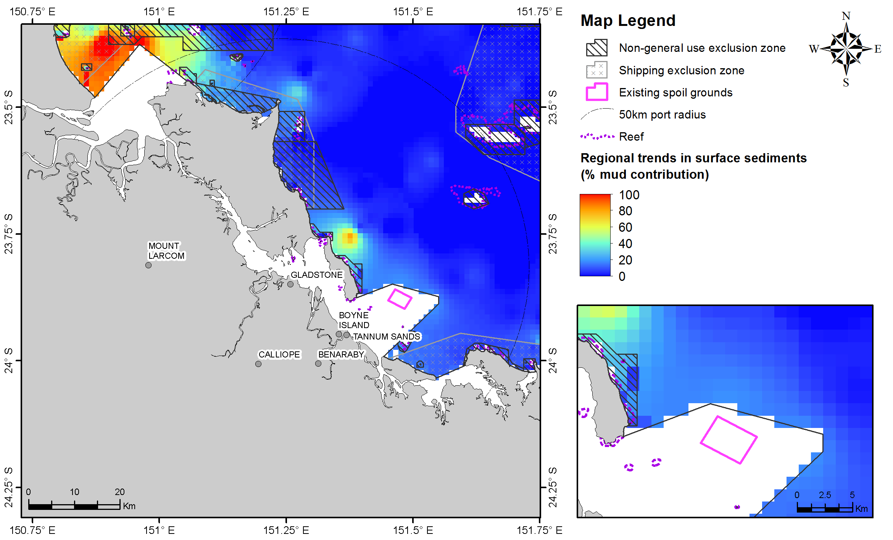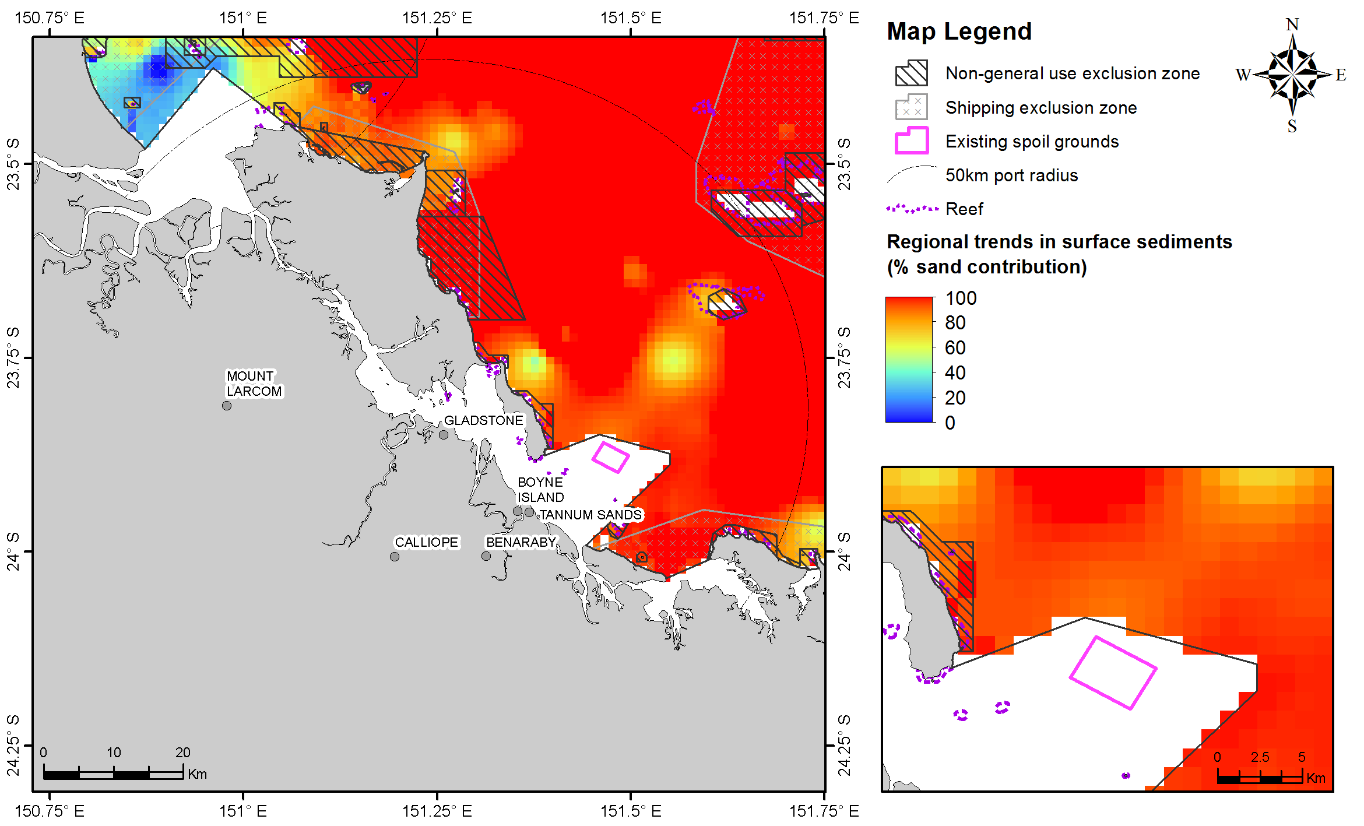
Figure 1. Percentage of mud (upper image) and sand (lower image) content in surface sediments within 50 km from the Port of Gladstone (source: Geoscience Australia marine samples database 2007).

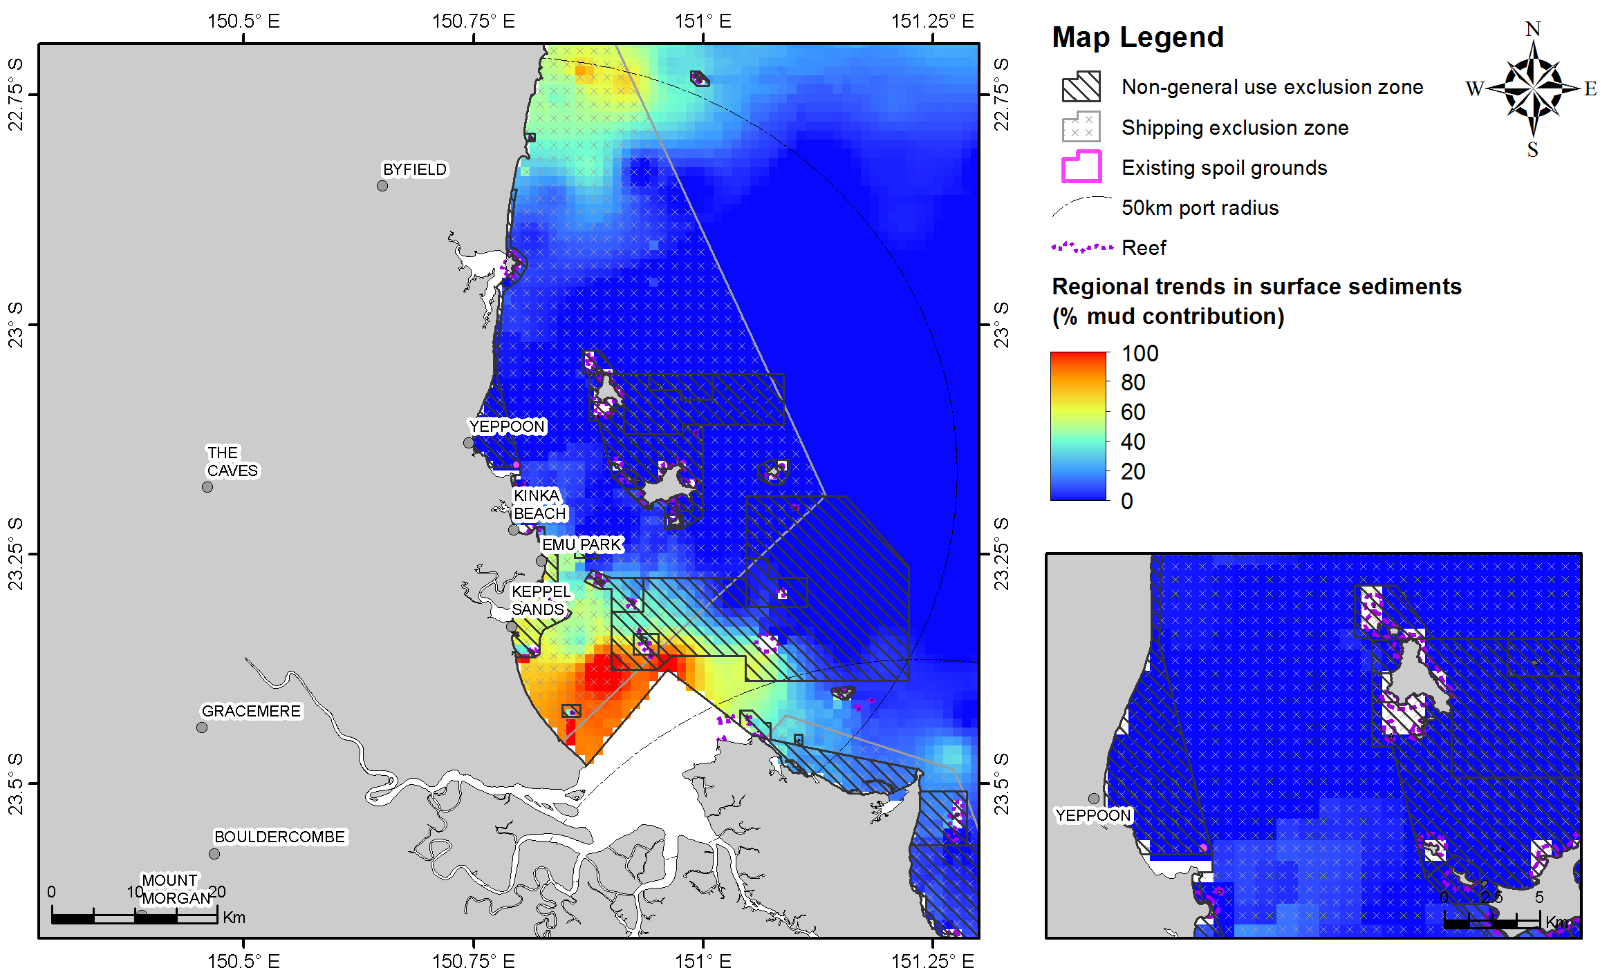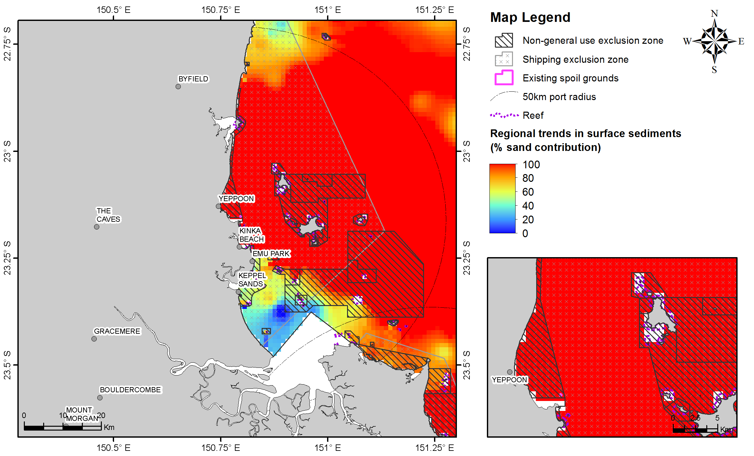
Figure 2. Percentage for mud (upper image) and sand (lower image) content in surface sediments within 50 km from Rosslyn Bay State Boat Harbour (source: Geoscience Australia marine samples database 2007).

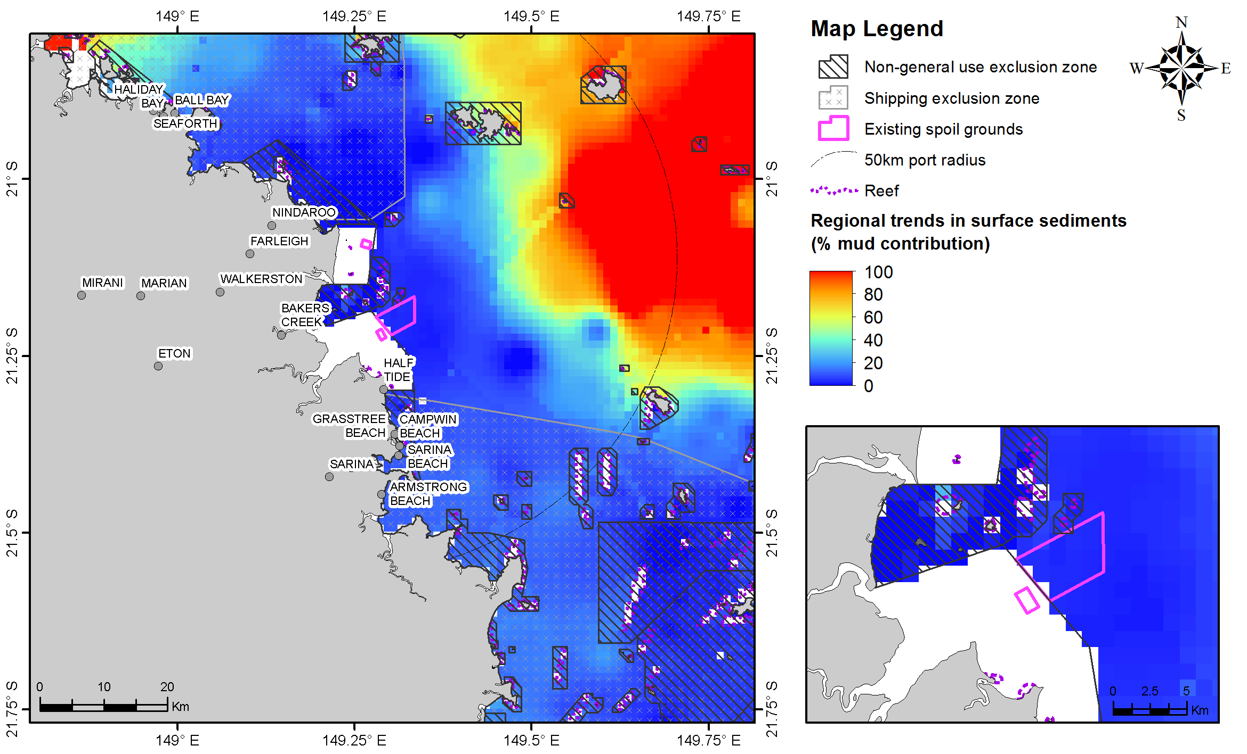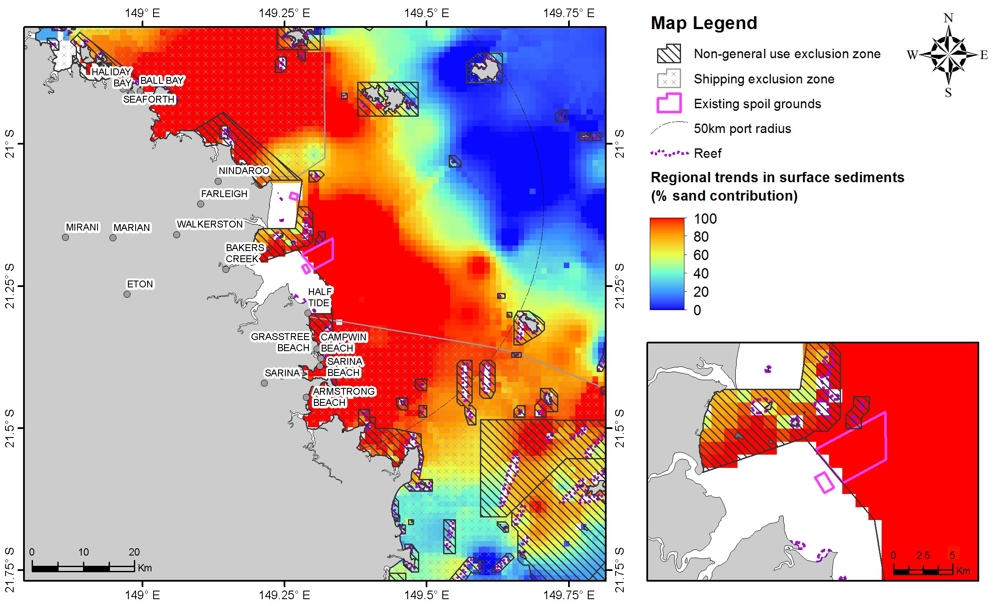
Figure 3. Percentage for mud (upper image) and sand (lower image) content in surface sediments within 50 km from the Port of Hay Point. (source: Geoscience Australia marine samples database 2007).

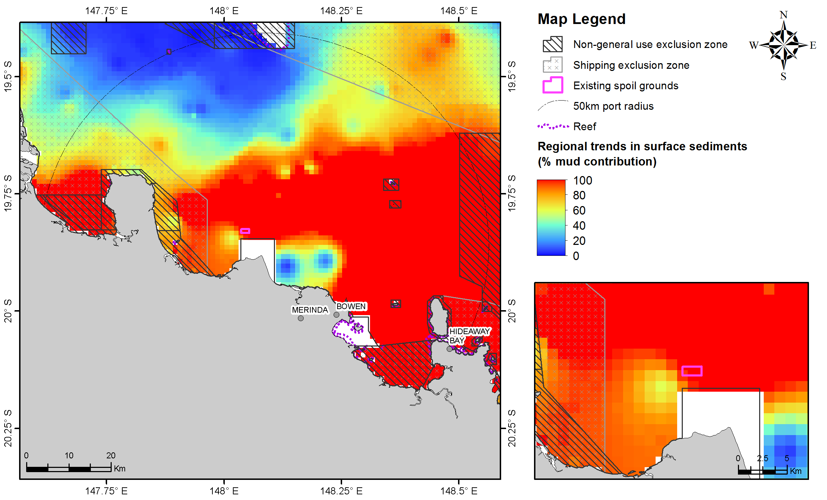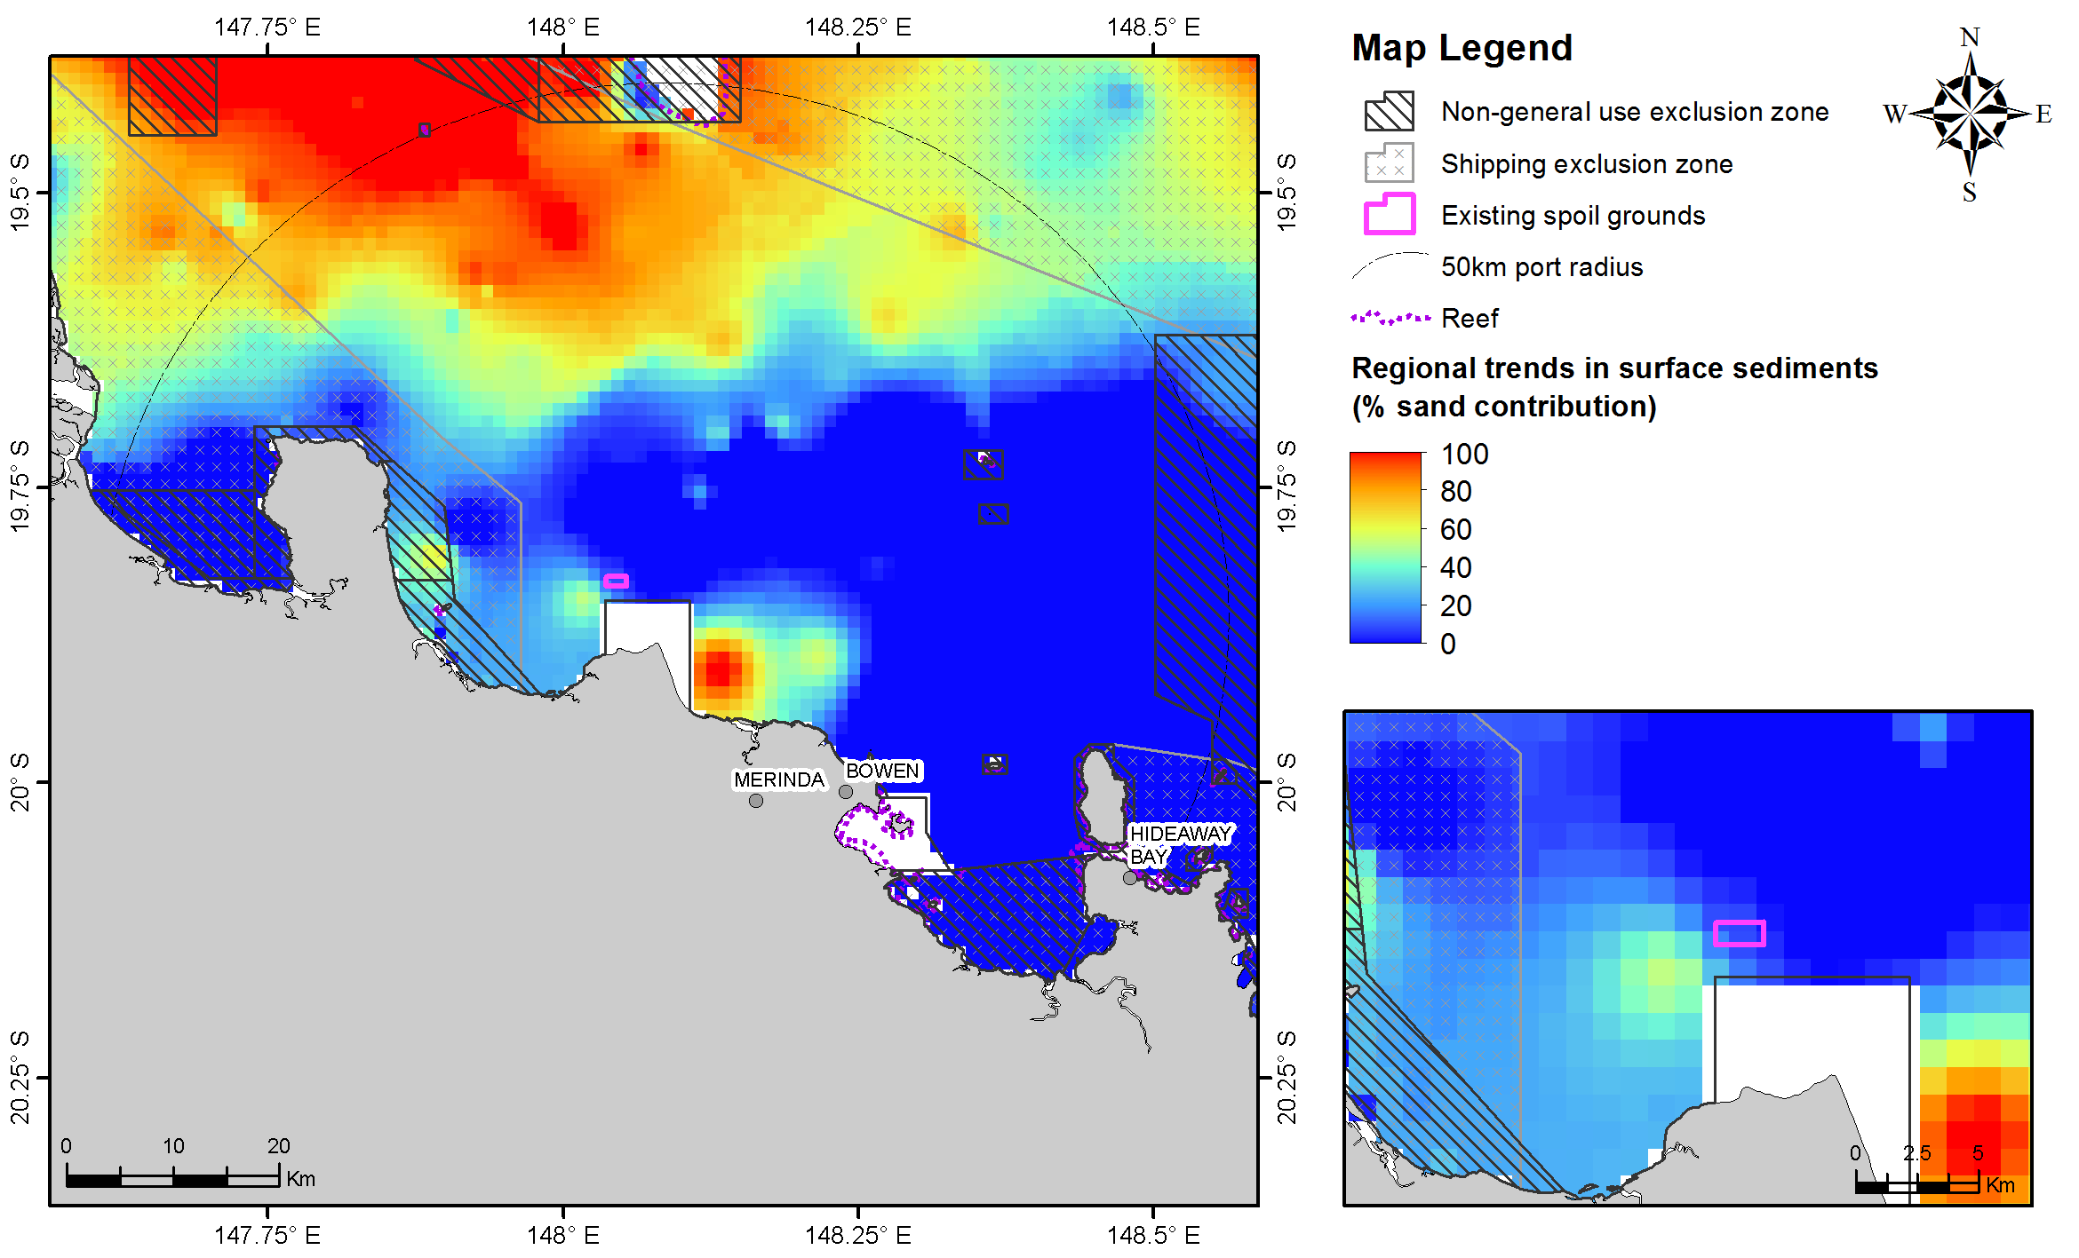
Figure 4. Percentage for mud (upper image) and sand (lower image) content in surface sediments within 50 km from the Port of Abbot Point (source Geoscience Australia marine samples database 2007).

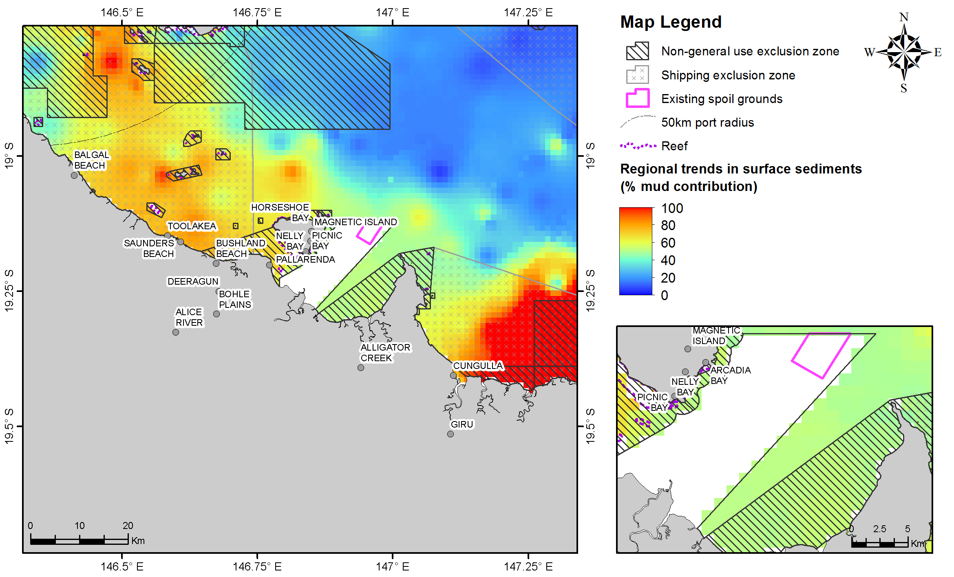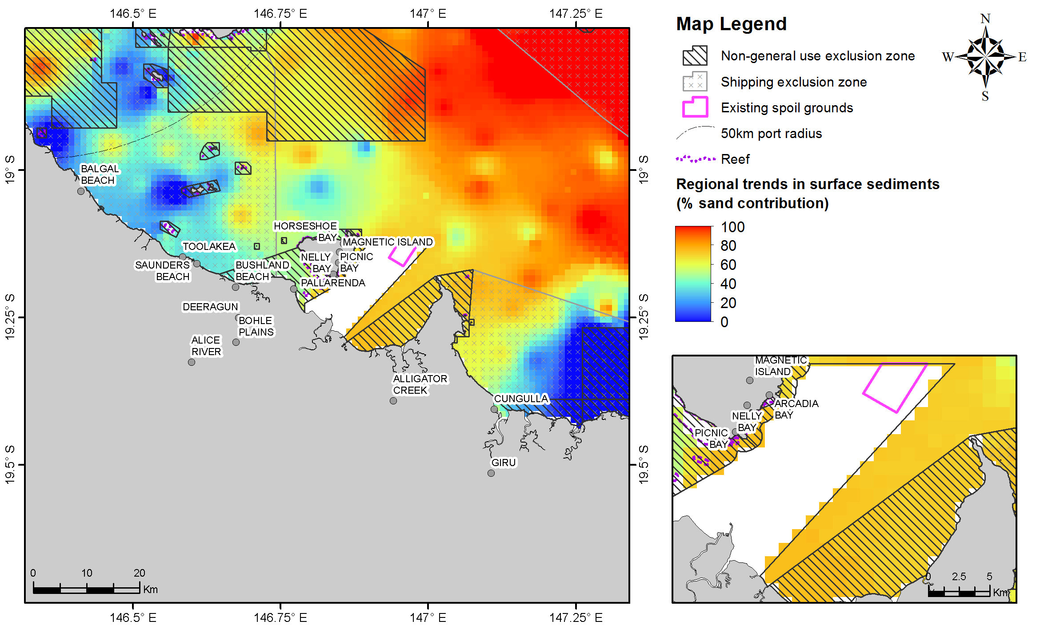
Figure 5. Percentage for mud (upper image) and sand (lower image) content in surface sediments within 50 km from the Port of Townsville (source Geoscience Australia marine samples database 2007).

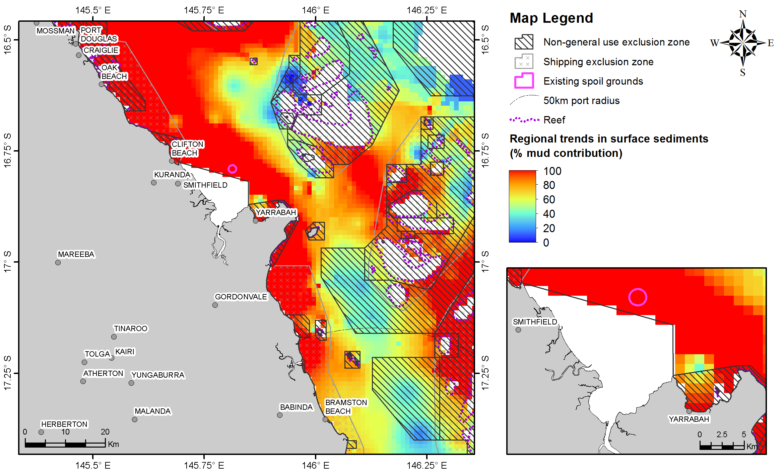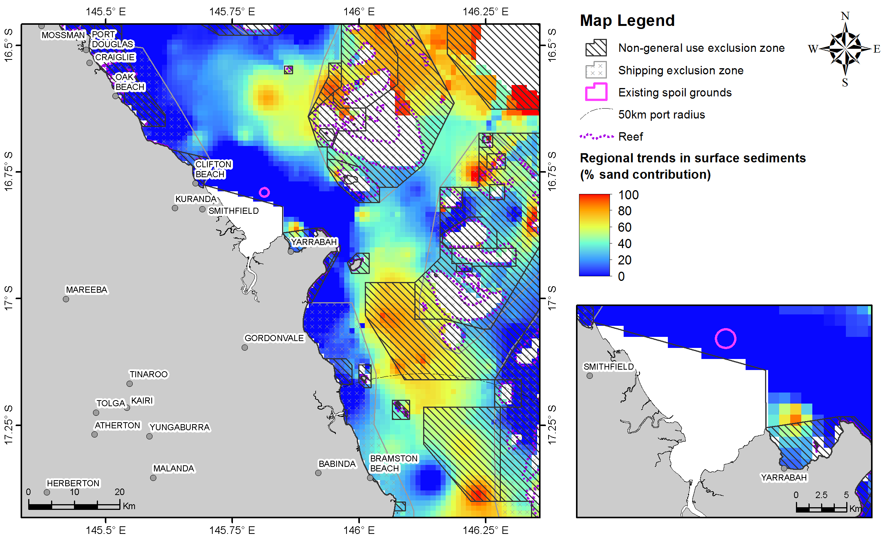
Figure 6. Percentage mud (upper image) and sand (lower image) content in surface sediments within 50 km from the Port of Cairns (source: Geoscience Australia marine samples database 2007).

