
Site Plan

Note: Information in this document may now be superseded. This includes the 2017 amendments to the Whitsundays Plan of Management 1998 such as updates to boundary descriptions to coordinate based descriptions.

Double Bay (East) Site Plan
(Prepared in August 2007)

1. Background

1.1 Rationale
Site plans are an important management tool used jointly by the Great Barrier Reef Marine Park Authority (GBRMPA) and the Queensland Parks and Wildlife Service (QPWS). They identify the significant values and management arrangements at a particular site, concentrating on the specific use issues and cumulative impacts.
Double Bay (East) has been assigned to a Protected Setting (Setting 5) in the Whitsundays Plan of Management 1998 (WPOM). Due to its protected setting, the WPOM requires that this site plan be developed to ensure protection of the natural, cultural and heritage values of the bay and to determine group size and vessel length limits.

1.2 Location
Double Bay is located on the mainland coast, approximately 12 kilometres north-west of Airline Beach. The setting 5 area addressed by this site plan is located in the eastern extremity of the bay (see Figure 1).
Most of the land adjacent to Double Bay is within Dryander National Park, managed by the QPWS. For more information, refer to the Environmental Protection Agency website.

2. Natural, cultural and heritage values
The values described below are not exhaustive, but are indicative of the significance of the area covered by this site plan.

2.1 Coral
Double Bay (East) contains a shallow reef, 0-2 metres deep at low water, which is dominated by massive colonies, including a Goniastrea species that has not been observed elsewhere in the Whitsunday region under such naturally high turbidity (De Vantier et al, 1992).
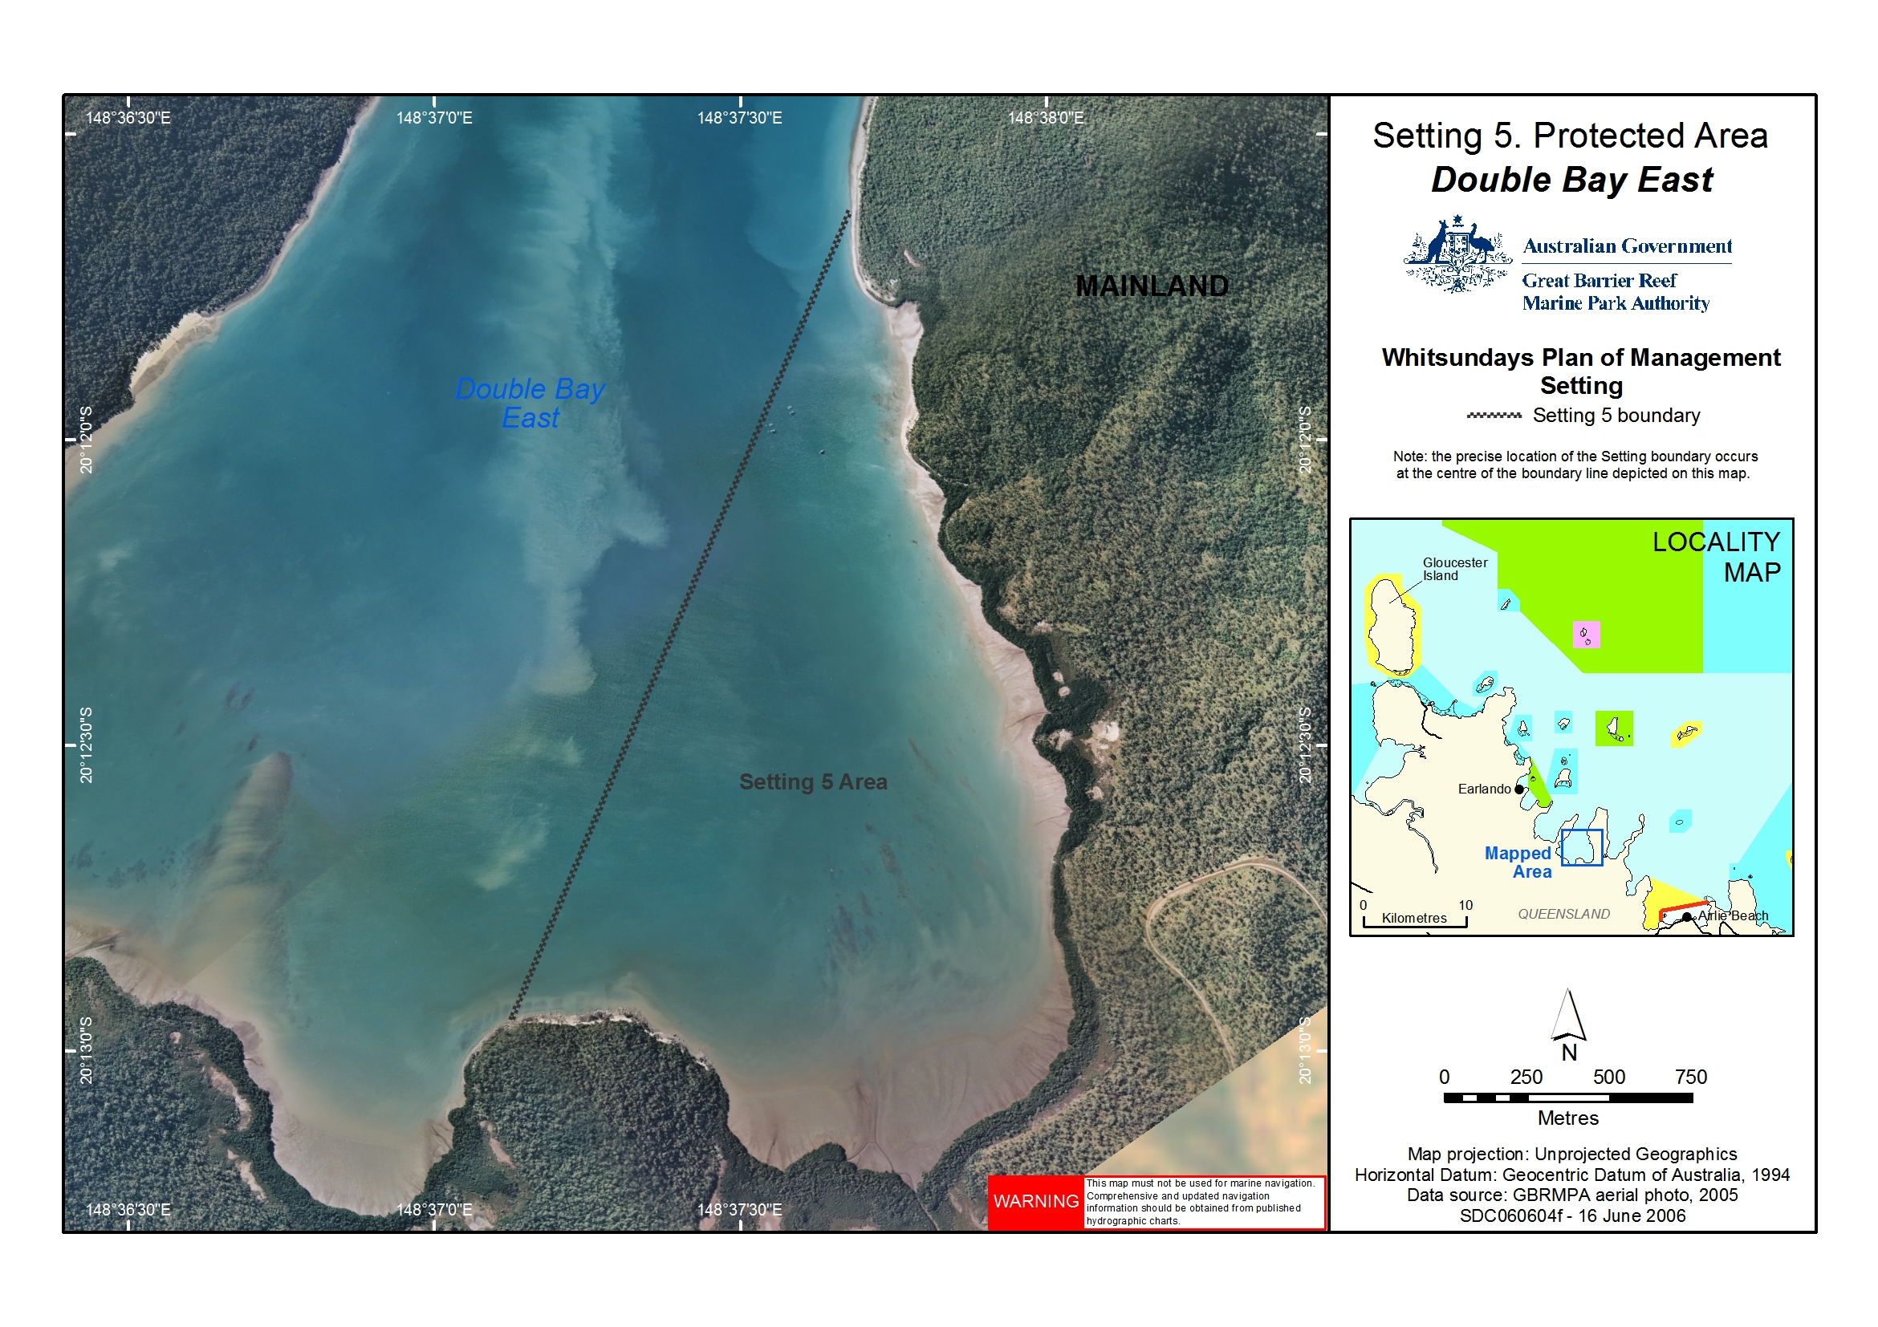
Figure 1: Location of Double Bay (East)

2.2 Mangroves
The shoreline of Double Bay (East) is dominated by mangrove communities, which play an important role is nutrient cycling, delivering organic matter that supports inshore food chains that many marine species rely on. The productivity of mangroves can be up to 20 times greater than open ocean waters and are often up to five times greater than rich coastal waters.

2.3 Traditional Owners
The islands and surrounding areas are culturally significant to the Ngaro Aboriginal Traditional Owner Group. The islands, reefs and surrounding waters are part of the cultural landscape and are still the focus for traditional access and use of available resources. Spiritual connections are often associated with the natural and cultural resources.
The Central Queensland Land Council Aboriginal Corporation is the representative body for Traditional Owners whose estates are located in the Whitsunday region.

3. Current use
Colfelt (2004) notes that eastern Double Bay provides a number of quiet, secure anchorages. Commercial tour operators visit the bay infrequently. The adjacent mainland is predominantly national park and the bay can only be accessed by boat.

4. Management strategies

4.1 Current management

4.1.1 Zoning
Double Bay (East) is a General Use (Light Blue) Zone under both State and Commonwealth Zoning Plans. Marine Park Zoning Map 10 shows the zoning at Double Bay. General Use Zones aim to provide opportunities for reasonable use, while still allowing for conservation. For more information on what activities are allowed in Double Bay (East) refer to the Activities Guide.
The Zoning Plan is one of a range of management tools used for Double Bay (East). Other management tools, which include the Whitsundays Plan of Management 1998, the Great Barrier Reef Marine Park Act 1975 and Great Barrier Reef Marine Park Regulations 1983.

4.1.2 Permits and the Whitsundays Plan of Management
Most commercial activities in the Great Barrier Reef Marine Park, including tourist operations, require a Marine Parks permit. Permits help the GBRMPA and the QPWS to manage impacts on sensitive areas, amongst other things. Further information on permits can be obtained on the GBRMPA website.
When the Whitsundays Plan of Management came into effect in 1998, permits allowing access to the Setting 5 area were capped. There are only a small number of permits with an endorsement allowing the conduct of commercial tour operations in the Setting 5 area of Double Bay (East).

4.2 Proposed management

4.2.1 Permits
The number of permits allowing commercial tour operators to access the Setting 5 area will be maintained at the current level. If existing permits are revoked, surrendered or expire, they may be re-allocated in accordance with the GBRMPA’s policy for Managing Tourism Permissions to Operate in the Great Barrier Reef Marine Park (including Allocation, Latency and Tenure).
Access to the Setting 5 area will be allowed for cultural tours run by, or in collaboration with, Traditional Owners if the permittee has been granted a Commercial Activities Permit issued by the QPWS to access the Double Bay site on the adjacent national park.

4.2.2 Group size and vessel length limits
Group sizes will be limited to a maximum of 15 people (including crew) and vessel length will be limited to 20 metres. This will apply to recreational Marine Park users. Commercial access will continue to be determined by existing permissions. If an existing permission allows the operator to exceed the group size and vessel length limits, the operator will maintain their current permitted capacity.
An amendment to the Whitsundays Plan of Management 1998 will be required in order to bring these group size and vessel length limits into effect.

5. Community engagement
This site plan was developed in consultation with the Queensland Parks and Wildlife Service, the Whitsunday Local Marine Advisory Committee, the Tourism and Recreation Reef Advisory Committee, Traditional Owners and local users of the Marine Park. The site plan was available for public consultation from 14 February 2007 to 19 March 2007 and comments were incorporated prior to the site plan being finalised. For further information, please contact the Authority on (07) 4750 0700 or email policyandplanning@gbrmpa.gov.au.

6. References
Colfelt, D. (2004). 100 Magic Miles of the Great Barrier Reef – the Whitsunday Islands. Windward Publications.
De Vantier, L.M. and van Woesik, R. (1992). Resource Assessment of Nearshore Coral Communities in the Whitsunday Region. Report to the Queensland Department of Environment and Heritage.
Lear, R., and Turner, T. (1977). Mangroves of Australia. University of Queensland Press.

