
Site Plan

Note: Information in this document may now be superseded. This includes the 2017 amendments to the Whitsundays Plan of Management 1998 such as updates to boundary descriptions to coordinate based descriptions.

Hill Inlet
(Prepared August 2007)

1. Background

1.1 Location
Site plans are an important management tool used jointly by the Great Barrier Reef Marine Park Authority (GBRMPA) and the Queensland Parks and Wildlife Service (QPWS). They identify the significant values and management arrangements at a particular site, concentrating on the specific use issues and cumulative impacts.
Hill Inlet has been assigned to a Protected Setting (Setting 5) in the Whitsundays Plan of Management 1998 (WPOM). Due to its protected setting, the WPOM requires that this site plan be developed to ensure protection of the natural, cultural and heritage values of the inlet and to determine group size and vessel length limits.

1.2 Location
Hill Inlet is located on the eastern side of Whitsunday Island, at the northern end of popular Whitehaven Beach. The focus of this site plan is the Setting 5 area managed by the Great Barrier Reef Marine Park Authority located outside the entrance to Hill Inlet, however, the management actions for this area also have implications for the inside of Hill Inlet, adjacent Tongue Bay and the intervening National Park. To provide for holistic management of these areas, this site plan links to current or proposed management strategies for Tongue Bay and Tongue Point where relevant. If visitor use or management arrangements at one of these adjacent locations changes, this site plan may need to be revised accordingly to ensure continued complementary management.

2. Natural, cultural and heritage values
The values described below are not exhaustive, but are indicative of the significance of the area covered by this site plan.

2.1 Scenic value
The view of the white silica sands of Hill Inlet and Whitehaven Beach, observed from aircraft and the lookout located on Tongue Point, is internationally recognised and has become a visual icon for the Whitsundays.
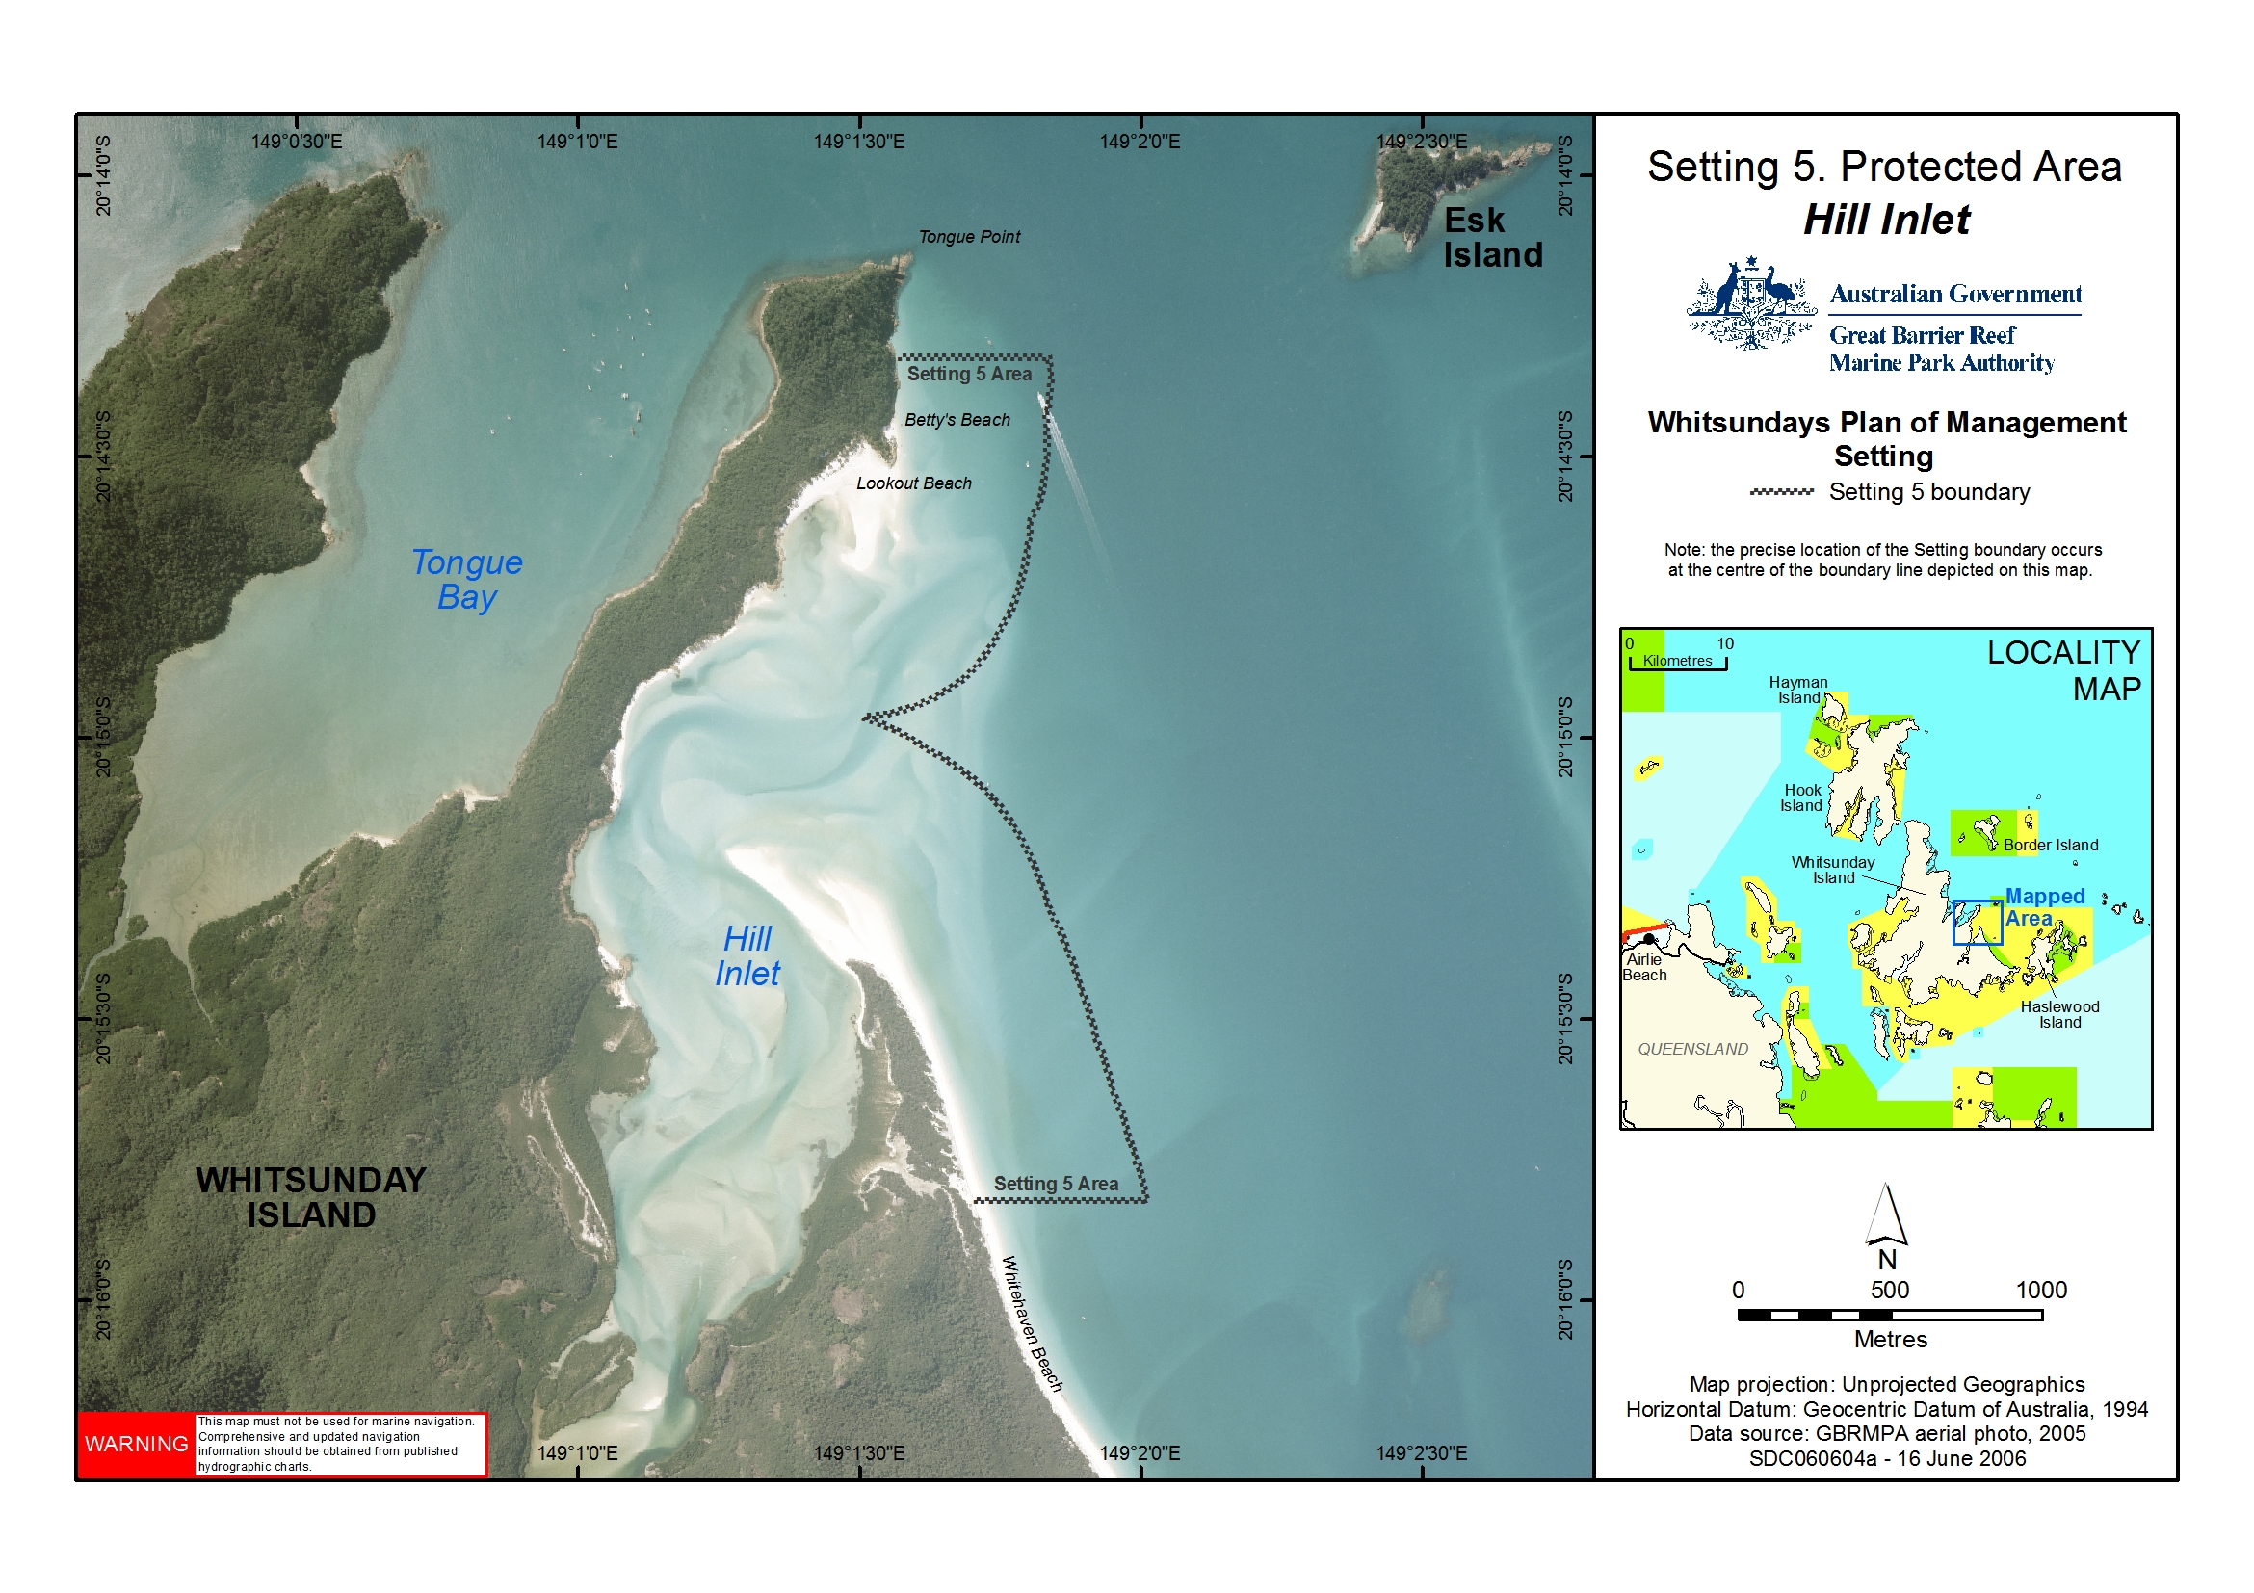
Figure 1: Location of Hill Inlet

2.2 Mangroves
The intertidal area of Hill Inlet is vegetated with mangroves, which play an important role in nutrient cycling, delivering organic matter that supports inshore food chains that many marine species rely on. The productivity of mangroves can be up to 20 times greater than open ocean waters and are often up to five times greater than rich coastal waters.

2.3 Seabirds
Hill Inlet provides nesting habitat for a range of shore- and migratory-birds that use the Whitsundays as a stopover on their annual migration. The silica sand flats provide habitat for beach stone curlews (Burhinus neglectus), pied oyster catchers (Haematopus longirostris), wader and other shorebirds and seabirds. Large numbers of crested terns (Sterna bergii) have been observed roosting on the sand spit and several species of waders have been recorded throughout the inlet. Several raptor species including the brahiminy kite (Haliastur indus), white-bellied sea eagle (Haliaetus leucogaster) and osprey (Pandion haliaetus) have also been recorded in Hill Inlet (QPWS, 1996).

2.4 Cultural significance
The inlet and surrounding areas are culturally significant to the Ngaro Aboriginal Traditional Owner Group. The island, reefs and surrounding waters are part of the cultural landscape and are still the focus for traditional access and use of available resources. Spiritual connections are often associated with the natural and cultural resources.
There are two recorded cultural sites accessed via the inlet. One is a rock shelter with rock art and stone artefacts. The other is an open midden scatter (Barker, 2004).
The Central Queensland Land Council Aboriginal Corporation is the representative body for Traditional Owners whose estates are located in the Whitsunday region.

3. Current use
Tongue Point has become one of the ‘must do’ locations for the Whitsundays tourism industry, with internationally renowned views of Hill Inlet and the white, silica sands of Whitehaven Beach. Commercial tour operators bring approximately 90,000 visitors to Tongue Point each year. It is estimated that this accounts for approximately 70 percent of visitation to Tongue Point (QPWS, 2006).

4. Management Strategies

4.1 Current management

4.1.1 Zoning
Hill Inlet is within a Conservation Park (Yellow) Zone under both State and Commonwealth Zoning Plans. Marine Park Zoning Map 10 shows the zoning at Hill Inlet. Conservation Park Zones provide for limited extractive use, with additional restrictions on most fishing activities. A Public Appreciation Special Management Area also applies to the Conservation Park Zone. Spearfishing is prohibited within the Public Appreciation Area. For more information on what activities are allowed in the Conservation Park Zone and Public Appreciation Area, refer to Zoning Map Activities Guide.

The Zoning Plan is one of a range of management tools for Hill Inlet. Other management tools include the Whitsundays Plan of Management 1998, the Great Barrier Reef Marine Park Act 1975 and the Great Barrier Reef Marine Park Regulations 1983.

4.1.2 Permits and the Whitsundays Plan of Management
A number of activities in the Great Barrier Reef Marine Park, including tourist operations, require a Marine Parks permit. Permits help the GBRMPA and the QPWS to manage impacts on sensitive areas, amongst other things. Further information on permits can be obtained on the GBRMPA website.
When the Whitsundays Plan of Management came into effect in 1998, permits allowing access to all Setting 5 areas were capped. There are only a small number of permits with an endorsement allowing the conduct of commercial tour operations in the Setting 5 area of Hill Inlet. However, as noted above, high numbers of visitors, both recreational and commercial, access adjacent Tongue Point and Tongue Bay. Tourism operators accessing the National Park at Tongue Point also require a Commercial Activity Permit (CAP) from the Queensland Parks and Wildlife Service.

4.1.3 Access
Due to the restricted commercial access into Hill Inlet, access to Tongue Point and the popular lookout is currently concentrated onto a small beach in Tongue Bay where vessels can put people ashore and anchor or pick up one of three public moorings. The beach is only readily accessible at high tide while the coral is covered. This causes an influx of visitors to Tongue Point at high tide, however, the demand by visitors is to view the inlet at low tide when the inlet has more scenic appeal. This focussed visitation pattern is placing pressure on the infrastructure and detracting from the experience of visitors to Tongue Point. At low tide, tenders and people walking across the reef to reach the beach in an attempt to avoid the peak visitation periods are damaging the fringing coral. The QPWS are investigating the feasibility of an all-tide access facility in Tongue Bay as a potential strategy to diffuse visitation patterns and mitigate the coral damage resulting from boats landing on the beach.

4.1.4 Whitsunday and Mackay Islands Visitor Management Strategy
The draft Whitsunday and Mackay Islands Visitor Management Strategy is a Queensland Parks and Wildlife Service initiative that will provide a framework for sustainable tourism and visitor use into the future for the islands and their beaches.
The QPWS has assessed Hill Inlet and the northern end of Whitehaven Beach as being appropriate to include within a protected setting as they are a part of a natural area that has been set aside for conservation. These areas will continue to be managed by the QPWS for minimal use by visitors. Tongue Point, Lookout Beach and Betty’s Beach have been assessed as being appropriate to include in a High Use setting as they provide visitor opportunities central to the tourism industry in the region. The QPWS propose to allocate High Use sites such as Tongue Point a specific carrying capacity and provide an appropriate level of supporting infrastructure such as walking tracks to minimise visitor impacts and improve visitors’ experiences.

The Setting 5 area complements this adjoining High Use setting by preserving the scenic amenity and vista sought by many visitors to the lookout and beaches. The waters adjoining these beaches and Hill Inlet will, therefore, continue to be managed for minimal use to ensure the scenic value is maintained.

4.2 Proposed management

4.2.1 Permits
The number of permits allowing commercial tour operations to access the Setting 5 area will be maintained at the current level. If existing permits are revoked, surrendered or expire, they may be re-allocated in accordance with the GBRMPA’s policy for Managing Tourism Permissions to Operate in the Great Barrier Reef Marine Park (including Allocation, Latency and Tenure).
Access to Setting 5 areas will be allowed for cultural tours run by, or in collaboration with, Traditional Owners if the permittee has been granted a Commercial Activities Permit issued by the QPWS to access the ‘Hill Inlet’ site on the adjacent national park.

4.2.2 Provision of all-tide access in Tongue Bay
The QPWS will assess the feasibility and ecological impacts of installing a facility such as a jetty, ramp, pontoon or channel to enable all-tide access to Tongue Point via Tongue Bay. The QPWS are working toward providing all-tide access via Tongue Bay to alleviate congestion and to ensure that vessels accessing Lookout Beach and Betty’s Beach do not compromise the scenic value of Hill Inlet.

4.2.3 Vessel access to Betty’s Beach
Tour operators with a Commercial Activity Permit (CAP) and a state marine park permit allowing them to take visitors to Lookout Beach and Betty’s Beach will be able to transit through the Setting 5 area to Betty’s Beach. This will assist in alleviating congestion on Tongue Point during peak periods and will help minimise coral damage to the landing area in Tongue Bay until all-tide access is provided. Vessels are not to anchor inside the Setting 5 area and are encouraged to use the anchorage and public moorings in Tongue Bay once passengers have disembarked. If all-tide access is provided in Tongue Bay, operators will be encouraged to only embark and disembark passengers via Tongue Bay and thereby preserve the scenic amenity from the lookout and beaches.

4.2.4 Group size and vessel length limits
Group sizes will be limited to a maximum of 15 people (including crew) and vessel length will be limited to 20 metres. This will apply to recreational Marine Park users. Commercial access will continue to be determined by existing permissions. If an existing permission allows the operator to exceed the group size and vessel length limits, the operator will maintain their current permitted capacity.
An amendment to the Whitsundays Plan of Management 1998 will be required in order to bring these group size and vessel length limits into effect.

5. Community engagement
This site plan was developed in consultation with the Queensland Parks and Wildlife Service, the Whitsunday Local Marine Advisory Committee, the Tourism and Recreation Reef Advisory Committee, Traditional Owners and local users of the Marine Park. The site plan was available for public consultation from 14 February 2007 to 19 March 2007 and comments were incorporated prior to the site plan being finalised. For further information, please contact the Authority on (07) 4750 0700 or email policyandplanning@gbrmpa.gov.au.

6. References
Barker, B. (2004). The Sea People: late Holocene maritime specialisation in the Whitsunday Islands, central Queensland. Pandanus Books.

Colfelt, D. (2004). 100 Magic Miles of the Great Barrier Reef: the Whitsunday Islands. Windward Publications Pty Ltd.

Lear, R., and Turner, T. (1977). Mangroves of Australia. University of Queensland Press.

QPWS – Queensland Parks and Wildlife Service. (1996). Unpublished survey.

QPWS – Queensland Parks and Wildlife Service. (2006). Draft Whitsunday and Mackay Islands Visitor Management Strategy.

