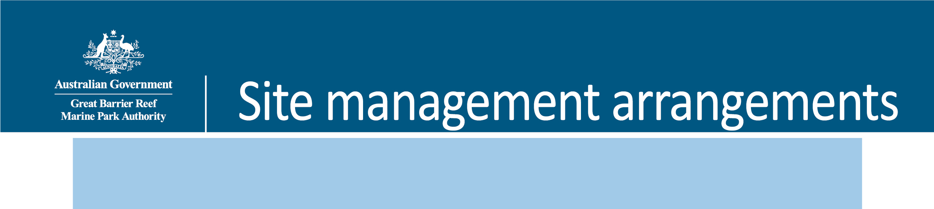
Ste Plan
Site Plan

Note: Information in this document may now be superseded. This includes the 2017 amendments to the Whitsundays Plan of Management 1998 such as updates to boundary descriptions to coordinate based descriptions.

Cow and Calf Islands
(Prepared August 2007)

1. Background

1.1 Rationale
Site plans are an important management tool used jointly by the Great Barrier Reef Marine Park Authority (GBRMPA) and the Queensland Parks and Wildlife Service (QPWS). They identify the significant values and management arrangements at a particular site, concentrating on the specific use issues and cumulative impacts.
Cow Island (20-064) and Calf Island (20-065) have been assigned to a Protected Setting (Setting 5) in the Whitsundays Plan of Management 1998 (WPOM). Due to their protected setting, the WPOM requires that this site plan be developed to ensure protection of the natural, cultural and heritage values of the waters surrounding the islands and determine group size and vessel length limits.

1.2 Location
Cow and Calf Islands are high continental islands, situated to the south of Long Island Passage and close inshore to Conway National Park. The islands themselves are part of the Molle Islands National Park, managed by the QPWS. For more information, refer to the Environmental Protection Agency website.

2. Natural, cultural and heritage values
The values described below are not exhaustive, but are indicative of the significance of the area covered by this site plan.

2.1 Fringing reef
Cow and Calf Islands have a shallow, inshore fringing reef covering an area of approximately 10 hectares. The reef is visible in the aerial photograph at Figure 1.

2.2 Mangroves
Mangroves are abundant along the southern shoreline of Cow Island and either side of the sandbar extending toward the mainland from the western end of Cow Island. During high tide, the sandbar and mangroves are submerged. Mangroves play an important role in nutrient cycling, delivering organic matter that supports inshore food chains that many marine species rely on. The productivity of mangroves can be up to 20 times greater than open ocean waters and is often up to five times greater than rich coastal waters.
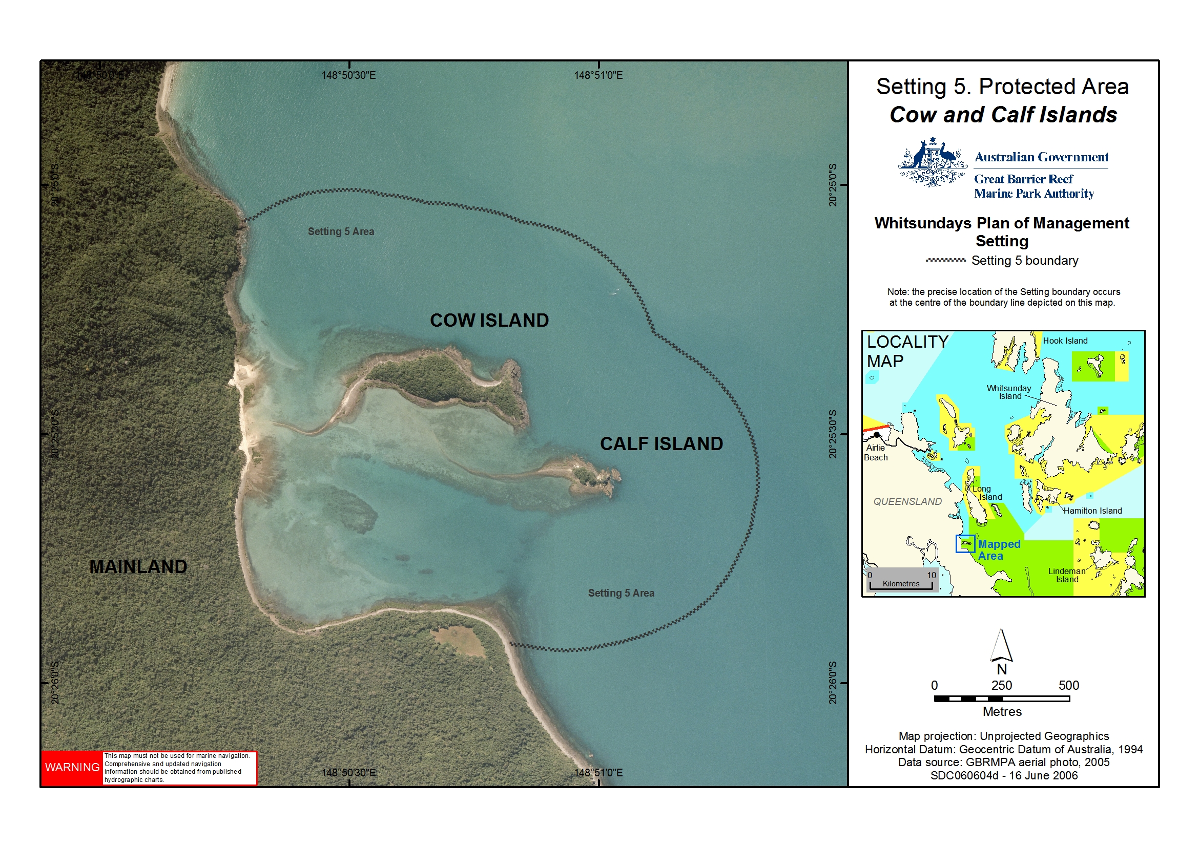
Figure 1: Location of Cow and Calf Islands

2.3 Traditional Owners
The islands and surrounding areas are culturally significant to the Ngaro Aboriginal Traditional Owner Group. The islands, reefs and surrounding waters are part of the cultural landscape and are still the focus for traditional access and use of available resources. Spiritual connections are often associated with the natural and cultural resources.
The Central Queensland Land Council Aboriginal Corporation is the representative body for Traditional Owners whose estates are located in the Whitsunday region.

3. Current use
Recreational visitation is believed to be low in comparison to the rest of the Whitsundays because the islands are not en route to more commonly visited destinations and the zoning does not allow fishing in the surrounding waters. The islands also have very limited beach access.
There is no recent record of commercial tour operators visiting Cow and Calf Islands. No Environmental Management Charge (EMC) returns have been recorded from visits to the islands or the fringing reefs since 1998.

4. Management strategies

4.1 Current management

4.1.1 Zoning
The waters surrounding Cow and Calf Islands are within a Marine National Park (Green) Zone under both State and Commonwealth Zoning Plans. Marine Park Zoning Map 10 shows the zoning at Cow and Calf Islands. The Marine National Park Zone is a ‘no-take’ area and extractive activities like fishing or collecting are not allowed without the written permission of the GBRMPA. For more information on what activities are allowed in the waters surrounding Cow and Calf Islands, refer to the Activities Guide.
The Zoning Plan is one of a range of management tools used for Cow and Calf Islands. Other management tools include the Whitsundays Plan of Management 1998, the Great Barrier Reef Marine Park Act 1975 and Great Barrier Reef Marine Park Regulations 1983.

4.1.2 Permits and the Whitsundays Plan of Management
A number of activities in the Great Barrier Reef Marine Park, including tourist operations, require a Marine Parks permit. Permits help the GBRMPA and the QPWS to manage impacts on sensitive areas, amongst other things. Further information on permits can be obtained on the GBRMPA website.
When the Whitsundays Plan of Management came into effect in 1998, permits allowing access to all Setting 5 areas were capped. There are only a small number of permits with an endorsement allowing the conduct of commercial tour operations in the Setting 5 area surrounding Cow and Calf Islands. As noted above, there are no recent records of commercial tour operators visiting the islands.

4.1.3 Whitsunday and Mackay Islands Visitor Management Strategy
The draft Whitsunday and Mackay Islands Visitor Management Strategy is a Queensland Parks and Wildlife Service initiative that will provide a framework for sustainable tourism and visitor use into the future for the islands and their beaches. Assessment by the QPWS suggests that both Cow and Calf Islands should be included within a protected setting as they are a part of a natural area that has been set aside for conservation. The islands are managed by the QPWS for nil to minimal use by visitors.

4.2 Proposed management

4.2.1 Permits
The number of permits allowing commercial tour operators to access the Setting 5 area will be maintained at the current level. If existing permits are revoked, surrendered or expire, they may be re-allocated. If they are to be re-allocated, it will be done in accordance with the GBRMPA’s policy for Managing Tourism Permissions to Operate in the Great Barrier Reef Marine Park (including Allocation, Latency and Tenure).
Access to the Setting 5 area will be allowed for cultural tours run by, or in collaboration with, Traditional Owners if the permittee has been granted a Commercial Activities Permit issued by the QPWS to access sites on Cow and Calf Island on the adjacent national park.

4.2.2 Group size and vessel length limits
Group sizes will be limited to a maximum of 15 people (including crew) and vessel length will be limited to 20 metres. This will apply to recreational Marine Park users. Commercial access will continue to be determined by existing permissions. If an existing permission allows the operator to exceed the group size and vessel length limits, the operator will maintain their current permitted capacity.
An amendment to the Whitsundays Plan of Management 1998 will be required in order to bring these group size and vessel length limits into effect.

5. Community engagement
This site plan was developed in consultation with the Queensland Parks and Wildlife Service, the Whitsunday Local Marine Advisory Committee, the Tourism and Recreation Reef Advisory Committee, Traditional Owners and local users of the Marine Park. The site plan was available for public consultation from 14 February 2007 to 19 March 2007 and comments were incorporated prior to the site plan being finalised. For further information please contact the Authority on (07) 4750 0700 or email policyandplanning@gbrmpa.gov.au.

6. References
Colfelt, D. (2004). 100 Magic Miles of the Great Barrier Reef – the Whitsunday Islands. Windward Publications.
Lear, R., and Turner, T. (1977). Mangroves of Australia. University of Queensland Press.

